Committee on Standards
in Public Life

Annual Report
July 2021 – June 2022

Honesty | Objectivity | Openness | Selflessness | Integrity | Accountability | Leadership
THE SEVEN PRINCIPLES OF PUBLIC LIFE

The Seven Principles of Public Life apply to anyone who works as a public office holder. This includes all those who are elected or appointed to public office, nationally or locally, and all people appointed to work in the public sector. The Principles also apply to all those in the private sector delivering public services.

HONESTY

Holders of public office should be truthful.

OBJECTIVITY

Holders of public office must act and take decisions impartially, fairly and on merit, using the best evidence and without discrimination or bias.

OPENNESS

Holders of public office should act and take decisions in an open and transparent manner. Information should not be withheld from the public unless there are clear and lawful reasons for so doing.

SELFLESSNESS

Holders of public office should act solely in terms of the public interest.

INTEGRITY

Holders of public office must avoid placing themselves under any obligation to people or organisations that might try inappropriately to influence them in their work. They should not act or take decisions in order to gain financial or other material benefits for themselves, their family, or their friends. They must declare and resolve any interests and relationships.

ACCOUNTABILITY

Holders of public office are accountable to the public for their decisions and actions and must submit themselves to the scrutiny necessary to ensure this.

LEADERSHIP

Holders of public office should exhibit these principles in their own behaviour and treat others with respect. They should actively promote and robustly support the principles and challenge poor behaviour wherever it occurs.

The Seven Principles were established in the Committee’s First Report in 1995; the accompanying descriptors were revised following a review in the 14th Report, Standards Matter, published January 2013 and in the 23rd Report, Upholding Standards in Public Life, published November 2021.
PREVIOUS REPORTS

2021, Upholding Standards in Public Life.

2021, Regulating Election Finance

2020, Artificial Intelligence and Public Standards

2019, Local Government Ethical Standards

2018, MPs’ Outside Interests

2018, The Continuing Importance of Ethical Standards for Public Service Providers

2017, Intimidation in Public Life

2016, Striking the Balance: Upholding the 7 Principles in Regulation

2015, Tone from the Top: Leadership, Ethics and Accountability in Policing

2014. Ethics in Practice: Promoting Ethical Standards in Public Life

2014, Ethical Standards for Providers of Public Services

2013, Strengthening Transparency around Lobbying

2013, Standards Matter: a Review of Best Practice in Promoting Good Behaviour in Public Life

2011, Political Party Finance: Ending the Big Donor Culture

2009, MPs’ Expenses and Allowances: Supporting Parliament, Safeguarding the Taxpayer

2007, Review of the Electoral Commission

2005, Getting the Balance Right: Implementing Standards of Conduct in Public Life

2003, Defining the Boundaries within the Executive: Ministers, Special Advisers and the Permanent Civil Service

2002, Standards of Conduct in the House of Commons

2000, Standards of Conduct in the House of Lords

2000, Reinforcing Standards: A summary

1998 The Funding of Political Parties in the United Kingdom

1997, Review of Standards of Conduct in Executive NDPBs, NHS Trusts and Local Public Spending Bodies

1997, Standards of Conduct of local government in England, Scotland and Wales

1996, Local Public Spending Bodies

1995, MPs, Ministers and Civil Servants, Executive Quangos

COMMITTEE MEMBERSHIP

Terms of Appointment

The independent Chair and the four independent members are appointed under the government’s Governance Code for Public Appointments for five-year, non-renewable terms. Vacancies are advertised on the public appointments website. The appointments are made by the Prime Minister.

Three political members are nominated for three-year, renewable terms by the respective party leaders and confirmed by the Prime Minister.

Lord (Jonathan) Evans of Weardale KC DL, Chair
1 November 2018 - 31 October 2023

Dame Shirley Pearce DBE
31 March 2018 - 30 March 2023

Ewen Fergusson
1 August 2021 - 31 July 2026

Professor Gillian Peele
1 August 2021 - 31 July 2026

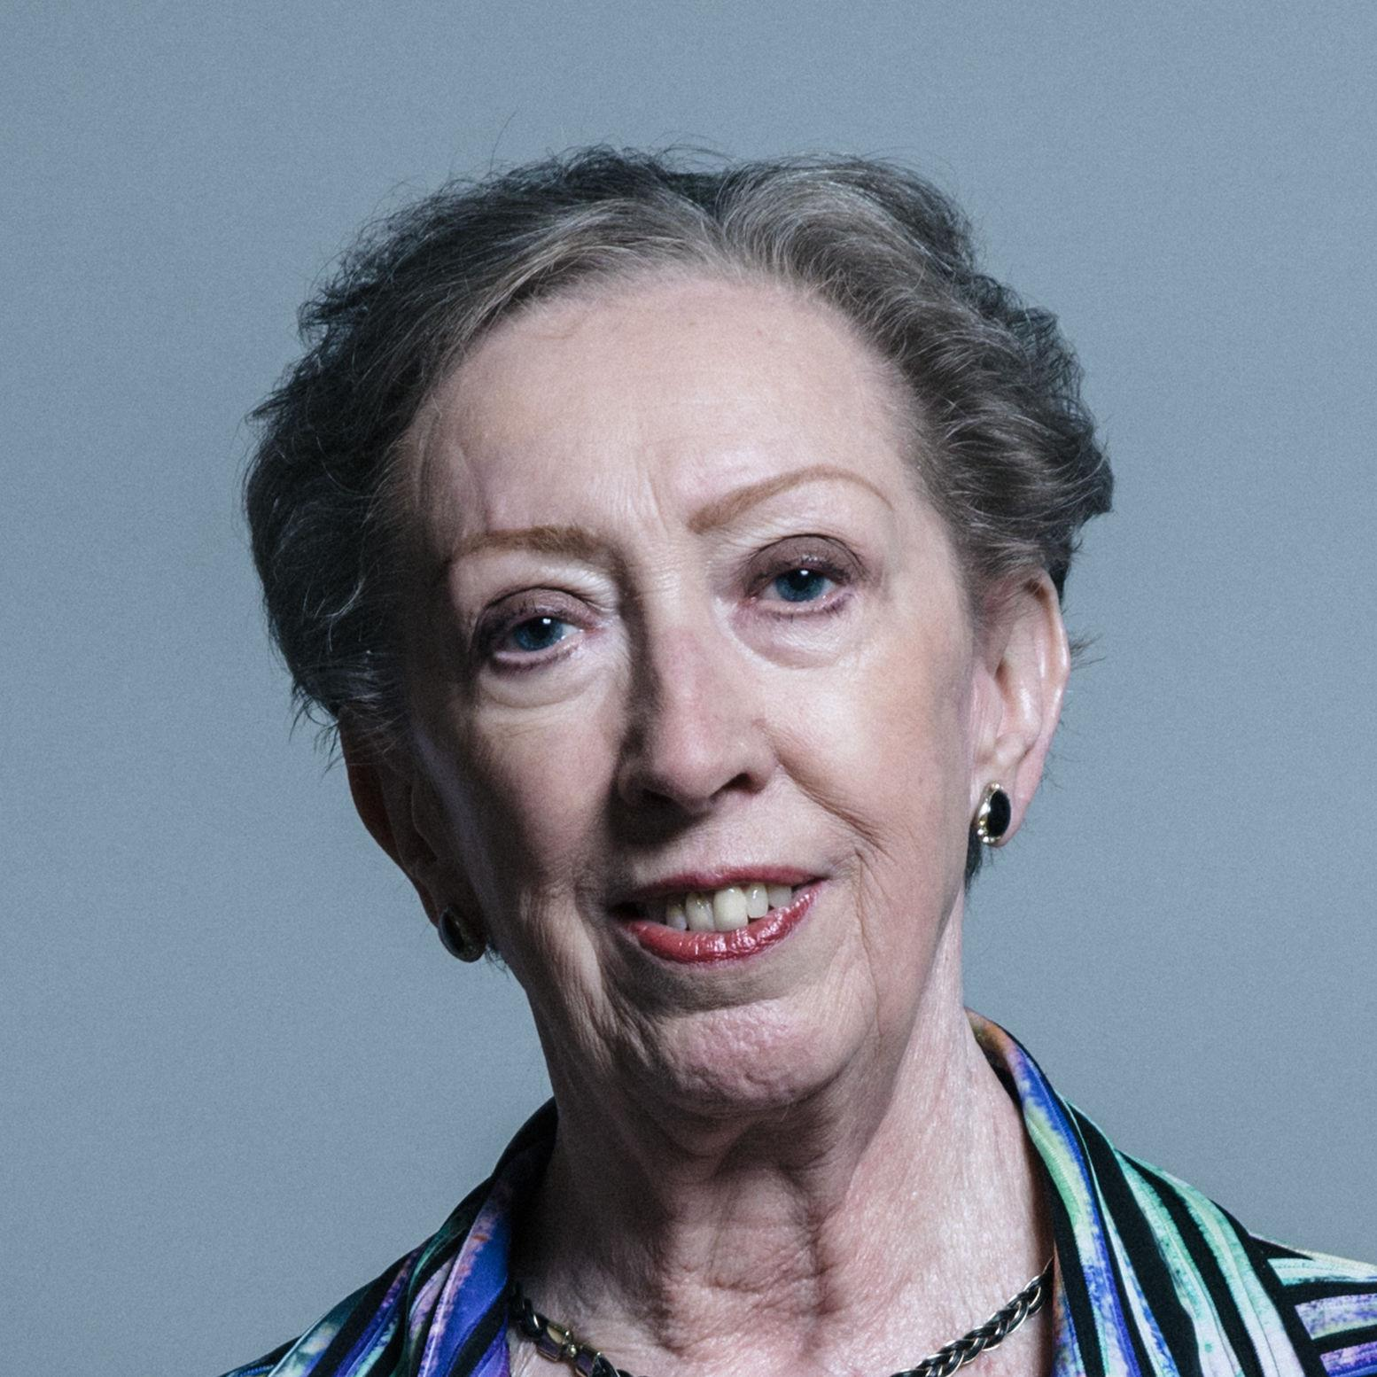

Rt Hon Dame Margaret Beckett DBE MP (Labour)
Reappointed 31 October 2019 - 30 October 2022

Rt Hon Lord (Andrew) Stunell OBE (Liberal Democrat)
Reappointed 1 December 2019 - 30 November 2022

Rt Hon Sir Jeremy Wright QC MP (Conservative)
21 November 2019 - 20 November 2022

There is a vacancy on the Committee for an independent member.

Members for part of the period of this report

Dr Jane Martin CBE
1 January 2017 - 31 December 2021

Monisha Shah
1 December 2015 - 30 July 2021

FOREWORD BY THE CHAIR

I am pleased to present the Committee on Standards in Public Life’s Annual Report for 2021/2022, my fourth as its Chair.

The Committee’s role – established twenty-eight years ago – is to promote the Nolan Principles of honesty, objectivity, openness, selflessness, integrity, accountability and leadership across public life by advising on the institutions, rules and processes necessary to support high standards of conduct.

These Principles outline the standards that the public expect from those who serve them: they are integral to the unwritten contract between those taking decisions and those subject to them. They are central to sustaining public trust in government, and to the health and good functioning of our democracy. The Principles apply to politicians, civil servants, local government officials, those in the National Health Service, the police, indeed all those in public service as well as those in private companies providing public services. High standards are necessary for efficient and effective decision making and policy delivery in the public sector. They are an enabler rather than a hindrance and they help set the framework within which politics and policy is conducted in our country.

It is regrettable that standards issues should have become increasingly contested and politicised in recent years. This can be deeply harmful both to public perception of standards in public life and to the legitimacy of the political process, and to ensuring that people in the public sector are treated fairly, equitably and are properly held to account for standards failures.

The Committee’s work - conducting evidence-based scrutiny of the regulatory framework - has been vital to maintaining commonly agreed standards that keep accountability to the public at the forefront, and helped prevent debates on standards issues being driven by purely partisan concerns.

This year has undeniably seen increased concern about standards of conduct in public life, and, while there is no such thing as a ‘golden age’ of standards, it is evident that the institutions and processes that support high standards of conduct are under considerable pressure and reforms to strengthen them are required.

We await a full response to our Upholding Standards in Public Life report which we published last November. This report made 34 recommendations to strengthen arrangements in central government. Those recommendations were a package of measures to deliver stronger rules, greater independence for standards regulators and a stronger compliance culture in central government.

To be effective, standards structures and processes require timely, ongoing and proactive attention. Retrospectively correcting standards failures is complicated and time consuming, drawing resources from other important work. That is why it is disappointing that reports from this Committee and others that would have delivered demonstrable strengthening of the standards regime have been overlooked. Issues that remain unresolved can have serious consequences for public trust in politicians, public office holders and institutions, as well as cost to the public purse.

As part of our Upholding Standards in Public Life report, we looked at the salience of the Seven Principles today. Evidence showed that they continue to be the right ones, but that there was a need to be more explicit about how people in public life should behave towards each other. We reflected this in a revised descriptor of Leadership: Holders of public office should exhibit these principles in their own behaviour and treat others with respect. They should actively promote and robustly support the principles and challenge poor behaviour wherever it occurs.

The Committee’s current focus is a review of what leadership means in practice. A robust regulatory system for maintaining high standards is crucial, but it is not enough on its own. We are collecting evidence on how a wide range of organisations ensure that high ethical standards are upheld when competing with the pressure from work, time, resources and professional demands.

The Committee recognises that it has been a turbulent period for the country and that the impact of the pandemic, the intense strain on many aspects of people’s lives, and the immediacy of response has, in some instances, caused usual procedures to be put aside. But, if we are looking to ‘reset’, it is time to engage with some of these difficult and long-standing standards issues, to reassure the public that the Nolan Principles remain at the heart of public life in the UK.

I would like formally to welcome Ewen Fergusson and Professor Gillian Peele who joined the Committee in August 2021, and say farewell to Dr Jane Martin CBE, whose term of appointment ended in December 2021. We are especially grateful to Jane for her outstanding work leading our Local Government Ethical Standards report. Jane’s deep expertise was a real asset to the review which was so warmly welcomed by the sector, and for which we remain in her debt. I would also like to thank all members of the Committee, the Chair of our Research Advisory Board, and the Secretariat for their adaptability and commitment during this past year.

Finally, I would like personally to thank all those who have contributed to our work - from a range of sectors and members of the public. We can only do our work with the input from a wide variety of voices, and those with first-hand experience and expertise of issues. We are indebted to all those who generously gave us their time and expertise.

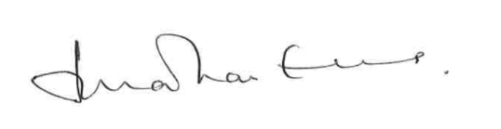

Lord (Jonathan) Evans of Weardale KCB DL
Chair
THE COMMITTEE’S REMIT

The purpose of the Committee on Standards in Public Life is to provide evidence-based advice to those in public office on maintaining high standards of conduct.

The Committee is an advisory non-departmental public body sponsored by the Cabinet Office which advises the Prime Minister on arrangements for upholding ethical standards across the whole of public life in England.

We conduct inquiries into areas of current concern about standards in public life; revisit areas to see if and how our recommendations have been put into effect; and we can also look ahead to emerging issues relating to public standards.

The Committee was established as a standing committee in October 1994, by the then Prime Minister, with the following terms of reference:

“To examine current concerns about standards of conduct of all holders of public office, including arrangements relating to financial and commercial activities, and make recommendations as to any changes in present arrangements which might be required to ensure the highest standards of propriety in public life.”

The remit of the Committee excludes investigation of individual allegations of misconduct. We are not a regulator and cannot investigate individual complaints.

On 12 November 1997, the terms of reference were extended by the then Prime Minister:

“To review issues in relation to the funding of political parties, and to make recommendations as to any changes in present arrangements.”

The terms of reference were clarified following the Triennial Review of the Committee in 2013. The then Minister for the Cabinet Office confirmed that the Committee “should not inquire into matters relating to the devolved legislatures and governments except with the agreement of those bodies”, and that “the Government understands the Committee’s remit to examine ‘standards of conduct of all holders of public office’ as encompassing all those involved in the delivery of public services, not solely those appointed or elected to public office.”

THE COMMITTEE’S ROLE AND HOW IT GOES ABOUT ITS WORK

- The Committee identifies areas of concern and undertakes impartial, evidence-based, reviews, making recommendations to uphold and drive improvement in standards in public life based on evidence received. Our independence of both government and Parliament is key.

- We make informed contributions to public debates about ethical standards, including through submissions to public consultations and participating in seminars and discussion events. We proactively identify and respond to emerging ethical risks and engage with a wide range of partners on the ethical standards agenda.

- We are committed to building a strong evidence-base for our reviews and to working with others to ensure that high ethical standards are met and that the Principles of Public Life are understood and embedded across public life.

- Our recent reports have been welcomed by the relevant sectors. Our reports on Local Government Ethical Standards, Regulating Election Finance and Upholding Standards in Public Life were commended for understanding the issues under review and offering balanced, considered recommendations in often complex areas.

- The Committee is not a regulator, we have no statutory powers and no remit to investigate individual cases. Our effectiveness depends on our independence, impartiality, and our ability to make powerful arguments for change - which in turn is based on our ability to conduct in-depth reviews, with a strong evidence base after wide-ranging consultation. We aim to follow-up our reviews with the relevant stakeholders to ensure that our recommendations stand the strongest possible chance of being implemented.

- We are part of a complex landscape. There is a wide range of different regulatory bodies involved in investigating, promoting and maintaining standards, based on the Nolan Principles - some of which came about as a result of the Committee’s recommendations over the past 27 years.

- You can hear more about how we carry out our work in our videos here.

COMMITTEE MEMBERSHIP

- The Committee comprises the independent Chair, four independent members and three political members nominated by the Conservative, Labour and Liberal Democrat parties. This mix of independent and political membership has served the Committee well, allowing the Committee to maintain a considered and impartial view whilst also understanding political perspectives.

- Independent members are appointed for a five-year, non-renewable term through open competition; political members are appointed for a three-year term which can be renewed. Party members are nominated by their party leader. The Chair and all members, independent and political, are appointed by the Prime Minister.

- The workload of Committee members is high. Independent members are asked to co-lead reviews, attend evidence gathering meetings and hearings, and to consider drafts of consultations and reports.

- The Committee has carried a vacancy for an independent member since January 2022. The recruitment process is run by the Cabinet Office. We are pleased that the recruitment process is now underway and we look forward to welcoming a new independent member in due course.

GOVERNMENT RESPONSES TO OUR REPORTS

- Whilst the Committee has no statutory basis, it has been the convention that the government responds in a timely manner to reports published by this Committee, considers each of our recommendations and offers a considered response in a published document.

- In recent years this has not been the case. Government responses have been slower, and with respect to some of the Committee’s reports, the government has not responded at all.

Election Finance

- We have not yet seen a full, considered response by government to our major review into the regulation of election finance published in July 2021.

Local Government Ethical Standards

- It took the government over three years to respond to our review on local government ethical standards. Our evidence-based report was welcomed by the sector, backing our call to strengthen the arrangements in place to support high ethical standards, whilst respecting the benefits of a localised approach.

- The government response accepted just a few of our recommendations in principle and rejected most. We believe this is a missed opportunity to update and improve the locally-based standards regime in local government. We would encourage those in local government to take up the government’s stated commitment to work with local authorities and representative organisations to ensure the hard work done by many working at a local level is not put at risk by a small minority of individuals who do not live up to the high standards expected.

Upholding Standards in Public Life
- At the time of writing, we are still awaiting the full government response to our Upholding Standards in Public Life report, published in November 2021, with our interim findings published in June 2021. A policy statement in response to this report, and that of Nigel Boardman, was promised in the New Year.

- The government published a policy statement on the Ministerial Code on 27 May 2022, which whilst making some improvement, did not go far enough. Whilst the new Code now sets out graduated sanctions for breaches of the Code as we recommended, our recommendation was linked to greater independence for the Adviser as part of a mutually dependent package of reforms. The new process for the Independent Adviser initiating reforms, whilst being an improvement in process, does not create the independence we called for. The Prime Minister’s consent is still required before the Independent Adviser may start an investigation.

- At present, following the resignation in June 2022 of Lord Geidt as the Independent Adviser on Ministers’ Interests, there is no Independent Adviser on Ministers’ Interests in post. The Committee has urged the government to make an appointment to this important and sensitive role, while the government undertakes its review of how this role works.

- Our view on these changes is clearly set out in the Chair’s blogs published on 1 and 16 June 2022.

OUR MAIN AREAS OF WORK JULY 2021 - JUNE 2022

Regulating Election Finance, July 2021

- In July 2021, we published a review of the complex subject of the regulation of election finance, Regulating Election Finance. We looked at the regulation and enforcement of donations and campaign expenditure by candidates, political parties and non-party campaigners in election campaigns.

- Given the Committee’s longstanding interest in this area, we wanted to consider whether the current framework for regulating campaign finance laws was coherent and proportionate. We felt this was an area where we could make a helpful contribution to the debate and we wanted to look at whether the current system continues to deliver.

- In line with our imperative of evidence-based reports, we heard from a broad range of contributors – political parties, third party campaigners, candidates, law enforcement bodies, academics, pro-democracy organisations, and the Electoral Commission. We ran a public consultation, public focus groups and held bilateral meetings. We also hosted roundtables with returning officers, smaller parties and independent candidates, and academics and organisations. As always, we are indebted to all those people who gave their time and expertise so willingly. We are particularly grateful to Piers Coleman, specialist adviser to the review, and Dr Sam Power, Lecturer in Corruption Analysis, University of Sussex, for their support and expert advice throughout.

- We set out a package of practical recommendations to modernise and improve the system for regulating the money spent to influence the outcome of elections and referendums. Our recommendations would make the regime more effective, transparent and proportionate.

- They are intended to balance the needs of those regulated by the system with the right of the public to know how money is being spent in trying to influence their vote; and the need for effective enforcement when rules are broken. Our report focused on encouraging compliance through developing the system of civil sanctions overseen by a strong and independent Electoral Commission.

- Our report did not make any direct recommendations about the governance and accountability of the Electoral Commission. That was not the purpose of our review since we were concerned principally with the Commission’s duties and powers as a regulator of donations and campaign finance laws.

- However, as a Committee, we are clear that it is vital to our democracy that we have a strong, independent Electoral Commission – one that is insulated from political pressures and at arm’s length from the government. We were, and remain, extremely concerned that the government pressed ahead with aspects of the Election Bill that we believed would be detrimental to the work and independence of the Electoral Commission.

- The Electoral Commission is unique among regulators. It must operate within a highly charged political environment. It must support people to comply with the law through guidance and advice, hold parties and campaigners to account and deliver transparency for voters – and it must do so while maintaining the confidence of the public and the very organisations it has been charged by Parliament with regulating. This is a challenging task in itself – and it has been a particularly turbulent few years for the Commission. While the Commission has some strong critics, the large majority of people we spoke to emphasised the importance and value of the Commission’s work.

Upholding Standards in Public Life - Standards Matter 2, November 2021

- The Committee published its latest report, Upholding Standards in Public Life on 1 November 2021. This was the final report of the Standards Matter 2 review. (Findings were published in June 2021.)

- The report included recommendations for reforming four areas of standards regulation in central government: the Ministerial Code and the Independent Adviser; ACOBA and the Business Appointment Rules; transparency around lobbying; and the regulation of public appointments. This was the first time CSPL published extensive recommendations in these areas for nearly ten years.

- The Committee also called for new primary legislation to establish in statute the independence of standards regulators, and for a new compliance function to be established across government.

- Lord Evans launched the report with a speech at the Institute for Government on 4 November 2021. We are awaiting a response from government to our recommendations.

- As part of the review the Committee surveyed the public's and stakeholders' views on the ongoing suitability and relevance of the Seven Principles of Public Life. The Committee found Nolan's original Seven Principles to be enduring and long standing, but decided to amend the descriptor to the Leadership principle to include a focus on treating others with respect.

- The review's final report followed a year of evidence gathering, which included engagement with ministers, senior civil servants, standards regulators, academics, trade unions, representative bodies, NGOs and think tanks. The Committee also ran a public consultation and public sector survey, commissioned public polling, and held focus groups. We are grateful to all who contributed.

Leading in Practice

- In March 2022, we launched our Leading in Practice review. This review is a natural follow on to our Upholding Standards in Public Life report.

- While a strong regulatory system is crucial to upholding high ethical standards, it is not enough on its own. Just as important is supporting and encouraging people to behave ethically and creating a culture which supports them to make ethical decisions, particularly in grey areas where there is not a specific rule to follow.

- This review is looking at how to build and sustain within organisations a climate conducive to ethical behaviour. In particular, we are examining the role of leadership - at all levels - in embedding the Seven Principles of Public Life in the culture and practices of public sector organisations. We are speaking to public sector institutions as well as looking at good practice in the private and charity sectors to maximise our learning.

- In the past 4 months, we have taken evidence from a wide range of organisations and from leaders at all levels.

- We intend to publish our report early in 2023.

PREVIOUS REPORTS: UPDATES

Artificial Intelligence and Public Standards, February 2020

- The Committee published its report on AI and Public Standards in February 2020. It made a number of recommendations about the need for effective and informed governance of the use of AI in the public sector.

- The review found that the Nolan Principles remain a valid guide for public sector practice and do not need reformulating for AI, but three are particularly relevant – openness, accountability and objectivity.

- We found that far from needing a single regulator, successful AI governance is a question of clear regulation and proper controls for managing and mitigating risk. We said that all regulators should consider and respond to the challenges of AI in the fields for which they have responsibility.

- In November 2020, we wrote to regulators asking them for an update on how they are adapting to the challenges posed by AI. We received a range of responses with some regulators being quite prepared to respond to the regulatory requirements and impact of AI and others noting that the regulation of AI is beyond their scope. Most regulators are in the early stages of thinking about these issues but some regulators are already considering the implications of AI to their regulatory models and governance practices.

- We welcome the government’s recent response to the report and continue to maintain a watching brief on progress made against the report’s recommendations.

- Since the publication of the Committee’s report, some key developments in the UK’s AI policy landscape have taken place:

  - The government has published updated guidance on using AI in the public sector and AI procurement. These are more user friendly than previous iterations but it is still unclear how the various sets of principles work together.

  - The government published its National AI Strategy in September 2021. As part of that, the Centre for Data Ethics and Innovation published a “roadmap to AI assurance” which takes a similar approach to our report in framing AI governance as not dissimilar to traditional risk management.

  - The Cabinet Office published an algorithmic transparency standard which requires public bodies using algorithms to support decision-making to provide information on how and why they are using them. This is a welcome step forward.

  - The future functions of the Centre for Data Ethics and Innovation were consulted on as part of the 2020 National Data Strategy but they remain part of DCMS and are not yet on an independent statutory footing, as we recommended they should be.

Local Government Ethical Standards, January 2019

- In January 2019, the Committee published a report and recommendations on local government ethical standards, an area of long-standing interest for CSPL.

- We undertook this review to assure ourselves that the current framework, post the 2011 Localism Act, was working and conducive to high standards in public life, rather than in response to any specific allegations of wrongdoing.

- That review took a year from announcement to publication. We took a range of evidence from local authorities, councillors, officers, Independent Persons, expert and representative groups. We visited a range of councils and received written evidence from members of the public in order to frame our conclusions and recommendations. We received 319 written responses as part of our public consultation; we held 2 roundtable events, 30 individual meetings, and visited 5 local authorities in England from different geographies and tiers.

- The review clearly showed that local authorities want to retain responsibility for ethical standards, for implementing and applying the Seven Principles of Public Life, but they want to be given the tools and powers to be able to do so effectively, to address the minority of councillors that engage in misconduct.

- As noted earlier in this report, we are disappointed that the government in its response rejected most of our recommendations, stating that it thought that the best route for change was best practice by local authorities. We hope that the government will work with the sector and move to take up our recommendations in the future.

WATCHING BRIEFS

Review of MPs’ Code of Conduct

- The Standards Committee published its initial report on the review of the MPs’ Code of Conduct with proposals for public consultation on 29 November 2021.

- The Committee contributed with written and oral evidence to this consultation, following up on the Committee's first round of evidence in October 2020.

- The Committee's second round of written and oral evidence focused on the potential introduction of "reasonable limits" on MPs' outside employment, reforms to the investigations and sanctioning process, and a new proposed ban on MPs acting as paid political consultants and strategists. The Chair wrote to the Standards Committee on 21 January 2022 and appeared before the Standards Committee on 25 January 2022.

- The Standards Committee published its final report and proposed amendments to the Code of Conduct on 25 May 2022.

Bullying and Harassment

- When allegations of widespread bullying and harassment in Parliament came to light in late 2018, it was clear that fundamental reform was needed to change the culture of both Houses and the way Parliament regulated the conduct of parliamentarians and staff.

- The establishment of the Independent Complaints and Grievance Scheme (ICGS) was a significant step forward, based on the important principle that those working in both Houses of Parliament would be subject to an independent and impartial process dedicated to upholding the new Behaviour Code.

- Recognising the importance of these reforms to the way standards are upheld in Parliament, and the emergence of further worrying cases in 2022, CSPL maintains its close watching brief in this area.

Impact of Covid-19 on Standards in Public Life

- We have continued to monitor the impact on Covid-19 on public standards over the past year, looking at standards issues arising as a result of the pandemic, including concerns about any compromise of the Nolan Principles; changes to parliamentary procedure and scrutiny; challenges around democratic accountability; and any impact on public trust.

BLOGS PUBLISHED DURING THE PERIOD OF THIS REPORT

Independent adviser role should be strengthened, Lord (Jonathan) Evans, June 2022
The government should go beyond a "low level of ambition" on the Ministerial Code, Lord (Jonathan) Evans, June 2022
Standards Bodies, Who’s Who 3, Professor Gillian Peele, April 2022
Leading in Practice, Ewen Fergusson, March 2022
Standards Bodies, Who’s Who 2, Dame Shirley Pearce, February 2022
Standards Commission for Scotland: Honesty and Trust, guest blog by Standards Commission for Scotland, January 2022
Standards Bodies, Who’s Who, Lord (Jonathan) Evans, November 2021
Amending the Descriptor to Leadership, Dr Jane Martin, November 2021
High Standards begin at home, Lord (Jonathan) Evans, November 2021
Review of the UK government’s Draft Electoral Commission Strategy and Policy Statement, Guest blog by Dr Alistair Clark, October 2021
Reforming Party Funding Arrangements, Lord (Jonathan) Evans, October 2021
An Opportunity to reform Election Finance, Dame Shirley Pearce, July 2021
Follow the money – time to repair election finance regulation, Lord (Jonathan) Evans, July 2021

ANNEXES

ANNEX A: ABOUT THE COMMITTEE

ANNEX B: MEMBERSHIP OF THE COMMITTEE

ANNEX C: DATA PROTECTION

ANNEX D: REPORTS PUBLISHED

ANNEX E: RESEARCH ADVISORY BOARD

ANNEX F: COMMITTEE BLOGS

ANNEX G: EXTERNAL EVENTS

September 2021

7 September: Lord Evans spoke at a Non-Executive Director Induction Event

November 2021

4 November: Lord Evans spoke at the Institute for Government one day Standards Conference launching the Committee's Upholding Standards in Public Life report

December 2021

2 December: Lord Evans spoke at the National Association of Local Councils (NALC) Future Communities Conference - online.

January 2022

11 January: Lord Evans gave evidence to PACAC on their inquiry Propriety of governance in light of Greensill

18 January: Lord Evans spoke at a Non-Executive Director Induction Event

25 January: Lord Evans gave evidence to the Commons Standards Committee on their review of the MPs' Code of Conduct

March 2022

3 March: Lord Evans spoke at a seminar hosted by the All-Party Parliamentary Group on anti-corruption and responsible tax, on Public Standards

16 March: Lord Evans spoke at the Cabinet Office and Civil Service Governance Teams Away Day

30 March: Lord Evans spoke at a Public Administration International (PAI) event to political parties from Macedonia

April 2022

26 April: Ewen Fergusson spoke at Non-Executive Director Induction Event

May 2022

13 May: Lord Evans spoke at a Leadership Conference for Local Government Lawyers

25 May: Ewen Fergusson spoke to the Public Relations Consultants Association (PRCA) about our Upholding Standards in Public Life report.

ANNEX H: COMMITTEE SUBMISSIONS TO PUBLIC CONSULTATIONS

October 2021: Cabinet Office consultation on Public Procurement

January 2022: House of Commons Standards Committee Review of the MPs’ Code of Conduct.

April 2022: Impress consultation on Code of Conduct

ANNEX I: FINANCIAL INFORMATION

The Chair is paid a remuneration of £36k pa with the expectation that he commits an average of 5-6 days a month, although this time increases significantly during periods of Committee reviews.

Independent members of the Committee on Standards in Public Life may claim £240 for each day they work on Committee business and claim for expenses incurred.

There has been a vacancy for an independent member since 1 January 2022.

The 3 political members of the Committee do not receive any fees or expenses.

As an advisory non-departmental public body, the Committee on Standards in Public Life receives a delegated budget from the Cabinet Office. Day-to-day responsibility for financial controls and budgetary mechanisms are delegated to the Secretary of the Committee. Creation of new posts are subject to the Cabinet Office Approvals process.

Members of the Secretariat are permanent civil servants employed by the Cabinet Office. There are 5 full-time members of the Secretariat.

The Committee’s media and communications activity is managed by a contracted Press Officer.

The Committee’s spend for 1 April 2021 - 31 March 2022 was £471k.

Published by the Committee on Standards in Public Life

The Committee on Standards in Public Life
Room G07, 1 Horse Guards Road
London
SW1A 2HQ

public@public-standards.gov.uk

www.gov.uk/government/organistaions/the-committee-on-standards-in-public-life

July 2022

Ethical Standards for Public Service Providers 2014; Striking the Balance, Upholding the Seven Principles in Regulation 2016; The Continuing Importance of Ethical Standards for Public Service Providers 2018.
https://questions-statements.parliament.uk/written-statements/detail/2021-12-16/hcws500
Our predecessors recommended the setting up of the Electoral Commission in 1998 and reviewed its work in 2007.

