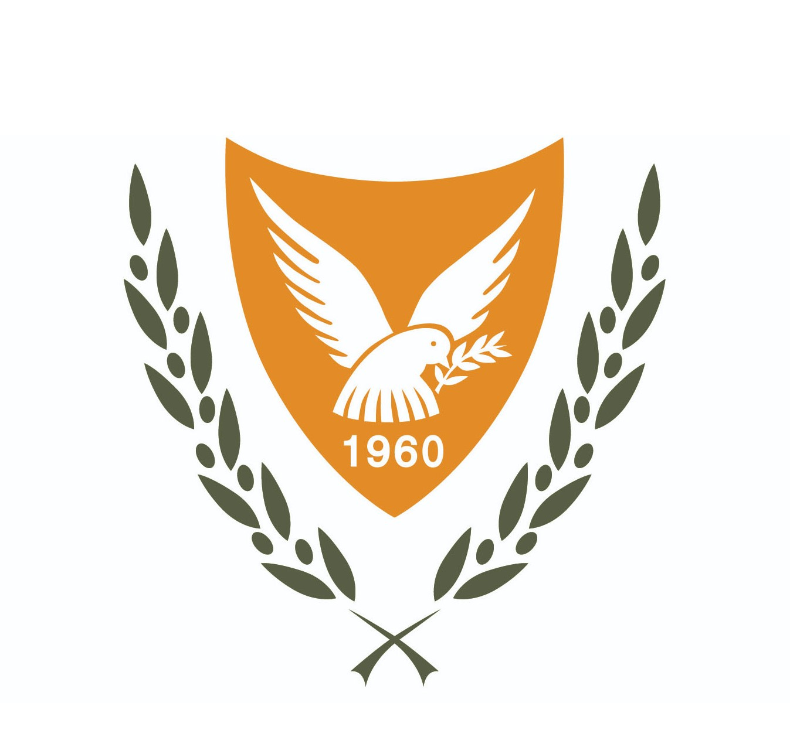
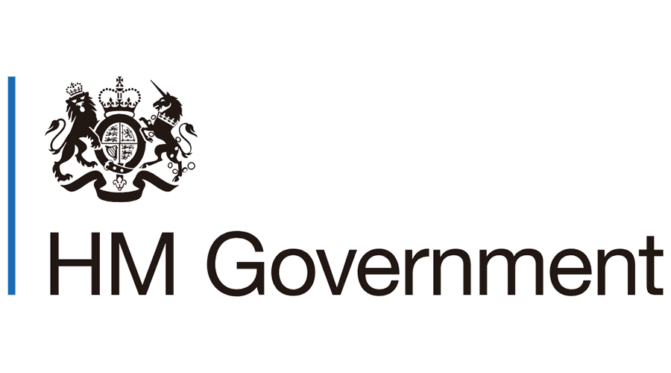

MEMORANDUM OF UNDERSTANDING
ON THE PROTECTION AND PROMOTION OF THE RIGHTS OF LGBTI+ PEOPLE
IN EUROPE AND IN THE COMMONWEALTH
BETWEEN
THE UNITED KINGDOM AND
THE REPUBLIC OF CYPRUS

- Introduction

The United Kingdom and the Republic of Cyprus share strong bilateral cooperation and partnership in several areas, and have a common history, continuing to this day as member countries of the Commonwealth. Over the years, both countries have strongly committed to making their societies fairer, where everyone feels safe and free to be themselves, celebrating diversity and its advantages with respect to equality and non-discrimination. This Memorandum of Understanding seeks to further strengthen this bilateral relationship.

The United Kingdom has a proud record in advancing equality for LGBTI+ people. From the 2004 Civil Partnership Act, which allowed same-sex couples to legally enter into binding partnerships, subsequently to allowing same-sex couples to fully marry. Similarly, the Gender Recognition Act 2004, which came into effect on 4 April 2005, gave trans people full legal recognition of their gender, allowing them to acquire a new birth certificate. With the Equality Act 2010, the UK, gave LGBTI+ employees protections from discrimination, harassment, and victimisation at work, bringing together existing legislation and adding protections for trans workers.

In its own bid to provide for a fairer society in Cyprus, the Government of Cyprus has taken steps to strengthen the area of LGBTI+ rights through several legislative measures, starting with Law 58(I)/2004 on Equal Treatment in Employment and Occupation, to the enactment of the Civil Union Law for all people, irrespective of their gender, in 2015. Also in 2015 the Government of Cyprus criminalised homophobic and transphobic rhetoric while, separately, gave the right to the courts to consider homophobic and transphobic motives as aggravated offenses that carry additional penalties. Currently it is preparing a law for Legal Gender Recognition to allow trans people to easily change their gender on their legal documents.

- Context

In 2019, the Governments of the UK and Cyprus, separately put themselves forward to chair and host two Roundtables of the Governmental LGBTI Focal Points Network (EFPN), assisted by the Council of Europe’s SOGI Unit.

London was going to host the 26th Roundtable of the EFPN in May 2020 alongside its commitment in hosting an International LGBTI+ Conference involving the Equal Rights Coalition. Nicosia was going to host the 28th Roundtable of the EFPN in May 2021. In both cases, meetings would be preceded by the one-day European IDAHOT+ Forum, a gathering of government delegates and civil society taking stock and coordinating actions for LGBTI+ protection across Europe and beyond.

In 2020, as COVID-19 was spreading in Europe, the UK was forced to postpone the event in London. As the pandemic was expanding, it exacerbated the already existing inequalities faced by marginalised groups, including LGBTI+ people, limiting their access to services and leading to increased levels of violence and discrimination.

Going into 2021, it was recognised that it is vital for all members of society to come together and build back better: from governments to civil society, businesses, and academics.

The first step for this increased international focus on LGBTI+ equality took place on the 18th and 19th of May 2021, when the Governments of the UK and the Republic of Cyprus co-chaired the IDAHOT Forum 2021 and the 26th EFPN Roundtable. This was a virtual event held from London and attended by about 150 delegates from all over Europe.

Following this event, the two governments agreed that they would both benefit and help other parties better by formalising their partnership in this area, focusing on the protection and promotion of the rights of the LGBTI+ people in Europe and in the Commonwealth, leading to the agreement of the signing of this Memorandum of Understanding.

- Scope of Cooperation

  - European Governmental Focal Points Network
The European Governmental LGBTI Focal Points Network (EFPN) is an intergovernmental working group dedicated to the advancement of the human rights of LGBTI+ persons in the Council of Europe (CoE) Member States. The main aims of the EFPN are:

      - To support governmental legal/policy experts in the development of legislation and policies to implement the CoE standards for SOGIESC equality through the exchange of good practice, peer legal and policy reviews and the development of policy texts and tools.

      - To interact and build synergies with international organisations and civil society at the European and international levels.

The Governments of the UK and Cyprus will expand their cooperation in the EFPN. To this end, the two countries have agreed to co-host two important EFPN events. The IDAHOT+ Forum in May 2021 and in May 2022.

The IDAHOT+ Forum is one of the major European annual events that brings together member countries of the Council of Europe, government representatives, policy makers, experts, and academics, as well as representatives from national and international organisations. As the main state-organised European LGBTI+ conference, it primarily aims to promote cooperation between governments but also between governments and civil society organisations.

Further to this, the partnership of the UK and Cyprus within the EFPN, will run in conjunction with the thematic review of the CM Recommendation 2010(5) on measures to combat discrimination on the grounds of sexual orientation and gender identity, led by the Council of Europe’s SOGI Unit. Participation in this review is vital for monitoring progress of LGBTI+ inclusion and equality across Council of Europe member states. Both countries will be active participants in the review and support the SOGI Unit in its engagement.

Additionally, in the scope of this MoU, the UK and Cyprus will use their common EFPN mandate to assist civil society in two key areas:

i.Commonwealth of Nations
The Commonwealth is a vibrant, consensus driven organisation with keen interest and a growing focus on the promotion of human rights, addressing climate change and empowering the youth. Despite this, 35 out of the 54 Commonwealth members criminalise same sex relations between consenting adults in some way. Both the Governments of the UK and Cyprus understand that a modern Commonwealth can and should play a positive role in improving the lives of LGBTI+ citizens.

During the Commonwealth Heads of Government Meeting (CHOGM) in London in 2018 the UK Government publicly declared that it would support any Commonwealth countries that want help to repeal laws discriminating against LGBTI+ people. Since then, it has delivered over £5.6 million in capacity building programmes to support the creation of inclusive legislation. Similarly, also during CHOGM 2018, the Minister of Foreign Affairs of Cyprus met with Commonwealth LGBTI+ activists pledging support.

The UK and Cyprus will create space for discussions between the EFPN member states, the EFPN secretariat and accredited Commonwealth LGBTI+ and human rights organisations, with the primary objective of sharing best practices on the way Governments and LGBTI+ civil society can work together to reduce inequality.

The UK and Cyprus understand the importance for joint efforts amongst Commonwealth member states and undertake to jointly take action where appropriate to progress of LGBTI+ rights in the Commonwealth.

It is understood that Cyprus, as a smaller Commonwealth state, can facilitate discussions on LGBTI+ rights amongst fellow Commonwealth states to compliment the perspective offered by the UK and strengthen support where appropriate and, via their High Commissions, to amplify appetite locally.

ii.Equal Rights Coalition
The Equal Rights Coalition (ERC) is a grouping of 42 states and more than 120 civil society organisations working to advance the human rights of and promote inclusive development for LGBTI+ persons globally. The ERC was created to address the limited number of mechanisms or structures through which governments could coordinate their diplomatic efforts, share information, and work together at the international level to help achieve LGBTI+ equality.

Both the United Kingdom and Cyprus are member states of the ERC. Furthermore, the United Kingdom, together with Argentina, took up the role of state co-chairs for the period of 2019 to 2021. Due to COVID-19, this mandate has now been extended to 2022.

In July 2021, under the UK Government and Argentina’s co-chairship, the ERC launched its first comprehensive strategy and implementation plan. The Strategy will contain several commitments for member states to implement domestically.

The UK and Cyprus will facilitate this conversation on implementation and policy change particularly through the cooperation of EFPN Members and the National Laws & Policies Thematic Group of the ERC.

To this end, as part of this MoU, the Government of Cyprus, agrees to join the ERC’s National Laws and Policies Working Group with a view to encouraging co-operation with the EFPN membership, seeking more membership of the ERC and ERC working groups from EFPN members states, and seeking to share EFPN best practice and learning with the wider ERC Working group.

  - Business Advocacy and LGBTI+ Equality

Evidence shows that open, inclusive, and diverse societies are better for economic growth, and that discrimination based on sexual orientation, gender identity or sex-characteristics can damage long-term economic prospects.

The governments of the UK and Cyprus will amplify and disseminate this message to businesses at a national and international level where possible, with particular effort towards fellow Commonwealth countries.

There is currently a dedicated and active section of the UK civil society examining the benefits of diversity and LGBTI+ equality in the workplace. The governments of the UK and Cyprus will take this opportunity to open the space for further discussions in two ways:
- Within the business industry itself by partnering larger international corporations with local small, medium enterprises (SMEs); for example, the Cyprus Chamber of Commerce and Industry and the Cyprus Employers & Industrialists Federation (OEB). There is an appetite for SMEs to become more active in LGBTI+ advocacy but they lack the connections and tools to do so. This will also have secondary benefits on the bilateral relationship and enhance the local reputation between the UK and Cyprus.
- Between the business industry and international organisations such as civil society and activists (TCEN) and multilateral institutions like the Council of Europe. Council of Europe and TCEN to bring the benefits of diversity in the workplace in Council of Europe and the Commonwealth member countries.
- Objectives and Principles

European Governmental LGBTI+ Focal Points Network
- Raise the level of engagement on LGBTI+ rights within the Council of Europe, through the work of the European Focal Points Network and the Steering Committee on Anti-Discrimination, Diversity and Inclusion (CDADI).
- Improved cooperation and best practice sharing between Commonwealth and European governments and civil society organisations.
- Progress the discussion around the benefits of diversity in the Commonwealth.
- Encourage closer cooperation among the UK and Cyprus Representations in the CoE in order to promote joint initiatives, in cooperation with the EFPN, and, where appropriate, with the support of the Council of Europe’s SOGI Unit.
Business Advocacy in LGBTI+ Equality
- Harness the power of global businesses and small, medium enterprises (SMEs) to advocate for LGBTI+ equality, emphasising inclusion and protection is good for businesses and good for the economy.
- Use the convening power of the UK and Cyprus partnership both locally through the High Commissions and internationally to advance international action with businesses and activists across Europe and the Commonwealth.
- Raise the level of political engagement locally in UK and Cyprus, with the support of the High Commissions, on promoting the rights of LGBTI+ people.

- Outputs

European Governmental LGBTI+ Focal Points Network
- OP1: At least four international fora will take place from May 2021 to January 2023, which will convene EFPN members and observers and representatives from across the Council of Europe and civil society. These meetings will discuss the objectives outlined above. A convening between the EFPN Member States and/or the EFPN secretariat with accredited Commonwealth civil society, to share good practices in the cooperation between governments and civil society.
- OP2: A thematic review of CM(2010)5 undertaken by Cyprus on legal gender recognition, led by the Council of Europe SOGI Unit.
- OP3: A common financial contribution led by the current hosts of the EFPN.

Equal Rights Coalition
- OP4: Cyprus will join the ERC’s National Laws and Policies Working Group.
- OP5: Through active membership of the ERC’s National Laws and Policies Working group, Cyprus and the UK will encourage active participation in the ERC from other EFPN members states and look for opportunities to share EFPN practices and experiences with the ERC National Laws and Policies Working Group.

Business Advocacy in LGBTI+ Equality
- OP6: At least one informational meeting that includes the Cyprus Chamber of Commerce and Industry and the Cyprus Employers & Industrialists Federation (OEB), together with the relevant Cypriot Ministry of Labour, Welfare and Social Insurance, and representatives from the UK Government, UK-based international businesses involved in LGBTI+ advocacy and relevant civil society, coordinated by the Cypriot Ministry of Labour, Welfare and Social Insurance. Support for this may also come from the British High Commission Nicosia, drawing on their networks and contact base.
- OP7: A UK-led business declaration recognising the economic and business case for LGBTI+ equality to be launched at the Global LGBT+ Conference in London in June 2022. The declaration will be informed by sector specific conversations involving global businesses and SMEs. These events will also provide networking opportunities between business representatives (global corporations with SMEs) and activists.

- Outcomes

- Strengthened international action and engagement across a multitude of institutions and international networks:
  - Strengthened cooperation between EFPN and wider Council of Europe.
  - Strengthened cooperation between ERC and EFPN.
  - Strengthened cooperation between EFPN and Commonwealth.

- Strengthened business sector with enhanced cooperation between international corporations and SMEs, as well as local civil society. All parties have a keen understanding of the business and economic benefits of LGBTI+ inclusion.

- Informed Cypriot business leaders and associations about the importance of the benefits of diversity and LGBTI+ equality in the workplace.

- Strengthened cooperation between UK and Cypriot Governments on promoting the benefits of LGBTI+ diversity within the Commonwealth.

- Strengthened bilateral relationship between the UK and Cyprus and increased local support and engagement via the High Commissions in Nicosia and London.

- Help promote structured collaboration with regards to LGBTI+ rights with like-minded Commonwealth member states.

- Timeline

Month | Deliverable
May 2021 | - 2021 IDAHOT+ (online) Forum hosted by UK
June - August 2021 | - Refine strategy and drafting of MoU
October 2021 | - UK Prime Minister's Special Envoy on LGBT Rights and Chair of the UK Government's Global LGBTI+ Conference, Lord Herbert, visit to Nicosia  - Stakeholder consultation and planning
November 2021 | - EFPN Roundtable
February 2022 | - Signing ceremony of MoU (tbc)
February 2022 | - Stakeholder consultation and planning
March 2022 | - Business roundtable in Nicosia (date tbc)  - Participation in 29th Roundtable of the EFPN hosted by Italy in Rome
April 2022 | - 2022 IDAHOT+ Forum message delivery to stakeholders
May 2022 | - 2022 IDAHOT+ Forum hosted by UK & Cyprus in Nicosia  - 30th Roundtable of the EFPN hosted by UK & Cyprus in Nicosia
June 2022 | - Global LGBTI+ Conference in London
July 2022 | - Commonwealth Games in Birmingham

- Implementation and Funding

Both parties undertake to secure funds required to fund the activities of this MoU. Unless otherwise agreed, travel expenses and daily subsidence will be the responsibility of the party where departures originate from, while hosting will be the responsibility of the receiving party.

- Prevention and Settlement of Disagreements

This MoU is not a binding legal agreement and does not create any rights or obligations under international laws or domestic laws in any jurisdiction. In the event of any conflict between the provisions of this MoU and bilateral understandings or arrangements, the conflicting sides will consult with one another on measures to resolve the problem and possible courses of action.

- Admission, Withdrawal and Review

- This MoU will come into effect from the date of signature by the Government Equalities Office of the United Kingdom and the Ministry of Justice and Public Order of the Republic of Cyprus.
- Amendments of commitment to this statement may be agreed in writing by both sides.
- The two sides may withdraw from this MoU with three month’s prior written notice of such intention.
- This MoU shall remain valid until 31 January 2023 from the date of signature and could be renewed and/or amended by mutual agreement between the two sides.

For Her Majesty’s Government of the United Kingdom  Rt Hon Amanda Milling  Minister of State at the Foreign, Commonwealth and Development Office | For the Republic of Cyprus  Stephie Dracos  Minister of Justice and Public Order

