Statement to Parliament regarding the UK Ratification of Protocol to the North Atlantic Treaty on the Accession of the Republic of Finland and the Protocol to the North Atlantic Treaty on the Accession of the Kingdom of Sweden, both done at Brussels on 5 July 2022

Presented to Parliament as an un-numbered Act Paper pursuant to section 22(3)(c) of the Constitutional Reform and Governance Act 2010
Statement to Parliament regarding the UK Ratification of NATO Accession Protocols for Sweden & Finland

On 18 May 2022 Finland and Sweden submitted formal applications to join NATO. This is a historic moment.

Finland and Sweden are NATO’s closest partners. They share our principles and values, including liberty, human rights, democracy, and the rule of law. They share the Alliance’s unwavering commitment to international security and the agreements on which it is based including the UN Charter and Helsinki Final Act.

They both have years of experience training and operating with Allies, and have made significant contributions to NATO-led operations and missions. Their decision to seek NATO membership follows extensive and democratic consultations in those countries.

The government is committed to strengthening security and defence at home and overseas. A strong NATO is at the heart of our ability to deter and defend against state adversaries.

With Russia conducting an illegal and barbaric war in mainland Europe, it is unsurprising that countries that already work closely with NATO would consider applying to join the alliance and to benefit from its collective security guarantees. We must ensure that Finland and Sweden are integrated into NATO as quickly as possible.

Therefore, in accordance with section 22 of the Constitutional Reform and Governance Act 2010 (CRAG) I wish to inform the House that I believe the Protocol to the North Atlantic Treaty on the Accession of the Republic of Finland and the Protocol to the North Atlantic Treaty on the Accession of the Kingdom of Sweden (together the “Protocols”) should be ratified without the requirements of section 20 CRAG having been met.

We need to demonstrate to two of our closest European security partners the importance we attach to our relationship with them and our whole-hearted support for their decision to join NATO.

It is imperative that Allies bring Sweden and Finland under NATO’s Article 5 umbrella as swiftly as possible. Both countries’ decision puts them at risk of a potentially aggressive Russian response. Russia has already made several threatening comments in the public domain regarding the possibility of Swedish and Finnish membership of NATO.

Using this process will ensure the UK’s part is concluded swiftly and use our example to encourage other Allies to think radically about how quickly they can respectively ratify Sweden and Finland’s accession. All thirty Allies need to ratify the protocols before Finland and Sweden can join the Alliance. I have been pushing my Allied colleagues hard to complete the ratification process as soon as possible. It is important that the UK does everything we can to do likewise.

We believe there is broad-cross party support for Sweden and Finland joining NATO. This process will enable us to ratify Swedish and Finnish accession before the summer recess. This Government is committed to both the principle and practice of parliamentary scrutiny of the UK’s treaties. However, due to the unprecedented international security circumstances in which Finland and Sweden have made their sovereign decision to apply for NATO membership, it is important to expedite their integration into NATO as quickly as possible for their safety and for the collective strength and security of the Alliance.

I confirm that the Protocols have been laid today in Parliament under Command Paper numbers CP 730 and CP 731.

The United Kingdom looks forward to formally welcoming our longstanding allies Sweden and Finland into NATO and standing with them side by side in defence of freedom and democracy.
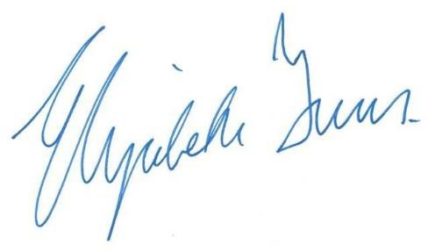
SECRETARY OF STATE FOR FOREIGN, COMMONWEALTH AND DEVELOPMENT AFFAIRS

DATE: 6 July 2022

