Meeting our future water needs: a national framework for water resources
16 March 2020
Version 1

We are the Environment Agency. We protect and improve the environment.
We help people and wildlife adapt to climate change and reduce its impacts, including flooding, drought, sea level rise and coastal erosion.
We improve the quality of our water, land and air by tackling pollution. We work with businesses to help them comply with environmental regulations. A healthy and diverse environment enhances people's lives and contributes to economic growth.
We can’t do this alone. We work as part of the Defra group (Department for Environment, Food & Rural Affairs), with the rest of government, local councils, businesses, civil society groups and local communities to create a better place for people and wildlife.

Published by:
Environment Agency
Horizon House, Deanery Road,
Bristol BS1 5AH
www.gov.uk/environment-agency
© Environment Agency 2020
All rights reserved. This document may be reproduced with prior permission of the Environment Agency.
Further copies of this report are available from our publications catalogue: http://www.gov.uk/government/publications or our National Customer Contact Centre: 03708 506 506
Email: enquiries@environment-agency.gov.uk

Forewords
If we don’t take action many areas of England will face water shortages by 2050. We need water to survive, our businesses, industry and farmers need it for their continued prosperity, and our precious natural environment needs it to thrive.
These apparently competing demands are equally important. We know that a healthy environment is fundamental to a healthy population and a healthy economy, yet we cannot have a healthy environment without investment in clean and plentiful water.
An increasing population, demand from agriculture and industry and improving our resilience to drought will all put significant pressures on our water resources. The climate emergency – periods of hotter and drier weather – will only exacerbate these pressures.
This report is the step-change in strategic and regional collaboration required to ensure the needs of all water users are brought together to better manage and share resources. It’s an opportunity to rethink water and help everyone make decisions on water supplies that can deliver the resilience and environmental enhancement we all want to see.
Whether it is our coastal wetlands, river ecosystems, or globally important chalk streams, restoring our environment so we’re the first generation to leave it in a better state than we found it, needs the buy in of all of society and those who depend on water.
This framework is a pathway to achieving this ambition.
Emma Howard Boyd, Chair of the Environment Agency
We have grown used to a constant supply of water to the point where it is difficult to contemplate what it would be like if it was not available. Yet, maintaining reliable water supplies needs careful management and planning and ours face significant pressures over the coming years.
This national framework is the result of collaboration across the water sector bringing in representatives from the water industry through Water UK and regional groups, agriculture, power generation, industry, drainage authorities, navigations, NGOs, regulators and government. It has been developed using the latest science, working closely with leading academics from the Environmental Change Institute at the University of Oxford and the University of Manchester.
The framework provides a strategic direction to long term water resource planning built on a shared vision to leave the environment in a better state than we found it, improve the nation’s resilience to drought, minimise interruptions to water supplies for all users of water and support growth while underpinning a thriving economy.
Over the next twelve months the five regional groups will be working to assess their needs in more detail and identify what is needed to improve the environment and realise a truly sustainable future for water resources. I look forward to continuing to support this sector-wide collaboration.
Jean Spencer, Independent Chair of the Senior Steering Group

Contents
Forewords 3
Contents 4
1. Summary 6
1.1. National and regional water needs 6
1.2. Building resilience to drought 8
1.3. Reducing water demand 9
1.4. Increasing water supply and moving water to where it is needed 10
1.5. Working across sectors 11
1.6. Enhancing the environment 12
1.7. Managing uncertainty 13
1.8. Next steps and conclusions 13
2. Introduction 14
2.1. Water resources national framework 15
2.2. Regional water resources planning 16
2.3. Responsive regulatory approach 17
2.4. Legislative context 17
3. Approach to developing the national framework 18
3.1. Understanding public water supply needs 18
3.2. Understanding water needs outside of the water industry 19
3.3. Understanding environmental needs 19
3.4. Governance 20
4. Pressures on public water supply 20
4.1. National pressures on public water supply 21
4.2. Regional pressures on public water supply 23
4.3. Pressures on public water supply within regions 26
5. Understand pressures on public water supply 32
5.1. Climate change 32
5.2. Drought resilience 35
5.3. Population change 36
5.4. Environmental protection 40
5.5. Other Pressures 47
6. Water use outside the public water supply 48
6.1. Agricultural water demand 53
6.2. Industrial water demand 55
6.3. Navigations water demand 57
7. Future non-public water supply demand 58
7.1. Agricultural demand - spray irrigation 60
7.2. Food and drink manufacturing 61
7.3. Electricity production 61
7.4. Paper and pulp 63
7.5. Chemicals manufacturing 63
8. Meeting public water supply needs 63
8.1. Approach 64
8.2. Meeting regional public water supply needs 65
9. Understanding the options available to meet public water supply needs 67
9.1. Water efficiency 68
9.2. Reducing leakage 73
9.3. Increasing supplies and transferring water 75
9.4. Beyond the strategic schemes 82
10. Regional planning 85
11. Barriers to collaboration in water resources planning 86
12. Conclusions 87
13. Next steps for the national framework 88
13.1. Environment 89
13.2. Models and evidence 89
13.3. Drought measures 89
13.4. Managing uncertainty 89
13.5. Technical methodologies 90
13.6. Catchment based approach 90
13.7. Barriers to collaboration 90
13.8. Longer term work 90

- Summary
Water is essential for life. The climate is changing and droughts are becoming more frequent. Society expects a continuous supply of safe, clean drinking water and that we plan for the needs of a growing population and thriving economy. Farmers need water to irrigate crops and for the wellbeing of their livestock. Action is needed now to secure a healthy environment for current and future generations.
The organisations responsible for England’s water supplies have come together to understand the long term needs of all sectors that depend on a secure supply of water – public water supply, agriculture, power generation, industry and the environment. These needs will be met through the development of regional water resources plans. Through a collaborative process, we have agreed what the regional plans should deliver and how, so they drive a step-change in water resources planning. In this way the national framework identifies strategic water needs for England and its regions across all sectors up to and beyond 2050.
The national framework sets out a strategic direction for the work being carried out by regional water resources groups by exploring the range of approaches available to meet the likely pressures. It has not set out to find the optimum mix of solutions. Instead, the regional groups are focused on developing the right combination of solutions and this will be included in their regional plans.
All have a part to play in meeting future water needs. For example, government is able to improve the options available by bringing forward policies to help reduce water demand. Regulators can remove any unnecessary regulatory barriers and give clear strategic direction on what is required. Bodies that represent major water users or other local interests can work with their members to understand their future water needs. Also water companies can bring their planning expertise and understanding of their networks to the table.
This national framework builds on previous reports from Water UK and the National Infrastructure Commission. Each of these reports starts from a different point in time and uses slightly different assumptions and methodologies, however the core findings are aligned. The case is clear that investment is required to reduce demand and increase supplies to increase resilience to drought and make sure that the nation’s water supplies and environment are able to cope with an uncertain future.
The national framework differs from previous work by focusing on the regional plans that will be developed over the coming years by the five regional water resources groups that are now in place. The strategic direction of these plans has been shaped by a senior steering group representing government, regulators, the water industry, bodies representing other major water users, environmental non-governmental organisations (NGO’s) and academia. It is this shift to collaborative regional planning, within an agreed framework, which will allow a step change in water resources.
  - National and regional water needs
If no action is taken between 2025 and 2050 around 3,435 million litres per day (Ml/d) extra capacity is likely to be needed in England by 2050 to meet future pressures on public water supply. This need is likely to grow further by the end of the century. Projections beyond 2050 carry increasing uncertainty. However our analysis suggests something in the region of 5,500 to 6,000 Ml/d additional water may be needed between 2025 and 2100.
Public water supply needs can be met by a combination of reducing consumption, reducing leakage, increasing supply and moving water from areas of surplus to areas of need. Each approach has strengths and weaknesses and we need a diverse range of solutions to realise the benefits and manage the risks of each approach.
If investment in additional capacity does not come forward we would see shortfalls in water supply across England. This would see households and businesses experiencing more frequent interruptions to supply. It would also see the environment put under greater pressure from water abstraction. Each region faces challenges, however, these are not spread evenly across England. Around half of the national need is in the south east of England.
The north sees relatively modest pressures on public water supply in comparison with the other regions. It also has significant surplus water in parts of the region. This is likely to offset the pressures it faces and potentially be available for transfer to other regions. The options in the current water company water resource management plans (WRMP) – in this case Northumbrian Water, Yorkshire Water and Hartlepool Water – are enough to meet the higher estimate of need in the north. Further efficiency savings could make additional water available for potential transfers. Water Resources North should explore the potential for transfers to neighbouring regions.
The west sees the second greatest pressures on public water supply when viewed in total. However, it is a large region and the pressures are smaller than those in the east when expressed as a proportion of the water supplied. The region also has a significant surplus and has the potential to make further savings through demand management as well as supply side options. This suggests that, despite the apparently significant pressures the region faces, it has the potential to transfer water. The options included in the current company WRMPs – in this case United Utilities, Severn Trent Water, Dŵr Cymru / Welsh Water and South Staffs Water – water resource management plans for companies in the west region appear sufficient to meet the higher estimate of need. Additional water could be made available through further demand management. Water Resources West should explore the potential for transfers to neighbouring regions.
The east faces significant pressure and has little surplus water available. Our modelling shows that the amount of water needed is equivalent to all the new supply options selected in the company WRMPs – in this case Anglian Water, Essex and Suffolk Water, Affinity Water, Severn Trent Water and Cambridge Water – but more ambitious reductions in water use and potentially additional capacity is necessary to meet the higher need estimate. Water Resources East’s focus will be on reducing the demand for water by all users and increasing the amount of water available through new water resource options and transfers. Exploring the potential for schemes that benefit other water users is also a priority given the high level of demand from other sectors in this region, particularly agriculture.
The south east faces the greatest pressures on public water supplies. If surplus water can be made available, the region will still need to develop options to supply more water, equivalent to all the new water resource options and transfers selected in company WRMPs – in this case Thames Water, Southern Water, South East Water, Affinity Water, SES Water and Portsmouth Water. This is as well as achieving ambitious efficiency reductions. If it cannot access the surplus water, then demand in the region will need to be reduced further or further resources developed. Water Resources South East needs to track progress on demand management particularly closely because, if savings are less than expected, it could develop a large shortfall. This may reduce resilience, limit progress on environmental improvements or lead to more frequent use of drought measures.
The west country sees relatively modest pressures. However, these are more significant when viewed as a proportion of the water supplied in the region. It has a significant surplus in parts of the region and if this can be used to meet the pressures faced by the region, the options in the company WRMPs – in this case South West Water, Wessex Water and Bristol Water – will deliver the extra water needed. West Country Water Resources’ priority is to make the region more efficient by achieving the ambitious reductions in water use and leakage; and to explore the potential to transfer water to other regions – particularly the neighbouring south east.
Beyond the public water supply, consumptive water use is most significant in the east of England, where agricultural use of spray irrigation dominates. Each region has a different pattern of water use outside public water supply that reflects the land use and economy locally. As well as having a water need themselves, each of these sectors bring opportunities for collaboration. For example, working with navigation authorities to transfer water through canals or investing in shared water storage with groups of farmers.
This document identifies how water is used outside the water industry in each region. It identifies priority sectors for each regional group to work with as they develop cross sector plans. Working across sectors will lead to more innovative and cost effective solutions, such as shared water storage, that will benefit water customers and others.
Regional groups will build on the analysis in this report to improve their understanding of water needs and develop plans to meet those needs. Based on the findings of this report and the advice of the senior steering group we have set out our view of what regional plans need to include as planning assumptions.
  - Building resilience to drought
Regional plans should be based on achieving a level of drought resilience so that emergency drought order restrictions, such as providing water only at certain times of the day (rota cuts) or through temporary taps (standpipes) in the streets, are expected to be implemented no more often than once in 500 years on average. This should be achieved by the 2030s and regional groups should determine a date within that range by considering the costs and benefits of alternative approaches to find an optimum. This planning assumption has been agreed by the senior steering group and is in line with the recommendation from the National Infrastructure Commission. Government is due to respond to this recommendation as part of its forthcoming National Infrastructure Strategy.
The increased level of public water supply drought resilience translates into an annual chance of no more than 0.2%, or a 5% chance of these restrictions being used over a 25 year period. Some flexibility is possible where costs are exceptionally high locally in comparison to benefits, for example, at resource zone level. Robust drought plans must be in place to protect those customers.
Increased resilience should not rely on the increased use of drought measures to boost supplies by, for example, allowing additional abstraction during drought, where this is environmentally damaging. Drought permits and orders should be used less frequently in future, particularly in sensitive areas. Water companies in regional groups should work with us to understand the environmental risks associated with each permit and order to support their planning.
Water companies in regional groups should revisit their planned frequencies of use for non-essential use bans in the light of the planned increase to drought resilience, recognising the benefits to customers if frequencies reduce. The planned implementation of non-essential use bans should not become more frequent to achieve the reduction in the use of more extreme restrictions such as standpipes and rota cuts.
Water companies in regional groups should explore how they can coordinate the use of temporary use bans to provide clearer messaging to customers and improve environmental protection at times of scarcity.
The current resilience to drought of sectors outside public water supply is far less well understood. However, these sectors will also be facing pressures from climate change, the need to reduce abstraction for environmental protection and changing patterns of demand in their sector. This means that water supplies that have been reliable in the past may not be reliable in the future.
Sectors that depend on water should engage with regional planning to be part of the solution. It may be that these sectors can also help increase the resilience of public water supplies, for example, navigation authorities can play an important part in moving water to where it is needed through the canal network.
  - Reducing water demand
Retailers and water companies have a duty in relation to efficient water use. However, while the water industry has an important role to play in reducing water demand, and has had some good successes, others have critical roles to play as well. For example, the Environment Agency takes efficient water use into account when issuing and monitoring abstraction licences. Government can also introduce policies to increase the efficiency of water using appliances or make it clearer which products are water efficient by mandating labelling.
Consumers also have an important role to play by using water wisely. Water metering has the potential to bring significant savings by making consumers more aware of how much they are using. This also helps water companies manage networks to reduce water losses. Retailers should work with their customers to help them improve efficiency and reduce demand and to help them understand and plan for the risk of droughts.
Government has committed to setting a personal water use target and has recently consulted on the measures available to reduce personal water use. This consultation has completed and government will be responding shortly.
In advance of the government’s response to the consultation, the national framework senior steering group has agreed the case for making ambitious demand savings. Based on the best available evidence the group agreed to work to an initial planning assumption of reducing average per capita consumption (PCC) to 110 litres per person per day by 2050 nationally. This is the lowest PCC that can realistically be achieved without government action in addition to water company action. However it can be achieved more cost effectively and at lower risk with action from government and the water industry.
Realising the potential of demand reductions while managing uncertainty and cost will require action from regional groups as well as government and regulators.
Regional groups should:
- contribute to a national ambition on average PCC of 110 l/p/d by 2050 - this should be reviewed every 5 years
- reduce the water lost from networks by 50% by 2050 from a baseline of 2017 to 2018
- pursue ambitious reductions in non-household demand and contribute to the evidence available on the potential savings - as part of this regional groups should work with non-household water retailers and new appointments and variations (NAVs) to align their approaches to planning, reducing demand, forecasting and monitoring non-household water use
- identify ways to reduce water use outside of public water supply
- explore how they can coordinate the use of temporary use bans (TUB) among the water companies operating in their region
- review their planned frequencies of use for TUB and non-essential use bans (NEUB) in the light of the planned increase to drought resilience - the planned implementation of TUBS and non-essential use bans should not become more frequent to achieve the reduction in the use of more extreme level four restrictions
Government and regulators will support the management of uncertainty around demand side savings by:
- introducing a new monitoring and reporting framework to monitor and report on progress on demand management. This will track the decision points in regional plans. If there is under-achievement against these triggers the group would recommend steps to turn this around, for example, policy change or behavioural change campaigns. This will be scoped early in 2020
- using the recent consultation on reducing personal water use to inform national policy on interventions that will support reductions in water use
  - Increasing water supply and moving water to where it is needed
Regional plans should identify a diverse portfolio of supply and demand side options, including significant supply side infrastructure by 2050. Supply side infrastructure, including options to increase storage, reuse water and move water to where it is needed, is required even with the most ambitious demand savings. Infrastructure is also important in managing the uncertainty associated with aiming to achieve ambitious demand reductions. Along with reducing reliance on drought measures that carry environmental risks.
Regional groups should:
- scope a wide range of supply options, such as reservoirs, water reuse and desalination, with a clear understanding of how long each would take to be implemented to allow options to be brought forward if demand is not reduced as expected
- explore the strategic options funded as part of Ofwat's gated process
- identify new options that are not included in the current plans and engage in the catchment based approach, particularly in priority catchments, to develop cross-sector options that provide broader benefits to society
- investigate the potential for increasing connectivity within and between regions through:
- longer distance transfers, such as those over 100km in length, and those that also include water storage to increase drought resilience
- shorter transfers that increase resilience to interruptions in supply
- When exploring transfers regional groups should:
- consider the potential to make them reversible so that they can increase the resilience of both parties
- be clear on how transfers would be used during droughts, including when one or both supplier or receiver is implementing drought management tools
- work with the Environment Agency, Drinking Water Inspectorate (DWI) and the Regulators Alliance for Progressing Infrastructure development (RAPID) to make sure that planned transfers are feasible and that any issues are carefully managed
  - Working across sectors
Regional groups should work with local business sectors that use non-mains supplies to seek innovative, cross-sector solutions including funding arrangements. This should begin with the most significant abstractors in their regions. Based on the analysis in this report:
- Water Resources East should continue to engage with the agricultural sector (particularly spray irrigation), the food and drink industry, power sector and wider industry
- Water Resources South East should engage with industry, particularly paper and pulp, and agriculture. This includes previously exempt abstractors using trickle irrigation for a range of purposes such as soft fruit growers
- West Country Water Resources should engage with the minerals sector and agriculture (particularly the livestock subsector)
- Water Resources West should engage with navigation operators and industry, particularly the chemicals sector, as well as agriculture
- Water Resources North should engage the power generation sector, industry and agriculture
Regional groups should work with water companies, non-household water retailers and new appointments and variations (NAVs) to align the approach to planning for water resources, managing droughts, reducing demand, forecasting and monitoring non-household use of mains water.
Understanding of how water demand is likely to change outside the water industry is low. Our work has collated the current state of knowledge, however further work is required to build on this. Water using sectors should prioritise this work as it will allow them to engage meaningfully in regional planning and allow them to increase their resilience in future. This is important across major sectors such as industry, agriculture and power.
Trade associations have an important role here to make sure that their members' needs are represented. We anticipate that they will play their part in developing the evidence, planning, and reducing water consumption by their members. Regional groups also have a role in developing this understanding locally and should work with trade associations to do so.

  - Enhancing the environment
Regional plans should seek to pro-actively enhance the environment and increase ambition in this area. This includes:
- meeting the water requirements of sites specially protected for nature conservation
- restoring sustainable levels of abstraction to freshwater and wetland habitats of principal importance listed under Section 41 of the Natural Environment and Rural Communities Act (2006), particularly chalk rivers and other sites identified as priority habitats for restoration
- restoring river flows to support the recovery of salmonid fish populations
- embedding the principle that new development should result in net environmental gain - the aim is for every plan to have a net positive impact on the local and national environment
Regional groups should work closely with the Environment Agency, Natural England and environmental groups as they are preparing their plans to agree a clear picture of future environmental water needs and a plan, including timescales, to meet those needs.
This long term view should be used to inform investment plans and make sure they are making sensible changes that contribute to the longer term goal. This is important to take us beyond the current iterative approach to environmental improvement in public water supply which sees changes made in a five year cycle. Regional groups should also make sure that plans are in line with the commitments of their members to reduce greenhouse gas emissions and that the greenhouse gas emissions of different options should be assessed and fed into their options appraisal.
To take this work forward regional groups should use the information in the national scenarios as a starting point for discussions with stakeholders and regulators. These will focus on environmental priorities to develop an agreed long term environmental destination and a plan to achieve it including short, medium and longer term actions. This work should consider:
- where the scenarios and other evidence suggests the largest abstraction recovery might be required
- how the greatest environmental benefits can be realised
- where further local and regional analysis is needed
- what the opportunities are to access more water without compromising ecology and while continuing to meet the relevant environmental objectives
- the potential for changes to abstraction that reduce reliance on direct river abstraction at low flows, for example, by working across sectors to make better use of stored water
- the costs and benefits of alternative approaches, comparing the costs and benefits of reducing abstraction against the costs and benefits of the interventions required to meet the shortfall in supplies through developing new resources or reducing demand - this should also consider the implications of alternative timescales for reducing abstraction
The Environment Agency will work with regional groups on this. We are making the data available from the scenarios we have explored. We are also organising workshops to discuss the approaches regional groups could use to developing the long term destination.
  - Managing uncertainty
The changes set out in this national framework, and some of those already committed to by the water industry, are ambitious. In particular, planning for ambitious reductions in per capita consumption and leakage introduces a risk that those reductions are not realised as planned. If this happened it could leave a shortfall in resources with impacts on security of supply or the environment. The risk therefore needs to be managed carefully.
Regional groups should plan to meet ambitious reductions in demand and leakage. They should also track progress closely against these aims and identify clear decision points where alternative approaches need to be brought in if demand, including personal water consumption and leakage, does not reduce as expected. These decision points are to make sure there is enough time for alternative approaches to be adopted should demand reductions not follow the expected track.
This adaptive planning approach should not be limited to demand. Regional groups should also track other sensitive drivers of water need including population, climate change and the need for environmental improvements to make sure that their plans remain up to date.
  - Next steps and conclusions
This report is not the end of the national framework. Rather, it represents an important milestone in a programme of work to arrive at a set of coordinated regional water resources plans. Once implemented, the regional plans informed by this national framework will:
- increase drought resilience
- improve the environment
- deliver a diverse portfolio of options that will provide reliable and safe water to meet England’s water needs by:
- helping household and non-household customers reduce their water use
- bringing about a step change in leakage management, reducing water losses by half
- increasing water supplies and improving our ability to move water to where it is needed
- looking beyond the public water supply, working with catchment partnerships and across sectors, to find solutions that create wider social benefits and provide value for money for customers
This is a big task for regional groups and we will work with them closely over the coming years to play our part. Our priorities in this are:
- supporting the development of a clear long term destination for environmental improvement and agreed approach to getting there - along with working with regional groups to assess the environmental impact of individual drought measures
- improving the sophistication of our models and evidence, particularly to support decision making around the right mix of options from a national perspective
- developing technical methodologies that improve risk management and decision making
- improving the links between abstraction management locally and strategic planning regionally through the catchment based approach
- addressing the remaining barriers to collaboration identified through our work
- Introduction
Water is essential for life and livelihoods. It allows the natural environment to flourish and businesses, agriculture and the economy to grow and prosper. As climate change bites, we are seeing more extreme weather events. We need to act now to ensure there is enough water to protect the environment, while meeting the needs of society over the long term.
The Environment Agency, as the environmental regulator of the water industry in England, regulates and works in partnership with the water companies to make sure the nation enjoys resilient and sustainable water supplies into the future. We do this alongside other regulators including Ofwat, the Drinking Water Inspectorate and Natural England. We also work closely with Natural Resources Wales which regulates water companies in Wales.
The way we plan for water resources is changing. The Water UK and National Infrastructure Commission reports present a clear case to increase resilience to drought to ensure the nation’s water supplies are fit for the future. To deliver this in the most effective way, we need to move beyond the constraints of planning for public water supply at an individual company level. Instead, we need to take an integrated, multi-sector approach to planning future water supplies at a regional and national level.
Thinking at a regional scale will open up a wider range of solutions. For example, a water company planning as part of a regional group, is more likely to consider supplying surplus water to a neighbouring company (or even developing water storage in order to support that transfer), than a company focusing purely on its own balance of supply and demand. This may be at a lower cost than the options available to the company that needs the water. Similarly, by working across sectors, regional groups will identify more innovative solutions and achieve better outcomes and better value for society as a whole.
This water resources national framework identifies the strategic long term water needs of England both nationally and within the boundaries of the regional water resources groups. It does this for all sectors that depend on a secure supply of water – public water supply, agriculture, energy generation, industry and the environment. Our vision is that by working together across all these sectors, we will have a joined up view of the actions that are needed now for a sustainable future.
Five regional water resources planning groups have already been established. This report sets out the case for these groups to work collaboratively. Working in this way will allow them to develop ambitious regional water resources plans that provide resilient and efficient water supplies into the future and have environmental protection at their core.
In its 25 Year Environment Plan government pledged that we would be the first generation to leave the environment in a better condition than we found it. Alongside this the plan pledged to improve resilience to drought and minimise interruption to water supplies.
In August 2018 water companies received a joint letter from: the Department of the Environment, Food and Rural Affairs (Defra), the Environment Agency, Ofwat and the Drinking Water Inspectorate (DWI). The letter set out what is needed to build resilient water supplies, including:
- how government and regulators are joining up to give clear direction to water companies through the water resources national framework
- how water companies and other large water users should plan at a regional scale to identify the best solutions for regions and the nation as a whole – they should look beyond their own direct needs and their own boundaries
- how government and regulators will provide a responsive regulatory approach to support regional and national planning by dealing with issues and barriers as they arise
  - Water resources national framework
The purpose of this national framework is to identify strategic water needs for England and its regions across all sectors up to and beyond 2050. Based on this it sets out the high level contribution needed from each region to meet these demands.
The work moves the evidence on from previous studies by looking beyond public water supply and focusing on the water needs by regional group. The priorities for these groups set out in this report will be reflected in the plans developed by each of the 5 regional water resources planning groups that cover England.
The national framework, while led by the Environment Agency, has been developed in collaboration with Ofwat, DWI and Defra as well as a wide range of stakeholders represented through the senior steering group. It is primarily focused on England as this is the Environment Agency’s remit. However, Welsh Government and Natural Resources Wales have been involved in the work and are represented on the senior steering group. This is to make sure that any proposals that may affect Wales have due regard to the interests of Wales, in particular, sustainable management of its natural resources and welsh legislation and policies. They are also represented in the Water Resources West group.
The national framework and the Ofwat Strategy are united in their aims of meeting long term challenges through increased collaboration and partnerships. This is about water companies providing greater public value and delivering more for customers, society and the environment. Every decision should be seen as an opportunity to add value to society and improve the environment. We want to encourage regional water resources groups to go beyond the standards set by regulators where appropriate and take account of wider public benefit. Groups should be proactive and engage with regulators and policy makers to highlight and help remove any unnecessary barriers to this.
All English water companies have signed up to a public interest commitment with specific 2030 commitments on carbon, leakage, plastics, social mobility and water poverty. We welcome this and ask regional groups to build on it to stretch their ambitions.
By bringing together the concepts of environmental net gain and public value across all water users, regional groups will be able to develop a ‘best value’ plan for each part of England in a way that has not been achieved before. Wider benefits should be included in the decision making process, so plans achieve more for customers and the environment and across all sectors that need water. Water resource projects which qualify as nationally significant under the Planning Act 2008 should consider the advice on net gain in the forthcoming National Policy Statement for Water Resources Infrastructure.
The national framework will become part of the water resources planning cycle. We will update it before the next round of plans and the modelling behind it will be developed over time. It has been shaped by a senior steering group comprising around 40 representatives from the water industry, other water users, environmental NGOs and government and regulators. The group is independently chaired by Jean Spencer who led the previous Water UK Long Term Water Resources Planning Framework. This group will remain in place to steer the development of coordinated regional plans. These, in aggregate, will deliver the water needs identified in this report.
In developing the national framework we have built on work led by Water UK and the National Infrastructure Commission. We have also worked closely with the University of Manchester and University of Oxford to use the models they have developed on future water needs.
  - Regional water resources planning
Five regional groups have been set up that cover England. Each regional group has been tasked with pulling together a regional plan. These include water companies and other water users. The groups are Water Resources South East, Water Resources East, Water Resources North, Water Resources West and West Country Water Resources. The boundaries of these groups, as used in the national framework modelling for England, are shown in the map below. Water Resources South East and East have been established for some time whereas North, West and West Country are relatively new.
Regional groups are critical to the development of integrated plans that include the right strategic solutions for the challenges facing the nation. Previously, water resource management plans have been developed by each water company from the bottom up. The previous round showed the limitations of this, as proposals for water transfers did not match and solutions were not sufficiently integrated. Developing plans at a regional scale, with strategic direction from the national framework, will help overcome this. We have set up a regional coordination group to make sure that the leads of the regional groups are speaking regularly and that the plans are joined up.
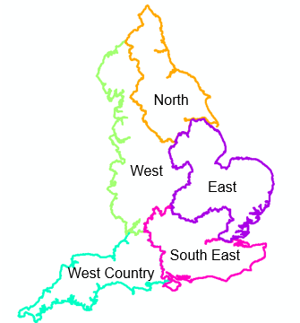
Each regional group will produce a regional plan by September 2023. These plans will:
- be integrated across water company and regional boundaries and include sectors beyond public water supply such as agriculture and industry
- include a clear environmental destination and milestones for getting there
- identify the right solutions, such as transfers and reservoirs, for their region and for the nation as a whole
- directly feed into the next water company water resource management plans (WRMPs)
It is likely that the groups will identify the need for new nationally significant infrastructure. Ofwat has made up to £469m available to a range of water companies. This will accelerate the development of a range of strategic schemes so that they are construction-ready during the 2025 to 2030 period. These solutions will be considered in the regional plans and, those that are selected, will be included in regional plans and therefore water resource management plans.
This level of information will allow the full and accurate assessment of any nationally significant infrastructure identified so the best solution can be taken forward. It is the regional groups that will determine the exact combination of solutions in their plans.
  - Responsive regulatory approach
Ofwat has established a regulators’ alliance for progressing infrastructure development (RAPID). The Environment Agency and DWI are active partners in RAPID and have provided staff for the new unit. RAPID will:
- oversee the portfolio of strategic schemes
- facilitate the development of the strategic solutions through the feasibility stages
- address cross-regulatory barriers to the successful delivery of the national framework and strategic infrastructure
The national framework will set out the need for additional capacity at a national and regional scale. RAPID will facilitate the development of strategic schemes that add to that capacity, ready to be implemented in the 2025 to 2030 period. RAPID will work closely with national framework stakeholders.
Regional groups will build on the understanding of water needs in the national framework, confirming the need within their regions and translating this into their statutory WRMPs. Once the Secretary of State allows the WRMPs to be published, water companies can apply for development consent with decisions made in line with the National Policy Statement for Water Resources Infrastructure.
  - Legislative context
The national framework is an Environment Agency led initiative, developed in collaboration with government, regulators and other stakeholders including the water industry and other significant water using industries, such as agriculture and energy.
As we have not consulted on the framework we have ensured a strong and widely representative group met regularly to steer the project. This was independently chaired and made up of approximately 40 members. We also ran a series of workshops with sector groups including the water industry, agriculture, environmental groups and industry.
The framework does not have a statutory basis. However, it sets out clear policies which government and the regulators jointly agree water companies and others should be working towards. Welsh government and Natural Resources Wales have also given their support to this framework. It complements the government’s 25 Year Environment Plan, the National Infrastructure Commissions report ‘preparing for a drier future: England’s water infrastructure needs’ and the draft National Policy Statement for Water Resources Infrastructure. It also has strong links to the river basin management plans, due to be consulted on from October 2020 and updated by December 2021. As regional plans currently have no statutory basis, there is no formal requirement for consultation. However regional groups agree that the plans should be developed collaboratively and stakeholders should have an opportunity to comment. Regional plans will be available for review and comment from January 2022.
Regional planning may soon have a statutory basis. Defra ran a consultation from January 2019 on ‘Improving our management of water in the environment’. The Environment Bill 2019-2020 includes the following proposal:
- the Minister may give a direction to two or more water undertakers to prepare and publish a joint proposal
- a joint proposal is a proposal that identifies measures that may be taken jointly by the undertakers for the purpose of improving the management and development of water resources
Water resources management plans (WRMP) are statutory and current legislation sets out the process for consultation and subsequent statement of response. The Secretary of State can call for public inquiries on WRMP and regional plans could be used as supporting evidence. The Environment Bill will allow for changes to this process through regulations issued by the Minister.
- Approach to developing the national framework
The evidence presented in the national framework is focused on understanding the needs of public water supply, water users outside of the water industry and environmental water needs.
  - Understanding public water supply needs
To understand public water supply needs we have used the data provided by each water company on water availability in their water resource management plans. We have aggregated this data to a regional and national scale and adjusted it so that it is comparable across companies.
We have used this data to understand future water needs and what is driving the change in these needs over time. This approach has also allowed us to compare different ways of addressing the need. These include the approaches used in water resource management plans and alternative scenarios that, for example, achieve more ambitious demand reductions.
Alongside our own analysis, we have worked with leading universities to bring different perspectives, new approaches and to make use of models they have developed. We have worked with the University of Oxford to explore the impacts of climate change on drought and, in turn, the impacts that drought is likely to have on the water supply network. This uses the university’s national model of water supply infrastructure that has also supported previous work by Water UK.
Our work with the University of Manchester has allowed us to explore the sensitivity of the factors affecting changing water needs. It has also looked at how different types of solutions, particularly water supply and water transfer options, compare when optimised by cost. This includes looking at hypothetical transfer options not yet scoped by the water industry.
  - Understanding water needs outside of the water industry
We have worked with a consortium led by Wood plc. This is to understand how much water is used by different sectors and subsectors outside the water industry now, and how that is likely to change in the future. This work focused on:
- agriculture: spray irrigation, livestock, protected edibles and ornamentals
- industry and manufacturing: paper and pulp, chemicals manufacture, food and drink production
- energy: electricity production – thermal power plants
The work included a detailed literature review, workshops, expert interviews, and analysis of abstraction data.
  - Understanding environmental needs
We have been working with the water industry and other abstractors for many years to address the legacy of environmentally damaging abstraction. This has seen hundreds of abstraction licences changed and billions of litres of water returned to the environment. Details of how we do this are included in the Abstraction Plan.
We work with the water industry to secure environmental improvement from a mix of licence changes and licence investigations (to determine whether a licence needs to be changed) as part of the Water Industry National Environment Programme (WINEP). The programme produces a list of actions every 5 years. These are fed into the WRMPs (because they influence the need for new investment) then get funded through the water company business plans.
We have used evidence from the most recent WRMPs to compile three scenarios of sustainability changes. These include a lower, middle and upper range of changes. We have used the upper of these in our estimation of pressures on public water supplies as it best represents the long term direction of travel.
Despite our work to bring about licence changes to protect the environment, the job is not complete. Further to this, climate change will alter the amount of water available throughout the year, bringing new pressures. We have therefore used our own models to explore the scale of changes required to abstraction to protect the environment under different scenarios, and what the impact of these might be on water availability. This is not about arriving at an exact number. Instead it will help regional groups understand the scale of change and how this is affected by different factors. In cross border catchments the environmental protection level also has to consider Welsh legislation and policy.
  - Governance
We have set up a range of groups to support the development of the national framework and deliver coordinated regional water resources plans.
The senior steering group is a group of around 40 representatives from government, regulators, water companies, bodies that represent water using sectors such as the NFU and Energy UK, academics and environmental non-governmental organisations. It has met quarterly since December 2018 and is independently chaired by Jean Spencer who led the previous Water UK Long Term Water Resources Planning Framework. It provides a strategic steer to the project and has shaped this work.
The regional coordination group (RCG) includes each regional planning group, government and regulators. This group is also chaired by Jean Spencer. It meets regularly and takes responsibility for making progress on actions between meetings of the senior steering group. The group is about making sure that the regional plans are coordinated and that they are ambitious enough to meet national needs.
The modelling advisory group is a sub-group of the RCG that includes technical representatives from the regional groups and is about making sure that technical methodologies are in alignment so that cross regional options can be explored. Modelling is a core component of the national framework and the group is a forum to share good practice and to ensure compatibility in modelling approaches.
- Pressures on public water supply
Public water supply is the water that is taken from rivers, reservoirs and groundwater and supplied through the networks of the 20 major water companies to homes and businesses in England. The national framework looks at the pressures on public water supply nationally, regionally and over time. These include climate change, the need to reduce water abstraction to protect the environment (environmental protection), population and the need to increase drought resilience (increasing drought resilience).
The analysis assumes that actions in the latest round of WRMPs are implemented up to 2025. From 2025 it assumes that nothing further is done to meet future water needs to 2050. This allows us to understand the scale of additional capacity required to meet future needs during that period. It is important to also recognise the progress that is planned over the next five years. Between 2020 and 2025, water companies have planned to:
- reduce leakage on average by 19%
- reduce domestic water consumption on average from 138 l/h/d to 132 l/h/d
- develop 145 Ml/d of new sources
- significantly increase resilience to drought
Each of the main pressures on public water supply: climate change, environmental protection, population and increasing drought resilience have a range of potential impacts. These ranges could be put together in many ways to represent the spread of potential pressures. However, in order to manage complexity, we have focused this section on one plausible scenario which we feel represents a reasonable assessment of likely future pressures. This includes:
- climate impacts taken from the latest water resource management plans
- the most ambitious environmental protection scenario taken from the most recent water resource management plans
- increased drought resilience to a 1 in 500 year drought (0.2% annual chance) as recommended by the national infrastructure commission and agreed by the senior steering group
- high population growth from the Cambridge Econometrics dataset that fits closely with the population data in water resource management plans
Some of these assumptions may prove to be high, for example, actual population could plausibly track the medium or low scenarios. However, there is also scope for the pressure to be greater still. For example, the analysis coming out of our work with the University of Oxford suggests climate impacts could be more significant than estimated in the current WRMPs. Sustainability changes are also likely to be greater in the long term, as suggested by our work looking at potential longer term impacts in section 5.4.2. On balance the scenario presents a useful reference for comparison.
  - National pressures on public water supply
Water companies currently put around 14,000 million litres of water into supply each day (Ml/d). Of this, more than half is used in households. The rest is evenly split between water used in non-households, such as industrial and business users and water lost through leaks in water companies’ and customers’ pipes. A small amount is used for other miscellaneous uses such as firefighting.
Figure 1: Shows how the water that was put into public water supply in 2018 to 2019 was used on average nationally.
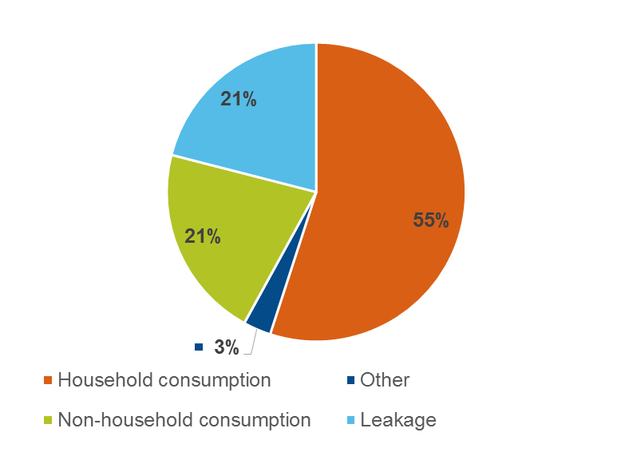

Water companies make sure there is enough water available through their water resource management plans which look at least 25 years into the future to understand how supply and demand will change and make sure they are balanced. In England these are regulated by the Environment Agency. Natural Resources Wales regulates companies that operate in Wales. In the latest round of plans water companies have identified a range of measures to reduce demand and increase supply.
Our modelling assumes that planned investments to reduce demand and increase supply over the next five years are implemented. This includes the first tranche of leakage reductions planned as part of the industry’s commitment to halve losses by 2050. From 2025 we assume nothing more is done to reduce demand or increase supply. This analysis therefore estimates water needs from 2025.
The main pressures on public water supply are: climate change, population growth, the need to improve the environment by reducing abstraction and the need to increase drought resilience. We have used data from water company plans to explore these pressures across England and presented them as the volume of water that would be needed to offset them.
If no action is taken after the next 5 years (2025) our modelling suggests that England could need up to 3,435 Ml/d by 2050 to meet public water supply needs. The need can be met by a combination of increasing supply, moving water (transfers) and reducing demand through water efficiency and reducing leakage. This need is likely to grow further by the end of the century. Projections beyond 2050 carry increasing uncertainty, however our analysis suggests something in the region of 5,500 to 6,000 Ml/d additional water may be needed between 2025 and 2100.
Figure 2 compares estimates of how much each of the pressures on public water supply is contributing to the potential additional national water need by 2050.

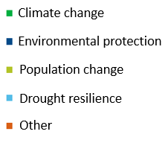

This analysis shows that the need to increase resilience to drought and population growth are contributing the most to water needs. Different pressures develop differently over time. Figure 3 shows this at a national scale. Climate change impacts have been considered in previous WRMPs resulting in investment already being put in place to support climate change adaptation. The impact of climate change is significantly greater when starting at 2020 as water companies have included impacts from climate change of around 640 Ml/d up to 2025 which is before the start date for this analysis.
Figure 3 represents the portion of additional water need driven by the need to increase drought resilience as immediate because it responds to a change in planning assumptions used. Pressures from population and climate change, on the other hand, develop throughout the period to 2050. Changes to abstraction for environmental protection develop up to around 2035 but then level off. This is likely to under-represent the changes needed in this area in total, particularly toward the latter part of the planning window due to the current approach to signalling the need for changes to abstraction that focuses on the most certain changes first.
Figure 3: The cumulative development of the national additional water need over time in Ml/d by driver. Note, this is for a ‘do nothing’ scenario and therefore excludes actions to meet these pressures.

  - Regional pressures on public water supply
The pressures on public water supply vary across England with the south east most affected. Since the national framework is aimed at identifying strategic water needs across the regions we have used the boundaries of those groups to break down our results. Pressures in the south east could be as much as 1,765 Ml/d by 2050. The west and the east also see significant pressures. The west country and the north require less water but still see pressures over the planning period to the year 2050.
The drivers of change also vary regionally. For example, changes to abstraction for environmental protection are more significant in the south east, east and west than in the north or west country. The water required to increase drought resilience is also significantly larger in the south east than elsewhere. The additional ‘other’ quantity is greatest in the south east. This includes a range of factors such as reductions in water availability caused by current or expected water quality issues driven by agricultural pollution such as high nitrate or pesticide levels reducing the quantity of water that can be used.

Figure 4: Future pressures on water resources nationally and by region in millions of litres per day (Ml/d) by 2050 assuming no further action is taken from 2025. This is based on: high population scenario, 1 in 500 drought resilience, high sustainability change and assumes existing surplus cannot offset the need.

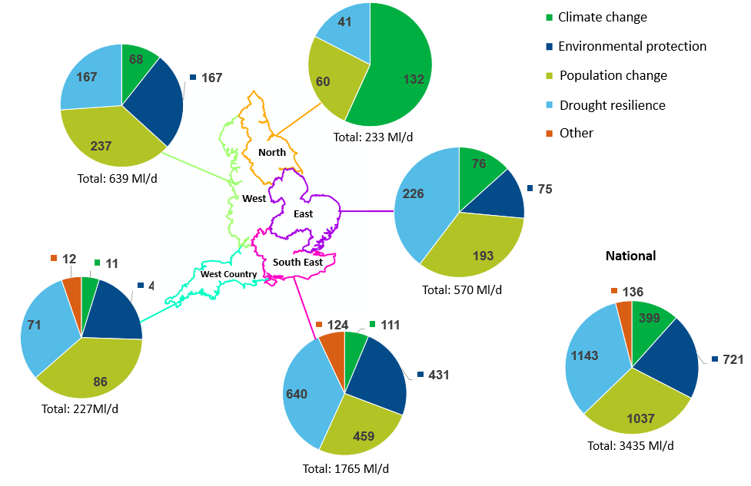
Water Resources North: Climate change is expected to have a significant impact on Water Resources North by 2050. The two other significant drivers of need are changes to abstraction for environmental protection and increased water consumption driven by population.
Water Resources West: Increased consumption, driven by population increases, is the largest driver of additional water need in the region by 2050. Increased public water supply drought resilience and increased protection for the environment also create a significant proportion of the pressures on water resources. The impact of climate change reducing water availability of existing supplies has a smaller, but still significant, impact.
Water Resources East: Increasing public water supply drought resilience is the largest driver of additional water need in this region. Increased consumption driven by population is another large component. Increased protection for the environment and reduced supplies due to climate change have smaller and roughly equal impacts on the additional amount of water required by 2050.
Water Resources South East: The potential additional water required in the south east by 2050 could be as much as half the total needed nationally. Over a third of this is driven by the need to increase public water supply resilience to droughts. Increased water consumption and increased protection for the environment also have significant impacts on water needs by 2050. Reduced supplies, due to deteriorating water quality, is another driver of water need.
West Country Water Resources: Increased consumption, driven by population growth, is the largest driver of need by 2050 in the west country. Increasing public water supply resilience to extreme droughts also drives a significant component of additional water needed, with increased protection for the environment also driving a notable component of the future water need.
The analysis in figure 4 looks at the absolute pressures on water supply. However, because some regions supply more water than others, looking at absolute pressures has the potential to mask significant changes to water needs in regions that supply less water and exaggerate the significance of changes in those that supply more. We have therefore adjusted the potential needs to 2050 by the total amount of water supplied in that region for comparison in figure 5.
Figure 5: The potential pressures on water needs as a percentage of the volume of water put into supply. This is to adjust for the scale of the regional groups.

Figure 5 shows that the pressures on water needs are greatest in the south east in both absolute terms and when expressed as a proportion of the water supplied. The east faces the next biggest pressures as a proportion of the water supplied. The west country sees the third biggest pressures when viewed as a proportion of the water put into supply despite seeing the smallest absolute pressures.

  - Pressures on public water supply within regions
The results up to this point have been shown at a regional scale. Below this are individual water company boundaries. Within those boundaries each company operates a number of water resource zones (WRZ) which are defined as the largest area of a water company’s supply system where all customers have the same supply risk. We have explored how the main pressures affect each of these WRZ and produced a range of maps to illustrate the trends and paint a more detailed picture of the likely pressures on public water supply between 2025 and 2050.
We have looked at the total impact of each pressure in each WRZ. However, looking at absolute numbers tends to highlight the WRZ that supply the most water which are those with the highest population. This can miss some important pressures in smaller WRZ that could represent a significant proportion of the water supplied. We have therefore also divided the absolute change by the water demand in 2025 to correct for the scale of the WRZ.
The following sections and maps illustrate how the impacts of the different pressures on public water supply vary within regions.
    - Climate change
Figure 6 shows the predicted impact of climate change on the water available for public water supply. Water companies used a variety of approaches to generate these estimates, based on UK Climate Projections 2009 (UKCP09) datasets and depending upon the perceived vulnerability of the individual WRZ to climate change.
UKCP09 indicated a likely change to drier, hotter summers and warmer, wetter winters. WRZ that are less vulnerable to a single season event, such as a dry summer, see less of a climate change impact. WRZ that are supported by groundwater abstraction are an example of this since groundwater abstraction can smooth the impact of shorter dry spells.
Climate change impacts have been considered in previous WRMPs resulting in investment already being put in place to support climate change adaptation. The impact of climate change is significantly greater when starting at 2020 as water companies have included impacts from climate change of around 640 Ml/d up to 2025 which is before the start date for this analysis.

Figure 6: The estimated impacts of climate change on public water supply between 2025 and 2050 in total and adjusted as a proportion of the water supplied in any given WRZ.

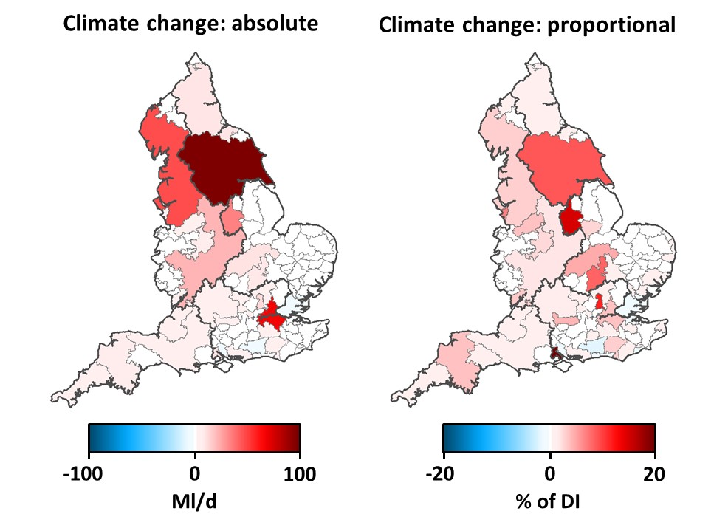

Between 2025 and 2050, around 35% of England’s WRZ show a climate change impact and these contain 65% of the water available for public water supply in 2025. Around 13% show a 5% or greater climate change impact and these WRZs contain 45% of the water available in 2025. The largest total climate change impact is focused within a few large WRZs.
Many of the WRZ represented here as less vulnerable to climate change are in the south and east of England. This is partly because these WRZ tend to have groundwater dominated supply sources which are less affected by shorter dry periods. In contrast, some of the WRZ in the north and west see greater estimated impacts because they have less groundwater storage. While groundwater supplies in the south east can provide resilience to public water supply it is important that this is not at the expense of the environment which includes our iconic chalk streams.
The data in figure 6 is from the latest water company assessments of risk. However, models, data and methodologies continue to develop apace and each development moves our understanding forward. Current assessments are generally based on the UKCP09 datasets and work is underway to understand how this will be altered by the UKCP18 products.
The Climate Change Risk Assessment 3 project is underway and technical results are expected later this year. These will improve our understanding of the nature of the climate risk on public water supply. There are indications that some of the newly released UKCP18 products are predicting greater impacts in the south and east perhaps due to drier autumns altering groundwater recharge which is essential to these regions.
    - Drought resilience
The maps in figure 7 represent the additional capacity required to increase drought resilience so that level 4 drought restrictions are not needed more than once every 500 years on average. The box 'Responding to drought' explains the various levels of drought response.

Looking at the water required to increase drought resilience as an absolute volume highlights the biggest WRZ or those that have the highest population, for example London. Viewing the capacity required as a proportion of the water currently supplied (the map on the right) presents a more varied picture. Within this, the need for additional capacity seems to be focused in the south east. However, this is not uniform and some WRZ, those in white or blue, are at that level of resilience in 2025.

Responding to drought
There are 4 levels of response to a drought. Level 1 responses include increased communications with customers and low risk winter drought permits that allow additional water to be taken from rivers or reservoirs. Level 2 responses include temporary use bans, formerly known as hosepipe bans, and low impact drought permits to allow increased abstraction in summer. Level 3 actions include restrictions on non-essential water use for businesses and drought permits that carry higher environmental risk to allow additional abstraction. Level 4 restrictions include standpipes and rota cuts. Level 4 is seen as a last resort as these measures would have major impacts on customers. These measures are also likely to be impractical, particularly when needed on a large scale in response to a drought, or in densely populated areas.
Figure 7: The estimated additional capacity required to increase drought resilience to a 1 in 500 level from the position in 2025. It represents this as a total on the left and as a proportion of the water supplied on the right.
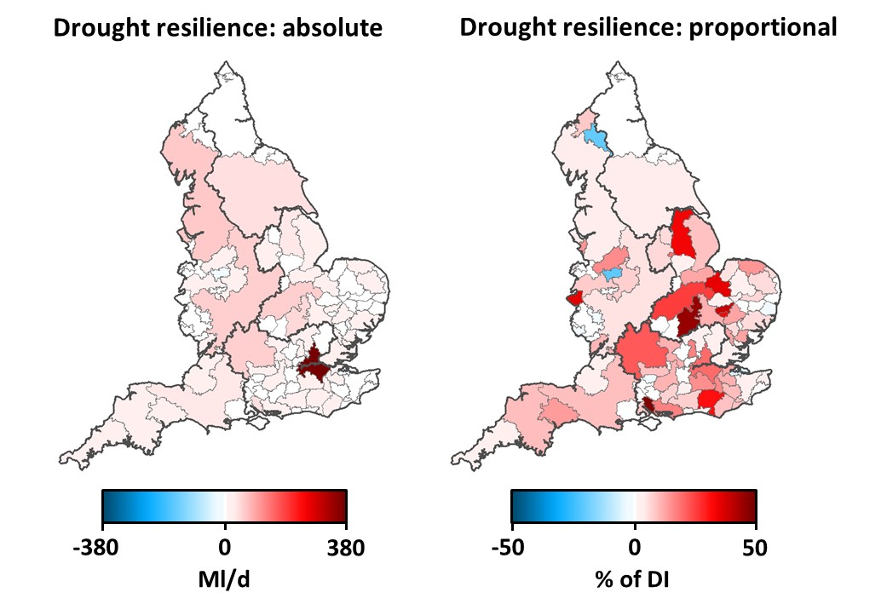

    - Population change
Our assessment of future water needs has assumed that water use per person does not change after 2025. This means that changes in household water consumption in our analysis are driven by population growth. The absolute change in water needs is skewed by differences in the total populations of different WRZ with bigger zones showing larger changes than smaller zones. This is clear in the absolute map which highlights the biggest WRZ. These happen to be in the north and the midlands. London is also highlighted due to its large population. The map that looks at the change in capacity required as a proportion of water supplied changes the picture significantly and highlights the south east as facing the greatest pressures from population change.
Figure 8: The estimated additional capacity required to meet the water demand resulting from change in population from 2025 to 2050. It represents this as a total on the left and as a proportion of the water supplied in each WRZ on the right.
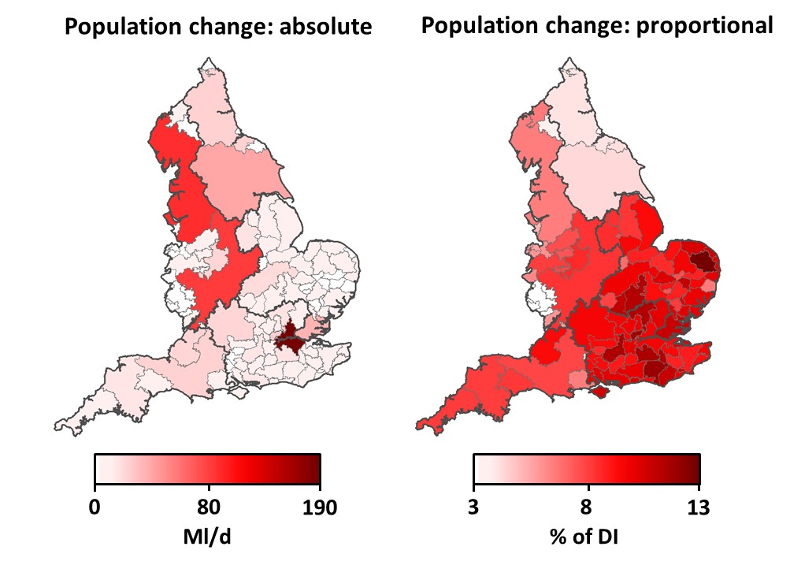
    - Environmental protection
The map showing the impact of changes to reduce water abstraction in water company plans is dominated by two large WRZ. Changes in London are driven by abstraction reductions to protect chalk streams. The changes in Severn Trent Water are from planned reductions in groundwater abstractions. The proportional change brings out the significance of smaller reductions. These are particularly significant in the south east which has a larger number of smaller zones than the north.

Figure 9: The estimated additional capacity required to replace water supplied from unsustainable abstraction between 2025 and 2050. It represents this as a total on the left and as a proportion of the water supplied on the right.
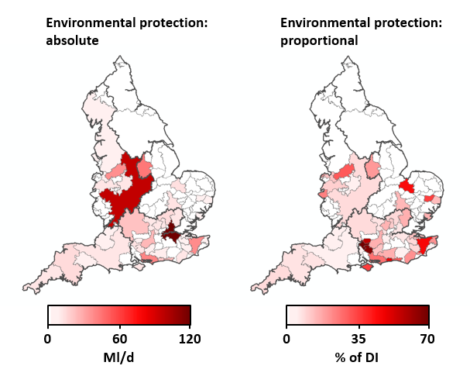

Figures 10 and 11 show how the individual pressures on public water supply combine. We have represented this both as a total impact and as a proportion of the water supplied in each WRZ. Figure 10 presents the individual and combined total pressures on public water supply at the WRZ level and Figure 11 does the same as a proportion of the water supplied in each WRZ.
The large WRZ in the north west, Yorkshire and midlands as well as London see the biggest combined pressures due to their size.

Figure 10: The total estimated additional capacity required to meet each pressure individually and in combination between 2025 and 2050.
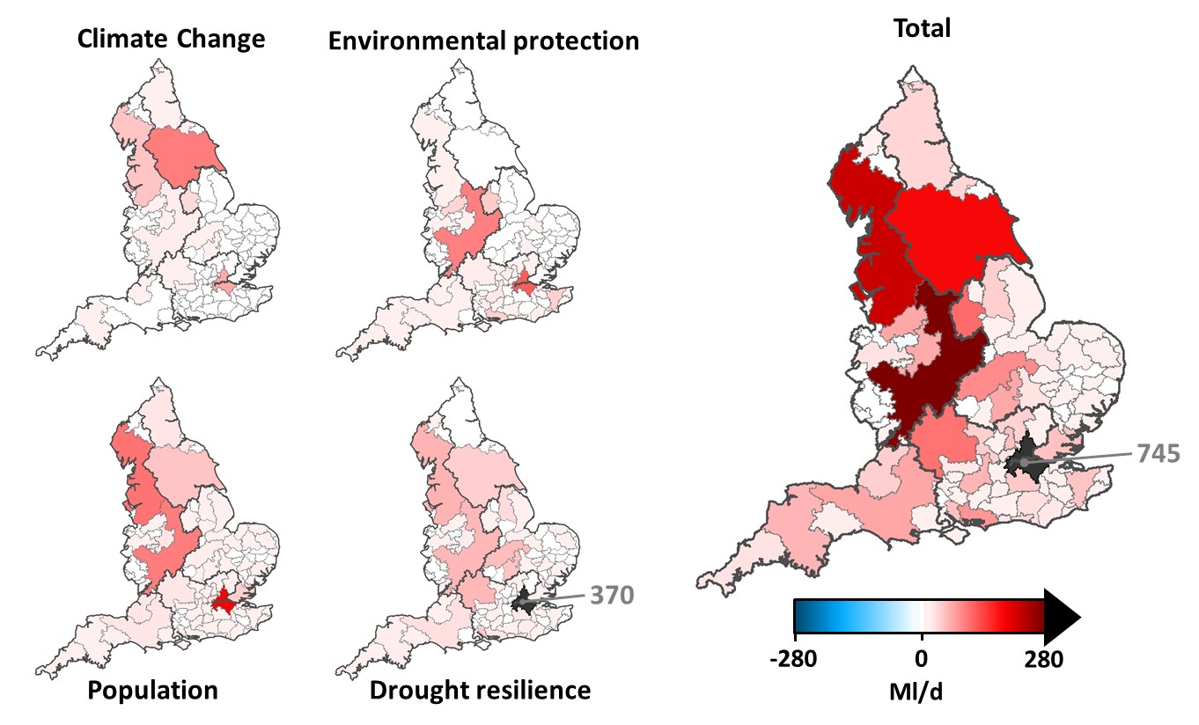
Figure 11: The estimated additional capacity required to meet each pressure individually and in combination between 2025 and 2050 as a proportion of the water supplied in each WRZ.

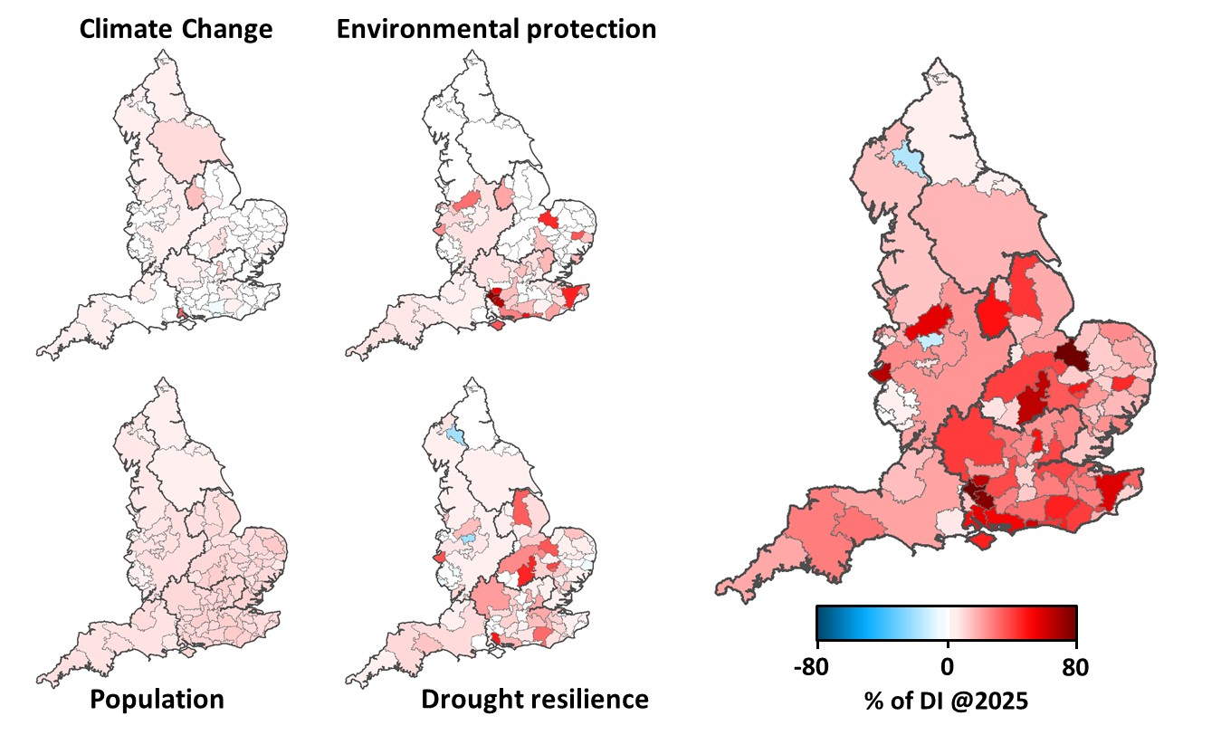

When the pressures are viewed as a proportion of the water supplied in each WRZ, those in the south and east see the biggest impact. The maps also illustrate differences in how impacts play out within regions. In particular, population change is relatively consistent between WRZ. In contrast, the impacts of sustainability changes and resilience are more variable. This is because sustainability changes are determined by the location of specific affected abstraction points and the water required to increase drought resilience is influenced by the starting level of drought resilience in a given WRZ. This is important because pressures that are ‘dispersed’ across a region may be best addressed with solutions like water efficiency that can also be widely deployed. Specific local issues may require more local and targeted interventions such as infrastructure schemes.
- Understanding the pressures on public water supply
Section 5 looks at each of the pressures on public water supply in more depth. It presents more information on the range of pressures likely. It also presents the results of further work to increase our understanding of what this means for public water supply needs.
  - Climate change
Our analysis of water industry data suggests the impact of climate change on national water supply in the water industry is around 400 Ml/d between 2025 and 2050. The impact of climate change on public water supply will be due to a range of factors including:
- changes in rainfall patterns causing lower flows in rivers in summer that lead to regulatory conditions to reduce or prevent abstraction triggering more frequently and for longer
- changing the profile of water availability across the year in a way that reduces the amount that can be stored in reservoirs
- changes in patterns of groundwater recharge altering the amount of water in aquifers available for abstraction and the potential for rising sea levels to increase the risk that saltwater contaminates aquifers (known as saline intrusion)
Climate change impacts have been considered in previous WRMPs resulting in investment already being put in place to support climate change adaptation. The impact of climate change is significantly greater when starting at 2020 as water companies have included impacts from climate change of around 640 Ml/d up to 2025 which is before the start date for this analysis. Water companies will already be planning measures to meet this water need. The reported impacts of climate change are therefore smaller than they would have been without this investment. The extent of climate change impacts on public water supplies may also be restricted by factors that are independent of climate change such as:
- regulatory limits on the amount that can be taken over a given time period
- physical constraints on the amount of water that can be taken such as pump capacity
- limitations of the distribution network and treated water storage that the site is supplying
The impact of climate change on the UK water industry is uncertain. It will depend on the trajectory of greenhouse gas emissions globally, how the climate will respond to those emissions and how individual water sources, surface water and groundwater, will be affected by that response.
Water companies have varied in their approaches to estimating these impacts so results are likely to be variable and not strictly comparable between companies. Plans are in place to develop a national climate dataset over the next few years for use by the different regional groups in order to increase consistency.
Climate change has the potential to bring sudden and unpredictable impacts. This is particularly relevant when considering that water companies can only really be confident in understanding how their sources, such as rivers and groundwater abstraction, will respond to weather that they have seen before. Climate change may bring new weather patterns such as extreme droughts that cause unpredictable issues for water sources that have previously been reliable. These changing weather patterns are likely to require different ways of managing water. For example, re-profiling water storage to fit with changing water availability.
    - A national view of climate impacts
We have worked with the University of Oxford to supplement the analysis of water company assessments of the impacts of climate change with some independent analysis that provides a nationally consistent view of the potential impacts of climate change on public water supply.
This work has used a large number of climate change scenarios, a new national hydrological model called DECIPHeR developed by the University of Bristol, and the University of Oxford’s water resource system simulation model of England and Wales. This was originally developed for the Water UK Long term Water Resources Planning Framework and has since been improved with cooperation from water companies.
This supplementary analysis is less detailed than the models that individual water companies hold. However, it is able to explore the impacts of a broad range of climate scenarios nationally, using consistent assumptions. To focus on future climate impacts other influences have been frozen, for example, per capita consumption has been fixed at 2020 levels. Climate change is investigated in the near future (2020 to 2050) and the far future (2070 to 2100) using ensembles of spatially coherent climate conditions which give a realistic representation of drought patterns nationally. The analysis uses the high greenhouse gas emissions scenario (RCP8.5).
The modelling suggests that, in the absence of investment to boost resilience, water shortages requiring level 3 or 4 drought actions (level 3 includes non-essential water use bans and higher risk environmental permits and level 4 includes standpipes and rota cuts) could become significantly more likely than they are today. Figure 5 shows that, in comparison with the historic period (1975 to 2004), climate change makes years with water restrictions twice as likely in 2050 (1.5% risk) and four times as likely by 2100 (3.1% risk) at a national scale. This estimates the impact of climate change assuming no increases in capacity are introduced and no reductions in demand are made.

Figure 12: Shows the independent assessment of climate risks to public water supply in the near future and far future regionally and nationally, expressed as the risk of level 3 or 4 restrictions to supply. The risk statistics have been converted from the catchment abstraction management strategy (CAMS) regional boundaries to the regional group boundaries. The geographic extent and correlation between these two regional divisions of England is summarised in appendix 1.

The effect of climate change on resilience varies locally. Water supplies across all regions in the south are at greater risk than the rest of the country. The scale at which the south east and east are affected by climate change is significant, especially when considering the additional pressures, such as population growth, that are likely to apply there. The impact of climate change is also considerably greater in the far future (2070 to 2099) than the near future (2020 to 2049).
The University of Oxford modelling suggests a greater impact from climate change than the current WRMPs which tend to report relatively modest impacts of climate change between 2025 and 2050. A significant difference in the modelling by the University of Oxford is that it explicitly simulates the impacts of extreme droughts and uses spatially coherent ensembles of climate scenarios (scenarios that are consistent across the country) from one modelling framework (weather@home2).
Climate change is expected to affect the likelihood, severity and duration of extreme droughts. Because the University of Oxford modelling is able to explore these changes in a comprehensive and consistent way, the results offer a useful perspective and are potentially revealing. To better understand the scale of the risk associated with climate change, a spatially coherent national drought library (meaning weather patterns are represented consistently across the country) is required for standardisation and improving consistency between estimates.
    - Climate impacts beyond changes to water availability
Because winter rainfall and summer storms are forecast to become more intense when they do occur, climate change is also likely to bring increased flood risk. This has the potential to damage water supply infrastructure and lead to interruptions in supply, as was seen following damage to the Mythe water treatment plant at Tewkesbury in 2007. Water companies need to make sure their networks are resilient to these risks. Water company assets can also be used to help manage flood risk. For example, by keeping reservoirs below capacity to help manage high river flows.
As well as planning to adapt to the pressures brought about by climate change, regional groups have the opportunity to help mitigate the impacts by reducing greenhouse gas emissions. Plans should be in line with the commitments already made on reducing greenhouse gas emissions, for example, the Environment Agency has committed to net zero by 2030, as has the UK water industry through Water UK. The National Farmers' Union (NFU) has the ambition for farming to be net zero by 2040. It is important that the appraisal of schemes takes into account the relative greenhouse gas emissions associated with each. This should include emissions from implementation and operation.
  - Drought resilience
The government has been clear, including in the 25 Year Environment Plan, that the water industry needs to increase its resilience to drought and maintain this in the face of pressures from climate change, population growth and the need to improve environmental protection. To do this the water industry will need to develop additional water supply capacity through measures to manage demand and increase supply.
In their latest plans the water companies are generally planning to increase drought resilience so that a 1 in 200 year drought event could be managed without the use of rota cuts or standpipes. This is known as a severe drought.
However, as set out by the National Infrastructure Commission, it is cost-effective to extend this further so that public water supplies are resilient to a 1 in 500 year event (an extreme drought). We support this recommendation, which has also been endorsed by the national framework senior steering group.
The additional capacity required to increase drought resilience is a relatively significant component of the total increased water need projected nationally at over 1,100 Ml/d. However, around 700 Ml/d of this is to achieve the increased resilience to a severe drought (1 in 200 year return period) which companies have already committed to. A large component of the water needed to increase drought resilience is in the south east.

Figure 13 shows the volume of water needed to increase drought resilience from the current level to a 1 in 200 and 1 in 500 level.

Drought permits and orders can be used to allow additional water to be taken from the environment at times of scarcity caused by exceptional shortages of rain. These are typically only issued once water companies have implemented temporary use bans (formerly known as hosepipe bans). Drought permits and orders can increase the resilience of public water supplies by reducing the risk of interruptions, however using these measures can also put additional stress on the environment at a time when it is already under pressure from low rainfall.
The assumptions water companies make in their plans about how drought measures will be used have an impact on water needs. Drought permits are some of the lowest cost options for increasing supply since they will not require investment in infrastructure. However, it is important that environmental costs are considered against the benefits. This is discussed further in section 9.5.
  - Population change
Water consumption is largely determined by how much each person uses and how many people are using it - population. The exception to this is consumption outside households, for example in manufacturing, which will also be driven by wider economic trends.
Per capita consumption represents how much water we each use at home in a typical day. In our modelling we have fixed per capita consumption at the volume estimated for the year 2025. This allows us to understand water needs driven by population change and to include options to reduce demand as part of the options to meet water needs.
Just over 20% of the water put into supply by water companies is classed as non-household use. This includes water consumed in business and industry. A retail market was set up in 2017 so that businesses are supplied and billed by a number of different retailers that are independent from the incumbent water companies that now act as wholesalers.
Retailers have an important part to play in managing demand for non-household water use and contributing to water resources plans. The retail market is still in its infancy, however we anticipate that regional groups and retailers will work together, exchange information and improve the monitoring, understanding and planning of non-household demand.
Reducing the demand for water from non-household sectors will play an important part in reducing demand overall. It can go hand in hand with increasing the efficiency of processes and business and reducing energy consumption. Regional groups should work with other companies, non-household water retailers and new appointments and variations (NAVs) to align the approach to planning water resources, reducing demand, forecasting and monitoring non-household use of mains water.
Water companies plan to meet demand based on growth projections set out in local authority plans. This is to make sure there is sufficient water available to accommodate local housing and population growth. As part of the national framework we have compiled these estimates to create an aggregated national population forecast worked up by each water company.
As well as the aggregated water company population forecasts, we also have a dataset generated by Cambridge Econometrics for the Climate Change Risk Assessment 3 project (CCRA3). This uses population projections published by the Office for National Statistics (ONS), which are based on historical data to 2016, with local authority projections provided to 2041 and national projections to 2100.
The Cambridge Econometrics dataset includes high, medium and low scenarios and each of these are plausible futures. The projections provided in the dataset are based on assumptions which are subject to inherent uncertainty. For example, population projections are based on assumptions of future levels of fertility, mortality and migration but these assumptions are influenced by many factors and future outcomes are likely to be different from the assumptions made.
We have compared the water company data to the Cambridge Econometrics data and found that the high scenario matches closely with the aggregate data produced by the water industry. This is what we would expect to see given government guidance to water companies is to plan for growth detailed in local authority plans so that they are not a barrier to that growth.
The Cambridge Econometrics data has the benefit of being based on consistent national assumptions and including comparable medium and low scenarios. For these reasons we have used it for the majority of our analysis, typically looking at the high scenario due to its alignment with the water company plans.
Using a high population scenario introduces the possibility of over estimating population growth and therefore demand. However, the risks from over estimating population growth are preferable to those from underestimating it. To manage these risks, regional groups should revisit their assumptions around population regularly as part of the planning process to correct for any changes.

Figure 14 shows the change in household water consumption nationally (the whole bar) and regionally (by sub-component) under four scenarios to 2050. ‘WRMP’ is the population data used in the latest water resource management plans and high, central and low are the three population datasets we have examined. All the consumption estimates assume 2025 per capita consumption. Therefore the consumption figures in the WRMP19 bar will differ from consumption figures in the water resource management plans.

The data aggregated from water company plans (WRMP19) and the high Cambridge Econometrics scenario are very similar. If per capita consumption is fixed, both scenarios drive around 1,100 Ml/d of additional water needs. The main difference is in the north where local authority estimates are higher than the Cambridge Econometrics scenarios. The central and low scenarios reduce likely demands significantly.

    - The Oxford to Cambridge arc
Some regions include potential hot spots for growth which have not been modelled explicitly in this analysis. The Oxford to Cambridge Arc is an example of this potentially affecting Water Resources East and Water Resources South East. Government's ambition for the Oxford-Cambridge Arc is to deliver transformational economic growth across the area.
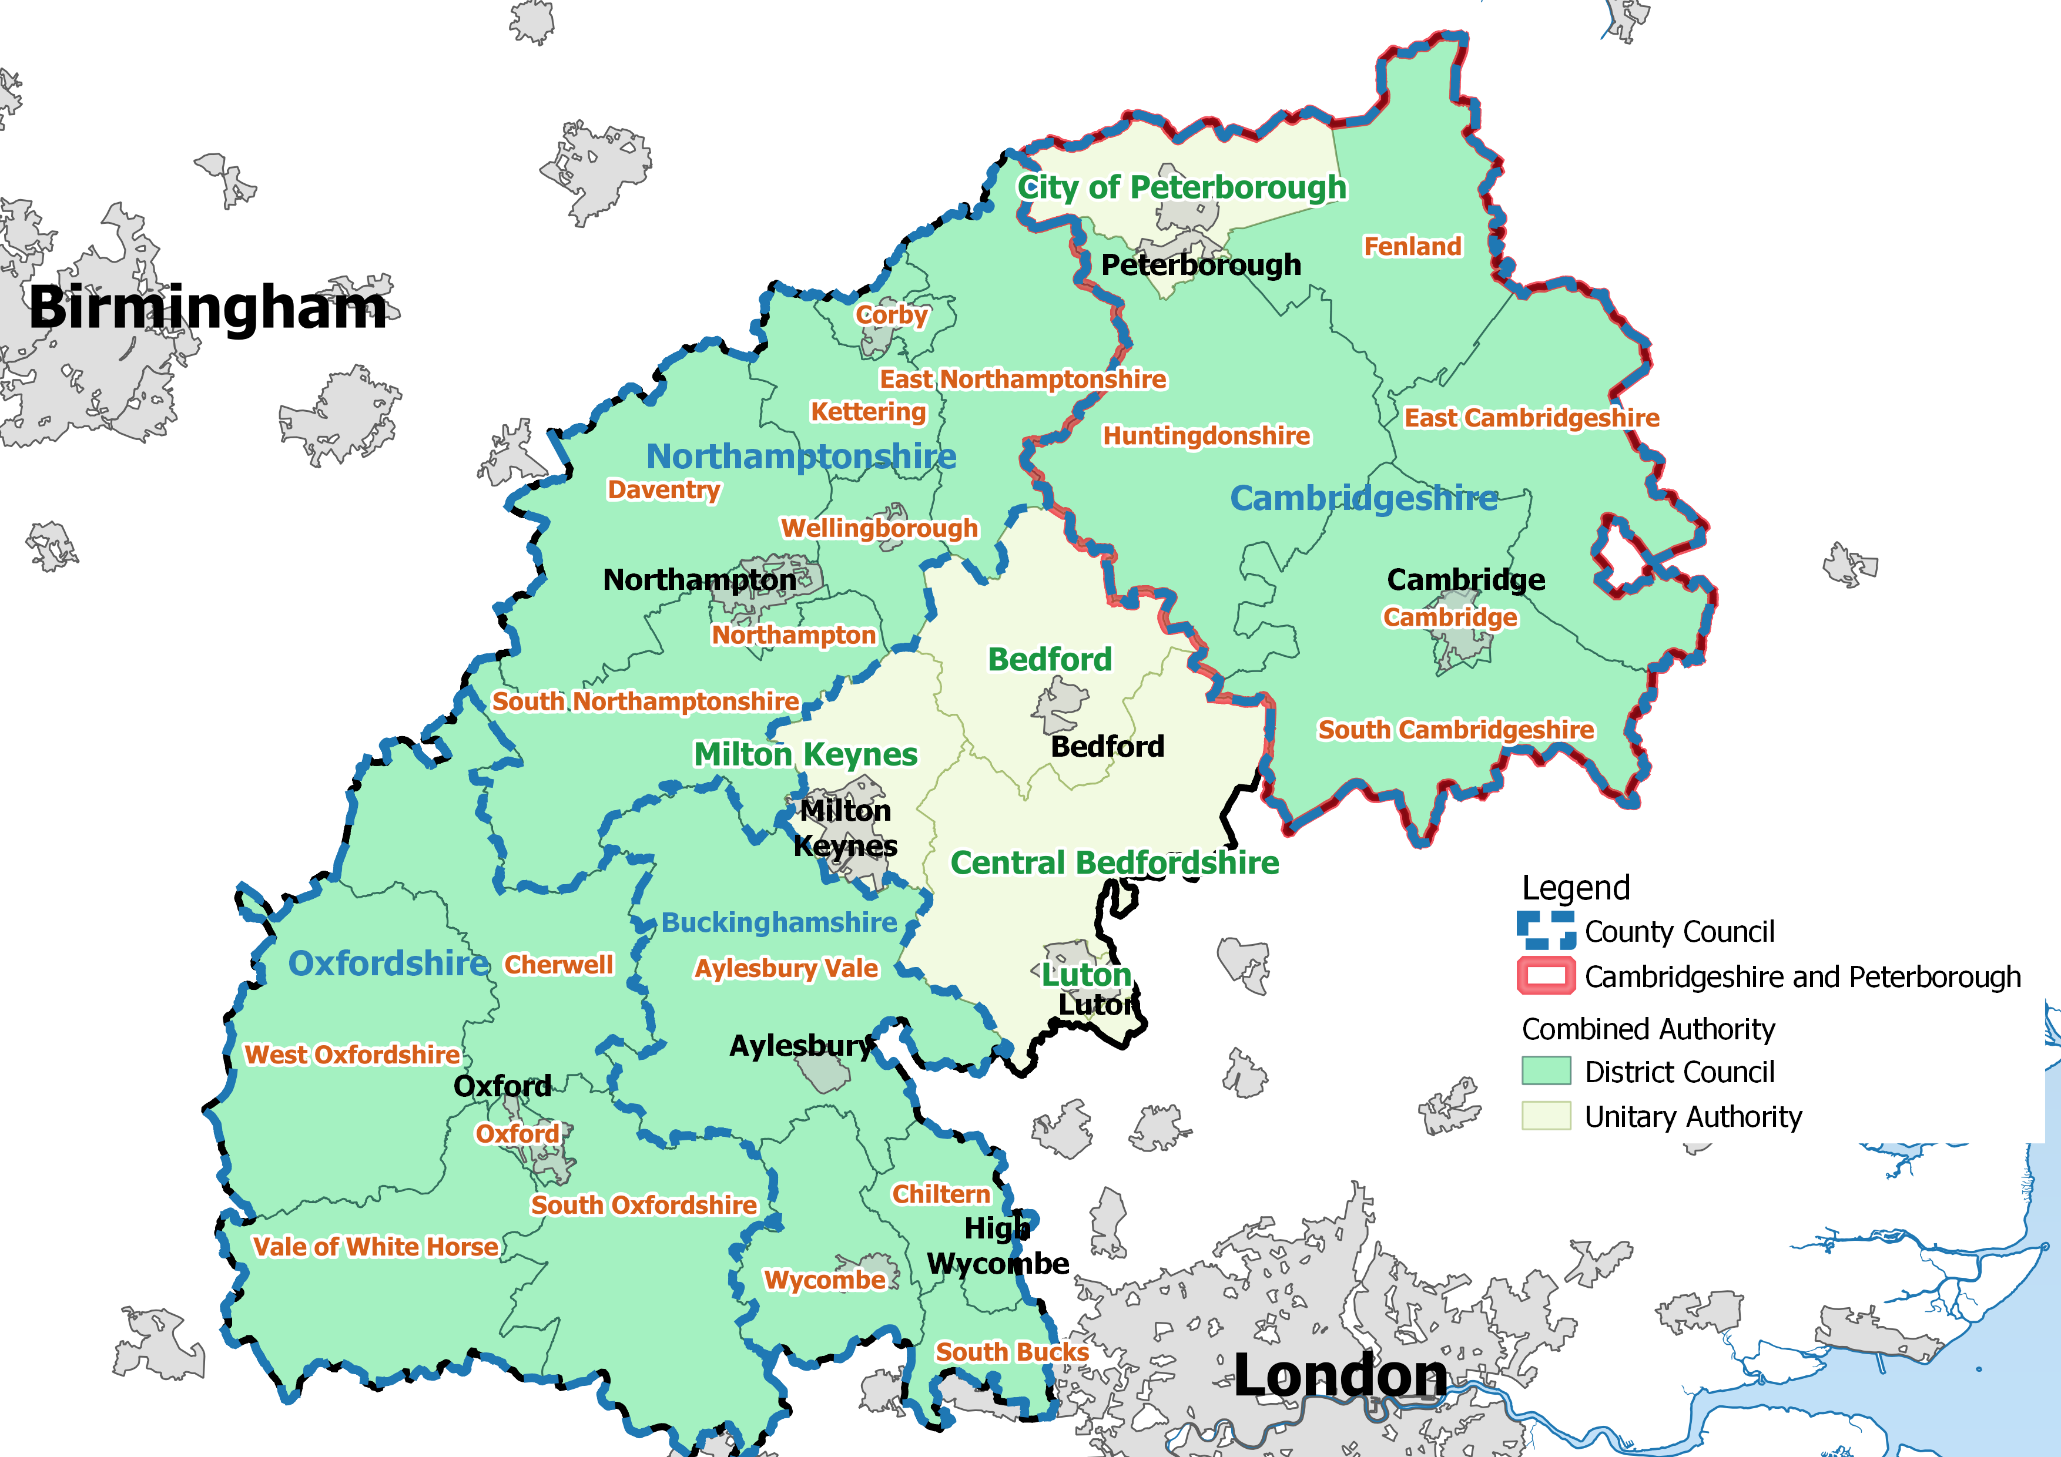

In 2017, the National Infrastructure Commission published Partnering for Prosperity: a new deal for the Cambridge to Milton Keynes to Oxford Arc which identified that up to one million new homes may be needed by 2050 if the Oxford to Cambridge Arc is to achieve its full economic potential. Government responded to the National Infrastructure Commission in 2018, and in March 2019 published a statement of government ambition, and a joint declaration between government and local partners.

The UK Infrastructure Transitions Research Consortium (ITRC), a collaboration of seven universities and over 55 partners from infrastructure policy and practice, has explored the potential impacts of growth in this area on water needs. It found that:
- long-term water demand in the Arc increases for their 'New Settlements' scenario, as the effects of high population growth exceed the reductions in demand planned for from existing water users through increased water efficiency
- at the eastern end of the Arc, the 'New Settlements' scenario could result in a doubling of the annual risk of water shortages
- growth in water demand in the Arc can best be mitigated by water companies investing in reducing leakage and applying ambitious demand management measures
- new water supply infrastructure can also bring the risk of water shortages to acceptable levels, including new reservoirs, water transfers and effluent re-use schemes
Government’s ambition for the Arc presents an exciting opportunity, but one that would have impacts for integrated water resource management. To prepare for this, the Environment Agency will continue to collaborate with Water Resources East and Water Resources South East and others as plans for growth develop.
  - Environmental protection
The water we all use comes from natural sources such as rivers and aquifers as well as reservoirs. Taking water from these sources is known as abstraction. This abstraction provides essential water for public supply, agriculture and industry. However, taking too much water is unsustainable and can harm ecology and reduce the natural resilience of our rivers, wetlands and aquifers. This is particularly challenging during extended periods of low rainfall – which we expect to see more of under climate change.
Unsustainable abstraction still diminishes some of the most iconic catchments and important habitats in the country, such as chalk streams, which are a globally important habitat. There are more than 224 chalk streams in the UK. These represent 75 to 80% of this habitat type globally and must be protected.
Sustainably abstracted water bodies are more resilient to climate change and drought so addressing unsustainable abstraction will help improve resilience. Water companies have a vital role to play in this work. They are big abstractors and are able to develop and manage resources in a way that other abstractors are not. Water companies also have a duty to have regard to the Water Framework Directive river basin management plans when exercising their functions.
The Abstraction Plan estimates that around 95% of surface water bodies and 85% of groundwater bodies will be sustainably abstracted by 2027. In the remaining water bodies it identifies that we may need to set alternative objectives where the costs of improvements outweigh the benefits.
The Environment Agency uses the Water Industry National Environment Programme (WINEP) to make sure that water companies take a leading role in addressing unsustainable abstraction. This brings about investment to resolve historical issues and investigations to prevent future environmental impacts from abstraction. Issues are identified using a combination of screening river flows and groundwater levels against indicators of what is required and local evidence from investigations.
The improvements identified through the WINEP are included in water resource management plans and funded through business plans. Our analysis of the additional water needs being driven by sustainability changes presented in figure 8 therefore reflects issues identified in the WINEP. Because our analysis of water needs starts at 2025, sustainability changes made before 2025 are excluded.

    - Sustainability changes in water company plans
We have modelled the impact of three different levels of sustainability changes on public water supplies in the national framework. These all take information from water company water resource management plans.
Figure 15: Sets out the range of sustainability changes explored in this analysis and highlights the volume of abstraction planned to be reduced by 2025 and by 2045.

The lower scenario includes sustainability changes that water companies have committed to making and is comprised primarily of changes the water companies are certain they will need to make.
The middle scenario includes all the changes in the lower scenario as well as possible but unconfirmed changes. Where companies have presented more than one scenario we have selected the largest reduction. Examples include changes to make sure abstraction does not increase in a way that damages the environment and estimates of the likely impact of changes that may be required following investigations planned between 2020 and 2025. In these cases, while there is evidence that water company action is needed, the exact response that is needed is not yet clear. While we are less certain that the specific changes in this scenario are the right changes they are in line with our view that further changes will be required in the future.
The upper scenario includes all the changes in the middle scenario and an indication of the direction of travel. The details of the action required in this scenario are less clear. Only a small number of relevant scenarios were presented by water companies. These focus on changes in abstractions to protect chalk streams, changes to flow standards and changes to prevent deterioration of water body status (where investigations are proposed for 2020 to 2025).
We have selected the upper scenario for our modelling because, although it is the least certain, it represents the changes most likely to be required in the long term and is in line with our high ambition for environmental improvement, also endorsed by the senior steering group. This supports the aim of the national framework which is to explore strategic water needs to 2050 and beyond.
The changes in these scenarios build on information that we have provided the water companies through the WINEP process. This is based on local information from investigations as well as higher level flow or level screening. This means it is the most robust source of information on likely changes so we have used it throughout this work. It does, however, have limitations. Firstly, it only includes changes to water company abstractions. Secondly, the sustainability changes identified through the WINEP and represented in water company plans, are relatively short term and incremental in nature.
To gain a better understanding of the likely scale of sustainability changes across all sectors and how abstraction may need to change in the longer term, we have carried out some high level work in addition to the scenarios above. This work explored the impacts of different levels of protection for the environment on potential reductions in abstraction required. It included the potential impacts of climate change and changes to future water needs across sectors. We have not used this work in our central results because it is based on national modelling and has not been tested at individual sites.
    - Further work exploring longer term changes to protect the environment
This supplementary work explores the sustainability changes potentially required across all sectors in the longer term. It aims to improve understanding of the possible scale of changes needed to water abstraction. This will support regional groups in their work to develop a long term destination for sustainable abstraction and actions to get there. We have looked at 3 main scenarios. These are; ‘business as usual’, ‘enhanced’ and ‘adapt’.
To understand the need for sustainability changes we looked at the balance between the flow in the river, the amount needed to support the ecology and the water available for abstraction. We have assessed the water balance under two different abstraction rates. The first is a typical rate of abstraction defined as ‘recent actual’ which is based on the information abstractors provide us on how much they have taken (abstraction returns). The second is a ‘future predicted’ rate which incorporates predicted abstraction growth. We have looked at actual and predicted abstraction to understand the scale of reductions in actual abstraction that are necessary. There will be additional constraints in places on the potential for abstraction to increase within licensed volumes to avoid deterioration which are not quantified here.
Under each scenario we explored the potential reductions in abstraction needed to achieve sustainable abstraction. The reduction calculations start with groundwater abstraction recovery first. This is because this tends to be the largest contributor to environmental pressure and many surface water abstractions are already constrained at low flows. The remaining reduction calculations consider changes to surface water licences excluding those that have an existing flow constraint, are from a reservoir, lake or level dependant catchment, or have an upstream supported flow.
Business as usual sees our regulatory approach remain the same. We continue to protect the same percentage of natural flows for the environment. Flow and groundwater balance tests evolve as a proportion of natural flows, flexing with climate change impacts. In this way the environment adapts to climate impacts on river flow and groundwater resources. Within the business as usual scenario we have also explored the volume of water that would need to be recovered to restore groundwater bodies that have been classed as uneconomic to recover. This is called ‘Business as usual including uneconomic water bodies’.
The enhanced scenario sees greater environmental protection for protected areas, SSSI rivers and wetlands, principal salmon and chalk rivers. In these water bodies the enhanced scenario applies the most sensitive flow constraint appropriate, increasing the proportion of natural flow that is protected for the environment. Flow and groundwater balance tests evolve as a proportion of natural flows as these are altered by climate change.
Under the adapt scenario we explore reducing the level of protection in some less sensitive or modified water bodies to allow access to more water. This scenario considers that we might not be able to achieve current environmental objectives everywhere in a shifting climate.
We explored each scenario from a 2025 baseline. This baseline assumes water companies have implemented the licence changes that are included in Ofwat’s 2019 Price Review between 2020 and 2025 to tackle unsustainable abstraction. It also includes commitments set out in the Abstraction Plan for other sectors. If these changes and commitments are not made, or they are not sufficient, then additional abstraction reduction would be needed. The scenarios use forecasts of natural flows for 2050 that take into account the impacts of climate change and future predicted abstraction rates (that include growth in future water needs).
We have not included existing actions to reduce abstraction beyond 2025 in any of the scenarios. This is because we want to compare the new pressures that would be faced under each scenario. Where there is too much abstraction, which could cause pressure on the environment, action would need to be taken. We have estimated the reductions in abstraction that would be required to address these pressures.

Results
The results suggest that in 2025, even after the 2020 to 2025 actions are implemented, a considerable reduction in abstraction is still required. This is in the region of 880Ml/d to meet our current planned ambition for 2027. We recognise that there is another two years for improvements to be made which may reduce this gap. Also, the gap itself has been calculated in a simplified way, and further work is required to better understand it and make sure that the right actions are in place when and where they are needed. However, this represents a potentially significant volume of water and requires further iteration locally with reference to existing investigations to understand more fully.
The table below sets out the potential scale of reductions in abstraction needed by 2050. These results include predicted abstraction growth and potential impacts of climate change on flows. They estimate the likely scale of abstraction reductions potentially needed to achieve sustainable abstraction across all sectors on a national scale. All of the scenarios suggest greater reductions in abstraction are likely to be required than those currently considered in water company water resource management plans.

Table 1: Sets out the potential scale of abstraction reduction needed to under the different scenarios in Ml/d
Scenario | Potential recovery required by 2025* in Ml/d | Potential recovery required by 2050 in Ml/d (excluding the baseline)* | Potential recovery required by 2050 in Ml/d (including the baseline)*
Business as usual | 880 | 340 | 1200
Business as usual including uneconomic water bodies |  | 1400 | 2300
Enhanced |  | 1300 | 2200
Adapt |  | 280 | 1160
*All numbers rounded to whole numbers
As well as requiring changes to abstraction licences, the reduction in natural river flows likely by 2050 will also trigger existing abstraction licence constraints, such as hands off flows that protect the environment at low flows, more frequently. The model estimates that this impact alone reduces abstraction by around 210 Ml/d without any licence changes.
Climate change will alter the amount of water available throughout the year. Rainfall patterns are expected to shift to wetter winter months and drier summer months. This means environmental pressures at low flows are very likely to increase.
Based on this analysis the reductions in abstraction required to improve environmental protection are likely to be substantial and affect water availability in the future. Maintaining resilient water supplies in the face of potentially significant reductions in abstraction will require investment in infrastructure which takes time and can have environmental impacts itself. An example of this is the high energy use, and resulting greenhouse gas emissions, associated with desalination technology.
To achieve the best environmental outcomes we need a balanced approach. This needs to improve environmental protection, prioritise the most valuable environmental improvements first and avoid unintended consequences (resulting from measures put in place to maintain water availability following reductions in water abstraction). We believe this approach is likely to draw elements from the enhanced, adapt and business as usual scenarios that we have looked at. It should be informed by local understanding and evidence to find the best solutions.
Figures 16 and 17 show the potential reductions in abstraction in the business as usual and enhanced scenarios (which represent the lowest and highest explored) by sector at the regional level. These give an indication of the potential changes in abstraction needed by region and by sector under these scenarios from now to 2050.

Figure 16: Sets out the potential reductions in abstraction by region in millions of litres per day (Ml/d) under the 2050 Business as usual scenario.
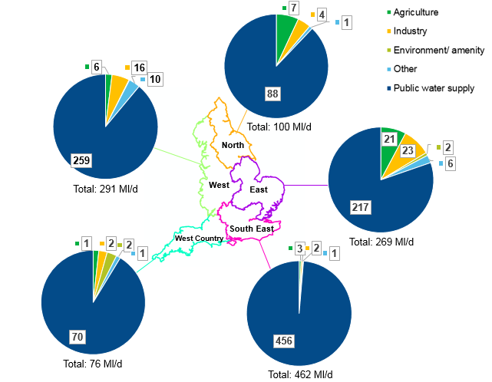
Figure 17 Sets out the potential reductions by region in millions of litres per day (Ml/d) under the 2050 Enhanced scenario.

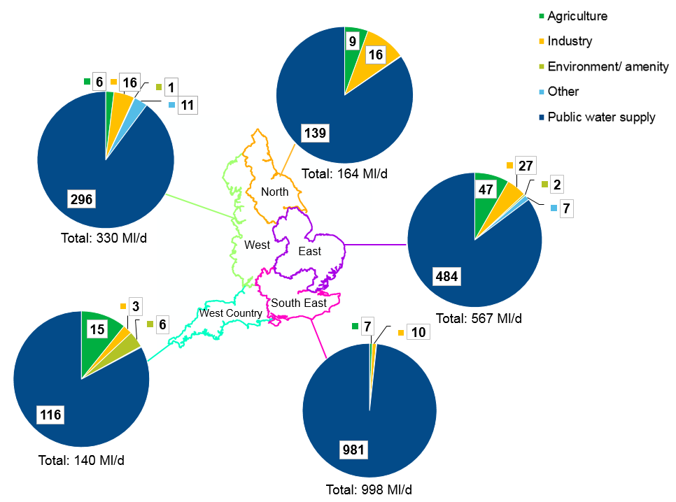
The results in figures 16 and 17 indicate the potential scale of change and the relative differences between the different scenarios. They suggest significant changes may be needed to public water supply abstraction. These are focused on the south and east of England as well as the West. All regions see some changes under this analysis.
Due to the limitations of this supplementary analysis the results should not be taken as representing the actual changes required to abstraction licences. The limitations of this analysis include:
- identifying issues at a national scale based on indicators of the quantity of water needed to support ecology - this does not include local intelligence on specific issues or specialised modelling that might be available on a regional or catchment scale
- using a single approach to modelling the possible impacts of climate change on flow rather than a wide range of scenarios to represent uncertainty
- relying on abstraction reduction as the only possible solution and not considering other changes such as altering the way reservoir storage is used as a way of addressing flow issues
The likely impacts of climate change suggest that a Business As Usual approach will be insufficient to protect some sensitive or ecologically important rivers. As we work with regional groups on long term plans for environmental improvement we should therefore consider ambitious environmental goals such as those included in the enhanced scenario. These include:
- meeting the water requirements of sites specially protected for nature conservation
- restoring sustainable levels of abstraction to freshwater and wetland habitats of principal importance listed under Section 41 of the Natural Environment and Rural Communities Act (2006), particularly chalk rivers and other sites identified as priority habitats for restoration
- restoring river flows to support the recovery of salmonid fish populations
To take this work forward regional groups should use the information in the national scenarios as a starting point for discussions with stakeholders and regulators. They should look at environmental priorities to develop an agreed long term environmental destination and a plan to achieve it, including short, medium and longer term actions. This work should consider:
- where the scenarios and other evidence suggests the largest abstraction recovery might be required
- how the greatest environmental benefits can be realised
- where further local and regional analysis is needed
- what the opportunities are to access more water without compromising ecology and while continuing to meet the relevant environmental objectives
- the potential for changes to abstraction that reduce reliance on direct river abstraction at low flows, for example, by working across sectors to make better use of stored water
- the costs and benefits of alternative approaches, comparing the costs and benefits of reducing abstraction against the costs and benefits of the interventions required to meet the shortfall in supplies through developing new resources or reducing demand - this should also consider the implications of alternative timescales for reducing abstraction
The Environment Agency will work with regional groups on this. We are making the data available from the scenarios we have explored. We will organise workshops to discuss the approaches regional groups could use to develop the long term destination.
  - Other pressures
By 2050 the ‘other pressures’ category includes a 187 Ml/d reduction in water available. This category includes reductions in water available for abstraction due to water quality issues. Pollution that comes from a wide range of sources such as agricultural run-off, rather than point sources such as wastewater treatment works, is responsible for an impact of 124 Ml/d on sources in Southern Water alone. This is identified as being from issues caused by fertiliser and pesticide usage. This particular issue is focused in three WRZ. Southern Water has developed options to mitigate these reductions including a number of catchment management schemes. Other water companies also see pressures linked to water quality. However these were not reported in their WRMP19 tables and are therefore not reflected in this analysis.
‘Other pressures’ also include small adjustments made for technical and reporting reasons as well as some changes associated with water sharing agreements between water companies.

- Water use outside the public water supply
Working across sectors, beyond public water supply, will present opportunities to develop innovative approaches to meeting water needs and improving the environment. Regional groups need to engage with the most relevant sectors locally to realise these opportunities. Further work is also required from water using sectors directly to improve their understanding of their own likely future water needs. We have reviewed current patterns of water use across England and how these may change in future. Based on this we have summarised priorities for each regional group.
- Water Resources East should continue to engage with the agricultural sector (particularly spray irrigation), the food and drink industry, power sector and wider industry
- Water Resources South East should engage with industry, particularly paper and pulp, and agriculture. This includes previously exempt abstractors using trickle irrigation for a range of purposes such as soft fruit growers
- West Country Water Resources should engage with the minerals sector and agriculture (particularly the livestock subsector)
- Water Resources West should engage with navigation operators and industry, particularly the chemicals sector as well as the agricultural sector
- Water Resources North should engage the power generation sector, industry and the agricultural sector
Regional groups should work with other companies, non-household water retailers and new appointments and variations (NAVs) to align the approach to planning for water resources, drought management reducing demand, forecasting and monitoring non-household use of mains water.
All the results up to this point have focused on the public water supply. To do so exclusively would miss an important part of the story on how water is used in England. This section considers the water demands from those that abstract water directly from the environment for purposes ranging from irrigation to industrial cooling.
The pressure on water resources extends across sectors that use water not supplied by water companies through direct abstraction. It is important that regional groups work with these sectors to develop a better understanding of their water needs and explore solutions to meeting existing and future demand, as well as protecting the environment. These could include novel solutions such as:
- using water stored for other purposes to buffer renewable energy generation
- reducing losses from canals to allow additional abstraction from rivers
- local water resource management arrangements to provide support at low flows for industry
- exploring alternative uses for water stored in reservoirs used for navigation
- re-using process water for other neighbouring businesses
- using water from sustainable drainage systems as a resource
- large and business scale grey and rainwater harvesting
The current resilience to drought of sectors outside public water supply is far less well understood than the resilience of public water supply. These sectors will also be facing pressures from climate change, the need to reduce abstraction for environmental protection and changing patterns of demand in their sector. Water supplies that have been reliable in the past may not be reliable in the future. Sectors that depend on water should therefore engage with regional planning to be part of the solution. It may be that these sectors can also help increase the resilience of public water supplies, for example, navigation authorities can play an important role in moving water through the canal network.
This section starts by looking at how total abstraction from freshwaters is used. It compares the volumes used for public water supply with the volumes used for other sectors nationally and by region. It then focuses on the main types of water use that consume a proportion of the water used, and are therefore consumptive to some degree. It looks at how these break down nationally and within the boundaries of the regional groups. The analysis uses data on historical abstraction provided by abstractors as part of their annual abstraction returns between 2010 and 2015 and focuses on sectors that are part of the abstraction licensing system.
This section gives a picture of how water is used across England and provides the regional groups with information on the sorts of sectors they should be working with when developing their regional plans. The two main sectors are agriculture and industry, each containing a range of different types of use.
Figure 18: Shows the current estimated proportion of abstraction from freshwaters (non-tidal) by purpose.

Over 80% of total freshwater abstraction outside public water supply is accounted for by hydropower (included in ‘power’ above) and aquaculture (included in agriculture above). These are non-consumptive, which means that the water they use is put back into the system close to where it is taken. From this point on we focus attention on consumptive or partially consumptive water uses. This is because these are the ones that remove some or all of the water they take from the system and therefore affect water availability most significantly. Consumptiveness is complex to estimate and is variable across sites, even sites using water for a similar purpose.
Figure 19: Shows a comparison of estimates of current consumptive abstraction from the water industry and estimates of current consumptive abstraction from other sectors. This is split by the volume used on average (recent actual abstraction) and the maximum that can be taken (the total volume on licences).
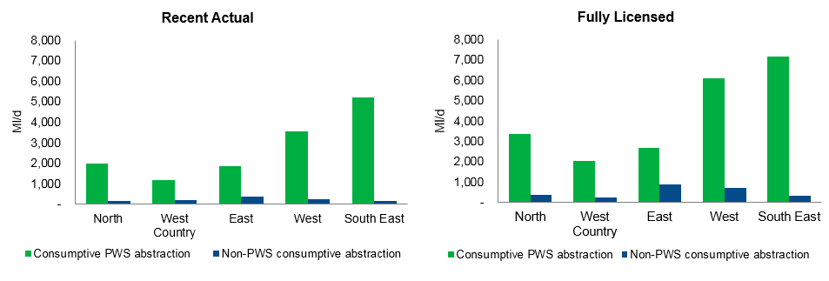
Figure 19 shows the dominance of water industry abstraction in each region whether by recent use or by licence volume. While the difference in scale is significant it masks the importance of non-public water supply abstractions in specific locations and at certain times of year. For example, industrial abstraction can dominate in certain catchments. Similarly, parts of East Anglia see very large demands from irrigation that occur in the summer, when water is most under pressure, and in concentrated areas of spray irrigation. These demands can be equivalent to local public water supply demands in those catchments.
The Lark catchment in East Anglia is an example of the volumetric significance of spray irrigation locally. In this catchment, daily licensed groundwater quantities for spray irrigation exceed those for public water supply abstraction. Around 49,000 cubic metres a day (49 Ml/d) is licensed for public water supply and approximately 62,000 cubic metres per day (62 Ml/d) is licensed for spray irrigation. The annual licensed groundwater quantity for spray irrigation is just over 1,000 Ml/year, equivalent to 2.7 Ml/d which is much less than public water supply at 4,380 Ml/year, equivalent to 12 Ml/d. This means that, although public water supply will be the dominant user annually, spray irrigation may exceed public water supply abstraction for short periods at peak times.

Figure 20: Shows how water is currently used once public water supplies, hydropower and aquaculture (non-consumptive uses such as fish passage and through-flow) are removed from the analysis and abstraction volumes are adjusted for consumptiveness.

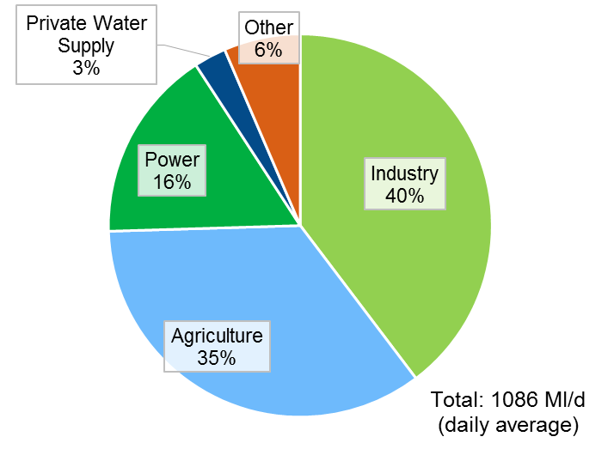

Figures 18 and 20 represent water use outside the water industry at a national level. The picture is more nuanced locally.
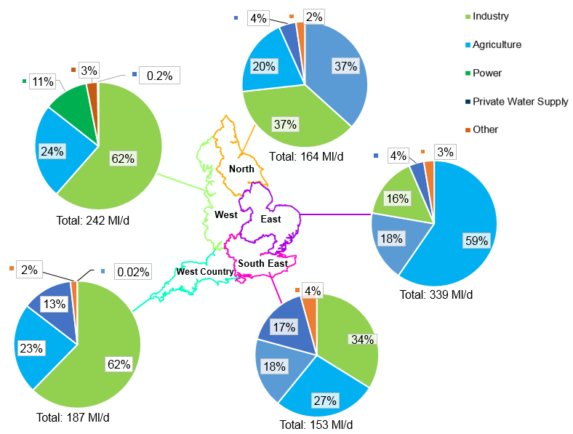
Figure 21: Shows how current consumptive water abstraction outside the water industry varies across the regional groups. The colours in the pie charts represent the usage type and the numbers at the bottom of each pie represent the total volumes.
This shows that Water Resources East sees the most consumptive water demand from outside the water industry. This is largely due to the significant quantity of water used in the agriculture sector in that region. However, there are also significant demands from the power sector and from industry.
Water Resources South East sees the lowest total demand from other consumptive water uses of all the regional groups. This demand is split in a similar way to the national average with industry and agriculture representing the largest sectors. The south east includes significant trickle irrigation which has historically been exempt from licensing. This includes the rapidly developing soft fruit industry. Because our work started with records of historic abstraction, and these sectors will not feature in those records, the water demand of these important sectors will not be fully represented in this work.
West Country Water Resources sees relatively low levels of consumptive abstraction outside the water industry. Non public water supply use is focused on industry. Further analysis shows that this is largely the minerals sector. There is also significant agricultural water use.
Water Resources West has the second highest consumptive water use outside the public water supply. This is dominated by industrial abstraction from the chemicals and paper sectors with agriculture the next biggest.
Water Resources North sees relatively low levels of consumptive abstraction outside the water industry. These are relatively evenly split between power generation and industry with agriculture the next biggest.
  - Agricultural water demand
This section looks in more depth at agricultural water demand across England. Within what we term ‘agricultural water demand’ are a range of different types of use. The categories used below are those recorded in the Environment Agency’s abstraction records. Nationally, agricultural water use is dominated by spray irrigation as shown in Figure 22 ‘General’ agriculture typically represents livestock and ‘other’ includes a range of uses including amenity, forestry, zoos and orchards.
Figure 22: Current estimated consumptive agricultural water abstraction use nationally.

The breakdown of agricultural water use, as well as the total, varies by region. Figure 23 shows the breakdown of current agricultural water use by region as well as the totals used. Throughout this section, the totals are given in millions of cubic metres per year and in megalitres per day (Ml/d). The Ml/d figure does not represent peak usage but assumes usage is spread evenly across the year. It is given only for comparison with the figures used to describe public water supply needs. In practice, spray irrigation is seasonal and annual quantities tend to be used over a relatively short period of time in the summer. In contrast, industrial water abstraction tends to be steadier throughout the year.
Figure 23: Current estimated consumptive agricultural water abstraction use by region.
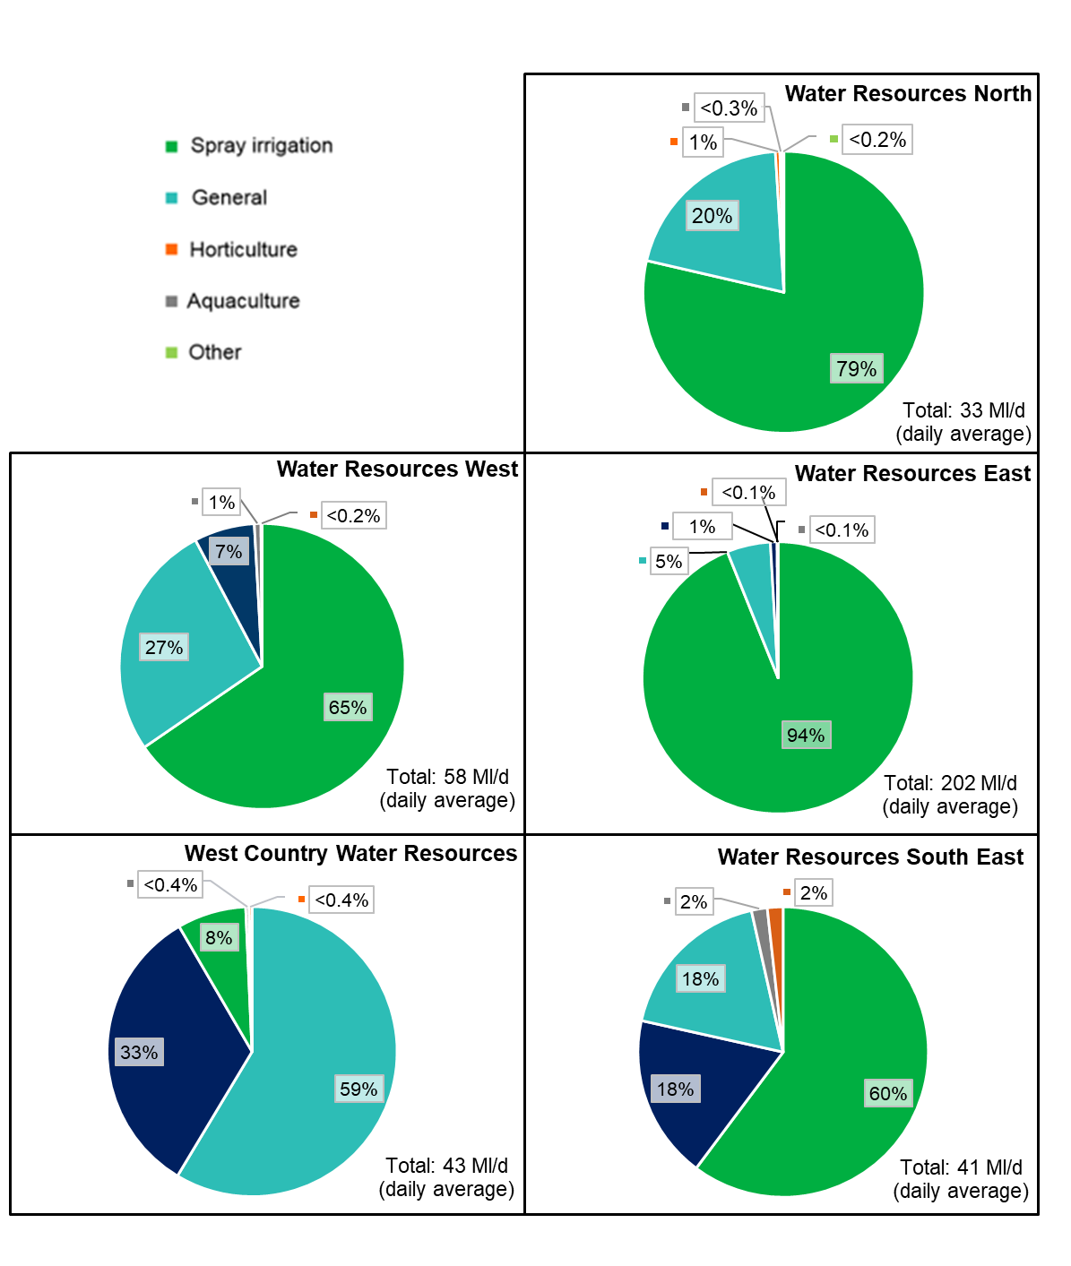

Figure 23 shows that direct abstraction for agricultural water use is higher in Water Resources East than it is in all the other regions combined. This totals 74 million cubic metres per year (202 Ml/d). Of this demand the vast majority (94%) is for spray irrigation. Total agricultural water use is then similar in all the other regions between 12 and 21 million cubic metres per year (33 to 58 Ml/d).
West Country Water Resources is notable for having far higher ‘general’ agriculture than the others and very little spray irrigation. This is because livestock is the dominant agricultural activity in the region. A significant component of livestock water demand is met from mains supplies and therefore excluded from this analysis. Previous work for Defra has estimated that the total volume of water used for livestock is similar to that used for spray irrigation nationally (when mains water is included).
The West Country Water Resources Group will need to work with the agricultural sector to understand this demand and the risks it poses for water supply in that region.
  - Industrial water demand
This section looks in more depth at industrial water demand across England. Industrial water demand is large and varied with many subsectors. This category includes: minerals and other extractions, paper and pulp, chemicals, food and drink, navigation, other, metals, breweries and golf. Understanding the impact that these different uses have on water availability, for example, how ‘consumptive’ they are is challenging. In some locations a few very large abstractors dominate the picture.
Figure 24: Shows the split of current estimated consumptive abstraction nationally from ‘industrial’ abstraction.

The first and largest user in figure 24 is minerals. However, 88% of this abstraction is from 8 abstractions in the west country region. The paper and pulp sector is the next biggest. This sector varies in the way it uses water and makes the case that much of their usage is non-consumptive. However, at least some of the water used is not returned and this varies by site. The chemicals and food and drink sectors including breweries and dairy then make up 13% each and are followed by smaller sectors. Sectors that contribute a small volume to the national figure are not labelled however they can be significant locally.
Figure 25: Shows how current industrial demands vary at a regional scale.
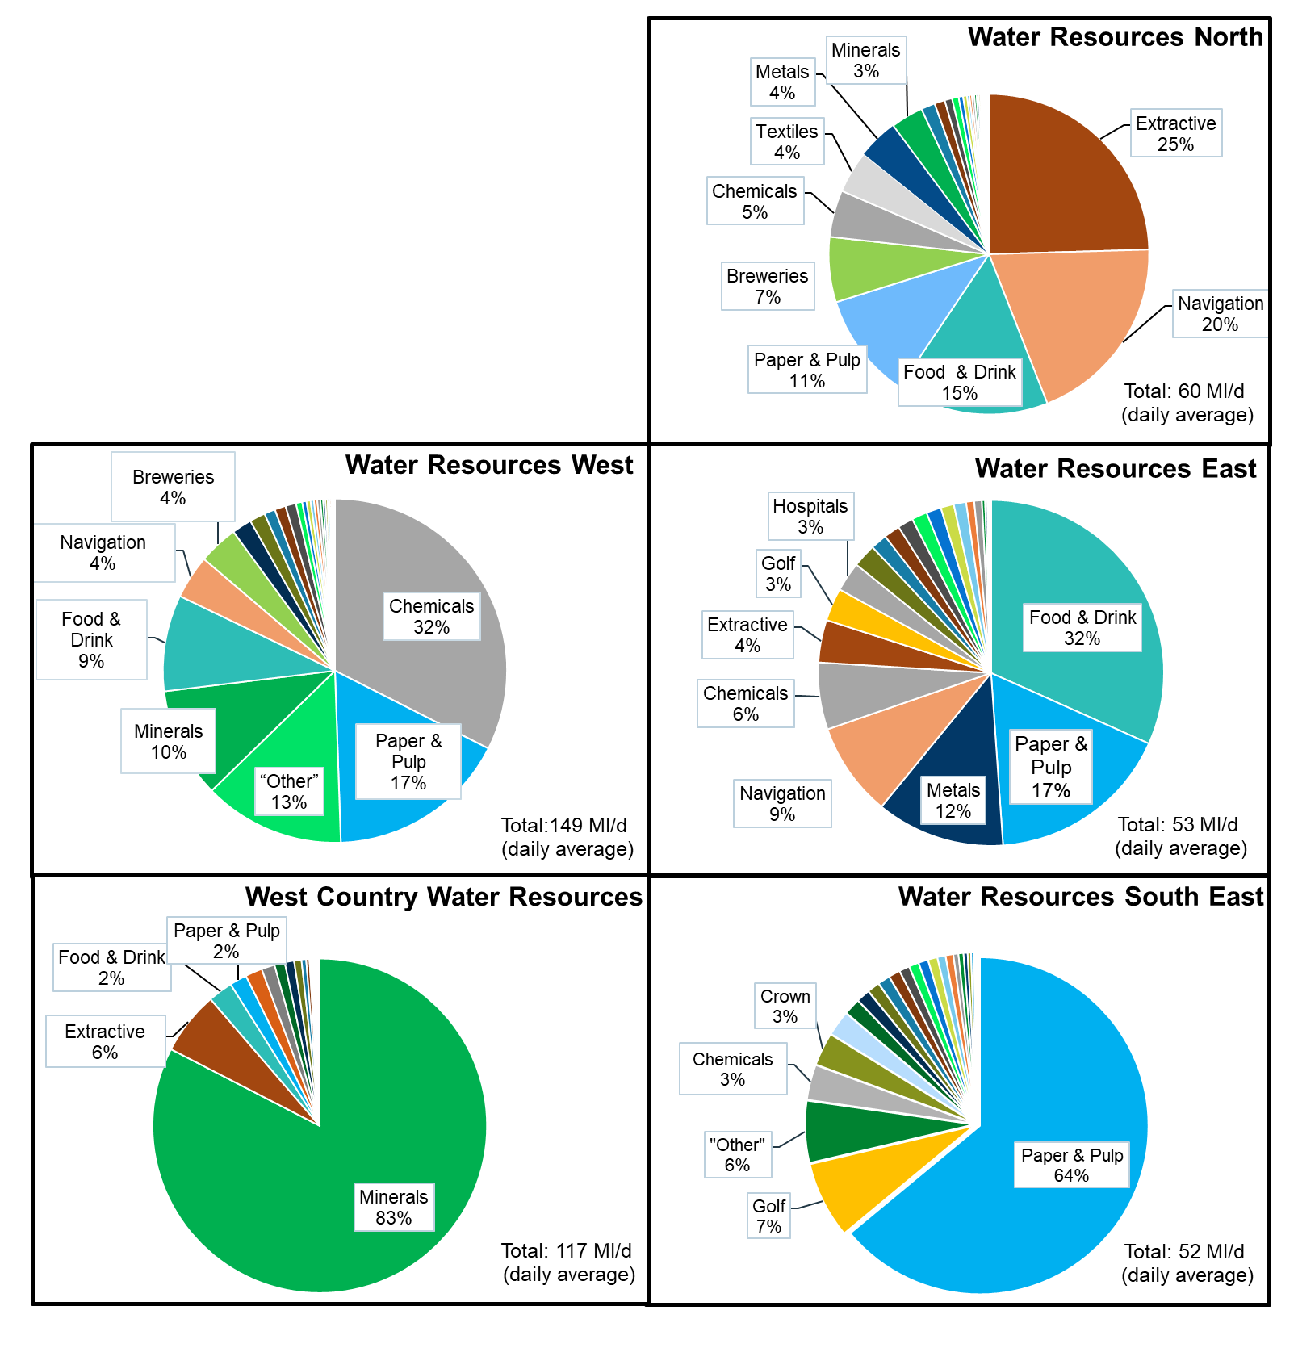
Figure 25 shows clear regional differences. Water uses that look small nationally become significant regionally, and even more so locally. This is because, in contrast with agriculture that is characterised by a large number of small water users, industrial abstraction is typically driven by a smaller number of larger water users.
Water Resources West sees the highest total abstraction from ‘industry’. This is dominated by chemicals and paper and pulp as well as significant abstractions in the minerals and food and drink sectors. Note, the west has significant water use for navigations which are not fully represented in figure 25. These are considered further in section 6.3.
Water Resources South East sees the highest proportion of demand from the paper and pulp sector with the majority of that sector located within the region and significant demand from golf courses.
West Country Water Resources is dominated by the minerals sector which, in turn, is dominated by a small number of large abstractions.
Water Resources North sees significant abstraction from extractive industries and navigation (canals) as well as from the food and drink sector and paper and pulp.
Water Resources East is notable for abstraction from the food and drink sector which will be associated with the significant agricultural demand in the region. This includes food processing that is co-located with food production, for example, potato processing. The east also sees some large abstractions for chemicals, metals and navigation.
  - Navigations water demand
This section looks in more depth at the demand associated with navigable inland waterways operated by the Canal and River Trust. It uses a new dataset available as a result of the removal of exemptions from abstraction licencing which historically applied to navigations. This data includes the navigable rivers and canals across England. These waterways are managed and maintained by a number of navigation authorities, of which the Canal and River Trust is the largest. The trust is a significant abstractor with a daily average of around 1500 Ml/d to maintain water levels and provide navigation.
Figure 26: Shows how the current annual average abstraction for navigations varies across the regional groups. The numbers at the top of each column represent the number of abstractions. The location of these abstractions is shown on the inset map.

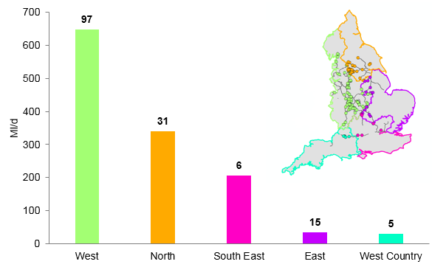
Figure 26 summarises a dataset representing recent abstraction volumes between 2011 and 2017. It shows that Water Resources West region has a greater number of navigation abstractions than all the other regions combined. This is also true when comparing the volumes used. The north region has the second largest abstraction for navigations, but is still only half the volume in the west.
It is important to note that abstraction information from the Broads Authority, one of the largest three navigation authorities in England, is not included. Therefore the abstracted volume in the east region is likely to be an underestimate.
Nationally, the average annual abstraction for navigations is 1,255 Ml/d. This is greater than the total average annual consumptive water demand from industry, power generation and agriculture (1040 Ml/d). While the annual average abstraction metric is a useful means of comparing water demand across sectors it will not give a feel for potential daily peak abstractions. These are likely to be significantly higher than the averages observed across a year.
Waterways used for navigation have an important role to play in water resource management. They have the potential to move a large volume of water from one place to another. Therefore they can facilitate water transfers. They can also be used to supply water abstractors directly. Due to the volume of water involved in navigations there is also scope to free up water for other purposes by investing in navigations. For example, reducing the water that is lost through leakage in a canal network. This can be significant and will reduce the amount of water that has to be taken from rivers or reservoirs to supply that network. The water freed up could then be made available for other purposes such as public water supply.
- Future non-public water supply demand
Understanding of how water demand is likely to change outside the water industry is low. This is problematic for these sectors which rely on access to water and face many of the same issues facing public water supply. It is also a barrier to engaging in the development of regional plans. Our work has collated the current state of knowledge but further work is required to build on this. Water using sectors should prioritise this work. It will allow them to engage meaningfully in regional planning and increase their resilience in future. This is important across major sectors such as: industry, agriculture and electricity production.
Trade associations have an important role here. They should make sure their members' needs are represented. We anticipate they will play their part in developing the evidence. Regional groups also have a role in developing this understanding locally and should work with trade associations to do so.

The analysis in section 6 is based on how water is currently used outside the water industry. This section looks at how this usage may change in the future. This is based on work with Defra and a team of sector experts led by Wood plc. They examined the drivers for, and uncertainties in, water demand outside the water industry. This has focused on direct abstraction rather than water supplied by water companies and has prioritised a range of water-using subsectors. A limitation of this approach is that it does not represent new abstraction emerging in locations where it does not take place already. More details of the analysis and results are included in appendix 5.
Some abstractions that were previously exempt from licensing are now subject to regulation following the Water Act (2003). As these abstractors are licensed it is expected that the estimates of non-public water supply use will increase. This applies to navigation, the minerals extraction industry (albeit more likely to be non-consumptive) and trickle irrigation in the agricultural sector.
Demand within each subsector, and for individual users, depends on many factors including water availability, product market forces, economics, policy and regulation. The work considered the following sectors:
- spray irrigation
- livestock
- protected edible crops and ornamental plants
- food and drink manufacturing
- electricity production
- paper and pulp
- chemicals manufacturing
The sectors were prioritised to cover a large proportion of current water use. Combined, these 7 subsectors are estimated to account for in excess of 60% of consumptive freshwater direct abstraction arising from outside the water industry. The results, based on standard growth estimates across England, show potential changes to spray irrigation, electricity production, paper and pulp, chemicals and food and drink. These growth estimates have not been adjusted for different regions due to limitations in the data available on future water use.
For other sectors, the study based estimates of growth on projections of non-household water use, supplied by water companies in their water resources management plans, as an indicator of how direct abstraction could change. This has limitations but has allowed the project to explore a more complete view of future non-public water supply abstraction. More work is required to assess the potential changes in demand from these other sectors.
Modelling future changes in sector productivity, location and water demand is highly complex. There are a lot of uncertainties as factors interact. This project made use of the best available information to form estimates of how water demand might change. Key drivers of water demand were identified for each sector. Some of these were common between sectors whereas some were specific to individual sectors.
Contrasting socio-economic scenarios were used to explore how different drivers could change under different circumstances. In this way we produced a range of possible future outcomes. Some projections show high growth, some low growth or reductions. Here we consider our ‘best estimate’ and an ‘upper’ range scenario to explore sensitivities.
Figure 27 shows the potential changes in water consumption for different sectors. The graph shows 3 scenarios. ‘Baseline’ represents actual average abstraction from 2010 to 2015. ‘Best estimate’ represents our assessment of the most likely estimate based on the evidence available. ‘Upper’ illustrates a reasonable upper estimate of possible water consumption. It shows an increase in demand for water not supplied by water companies for all sectors. For the sectors we have not looked at in detail there is no 'upper' estimate. Therefore the higher estimates of water consumption use trends are taken from analysis of water company data on non-household water use from public water supply.
In all the sectors examined in detail the potential increase in demand remains lower than the total volume currently licensed for abstraction nationally. This suggests that at a national scale these sectors have sufficient water. However, this does not necessarily mean that sufficient water is available when and where it is required.
If the upper range of demand increase for power generation occurs in the north, it could exceed current licensed volume. Similarly, if the upper range of demand for paper and pulp manufacture occurs in the south east and east, it could marginally exceed the licensed quantity. For every sector in almost every region, a selected number of abstractions would be limited by their annual licensed limit under the upper range of demand increases.
Increasing abstraction, even within existing licence constraints, could result in environmental pressures that would need to be addressed through licence changes. This is a particular risk when combining increased abstraction with the impacts of climate change over time. Abstractors should not assume they can always meet future growth using volumes of water held on their licences but historically unused.
Figure 27: Potential range of changes to non-public water supply use to 2050.

Planning for changes to non-public water supply demand is challenging and will need to be reviewed as plans progress. We anticipate that regional groups will work with local business sectors that abstract directly and seek opportunities for collaboration.
  - Agricultural demand - spray irrigation
The highest demand for spray irrigation is in the drier parts of England, particularly East Anglia. The demand varies from year to year with weather conditions as well as agricultural practices.
There has been an underlying downward trend in irrigation since 1990, possibly due to tighter abstraction licence conditions; increased costs of irrigation (rising energy costs); increased efficiency and changes in cropping. However, the evidence gathered in this study suggests that the water used in spray irrigation is likely to increase in the longer term.
There are a range of factors driving the likely increase in water demand for irrigation. These include some of the same pressures facing public water supply such as increases in population (which will increase food demand) and climate change (leading to hotter, drier summers that increase irrigation needs). Some are more specific to the sector such as a slowing of the improvement in crop yields by area which have reduced the total land area needed since the 1960's but now could see more land needed to expand production.
The biggest projected increase in use is likely to be in Water Resources East where the largest volume of irrigation takes place now. Nationally the demand could range from the baseline of around 100 million cubic metres per year (274 Ml/d) to almost 200 million cubic metres per year (548 Ml/d). This is with a best estimate of 140 million cubic metres per year (384 Ml/d). It could be significantly higher than this in a dry year and at peak times of the year.
There is significant uncertainty around these figures as demands will be affected by a wide range of broader factors. These include future food policies, diet trends, the proportion of food that gets wasted, how efficiently irrigation is used and quality standards for the end product (less irrigation can affect the appearance of crops).
  - Food and drink manufacturing
The food and drink sector is very diverse. It includes a wide range of water uses including water used in breweries, potato processing, water bottling and so on. Generating projections for the industry as a whole is therefore challenging. Just like in other sectors, individual conversations and working at the regional level is going to be important for understanding local pressures and needs.
Food and drink is manufactured across the whole of England. The north west, Yorkshire and Humber and east midlands has the largest proportion of turnover and gross value added. Water Resources West has the greatest volume and Water Resources South East the least.
Overall water consumption (both from public water supply and non-public water supply) has declined in recent years. This is due to economic conditions and a commitment by the industry to reduce its water consumption.
Projections indicate that water needs for the food and drink industry could range from the baseline of 20.8 million cubic metres per year (57 Ml/d) to 33.4 million cubic metres per year (92 Ml/d). The best estimate is 26 million cubic metres per year (71 Ml/d). The greatest potential best estimate increases are in Water Resources West at 1.9 million cubic metres per year (5 Ml/d) and Water Resources East at 1.6 million cubic metres (4 Ml/d).
  - Electricity production
The electricity sector involves a complex range of commercial, policy and technical drivers of change. We considered water used in thermal power generation and its consumptive use of freshwater. Production is still dominated by thermoelectric generation (such as gas, nuclear and thermal renewables) but there is a growing range of electricity generating technologies, some of which require no water to operate like wind and solar.
Evaporative cooling is the largest consumptive use of water directly abstracted by the sector. The historical data shows that 40% of this is located in the Water Resources East region, 28% in Water Resources North, 19% in Water Resources South East, and 13% in Water Resources West. This historical use is spread across 14 sites. A review of recent evidence indicates that 4 of the sites included in the figures above have been closed (whether temporarily or permanently). As a result, water use at least in the short-term, may be significantly reduced.
Despite potential thermal efficiency improvements, the consumption of freshwater from thermal power could rise in the future. Future operations (more starts, stops, and part loading) and the adoption of carbon capture and storage (CCS) technology, could lead to a doubling of freshwater consumption from 2010 levels by 2050. The range of specific gross and consumed water is dependent on site specific best available techniques (BAT) measures, operational variations and the weather.
Consumptive water use associated with CCS is likely to be between 1.45 and 1.9 times higher than thermoelectric generation without it. CCS, including bio-energy with carbon capture and storage (BECCS) is a technology likely to be implemented to meet the UK’s zero carbon targets. Hydrogen could also play a key part in a decarbonised energy world, either produced from natural gas alongside carbon capture and storage or by electrolysis using renewable generation. More work will be needed in future to improve the understanding of the impacts these new technologies will have on the demand for water, however it could be significant.
Scenarios developed recently by the Committee on Climate Change and National Grid point to a significant increase in electricity demand. Decarbonisation targets are likely to play a major role in determining how this electricity is generated. The mix of electricity generation plants and technology will affect the amount of water consumed significantly.
In a scenario of high CCS, demands for water exceed the volume of water licensed for abstraction at existing sites in the north west, Humber, east midlands and Thames regions. This suggests that careful consideration is needed of the locations for siting new plant. Although in many cases current locations with generation facilities may be extended. Also existing plants may get replaced or at least upgraded. Therefore new locations would need to be made available if demand is met by a large proportion of conventional or nuclear power.
Extensive use of CCS and the development of hydrogen production and use would bring a nationally significant demand for high quality process water and cooling water. Energy UK estimates that process water consumption alone could be expected to amount to several hundred Ml/d, with some scenarios approaching 1,000 Ml/d. The balance of how these demands will be met through the direct use of freshwater or saltwater sources, and indirectly through public water supply (non-household demand), and where they will be located, is not yet known.
Projections from the Wood plc work indicate that consumptive water use for power generation could range from the baseline of 64.5 million cubic metres per year (177 Ml/d) to an upper range of 103.3 million cubic metres per year (283 Ml/d). Perhaps more so than any other sector, water needs for electricity generation will vary greatly based on what changes at a small number of sites. The greatest potential increase at best estimate are in Water Resources East at 4.9 million cubic metres per year (13 Ml/d) and Water Resources North with a best estimate at 4.8 million cubic metres per year (13 Ml/d).
Meeting the challenge of the water resource needs of achieving UK net-zero efficiently, will require innovative approaches. These are likely to include the development of new types of installation. They will contribute products into multiple ‘traditional sectors’, and involve several installations and users bound together in water sharing agreements. This could include, for example, joining up desalination or water reuse with renewable energy sources to use excess electricity generated from renewable sources for water treatment when electricity demand is low.
For these reasons, there is greater uncertainty associated with these estimates than the other sectors. This is because freshwater demand will be governed by the mix of technology which could change considerably as electricity generation is decarbonised. The changes the sector is facing will bring both challenges and opportunities for water management and regional groups are well placed to play their part in meeting the challenges and realising the opportunities.
  - Paper and pulp
Paper mills are located across England with the primary clusters in the south east (north Kent) and north west (Greater Manchester). A considerable amount of water is also taken from the mains supply and much is returned to the environment.
Recent trends show a general reduction in water use. This follows production but changing products could also have an impact on water use and could cause an increase. The sector is also particularly sensitive to the quality of water available as well as the quantity which adds another dimension to the sector’s need.
Projections indicate that use could range from the baseline of 27.8 million cubic metres per year (76 Ml/d) to 40.5 million cubic metres per year (111 Ml/d). The best estimate being 31.1 million cubic metres per year (85.2 Ml/d). The greatest potential best estimate increase is in Water Resources South East at 1.5 million cubic metres per year (4 Ml/d) and Water Resources West, at 1.1 million cubic metres per year (3 Ml/d). If the upper range of demand increase occurs in the south east or east, it could exceed current licensed volume.
  - Chemicals manufacturing
Chemicals manufacturing takes place across the whole of England. The main clusters in England are located in the north west, Humberside and Teesside. It is estimated that about 75% of consumption comes from mains water. The greatest water use is in Water Resources West. A report by the Chemistry Council predicts a 50% increase in chemical production in the United Kingdom between 2016 and 2030.
Projections indicate that use could range from the baseline of 21 million cubic metres per year (58 Ml/d) to 31.3 million cubic metres per year (86 Ml/d). A best estimate being 25.6 million cubic metres per year (70 Ml/d). The greatest potential increase at best estimate is in Water Resources West at 4 million cubic metres per year (11 Ml/d).
- Meeting public water supply needs
Section 8 returns to public water supply and explores the range of approaches available to meeting future needs of those supplied by the water industry. This includes reducing water demand by using water more efficiently in homes and businesses and reducing the volume of water lost through leaky pipes. It also includes options to increase access to water by, for example, increasing storage or moving water to where it is needed.

Table 2: Includes the main categories of options to meet additional public water supply needs
Option | Description
Household water efficiency | Water saved in the home by using water wisely and improving technology. This also includes finding and fixing leaks from domestic plumbing systems, particularly from leaking toilet valves.
Non-household water efficiency | Water saved from helping non-household customers such as business and industry to use water more efficiently.
Leakage reduction | Water saved by reducing the volume lost from pipes including finding and fixing leaks quicker, reducing losses by managing pressure and replacing old pipes. This includes reducing losses from household supply pipes that are the responsibility of customers.
Increased supply and transfers | Options to increase supply developed by water companies for their water resource management plans including; reservoirs, transfers, desalination and groundwater abstraction.
Drought measures | Drought permits and orders can allow additional abstraction during periods of prolonged dry weather. These are known as supply side drought measures.
Temporary use bans | Savings assumed from the use of temporary use bans (formerly known as hosepipe bans) that typically reduce peak household usage.

Before exploring how to meet public water supply needs it is important to note that the national framework has not set out to find the optimum solution. Its aim is to set a strategic direction for the regional groups by exploring the range of approaches available to meet the likely pressures. It is the regional groups that are tasked with developing the right combination of solutions through the production of regional plans. The analysis below is aimed at steering that work.
  - Approach
To explore the range of approaches available to meet public water supply needs we have looked at 3 different levels of demand reduction. In each we have assumed that the supply and transfer options selected in the latest water resource management plans are available to meet future needs. We have also assumed fixed savings from temporary use bans and consistent availability of drought permits and orders.
We have compared the savings possible from each level of demand reduction against the estimate of water needs from section 4. The scenarios are:
- ‘low demand’ – includes more ambitious reductions in demand than are currently planned for both households and non-households through water efficiency
- ‘central demand’ – is the central scenario designed to represent the ambition in current water resource management plans
- ‘high demand’ – explores a scenario where the demand and leakage reductions being planned for are not achieved
Table 3: Shows the options included in each approach for 2050.
 | Low demand | Central demand | High demand
Personal consumption (l/p/d) | 110 | 119 | 127
Non-household consumption | 4% reduction | No change | No change
Leakage | 50% reduction | 50% reduction | 30% reduction
Increased supply and transfers | Selected options from most recent plans (WRMP19)
Temporary use bans | 2% saving
Drought measures | 70% of reasonable measures
  - Meeting regional public water supply needs
Some of the pressures on public water supply develop in areas that already have more water than they need (surplus water). Others develop in areas with little or no additional water available. In some cases existing surplus water could be used to offset some of the pressures. In others, it may be in the wrong place or not be available due to environmental constraints. We have therefore estimated water needs with and without the use of the existing surplus to represent the range of likely needs. Assuming the surplus water can be used gives a lower additional water need and assuming it cannot gives a higher additional water need.
We have compared the potential regional needs by 2050 against the options included in table 3 to meet those needs. These are represented in figure 28. The top of the grey bar shows the higher estimate of total pressures on water availability. This assumes that no water held in surplus within a region can be offset against the pressures. The top of the black bar shows the lower additional need assuming that all existing surplus can be used to offset the pressures. The colour bars show the solutions available under the different approaches in table 3.

Figure 28: Shows estimated additional water needs by region in 2050 under a 1 in 500 drought resilience and high population scenario. Next to these needs are the options included in the three scenarios above.
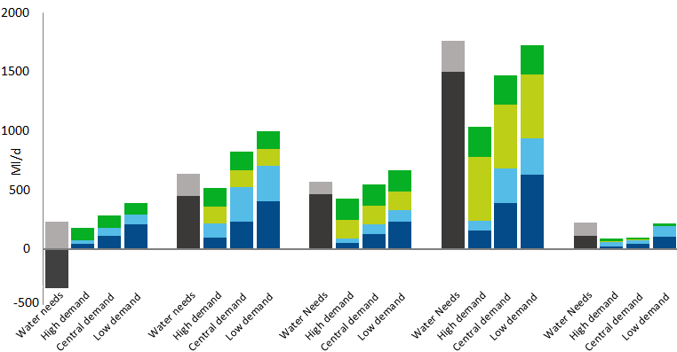
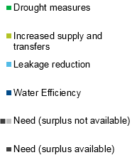
North West East South East West Country
Figure 28 explores the relationship between the pressures each group faces and the options they have available. Comparing the heights of the pressures bars with the heights of the solutions bars shows the situation of each regional group. Note, the water efficiency and leakage savings have increasing uncertainty as they become more ambitious.
The increased supply and transfers bar in figure 28 includes all the preferred options selected in water company water resource management plans 2019. Regions will have other options available that were not selected and are not presented here. Drought measures are included as an option for completeness. However, we want to see these measures used less frequently, particularly in sensitive areas. Regional groups should work with the Environment Agency and others, including Natural England, to understand the environmental risks associated with their individual drought permits and orders.
The north sees relatively modest pressures on public water supply in comparison with the other regions. It also has significant surplus water in parts of the region. This is likely to offset the pressures it faces and potentially be available for transfer to other regions. This is represented by the bar below zero which shows the volume of water that may be available if the surplus water can be accessed. It is the only region where this is greater than the pressures faced. The options in the current water company WRMPs – in this case Northumbrian Water, Yorkshire Water and Hartlepool Water – are enough to meet the higher estimate of need in the north. Further efficiency savings could make additional water available for potential transfers. Water Resources North should explore the potential for transfers to neighbouring regions.
The west sees the second greatest pressures on public water supply when viewed in total. However, it is a large region and the pressures are smaller than those in the east when expressed as a proportion of the water supplied. The region also has a significant surplus and has the potential to make further savings through demand management as well as supply side options. This suggests that, despite the apparently significant pressures the region faces, it has the potential to transfer water. The options included in the current water company WRMPs – in this case United Utilities, Severn Trent Water, Dŵr Cymru (Welsh Water) and South Staffs Water – appear sufficient to meet the higher estimate of need. Additional water could be made available through further demand management. Water Resources West should explore the potential for transfers to neighbouring regions.
The east faces significant pressure and has little surplus water available. Our modelling shows that the amount of water needed is equivalent to all the new supply options selected in the water company WRMPs – in this case Anglian Water, Essex and Suffolk Water, Affinity Water, Severn Trent Water and Cambridge Water – but more ambitious reductions in water use and potentially additional capacity is necessary to meet the higher need estimate. Water Resources East’s focus will be on reducing the demand for water by all users and increasing the amount of water available through new water resource options and transfers. Exploring the potential for schemes that benefit other water users is also a priority given the high level of demand from other sectors in this region, particularly agriculture.
The south east faces the greatest pressures on public water supplies. If surplus water can be made available, the region will still need to develop options to supply more water, equivalent to all the new water resource options and transfers selected in water company WRMPs – in this case Thames Water, Southern Water, South East Water, Affinity Water, SES Water and Portsmouth Water. This is as well as achieving ambitious efficiency reductions. If it can’t access the surplus water, then demand in the region will need to be reduced further or further resources developed. Water Resources South East needs to track progress on demand management particularly closely. If savings are less than expected, it could develop a large shortfall which may reduce resilience, limit progress on environmental improvements or lead to more frequent use of drought measures.
The west country sees relatively modest pressures. However, these are more significant when viewed as a proportion of the water supplied in the region. It has a significant surplus in parts of the region and if this can be used to meet the pressures faced by the region, the options in the water company WRMPs – in this case South West Water, Wessex Water and Bristol Water – will deliver the extra water needed. West Country Water Resources’ priority is to make the region more efficient by achieving the ambitious reductions in water use and leakage. It also needs to explore the potential to transfer water to other regions – particularly the neighbouring south east.
- Understanding the options available to meet public water supply needs
This section sets out more detail on the options available for meeting public water supply needs. It explores the uncertainties around each and the contribution they can make to regional plans.

  - Water efficiency
Realising the potential of demand reductions while managing uncertainty and cost will require action from regional groups as well as government and regulators.
Regional groups should:
- contribute to a national ambition on average PCC of 110 l/p/d by 2050. This should be reviewed every 5 years
- pursue ambitious reductions in non-household demand and contribute to the evidence available on the potential savings - as part of this regional groups should work with non-household water retailers and new appointments and variations (NAVs) to align their approaches to planning, reducing demand, forecasting and monitoring non-household water use
- identify clear decision points that allow enough time to adopt alternative approaches should demand reductions not follow the expected track - and additional interventions from the monitoring and reporting framework not turn this around
- pursue a diverse range of approaches to meeting water needs including resource development, transfers and demand management, to manage the risks from over-reliance on any one approach alone - this should also recognise the wider benefits of actions such as the network management benefits of increasing metering rates
- explore how they can coordinate the use of temporary use bans (TUB) among the water companies operating in their region
- review their planned frequencies of use for TUB and non-essential use bans (NEUB) in the light of the planned increase to drought resilience - the planned implementation of TUBS and non-essential use bans should not become more frequent in order to achieve the reduction in the use of more extreme level four restrictions
Government and regulators will:
- introduce a new monitoring and reporting framework to scrutinise progress on demand measures and track decision points - failure against these points would trigger additional national effort, such as policy change to support smart metering or behavioural change campaigns, in the event of under-delivery - this could be managed by a sub-group of the senior steering group
- focus national policy on interventions that will make a significant impact for the associated cost - evidence suggests that product labelling and standards have an important role to play in this. Water metering also has the potential to bring significant savings as well as helping water companies manage networks to reduce water losses

Per capita consumption (PCC) is the volume of water each of us use in our homes daily. It is currently 143 litres per person in England on average. This water is used for bathing, showering, flushing toilets, washing dishes, drinking and preparing food.
Figure 29: Shows the proportion of water used for a variety of purposes in a typical household.

One of the biggest drivers of additional water needs is increased water consumption, largely driven by increased population. If each person reduced the amount of water they use, it would go a long way to meeting future needs. Reducing consumption is not about stopping people using water, but about reducing waste and using water wisely.
The government’s 25 Year Environment Plan included a commitment to work with the water industry to set an ambitious personal consumption target. Following this the water industry and regulators have worked together with expert consultants. They have evaluated a range of approaches to achieving different levels of demand reduction with associated cost estimates. Based on this work, the water industry body (Water UK) has proposed a preferred approach and a range of alternatives. These were discussed with the senior steering group in October 2019:
1. Most cost effective: Mandatory water labelling of all products that use water with minimum product standards. The research suggests that this provides the greatest reduction and most favourable cost ratio. It requires policy change to introduce the labelling and standards.
2. Most ambitious: Mix of actions within water company control and those requiring policy (this also includes labelling and water metering). This is represented by the enhanced 03 scenario in the Water UK work.
3. Independent of policy change: This is a batch of measures within the control of water companies and developers. It has a significantly higher cost and lower savings. It is represented by the enhanced 02 scenario.
Table 4: PCC scenarios and a summary of the calculated costs and benefits.

Scenario | Interventions | Net present value (£m)
Most cost effective | Water labelling (with minimum standards) | 3,875
Most ambitious | Smart metering (voluntary switching) and water labelling with minimum standards | -391
Independent of policy change | Smart metering (voluntary switching), innovative tariffs, targeted water audits, community water reuse and increased media campaigns | -4,648

The project set out uncertainty around PCC estimates with upper and lower bounds. These uncertainty bounds are ‘asymmetric’ and show that the potential for under achievement on demand reductions is greater than the potential for over achievement. This is an important consideration for policy makers and presents a risk for regional groups to manage in their plans when these are based on assumed reductions in consumption.
To understand the significance of the potential savings from these scenarios, we have explored the volume of water each could save against the total potential pressures on water by 2050 nationally. We have included in this the confidence limits associated with the proposals as these show the maximum, most likely and minimum savings likely to be achieved.
Figure 30 shows the volume of water that could be saved under the scenarios above against the additional water needed by 2050. It also includes the savings that could be achieved by the demand reductions already planned for in the current plans. The bottom of the pale blue bar shows the lower estimate of savings. The top of the pale blue bar represents the central estimate of savings and the top of the darker blue bar represents the upper range of savings.

Figure 30: The volume of water that could be saved under the scenarios above against the higher estimate of water needs by 2050 (assuming surplus water is not available).

Picking out the most cost effective scenario, water labelling only, this suggests that PCC could be driven down to the 80s by 2050. However it also shows that, under the same scenario, PCC could be approaching 110. The picture is the same for each of the scenarios with a significant range above the central assumption.
Figure 30 shows that each of the demand reduction scenarios could achieve significantly more than is currently planned in the water resource management plans. It also shows that the uncertainty around these savings is significant. For example, the approach identified as the most cost beneficial (water labelling only) could potentially save almost 3,000 Ml/d or as little as 1,200 Ml/d. The savings realised will also be spread across the country and will not always be in the places required.
The level of uncertainty above is greater than that around infrastructure options. This is illustrated by recent trends over the last 4 years which show PCC has increased year on year. This is despite efforts by the water industry to reduce it through campaigns and offering water efficient fittings to customers.
Despite the uncertainties, options that reduce demand have important cost and environmental benefits. A massive 89% of CO2 emissions from water use comes from heating water in our homes. The Energy Savings Trust estimates that hot water use emits 875kg of CO2 per household per year. Reducing the use of hot water, by installing a water efficient shower head or taking shorter showers, reduces greenhouse gas emissions.
Measures to reduce demand are also flexible and scalable meaning they can be increased or reduced as pressures change. Demand reductions can be brought in more quickly than infrastructure options to make early progress towards meeting future water needs. All of these benefits help balance the risks introduced by the uncertainty around them.
The two most ambitious scenarios from the Water UK work included in figure 30 rely on policy change to introduce mandatory labelling of water using fittings and associated standards. Government is currently reviewing policy on water efficiency following a recent consultation. Given this, we propose that regional groups plan to help customers reduce their water use to around 110 l/p/d. This planning assumption is achievable without further policy interventions. With support from government on policy change, evidence suggests that the savings could be greater and achieved at a lower cost.
The combination of volumetric significance and uncertainty associated with water efficiency savings requires careful consideration in plans. This is to make sure that a cost effective, adaptive and resilient approach is developed that gets the best out of the range of options available to address additional water needs.
    - Non-household demand from public water supply
Just over 20% of public water supply consumption is from non-households, such as business and industry, rather than households.
The current best estimate of future non-household demand is included in water resource management plans. These plans suggest that total non-household demand could decline slightly between 2025 and 2050 from 2,897 Ml/d to 2,860 Ml/d. This is against an assumption of increased economic output and therefore includes an assumption of improving efficiency.
Domestic water use in non-households has the potential to be reduced in a similar way to individual use. This means that water efficiency in businesses should improve alongside reductions in PCC. Despite this, and because we currently have much less evidence on potential savings from non-household demand than we do for household demand, we have modelled savings equivalent to around half of the savings achievable by reducing household consumption.
There is still more to do to understand and predict future non-household demand. We propose to review this by working with a sub-group of the senior steering group and Water UK. This will allow our modelling and projections to be improved.
Regional groups should pursue ambitious reductions in non-household demand and contribute to the evidence available on the potential savings. In the same way that we have set out for per capita consumption, regional plans should include clear decision points to test if planned reductions in non-household use are being achieved.
Reducing the demand for water from non-household sectors will play an important part in reducing demand overall. It can go hand in hand with increasing the efficiency of processes and business and reducing energy consumption.
Regional groups should work with non-household water retailers and new appointments and variations (NAVs) to align the approach to planning water resources, reducing demand, forecasting and monitoring non-household use of mains water. They should engage with NAVs and non-household water retailers about the expectations of them in relation to demand forecasting and water efficiency messages and restrictions including non-essential use bans.
Retailers have an important part to play in managing non-household water demand and contributing to water resources plans. The retail market is still in its infancy. However we anticipate that regional groups and retailers will work together, exchange information and improve the monitoring, understanding and planning of non-household demand.
    - Temporary use bans and non-essential use bans
Temporary Use Bans (TUBS) are not strictly comparable to additional water supplies or sustained demand management because they are only to be used in response to a prolonged period of dry weather. However, restricting certain types of water use can be necessary, particularly while drought resilience is being increased. TUBS have an important role to play in managing peak water demand which can otherwise increase significantly at times of shortage. Restraint at these times can reduce environmental impacts from abstraction.
Regional groups should explore how they can coordinate the use of temporary use bans among the water companies operating in their region. By acting together there is potential to make greater savings and to communicate a clearer message to water users. Changes would then be included in water companies’ statutory drought plans.
Non-essential use bans are a way of reducing water use in a drought by restricting a range of water uses. They have a higher impact on users than TUBS and require a drought order to be implemented. They can restrict a range of water uses including, but not limited to, window cleaning, vehicle washing with a hosepipe or in a car wash, filling or maintaining non-domestic swimming pools and watering outdoor plants on commercial premises. Further information about non-essential use bans is available in the 2011 Drought Direction.
Regional groups should revisit their planned frequencies of use for TUBS and non-essential use bans in the light of the planned increase to drought resilience. Although increased resilience will tend to result in a reduced frequency of such interventions, this does depend on the system and the planned nature of investment. Irrespective of this, the planned implementation of TUBS and non-essential use bans should not become more frequent in order to achieve the reduction in the use of more extreme level four restrictions.
  - Reducing leakage
To realise the potential of leakage reductions regional groups should:
- plan to achieve leakage reductions of 50% on average by 2050, in line with the recommendations from the National Infrastructure Commission and the commitment already made by the industry
- collaborate with the water companies involved in the UKWIR leakage research programme to develop an innovative and cutting edge leakage management approach
- manage the risk in the same way as the risk of not achieving reductions in per capita water consumption by:
- identifying clear decision points in regional plans that allow enough time for alternative approaches to be adopted should leakage reductions not follow the expected track
- pursuing a diverse range of approaches to meeting additional water needs including resource development, transfers and demand management, in order to manage the risks from over-reliance on any one approach alone

The water industry has already committed to reducing leakage by 50% by 2050 from 2017 to 2018 levels. The reduction in leakage is in line with the recommendation from the 2018 report by the National Infrastructure Commission, preparing for a drier future. We support this reduction and it should be reflected in regional plans. A 50% reduction is ambitious and companies will have to significantly improve the way they manage leakage to achieve it. This will mean:
- finding and fixing leaks far quicker
- improving the way the network is managed to give better information on where and how much water is lost as well as managing pressure more effectively
- increasing the rate at which networks are renewed to prevent leaks from occurring
A benefit of pushing leakage reduction to unprecedented levels is that - because it is beyond what has been tried before - it will drive innovation. The challenge is making sure that the resilience of water supplies is not reduced, or the environment damaged, by not achieving the planned leakage reduction. To explore the exposure to this risk we have compared the total water saved by a 50% reduction against what would be saved by a 30% reduction.
Figure 31: Water saved from leakage reductions from 2025 in a range of cases; a 50% reduction, reductions currently planned for (WRMP19), 40% and 30% reductions.

Figure 31 shows that companies are already planning for a significant reduction in leakage after 2025 of around 750 Ml/d by 2050 (in the WRMP19 column). This is on top of the planned reduction of 656 Ml/d from 2018 to 2025. Going for a 50% reduction pushes this further but not by a huge margin. The fourth bar, based on average leakage reduction of 30% shows the vulnerability to under achieving on leakage. Achieving a national leakage reduction of 30% instead of 50% would create a shortfall of around 550 Ml/d. This is a significant amount of water that would have to be found elsewhere. It is therefore critical that the water industry focuses on achieving this target and tracks progress closely.
Water UK, the body that represents the UK water industry, and UK Water Industry Research (UKWIR) have acknowledged the need to develop a radically different approach to managing leakage to meet the 50% commitment. To meet this ambition Water UK has committed to triple the rate of leakage reduction across the sector by 2030.
UKWIR is leading a programme to help achieve these stretching targets. The programme is also coordinating the research into leakage that individual water companies are already planning so that they can achieve more through collaboration and make the most of the research. This will produce a ‘heat map’ to show the research programme and its priorities in early 2020.
The programme plans to seek innovation across 4 elements of leakage management: prevention, awareness, locate and mend (PALM). This will include mains replacement and how to accelerate the process of locating and mending leaks.
It is important that regional groups are engaged with this programme and that the necessary contacts are made within the water companies in each group such as leakage and asset managers.
  - Increasing supplies and transferring water
Regional groups should:
- develop a diverse portfolio of supply and demand side options including significant supply side infrastructure by 2050 - supply and transfer infrastructure is required even with the most ambitious demand savings we have considered and these carry uncertainty - it is also an important means of reducing reliance on drought measures that carry environmental risks
- scope a wide range of supply options with a clear understanding of how long each would take to be implemented to allow options to be brought forward if demand is not reduced as expected
- explore the strategic options funded as part of the gated process
- identify new options that are not included in the current plans and engage in the catchment based approach, particularly in priority catchments, to develop cross-sector options that provide broader benefits to society
- investigate the potential for increasing connectivity within and between regions through:
- longer distance transfers, such as those over 100 km in length, and those that also include water storage to increase drought resilience
- shorter transfers that increase resilience to interruptions in supply
- when exploring transfers regional groups should:
- consider the potential to make them reversible so that they can increase the resilience of both parties
- be clear on how transfers would be used during droughts, including when one or both supplier or receiver is implementing drought management tools
- work with the Environment Agency, DWI and RAPID to make sure that planned transfers are feasible and that any issues are carefully managed

This section is concerned with options to increase water supply or move water to where it is needed via transfers. It refers to these options as ‘infrastructure’ as shorthand to distinguish them from options to reduce demand. These will include:
- water transfers of different scales and lengths
- reservoirs
- groundwater abstraction
- river abstraction
- water reuse
- desalination
Infrastructure options play a particularly important role given the uncertainty that surrounds the ambitious planned reductions in leakage and per capita water consumption. In July 2019 the senior steering group agreed that the industry needs to pursue a mixed portfolio of approaches to balance these risks and avoid over-relying on any one approach. This was reaffirmed in October 2019.
To further explore infrastructure needs, we have estimated how much of the higher public water supply needs could be met by reduced demand in each of the three demand scenarios: high, central and low. In this analysis we assumed that surplus water cannot be made available to address needs without investment in infrastructure. This is because we are looking at the picture nationally and moving water large distances to use surplus becomes a transfer that requires infrastructure. The remaining need, after savings from demand management, is then the capacity that would be met by infrastructure under each scenario.
Our approach assumes that demand management - reducing leakage and using water more efficiently - is used before infrastructure investment. This reflects the commitments that water companies have already made to leakage reductions and the ambition of government and the water industry to increase water efficiency. Water efficiency measures are also often lower cost than big infrastructure, can be put in place quickly and bring environmental benefits so are often put in place first.

Figure 32: Shows additional national public water supply needs between 2025 and 2050 (assuming existing surplus cannot be made available). It shows how much of those needs could be met by three demand scenarios (in blue): high, central and low. It then assumes that the remaining need would be met by infrastructure and estimates this (in light green). The chart on the left excludes the use of drought measures and the chart on the right includes them.
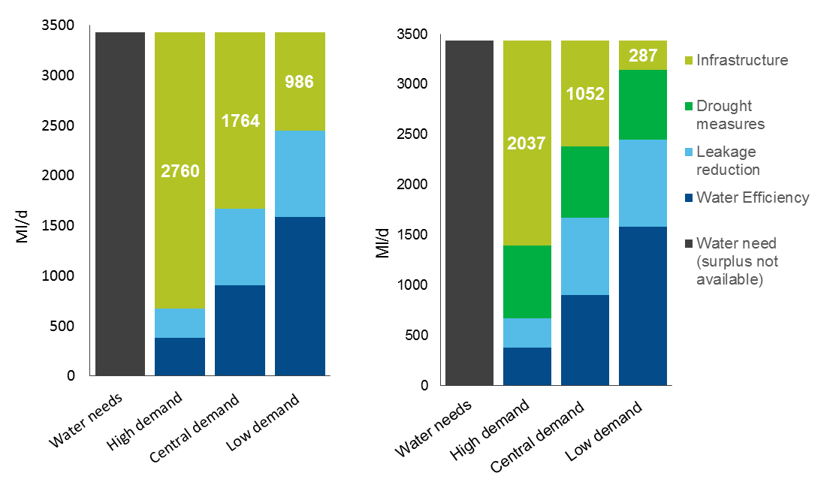

Figure 32 shows that, under a high demand scenario where per capita consumption and leakage do not decrease as planned and drought measures are not used, up to 2,760 Ml/d of infrastructure could be needed to bridge the gap. Where drought measures are used this decreases to just under 2,040 Ml/d. Under the central demand savings the infrastructure gap is 1,760 Ml/d without drought measures and around 1,050 Ml/d with drought measures. If the ambitious demand savings are realised the gap is just under 1,000 Ml/d and as low as 290 Ml/d with all reasonable drought measures in place.
This presents a large range of potential infrastructure needs and demonstrates the importance of assumptions surrounding how drought measures will be used. We want to see the use of drought measures decrease to improve environmental protection and infrastructure development has an important role to play in this. This analysis also highlights the importance of realising the ambitious demand management savings given the large volumes of water associated with them.
The analysis in figure 32 should be taken as indicative because:
- water needs could vary due to uncertainties around drivers such as population growth, climate impacts, changes in the scale of reductions needed in abstraction
- the ability of demand reductions to make savings in the locations the savings are required and physical limitations in the ability to transfer water from areas of surplus to areas of need
- the feasibility and environmental impact of drought measures which needs to be understood more fully
    - Strategic options
We are pleased to see work underway to explore a range of strategic options. We will be working closely with the regional groups to make sure this is done in a coordinated way. These options are summarised in figure 33. Together, the strategic schemes could deliver over 1,500 Ml/d.
Figure 33: The strategic schemes that are currently part of the gated process.
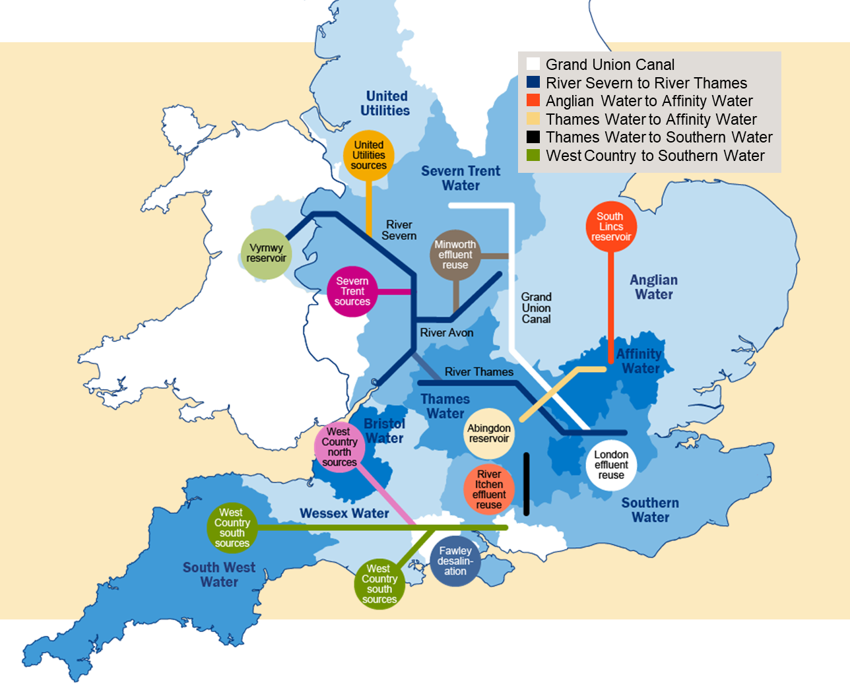

As part of our work with the University of Oxford we have explored the drought resilience benefits of the strategic schemes under climate change within their national model of water resources infrastructure. This work looked at the schemes included in Ofwat’s draft determination as the final determination was not available at the time of the analysis. To understand the effect of infrastructure options alone other factors have been frozen. This includes fixing per capita consumption at 2020 levels. Because of this, the analysis does not include the benefits from other measures such as those to reduce demand for water and leakage.
Results from the University of Oxford analysis are summarised in Figure 27. They suggest that, when all the strategic schemes in the draft determination are implemented, the risk of years with level 3 or 4 water restrictions occurring is reduced by 35 to 40% at the national level (from 1.4% to 0.8% in 2050 and from 3.1% to 2% in 2100). This means the options currently being explored are likely to be effective in significantly increasing resilience to drought. The Oxford work looked at the chance of needing level 3 or 4 restrictions whereas the national framework has focused on the chance of level 4 restrictions as those are the most severe. Looking at the chance of level 3 or 4 restrictions gives higher probabilities of those restrictions being in place than focusing on the chance of level 4 restrictions alone.
The changes in risk described above are averaged over England. However, a large number of the strategic infrastructure options target supply in the east and south east since this is where the greatest pressures are. For example, the Upper Thames Reservoir, Severn to Thames Transfer and Beckton Water Reuse in the south east and South Lincolnshire reservoir in the east, all act to reduce the risk of restrictions in these areas. Implementation of all the strategic options acts to increase resilience by 40-50% in the east and south east.
Figure 34: Shows the extent that the strategic options increase drought resilience in the near future and the far future. This is shown for the east and south east separately as well as nationally.

    - Increasing drought resilience
Historically, water supplies have been increased in two main ways. The first is collecting water when it is available and storing it until it is needed (reservoirs or use of aquifers). The second is moving it from a place where it is available to a place where it is needed (transfers). Our work with the University of Oxford has shown some interesting insights about how water transfers could help reduce risks from future droughts.
The national modelling suggests that, when reservoir storage in a catchment is stressed, there is a 40% chance that the neighbouring catchment will also be stressed. The correlation is stronger still when looking at a system without reservoir storage, such as direct river abstractions which sees around a 70% chance of correlation. This indicates that, although increasing connections between neighbouring water resource zones is likely to increase drought resilience, it may not increase drought resilience as much as longer transfers. In other words, longer transfers have a greater chance of matching locations where water is available with locations where water is needed in a given drought situation.
This co-incidence of the drought threshold levels appears to reduce rapidly over distance. The modelling suggests that the combination of the change in the nature of resources, plus meteorological variability means that storage systems are unlikely to experience critical drought risk at the same time once they are separated by more than 100 to 150 km. This suggests that there is scope to increase drought resilience by developing longer transfers. The longest transfers in England are currently around 120 km.
The case for longer transfers is boosted further by the finding, also emerging from our work with the University of Oxford, that although climate change appears to increase the severity of droughts, it does not appear to have an impact on their spatial pattern. This suggests that water transfers planned for today, based on our current spatial understanding of drought, are likely to continue to improve resilience in the future.
Although long transfers seem to have the greatest potential for increasing drought resilience they are also the most complex to put in place and bring the greatest range of challenges. Increased connectivity of neighbouring zones is likely to be simpler and could also have wider benefits. These include increasing the resilience of the network to pressures such as unexpected issues at individual sources of supply leading to them being taken out of action (known as outage).
The legal and regulatory arrangements for water transfers are likely to be as critical as hydrology and climate. It is vital that water companies and others are clear how transfers would be used during droughts. This should include clear arrangements for when one or both parties is implementing drought management measures such as temporary use bans.
Unlike electricity, that can be moved freely in a national grid, water is heavy and pumping it long distances uses significant energy with associated cost and greenhouse gas emissions. This is not unique to transfers, for example, other options like reservoirs and desalination also have associated environmental impacts. However, it is an important consideration when comparing options and another reason that we should not rely solely on infrastructure options but look to manage demand as well.
As well as costs and greenhouse gas emissions, transfers have the potential to bring environmental, public health and acceptability issues if they are not carefully managed. For example, transferring water through river systems can hasten the spread of invasive non-native species, or risk the broader environmental health of the receiving water body. Care is required when mixing water from different sources to make sure that the water remains wholesome and acceptable to consumers. This is particularly important where the natural composition of water in a distribution system is altered.
With proper planning many of the issues associated with transfers are surmountable. The Environment Agency is setting up a technical appraisal unit to help the assessment of such transfers. This unit will make regulatory decisions that take into account the broader context, working across operational boundaries and disciplines, and will work with the Drinking Water Inspectorate to protect consumer interests in drinking water quality.
    - Alternative approaches to transfers
We have worked with the University of Manchester to explore the potential that different combinations of water transfers have for satisfying future water needs. The aim here is to look at the potential benefits from water transfers that do not yet exist and have not been scoped. Then to compare this with the transfers that have been scoped, and selected for implementation within water company plans. This is to see if a more effective approach to transferring water could potentially be developed. To do this we used a national water resource supply-demand model for option comparison, created with the University of Manchester.
The model represents national water resources needs based on water company data. It is similar to the approach we used to estimate water pressures and compare scenarios of options available to meet future needs. However, it takes this further by allowing us to begin to explore options that perform well against a given objective such as cost and the extent of transfer use. The model can examine many combinations of options that meet water needs and then search for the most efficient solution against one or more objectives.
We tasked the University of Manchester’s model with meeting national public water supply needs in 2050 with the most cost-effective mix of transfers and local supply options. Costs of supply options are based on water company data. In contrast, the scale of investment required for alternative transfers is estimated based on the volume of water they could move multiplied by the distance they would span. This approach allows the model to consider theoretical transfers that have not been scoped in water company plans and therefore do not have associated cost estimates.
The model was tasked with meeting national public water supply needs under each of the three demand scenarios used in earlier sections of this report; ‘high’, ‘central’, and ‘low’ demand. It was run with existing transfers in place and either access to only the new transfers in the current water company plans or with the ability to set up new transfers according to need.
The aim was to compare the effectiveness of the transfers identified in the water resource management plans with transfers that emerge from the modelling as the model seeks to meet national needs most efficiently starting from a clean slate.
A national view of options
The model suggests that, by taking a national view of options, it is possible to arrive at a more efficient solution for a similar supply cost than is possible using only transfers identified in the current water company plans. The model found that, when configured with transfers identified in the current water company plans, local supply options were insufficient to satisfy 2050 water needs under any of the three scenarios. However, a more efficient combination of local supply side expansion and transfer use can satisfy 2050 water needs in all the demand scenarios.
A similar supply expansion and use of transfers is required to satisfy the need in the ‘low’ and ‘central’ demand scenarios, while more transfer use is required in the ‘high’ demand scenario. This suggests that the water need in the ‘low’ and ‘central’ demand scenarios falls below a threshold that can be satisfied using more efficient development of supply expansion and transfers. Once this threshold is exceeded in the ’high’ demand scenario, more transfer use is required to meet national water needs. This increases the estimated total infrastructure ‘cost’ of the solution in the ‘high’ demand scenario. It indicates that, while the current national capacity of supply expansion options is sufficient for meeting such high water needs, greater connectivity between regions is required for national demand to be met.
These findings suggest that the current bottom up approach to water company planning, where individual or small groups of water companies identify and explore water transfers, may not be identifying the most efficient transfer options. This supports the case to complement regional planning with an ongoing top down review of potential approaches. We will work with partners over the coming years to do this.

Exploring transfers that are effective in the model
The modelling identified some inter-regional transfers that tend to be needed to avoid very high supply costs. It does this by revealing instances where a small reduction in the scale of transfers between regions in a portfolio of options rapidly increases costs coming from the supply side options required to bridge the gap. In these cases, the transfers included before the cost increases are likely to be particularly important for meeting the national need while managing costs. The results suggest that these transfers, or transfers at a similar scale or capacity, should be in the batch of solutions considered by the regional groups, at least to explore their feasibility. Identifying these options is another potential benefit of a national top down review of options.
The modelling suggests strategic transfer configurations include transfers from water resource zones with surpluses in the north, west country and west to zones with deficits in the east and south east. The analysis suggests that these transfers, along with significant local supply-side expansion in the east, south east and west, can satisfy the national deficit under all three demand scenarios, and need less supply infrastructure investment than would be required if only transfers identified in the current water company WRMPs were selected. While the strategic inter-regional transfer configurations identified in the model would reduce the need for local supply expansion there would also be an additional cost associated with their implementation, which the model estimates via proxy. It is therefore unclear as to whether these new transfers are cost effective relative to investing more in local supplies. This highlights the need for further work around costing the potential future transfer pathways between all neighbouring water resource zones.
The transfers and options discussed should not be considered as the optimum mix. Instead this is an indication of the scale and type of transfers that represent a theoretically efficient way of improving the connectivity of water resources across England.

Assumptions used in the modelling
The model makes a range of assumptions that are important to understand:
- it assumes that transfers are made from the centre of a resource zone when, in practice, it may be more effective to make the transfer from closer to the outside of a zone
- it calculates transfer distances as the crow flies and does not take account of issues from physical barriers
- it only considers water transferred in pipes rather than rivers
The model is not able to consider practical issues such as water quality or environmental protection. It may be that, in practice, the transfers identified by the model are not feasible. However, this analysis is not intended to define the right mix of water transfers. Instead, it indicates that there is a case for continued development of national modelling to explore different combinations of solutions at a national scale. The results from this ongoing modelling can then be used to shape, enhance and challenge the regional plans that are developed.
  - Beyond the strategic schemes
As well as exploring the big strategic options it is also important to investigate a wide range of other schemes. Some of these have been scoped already and others are yet to be identified. Regional groups will need to seek out innovative solutions and we believe that these are often best found through collaboration.
The Abstraction Plan introduced our intention to focus on a number of priority catchments to improve abstraction management by increasing water availability and improving the environment. The first 4 priority catchments were announced in May 2018. The Environment Agency has now introduced 6 additional catchments. These will build considerably on the programme of work we are already pursuing and develop our use of the catchment based approach. Figure 35 shows the locations of the priority catchments. Purple catchments are newly identified priority catchments.
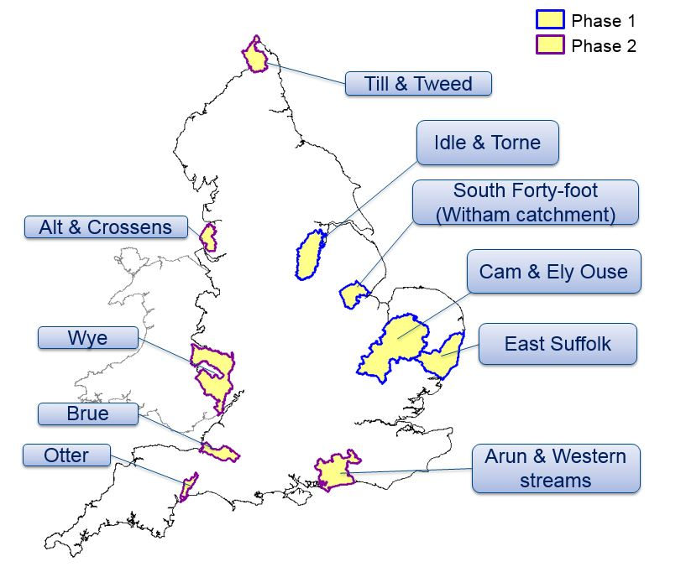
Figure 35: Shows the locations of the Environment Agency’s priority catchments.

These catchments cover a range of regional groups and we believe there are particular opportunities for regional groups to engage in these projects. The East Suffolk catchment is a particular example of this.

Collaborative water management in the East Suffolk catchment
The East Suffolk catchment is water stressed. High agricultural demand and increasing demand from new developments mean there is not enough additional water available to meet needs. People in the catchment are working together to find smart solutions that otherwise might have been overlooked. These are being trialled as part of the East Suffolk Priority Catchment.
The Holistic Water Management project has been leading the way through partnership working. This will see up to 600,000 cubic metres per year of freshwater that was previously being pumped to tide to manage flood risk pumped higher up the catchment to a group of agricultural abstractors. Existing above ground storage and new storage will make sure the water is available when it is needed. The Environment Agency has issued the licences for this to operate and the process for developing the 9.5km pipeline is underway.
An Interreg project (FRESH4C’s), is taking this concept further. As well as using surface water storage (reservoirs) the project is exploring the potential to use this water to recharge underground storage in aquifers. This could bring significant benefits to the agricultural community and to public water supply.
  - Supply side drought measures
Regional plans should:
- be based on achieving a level of drought resilience so that level 4 restrictions are expected to be implemented no more often than once in 500 years on average. This should be achieved by the 2030s and regional groups should determine a date within that range by considering the costs and benefits of alternative approaches to find an optimum. This translates into an annual chance of no more than 0.2%, or a 5% chance of these measures being used over a 25 year period. Some flexibility is possible where costs are exceptionally high locally in comparison to benefits, for example, at resource zone level. In this case robust drought plans must be in place to protect those customers. This planning assumption has been agreed by the senior steering group and is in line with the recommendation from the National Infrastructure Commission. Government is due to respond to this recommendation as part of its forthcoming National Infrastructure Strategy
- use the outputs of work with the Environment Agency and others, including Natural England, to understand the environmental risks associated with individual drought permits and orders. We expect this will lead to:
- using drought permits and orders less frequently in future, particularly in sensitive areas
- making use of low risk measures in order to increase resilience and avoid unnecessary investment
- include sectors outside public water supply that depend on water. These sectors will need to engage with regional planning to be part of the solution. It may be that they can also help increase the resilience of public water supplies, for example, navigation authorities can play an important part in moving water through the canal network and create water transfers

Supply side drought measures, including drought permits and drought orders, can allow abstraction to continue or increase at times of scarcity when it would otherwise be reduced. This is to increase access to water to maintain public water supply at times of exceptionally low rainfall.
Including the use of these measures in plans can make the water available go further and avoid developing resources that may never be needed at the expense of the bill payer. It can also avoid the development of unnecessary new infrastructure that could, in itself, have an environmental impact. While drought measures provide a benefit in the shape of reduced costs and increased resilience, they can also have environmental impacts. Those measures, particularly those at sensitive sites, should be used less frequently.
Drought permits and orders vary greatly and so do the environmental risks associated with them. Some winter permits, that allow additional water to be taken when supplies are healthy, can be very low risk. However, some orders that allow increased abstraction in the summer can have significant environmental impacts. It is necessary to understand the environmental risks of each permit individually in order to make sure it is used and planned for appropriately. The use of these measures should then be compared against alternative approaches to increasing resilience.
The challenge is to make use of drought measures to maintain security of supply when they are genuinely required and where environmental risks are small while making sure they are not used to support security of supply at the expense of the environment. The latter would not represent a meaningful increase in resilience.
We will work with regional groups, Natural England and others to understand the environmental risks associated with individual drought measures and make sure that, where they are used, they are used appropriately.
- Regional planning
The national framework sets out the challenge for water resources over the next generation and sets clear expectations of water companies and regional groups. It is now for the regional groups to work together to develop ambitious and joined up plans which identify the right strategic options to meet the challenges we face. Appendix 2 details the actions that must, should and could feature in regional plans. This section provides a brief summary of Appendix 2.
Regional plans will identify how best to create resilient water supplies for all users, while protecting and enhancing the environment. They will be developed collaboratively by the water companies, other water-using sectors, environmental groups and regulators who collectively make up the regional water resources planning groups. Groups should also engage with other stakeholders such as local authorities, devolved government and interest groups.
Regional plans will feed directly into water company water resource management plans (WRMPs) and the timetable has been set to enable that to happen, with the consultation on regional plans aligning with the pre-consultation of WRMPs. The strategic schemes which have been allocated funding by Ofwat will be taken through a gated process by RAPID to ensure the funds are spent to time and quality standards. The timing of the gates are also aligned with the regional plan timeline.
Figure 36 sets out the timeline for the regional planning process that regional groups must work within and the first milestone is a resource position statement in early 2020. In this statement, each regional group will set out the baseline supply demand balance for the region, multi sector growth, areas of uncertainty and known options for resolving any deficit. It is also an opportunity for the region to set out its initial ambition for the environment and resilience.
The first draft regional plans will be prepared for August 2021 and shared with other regions, government and regulators. The regional groups have a four month window to ensure a joined up national picture can emerge and the regional coordination group will develop and trial a process for this reconciliation of plans. Once the plans are in alignment a wider consultation will take place from January 2022.
We are working with the Consumer Council for Water (CCW) to make sure planned consultations across regional plans, the Ofwat gated process and WRMPs are complimentary.

Figure 36: Timeline for the regional planning process

- Barriers to collaboration in water resources planning
To manage water resources effectively it is essential that those who have responsibility for planning for water are able to work together. The national framework and earlier reports from the National Infrastructure Commission and Water UK, highlighted the need for greater collaboration in the water sector. This is particularly important for the development of strategic schemes such as water transfers. The development of resources across sectors is also important for maintaining and improving resilience in water resources and this creates further challenges for collaborative working.
As part of the national framework project we commissioned research into the barriers that stop or frustrate collaboration in water resources planning. JBA Consulting engaged with over 40 individuals which generated over 100 individual possible barriers. We hosted a workshop with the national framework Senior Steering Group (SSG) and others to help prioritise these for action. With the support of the project steering group and the SSG these barriers were reviewed to arrive at a list of 19 priority barriers that have the potential to impact on the development and/or delivery of collaborative schemes.
The development of the national framework, the move to regional planning and the establishment of regulators’ alliance for progressing infrastructure development (RAPID) will address a number of the barriers. Technical barriers will be addressed through the water resource planning guidance (WRMP24) and a policy task and finish group, chaired by the Water Resources South East group, has been set up as a sub-group of the regional coordination group, to track and ensure progress of the policy barriers.
Appendix 3 includes a list of the barriers prioritised for action. A copy of the full JBA report is available on request.
- Conclusions
The need to increase drought resilience, population growth and climate change are all putting pressure on public water supply. This comes at a time when we are striving to be the first generation to leave the environment in a better condition than we found it. It means that the aim is not just to meet these pressures and stay as we are, but to meet the pressures and improve the environment by reducing the impact of water abstraction. The greatest need is seen in the south east however other regions, particularly the east, also see significant challenges.
At the same time, many sectors outside the water industry who abstract water directly will be looking to develop or change the way they use water. These sectors face many of the same challenges and are less well equipped to manage water than water companies. Joining up and working together towards integrated water management will unlock new solutions that benefit all parties. This will be needed to meet the challenges we face and the goals we all want to achieve.
Actions to manage water demand, such as reducing usage and leakage, have a vital role to play in meeting future needs. These actions can be delivered quickly, are scalable and are often less costly than increasing water supply through infrastructure or moving water from areas of surplus to areas of need. Alongside these positives, demand reductions also carry uncertainties which need to be carefully managed. If we are to secure the benefits of demand management we must manage the risks effectively.
Even with ambitious demand management the case is clear for increasing water supplies. This is particularly true in the south east. The best way to meet future needs is by pursuing a balanced mix of approaches that includes new storage, transfers, reduced leakage and increased water efficiency.
Once implemented, regional plans will:
- increase drought resilience so level 4 restrictions are expected to be implemented no more often than once in 500 years on average - with an annual chance of no more than 0.2%
- improve the environment by developing a shared long term destination on environmental protection that includes how we will adapt to climate change and an agreed set of actions for each region to get there
- deliver a diverse portfolio of options that will:
- help household and non-household customers reduce their water use
- bring about a step change in leakage management, reducing water losses by half
- increase water supplies and improve our ability to move water to where it is needed
- look beyond the public water supply, working with catchment partnerships and across sectors to find solutions that create wider social benefits
This is a lot to ask of the regional groups and we will work with them closely over the coming years to play our part. Our priorities in this are:
- supporting the development of a clear long term destination for environmental improvement and agreed approach to getting there and working with regional groups to assess the environmental impact of individual drought measures
- improving the sophistication of our models and evidence, particularly to support decision making around the right mix of options from a national perspective
- developing technical methodologies that improve risk management and decision making
- improving the links between abstraction management locally and strategic planning regionally through the catchment based approach
- addressing barriers to collaboration identified through our work but not yet resolved
We see a unique opportunity over the coming years to improve the resilience of the nation’s water supply. The shift to regional planning, steered by the national framework, will help select the right strategic solutions. The government’s National Policy Statement will provide a more suitable planning process for nationally significant infrastructure. The Ofwat gated process and the Regulators’ Alliance for Progressing Infrastructure Development will make sure that infrastructure is fully investigated and the governance that we have built around this area will make sure that the work remains coordinated and on track.
- Next steps for the national framework
This report is not the end of the national framework. Rather, it represents an important milestone in a programme of work to arrive at a set of coordinated regional water resources plans. These plans will provide reliable and safe water to meet the needs of the nation, improve the environment, improve drought resilience and represent good value for customers.
In this report we have set out national and regional water needs and regulatory expectations of regional groups. This will shape regional plans which will, in turn, flow through to water resource management plans and business plans. We do not, however, want the findings of this report to be etched in stone. Instead we want to continue to build our understanding of future water needs, develop the sophistication of our modelling and use this ever-improving picture to help shape regional plans as they are developed.
As well as using our evidence to shape regional plans we will also use it to challenge them and inform our advice to government on the water resource management plans that are ultimately submitted. This makes it even more important to keep the work up to date and to continue developing the evidence.
As well as the work we have committed to supporting in the coming years we also see the need for longer term work around:
- reviewing regulatory frameworks and the roles of different organisations in planning
- improving integration by combining water, wastewater and flood management planning
Our planned work is explained in more detail in the following sections.

  - Environment
Our goal is to agree a long term destination for environmental improvement and an approach for getting there. Regional plans will then be able to use this to make sure that their investment decisions are right for the long term. This will involve making sure we are aiming at the right protection and have the right designations in place. We will work with Natural England in particular in this regard. We will also work with the regional groups to develop an agreed timetable for sustainability changes that will allow longer term planning and flow through WINEP into the plans.
Regional groups need to grasp this work and engage with local environmental groups to understand local pressures. The Environment Agency will provide resources and expertise to ensure consistency and compliance with regulatory requirements.
As part of this, the Environment Agency will also work with Defra on a two-year research project aimed at improving our understanding of environmental water needs. In parallel we are developing a methodology for including natural capital valuations in decision making as part of water resources planning. Along with looking at the case for expanding the range of standard valuation figures available for different types of environmental benefits.
  - Models and evidence
We want to continue to develop our understanding of future water needs. In particular, we want to continue our work with leading universities to understand the trade-offs between different water resources options. This will be important as regional groups develop their assessments of the optimal mix of options. We will support this by providing a national overview. Over time we aim to develop a national model that includes a more sophisticated representation of national water resources supply infrastructure. We will use this model to support and challenge regional plans and inform our advice to government on the plans that come forward.
  - Drought measures
Supply side drought measures, such as drought permits and orders, can allow additional abstraction at times of exceptional water shortage. They can significantly reduce the cost of increasing drought resilience and avoid over-investing in infrastructure that would never be used. On the other hand, using these measures to increase the amount of water that can be taken carries an environmental risk.
We have said in this report that regions must not increase their drought resilience at the cost of the environment. However, we recognise that understanding the environmental risk of each drought measure is complex. We therefore want to work with the regional groups and water companies to improve this understanding. Our intention is that drought permits and orders are used less frequently in future, particularly in sensitive areas.
  - Managing uncertainty
We will support the management of uncertainty around demand side savings by working with government to introduce a new monitoring and reporting framework. It will monitor and report on progress on demand management. This will track the decision points in regional plans. If there is under-achievement against these triggers the group would recommend steps to turn this around, for example, policy change or behavioural change campaigns. This is likely to be a sub-group of the senior steering group and will be set up in early 2020. Government will also use the recent consultation on water efficiency to inform thinking on interventions to support reductions in water use.
  - Technical methodologies
The pressures that combine to create the water need that we observe for 2050 are complex. Some, for example the impact of climate change on drought, create significant uncertainty that needs to be managed carefully. The range of options available to meet this need, their relationship to one another, and restrictions on their availability over time requires decision making and risk management within significant uncertainty. We are commissioning research to improve the tools and methodologies available to water companies and regional groups for managing uncertainty.
  - Catchment based approach
In section 9.4 on supply options we stressed the importance of joining up with catchment based work, for example the Environment Agency’s priority catchments. We will continue to improve the links between this work and the higher level strategic plans developed by the regional groups. We believe this will produce better plans with better environmental outcomes and more innovative solutions.
  - Barriers to collaboration
Our work looking at barriers to collaboration on water management within and outside the water industry identified a wide range of barriers. We have prioritised these for action - as set out in Section 11 Barriers to collaboration and in appendix 3 - but further work is required to make sure that the regulatory framework in place is not blocking the outcomes that we want to see.
  - Longer term work
As set out in the letter from government and regulators in August 2018, we believe that regional planning is capable of identifying the right strategic developments. We also believe that these can be fed through into water resource management plans, business plans and be put in place. However, government and regulators will be monitoring the progress that is being made and, in parallel, considering alternative regulatory approaches that could be implemented if progress is not made.
One of the alternatives we will work with RAPID to scope is one that sees a deeper role for the national framework. This would see it scoping the detailed needs of the water industry, removing some of the planning function from the water companies themselves.
We will also consider the case for broadening the scope of regional plans beyond water resources. This could improve links with the new wastewater and drainage plans and, for example, closer links with flood management.

Would you like to find out more about us or your environment?
Then call us on
03708 506 506 (Monday to Friday, 8am to 6pm)
email
enquiries@environment-agency.gov.uk
or visit our website
www.gov.uk/environment-agency
incident hotline
0800 807060 (24 hours)
floodline
0345 988 1188 (24 hours)
Find out about call charges (www.gov.uk/call-charges)
Environment first:
Are you viewing this onscreen? Please consider the environment and only print if absolutely necessary. If you are reading a paper copy, please don’t forget to reuse and recycle.

Water Resources Long Term Planning Framework, Water UK (2016)
Preparing for a drier future, England’s Water Infrastructure Needs, National Infrastructure Commission (2018)
Note, this resilience level applies to England not England and Wales. However, water company zones that are in Wales and part of the Water Resources West regional plan will work to the same resilience level as the rest of the region.
A Green Future: Our 25 Year Plan to Improve the Environment, HM Government (January 2018)
Consultation on measures to reduce personal water use, Defra (July 2019)
Water Resources West should also continue to engage with Natural Resources Wales and Welsh Government
A Green Future: Our 25 Year Plan to Improve the Environment, HM Government (January 2018)
Building resilient water supplies - a joint letter from Defra, the Environment Agency, the Water Inspectorate and Ofwat to companies (August 2018)
Water Resources West includes part of DCWW’s supply area in Wales, but these areas are not covered by the national framework modelling work for England.
Welsh Government and Natural Resources Wales will also be advisers to RAPID on options affecting Wales.
A Green Future: Our 25 Year Plan to Improve the Environment, HM Government (January 2018)
Preparing for a drier future: England’s water infrastructure needs, National Infrastructure Commission (April 2018)
Draft National Policy Statement for Water Resources Infrastructure, HM Government (April 2019)
Improving our management of water in the environment, Defra (2019)
Environment Bill 2019-20, HM Government (January 2020)
Water Abstraction Plan, Defra and Environment Agency (2017)
Assuming a target drought resilience of 1 in 500 and high population growth scenario.
Note, the increase in resilience can be profiled to the 2030s.
WRZ range from 5,000 to 8 million people with demand between 1.4 Ml/d and 2,070 Ml/d.
Represented as WRZ ‘deployable output’
‘Distribution Input’ is used as the measure of water supplied in any given WRZ. This is the total water put into the water company’s pipes or ‘distribution system’
Note, the Oxford work looked at the chance of needing level 3 or 4 drought restrictions whereas the NIC looked at the chance of level 4 restrictions. This is why the return periods differ. The Oxford work also used a different, less detailed, analysis of flows and climate risks than the water company models, which underpinned the NIC analysis and the figures reported in earlier sections of this report.
A Green Future: Our 25 Year Plan to Improve the Environment, HM Government (January 2018)
Except when issued in winter when temporary use bans are not effective because outdoor water use is minimal.
Note, per capita consumption is how much water is used in the home. Water is also used outside the home, for example, in business and industry.
Partnering for Prosperity: a new deal for the Cambridge-Milton Keynes-Oxford Arc, National Infrastructure Commission (November 2017).
Government response to Partnering for Prosperity: a new deal for the Cambridge-Milton Keynes–Oxford Arc, HM Government (2018).
The Oxford-Cambridge Arc: government ambition and joint declaration between government and local partners, HM Government (2019).
A sustainable Oxford-Cambridge corridor? Spatial analysis of options and futures for the Arc. ITRC-Mistral executive summary (January 2020)
The work looked at two contrasting spatial scenarios for new dwellings: (1) expansion of existing conurbations, and (2) the development of new settlements.
The State of England’s Chalk Streams, WWF (2014)
Water Abstraction Plan, Defra and Environment Agency (2017)
Based on recent actual rates of abstraction.
Both of these figures include the potential recovery required by 2025.
Natural Environment and Rural Communities Act (2006)
It uses data on historical abstraction and therefore focuses on sectors that are part of the licensing system. This will exclude a range of water uses such as trickle irrigation and navigations which have historically been exempt.
Assumes around 60% is not put back close to where it was taken on average.
Assuming agricultural water use is profiled evenly across the year. This will not be the case as it will be significantly skewed to the summer months.
King, J. and Weatherhead, E.K. Water Use in Agriculture: Establishing a Baseline, Defra Project WU0102 (2006)
Water Act (2003)
Hydrogen in a low-carbon economy, Committee on Climate Change (2018)
Future Energy Scenarios, National Grid (2019)
Note, we have started with the drought permits / orders that were included in previous work by Water UK and cut these down by 30% to represent a reduction in their usage to reduce environmental risk.
Annual average per capita consumption expected in a dry year
Data from WRMP19 for 2018/19. Final planning, dry year annual average scenario. Data is weighted to the proportion of measured/unmeasured properties.
A Green Future: Our 25 Year Plan to Improve the Environment, HM Government (January 2018).
Note, the benefits of smart metering here are restricted to savings in water use from behaviour change. In practice smart meters are likely to provide wider benefits by providing information that will allow a water company to optimise its supply grid and drive down leakage
Reproduced from Water UK, Pathways to long-term PCC reduction, Artesia and Eftec (2019).
Greenhouse gas emissions of water supply and demand management options, Science Report – SC070010, Environment Agency (2008)
At Home With Water, Energy Savings Trust (2013)
The Drought Direction 2011, Defra (2011)
Some water companies have increased their ambition on leakage reduction since submitting their water resource management plans. This is the case for the companies in the west country which are now planning on a 50% leakage reduction by 2050. This is therefore under-represented in the WRMP19 column.
Final determination, Ofwat (2019)
Defined as at 1 percentile on reservoir storage.
Water Abstraction Plan, Defra and Environment Agency (December 2017)
Preparing for a drier future: England’s water infrastructure needs, NIC (April 2018)
Water resources long-term planning framework, WaterUK (September 2016)

