Order Decision
Site visit made on 20 April 2022
by D M Young JP BSc (Hons) MPlan MRTPI MIHE
an Inspector appointed by the Secretary of State for Environment, Food and Rural Affairs
Decision date: 16 May 2022

Order Ref: ROW/3255068
- This Order is made under Section 119 of the Highways Act 1980 (the 1980 Act) and is known as the Buckinghamshire County Council (Public Footpath No.25 (Part) and Public Footpath No.28 (Part) Parish of Tingewick) Public Path Diversion Order 2020
- The Order is dated 10 February 2020 and proposes to divert the public right of way shown on the Order plan and described in the Order Schedule.
- There was one objection outstanding when Buckinghamshire County Council submitted the Order to the Secretary of State for Environment, Food and Rural Affairs for confirmation.
Summary of Decision: The Order is Confirmed

Procedural Matters
- This case concerns the proposed diversion of part of Public Footpath 25 (FP25) and part of Public Footpath No.28 (FP28) which traverses private land to the rear of White Hart, Tingewick.
- No-one requested an accompanied site visit, so my inspection was carried out unaccompanied.

The Main Issues
- The Order is made in the interests of the owner of the land crossed by the Footpath. Section 119 of the Act requires that, before confirming the Order, I should be satisfied that:
  - it is expedient, in the interests of the owner, that the footpath in question should be diverted;
  - the new footpath will not be substantially less convenient to the public;
  - it is expedient to confirm the Order having regard to its effect;
    - on the public enjoyment of the path as a whole; and
    - the effect the coming into operation of the order would have with respect to the land served by the existing path and the land over which the new path is created together with any land held with it, having regard to the provisions as to compensation.
- In addition, in determining whether or not to confirm the Order, I am required to have regard to the provisions of any rights of way improvement plan (“ROWIP”) prepared by any local highway authority whose area includes land over which the Order would create or extinguish a public right of way.

Reasons

Whether it is expedient, in the interests of the owner of the land, that the footpath in question should be diverted
- As I saw on my site visit, the legal line of FP25 runs to the rear of the applicants’ property, known as ‘White Hart’. As it turns northwards it skirts the eastern edge of a stable block before crossing a field on the northern edge of the village.
- Given the proximity of the footpath to the rear elevation of White Hart and the landowners’ stated desire to keep horses on the land, it is not unreasonable for them to want to divert the footpaths to increase privacy, security and general enjoyment of their property.
- Having regard to the above and given that there is no evidence to the contrary, I am satisfied that it is expedient in the interests of the landowners that the footpaths should be diverted.

Whether the new route will not be substantially less convenient to the public
- According to the Council, the existing alignment of the footpath is 115m whereas the Order route is 142m. In my view a 27m increase is fairly modest particularly bearing in mind most users of FP25 are likely to be using it as part of a longer distance recreational route.
- The alignment of the Order route away from the stables would be more coherent than the current legal alignment. I also accept that the replacement of the stone steps at the intersection of FP25 and FP28 would be more convenient for walkers particularly the less mobile and would accord with the Council’s ROWIP.
- No additional gates or stiles would be erected, and the unmade surface of the Order route would be similar to the existing route. Accordingly, I am satisfied the Order route would not be substantially less convenient to the public.

The effect of the diversion on public enjoyment of the route as a whole
- There is no suggestion from the objector that the diversion would adversely affect the public’s enjoyment of the route as a whole. In my view, the Order route would retain the rural qualities of FP25 as it traverses open fields to the north of Tingewick but would remove any uneasiness users might have about intruding into what is clearly a private space, regardless of their legal rights.
- There would be no obvious detriment to views enjoyed in either direction or decline in one’s enjoyment of the route. I therefore conclude that the new route would not diminish the public’s enjoyment of the route as a whole.

The effect the coming into operation of the Order would have with respect to the land served by the existing route and the land over which the new route is created together with any land held with it, account being taken of the provisions as to compensation
- The land crossed by the existing route would remain within the ownership of the applicants. I have carefully considered the objection from the adjoining landowner (Mrs Clark) who is concerned that the Order route being closer to her land would compromise her ability to carry out various activities.
- However, the Order route, although closer, would not be contiguous with the objector’s land and ample separation would be maintained. It is also pertinent that FP25 already traverses the objectors land further to the west. The other issues raised in relation to shooting and dogs are not relevant to my consideration of this Order under Section 119 of the 1980 Act. The Order would not change the current position that landowners are responsible for ensuring their activities do not pose a risk to others.
- I therefore conclude that the Order route would not have any negative effect on land served by the existing or proposed routes.
- No compensation issues have been raised.

Conclusions
- I have concluded above that the Order is expedient in the interests of the landowner. The proposed route would not be substantially less convenient, and I am satisfied that it is expedient to confirm the Order having regard to its effect both on public enjoyment and land served by the existing route and proposed route. There is nothing in the submissions referred to above or from my site visit that would lead me to conclude that it would not be expedient to confirm the Order.

Formal Decision
- The Order is confirmed.

D. M. Young

Inspector

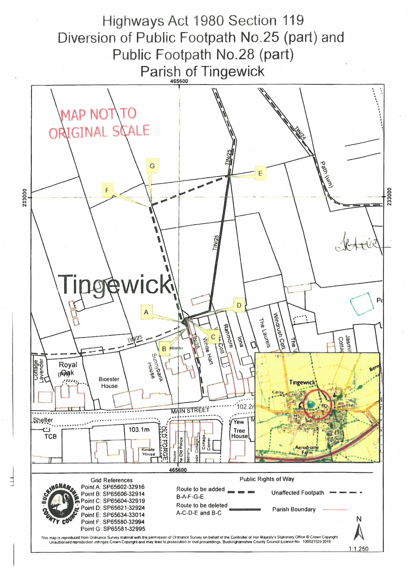

I note the Applicants refer to the property as ‘Old White Hart’
Mr & Mrs Paoli
The stables and field are under the same ownership as White Hart

