Order Decision
Site visit made on 31 March 2022
by Wendy McKay LLB Solicitor (Non-practising)
an Inspector appointed by the Secretary of State for Environment, Food and Rural Affairs
Decision date: 24 May 2022

Order Ref: ROW/3251916
- This Order is made under Section 53(2)(b) of the Wildlife and Countryside Act 1981 (the 1981 Act) and is known as the Devon County Council (Footpath No 7, Gittisham) Definitive Map Modification Order 2019.
- The Order is dated 16 December 2019 and proposes to modify the Definitive Map and Statement for the area by adding a public footpath as shown in the Order plan and described in the Order Schedule.
- There was one objection outstanding when Devon County Council submitted the Order to the Secretary of State for Environment, Food and Rural Affairs for confirmation.
Summary of Decision: The Order is not confirmed.

Procedural Matters
- I made an unaccompanied site inspection on 31 March 2022 when I was able to view the whole of the Order route.
- The Order has been made in compliance with a direction to Devon County Council, the Order Making Authority (OMA), by the Secretary of State in 2019 following a report made by another inspector. The OMA does not support the confirmation of the Order as made and takes a neutral stance.

The Main Issues
- Section 53(3)(c)(i) of the 1981 Act requires me to consider whether, on the balance of probabilities, the evidence shows that a public footpath subsists over the Order route.

Reasons
- The case for the Order route places little reliance upon evidence of recent use. The evidence relied upon in this case is largely historical and documentary. I shall now first consider the various items of documentary evidence submitted in support of the Order route.

Documentary evidence

The Tithe Maps
- Extracts from the Buckerell Tithe Map dated 1845 and the Gittisham Tithe Map dated 1838 have been provided. The Tithe Maps do not show the Order route, nor do they provide assistance with its status. The evidence relating to the Tithe Maps, in itself, therefore provides little support for the claim. However, the maps and transcribed apportionments confirm the names and numbers of the fields through which the Order route is said to pass. The references to 187 Jarvis Park, 144 Long Meadow in Gittisham, and 514 Ten Acres in Buckerell assist in the interpretation of the Court Leet presentments to which I shall now turn.

Presentments to the Court of Leet
- In support of the Order, reliance is placed upon presentments made to the Court Leet in the nineteenth century. There are three references to deficiencies in the condition of the path furniture along the route. The first presentment made on 3 November 1803 records a bridge out of repair “in a field called Ten Acres”. The second presentment made on 17 October 1811 refers to a bridge between two Closes called Jarvis Park and Ten Acres which was said to be dangerous and out of repair. The third presentment on 20 October 1819 records that: “there is a rail wanted at the bottom of the Long Meadow in the footpath towards Honiton”.
- The Objector submits that the evidence provided by the three presentments to the Court of Leet in 1803, 1811 and 1819 should be treated with caution. The 1803 and 1811 presentments each refer to a bridge said to be out of repair but neither indicate whether the bridge was on the Order route, or the basis on which the individual subject to the presentments was held liable.
- In support of the Order route, the Ramblers Association submit that it is clear on maps and plans produced over a period of many decades that there is a watercourse or ditch on the Order route between Ten Acres and Jarvis Park. They consider that both logic and common sense dictate that the position of the bridge would be over a watercourse or ditch; that the bridge is a means of passage on foot over that ditch, and that the bridge was therefore on and formed part of the Order route. However, whilst those maps and plans do provide evidence of the existence of a watercourse over which the Order route crosses at one point, they do not provide any indication of the presence of a bridge. It does not necessarily follow that the bridge referred to in those presentments was in fact on the Order route. I consider that the position remains unclear in that respect.
- Turning to the 1819 presentment, this provides the only reference to a footpath in the presentments. The Objector acknowledges that the 1819 presentment does refer to a footpath, but submits that it is wrong to assert that this must be on the Order route for the reasons they provide including that the reference to the “footpath towards Honiton” could equally well relate to the path identified by Mr Foden, an Archivist and Historical Researcher instructed by the Landowner, which is not the Order route but runs to Hodges Lane.
- I do not consider it to be significant, as the Ramblers suggest, that the reference in the presentment is to a footpath, whereas Hodges Lane is identified as a lane on the various maps, nor does its orientation dissuade me from that view. I find the alternative interpretations for the 1819 presentment put forward by the Objector to be entirely plausible and they emphasise the uncertainty associated with this aspect of the documentary evidence.
- Furthermore and most importantly, the basis for any liability is not explained. The functions of the Court Leet and the Court Baron are relevant to this consideration. The Ramblers refer to the Alcester Court Leet which identifies its remit as including: “To enquire regularly and periodically into the proper condition of watercourses, roads, paths, and ditches; guard against all manner of encroachments upon the public rights, whether by unlawful enclosure or otherwise”. They submit that this is the basis on which the individual subject to the presentment was liable and that bearing in mind the function of a Court Leet to protect public rights, the presentments clearly refer to deficiencies in furniture on a public path over and between Ten Acres and Jarvis Park and on a path along the bottom of Long Meadow.
- However, the Objector highlights that at that time different courts would often sit alongside each other. This appears to have been the case for Gittisham. It is apparent from the relevant headings that the roll expressly relates to the Court of Leet and the Court Baron. The jurisdiction of the Court Baron encompassed property disputes, and included disputes as to the performance of the obligations of copyholders to the lord of the manor. The submitted extracts provide no explanation of the basis on which the persons concerned were held to be liable for the upkeep of the bridge between Jarvis Park and Ten Acres or the rail on the footpath at the bottom of Long Meadow. In relation to the bridge, the absence of any reference to a footpath in the 1803 and 1811 presentments strongly supports the view that the upkeep of the bridge in an unidentified location was more likely referrable to an obligation on the part of the copyholder than a duty to maintain a highway.
- In conclusion, it clearly cannot be assumed, on the basis of the available evidence, that the presentments require repairs to public rights of way. Whilst they may have done so, it seems to me that it is more likely that they concerned other matters or disputes that came before the Court Baron sitting alongside the Court Leet at that time. In any event, it cannot be accepted that these presentments must necessarily have related to the Order route. The reference to the “footpath towards Honiton” would also be consistent with the route being via Hodges Lane. I attach only limited weight to the evidence provided in relation to the Court of Leet between 1803 and 1819.

The Finance Act Record Plan and field book entries
- In support of the Order route, there is also reliance placed upon documentation relating to the 1909/1910 Finance Act. The Order route crosses three hereditaments, namely, Goldcombe, Glebe and Hayne Farms. The details of the valuations of these three hereditaments are recorded in the relevant Gittisham Field Book.
- The Field Book entry for Goldcombe Farm shows that the property was owned freehold by “R Marker”. The owner at the time of the Finance Act claimed to be unaware of any “Fixed Charges, Easements, Common Rights and Restrictions” on the mandatory Form-4. No deductions were recorded for public rights of way in this hereditament.
- The Field Book entry for the Glebe shows the field was part of the freehold benefice of Reverend Duncan. The entry details a footpath and a right of way through OS field 238. Although the owner appears to have identified a footpath on his Form of Return, no deduction was noted.
- The Field Book entry for Hayne Farm shows the property was owned freehold by “R Marker”. The valuer gave a deduction in H25 Hayne Farm for public rights of way in Hodges Lane field numbers 151, 189 and 191. The Ramblers submit that this entry supports the existence of another public right of way along Hodges Lane, across field number 189 and into 191 with the section in 191 and onwards being identical to the Order route. However, no deduction is recorded for any path passing eastward through 191 and continuing to Hayne Lane.
- The Objector submits that the position in respect of the Finance Act valuation maps and Field Books has been clarified by the research of Mr Foden. The Objector accepts that rights of way were acknowledged over Haynes Farm but contends that these were limited to a private right of access to a landlocked field owned by the Trustees of Beaumont Charity and a right of way over OS field numbers 151, 189 and 191. The Objector submits that those field numbers do not follow the Order route but delineate a different footpath route leading from Goldcombe Farm to Hodges Lane. Furthermore, while the official calculated a figure for a deduction for both rights neither was used within the valuation and under “Fixed Charges, Easements, Common Rights, and Restrictions” the Field Book recorded “Not known”. No rights of way were acknowledged in respect of the Order route as it runs over Goldcombe Farm.
- The Ramblers submit that the Finance Act evidence confirms a “footpath” across the Glebe field 238 (which is adjacent to 191 and on the way to Goldcombe Farm). However, as indicated above, whilst a “footpath” was acknowledged across field number 238, no deduction either as a private easement or a public right of way was made in respect of it. The position in relation to its status and purpose remains unclear. In my view, it cannot safely be concluded that the footpath through field number 238 represents a public right of way.
- In relation to the reference to a public footpath from Goldcombe Farm to Hodges Lane, the Ramblers place reliance upon mapping evidence to suggest that the footpath route between those points could only have followed the line of the Order route, since it passes from Goldcombe Farm at Parsonage Lane, as far as and including along the cross-field path over field number 191. However, no public rights of way were acknowledged in relation to the Order route as it runs over Goldcombe Farm. I find it unhelpful to speculate in this way as to what might or might not have been the route of such a path. The evidence, such as it is, is far too uncertain to be of much assistance in that respect.
- The absence of a positive acknowledgement at that time of any rights of way over the other hereditaments across which the Order route would have run is telling and weighs strongly against the existence of any such rights. I concur with the Objector that the very full information provided by Mr Marker and his tenant makes the omission of a footpath terminating at Hayne Farm all the more significant. Whilst I recognise that there was no obligation whatsoever on landowners to identify public rights of way under the Finance Act, I find no reason to suppose that this represents a deliberate and incorrect omission.
- I conclude that the Finance Act material provides little support for the existence of a public right of way over the length of the Order route at that time. No public rights of way were declared under the Finance Act over land at Goldcombe Farm, nor over the Hayne Farm fields 192, 194, and 195, nor through the farm curtilage leading to Hayne Lane which all form parts of the Order route. Whilst the Finance Act documents provide some evidence of the existence of a right of way running over field number 191, that evidence at its highest only provides support for the middle section of the Order route. The evidence which exists in relation to the Finance Act documentation does not show that public rights continued both through to Hayne Lane and to Parsonage Lane, along the lines of the Order route.

Comments made in the Definitive Mapping process
- In support of the Order route, the Ramblers submit that the evidence of the Definitive Map process indicates that all three tiers of local government in the 1950s regarded footpath 7 as a public path and that this may be sufficient to establish the subsistence of public rights on the balance of probabilities.
- The Order route was not included in the original survey on behalf of Gittisham Parish Council in October 1950 for six paths to be put forward for recording as public rights of way on the Definitive Map. However, the Ramblers identify that an undated map was prepared at a later date which identified “footpath 7”. This coincides with the current Order route. The undated survey form records that: “Mr Hayman of the Parish Council states this path is required and was omitted due to an oversight. The RDC confirm this. The path has been pencilled in on the map.” The Parish Council survey form also records an answer of ‘No’ to the question as to whether the path was likely to be disputed, and ‘Yes’ to the question as to whether the path was required in the future.
- In November 1953, the County Council completed a form that described footpath 7 as a public footpath and specifically struck out the ways with higher public rights, ‘which do not apply’. A detailed description of this ‘Right of Way’ was also provided which corresponds with the Order route, and the information was signed off by the Divisional Surveyor.
- The Ramblers also draw attention to a parish minute from April 1956 which states: “Path no.7 Goldcombe Farm to Hayne Farm was omitted from the Parish Council’s survey. Reply to Devon County Council that path has not been used for a very long time and was not likely to be used in the future.” They submit that the fact that footpath 7 was omitted from the Definitive Map should not be given weight against public rights subsisting. Instead, the Parish, Rural District and County Council’s views as to its public status should be accorded considerable weight. They correctly observe that lack of current use does not remove any public rights that already exist by virtue of past use given that “once a highway, always a highway”, and the detail in the minutes that the path was not likely to be used in the future is no evidence, then or now, that the path is not a public right of way and should not be taken into consideration.
- In support of the Order route, attention is also drawn to a report of the County Engineer and Planning Officer in relation to a 1992 review of the Definitive Map. This states that: “The claim for the connecting route running between Hayne and Goldcombe Farms appears prima facie to be a valid proposal; it was claimed by the parish in the 1950’s, and is stated to have been omitted from the Definitive Map due to an oversight. This claim will receive further investigation but is not affected by the A30 proposals.”
- The Objector submits that neither the Parish Council nor the County Council extracts give any indication of the evidence on which they were based. The Objector also points out that the Parish Council’s view is only in the form of a suggestion, and it does not amount to a determination that the footpath existed with that status. The County Council’s comments amount to little more than a description of the path, and they do not confirm the existence of that path as a public right of way. Neither document provides any indication as to whether this path was consulted upon and, if so, whether there were objections to its inclusion. The comments in the 1992 report rely substantially on the earlier 1953 material to provide support for the route, and merely indicate that further investigation would take place on this matter.
- In my opinion, the considerations which led omission of the path from the final version of the Definitive Map remain unclear. The Ramblers suggest that the path “did not make it” on to the Definitive Map for reasons that appear to be entirely illegitimate. However, it seems to me that the evidence provided by the Definitive Mapping process is limited in its scope. It does not clarify and explain the full investigation and subsequent considerations which would have occurred at those times. The comments and responses made in these documents are difficult to interpret as they stand, and an evaluative judgment on the status of the footpath is noticeable by its absence. The relevant extracts lack substance and do not support the assumption that footpath 7 was omitted from the Definitive Map for illegitimate reasons. I conclude that the Parish Council and the County Council extracts should carry little weight in support of the Order route. However, the fact that the path does not appear on the Definitive Map does not weigh against the existence of public rights should they be shown to exist through other cogent evidence.

The Ordnance Survey Mapping
- The First Edition of the Ordnance Survey Map published in 1890 shows a route that is annotated as “F.P.” and which follows almost exactly the same route as footpath 7. The exception being, as was noted by the previous inspector, that the route is shown as entering Goldscombe Farm at its southern end, whereas the Order route is shown as skirting round the farm buildings to join Parsonage Lane. The 1903 Second Edition of the Ordnance Survey Map also shows a route similarly annotated as “F.P.” that follows the same route as that shown on the earlier First Edition.
- The path is also shown on the Provisional Edition of the 1:25000 Ordnance Survey Map published in 1949 and the ‘A’ Edition of the 1:25000 provisional series published in 1963 following a resurvey in 1959. That later map refers to part of the route as a track, and again the route is shown as entering Goldscombe Farm.
- In support of the Order route, the Ramblers submit that Ordnance Survey Maps at the end of the nineteenth and beginning of the twentieth centuries and again in the 1940’s and 1960’s show that a path was visible on the ground at the time of the surveys with the implication that it was being used. However, Ordnance Survey Maps are not evidence of the status of a path only of their physical existence. I find the evidence provided by the Ordnance Survey Mapping to be of limited assistance in this case.

Aerial photographs
- The Devon County Council has made available a number of aerial photographs taken between 1946 and 2007. The earliest photographs are more difficult to discern, but there is some evidence of a track leading from Hayne Farm into fields on part of the claimed route and the track leading from Goldcombe Farm. However, other fields on the route do not show any such evidence. The later photographs are much clearer and also show the tracks leading from Hayne Farm and Goldcombe Farm along parts of the claimed route which continue to other adjoining fields. Nevertheless, there is no evidence of paths/tracks crossing the interconnecting fields between the two farms. In any event, these photographs do not provide any assistance as to how the tracks shown were being used at those times and whether they were being used for public or private purposes.

Physical evidence
- At the time of my site visit I found it possible to walk most of the Order route with relative ease. However, at one point the route was obstructed by a barbed wire fence and bank which I consider the majority of walkers would find difficult to negotiate. I did not observe any evidence of recent use by walkers, including those with dogs.

Other evidence
- The Ramblers also indicate that they have anecdotal evidence that footpath 7 was used in the 1970s, 1980s and 1990s by a local resident and that the then tenant of Hayne Farm was surprised that it was not waymarked as a public footpath. However, anecdotal evidence is all that it is and there is no direct evidence from any witnesses to support that contention. As such, I am unable to attribute any weight to it.

Other matters
- The submissions of supporters and objectors raise a number of matters including that a lot more people have been noticed walking in the area since the development of the housing estate at Hayne Farm, and that this “new footpath” would be a safe place to walk and also offer the opportunity for a circular walk. In addition, attention is drawn to the worsening situation for walkers in and around Gittisham in the last couple of years, and the planned expansion of the Hayne Farm housing into the old farm buildings area with the developer being willing to include the footpath in their housing layout. However, the various points raised concern matters which fall outside the criteria set out in the relevant legislation. I have not therefore attached any weight to them in reaching my decision.
- Although the Order was made as a result of another inspector’s decision in 2019, I have had the benefit of additional submissions and evidence and have visited the route. Furthermore, that inspector had the options of considering whether a right of way had been shown to subsist on the balance of probability, or a right of way had been reasonably alleged to subsist. He concluded that the evidence fell short of the standard of proof required to show that, on the balance of probability, a public right of way on foot subsists along the appeal route. However, he found no incontrovertible evidence that the claimed right could not have existed and some evidence to show that a footpath did in fact exist along the claimed route. He considered the evidence to be sufficient to show that the existence of the public right of way claimed could be reasonably alleged. In contrast, the only option available to me is to consider whether, on the balance of probabilities, the evidence shows that a public footpath subsists over the Order route. I am entirely satisfied that it does not.

Conclusions
- I have considered the various items of documentary and other evidence before me both individually and taken as a whole. There are no individual aspects of that evidence to which I attach more than limited weight, and neither the documentary, nor user evidence alone is sufficient to demonstrate that the Order route is a public right of way. When considered cumulatively the inherent weaknesses of the material relied upon are such that the combination of all the evidence does not lead me to a different view. Accordingly, I conclude, on the balance of probabilities, that the available evidence does not indicate that the definitive map is incorrect or that a public footpath subsists over the Order route.
- I conclude that the Order should not be confirmed.

Formal Decision
- The Order is not confirmed.

Wendy McKay

Inspector

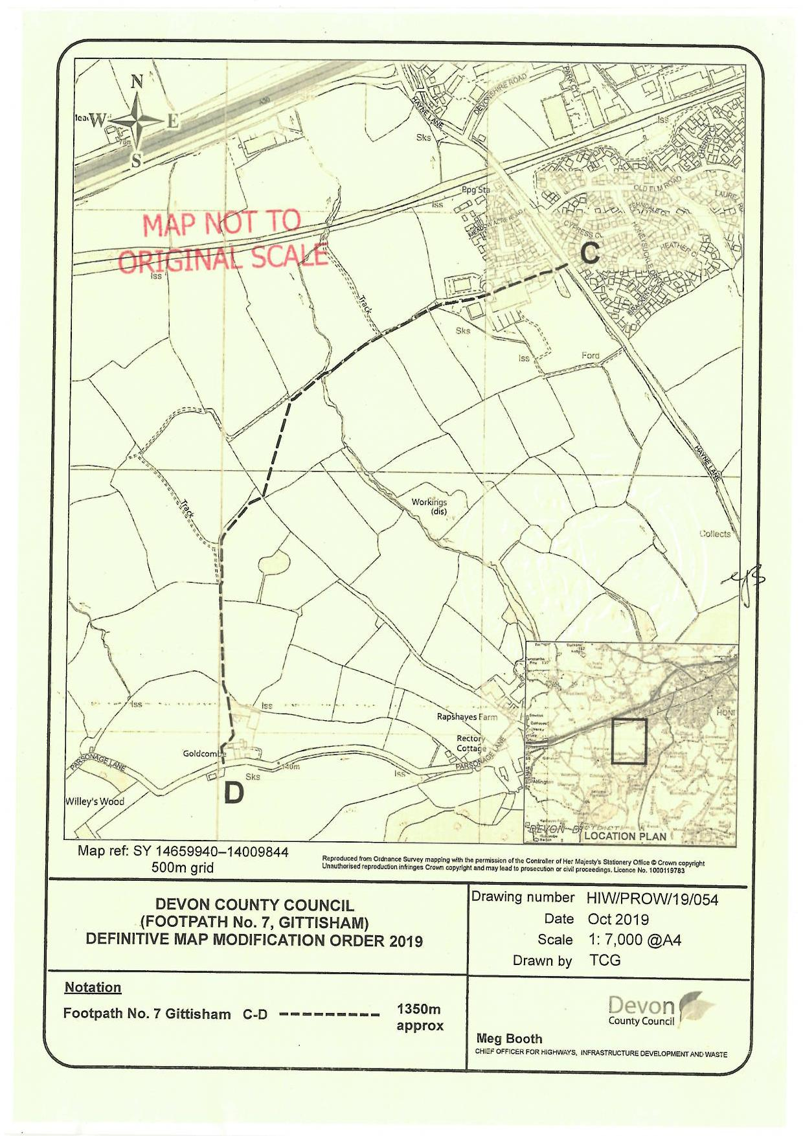

Extract from Wikipedia

