Appeal Decision
by A Spencer-Peet BSc(Hons) PGDip.LP Solicitor (Non Practicing)
an Inspector appointed by the Secretary of State for Environment, Food and Rural Affairs
Decision date: 13 May 2022

Appeal Ref: FPS/Y2003/14A/1
- The appeal is made under Section 53(5) and Paragraph 4(1) of the Wildlife and Countryside Act 1981 (the 1981 Act) against the decision of North Lincolnshire Council (the Council) not to make an Order under Section 53(2) of that Act.
- The Application dated 31 March 2017 (the Application) was refused by the Council
on 8 July 2021.
- The Appellants claim that the definitive map and statement (the DMS) for the area should be modified by the addition of a Footpath.

Summary of Decision: The appeal is allowed.

Preliminary Matters
- I have been directed by the Secretary of State for Environment, Food and Rural Affairs to determine an appeal under Section 53(5) and Paragraph 4(1) of Schedule 14 of the 1981 Act.
- I have not visited the site. However, I am satisfied I can make my decision without the need to visit the site. The appeal is based on user evidence and has been determined on the papers submitted.
- The appeal is made against the Council’s decision not to make an order in respect of the Application to add a footpath to the DMS from Ness End Farm, Far Ings Road, to the Viking Way footpath located on the Humber Riverbank.
- However, the Council have put it to me that the decision not to make an order in this case, was based on the map which was submitted in support of the Application, and which shows the alleged route ending in a cul-de-sac north of Ness End Farm. Nonetheless, whilst I acknowledge the Council’s submissions in that regard, it is clear from the wording of the Application that the alleged route was from “Ness End Farm, Far Ings Road’. It appears from the submissions in this appeal that it was clear to the relevant interested parties that the claimed route would start/end at Far Ings Road and not from a point north of Ness End Farm. Consequently, I have determined this appeal on the basis that the alleged route starts/ends at Far Ings Road, and which connects to the Viking Way footpath located on the Humber Riverbank (the Appeal Route) as shown on the attached plan.

Main Issue
- The Application was made under Section 53(2) of the 1981 Act which requires the surveying authority to keep the DMS under continuous review, and to modify them upon the occurrence of specific events cited in Section 53(3) of the 1981 Act.
- Section 53(3)(c)(i) of the 1981 Act provides that a modification order should be made on the discovery of evidence which, when considered with all other relevant evidence available, shows that a right of way which is not shown on the DMS subsists or is reasonably alleged to subsist over land in the area to which the map relates, being a right of way such that the land over which the right subsists is a public path.
- As set out in the case of R v Secretary of State ex parte Norton and Bagshaw, an Order to add a route should be made if either of two tests is met:

A: Does a right of way subsist on the balance of probabilities?

B: Is it reasonable to allege that a right of way subsists? For this possibility to exist, it will be necessary to show that a reasonable person, having considered all the relevant evidence available, could reasonably allege that a right of way subsists.
- As noted above, the appeal relies on user evidence. For a claim that a right of way exists based on user evidence under section 31 of the Highways Act 1980 (the 1980 Act), the evidence must demonstrate that use has occurred over a claimed route for a period of at least twenty years prior to the date at which the public’s right to do so was brought into question. If user evidence is sufficient to raise the presumption that the route was dedicated to the public, that presumption is rebuttable if there is sufficient evidence to show that during the relevant twenty year period, there was no intention on behalf of the landowner to dedicate the route to the public.
- A statutory right under section 31(6) of the 1980 Act allows landowners to deposit a statement and plan showing admitted public rights of way over the relevant land, and to make a declaration that no other additional rights of way over that land have been dedicated since the date the plan was deposited with the appropriate Council. In the absence of evidence to the contrary, the deposit and associated declaration are deemed to negate the intention of the landowner, and successors in title, to dedicate additional ways as a highway.
- In addition to the above, there is also a common law test for the dedication of a public right of way for which no minimum or fixed user period is required. Dedication may be presumed if there is sufficient evidence, from which it could reasonably be inferred, that the landowner has dedicated a right of way and the public has accepted that dedication.
- The main issue in this appeal is whether on the balance of probabilities a public footpath subsists along the claimed route or is reasonably alleged to subsist.

Reasons
- The Application was to add to the DMS a footpath running north-south over land which, the evidence before me confirms, currently forms part of the Far Ings Nature Reserve and which is owned and managed by the Lincolnshire Wildlife Trust (the LWT).
- In refusing to make an order, the Council concluded that the Applicants had neglected to offer a specific event on behalf of the landowner which brought into question the right of the public to use the way and from which the period of twenty years, referred to in section 31(2) of the 1980 Act, could be calculated from. Subsequently, the Council determined that, in the absence of an earlier relevant event, under the provisions of sections 31(7A) and 31(7B) of the 1980 Act, it was the date of the Application which called use of the way into question, and that there was insufficient evidence of a twenty year period to support the claim for a public right of way over the Appeal Route, when that evidence was weighed against steps taken by the landowner to prevent use along the claimed route.

When the public to use the claimed route was first brought into question
- In light of the above, and before consideration of the user evidence submitted in support of the Application, it is necessary to determine when the alleged right of way was brought into question, and so that the statutory period of twenty years can be calculated up to that date in accordance with section 31(2) of the 1980 Act.
- There is dispute between the Council and the Appellants as to when the alleged right for the public to use the Appeal Route was brought into question. However, in this appeal I have been presented with a number of possibilities as to when the date might be with regards to the date upon which the alleged right for the public to use the Appeal Route was brought into question.
- The first possibility relates to dates when signs were erected around and close to the Appeal Route and when users who were accompanied by dogs were challenged. The Appellants have put it to me that such signs and oral challenges started in 2016. Whilst it is acknowledged that the Council’s submissions provide that there was dispute regarding the policing and enforcement of a no dog policy on the relevant land from 1987 onwards, in my view such actions or challenges do not relate to the use of the path by the public without dogs and which would bring into question that alleged use.
- The other possibilities concern: (i) the date, being 31 March 2017, upon which the application to modify the DMS was made by the Appellants, as provided for under sections 31(7A) and 31(7B) of the 1980 Act, (ii) in respect of when the LWT completed the process of lodging a statement, map, and subsequent declaration, with the Council under section 31(6) of the 1980 Act, or (iii) by the erection of locked gates at Ness End Farm in 1996 when the landowner rerouted the track through an adjacent carpark onto Far Ings Road.
- It is acknowledged that the first statement and map deposited by the LWT under section 31(6) of the 1980 Act is dated 4th August 2003, whereas the subsequent declaration is dated 8th December 2006. On that basis, I am satisfied that the required formalities contained within section 31(6) of the 1980 Act were fully observed in December 2006. A subsequent statement, map and declaration under section 31(6) of the 1980 Act was deposited by the LWT in March 2014.
- It has been put to me by the Council that the initial deposit made by the LWT in December 2006, and which was made prior to the requirement to enter those deposits onto a register which came into force October 2007, is not sufficient evidence to bring the right of the public to use the Appeal Route into question. The main parties refer to case law on this point.
- Section 31(6) of the 1980 Act is clear that, “…declarations in valid form…are in the absence of proof of a contrary intention, sufficient evidence to negative the intention of the owner or his successors in title to dedicate any such additional way as a highway”. In this regard, for the reasons given above, the declaration was in a valid form and further to my consideration of the case law presented, in this instance the completed process of depositing the declaration provides sufficient evidence of a lack of intention to dedicate and bring into question the right of the public to use the Appeal Route as at December 2006.
- It is therefore unnecessary to further consider the application date of March 2017, by reason of the deposit under section 31(6) of the 1980 Act in December 2006 which brought into question the right of the public to use the route as at an earlier date, and given that no twenty year period of continuous uninterrupted use could apply between 2006 and 2017 due to that deposit under section 31(6) of the 1980 Act.
- However, and notwithstanding the above findings in respect of the 2006 deposit under section 31(6) of the 1980 Act, there is the issue of whether the rerouting of the track through an adjacent carpark rather than through Ness End Farm in 1996 amounts to bringing into question the alleged right for the public to use the route.
- In my view, and from the evidence before me which indicates that the claimed route was obstructed by locked gates constructed at Ness End Farm, is sufficient to demonstrate a lack of intention to dedicate by the landowner and to bring the right of the public to use the route into question as at 1996. Consequently, the twenty year period for the route which goes through Ness End Farm should be calculated retrospectively from 1996, being 1976 to 1996.

User Evidence
- A number of user evidence forms (UEFs) have been submitted in support of the Application, with further details being provided by some of those users at a later date and which provided additional information regarding use of the route before and after 1996 when the abovementioned gates were erected preventing access through Ness End Farm.
- Thirteen UEFs completed by people claiming to have used the route over the entire period between 1976 and 1996 have been provided. Additionally, seventeen further UEFs from people claiming to have used the route between 1976 and 1996 but which do not demonstrate use over the entire twenty year period, have also been submitted.
- The UEFs and the later supplied additional information from those users, identifies the claimed route. The frequency of use varies between the users, but it appears that a significant proportion of those users completing the UEFs stated that they used this route more than once a week, with some indicating daily use.
- Overall, whilst the number of UEFs submitted in support of the application are quite low and that the frequency of use varies between the respective users, by reason of the consistency of details provided on the UEFs and given that the route is not located in a densely populated urban setting, I am satisfied that the user evidence supplied supports the contention that a public right of way, which crosses through Ness End Farm to connect with Far Ings Road, came into existence prior to 1996.

Documentary Evidence
- Ordnance Survey maps from 1887, 1908 and 1945 indicate the existence of a path in the location of the Appeal Route. Notwithstanding the noted difference between the alignment of the path shown on the various maps and where it connects with Far Ings Road, whilst such maps provide good evidence of the features that were on the ground at that time, they do not indicate or confirm as to whether a public right of way exists.

Other Matters
- As noted above, submissions in this appeal include details regarding an alternative route taken through a carpark connecting with Far Ings Road, following the erection of the locked gates at Ness End Farm in 1996. In that respect, the Appellants have put it to me that dedication of that section, between Far Ings Road and connecting to a point on the claimed route north of buildings at Ness End Farm, could be inferred under common law by reason of the actions taken by both public users and by LWT wardens since 1996.
- However, whilst I acknowledge the user evidence submitted with regards to use of that section post 1996, I note that from the ‘Statement in support of evidence’ submitted with the Application, that it was the Appellants’ belief that “a public right of way subsists or is reasonably alleged to subsist and that the evidence…shows use by the public with dogs ‘to raise the presumption of dedication by virtue of use over 20 years…’ as per Section 31 of the Highways Act 1980”. As such, I have not found it necessary to consider whether there has been common law dedication for that section which connects Far Ings Road to a point north of Ness End Farm on the claimed route as part of this appeal.
- I have carefully considered the objection raised by the LWT and acknowledge the considerable amount of information provided in this appeal with respect to the bird breeding successes at the Nature Reserve and the potential effects of dogs disturbing nesting sites. However, this appeal concerns whether, on the balance of probabilities a public footpath subsists along the claimed route or is reasonably alleged to subsist, and therefore matters such as for example whether dogs accompanying walkers would be likely to disturb nesting sites, cannot be considered further as part of this appeal. Furthermore, whilst it is acknowledged that the claimed route is located within a Site of Special Scientific Interest (SSSI), I have not been provided with any evidence to suggest that designation of an area as a SSSI would be, by itself, a bar to dedication of use of the path by the public.

Conclusion
- Having regard to the above and all other matters raised in the written representations, I conclude that the user evidence available does show that on the balance of probabilities that a footpath subsists or can be reasonably alleged to subsist for statutory dedication under section 31 of the 1980 Act.

Formal Decision
- In accordance with paragraph 4(2) of Schedule 14 to the 1981 Act, the Council is directed to make an order under section 53(2) and Schedule 15 of the 1981 Act not later than three months from the date of this decision to modify the definitive map and statement to add a footpath as set out in the application dated 31 March 2017. This decision is made without prejudice to any decision that may be given by the Secretary of State in accordance with powers under Schedule 15 of the 1981 Act.

Mr A Spencer-Peet

INSPECTOR

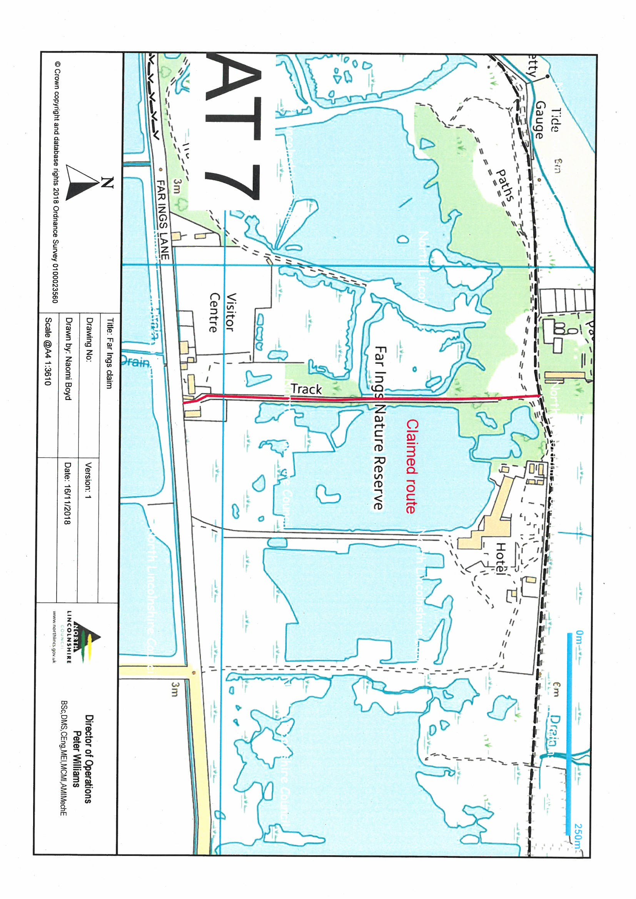

R v Secretary of State ex parte Norton and Bagshaw [1994] 68 P & CR 402
Godmanchester & Drain v SSEFRA [2007] UKHL 28, Paterson v SSEFRA [2010] EWHC 394 and Mann v Brodie [1885] HL 378, 10 APP CAS 378.

