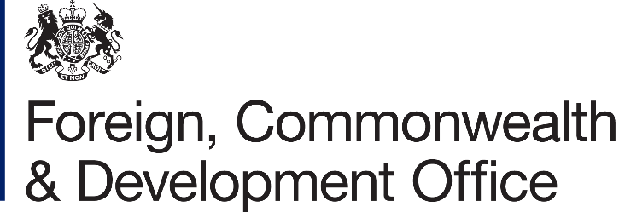

Information Rights Unit
WG.75
King Charles Street
London
SW1A 2AH
Email: information.rights@fcdo.gov.uk

www.gov.uk/fcdo
9 December 2021
FREEDOM OF INFORMATION ACT 2000 - REQUEST REF: FOI2021/30754

Thank you for your email of 12th November asking for information under the Freedom of Information Act (FOIA) 2000. You asked:

Please find below my FOI request regarding malicious emails sent to the department.
The date range for the requests is from 2018 to present day. The data shall include a breakdown by year and by individual departments (e.g. separate departments, agencies, or public bodies within the main government agency), if applicable.
1. How many malicious emails have been successfully blocked?
2. What percentage of malicious emails were opened by staff?
3. What percentage of malicious links in the emails were clicked on by staff?
4. How many ransomware attacks were blocked by the department?
5. How many ransomware attacks were successful?

I am writing to confirm that Foreign, Commonwealth and Development Office Services has now completed the initial assessment for the information requested. Section 12 of the Freedom of Information Act is applied.

Section 12 of the Freedom of Information Act makes provision for public authorities to refuse requests for information where the cost of dealing with them would exceed the appropriate limit. The limit has been specified in the Freedom of Information and Data Protection (Appropriate Limit and Fees) Regulations 2004. For central government the appropriate limit is set at £600. This represents the estimated cost of one or more persons spending 3 ½ working days in determining whether the Department holds the information, and locating, retrieving and extracting it. Your request as presently formulated is widely-framed and I estimate that it will take more than 3 ½ working days to locate, retrieve and extract this information. In these circumstances we are not obliged under the Act to comply with your request. A way to refine your request to meet the appropriate

cost limit of £600 would be to limit your request to our centrally managed corporate network which would include devices which are deployed around the world.

Please note that any new request will be given a separate reference number and we will then consider whether we can provide the information requested within the appropriate cost limit. This would of course be subject to the consideration of whether any of the other exemptions under the FOI Act apply.

If you would like a review of our decision, please email: information.rights@fcdo.gov.uk or write to Information Rights Unit, Foreign, Commonwealth & Development Office, Room WG.75, King Charles Street, London, SW1A 2AH. Please note you have 40 working days to do so from the date of this letter.
You can apply directly to the Information Commissioner. However, the Information Commissioner will not normally make a decision unless you have first exhausted the complaints procedure provided by the FCDO. The Information Commissioner can be contacted at: Information Commissioner's Office, Wycliffe House, Water Lane, Wilmslow, Cheshire SK9 5AF, or online at https://ico.org.uk/make-a-complaint/

Yours sincerely,

Information Rights Unit

For information about how the FCDO handles personal information please see our Personal Information Charter

