



Burlington Lodge & Annex
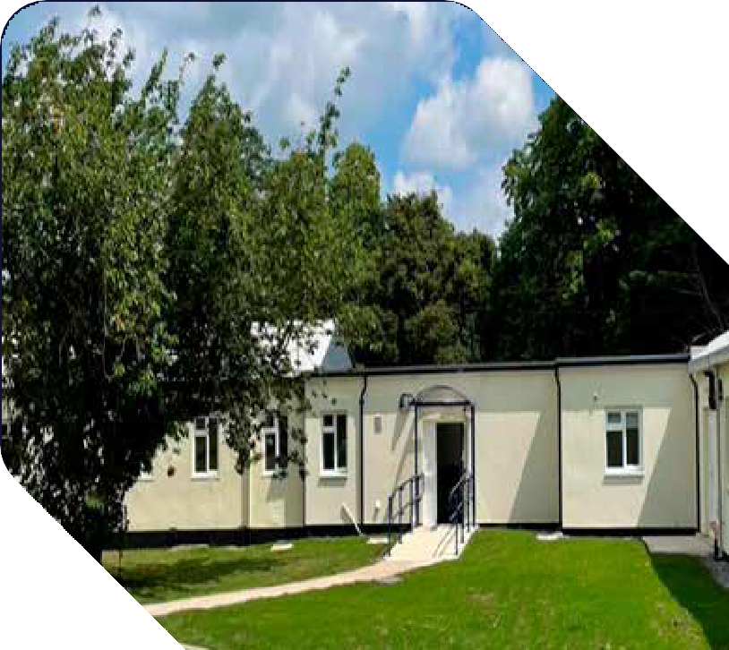
Community Support Residential Facilities available at the Services Cotswold Centre

Site Map

Main Entrance to Site
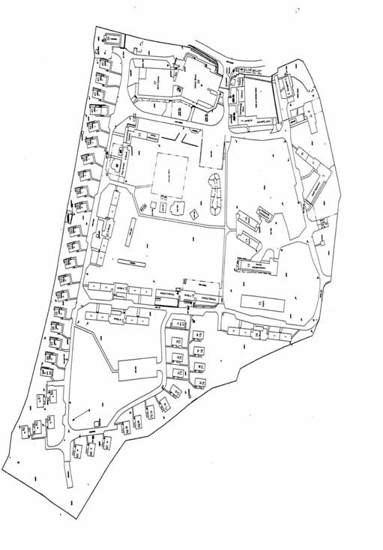


N 5

4 1

3

2

- Burlington Lodge
- Burlington Lodge Annex
- Play Park
- Community Centre
- Admin Block

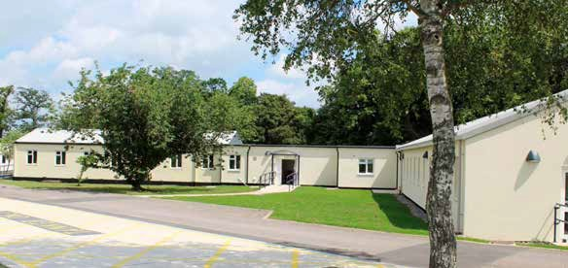
What is the Burlington Lodge and Annex?
Community Support Residential Facilities 1

Burlington Lodge is a modern single storey self-contained block which houses 38 bed spaces, a lounge / recreation area, kitchen,
ablution areas and a laundry facility. It also offers a private garden space.
Burlington Lodge Annex is a short walk from the main building
and offers a large kitchen, dining area and recreation / activity spaces (both indoors and outdoors).

Where is Burlington Lodge and Annex?

Burlington Lodge is located on the east side of the SCC site which affords it plenty of space and privacy from other residents. (Please refer to site map).
The Annex is situated within 50 metres of Burlington Lodge.

Use of Burlington Lodge and Annex

Both buildings will primarily be used to support Tri-Service Community Support Residential activity and delivery.*

* Subject to need, and in line with the Centre’s principles of use, priority will be given to provide emergency evacuation and group transit accommodation when/if required.
2 Burlington Lodge & Annex

Accommodation

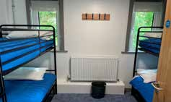
All accommodation is fully furnished with towels and bedding provided
Burlington Lodge comprises of:

- 8 x 4 bed dormitories
- 2 x 2 bed staff rooms
- 1 x 1 bed DDA compliant room
(including trundle bed) Dormitory Bedroom
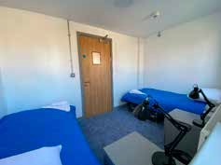
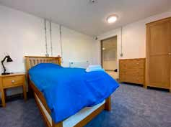

Staff Bedroom

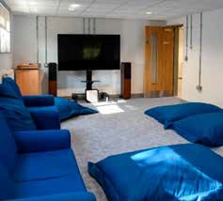
DDA Bedroom
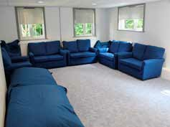
Lounge with TV, DVD and Freeview Box
Community Support Residential Facilities 3

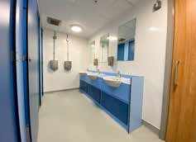

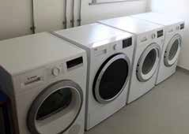
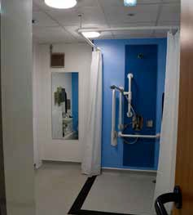
Laundry Room

Secluded garden to rear of building
offering BBQ facilities
Ablution areas including a DDA compliant wet room
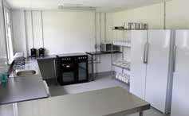
Fully fitted kitchen including refridgerator, freezer, cooker, microwave, crockery and cutlery
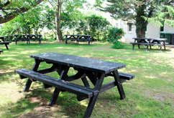
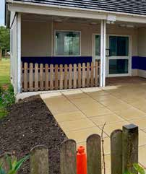
4 Burlington Lodge & Annex

Activity and Dining areas

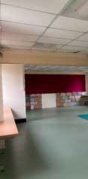
Burlington Lodge Annex

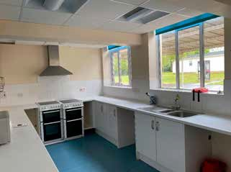
Fully fitted kitchen including refrigerator, freezer, cooker, microwave, crockery and cutlery

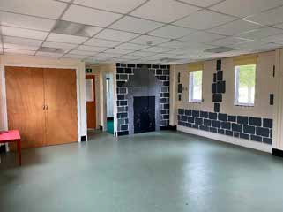
Dining Area
Community Support Residential Facilities 5

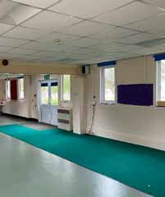
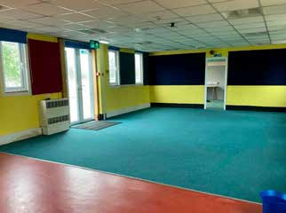
Recreational & Activity Areas

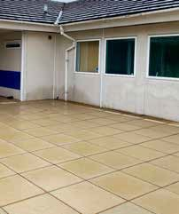
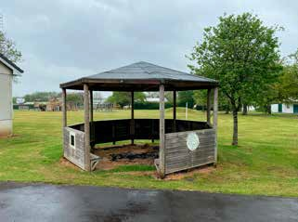
6 Burlington Lodge & Annex

Also available at the SCC………..

Available Evenings (1900-2200 hrs)
Admin Block Main Hall – providing Skittle Alley

Admin Block Games Room - providing Snooker and Table Tennis

Community Centre
- providing board games and a comfortable TV area
Large Play Park

Basketball Court/ 5-a-side Football Pitch

Lending Library – providing books, DVDs and Board Games
Booking via RQMS required
No Charge

Available Evenings (1900-2200 hrs)
No advance booking required
No Charge

Available 1700-
2200 hrs
Booking via RQMS required
No Charge

Available 24/7
No booking required
No Charge

Available 24/7
No booking required
No Charge

Available 24/7
No booking required
No Charge
Community Support Residential Facilities 7

Burlington Lodge Occupancy

Terms and Conditions

By booking to stay in Burlington Lodge you agree the following:
- Cleaning.
  - You will leave Burlington Lodge in a clean and tidy condition.
  - All beds are to be stripped down, duvet and pillows to be folded and placed at the head of the bed and dirty linen to be placed in a pile at the foot of the bed.
  - The kitchen requires the following:
    - The oven and grill are to be left clean and grease free.
    - The fridge and freezer are to be left empty and are to be cleaned internally and externally.
    - The microwave is to be cleaned internally and externally (including the microwave plate).
    - All cooking utensils, crockery and cutlery are to be washed up and put away.
    - Any spillages in the cupboards or drawers are to be cleaned.
  - A full check of communal areas, dormitory cupboards and drawers is to be conducted prior to departure to ensure no personal items are left behind.
  - All carpeted areas are to be hoovered and hard floor surfaces swept.
- Damages. All damages are to be reported either to the Reception Office or the Gate Guard. Please be aware that any damage will incur a charge being raised.
- Faults. Faults of a non-urgent nature are to be noted on the fault sheet located in the accommodation folder issued on arrival. Urgent faults are to be notified by phone on 01225 810358.
- Garden. Burlington Lodge garden area is to be left tidy and free of litter.
Any outside equipment used is to be returned to storage areas prior to departure.
5, Behaviour. You are responsible for your party’s behaviour whilst on site. Please respect others’ rights to a peaceful and enjoyable stay at the Centre.
- Parking. Car parking is either in designated carparks or laybys.
Under no circumstances are you to park on single track roads or on the grass.
- March In/March Out. A date/ time for formal March In/March Out inspections by the SCC Senior Storekeeper is to be booked via Reception by the Group Leader. If arrival is outside of normal office
hours, the Group Leader is requested to call in at Reception at the start of the next working day.
8 Burlington Lodge & Annex

How much does it cost?

Burlington Lodge (including the Annex) is charged at £2.00 per person per night*

Booking forms are available upon request from SCC.
You just need to complete the form and email it back to us
- we will confirm your booking as soon as possible (usually within 24 hours)

We will also send you a room allocation form to assist you in allocating bed spaces for your group

Examples of these forms are included in this pack for your information

Contact us

The Services Cotswold Centre,
Neston, CORSHAM, Wiltshire, SN13 9TU

Tel: 01225 810358 | Mil: | 94382 4521
Fax: 01225 816918 | Mil: | 94382 4529

E-mail: RC-AWS-SCC-Bookings@mod.gov.uk

Annex A to
AWS SOI SCC/03/17
Dated Dec 20
Community Support Residential Facilities 9

Annex A: SCC Burlington Lodge Booking Application Form
SCC Burlington Lodge Booking Application Form Chargable at £2.00 per person per night*
PART 1: Unit Details
Unit
Unit POC
Contact Number
Contact Email
Dates Required | FROM |  | TO
Description of Activity:
PART 2: Accomodation Required for:
Ser | Full Name | Ser | Full Name
1 |  | 16
2 |  | 17
3 |  | 18
4 |  | 19
5 |  | 20
6 |  | 21
7 |  | 22
8 |  | 23
9 |  | 24
10 |  | 25
11 |  | 26
12 |  | 27
13 |  | 28
14 |  | 29
15 |  | 30

10

Burlington Lodge & Annex

Data Protection Statement:
 | The Ministry of Defence is committed to the protection of your personal data in accordance with the Data Protection Act 2018. Information about how the MOD handles your data is available in the MOD Privacy Notice. We will only retain your personal information for as long as necessary to fulfil the purposes  we collected it for, including for the purposes of satisfying any legal, accounting, or reporting requirements. It is important that the personal information we hold about you is accurate and current, therefore please keep us informed if your personal information changes during the delivery of any service. We will in some circumstances have to share your data with third parties, where we are required  to do so by law, in an emergency situation or if a safeguarding concern is raised
Signature:
Form to be forwarded to:
SERVICES COTSWOLD CENTRE, Neston, CORSHAM, Wilts, SN13 9TU

Tel Civ: 01225 810358 Mil: (9)4382 4521 -
Fax Civ: 01225 816918 Mil: (9) 4382 4529
Email: RC-AWS-SCC-Bookings@mod.gov.uk
Community Support Residential Facilities 11

Burlington Lodge Room Allocation

(for completion by Group Leader)

Room No | Room Type | Allocation |  | Additional Notes (if Applicable)
 | 1 Bed DDA  Compliant Room | 1
S1 | 2 Bed  Staff Room | 1
S1 | 2 Bed  Staff Room | 2
D1 | 4 Bed Dormitory | 1
D1 | 4 Bed Dormitory | 2
D1 | 4 Bed Dormitory | 3
D1 | 4 Bed Dormitory | 4
D2 | 4 Bed Dormitory | 1
D2 | 4 Bed Dormitory | 2
D2 | 4 Bed Dormitory | 3
D2 | 4 Bed Dormitory | 4
D3 | 4 Bed Dormitory | 1
D3 | 4 Bed Dormitory | 2
D3 | 4 Bed Dormitory | 3
D3 | 4 Bed Dormitory | 4
D4 | 4 Bed Dormitory | 1
D4 | 4 Bed Dormitory | 2
D4 | 4 Bed Dormitory | 3
D4 | 4 Bed Dormitory | 4
D5 | 4 Bed Dormitory | 1
D5 | 4 Bed Dormitory | 2
D5 | 4 Bed Dormitory | 3
D5 | 4 Bed Dormitory | 4

12

Burlington Lodge & Annex

Room No | Room Type | Allocation |  | Additional Notes (if Applicable)
D6 | 4 Bed Dormitory | 1
D6 | 4 Bed Dormitory | 2
D6 | 4 Bed Dormitory | 3
D6 | 4 Bed Dormitory | 4
D7 | 4 Bed Dormitory | 1
D7 | 4 Bed Dormitory | 2
D7 | 4 Bed Dormitory | 3
D7 | 4 Bed Dormitory | 4
D8 | 4 Bed Dormitory | 1
D8 | 4 Bed Dormitory | 2
D8 | 4 Bed Dormitory | 3
D8 | 4 Bed Dormitory | 4
S2 | 2 Bed Staff Room | 1
S2 | 2 Bed Staff Room | 2

Community Support Residential Facilities 13
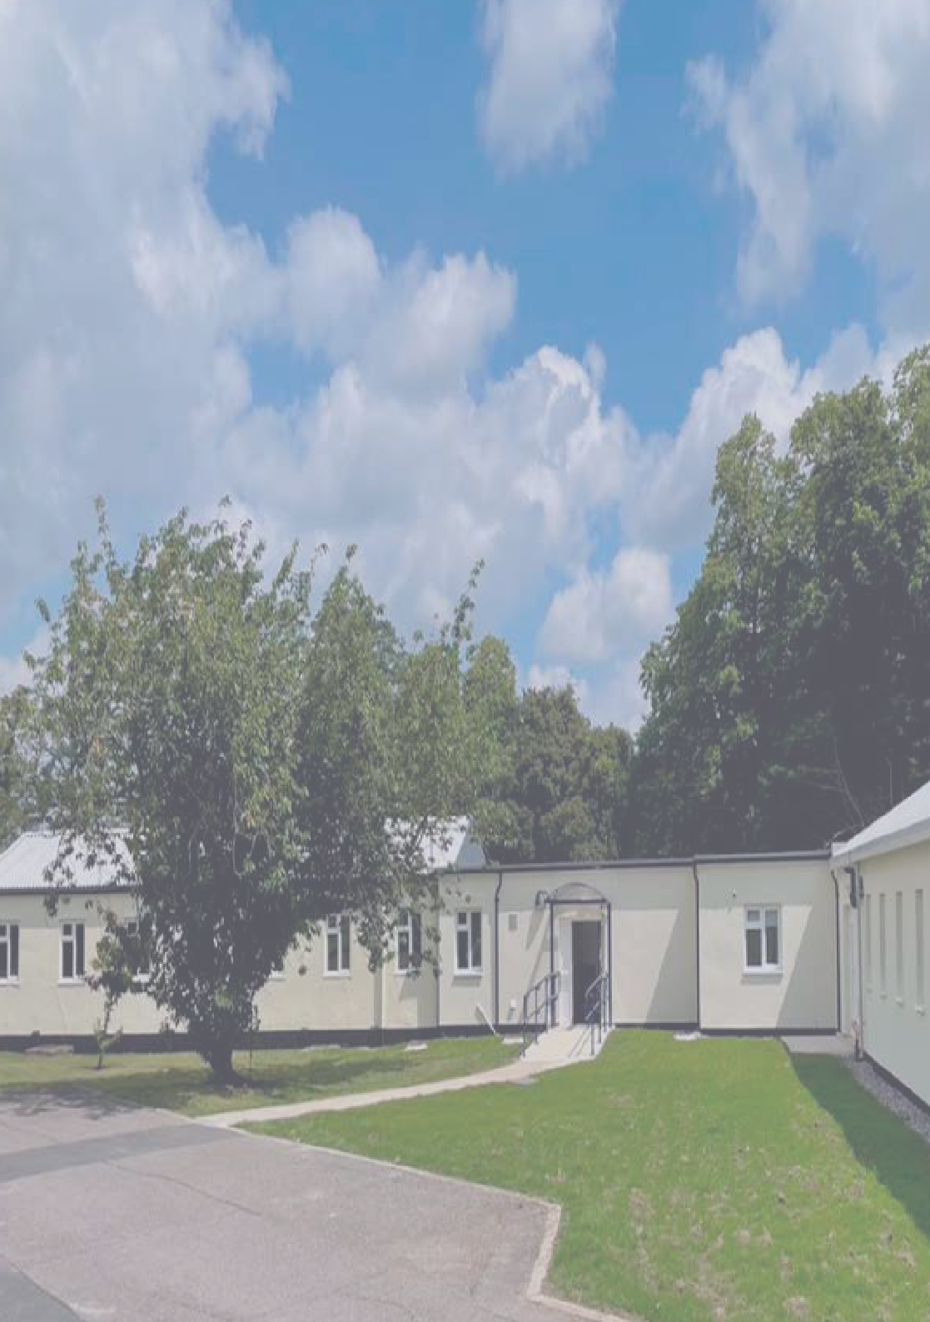

Creative Media Design ADR010176

