Technical recall easy read letter template. Use screening centre headed paper. This letter includes text boxes to be completed before sending.
Dear Click here to enter text.
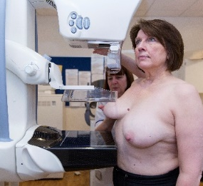
Thank you for coming to your recent NHS breast screening test.
We are inviting you to come back for another test because the images we took of your breasts were not very clear.
This does not mean anything is wrong.
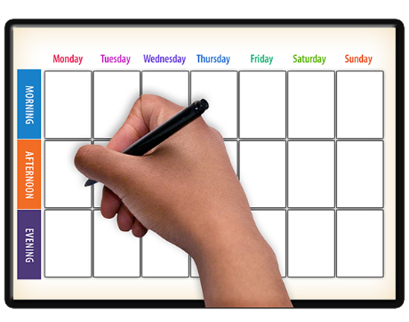 | Your appointment is at:  Click here to enter text.  on  Click here to enter text.
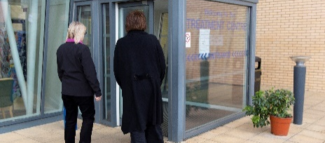 | You can bring a friend or carer with you.
Call Click here to enter text if you:
- want to change the appointment to a different time or place
- will need some extra help at your appointment
- want more information or to speak to a breast care nurse before your appointment
 | For more support, call your learning disability team on Click here to enter text.
Yours sincerely,

