Recall to assessment easy read letter template. Use screening centre headed paper. This letter includes text boxes to be completed before sending.

Dear Click here to enter text.
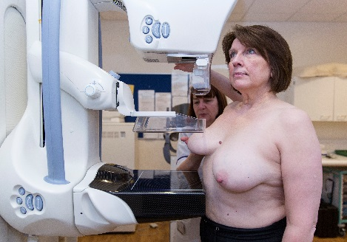
Thank you for coming to your recent NHS breast screening test.

We are inviting you to come for more tests at an assessment clinic.
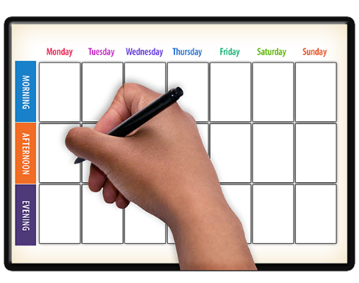
Your appointment is at
Click here to enter text.

on
Click here to enter text.

The appointment may take between
2 and 4 hours.
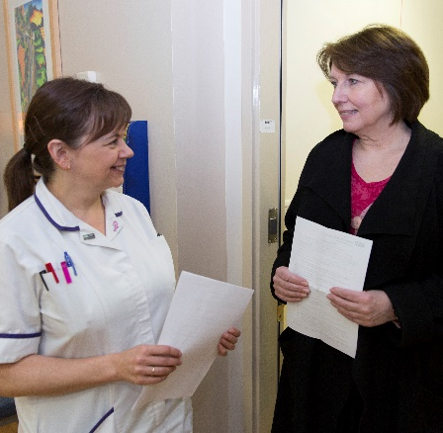
Some women need more tests at an assessment clinic before we can give them a screening result.

Most women who come to an assessment clinic do not have breast cancer.

But if more tests show that you might have cancer someone will talk to you about what will happen next.
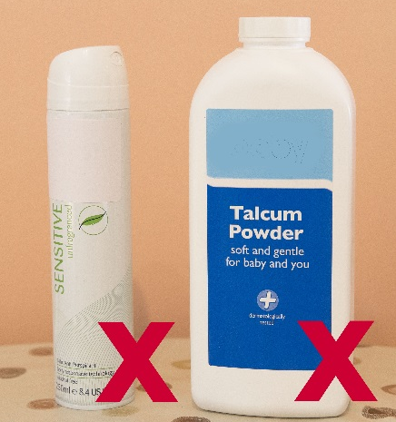 | Do not use talcum powder or a spray underarm deodorant before your appointment.  You can use a roll-on deodorant.
 | It is a good idea to wear a top with a skirt or trousers, so you only have to take your top off for the test.
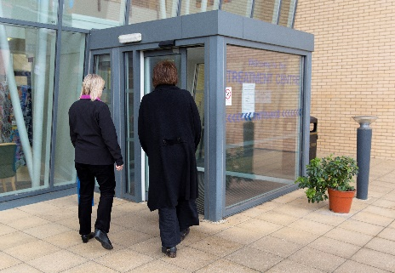 | You can bring a friend or carer with you.
Call Click here to enter text if you:
- want to change the appointment to a different time or place
- will need some extra help at your appointment
- want more information or to speak to a breast care nurse before your appointment

 | For more support call your learning disability team on Click here to enter text.

Yours sincerely,

