Normal result easy read letter template. Use screening centre headed paper. This letter includes text boxes to be completed before sending
Dear Click here to enter text.
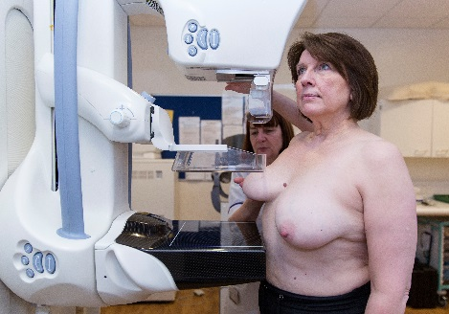

Thank you for attending your recent breast screening test.

Your results are normal.

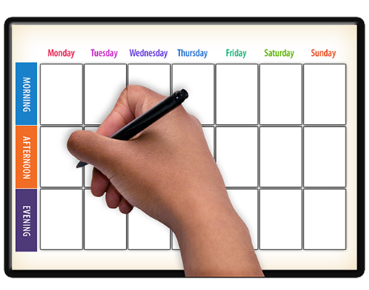

We will invite you for screening again 3 years from now.

We carry on inviting women until their 71st birthday.
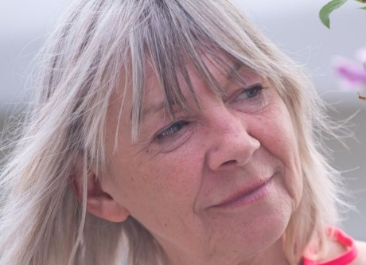 | If you are aged 71 or over, you can still have breast screening every 3 years.  But you need to call to book your test when you are 71 or over.  This is the number to call: add local service number.
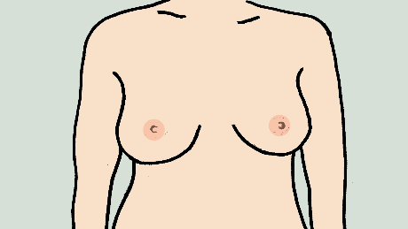 | It is important to get to know how your breasts normally look and feel.  You should speak to your doctor if you ever find anything unusual.
Yours sincerely,

