Committee on Standards in Public Life

Committee on Standards in Public Life
Room G07
1 Horse Guards Road
London
SW1A 2HQ
public@public-standards.gov.uk

Rt Hon Angela Rayner MP
Deputy Leader, Labour Party,
Shadow First Secretary of State,
Shadow Chancellor of the Duchy of Lancaster
Shadow Secretary of State for the Future of Work

Sent by email

6 June 2022

Dear Angela Rayner,

Thank you for your letter of 2 June letting me know that there will be an Opposition Day Motion, due to take place on 7 June, to discuss recommendations in our report Upholding Standards in Public Life. I note that you have written in similar terms to Lord Stunell, Sir Jeremy Wright MP, and Dame Margaret Beckett MP.

High ethical standards, and effective regulatory processes to maintain the standards expected, are integral to the operation of effective government. The Seven Principles of Public Life - honesty, integrity, accountability, openness, selflessness, objectivity and leadership - continue to define the public's expectations of conduct for all those in public office.

The evidence we heard during our review showed that the current system of ethics regulation is too dependent on conventions; that standards regulators in government are not sufficiently independent; and that government needs to take a more formal and professional approach to its own ethics obligations. We made 34 recommendations to government to address these gaps and concerns.

You will have seen my letter to Lord True responding to recent changes to the Ministerial Code and the role of the Independent Adviser on Ministerial Interests. We also published a blog expressing the Committee’s concern that the government has only implemented part of a package of recommendations that are mutually dependent.

We look forward to the government’s response to the recommendations in our report soon.

I am copying this letter to the Rt Hon Steve Barclay MP, Chancellor of the Duchy of Lancaster; Lord True, Minister for the Cabinet Office; and Darren Tierney, Director General, Propriety and Ethics Team, Cabinet Office. My office will publish this letter on the Committee's website later today.

Yours sincerely,
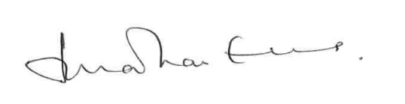

Lord Evans of Weardale KCB DL
Chair, Committee on Standards in Public Life

