Dear Adnan Khan,

I am writing to you to discuss a three part policy the government should implement to facilitate a fair transition from fossil fuels globally. I will define “fair” as being when no country's economic position is significantly worsened as a result of the transition. A country's “economic position” can be understood as a combination of GDP relative to others and domestic income/wealth inequality which will help to measure equitableness on the international and domestic level.

Fossil fuels contribute to 74% of all emissions in the world per year (U.S Energy Information and Administration, 2021) meaning the solution to the climate crisis has widely been suggested to be a transition away from fossil fuels. However, fossil fuels are deeply ingrained within most world economies, particularly in developing nations, and thus a badly thought through transition could widen global and domestic inequality.

The first central aspect to my suggestion is for the UK to galvanise the G7 and other allies to launch the initiative to create the International Development Group (IDG) which will create the International Fund for Environmental Development (IFED). The IFED will consist of employees specialised in managing money, development and green technology. Every year developed countries will donate a proportion of their GDP towards the fund. This money will then be collected and distributed to developing countries around the world depending upon the expected cost of transition. Experts at the IFED will work in conjunction with the developing nations to discuss the transition phase process and to provide skilled workers to aid domestic labour in fulfilling the plan.

In order to incentivise developing nations to participate, countries which are members of the IDG would agree that all trade deals made with developing countries would be contingent upon their participation and following through on transition plans agreed with the IFED. Thus creating a financial incentive to go through the transition.

Developed nations will be politically incentivised to join the IDG . Statistics show that 76% of adults in the UK are concerned about climate change (Tanna, Edser and Davis, 2021), 67% of Americans think The Federal Government is not doing enough to “reduce the effects of global climate change” (Funk and Kennedy, 2020) and 44% of Germans are extremely worried about the climate (Timperley, 2017). Thus, changing demands of the electorate within developed nations, along with international pressure, will likely act as a strong political incentive for politicians to show they are taking actionable change in the global fight against the climate crisis by joining the IDG.

Finally, in order to incentivise developed nations to reduce fossil fuel emissions themselves the UK could implement the EUs plan to impose carbon taxes on imports. It is likely this would lead to retaliatory import carbon taxes by other countries, creating a widespread standard carbon import tax across the world. Members of the IDG would agree not to tax developing nations. The financial incentive for firms in developed countries to use high carbon footprint production methods (HCFPM) would decrease thus causing an increase in substitution of HCFPM for low carbon footprint production methods. This leads to an increase in demand for the latter which would likely increase supernormal profits for firms producing renewable energy, sustainable materials etc. These profits could be reinvested by these firms to improve dynamic efficiency resulting in cheaper and better products shown in diagram 1 via an outward shift of firms marginal cost curves. This trickle down effect could boost the pace of transition for developed countries (by increasing the rate of innovation) and make the transition of developing countries cheaper to implement.

Diagram 1
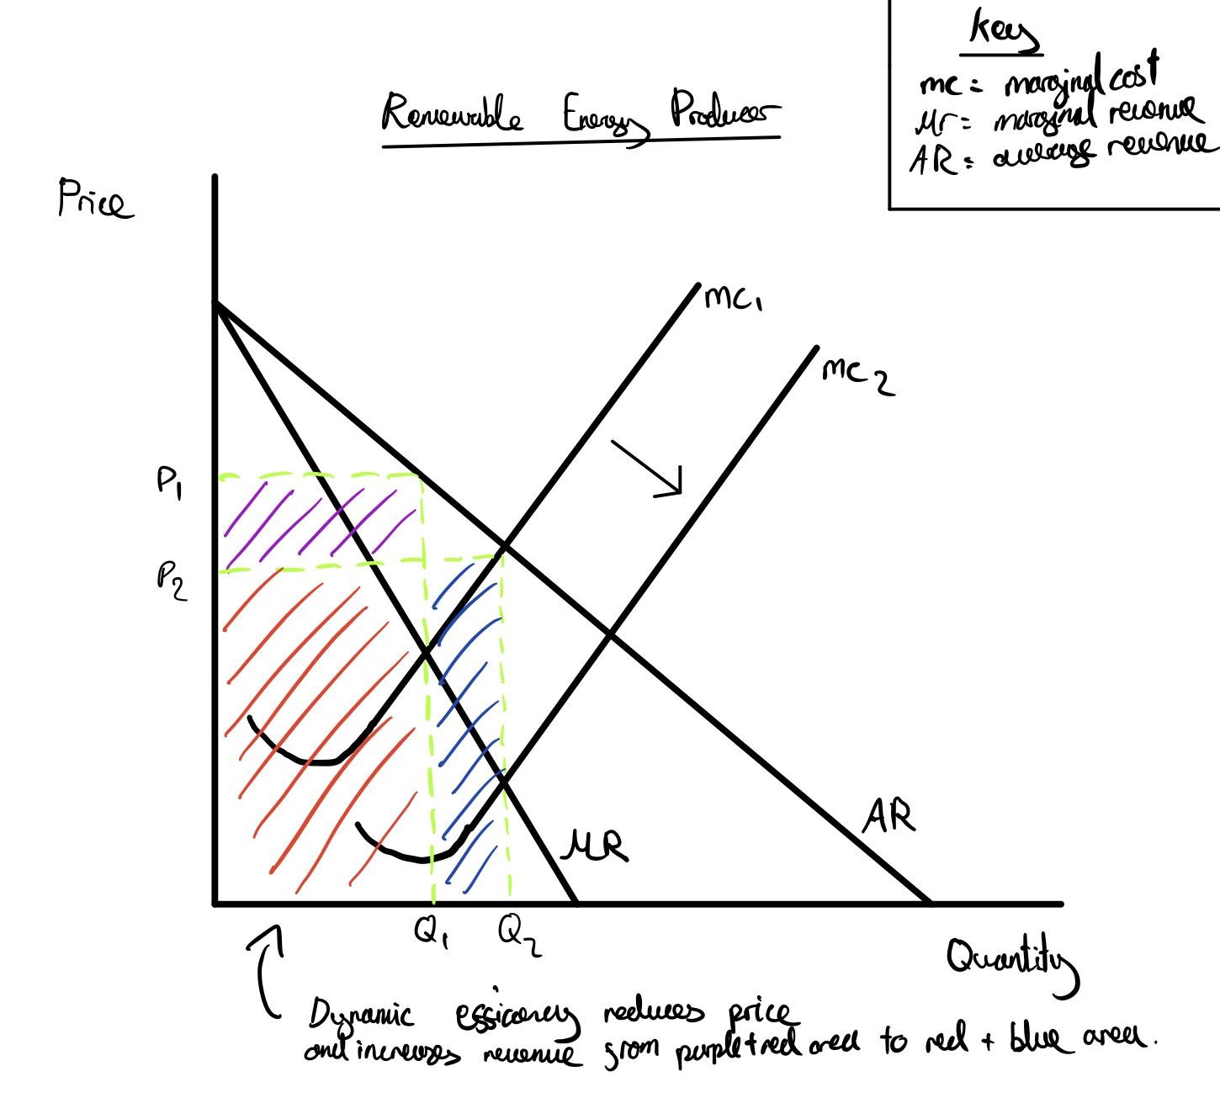

I believe this suggestion is substantially fair because developing nations will have a lengthier and more costly (relative to GDP) process of transition than developed countries due to lower labour skill, worse infrastructure etc. The developed nations giving out a subsidy counter this disadvantage by taking on some of the burden. The imposition of the tax is arguably fair because developed nations who it affects the worst are nations which have likely chosen to not invest in green technology as much in the past, making the cost of the tax an additional incentive for those nations to change rather than an unjust punishment.

However, I recognise aspects of my suggestion are not all fair; the imposition of a carbon tax on imports will disproportionately affect low income consumers and small businesses but this tax will likely a) not be large enough to significantly widen domestic inequality and b) is intended to be a temporary innovation catalyst feature. Furthermore, the question of what is “fair” is subject to change person by person which could alter the approach to a “fair” transition. Regardless, this suggestion is a way of minimising the magnitude of winners and losers such that the transition maintains the same general respective economic positions of countries as before, substantial enough to be “fair”.

Yours Sincerely,

Blake Merriman

Bibliography

- Funk,C. and Kennedy,B. (2020) How Americans see Climate Change and the Environment in 7 Charts. Available at: https://www.pewresearch.org/fact-tank/2020/04/21/how-americans-see-climate-change-and-the-environment-in-7-charts/ (Last Accessed: 17 February 2021). Comments: Some of the data collected in this article was done in fairly small survey groups (around 3,700 participants) making data used potentially unreliable. However, the source states that surveys amongst other information were used to create the tables making the results likely more accurate. Overall, the source (Pew Research Centre) is reputable and non biased.

- Tanna,P., Edser,K and Davis,J. (2021) Data on Public Attitudes to the Environment and the Impact of Climate Change, Great Britain. Available at: https://www.ons.gov.uk/peoplepopulationandcommunity/wellbeing/datasets/dataonpublicattitudestotheenvironmentandtheimpactofclimatechangegreatbritain (Last Accessed: 16 February 2021). Comments: The Data was produced by the ONS which tends to create highly reliable, non biased datasets thus making this data very reliable.

- Timperley,J. (2017) Germans Most Worried About Climate Change, Analysis Shows. Available at: https://www.carbonbrief.org/germans-worried-climate-change-analysis-shows (Last Accessed: 18 February 2021). Comments: Source is slightly outdated now (roughly five years old) which could cause for the figures stated about the extent to which Germans are worried about climate change to be understated (since the climate crisis has worsened over recent years). Source is the “Carbon Brief” which is a reputable source winning many awards for investigative journalism and data visualisation. There seems to be a weak to no political agenda in this source making the data given still very reliable.

- U.S. Energy Information and Administration. (2021) Energy and the Environment Explained. Available at: https://www.eia.gov/energyexplained/energy-and-the-environment/where-greenhouse-gases-come-from.php (Last Accessed: 18 February 2021). Comments: The EIA is an independent Statistics and Analysis Institution purely providing an informative service (with no ties to fossil fuel companies) making this source less likely to intentionally over or understate data on the impact of fossil fuels on CO2 emissions. Thus, this source is very reliable.

