High Income Child Benefit Charge Research
HM Revenue and Customs Research Report 644
Qualitative research with customers


Authors: Helen McCarthy, Emma Forsyth, Nilufer Rahim and Joshua Vey
Date: 31.05.22
Prepared for: HMRC
Acknowledgements
The research team would like to thank Stevie McGuinness, Kylie Wade and Rhiannon Hardy for the expert advice and support they have offered throughout this research study.

We would also like to express our gratitude for the work of Georgia Lucey, Kate Belcher, Alina Fletcher, Eliska Holland and NatCen’s Telephone Unit in engaging and interviewing research participants and carrying out data management.

Finally, we would like to acknowledge the 48 individuals who made this research possible by sharing their time and insights with us.

Disclaimer
The views in this report are the authors’ own and do not necessarily reflect those of HM Revenue & Customs.

© Crown Copyright 2022
Copyright in the typographical arrangement and design rests with the Crown. This publication may be reported free of charge in any format or medium provided that it is reproduced accurately and not used in a misleading context. The material must be acknowledged as Crown copyright with the title and source of the publication specified.
Published by HM Revenue and Customs, May 2022
www.hmrc.gov.uk

Contents

1 Introduction 6
1.1 Context for the research 6
1.2 Research aims and methods 7
1.3 Interpreting the findings 7
2 Participants’ circumstances 8
2.1 Participants’ circumstances 8
2.2 Child Benefit and HICBC customer journeys 9
3 Enablers to compliance 11
3.1 Methods of compliance 11
3.2 Enablers to compliance 12
4 Barriers to compliance 17
4.1 Main barriers to compliance 17
5 Supporting customers to pay the charge 26
5.1 Participants’ suggestions for support 26
5.2 Identifying areas of support using COM-B 27

Tables
Table 1:1 Sample breakdown by compliance group 7
Appendix table A:1 Sample breakdown by additional primary characteristics 31
Appendix table A:2 Sample breakdown by secondary characteristics 31

Figures
Figure 2.1 HICBC compliance pathways 10
Figure 3.1 Enablers at different stages of compliance 12
Figure 4.1 Barriers to compliance 17
Figure 4.2 Barriers at different stages of compliance 18
Figure 5.1 COM-B model for HICBC 27

Executive summary

Introduction and approach

This report presents the findings from qualitative research with HMRC customers who are liable for the High Income Child Benefit Charge (HICBC). Using 48 in-depth interviews, the research sought to understand the factors underpinning customers’ responses to the charge and to help HMRC support and guide customers to understand and meet their liability.

The sample of research participants included couples and single parent families with an active Child Benefit claim. They had either fully met their HICBC liability in tax years 2017-18 and 2018-19 (the compliance period) or had not fully complied with the charge. They were mainly employees who were paying income tax through ‘Pay As You Earn’ (PAYE), with more limited representation of people whose main tax payment method was via Self-Assessment. Reflecting their liability for the charge, at least one person per household was earning over £50,000 during the compliance period, though the composition of participants’ pay ranged from stable and straightforward (i.e. receiving the same income each month) to complex (i.e. made up of different parts) and fluctuating.

Key findings

Enablers to compliance
Customers can meet their liability for HICBC by opting out of payments or by paying the tax charge through completing a Self-Assessment tax return. The method participants chose was influenced by their perceptions of convenience (the desire to avoid additional administrative burden) and the implications on their financial situation, including the prospect of financial gain.

A range of factors contributed to customers meeting their liability, but the research identified two key enablers.
- Firstly, it was vital that participants were aware of the charge and their liability at the point of becoming liable.
- Secondly, participants needed to understand that it was their responsibility to take action, know the rules around liability and income thresholds, and understand the steps they needed to take.
Participants who had met their liability had gained this level of awareness and understanding either through proactively seeking out further information or from HMRC communications, such as letters or reminders, which informed their response.

A stable and straightforward income and familiarity with the Self-Assessment process, were identified as additional factors in enabling customers to meet their liability.

Customers were motivated to meet their responsibility, even where they did not agree with the policy. They spoke of the desire to do the right thing by paying the charge as well as avoid negative consequences from HMRC.

Barriers to compliance
For participants of this research, non-compliance was not an active or intentional decision. Customers were motivated to meet their liability, regardless of their views of the charge, but they faced barriers at different stages of their journey. The research identified four main barriers which led to customers either failing to take action in relation to the charge, taking action too late or making errors when taking action. It was common for customers to experience multiple barriers at different stages of their customer journey, which sometimes led to repeated errors. The main barriers were:
- lacking awareness of the charge, sometimes several years into building up the charge;
- not accurately understanding important details of HICBC or Child Benefit e.g. that it is the customer’s responsibility to notify HMRC or that Child Benefit is paid every four weeks;
- not understanding the process of complying e.g. completing Self-Assessments, paying through tax code adjustment or opting out; and
- having complex earnings in the form of composite or fluctuating incomes leading to errors in accurately paying the charge.
For customers with no prior experience of paying tax through the Self-Assessment process, the timeline around the tax year and the level of information needed, added complexity to the process, particularly for those who were time-poor and who assumed that HMRC already held information on their income. Participants were often unaware of problems with their Self-Assessment until contacted by HMRC about the issue.

Participants reported that communication from HMRC could sometimes exacerbate these barriers, particularly where initial letters were not perceived to be targeted or clear, or communication about ongoing compliance was delayed. However, communication from HMRC was also perceived to be a helpful source of support by participants who did not understand their role, who lacked confidence in their capability, or, who needed to organise a payment plan to pay the charge they owed.

Areas for further support
Participants made several suggestions on how support from HMRC could be improved based on their experiences. The study also used the COM-B model of behaviour change to identify what would help HMRC support customers to meet their liability. There were three key areas of focus for actions to improve customers’ capability.
- Raising awareness of the charge itself and key details: notifications from HMRC at different stages of the Child Benefit claim; messaging around key deadlines and communication through employers. The latter may help to promote awareness given social norms inhibit opportunities to discuss tax matters in an informal setting.
- Improving understanding of the process of meeting liability by ensuring customers have access to the help they need to pay the charge. Participants wanted clearer and more comprehensive information available online. Promotion of existing tools such as the Child Benefit tax calculator could help to meet this need.
- Enhancing communication from HMRC: communicating with customers around common errors would help customers to change their behaviour. Participants called for a more informative, supportive and empathetic approach from HMRC customer service representatives, with more joined-up working between departments and greater responsiveness in the form of swifter follow up communication. Whilst the findings suggest that those who had not fully met their liability wanted to comply with the charge, customers may feel less motivated if they lack confidence in dealing with tax issues or associate paying the charge with stress or anxiety. A supportive approach from HMRC staff could thus improve the ease with which customers engage with the charge on an ongoing basis.
Although the majority of customers do fully meet their HICBC obligations, those that do not may benefit from further support from HMRC. Strengthening the structures in place to ensure customers know about, understand and are sufficiently supported to pay the charge may help to enable compliance.

Introduction
This report presents findings from qualitative research with the High Income Child Benefit Charge (HICBC) population. This research was carried out by NatCen Social Research on behalf of HMRC. Using 48 in-depth interviews with customers liable for HICBC, the research sought to understand the differing behavioural drivers of compliance and non-compliance in this area, to help HMRC support and guide customers to understand and meet their liability for the charge.

Context for the research

The High Income Child Benefit Charge (HICBC) was introduced in January 2013. The HICBC is a tax charge that applies to anyone with an adjusted net income over £50,000 who receives Child Benefit, or whose partner gets it. The tax charge is equal to one per cent of the total Child Benefit received for every £100 earned over £50,000. For those with an adjusted net income in excess of £60,000, the tax charge is equal to 100 per cent of Child Benefit payments received. Individuals liable for HICBC must complete a Self-Assessment tax return each year and pay the charge they owe. Alternatively, families can choose to opt out of receiving Child Benefit payments, which means they are no longer liable for the charge. They will need to pay the tax charge owed on any Child Benefit payments received until that point.

Whilst the majority of customers do comply with HICBC by paying the charge or opting out of payments, since its introduction, HMRC has identified several risks of non-compliance relating to levels of awareness and understanding of HICBC. This includes customers claiming Child Benefit but failing to register for Self-Assessment to pay HICBC, or, omitting the charge from their Self-Assessment tax return (intentionally or in error). In addition, some individuals decide not to claim Child Benefit at all, rather than claiming and opting out of receiving payments. HMRC encourage families to claim Child Benefit to keep the non-monetary benefits, even where HICBC applies. HMRC has undertaken activity to raise public awareness of these non-monetary benefits which include receiving National Insurance (NI) credits which count towards the State Pension and children automatically receiving a NI number before their 16th birthday.

Existing qualitative and quantitative research commissioned by HMRC has both strengthened the evidence base on HICBC compliance behaviours and informed development of the Child Benefit claim system, guidance and communications.
- The Child Benefit customer survey (HMRC, 2017) found that 50 per cent of respondents were aware that if their (or their partner’s) income exceeded a set threshold they may be required to repay some or all of their Child Benefit, but only 14 per cent knew it was £50,000. The two most common reasons driving compliance related to financial gain and convenience.
- Qualitative research with parents who were liable for the charge highlighted a number of common misconceptions related to HICBC (HMRC, 2018). Some incorrectly believed they were no longer eligible for Child Benefit. Some were not aware that it was their responsibility to inform HMRC when their income rose above the threshold. Awareness of the difference between claiming Child Benefit and receiving payments was low, including the option of claiming and then opting out of payments.
- HMRC commissioned research with parents to explore their views and responses to a redesigned front page for the Child Benefit claim form (HMRC, 2019). The research found that the decisions of parents with an adjusted net income below £60,000 were motivated by financial gain. Including a statement which emphasised the link between compliance and contact from HMRC was felt to be particularly effective in encouraging action.
Despite increased activity by HMRC to help customers to comply with HICBC, there is evidence of some groups of customers returning to non-compliance following an intervention from HMRC. Supporting customers to comply with HICBC therefore remains a priority for HMRC. This study builds on the existing research to fill gaps in the evidence base and provide a more detailed picture about the compliance behaviours associated with the tax charge.

Research aims and methods

The research aimed to answer the following research questions:
- What are the behaviours and motivations of customers who comply with HICBC and those who fail to comply, in some cases repeatedly?
- What are the barriers and enablers to compliance? What would motivate compliance among those who fail to comply?
- What do customers understand about HICBC and what they need to do?
- What support or guidance have customers received or accessed? What further support or guidance is needed?
The research used a qualitative approach to answer these questions. It consisted of 48 in-depth interviews, lasting approximately 45 minutes, with customers liable for HICBC, which took place by telephone or using video-conferencing software. Interviews took place between January and March 2021. A breakdown of the achieved sample is shown in Table 1.1, with further details in Appendix B. The five compliance groupings relate to actions which occurred in tax years 2017-18 and 2018-19 – this is referred to as the ‘compliance period’ in the rest of the report.

Table 1:1 Sample breakdown by compliance group
Non-compliant |  | Compliant
1 Never complied with HICBC | 12 | 4 Compliant and opted out | 6
2 Complied after compliance activity but returned to non-compliance | 12 | 5 Compliant and paying the charge | 6
3 Non-compliant but are acting to address obligation | 12

Interpreting the findings

The report avoids giving numerical findings, since qualitative research cannot support statistical analysis. This is because purposive sampling seeks to achieve range and diversity among sample members rather than to build a statistically representative sample. The questioning methods used are designed to explore issues in depth within individual contexts rather than to generate data that can be analysed statistically. What qualitative research does do is provide in-depth insight and explanation into the range of experiences, behaviours, views and suggestions. Wider inference can be drawn on these bases rather than on prevalence.

Verbatim quotations and case illustrations are used to illuminate the findings. They are labelled to indicate customers’ compliance subgroup, and their self-reported income band and main tax payment method. Further information is not given to protect the anonymity of research participants. Quotes and case illustrations are drawn from across the sample.

Participants’ circumstances
This chapter introduces the participants of the research, outlining wider circumstances and characteristics relevant to the charge. It then sets out the range of pathways taken by these customers that led to different HICBC compliance behaviours.

Participants’ circumstances

Household composition

The sample of interview participants included both couple and single parent families with one to four children. These families had an active Child Benefit claim, though some had opted out of receiving payments. The sample consisted of all parents, as opposed to stepparents or other adults with responsibility for children. Family circumstances had remained largely stable over the years, albeit with some relationship breakdown. In this way, for the participants of this research, changes in liability for HICBC related to changes in their income rather than changes in family circumstances (i.e. moving in or splitting up with a partner who claimed Child Benefit or earned over the HICBC income threshold).

Employment and earnings

The sample consisted mainly of people who were employees. They were in senior professional jobs, and their earnings had risen steadily over the preceding years. The sample included some self-employed participants who were business owners or who earned additional income ‘on the side’. However, due to the smaller sample size of self-employed participants, the insights from this group are more limited.

The sample was made up of single and dual income families. During the compliance period (tax years 2017-18 and 2018-19) being explored in this research, participants were in employment and tended to be working full-time hours. More recently some participants had been furloughed or lost their jobs because of the COVID-19 pandemic, but this was not relevant to the compliance behaviour discussed in this report.

Reflecting liability for the charge, participants earned between £50,000 and £60,000 or over £60,000 during the compliance period. Their earnings were employment-related, but some brought in additional income from rental properties. Participants generally described their financial situation as comfortable during the compliance period, unless they had substantial outgoings such as large mortgages, debts or other expenses which meant their incomes were more stretched.

There was notable complexity in the composition of participants’ pay. In some cases, this had implications for participants’ understanding of their liability for HICBC or for the accuracy with which they reported their incomes. This is discussed further in Chapter 4. Participants’ salaries fell into three main groups in relation to both composition and stability.
- Basic income: One group had a stable and predictable income made up of their basic salary only.
- Composite income: A second group received additional benefits or allowances on top of their basic salary, for example, for fuel costs. They did not always realise that these allowances are included in the calculation of adjusted net income.
- Fluctuating income: A third group had fluctuating and less predictable incomes which varied each month depending on overtime, commission, bonuses, or profits. These extras, combined with basic salaries, could increase income beyond HICBC liability thresholds.

Tax payment methods and experiences

Reflecting that the sample mainly consisted of employees, PAYE was the main tax payment method for participants of this research. As a result, experience in completing Self-Assessment tax returns was very mixed.
- One group of participants were Self-Assessment ‘first-timers’ who only completed a Self-Assessment to meet their liability for HICBC.
- A second group had prior experience of Self-Assessments to varying degrees. Where they had more experience this was because they regularly reported rental, self-employed income, or work-related allowances in a Self-Assessment. Others had more limited direct experience because they used an accountant to report other income through Self-Assessment; had helped partners to complete a Self-Assessment or had completed returns many years ago.
Views of the Self-Assessment process were mixed, both among first timers and prior users, as was the picture in relation to compliance behaviour.

Child Benefit and HICBC customer journeys

Child Benefit claims

Uses of Child Benefit included either putting payments away into children’s savings and trust funds or using payments to meet the additional costs of bringing up children. Decision-making about claiming Child Benefit, as a perceived ‘universal entitlement’ was generally very straightforward, though the decision varied in terms of how active it was, with some participants claiming because they perceived a need for the extra income while others had simply applied as it was the ‘done thing’.

Overall, the non-monetary benefits of claiming Child Benefit did not tend to feature in decision-making due to limited awareness of them. The exceptions to this were participants whose partners had given up work or reduced their hours and who were motivated to claim Child Benefit because they were aware this would contribute to their state pension.

HICBC customer pathways

Figure 2.1 illustrates the compliance pathways for participants of this research.

Figure 2.1 HICBC compliance pathways
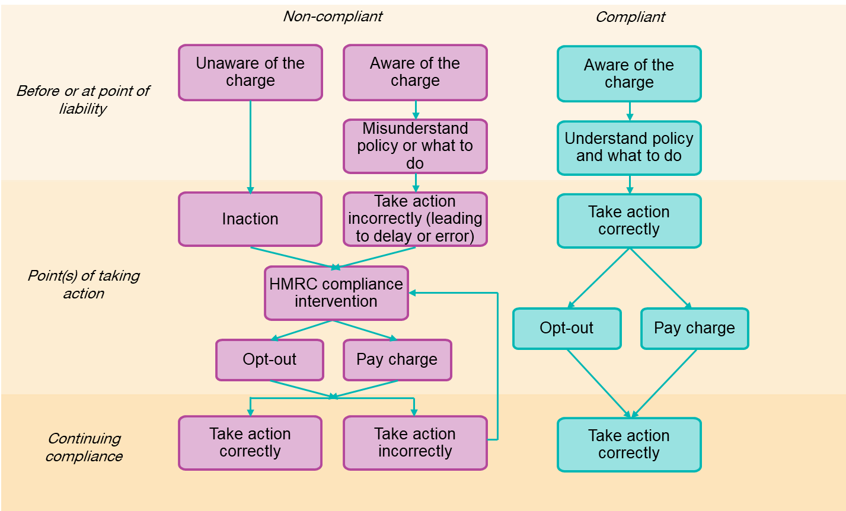

Some customers were already earning over the £50,000 threshold when the charge was introduced, or when they started their claim, while others became liable afterwards. Some participants were unaware of HICBC when they became liable and continued their claims until they received a compliance intervention from HMRC. Other customers were aware of HICBC and went on to make a Child Benefit claim or continue receiving payments for existing claims knowing they would need to repay all or some of the benefit via the tax charge.

At the point of needing to act, participants who complied with the charge had sufficient understanding of the policy to comply correctly by either opting out or paying the charge. Other customers who were aware of HICBC acted incorrectly (through error or delay) due to misunderstanding the policy or process. This led to a compliance intervention from HMRC which in turn led to sustained compliance or repeated non-compliance if action was again taken incorrectly.

Enablers to compliance
This chapter describes the key factors that enabled customers to meet their liability for HICBC. It draws on interviews with participants who had complied with HICBC, either by opting out of Child Benefit payments or by paying the tax charge.

Methods of compliance

Customers who are liable for HICBC can address their liability either by choosing to receive Child Benefit payments and pay any tax charge owed at the end of each tax year, or by not getting Child Benefit payments but keeping their claim active – known as opting out. These options, including the reasons why customers chose a particular approach, are discussed in turn below.

Paying the charge

Participants who had paid the charge had done so by completing a Self-Assessment tax return, and then had chosen either to pay the charge outright or had decided to pay via their tax code. Participants who earned between £50,000 and £60,000 and paid the charge were mainly motivated by financial gain, both in terms of the Child Benefit money they were entitled to, as well as the interest earned on payments while the year.

Participants who earned over £60,000 and paid the tax charge were motivated by convenience. They paid the charge out of habit or because they were completing a Self-Assessment anyway for other reasons. There was also the view that continuity was important in case Child Benefit policies change in the future.

“Once you started doing it, it's a habit and you just carry on doing it. So it's probably, yes, maybe a bit of laziness to say, okay, we don't need it anymore, so let's not take it, but once you've just got a system in place and you're used to doing it, it's easier to just stick to it than change something.”
P40, Group 5, Both PAYE and SA, £60,000+
Others earning over £60,000 and continuing to get payments and pay the tax charge were motivated by the (incorrect) belief that they had to do this to continue to receive the non-monetary benefits of Child Benefit. In one example, discussed below in case illustration 3.1, this misunderstanding led to a customer electing to receive payments after previously opting out.

Opting out

For participants who opted out, their decision was largely driven by the knowledge that they would not gain anything financially (all had an individual income more than £60,000). A further motivation for opting out was to avoid the administrative burden associated with paying the charge. Participants mentioned the financial management needed to pay back what they owed at the end of the year and the paperwork involved in completing a tax return.

“The decision to no longer claim was fairly easy in that we would not keep any of it. This is my understanding, anyway. We wouldn't get any benefit from it, we weren't close to getting any sort of tapered benefit, so we just looked for the easiest way of dealing with it. The easiest way of dealing with it seemed to be to find the form saying we didn't want to receive it in the first place.”
P43, Group 4, Both PAYE and SA, £60,000+
Opting out of payments was widely described as the simplest and easiest option and, whilst recall was limited, generally participants said that the process of opting out had been straightforward. They had either called the Child Benefit helpline or filled out a form (both post and online forms were mentioned).

Reflecting previous research with customers, there was a lack of understanding of the difference between claiming Child Benefit and receiving payments. The term ‘claim’ was felt to be synonymous with the latter, and so participants who had opted out were not always aware that they continued to have an active Child Benefit claim, and therefore still qualified for the non-monetary aspects of Child Benefit. This is illustrated in case illustration 3.1.

Case illustration 3.1: Misunderstanding the difference between stopping payments and ending their claim. P41, Group 4, PAYE, £60,000+.

The customer was aware that by claiming Child Benefit they would qualify for National Insurance credits. They therefore decided to start receiving payments again after previously opting out. They did not realise that by opting out of payments they would still have an active claim and therefore qualify for the non-monetary benefits of Child Benefit.

Enablers to compliance

There were a range of factors that enabled customers to meet their liability, which came into play at different stages of their journey (as illustrated in Figure 3.1). Below each enabler is discussed in turn, however, it is important to note that in most cases a range of factors came into play, and for each individual a different combination of factors worked together to enable compliance.

Figure 3.1 Enablers at different stages of compliance
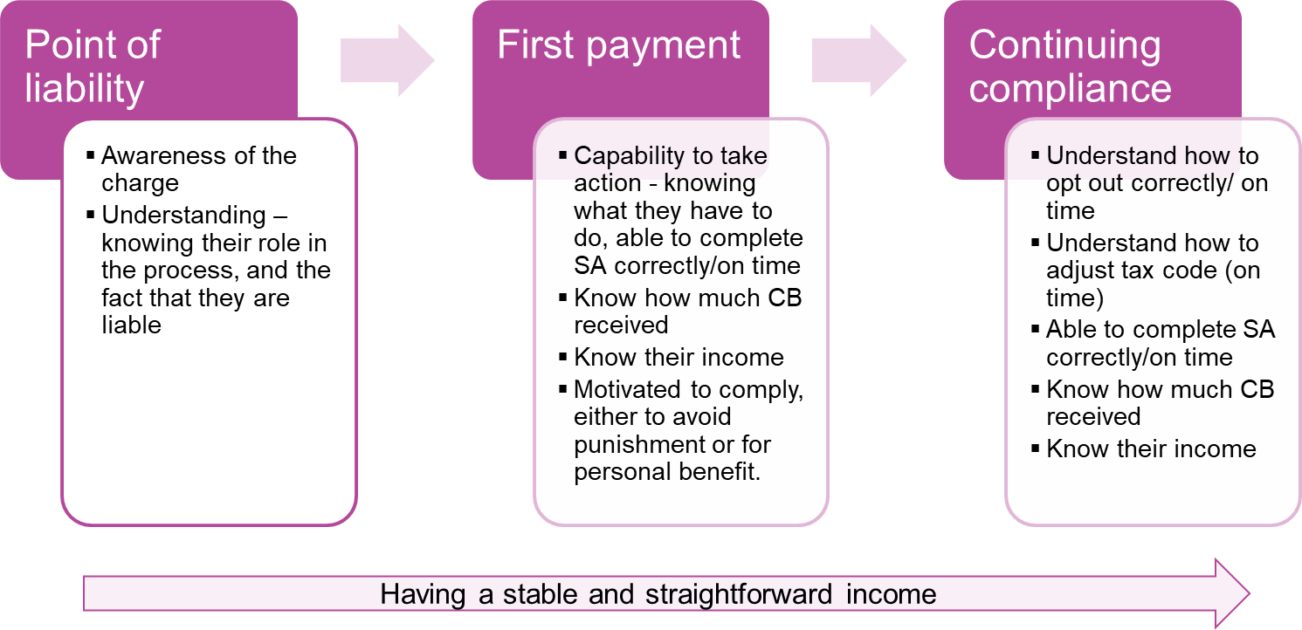

Awareness and understanding

The research identified awareness and understanding of HICBC to be two important, interlinked enablers to compliance. As shown in Figure 3.2 below, being aware of the charge was essential at the point of becoming liable. It was then important for customers to understand their role and what they needed to do to comply.
Figure 3.2 Role of awareness and understanding
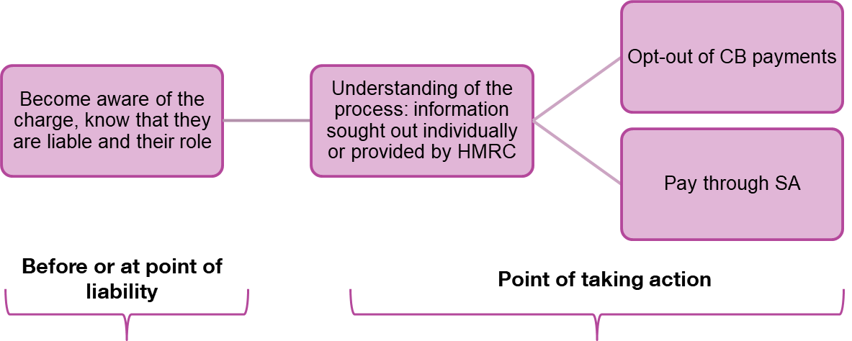

Awareness

Being aware of the charge, either before becoming liable or at the point of liability, was an essential first step in the compliance journey, and participants reported learning about HICBC through a range of sources, depending on when they had started their Child Benefit claim.

For participants who had opened a claim after the introduction of the charge, the main source of awareness had been the workplace. As illustrated by case illustration 3.3, this, combined with a proactive response, enabled compliance.

Participants who started their claim prior to the introduction of the charge became aware of it either through direct communication from HMRC or from the media coverage at the time of its introduction. Where media coverage had been the main source of information, participants reported proactively following the news and politics. This can help to explain why some customers became aware of the charge at the time, and others did not.

Case illustration 3.3: Heard about the charge and kept an eye on their income. P41, Group 4, PAYE, £60,000+
This participant started claiming Child Benefit in 2014, at which point they earned below £50,000. They had heard about the charge at work and so kept an eye on their income. Upon becoming liable in 2016, they immediately opted out of payments. The fact that they knew about the charge before they became liable and proactively monitored their income enabled them to comply first time, with no outstanding charge to be paid. “I just knew that it was something I needed to action.”

Understanding

Awareness was vital but did not alone result in compliance. The findings indicate the importance of customers understanding certain aspects of the charge, most notably the following principles.
- Liability and thresholds – participants who had met their liability understood the basic elements of the policy, including that the charge is based on individual earnings, and that people are liable to pay the charge on a sliding scale between £50,000 and £60,000, before paying back the full amount when above £60,000.
- Their role in the process – understanding that it was their responsibility to contact HMRC and take action was a key enabler. Having this knowledge prevented non-compliance, which occurred where customers had wrongly assumed that they would simply be contacted by HMRC if and when they were liable (see Chapter 4).
“You have to stand up and say it yourself. I know some people who have tried to say, 'I'm not paying it because I don't earn it,' and then their husband gets fined later on because he hasn't put in for it.”
P45, Group 4, SA, £60,000+

The fact that participants who had complied demonstrated good understanding of these two principles highlights their importance for compliance. However, the research found that a full and accurate understanding of all aspects of the charge was not essential for compliance. In particular, the difference between ending a claim and opting out, the non-monetary benefits of Child Benefit and the options for ways of paying the charge were less clear to some participants. For example, among participants who completed a Self-Assessment and paid the charge through their tax code, there was mixed understanding of exactly how this worked. In one case, the participant had successfully paid the charge this way but was nonetheless unclear about how it worked.

“I see an amount on my tax code notice, but I do not understand how that amount is calculated.”
P39, Group 5, Both PAYE and SA, £50,000-£60,000

Gaining awareness and understanding

The research identified two main ways compliant customers gained the level of awareness and understanding needed to comply (illustrated in Figure 3.2). The first was by seeking out further information on the charge from both government (such as the Gov.uk) and external sources (such as financial advice websites). Customers described doing this for various reasons, including to find out whether they were liable and what they were required to do. Doing so helped them to comply, as demonstrated in case illustration 3.4.

Case illustration 3.4: Seeking out further information. P37, Group 5, PAYE, £50,000-£60,000
The customer was aware of HICBC at the time it was introduced as he follows the news closely. However, he was not liable at the time. A couple of years later, the participant realised he had become liable when he received his P60. He sought out guidance about what he needed to do, using Gov.uk in the first instance, followed by MoneySavingExpert.com, which helped to explain things in a clear and accessible way. “The government website to start with. You start there and then when that doesn't make sense, I find Money Saving Expert is pretty good, talking about it in more sensible chunks.”

For a second group of participants the support and guidance they received from HMRC, which included letters or reminders, was a key facilitator to compliance. Participants had either received correspondence before becoming liable (described in case illustration 3.5) or at the point of taking action. The latter, for example, occurred where a participant had received a reminder to submit their Self-Assessment. In this case the correspondence from HMRC had directly prompted compliance.

Case illustration 3.5: Receiving support and guidance from HMRC. P47, Group 4, PAYE, £60,000+
The customer became liable in 2014-15. They continued to receive payments and paid back the charge when earning below the upper threshold, and opted out when their income rose above £60,000. The customer received a letter at the time they became liable outlining the options and thus had the information needed to make an informed decision. “I remember the key messaging at the time was that you could, you had the choice to opt out or you had the choice to still receive it, but then it would be taken back through your tax”

Income and tax situations
There was evidence that having a simple and predictable financial situation made it easier for customers to complete the Self-Assessment and therefore acted as an enabler to compliance.

“It's a long form, but for me, most of it, it doesn't apply because I don't have various bits of pots of income”
P44, Group 5, Both PAYE and SA, £60,000+
Where compliant participants’ income and tax situations were more complex, there were other factors related to participants’ income and tax situations that helped them complete the Self-Assessment correctly and on time. These included:
- having some prior experience of Self-Assessment or seeking out guidance on the process. Across the sample there were mixed views on the Self-Assessment guidance provided on the Gov.uk website, but one view was that this was a good first port of call, and the fact the process was digitalised was also viewed favourably; and
- using strategies to manage the process, and reduce the risk of errors, such as keeping information related to finances in one place. Participants also mentioned keeping Child Benefit payments in a separate bank account to ensure they could pay the charge at the end of the year.

Motivations

The findings indicate that whether customers wanted to comply or not was a less influential factor in participants’ decision to comply. Once aware of the charge, participants who had been non-compliant expressed similar motivations.

Extrinsic motivations, where action is taken due to an external threat, were widely evident in participants’ accounts. They spoke of the desire to avoid owing money to HMRC and receiving fines or penalties. Such enforcement measures were mentioned in relation to HMRC campaigns around Self-Assessment deadlines, and to other types of tax which they also paid to avoid consequences,

“It's like Council Tax, why do you pay it back? You have to pay it or you go to prison, and I find that with HMRC, you can't owe them money because you might get a big lump sum taken out of your next pay packet.”
P40, Group 5, Both PAYE and SA, £60,000+
Intrinsic motivations, where action is taken because of the internal desire to do so rather than any external threat or reward, played a secondary role in compliance. There were examples where participants stated that they had wanted to do the right thing and follow the rules.

“I'm earning a high wage, so therefore it’s right and proper, in a sense, fairness; fairness is important to me.”
P44, Group 5, Both PAYE and SA, £60,000+

Views and perceptions of HICBC

Customers who had always complied did not necessarily support the HICBC policy, which suggests that positive perceptions are not essential for compliance. Views of the policy were, like motivations, largely comparable among both customers who had and had not met their liability correctly. This included the view that it was unfair for the threshold to be based on individual earnings rather than household income.

“I feel annoyed that I asked for the money for my kids so that I can give them extras, and then my husband is having to do a Self-Assessment and give it all back.”
P45, Group 4, SA, £60,000+
Customers had nonetheless complied, for the other reasons discussed in this chapter. In some instances, participants did not hold a strong view on the policy and accepted that as higher earners they were not entitled to keep the payments. Where this was the case it is likely that their view on the charge was one of multiple factors enabling compliance.

The way that participants conceptualised the charge in some cases also influenced their response. In one example, a participant had interpreted the policy to mean that they were no longer entitled to Child Benefit payments, this was influential in their decision to comply by opting out.

“I didn't really think of it as a charge, I just thought it was the benefit being stopped.”
P43, Group 4, Both PAYE and SA, £60,000+

Barriers to compliance
This chapter explores the barriers that prevented customers from fully meeting their liability. It begins by describing the different ways people failed to meet their liability before discussing each barrier in detail.

Main barriers to compliance
Across the sample, there were three main ways in which participants had not met their HICBC liability. Customers had either:
- failed to meet their liability initially but had fully paid the charge following a HMRC intervention;
- failed to meet their liability initially, had paid the charge following a HMRC intervention, but had subsequently failed to fully pay the charge on another occasion and returned to some degree of non-compliance during the compliance period; or
- only partially met their liability during the compliance period.
These different journeys arose from customers failing or delaying taking action in relation to the charge, or making errors when complying. For participants of this research, failing to meet HICBC liability was not an active decision but arose as a result of the barriers discussed below. Moreover, participants were not always fully aware of having failed to meet their liability, suggesting that they were unaware of errors that had been made.

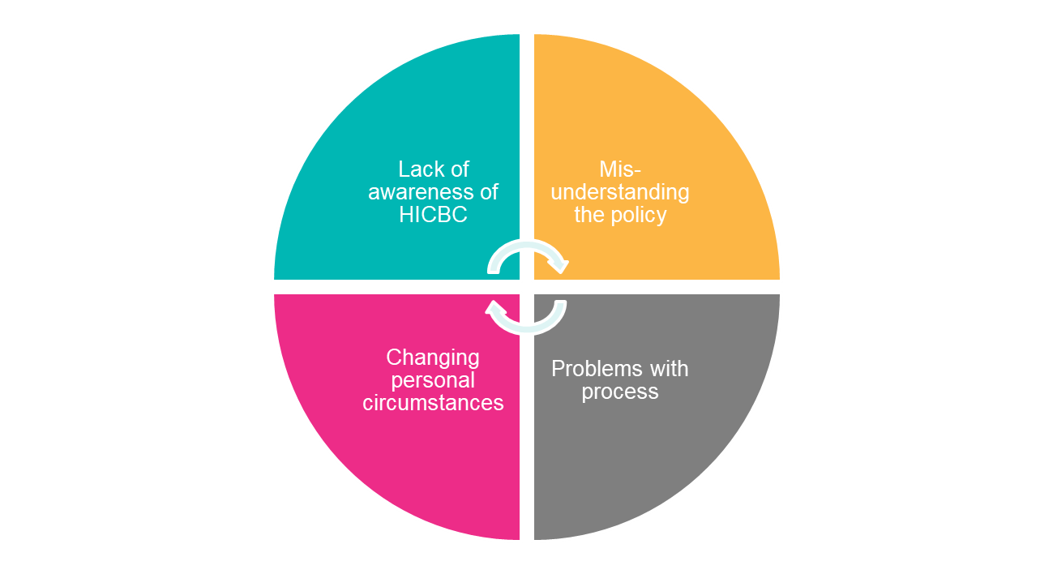
Four main barriers to compliance were identified, that could lead to different forms of behaviour: inaction, delay, or error. These were:
- lack of awareness of HICBC;
- misunderstanding of the policy;
- changing personal circumstances; and
- problems with the process.
These barriers to compliance, discussed in turn below, were often experienced in combination. As illustrated in Figure 4.2, underpinning these barriers were a range of obstacles that were experienced at different stages of the compliance process. When different barriers came into play at different stages of the process, this sometimes led to a return to non-compliance or made it harder for customers to fully meet their liability. This is explained further in this section, as are issues with communication from HMRC which could also exacerbate or alleviate these barriers.

Figure 4.2 Barriers at different stages of compliance
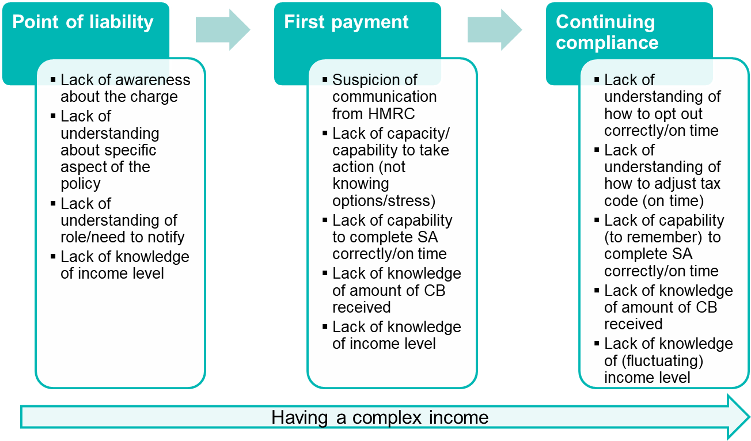

Lack of awareness of HICBC
Lack of awareness about HICBC was a key barrier to complying at the point of liability and led to inaction, as described below in case illustration 4.1. Typical cases involved customers who were completely unaware of the policy until they were contacted by HMRC regarding their liability, typically two to four years after they had become liable. This included participants who had started their Child Benefit claims both before and after the charge was introduced.

Customers who had started their claim prior to the introduction of the charge reported not having heard about it through any means, including in the press or from their employer. The fact that HICBC relates to pay and tax was reported to have inhibited people from talking about it in a social setting. However, there were also examples of customers who had heard about the policy in the news at the time of its introduction but had forgotten about it subsequently because they had not been in the income bracket to be liable at the time.

Those who had applied for Child Benefit or updated their claims more recently appeared to have had a greater level of awareness, suggesting that changes to Child Benefit claim forms have made some difference. In these cases, one of the other barriers, often linked to misunderstanding their role in notifying HMRC of their income (discussed below), had made it difficult for them to fully meet their liability.

Where awareness was the barrier, customers who were contacted by HMRC either went onto fully pay the charge or encountered further barriers leading to them only partially meeting their obligation.
Case Illustration 4.1: Lack of awareness of HICBC plus subsequent barriers linked to understanding of the process. P7, Group 1, PAYE, £60,000+
This customer was completely unaware of HICBC prior to being contacted by HMRC in mid-2017. The letter from HMRC was in reference to the customer’s liability in 2016-17 and several years prior to that, meaning he had accrued interest and penalties. The customer opted out of Child Benefit payments in 2017 when contacted and arranged a payment plan to pay back the amount owed. However, the customer still had to complete another Self-Assessment in 2019 for the few months in 2017-18 he had received Child Benefit payments. The customer encountered some issues paying this as HMRC reportedly sent a letter specifying a charge for the incorrect tax year. “I wasn't aware that there was any cap on it [Child Benefit] at all. (…) It was quite frustrating to then have to pay a penalty and the interest on it when I hadn't been aware. It was a genuine mistake.”

Misunderstanding the policy
Knowing about the charge did not always lead to people fully meeting their liability where the main driver of non-compliance was a lack of understanding of specific elements of the policy. Depending on the barrier this could lead to inaction, delay or error, such as underpayment of the charge.

A recurring theme was a misunderstanding of the customer’s responsibility around notifying HMRC about their liability. Instead, there was an expectation that HMRC would contact customers. In this way, letters from HMRC were interpreted as simply a notification.

“I'd seen stuff in the press around 6 months before and I thought well I don’t have to do anything as someone will tell me, was my assumption. This might have been the wrong assumption... but no one said I must get in contact or take action.”
P11, Group 1, PAYE, £60,000+
A lack of understanding could also extend to specific elements of the policy and lead customers to think HICBC did not apply to them. Examples included thinking that the charge only applied to new Child Benefit claims, not existing ones, or not understanding the thresholds for HICBC. Across the sample, there was broad understanding that there were two thresholds and that between the two there was a sliding scale at which point some Child Benefit was paid back. However, there was a lack of understanding about the specifics of how the charge was calculated.

“I still haven't got a clue what the scale or the ratio is between £50,000 and £60,000 and how much [I need to pay back], but I know it's coming, and I just have a rough amount in my head of how much it may or may not cost me.”
P33, Group 3, Both, £50,000-£60,000
There was also a degree of confusion and misunderstanding about the thresholds. Customers either did not know what the thresholds were, thought they were based on household income or thought the thresholds were higher. A lack of knowledge about thresholds could lead to non-compliance if people were not aware that they were liable.

A lack of understanding of the Child Benefit process could also lead to underpayment of HICBC, as shown in case illustration 4.2. Participants who were not the recipients of Child Benefit did not always realise that it was paid four-weekly rather than monthly, and therefore declared a lower amount on their Self-Assessment, leading to an underpayment. In these cases, participants only become aware of the error once contacted by HMRC.

“I just did 12 times whatever it was, put that in, and it was less than the figure that they'd charged. Then, like six months later, they phoned, someone got in touch, and said, 'Oh, you've underpaid your tax,' or whatever, and I can't remember how… Oh, yes, because I think it's because it's 13 [payments] because it's [paid every] four weeks”
P32, Group 3, Both PAYE and SA, £60,000+
In another example, an error was made as a new child was added to the Child Benefit claim part way through the year, but the Self-Assessment was completed based on one child only. Other people described discrepancies between their calculations of the amount of Child Benefit received and the HMRC Child Benefit tax calculator. While some participants erred on the side of caution by using the HMRC figures, this highlights how errors could happen.
Case Illustration 4.2: Misunderstanding the policy, miscalculating Child Benefit received. P17, Group 3, PAYE, £60,000+
This customer was aware of HICBC since it was introduced in 2013 because his employer told him about it. His wife had started their Child Benefit claim in 2010. He thinks he was liable as soon as the charge was introduced and started doing Self-Assessments straight away. The customer initially found the Self-Assessment process difficult, “there's a lot of terminology that you've never come across before, so you don't understand it.” He now finds it is easier as it is digitalised, and he has a process: using a separate account to put Child Benefit aside in order to pay it back. But the customer underpaid in 2018-19 due to making a mistake with calculating the amount of Child Benefit received. He input 12 Child Benefit payments instead of 13. He reported that he initially received a letter from HMRC saying he had not paid any tax but then a second letter explaining the underpayment. The customer paid the outstanding amount on Self-Assessment for 2019-20.

Personal circumstances

Complexities in income and circumstances posed barriers to compliance. Typical cases in which this barrier became relevant included people whose basic income fell between £50,000 and £60,000 and who paid their income tax primarily through PAYE.

Not understanding what types of income counted towards the HICBC threshold, such as not realising that a company car or a fuel allowance was included as adjusted net income was one example of this. As a result, people did not take action as they did not realise they were liable (see case illustration 4.3).

Having income that fluctuated in various ways (through bonuses, overtime, commission or having multiple sources of income such as dividend payments) could also lead to people not realising they were liable. Participants with income from bonuses, commission or overtime did not always have clear visibility of when they had crossed the threshold for liability. Where there were misunderstandings about liability thresholds this exacerbated the issue. While some forms of fluctuation were more predictable, for example bonuses paid at certain times of the year, others, such as those working overtime or receiving dividend payments, were less easy to keep track of. This could potentially lead to situations in which participants were falling above and below the threshold of liability, making it hard for them to be aware of when they owed the charge or making errors in the income reported. For these reasons, composite and in particular, fluctuating incomes, often led to customers repeatedly failing to meet their liability, even after being contacted by HMRC.

“It’s something you really have to keep a close eye and because my salary is right in and around the level”
P22, Group 2, PAYE, £60,000+

Case Illustration 4.3: Personal circumstances and problems with the process. P36, Group 2, Both PAYE and SA, £60,000+
The customer has three children and his wife started claiming Child Benefit 11 years ago when his income was under the threshold. He became aware of the charge around 2017, but thought his basic salary was under the threshold for liability. With the bonus included, however, his income exceeded the threshold. “Because in my mind it was just, oh my basic pay is under [the threshold], I never really thought about it.” In early 2019 he got a pay rise and had his third child. He realised his basic salary was above the threshold, so his wife did not claim Child Benefit for the third child and they opted out of payments for the other children. In autumn 2019 he received a letter from HMRC regarding liability from 2017 onwards. He used the Child Benefit tax calculator to work out what was owed and contacted HMRC. HMRC sent backdated Self-Assessment forms but it took several months to receive these, meaning it was difficult to complete them by the Self-Assessment deadline. Although he feels relatively confident with tax and financial affairs, he still found the Self-Assessment process challenging due to the language of the form and the fact that he was not the recipient of the Child Benefit, and so he required input from his wife.

Problems with the process

Where participants experienced problems with process of meeting their obligation, this could lead to them not fully addressing their liability. These issues related to the process of:
- opting out of payments;
- completing the Self-Assessment; or
- paying the charge through tax code adjustment.
Several different types of barriers and issues arose due to a lack of understanding of these processes and their deadlines, or participants’ capability to execute them. Some of these barriers led to errors while others led to delay or inaction. Participants were often not aware of when things had gone wrong until they were contacted by HMRC about the issue.

Opting out of Child Benefit payments

As has been found in previous research (HMRC, 2018), a prominent theme that emerged in interviews was a lack of understanding of what opting out of Child Benefit payments means. Customers thought they were no longer eligible for Child Benefit and were not aware that they still had an active Child Benefit claim but just did not receive payments. As a result, they were confused, and sometimes worried, when they received further communication from the Department for Work and Pensions about continuing their Child Benefit claim (for instance when their child turned 16) as they were unclear how this would affect their HICBC liability.

“My view is I can't see how you can opt out of something that you're not entitled to, because I'm not in it to start off with. (…) I didn't see what the point of the letter was, because I'm not claiming Child Benefit, so therefore why send me a letter to say I could opt in or opt out if I'm not entitled to claim it?”
P2, Group 2, PAYE, £60,000+
This lack of understanding was visible in other aspects of the research: for instance, there were people who earned over £60,000 who would have preferred to opt out of Child Benefit payments, but continued to get them in order to receive the non-monetary benefits of Child Benefit. This opened up the potential for customers to inadvertently make new errors, such as by inputting the wrong amount of Child Benefit (as illustrated in the case illustration 4.2 above).

This lack of understanding impacted on behaviour in two key ways. Opting out of payments often happened at the point of customers becoming aware of their liability when contacted by HMRC. This was usually in the summer or autumn of the year following the tax year for which people were liable. At the point of opting out participants had usually received several months of Child Benefit payments, but once opted out believed they no longer had any liability. They did not realise that they still owed the tax charge for those months and so inadvertently failed to address their liability again in the subsequent year when they failed to submit a Self-Assessment (see case illustration 4.4 below). In other cases, participants were confused as to whether they needed to continue completing Self-Assessments, particularly in light of seemingly contradictory advice that they had accessed.

“I went online this year, and it says, 'If you don't claim child allowance [Child Benefit], then you don't have to fill in a [SA] form’, which is fine, that's all fine coming from the government website, but I kept getting email messages saying, 'You have to fill in a Self-Assessment’. So what do you do? Do you fill it in or do you not?”
P19, Group 3, PAYE, £50,000-£60,000
4.4 Case Illustration: Problems with opting out leading to a return to non-compliance. P25, Group 2, Both PAYE and SA, £60,000+
The customer has two children and her income was under the threshold at the time of starting her Child Benefit claim. She had a pay rise in 2017-18 that took her over the HICBC threshold and around the same time became aware of the charge through hearing about it from a colleague. She waited to get her P60 as her bonus means her income fluctuates and then contacted HMRC regarding her liability. She paid back a lump sum and opted out of payments (mid 2018). She was subsequently contacted by HMRC in 2020 regarding underpayment of the charge in 2018-19 – in relation to the few months of Child Benefit she had received before opting out. Following a HMRC investigation her non-compliance was deemed a mistake. “I was also under the assumption that when I paid back that lump sum when I first called in I think June 2018, I thought I'd paid back absolutely everything. What they hadn't explained at that point was, they hadn't done anything for the new tax year.” She recently received a letter about Child Benefit when her child turned 16. The letter talked about continuing the Child Benefit claim. She was confused and worried about whether this will re-start payments. “It wasn't clear. It said, 'If you want to continue claiming' and I'm thinking, oh gosh! Well, do I or don't I?! I don't know.”
The second way that this lack of understanding impacted behaviour was by leading people to believe that they should not make new Child Benefit claims for any new children as they believed they were no longer eligible for it (illustrated in the case study 4.3 above).

Completing the Self-Assessment

There were mixed views about the Self-Assessment process. While some participants described it as “straightforward”, others found it “scary”. It was especially challenging for those who were doing it for the first time and who had previously always paid their tax through PAYE. Barriers related to the Self-Assessment fell into three categories.
- Logging in and completing the form: The registration process was considered slow and arduous, due to the number of different codes and identifiers needed. The form itself was also considered difficult due to the terminology used and the length of the form. The language on the form was challenging to participants who thought of themselves as financially savvy but was an even bigger barrier for those who lacked confidence in dealing with financial or tax-related affairs. In addition, participants found the length of the form overwhelming and did not know what level of detail they needed to provide. Completing the form was reported to be stressful due to the risk of doing so incorrectly, and some acknowledged that they would not necessarily be able to identify if this had happened.
“I guess it's the anxiety of not getting it right and not really knowing why that might be.”
P5, Group 1, PAYE, £60,000+
- Gathering the information: Accessing all of the information needed for the Self-Assessment, particularly for historical forms where charge had accrued for previous years, could be challenging. It could also be difficult to gather the information needed for households where the person liable for HICBC was not the Child Benefit recipient and therefore did not directly receive regular statements. Working out how much Child Benefit had been received involved working though bank statements in the absence of an annual statement of Child Benefit payments.
- Being able to access advice/support: A barrier to being able to complete the Self-Assessment form correctly was an inability to access the right support and advice. Participants found it difficult to contact HMRC, particularly around the Self-Assessment deadline. It was also difficult to get through to someone who could help them, with people describing being transferred from department to department.
“I think they’re [HMRC] again difficult to get hold of. I often rang them and then after 40 minutes just hung up because no one has answered.”
P11, Group 1, PAYE, £60,000+
It appeared that even among those who reported finding Self-Assessment straightforward, errors could still occur. Within the sample, there were examples of people who had professional support from accountants, as well as people who had experience completing Self-Assessment for other income streams who were only partially meeting their liability. In these cases, people were unaware of the errors being made.

Paying through a tax code change

The process of paying the charge through tax code adjustment could also lead people to only partially meet their liability. This happened when participants did not understand that tax code adjustments need to be repeated every year (see case illustration 4.4 below) or when they missed the deadline for requesting a tax code adjustment.

“I had to be particularly proactive to, you know, last year, and got the [SA] form completed in time to be able to do it [pay the charge] by PAYE”
P30, Group 3, Both PAYE and SA, £50,000-£60,000
There may have been further errors arising during this process that customers were unaware of and therefore unable to articulate.
Case Illustration 4.4: Problems with the process, paying through a tax code P100, Group 2, PAYE, £60,000+
This customer became liable for HICBC when it was first introduced in 2013. He initially lacked awareness of the charge and took no action regarding his liability until he was contacted by HMRC. Once made aware of his liability in 2018, he completed retrospective Self-Assessments and paid back a lump sum. Subsequently, he wanted to opt out of Child Benefit payments, but his partner wanted to keep receiving them in order to receive non-monetary benefits, so she continues to receive payments even though he now earns above £60,000. In the 2018-19 he completed Self-Assessment and organised for the payments to be taken for that tax year through PAYE. However, in 2019-20, he became non-compliant again as he had not realised that the tax code change would only last for one year. “This isn't being arrogant at all, but I think if I can get caught out, then I'm sure a lot of other people can get caught out as well.”
With all of the processes for complying, the timelines around the tax year added to participants’ confusion, particularly for those who pay their tax through PAYE.

“I think it's just alien to think that when you just pay your tax every month, and you don't worry about it or you don't even think about it, in that it's the tax year that ended last April is now what people have to pay by the end of this January. Everything just seems so far apart that it doesn't seem connected and things.”
P15, Group 1, PAYE, fluctuating income above and below £50,000
Having time to meet obligations related to the charge, while being a busy parent with young children, was also a barrier. Participants with families and (mostly) full time jobs reported being time-poor overall and this interacted with the other barriers mentioned above.

“Everyone is busy. The whole reason you're claiming Child Benefit is because you've got young children, and the amount of time that you've got, you're tired half the time, you're trying to hold down a job, you're trying to bring up young children, to stay on top of all the different changes in tax and all that sort of stuff, it's really, really hard.”
P3, Group 2, PAYE, £60,000+

Communication from HMRC

Beyond the barriers identified above, communication from HMRC could also enable or hinder people to meet their liability. Communication that supported people to meet their liability included initial letters for people who did not understand their own role in notifying HMRC, calculations of the amount owed for those who felt unable to calculate it themselves, and the ability to negotiate a payment plan to pay the liability over time.

Where participants felt communication had hindered the process of meeting their liability they mentioned different types of communication, discussed below.

Initial letters

There were two issues with initial intervention letters. Letters were often perceived as not targeted or specific enough and as a result could lead to inaction. The language that people ‘may’ be over threshold contributed to participants’ perception that letters were part of a generic mail-out rather than sent to the individual due to their personal circumstances. Errors or differences in letters, such as misspelled names or the use of white rather than the usual brown envelopes, also led to inaction as people believed the letter to be a scam. Participants felt if letters could be more personalised, such as by including customers’ National Insurance numbers or details they believe HMRC hold on their income, this would lead to more immediate action. There was also a perception that the action required was not always clear enough. A misunderstanding about the timelines around tax years also appeared to lead to inaction with one participant realising that they had to do something but thinking that they could wait until the next tax year.

In other cases, initial letters caused customers to feel threatened and anxious. While this usually drove immediate action, it could also lead to people ignoring the letter as they felt too stressed to be able to deal with it. This was particularly the case for participants who lacked confidence with tax affairs and who felt that they lacked the capability (emotionally or in terms of the competencies required) to take action.

“At the time it was simply a question of, I'm extremely busy, they haven’t told me exactly how much they want, I'll do that later. (…) I didn’t have the ability to deal with it.”
P5, Group 1, PAYE, £60,000+

Ongoing communication about compliance

Issues with ongoing communication could also create challenges. Once customers were engaging with HMRC regarding paying the charge, delays in letters arriving from HMRC could cause difficulties as they became outdated and did not reflect any remedial action that had been taken via telephone in the intervening period. Having multiple case officers covering different years of charge repayment also caused confusion for customers trying to pay back historically accrued charges.

These delays also occasionally made it difficult for people to comply within the required timeframe. Examples included participants only receiving necessary paperwork for historical Self-Assessments a week before the deadline for Self-Assessment. This then required them to contact HMRC to negotiate an extension. In addition, specific issues around communication being received only through the online portal were also raised. People explained that they did not always check this and did not expect crucial information to be communicated through that method.

Reported errors in communication

Where participants reported errors in communication from HMRC, this could also make the process of meeting HICBC liability more difficult. Participants reported incidents of letters being issued with incorrect figures owed for particular tax years, although it was unclear whether this was due to error on the part of the customer or HMRC. There was also a reported example of incorrect advice being given about liability, leading to one person failing to pay the charge despite having contacted HMRC regarding their liability. While it was not clear whether this was a real error or a miscommunication, this had led to a delay in taking action.

Lack of acknowledgement of payment

Participants had different experiences as to whether they had received any acknowledgement of their payment following contact with HMRC. Making payments was generally considered easy. However, participants were left feeling dissatisfied if their payment, particularly for larger one-off lump sums, was not acknowledged.

“They [HMRC] don't actually - which I think is really bad - they don't actually acknowledge that they've received it [the payment].”
P9, Group 3, PAYE, £50,000-£60,000

Supporting customers to pay the charge
This chapter first explores participants’ suggestions for how HMRC could better support customers in meeting their liability for HICBC. It then reviews the barriers and enablers to complying with the charge using the COM-B model of behaviour change and highlights areas in which support for customers could be enhanced.

Participants’ suggestions for support

Customers had sought information, support and guidance from both government and external sources in order to either better understand details of the charge or to understand how to take action to meet their liability. Support from HMRC included phone and email correspondence, as well as use of Gov.uk. External sources of information and support included general internet research, financial advice articles or websites, (such as MoneySavingExpert.com or the personal finance sections of newspapers) and friends, family and colleagues.

Participants’ suggestions about how HMRC could improve the support it provides in relation to the charge related to three key themes: raising awareness; improving customer understanding of the process; and enhancing HMRC communications. It should be noted that not all customer suggestions would be feasible to implement.
- Raising awareness of the charge: customers felt it would be helpful to receive more notifications about HICBC to raise awareness of the charge and necessary actions. They suggested that HMRC alert customers to HICBC at different points in the Child Benefit claim, such as at the start, at or near the point of liability and on an ongoing basis after becoming liable. In addition, it was felt that large-scale public advertising campaigns could be effective ahead of key deadlines, such as for Self-Assessment, or in areas typically frequented by parents. Participants also suggested that employers could be an effective channel for raising awareness of HICBC, for example, through messages on payslips and P60s.
- Improving customer understanding of the process: participants suggested making existing information on the charge (both online on Gov.uk and in written and telephone correspondence from HMRC) clearer and more comprehensive. Examples highlighted included providing more guidance on how to complete a Self-Assessment, and more information on the full range of options available to meet their liability and on how the charge is calculated. Digital tools were also suggested by participants, such as videos or calculators, however since an online Child Benefit tax calculator already exists, this implies a need to raise awareness of existing support. Participants also felt that the language in the Self-Assessment form could be simplified, or a separate streamlined form offered to customers whose only reason for completing Self-Assessment is HICBC. A further suggestion was that HMRC offer to subtract the charge from future Child Benefit payments or automatically adjust the tax code of PAYE customers, as is done for student loans.
- Enhancing HMRC communication: experiences of contact with HMRC in relation to HICBC were mixed. Participants favoured a more informative, supportive and empathetic approach from customer service representatives, particularly when setting up payment plans for accrued charge. They wanted greater information sharing between different departments within HMRC to avoid repeating details of their case and to remove the need for customers to make HMRC aware of their liability for the charge and to take action to pay it. For those who had accrued multiple years of historic liability, they recommended having a single caseworker to avoid having multiple payment plans. Customers also called for greater responsiveness in the form of swifter follow up communication, particularly for remedial actions, as well as acknowledgement of the details of each individual case. In one instance, a participant suggested emails should replace follow-up letters, to prevent follow-up correspondence arriving weeks after a conversation with HMRC.

Identifying areas of support using COM-B

This section uses the COM-B model of behaviour change to consider the factors affecting customers’ behavioural responses in relation to paying the charge and to highlight areas where further support for customers may be helpful. The COM-B model sets out three main aspects of behaviour change: capability, opportunity and motivation, and states that if one or more of these three factors are in deficit it is less likely that behaviour change will occur (Michie et al., 2011). Figure 5.1 illustrates the factors that correspond with this framework in relation to complying with HICBC. The factors grouped by capability, opportunity and motivation are interlinked. Opportunity, in particular, affects capability and motivation and this is important in considering the support in place in the wider environment.

It should be noted that attitudes towards the policy, whether positive or negative, were not influential in shaping the behaviour of participants of this research and participants did not intentionally fail to pay the charge. This is not to say that these issues do not affect HICBC customers in the wider population.

Figure 5.1 COM-B model for HICBC
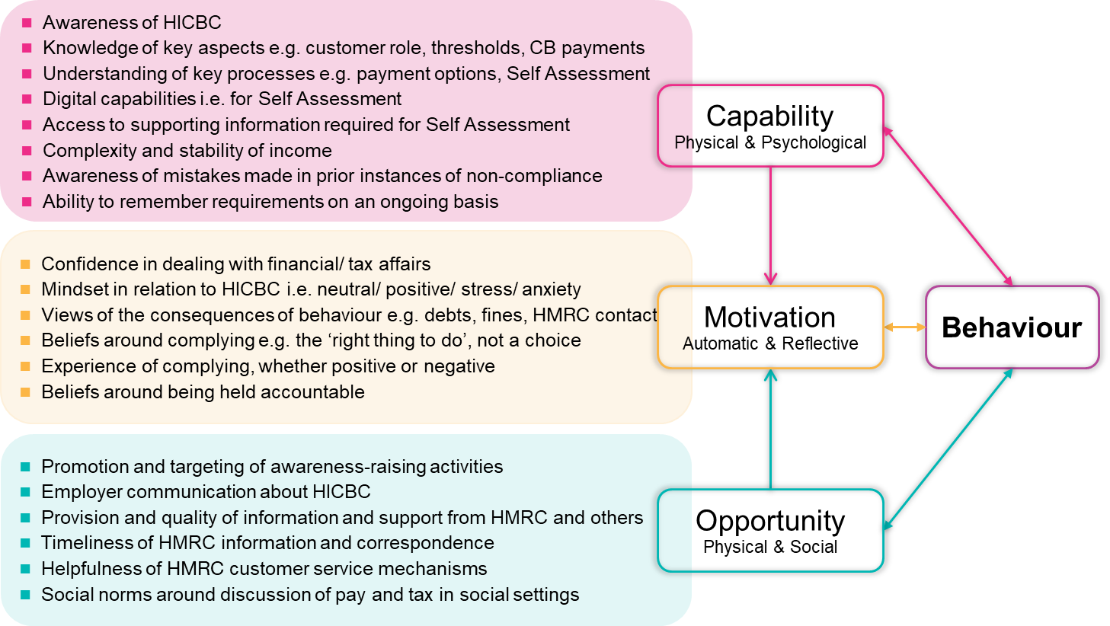

Capability

Capability related factors were the most wide-ranging for participants of this research. It is essential for customers to know about the policy in order to take action, with a lack of awareness of the charge forming a key barrier among those who did not meet their liability. Lacking awareness of the policy was nonetheless a one-off barrier for each customer, while other issues relating to capability had the potential to be more persistent if not addressed, and to lead to repeated issues paying the charge. While a full and accurate understanding of the policy was not a pre-requisite to meeting one’s liability, the findings suggest that comprehension of various key elements was required, and may therefore benefit from greater emphasis in support from HMRC.

One such element was customers’ misunderstanding of their own role; specifically, the onus on customers to report their income to HMRC upon becoming liable. For PAYE-only customers, the need to proactively inform HMRC of their income was counter-intuitive due to the widely-held belief that HMRC already holds this information. Secondly, there were indications that errors resulting from miscalculating Child Benefit payments and underpaying the charge arose during Self-Assessment and could benefit from clarification. This mistake was compounded by liable customers (i.e. the higher earner) not being fully aware of the frequency and value of Child Benefit payments due to them usually not being the recipient parent. Customers also need to understand the rules for different HICBC income thresholds and how net adjusted income is defined. Explicit guidance on this latter point could be particularly important, given the complexities of some customers’ income, which could fluctuate from month to month, resulting in customers failing to notify HMRC of their liability or reporting their income inaccurately.

Evidence suggests a need for more information and support to address process-related difficulties, including how to successfully complete Self-Assessment tax returns; how to pay the charge through tax code adjustments and the need to report outstanding payments after opting out. PAYE-only customers spoke of the unfamiliar and complicated nature of the Self-Assessment process. This highlights the need for support for Self-Assessment ‘first timers’ as well as information and guidance on an ongoing basis. The strategies developed by compliant customers in collating the information needed for Self-Assessment and organising Child Benefit payments, such as having spreadsheets or separate bank accounts, could serve as useful tips, as could greater promotion of existing support mechanisms such as the Child Benefit tax calculator and help functions for Self-Assessment that participants were unaware of.

Finally, the fact that customers were not always aware when they had not fully met their liability or could not identify where the problem had arisen reduces the likelihood of future behaviour change. Communicating this information as quickly as possible and highlighting common errors could help to avoid this problem.

Motivation

Factors relating to motivation were influenced by mind-set and experiences of the process; social norms around the payment of tax; and views of the consequences of complying.

Though not a widespread issue, customers who lacked confidence in, or found dealing with tax issues stressful, could delay action. Dissatisfaction with support and customer service from HMRC reinforced this and contributed to overall negative feelings about the process which may affect motivation to address the charge in the future. It may be that a supportive approach from HMRC staff, which some customers spoke positively of, could improve the ease with which customers engage with the charge on an ongoing basis. In addition, practical support, such as online tutorials, may help to address confidence barriers.

Customers were explicitly motivated to comply with the charge, both because they believed it was the right thing to do (linked to a strong social norm around tax payment) and because they acknowledged the unavoidable consequences of not complying (debts, fines and contact from HMRC.) As flagged in previous research, messaging that emphasises these aspects may help motivate customers. However, it is unlikely to be effective alone, and will need to be accompanied by awareness-raising strategies and appropriate information and support.

Complying was also positively linked to participants’ views of their own identities, as professional, capable and law-abiding people. Indeed, the findings indicate that these attitudes towards the payment of tax override negative attitudes towards the policy which were limited but nonetheless present across both those who had and those who had not met their liability.

Opportunity

The opportunity to comply rests on structures being in place to ensure customers know about, understand and are sufficiently supported to pay the charge. With regards to raising awareness of HICBC, the findings suggest a role for:
- more comprehensive contact with liable customers, using multiple contact strategies at pertinent stages in the customer journey; and
- improved targeting of awareness-raising activities, to reach liable customers, support timely completion of Self-Assessment tax returns and to promote awareness of existing tools e.g. the Child Benefit tax calculator.
The importance of these sorts of activities is clear when considering comments from participants implying that social norms inhibit discussion of pay in social settings, meaning that word of mouth cannot be relied on as a tool to support dissemination of information about the charge.

Earlier sections have discussed the role of HMRC in providing the information and support needed to facilitate capability and positively influence motivations. There was also evidence that other parties were playing a role too. Participants described the way in which financial advice websites and press articles filled perceived gaps in their knowledge of HICBC. In addition, the instances in which employers brought HICBC to customers’ attention were valued. Customers’ explanations about how they heard about Child Benefit through hospitals, health visitors and early years settings, also shed light on other channels through which HICBC could be promoted, though it is likely that fewer customers will be liable at this stage in their claim. These findings indicate that to maximise opportunity and capability to comply, finding ways of working with other parties may help HMRC to spread the message about HICBC.

References
HM Revenue & Customs. (2017). Child benefit customer survey. Retrieved from: https://assets.publishing.service.gov.uk/government/uploads/system/uploads/attachment_data/file/806165/Child_Benefit_Customer_Survey_-_HMRC_research_report_470.pdf

HM Revenue & Customs. (2018). High income child benefit charge: Awareness, understanding and decision-making processes. Retrieved from: https://assets.publishing.service.gov.uk/government/uploads/system/uploads/attachment_data/file/806154/High_Income_Child_Benefit_Charge_Awareness_-_HMRC_research_report_533.pdf

HM Revenue & Customs. (2019). Customer research into the Child Benefit claim form. Retrieved from: https://assets.publishing.service.gov.uk/government/uploads/system/uploads/attachment_data/file/806207/Customer_research_into_the_Child_Benefit_claim_form_-_HMRC_research_report_532.pdf

Michie, S., Van Stralen, M.M. and West, R. (2011). The behaviour change wheel: a new method for characterising and designing behaviour change interventions. Implementation science, 6(1), 1-12.

Ritchie, J., Lewis, J., Nichols, C.M. and Ormston, R. (2014). Qualitative Research in Practice. Sage: London. (2nd Edition).

Technical details

Recruitment
An opt out approach was used to recruit participants for the research. This began with HMRC drawing a sample of customers liable for HICBC from their records and issuing an opt out letter to each person. A two-week period followed whereby selected customers had two weeks to opt out of further contact about the research. Those wishing to opt out from further contact were then removed from the sample file before it was transferred securely to NatCen. NatCen then made follow-up phone calls to customers to explain the research and arrange interviews with those willing to take part. Each participant was offered the opportunity to donate £30 to one of three charities supporting families and children.

Sampling
The sample design and selection of participants used a purposive approach. This is widely used in qualitative research and selects participants on the basis of key characteristics that are expected to affect the views, experiences or behaviours that are the subject of the study. The sample was intended to achieve a mix of customers across five key compliance groupings (see Table A.1), income bands and tax payment methods (see Table A.1), as well as other Child Benefit, HICBC-related and socio-demographic characteristics (see Table A.2).

Appendix table A:1 Sample breakdown by additional primary characteristics

Sampling criteria | Characteristics | Non-compliant | Compliant
Income | £50,000 to £60,000 | 12 | 3
 | Over £60,000 | 21 | 7
 | Fluctuates above and below £50,000 | 3 | 2
Main tax payment method | Pay As You Earn (PAYE) | 19 | 7
 | Self-Assessment (SA) | 5 | 1
 | Both | 12 | 4

Appendix table A:2 Sample breakdown by secondary characteristics

Sex | Female | 8
 | Male | 40
Number of children claiming Child Benefit for Age | 1 | 16
 | 2 | 24
 | 3 | 8
 | 30 or under | 0
 | 31-44 | 25
 | 45+ | 23
Household type | Couple | 47
 | Single | 1
Timing of Child Benefit claim | Before 2013 | 37
 | 2013-2016 | 5
 | 2017 and after | 6
When earnings exceeded £50,000 | Before introduction of charge | 9
 | After introduction of charge | 39
Region | Wales | 0
 | Scotland | 5
 | N. Ireland | 1
 | West Midlands | 4
 | East Midlands | 5
 | Greater London | 7
 | North East | 2
 | North West | 6
 | South East | 9
 | South West | 2
 | Yorkshire | 0
 | East of England | 7

Data collection
Topic guides, designed in collaboration with HMRC, were used to guide the interviews. The themes covered included:
- Participant background
- Awareness and understanding of the HICBC
- Motivations and barriers driving responses
- Views of any support and guidance received
- Suggestions for improving the support offered by HMRC to customers.
The data was analysed using NatCen’s Framework approach which allows in-depth exploration of the data by case and by theme (Ritchie et al, 2014).

At NatCen Social Research we believe
that social research has the power to
make life better. By really understanding
the complexity of people’s lives and what
they think about the issues that affect
them, we give the public a powerful and
influential role in shaping decisions and
services that can make a difference to
everyone. And as an independent, not for
profit organisation we’re able to put all
our time and energy into delivering social
research that works for society.

NatCen Social Research
35 Northampton Square
London EC1V 0AX
T 020 7250 1866
www.natcen.ac.uk

A Company Limited by Guarantee
Registered in England No.4392418.
A Charity registered in England and Wales (1091768) and Scotland (SC038454)

endnotes People are also liable if they have a child living with them, for whom someone else receives Child Benefit and then contributes at least an equal amount towards the child’s upkeep.
Prior to the introduction of the charge HMRC ran a national media communications campaign to raise awareness of the HICBC (HMRC (2020) The High Income Child Benefit Charge)
https://www.gov.uk/child-benefit-tax-calculator
Capability refers to an individual’s psychological and physical capacity to engage in the activity concerned, including having the necessary knowledge and skills. Motivation refers to brain processes that direct behaviour, including both explicit decision-making and emotional responses. Opportunity captures the factors that lie outside the individual (physical and social) that make the behaviour possible or prompt it.

