Application Decision
Inquiry opened on 30 November 2021
by Barney Grimshaw BA DPA MRTPI(Rtd)
an Inspector appointed by the Secretary of State for Environment, Food and Rural Affairs
Decision date: 24 May 2022

Application Ref: COM/3262817
Woodcock Hill Village Green, Borehamwood
Register Unit: VG 120
Registration Authority: Hertfordshire County Council
- The application, dated 5 November 2020, is made under Section 16 of the Commons Act 2006 (“the 2006 Act”) to deregister and exchange common land.
- The application is made on behalf of Laing Homes.
- The release land comprises 33000m² of the existing Woodcock Hill Village Green to the south-west of Vale Avenue.
- The replacement land comprises 36000m² of land north of Barnet Lane (A411), to the west of Woodcock Hill Village Green.

Decision
- The application is granted in accordance with the terms of the application [Ref: COM/3262817] dated 5 November 2020, and the plan submitted therewith.

Preliminary Matters
- Section 16(1) of the 2006 Act provides, among other things, that the owner of any land registered as common land may apply for the land (“the release land”) to cease to be so registered. If the area of the release land is greater than 200m² a proposal must be made to replace it with other land to be registered as common land (“the replacement land”).
- An inquiry into this application was opened on 30 November 2021 by another inspector but then adjourned until 24 January 2022, when I re-opened the inquiry. The inquiry then continued on 25, 27 and 28 January 2022, and, after a further adjournment, on 15 March 2022.
- I made an inspection of the site on 17 March 2022 when I was able to view both the release land and the replacement land and other parts of the village green. I was accompanied at the inspection by representatives of the applicants and objectors.
The Release Land
- The release land comprises an area of 33,000m² of the existing Woodcock Hill Village Green which slopes upwards from north to south (shaded pink on the attached plan). It consists of rough grassland with scattered trees, shrubs and hedgerows with mown/worn footpaths.
The Replacement Land
- The replacement land comprises 36,000m² of land immediately to the west of the existing village green (shaded green on the attached plan). It consists of grazed pasture land and woodland.

The Application
- The application is made on behalf of Laing Homes, part of the Taylor Wimpey plc Group (TW), the owner of the release land. The replacement land is owned by third parties but held under contract by TW. The stated purpose of the application is to provide a larger, more accessible and improved village green on adjacent land. The applicants have made no secret of the fact that in due course they may aspire to develop the release land for housing, but no proposals have yet been made nor any permission for such development sought. Should development proposals be put forward in the future, these will be subject to a separate process to assess their merits and the possibility of such proposals cannot and should not affect consideration of the current application.
- On behalf of Hertsmere Borough Council (HBC) it is argued that the application is premature and, as it is government policy that development should be plan led, consideration of the alteration of the village green should not take place prior to the preparation of a new local plan. On behalf of the applicants, it is argued that the planning process is separate from that under the Commons Act 2006 which contains nothing to suggest that an application for de-registration of a village green cannot be made at any time. This is in my view correct. Although the 2006 Act has now been amended so as to prevent the registration of village green status being used as a means to prevent development already proposed from taking place, this does not mean that consideration of the de-registration of village greens must await the preparation of local plans or other development proposals. I also note that prior to the registration of the current village green in 2008, the proposed release land had been safeguarded for housing purposes in a 2003 local plan. Accordingly, its registration was itself not plan led.
- During the inquiry some doubt was raised regarding whether the preparation of a new local plan was still being pursued. In the light of the above, I do not think this affects consideration of the current application in any way. If the application is approved and at some future date a proposal is made for the development of the release land, this will be a matter for HBC itself to consider taking account of appropriate matters set out in other legislation and in any local plan then in place. I see no reason why such consideration would be prejudiced in any way by the de-registration of the release land.
- In conjunction with the application, if approved, the applicants have undertaken to carry out improvements to a further 24,000m² area of the existing Village Green within their ownership but outside the proposed release land. This land is referred to as the ‘improvement land’ and is shaded yellow on the attached plan.
- A further 43,000m² area of the existing Village Green is unaffected by the application (shaded blue on the attached plan).
- In association with the application, the applicants, along with the other current owners of the replacement land, have submitted a Planning Obligation by way of a Unilateral Undertaking. This would come into effect on the approval of the application and bind the applicants:

- to carry out proposed improvement works on the replacement land and the improvement land within 18 months; and

- to establish, within 1 year of the approval date, a management company with a long lease (999 years) over land to be improved. This company to be responsible for management and maintenance works over a period of 15 years funded by a contribution of £370,000 from the applicants and payable in 4 instalments. The management company also to establish a Village Green Committee to liaise with the company in the delivery of management and maintenance and to carry out at its discretion continued management and maintenance after the end of the 15 year period.

The Statutory Requirements
- I am required by Section 16(6) of the 2006 Act to have regard to the following in determining this application:
- the interests of persons having rights in relation to, or occupying, the release land;
- the interests of the neighbourhood;
- the public interest;
- any other matter considered to be relevant.
- I will also have regard to published guidance in relation to the determination of applications under Section 16.

Assessment
The interests of persons occupying or having rights in relation to the release land
- The release land is owned by Laing Homes (TW), the applicants. There are no registered rights of common over it. The public have the right to access the land for the purpose of lawful sports and pastimes and the effect of the application on the interests of the public are considered later.
The interests of the neighbourhood
- The 2006 Act does not define the term ‘neighbourhood’. However, published guidance makes it clear that the term should be taken to refer to the local inhabitants.
- In this case, the neighbourhood of the existing village green was precisely defined prior to its registration in 2008. This consisted of properties in specified streets to the north and east of the green.
- The village green was registered on the basis that it had been used by inhabitants of the neighbourhood for lawful sports and pastimes for a period of 20 years prior to 1 December 2001. In practice, it was noted that the main use of the land had been for walking, including walking with dogs and/or children.
- Since the registration of the village green, volunteers from the local community, coordinated by the Woodcock Hill Village Green Society (WHVGS), have carried out maintenance and improvement work on the green. With regard to the proposed release land and improvement land, this has included the clearance of brambles and scrub to keep footpaths open, planting of trees, excavation of ponds and the placing of benches along with fund raising to support these activities. The WHVGS was said to have members from 300 households, predominantly within the defined neighbourhood, who each paid a £5 per annum membership fee.
- Prior to 2018 most of this work by the WHVGS was carried out with the permission of the landowner, the current applicants, but permission was withdrawn in 2018 and since then little or no work has been carried out.
- It is clear that residents of the neighbourhood greatly value the village green and have invested considerable time and effort into its maintenance and improvement over a lengthy period. Accordingly, it is understandable that the prospect of the results of their efforts being lost in so far as the release land is concerned is regarded as a cause for concern and reason for opposing the approval of the application. Although it is proposed that the Village Green Committee to be established by the management company which will be responsible for the future maintenance of the land to be improved if the application is approved should include representatives of the local community, this is not regarded as adequate compensation.
- The release land is the northernmost and lowest lying part of the existing village green and is overlooked by adjacent residential development. On my visit it was largely overgrown and difficult to access with the exception of one well-trodden footpath. It was extremely wet underfoot and the footpath was muddy and slippery. The land rises to the south and reportedly other parts of the green are more intensively used. Nevertheless, the release land is closest and most accessible to a large proportion of properties in the defined neighbourhood by way of access points on Vale Avenue and Byron Avenue that would no longer be available if the application is approved.
- The area of the replacement land is slightly greater than that of the release land, so approval of the application would not lead to any net loss of village green land.
- The replacement land adjoins the western edge of the existing green but is different in character to the release land and other parts of the existing green. It consists of a relatively flat grassed area, used for grazing until recently, and a belt of woodland. It is further away from many properties in the defined neighbourhood than the release land. However, a proposed new access point from Barnet Lane at the south-west corner of the land would make the revised village green more easily accessible from properties to the west.
- It was argued on behalf of some objectors that the release land is in Borehamwood and the replacement land in Elstree. It was alleged that the two communities are different in character, which may well be the case. However, I see no reason why one community should take precedence over the other with regard to access to the village green. I also note that the two communities are jointly represented by a single Town Council and various other bodies.
- Because the replacement land is different in character to the release land and the rest of the village green, it would offer the opportunity for a greater range of activities to take place on the green.
- Overall, the proposed deregistration and exchange will affect the interests of the neighbourhood by restricting access to the closest part of the village green to some of the defined neighbourhood. It will also reduce the amount of semi-natural grassland that is accessible. On the other hand, the release land is arguably the least attractive part of the village green for many users and the replacement land will offer the potential for a wider range of activities on the green and will make it more accessible for some people not currently resident within the previously defined neighbourhood. Also, proposed works on the improvement land should enhance the attraction of that part of the green.
- On balance, although the strength of local opposition to the application is understandable, it is my view that the potential benefits resulting from the proposals outweigh the perceived disadvantages with regard to the interests of the neighbourhood.
The public interest
Nature Conservation
- The release land and improvement land form part of the non-statutory Woodcock Hill Fields Local Wildlife Site (LWS) and the replacement land in part is within the Elstree Tunnels Grasslands East LWS. Both sites have been designated because of the grassland habitats they support. However, ecological survey work undertaken on behalf of the applicants suggests that neither LWS currently supports grassland habitats of high conservation importance. The designation of these sites will not be affected by the application whether or not it is approved.
- It was common ground between the parties that the nature conservation value of the release land has already been degraded to some extent by the spread of brambles, nettles and scrub as a result of maintenance work having been curtailed since 2018. It can be expected that this process will continue unless active maintenance is resumed.
- The applicants have indicated that they have no intention of renewing the permission for the local community to carry out maintenance work on the site. It is suggested on behalf of objectors that there might not be a need for some such work to be permitted as it could be construed as a ‘lawful sport or pastime’ appropriate to a village green. This suggestion is disputed by the applicants, and it appears to be the case that to date little work has been carried out since the withdrawal of permission in 2018.
- A great deal of information and opinion regarding the existing and potential value of the application land for nature conservation was submitted. The applicants submitted an Ecological Appraisal, an Environmental Implementation Maintenance and Management Plan, an Arboricultural Impact Assessment and detailed Landscape Proposals. These are said to show that the proposals contained in the application will not have an adverse effect on the designated LWS sites and that the proposed landscape improvement works on the replacement land and the improvement land will provide material biodiversity benefits in these areas.
- On behalf of objectors, it is argued that the applicants could have done much more to protect and enhance the nature conservation value of the release land and to provide a more natural and biodiverse environment for the replacement land. However, I note that the landscaping proposals put forward include the planting of a wide range of native trees and shrubs, understorey planting within woodland areas and enhancement of existing grassland habitat.
- It is also argued by objectors that the proposals should be assessed using a biodiversity metric with a need to demonstrate a 10% uplift in biodiversity. The applicants’ response is that such an approach can be useful in carrying out ecological assessments but is not necessary or appropriate in order to determine the current application.
- I do not consider it necessary to analyse all the available information in detail here although I have read and considered it all. In so far as the assessment of the merits of the application is concerned, a few critical factors should be borne in mind.
- The application contains no proposals for development of any sort on the release land and to that extent approval would not result in the loss of any habitat. As already mentioned, its conservation value may continue to degrade to some extent, but this will occur irrespective of whether the application is approved or not unless maintenance work resumes.
- The landscape improvement proposals put forward by the applicants and the proposed funding for future management should result in enhancement of the nature conservation value of the replacement land and the improvement land relative to the present condition of these areas.
- Nature conservation is only one of several factors that should be taken into account. Although the opportunity for the enjoyment and study of nature is an important public benefit of the existence of the village green, it is not one that should exclude provision of opportunities for other lawful sports and pastimes also to be enjoyed.
- Overall, the proposed de-registration and exchange of village green land would appear unlikely to result in any significant adverse effect with regard to nature conservation and the proposed landscape works on the replacement land and improvement land are likely to enhance the nature conservation value of those areas.
Landscape
- None of the land affected by the application falls within any designated landscape area. However, the village green is unusual in being a relatively undisturbed natural area so close to residential development. As no development is proposed on the release land in the application, its approval would not result in any significant change to the landscape of that area, although people would no longer be able to enjoy it from within the area itself.
- The applicants have submitted detailed proposals for the replacement land and improvement land which include the planting of a hedgerow, trees and shrubs, the construction of paths of various types and the placing of seating areas or picnic tables, play equipment and information boards.
- Objectors argue that the open grassland part of the replacement land is relatively uninteresting compared to the release land and that, even with the extensive landscaping works proposed, will not achieve a similar level of attraction.
- Clearly, the replacement land is quite different in character to the release land and the rest of the existing village green. Nevertheless, the works proposed should enhance its appearance through the additional planting which will also screen it to some extent from Barnet Lane and housing development to the west. The landscape value of the woodland area will be undiminished, but the woodland will become accessible to the public and the proposed planting on the improvement land should reinforce its natural quality.
- The provision of seating areas, picnic tables and play equipment will introduce new elements to the village green but the location of these will not detract from the natural appearance of the existing parts of the green.
- Overall, the proposals in the application would result in little damage to the landscape of the release land and some enhancement of that of the replacement land and improvement land.
Public Access
- At present the existing village green is accessed at 6 points, 2 on Vale Avenue, 2 on Barnet Lane and 1 each on Carrington Avenue and Byron Avenue. If the application is approved, the existing access points from Byron Avenue and from Vale Avenue, opposite Tennison Avenue will be lost but a new access will be opened on Barnet Lane, the existing access from Vale Avenue close to its junction with Milton Drive will be relocated 12m further south and improved, and a new access from Byron Avenue may become available. Other access points would be unaffected.
- The possible new access from Byron Avenue would require the agreement of HBC, the owner of land over which the access would run. This land is part of a garage area and its use for the proposed access would require evaluation of its impact on the existing use of the land and any risks which might arise from its use which would then be considered by the council before any agreement could be reached. To date, it is stated on behalf of HBC that it has not been formally approached regarding this matter and the council opposes the approval of the application. It cannot therefore be assumed that a new access from Byron Avenue will become available if the application is approved. On the other hand, the possibility of such an access has not been ruled out and the applicants have stated that they will carry out all the necessary works on their land for this access to be established.
- Analysis by a transport consultant on behalf of the applicants, which was not challenged by objectors, showed that 23 out of 480 households within the defined neighbourhood would no longer be within 400m (5 minutes) walk of an access point if the application is approved and no new access from Byron Avenue made available. All 23 of these households would still be within 500m of access points. If all households in the area are considered, 8 out of 713 would no longer be within 400m but an additional 195 would be within 800m (10 minutes) walk and a further 282 within 1200m.
- This analysis suggests that approval of the application would have only a marginal adverse effect on accessibility from the defined neighbourhood but would significantly improve access from a wider area, notably that to the west of the green. I also note that residents from the west would be able to access the revised green without having to walk an additional 350m approximately along the steep and relatively narrow footway adjacent to the busy Barnet Lane.
- Various new paths are proposed to be established within the replacement land and improvement land including an informal surfaced path, bark mulch paths within the woodland area and mown paths. These would improve accessibility within the village green.
- Overall, approval of the application would not in my view have a significant adverse effect on public accessibility to the village green and would bring benefits to some users.
Archaeological remains and features of historic interest
- Neither the release land nor the replacement land contains any scheduled ancient monuments. Historic England was consulted regarding the application and has raised no objection.
- The site of a former Admiralty Telegraph is marked by an information board within the improvement land. The Telegraph was erected at the time of the Napoleonic Wars as part of a chain enabling messages to be passed to Plymouth, Portsmouth and Yarmouth by way of the Admiralty in London. The views to the north and south from the site of the Telegraph would not be affected by proposals in the application.
- A beacon forming part of a network lit at the time of the Spanish Armada was situated on Woodcock Hill. A more modern beacon is now in place on part of the village green unaffected by the application proposals. This has been lit on a number of occasions and in 1988 a procession from the town to the beacon to commemorate the 400th anniversary of the Armada was said to have crossed the release land.
- There are two 19th century air shafts situated on the replacement land from the railway which passes beneath. These are of modest local heritage interest and will remain in place whether or not the application is approved.
- Overall, I have no reason to believe that the proposed exchange will have any adverse effect on archaeological remains or features of historic interest.
Conclusions on the public interest
- Overall, the proposed deregistration and exchange will have little adverse effect on the public interest and potentially will bring some benefit.
Other Matters
- The proposed funding to be provided for the maintenance and management of improved areas over a 15 year period was questioned on behalf of objectors. I have seen no breakdown of how the figure of £370,000 was arrived at or how it is intended to be spent. This will presumably be a matter for the proposed management company to address. However, it is a substantial sum which should be capable of being used to effectively ensure that landscaping works are properly managed and new planting well established. After 15 years, alternative funding and/or other means of ensuring continued maintenance of the green will be needed, but it would not be reasonable to expect the applicants to be responsible for this indefinitely.
- One person holds a grazing licence on part of the replacement land. This is terminable on one month’s notice and would not therefore affect the implementation of proposed works.
Conclusion
- The proposals in the application satisfy all the criteria set out in Section 16(6) of the 2006 Act. The application should therefore be granted.

Order

On behalf of the Secretary of State for Environment, Food and Rural Affairs and
pursuant to section 17(1) and (2) of the Commons Act 2006, I HEREBY ORDER
Hertfordshire County Council, as commons registration authority for the area in
which the release land and the replacement land are situated:

(a) to remove the release land from its register of village green land, by amending
register unit VG 120 to exclude the release land;

(b) to register the replacement land as village green, by amending register unit
VG 120 to include the replacement land;

First Schedule – the release land

Colour on plan | Description | Extent
Shaded pink | Land at Woodcock Hill Village Green | 33,000m²

Second Schedule – the replacement land

Colour on plan | Description | Extent
Shaded green | Land adjacent to Woodcock Hill Village Green. | 36,000m²

Barney Grimshaw
INSPECTOR

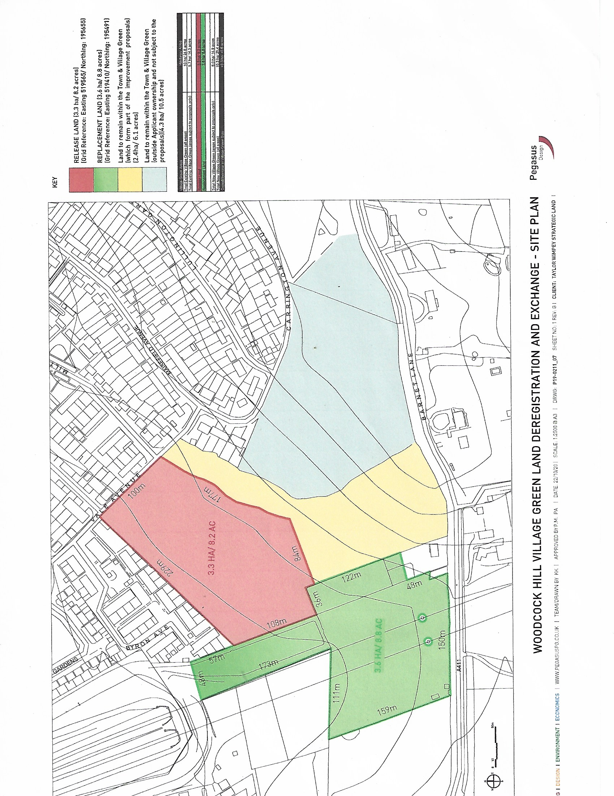

Section 16(8) of the 2006 Act provides that the public interest includes the public interest in: nature conservation; the conservation of the landscape; the protection of public rights of access to any area of land; and the protection of archaeological remains and features of historic interest.
Common Land Consents Policy Guidance, November 2015 , Defra.
The Explanatory Memorandum to the Deregistration and Exchange of Common Land and Greens (Procedure)(England) Regulations 2007, SI2007 No.2589.

