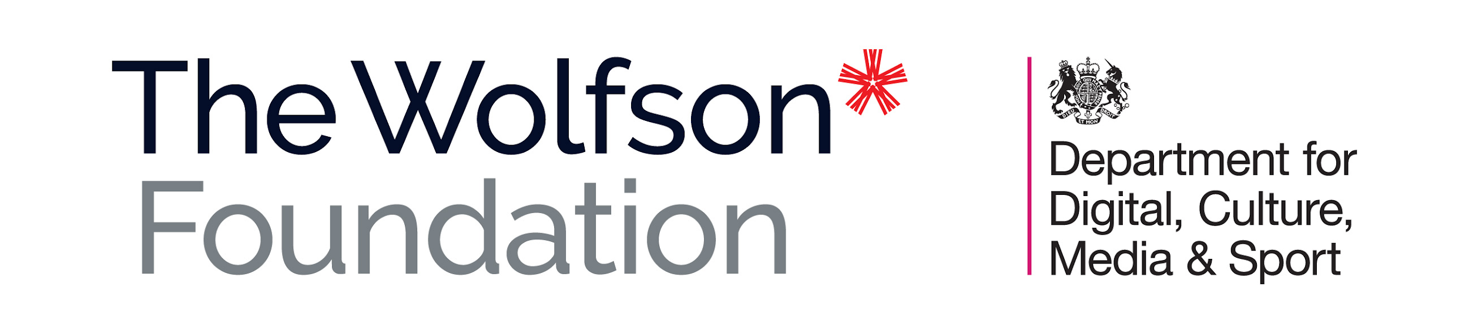
DCMS/WOLFSON MUSEUMS & GALLERIES
IMPROVEMENT FUND 2022-24
BID PRO FORMA
All bids must be submitted on the standard pro forma. Please ensure you have read the ‘Guidance note for applicants’ before completing the form. Bids that do not conform to the guidance outlined may not be accepted.
BID SUMMARY
Name of museum
Name of museum group/service/university
(if applicable)
Project title
(max. 15 words)
Project description
(max. 50 words)
Total project cost (£)
Total eligible costs (£)
Funding request (£)
Primary contact
(name, role, email, phone)
Secondary contact
(name, role, email, phone)

SECTION 1: About the applicant
Name of museum
Address
Name of museum group/service/university (if applicable)
Museum profile (max. 250 words)
Visit numbers
2019/20
2018/19
2017/18
Head of organisation
Trustees (if applicable)

SECTION 2: About the project
Project title (max. 15 words)
Project description (max. 50 words)
Which of the fund criteria does the project meet? (mark with an X all the boxes that apply)
1 | Material improvements to the display and interpretation of collections, in permanent galleries, exhibition spaces and public spaces, to enhance visitor experience
2 | Improvements to access and/or interpretation for visitors with disabilities
3 | Improvements to environmental controls, collections storage and conservation facilities to enhance the care of collections
Project overview (max. 500 words)
The need for the project (max. 250 words)
.
Collection(s) that will benefit from the project (max. 250 words)
Expertise/ evidence informing the project (max. 250 words)
Future sustainability of the organisation
Financial (max. 250 words)
Environmental (max. 250 words)

SECTION 3: Project Management
Internal management
Project timetable
Date(s) |  | Milestone
Planning permission (max. 150 words)
Supporting information provided with the bid
1 | Current images of the relevant space(s)
2 | Floorplan of the relevant spaces
3 | Artist’s impression of the completed project

SECTION 4: Project finances
Total project cost (£)
Total eligible costs (£)
Cost breakdown (including ineligible costs)
Item | Net cost (£) | Irrecoverable VAT (£) | Total cost (£)
TOTAL:
Supporting notes (max. 50 words)
Match funding
Total funding secured (£)
Details (if applicable)
Shortfall (£)
Funding request for this bid (£)
Plans for raising the balance (max. 150 words)
Suppliers and competitive tender (max. 150 words)

