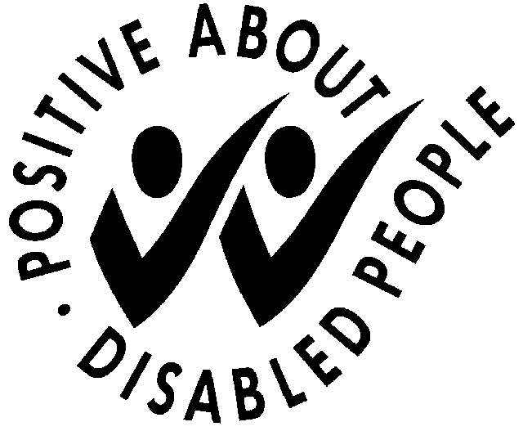
PEOPLE WITH DISABILITIES:
GUARANTEED INTERVIEW REQUEST FORM

OUR POLICY

As a member of the Employers Forum on Disability, we are committed to actively encouraging applications from people with disabilities.

As part of our commitment to the Job Centre Plus Disability Symbol, applicants with a disability are guaranteed an interview if they meet the minimum criteria for a job vacancy. The job description gives you the minimum criteria.

Declaring a disability for the purposes of a guaranteed interview is your decision and is entirely voluntary.

Definition of a disability
The Equality Act 2010 (EA) generally defines a disabled person as:
- someone who has a mental or physical impairment that has a substantial and long-term adverse effect on the person’s ability to carry out normal day-to-day activities.

We aim to select staff on suitability for the job and welcome your application if your disability does not stop you from doing the job in accordance with our responsibilities as an employer in accordance with the EA 2010.

Please tick, if appropriate:
I consider that I have a disability under the terms of the Equality Act 2010 and wish to apply for a guaranteed interview, providing I meet the minimum criteria for the job vacancy.

Whether you choose to apply under the Guaranteed Interview Scheme or not you can still ask us to make particular arrangements for you when attending an interview. You can also contact us if you want to discuss the criteria for the job or have questions regarding your application.

Name:
Address:
Date:

If you are applying under this scheme please complete this form and return it with your application form.

