Redundancy Payments Service ‘RP14 and RP14A Upload Instructions’ (using official templates)

Contents
1.Submitting RP14 and RP14A information to the Redundancy Payments Service (RPS) Case Management System (CMS).
2.Entering data on the RP14 and RP14A forms using the official Microsoft Excel templates.
4. Updating an existing RP14A.
3. Exporting the data from the Microsoft Excel templates into XML.
4. Uploading the exported XML file through the Insolvency Practitioner (IP) Upload Service.
5. Troubleshooting.

Purpose of these instructions
- these are instructions for uploading forms RP14 and RP14A using the official Insolvency Service templates
- these instructions do not cover uploading forms RP14 and RP14A using IP case management systems
- there are separate instructions and guidance for uploading of forms RP14 and RP14A using IP case management systems

Process Overview
Submitting RP14 and RP14A forms electronically is a 3 step process.
- Enter the data using the Microsoft Excel Spreadsheet.
- Export the data from the Microsoft Excel Spreadsheet into XML format.
- Upload the exported XML file to the RPS using the Insolvency Practitioner Upload Service online portal.

Templates
Use the official template for the RP14 and the official template for the RP14A
These templates work only with Microsoft Excel and no other spreadsheet software.
Entering RP14 data
Download the template and make a copy to work with. Open the copy to enter the data.
Complete the data entry fields in the spreadsheet.
You must include the:
- name of business (question 1)
- Pay records contact details (part 4)
- IP contact details
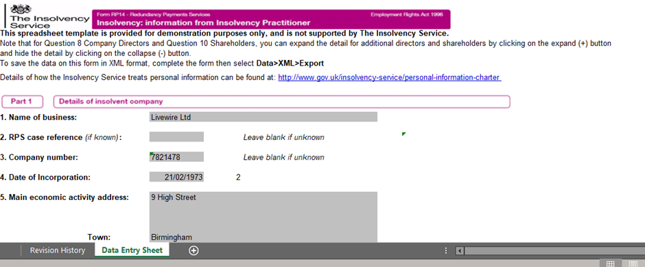

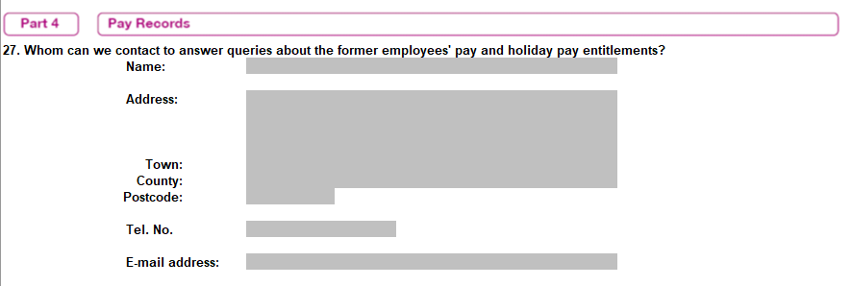

We will send redacted copies of the RP1’s to the email address you provide.
If you do not provide the name of business, the Payroll records contact, and the IP contact details, the XML will not upload.
You must only enter data in the shaded cells on the template. Anything entered that is not in the shaded cells will not export to XML.
When entering director and shareholder details, the second and further entries are collapsed by default. To enter details of more than one director or shareholder, click on the (+) button on the left-hand side to expand the relevant area.
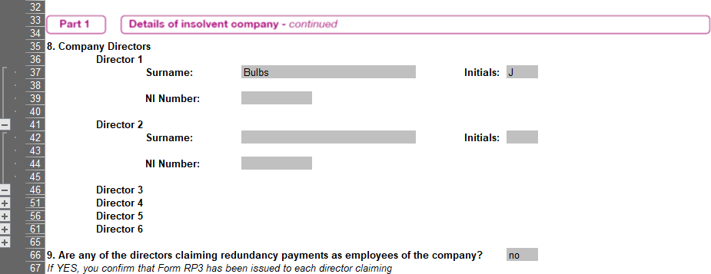

Saving the draft RP14 data
Once you have entered all the information into the template, save the file. It will save as a .xls file. For example: ‘sampleRP14.xls’.
Keep the .xls file for your records.
Once you’ve saved a completed file, you will need to follow the guidance below to export it to XML format.
Exporting data from the spreadsheet in XML format
The XML Export function is supported by Microsoft Excel however it is in the ‘Developer’ tab, which is not enabled by default.
To install the ‘Developer’ tab, follow these instructions:
1. Click the ‘File Tab’ and then choose ‘Options’. You will see the following window:
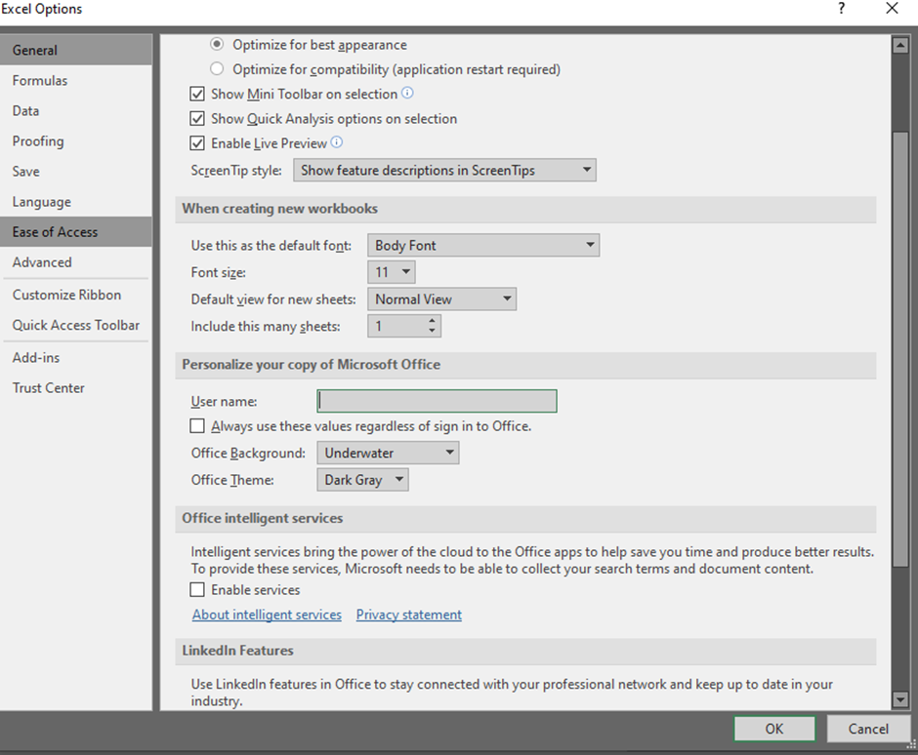

2. The ‘Excel Options’ dialogue box will be displayed, click the ‘Customize Ribbon’ option. You will see the following window:
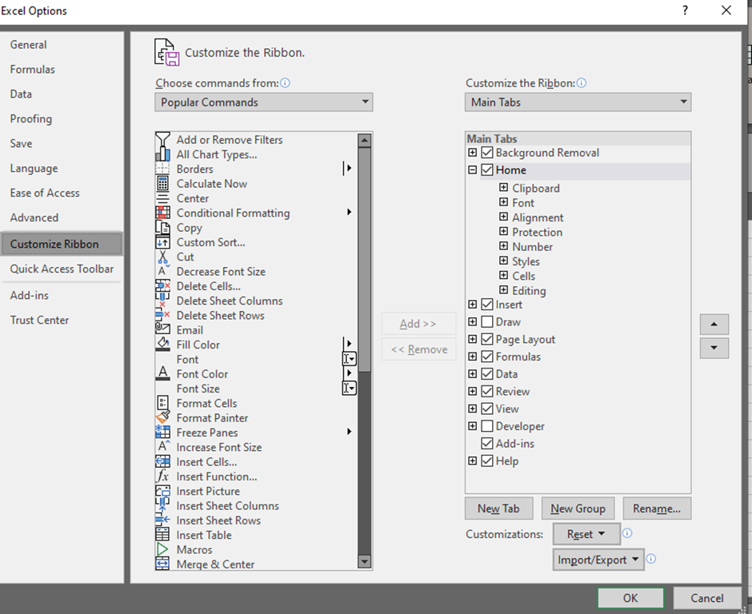
3. Tick the ‘Developer’ option in the right sidebar and click OK
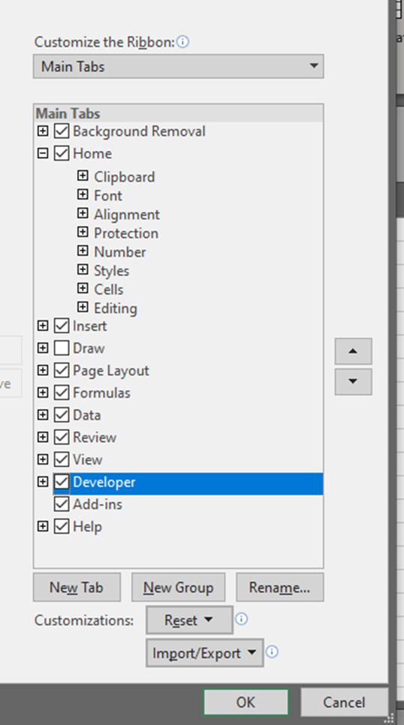
4. You will find the ‘Developer’ tab on the ribbon:

5. Click on the ‘Export’ button in the ‘Developer’ tab to export the XML data from your spreadsheet. You will be prompted to save the document, please assign it with a name which contains no spaces or punctuation marks (other than .xml) and has fewer than 10 characters.

Entering RP14A data

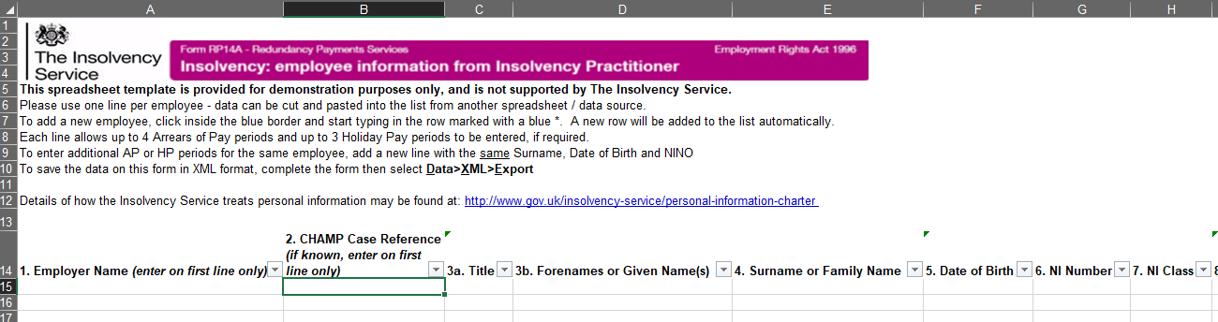

Entering RP14A data (Values)
- there are total 48 columns, with column headings from 1 to 25b
- columns 3a, 5, 12, 13, 17, 18d, 19d, 20d, 21d, 22g and 23c require specific values which must be selected from the dropdown box
- entering any other value than the ones provided in the dropdown box will result in invalid data export and the system will not accept the data
- all other fields contain help text which describes the nature of the information requested and the format it should be entered in

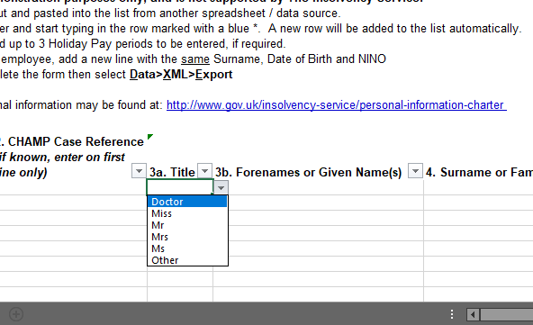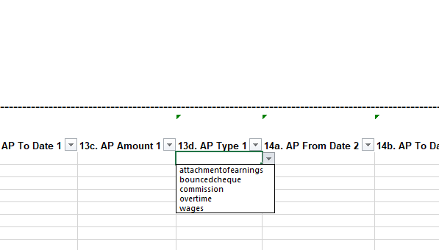

Entering RP14A data (Employee details)
- when completing the RP14A spreadsheet, enter each employee’s details on a new row
- do not leave blank or empty rows in between, or at the beginning and end of the list of rows
- you must include a validly formatted National Insurance Number and the RPS ‘CN’ case reference number for each employee line. Failure to do so will mean your XML will not upload
- you can find guidance on how to input National Insurance Number formats
- do not include more than two decimal points in any entry. Failure to do so will mean your XML will not upload

Entering RP14A data (arrears of pay and holiday taken but not paid)
- up to 4 arrears of pay (AP) periods and 3 holiday taken but not paid periods (HTNP) can be specified per employee. Leave unused fields blank
- each individual period can cover more than one week. You should not add another new row for the same employee if you need to provide details of AP claims and HTNP claims for longer periods
- if you need to provide further details, please email RPS

Saving the draft RP14A data
- once you have entered all the information into the template, save the file. It will save as a .xls file. For example: ‘sampleRP14A.xls’
- keep the .xls file for your records
- once you’ve saved a completed file, you will need to follow the guidance below to export it to XML format

Exporting data from the spreadsheet in XML format
The XML Export function is supported by Microsoft Excel however it is in the ‘Developer’ tab, which is not enabled by default.
If you have not already done so, follow these steps to install the ‘Developer’ tab:
1. Click the ‘File Tab’ and then choose ‘Options’. You will see the following window:

2. The ‘Excel Options’ dialogue box will be displayed, click the ‘Customize Ribbon’ option. You will see the following window:
3. Tick the ‘Developer’ option in the right sidebar and hit OK
4. You will find the ‘Developer’ tab on the ribbon:

5. Click on the ‘Export’ button in the ‘Developer’ tab to export the XML data from your spreadsheet. You will be prompted to save the document, please assign it with a name which contains no spaces or punctuation marks (other than .xml) and has fewer than 10 characters.

Updating an existing RP14A
Entering a new RP14A for a claimant with a previously submitted RP14A
- you must include all the information previously submitted
- if the information previously submitted has changed, please provide all the information again, with the new data overwriting the old
- for example – An employment end date was provided with all the other information on an RP14A. You now need to inform us of a new employment end date. When providing us with the new updated RP14A, provide ALL the data again, including the new employment end date
- updating the RP14A with just the new or updated information and leaving all other data fields blank, will overwrite the previous submission with ‘blank’ fields. This means any previous information on the RP14A will be removed

Updating an existing RP14A with new information
- if the information has not been submitted before and you are providing it for the first time, please provide all the information again, with the new data
- for example – an RP14A was provided with all information apart from details of Arrears of Pay (AP) owed to the claimant
- you now need to inform us of the AP owed to the claimant. When providing us with the updated RP14A, provide all the data again, inclusive of the new data
- updating the RP14A with just the new / updated information and leaving all other data fields blank, will overwrite the previous submission with ‘blank’ fields. This means any previous information on the RP14A will be removed detailing the AP owed

Updating RP14A data for a single claimant
- if you are updating the RPS about only one claimant, you only need to provide an updated RP14A for that claimant, and not include an RP14A entry for all other claimants
- once all the information has been entered into the template, save the file
- the files will be saved with an .xsl extension. For example, SampleRP14A.xsl
- keep this file for your records
- once you’ve saved a completed file, you will need to export it to XML format

Uploading an RP14 / RP14A XML file to the RPS through the new upload portal
Go to the new IP upload service web site
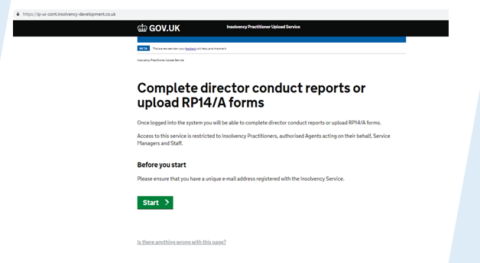

- log on to the IP upload service

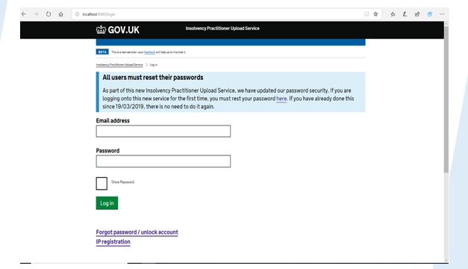

- all current users of the Director Conduct Reporting Service (DCRS) - IP’s, their service managers and staff - will have to reset their passwords when attempting to log onto the new IP upload service for the first time
- agents of IP’s appointed to deal with employment matters, including RPS claim submissions will be set up and provided with log on credentials by the RPS
- all users, including IP’s, service managers and staff will be able to upload RP14 / RP14A’s
- IP’s and service managers can add new users to upload RP14 / RP14A’s, in the same way as on the DCRS service
- agents who require set up please email RPS
User Permissions
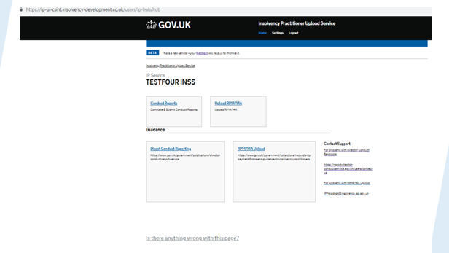
- all users will be able to see both the ‘DCRS’ and ‘Upload RP14 / RP14A’ options
- all users will be able to upload RP14 / RP14A’s
- only IP’s, their service managers and their allocated staff will be able to see any content on the DCRS function
- the DCRS service will continue to operate as usual

Proceed to upload the XML file to the RPS
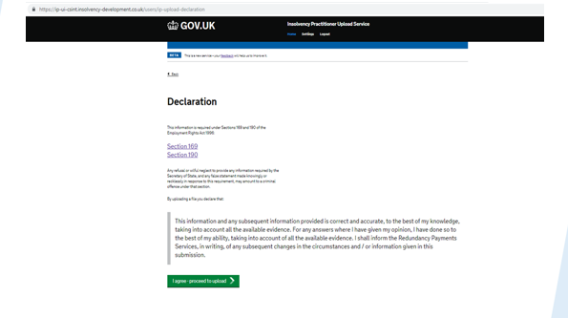
- to proceed to upload an RP14 / RP14A XML file, you will need to accept the declaration
- you will move to the upload page. Click on choose file and select the file you wish to upload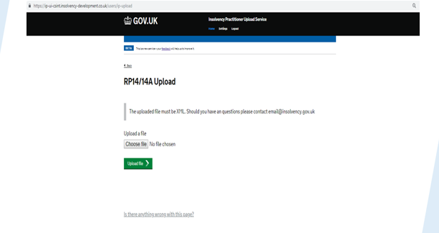

- when you have successfully uploaded the XML, you will see a message saying, ‘upload complete’
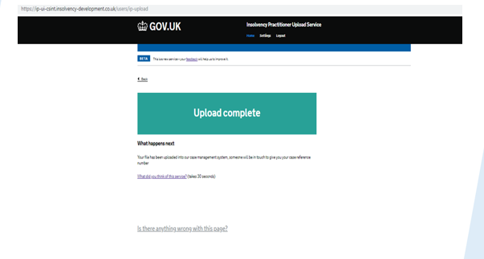
- if your upload was unsuccessful, you will see an error message
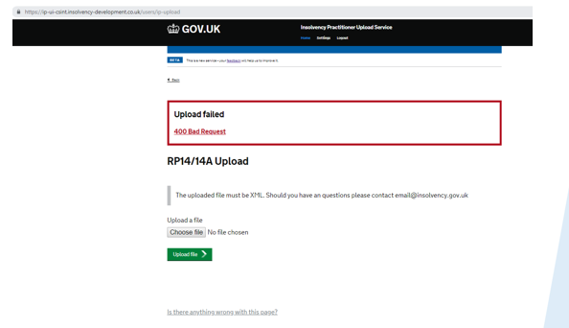
- you can find further information about why the XML has failed to upload and the types of error messages in our FAQ’s
- if you have any queries about the RP14 / RP14A upload, please email RPS

