


Aerodrome Design Standard
Visual Aids
Technical Standard : VA 01: 2022 | AERODROME MANAGEMENT
Version 1 – January 2022

Document Information
DIO Sponsor:  Bryan Dunn, BEng (Hons.), CEng, MIET.  Head, Engineering and Construction, Technical Services. | Date of Issue: 25 Jan 2022
Contact if different from above Sponsor:
Khem Kumar Basel, BSc (Hons), MSc, CEng, MIET, MIEEE.
Deputy Senior Authorising Authority (AGL), Senior Electrical Engineer,
Technical Services, Engineering & Construction, Electrical Infrastructure

Email: khem.basel539@mod.gov.uk
Mobile: 0797 0227 690
Skype : +443001524265
Who should read this: Consultants, Aerodrome Visual aids Designers, Contractors, DIO Project Managers and Requirement Managers, DIO Service Delivery Staff, Project Mangers, Skilled Persons (AGL), Authorised Persons (AGL), Authorised Engineers (AGL), Airfield Maintenance Managers, Maintenance Management Organisation Staff, MMO Supply Chain Staff etc
When it takes effect: Immediately | When it is due to expire: When Rescinded
Equality and Diversity Impact Assessment
This policy has been Equality and Diversity Impact Assessed in accordance with the Department’s Equality and Diversity Impact Assessment Tool against:
Part 1 Assessment Only (no diversity impact found)

Document Name: | Aerodrome Design Standard - Visual Aids
Version No: | 1.0
Version Date: | Jan 2022
Author: | DIO - AECOM
Reviewed by: | Andy Dunn (Hd EI) and Khem Basel (SME AGL)
Approved by: | Bryan Dunn, Hd Engineering and Construction
Review Date: | May 2021

DOCUMENT HISTORY

Date Issued | Version | Author | Reason for Change
25/01/2022 | 1.0 | DIO - AECOM | N/A – Initial Issue

FOREWORD
The Military Aviation Authority (MAA) is part of the Ministry of Defence and the Defence Safety Authority and is responsible for the regulation, assurance, and enforcement of the defence air operating and technical domains. They are responsible for the issue of regulatory publications including overarching documents, Regulatory Articles (RAs) and manuals. This Standard has been prepared to complement and support the provision of aerodrome visual aids required in RA 3500 to RA 3590 titled ‘aerodrome design and safeguarding’ (Issue 2).
This Standard has been prepared by Defence Infrastructure Organisation’s Technical Services, in conjunction with industry, and is provided for the use of all organisations responsible for the provision visual aids at aerodromes regulated by the MAA. It is provided to support the requirements contained within their regulatory publications and aid compliance, standardisation, and the resilience of the installed systems. The principle users are expected to be those that both instigate and provide new or replacement visual aids including Project Sponsors, Project Managers, Site Managers, Designers, Installers, and those undertaking assurance activities.
Aerodrome visual aid systems comprise of a number of a components that provide sufficient visual cues for the pilot of an aircraft to safely, regularly, and efficiently undertake approaches landings, taxi or take-off and others that use the movement area. This Standard provides technical requirements and guidance on both the general electrical installations and those installations that are specifically provided to support aircraft operations.
Every attempt has been made to support the requirements in the applicable regulatory article. Where the reader considers the requirements within this Standard contradict a regulatory article, they should consult the DIO Technical Authority for assistance and contact details are given in Section 3.

ACKNOWLEDGEMENTS
The design strategies, methods and appositions described within this standard have been developed to assist designers, asset managers, contractors, installers and maintainers in interpreting the requirements of the Military Aviation Authority, Regulatory Articles 3000 Series. This document is not primarily written to support Rotary Wing Aerodrome requirements.

This Standard has been written for Defence Infrastructure Organisation, Technical Services, Engineering & Construction, and Electrical Infrastructure by AECOM Infrastructure and Environment UK Limited. Technical Contributors to this Standard include:

J Edward Clegg BSc, MIET, CEng. AECOM
Robert A Walker MBA, BEng (Hons) C.Eng., MCIBSE
Christopher Blake Eng Tech, LCIBSE

All queries relating to the application and content of this Standard should be directed to: -

DIO Technical Services,
Engineering & Construction,
Electrical Infrastructure Team
St George’s House, DIO HQ, DMS Whittington. Lichfield, WS14 9PY. United Kingdom.

Email: khem.basel539@mod.gov.uk ;
Mobile : Mobile: 0797 0227 690
Skype : +443001524265│

Table of contents
Drawings associated with this document 1
1. Introduction 2
2. Abbreviations 2
3. Design & Installation Standards 4
3.1 Introduction 4
3.2 Statutory & Safety Regulations 4
3.3 Guidance Documents 4
3.4 DIO Technical Publications. 4
3.5 Standards and Specifications for AGL equipment and systems. 4
3.6 Standards and Specifications for General Electrical and Associated Installations and Systems 5
3.7 Additional References 5
3.8 Life Expectancy 6
3.9 Design for Maintenance 6
4. The Construction (Design and Management) Regulations 7
4.1 Introduction 7
4.2 Client 7
4.3 Client AGL Footnote 7
4.4 Principal Designer AGL Footnote 8
4.5 AGL Designer Footnote 8
4.6 Principal Contractor 8
4.7 Principal Contractor AGL Footnote 9
4.8 Skilled Person AGL 9
5. Information Required by the Designer Prior to Commencement of AGL Design 10
5.1 Aerodrome Specific Information and Data 10
6. Means of Compliance 11
6.1 Acceptable Means of Compliance AMC 11
6.2 Alternative Acceptable means of Compliance 11
7. Approach Lighting 12
7.1 Purpose 12
7.2 Approach Obstacle Limitation Surfaces 12
7.3 Approach Design Criteria 13
7.4 Approach Topographical Survey 14
7.5 Approach Lighting Drawing Presentation 15
7.6 Approach Lighting Patterns 16
7.7 Simple Approach 16
7.8 High Intensity Centre-Line and Crossbar Approach System 18
7.9 CAT II Approach Lighting Systems 24
7.10 Specific Requirements for AGL Cabling Serving Approach Lights Systems 25
8. Precision Approach Path Indicators 28
8.1 Introduction 28
8.2 Glideslope and ILS Harmonisation 28
8.3 PAPI Configuration 29
8.4 PAPI Obstacle Protection Surface Considerations 30
8.5 Positioning of PAPI Systems 31
9. Runway Lighting 35
9.1 Runway Edge Lighting 35
9.2 Positioning and Mounting of Runway Edge Lights 37
9.3 Runway Distance to Go Markers (RDM) 38
9.4 Runway Threshold Lights 39
9.5 Runway Threshold Wing Bar Lights 40
9.6 Runway End Lights 40
9.7 Runway Centreline Lights 41
9.8 Runway Touchdown Zone Lights 42
9.9 Stopway Lights 43
9.10 Taxiway Lights 43
9.11 Taxiway Edge Lights 45
9.12 Stop Bar Lights 45
9.13 Runway Guard Lights 46
9.14 Road-Holding Position Lights 46
10. Miscellaneous Lights 48
10.1 Undercarriage Inspection Systems 48
10.2 Arrestor Cable Marker Boards 48
11. Obstacle Lighting 50
11.1 Obstacle Lighting 50
12. Permanent Fixed Wing Aerodrome – Signs 52
12.1 Mandatory Instruction Signs 52
12.2 Information Signs 53
12.3 Aerodrome Access Boards 54
13. AGL Lights 55
13. Selection of Lights 55
13.2 LED AGL Light Brilliancies 55
14. Primary Circuit Design and Selection 58
14.1 Series Circuit Transformers (SCT) 58
14.2 Primary Circuit 58
14.3 Alternative AGL Power Circuit Technology 60
14.4 Transformer Mains Supply with Earth monitoring (TMSE) 61
14.5 Constant Current Regulators (CCR) 61
14.6 MCS / CMS 62
15. Earthing and Bonding 64
15.1 AGL Circuit Earthing 64
15.2 Counterpoise System 65
16. Light Fixture Numbering 67
16.1 Background 67
16.2 Requirement 67
16.3 Light Fixture and Unit Symbols 68
16.4 AGL CAD Layering 70
16.5 Primary Cable Routing 72
17. A & B Centres 73
17.1 Description 73
17.2 B Centre Identification 73
17.3 Power Supplies 73
17.4 B Centre Earthing 74
17.5 Standby Power Supplies 75
17.6 Electrical Installations within the B Centres 76
17.7 AGL Power Supply Units 78
17.8 B Centre Environmental Conditions 80
17.9 Protection against Transient Overvoltage of Atmospheric Origin/Due to Switching 81
17.10 Alternative Power Supply Technology 82
17.11 General and Emergency Lighting 82
17.12 General Domestic Power 82
17.13 Fire Alarms 82
17.14 First Aid Kits and Safety Notices 83
17.15 Siting Board 83
18. Apron Flood Lighting 84
18.1 Purpose 84
18.2 Apron Lighting Design Criteria 84
18.3 Apron Lighting Measurements 85
18.4 Measurement Test Records 87
19. General Requirements for Commissioning of AGL Systems 90
19.1 Requirement 90
19.2 System Installation 90
19.3 Commissioning 90
19.4 AGL Design and Installation Compliance Certificate 95
19.5 Assurance Certification 95
20. Airfield Markings 98
20.1 Background 98
20.2 Requirement 98
20.3 AGL and Markings Relationship 99

Drawings associated with this document

The following drawings form part of this design standard and shall be read in conjunction with this document.

Drawing Reference | Size | Title
DIO-VA-001 | A3 | Approach Spacing and Configuration
DIO-VA-002 | A3 | Typical Approach Profile
DIO-VA- 003 | A3 | Typical Approach CrossBar
DIO-VA-004 | A3 | CAT II Supp Approach Spacing and Configuration
DIO-VA-005 | A3 | PAPI Setting Out Schematic
DIO-VA-006 | A3 | Runway Lighting system of numbering
DIO-VA-007 | A3 | Runway Edge Spacing & Configuration
DIO-VA-008 | A3 | Threshold & Runway End Spacing and Configuration
DIO-VA-009 | A3 | Airfield Signage Mandatory & Information. Typical Legends
DIO-VA-010 | A3 | Taxiway Centreline lights Spacing and Configuration
DIO-VA-011 | A3 | AGL Ducting System Typical Details
DIO-VA-012 | A3 | AGL Substation ‘B’ Centre Typical Layout
DIO-VA-013 | A3 | Approach Fencing Typical Detail
DIO-VA-014 | A3 | Airfield Markings & AGL Location Details

Introduction

    - This document deals with the design and installation of Aeronautical Ground Lighting (AGL) services at military aerodromes under the aegis of the Military Aviation Authority (MAA). The MAA has issued Regulatory Articles (RA) which deal with the requirements of Military Aerodrome Design and Safeguarding.

    - The information in this document will amplify the requirements of RA 3500-3599 to enable designs to be produced to a unified system for all military aerodromes.

    - In this document the full compendium of RA 3500-3599 shall be known as the RAs. Individual parts of the RAs will be referenced in full.

    - CDM requirements shall apply to all works.

    - Terms used in sub clauses.

      - Client: the entity commissioning the project.

      - Technical Authority: DIO Technical Services.

      - Designer: The entity responsible for undertaking the Aeronautical Ground Lighting Design.

      - Design: the AGL design solution produced by the Designer, represented by Drawings, Schedules and Specifications.

Abbreviations

    - In this document, the Terms used in the MAA Master Glossary (MAA02) have been used. However, some terminology has been reduced to the vernacular.

    - In this document, the term Air System may be reduced to the word “aircraft” where this excludes the ground-based systems.

    - Other standard abbreviations and their definitions which are not listed in MAA02 (e.g., ASDA, LDA, TODA, TORA) can be found in the International Civil Aviation Organization (ICAO) Annex 14 Volume 1.

    - Where a new abbreviation has been introduced it has been written out in full followed by its abbreviation, which will then be subsequently used; example: Manoeuvring Area Signage (MAS). In that case the abbreviation MAS is also listed in MAA02, but that abbreviation will not be used in this document and this will apply to other clashes of abbreviation.

    - The RAs use the word “light fixture” or “light unit” to describe an apparatus which distributes or transfers the light emitted by a light source and which includes all the items necessary for fixing and protecting the light source and for connecting it to a supply circuit. In this document a “light unit” is used to mean an apparatus where more than one light fixture is encapsulated within an outer cover (e.g., 3 Light PAPI).

    - Where the word “light” is used in this document it shall be taken to either mean a light fixture or the beam of photons that constitute light.

Table 2.1 Abbreviations

AAB Aerodrome Access Boards  AMC Acceptable Means of Compliance  AAMC Alternative AMC  ABO Airfield Blackout  ADH Aviation Duty Holder  AGL Aeronautical Ground Lighting  AIB Aeronatical Identification Beacon  ALC Airfield Lighting Control  AOL Airfield Obstruction Lights  AP Aiming Point  ASDA Accelerate-Stop Distance Available  ATC Air Traffic Control  ATM Air Traffic Management  BI Back Indication  BS British Standard  0C Degrees Celsius  CAA Civil Aviation Authority  CAD Computer Aided Drawing  CAP Civil Aviation Publication  CDL Commissioning Datum Level (IR)  CDM Construction, Design and Management  CGL Circling Guidance Lighting  CLnB Centreline + n Crossbars, where n=2,3,4,5  CCR Constant Current Regulator (Generic term)  CITB Construction Industry Traing Board  CMS Control and Monitor System (software logic)  CSA Cross Sectional Area  CSS Circuit Selector Switch  DAM Defence Aerodrome Manual  DB Distribution Board (Electrical)  DE Defence Estates (replaced by DIO)  DIO Defence Infrastructure Organisation  DSS Distribution Sub Station  EASA European Aviation Safety Agency  ELM Earth Leakage Monitoring  EVS Enhanced Vision System  FP Feeder Pillar  GP Glidepath (ILS)  GP General Purpose (Cable)  GRP Glass Reinforced Plastic  HAS Hardened Aircraft Shelter  HIA High Intensity Approach  HISL High Intensity Side Lighting  HV High Voltage (potential above LV)  IEC International Electrotechnical Commission  ICAO International Civil Aviation Organisation  IET Institution of Engineering and Technology  IFR Instrument Flight Rules  ILS Instrument Landing System  IR Insulation Resistance  IRDM Illuminated Runway Distance Marker  IRVR Instrument Runway Visual Range  JSP Joint Services Publication  LED Light Emitting Diode  LDA Landing distance available  LDU Link Disconnecting Unit (Cable)  LISL Low Intensity Side Lighting  LV Low Voltage  MAA Military Aviation Authority  MADS Manual of Aerodrome Design & Safeguarding (Non extant)  MALMS Mobile Airfield Lighting Measuring System  MAS Manoeuvring Area Signs  MCR Micro Controlled CCR (Thyristor)  MCCR Micro Controlled CCR (IGBT- sinewave) | MCS Modular Control System (Relay logic)  MDL Maintenance Datum Level (IR)  MEG M&E Engineering Guide  MMO Maintenance Management Organisation  MOD Ministry of Defence  MRL Maintenance Remedial Level (IR)  MT Motor Transport  NI Non Instrument  NPI Non Precision Instrument  NVD Night Vision Device  NVG Night Vision Goggles  OC Open Circuit  OCP Open Circuit Protection  ODD Output Disconnecting Device  OLS Obstacle Limitation Surface (Approach)  O&M Operation and Maintenance  OPS Obstacle Protection Surface (PAPI)  PAPI Precision Approach Path Indicator  PAR Precision Approach Radar  pf Power Factor (ratio W/VA)  PG Practitioner Guide  PI Policy Instruction  PIA Precision Instrument Approach  PSA Property Services Agency  PSU Power Supply Unit  PVC Polyvinyl Chloride  PWM Pulse Width Modulation  QDM Magnetic Heading of runway  RA Regulatory Articles  RAF Royal Air Force  RBO Runway Blackout  RCL Runway Centreline Lighting  RDH Reference Datum Height (ILS)  RDM Runway Distance Marker  RES Runway End Services  RGL Runway Guard Light  RHAG Rotary Hydraulic Arrestor Gear  RMS Root Mean Square  RMU Ring Main Unit  RNAS Royal Naval Air Station  RVR Runway Visual Range  SATCO Senior ATC Officer  SCT Series Circuit Transformer.  SRP Safety Rules and Procedures  STANAG Standardisation Agreement (NATO)  SWA Steel Wire Armour  TCH Threshold Crossing Height (ILS)  TDZ Touchdown Zone  Th Tungsten Halogen  TISE Transformer Isolating Series Earthed (Obsolete)  TL Traffic Light  TMSE Transformer Main Supply with ELM  TODA Take-off distance available  TORA Take-off run available  TSR Transformer Series Regulating ( IRDMs)  TT Taxitrack Circuit  TX Transformer (other than SCT)  UCLS Undercarriage Check Lighting System  UFC Unified Facilities Criteria (US military regulations)  UPS Uninterruptible Power Supply  USAF United States Air Force  VA Volt Amps –Power (Reactive+Resistive)  VAP Visiting Aircraft Pan  VCR Visual Control Room  VFR Visual Flight Rules  W Watt – Power (Resistive)

Design & Installation Standards

Introduction

    - In addition to this document, the Designer shall refer to the following documents while undertaking the Design:

Statutory & Safety Regulations

    - Current versions of:

      - Electricity Safety, Quality and Continuity Regulations 2002.

      - Health and Safety at Work etc. Act 1974

      - The Construction (Design & Management ) Regulations 2015.

      - Electricity at Work Regulations 1989.

      - Provision and Use of Work Equipment Regulations 1998 (PUWER).

      - Regulations and requirements of the local electricity, telecommunications, gas and water Undertakers.

Guidance Documents

      - IET Guidance Note 3: Inspection and Testing.

DIO Technical Publications.

      - PI 29/2005 : Construction installation, commissioning and maintenance of AGL circuits.

      - PG 01/2008 : Management of Visual Aids at Military Aerodromes.

      - PI 19/2006 : Mandatory Services available to support MCS.

Standards and Specifications for AGL equipment and systems.

      - BS EN IEC 61820-1:2019. Electrical Installations for aeronautical ground lighting at aerodromes.

      - BS EN 61821- Electrical installations for lighting and beaconing of aerodromes: Maintenance of aeronautical ground lighting constant current series circuits.

      - IEC 61822-2 Electrical installations for the lighting and beaconing of aerodromes: Constant Current Regulators.

      - BS EN 61823 - Electrical installations for lighting and beaconing of aerodromes: AGL Series Transformers.

      - IEC TS 61827 - Electrical installations for lighting and beaconing of aerodromes: Characteristics of Inset and Elevated Lights used on Aerodromes and Heliports.

      - Guidance on AGL installations can be obtained by reference to International Standards issued by: International Electro-technical Commission; CENELEC.

Standards and Specifications for General Electrical and Associated Installations and Systems

      - BS 7671 Requirements for Electrical Installations.

      - BS 5839 Fire Detection and Fire Alarm Systems for Buildings.

      - BS 5266 Emergency Lighting.

      - BS EN 62305-1 Protection against Lightning: General Principles.

      - BS EN 62305-2 Protection against Lightning: Risk management.

      - BS EN 62305-3 Protection against Lightning: Protection of the structure.

      - BS EN 62305-4 Protection against Lightning: Electronic systems Protection.

Additional References

    - There may be instances where the Designer requires further clarification on certain issues, which cannot be found in this document, the RAs or the suite of documents listed herein. In such instances the Designer may refer to the following documents and shall seek the opinion of the Technical Authority prior to implementation of any design principles found in the latest version of following documents.

      - ICAO Annex 14 Vol I - Aerodrome Design and Operations

      - ICAO Aerodrome Design Manual Part 4- Visual aids.

      - ICAO Aerodrome Design Manual Part 5 – Electrical.

      - ICAO Aerodrome Design Manual Part 6 – Frangibility.

      - CAA CAP 168 and CAP 1168.

      - Defence Works Functional Standards.

      - Design & Maintenance Guide 08.

      - UFC 3-535-01 Unified Facilities Criteria (UFC) Visual Air Navigation Facilities.

    - Where the Designer requires further design clarification, they shall consult the Technical Authority:
      - Technical Services, Engineering & Construction, Electrical Infrastructure Team, St George’s House, DIO HQ. DMS Whittington, Lichfield. WS14 9PY. United Kingdom.

      - E-mail address for the point of contact at Technical Services: Khem.basel539@mod.gov.uk

Life Expectancy

    - The AGL installation shall be designed and installed to achieve its service life expectancy. In general terms the following shall be consider the minimum design lives:

      - AGL Light Fixtures: 20 years.

      - AGL Primary and Secondary circuits: not less than 15 Years.

      - AGL equipment in A and B Centre Installations: 25 years.

Design for Maintenance

    - The Design shall consider the Service Life Cycle include the decommissioning of the AGL, associated hazards and risk mitigations.

    - The Design shall include the requirement for the Contractor to provide a comprehensive list of spares in adequate time for the Client or their representative to purchase adequate spares so that the installation can be put into operation at handover, without compromise to the installation’s serviceability or flight safety.

THE Construction (Design and management) regulations

Introduction

    - This section defines roles and responsibilities of the major stakeholders involved in the design and installation process as defined in the CDM regulations as applicable to AGL design.

    - The definitions of Client, Principal Designer, Designer, Principal Contractor, and Contractor are taken from the industry guidance written by industry volunteers appointed via the Construction Industry Advisory Committee (CONIAC) published by the CITB.

    - The Designer shall undertake the Design in accordance with the Construction (Design & Management) Regulations.

    - Footnotes have been provided as guidance specifically to AGL installation design, installation and commissioning requirement. These footnotes do not override the Construction (Design & Management) Regulations.

Client

    - A Client is an organisation or individual having a construction project carried out in connection with a business.

    - The CDM regulations apply to both domestic and commercial Clients. This guidance document is for commercial Clients in relation to the provision of AGL.

    - A Client has responsibility to make suitable arrangements for managing a project.

    - The Client shall define very clearly in a written document the full requirement of the AGL. This includes making sure that:

      - Other duty holders are appointed.

      - Enough time and resources are allocated.

      - Relevant information is prepared and provided to other duty holders.

      - The Principal Designer and Principal Contractor carry out their duties.

      - Welfare facilities are provided.

Client AGL Footnote

    - In most instances on MOD Airfields the Client will either be:

      - Defence Infrastructure Organisation.

      - The Maintenance Management Organisation.

      - Where the Client is the MMO, it shall be understood that the MMO shall consult the Regulated Entity on all decisions relating to operational requirements.

Principal Designer AGL Footnote

    - It is unlikely that the Principal Designer will have detailed knowledge of AGL design and installation practices, therefore the Designer shall offer support and direction as required so that the Principal Designer fulfils their duties.

AGL Designer Footnote

    - An AGL designer is someone who, as part of a business, has a demonstrable track record of preparing, modifying or developing designs for the visual aid’s services.

    - The Designer of the AGL Systems will be referred to throughout this document as “the Designer”.

    - The Designer shall demonstrate a sound understanding of AGL design and installation practices to fulfil this role.

    - The Designer’s role when preparing or modifying designs is to eliminate, reduce or control foreseeable risks that may happen during construction or maintenance and use of the services after it has been installed.

    - The Designer also provides information to other members of the project team to help them fulfil their duties.

Principal Contractor

    - A Principal Contractor is appointed by the Client to plan, manage, monitor and coordinate health and safety during the construction phase of a project when there is more than one contractor involved.

    - The Principal Contractor’s duty is to:

      - Plan, manage, monitor and coordinate health and safety in the construction phase of a project.

      - Liaise with the Client and Principal Designer.

      - Prepare the construction phase plan.

      - Organise cooperation between contractors and coordinate their work.

    - The Principal Contractor ensures that:

      - Suitable site inductions are provided.

      - Reasonable steps are taken to prevent unauthorised access.

      - Workers are consulted and engaged in health and safety matters.

      - Welfare facilities are provided.

Principal Contractor AGL Footnote

    - The contractor carrying the AGL installation works shall demonstrate that they are fully familiar with safe AGL installation and working practices.

Skilled Person AGL

    - Any worker involved in AGL installation works shall, in addition to general worker requirements, demonstrate the required competencies through holding industry recognised and specific qualifications.

Information Required by the Designer Prior to Commencement of an AGL Design

Aerodrome Specific Information and Data

    - In order to undertake an efficient design within the required timescales, it is necessary that the Designer acquires the essential information from the Client/Regulated Entity.

    - This information shall be available before commencing the design. The following information is essential:

      - For each approach the type of approach existing and required (e.g., CAT I, CAT II, NPI, NI).

      - For each runway the Take-off RVR.

      - For each approach the Glideslope angle and the desired MEHT. In addition, where ILS exists the Threshold Crossing Height (TCH) or Reference Datum Height (RDH) of the ILS and the Pilot’s eye to the aircraft’s ILS aerial (in approach attitude) distance for the aircraft that most commonly uses the approach.

    - The following information is useful for background information:

      - The Measured Height survey of the Aerodrome.

      - The latest Biennial Airfield Inspection Report.

      - Any relevant Study or Report relating to the works in question.

      - Topographical survey for the PAPI installations.

      - Topographical survey for the approach lighting installations.

      - ILS sensitive area or critical zone; Height of ILS antenna; aircraft movement procedures on taxiway and holding arrangement etc.

      - A&B Centre as fitted drawings.

      - AGL as fitted drawings.

      - Airfield buried Services as fitted drawings.

      - Substation earthing record information including earth impedance values.

      - An up-to-date airfield light schedule currently referred to as CU (M&E) 1097 Schedule.

    - Having been furnished with this information the Designer shall carry out an assessment to determine if all the existing and desired requirements can be accomplished within the existing Airfield Operating Surfaces constraints.

Means of Compliance

Acceptable Means of Compliance AMC

    - The Designer shall provide a compliant design using this document, together with other standards and documents referred to herein. This process will form the Designer’s first means of compliance. i.e., the Acceptable Means of Compliance in accordance with the RA 3500 series.

    - MAA 03 defines the AMC process as: The “Acceptable Means of Compliance” (AMC) represents the preferred means by which the MAA expects the intent of the Regulation to be met. AMC contains the permissive verb “should”, highlighted in bold for visual impact, to indicate that another approach may be acceptable.

Alternative Acceptable means of Compliance

By exception, where the Designer believes an AMC design cannot be achieved, the Designer shall, with the acceptance of the Technical Authority and Client, prepare and submit an Alternative Acceptable Means of Compliance (AAMC) request to the Regulated Entity for their action.

    - The MAA 03 defines the AAMC process as:

      - If the Regulated Entity believes it can better achieve the intent of the Regulation by using an Alternative AMC (AAMC), it may formally apply to the MAA to have this alternative means approved. Note that the MAA is not duty bound to approve an AAMC request.

      - Such approval will only be given where the Regulated Entity can produce evidence to show to the satisfaction of the MAA why the AAMC is necessary and appropriate in lieu of the AMC, and that the AAMC can achieve the requisite level of Air Safety by compliance with the Regulation. After MAA approval has been given, the applicant is responsible for ensuring that the activities defined in the AAMC are promulgated, understood and followed appropriately.

      - Where a Designer does not believe that he can achieve an AMC or AAMC design, but believes that in the future, new equipment or new techniques can provide an AMC, then a Waiver shall be applied for to complete the design.

Approach Lighting

Purpose

    - Approach lighting systems provide a pilot with visual guidance by day or night to assist in:

- Locating the runway in use while approaching or orbiting the aerodrome.

- Aligning the aircraft onto the runway centreline.

- Levelling the aircraft wings using the crossbars as an artificial horizon.

- Assessing the height, rate of descent, and aiming point for runway touchdown.

- Estimating the distance from the runway threshold during the final stages of approach.

Approach Obstacle Limitation Surfaces

    - Information regarding Surfaces and Planes. Mathematically a Surface is three-dimensional, whereas a Plane is two dimensional. However, beyond the strict mathematical concepts the two entities may be almost identical, such that a flat Surface is a Plane or that an Inclined Plane is a Surface. Hence where the RAs use either term, they shall be taken to mean the same thing.

    - For all approaches, the Designer shall fully understand the criticality of the Obstacle Limitation Surfaces (OLS) and how these are applied to runway approach lighting systems.

    - Annex A of RA3512 mandates several OLS criteria, but the following Table identifies the key data for approaches:

Table 7.1 Approach Obstacle Limitation Surfaces

Approach type | Non-Instrument |  |  |  | Non-Precision |  |  | CAT I |  | CAT II
Runway Code | 1 | 2 | 3 | 4-6 | 1,2 | 3 | 4-6 | 1,2 | 3,4 | 3-6
Initial OLS Width (m) | 60 | 80 | 150 | 150 | 150 | 300 | 300 | 150 | 300 | 300
Azimuth Divergence (%) | 10 | 10 | 10 | 10 | 15 | 15 | 15 | 15 | 15 | 15
OLS Slope (%) | 5 | 4 | 3.3 | 2.5 | 3.3 | 2 | 2 | 2.5 | 2 | 2
OLS Length (km) | 1.6 | 2.5 | 3.0 | 3.0 | 2.5 | 3.0 | 3.0 | 3.0 | 3.0 | 3.0
Commence before  Threshold (m) | 30 | 60

    - This OLS is a plane, above which no objects should exist. In the case of a road, unless the road surface is at least 4.8m below the Approach OLS, it will be necessary to install traffic lights (airfield or Public type) to prevent vehicles infringing the OLS.
    - A railway line shall have a clearance of 5.4m below the OLS, otherwise the railway signals shall require to be interlocked with the airfield control system.

    - Figure 7.1 gives an example of the Approach OLS for a runway code 3 having CAT I facilities. The figure illustrates the data shown in red in Table 7.1.

Figure 7.1 Approach OLS

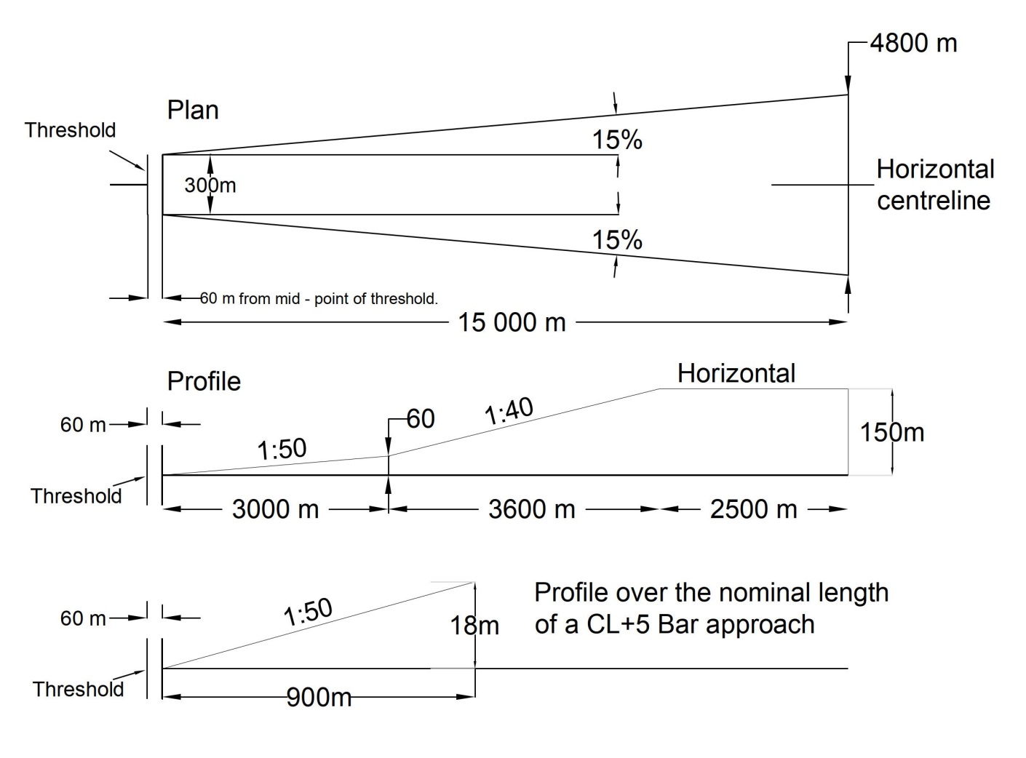

Approach Design Criteria

    - The commencement of the Approach OLS is associated with the position of the Threshold. If a physical obstacle (such as a Chimney or Telecom Mast) does penetrate the Approach OLS and these cannot be reduced in height or removed, then an option is for the Client to consider displacing the runway threshold.

    - Displacing the Threshold further back onto the runway will have the effect of lifting the Approach OLS further out from the runway end. This alone may lift the Approach OLS above the Obstacle to be cleared.

    - Any displacement of a Threshold must be instigated by the Regulated Entity.

    - In addition to fixed obstacles other “virtual” objects such as roads or railways may penetrate the Approach OLS in a similar manner to a fixed Obstacle. However, such objects may effectively be removed from the Approach OLS by the provision of traffic lights or signal controls at the outer edges of the Approach OLS.
    - The introduction of public road traffic light or rail signals shall require the consent and approval of local external agencies. Such approvals cannot be guaranteed.

    - The Approach OLS for the first 3km is never less than 2% (1:50). There may be some instances where objects may exist which cannot be removed, lowered or relocated economically. These objects may be located so close to the threshold that they cannot be cleared by the 2% slope. The most likely object would be the airfield security fence if it is positioned close to a paved area such as an undershoot RESA.

    - Where such conditions exist and no alternative is possible, with the approval of the Technical Authority, the 2% slope may be exceeded or a “stair step” implemented, in order to keep the approach light fixtures above the objects. Such “step” or increased gradients may be resorted to only when it is impracticable to follow standard slope criteria, and they shall be held to the absolute minimum. Under this criterion no negative slope is permitted in the outermost portion of the system.

    - Note that there is a further plane specific to the Approach and this is the Approach Light Plane (ALP). This plane is more commonly termed the Approach Lighting Profile. The ALP is rectangular and extends to 60m either side of the extended runway centreline and 60m beyond the end of the approach lighting system.

    - RA3515(3) gives the restrictions on the limits of the ALP, and again obstacles shall be considered when designing the ALP, so as not to cause obstruction to the visual cues given by the lighting system.

    - No objects are permitted to exist within the boundaries of the ALP which are higher than the ALP except as designated herein. All roads and highways are considered as obstacles extending 4.8 m above the crown of the road, except aerodrome service roads where all vehicular traffic is under control of the aerodrome authorities and coordinated with the aerodrome traffic control tower. Railways, regardless of the amount of traffic, are considered as obstacles extending 5.4m above the top of the rails. If such obstacles cause an obstruction to the visual clues, the ALP shall be raised, or measures taken to prevent vehicles remaining stationary at positions which would block the light output from lights of the approach, such as the provision of traffic lights controlled via ATC. Consideration should also be given the yellow box road markings where additional clarity is required, or installation of traffic lights is not possible.

    - To establish the data for determining the shape of the ALP, it shall be necessary for the Designer to obtain a topographical survey of the ground over which the approach will be installed.

    - The Designer shall establish a datum level on the runway pavement; this datum shall be located on the runway centre line on the axis of the threshold lights.

    - The survey shall extend to at least 60m beyond the end of the proposed system and encompass a width of 60m either side of the extended runway centreline.

Approach Topographical Survey

    - The survey shall include:

      - Positions and heights of all buildings, trees, roads, rivers, railways, canals, airfield boundary overhead power lines and other physical obstructions in the approach path.
      - Whether the land is under grazing or cultivation or is wooded land or golf course, etc.

      - The positions and constructions of crash or arrestor barriers, radio aids or beacons standing within the approach area - e.g., ILS.

      - The extent and construction of the overrun area, together with details of any projected regrading to revised levels.

      - In special cases where the approach lies over water (e.g., the sea, rivers and estuaries, marshes and similar) the survey shall indicate the practicability of providing stable mounting supports, or a suitable marine construction, where the water depth the nature of the bottom, navigational usage and any other circumstances indicate that an approach lighting system, in part or complete, might be economically realised. Consideration is also to be given in such circumstances, to the reduction of the approach lighting pattern such as reducing the number of cross bars and length of the centre line. The Designer should also consider the problems of maintenance and to the cost of such maintenance once the system has been installed.

    - A study of the Measured Height survey shall also be undertaken by the Designer to determine if there are objects that have been missed in the topographical survey.

Approach Lighting Drawing Presentation

    - Having collated all the data, the approach scheme shall be drawn in the following formats:

Figure 7.2 Approach Scales
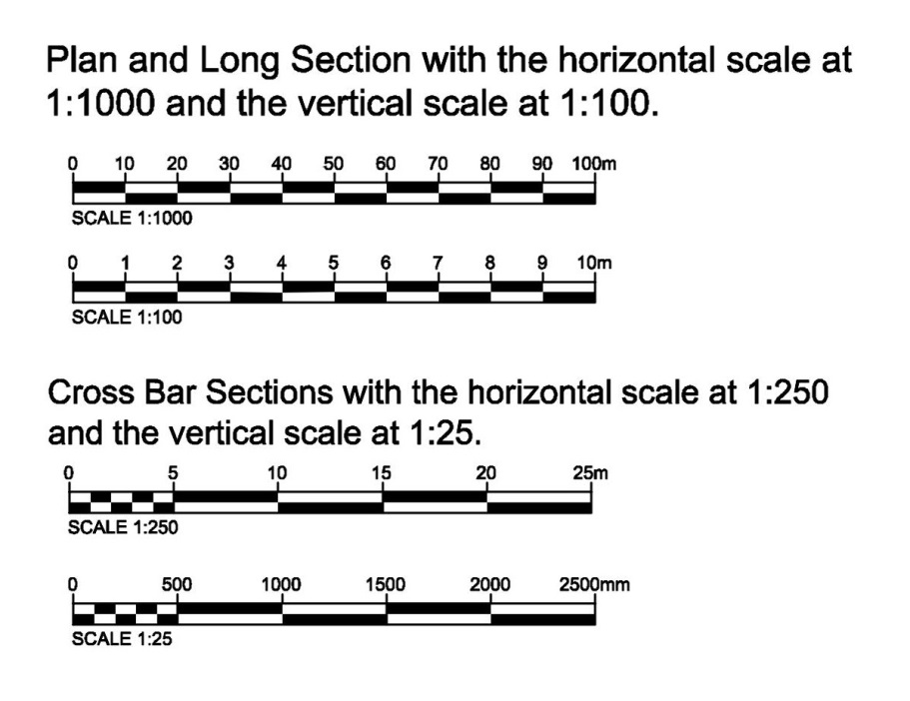

NB: Scale bars shall be shown on the design drawings.

Approach Lighting Patterns

    - The following approach lighting systems are described in RA 3515:

- Simple approach; RA3515(5), Paragraphs 25 to 31.

- High intensity centreline and crossbar; RA 3515(6) Paragraphs 32 to 36.

Simple Approach

    - If the approach is either NI or NPI, the simple approach is to be installed if aircraft can be accepted using VFR on this approach at night. It is not acceptable where low visibility approach is anticipated.

    - It shall consist of a row of light fixtures (spacing interval of 60m) on the extended centreline of the runway extending over a distance of not less than 420m from the threshold with a row of light fixtures forming a crossbar 30m in length at a distance of 300m from the threshold.

    - When it is desired to improve the guidance, centre-line spacing interval of 30m may be used.

    - RA3515(5) also gives an option where it is physically difficult to install the system to 420m; it may be acceptable to terminate the system at the 300m crossbar. If this option is acceptable, then an additional crossbar at 150m shall be installed.

    - The RAs do not discuss simple approach lighting that can be used on airfields which are part of the MOD estate but operated by the United States Air Force. For details of such lighting reference may be made to the Unified Facilities Criteria document, UFC 3-535-01. In principle, Host nation’s standard should apply unless visiting force’s standard is stringent.

    - The final additional option is where a 300m system is physically not possible, then the approach can be achieved by installing a barrette system as far as is physically possible.

Figure 7.3 Typical Simple Approach Options
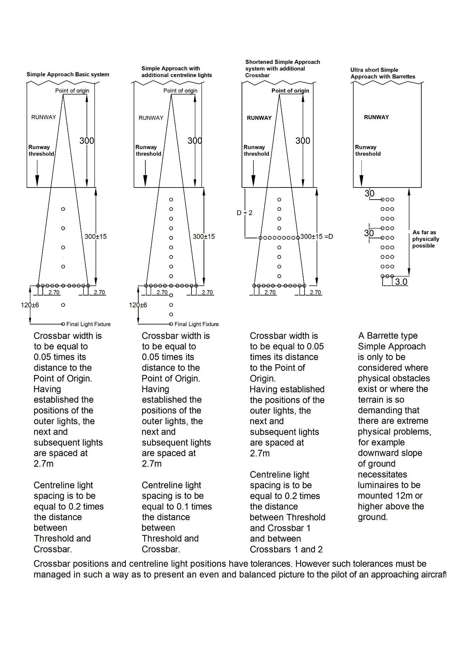

    - The requirement for a simple approach shall ultimately be decided by the Regulated Entity responsible for the operating requirements of the aerodrome. However, the options that are provided in this document give a range of facilities that can be discussed with the Regulated Entity for the Regulated Entity to decide as to the facility that can be provided. The Designer shall make the Regulated Entity aware of both the advantages and disadvantages of each option, considering the terrain and the impact on maintenance of each option.

    - RA3515 (5) mandates that the lights of a simple approach may be uni-directional for a PI approach but on NI/NPI approaches should show at all angles in azimuth to a pilot on base leg and / or final approach. HI unidirectional lights shall be installed on approaches to runways where HI runway edge lights are fitted.

    - The RA recognises omni direction lights on runway edges provide circling guidance to pilots whilst uni-directional HI lights define the runway edge.

High Intensity Centreline and Crossbar Approach System

    - This system is required for approaches that are CAT I or CAT II Precision Instrument Approach. The majority of approach lighting installations on MOD airfields support CAT 1 as detailed with RA 3515(6).

    - By exception where CAT II approach light patterns are required to support airfield operations, the Designer shall refer to RA3515(7) which details the supplementary approach lighting required for CAT II patterns.

    - RA 3515(1) states:

“If a Runway is declared as a Precision Approach Runway, through having a PAR,
then it should have corresponding levels of lighting relative to the Declared Operating Minima at the aerodrome”.

    - However, RA 3515(1) goes on to say:

“It is noted that all runways at an aerodrome may not be required to have the same scale of visual aids. RA 3515 requires the scale of visual aids be determined according to the Operating Minima, Nature and Types of Air System operations”.

    - The Designer shall liaise with Client to ascertain exactly which approach system will be adequate for the proposed airfield operations. Note that the application of PAR itself does not generate a requirement for a CL5B approach lighting system on a runway heading.

    - The Designer shall further note that a CL5B approach lighting pattern is mandatory where fixed wing aircraft approaches are conducted in RVR condition down to 550m.

    - The RAs do not discuss barrette approach lighting. This lighting system has been installed on MOD aerodromes operated by the United States Air Force. For details of such lighting refer to the Unified Facilities Criteria document, UFC 3-535-01.

    - The RAs do not discuss the provision of a sequenced flashing light system, even though such a system exists on Mount Pleasant Airfield (Falkland Islands). In the future such systems shall only be considered after discussions with the Client.

    - Figure 7.4 below is taken from Figure 2 of RA3515 (6) Figure 2:

Figure 7.4 Centre Line and Cross Bar Approaches
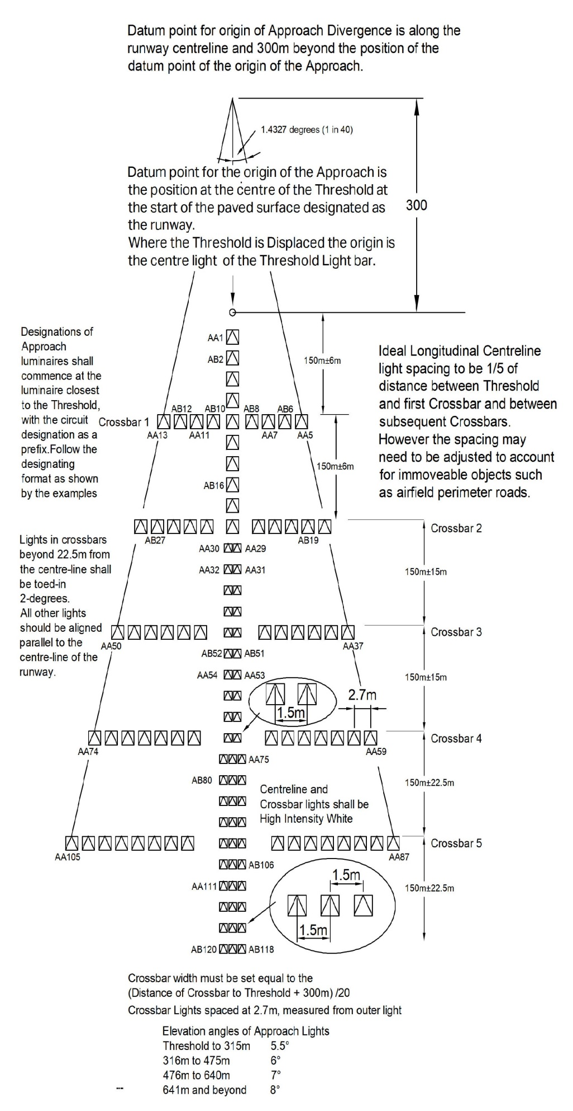

    - For the ALP, RA 3515(3) Paragraph 16 states:

‘.. should have a vertical profile limit no greater than 1:66 rise and no less that 1:66
fall for the first 300m, and no less than 1:40 fall thereafter’.

Figure 7.5 Approach Profile

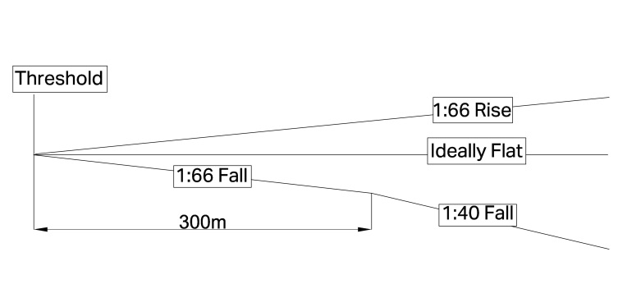
    - Within a stopway or clearway, and within 150m of the end of a runway, the light fixtures shall be mounted as near to the ground as local conditions permit in order to minimize risk of damage to aeroplanes in the event of an overrun or undershoot. In circumstances where pavements are located prior to the Threshold and are aircraft manoeuvring areas or are Runway strip or RESA there may be no option but to install inset light fixtures. Such circumstances may preclude compliance with the mandated rise or fall of the ALP at the Threshold. The origin of the ALP shall remain at the Threshold and the first elevated light fixture shall follow an ALP that assumes the inset light fixtures would have been elevated.

    - All efforts shall be made to install approach light fixtures at the same height as the Threshold. On falling ground light fixtures are to be maintained at threshold level unless this requires poles in excess of 12m.

    - Notwithstanding the above, every effort shall be made to install light fixtures within the confines of the ALP gradients shown in Figure 7.5.

    - The gradients of the centre line in any section (including a stopway or clearway) should be as small as practicable, and the changes in gradients should be as few and small as can be arranged and should not exceed 1 in 60. Experience has shown that as one proceeds outwards from the runway, rising gradients in any section of up to 1 in 66, and falling gradients of down to 1 in 40, are acceptable.

    - Where light fixtures could be accommodated within this envelope but may be obstructed by roads or railways the gradients are to be adjusted to lift the ALP by up to the maximum gradient to ensure the light fixtures clear the obstacles. If it is not possible to stay within the permitted gradients methods should be installed to prevent road or rail vehicles remaining stationary at positions which would block the light output from lights of the approach.

    - Where light fixtures are to be positioned in arable fields (with no livestock) every effort shall be made to mount them at a height to avoid obstruction by growing crops. Certain crops, for example Maize, are extremely tall. Crop type may need to be discussed between farmer and MOD Land Management Section.

    - The cross bars are to be at a right angle to the centre line.

    - Cross bar widths shown in RA 3515(6) Figure 2 only apply for nominal 150m longitudinal separation. Deviation from 150m separation requires crossbar widths to be adjusted to ensure that the outermost lights are on the correct subtended angle of the approach.

    - When it is necessary for a cross bar to be displaced from its standard position, remaining cross bars are to be moved relatively to minimise the differences in spacing. The centre line light fixtures are to be as evenly spaced as site conditions permit.

    - The Designer shall produce drawings based on the example drawings. Note that the example drawings are partial, to enable them to be included in this document. Actual drawings shall be drawn at A1 scaled and printed at A1 or A3.

Figure 7.6 Approach Layout and Sections Incorporating Topographical Survey Information
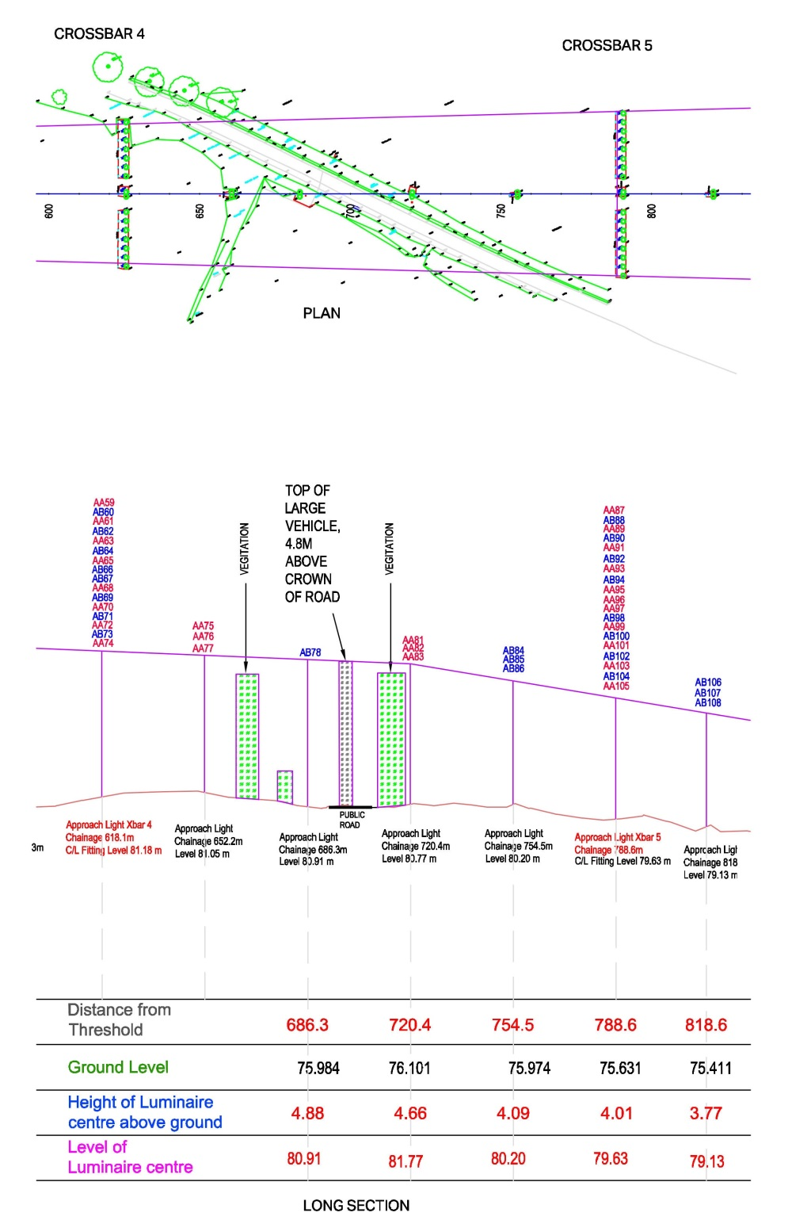
vd
    - Figures 7.6 and 7.7 indicate that each light fixture has a unique designation. Each light fixture has an alphabetic prefix which indicates that it is part of a circuit. The drawings use a pair of prefixes that show that the approach is interleaved over these two circuits. Such interleave is standard for military airfields and the interleave indicated shall be adhered to.

    - For supplementary approaches, the light fixtures shall be serviced by a separate pair of interleaved circuits, as indicated in Figure 7.8.

Figure 7.7 Dimensioned Approach Cross Bar Section
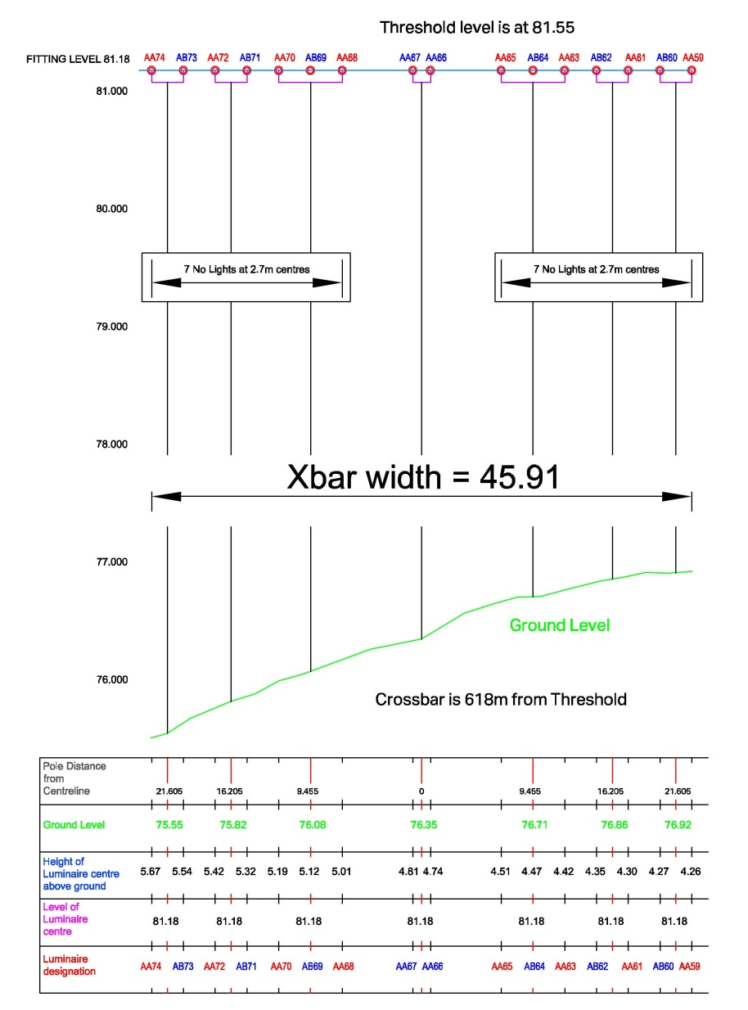

    - The Designer’s drawing shall use colours for ease of understanding.

    - Not shown on the example are any proposed pits, duct/trench routes and fences. They shall be shown on full sized (A1) drawings in plan format.

    - Within the airfield boundary and under the ALP, all hard vegetation, such as bushes and trees shall be completely removed.

    - Where necessary approach light fixture supports outside the airfield boundary shall be protected from cattle and other livestock by the installation of a 100mm frangible post and rail fence, with a maximum height of 1.2m.

    - The absolute minimum of metal shall be used in its construction. Gaps or gates in the fences shall be installed where light fixture supports have hinged facilities to allow light fixtures to be lowered for maintenance. The drawing shall show the gap or gate in the correct position to allow the support to fold such that the light fixture is face up when the support is lowered.

    - Lighting installations that are taller than 2m above the adjacent ground shall have a permanent hinge fitted. Where supports are between 2m and 5.5m tall, the hinge is to be at the base of the support and those above 5.5m shall be mid-hinged.

    - It is generally required that where either the support or light fixture is constructed from electrically conductive material all such structures exceeding 2m in height shall be earthed. If the structure is less than 2m in height it shall not be earthed.

    - Cabling on or inside structures above 2m tall shall maintain the frangibility of the whole support structure by providing points of cable disconnection at the base of the support and adjacent to the light fixture.

CAT II Approach Lighting Systems

    - For CAT II operations, a substantial modification of the approach lighting system is required and to this end, a supplementary lighting system shall be installed. This is discussed in RA 3515(7) Paragraphs 37 to 39.

    - Associated with this upgrade will be the introduction of touchdown (TDZ) and runway centreline lights. A description of these systems is provided in later sections. The requirement for the layout of the supplementary approach is in part dictated by the layout of the TDZ system.

    - The gauge between the TDZ barrettes is to be preferably 18m but can be up to 22.5m. EASA and ICAO confirm that the distances between the runway centreline and the inner TDZ lights are between 9m and 11.25m, not between 9m and 11.5m as shown by CAP168 and RA 3515.

    - None of the regulations (RA, EASA, and ICAO) discuss the fundamental reason for the layout of the width or gauge of the TDZ system. There is no clear guidance as to which spacing to choose, but it seems likely that it is related to runway width. Therefore, the Designer shall propose a gauge based on the runway width for consideration by the Client, such gauge is to be mirrored to the supplementary approach. The drawings used in all the regulations are based upon perfect approach layouts, such that the first and second crossbars are set exactly at 150m and 300m, with none of the permitted tolerances used. The Designer can as required incorporate the design tolerances given in the RAs.

Figure 7.8 Dimensioned Cat II Approach Configuration
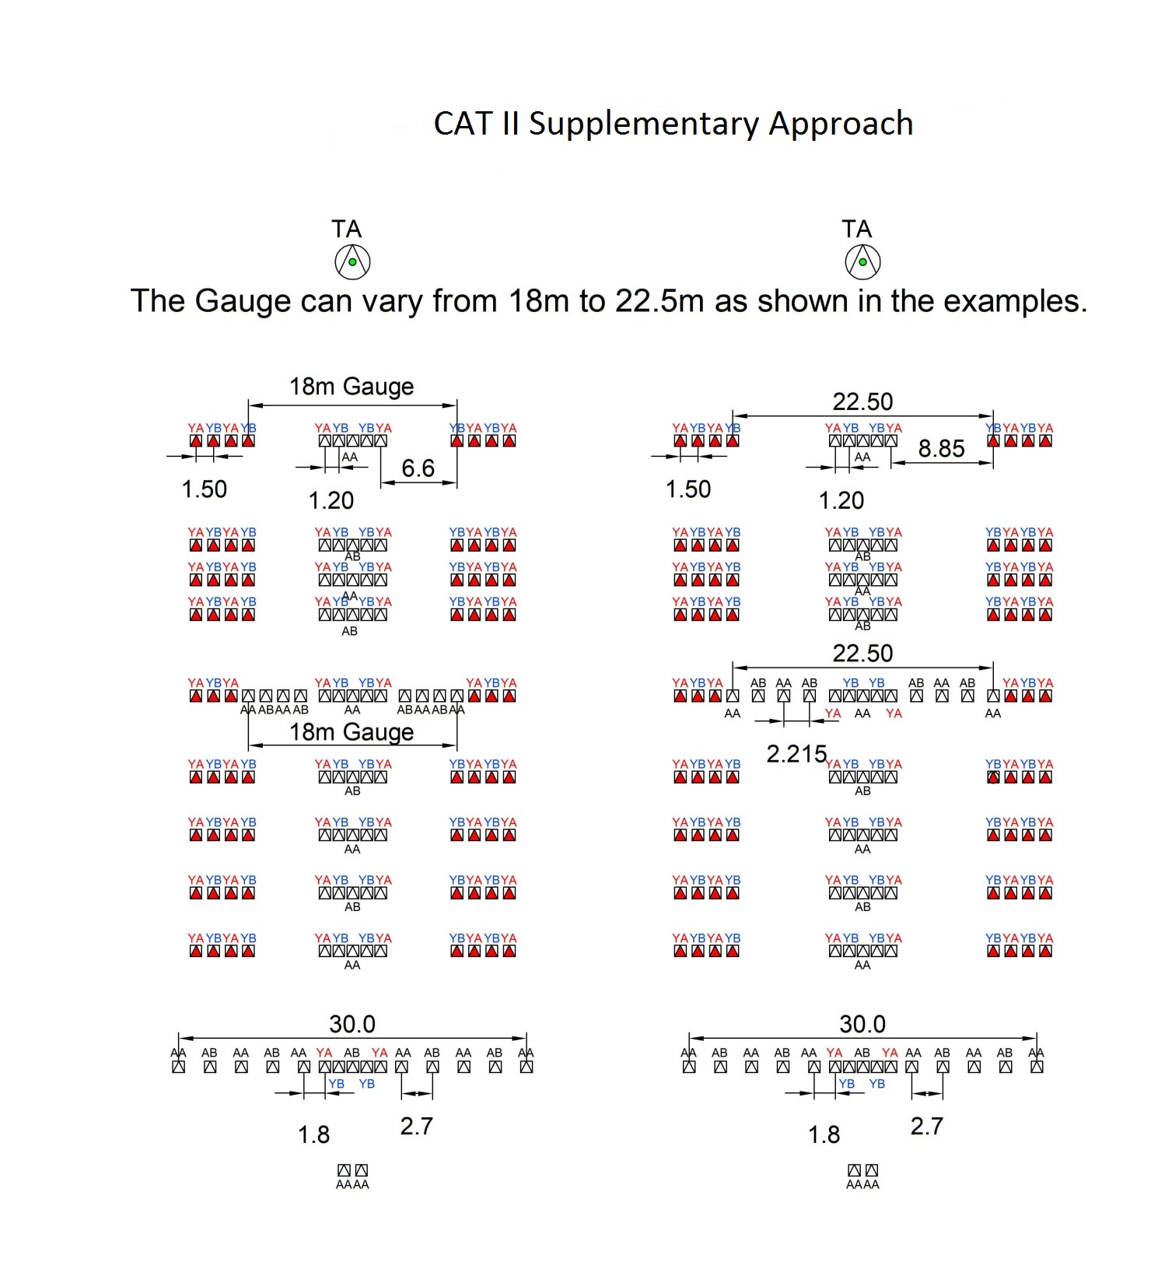

Specific Requirements for AGL Cabling Serving Approach Lights Systems

    - The preferred method of installation for approach cables is via a pit and duct system.

    - On land outside the airfield boundary, a single duct or a pair of ducts shall be laid at a depth not less than 1000mm. The cables should be placed at a sufficient depth to protect from external damage unless adequate mechanical protection is in place.

    - Should, by exception, trenches be recommended, cables shall be armoured, irrespective of their depth. The armour shall be continuous through all joints and earthed at one extremity only to the standard AGL earth.

    - Each pit shall contain an earth bar. The earth bar shall be copper, a minimum of 25mm x 3mm and be fixed to the pit wall via propriety fixings. Within each pit, an individual earth cable of 6mm² CSA, sheathed in green/yellow shall be connected from the earth bar to each AGL transformer earth stud.

    - The earth bar shall be connected to the AGL earth bar in a B Centre. The connection shall be made via a 6mm2 copper conductor or where a Counterpoise system has been installed via the 16mm2 copper Counterpoise cable.

    - Where the area in which pits would normally be installed is liable to flooding, consideration can be given to the provision of lockable vandal-proof boxes on posts that are higher than the anticipated high-water mark. Primary cables shall be suitably protected where they emanate from ducts or trenches in the ground to the transformer boxes by encasing them in a vandal-proof material. Such containment and box to be provided with Danger High Voltage labels.

    - Pits shall be equipped with brackets or baskets in order to mount the AGL SCTs and any joints clear of the bottom of the pit. All pit covers shall be the F900 strength. The MAA Regulatory Articles do not specifically refer to the requirement for F900 Heavy Duty chambers, frames and covers. Designers shall mandate chambers with an F900 rating within the defined Clear and Graded Area (CGA) of the Runway Strip. Beyond the defined CGA, areas may exist that can be used for occasional and emergency use of aircraft. These include RESAs, Stopways, Net Barrier Overruns and Clearways. Pits in such areas shall be installed with F900 equipment. All F900 pits which are sited in unpaved ground shall be delethalised. Outside or beyond the areas defined above, the requirement can be relaxed to D400 in keeping with the service vehicles that may travel over the area. D400 equipment can be provided in Taxiway strips that are outside of the CGA of the Runway strip. D400 equipment does not require delethalisation but must not protrude above the adjacent surface.

    - In order to facilitate the lifting of pit covers an area to the short side of the pit shall have a hardstanding of sufficient size to allow the use of pit lifters.

    - The Designer shall ensure that the pits are designed to ensure that heavy covers and equipment can be handled in a safe manner by an operative accessing them.

    - A drawing, based on the example of Figure 7.9 below, shall be prepared.

    - The Designer shall ensure that the secondary leads between the SCT and light fixture are sized to take into account the voltage drop on the cable does not affect the performance of the light source.

Figure 7.9 Approach Transformer Pit Configurations
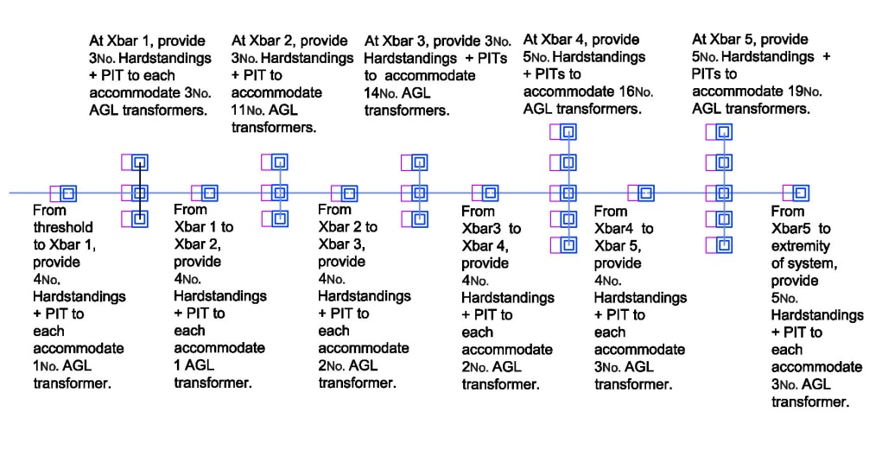

    - In respect of AGL cables, the previous requirement was that they shall comply with specification M&E 42. However, this specification is no longer extant and shall not be quoted in the design. For cables within the airfield boundary and deep ducted outside the airfield boundary, the cables shall be constructed as 7 strand copper wire giving a total CSA of 6mm². They shall be insulated with a suitable material to withstand 3000V peak voltage. They shall have a sheath laid over the insulating layer. Cables with higher insulation ratings may be installed if economically justified.

PRECISION APPROACH PATH INDICATORS

Introduction

    - Precision Approach Path Indicators (PAPI) belong to a group of systems termed Angle of Approach Indicators (AAI), which included various early systems such as VASI. The PAPI system was recognised as the optimum system and as such it has replaced all older systems.

    - All AAI systems are provided primarily to allow a pilot to approach at the correct angle and to land at the appropriate point of the runway.

    - In addition, PAPI system provides accurate information on the rate of change of approach angle and provides some measure of "artificial horizon" or roll guidance to the pilot, prior to touchdown.

    - The AMCs pertaining to PAPI systems are given in RA 3515(8) paragraphs 40 to 48.

Glideslope and ILS Harmonisation

    - On an instrument approach procedure, harmonisation between the radio-navigational aids and the PAPI signal is necessary to prevent course or attitude changes during this final sector of the approach. This is achieved by co-locating as far as is possible the origins of the glideslopes of the Instrument Landing System (ILS) and PAPI system.

    - The most common Glideslope is 30, but at various airfields Glideslopes of 20 30 minutes and 30 30 minutes have been used. Where ILS has been installed the ILS equivalent of the MEHT for PAPI is known as the Threshold Crossing Height (TCH) or Reference Datum Height (RDH). The ILS is a radio beam which is received via an aerial on the aircraft and decoded by on-board radio receiver equipment which then generates a visual display to the pilot.

    - The PAPI system is a visual system that is sensed by the eye of the pilot. To achieve harmonization for the two systems it is necessary to know the distance between the aircraft’s aerial and the pilot’s eye. The distance between the two is affected by the attitude of the aircraft in the approach configuration, because the nose of the aircraft is tilted up in the approach attitude. Hence the MEHT for the PAPI is the sum of the TCH or RDH at the Threshold, plus or minus the distance from aerial to pilot’s eye in the approach attitude. In some circumstances, the aerial could be located above the cockpit and as such the MEHT would be lowered. If this is the case, then Wheel Clearance shall be checked. The other consideration is that because there are many types of aircraft, the only option is to determine the MEHT for the most common aircraft that uses this approach. The Client should provide the MEHT.

    - Where ILS is not provided, the MEHT having been received from the Client, the Designer shall check that there is adequate wheel clearance over the Threshold. Table 8.1 and its associated Notes shall be used to check that the given MEHT gives the required wheel clearance at the threshold.

Table 8.1 Wheel Clearance over Threshold for PAPI

Eye-to-wheel height of Aircraft in the approach configuration  Note 1 | Desired wheel  clearance (metres)  Notes 2,3 | Minimum wheel  clearance (metres)  Note 4
A | B | C
Up to but not including 3m | 6 | 3 (note5)
3 m to but not including 5m | 9 | 4
5 m up to but not including 8 m | 9 | 5
8 m up to but not including 14 m | 9 | 6
Note 1. In selecting the eye-to-wheel height group, only aeroplanes meant to use the system on a regular basis shall be considered. The most demanding among such aeroplanes shall determine the eye-to-wheel height group.
Note 2. Where practicable the desired wheel clearances shown in column B shall be provided
Note 3. The wheel clearances in column B may be reduced to no less than those in column C where an aeronautical study indicates that such reduced wheel clearances are acceptable.
Note 4. When a reduced wheel clearance is provided at a displaced threshold the corresponding desired wheel clearance specified in column B shall be available when an aeroplane at the top end of the eye-to-wheel group chosen overflies the extremity of the runway.
Note 5. This wheel clearance may be reduced to 1.5 m on runways used mainly by lightweight non turbo-jet aeroplanes.

PAPI Configuration

    - A full PAPI system comprises two wing bars (port and starboard) each consisting of four PAPI light units.

    - LED systems have been developed but will be described in subsequent versions of this Design Document.

    - Each wing bar provides full glideslope information and shall agree with its twin wing bar. Each light unit emits a unidirectional beam of light with a white upper sector and a red lower sector separated by a very narrow transition band.

    - Each wing bar of the PAPI is to have a separate power circuit. The CCR for each PAPI circuit shall be capable of being programmed such that if it is commanded Off by the control system, then it shall default to a very low value of output current. This status is commonly described as Black Heat.

    - Where for physical reasons it is not possible to provide both port and starboard wing bars, then a single wing bar may be acceptable. It is noted that civil airports generally only install a port side wing bar. At some civil airports this wing bar has been modified for continuity of service by providing pairs of two lamp light units at each of the four positions and supplying each light unit within a pair with a separate circuit. For the rare situation where on military sites it is only possible to provide a single wing bar, this type of interleave may be considered.

    - Where the standard port and starboard wing bars are to be provided, but lack of space at the sides of the runway a 4-light unit system cannot be installed, then an option may be considered to install an APAPI system on runways without ILS. The arrangement is that only two light units are provided at each side of the runway.

PAPI Obstacle Protection Surface Considerations

    - Associated with a PAPI installation is an Obstacle Protection Surface (OPS). The PAPI beam should be within the OPS.

    - RA 3515 states that the OPS parameters are given in ICAO Annex 14 Vol 1 Table 5-3 & Figure 5-19. The ICAO parameters are considerably different from the parameters quoted in both JSP 554 and MADS (both now non extant) and shall be noted so that the figures shown in the withdrawn documents are not used. Figure 8.1 indicates an example derived from data in ICAO Table 5-3.

Figure 8.1 PAPI Obstacle Protection Surface
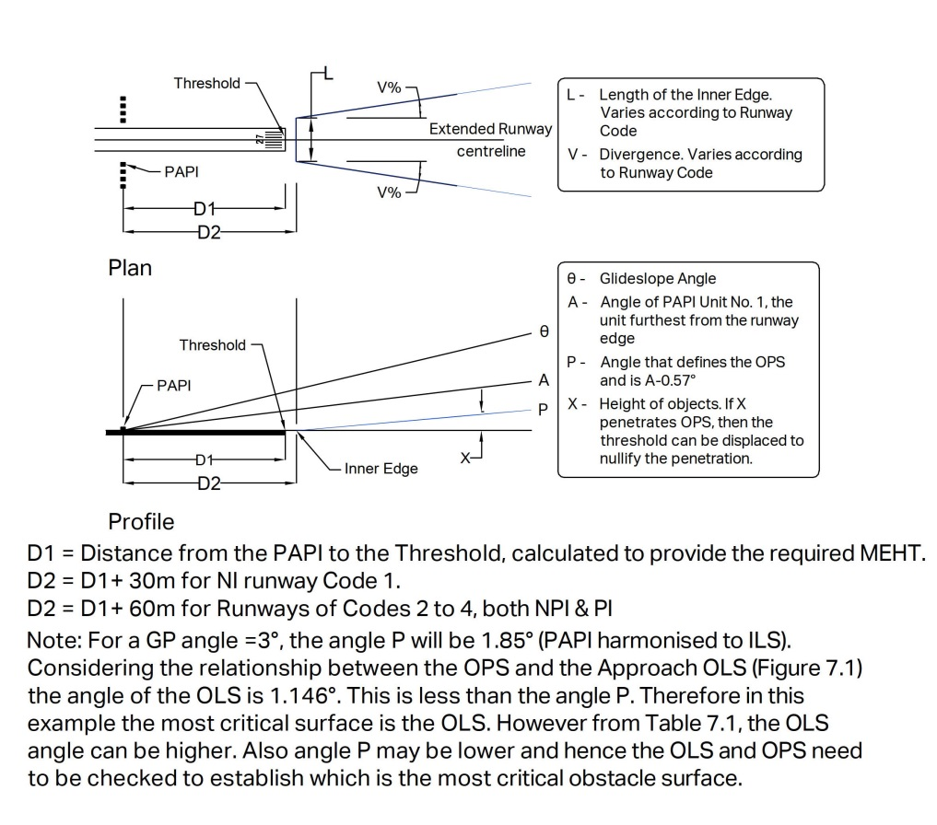
    - Having established the OPS, it follows that there needs to be a check to ascertain if any objects are above the OPS. For practical purposes it is unlikely that an approach will have been constructed where land up to the Threshold rises so severely that the OPS will be penetrated by the land. The most likely scenarios are that the land rises gently, is flat or falls either gently or severely. Where objects would infringe the OPS, the optimum solution is to displace the threshold (and hence the OPS) to a position where such infringing objects would then be under the OPS. If that can be achieved it is then possible to reduce the MEHT provided that the corresponding desired wheel clearance specified will be available when an aeroplane at the top end of the eye-to-wheel group chosen overflies the extremity of the runway or where an undershoot RESA exists, the extremity of the RESA.

Figure 8.2 The Standard ICAO PAPI Drawing
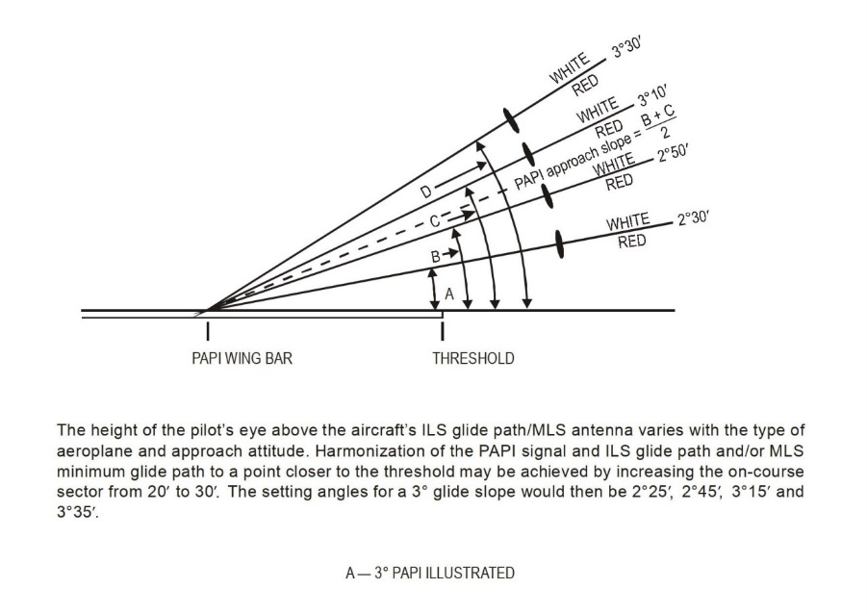

Positioning of PAPI Systems

    - PAPI locations relative to the runway edge are to be as detailed in RA 3515(8) Figure 4. Figure 8.2 above is reproduced from Figure 5-20 in ICAO Annex 14 Vol 1 and gives an overview of the elevation angles for a 30 glideslope.

    - Where the ground on which the PAPI is to be installed is at the same height as the centre of the threshold light fixtures, then the approximate position of the PAPI units is relatively simple to calculate and is: MEHT/the tangent of the angle of PAPI unit 2 less two minutes of arc (use 19 as the Cotangent of this angle for a glideslope of 3°). Note that 3° has been chosen simply to define a starting point for the ground survey.

    - As an example, if the MEHT is given as 15m and the glideslope angle is 30 the first approximation of the position of the PAPI will be 285m from the threshold.

    - The MEHT is the sum of any ILS TCH (RDH) plus the distance between the ILS aerial of the aircraft and the position of the pilot’s eye in the approach attitude of the aircraft.

    - It is then a question of determining the heights of various positions of each PAPI unit and the threshold height. The latter will be found in the required topographical survey.

    - It is very unlikely that the heights of the ground at the PAPIs will be the same as the height at the centre of the threshold light fixtures.

    - To determine PAPI ground heights it will be necessary to be furnished with a topographical survey covering the likely areas on which the PAPIs can be located. A useful starting point will be the theoretical position (285m in the case of the example) and surveying 50m either side of that point in 1m steps.

    - Another consideration is that the PAPI lens will be a certain height above the ground. It is known that, if possible, the physical top of a PAPI unit shall not exceed 0.9m. To allow for reasonable maintenance access the bottom of a PAPI unit shall not be lower than 0.4m above the ground. It is therefore recommended that the first approximation of Lens Height is to be set at 0.6m above the ground.

    - With the availability of 3D CAD facilities, the process of sequentially transferring the topographical data into an Excel file should be less time-consuming than a manual exercise.

    - A typical Excel file is shown below as Table 8.2 giving details for PAPI positioning on an approach with ILS facilities and the design shall incorporate either an Excel file similar to the example or in a different form that will achieve the requirement to show the heights of each individual PAPI ground height, its lens height and total height, the threshold height and the optical beam height of each PAPI unit at the threshold.

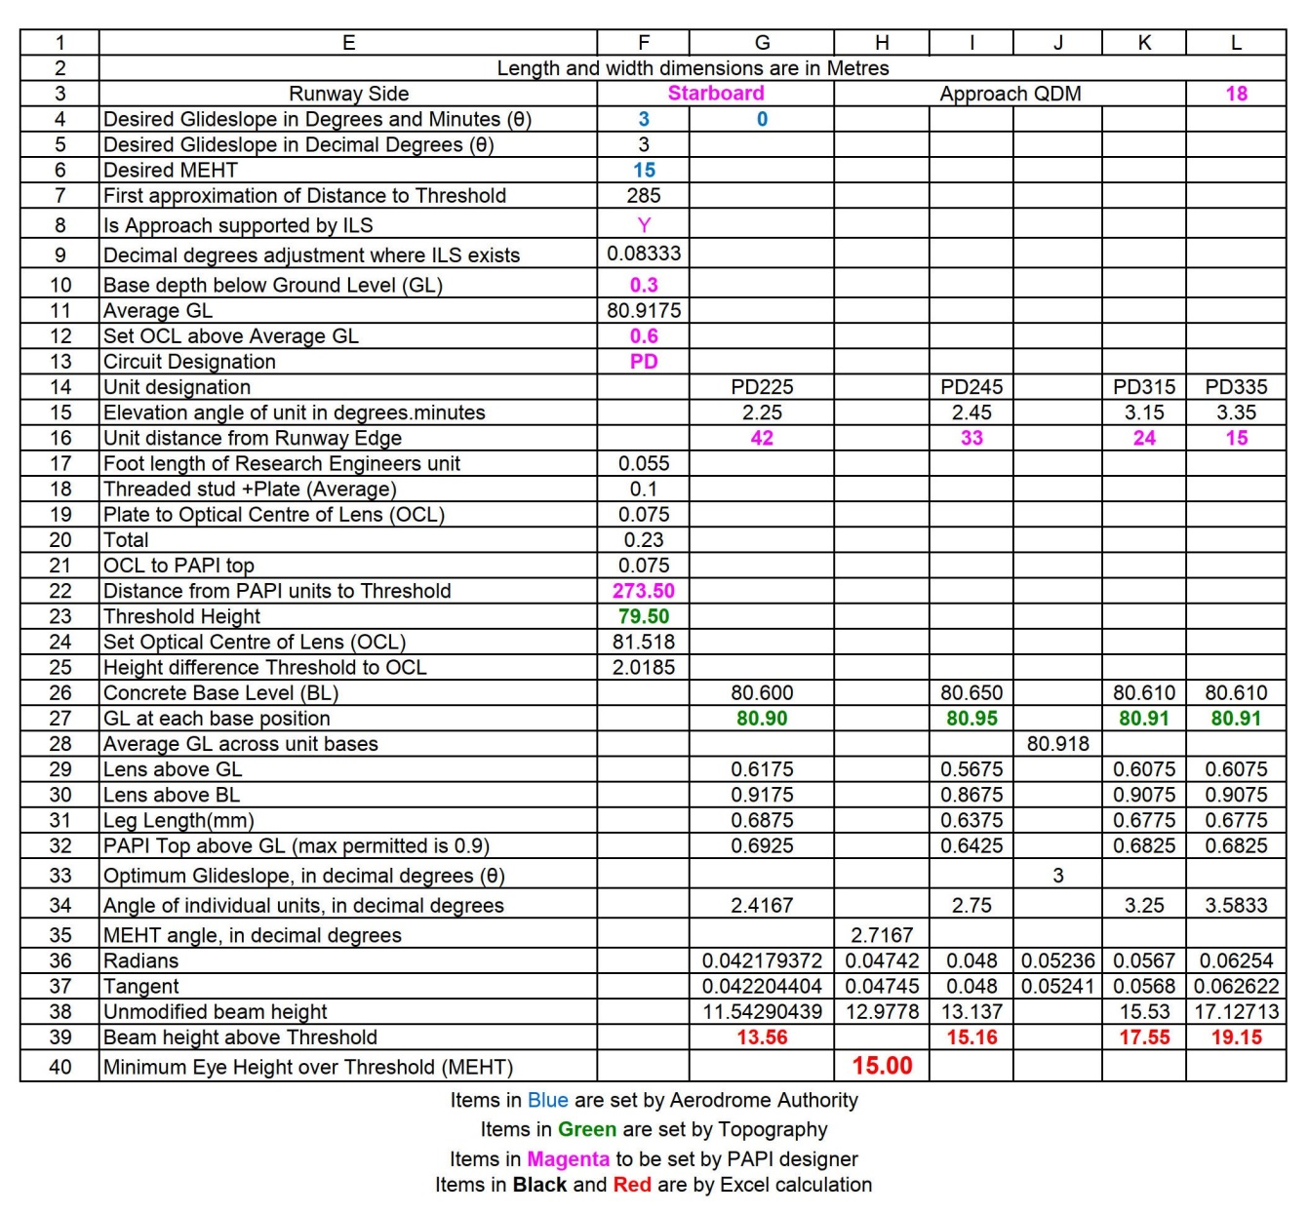
Table 8.2 Approach with ILS
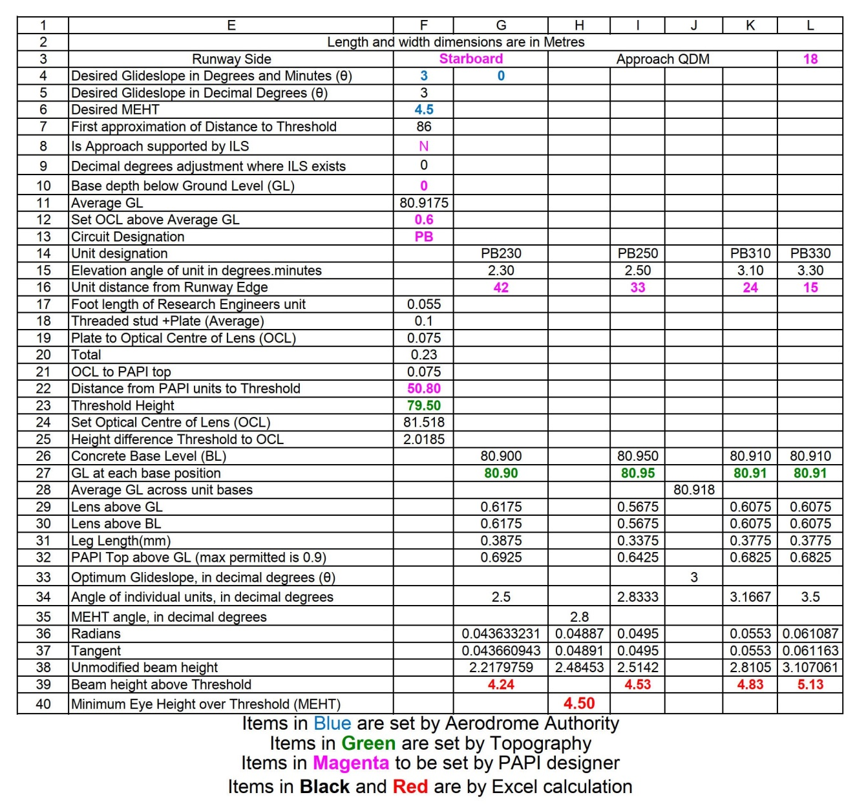
Table 8.3 Approach without ILS

    - Associated with a PAPI installation is an Optical Touchdown Point (OTP). This is a point on the Runway Centreline where the virtual Glideslope beam (e.g., 3°) would intersect with the pavement. All extrapolated beams from the eight Port and Starboard units should meet at the same distance from the Threshold, if all units are at the same ground height and the same distance from the Threshold. If this meeting point is mirrored to the Runway Centreline, it will define the origin of the PAPI system and hence give the position of the Aiming Point Marking. Caveats apply if the gradients of the ground on which Port and Starboard systems are positioned cause the Port and Starboard units not to be at the same distance from the Threshold.

    - ICAO Design Manual Part 4 Page 8-21 has a worked example of PAPI positioning.

    - Table 8.3 above shows details for an approach with a displaced threshold on a very short runway that requires as much landing distance as possible. The MEHT has been reduced to the absolute minimum. It can only be used by very small aircraft and complies with the allowance shown in Note 4 of Table 8.1
    - Where ILS is provided, the PAPI system will generally be found to be sited upwind of the ILS glidepath aerial.

    - The regulations allow the gradient of the ground in the clear and graded region at the sides of a runway to be as great as 2.5% or even 3% whereas the gradient of the slope across the PAPI wing bar is restricted to 1.25%. In such circumstances the total height of some PAPI units may exceed the permitted 0.9m. Transverse gradient on the graded surface on PAPI location shall be minimal to install to PAPI within the specified tolerance.

    - A substantial concrete base is to be provided for each of the PAPI units.

    - The concrete bases shall be flush fitted, with suitable delethalisation.

    - The top of the PAPI body shall not exceed 900mm in height.

    - Figure 8.3 below indicates a general representation of an installation and such a drawing is to be produced.

Figure 8.3 Typical PAPI Installation

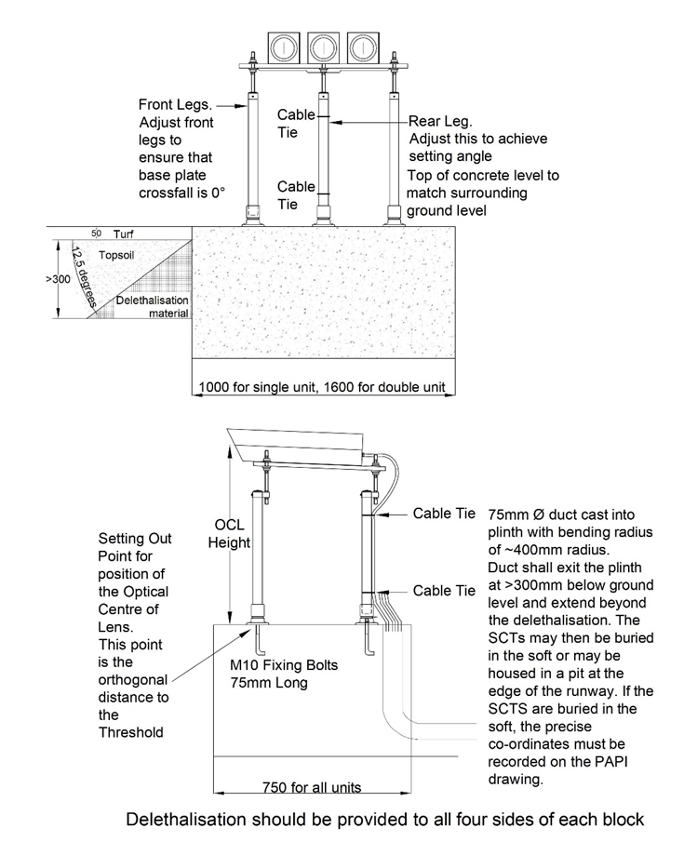

RUNWAY LIGHTING

Runway Edge Lighting

    - RA 3515(9) mandates that runway edge lighting service is required on all runways for night operation and on precision runways for day and night operation. Issue 2 of this regulation does not require both High Intensity and Low Intensity lights to be provided on a specific runway. High Intensity systems may be accompanied by Circling Guidance lights (CGL).

    - RA 3515(9) Para 50f states “On a runway without centre-line lighting, a section of the lights 600 m or one-third of the runway length, whichever is the less, at the remote end of the runway from the end at which the take-off run is started, should show yellow”.

    - RA 3515(9) Para 50 g (2) states “A section of the lights 600 m or one-third of the runway length, whichever is the less, at the remote end of the runway from the end at which the take-off run is started, may show yellow”.

    - RA 3515(9) Para 57 states:” The section of the lights 600 m or one-third of the runway length, whichever is the less, at the remote end of the runway from the end at which the take-off run is started, may also show white colour where runway centreline lights or Illuminated Runway Distance Markers are installed”.

    - Considering RA 3515(9) Paras 50f, 50g(2) & 57, the Designer shall consult the Client as to his requirement for the provision of white or yellow colour coding.

    - Circling Guidance light fixtures or component should be located at uniform distance not more than 100m; and preferably combined or collocated with HI edge lights where installed.

    - Those instructions shall generally be followed, but with the following information giving supplementary instructions. It is the long-term desire to bring the present format of separate High Intensity, Low Intensity and possibly Runway End systems into a single system. On PI runways Low Intensity systems will be known as Circling Guidance systems.

    - The preferred type of runway edge light fixture is elevated. Where elevated light fixtures are installed the total height shall be less than or equal to 360mm above the adjacent pavement level.

    - To prevent damage occurring to the light units, inset edge lights shall be used within the swept area of an aircraft arresting system and at junctions of intersecting pavements. However inset omni-directional light fixtures shall not be installed in the areas where an aircraft may roll over these omni-directional lights.

    - RA 3515(9) Para 55 states: “Where required, both a high intensity edge light unit and a unit for circling guidance may be collocated…..” Where such light fixtures are at the same height, this may create a serious obscuration problem. Therefore, although still considered to be collocated, a gap of not more than 2m may be inserted between the high intensity and circling guidance light fixture positions, with the circling guidance light fixtures positioned upwind of the high intensity light fixtures applicable to the primary approach direction. The HI and CG light fixtures may be on the same or separate circuits.

    - RA 3515(9) Para 55 states: “Where required, both a high intensity edge light fixture unit and a unit for circling guidance may … have a combined unit installation.” Such a combined unit can be used, provided that the high intensity and circling guidance portions are on the same circuit.

    - Within the current regulations, there is scope for various options for the layout and operation of runway edge lights.

      - On precision runways install the High Intensity light fixtures at a spacing not exceeding 60m.
      - Where required Circling Guidance lights can accompany the High Intensity lights.
      - On non-precision runways install Low Intensity light fixtures at a spacing not exceeding 100m.
      - It is not mandatory for runway edge systems to be runway dependent.

    - The Designer shall liaise with the Client to identify which option will achieve the Regulated Entity’s operating conditions. However, the Regulated Entity should be made aware that the long-term aim is to amalgamate High and Circling Guidance systems into a single runway independent system using a light fixture that has a bi-directional light source surmounted by an omni-directional component acting as a Circling Guidance light source. The composite light fixture to operate as a single unit. The system should also incorporate the Runway End light fixtures.

    - The longitudinal spacing shall take into consideration the positions of the runway ends. The distance between runway ends shall be measured and divided into equal spaces, such that each space shall not exceed the chosen spacing of the runway edge lights.

    - Where a threshold is displaced, and the runway is equipped with runway edge lights any omni-directional component is not essential in a displaced threshold area.

    - Where, for NI and NPI, the runway is only required to be equipped with low intensity edge lights, these shall be provided throughout the runway. However, in this case, all the light fixtures shall be units comprising a high Intensity bi-directional portion with an integral omni-directional portion. The omni-directional shall always show white, with the bi-directional colour coding identical to high intensity runway edge lights. The complete unit is to be on the same circuit.

    - Colour coding of high intensity runway edge lights is to be as mandated in RA 3515(9) Paragraphs 50f, 50g and 57.

    - Where runway centreline lights are not provided on runways of length less than 1831m, the caution zones indicated by yellow lights on the runway edge shall always be equal to or less than 600m. In that case, it will not be possible to align the positions of the RDMs to the commencement of the yellow caution zones.

    - Beam intensities (at maximum setting) for high intensity runway edge lights shall be as defined by RA 3515(29) and ICAO, within a tolerance of ± 50% of the specified design value or minimum average specified.

    - Beam intensities (at maximum setting) for low intensity runway edge lights, either as separate units or part of a combined unit shall be as defined by RA 3515(9), Paragraphs 50a and 50b, within a tolerance of ± 50% of the specified design value or minimum average specified.

    - Runway edge lights shall be designed so that the beam intensities of 100%, 30%, 10%, 3%, 1% and 0.3% of the specified minimum average can be visually discerned not to overlap and the change in illuminance with respect to the input current from one level to another is measurable.

    - Inset runway edge light fixtures shall be set in SR8Niec or similar seating rings, with an SRA8iec/13iec or similar adaptor if required for 8-inch light fixtures.

    - If for any reason seating rings must be positioned in porous friction course pavement, the seating ring shall be an SR8iec or similar. This is the type that has flanges on the outside.

    - Elevated runway edge light fixtures shall be mounted on any appropriate plate or in a cast iron cover plate set in a cast iron seating ring. Whatever mounting is used the top of the light fixture shall not exceed 360mm above the adjacent pavement surface.

    - Whatever mounting arrangement is made, it is mandatory that the shape of the mounting shall shield any studs, nuts or bolts from protruding above the level of the mounting shield adjacent by more than 2mm.

    - Where the pavement has the maximum permitted slope of 2.0%, the mounting shall be set exactly horizontal, such that the edge of the mounting higher up the slope is flush with the pavement. No shims or other devices shall be used to make the light fixture perfectly horizontal.

Positioning and Mounting of Runway Edge Lights

    - For inset light fixture installation, the pavement gradient between the light fixture position edge and runway pavement edge shall be uniform and shall not be more than 2.0%. Excessive or a step gradient between runway pavement and the inset light fixture position is NOT permitted as it obscures the light beam from inset units and makes dysfunction of its purpose.

    - If no shoulder is provided, the runway edge light fixtures can be installed on a paved surface and that surface shall have a transverse slope of less than or equal to 2%. The centre of the light fixtures shall be located at a minimum of 400mm from the outer edge of that paved surface.

    - If a shoulder is provided for the runway, the runway edge light fixtures should be located on the shoulder, provided that the transverse slope of the shoulder is constant at 2.5% and the shoulder exceeds 1m in width.

    - Where the runway is paved light fixtures shall be fixed to the paved surface.

    - Runway edge light fixtures can be positioned up to 3m distant from the edge of the runway if a sufficiently wide paved area is provided. A runway edge light fixture shall not be positioned in an unpaved area or in a V-channel drain.

    - If the runway is provided with a runway side stripe marking, the declared width of the runway is the distance between the outer edges of the runway side stripe marking, irrespective of the lateral position of the runway edge light fixtures. If in these circumstances, the runway edge light fixtures are compelled to be installed within the paved area designated as the runway, the runway side stripe marking shall be installed at least 50mm inside the runway edge light fixtures, to avoid painting over the light fixtures.

    - Elevated edge light fixtures shall not be mounted on tripod stands nor on ground mounting stakes.

    - The preferred method of installation for all runway cables is via a pit and duct system.

Runway Distance to Go Markers (RDM)

    - RA 3517(10) mandates that RDMs shall be installed on all runways.

    - RA 3515(24) mandates that Runway Distance to Go Markers (RDM) shall be illuminated where the runway is to be used at night.

    - RA 3515(24) Para 107 mandates the requirements for IRDMs.

    - The Designer shall apply the above mandates.

    - RA 3517(10) Para 31a, b, d and Paras 32, 33 and 34 give the requirements for provision of RDMs.

    - These AMCs shall be applied. RA 3517(10) Para 35 is guidance material to indicate the longitudinal positioning of RDMs. However, it must be noted that the information given by RDMs and IRDMs must not take into consideration areas such as Runway Strips and/or RESA’s.

    - Note that RA 3517(10) Para 31c effectively equates 1000ft to 300m. It is not. 1000ft is 305m.

    - The method given in RA3517(10) Para 35 for positioning of RDMs shall be followed, except that it is recommended that the figure of 305m be used for the divisor.

    - Whatever distance there is between the two caution zones shall then be divided equally with the proviso that the distance between RDMs shall never be less than 305m.

    - The same philosophy shall be applied where runway centreline light fixtures are provided, with the approximate alignment of the 1000ft (305m) RDM to the commencement of the final 300m all red zone on runways of lengths equal to or greater than 1831m.

    - Secondary leads serving the IRDM units shall be kept to a minimum length to avoid them being exposed to the weather and limit the associated trip hazard.

Runway Threshold Lights

    - Runway threshold lights shall be provided for a runway equipped with runway edge lights in accordance with Regulation RA 3515(10), except on a non-instrument or non-precision approach runway where the threshold is displaced, and wing bar lights are provided.

    - RA 3515(10) Para 60 states the standard requirements.

    - These instructions shall generally be followed, but with the following information giving supplementary instructions.

    - It shall be noted that the current regulation does not specify a requirement for runway dependency.

    - The Designer shall liaise with the Client to identify the Client’s requirement in respect of runway dependency. This document recommends that on PIAs the operation shall remain as runway dependent.

    - RA 3515(10) Para 60a allows the threshold light fixtures to be positioned up to 3m beyond the extremity of the runway. This shall only be allowed where an additional pavement has been constructed beyond the extremity of the runway of sufficient size to accommodate the threshold lights. Para 60b states that where a Threshold is displaced the Threshold Lights shall be positioned at the Threshold.

    - Displaced threshold light fixtures shall be inset. Other threshold light fixtures shall generally be inset type, but where they are positioned beyond the extremity of the runway, the gradient of the additional pavement may cause obscuration of the light output. In that case elevated light fixtures of height less than or equal to 360mm shall be installed. However, if the additional pavement is part of a stopway or net barrier overrun pavement, then inset type light fixtures shall be installed.

    - The spacing of threshold lights (including displaced thresholds) shall be equidistantly spaced between the rows of edge lights and symmetrical around the runway centre line: -

      - On precision approach Cat I runways at least the number of lights that would be required if the lights were uniformly spaced at 3m between the rows of runway edge lights.

      - On precision approach runways CAT II, lights uniformly spaced between rows of the runway edge lights at intervals of no more than 3m.

    - The distance between the runway edge lights (across the runway) shall be divided into an odd number of equal parts. This will result in the two centre Threshold lights being either side of the runway centreline. The gap in the centre will then be available for the installation of a net barrier aiming light or a runway centreline light, as appropriate. All threshold light fixtures shall be uni-directional green.

    - Where an Air System arresting system is installed and the threshold lights are located within the hook engagement area (150 m before (upwind) of the wire) it will be necessary to provide inset light units (fully flush) to avoid hook engagement problems.

Runway Threshold Wing Bar Lights

    - Regulation RA 3515(11) mandates the requirements for runway threshold wing bar lights and states that Wing Bar lights are only required for PI approaches when additional conspicuity is considered desirable. For NI and NPI approaches Wing Bar lights shall be provided where the threshold is displaced, and runway threshold lights are required, but are not provided.

    - Pavement or ground shall have uniform gradient and sufficient strength to support installed wing bar light fixtures. A continuous level beam is recommended on which all light fixtures can be installed. However, there may be problems associated with adjacent taxiway pavements. Elevated light fixtures are recommended, but they shall not exceed 360mm in height, nor shall elevated light fixtures be installed on any taxiway pavement.

    - It shall be noted that in the current regulation there is no requirement for runway dependency, nor is it mandatory to provide wing bar light fixtures on PIAs.

    - Hence a discussion with the Client is essential to identify the Regulated Entity’s requirement for the provision of wing bar light fixtures. If they are to be provided, then if a Threshold system is also provided the Wing bars shall be incorporated into that system. Only where an approach system is provided without a Threshold system, the Wing Bars shall be part of the Approach system.

    - Where wing bar light fixtures are provided, RA 3515(11) Para 63b. mandates that for each wing bar at least five light fixtures are provided.

    - The spacing of runway threshold wing bar light fixtures shall be a continuation of the spacing of the threshold light fixtures. The minimum spacing for wing threshold lights shall be 2.5m.

    - Wing threshold bars shall be both collinear with threshold bar and the runway edge lights. All wing threshold light fixtures shall be uni-directional green.

Runway End Lights

    - Regulation RA 3515(12) mandates the requirements for runway end lights.

    - RA 3515(12) Para 65 indicates the standard requirements.

    - Those instructions shall generally be followed, but with the following information giving supplementary instructions.

    - RA 3515(12) Para 65a allows the runway end light fixtures to be positioned up to 3m beyond the extremity of the runway. This shall only be allowed where an additional pavement has been constructed beyond the extremity of the runway of sufficient size to accommodate the runway end light fixtures.

    - Generally, runway end light fixtures shall be inset type, but where they are positioned beyond the extremity of the runway, the gradient of the additional pavement may cause obscuration of the light output. In that case elevated light fixtures of height less than or equal to 360mm shall be installed. However, if the additional pavement is part of a stopway or net barrier overrun pavement, then inset type light fixtures shall be installed.

    - Where the position of runway end light fixtures and the position of threshold light fixtures are collocated, the runway end light fixtures shall be set between the threshold light fixtures. All runway end lights shall be uni-directional red.

    - Where the position of elevated runway end light fixtures and the position of elevated threshold light fixtures are in the same line, the runway end light fixtures shall be positioned symmetrically either side of the runway centreline in the gaps between the threshold light fixtures.

    - Where a net barrier exists, a runway end light fixture shall be installed co-linear with both the other runway end light fixtures and the runway centreline and shall be uni-directional green to the direction of the runway.

    - Where an Air System arresting system is installed and the end lights are located within the hook engagement area (150 m before (upwind) the wire) it will be necessary to provide inset light units (fully flush) to avoid hook engagement problems.

Runway Centreline Lights

    - RA 3515(1) Table 1 mandates that the provision of runway centreline light fixtures (RCL) is mandatory for CAT II approaches but is only operationally desirable for CAT I approaches.

    - RA 3515(1) Table 1 Note b recommends RCL where the width between the runway edge light fixtures is greater than 50m.

    - RA 3515(13) further requires that runway centreline light fixtures shall be provided on runways intended to be used for take-off with an operating minimum below a Runway Visual Range (RVR) of 350m.

    - The colour coded RCL system provides visual cues from threshold to the runway end for landing and from one runway end to the other end for take-off. However, it must be noted that the information given by the basic colour coding of the RCL must not take into consideration areas such as runway strips and/or RESAs. Where these areas are used as manoeuvring areas, additional red and/or white RCL may be used in such areas.

    - If a threshold is displaced, and RCL is provided, then white RCL may be provided between the runway end lights and the displaced threshold for an aircraft starting its take-off run in the pre-threshold zone. RA3515(13) Paragraphs 67, 68, 69 give the options.

    - RCL lights shall be low profile and for 60m either side of any arrestor wire they shall be fully flush. Where an Air System arresting system is installed and centre line lights are also installed within the hook engagement area (150 m before and after the wire) it will be necessary to provide inset light units (fully flush) to avoid hook engagement problems.

    - LED RCL lights are available from the manufacturers in both 8 inch and 12-inch versions. The recommended method of installation shall be that the appropriate SCT is installed at or outside of the runway edge and the secondary connection is installed below the wearing course, using two copper nylon sheathed wires of minimum 4mm² CSA.
This type of cable is Thermoplastic High Heat Nylon (THHN) or sometimes known simply as T90 cable. Be aware that the length of secondary cable needs to be taken into account when calculating the power rating of the SCT.

    - If it is proposed to install a centreline duct along the length of the runway, then the SR8Niec (or SR8iec in PFC) seating ring can accommodate an SCT in the void below the ring. The seating can then either accommodate a 12-inch light or an 8-inch light using an SRA8iec/13iec adaptor. Duct depth and duct protection needs to be carefully designed to avoid the possibility of reflective cracking of the pavement material above.

    - Each assembly of seating ring and its light fixture will be subject to the weight of aircraft. If the underlying pavement material is not of adequate strength, the assembly may eventually sink. The Designer shall liaise with the pavement engineers to determine if the seating ring requires to be installed on a load resistant concrete disk. If a disk is provided it shall have a central hole of approximately 30mm diameter for the purpose of cable entry or drainage.

    - Where the secondary connection is made by cables in the pavement, the cables shall be laid in saw cuts. The saw cut shall be approximately 10mm wide and at least 100mm deep. Approximately 500mm from the centre of the seating ring the sawcut shall be angled down to a depth of approximately 100mm below the aperture of the seating ring. The cables shall be overlaid with a material tape that fills the sawcut. The sawcut shall be filled with either with hot bitumen or epoxy resin.

    - If runway centreline light fixtures have been offset to avoid bay joints, the light fixture mountings offset should be a minimum of 75mm.

Runway Touchdown Zone Lights

    - Regulation RA 3515(14) mandates the requirements for runway touchdown zone light fixtures.

    - RA 3515(14) Para 72 shall be followed.

    - RA 3515(14) Para 72d indicates barrette spacing of either 30m or 60m. The Designer shall liaise with Client in order to ascertain which spacing best support the airfield operations.

    - However, it is noted that RA 3515(14) Para 72e. states:

“Have a lateral gauge of the barrettes equal to that of the Supplementary Approach lighting red side row barrettes...”

    - And that RA3515(7) Para 38c states:

“Have the red side row lights set at the same lateral spacing (gauge) as
the touchdown zone lights”

    - Such a circular argument does not assist in determining the gauge to be used. It is suggested that it might be related to the width of the runway.

    - The Designer shall liaise with the Client to decide what lateral spacing (gauge) shall be used.
    - For installation, the recommended method is the provision of 100mm diameter ducts from the runway edge connecting to the bases of the light fixtures. Primary cables can then be inserted in the ducts. Duct depths and duct protection need to be carefully designed to avoid the possibility of reflective cracking of the pavement material above. However slotted secondary cables from pits at the runway edge are acceptable. It is important to consult the pavement engineers as to which method is optimum to avoid the various types of cracking of the pavement.

Stopway Lights

    - Regulation RA 3515(15) mandates the requirements for stopway lights.

    - RA 3515(15) Para 75 indicates the standard requirements for stopway lights.

    - RA 3515(15) Para 75a allows the stopway light fixtures to be positioned up to 3m beyond the extremity of the runway. This shall only be allowed where an additional pavement has been constructed beyond the extremity of the runway of sufficient size and strength to accommodate the stopway light fixtures.

Taxiway Lights

    - RA 3515(1) Table 1 has both Operationally Desirable and Mandatory options for taxiway centreline lights on CAT I Operating Category. For clarity on CAT I airfields, taxiway edge lights may be replaced with centreline lights where take-off is carried out at RVR lower than 550m. It is mandatory for operation at RVR lower than 350m.

    - Taxiway / Taxi lane centre line lights shall be provided on an exit taxiway, taxiway, de-icing/anti-icing facility and apron taxi lanes intended for use in RVR conditions less than a value of 350 m in such a manner as to provide continuous guidance between the runway centre line and aircraft stands, except that these lights need not be provided where the traffic density is light and taxiway edge lights and centre line marking provide adequate guidance.

    - In order to maintain flexibility of use, it is not normal practice to install centre lighting on apron aircraft stands, unless specifically required by operators.

    - It is recommended taxiway centre line lights should be provided on a taxiway intended for use at night in runway visual range conditions of 350 m or greater, and particularly on complex taxiway intersections and exit taxiways, except that these lights need not be provided where the traffic density is light and taxiway edge lights and centre line marking provide adequate guidance.

    - Regulation RA 3515(16) mandates the requirements for taxiway centreline lights.

    - RA 3515(16) Paragraphs 72, 73 and 74 indicate the standard requirements for taxiway centreline lights.

    - In RA 3515(16) Para 72b. (1). (a). it states:

“On runways equipped with ILS, taxiway centre-line lights located within the ILS critical/sensitive area… should be colour coded to show alternate green/yellow in both directions.”

    - This statement follows the format from CAP 168 and applies to selected UK civil airports and currently to all MOD military airports.

    - In RA 3515(16) Para 72c. (3) it states (for an exit taxiway)

“Where Air Systems follow the same centre-line in both directions, show green to Air Systems approaching the runway”

    - This statement follows the format from ICAO Annex 14 Vol 1 Figure 5-26 Taxiway Lighting and applies to most International civil airports.

    - It seems clear that there is a contradiction in these two AMCs, as one statement states green/yellow in both directions and the other states green to aircraft entering the runway. This document endorses the ICAO Annex 14 Vol 1 Figure 5-26.

    - In RA 3515(16) Para 72c. (2) it states:

“Have alternate taxiway centre-line lights ……. from their beginning near the runway centreline to the perimeter of the ILS critical/sensitive area, or the lower edge of the inner transitional surface….”

    - The Designer shall obtain details of the ILS critical/sensitive area, or the lower edge of the inner transitional surface from the Client to enable compliance with this AMC.

    - Light fixture manufacturers are predominantly producing taxiway centreline lights to comply with civil aviation requirements, as given in ICAO Annex 14 Vol 1, Figures A2-12, A2-13, and A2-14 which can result in higher light output than desirable for military operations. The Designer shall confer with light fixture manufacturers to ascertain if taxiway centreline lights can be supplied with light outputs as shown in ICAO Annex 14 Vol 1 Figure A2-15.

    - The Designer shall liaise with the manufacturers so that the light fixtures supplied comply with the individual photometric requirements as shown in ICAO Annex 14 Vol 1, Appendix 2 Figures A2-12 to A2-19. The Designer shall select the correct light fixture based on the required light fixture spacing, RVR, local take-off requirements, position on taxiway centreline and operational requirements of the airfield.

    - The provision of taxiway centreline lights on curves of varying radii and occasional change of direction can be exceptionally difficult to design manually. In these circumstances the use of the facilities offered by a CAD system can be most invaluable as such systems can divide complex curved lines into curved segments of the desired length (15m or 7.5m). The arc length between adjacent lights will then be the desired length.

    - Taxiway centre-line lights should be located on the taxiway centreline marking, except that they may be offset by not more than 0.3m where it is not practicable to locate them on the marking. A longitudinal tolerance on the taxiway centreline of minus 1.5m may be applied to light spacing where it might be necessary to avoid pavement expansion joints and their specified tolerances. These tolerances should not be applied locally but to maintain the uniformity of the spacing in the system and to address the pavement construction.

Taxiway Edge Lights

    - RA 3515(17) mandates the requirements for taxiway edge lights.

    - RA 3515(17) Paragraphs 78, 79, 80 state the standard requirements for taxiway edge lights.

    - Where edge lights are provided on the edges of runway turnpads, de-icing/anti-icing facilities, holding bays and aprons that have rectangular corners, then an edge light shall be provided in the corner, supplemented by an edge light on each straight face at no more than 2m. The pavement shoulders extending away for these points shall be provided with uniformly spaced edge lights as per RA 3515(17) Paragraphs 78, 79 and 80.

    - RA 3515(17) Para 80 mandates the provision of runway turnpad lights as though they were edge lights, when in fact the light fixture types to be used in the centre of turnpad shall be taxiway centreline lights.

    - RA 3515(17) Para 80e indicates that the outputs of the runway turnpad lights shall be in accordance with ICAO Annex 14 Vol 1, Appendix 2 Figures A2-13, A2-14, A2-15. These same characteristics are applied on taxiway edge lights, not only turn pads. Lights on Turning circles to have the characteristics of taxiway centreline lights.

Stop Bar Lights

    - Regulation RA 3515(18) mandates the requirements for stop bar lights at all Runway-Holding Positions and Intermediate-Holding Positions intended for use in RVR conditions less than 350 m, except where:

- Appropriate aids and procedures are available to assist in preventing inadvertent incursions of traffic onto the runway; or

b. Operational procedures exist to limit the number of:
(1) Air Systems on the manoeuvring area, or on final approach within 5 nm, to one at a time; and
(2) Vehicles on the manoeuvring area to the essential minimum.

    - RA 3515(18) Paragraphs 85, 86 and 87 indicate the standard requirements for stop bar lights.

    - Stop bars do not currently feature on military airfields as the free roaming of service vehicles may be compromised by the presence of stop bars.

    - Where the airfield looks towards the provision of stop bars the Designer shall ascertain whether the AGL MCS can support the implementation of stop bars.

    - It shall be noted that the provision of stop bars may require the full replacement of the AGL MCS and the production of the station specific safety case. The Regulated Entity shall be responsible for defining the need for stop bars and the necessary operational justification.

    - Where stop bars are to be provided, they shall be installed in accordance with RA3515(18).

    - Where the provision of stop bars has been requested and taxiway centreline lights are provided, the Designer shall liaise with the Technical Authority regarding the interlocking of taxiway centreline lights adjacent to the stop bar and the potential requirement for runway lead on and lead off lights.

    - Stop bar circuits shall be interleaved.

Runway Guard Lights

    - Regulation RA 3515(19) mandates the requirements for runway guard lights.

    - RA 3515(19) Paragraphs 90 and 91 state the requirements for runway guard lights.

    - The Designer shall follow the requirements of RA 3515 and shall also take note of the following supplementary information when producing the Design:

    - Runway Guard Lights (RGL) shall be switchable from the panel in the VCR. The panel shall have a single service button to command all RGLs on or off.
The control system shall be equipped to receive indications that all RGLs are active, and none has suffered a total failure of one or both light sources in the RGL.

    - RGL fixtures may be powered from a 240V supply that emanates from a contactor unit. The currently available MCS compatible contactor unit has just four sections and it shall be used to switch no more than four RGLs. It shall be controlled by the control system and shall be capable of indicating to the control system the status of the RGL. Where more than one RGL contactor is installed, the indications shall be combined to deliver a single status indication to the VCR.

    - RGLs may be powered from a CCR, provided that the CCR is completely capable of discriminating between the on/off fluctuation of working lights and the failure of a single light source within the system.

Road-Holding Position Lights

    - The Designer shall note that for the purposes of this document Road Holding Position Lights refer to traffic lights installed on the aerodrome, which are operated and controlled by the aerodrome (ATC).

    - Regulation RA 3515(20) mandates the requirement for road holding position lights.

    - RA 3515(20) Para 96 states the provision of road holding position lights.

    - Regulation RA 3515(20) makes no mention of roads that do not intersect with taxiways. Many roads cross approach or take-off paths and therefore the provision of such lights needs to be considered.

    - AMC RA 3515(20) has no information in respect of where roads are located beyond the airfield boundary. Where road holding position/ traffic lights are required beyond the airfield the Designer shall refer to the Technical Authority for further advice.

    - Road holding position lights shall be provided at the intersection of all vehicular roads with runways (including taxiways used for vehicular traffic), except apron taxiways where the road is provided with the appropriate road markings and signs.

    - Note that vehicular roads on the airfield are often referred to as Motor Transport Routes or MT Routes.

    - Road holding position lights shall be located 1.5 m from the edge of the left-hand side of the road (or in accordance with local traffic regulations), at a suitable height, and adjacent to the road-holding position marking.

    - Road holding position lights shall comprise red (stop) / green (Go) traffic light or a flashing red and steady green. The Designer shall seek guidance from the Client as to which application best suits the airfield’s operational requirement. All Road holding position lights on an individual airfield shall be of the same pattern and control methodology. Road Holding Lights shall be powered from a 240V supply that emanates from a contactor unit. The currently available MCS compatible contactor unit has just four sections and it shall be used to control no more than four Road Holding units.

    - Road holding position lights within the airfield and approach area shall be controlled via ATC.

    - Road holding position lights shall provide an alarm to ATC Desk on the failure of red aspect.

    - Signal alarm shall be raised when a 25% failure of the LED arrays is reached. Refer to section on the MCS.

    - The Designer shall agree the location of all road holding position lights with the Client.

    - Road Holding position lights shall be installed at a suitable height depending upon location and assessment, whilst observing mandatory clearances.

Miscellaneous Lights

Undercarriage Inspection Systems

    - An Undercarriage Check Lighting System (UCLS) or an Undercarriage Check Flare-path (UFPS) system should be provided where there may be an operational requirement to view the undercarriage of an aircraft.

    - Generally, the UCLS is provided for fixed wing aircraft which are most common at RAF airfields.

    - The UFPS is most appropriate to Rotary Wing aircraft and is generally installed at Royal Naval Air Stations.

    - Details of the layouts and angular settings are given in RA 3515(23).

    - Electrical power shall be derived from a 3 phase and neutral supply connected to a D23 Contactor unit. The D23 shall generally be sited in the A centre and shall be connected to the control system, with a Back Indication fed from an auxiliary contact of the contactor.

    - External conductors should be copper with a minimum CSA of 10mm2, including the neutral. There will be current in the neutral as the system does not have a load split equally across the 3 phases. The 3 phases should be distributed symmetrically across the lights as shown in the Figure 10.1 below:

Figure 10.1 UCLS
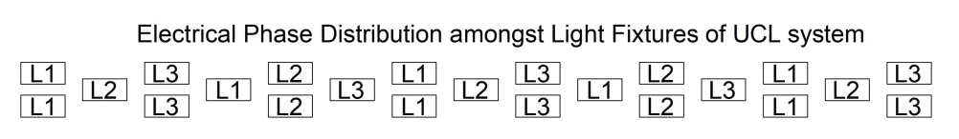

    - The system should be sited on the airfield in a convenient position to enable the
aircraft’s undercarriage to be checked from the visual control positions without
disrupting or hazarding aircraft in the circuit area.

    - Set out light fixtures accurately to avoid zebra striping within the system.

Arrestor Cable Marker Boards

    - These arrestor systems are referred to as Rotary Hydraulic Arrestor Gear (RHAG) and consequently the boards might colloquially be described as RHAG Markers.

    - RA 3515(24) requires arrestor cable locations be identified with illuminated marker boards for night operation and low visibility use.

    - Marker boards shall be installed on both sides of the runway.

    - The illuminated marker board shall be of the same size construction and proportion as the IRDs, except that the board shall be provided with large yellow circle on a black background.

    - The boards should take their 240v power supply from the RHAG unit adjacent the sign position. This supply is to feed a contactor unit known as a GP48. Such a unit can control one or two RHAG markers. Since RHAG markers are provided on each side of the Runway, the design can use a single GP48 if suitable ducting is provided across the runway for the control and indication signals.

    - The marker boards shall be controlled via the MCS Arrestor Panel in the ATC VCR. The GP48 shall provide fault warning via the MCS.

    - Note that the arrestor cable systems are not under the custodianship of DIO and approvals for electrical connections etc. shall be made via the Client.

Obstacle Lighting

Obstacle Lighting

    - RA 3518(7) mandates the requirement for obstacle lighting.

    - Note that RA 3518(7) is in line with ICAO Annex 14 Vol I para 6.2.

    - RA 3518(8) details the location and number of light fixtures required.

    - The Designer shall discuss with the Client/ Regulated Entity the requirement for Airfield Obstruction Lights (AOL) using the Client’s mapped obstacle limitation surfaces.

    - The MCS Safety Case states that airfield obstacle light fixtures shall be controlled via a single push button on the AGL panel in the ATC VCR whereby operators shall be able to illuminate or extinguish all AOL by the push of the single button. The cost of provision of the infrastructure required to support this application may be considered prohibitive by certain stakeholders. In such instances the Designer may look for a simpler method of controlling obstruction lights. However, the Designer shall refer the back to the Technical Authority for advice, before offering alternative solutions which may contravene the MCS Safety Case.

    - Due to ongoing development at a number of airfields, many AOL are now controlled by photocells and/or timeclocks and not subject to ATC control or airfield and/or runway blackout.

    - AOL beyond the airfield boundaries may be controlled by photocell.

    - Obstacle light fixtures shall take their power supply from the power supply local to the position. The power supply is to be 240V. Where available, power supplies with back-up generators shall be used. Where the power supply is taken from a building that may be out of use and as such its power supply may be switched off, the Designer shall seek solutions to retain power to the AOL.

    - Where AOL on airfields is controlled by ATC, the standard method is to site a D23 contactor near to the 240V power supply. The contactor shall be controlled by a site-wide signal generated by the MCS. The original design of the MCS envisaged that a 50V signal would be placed in the general-purpose cable that encompassed all the substations on the airfield. Some years ago, it was found that the battery capacity of the MCS in the A Centre was insufficient to activate all the AOL contactors, especially where there were many contactors spread over a very large area. An auxiliary power unit was added to the A Centre system to boost the capacity of the AOL command.

    - Apart from the AOL on the top of the ATC tower, there is no indication of the status of other AOLs on the airfield. The contactor unit for these AOLs shall be a D23 unit. The contactor unit for the AOL on the tower shall be a D20 unit or an equivalent. This arrangement also functions so that the MCS receives a correct indication from the AOL system. This AOL shall be correctly linked to its contactor to provide such a status signal. There shall be no deliberately false indication to the MCS.

    - It has also been noted that even if the power block within the auxiliary power unit fails it is possible to generate a deliberately false indication to the MCS. If the power block fails, the MCS shall receive an immediate signal that there is a problem. The MCS shall not have to wait until the AOL command is sent from the MCS control panel for an alarm to be generated.

Permanent Fixed Wing Aerodrome – Signs

Mandatory Instruction Signs

    - RA 3516(1) mandates the requirement for the provision of aerodrome signs.

    - RA 3516(1) Para 1 state the general characteristics for all aerodrome signs.

    - Where sign illumination is required, signs to be illuminated in accordance with the requirements stated in Annex 14 Vol 1 Appendix 4.

    - RA 3516(2) details the aerodrome mandatory signs.

    - Mandatory signs include runway designation signs, CAT I, II or II holding position signs, runway-holding position signs, road-holding position signs, and NO ENTRY signs.

    - A mandatory instruction sign shall consist of an inscription in white on a red
background.

    - To establish a simple and unified system of taxiway designations and signage, the Designer shall consider and apply the following as required:

    - RA 3516(2) Para 8c states “Runway Holding Position sign should have an inscription consisting of the taxiway designation and a number….”

    - Where an ILS (CATI, II) holding position occurs in rear of the IFR/VFR runway holding position, this shall be regarded as an additional runway holding position and it is recommended that it be identified with the taxiway designator, as shown in the Figure 12.1 below, and where the sign at the IFR/VFR position is designated as F1, in accordance with Item 12.1.9 then F2 is in accordance with Item 12.1.9.

Figure 12.1 Typical ILS Holding Position Sign

.

    - The designations of taxiways shall consist of a single letter, or where the quantity of taxiways exceeds twenty-two, the designations of the excess shall be agreed between the operator and Technical Authority. To maintain consistency across the MOD estate it is recommended that Taxiway designations should not contain numbers.

    - Where more than one mandatory hold sign exists on a taxiway each taxiway location sign on that taxiway that accompanies that Hold sign shall be supplemented by a unique number.

    - The Designer shall review and obtain acceptance of signage proposals from the Client and other stakeholders prior to the design being issued to third parties.

    - The Designer shall take into account the effects of jet efflux when positioning signs in order to avoid damage to signs wherever practical.

    - Currently the majority of Mandatory signs are served via the adjacent taxiway circuit. It was noted that in the past in night operations all taxiway circuits were lit. However, this may not now be the case and consequently there may be some runway Hold signs as a measure of preventing runway incursion may be unlit. The option to provide one or more separate sign circuits for hold positions should be considered.

    - Internally lit mandatory signs shall be provided with an alternative power
source in accordance with the requirements for the airfield.

Information Signs

    - RA 3516(3) mandates the requirements for information signage.

    - Information signs are provided to support operational needs. Hence, should be discussed with Operation /ATC to determine the scale of the information signs at an airfield.

    - Military airfield operators should look to minimise the quantity of information signs as the airfield layouts are often simple and pilots are generally familiar with the airfield layout. The Designer shall liaise with the Client and other stakeholders to agree an adequate and workable signage solution.

    - A typical information signage installation shall comprise of but no be limited to:

- Direction signs

- Location signs

- Destination signs

- Runway exit signs

- Runway vacated signs

- Intersection take-off signs

    - An information sign other than a location sign shall consist of an inscription in
black on a yellow background.

    - A location sign shall consist of an inscription in yellow on a black background,
and where it is a stand-alone sign, shall have a yellow border.

    - The Designer shall liaise with the Client to determine if Information Signs are to be illuminated or non-illuminated. All sign faces shall be retroreflective.

    - Where information signs are illuminated, the signs shall be served via the adjacent taxiway circuit.

    - The Designer shall take into account the effects of jet efflux or helicopter down wash when positioning signs in order to avoid damage to signs wherever practicable.

Aerodrome Access Boards

    - RA 3516(4) mandates the aerodrome access boards in the style of mandatory instruction signs shall be provided.

    - AABs shall be erected in prominent positions at all points where roads and motor transport routes join the movement area.

    - Traffic light positions shall be accompanied by AABs.

    - AABs shall be worded as follows:

‘STOP
MOVEMENT AREA
VEHICLES ARE NOT TO BE DRIVEN PAST THIS POINT WITHOUT THE
PERMISSION OF AIR TRAFFIC CONTROL'.

    - In addition to the AABs noted above, the Designer shall liaise with the Client to ascertain if any additional noticeboards are required such as for example boards reading:

VEHICLES MUST GIVE WAY TO AIRCRAFT.
ALL VISITING DRIVERS ARE TO REPORT TO AIR TRAFFIC CONTROL BEFORE
PROCEEDING ON TO THE MOVEMENT AREA.

    - Airfields which operate in CAT II shall have illuminated AABs on all vehicular access points to the airfield warning the driver that the airfield is operating under low visibility procedures. These signs shall be controlled by the AGL control and monitoring system. Note AAB’s on CAT I airfields are not normally illuminated.

AGL Lights

Selection of Lights

    - New installations shall utilise LED light fixtures. However, it is noted that the UK military market is small compared with the worldwide civil airport light fixture market. Therefore, manufacturers may not all produce light fixtures compatible with military requirements. Only military compliant light fixtures shall be installed. Where no light fixture can be found to fully comply with military requirement, the Designer shall liaise with the Technical Authority. If it is accepted by the Technical Authority that there is no military compatible light fixture available for that specific application, then the Designer shall seek acceptance via the MAA Acceptable Means of Compliance process (AAMC). The use of this process will only be considered when all other options for compliance have been exhausted.

    - The advantages of LED light fixtures have lower power consumption for the same light output as tungsten halogen and extended life of the actual semiconductor elements, although this may be less than thought due to the required presence of the interface between the existing infrastructure and the diode array. This interface reliability may well lower the average Mean Time Between Failure (MTBF) of the light fixture. Lifecycle data provided for the light fixtures installed refers to the light fixture. The Designer shall not select or approve a light fixture that will require midlife upgrades or component replacement in order to achieve acceptable safe operating life.

    - One advantage of the filament lamp was its simple ability to register a total failure and the military CCRs can register a change of its output wave characteristics if a filament fails. This is known as Percentage Lamp Failure (PLF). An unmodified LED light fixture has no capability to register this type of failure. The LED manufacturers can install an option to produce the simulated failure of an open circuit. It is mandatory to install all LED light fixtures equipped with this option.

LED AGL Light Brilliancies

    - Current settings at different levels shall give various intensity outputs compatible to operational conditions.

    - Tungsten halogen light sources have been used for many years and much empirical research has been done to establish the relationship between the light output (brilliance) and the current running through the filament. It was found that the relationship was approximately exponential, and a series of tables was produced that showed the brilliance at selected levels of current. In the case of an LED, the brilliance is linearly related to the current and hence a direct replacement of an LED for a filament cannot be achieved.

    - This is one reason why an interface is required, the other being that LEDs operate most efficiently on direct current using pulse width modulation technique. To ensure that manufacturers of LED know what is expected of them the Federal Aviation Authority (FAA) of the United States produced an Engineering Brief (EB) entitled EB67D. The Table below has been extracted from that EB and shows the allowed variation in intensity at selected currents. One interesting point to note is that the minimum current listed is 2.8A. This reflects the fact that for currents less than this, it cannot be guaranteed that the complete light fixture (including the interface circuitry) will operate.

Table 13.1 LED Light Currents as defined in EB67D

LAMP CURRENT | % MINIMUM INTENSITY | % MAXIMUM  INTENSITY
6.6 | 100 | n/a
5.5 | 23.9 | 44.1
5.2 | 16.9 | 31.3
4.8 | 10.4 | 19.2
4.1 | 3.9 | 7.3
3.4 | 1.0 | 2.0
2.8 | 0.15 | 0.7

    - The Designer shall liaise with the light fixture manufacturer to ascertain that their products comply with EB67D and what options they offer so that their light fixture’s output achieves the required intensities with the proposed CCRs and SCTs.

    - RA 3520 contains a similar table of information. However, it is framed with respect to primary currents of 12A rather than 6.6A, as 12A circuits are still in widespread use on military airfields.

    - Current settings at different levels shall give various intensity outputs compatible to operational conditions.

    - The Table 13.2 below indicates a possible alternative to Table 2 of RA 3520.

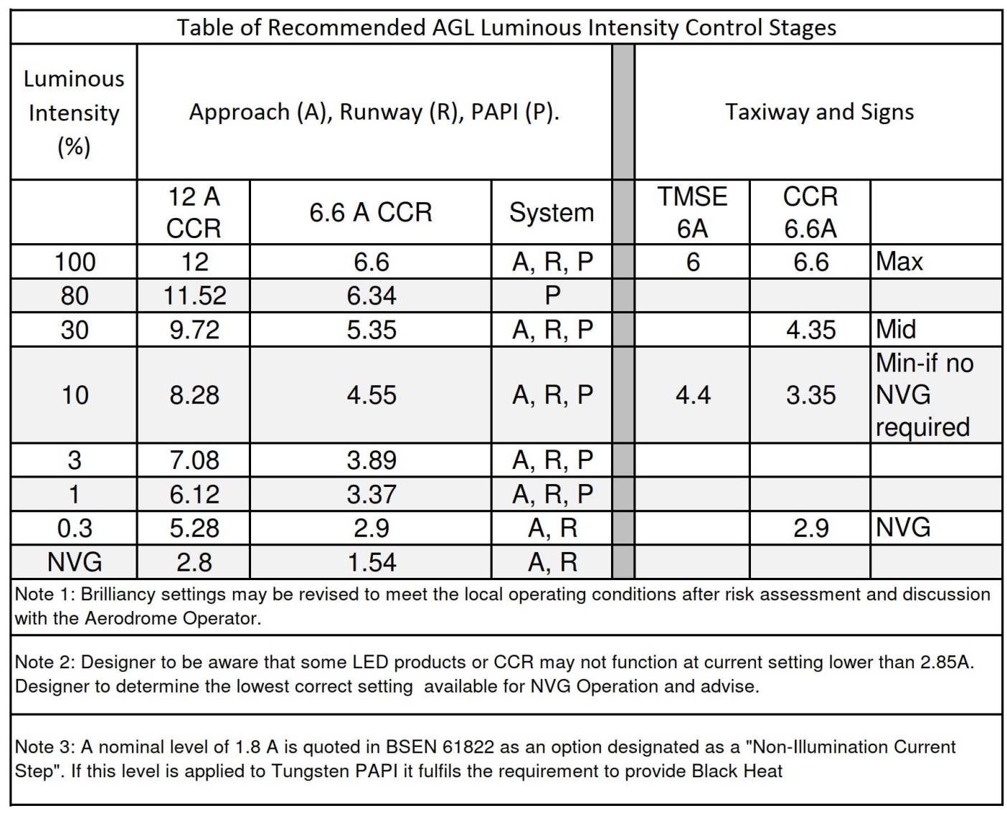
Table 13.2 Alternative Table to Table 2 of RA 3520

    - The 12A configuration was very appropriate for military high wattage tungsten halogen circuits, but with the use of low power LED circuits, 6.6A primary circuits are the now the preferred option, as it maintains consistency with taxiway circuits and are in common with the majority of civil aerodrome installations. Commonality with civil aerodromes will lead to better spares support, than with 12A Primary circuits. The Designer shall bear in mind that the voltage on the primary circuits shall be kept below 2000V.

    - The required illuminance intensity for approach systems are specified in ICAO Annex 14 Volume 1 Appendix A.

Primary Circuit Design and Selection

Series Circuit Transformers (SCT)

    - Although in the future, there may well be completely different configurations of AGL circuits, this document addresses the circuits as related to the current version of the RAs. This assumes that AGL circuits shall be series circuits, powered by CCRs with various levels of current to achieve the required light brilliance.

    - The current global standards for primary currents are 6.6A and 20A. The MOD estate is currently using 12A primary circuits except for taxiways. Historically primary circuits on taxiways have been 6A and are generally powered from TMSE units. However all currently manufactured light fixtures are constructed as 6.6A operation. Still in widespread use, but no longer available as standard products, are 6A taxiway edge and centreline lights.

    - 6.6A primary circuits are the now the preferred option, as it maintains consistency with taxiway circuits and are in common with the majority of Civil aerodrome installations. Commonality with Civil aerodromes will lead to better spares support, than with 12A Primary circuits. The Designer shall bear in mind that the voltage on the primary circuits shall be kept below 2000V.

    - Series Circuit Transformers (SCT) are widely available with 1:1 turn-ratio, intended for 6.6A circuits.

    - 12A to 6.6A SCTs are still available as are 6A to 6.6A but are to be regarded as specials and are only available from a small number of manufacturers. For taxiways still equipped with both 6A primaries and secondaries, the PSA listed a quantity of TISE transformers, and these are still in widespread use. However, with the introduction of the standard BSEN 61823, all TISE units have become non-compliant with this standard and shall not be used on any new circuit, nor used to replace a failed TISE.

    - All new SCTs shall be compliant with BSEN 61823.

    - All AGL SCTs shall have an earth connection to one lead of its secondary winding. The connection shall be in the form of a threaded stud that has been installed before the encapsulation material is added.

    - BSEN 61823 specifically states that transformer cores shall not be earthed.

Primary Circuit

    - Several recent projects on military sites have been installed using 6.6A primaries and these have been accepted by the MAA. The Design shall utilise only 6.6A circuits, bearing in mind that it is generally possible to use low power LED light fixtures rather than increasing the quantity of circuits.

    - There have been instances where 6A primaries have been retained for new LED taxiway circuits using the 6A to 6.6A SCTs where new 6.6A LED light fixtures have been installed. A change to the primary current of 6.6A shall be mandatory to avoid having to install 6A to 6.6A SCTs. Although this may appear to contradict Table 2 of RA 3520, the Table does contain a note to say:

“These current values may need to be adjusted where LED technology is used”

    - Having designed the proposed circuit with the correct number of light fixtures and length the Designer shall calculate the circuit load.

    - The AGL circuit load therefore consists of the following components:

The total wattage of all the lamps on the circuit.

      - An allowance, if necessary, for the losses in long AGL transformer secondary extension leads.
      - An allowance of 10% for the inefficiency of the AGL lamp SCTs.
      - Power losses in the AGL primary series loop cable. This is simply an I2R power loss. A typical circuit would use 6mm2 AGL cable, which has a resistance of 3 ohm per kilometre.
      - An allowance for lamp failures, conditions of reduced supply voltage and other supply losses - oversize by 10%.

    - In summary, the total CCR load will be:

(((Total light fixture wattage + SCT secondary extension lead I2R losses) x 1.1) + (I2R power loss in the AGL primary series loop cable))) x 1.1

Having calculated the total load, the design shall use an appropriately sized CCR. However, do not use a CCR which has a maximum voltage output that would require the CCR to be set to less than 40% of its maximum to match the maximum load.

    - The default method for connecting the SCTs to the primary cables shall be by heatshrink joints. The evolution of heat shrink jointing techniques is discussed in detail in PI 2009/05 and this document should be studied. The method of circuit installation comprises of laying the primary cables along the line of the circuit. Once installed, the cables can be cut at the appropriate SCT positions. Heat shrink joints are then installed between the cable ends and the cables emanating from the SCTs.

    - Generally, an SCT may be supplied complete with cable ends terminated in factory made connectors. In that case the connectors will need to be cut off to be replaced by the heat shrink joint. The installation of the joint will be undertaken in the field and is therefore subject to weather conditions. The success of the joint relies on the heat sensitive adhesive bonding correctly to the insulation and sheath and to achieve this careful cleaning and abrading of the cable layers and proper application of heat are essential. Both procedures can be affected by extreme cold and humidity, so it is important that everything is undertaken to mitigate such conditions.

    - Where the cables between SCTs are laid in ducts and the SCTs are installed in hard pits, an alternative method of connecting the SCTs may be considered. As was mentioned before many SCTs are supplied with factory made plugs and sockets. Hence the primary cables could also be terminated in the appropriate plug and socket, defined in FAA AC 150-5345-26, which is the specification for
FAA L-823 connectors. There are two versions of such plug and socket. The first is designed to be fitted in the field and the waterproofing infill is silicone grease. The other version is better suited to workshop fitting as the waterproofing infill is polyurethane resin and it is recommended that this material is allowed to cure in a clamped position for an extended period.

    - For the resin joints, the method shall be to measure out the various distances between pits and cut the primary cables to appropriate lengths. To these lengths of cable are attached a resin plug to one end and a resin socket to the other end of the measured length of primary cable. The joints shall be attached in a dry workshop and secured in position for at least 24 hours to allow complete curing of the resin. Cables are then taken to site and fed through the duct to the pit, where they can be mated with SCT. This technique has been successfully used at civil airports and has proved to maintain high values of IR for long periods.

    - Plug/socket joints shall not normally be assembled in the field. However, within each circuit at least one cable end (but no more than two) shall be equipped with a silicone grease filled plug/socket joint. The use of resin filled joints is not recommended for field work as complete void filling is not guaranteed and joint movements make total curing difficult. The position of the joint shall be approximately halfway (or a third with two cable ends) around the loop. This will provide a disconnection point without having to cut the cables and as such will enable sectionalisation for IR tests. It may also be useful for an earth continuity test, using the primary cable to the B Centre as an insulated control cable.

    - The use of 5kV cables is becoming more common, as this type is perfectly acceptable and is often more economic than procuring 2kV cables. However, it is essential that the Designer specifies a joint that is tailored to the exact dimensions of the cable insulation and sheaths.

    - The use of brackets or baskets to be installed in pits was detailed in section 7. It shall be noted that such equipment shall be installed in all pits where SCTs or cable joints are installed.

Alternative AGL Power Circuit Technology

    - As was mentioned above, the future of AGL circuits is diversifying rapidly with use of circuits that do not employ a simple series circuit driven by a multi-level CCR. Examples are:

      - A fixed level of current but with a modulated pulse width. There is an example of this type installed on one military airfield.

      - Standard or fixed level CCR with the circuit power packaged with command and monitor data that serves individually addressable light fixtures.

    - AGL circuit with fixed level of current with addressable light fixtures and the primary cables interfacing directly with the light fixtures by induction techniques. This type does not require the installation of field SCTs possibly giving the opportunity to reduce the total quantity of pits.
    - In the short term these alternative AGL circuits will not be discussed within this document as the present RAs do not refer to any such new types. These new types of systems have been developed for the complex requirements of medium to large civil airports, whereas currently military airports do not have such complex requirements, such as taxiway block switching. However, as the new types of technology mature and prove to be reliable and efficient, there will be opportunities for the Designer to select a technology best suited to a military application.

Transformer Mains Supply with Earth monitoring (TMSE)

    - The TMSE comes under the general heading of “Regulator”, but in fact does not regulate but merely outputs a fixed voltage. The TMSE was designed to operate with either a nominal 415V or a nominal 240V input to its primary windings. The secondary side had multiple windings such that when the input was at 415V, a choice of secondary windings would be used to achieve a current of 6A. Having discovered the correct set of windings, if the input was changed to 240V it is found that the circuit current would reduce to approximately 4.4A. Hence the circuit could only have two brilliance settings. The switch from 415V to 240V necessitated the use of a contactor system to achieve the switch. The contactor unit is designated as a D22. TMSEs are still in widespread use on taxiways but must now only be used to replace a failed TMSE unit.

    - In the civil airport environment, taxiway circuits are deemed to have a necessary three levels of brilliance, so to bring military systems to compatibility with civil systems, a change of technology is required. Preparations for this were made when an upgrade to the MCS was last undertaken. To complete the process requires the removal of a TMSE and replace with a CCR. Further modifications are needed to the MCS and all TMSEs connected to the remote MCS must be replaced by CCRs.

Constant Current Regulators (CCR)

    - The first generation of actual regulators were termed Series Circuit Regulators (SCR). The technology was ferro-resonant, and they produced good quality sinusoidal waveforms, with phasing that matched the input supply. As such they could be used in series to produce higher wattages. Unfortunately, they were both complicated and expensive to produce. It is interesting to note that the FAA continues to prefer this type of regulator.

    - The SCR was replaced by units using a much inferior technology, a misleading name and very poor waveforms with high levels of harmonics. However, they were less complicated to understand and most importantly they were cheaper to produce. The technology is effectively PWM via a Thyristor stack. This slices pieces out of a sine wave to achieve variable levels of RMS voltage and hence produce levels of RMS currents in the series circuit. Hence strictly speaking they are “Varying Voltage Regulators” intended to constrain the current to specific levels, by means of monitoring the circuit current and updating the voltage in response to any changes in the desired current.

    - They are still Series Circuit Regulators, but an alternative name was needed to differentiate between these and the ferro-resonant type. Hence the designation CCR and are generation 2. The poor waveforms are essentially because Thyristors cannot be switched off, except by the input voltage falling to zero.
Set up of parameters required skilful use of screwdrivers.

    - With the availability of microprocessors came generation 3, now denoted as the MCR. Same poor waveforms, but easier to set up and maintain as the software could control parameters.

    - As the semiconductor industry progressed, new semiconductor packages came along, with the availability of high-power units designated as Insulated Gate Bipolar Transistors (IGBT). These units combine the low input current of Field Effect Transistors (FET) coupled to the high current capacity of bipolar transistors. They can be turned on and off at will and are hence ideal for microprocessors to produce good quality sinusoidal waveforms. This is Generation 4, now denoted as the MCCR. The design of Uninterruptible Power Supply (UPS) uses the same techniques as the MCCR.

    - The MCCR is highly recommended for circuits using LED Lights.

    - Generally, on military airfields, CCRs are connected to the control system via parallel input/output connections, but for MCRs and MCCRs there are options for serial input/output. These advanced communications systems allow for more options, especially the interrogation of many more fault conditions. Such advantages are not available when communicating with the military MCS.

MCS / CMS

    - This section is on MCS/CMS primarily for background information.

    - Associated with AGL circuits is a command and monitor system. Such a system became available in the late 1970sn and is known as the Modular Control System (MCS). This is still widely used on military airfields and over such a long period has proved to be an example of a simple but robust, relay method of controlling military AGL. The MCS was not designed to accommodate a recording system, but just as monitor screens have been added to the MCS it would be possible to do this.

    - In the wider world there has been much innovation in a Command and Monitor System (CMS), especially with the introduction of Programmable Logic Controllers (PLC). The physical manufacture of CMS is relatively straightforward as the elements are modular and can be assembled on back-frames with the PLC at the core and items such as input, output and transmission modules being added as required. As the name PLC suggests the system is programmable to accommodate almost any situation, including the ability to communicate with a system that can record all activities and fault conditions.

    - The MCS, although at the time of the document being written is still giving useful service on many airfields it has drawbacks that make it difficult to modify for certain new operations and therefore is not really suitable for anything other than the simple tasks for which it was originally designed.

    - Note that the MCS remains under the custodianship of the DIO and that DIO hold the Safety Case for the control system.

    - Where the proposed AGL Design requires any changes or modifications to the MCS control system, the Designer shall refer to the Technical Authority, who will decide what the implications are on the MCS system and instigate the necessary design configuration changes with the safety case holder.

    - AGL requirements shall generally be accommodated within the MCS. Where such changes cannot be accommodated with the MCS, the Designer shall seek guidance from the Technical Authority.

    - The MCS was originally designed to control tungsten halogen light fixtures, traffic lights, Illuminated boards, etc. The Designer shall seek verification of the compatibility of all LED equipment to be installed and controlled via the MCS.

    - In particular, the MCS shall provide full back indication and fault monitoring of all equipment to be connected to it.

Earthing and Bonding

AGL Circuit Earthing

    - The design intent for the AGL earth is to ensure the secondary side of all AGL field equipment across the airfield including metallic structures is maintained at the same earth potential, via a common secured, reliable and continuous equipotential bond.

    - Radial, Mesh or grid connections may be acceptable as long as it demonstrates a secured, reliable and continuous bonding network.

    - Cross connections within the earth network are recommended to ensure that the resistance to earth of the system shall not exceed 6Ω.

    - Separate loops may be provided for Approach systems. Light fixture bodies above 2m in height shall be bonded to the AGL earth.

    - The AGL earth shall connect with each B centre earth bar.

    - The Designer shall provide a notional earthing schematic as part of the design, noting that it must not show spurs to individual items, as the mandate is to provide two paths to earth from each light fixture.

    - AGL seating (plates, pots, and rings) do not require bonding to the AGL earth unless there is specific risk.

    - Where the AGL earth cables are direct buried the cable shall be a minimum of 6mm2 bare copper.

    - Where AGL cables are routed via ducts the cables shall be a minimum of 6mm2 green and yellow insulated copper cable.

    - Where insulated earth cables are installed, then earth rods shall be provided with the distance between earth rods not to exceed 300m and at change in direction.

    - Earth rods shall be easily accessible for future testing i.e., within transformer pits or dedicated earthing pits.

    - During installation the contractor shall be requested to measure, prove and record cable continuity prior to back filing of trenches.

    - Where the Designer proposes to install supplementary earth rods in the transformer pits, the earth electrode test link shall be installed at the top of the pit.

    - Each transformer pit shall be provided with an individual copper earth bar mounted toward the upper part of the pit for easy access for testing. The earth bar shall be provided with a removal link to disconnect the earth bar from the AGL circuit earthing system during testing.

    - Earth studs of all SCTs, shall be bonded to the AGL circuit earth using green/yellow insulated 6mm² CSA copper within the transformer pits.

    - Note that an AGL circuit earthing system comprises a single earth cable per AGL primary cable route, not circuit earths for each individual primary AGL circuit. This earth shall take the form of a ring connecting to all the B Centre earth bars. However, in order to keep the resistance to earth to the low values required, cross connections between parts of the ring are recommended.

    - The Designer shall ensure the as-installed record drawings and maintenance manuals, identify all necessary testing positions and their associated continuity values, to allow maintenance technicians to prove continuity across the full network in the future.

Counterpoise System

    - A counterpoise earthing system is a form of Lighting Protection System (LPS), installed to protect the AGL installation against the effects of lightning strikes.

    - Lightning protection calculations shall be in accordance with BS EN 62305. Where the calculation requires lightning protection to be provided, counterpoise earthing shall be incorporated into the design.

    - A counterpoise system is specifically installed to reduce the resistance to the general mass of earth of the ground and spread the target earth for reception of lightning strikes. Provided that adequate multiple paths to earth exist along its route, it can provide lightning and surge protection to all metallic items of equipment.

    - Where counterpoise is required, a 16mm2 copper cable shall be used as the main counterpoise conductor and shall be installed in the ground above the duct system.

    - The drawing below is a representation of how the counterpoise system provides protection.

Figure 15.1 Counterpoise Earthing
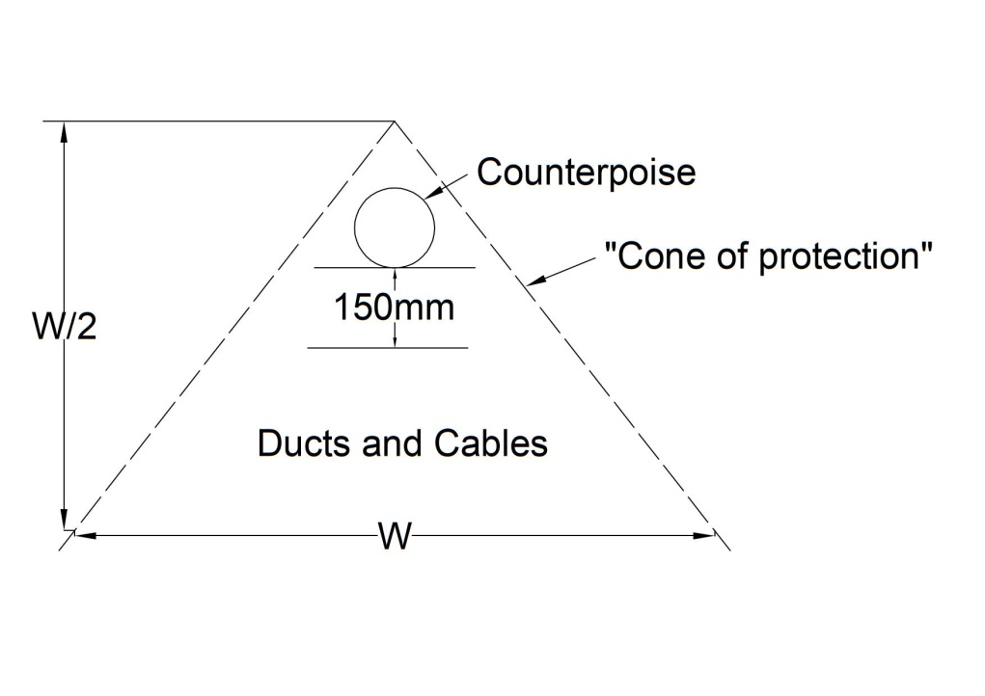
    - The counterpoise shall commence at an earth bar of all B centres and shall be in the form of a mesh or grid connection on the runways and taxiways, with spurs out to the extremities of any approaches.

    - As far as practical, the counterpoise cable shall not be cut and connections to it shall be made by clamps connected to earth rods and AGL circuit earth points. A supplementary earth rod shall be connected to the counterpoise cable at suitable points, such that there shall be an earth rod at a maximum of 300m apart.

    - An earth resistance value above 10 Ohm for the LPS should not be interpreted as satisfactory for all installations. Reduced earth resistance values might be necessary to provide effective lightning protection where the lightning risk assessment is high.

    - Where a Counterpoise system is installed additional connections from pit earth bars should be made to items not normally connected to the AGL earth system.
These include inset light fixtures and plates that support elevated light fixtures, PAPI support legs, sign legs, RHAG marker legs and IRDM legs.

Light FIXTURE Numbering

Background

    - In order to establish a unified system for all drawings, a study was undertaken across the military estate to determine how light fixtures and circuits have been designated. Although RA3590 gives an example of a light fixture designation (27/A/14), it was found that very few light fixtures were designated with this concept. Furthermore, the use of a runway QDM in the light fixture numbering system is not optimum as in the long term the QDM can change by virtue of magnetic field changes.

    - On the PSA drawing CU(M&E)0192, for a runway edge system, it was noted that the light fixtures were designated alphabetically according to their circuit designations. In that instance there were six runway circuits, A, B, C, D, E, F. Building on that principle, an early consideration was to simply extend the system through the alphabet for all other circuits. However, it is possible in cases where there is more than one runway there might be insufficient letters of the alphabet to cover all circuits.

Requirement

    - In order to avoid confusion and the need to have a fixed and robust numbering schedule the Designer is to use the PSA alphabetic system but prefix the letter by a designator based on the circuit use. The following prefixes are recommended:

A Approach (including Wing bars if Threshold lights are not provided)
C Runway centreline
E LISL, End, Stopway, IRDM (NPI and NI runways)
E CGL (where separately provided on PI runways)
K Sign (if separate circuit)
L Lead on (only provided if interlocked with a stopbar)
P PAPI
R HISL, End, Stopway, CGL, IRDM (PI runways)
S Stopbar
T Threshold (including Wing bars)
TT Taxiway (includes lead off and Signs)
Y Supplementary approach
Z Touchdown zone

    - Numbering of light fixtures on runways shall commence from B1a, B2a, B3a, etc., with odd numbers on the port side and even numbers on the starboard side. Where B1a is not associated with the approach that is regarded as the primary approach the numbering shall commence from the B Centre (and hence approach) associated with either the prevailing wind and/or the provision of ILS. Numbering on approaches shall commence at the threshold. Light fixtures within a system shall be numbered consecutively irrespective of its circuit allocation. For example, on an approach, the numbering shall be AA1, AB2, AA3….AB120.

    - Port side PAPI units shall be on circuit PA (primary approach), PC, PE, etc., with starboard units as PB (primary approach), PD, PF, etc.

    - In ICAO, PAPI numbering is shown as A, B, C, D and in RA3515, PAPI numbering is shown as 1, 2, 3, 4, with unit 1(A) being the furthest from the runway edge. This type of numbering lacks information regarding the elevation angle for each unit, which this document addresses. Hence it is recommended that each PAPI unit should be designated according to its circuit and elevation angle, (excluding the degree and minute indicators) with the lowest designation corresponding to Unit 1 (A in ICAO). With this type of designation, it should assist when checking alignments at both commissioning and maintenance visits.

    - For example, with a glideslope of 30 00’ and ILS installed, the Port side units on a primary approach would be designated as PA335, PA315, PA245 and PA225, commencing with PA335 nearest to the runway edge.

    - For example, with a glideslope of 20 30’ and no ILS installed, the Starboard side units on a secondary approach would be designated as PD300, PD240, PA220 and PD200, commencing with PD300 nearest to the runway edge.

    - Where IRDMs are installed, they shall be designated as the circuit(s) to which they are connected, and have a number corresponding to their nearest light fixture +1000. Hence if the nearest light fixture on their circuit is numbered 45, the IRDM number shall be 1045.

    - Taxiway light fixtures shall be numbered but there is no constraint regarding start and end of sequence. In the absence of an RFID or GPS tagging system each light shall have a designation painted adjacently, but it shall not be required to add TT as a prefix to the designation. For example, light number 45 on circuit TT7 shall be shown on the drawing as TT7/45, but on the ground as 7/45, as this designation is unique on the airfield. Where a taxiway circuit serves more than one taxiway, an alphabetical suffix may be added to the designation to impart geographical information. For example, TT7 exists on both taxiways A and B, with 7/45 the final light on A. The first light on B should be designated as 7/46, but a suffix can be appended to show 7/45A and 7/46B.

Light Fixture and Unit Symbols

    - Although document BSEN 60617 Electrical Part 11 is no longer extant, the information it contained was and remains an excellent source for the concept of standardising light fixture and unit symbols.

    - It is showed that:

Elevated lights shall have a square outer envelope, with inset lights to have a circular outer envelope. Within the outer envelope, omni-directional lights should have a circular envelope.

    - The visible colours from the light fixture shall be:

White (or Clear) – none
Red – solid
Blue – a cross
Green – small circular solid disc
Yellow – stripes
Blank – letter B.

    - Some examples are shown below.

    - The Designer shall use symbols based on the above concepts as below.

Figure 16.1 Light Symbols

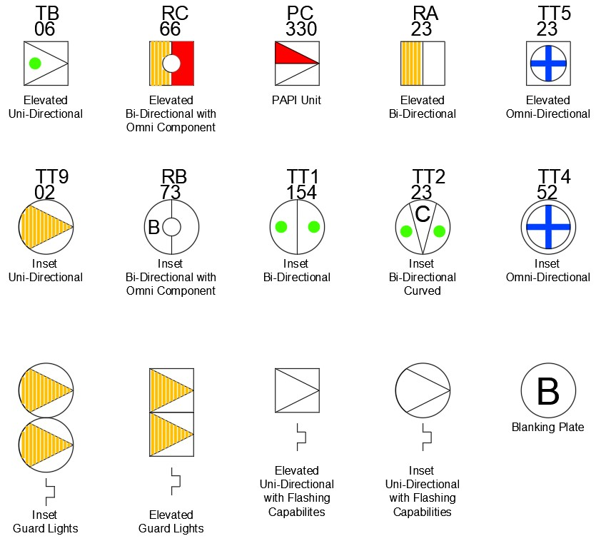

AGL CAD Layering

    - For a consistent format across the MOD estate, each light fixture symbol and cable across the entire airfield shall be placed on a CAD layer. The layer shall have the following coding:

Discipline | Sub-Trade | Status | Service | Sub-Service | Phase/Option
AGL | E | EXT | PRI | RA | _A

    - The coding is split into several sections separated by a dash (-) these are Discipline, Sub Trade, Status, Service, Sub-Service and Phase/Option. There must be an underscore (_) between the Sub-Service and the Phase/option.

Discipline
Code | Discipline
AGL | Aeronautical Ground Lighting

Sub-Trade
Code | Sub-Trade
E | Electrical
C | Civil

Status
Code | Status
EXT | Existing Installation
NEW | Proposed Installation

Service
Code | Service | Notes
APP | Approach
RWY | Runway
TWY | Taxiway
MSC | Miscellaneous | E.g., Traffic Lights, OBs Lights, Signage, Text
PRI | Primary Cabling | Limited to Sub-Trade E
SEC | Secondary Cabling | Limited to Sub-Trade E
P&D | Pit & Duct | Limited to Sub-Trade C

Sub-Service
The Sub-service will be dependent on the Sub-Trade code.

Sub-Trade Code E
The Sub-service will be the AGL circuit reference of the installation.

Sub -Trade Code C
PIT | AGL Pit
PDR | Primary Duct Route (Primary AGL Cables installed in Ducts)
SDR | Secondary Duct Route (Secondary AGL Cables installed in Ducts)
SAW | Saw Cut (Secondary AGL Cables installed in the Saw Cut)
SFT | Soft (AGL Cables installed in the soft)

Common Sub -Trade items
NOTE | Notes on CAD file NOT for printing on Drawings
TEXT | Notes of CAD required to be printed on Drawing
LEG | Legends
TBLK | Title Blocks/Drawing Information/Logos/Scales etc.

Option / Phase

The Option/Phase identification is only required if multiple design options or construction phases are present on the project.

Design Options shall be identified as numerical versions e.g., 1, 2, 3… etc.
Construction Phases shall be identified as alphabetical iterations e.g. A, B, C… etc.
Where no phases or options are present, and X shall be used.

Example CAD Layering and interpretation
AGL-E-EXT-PRI-TT9_X | AGL – Electrical – Existing – Primary Cabling – Circuit TT9 – No options or phases
AGL-E-NEW-SEC-AA_2 | AGL – Electrical – Proposed – Secondary Cabling – Approach Circuit A – Design Option 2
AGL-C-NEW-P&D-PIT_C | AGL – Civil – Proposed – Pit & Duct – AGL Pit – Construction Phase C
AGL-E-NEW-RWY-RA_X | AGL – Electrical – Proposed – Runway – Circuit RA – No options or phases
AGL-C-NEW-P&D-SAW_1 | AGL – Civil – Proposed – Pit & Duct –Saw Cut – Design Option 1

    - No information shall be placed on Layer 0.

    - Each light type symbol (a CAD Block) shall be accompanied by a set of attributes. The attributes shall not be displayed on the drawing. The attributes shall include all items that would be essential to produce information that can be used for the data in an AGL Schedule. Minimum attributes would include: Circuit, Allocated Light Number, Manufacturers Part No., Light type wattage, SCT wattage, SCT Location, Seating Ring Type, Adaptor Ring Type.

    - Each light type symbol shall be accompanied by an allocated number and circuit. The number and circuit shall be the same as that listed in its attribute list. The number and circuit shall be shown on drawings and displayed in a convenient position adjacent to the light type symbol, whilst avoiding clashing with other information. Some examples are shown in Figure 16.1

Primary Cable Routing

    - Where Primary Cable Routes are within a Pit & Duct System the Primary Cabling Routing shall be Identified as shown in Figure 16.2 below:

Figure 16.2 Pit & Duct Drawings
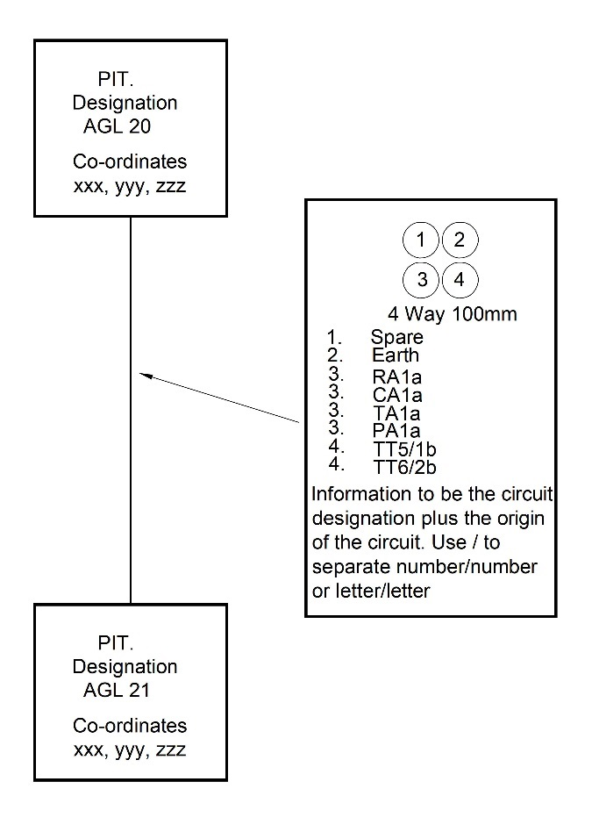

    - Each pit location shall be accompanied by a GPS reference for the centre of the pit cover accurate to within 1 metre. Referenced by xxx,yyy,zzz, where zzz is the invert level of the pit.

    - Where primary cable routes are buried in the soft, the generalised routes of the primary cabling and the circuit designation shall be clearly identified. The intended locations of SCTs shall also be identified.

A & B Centres

Description

    - AGL installations are served via a number of dedicated substations located around the airfield. These substations house the AGL control equipment (the MCS), power supply units and associated equipment.

    - There are two types of AGL substation, the first being:

    - A Centre: The A centre is located within the Air Traffic Control Tower Building and contains the central AGL control system cabinet and associated electrical equipment. The A Centre is an LV area.

    - B Centre: There are several B centres sited on each airfield. They are normally located adjacent to runway ends and the approach heading they serve. B centres incorporate separate HV and LV areas. Note the HV areas are subject to restricted access in accordance with Technical Authority HV procedures.

B Centre Identification

    - The notation B1a is broken down as follows:

      - B (Type of Substation).

      - 1 (Runway Priority).

      - a (Being the main heading for that runway with b being the secondary heading). Note: there are a few airfields where the “a” and “b” are interchanged. Such instances are historical anomalies.

    - Typically, airfield installations comprise both A and B centres.

Table 17.1 A and B Centre notation and ideal location

Centre | Location | Areas | Contents
A | ATC Tower | LV | Central AGL control equipment
B1a | Adjacent Main Runway Primary Approach | HV and LV | Outstation AGL control equipment AGL power supplies and associated equipment
B1b | Adjacent Main Runway Secondary Approach | HV and LV
B2a | Adjacent Secondary Runway Primary Approach | HV and LV
B2b | Adjacent Secondary Runway Secondary Approach | HV and LV
B3a | Adjacent Third Runway Primary Approach | HV and LV
B3b | Adjacent Third Runway Secondary Approach | HV and LV

Power Supplies

    - A Centre:

    - The A Centre takes power from the ATC supply. The A centre standby power supply will take its standby power supply from the ATC tower generator.

    - B Centres (s):

    - Each B centre shall be served via a dedicated HV substation, located adjacent the B centre building and that the B centre is to be served via a dedicated LV circuit from an associated feeder pillar.

    - The B centre power supply shall feed a main distribution centre within the B centre. The main distribution centre shall incorporate or supply following circuits/services:

      - Lockable Incoming main switch.

      - Generator input and bypass arrangement.

      - Separate HV room AGL equipment with local lockable isolators.

      - Separate LV room AGL equipment distribution board supply.

      - Separate B centre domestic power and lighting distribution boards(s).

      - Fire alarm supply.

      - Power factor correction equipment where the Designer deems necessary.

      - Voltage, current and energy meter equipment including a BMS outstation capable of transmitting readings back to the station central BMS.

    - It is essential that the CCR and TMSE supplies be arranged in such a manner that during routine AGL testing the AGL CCR/TMSE distribution board can be isolated and locked off, to allow the AGL technicians to carry out the required tests via a single point of lockable isolation at the distribution board feed. All domestic services such as building light, and power shall be capable of being maintained in operation during the AGL testing.

    - AGL power supply equipment in general such as CCRs and TMSEs can cause distortion to the electrical supply through harmonics and other unfavourable electrical characteristics. The Designer shall take this into account during the design of the B Centre power supplies.

B Centre Earthing

    - The B Centre shall be provided with a continuous copper earth bar (minimum size 25mm x 3 mm) around the B centre. The earth bar will be mounted on propriety fixings to the building fabric.

    - The earth bar shall serve all normal electrical earths: AGL field circuits, earths, surge arrestor earths, generator earths and bonding conductors shall be connected to the earth bar. Bonding, AGL and surge arrestor connections shall be grouped in common locations were possible. These common locations will be provided with isolation of facilities to allow separate testing of the building, surge arrestor and AGL earths.

    - Suitable isolation points will be provided to allow periodic testing of the main building earth.

    - Where installed, counterpoise lightning protection shall be connected to the B centre earth bar unless the station’s earthing procedures dictate otherwise and, in such cases, the Designer shall seek clarification from the Technical Authority.

    - The earth bar will be connected to the building’s main earth terminal.

Standby Power Supplies

    - Each B centre should be provided with a dedicated standby generator.

    - The type, capacity and transfer characteristics are dependent upon the operational criteria of the runway to be served. The Designer shall liaise with the Client and refer to RAs in order to determine the exact requirement for standby power. RA 3520(1) defines the maximum switchover times required under mains failure for different airfield operational criteria.

    - Generator controls shall be designed in order that generators will start automatically under mains failure conditions, but will only return to mains via manual control, allowing airfield operators time to establish whether the mains supply is stable and when there is a convenient opportunity to change supplies without affecting flying operations.

    - Under certain airfield operational requirements, the standby generators may be required to operate as the airfield’s primary power supply with the mains supply being the standby supply. Under these circumstances upon generator failure the mains supply shall be re-established to facilitate the AGL lights to return to 50% output from 50% within 1 second when lights are being operated at intensities of 25% or above. Refer RA3520(1) paragraph 13 for the exact requirement. The generator set chosen shall be capable of being run under full load conditions for an extended period to be agreed with the Client, but for a minimum of 24 hours.

    - Generators shall provide two signals to ATC via the AGL control system the first being to show when the set is running and the second being a common fault signal, whereby ATC can make the station generator operators aware of a fault for their investigation. The common fault signal shall include as a minimum:

      - Low fuel.

      - Battery failure.

      - Not in automatic mode.

      - Oil, coolant fuel leaks.

      - Over temperature.

      - Voltage out of parameters.

      - Any other scenarios which may affect ongoing airfield operations.

    - Where there is no suitable hardwired connection available or planned, back to ATC from the generator location, the Designer shall liaise with the Client to establish a method of relaying fault signals back to ATC. Where a station-wide generator monitoring system is provided the B centre generators shall be connected to this system.

    - Where diesel standby generator sets are to be utilised, each set shall be provided with a set mounted day tank capable of allowing the generator to run for 8 hours at full load, with a further bulk tank capable of supporting the generator running at full load for a further 24 hours.

    - Fuel tanks will be provided with bunds and any other precautionary equipment and installations to meet local environmental regulations and legislation.

    - Generators shall be provided with earthing facilities compatible BS 7430.

    - Generator installations will be subject station siting boards. The Designer shall submit the necessary supporting information for these.

    - Generators shall be provided with a bypass switch to allow the generator to be removed from service for critical maintenance or replacement whilst maintaining power to the B centre in question.

    - B centres shall be provided with an external socket arrangement to allow the connection of temporary portable generator in the event of the fixed generator being out of service.

    - Any proposed new or modifications to existing AGL generators shall be coordinated with the Custodians of the station main stand by power systems so that AGL generator operation is not detrimental the station wide standby power strategy.

    - AGL installations commonly produce harmonics and have can have poor power factors The Designer shall take this into account when selecting a standby generator.

    - B Centre generators are only to supply the AGL installation, B Centre domestic and essential facilities for aerodrome operations including NAVAIDS.

Electrical Installations within the B Centres

    - Wherever possible electrical installations within B centres shall be routed within the building and above the floor. Where existing floor ducts are available and are proven not to be subject to flooding or vermin infestation these can be reused for AGL primary circuitry. However, in all new or fully refurbished B centres AGL circuitry shall be routed on cable trays/ racks above the floor. All new or fully refurbished B centres shall be made waterproof, and ducting shall enter the building at a level above any anticipated flood level.

    - Electrical services with the B Centres shall be as a minimum, be segregated into the following categories, each requiring separate trays/ladder or containment.

      - AGL primary circuits.

      - LV power circuits.

      - AGL control, communications and monitor system cables.

    - Circuits shall be appropriately segregated to avoid electrical interference between circuit transfer of electrical faults to other circuits so that electrical safety is maintained.

    - All cables exiting the building shall be routed via suitable holes/ducts sealed to prevent the ingress of water and vermin. Control, LV and AGL circuits shall not be routed through the same holes/ducts.

    - All CCRs and TMSEs shall be served via with local lockable isolators. Isolators shall not be grouped into common blocks; all isolators shall be mounted adjacent to the relevant item of equipment. Where CCRs are portable (on wheels) the final connections between the LV isolator and item of equipment shall be made via BS EN.60309 plug and sockets utilising suitably selected flexible cabling. Each plug and socket shall be suitably labelled so that plugs are placed in the correct socket.

    - Isolators, switches fused connection units serving items of fixed equipment shall be suitably labelled. Where the station uses IRFD or GPS tagging, the station protocol for such tagging shall be adopted and continued within the B centre.

    - All AGL power supplies require two phase power. In these instances, two-phase power supplies shall be balanced across the three phases so as not to distort incoming supply under normal airfield operations.

    - B centre floors shall be flat and suitable for the movement wheel equipment. There shall be no mounting plinths or raised sections of flooring. Where existing B centres are being re-fitted, the plinths shall be removed.

    - DMG 08 is the basis upon which fixed electrical equipment within switch/plant rooms shall be laid out, so that maintenance space is provided, and electrical safety is achieved. However, DMG 08 does not make direct reference to AGL B centres and their movable (wheeled) equipment such as CCRs.

    - Noting that CCRs are moveable for maintenance, the Designer shall consider this when space planning B centres and determining the optimal space requirement for equipment maintenance. There shall be a clearance of at least 100mm between any two items of equipment for heat dissipation.

    - Items of semi portable equipment shall have suitable locking devices to prevent free movement.

    - The Designer shall verify with the Client the access requirements for each item of equipment to be installed. Note that certain CCRs require front, rear and side maintenance access.

    - Each primary circuit emanating from a CCR, shall have a means of being disconnected for the purposes of the earthing the cables, to enable field works to be undertaken in safety. A secondary purpose is to enable a safe method of testing the IR value and the loop resistance values of the primary circuits. A tertiary purpose is the safe method of shorting the two outputs of the CCR. All these purposes are accomplished in an ODD. Prior to the issue of this document all functions were generally contained within a unit designated as a Cable Termination Panel (CTP).
A CTP was manufactured to contain 5 No. of the ODDs and it also held a meter and switches such that each individual circuit could be metered. Since all MCRs and MCCRs are equipped with accurate true RMS meters it is now questionable if meters are required in a CTP, if only MCRs and/or MCCRs are installed in a particular B Centre.

    - Nevertheless, the layout of the CTP is generally admired, such that it is not thought, that a better layout can be achieved. The layout has excellent containment of cables and locking facilities that are optimal for the purposes of safety. Notwithstanding these qualities there is no reason why designers cannot produce alternative designs that will achieve the same facilities as the CTP. Each compartment of a CTP has an Output Disconnecting Device (ODD) and if alternate designs are envisaged, ODDs shall be included in the design. Designers will be aware that there are several proprietary ODD units are available on the market.

    - Each individual ODD shall be lockable by padlock. The ODD housing shall be fitted with a Circuit Information Card, as shown In Figure 17.1, with information appropriate to the specific circuit.

Figure 17.1 Example of a Circuit Identification Card (CIC)
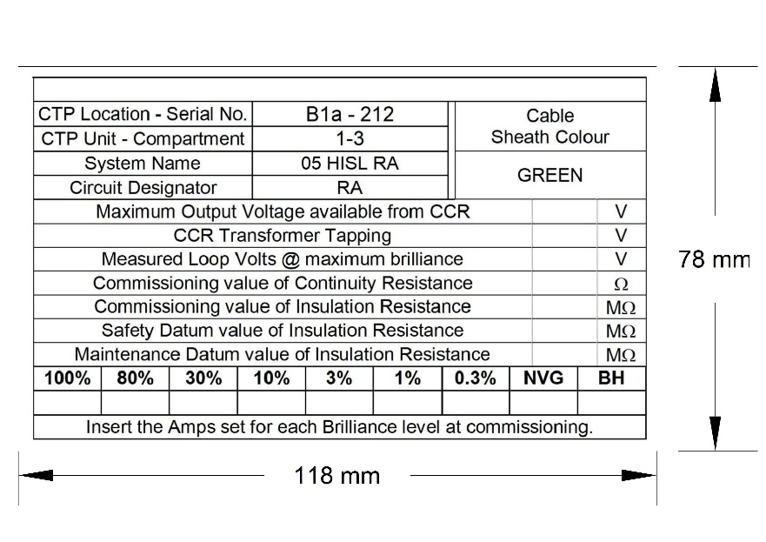

    - There are several types of contactor that have been designed to interface between the MCS and auxiliary AGL equipment (Traffic Lights, Runway Guard Lights, RHAG Markers, AIBs and AOLs). For historical reasons the contactor units have the prefix D followed by a number. The Designer shall be at liberty to quote these types in the design. However, if there is a desire to improve on such designs, the Technical Authority is willing to discuss new ideas.

AGL Power Supply Units

    - All new AGL power supplies shall be via Sinusoidal Output MCCRs.

    - Each New Regulator shall be manufactured to BSEN 61822 and as a minimum incorporate the following design features:

      - Input supply between 400V and 415V 2 phase.

      - MCCR primary current output selectable from Min 2.6A to 12A. max.

      - Earth leakage monitoring and measurement display.

      - 6 step brilliancy control.

      - Percentage lamps failure monitoring.

      - Control I/O to be compatible with MCS standard plug and sockets.

      - Sine wave output at all brilliances on resistive loads.

      - Active control to maintain performance on non-linear loads.

      - Near unity power factor at all brilliancy levels.

      - Display of true output current RMS value.

      - Open circuit protection.

      - Short circuit protection.

      - Monitoring of current intolerance.

      - Output VA drop error.

      - Dual hours run counter records of runtime at maximum brilliancy and total hours run time at any brilliancy level.

      - Near instantaneous reaction to current overloads during switching and generator operations.

      - Internal/External brilliancy control.

      - CCR “On”- current flowing in the series loop.

      - Warning indication of “Open Circuit”, “Over Current” and “Output Current Tolerance Fault”.

      - Elapsed time hours counter at maximum brilliancy.

      - Elapsed time hours counter of total hours run.

      - Built-in adjustable current ramp for switch on, to enhance lamp life by reducing stress on lamp filaments.

      - Parameters configurable from front panel.

      - Castors for easy manoeuvrability where stacked options are not applied.

      - Eye bolts for easy lifting.

      - Built in 24/48V supply for control systems.

      - Vermin proof powder coated cabinet.

      - Internal surge arrestor (Refer elsewhere in this document for surge arrestor specification).

      - BSEN 61822 indicates that a CCR can be equipped with a facility designated as a non-illumination current step. In military systems this is referred to as Black Heat. All new CCRs shall be equipped with this facility which can be programmed to be On or Off.

    - The MCCR shall be able to operate within the following conditions:

      - For nominal input voltage ± 10%.

      - For ambient temperatures from -40°C to + 50°C.

      - For a relative humidity range of 10% RH to 95% RH.

      - Maximum 30% of SCTs open circuit in their secondary winding.

    - Protection devices:

      - Protection against “Open Circuit” to be activated when the output current falls below 1 amp for more than 100ms.

      - Protection against “Over Current” to be activated when the current reaches 102.5% of nominal value for more than 5s or the current reaches 125% of nominal value for more than 300ms.

    - Where stacked MCCRs are proposed, MCCRs within the stack displays shall be fully readable. The CCR shall be accessible for maintenance without the need for operatives to use stepladders or other types of access equipment.

    - New MCCRs shall be provided in all instances unless it can be proven by the Designer that it is practical and safe to reuse existing CCR/MCRs.

    - TMSEs shall not be reused without the direct approval of the Technical Authority.

B Centre Environmental Conditions

    - B centre environmental conditions shall be maintained within the manufacturers recommend operational parameters for all items of equipment used.

    - As a minimum each B centre shall be provided with:

      - Thermostatically controlled run and standby fan. Air inlets will be required for make-up air.

      - Thermostatically controlled run and standby electric frost protection heater.

Protection against Transient Overvoltage of Atmospheric Origin or Due to Switching

    - All AGL field circuits shall be provided with AGL specific surge arrestors to principally protect the B centre AGL equipment and installations against the effects of a lightning strike.

    - BS 7671 is not specifically written with respect to AGL installations and consequently, the Designer shall carry out a risk assessment in accordance with the principles detailed in BS 7671 section 443 and act upon the risk assessment in accordance with BS 7671 and BS EN 62305.

    - The Designer shall ensure the type & rating etc. of the surge arrestors be carefully selected to coordinate their effective operations.

    - Installation shall be carried out in accordance with BS EN 62305.

    - Individual pieces of AGL equipment such as CCRs, control systems and light fixtures often incorporate their own individual surge protection devices. Where this occurs the surge arrestors shall be coordinated so that a fully functional design is achieved without compromising the safety or functionality of each component installed.

    - Individual surge arrestors shall be connected to the B centre earth bar. The Designer shall size each surge arrestor and its associated earth cable.

    - As a minimum AGL specific surge arrestor shall comply with the following requirement:

      - Nominal A.C. rating 4.0 kV rms.

      - Maximum continuous operating D.C. voltage 5.2 kV.

      - Arrestor classification 5000A.

      - High current 65kA.

      - Energy handling capability equivalent 1.

      - IEC 60099-4 Clause 8.4.2 table 5 & 8.5.5.

      - Withstand based on 2000ms rectangular wave 250A.

      - Operating temperature -40 C to +40 C.

      - Standard IEC 60099-4.

    - The Designer shall apply BS 7671 requirements with respect to protection against transient overvoltage of atmospheric origin or due to switching to all parts of the installation within the building in question, in addition to the AGL installation.

Alternative Power Supply Technology

    - It is recognised that AGL technology developing at a rapid pace and new systems not incorporating the traditional regulator and primary circuits may be considered more suited for a particular application. In such instances the Designer shall submit a detailed technical and business case for review by the Technical Authority prior to installation.

General and Emergency Lighting

    - Both the vertical and horizontal lighting levels within the A & B centres shall be adequate to allow safe access, maintenance of equipment. Vertical labels and readouts shall be easily read. Lighting level on the floor shall be a minimum of 300 lux.

    - Energy efficient light sources suited to building shall be used. Manual control of the lighting within the building is preferred, as automatic control may result in light being switched off whilst operatives are working on or with equipment.

    - Emergency lighting shall be provided with the A & B Centres in accordance with relevant British or local standards, due to the nature and usage of the building it is envisaged that enhanced provision will be required.

    - The Designer shall carry out a risk assessment so that the correct level of general / emergency switching protocols is provided to support the light levels used and method of switching.

    - The entrances and exits to the buildings shall have general and emergency lighting.

General Domestic Power

    - General purpose double pole switched socket outlets shall be provided thought the A & B Centres.

Fire Alarms

    - Due to the nature of equipment installed within a B centre and its criticality with respect to flight safety it is recommended that an automatic fire detection system be provided.

    - The Designer shall carry out a full risk assessment in association with the station fire officer to determine the level of fire alarm provision required. It is anticipated in the majority of instances a fire alarm system in accordance with BS5839 P1 standards will be required.

    - The fire alarm system shall be capable of sending and receiving fire and fault signals to and from the station’s main fire alarm system. Where such interconnecting infrastructure is not available on the airfield the Designer shall agree with the Client a suitable method of relaying fire conditions from the remote B centres, to the station fire service.

First Aid Kits and Safety Notices

    - A & B centres shall be provided with first aid kits and safety notices relating to all health and safety risks with the centres.

Siting Board

    - Any new, or extension to an existing, B centre shall have a station siting board. The Designer shall submit to the Technical Authority a statement of need for the works and details of any new or amended electrical installation, within and external to, the B centre.

Apron Flood Lighting

Purpose

    - The primary functions of the apron lighting are to:

      - Assist the pilot to taxi his aircraft into and out of the final parking position.

      - Provide lighting suitable for embarkation and debarkation of passengers (where applicable).

      - Load and unload cargo.

      - Refuel.

      - Use other apron services functions.

      - Maintain airfield security.

Apron Lighting Design Criteria

    - Apron floodlighting shall be provided on a de-icing / anti-icing facility and on any designated air system parking position intended to be used at night.

    - Floodlighting columns shall be sized so that they do not penetrate the obstacle limitation surfaces.

    - In order to reduce light pollution of the night sky, the design shall utilise floodlighting light fixtures with controlled light output. Light shall be focused down onto the apron / dispersal surface, while providing adequate illuminance. There shall be minimum glare to pilots of air systems in flight and on the ground, aerodrome and apron controllers and personnel on the apron.

    - The Designer shall submit supporting data for any environmental impact analysis relating to floodlight proposals as requested by the Technical Authority.

    - Allowable heights for floodlighting masts adjacent the aprons are based on the transitional surface stated in RA 3512. The slope begins at the edge of the runway strip (150m offset from the centreline).

    - Where floodlighting columns shall be provided in the vicinity of explosive storage and handling facilities, the scheme shall be in accordance with the requirements of DSA 03.OME Part 2 regarding Explosive Installations. Floodlighting mast shall have 150% or more lateral clearance between a lighting structure and an explosive building i.e., the apron shelter. For example, a 25m column/mast shall be 37.5m back from the shelter.

    - Floodlights shall be arranged so that an air system stand receives light from two or more directions to minimise shadows.

    - Average illuminance for an air system stand, as a minimum, shall be:

      - Horizontal illuminance - 20 lux with a uniformity ratio (average to minimum) of not more than 4 to 1, and
      - Vertical illuminance — 20 lux at a height of 2m above the apron in relevant directions, and

      - Have an average illuminance for other apron areas of at least 50% horizontal and vertical illuminance of the average illuminance on the air system stands with a uniformity ratio (average to minimum) of not more than 4 to 1.

    - Each apron installation shall be provided with local external floodlighting control panels. The floodlighting control panels shall incorporate switching from the following locations:

      - ATC VCR.

      - SQN main building and apron cabins.

    - Lighting columns shall have three phase and neutral supplies. Three-phase only supplies shall not be used.

    - Each column shall be provided with suitably rated socket outlets to permit the head frames to be lowered for maintenance purposes using the manufacturers recommend lowering equipment. The socket outlets shall be provided with RCD protection.

    - Each column shall be provided with an individual photocell-controlled AOL.

    - Apron floodlights shall have override control from ATC. The Designer shall liaise with the Client to ascertain whether airfield blackout is a requirement and where it is this shall be included in the design.

    - Where more than one column is supplied from a panel, a timed sequence of power application shall be included to prevent large inrush currents.

    - Each column shall also be provided with lightning protection which shall be earthed via a suitable earth pit. Test positions shall be suitably coordinated with the apron so as not to comprise the apron surface and aircraft movements.

    - The columns shall be provided with suitable mass concrete foundations in accordance with manufacturer’s recommendations.

    - The Designer will be responsible for preparing and initial floodlighting design for stationing siting board. The design shall accurately locate and give heights of all floodlighting columns along with illumination levels.

    - Prior to installation the Designer shall submit details of the proposed floodlighting scheme for an engineering appraisal by the Technical Authority. Installation works will not be permitted to commence until the engineering appraisal process has been completed to the satisfaction of the Client.

Apron Lighting Measurements

    - The apron floodlighting illuminance levels shall be evaluated when first installed, following stand reconfiguration or after any major maintenance or repair has been undertaken, to determine that the levels meet RA3515 compliance.

    - The apron floodlighting illuminance level assessments shall be conducted using this Design Standard and ICAO Annex 14 as guidance documents.

    - The apron floodlighting illuminance level assessments for each apron stand shall be completed whenever a new stand is installed or re-configured, following any major maintenance to floodlight masts/installations and at least once every 12 months.

    - All illuminance meters shall be operated in accordance with the manufacturer’s instructions, and where there is any reason to doubt the accuracy of the apron floodlighting illuminance level assessment, it shall be repeated.

    - Particular attention shall be paid to manufacturer’s guidance regarding regular calibration of any light meter used.

    - Consideration shall be given to the selection of a suitable light meter. Ideally the meter shall be colour and cosine corrected. If this is not the case, readings at low angles and of sodium lamps could be adversely affected.

    - The area to be assessed shall be clear and empty of aircraft, vehicles and equipment.

    - All floodlight measurement shall be taken during the hours of darkness.

    - All measurements associated with new installations shall be compared with original design calculations and any irregularities shall be addressed.

    - A typical apron stand shall be assessed using a grid system consisting of at least 15 measuring points.

    - The measuring points shall be as follows:

      - 5 equidistant along the stand centreline starting approximately 5m from the head of stand parking position. (this is approximately the nose wheel position for the largest aircraft that’s able to use the stand).

      - An additional 10 points shall be positioned either side of the stand centreline, equidistant between the centreline and edge of the parking position.

      - Where edge of stand markings are not present the measurements shall be taken 5m either side of the stand centreline.

    - The following paragraphs describe both vertical and horizontal illuminance:

      - Horizontal illuminance - The light meter shall be placed at ground level with the light sensor pointing upwards.

      - Vertical illuminance - The light meter shall be positioned at a height of 2m (preferably using a purpose-built pole), the light sensor shall be facing the head of stand (i.e., at 90° to the horizontal).

    - When the apron floodlighting illuminance levels of an apron stand are found to be below the required level, appropriate corrective maintenance action shall be initiated to improve the levels in order to attain compliance with RA3515 requirements.
    - Remedial actions may include replacement of unserviceable/damaged lamps, cleaning of lamps, replacement of lamps with lamps of a different rating, re- positioning of lamps and re-siting of floodlight masts.

    - If stand floodlighting illuminance levels remain non-compliant, every effort shall be made to find a compliant solution.

    - HAS sites can have many physical and regulatory constraints imposed on the parking pans such as wing tip clearances and those associated with aircraft arming/ explosives handling, which can make the positioning of floodlighting columns difficult and inefficient with respect to light output.

    - In order to avoid these constraints, the Designer shall look to install pan floodlights to the HAS building structure in preference to stand alone columns.

    - It is recognised that when floodlights are only positioned in a single aspect, such as above a HAS door, it is unlikely that lighting levels recommended for aircraft parking stands can be achieved. In these instances, the Designer shall look to achieve a minimum of 20 lux across the central 75% of the pan 6m away from the HAS facade and minimum 10 lux across the central 75% of the pan 18m away from the HAS facade.

    - The horizontal and vertical lighting levels measurement positions shall be taken in accordance with the requirements for apron lighting.

    - The Designer shall aim to achieve a 4:1 uniformity as for normal apron lighting, for 75% of the pan width.

    - The Designer shall look to minimise glare from the lights for pilots taxing on and off the pan.

    - HAS floodlighting shall be manually controlled from within the HAS building.

Measurement Test Records

    - The Designer shall submit records to the Technical Authority of the apron floodlighting assessments to be used to prove compliance and when audited by MAA / DIO.

    - The records shall provide the following:

      - Signed Summary sheet for all apron stands tested.

      - Copies of the calibration certificates of the illuminance meters.

      - Surveyors’ notes (detailing weather conditions during testing, any issues encountered).

      - Report for each individual apron stands tested.

Figure 18.1 Example Apron Illuminance Summary Sheet

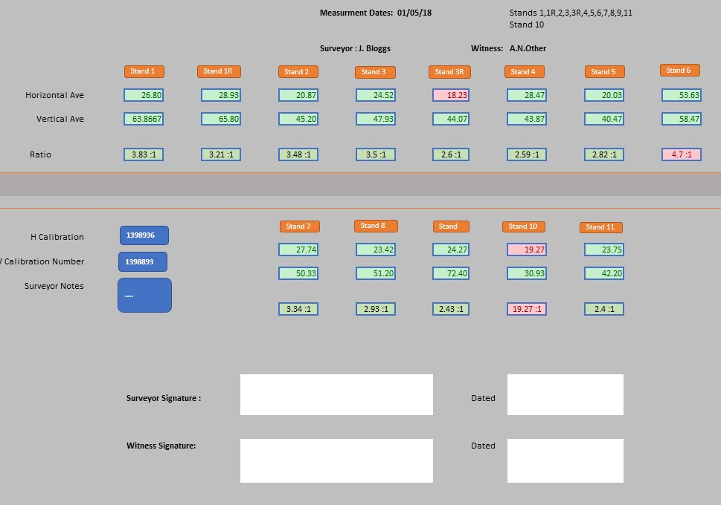

Figure 18.2 Example Individual Stand Measurement Record

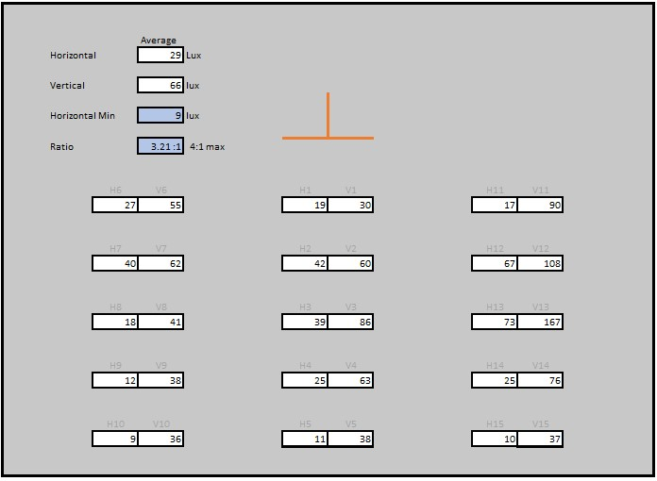

General Requirements for Commissioning of AGL Systems

Requirement

    - Every AGL installation shall, during installation / erection and on completion, before being put into service, be inspected and tested to verify, so far as is reasonably practicable that the requirements of both PI 29/2005 and PG 01/08 and BS 7671 (where applicable) have been achieved.

System Installation

    - A full commissioning test plan based on the recommendations in PG01/08 Annex C (Commissioning of AGL systems) and Table 19.1 “AGL Installation Commissioning Requirements” shall be submitted by the contractor / installer to the Designer or his representative a minimum of 6 weeks prior to the commissioning commencement.

    - On acceptance of the plan, the Designer or his representative will authorise the installation and, if appropriate, decommissioning of relevant AGL equipment.

    - In addition, where the installation and or commissioning of AGL equipment necessitates disruption to the normal operations or services at an aerodrome, the following details shall be submitted to the Designer or his representative at a date previously agreed with the airfield operators but at least 10 flying days before the intended date of disruption.

      - Details of the impact on normal operations.

      - Timescales for any disruptive activities

      - Temporary operating instructions (Aerodrome and ATC).

Commissioning

    - Commissioning Plan: The Designer or his representative shall carry out an inspection of the completed installation and may require access to the results of any on-Site commissioning trials prior to operational use. Where necessary, an inspection programme will be agreed in order to allow for a phased introduction of the final installation. The inspection will include the following items:

      - System operation functionality check.

This check covers the following items where appropriate:

      - The submission of a satisfactorily completed commissioning test schedule (Table 19.1 below refers) and a full demonstration of the system operational functionality.

      - A flight check (for changes to the infield and approach lighting systems). Where the installation includes the addition of, or a change to, the control and monitoring elements of the AGL system.

    - The following table of commissioning requirement has been taken from PG 01/08. The Designer shall define within the project brief instruction specification, Works Information and Site Information and the requirement for the Contractor/ installer to carry out the tests detailed within the following table:

Table 19.1 AGL Installation Commissioning Requirements

SYSTEM COMPONENTS/ PHASES | RECOMMENDED TASK | ADDITIONAL NOTES
New Series Circuit Transformer (SCT) | For each new SCT with the secondary bonded to the core and earth, test the insulation resistance of the primary to earth with a 1kV insulation tester. On SCTs without an earth bond on the secondary, test primary and secondary to earth and primary to secondary insulation resistance. | Produce a test result sheet referenced as an Appendix to the Commissioning Plan.
Used Series Circuit Transformer (SCT) | Any SCTs, which may have been removed from the installation and is to be re-used shall be subjected to a 24 hour “soak test” prior to testing with a 1kV insulation tester | Produce a test result sheet referenced as an Appendix to the Commissioning Plan.
AGL Cable | All circuits shall be positively identified and labelled with correct circuit identification marking in compliance with circuit identification requirement detailed in this document | Labelling to be printed and indelible. Produce a record sheet referenced as an Appendix to the Commissioning Plan.
AGL Cable | Tests shall be conducted on each section of cable to earth, no greater than 1 km in length, and prior to backfilling. Each test shall meet the minimum resistance to earth for cable as detailed in PI 29/2005 Figure 4. | Produce a test result sheet referenced as an Appendix to the Commissioning Plan.
AGL Circuit sections | Tests shall be conducted on each section of circuit, including connected series circuit SCTs, to earth, no greater than 1 km in length, and prior to backfilling. Resistance values shall not be less than the calculated value as detailed in PI 29/2005. Typically, SCTs and cable sections will have insulation resistance values in excess of 1GΩ. | Produce a test result sheet referenced as an Appendix to the Commissioning Plan.
Series Circuit Transformer Earth Connection Verification | After completion and backfilling of trenches a test shall be made to prove that the secondary windings of SCTs are connected to the protective conductor and to the earth electrodes or the earth bar in the ‘B’ Centre. | Produce a test result sheet referenced as an Appendix to the Commissioning Plan.
CCR Commissioning | CCR commissioning shall follow all stages as recommended by the manufacturer which shall include but not be limited to: All connection check, Input Voltage Check, Output Tapping Check according to calculated load. | Produce a Record Check sheet referenced as an Appendix to the Commissioning Plan.
CCR Commissioning | CCR commissioning shall follow all stages as recommended by the manufacturer which shall include but not be limited to: Open Circuit Trip, Overcurrent Trip, Lamps Out Alarm/Trip, and Earth Fault Alarm/Trip. | Produce a test result sheet referenced as an Appendix to the Commissioning Plan.
CCR Commissioning  (Brilliancy) | Brilliancy adjustments shall follow all stages as recommended by the manufacturer with settings adjusted to those corresponding to current regulations. | Produce a Record Sheet referenced as an Appendix to the Commissioning Plan and values entered in “As Built Documentation”.
Earthing Certification | After a certificate issued from the installation organisation, stating that all exposed conductive parts in the installation are earthed, has been accepted by the Client or representative, tests for continuity and insulation resistance shall be carried out. | Earth test may be witnessed prior to Certification Acceptance
Safety Datum | For each circuit installed the Safety Datum as defined in PI 29/2005 shall be calculated. | Circuit Safety Datum values to be recorded as an Appendix to the Commissioning Plan and results entered in “As Built Documentation”
Maintenance Remedial Level | For each circuit installed the Maintenance Remedial Level as defined in PI 29/2005 shall be calculated. | Circuit Maintenance Remedial Level values to be recorded as an Appendix to the Commissioning Plan and results entered in “As Built Documentation”
Maintenance Datum | For each circuit installed the Maintenance Datum as defined in PI 29/2005shall be calculated. | Circuit Maintenance Datum values to be recorded as an Appendix to the Commissioning Plan and results entered in “As Built Documentation”
Commissioning Datum | For each circuit installed the Commissioning Datum as defined in PI 29/2005 shall be calculated and compared with measured value. | Circuit Commissioning Datum values to be recorded as an Appendix to the Commissioning Plan and results entered in “As Built Documentation”
Continuity Check and Resistance Measurement | The continuity resistance of series circuits shall be measured, and the value obtained shall accord with the estimated value of 3.02 ohm per 1000 m of 6mm² cable plus 0.04 ohm per series circuit transformer. | Circuit Resistance to be recorded as an Appendix to the Commissioning Plan and results entered in “As Built Documentation”
Minimum time for conducting Insulation Resistance tests | Establish a minimum time for conducting each test. For readings of insulation resistance, the instrument shall be operated for a definite length of time, either 30 seconds to 1 minute, and read at the end of that time. All future tests shall be conducted with the same length of operating time. | Established Test Time and Test Voltage (if not at 3000V) shall be recorded on the Insulation Test Appendix.
Initial (1st) Insulation Test (Disconnected from ODD) | Initial Insulation Resistance Test. After continuity test to record the resistance to earth value and to verify circuit is within the Safety Datum Level. | Circuit Insulation Resistance to be recorded as an Appendix to the Commissioning Plan and results entered in “As Built Documentation”
Second (2nd) Insulation Test (Connected at ODD) | Initial Insulation Resistance Test. After continuity test to record the resistance to earth value and to verify circuit is within the Safety Datum Level. | Circuit Insulation Resistance to be recorded as an Appendix to the Commissioning Plan and results entered in “As Built Documentation”
Third (3rd) Insulation Test (Connected at ODD) | After the installation has been operated at full intensity for not less than six hours and while the series circuit SCTs are still warm | Circuit Insulation Resistance to be recorded as an Appendix to the Commissioning Plan and results entered in “As Built Documentation”
Fourth (4th) Insulation Test (Disconnected from ODD) | After the installation has been operated at full intensity for not less than six hours and while the series circuit SCTs are still warm | Circuit Insulation Resistance to be recorded as an Appendix to the Commissioning Plan and results entered in “As Built Documentation”
Fifth (5th) Insulation Test (Connected at ODD) | At least three hours later when the series circuit SCTs have cooled | Circuit Insulation Resistance to be recorded as an Appendix to the Commissioning Plan and results entered in “As Built Documentation”
Sixth (6th) Insulation Test (Disconnected from ODD) | At least three hours later when the series circuit SCTs have cooled | Circuit Insulation Resistance to be recorded as an Appendix to the Commissioning Plan and results entered in “As Built Documentation”
Insulation Resistance Test (ODD back to Regulator) | Each test to be performed in accordance with PI 29/2005. | Circuit Insulation Resistance to be recorded as an Appendix to the Commissioning Plan and results entered in “As Built Documentation”
Commissioning Datum Results | For new circuits the Commissioning Datum shall comply with PI 29/2005 Annex B - Commissioning requirements for the installation of new and refurbished works on AGL primary cable circuits.  Minimum Commissioning Datum Level (CDL)  CDL = 3000/ (0.02μA x No of series circuit transformer + 0.02μA x cable length in m/100). Ω  The actual leakage current, measured at commissioning stage, shall be used in the above calculation when this is less than the calculated value. | Circuits shall not be accepted until remedial works are completed to achieve expected Commissioning Values at set precedent.
ODD Labelling | ODD housing shall be fitted with a Circuit Identification Car (CIC). The CIC is shown on Drawing  DIO-VA-012. It shall give the required information. | Labelling to be printed and indelible.
Elevated light fixtures | Check all frangible couplings are correctly installed | Produce a Record Check Sheet referenced as an Appendix to the Commissioning Plan.
Elevated light fixtures | Check all screws and or nuts and bolts are secure. | Produce a Record Check Sheet referenced as an Appendix to the Commissioning Plan.
Elevated light fixtures | Check all light fixtures are set to the correct alignment in accordance with this document | Tolerance to be within ±½º  Produce a Record Sheet referenced as an Appendix to the Commissioning Plan and variations ±½º entered in “As Built Documentation”.
Elevated Approach light fixtures | Check all light fixtures mounted above 2m are earthed. | Produce a Record Check Sheet referenced as an Appendix to the Commissioning Plan.
Inset light fixtures | Check all screws and or nuts and bolts are secure. | Produce a Record Check Sheet referenced as an Appendix to the Commissioning Plan.
Inset light fixtures | Check all screws and or nuts and bolts are within tolerance with respect to installed seating ring or pot. | Check with manufacturer if in doubt. No protrusions above tolerance are acceptable.
Inset light fixtures | Check all light fixtures are set to the correct alignment in accordance with current regulations  This should be witnessed and recorded during installation. | Tolerance to be within ±½º  Produce a Record Sheet referenced as an Appendix to the Commissioning Plan and variations ±½º entered in “As Built Documentation”.
PAPI Installations | Check cross fall of each unit is 0º. Check each unit is set to appropriate angle for the required resultant glide slope. This check shall be made with a Theodolite and staff. | Adjust as necessary.  Tolerance to be within ± 1.0’ (minute)  Produce a Record Sheet referenced as an Appendix to the Commissioning Plan and variations ± 1.0’ entered in “As Built Documentation”.
PAPI Flight Acceptance Check | Arrange for Flight Check of system for appropriate signals as detailed in current regulations | Contractor shall be on Site to make any final adjustments.
All AGL light fixtures | Check all light fixtures at each location is marked with an identification number legible, where practicable, from a passing vehicle in compliance with current regulations | Produce a Record Check Sheet referenced as an Appendix to the Commissioning Plan and enter identifications in “As Built Documentation”.
Photometric Testing of AGL Systems | The Photometric Performance of each AGL system shall be measured by a DIO recognised Mobile Photometric Testing Device to demonstrate that the installed light fixture design performance is operating at 100%, or above, of the Isocandela Figures referenced in RA3500 series | Photometric measurements shall be generated and presented in tabular and bar chart formats
BS 7671 Test Certificate | Where works to any LV installation subject to BS 7671 compliance are carried out, a BS 7671 test certificate shall be provided | The BS 7671 test certificate must be signed by a suitably qualified and competent person.

AGL Design and Installation Compliance Certificate

    - Upon completion of the commissioning, the Designer along with all other relevant parties shall complete and issue the AGL Design and Installation Compliance Certificate (Table 19.2). The AGL Design and Installation Certificate is only valid when submitted along with records and the results of applicable tests and Inspections as stated above in Table 19.1.

Assurance Certification

    - As defined in RA3500(1) Para 4, the following information, where applicable to the installation carried out, shall be included in the assurance certification of any major or minor works project.

- Aeronautical Ground Lighting (AGL) Design and Installation Compliance Certificate (See Table 19.2)
- In-situ AGL Photometric Test Certificate of Compliance1
- Apron Floodlighting Photometric Test Certificate of Compliance
- Certificate of Compliance for provision of Secondary Power Supplies2
- Precision Approach Path Indicator (PAPI) Fight Check Form3
- AGL Control System Functional Test Certificate4
- Insulation Resistance Test results5
- “As Built” Drawings (including final surface levels)
- Updated Airfield Lighting Schedule
- AGL Equipment Warranties

Notes

1 This applies to all new refurbished or modified installations where more than 25% of the system has been changed. Systems are to only include all runway services, taxiway centre lines and stop bars.
2Determined by the Runway Approach Category and Take-off Runway Visual range (RVR)
3Where bases may have been affected, runway levels have changed or a PAPI unit has been damaged or removed and replaced.
4Full system check required after any work is undertaken. Compliance with Defence Infrastructure Organisation (DIO) Policy Instruction 19/2006 is mandatory.
5 Results to comply with DIO Policy Instruction 29/2005 Annex B.
    - The assurance certification at para 19.5.1 sub-items A to F, where applicable, shall be provided to the Client prior to the formal completion of the works.

Table 19.2 AGL Design and Installation Compliance Certificate

AGL DESIGN AND INSTALLATION COMPLIANCE CERTIFICATE

DETAILS OF THE CLIENT
INSTALLATION ADDRESS

DESCRIPTION AND EXTENT OF THE INSTALLATION  Description of installation: | New installation □
Extent of installation covered by this Certificate:  (Use continuation sheet if necessary) see continuation sheet No: ........ | Addition to an existing installation
 | Alteration to an existing installation
FOR DESIGN
I/We being the person(s) responsible for the design of the AGL installation (as indicated by my/our signatures below), particulars of which are described above, having exercised reasonable skill and care when carrying out the design and additionally where this certificate applies to an addition or alteration, the safety of the existing installation is not impaired, hereby CERTIFY that the
design work for which I/we have been responsible is to the best of my/our knowledge and belief in accordance with RA3500 Series, amended to ............. (date) except for the departures, if any, detailed as follows:

Details of departures from RA3500 Series:
Details of permitted exceptions confirmed by an appropriate AAMC. Where applicable, the AAMC shall be attached to this Certificate.
AAMC attached □
The extent of liability of the signatory or signatories is limited to the work described above as the subject of this Certificate.
For the DESIGN of the installation: **(Where there is mutual responsibility for the design)

Signature: ................................. Date: ............... Name (IN BLOCK LETTERS): ................................................ Designer No 1

Signature: ................................. Date: ............... Name (IN BLOCK LETTERS): ................................................ Designer No 2**
FOR CONSTRUCTION
I being the person responsible for the construction of the electrical installation (as indicated by my signature below), particulars of which are described above, having exercised reasonable skill and care when carrying out the construction hereby CERTIFY that the construction work for which I have been responsible is to the best of my knowledge and belief in accordance with RA3500 Series, amended to .............(date) except for the departures, if any, detailed as follows:
Details of departures from RA3500 Series:

The extent of liability of the signatory is limited to the work described above as the subject of this Certificate. For CONSTRUCTION of the installation:
Signature: ................................. Date: ............... Name (IN BLOCK LETTERS): ................................................ Constructor

FOR INSPECTION & TESTING
I being the person responsible for the inspection & testing of the AGL installation (as indicated by my signature below), particulars of which are described above, having exercised reasonable skill and care when carrying out the inspection & testing hereby CERTIFY that the work for which I have been responsible is to the best of my knowledge and belief in accordance with RA3500 Series, amended to .............(date) except for the departures, if any, detailed as follows:
Details of departures from RA3500 Series:

The extent of liability of the signatory is limited to the work described above as the subject of this Certificate. For INSPECTION AND TESTING of the installation:
Signature: ................................. Date: ............... Name (IN BLOCK LETTERS): ................................................ Inspector
Signature: ................................. Date: ............... Name (IN BLOCK LETTERS): ................................................ Inspector

Comments:
PARTICULARS OF SIGNATORIES TO THE AGL INSTALLATION CERTIFICATE
Designer (No 1)
Name: .............................................. Company: ...............................................................................
Address: .........................................................................................................................................................
....................................................................... Postcode: ................... Tel No: ........................................
Designer (No 2)
(if applicable)
Name: .............................................. Company: ...............................................................................
Address: .........................................................................................................................................................
....................................................................... Postcode: ................... Tel No: ........................................
Constructor
Name: .............................................. Company: ...............................................................................
Address: .........................................................................................................................................................
....................................................................... Postcode: ................... Tel No: ........................................
Inspector (No 1)
Name: .............................................. Company: ...............................................................................
Address: .........................................................................................................................................................
...................................................................... Postcode: ................... Tel No: ........................................
Inspector (No 2)
(if applicable)
Name: .............................................. Company: ...............................................................................
Address: .........................................................................................................................................................
...................................................................... Postcode: ................... Tel No: ........................................
COMMENTS ON EXISTING INSTALLATION:
.................................................................................................................................................................................................................
.................................................................................................................................................................................................................
.................................................................................................................................................................................................................
.................................................................................................................................................................................................................
.................................................................................................................................................................................................................
.................................................................................................................................................................................................................
.................................................................................................................................................................................................................
.................................................................................................................................................................................................................
SCHEDULES
The attached Schedules are part of this document and this Certificate is valid only when they are attached to it.
............ Schedules of Inspections and............ Schedules of Test Results are attached.
(Enter quantities of schedules attached).

AIRFIELD MARKINGS

Background

    - There is a clear and distinct relationship between pavement markings and aeronautical ground lighting, with both elements working in tandem to provide pilots with the critical visual aids for aircraft approach, landing, taxi and take-off.

Requirement

    - The Military Aviation Authority has compiled best practice for airfield markings into the Regulatory Article (RA) 3514 Permanent Fixed Wing Aerodrome Markings as follows:

      - RA3514(1): Defines the requirements for General Markings.

      - RA3514(2): Defines the requirements for Runway Markings.

      - RA3514(3) : Defines the requirements for Aiming Points and Touchdown Markings.

      - RA3514(4) : Defines the requirements for Taxiway Markings.

      - RA3514(5) : Defines the requirements for Vehicle Roadway Markings.

      - RA3514(6) : Defines the requirements for Air System Stand Markings.

      - RA3514(7) : Defines the requirements for Arrestor System Markings.

      - RA3514(8) : Defines the requirements for Mandatory Instruction Markings.

      - RA3514(9) : Defines the requirements for Information Markings.

    - Each of the above sections of RA3514 details the regulatory requirement, the AMC and provides guidance material for the individual markings:

    - Where the Designer requires further guidance, the following documents listed in hierarchical relevance shall be referred to:

      - ICAO Doc 9157 Aerodrome Design Manual.

      - ICAO Annex 14 Aerodromes.

      - CAP 168 – Licensing of Aerodromes.

      - CAP 637 – Visual Aids Handbook.

      - EASA Certification Specifications and Guidance Material for Aerodrome Design.

AGL and Markings Relationship

    - Notwithstanding the above, the Designers attention is drawn to the fact that there is a clear and defined relationship between the visual aids and aerodrome markings in certain key areas. Examples of such relationships are provided in the following table:

Table 20.1 Visual Aid Application and Criteria

Visual Aid Reference | Visual Marking Reference |  | Criteria
Threshold Lighting | Threshold Piano Keys  Threshold Transverse Stripe (where displaced or runway paved end is not square to centreline) |  | Threshold Lighting should be aligned with the start of the defined runway surface or may be positioned up to 3m beyond the extremity of the runway on a paved area. Where a Displaced threshold Transverse Stripe is provided, the Threshold light mountings shall be installed so that any part of the light mounting is 50mm on the Approach side of the Threshold marking. This is to avoid painting over the light. The position of the lights should be understood to indicate the Threshold position.
Runway End Lighting | Threshold |  | Where the Threshold is at the extremity of the runway, the Runway End lights shall be collocated with the Threshold Lights.  For a Displaced Threshold the Runway End Lighting should be aligned with the end of the defined runway surface or may be positioned up to 3m beyond the runway extremity.
Runway Centreline Lighting  (RCL) | Runway Centreline Marking. |  | If Runway Centreline lights are to be provided it shall be ensured that a gap of 50mm is provided longitudinally either side of each light mounting to avoid painting over the light.  Divide the distance between the conjugate Threshold Light positions by 15 or 30 (depending on required RCL density) and round up the number.  Divide the distance between the conjugate Threshold Light positions by this number to give accurate spacing between the Threshold lights. Where the Threshold/End lights are positioned beyond the extremity of the runway, the final centreline light shall be replaced by a Runway end light.  The spacing calculation will ensure that the position exactly midway between the inner adjacent Displaced Threshold lights coincides with an RCL position.
Visual Aid Reference |  | Visual Marking Reference |  | Criteria
Runway Edge Lighting |  | Runway Edge Marking (where required) |  | Runway Edge lights may be spaced up to 3m beyond the runway edge if a paved surface is available. Where little room exists for the lights outside the edge marking, the marking can be displaced inboard to avoid painting over the light mountings. Recommended 50mm distance
(A)PAPI |  | Aiming Point (AP) markings should be located coincident with the origin of the PAPI glideslope. Touchdown Zone (TDZ) markings shall be provided around the aiming point as per the required arrangement. |  | If TDZ lights are required, they shall be installed as per the regulations. However, if any TDZ light position was to clash with AP or TDZ markings, the overall layout of the markings shall be adjusted longitudinally within the permitted tolerances to ensure that the overall marking pattern remains consistent, and no part of the markings is within 50mm of the light mounting.
Taxiway-Runway Hold |  | Runway Hold Bar - Pattern A. |  | The position and orientation of the Hold Bar (solid line) shall ensure that no part of the aircraft shall infringe the permitted straight-line distance from the runway centreline, plus such a distance as to allow a final yellow lead off light mounting to be installed on the runway side of the Hold Bar by at least 50mm. Where taxiway centreline light mountings are all green (no ILS), the offset distance shall be such that no light mounting shall be within 50mm either side of either line.  Where a Stopbar is to be provided, all light mountings in the Stopbar are to be positioned on the Taxiway side of Exit Bar (dotted line) in the 900mm between the Exit Bar and the taxiway centreline marking.

    - The above should not be taken as a comprehensive listing but is simply intended to highlight to the Designer that the requirement for visual aids markings and lighting are interlinked. The Designer should determine the required markings and visual aids based on the relevant airfield code, approach category and in engagement with the Regulated Entity, relevant stakeholders and the DIO subject matter experts.

    - Where existing markings do not comply with RAs, they shall be updated at such time that they are part of a general refurbishment project.

