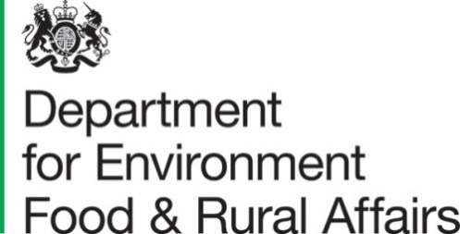

Published 31 March 2022

Farming Statistics - Livestock Populations 1 December 2021, UK

This release contains livestock numbers on agricultural holdings in the United Kingdom for cattle and sheep. Data come from various sources, full details of which are provided in the methodological notes on page 10.
Pig statistics for the United Kingdom at 1 December have been discontinued as the data are no longer available from the Devolved Administrations.

Key Messages
At 1 December 2021 in the United Kingdom there were:
- 9.4 million total cattle and calves, an increase of 0.8% since December 2020
- 3.3 million cattle in the breeding herd, a decrease of 0.3% since December 2020
- 22.8 million total sheep and lambs, an increase of 3.0% since December 2020
- 14.5 million breeding ewes, an increase of 2.7% since December 2020

Contents

What you need to know about this release 3
Contact details 3
Section 1 – Detailed results 4
1.1 - Cattle 4
1.2 - Sheep 6
Section 2 – About these Statistics 8
2.1 Survey methodology 8
England 8
Wales 8
Scotland 8
Northern Ireland 9
2.2 Data notes 9
2.3 Data uses and users 9
2.4 Other survey results and publications 10
2.5 Feedback 10

What you need to know about this release

This section ensures any important information is clearly explained so users do not misunderstand the data.

Contact details

Responsible statisticians: Emma Howat (cattle) and Ruth Ireson (sheep)
Team: Farming Statistics, Department for Environment, Food and Rural Affairs
Email: farming-statistics@defra.gov.uk
Tel: 03000 600 170

National Statistics Status
National Statistics status means that our statistics meet the highest standards of trustworthiness, quality, and public value, and it is our responsibility to maintain compliance with these standards.
The continued designation of these statistics as National Statistics was confirmed in 2014 following a full assessment by the UK Statistics Authority against the Code of Practice for Statistics.
Since the last review of these statistics in 2014, we have continued to comply with the Code of Practice for Statistics, and have made improvements including:
- Improved data visualisations throughout the statistical release.
- Adding Table 4: Effect of revisions to Sheep figures for the previous year to the release.
- Improved coverage of the pig sector by running a special data collection exercise each year to collect data from a central point for some of the largest companies.
- Improved quality of sheep data by working closely with the data owners, APHA, to improve the form and population list.

For general enquiries about National Statistics, contact the National Statistics Public Enquiry Service:

Tel: 0845 601 3034
Email: info@statistics.gov.uk.
You can find National Statistics on the internet on the Gov.uk website.

Section 1 – Detailed results

1.1 - Cattle
The total number of cattle and calves in the UK increased by 0.8% between December 2020 and December 2021 and now stands at over 9.4 million animals.

The UK breeding herd, which is made up of dairy and beef cows over two years old with offspring, accounts for 35% of total cattle and 47% of all female cattle. The breeding herd has decreased by 0.3% since last year and totals 3.3 million. The beef breeding herd showed a decrease of 0.9% and stands at 1.4 million while the dairy breeding herd showed a 0.1% increase and stands at just under 1.9 million.

Figure 1: Female dairy and beef herds at 1 December 2017 to 2021

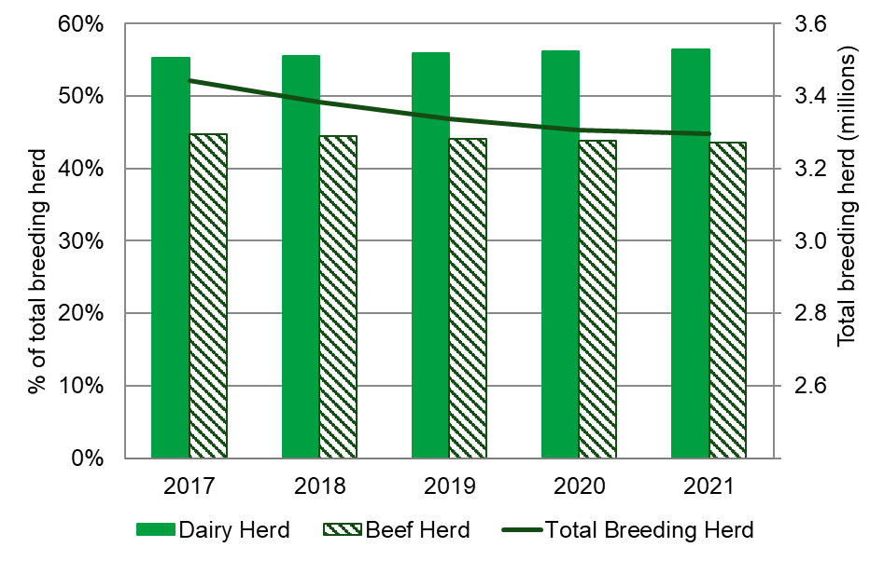

Table 1: Cattle and calves on UK agricultural holdings on 1 December (a)
Thousands
 | 2019 | 2020 | 2021 | % Change 2021/20
Total cattle and calves | 9,459 | 9,366 | 9,442 | 0.8%
All female cattle | 6,954 | 6,906 | 6,958 | 0.7%
Aged 2 years or more | 3,975 | 3,877 | 3,832 | -1.2%
Total breeding herd | 3,337 | 3,307 | 3,296 | -0.3%
Beef herd | 1,470 | 1,451 | 1,437 | -0.9%
Dairy herd | 1,867 | 1,856 | 1,859 | 0.1%
Other female cattle | 637 | 570 | 536 | -6.0%
Beef | 338 | 305 | 303 | -0.8%
Dairy | 299 | 265 | 233 | -12.0%
Aged between 1 and 2 years | 1,405 | 1,408 | 1,452 | 3.1%
Beef | 886 | 881 | 896 | 1.8%
Dairy | 519 | 527 | 555 | 5.3%
Less than 1 year | 1,574 | 1,621 | 1,675 | 3.3%
All male cattle | 2,504 | 2,460 | 2,483 | 1.0%
Aged 2 years or more | 289 | 247 | 244 | -1.4%
Aged between 1 and 2 years | 929 | 912 | 928 | 1.8%
Less than 1 year | 1,286 | 1,300 | 1,311 | 0.9%
- Figures are sourced from the Cattle Tracing System (CTS) in England, Wales and Scotland and the equivalent APHIS system in Northern Ireland. The data include returns from all holdings with cattle so are not subject to survey error.

1.2 - Sheep
The total number of sheep and lambs in the UK increased by 3.0% between December 2020 and December 2021 and now stands at 22.8 million. Over the same period the female breeding flock increased by 2.7% to 14.5 million animals while other sheep and lambs showed the highest percentage increase at 3.7% and now stands at 8.3 million.

Figure 2: Total sheep and lambs in the UK at 1 December 2017 to 2021
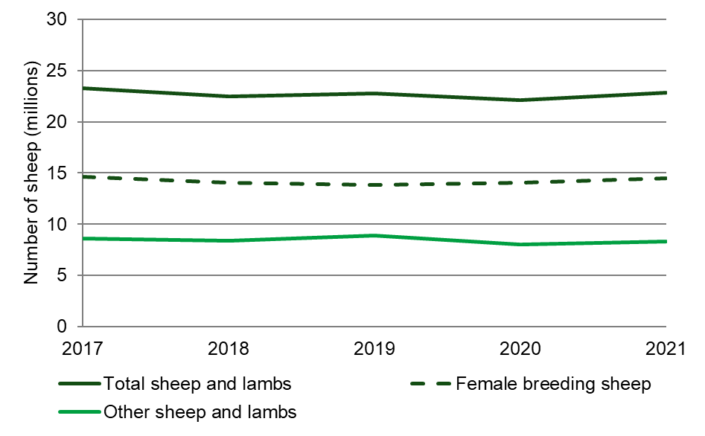

Figures for England and Northern Ireland for 2020 have been revised to take into account late returns and data cleansing. The figures in table 2 have been updated as a result. Table 3 shows the effect of the revisions.

Table 2: Sheep and lambs on agricultural holdings on 1 December
Thousands
 | 2019 | 2020 | 2021(a) | % Change 2021/20
Total sheep and lambs | 22,779 | 22,134 | 22,803 | 3.0
Female breeding sheep | 13,857 | 14,084 | 14,458 | 2.7
Other sheep and lambs | 8,921 | 8,050 | 8,345 | 3.7
- 2021 results are provisional.

Table 3: Effect of revisions to Sheep figures for 2020
Thousands
 | 2020
 | Original | Revised | % Change
Total sheep and lambs | 21,845 | 22,134 | 1.3
Female breeding sheep | 13,863 | 14,084 | 1.6
Other sheep and lambs | 7,982 | 8,050 | 0.9

Section 2 – About these Statistics

2.1 Survey methodology

England
Data for this 2021 December livestock publication comes from several different sources.

Cattle
Cattle results are sourced from the Cattle Tracing System (CTS). The data include returns from all holdings with cattle so are not subject to survey error. More information on the use of this administrative data can be found on the survey notes and guidance web page.

Sheep
Sheep data came from the Sheep and Goat Inventory (an annual exercise requiring all sheep and goat keepers to record animals under their keepership at 1 December). It is a requirement to hold the inventory for livestock tracing and identification purposes. Sheep and goat keepers will receive either a paper form or an email request to complete their inventory in late November. Since 2010 the information collected by the inventory is used to estimate the size of the English sheep flock at 1 December. More information is available at Use of the sheep and goat inventory for estimating sheep populations (PDF, 114KB, 6 pages)
Data analysis
The data sheep are subject to rigorous validation checks which identify inconsistencies within the data or large year-on-year changes.

Wales
Until 2012 sheep numbers were collected via the Welsh December survey of agriculture. Since 2013 the sheep data has been sourced from the Welsh Sheep and Goats Inventory, which is an annual exercise requiring all sheep and goat keepers to record animals under their keepership as at 1 January. The Inventory figures are adjusted to take account of the number of sheep slaughtered during December to produce an equivalent figure. Cattle data are taken from the Cattle Tracing System (an administrative system primarily set up for animal health monitoring purposes). Since 2013 Wales has not produced pig data in December.
Further details of agricultural statistics in Wales can be found on the Welsh Government website.

Scotland
As part of the Agricultural Analysis Unit’s Transformation Programme (for more information please visit this blog post), the December Agricultural Survey did not take place this year and only the Annual Sheep and Goat Inventory was undertaken.

The Annual Sheep and Goat Inventory collects numbers of sheep and goats as of 1st December from all identified sheep keepers across Scotland. The sample of 18,826 keepers was collated based on sheep numbers returned for the June Agricultural Census, sheep tags requested from ScotEID, and sheep keepers registered with APHA (Animal and Plant Health Agency). There were 14,147 responses giving a 75% response rate. Estimates are made for non-responses.

Cattle results are sourced from the Cattle Tracing System (CTS). The data include returns from all holdings with cattle.

Final results for Scotland will be published on 29 March 2022 by the Scottish Government, Rural and Environment Science and Analytical Services, Q Spur, Saughton House, Broomhouse Drive, Edinburgh, EH11 3XD (e-mail agric.stats@gov.scot) and will be available online (search for “Sheep and Goat Inventory Table 2021”) at www.gov.scot/publications/.

Northern Ireland
Northern Ireland information is compiled from several administrative data sources. Cattle data is taken from the Animal and Public Health Information System (APHIS) and sheep data is taken from the NI Sheep and Goat Inventory. This administrative data is supplemented by the June and Agricultural and Horticultural Census to create representative estimates for all of Northern Ireland as at December. The December Survey is no longer run and from this year pig data for December are not available.
Full results from the Agricultural and Horticultural Census Northern Ireland are published by the Department of Agriculture, Environment and Rural Affairs for Northern Ireland, Dundonald House, Belfast, BT4 3SB (telephone: Belfast (02890) 525450) and will be available at www.daera-ni.gov.uk/articles/agricultural-census-northern-ireland

Since June 2020 new methodologies have been adopted to create the Agricultural Census in Northern Ireland sample using Departmental Administrative Data and to improve the quality of estimates for farms that did not respond. For some statistics this has created a break in the series of data and for these variables data should not be compared to published figures in previous years. Full explanation of these changes along is available in a methodology and quality report – available at www.daera-ni.gov.uk/publications/agricultural-census-northern-ireland-methodology-and-quality-report.

2.2 Data notes
- All percentage changes are based on unrounded figures.
- Totals may not necessarily agree with the sum of their components due to rounding.

2.3 Data uses and users
- This data helps us monitor changes in livestock populations over time.
- The numbers are used to make forecasts of meat and milk production to inform industry of the availability of supply which affects prices.
- Livestock distributions across the UK also help assess the risk of animal diseases and to control outbreaks.

2.4 Other survey results and publications
Next publication: March 2023: Farming Statistics Livestock Populations 1 December 2022, United Kingdom
More detailed results can be found at the Structure of the livestock industry in England and the UK at December. These data series include annual statistics on the number of cattle, sheep and pigs in England and the UK as at 1 December each year from 1992 and 1996 respectively.

2.5 Feedback
We welcome feedback and any thoughts to improve the publication further. Please send any feedback to: farming-statistics@defra.gov.uk. Suggested questions to help you structure your feedback are below, but all feedback is welcome:
- How relevant is the current content of the publication to your needs as a user?
- What purpose do you require the data for?
- Which data do you find most useful?
- Is there any content that you did not find useful?
- Do you have any suggestions for further development of this release, including additional content, presentation, and any other thoughts?

