Published 6th July 2021
Balance sheet analysis and farming performance,
England 2019/2020
This release presents the main results from an analysis of the profitability and resilience of farms in England using data from the Farm Business Survey. Six measures have been examined; liabilities, net worth, gearing ratios, liquidity, net interest payments as a proportion of Farm Business Income and Return on Capital Employed (ROCE).
Key Results
Liabilities
- The average (mean) level of liabilities (debt) across all farms was £248,200 per farm, a slight increase from 2018/19.
- Seventeen percent of farms had liabilities of at least £400,000; 26% had liabilities of less than £10,000.
- The average level of debt was greatest for farms specialising in pigs and poultry (£563,200), dairy (£458,800), and general cropping (£345,400). Grazing livestock farms (lowland and LFA) had the lowest average liabilities at £99,100 and £103,700 respectively.
- Farms in the East of England had the greatest average liabilities of £338,400, whilst farms in the South West had the lowest average level of debt (£185,300).
Net worth
- The average net worth across all farms was £1.87 million, with little change from 2018/19. More than a third of farms (39%) had a net worth of at least £1.5 million.
- Mixed, mainly owner occupied farms had the highest average net worth of £2.78 million while wholly tenanted farms had an average net worth of £302,000.
- Cereal and general cropping farms had the highest average net worth of £2.82 million and £2.81 million respectively, driven by the larger area and quality of land owned by these farms. Horticulture farms had the lowest average net worth of £0.81 million.
- Average net worth increased with farm size; from £1.20 million for spare and part-time farms to £4.3 million for very large farms. On a per hectare basis, however, spare and part-time farms were worth £19,300 per ha and very large farms were worth £11,600 per ha.
Gearing ratio
- The average gearing ratio across all farms was 12%, no change on 2018/19 and largely unchanged since 2009/10.
- Just over half (52%) of farms had a gearing ratio of less than 5%. Only a small number of farms (8%) had a gearing ratio over 40%. This indicates that the majority of farms are in a favourable situation for this measure, which is a situation unchanged on 2018/19.
- Compared to other farm types, pig and poultry farms had the highest average gearing ratio (32%).
- The gearing ratio increased with farm size from 7% for spare and part-time to 17% for very large farms.
- Wholly tenanted farms had a higher average gearing ratio (25%), compared to other tenure types. Owner occupied farms had an average gearing ratio of 8%.
Liquidity
- The average liquidity ratio was 239%, an increase on 222% from 2018/19. There has been no overall upward or downward trend since 2009/10.
- The majority of farms had a strong liquidity ratio, with 69% having a ratio of at least 200%, indicating that most are able to meet their current liabilities using their current assets. However, 16% of farms potentially face financial difficulties with a liquidity ratio of less than 100%.
- On average, grazing livestock farms and cereals farms had the highest liquidity ratios: 331% for those grazing farms in lowland areas, 297% for those in LFA and 313% for cereals farms; pigs and poultry farms had the lowest average liquidity ratio of 132%.
- In 2019/20, spare and part-time and medium farms had the largest average liquidity ratios, 332% and 330% respectively, while very large farms saw the smallest average ratio of 187%. There was no observable relationship between farm size and liquidity ratio.
- Farms with high economic performance (i.e. top 25%) had the highest liquidity ratio (356%), with medium performing farms having the lowest liquidity ratio of 186%.
Net Interest payments as a proportion of Farm Business Income (FBI)
- Net interest payments were 13% of FBI, an increase from 2018/19. The increase was driven by a fall in FBI while the average net interest payments per farm remained unchanged compared to 2018/19.
- Thirty-four percent of farms paid no interest or were net recipients of interest; similar to last year these farms were more likely to be spare and part-time farms, high performing farms or horticulture farms. Almost 51% of horticulture farms paid no interest or were net recipients of interest.
- A further 12% of farms had a negative FBI before interest payments and would not have been able to pay some, or all, of the interest on their debts, without additionally borrowing or drawing on their assets. This measure was greatest for pig and poultry farms and lowland grazing livestock farms (17% and 19%) and least for general cropping farms (5%).
Return on Capital Employed
- The median ROCE was -0.4% in 2019/20, a continued decrease from 2017/18. There was a wide range of values across farms and over half (54%) of farms had a negative return.
- Matching previous years, wholly tenanted farms tended to have a much higher spread of returns than other types of tenured farms. This difference became negligible after accounting for land value for the other tenancy types.
- All high performing farms had a positive ROCE, while almost all low performing farms had a negative return.
Contents
What you need to know about this release 5
1. Liabilities 6
2. Net worth 12
3. Gearing ratio 18
4. Liquidity ratio 23
5. Net Interest payments as a proportion of Farm Business Income (FBI) 27
6. Return on capital employed 31
7. Survey details 35

What you need to know about this release
Contact details
Responsible statistician: Sam Finlayson
Email: fbsqueries@defra.gov.uk
Key words:
Liabilities, Net worth, Gearing, Liquidity, Return on Capital Employed, Farm Business Income.
Definitions of these key words are provided in Survey Details, Section 7.8.
Introduction
This release presents the main results from an analysis of the profitability and resilience of farms in England using data from the Farm Business Survey. This notice provides an analysis of six indicative measures, shown in the table below:
Table of indicative measures and rationales
Measure | Rationale
Liabilities | A measure of total indebtedness
Net worth | A measure of wealth
Gearing | To explore investment habits and the potential risk associated with farming enterprises
Liquidity | To examine the short term financial viability of farms
Net interest payments as a proportion of Farm Business Income | To examine whether farms can afford to pay the interest on their debts
Return on Capital Employed (ROCE) | Provides an indication of productivity and efficiency
The data used for this release is only from those farms that had complete returns for their assets and liabilities. Annual weights were derived for this sub sample in line with the method described in the Survey Details section (e.g. to preserve the population totals for robust farm types and farm size groups).
Where data have been presented in real terms, a GDP deflator has been used.
The results are presented together with confidence intervals. The results presented in this notice can be found at: https://www.gov.uk/government/statistics/balance-sheet-analysis-and-farming-performance-england
Figures in italics are based on fewer than fifteen observations and should therefore be treated with caution.
Regression models were fitted to the key results to help determine the main factors driving response in 2019/20. In each case five factors were considered - farm type, farm size, farm tenure, region, and farm economic performance, see Section 7 Survey details.

1. Liabilities
This section examines the indebtedness of farm businesses, as measured by their total liabilities. Liabilities are the total debt (short-term and long-term) that the farm business holds, including mortgages, long term loans and monies owed for hire purchases, leasing and overdrafts. A farm with high levels of liabilities will require consistent income flows to ensure that interest payments can be met.
The average level of debt across all farms in 2019/20 was around £248,200, a slight increase from the previous year (Figure 1.1). The component parts of average liability per farm in 2019/20 are shown in Figure 1.2: 17% of all farms had liabilities exceeding £400,000, with 26% owing less than £10,000, with little change on the previous three years.
Figure 1.1 Average liabilities per farm, in current values and real terms (2019/20 prices)(a), England 2009/10 to 2019/20
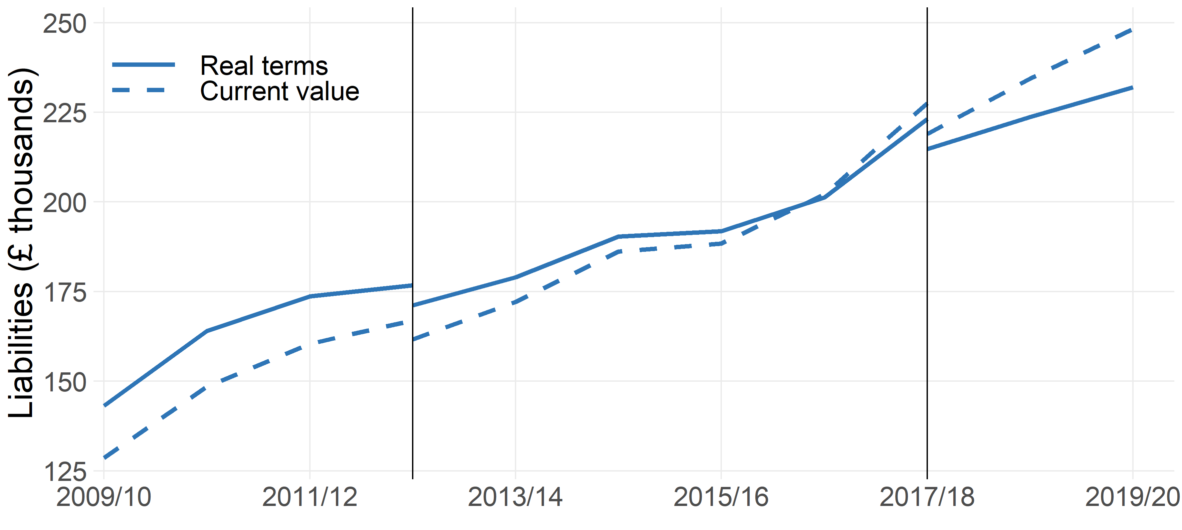
Farms shown have at least 25,000 euros of Standard Output.
- Deflated by GDP.
Standard output coefficients were updated in 2012/13, and 2017/18 using 5 year averages centred on 2010 and 2013 respectively. Figures prior to 2012/13 were based on a 5 year average centred on 2007. Results for the two transition years have been calculated using old and new coefficients for comparability and are denoted by the vertical black lines.
Figure 1.2 The composition of liabilities (£ per farm) for the average farm, England 2019/20
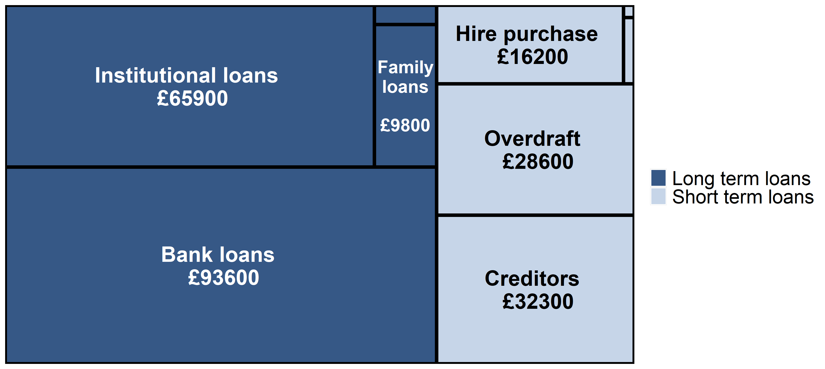
The size of the box for each category is proportional to its contribution to the overall average liability per farm. The ‘Other short term loans’, ‘Leasing’ categories (top right) and ‘Other loans’ category (middle top) are too small to be captioned in the plot, their contributions are £800, £100 and £1,300 per farm respectively.

For those farms in the top performance group, the average level of debt has increased considerably since 2012/13. For the lowest performing farms, the average level of debt has changed little in recent years (Figure 1.3). From 2009/10 to 2019/20, the gap in liabilities between the top performance group and the lowest performance group has widened from £50,000 to £230,000 respectively.
Figure 1.3 Average liabilities per farm, by farm economic performance band, England 2009/10 to 2019/20
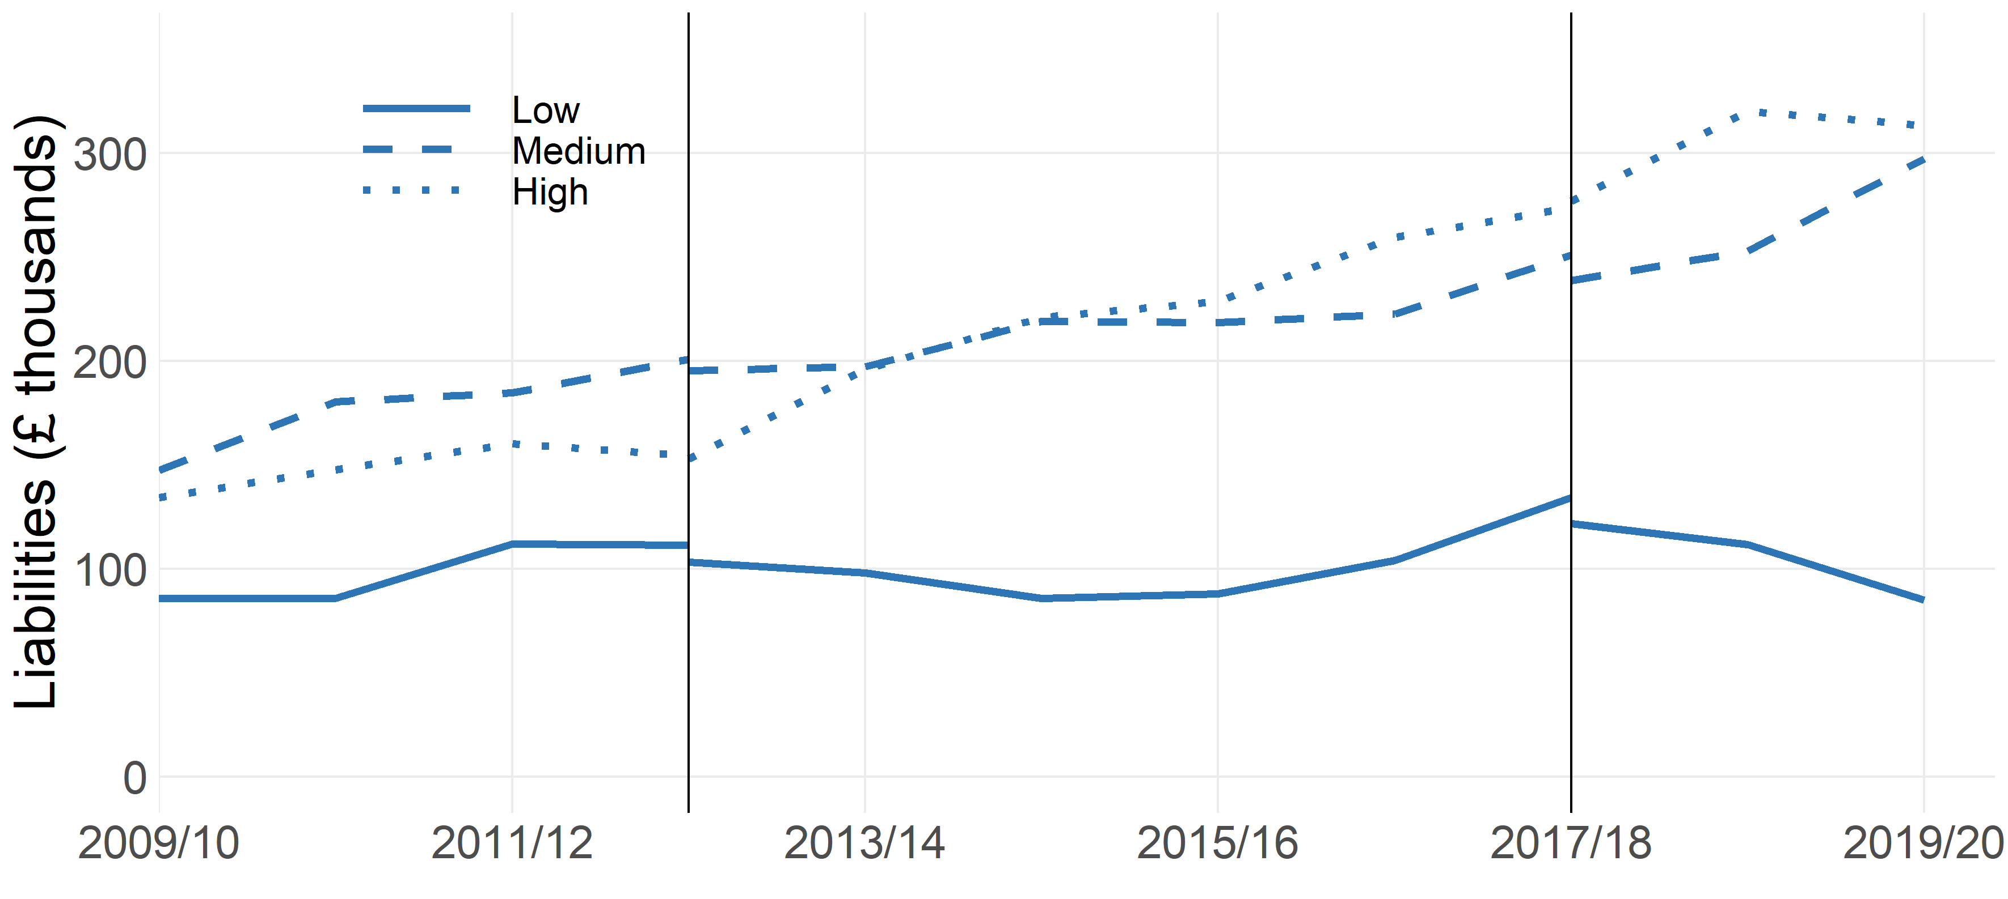Standard output coefficients were updated in 2012/13, and 2017/18 using 5 year averages centred on 2010 and 2013 respectively. Figures prior to 2012/13 were based on a 5 year average centred on 2007. Results for the two transition years have been calculated using old and new coefficients for comparability, and are denoted by the vertical blue lines.

In 2019/20 farm type, size, region, and tenancy type were found to be related to the level of debt.
Figure 1.4 shows the relationship between liabilities and farm type. The variation in average liability between farm types may be due to differences in the amount of capital investment required, or differences in farm profitability. The average level of debt was greatest for farms specialising in pigs and poultry (£563,200), dairy (£458,800), and general cropping (£345,400). Grazing livestock farms (LFA and lowland) had the lowest average liabilities at £103,700 and £99,100 respectively. After a large rise in average liabilities for pigs and poultry between 2017/18 and 2018/19, the value has changed little in 2019/20. However, there are large confidence intervals associated with this estimate, so any comparisons with this value should be treated with caution.
Figure 1.4 Average liabilities (£ thousands per farm) by farm type, England 2018/19 and 2019/20
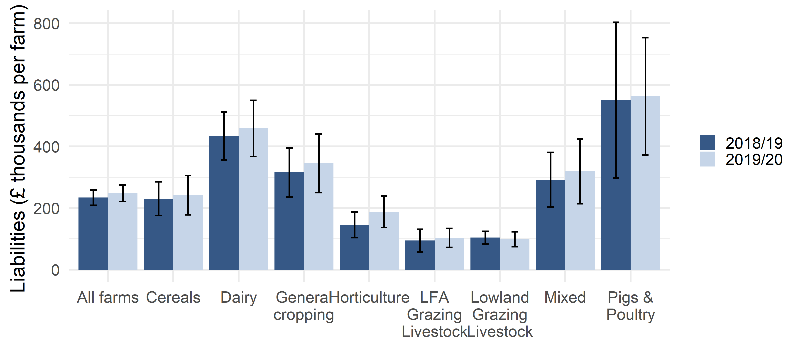Liability values are shown here with 95% confidence intervals. Pigs & poultry farms have notably larger confidence intervals, as the sample size is relatively small.

Figure 1.5 shows the distribution of liabilities for each farm type. Sixty-one percent of dairy and nearly half (47%) of pigs and poultry farms had liabilities of at least £150,000. Approximately one third of grazing livestock farms, and 42% of horticulture farms had liabilities of less than £10,000.
Figure 1.5 Distribution of liabilities (per farm) by farm type, England 2019/20
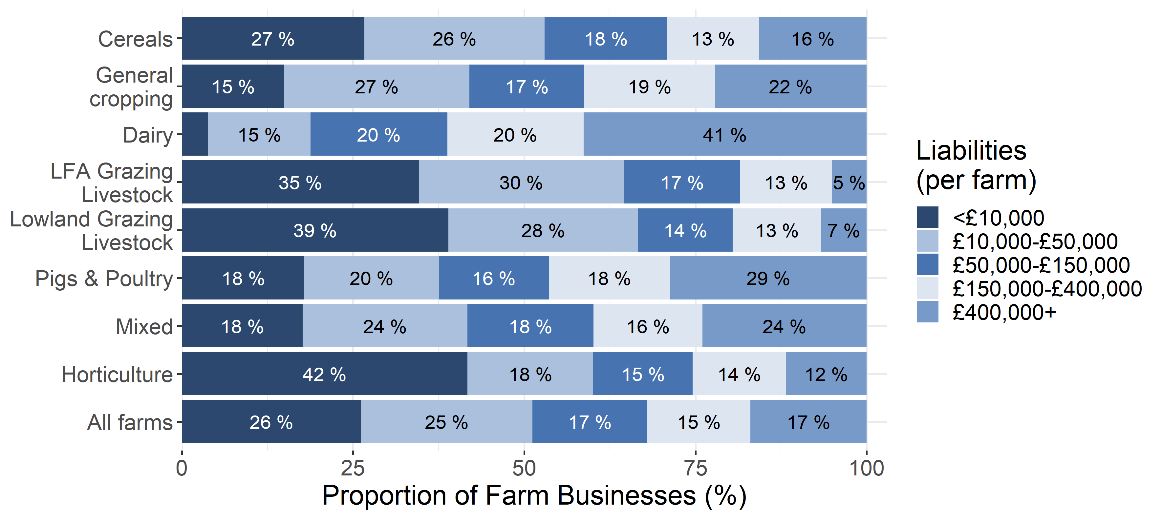Text is not displayed where proportions are below 5%.

The level of debt tends to increase with farm size (Figure 1.6), rising from an average of around £90,200 for spare and part-time farms, to £883,100 for very large farms. When the farms’ area is taken into account, there is a similar trend with very large farms still having the highest average liabilities per hectare (£2,332 per hectare) compared to small farms (£1,090 per hectare). Across all farms the average debt per hectare was £1,630. Forty-two percent of spare and part-time farms had liabilities under £10,000 compared to 4% of very large farms, with little change on 2018. Just over half (56%) of very large farms had at least £400,000 worth of debt.
Figure 1.6 Distribution of liabilities (per farm) by farm size, England 2019/20
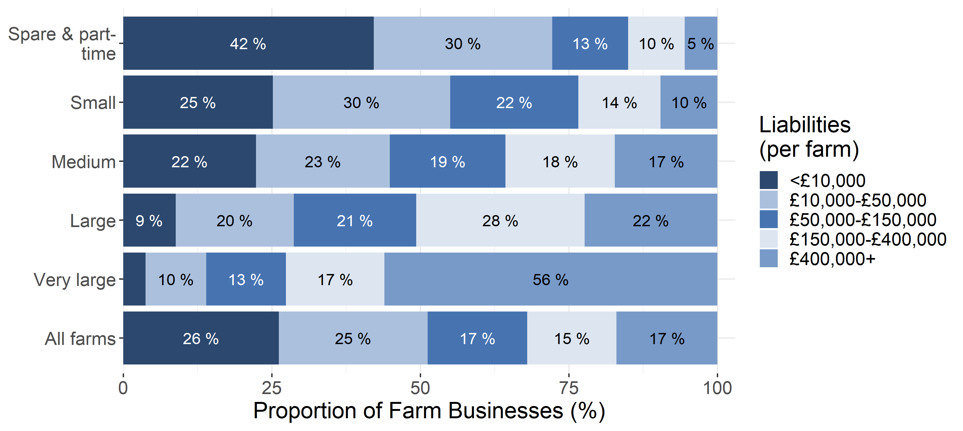
Text is not displayed where proportions are below 5%.

The average level of debt varied by region across England, even after allowing for farm type and size. In general, farms in the north had lower debt levels than those in the south; farms within the East of England had the highest average debt level of around £338,400, whilst farms in the South West had the lowest average level of debt (£185,300).

2. Net worth
This section examines the net worth of farm businesses in England. Net worth represents the wealth of a farm if all of their liabilities were called in. It is measured by subtracting the value of the total liabilities from total assets, including tenant type capital and land. Those farms with a high net worth are more likely to be resilient to changes in their income in the short term, as they can draw on their reserves to support the business if the financial position of the farm deteriorates.
The average net worth across all farms in England was £1.87m in 2019/20 (Figure 2.1). There has been a general increase in both current values and real terms since 2009/10 (Figure 2.2), driven mostly by an increase in the value of land and other assets, though since 2017/18 the real terms value has stagnated. More than a third (39%) of farms had a net worth of at least £1.5 million in 2019/20.
Figure 2.1 Net worth calculation, England 2019/20
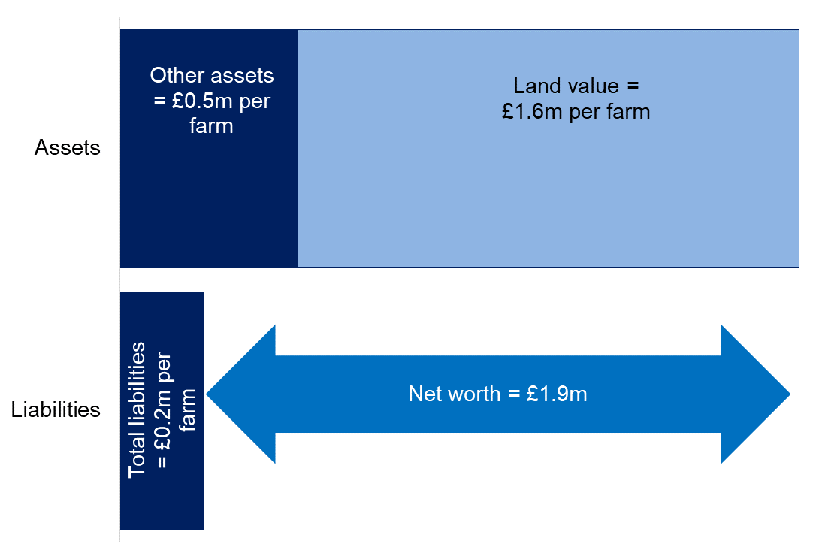

Figure 2.2 Average net worth per farm in current values and real terms (2019/20 prices)(a), England 2009/10 to 2019/20.
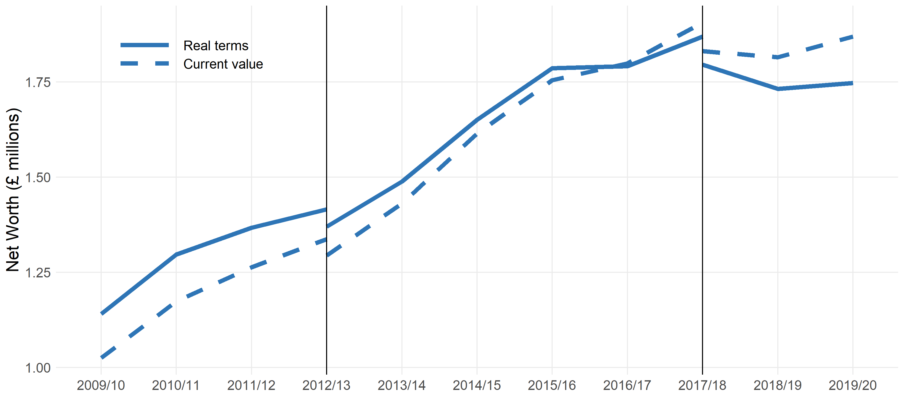
(a) Real terms figures have been deflated by GDP.
Farms with at least 25,000 euros of Standard Output.
Standard output coefficients were updated in 2012/13, and 2017/18 using 5 year averages centred on 2010 and 2013 respectively. Figures prior to 2012/13 were based on a 5 year average centred on 2007. Results for the two transition years have been calculated using old and new coefficients for comparability, and are denoted by the vertical blue lines.

Those farms with lower net worth (less than £0.5 million), were more likely to be medium, small and spare and part-time rather than larger farms. They were also more likely to be pigs and poultry or horticulture farms and/or wholly tenanted farms than other tenancy options. Those farms with greater net worth (at least £1.5 million), were more likely to be large or very large farms; to be dairy, cereal or general cropping farms rather than other farm types; to be in the South East of England; to be mixed -mainly owner occupied rather than tenanted, or to be economically high performance farms.
Farms with greater land ownership tend to have a greater net worth. Farms that are of mixed tenure but mainly owner occupied had the greatest average net worth of £2.78 million, whilst wholly tenanted farms had an average net worth of £302,000. Average net worth has grown for each of tenure type since 2009/10 (Figure 2.3), though fully tenanted farms have grown by a smaller proportion. This relationship of tenancy type demonstrates the important contribution of land value to net worth.
Figure 2.3 Average net worth by farm tenure, England 2009/10 to 2019/20
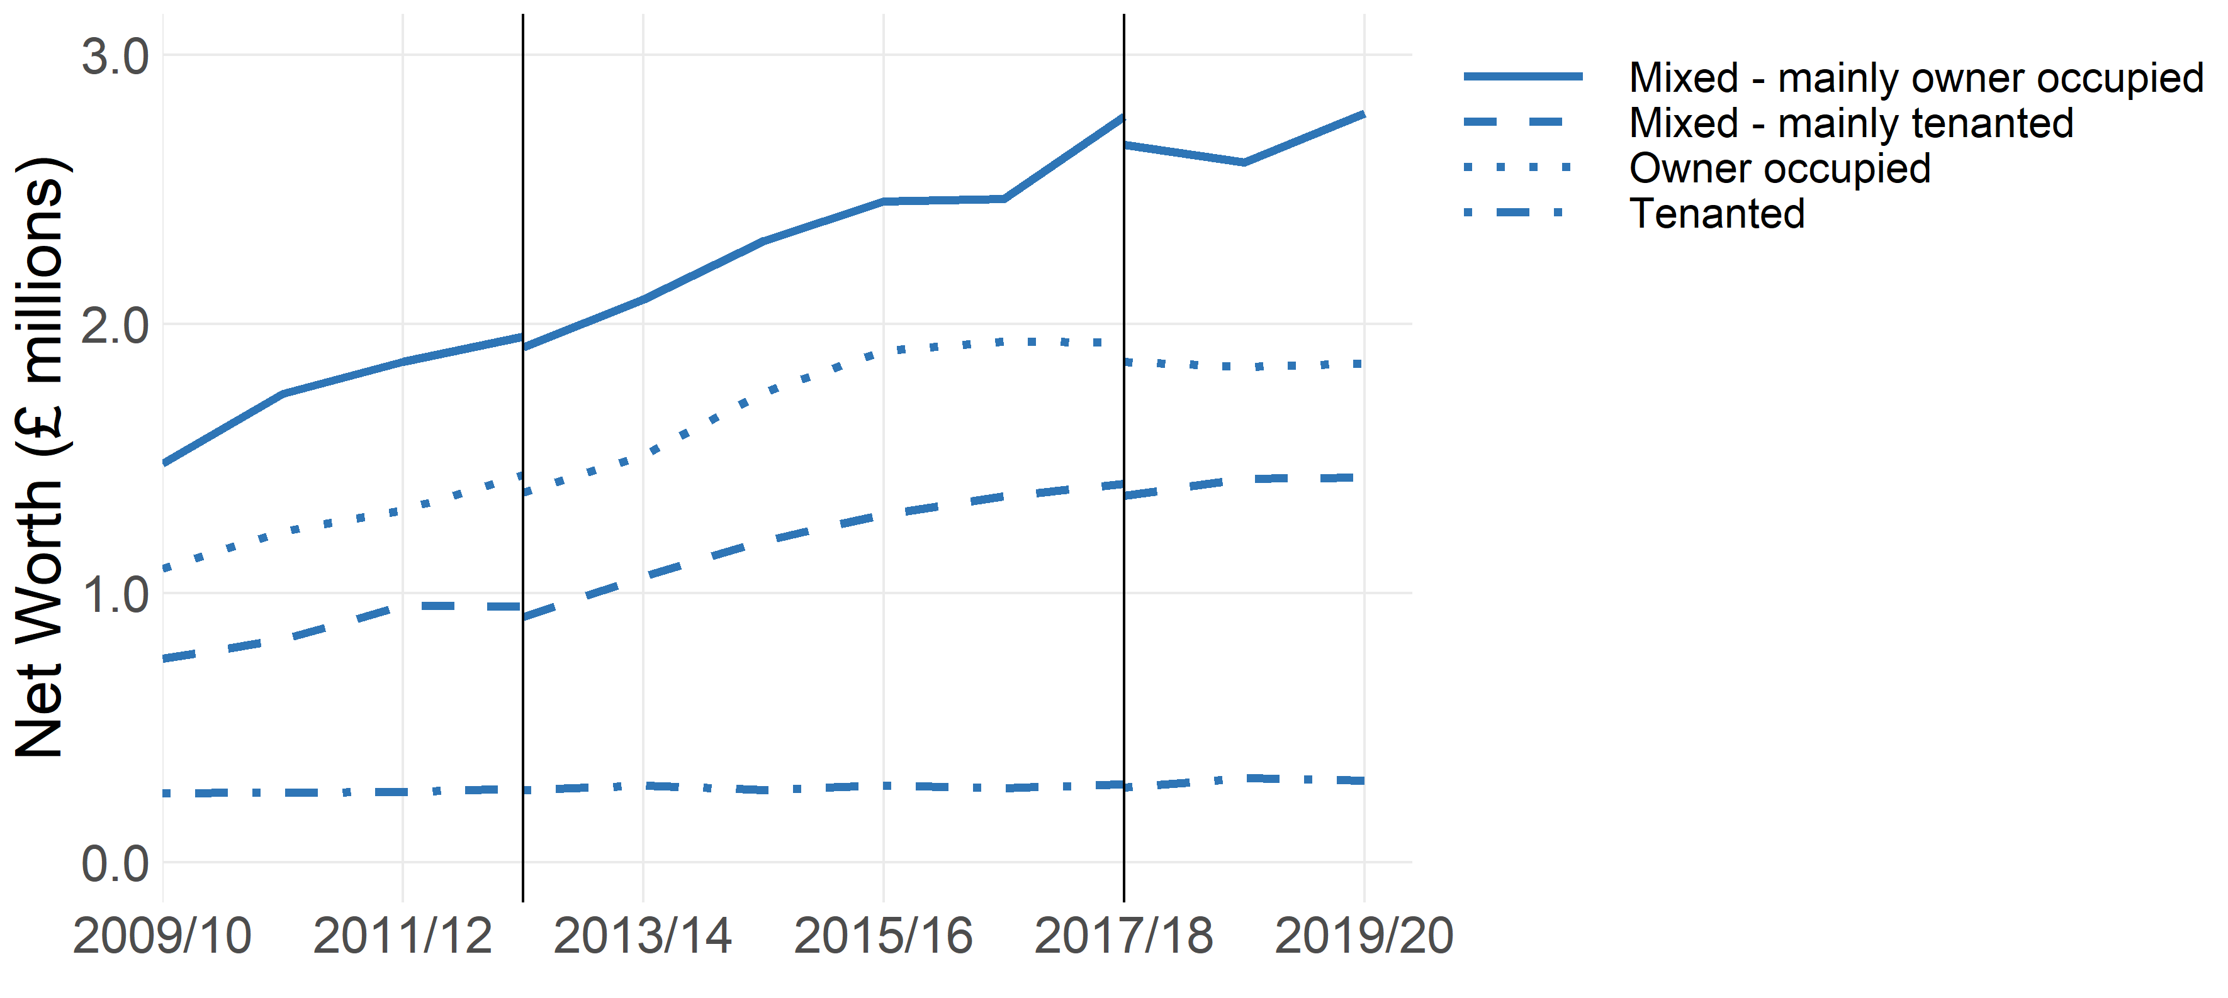

Standard output coefficients were updated in 2012/13, and 2017/18 using 5 year averages centred on 2010 and 2013 respectively. Figures prior to 2012/13 were based on a 5 year average centred on 2007. Results for the two transition years have been calculated using old and new coefficients for comparability, and are denoted by the vertical blue lines.
As in previous years, cereal and general cropping farms had the highest average net worth, at £2.82 million and £2.81 million respectively, with the larger average area of land owned by these types of farms likely to be the main driver. Horticulture farms had the lowest average net worth, at £0.81 million. There are differences in the distribution of net worth between farm types (Figure 2.4); over half of cereal (61%), general cropping (53%) and dairy (54%) farms had an average net worth of at least £1.5 million compared to 11% of LFA grazing livestock and 14% of horticulture farms. On a per hectare basis, horticulture and pigs and poultry had greater average net worth compared to other farm types, at around £35,500 and £19,100 per hectare respectively. LFA grazing livestock farms had the lowest average net worth per hectare at £5,100.
Figure 2.4 Distribution of net worth by farm type, England 2019/20
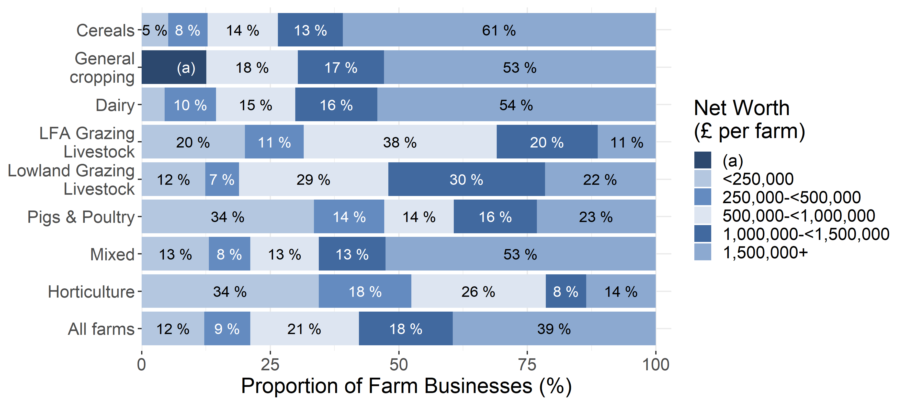

Text is not displayed where proportions are below 5%. For General cropping farms there were an insufficient number of observations in the two lowest bands. These are denoted (a).

As with liabilities, the average net worth of farms increases with farm size (Figure 2.5); from £1.20 million for spare and part-time farms, to £4.3 million for very large farms. The proportion of farms with a net worth of over £1.5 million increases with the size of the farm business, from 29% of spare and part-time farms to 68% of very large farms (Figure 2.6). However, this relationship between net worth and farm size does not hold on a per hectare basis. Spare and part-time farms have an average net worth of £19,300 per hectare compared to £11,600 for very large farms.
Net worth varied between regions. Farms in the East of England had the highest average net worth at £2.9 million, an increase from £2.5 million in 2018/19. In contrast, those in the North West had the lowest average net worth at £1.1 million, the same figure as 2018/19. More than half of farms in the South East (54%) had a net worth of over £1.5 million, compared to just under a quarter (23%) of farms in the North West.

Figure 2.5 Total average net worth by farm size (£ millions per farm), England 2019/20

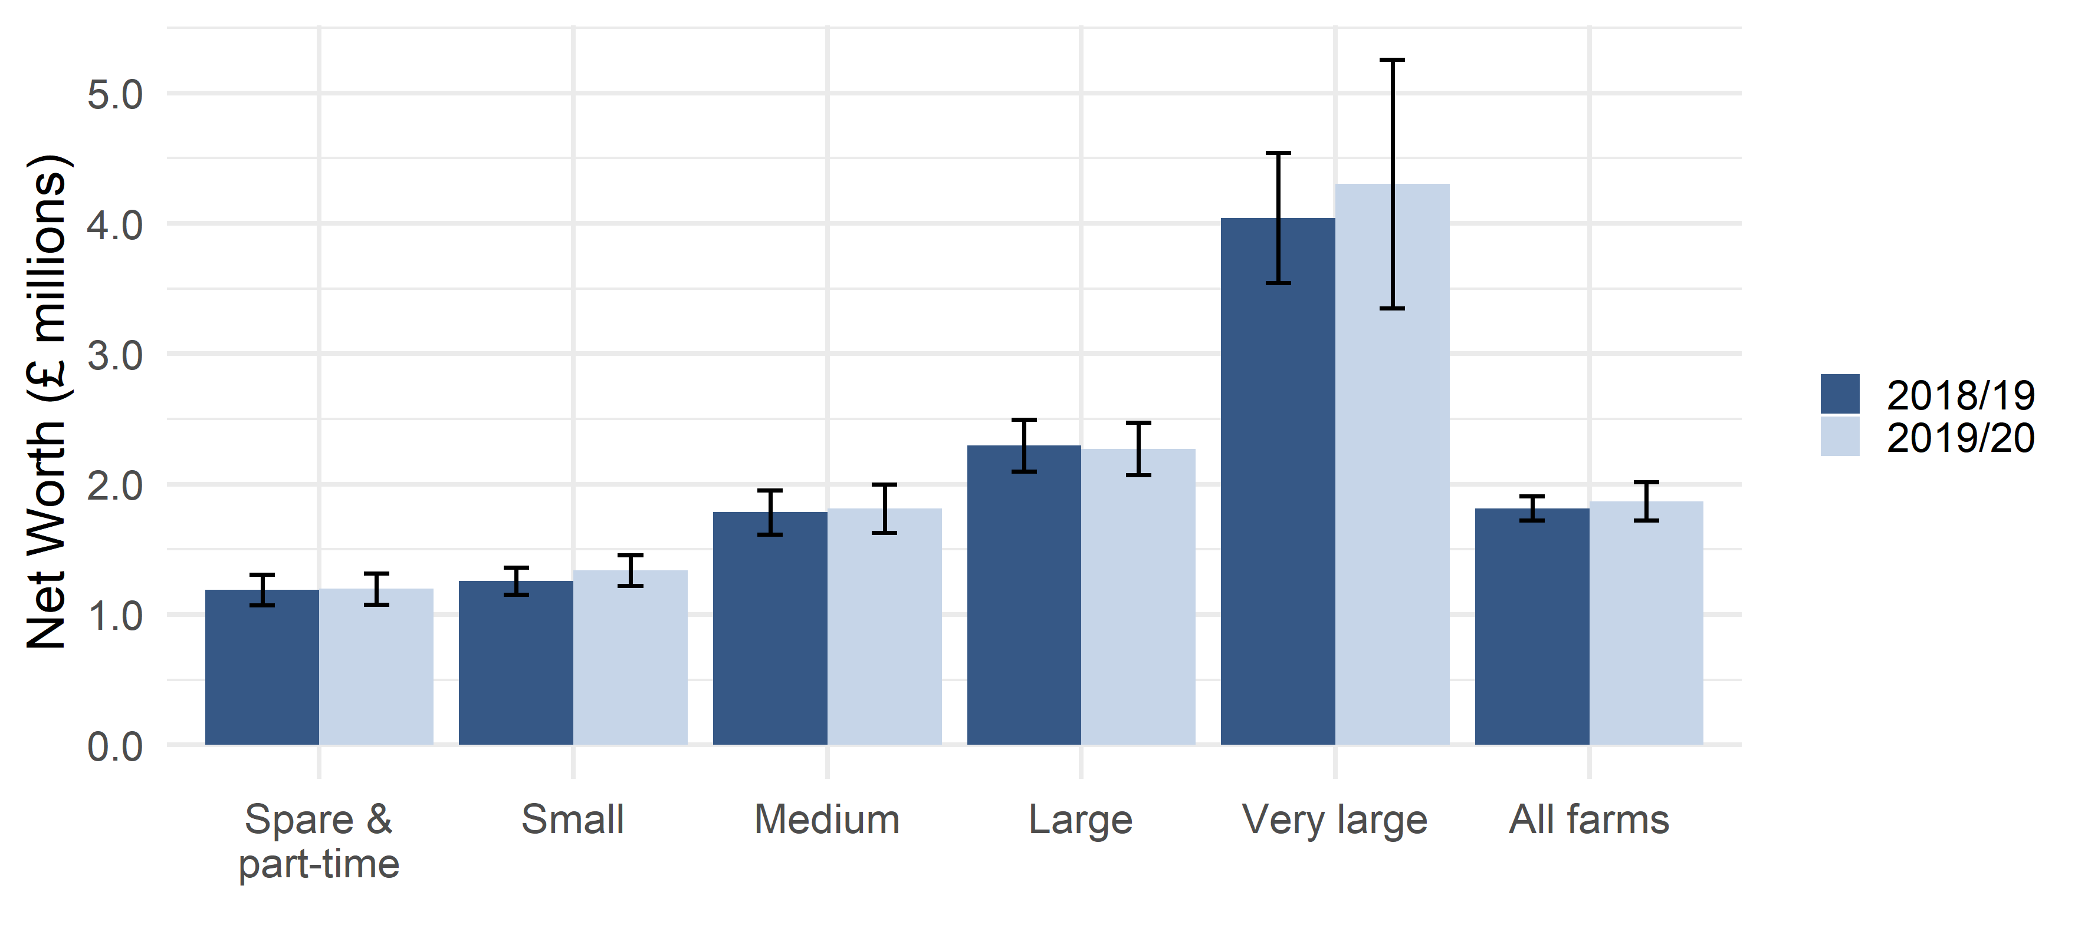
Liability values are shown here with 95% confidence intervals. Pigs & poultry farms have notably larger confidence intervals, as the sample size is relatively small.

Figure 2.6 Distribution of net worth by farm size, England 2019/20
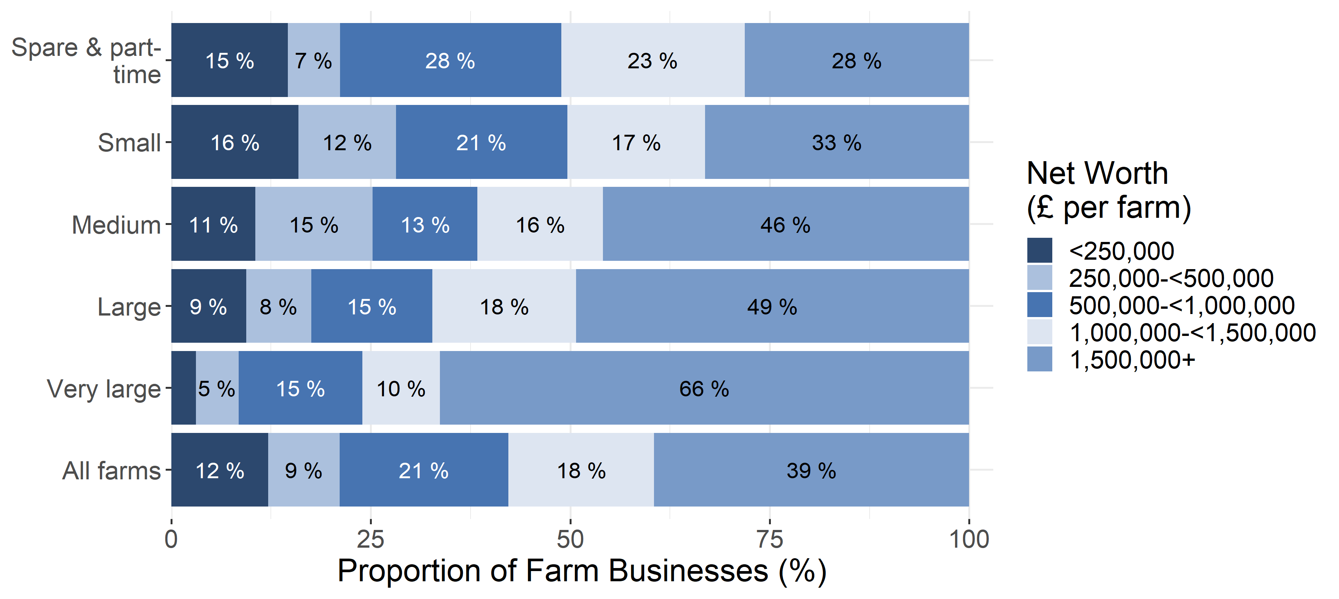

Text is not displayed where proportions are below 5%.

3. Gearing ratio
In order to get a deeper understanding of the indebtedness of a farm we can compare what the farm business owes (its liabilities) with the assets that the owners have tied up in the business. We use an accounting measure which expresses a farm’s liabilities as a proportion of its assets, sometimes referred to as the gearing ratio.
If a farm has assets equal to its liabilities, this will give a gearing ratio value of 100%, and if their assets are twice as large as its liabilities, the gearing ratio will be 50%. This provides a measure of the long term financial viability of a farm. A lower ratio is generally seen as more acceptable because this suggests that the farm business is more likely to be able to meet its investment needs from earnings. A higher ratio may be seen as a greater risk as interest costs will be higher and the farm will have lower funds to borrow against. However, being highly geared does not necessarily imply an unsuccessful business. Investment can increase profitability, so increasing the gearing ratio can lead to better performance.
Figure 3.1 Gearing ratio calculation, England 2019/20

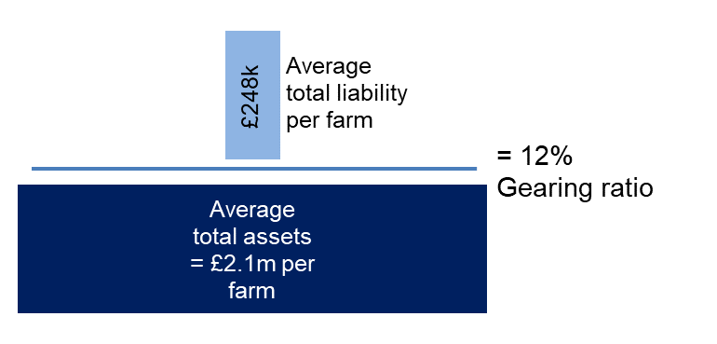

The average gearing ratio of farm businesses in England was 12% in 2019/20, changing very little since 2009/10 (Figure 3.2). Only a small number of farms (8%) had a gearing ratio over 40%. This indicates that the majority of farms are in a favourable situation for this measure, which is a situation unchanged on 2018/19.

Figure 3.2 Average gearing ratio (%) per farm, England 2009/10 to 2019/20
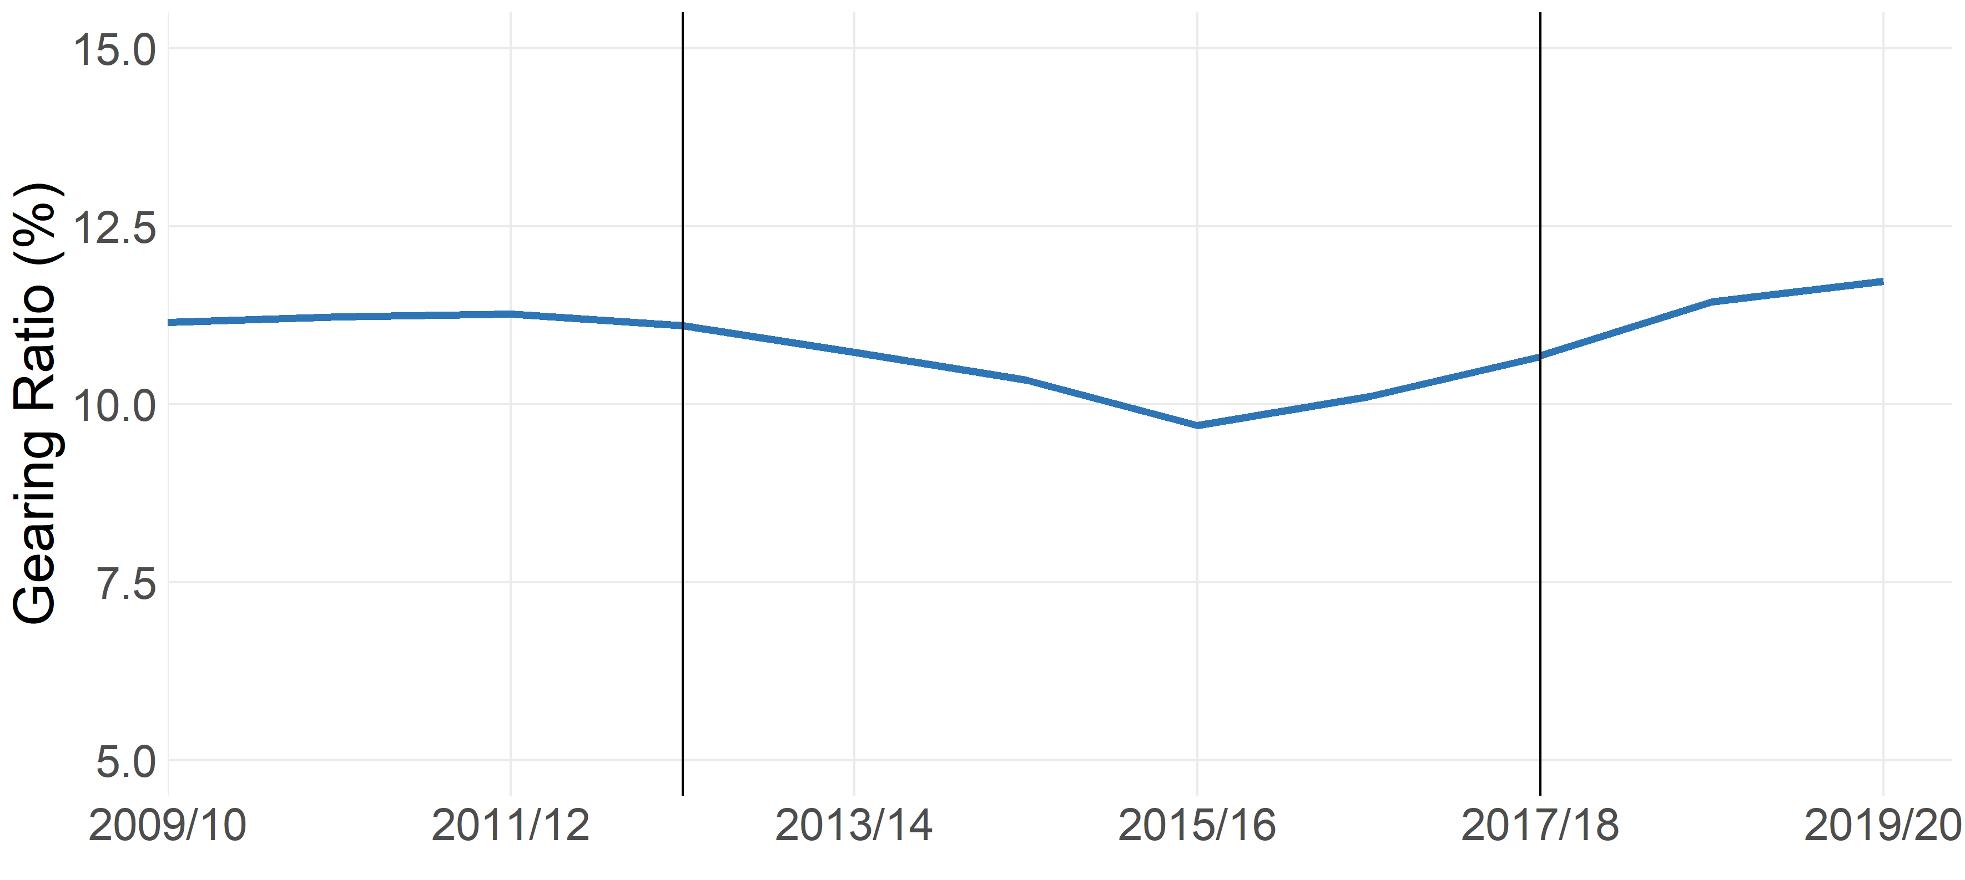
Farms with at least 25,000 euros of Standard Output.
Standard output coefficients were updated in 2012/13, and 2017/18 using 5 year averages centred on 2010 and 2013 respectively. Figures prior to 2012/13 were based on a 5 year average centred on 2007. Results for the two transition years have been calculated using old and new coefficients for comparability, and are denoted by the vertical blue lines.

Farm type, size, and tenure were found to be related to the gearing ratio.
Pig and poultry farms continued to have the highest average gearing ratio (32%) in 2019/20, with 22% having a gearing ratio that exceeded 40% (Figure 3.3). Cereals, grazing livestock (LFA and lowland) and general cropping farms all had lower average gearing ratios, each at or below 11%.The average gearing ratio increased with farm size, from 7% for spare and part-time farms to 17% for very large farms (Figure 3.4), both of which were unchanged on 2018/19.

Figure 3.3 Distribution of Gearing Ratio by farm type, England 2019/20
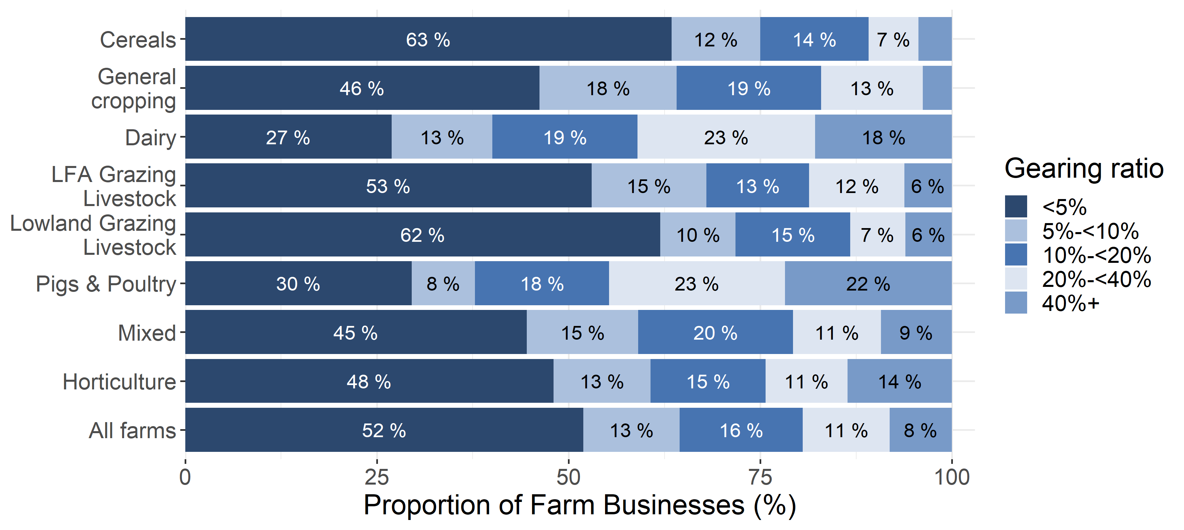
Text is not displayed where proportions are below 5%.

Figure 3.4 Distribution of Gearing Ratio by farm size, England 2019/20
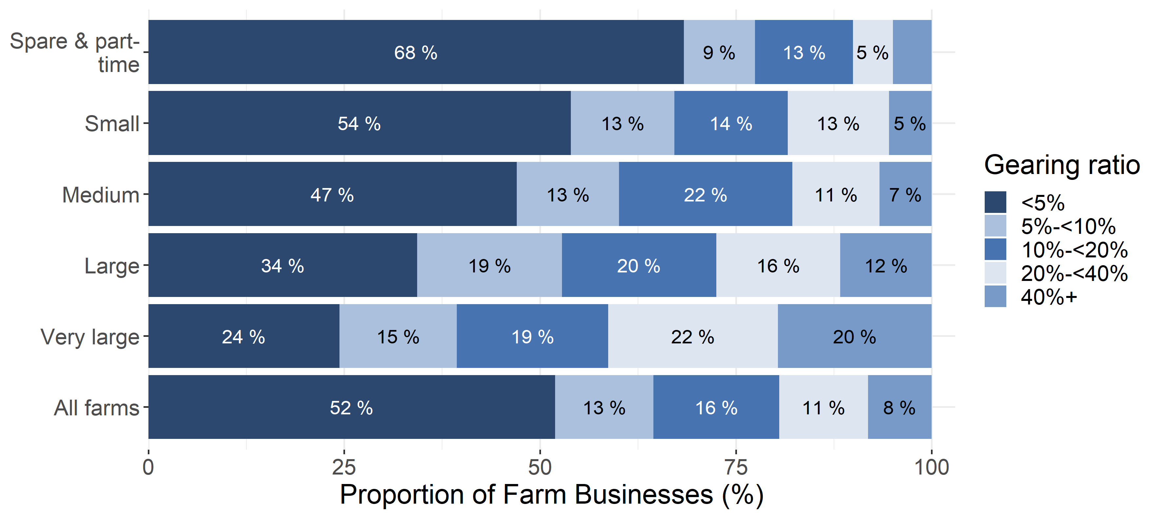
Text is not displayed where proportions are below 5%.

The gearing ratio tends to reduce with the level of land ownership. Tenanted farms had an average gearing ratio of 25% whilst owner occupied farms had an average gearing ratio of 8%. Just 4% of owner occupied and 6% of mixed – mainly owner occupied farms had a gearing ratio of 40% or more, compared to around a fifth (17%) of tenanted farms (Figure 3.5). These findings highlight the importance of the value of land in contributing to owner occupied and mixed tenure farms’ asset base.
Figure 3.5 Distribution of Gearing Ratio by farm tenure, England 2019/20
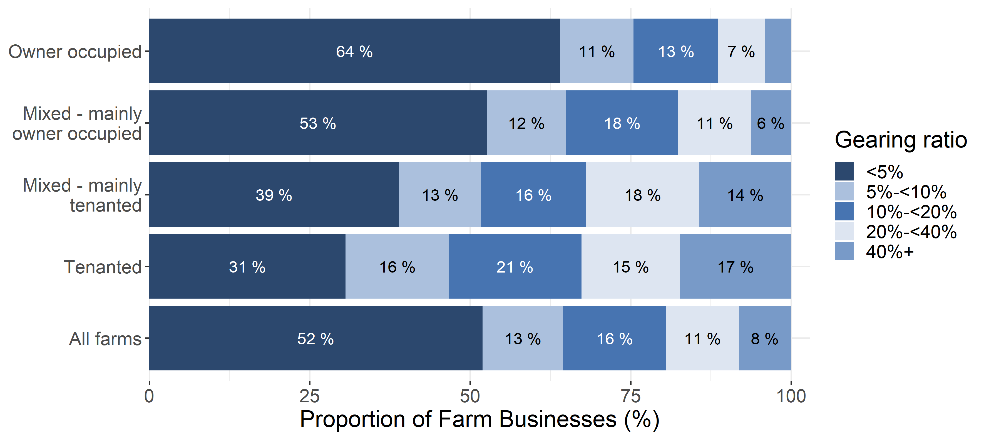
Text is not displayed where proportions are below 5%.

Those farms with lower liabilities also tended to have a lower gearing ratio (Table 3.1). Almost all (97%) of those farms with less than £10,000 liabilities, had a gearing ratio of less than 5% which indicates that these farms are in a favourable situation as they have a very small amount of liabilities compared to assets. However, of those farms with at least £400,000 of liabilities, a third (33%) had a gearing ratio of over 40%. By itself, as previously mentioned, a high gearing ratio is not necessarily a marker of a less successful business.
Table 3.1 Proportion of farms by Gearing ratio and liabilities (£ thousands), England 2019/20
Gearing Ratio | <£10 | £10-<£50 | £50-<£150 | £150-<£400 | £400+
<5% | 97% | 75% | 38% | 7% | 1%
5%-<10% | 3% (a) | 16% | 24% | 20% | 8%
10%-<20% | 3% (a) | 6% | 22% | 41% | 26%
20%-<40% | 3% (a) | 3% (b) | 11% | 22% | 32%
40%+ | 3% (a) | 3% (b) | 6% | 10% | 33%
All farms | 100% | 100% | 100% | 100% | 100%
Some data have been grouped due to insufficient observations. The two groups are denoted (a) and (b).

Those farms with higher net worth also tended to have a lower gearing ratio (Table 3.2). Of those farms with a net worth of under £250,000, 27% had a gearing ratio of over 40%, compared to 2% of farms with a net worth of over £1.5 million. Similarly, almost a third (32%) of farms with a net worth of under £250,000 had a gearing ratio of under 5%, compared to over half (55%) of farms with a net worth of at least £1.5 million.
Table 3.2 Proportion of farms by Gearing ratio and net worth (£ thousands), England 2019/20
Gearing Ratio | <£250 | £250-<£500 | £500-<£1000 | £1000-<£1500 | £1500+
<5% | 32% | 40% | 54% | 60% | 55%
5%-<10% | 13% | 13% | 12% | 12% | 13%
10%-<20% | 13% | 17% | 14% | 12% | 20%
20%-<40% | 14% | 12% | 12% | 12% | 9%
40%+ | 27% | 17% | 8% | 4% | 2%
All farms | 100% | 100% | 100% | 100% | 100%

4. Liquidity ratio
‘Liquidity’ is a measure of the short term financial viability of farms. A large proportion of the assets of a farm, such as land or machinery, will typically have a monetary value that is difficult or costly to realise in the short term. The liquidity ratio provides an indication of the ability of a farm to finance its immediate financial demands from its current assets (i.e. those which can be realised easily, excluding land or machinery), such as cash, savings or stock (Figure 4.1).
If the liquidity ratio is equal to or above 100%, then a farm is able to meet its current liabilities using current assets. If the ratio is less than 100%, then a farm is unable to meet its immediate financial demands using current assets.
Figure 4.1 Liquidity ratio calculation, England 2019/20
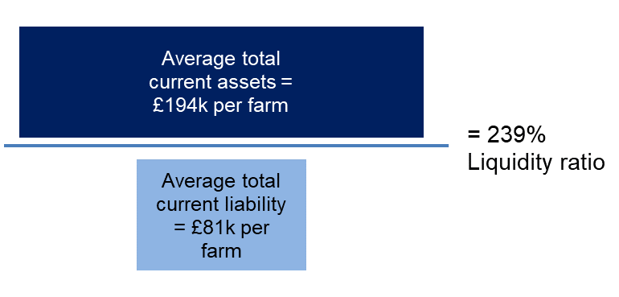

The average liquidity ratio of farm businesses in England has increased from 222% in 2018/19 to 239% in 2019/20. Since 2009 there have been fluctuations in this statistic, but no overall upward or downward trend (Figure 4.2). The majority of farms continue to have a strong liquidity ratio; around two thirds (69%) had a ratio of at least 200%, suggesting that they could easily cover their immediate financial demands with their current assets.
Fewer than one in five farms (16%) had a liquidity ratio below 100% (Figure 4.3), the point at which current assets do not cover liabilities (debts). Dairy (34%) and pigs and poultry (26%) farm types are most likely to be in this situation, a repeat of 2018/19. Fifteen percent of low economic performance farms also have liquidity ratios below 100%, while just 9% of high economic performance farms do (Figure 4.5). This gap between low and high performance farms has narrowed since 2018/19, though 21% of medium performance farms now meet this criterion, exceeding the low performance farms.

Figure 4.2 Average liquidity ratio (%) per farm, England 2009/10 to 2019/20
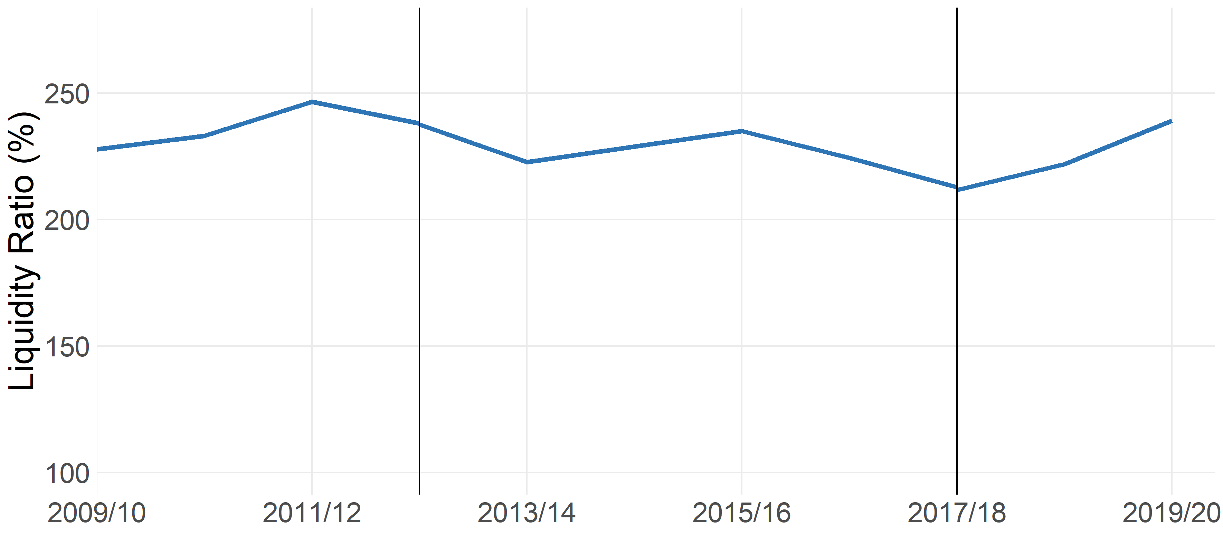
Farms with at least 25,000 euros of Standard Output
Standard output coefficients were updated in 2012/13, and 2017/18 using 5 year averages centred on 2010 and 2013 respectively. Figures prior to 2012/13 were based on a 5 year average centred on 2007. Results for the two transition years have been calculated using old and new coefficients for comparability, and are denoted by the vertical blue lines.
A small number of farms with no recorded current liabilities have been excluded from this analysis.

Grazing livestock farms (lowland) (331%) and cereals farms (313%) had the highest average liquidity ratios. This represents a substantial rise for cereals farms on 2018/19 (228%). Pigs and poultry farms again had the lowest average liquidity ratio at an unchanged 130%, followed by dairy farms which fell from 159% to 143%.
As with 2018/19, the liquidity ratio is not directly related to farm size. Instead, spare/part-time farms and medium farms have the highest average ratio of 331% and 330% respectively. Very large farms saw a smaller average ratio of 187%. Around 21% of large and 24% of very large farms had a liquidity ratio of less than 100%, compared to 12% of spare and part-time farms, or 15% of small farms (Figure 4.4).
Figure 4.3 Distribution of liquidity ratio by farm type, England 2019/20
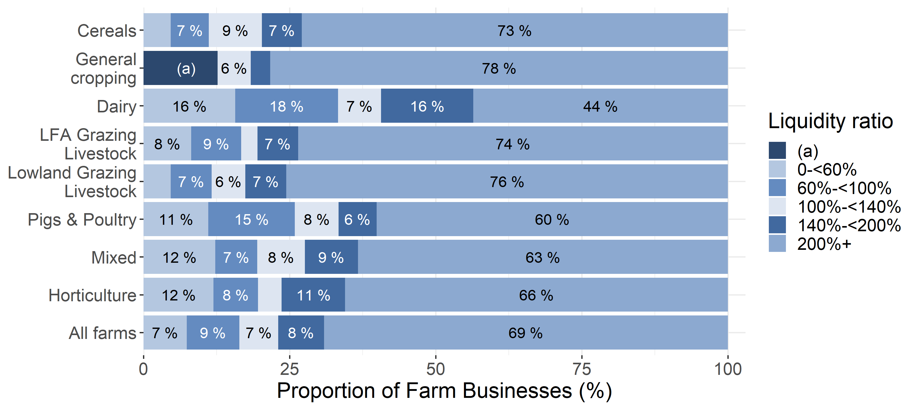
Text is not displayed where proportions are below 5%. For General cropping farms there were an insufficient number of observations in the two lowest bands. These are denoted (a). A small number of farms with no recorded current liabilities have been excluded from this analysis.

Figure 4.4 Distribution of liquidity ratio by farm size, England 2019/20
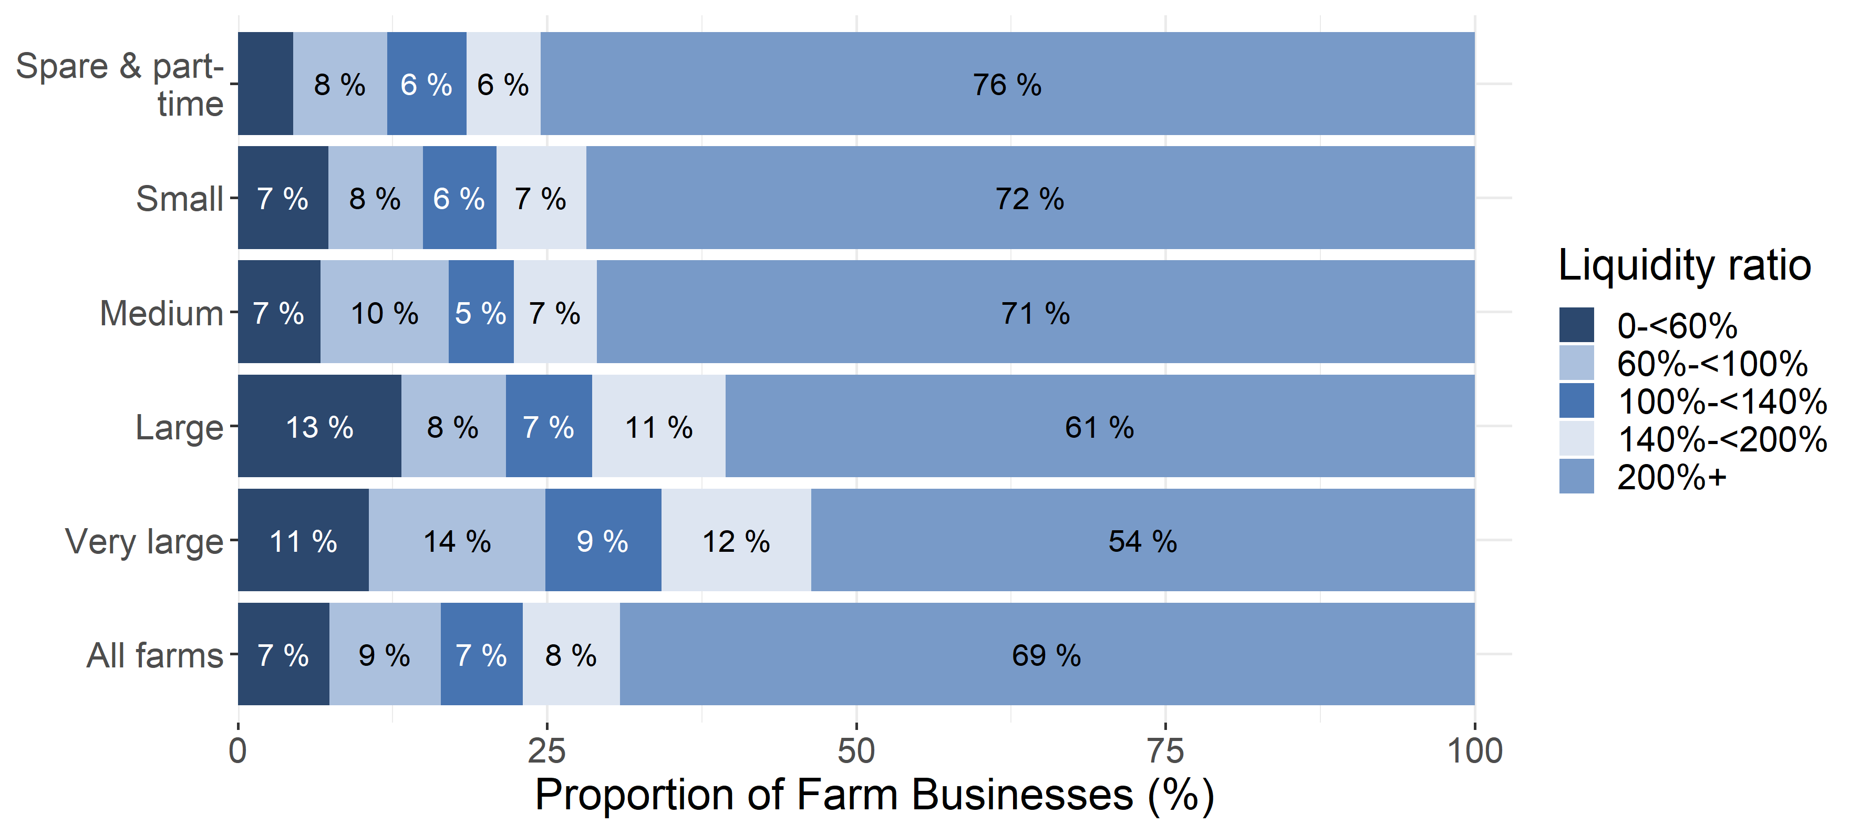

Text is not displayed where proportions are below 5%.
A small number of farms with no recorded current liabilities have been excluded from this analysis.

Those farms in the high economic performance band (top 25% of farms) had a higher average liquidity ratio (356%) compared to those in the low economic performance band (280%), a wider gap than 2018/19 but similar to 2017/18 and previous years. Perhaps more strikingly medium performance bands had the lowest average liquidity ratio (186%). As with 2018/19, the associated confidence intervals are relatively large, so caution should be taken over the interpretation of this change. Over three quarters (78%) of farms in the high economic performance band had a liquidity ratio of 200% or more (Figure 4.5).
Figure 4.5 Distribution of liquidity ratio by economic performance band, England 2019/20
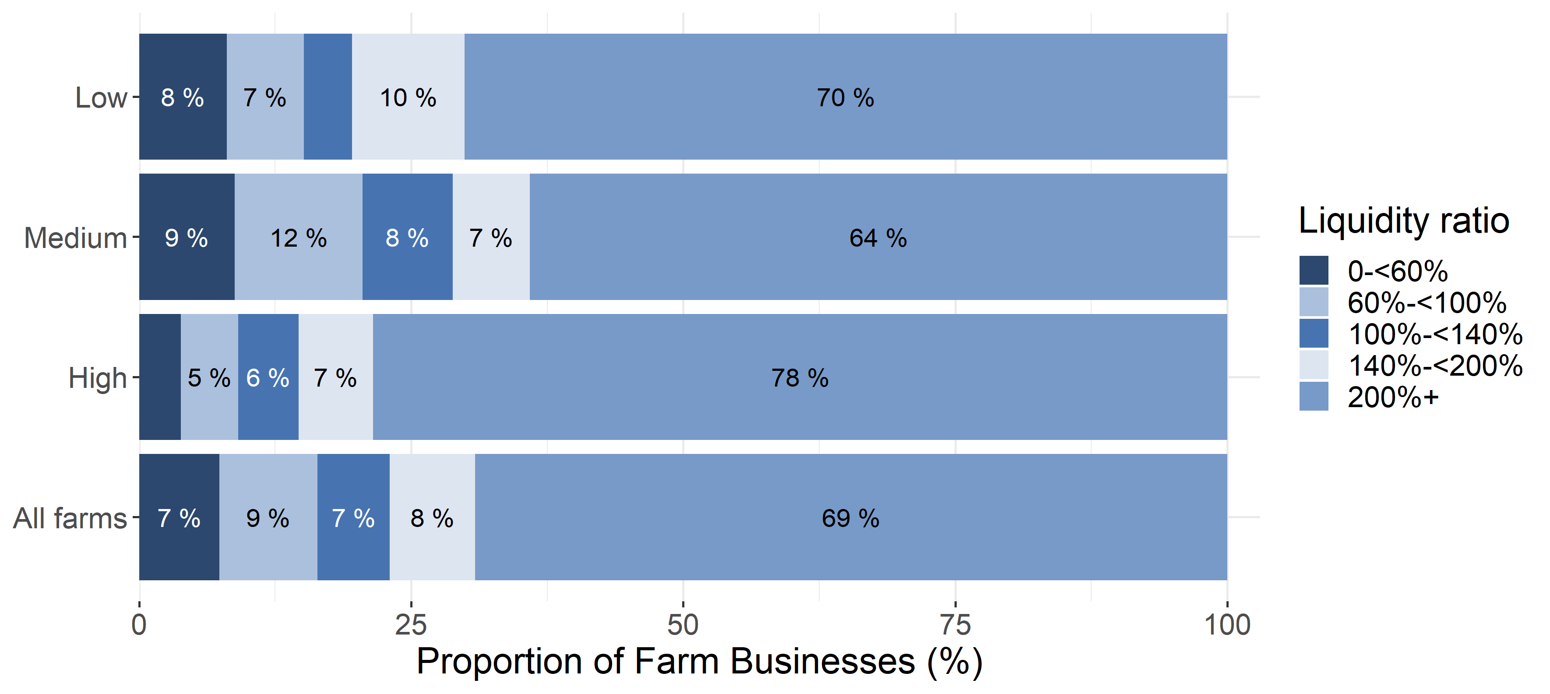

Text is not displayed where proportions are below 5%.
A small number of farms with no recorded current liabilities have been excluded from this analysis.

5. Net Interest payments as a proportion of Farm Business Income (FBI)
This section examines net interest payments as a proportion of FBI (Figure 5.1). This measure provides an indication of whether farms can afford to pay the interest on their debts.
Figure 5.1 Net interest as a proportion of FBI calculation, England 2019/20
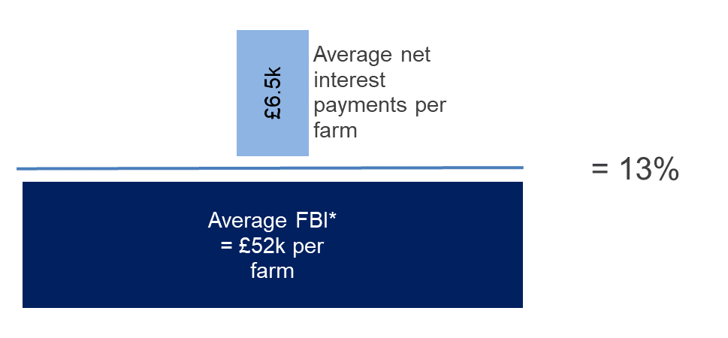
*For this measure FBI is calculated before deducting net interest payment.

Net interest payments were, on average, 13% of FBI in 2019/20. This proportion steadily increased from 2011/12 to 2015/16 as net interest payments increased whilst FBI fell (Figure 5.2). This pattern has been repeated since 2017/18.
Figure 5.2 Average net interest payments as a proportion of FBI, England 2009/20 to 2019/20
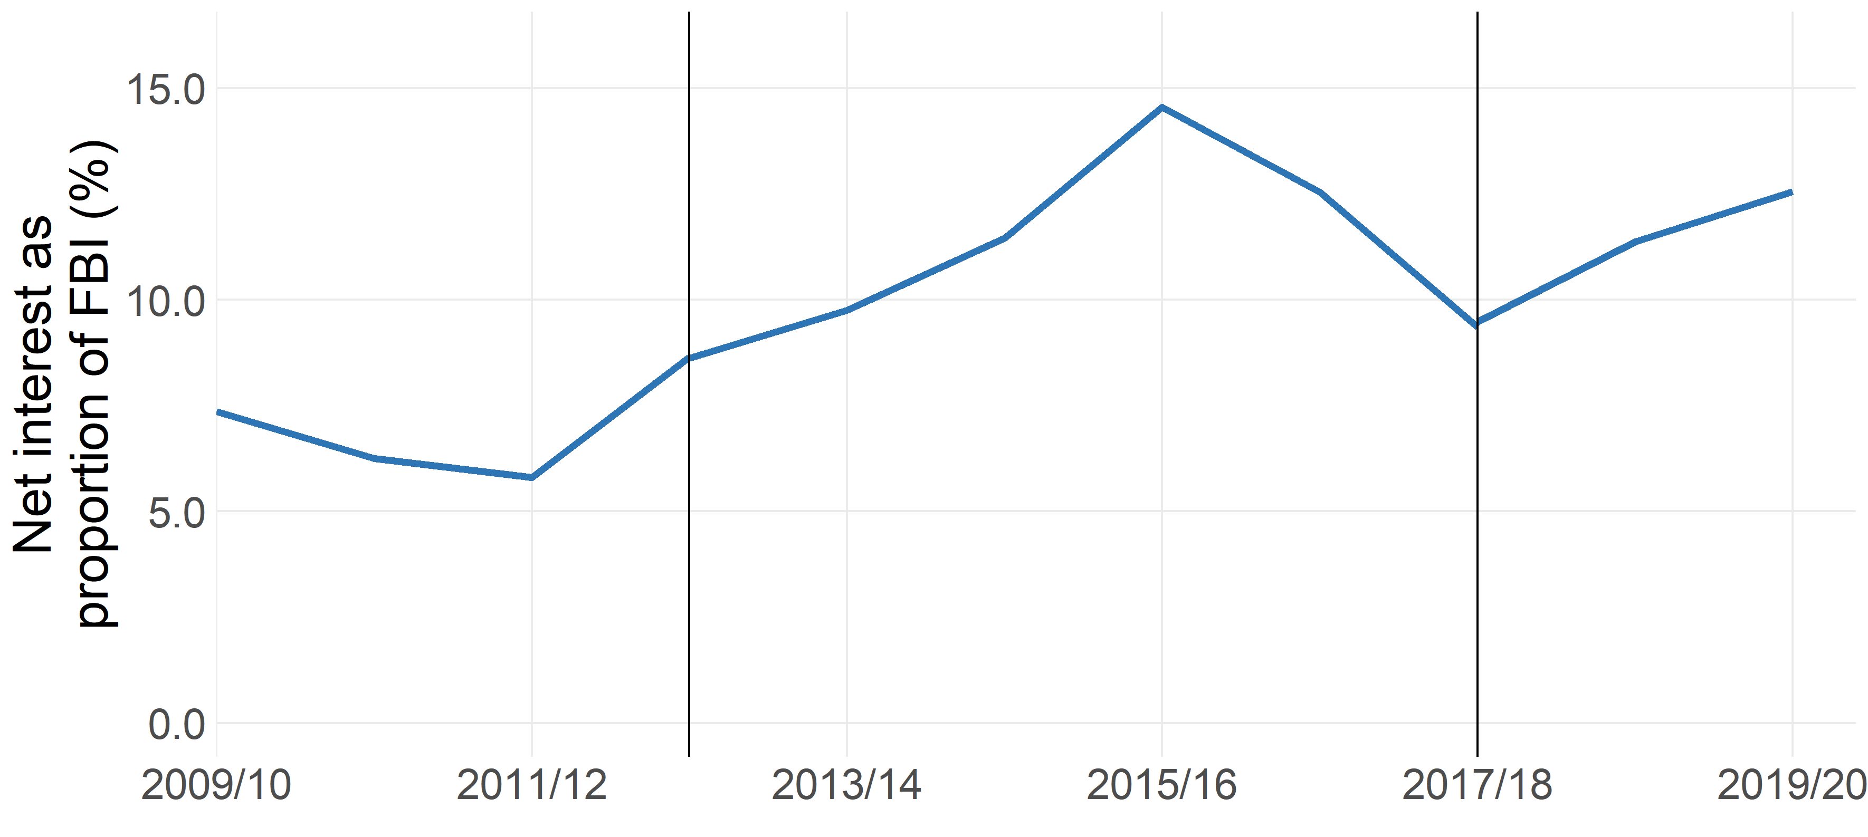
Farms with at least 25,000 euros of Standard Output.
Standard output coefficients were updated in 2012/13, and 2017/18 using 5 year averages centred on 2010 and 2013 respectively. Figures prior to 2012/13 were based on a 5 year average centred on 2007. Results for the two transition years have been calculated using old and new coefficients for comparability, and are denoted by the vertical blue lines.

In 2019/20 the farm types with the greatest net interest payments as a proportion of FBI were mixed farms (22%) and lowland grazing livestock (21%), and least for horticulture farms (7%). Average FBI has decreased in 2019/20 for a second year running, in particular for dairy and grazing livestock farms, which have seen further substantial falls in FBI since 2017/18. For more information on FBI please see Farm Accounts in England.
Thirty-four percent of farm businesses paid no interest (i.e. had no loans) or the interest received (i.e. on savings or investments) was greater than the interest paid on loans. Over half of horticulture farms were in this group, compared to just 16% of dairy farms (Figure 5.3). Around a quarter of pigs and poultry (23%) and nearly a third of dairy farms and mixed farms (28% and 29% respectively) paid net interest equivalent to 20% or more of their FBI, compared to just 9% of horticulture farms (Figure 5.3).

Figure 5.3 Distribution of net interest payments as a proportion of FBI by farm type, England 2019/20
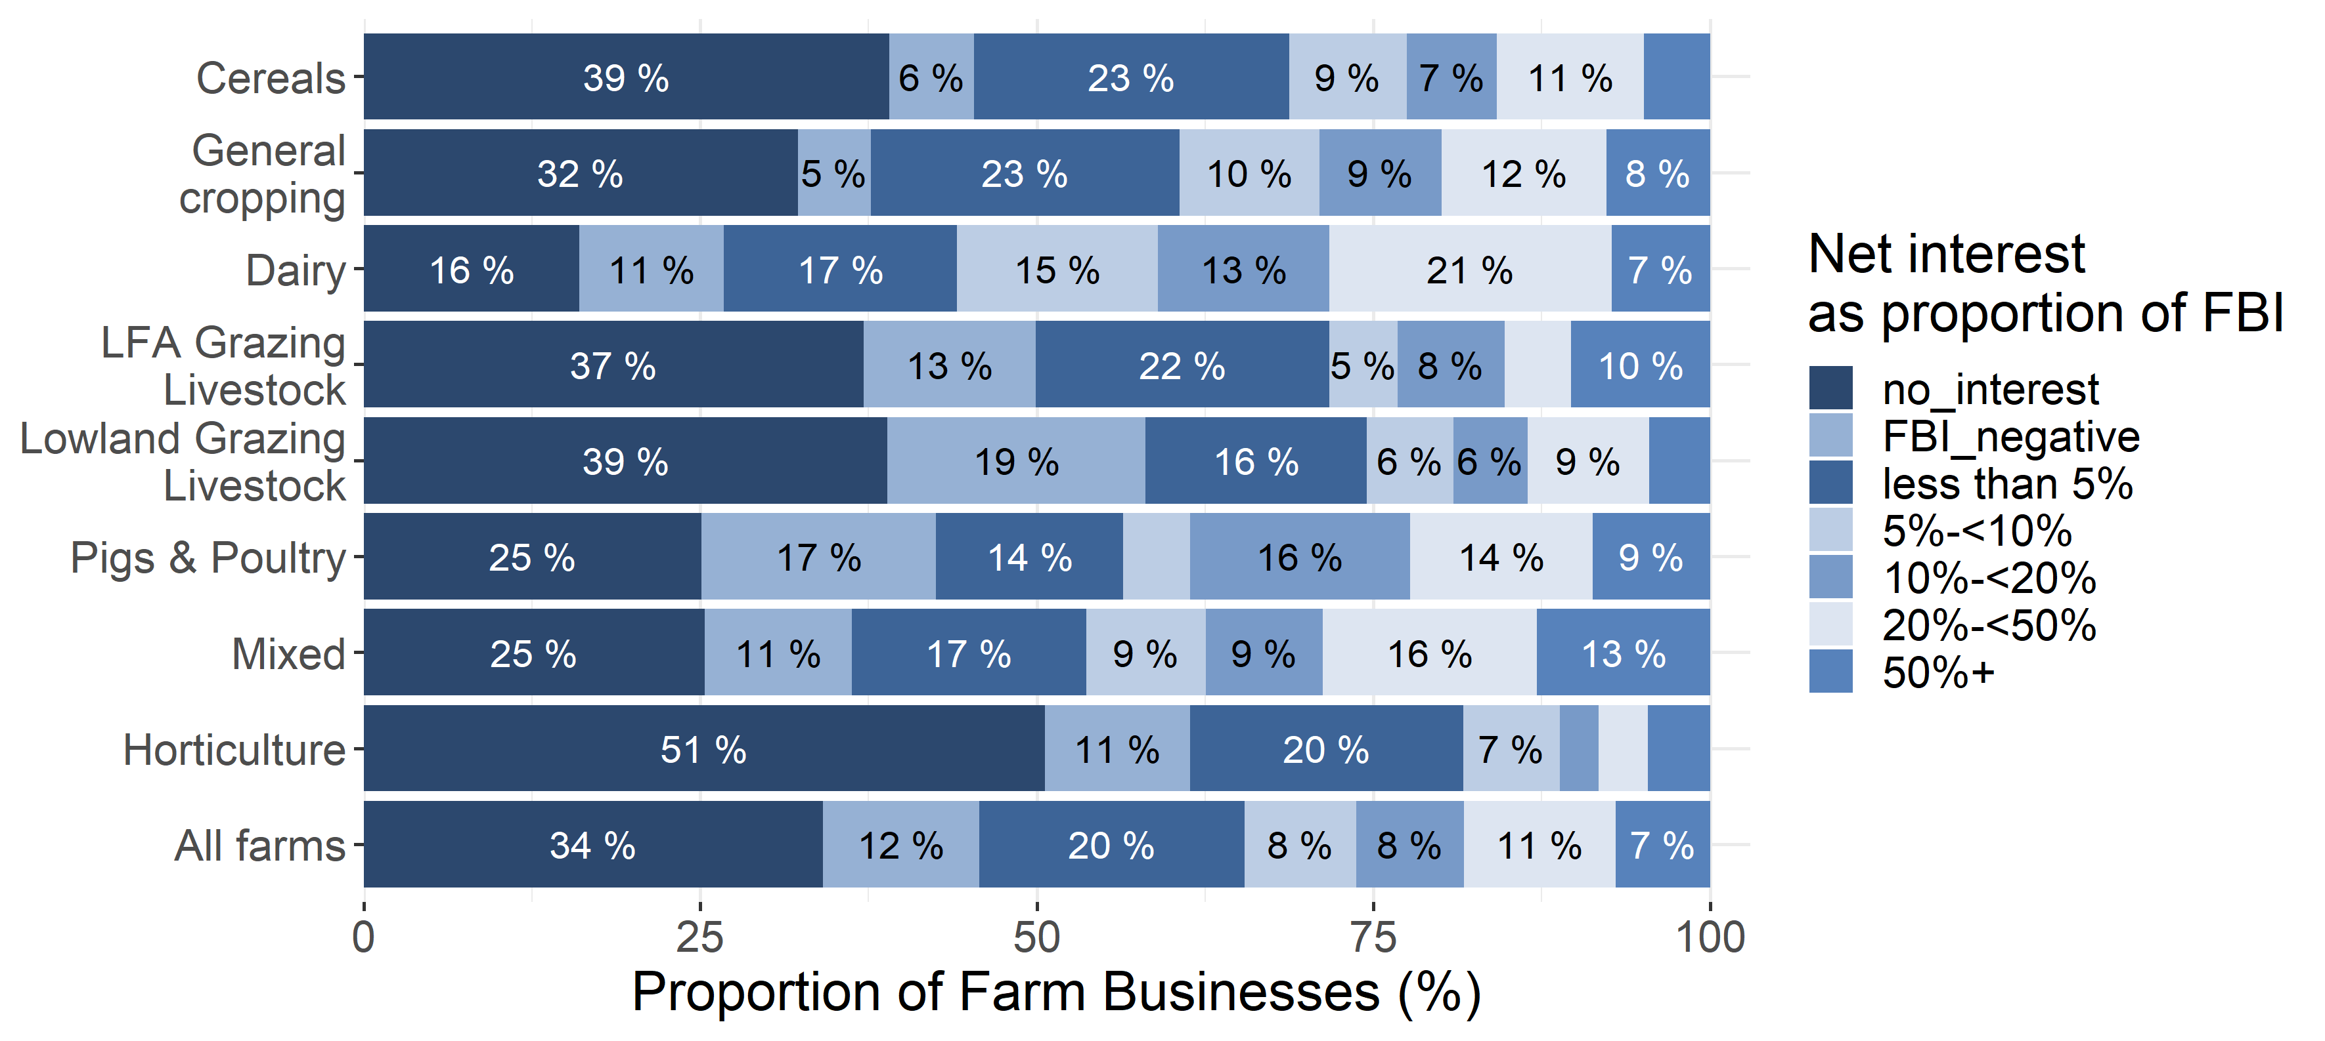
Text is not displayed where proportions are below 5%.
The negative FBI group includes farms for which FBI was negative before paying interest payments but excludes farms paying no interest or net recipients of interest.

A larger proportion of smaller farms had interest received or paid no interest as a proportion of FBI than larger farms; 44% of spare and part-time farms had net interest payments equivalent to 5% or less of their FBI, compared to 16% of very large farms. The proportion of farms who paid net interest equivalent to 20% or more of their FBI was about 18% for all farm sizes (Figure 5.4).
Figure 5.4 Distribution of net interest payments as a proportion of FBI by farm size, England 2019/20
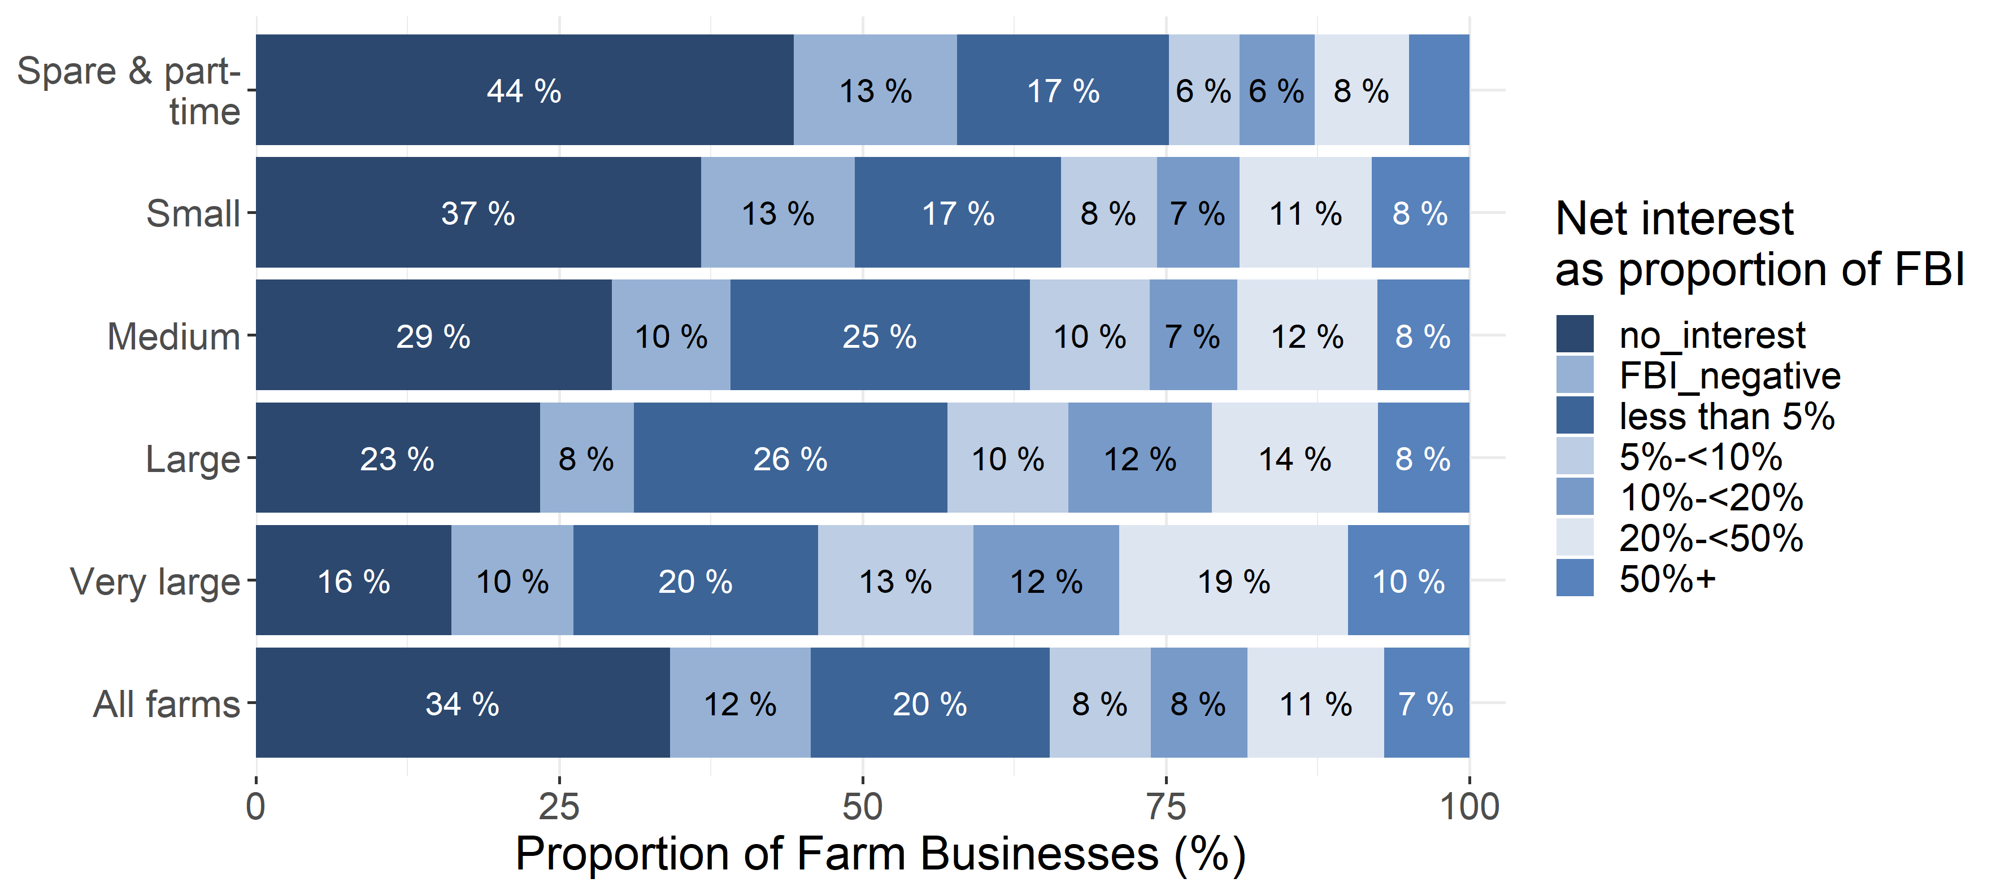
Text is not displayed where proportions are below 5%.
The negative Farm Business Income (FBI) group includes farms for which FBI was negative before paying interest payments but excludes farms paying no interest or net recipients of interest.

Twelve per cent of farms already had a negative FBI (before interest payments) and would have been unable to pay some or all of the interest on their debts without further borrowing or drawing on their assets. A further 7% of farms had a net interest greater than 50% of their FBI. Of these, 42% had net interest payments greater than their available income, these farms would have needed to draw on available assets to meet their interest payments.

6. Return on capital employed
Return on capital employed (ROCE) is a measure of the return that a business makes from its available capital. ROCE provides a more holistic view than profit margins, focusing on efficient use of capital and low costs, allowing an equal comparison across farms of differing sizes. A positive ROCE value indicates that a farm is achieving an economic return on the capital used, while a negative ROCE value indicates that a farm is not achieving an economic return on the capital employed. ROCE is calculated using the following equation:
ROCE = Earnings before Interest and Tax
Capital Employed
Earnings before Interest and Tax has been calculated using Defra’s main income measure, Farm Business Income (FBI), minus the imputed cost of all unpaid labour. Capital employed is the available amount that each farm could use to earn profit in the upcoming financial year. It has been calculated by subtracting current (i.e. short term) liabilities from total assets.
Given the distribution of the ROCE measure, the average is most appropriately described using the median (shown below) rather than the mean. Both measures are presented in the accompanying workbook of results.
Given the importance of land as an asset base for farming, an additional measure of ROCE has been investigated which excludes the value of land from assets. These results can be also found in the accompanying workbook of results.
The median ROCE for all farm businesses declined between 2011/12 and 2015/16, but rose slightly in 2016/17 and 2017/18 to 0.2% (Figure 6.1) before falling to -0.4% in 2019/20. Over half (54%) of farms had a negative return, indicating that these businesses are not achieving an economic return on the capital employed. Around 4% of farms had a ROCE of over 10%.
Figure 6.1 Return on capital employed (ROCE, median values, %) per farm, England 2009/10 to 20019/20
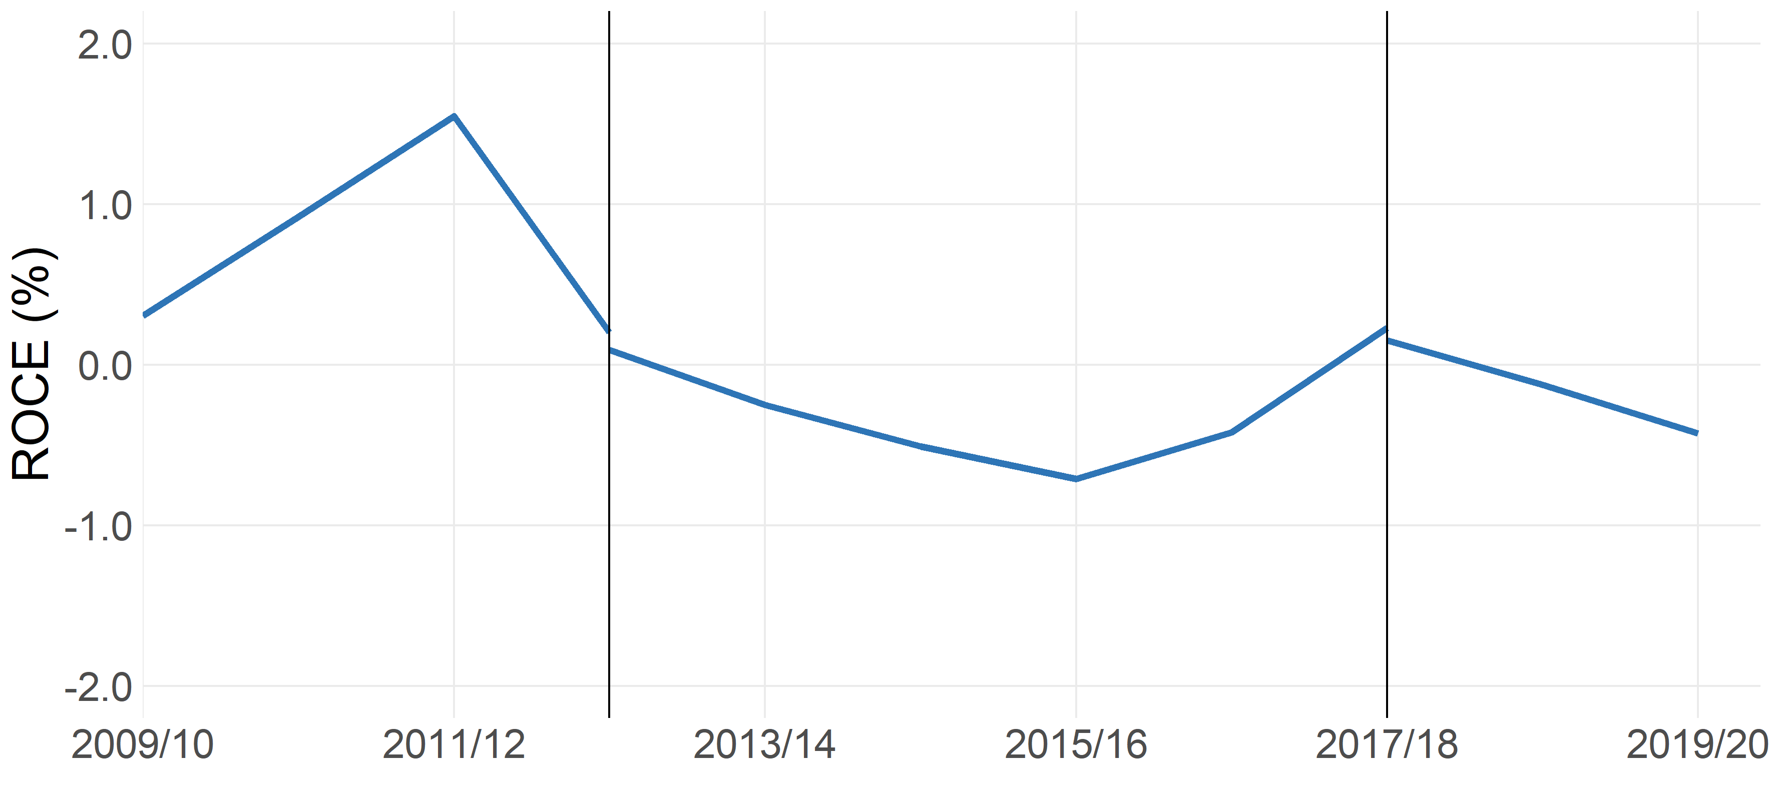
Farms with at least 25,000 euros of Standard Output.
Standard output coefficients were updated in 2012/13, and 2017/18 using 5 year averages centred on 2010 and 2013 respectively. Figures prior to 2012/13 were based on a 5 year average centred on 2007. Results for the two transition years have been calculated using old and new coefficients for comparability, and are denoted by the vertical blue lines.

Farm size and economic performance were found to be related to ROCE.
Figure 6.2 shows the distribution of ROCE by farm size. The proportion of farms with a negative ROCE generally decreased as farm size increased.
Figure 6.2 Box plots showing spread of ROCE by farm size, England 2019/20
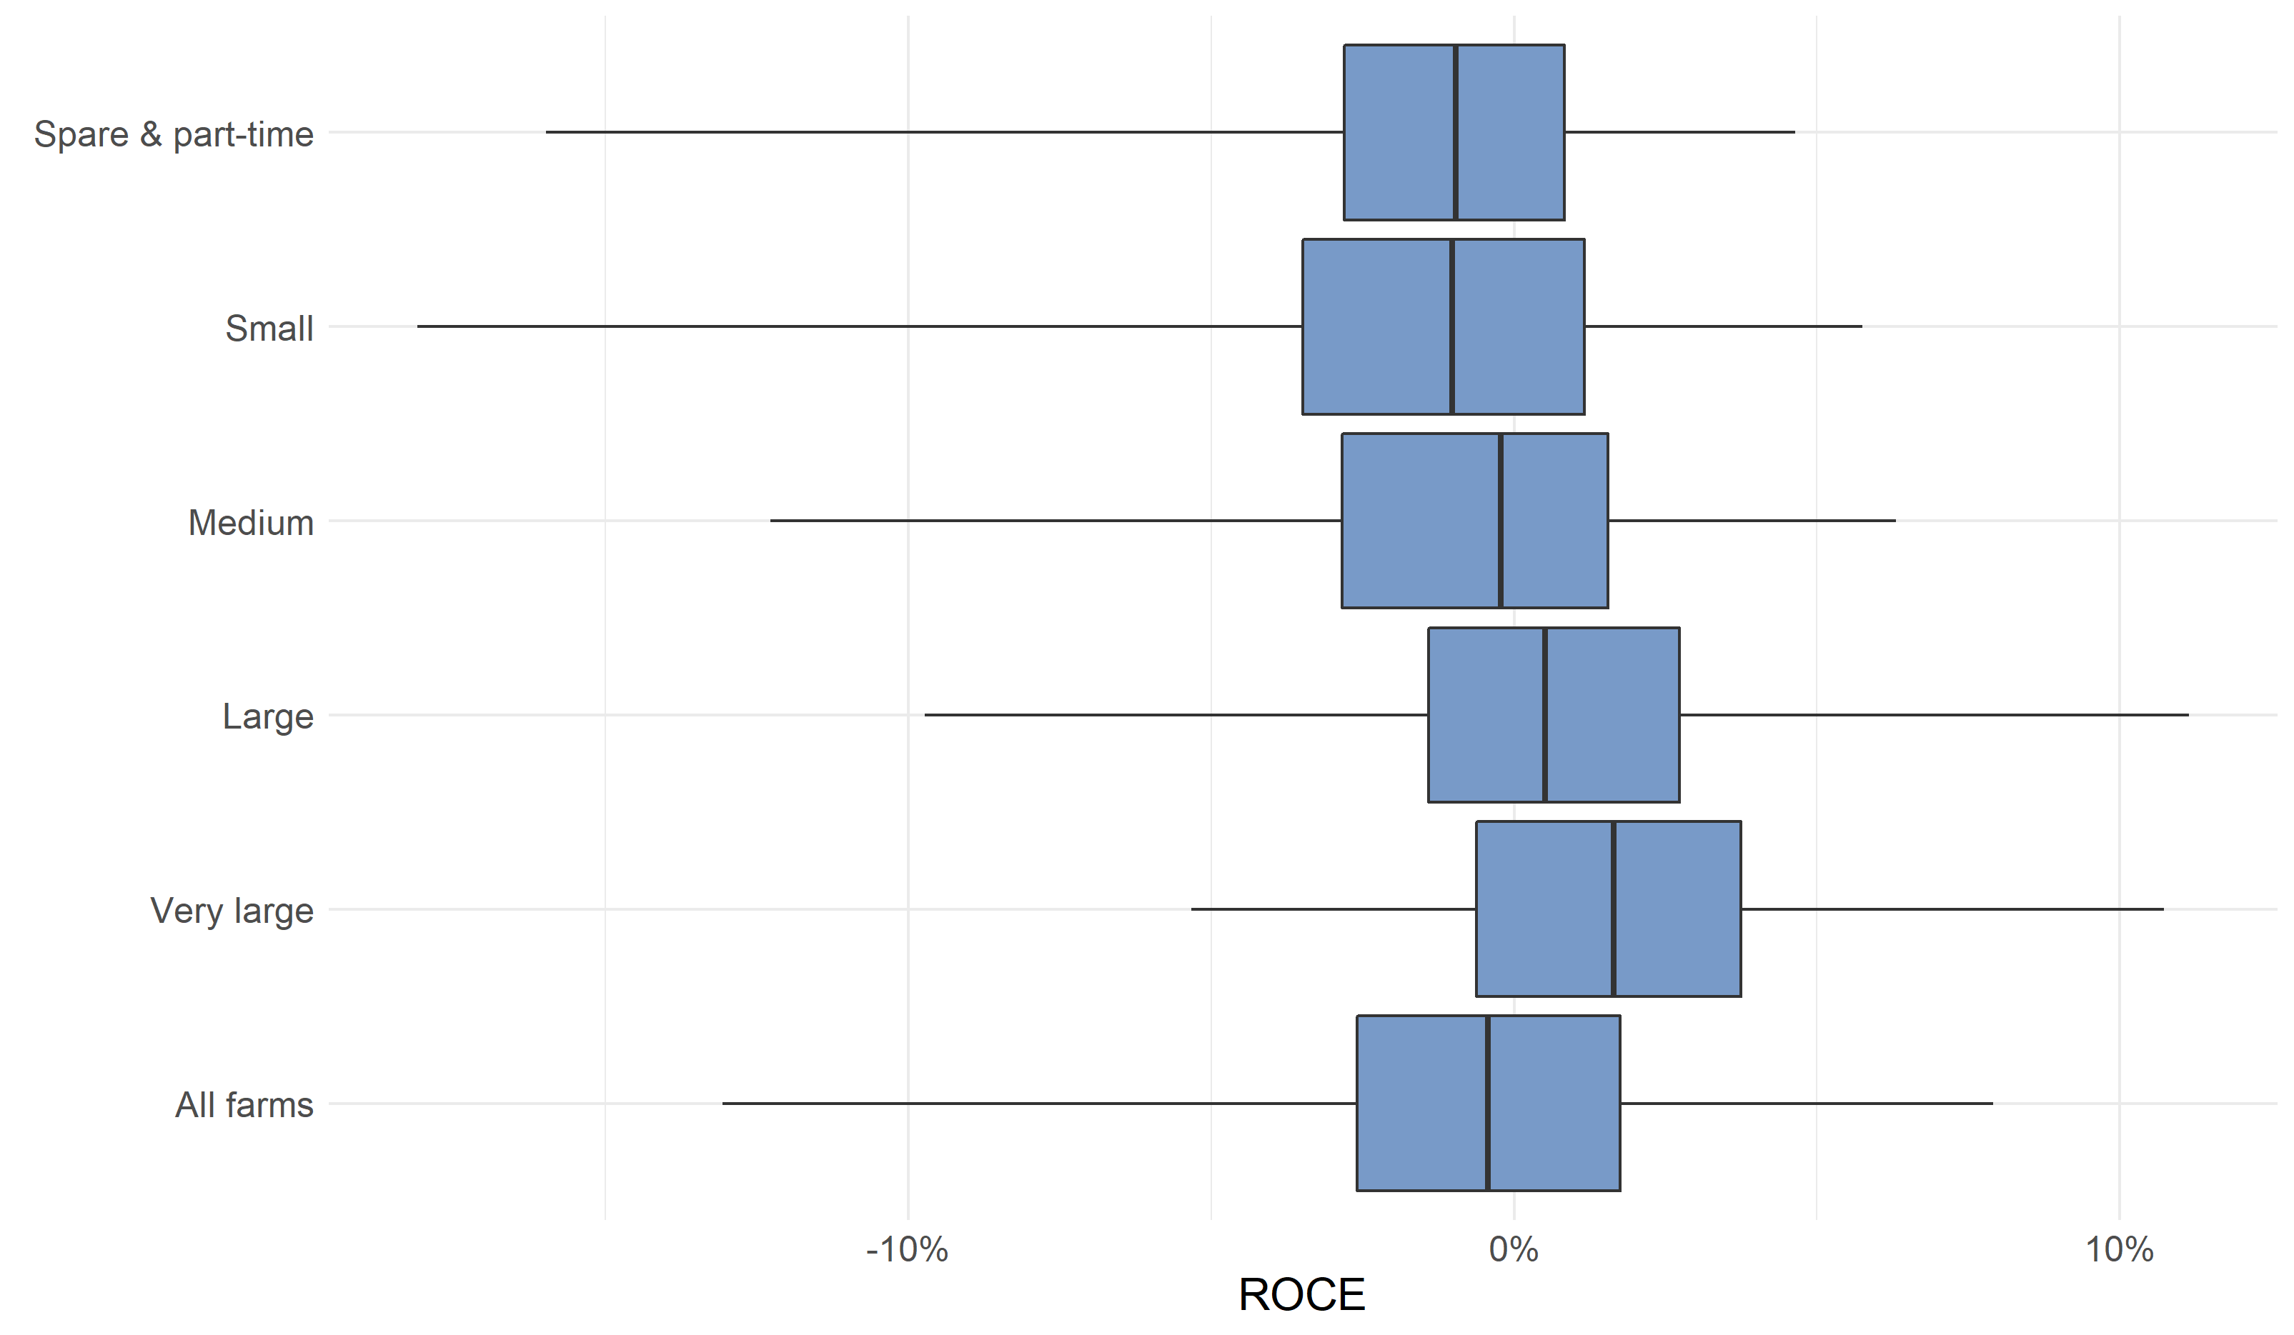
Within each blue box, the vertical line represents the median ROCE, with the box itself showing the spread between the first and third quartiles. Thus 50% of farms lie within the range shown by the blue box. The horizontal lines to each side indicate the spread between the lowest 5% of farms and the top 5% of farms. Thus 90% of farms lie within the range indicated by the lines.

Median ROCE scores were related to farm economic performance (Figure 6.3). No high performing farms had negative ROCE, with a stark contrast against low performing farms where nearly all farms had a negative ROCE. Excluding land has no impact on these statistics.
Figure 6.3 Box plot showing spread of ROCE by economic performance band, England 2019/20
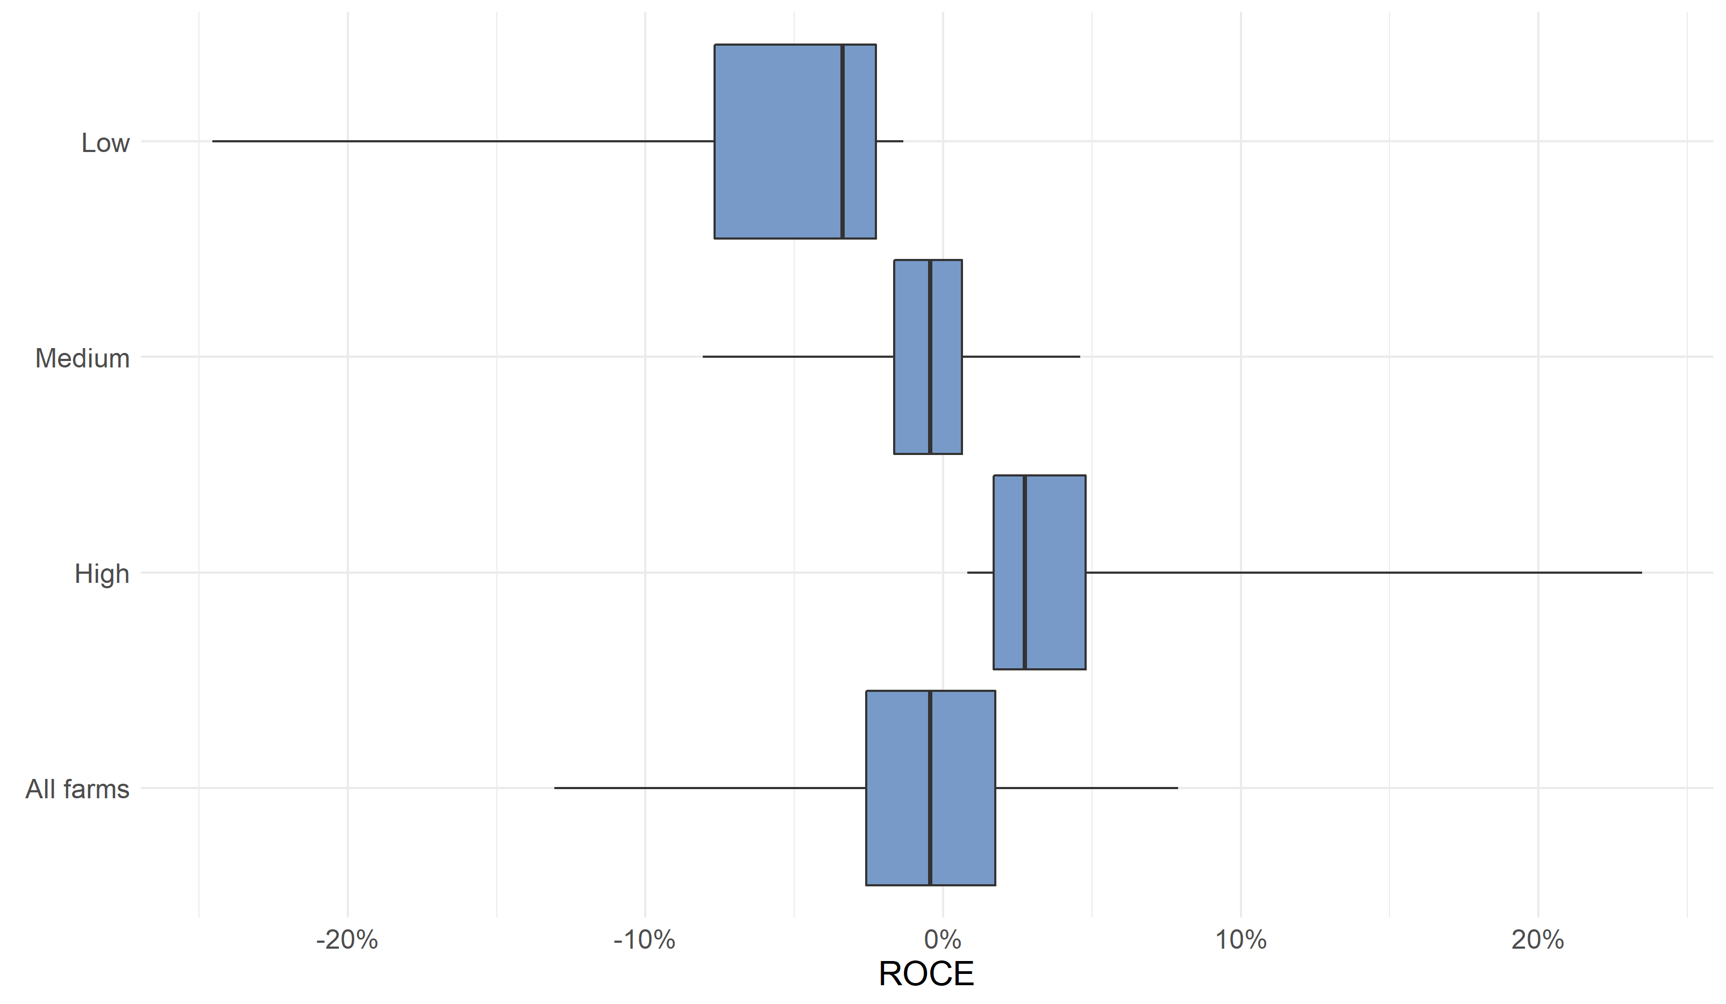

Within each blue box, the vertical line represents the median ROCE, with the box itself showing the spread between the first and third quartiles. Thus 50% of farms lie within the range shown by the blue box. The horizontal lines to each side indicate the spread between the lowest 5% of farms and the top 5% of farms. Thus 90% of farms lie within the range indicated by the lines.

7. Survey details
7.1 Survey content and methodology
The Farm Business Survey (FBS) is an annual survey providing information on the financial position and physical and economic performance of farm businesses in England. The sample of around 1,750 farm businesses covers all regions of England and all types of farming with the data being collected by face to face interview with the farmer. Results are weighted to represent the whole population of farm businesses that have at least 25 thousand Euros of standard output as recorded in the annual June Survey of Agriculture and Horticulture. In 2019, this accounted for approximately 56,500 farm businesses .
For further information about the Farm Business Survey please see: https://www.gov.uk/government/organisations/department-for-environment-food-rural-affairs/series/farm-business-survey
7.2 Data analysis
The results from the FBS relate to farms which have a standard output of at least 25,000 Euros. Initial weights are applied to the FBS records based on the inverse sampling fraction for each design stratum (farm type by farm size). These weights are then adjusted (calibration weighting) so that they can produce unbiased estimators of a number of different target variables.
The data used for this analysis is from those farms present in the Farm Business Survey for 2009/10 to 2019/20 that have complete returns on their assets and liabilities. In 2019/20 this subsample consisted of 1,643 farms. This subsample has been reweighted using a method that preserves marginal totals for populations according to farm type and farm size groups. As such, farm population totals for other classifications (e.g. regions) will not be in-line with results using the main FBS weights, nor will any results produced for variables derived from the rest of the FBS (e.g. Farm Business Income).
7.3 Accuracy and reliability of the results
We show 95% confidence intervals against the results. These show the range of values that may apply to the figures. They mean that we are 95% confident that this range contains the true value. They are calculated as the standard errors (se) multiplied by 1.96 to give the 95% confidence interval (95% CI). The standard errors only give an indication of the sampling error. They do not reflect any other sources of survey errors, such as non-response bias. For the Farm Business Survey, the confidence limits shown are appropriate for comparing groups within the same year only; they should not be used for comparing with previous years since they do not allow for the fact that many of the same farms will have contributed to the Farm Business Survey in both years.
We have also shown error bars on the figures in this notice. These error bars represent the 95% confidence intervals (as defined above).
7.4 Statistical methods
Generalised linear models were fitted to examine which of five predictive variables (farm type, size, tenure type, region and economic performance) were related to each of the response variables of interest (liability, gearing ratio, liquidity, interest payments as a proportion of FBI and ROCE). In each case the distribution of the response variable was examined, and if necessary log 10 or square-root transformed to conform to assumptions of normality. Where a binomial response variable was used (i.e. farms having a liquidity ratio of less than 100%) a binomial based generalised linear model was fitted using a binomial error distribution and a logit link. No statistical model was fitted to the net worth, liquidity or net interest as a proportion of FBI data, as no suitable model structure was found for the data which satisfied assumptions of normality. In all instances a model simplification procedure was used; firstly all parameters were fitted and then a backwards stepwise approach was used to drop the non-significant terms. Where a parameter was of borderline significance the predictions were examined to see if there was a logical pattern and then judgment used to determine whether to retain or drop the parameter from the model. The fit of each model was inspected using plots of model residuals.
7.5 Availability of results
This release contains headline results for each section. The full breakdown of results, by farm type, farm size tenure, region and economic performance can be found at: https://www.gov.uk/government/statistics/balance-sheet-analysis-and-farming-performance-england
Defra statistical notices can be viewed on the Food and Farming Statistics pages on the Defra website at https://www.gov.uk/government/organisations/department-for-environment-food-rural-affairs/about/statistics. This site also shows details of future publications, with pre-announced dates.
7.6 Data Uses
Data from the FBS are widely used by the industry for benchmarking and inform wider research into the economic performance of the agricultural industry, as well as for evaluating and monitoring current policies.
Data from the Farm Business Survey (FBS) has also been provided to the EU as part of the Farm Accountancy Data Network (FADN).
7.7 User engagement
As part of our ongoing commitment to compliance with the Code of Practice for Official Statistics http://www.statisticsauthority.gov.uk/assessment/code-of-practice/index.html, we wish to strengthen our engagement with users of these statistics and better understand the use made of them and the types of decisions that they inform. Consequently, we invite users to make themselves known, to advise us of the use they do, or might, make of these statistics, and what their wishes are in terms of engagement. Feedback on this notice and enquiries about these statistics are also welcome.
7.8 Definitions
Mean
The mean (average) is found by adding up the weighted variable of interest (e.g. liabilities or net worth) for each individual farm in the population for analysis and dividing the result by the corresponding weighted number of farms. In this report average is usually taken to refer to the mean.
Percentiles
These are the values which divide the population for analysis, when ranked by an output variable (e.g. ROCE or net worth), into 100 equal-sized groups. For example, twenty five percent of the population would have a net worth below the 25th percentile.
Median
The median divides the population, when ranked by an output variable, into two equal sized groups. The median of the whole population is the same as the 50th percentile.
Farm Type
Where reference is made to the type of farm in this document, this refers to the ‘robust type’, which is a standardised farm classification system. For this publication, pigs and poultry have been amalgamated into a single farm type category.
Farm Sizes
Farm sizes are based on the estimated labour requirements for the business, rather than its land area. The farm size bands used within the detailed results tables which accompany this publication are shown in the table below. Standard Labour Requirement (SLR) is defined as the theoretical number of workers required each year to run a business, based on its cropping and livestock activities.
Table 7.1 Farm size by Standard Labour Requirement (SLR)
Farm size | Definition
Spare & Part-time | Less than 1 SLR
Small | 1 to less than 2 SLR
Medium | 2 to less than 3 SLR
Large | 3 to less than 5 SLR
Very Large | 5 or more SLR
Farm Economic performance
Economic performance for each farm is measured as the ratio between economic output (mainly sales revenue) and inputs (costs). The inputs for this calculation include an adjustment for unpaid manual labour. The higher the ratio, the higher the economic efficiency and performance. The farms are then ranked and allocated to performance bands based on economic performance percentiles:
- Low performance band - farms that were in the bottom 25% of economic performers
- Medium performance band - farms that were in the middle 50% of performers
- High performance band - farms that were in the top 25% of performers.
Assets
Assets include milk and livestock quotas, as well as land, buildings (including the farm house), breeding livestock, and machinery and equipment. For tenanted farmers, assets can include farm buildings, cottages, quotas, etc., where these are owned by the occupier. Personal possessions (e.g. jewellery, furniture, and possibly private cash) are not included.
Net worth
Net worth represents the residual claim or interest of the owner in the business. It is the balance sheet value of assets available to the owner of the business after all other claims against these assets have been met. Net worth takes total liabilities from total assets, including tenant type capital and land. This describes the wealth of a farm if all of their liabilities were called in.
Liabilities
Liabilities are the total debt (short and long term) of the farm business including monies owed. It includes mortgages, long term loans and monies owed for hire purchase, leasing and overdrafts.
Tenant type capital
Tenant type capital comprises assets normally provided by tenants and includes livestock, machinery, crops and produce in store, stocks of bought and home-grown feeding stuffs and fodder, seeds, fertilisers, pesticides, medicines, fuel and other purchased materials, work in progress (tillages or cultivations), cash and other assets needed to run the business. Orchards, other permanent crops, such as soft fruit and hop gardens and glasshouses, are also generally considered to be tenant-type capital.
Return on capital employed (ROCE)
Return on capital employed (ROCE) is a measure of the return that a business makes from the available capital. ROCE provides a more holistic view than profit margins, focusing on efficient use of capital and low costs and allowing an equal comparison across farms of differing sizes. It is calculated as economic profit divided by capital employed.
Liquidity ratio
The liquidity ratio shows the ability of a farm to finance its immediate financial demands from its current assets, such as cash, savings or stock. It is calculated as current assets divided by the current liabilities of the farms.

Gearing ratio
The gearing ratio gives a farm’s liabilities as a proportion of its assets.
Utilised Agricultural Area (UAA)
Utilised Agricultural Area (UAA) is the crop area, including fodder, set-aside land, temporary and permanent grass and rough grazing in sole occupation (but not shared rough grazing) i.e. the agricultural area of the farm. It includes bare land and forage let out for less than one year.
Farm business income (FBI)
Farm Business Income (FBI) for sole traders and partnerships represents the financial return to all unpaid labour (farmers and spouses, non-principal partners and directors and their spouses and family workers) and on all their capital invested in the farm business, including land and buildings. For corporate businesses it represents the financial return on the shareholders capital invested in the farm business. Note that prior to 2008/09 directors remuneration was not deducted in the calculation of farm business income.
Farm Business Income is used when assessing the impact of new policies or regulations on the individual farm business. Although Farm Business Income is equivalent to financial Net Profit, in practice the measures are likely to differ because Net Profit is derived from financial accounting principles whereas Farm Business Income is derived from management accounting principles. For example in financial accounting output stocks are usually valued at cost of production, whereas in management accounting they are usually valued at market price. In financial accounting depreciation is usually calculated at historic cost whereas in management accounting it is often calculated at replacement cost.

© Crown copyright 2021. You may re-use this information free of charge under the terms of the Open Government Licence v.3. To view this licence visit www.nationalarchives.gov.uk/doc/open-government-licence/version/3/

For a definition of farm economic performance see the Section 7. on definitions.
A generalised linear regression model was fitted to examine which factors (farm type, farm size, region, tenure and economic performance) were related to liabilities in 2019/20. Farm type, size, region, and tenancy type were found to be significant predictors of farm liability, p < 0.05).
Farm sizes are based on the estimated labour requirements for the business, rather than its land area. Please see the section on definitions for more information.
Per hectare of farmed area. Farmed area = Utilised Agricultural Area + net land hired in (i.e. land hired in minus land hired out)
For a definition of tenant type capital see the section on definitions
A generalised linear regression model was fitted to examine which factors (farm type, size, region, tenure and economic performance) were related to the probability of having a net worth of less than £500,000. All factors were found to be significant (p < 0.05).
For a definition of farm economic performance see the section on definitions.
A generalised linear regression model was fitted to examine which factors (farm type, size, region, tenure and economic performance) were related to the probability of having a net worth of £1,500,000 or more. All factors were found to be significant (p < 0.05).
Per hectare of farmed area. Farmed area = Utilised Agricultural Area + net land hired in (i.e. land hired in minus land hired out)
Farm sizes are based on the estimated labour requirements for the business, rather than its land area. Please see the section on definitions for more information
A generalised linear regression model was fitted to examine which factors (farm type, size, region, tenure and economic performance) were related to the gearing ratio in 2019/20. Farm type, size and tenure were found to be significant (p <0.05).
Liquidity ratio is current assets divided by current liabilities.
For a definition of farm economic performance see the section on definitions.
Because Farm Business Income (FBI) includes net interest payments as a cost, for this measure we have used FBI before deducting net interest.
Note that the incidence of negative ROCE is higher than the incidence of negative FBI. This is because the value of unpaid labour has been deducted from FBI.
Short term liabilities are deducted in order to measure the capital assets that would remain after short term commitments have been met. Overdrafts are treated as a long term liability and therefore not deducted.
A generalised linear regression model was fitted to examine which factors factors (farm type, size, region, tenure and economic performance) were related to ROCE. Size and economic performance were significant (p<0.05).
For a definition of standard output please see the UK classification document here: https://www.gov.uk/farm-business-survey-technical-notes-and-guidance
Prior to the 2010/11 campaign, the coverage of the FBS was restricted to those farms of size ½ Standard Labour Requirement (SLR) or more. For a definition of SLR please see the UK classification document here: https://www.gov.uk/farm-business-survey-technical-notes-and-guidance
Further information on calibration weighting can be found here: https://www.gov.uk/farm-business-survey-technical-notes-and-guidance

