Safety Alert Parts A, B, & C |  |  |  | Health and Safety
Subject: Risk of unintended lifting of ‘EJ Co.’ tri-angular inspection covers by Runway Sweeper FOD magnet, located in Aircraft Operating Surfaces (AOS)

Number: SA 2022-04
DIO Sponsor: Bryan Dunn |  |  | Date of issue: 17th March 2022
Contact if different from above Sponsor:

John Cook
AH Airfield Pavements (Design & Construction)
Technical Services, Engineering & Construction
Defence Infrastructure Organisation.
St George’s Hse, DMS Whittington, Lichfield WS14 9YP

Email: DIOTS-EngAPStdsmultiuser@mod.gov.uk
Tel: +44 (0) 7816396049

This Safety Alert is to be read by the following, so appropriate action can be taken:
- DIO Regional Delivery (FDIS / NGEC or equivalent contracts)
- DIO Major Projects & Programmes
Others interested in the content of this Safety Alert might include:
Aerodrome Operators, Aviation Duty Holder(s) Facing, Assurance Managers, Estate Facility Managers, Assurance Managers in Regional (Service) Delivery, Health & Safety Advisors, Top Level Budget Holders, Prime Contractors, Project Managers, and Infrastructure Managers.

When it takes effect: Immediately |  | When it is due to expire: When updated or rescinded.
 | This Safety Alert does not necessarily cover all aspects of the subject matter and readers should make themselves aware of other potential issues. Readers should also not rely on DIO Publications as their only means of becoming aware of safety issues, but they should consult widely across other media to maintain awareness.
Aims
- The aim of this Safety Alert is to bring to the attention of appropriate persons or organisations:
  - The need to retrospectively supply and install hinge locking components to a specific manufacturer and type of inspection cover lids that have been identified, under certain circumstances, as posing a potential hazard to the safe movement of aircraft on an aerodrome.
  - To ensure that, where necessary, such retrospective installation has occurred.
  - To raise awareness to design out such risks at first installation.
Introduction
- Compliance with the contents of this Safety Alert will enable Defence to reduce flight safety risk to as low as tolerable and comply with relevant safety legislation and regulations.
- For clarification, the terms AOS (Aircraft Operating Surfaces) and Movement Areas are interchangeable, both describing those parts of an aerodrome intended for the surface movement of aircraft, including e.g., runways, taxiways, aprons, and other areas for use by aircraft, whether under own power or being towed.
- Any work required because of this Safety Alert must be carried out in accordance with JSP 850 – Infrastructure and Estate Policy.
Background
- An Air Safety Occurrence has been reported at a Defence aerodrome, concerning installation of ‘inspection chambers’ located within a taxiway (Defence Air Safety Occurrence Report (DASOR) reference: asor\Marham-RAF\Stn-RAFMarham\No Aircraft\19\9173.)
- The occurrence involved the unintended ‘lifting’ of triangular shaped inspection chamber lids by the Airfield Surface Sweeping Vehicle (ASSV) Schmidt AS990 and the energized Foreign Object Debris (FOD) magnet attachment (PMB 2400). It is important to note that the inspection chamber lids, in this instance, did not have any retaining components installed to the lids, but relied on their own self weight to remain seated in their frames. On discovering the dislodged lids, which were undamaged, they were repositioned to the normal closed and safe position.
- The field density of the FOD magnet (at 100mm above ground) was able to unseat and lift the single 62.5kg triangular-shaped inspection chamber lid. Unintended lifting has the potential to cause damage to the inspection chamber installation, the adjacent pavement surface, the sweeper machinery, and possible harm to operatives. Should a dislodged or removed lid go un-noticed, a hazard could also exist to the safe movement of aircraft.
- It has been confirmed that the sweeper and magnetic attachment were operating correctly and in accordance with set parameters and procedure. It is not considered feasible to alter the sweeper machinery, FOD magnet specifications nor amend the method of sweeping operations i.e., momentarily raising of the magnet, or avoiding inspection chamber lids are deemed unacceptable for the purpose of FOD detection and removal.
- During subsequent investigations following the occurrence, it has been determined by the manufacturer/supplier (EJCO) that the triangular shaped inspection chamber lids are present at the following airfields, having been supplied by them, and installed within a Major Project during the last 5 years:
- RAF Marham
- RAF Lossiemouth
- RAF Northolt
PART A

- This Safety Alert concerns the following make and model of inspection chamber lids:
Manufacturer: EJCO.com
Access Cover and Frame Reference: DT9S075075A F900 NF and DT9S150075A
Material: SG Iron to ISO 1083 / EN1563, Grade 500-7
Load Class: F900 (EN124-2:2015)
(To aid identification see photos at Annex A, and manufacturer’s data sheets are reproduced at Annex B.)
(It should be noted that inspection chambers with single opening (two triangular half lids) and double opening (four triangular half lids) may be present in the Movement Areas).
- The Maintenance Management Organisation (MMO) (or similar such organisation as appointed), on direction from Regional Delivery (RD) shall initiate the following:
  - For each airfield listed at paragraph 9, identify, and record any inspection chamber lid type (as detailed at paragraph 10 and Annex B), located within active Aircraft Operating Surfaces (AOS).
  - On identification of any ‘in-scope’ lid/s, determine whether the lid hinge retainers are already in-situ (no further action necessary) or if not present, record such locations for retro-fit action.
- The MMO is to notify their respective DIO Regional Delivery Manager, within six weeks of the direction received, of the results (including a ‘nil found’ response). The DIO Regional Delivery Manager will in turn notify the DIO Regional Delivery Safety Alerts Team of the results by email (DIO-RDSafetyAlerts@mod.gov.uk).
- For purposes of ‘as-installed’ records and to assist with identification, the Regional Delivery (RD) may determine the need to liaise with DIO Major Projects and Programmes (MPP) to receive the project CDM 2015 ‘Health and Safety File’, if not already in possession of RD.
PART B

- The Maintenance Management Organisation (or similar such organisation as appointed), on direction from Regional Delivery (RD) shall initiate the following:
  - As per records and identification of ‘in-scope’ lids determined from the activities at Part A, the retrofitting of hinge retainers, as described at paragraph 15, shall be carried out. Technical advice and supply of parts can be provided by the manufacturer, EJCO:

Mr Andrew Collins
Head of Business Development
EJCO
Mobile +44 (0) 7702 917330
andrew.collins@ejco.com

- The retrofitting of the in-scope inspection chamber lids is referred to as ‘changing the status of the manhole cover from ‘as is’ to “captive retained”’, and involves the following procedure:
  - Fitting of a retainer pin and a bolt at each hinge. (When the retainer pins and bolts are retrofitted, the magnet may still lift the cover by a minimal amount (5-10mm), but the retainer pin holds the cover in place and once the magnet has passed over, the cover re-seats into the frame.)
  - On completion of the retrofit as detailed in paragraph 15(a), a commissioning test should be undertaken, by passing the FOD magnet over the covers, to determine that successful retention of the cover/s has been achieved.
PART C

- The MMO is to notify the DIO Regional Delivery Safety Alerts Team (DIO-RDSafetyAlerts@mod.gov.uk), through their respective DIO Regional Delivery Manager or equivalent, of the actions completed in accordance with Part B.

General Note
- For all new and future inspection chamber installations at aerodromes, consideration shall first be given to placing such installations beyond/outside the Movement Areas. If this cannot be achieved, and in all circumstances unavoidable, and it is essential to place such installations within the Movement Areas, then to satisfy the rationale of Military Aviation Authority Regulation Article 3511, covers, lids and other embedded items in the AOS pavement surfaces, shall be specified and installed, to avoid any possibility of unintentional lifting, removal or dislodging by whatever effect caused. It is recommended that DIO Regional Delivery and DIO Major Projects and Programmes promulgate the contents of this Safety Alert into their respective ‘Learning from Experience’ (LfE) processes.

Annex A

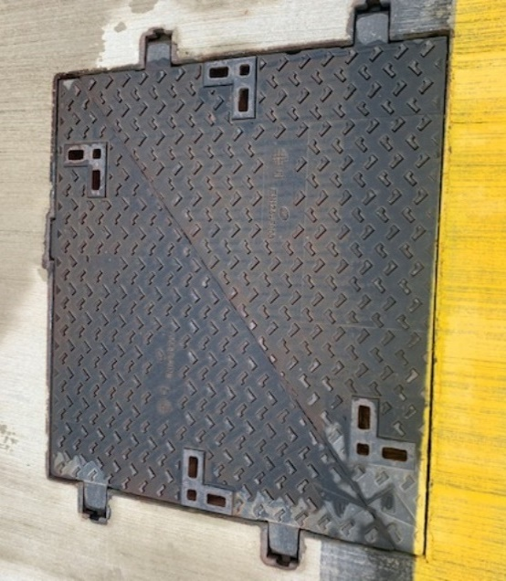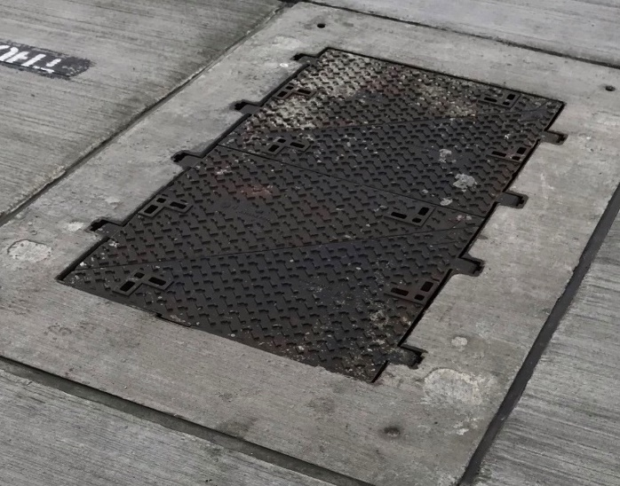

Inspection chambers as detailed in paragraph 10; single opening (L) and double opening (R)
triangular half covers (62.5kg each)

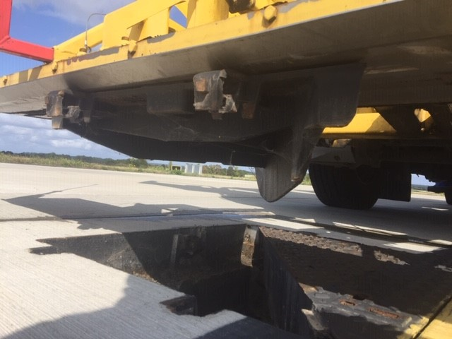

HAZARD: Without hinge retaining pins and bolts installed this photo shows one half-cover being lifted out of the seating frame by the FOD magnet attachment.
Annex B

Sample Data Sheets of DT9S075075A F900 NF and DT9S150075A to aid identification.

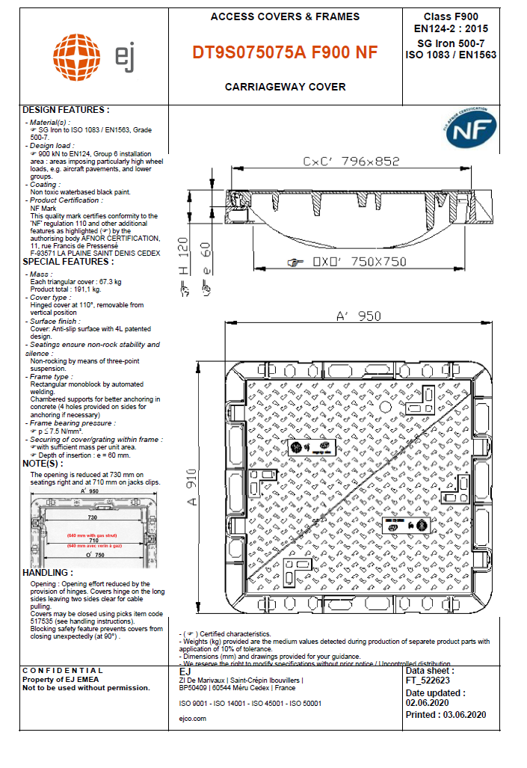
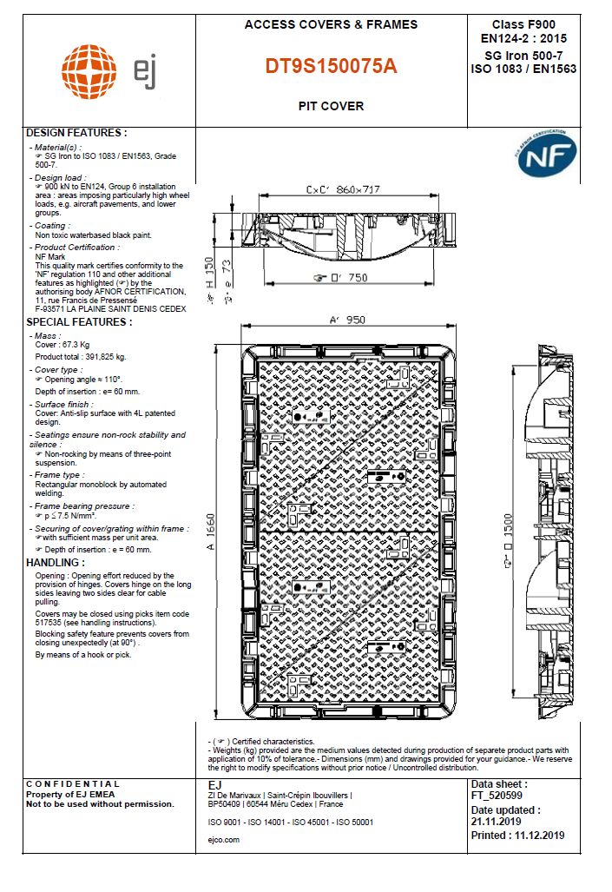

Annex C

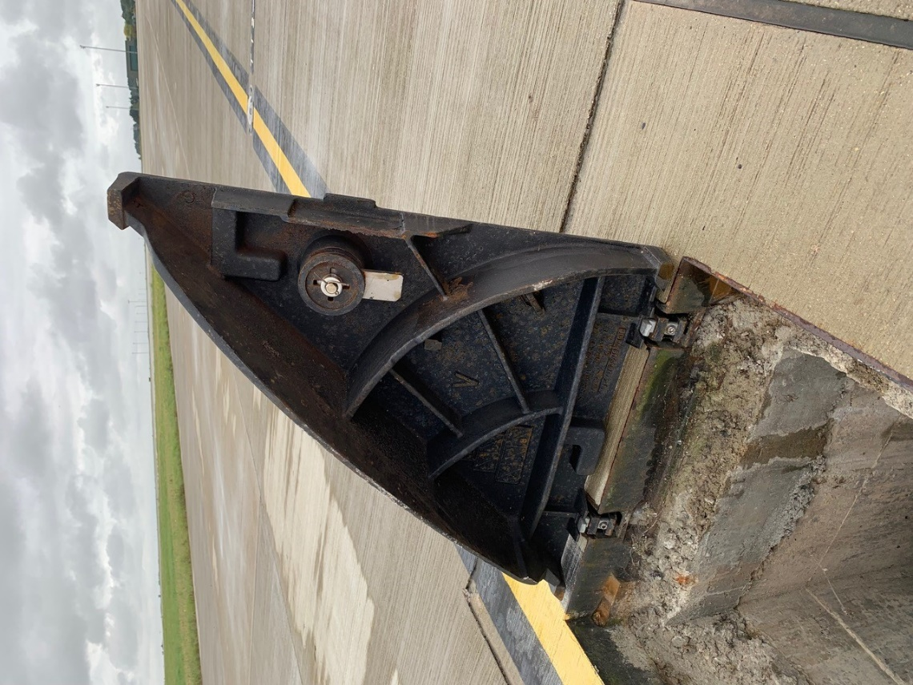

Location of retaining pins and bolts (2No per lid).

The photo above shows the retaining pins and bolts in position.

Without the retaining pins and bolts installed, the lid, in the lowered position, can, under certain conditions, be lifted, in the horizontal position, ‘vertically’ out of the chamber lid surround by the Sweeper FOD magnet.

