Application Decision
on papers
by Heidi Cruickshank BSc MSc MIPROW
Appointed by the Secretary of State for Environment, Food and Rural Affairs
Decision date: 8 March 2022

Application Ref: COM/3273667
Clapham Common
Register Unit No: CL73
Commons Registration Authority: London Borough of Lambeth
- The application, dated 23 April 2021, is made under Article 12 of the Greater London Parks and Open Spaces Order 1967.
- The application is made by the London Borough of Lambeth to construct temporary works on common land.
- The works comprise:
- fencing;
- other structures; and,
- the creation of a site for temporary events for a fixed period of time.

Decision
- Consent is not granted for works in the period 16 August 2021 – 9 September 2021 as set out in the application dated 23 April 2021 and accompanying plan.

The Application
- The application relates to temporary works to be carried out in the north-eastern part of the common over the dates 16 August 2021 – 9 September 2021. This related to works associated with an Event Application for up to 4 days of events over the August 2021 Bank Holiday.

Procedural Matters
- The application of 23 April 2021 was made less than four months prior to the expected start date of the works, 16 August 2021. As set out in Common land guidance sheet 1a, version updated 16 March 2021, available on gov.uk:

“The length of time taken to decide your application will depend on the nature and extent of the works, the number of objections and the procedure followed.

As a guide, if there are no objections, and the issues can be determined without an exchange of written representations, we would expect to decide your application within three months of you meeting all the advertising/ consultation requirements in full. This might extend to around five months if an exchange of written representations is needed, and around ten to twelve months for cases that require a site visit or a public inquiry or hearing. More complex inquiry cases, or cases where an inquiry is held alongside a related inquiry (e.g. into a planning application) may take much longer.”
- This application attracted 475 representations. One of these was neutral and three in support, with the remaining 471 in objection to the application. Given the high level of public interest in the matter, the appropriate way to deal with the application would be way of a public Inquiry.
- The earliest date at which a decision might be expected, even in normal circumstances, would be well beyond the date at which the works were intended. Whilst the Planning Inspectorate was working in unusual circumstances, arising from the covid-19 pandemic, the timelines were even more challenging.
- It is understood from the applicant that the works went ahead without consent and were subsequently removed, with the site returned to The London Borough of Lambeth (LBL) on 6 September 2021. With that information in mind, time was taken to consider the value of holding a public Inquiry into temporary works, which had already been removed.
- Alongside this the Planning Inspectorate were informed that there would be another application relating to the same, or similar, works for August 2022. In relation to any ‘2022 application’ – taking account of the unsatisfactory situation arising from the 2021 application – the Planning Inspectorate undertook to expedite processes, as a special circumstance, to deliver a decision within six months of an application.
- A view was taken that it was not likely to be a sensible use of public time and resources to hold a public Inquiry into the 2021 application. The preliminary preference was to take a decision on the basis of the documentation and representations which had already been submitted to the Planning Inspectorate. Regulation 16(2) of the Works on Common Land (Procedure)(England) Regulations 2007 places a duty on the Planning Inspectorate to consult with the applicant before reaching a decision to change procedure. This was undertaken in January 2022, with the applicant agreeing to that change.
- One of the objectors, the Friends of Clapham Common, suggested that a joint Inquiry should be held into the 2021 and 2022 applications. Whilst understanding the desire for the merits of the matter to be considered it would not be a good use of public time and resources to do so. It will be more productive for all parties to concentrate on any 2022 application, the decision for which would be delivered in a meaningful timescale to grant, or not grant, consent to those works.
- Taking all relevant procedural matters into account, this decision was taken on the papers submitted in relation to the application and the representations made in response to the notice.

Description of the Land
- Clapham Common (the common) covers an area of 81.1 hectares and is registered as common land (CL73) under the Commons Registration Act 1965. The common is owned by LBL. The common is sited in London, a highly populated urban area with three main roads, the A3, A24 and A205, crossing or edging the common. Residential roads and streets, with industrial, retail and leisure areas surround these roads and/or the common.
- There are no rights of common recorded over the land. There are rights of access to the general public.

Main Issues
- In determining applications made under Article 12 of the Greater London Parks and Open Spaces Order 1967 regard should be had to matters under section 39 of the Commons Act 2006 (CA06):

the interests of persons having rights in relation to, or occupying, the land (and in particular persons exercising rights of common over it);

the interests of the neighbourhood;

the public interest, which includes the interest in nature conservation, conservation of the landscape, protection of public rights of access and the protection of archaeological remains and features of historic interest;

any other matters considered to be relevant.
- Section 39(7) CA06 provides that consent may be given in relation to works which have been commenced or completed; and any consent so given has effect from the time of commencement of the works.
- Defra’s Common Land Consents Policy, November 2015, is also relevant to the consideration of such applications.
- Issues raised in response to the notice of application related to the reference to the ‘event site’; the number of events on the common; anti-social behaviour associated with events; noise from the event; waste from the event; damage from the event; income generation and use; traffic management; loss of open space; covid-19 impacts; and potential links to other applications. A number of matters relate to the event that could be accommodated by the works rather than the works themselves.

Reasons
- As the works have already been carried out this decision cannot do as some objectors may have desired, which would be that the proposed works were not granted consent and, therefore, the event perhaps would not have occurred; the event has already taken place over the August 2021 Bank Holiday weekend.
- This was not a retrospective application; it was made in advance of the works, albeit not in a reasonable timescale for the decision to be made. In addition, the works were temporary, not permanent, and they have now been removed; there is no good reason to provide consent for something which does not exist. It would not be a good use of public time and money to determine this application retrospectively.
- As a result, the reasonable outcome must be that the consent is not granted, that decision being taken without considering the merits of the application itself.

Conclusions
- Taking account of all the above points, I do not grant consent in respect of this application.

Heidi Cruickshank
Inspector

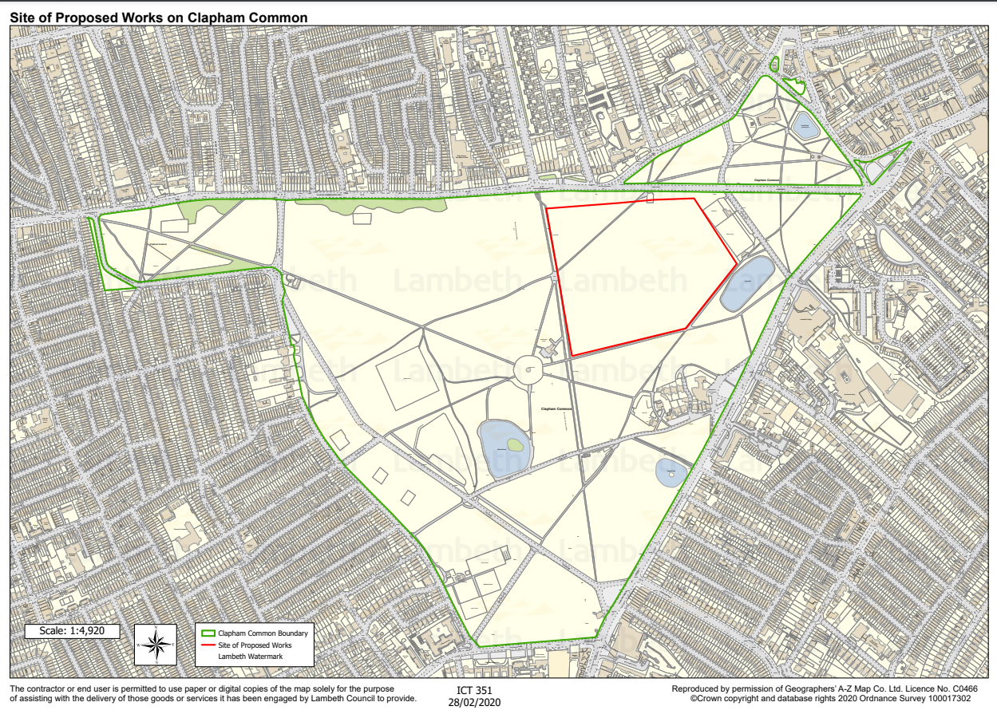
PLAN NOT TO ORIGINAL SCALE

