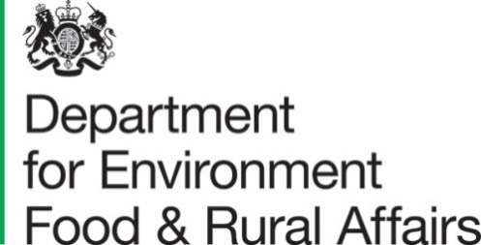
Published February 24th 2022

Farmer Opinion Tracker for England – October 2021

This report contains estimates from the Farmer Opinion Tracker providing a snapshot of views and opinions towards Defra’s vision for farming at this time. Farmers were asked questions about business planning, relationships with farming organisations and Defra, new schemes and the future of farming.

Key Messages for October 2021
- Farmers on 61% of holdings said that they either fully (7%) or roughly (54%) understand Defra’s vision for farming, an overall decrease from 67% in April 2021.
- Farmers on 64% of holdings indicated that they will need to make changes to their farm business in the next 3 to 5 years, an increase from 60% in April 2021 and 54% in October 2020.
- Farmers on 85% of holdings said that Defra paying for environmental outcomes will be very (67%) or moderately (18%) important to their business in the future.
- Farmers on over two thirds of holdings (68%) are not at all confident that changes to schemes and regulations will lead to a successful future for farming.
- Just under half of farmers on all holdings (45%) feel positive about their future in farming (7% very positive; 38% somewhat positive).
Farmers were offered the opportunity to express opinions and their thoughts on farming i.e. what was on their mind at the time of filling in the survey. The open text comments analysis in section 2 provides context around the statistics. The survey is open for a set period of time which may not always be aligned with communication from Defra on schemes and changes e.g. detailed announcements on new Environmental Land Management (E.L.M.) schemes were made in December 2021 and January 2022.
- Similar to previous surveys there were concerns about import standards and protecting British agriculture; feedback about E.L.M. schemes; and mixed and negative sentiment about relationships with Defra. Apprehension about the future farming vision and business viability were more prominent in this survey, as well as impacts on wellbeing, and feedback about specific regulations and climate change. There were new references to higher input costs but fewer comments about low commodity prices.
Contents
What you need to know about this release 3
Contact details 3
Official Statistics 3
Section 1 – Detailed results 4
1.1 Vision 4
1.2 Changes 5
1.3 Groups 10
1.4 Environment 12
1.5 Relationships 16
Section 2 – Open Text Comments 21
2.1 Future Farming Vision 21
2.2 The Agricultural Transition Period and Environmental Management 21
2.3 Relationships and Communication 22
2.4 Markets and Food Standards 23
2.5 The Reality of Farming Life ‘On the Ground’ 23
2.6 Miscellaneous 24
2.7 What’s Different Now? (Comparison to previous results) 24
Section 3 – About these statistics 26
3.1 Methodology 26
3.2 Data analysis 26
3.3 Accuracy and reliability of the results 26
3.4 Uses and Users 26
3.5 Definitions 27
3.6 Future publications 27

What you need to know about this release

Contact details

Responsible social researcher: Hannah Baker
Team: Future Farming Insights and Evaluation - Department for Environment, Food and Rural Affairs
Email: Farming.Research@defra.gov.uk

Responsible statistician: Emma Howat
Team: Farming Statistics - Department for Environment, Food and Rural Affairs
Email: farming-statistics@defra.gov.uk
Telephone: 03000 600 170

Official Statistics

Official statistics are produced to the high professional standards and comply with the United Kingdom Statistics Authority’s Code of Practice for Statistics. The Code of Practice for Statistics sets the standards that producers of official statistics should commit to. Compliance with the Code gives you confidence that our published statistics have public value, are high quality, and are produced by people and organisations that are trustworthy.

Section 1 – Detailed results

1.1 Vision
Defra is setting out what they think the future for farming would look like. In this vision, England’s farmers improve the health of our environment and animals as part of a sustainable, productive agricultural sector. When asked if they know what Defra’s vision meant for farming, farmers on 61% of holdings said that they either fully (7%) or roughly (54%) understood Defra’s vision (see Figure 1). This proportion is an overall decrease from 67% in April 2021 (fully understand 5%; roughly understand 62%). In October 2021, a further 36% said they didn’t know but would be interested to know more. Farmers on the remaining 3% of holdings didn’t need to know what the future vision meant for farming.

Figure 1: Proportion of holdings that understand Defra’s vision for farming, September 2019 to October 2021
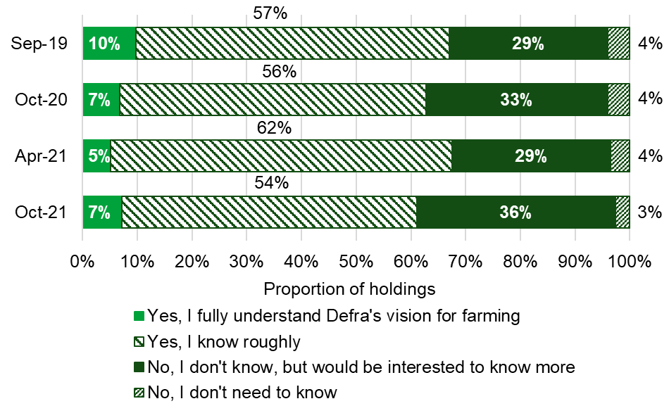

1.2 Changes
In 2021, DEFRA started the transition away from the EU Common Agriculture Policy which will involve changes to the payments farmers receive and the regulations their businesses must follow. Farmers were asked whether they had all the information they needed at this point to help with their business planning (see Figure 2). Farmers on 37% of holdings said they had all (5%) or most (32%) of the information they required. This proportion has decreased overall from 40% in April 2021. In October 2021, a further 24% indicated that they didn’t have any information but knew where they could find it. Farmers on nearly a third (30%) of holdings said they didn’t have any of the information they needed for their business planning and were unsure where to find it. The remaining 8% of all holdings didn’t know if they had all the information they needed.

Figure 2: Proportion of holdings that have the information they need to inform business planning, September 2019 to October 2021
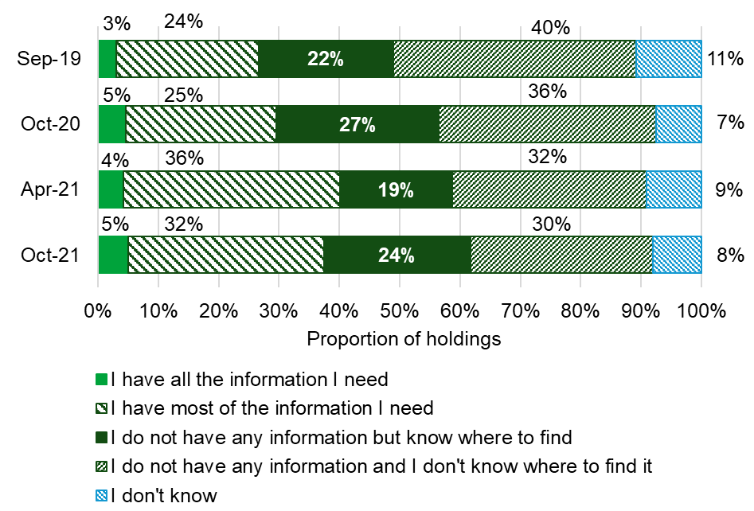

Farmers on 64% of holdings believe they will need to make changes to their business in the next 3-5 years. This is an increase from 60% in April 2021 and 54% in October 2020 (see Figure 3). Approximately 12% of farmers on all holdings indicated that they don’t need to make any changes to their farming business and just under a quarter (24%) don’t know what changes they need to make.

Figure 3: Proportion of holdings that need to make changes to their farm business in the next 3 to 5 years, September 2019 to October 2021
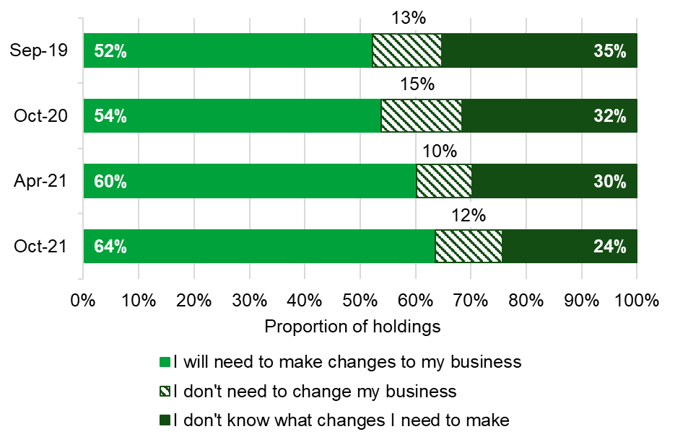

Farmers who answered that they will need to make changes to their farm business in the next 3 to 5 years were then asked what changes they will need to make (see Figure 4). Farmers are most likely to stay farming but diversify their business into non-farming areas with 53% of farmers on all holdings selecting this option. This proportion has increased from 42% in April 2021, where it was also the most popular option. Nearly a third (32%) will stay farming but increase productivity and farmers on 30% of holdings will stay farming and grow the business. Farmers on only 9% of holdings are planning on retiring or passing the farm onto the next generation and 3% would leave farming for other reasons. Farmers on 3% of holdings stated other changes they plan to make to their farm business which included improving efficiency and maximising environmental schemes.

Figure 4: Changes to farm business, April 2021 to October 2021
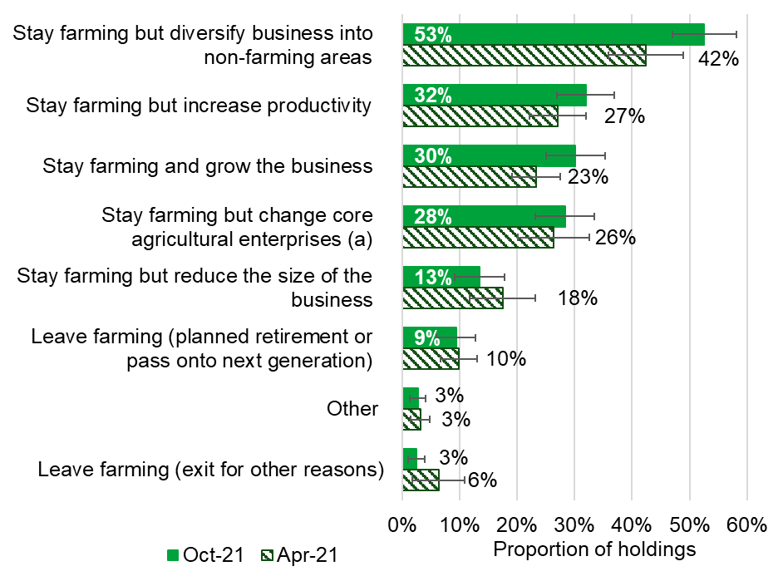
Note: Farms could select more than one option.
- for example, change crops and/or livestock

These proportions varied quite significantly across farms. Compared to 28% of all holdings, a higher proportion (44%) of holdings in the South East including London intend to stay farming but change the core agricultural enterprise. Whereas farmers in the West Midlands and East Midlands are less likely to make this change in the next 3 to 5 years (20% and 19% of holdings respectively).
Farmers on cereal holdings (62%) are more likely to stay farming but diversify their business into non-farming areas in the next 3 to 5 years (see Figure 5). This option was not as popular for farmers on dairy holdings, with only 30% of these farmers selecting this option.
Farmers on nearly a third (32%) of all holdings intend to stay farming but increase productivity in the coming years, an increase from 27% in April 2021. This proportion varied across farm size, with 43% of larger holdings and 36% of medium holdings selecting this option compared to 20% of small holdings (see Figure 6).
Figure 5: Proportion of holdings that plan to stay farming and diversify into non farming areas, by farm type
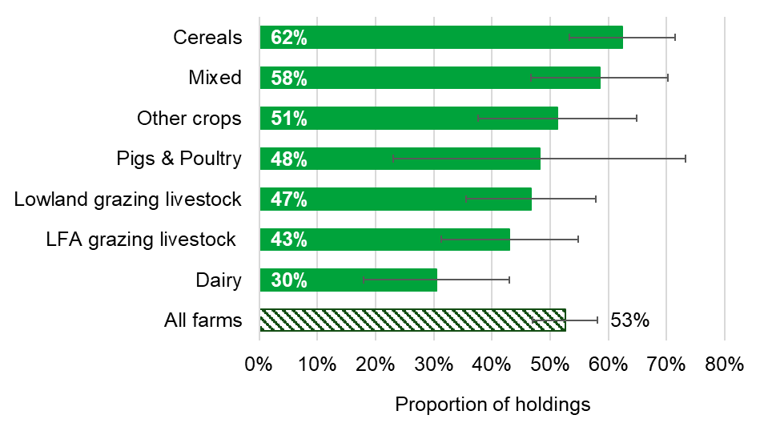
Note: Farms could select more than one option.

Figure 6: Proportion of holdings that plan to stay farming but increase productivity, by farm size
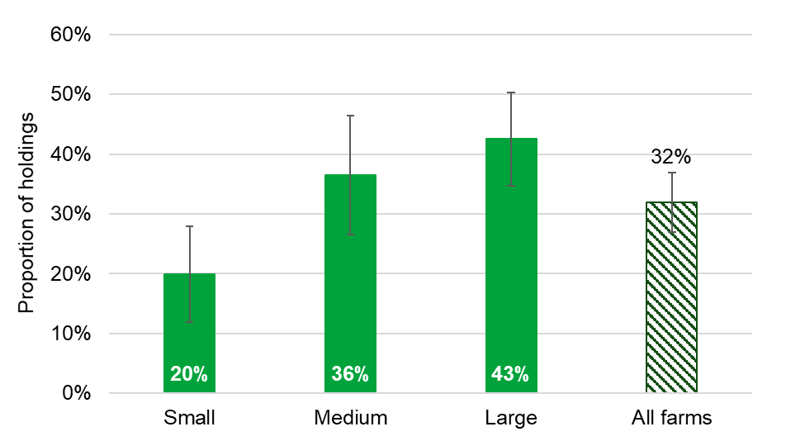
Note: Farms could select more than one option.

Farmers on 62% of holdings are either very (12%) or somewhat (50%) confident that they can respond to any changes that are needed. This is an increase from 54% in April 2021 (fully confident 9%; somewhat confident 45%). In October 2021 this proportion varied across English regions, as 70% of farmers in the South East including London are confident that they can make changes compared to 54% holdings in the West Midlands and Yorkshire and the Humber. Farmers on over a quarter of all holdings (28%) are not at all confident they can respond to the changes needed and the remaining 10% are unsure (see Figure 7).

Figure 7: Proportion of holdings that are confident they can respond to changes, by English region
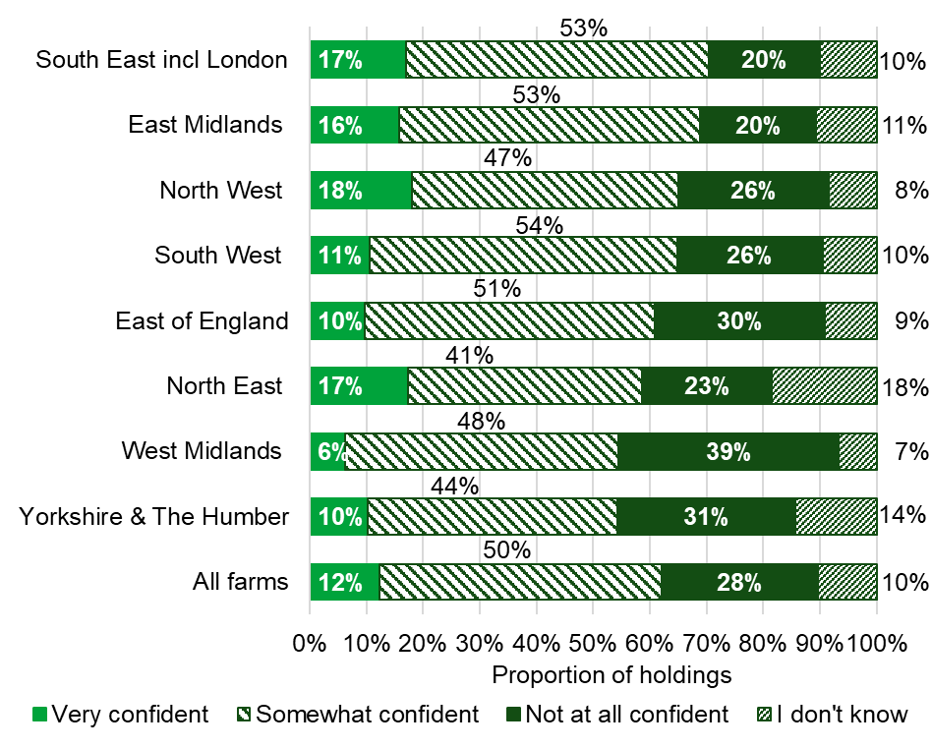

1.3 Groups
Farming organisations and advisors have a role in helping farm businesses to adapt to the changes needed. Farmers on 30% of holdings agreed that these organisations were helping them to make changes, with an additional 4% strongly agreeing (these proportions remain relatively unchanged from April 2021). Approximately 42% neither agreed or disagreed and a further 22% said they either disagreed (16%) or strongly disagreed (7%) that these organisations were helping them to make changes (see Figure 8).

Figure 8: Proportion of holdings that agree farming organisations and advisors are helping them make changes to their business
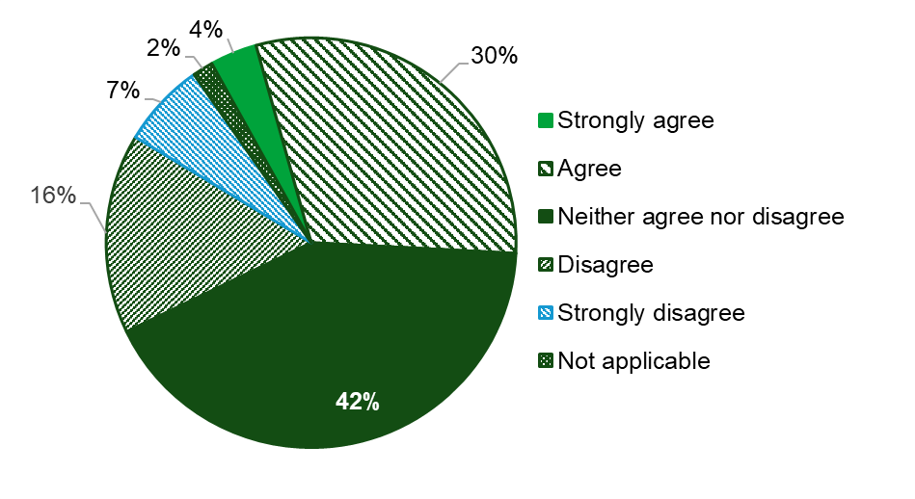

The future vision for farming involves farm businesses responding to both existing and new market demand for produce. Farmers on over two thirds of holdings (70%) said that producing for the end market would currently be very important for their farm business with a further 23% indicating that it would be moderately important (see Figure 9). Only 5% said that it was not at all important.
Looking to the future, producing for the end market was said to be very important by 74% of holdings and 15% indicated that it would be moderately important. Only 5% said it was not at all important and farmers on the remaining 5% of holdings were unsure.

Figure 9: Proportion of holdings that believe producing for the end market is important for their business
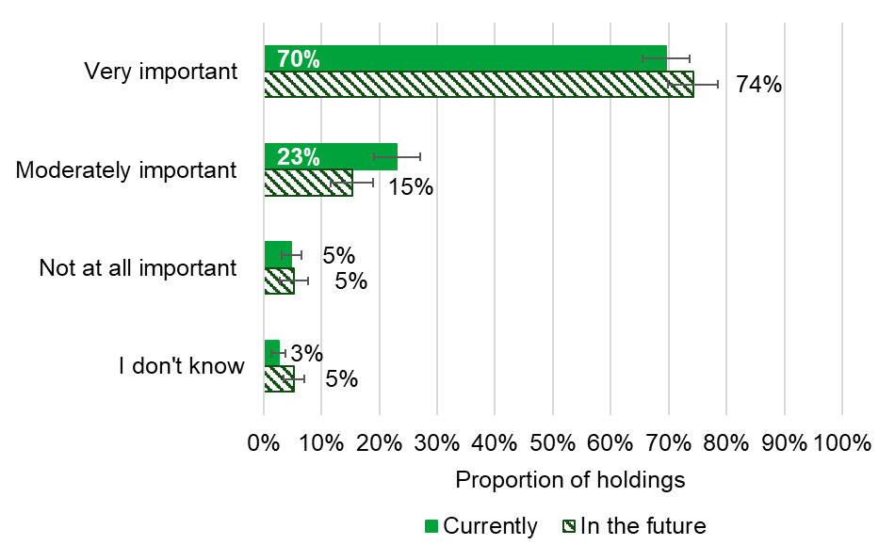

1.4 Environment
Defra's vision for farming involves providing environmental outcomes. Farmers on 80% of holdings said Defra paying for environmental outcomes was currently very (47%) or moderately (33%) important for their business (see Figure 10). A further 15% said that it was currently not at all important.
When asked how important it will be in the future for Defra to pay for environmental outcomes, farmers on 67% of holdings said it would be very important. A further 18% believed it would be moderately important and only 6% said that Defra paying for environmental outcomes in the future was not at all important (see Figure 10).

Figure 10: Proportion of holdings that believe Defra paying for environmental outcomes would be important for their business
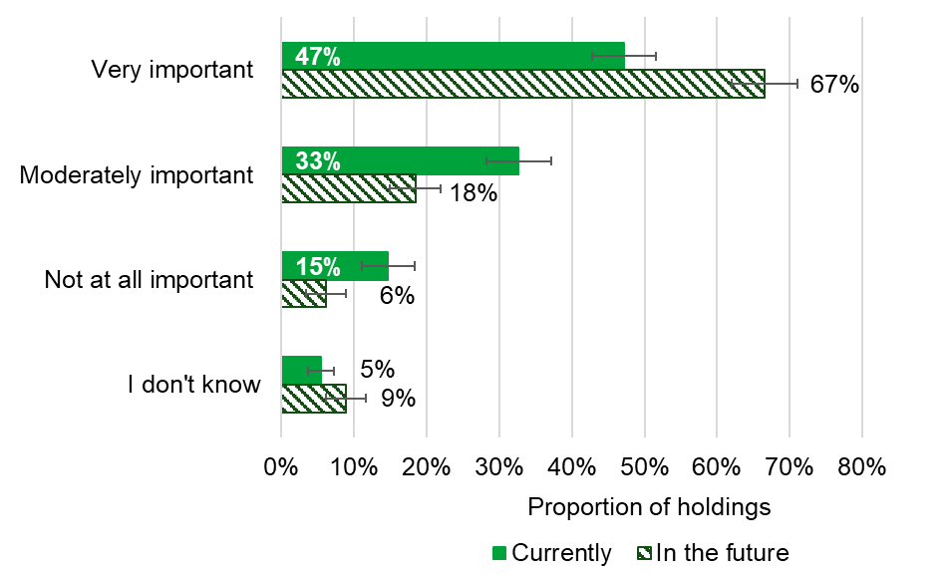

Environmental safeguards and standards in farming are maintained by both enforcing regulations and empowering individual responsibility. Farmers on 33% of holdings either agreed (29%) or strongly agreed (3%) that the current approach balances enforcement with individual responsibility (see Figure 11). This is an overall decrease from 37% in April 2021 and 43% in October 2020. Farmers on 37% of holdings neither agreed nor disagreed with the statement. A further 21% disagreed that the current approach balances enforcement with individual responsibility and 7% strongly disagreed.

Figure 11: Proportion of holdings that agree the current approach balances enforcement with individual responsibility
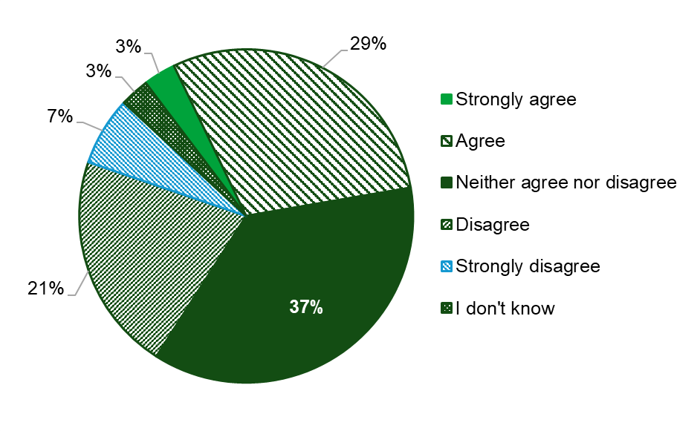

Regulations protect the environment, farmed animals and public health. Farmers on 85% of holdings said that they are either very (28%) or somewhat (57%) confident that they understand which regulations apply to their farm. A further 12% are not at all confident and only 2% don’t know which regulations apply to their farm (see Figure 12).

Figure 12: Proportion of holdings that are confident they understand which regulations apply to their farm
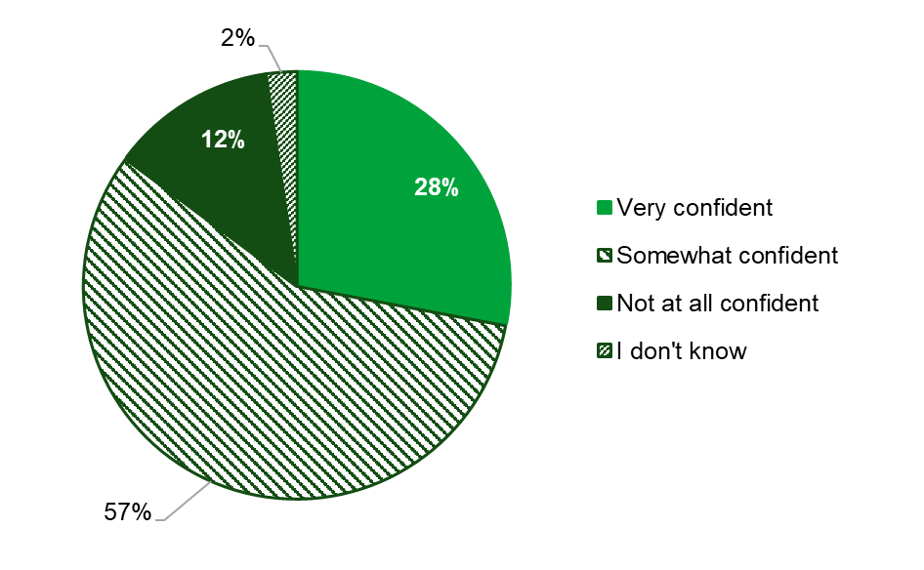

Farmers were asked to consider the regulations that apply to their farms (outside the rules associated with any payment schemes) and 33% of all holdings indicated that they fully understood the purpose of the rules. This proportion varied by farm ownership, decreasing to 25% of tenanted holdings compared to 36% of fully owned holdings and 34% of mixed holdings (see Figure 13). Farmers on over half of all holdings (56%) say that they roughly understood the purpose of the rules which apply to their farm. A further 9% don’t understand the purpose but want to know and only 2% said that they don’t need to know.

Figure 13: Proportion of holdings that understand the purpose of the regulations which apply to their farm, by farm ownership
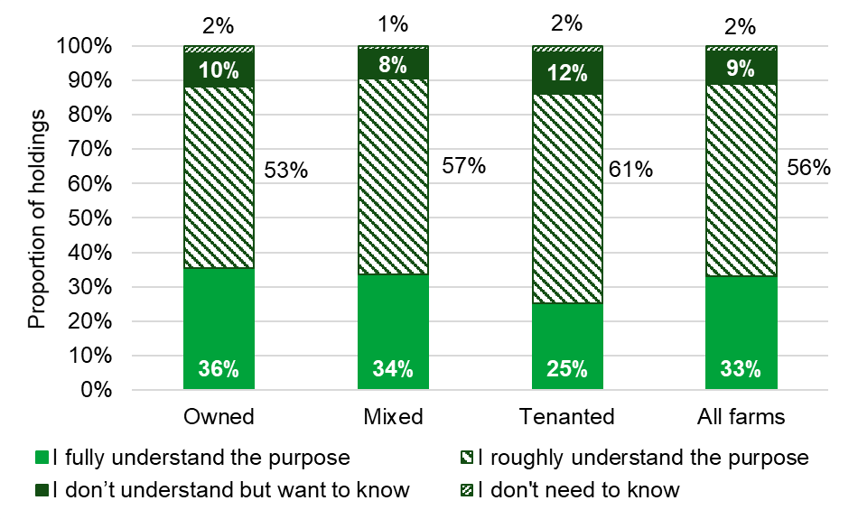

1.5 Relationships
Farmers were asked how confident they were that changes to schemes and regulations will lead to a successful future for farming and over two thirds of holdings (68%) said that they are not confident at all (see Figure 14). Almost a quarter of holdings indicated that they are either very (1%) or somewhat (23%) confident in the changes to the schemes. This overall proportion varied across farm types, as 31% of cereal holdings are confident compared to 16% of other crops holdings. The remaining 7% of farmers on all holdings don’t know if the changes to schemes will result in a successful future for farming.

Figure 14: Proportion of holdings that are confident the changes to schemes and regulations will lead to a successful future in farming, by farm type
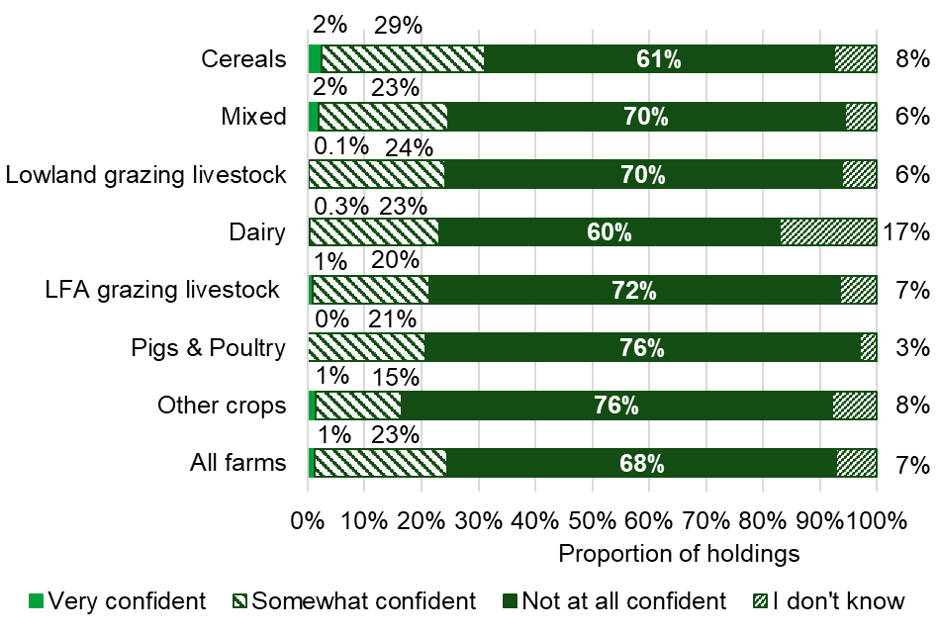

Defra and Defra agencies such as the Rural Payments Agency and Natural England are working together to deliver planned changes to schemes and regulations. Farmers on two thirds of holdings (66%) are not at all confident in Defra and Defra agency’s ability to deliver planned changes to schemes and regulations. This increased to 80% of holdings in the North West and 75% in the North East compared to 61% of West Midland holdings (see Figure 15). A further 28% of all holdings are either very (2%) or somewhat (26%) confident in Defra and Defra agency’s ability to deliver planned changes to schemes. Farmers on the remaining 5% of holdings are unsure.

Figure 15: Proportion of holdings that are confident in Defra and Defra agency's abilities to work together to deliver changes to schemes and regulations, by English region
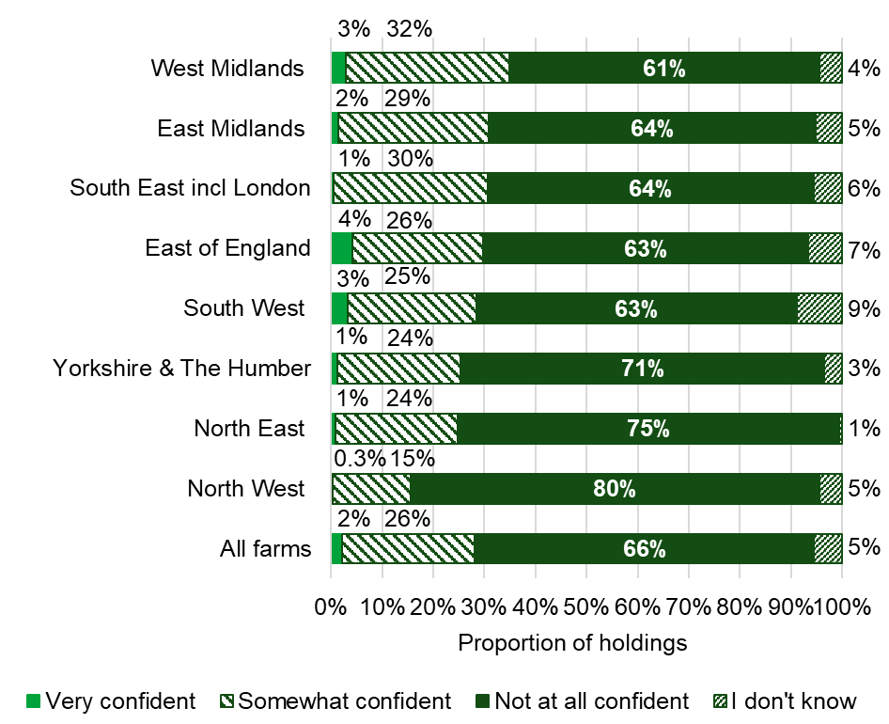

As part of delivering the changes, farmers on 52% of holdings are not at all confident that their relationship with Defra and Defra agencies (such as the Rural Payments Agency and Natural England) will develop positively in the future. This proportion has increased from 40% in April 2021 and 44% in October 2020, although in previous years farmers weren’t asked to consider changes to schemes when asked about their relationship with Defra. Farmers on 36% of holdings are either very (3%) or somewhat (33%) confident that their relationship with Defra will develop positively in the future. The remaining 12% of holdings said that they were unsure (see Figure 16).

Figure 16: Proportion of holdings that believe their relationship with Defra and Defra agencies will develop positively in the future, September 2019 to October 2021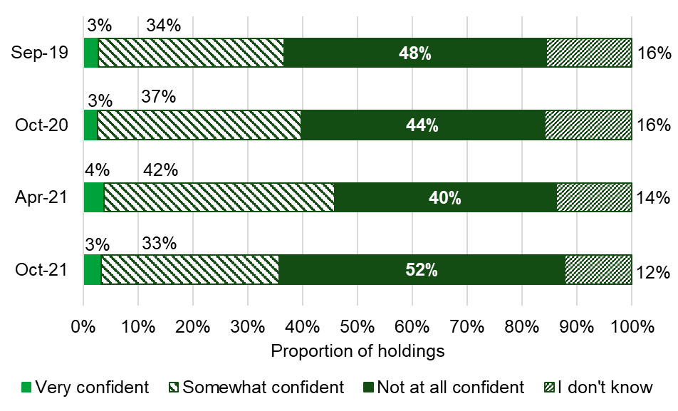
When asked to consider the changes to existing payments and regulations as well as the new schemes that will be available, farmers on 36% of holdings feel either very (4%) or somewhat (32%) positive about the future of farming. This proportion varied by farm type, as 45% of lowland grazing livestock holdings are positive compared to 26% of other crops holdings (see Figure 17). Farmers on over half of all holdings (55%) are not at all positive about the future of farming and the remaining 9% are unsure.

Figure 17: Proportion of holdings that feel positive about the future of farming, by farm type
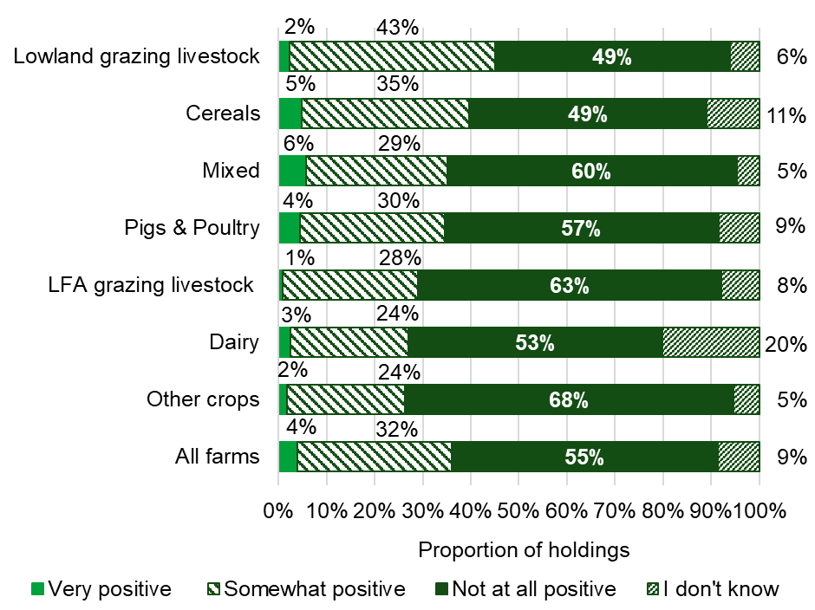

Farmers on 45% of holdings felt positive about their own future in farming (very positive 7%, somewhat positive 38%). Of the remaining holdings, just under half (47%) felt not at all positive and 9% unsure how they feel about their future in farming (see Figure 18).
Figure 18: Proportion of holdings that feel positive about their own future in farming
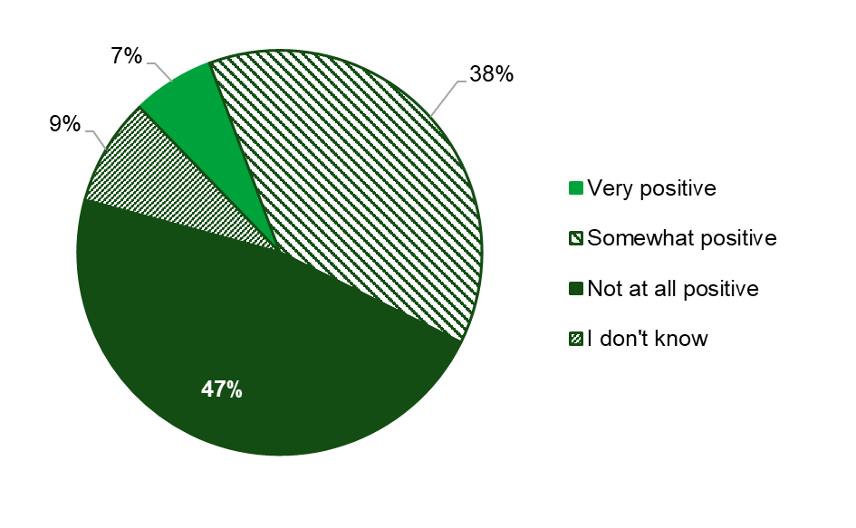

Section 2 – Open Text Comments

427 comments were provided from a variety of farm sectors, sizes, tenures, and locations. Approximately 34% of survey respondents provided a comment.
It should be noted that people with strong views are more likely to comment. This can potentially result in negative comments appearing more prevalent than might be the case i.e. respondents who are relatively content are less likely to provide comments.
A variety of themes were covered. The most commonly mentioned themes were about relationships between the farming community and Defra, feedback about Environmental Land Management (E.L.M.) schemes, and concerns about international trade deals and import standards.

2.1 Future Farming Vision

High Level Vision Feedback and Sentiment
The future farming vision was a more prominent theme (mentioned in a third of all comments) compared to previous surveys. Overall, there was mainly mixed or negative sentiment (e.g. “I feel the vision is good and as long as the government support British farming, I feel the proposal will work very well, however if we still insist on importing everything the farmer will lose heart and this will stand for nothing”). Similarly to previous surveys there were references to the vision being “muddled”. The main reason for this was a perception that Defra was “out of touch” with farming life. Other reasons included doubt in Defra’s commitment to farmers; scepticism about Defra’s ability to deliver (sometimes based on previous experiences); and questions about Defra’s policy priorities. There were a few positive and optimistic comments (e.g. “I think that British Farmers will cope with the changes”).
There were a few suggestions for how the vision could be improved, for example fairer treatment of farmers; not hindering food production; ensuring accountability of large agribusinesses; improving communication and transparency of decisions; enabling profitable farms by driving up demand and reducing costs; and educating the public about respecting the countryside.

2.2 The Agricultural Transition Period and Environmental Management

Environmental Land Management (E.L.M.) Schemes
As in previous surveys, feedback about E.L.M. schemes was a major theme; mentioned in just under half of all comments. There were concerns about payments (e.g. being too low and not a suitable “replacement” for the loss of direct payments); restrictive eligibility criteria; the complexity of schemes; and a perceived lack of reward for existing environmental management. There were frustrations from the lack of detail about E.L.M. schemes; for some this was “critically restricting future business planning”. It is important to note that details, including payment rates, for the Sustainable Farming Initiative were not published until 2nd December 2021, five days before the survey closed.
Some respondents revealed negative experiences of current or previous agri-environmental schemes which had influenced their perceptions and potential uptake of future support. These included late and low payments, “nit picking” rules, administration burden, and not achieving the desired outcomes. Other respondents lacked confidence in Defra to deliver E.L.M. schemes because of pressures on resources and a lack of policy direction.

Farming Priorities
As with previous surveys, respondents described different farming styles and their individual priorities for farming. Many respondents emphasised the need to prioritise food production to meet the needs of a “growing population”. Production was core to many farmers’ roles and identities; “we are farmers and want to farm the land”. The need for environmental protection and the work farmers already do to care for the environment was mentioned but was less prevalent in comments. Other respondents preferred a more balanced approach which enabled food production whilst managing the environment. These different farming styles were often linked to wider issues around E.L.M. schemes, international trade, imports, and business viability. There was a perception from a few respondents that Defra was accommodating environmental lobby groups and not listening to farmers.

2.3 Relationships and Communication

Defra’s Relationship with the Farming Community
The relationship between Defra, Defra agencies, and the farming community was a prominent theme again, mentioned in a third of all comments. Many respondents voiced concerns about a lack of understanding of, and care for, farming life (especially in relation to poor experiences with red tape, inspections, and penalties). The value of on-the-ground practical experience was emphasised by many respondents as crucial for developing policies. There was a perception that Defra and agencies sometimes don’t listen, respect, value or encourage farmers, undermining the competence of the farming community. A lack of trust was also highlighted in the context of trade deals undermining farming standards. Similar to the previous survey, there was a key point about lack of join-up between Defra and agencies and conflicting messages about farming and environmental regulations (e.g. manure application for soil health versus water quality protection).
There were a few positive comments about partnership working, including an “excellent relationship with Natural England”, and “working with DEFRA has been in the last few years (apart from COVID) a better experience”. There were a few requests for a more constructive and open relationship both between agencies and with the farming community. Other suggestions for improvements included a “culture shift” to more collaboration; providing streamlined, individual, and simple information and support (rather than taking a “policing” role); being more approachable; and demonstrating how Defra is listening to farmers.

Defra’s Communication with the Farming Community
Many respondents described communications from Defra and agencies as “vague” and lacking detail and were in turn linked to feedback about E.L.M. schemes, relationships, and the future farming vision. A few respondents were unaware of the upcoming changes or mentioned “hearsay” from peers as their only source of information. The lack of detail was sometimes attributed to a perception that Defra does not know what it wants. Links were made between the lack of clarity of information and the impact on decision making, business planning, wellbeing, and future business viability; some farmers felt “in limbo”. There were requests for “concrete proposals” with accurate, individual, and financial details to be made available immediately. There were also a few requests for more direct communication between policymakers and “on-the-ground" farmers.

2.4 Markets and Food Standards

International Trade Deals
A key theme about external trade is becoming more pronounced throughout the surveys, now accounting for around a quarter of all comments . As well as growing in significance, the focus has shifted from perceived implications of leaving the EU to negotiated international trade deals and the perceived impacts of an increase in imports on the industry. There were concerns around lower animal welfare and environmental standards; competition; “fairness”; and the need for a “level playing field”. A perceived lack of support for the industry and the need to “buy British” were raised as impacting relationships with government.

2.5 The Reality of Farming Life ‘On the Ground’

Business Viability and Planning
Business viability was consistently raised in relation to the future farming vision, the loss of the Basic Payment Scheme (BPS), and the introduction of E.L.M. schemes. Respondents voiced concerns about the future viability of their own farms as well as the sector as a whole. This was a particular worry for respondents with limited options to adapt. Some respondents were particularly fatalistic, suggesting that “the future looks bleak” and need for a “survival” mentality. There were suggestions that some respondents will leave the industry; some farms could “go to the wall”.
However, a few comments emphasised taking action to improve business resilience, and examples included diversifying income streams to support regenerative agriculture, reducing input costs, and breed selecting for resilient sheep. There were also positive outlooks on future change referencing the usefulness of grants for equipment, and overall hope e.g. “despite current edicts, I am hopeful for the industry and survival within it”. Some respondents emphasised the long-term nature of farming and were frustrated with their limited ability to plan ahead. A few respondents cited a lack of information about E.L.M. schemes and other regulatory changes in suggesting that some farm businesses were “stagnating” while farmers waited for changes to be announced.

Weather and Climate Change
Issues relating to climate change and weather were raised in a few comments. The COP26 summit (31st October to 13th November 2021) could have prompted respondents’ focus on net zero and climate change, such as concerns about reducing meat-based diets, rewilding agendas, and feeding a growing population. A few respondents noted the impact of increasing imports on food carbon footprints. A few respondents also felt farmers were being blamed for climate change alongside receiving limited recognition of the environmental benefits they deliver. Adverse weather was briefly mentioned as a volatile external factor impacting the farming community, alongside other external factors such as input costs (especially fuel and fertiliser).

Wellbeing
Wellbeing was a cross cutting theme, including negative impacts from uncertainty, loss of BPS payments, and regulation. A few farmers were “struggling to cope” and some comments referenced stress, anxiety, worry, fear, lack of hope, and depression. These were sometimes caused by the inability to plan for the future, apprehension about the policy direction (e.g. reduced food production and reliance on imports), and tight margins creating a “crisis point”. One respondent raised concerns about the suicide rate among farmers. The strength of feeling was clear with some respondents using capital letters and exclamation marks for emphasis.

Specific Challenges for Different Farm types
Over a fifth of all comments revealed insights about challenges and opportunities for different farm types. Similar to previous surveys, most comments were received about tenant farms and small, family farms. Tenant farmers mentioned common challenges about restrictions from landlords (e.g. in diversifying the farm), farming subsidies “bypassing” some tenants and going into “landlords’ pockets”, and challenges about paying rent when subsidy payments were changing. Some tenant farmers felt “left out” from E.L.M. schemes and grants - there was a lack of confidence in their eligibility for schemes, being recognised for their environmental work, or their ability to afford additional costs. This was causing some concern about their future viability.
Small and/or family farms were also highlighted as a potentially vulnerable sector. This was due to limitations of resources (e.g. capital, land, staff, time) and smaller economies of scale to adapt; a common assumption that small farms will “lose out” from E.L.M. schemes; and that the future farming vision was focused on larger, industrial scale farming. A few respondents mentioned the negative impact of losing small farms on animal welfare and the environment.
There were a few comments about specific challenges experienced by hill, upland, marginal and commons farms. Challenges included their reliance on subsidies; concerns about how to replace BPS payments; Defra not understanding the unique needs of these farms; and not demonstrating how they fit into the future vision. The unique situation of these farms was highlighted as causing additional pressures and impacts on wellbeing.

2.6 Miscellaneous

Survey comments
A few comments provided feedback on the survey itself. Some were positive and voiced appreciation for the survey. Others were critical, suggesting the survey was “pointless” or suggesting that the questions were poorly worded, or the options given were not appropriate. A few respondents suggested that they couldn’t fully answer the survey due to the limited information available to them.

2.7 What’s Different Now? (Comparison to previous results)
While there are recurring themes across the opinion trackers, some changes have occurred. In this tracker, a higher proportion of respondents provided a comment at the end of the survey.
The issue of protecting British agriculture has been raised in all the trackers but continues to gain more focus and importance each time. This was closely linked to an increase in the number of comments raising concerns about import standards and perceptions that the government was prioritising international trade over “home” production (based on recently negotiated trade deals).
Issues relating to E.L.M schemes have been dominant in all the trackers, however more comments were made about the schemes in this particular survey. In addition to requests for further information (which has been raised consistently), there were more prominent concerns about payment levels and eligibility.
A higher proportion of comments were made about the farming community’s relationship with Defra although the mixed and negative sentiment has generally remained the same across surveys. There were also more comments about business viability, the future farming vision, wellbeing, and references to specific challenges for different farm types in this survey.
A higher number of comments referred to climate change in this tracker. This is likely due to the prominence of the COP26 summit while the survey was open. While very few comments discussed climate change in isolation, many referred to it in relation to other issues (including those covered in previous trackers). For example, the impact of imports on carbon footprints, the problem of “outsourcing” environmental pollution to other countries, and the need to “buy local” to limit emissions.
Covid-19 was only a very minor theme, similar to the previous survey. The impact of inflation and higher input costs was more prominent in this survey, and it was stated that this was tightening profit margins even further – this was sometimes linked to supply chain issues from Covid-19 or changing arrangements since leaving the EU. There was less mention of low commodity prices and the power of supermarkets in this survey, but more feedback about specific regulations (for example spreading manure, which had featured prominently in the farming media during the survey period).

Section 3 – About these statistics

3.1 Methodology
The Farmer Opinion Tracker provides a snapshot of views and opinions towards Defra’s vision for farming as at October 2021. Farmers were asked questions about Defra’s vision for farming, business planning, relationships with farming organisations and Defra and the future of farming.
The results provided in this report are based on surveys sent to a representative sub-sample of the farming community in England, approximately 6,000 holdings. The survey was voluntary and 1,267 responses were received (including some partial responses), resulting in a response rate of 20%.
To be included in the main sample, holdings had to have at least 50 cattle, 100 sheep, 100 pigs, 1,000 poultry or 20 hectares of arable crops or orchards. Therefore, all results given in this statistical report reflect just over 60 thousand holdings that exceed these thresholds out of the total English population of almost 107 thousand commercial holdings.

3.2 Data analysis
Results have been analysed using a standard methodology for stratified random surveys to produce national estimates. With this method, all of the data are weighted according to the inverse sampling fraction.

3.3 Accuracy and reliability of the results
We show 95% confidence intervals against the results in the Farmer Opinion Tracker dataset. These show the range of values that may apply to the figures. They mean that we are 95% confident that this range contains the true value. They are calculated as the standard errors (se) multiplied by 1.96 to give the 95% confidence interval (95% CI). The standard errors only give an indication of the sampling error. They do not reflect any other sources of survey errors, such as non-response bias.

3.4 Uses and Users
The survey was set up to collect farmer opinion on the future for farming in England prior to, and during, the Agricultural Transition. The aim is to be open and transparent about what we are hearing from the farming community and then acknowledge and respond to areas where we need to improve. The data collected via this survey will be used to create a baseline dataset of farmer opinion which can then be monitored over time to see how it is changing as we move through the agricultural transition period.

3.5 Definitions

Region
This refers to the NUTS1 regions in England, for the purposes of this analysis we have combined the South East with London.

Farm type
This refers to the ‘robust type’, which is a standardised farm classification system. Farms are split into Dairy, Grazing Livestock Less Favoured Areas (LFA), Grazing Livestock Lowland, Mixed, Other crops, Cereals and Pigs & Poultry (Specialist Pigs and Specialist Poultry combined).

Farm sizes
This is based on the estimated labour requirements for the holding, rather than its land area. The farm size bands used within the detailed results tables which accompany this publication are shown in the table below. Standard Labour Requirement (SLR) is defined as the theoretical number of workers required each year to run a holding, based on its cropping and livestock activities.
Farm size | Definition
Small | Less than 2 SLR
Medium | 2 to less than 3 SLR
Large | 3 or more SLR

Farm ownership
This is based on data from the June Survey of Agriculture and Horticulture. The types are split into:
- Owned - all area on the holding is owned
- Tenanted - All area on the holding is rented under a Full Agricultural Tenancy, Full Business Tenancy, Other agreement or is seasonally rented in (364 days or less)
- Mixed - area on the holding is a mixture of owned and tenanted

3.6 Future publications
The Farmer Opinion Survey for England was first run in Autumn 2019. The survey was set up to collect opinion prior to, and during, the agricultural transition which is the period of the Future Farming and Countryside Programme. Therefore, it is expected
the survey will run every 6 months until 2028. Please note, only one survey was run in 2020 as Covid disrupted data collection.

The next survey will be run in spring 2022. The publication date will be announced on the research and statistics webpage on gov.uk.

