NOTICE OF ORDER
Wildlife & Countryside Act 1981 - S53

Hampshire County Council & Wokingham Borough Council
The Hampshire (Hart District 27) (Bramshill) &
The Wokingham Borough Council, Parish of Swallowfield (Swallowfield Byway Open to All Traffic 38 And Swallowfield Restricted Byway 39) Definitive Map Modification Order to 2019

Notice is hereby given that the above referenced Order has been submitted to the Secretary of State for Environment, Food and Rural Affairs for determination. An Inspector will be appointed by the Secretary of State to determine the Order.

The start date for the above Order is 01 February 2022.

Consideration of the Order will take the form of a public local inquiry.

The Inquiry will be held at The Council Chamber. Civic Offices, Shute End, Wokingham, Berkshire RG40 1BN on 20 July 2022 at 10.00am.

The effect of the Order, if confirmed without modifications, will be to modify the definitive map and statement for the area as described in the Schedules below.

SCHEDULE
PART I
Modification of Definitive Map
Description of paths or ways to be added

From grid reference SU 75296 63512 to grid reference SU 75251 63479
A byway open to all traffic varying between 7.9 and 13 metres in width, commencing as a continuation of Jouldings Lane, adjacent to the entrance to Jouldings Farm, and proceeding in a south-westerly direction alongside the farm to the edge of the River Blackwater at Jouldings Ford, as shown by grey shading and a broken green line between Points A and B on the accompanying map.
A total length of 57 metres.

From grid reference SU 75251 63479 to grid reference SU 75124 63219
A restricted byway varying between 7.7 and 13 metres in width, commencing 5 metres north-east of the county boundary at Jouldings Ford, and proceeding in a south-westerly direction between hedges, through field gates at SU 75228 63439 (Point X) and SU 75140 63252 (Point Y), as shown on Ordnance Survey 25 inch map of 1896, to a junction with Well House Lane, as shown by grey shading and a broken green line between Points B and D on the accompanying map.
A total length of 290 metres.

NOTE: ALL LENGTHS ARE APPROXIMATE

PART II
Modification of Definitive Statements
Variation of particulars of paths or ways

The following description shall be added to the Definitive Statement for the Parish of Swallowfield:

Swallowfield Byway Open To All Traffic 38
SU 75296 63512 to SU 75251 63479
Commencing at a junction with Jouldings Lane, proceeding south-westward over track between hedges for 57 metres to the River Blackwater (Jouldings Ford). Varying between 7.9 and 13 metres wide, as shown by grey shading on the Order map.

Swallowfield Restricted Byway 39
SU 75251 63479 to SU 75249 63475
Commencing at the edge of the River Blackwater, proceeding south-westward through Jouldings Ford for 5 metres to the county boundary. 13 metres wide, as shown by grey shading on the Order map.

The following description shall be added to the Definitive Statement for the Parish of Bramshill:

Bramshill Restricted Byway 503
SU 75249 63475 to SU 75124 63219
Commencing at a junction with the county boundary, proceeding south-westward over track between hedges for 285 metres to Well House Lane. Varying between 7.7 and 13 metres wide, as shown by grey shading on the Order map.
Field gate at SU 75228 63439 & Field gate at SU 75140 63252

Any queries relating to this Order should be referred to Clive Richards at The Planning Inspectorate, Rights of Way Section, Room 3/A Eagle Wing, Temple Quay House, 2 The Square, Temple Quay, Bristol, BS1 6PN. Telephone: 0303 4445502. Email: rightsofway2@planninginspectorate.gov.uk Please quote reference number ROW/3271783 on all correspondence.

Any person wishing to view the statements of case and other documents relating to this Order may do so by appointment at Hampshire County Council, Podium Level, The Castle, Winchester, SO23 8UJ by contacting the Countryside Service Office on 0370 779 0202 to make an appointment. Any queries relating to documents should be directed to the Council. Our contact: Jennifer Holden-Warren, Tel: 0370 779 0383, Email: Jenny.Holden-Warren@hants.gov.uk

Timetable for sending in statements of case and proofs of evidence

Within 8 weeks of the start date by [by 29 March 2022]

The Order Making Authority must ensure their statement of case is received by the Secretary of State. As soon as possible after the deadline, the Secretary of State will send a copy (excluding copies of any supporting documents - these will be available to view at the Authority’s offices) to everyone who has made an objection or representation and the applicant and any other person who has written to us in respect of the Order.

Within 14 weeks of the start date [by 10 May 2022]

Everyone who has made an objection or representation and anyone who wishes to give evidence at the Inquiry must ensure their statement of case is received by the Secretary of State. As soon as possible after the deadline, the Secretary of State will send full copies to the Authority. Copies will also be sent to the applicant, every person who has made an objection or representation and any other person who has written to us in respect of the Order (excluding copies of any supporting documents - these will be available to view at the Authority’s offices).

Within the same period the applicant (if applicable) must ensure their statement of case is received by the Secretary of State. As soon as possible after the deadline, the Secretary of State will send a full copy to the Authority. Copies will also be sent to everyone who has made an objection or representation and any other person who has written to us in respect of the Order (excluding copies of any supporting documents - these will be available to view at the Authority’s offices).

4 weeks before the date of the inquiry [by 22 June 2022]

The Authority, everyone who has made an objection or representation, the applicant (if applicable) and anyone who wishes to give evidence at the Inquiry must ensure their proof of evidence (together with any summary) is received by the Secretary of State. As soon as possible after the deadline, the Secretary of State will send copies of:

- the Authority’s proof of evidence to everyone who has made an objection or representation, the applicant and anyone who has submitted a statement of case (including copies of any supporting documents – although none should be submitted with a proof of evidence);

- the applicant’s proof of evidence to the Authority, everyone who has made an objection or representation and anyone else who has submitted a statement of case (including copies of any supporting documents – although none should be submitted with a proof of evidence); and

- all other proofs of evidence to the Authority, the applicant, everyone who has made an objection or representation and anyone else who has submitted a statement of case (including copies of any supporting documents – although none should not be submitted with a proof of evidence).

All parties must keep to the timetable set out above and ensure that statements of case and proofs of evidence are received by the Secretary of State on time. Late documents will be returned.

We cannot accept any inflammatory, discriminatory or abusive comments. Any documents containing such comments will be returned.

Notice of order for inquiry

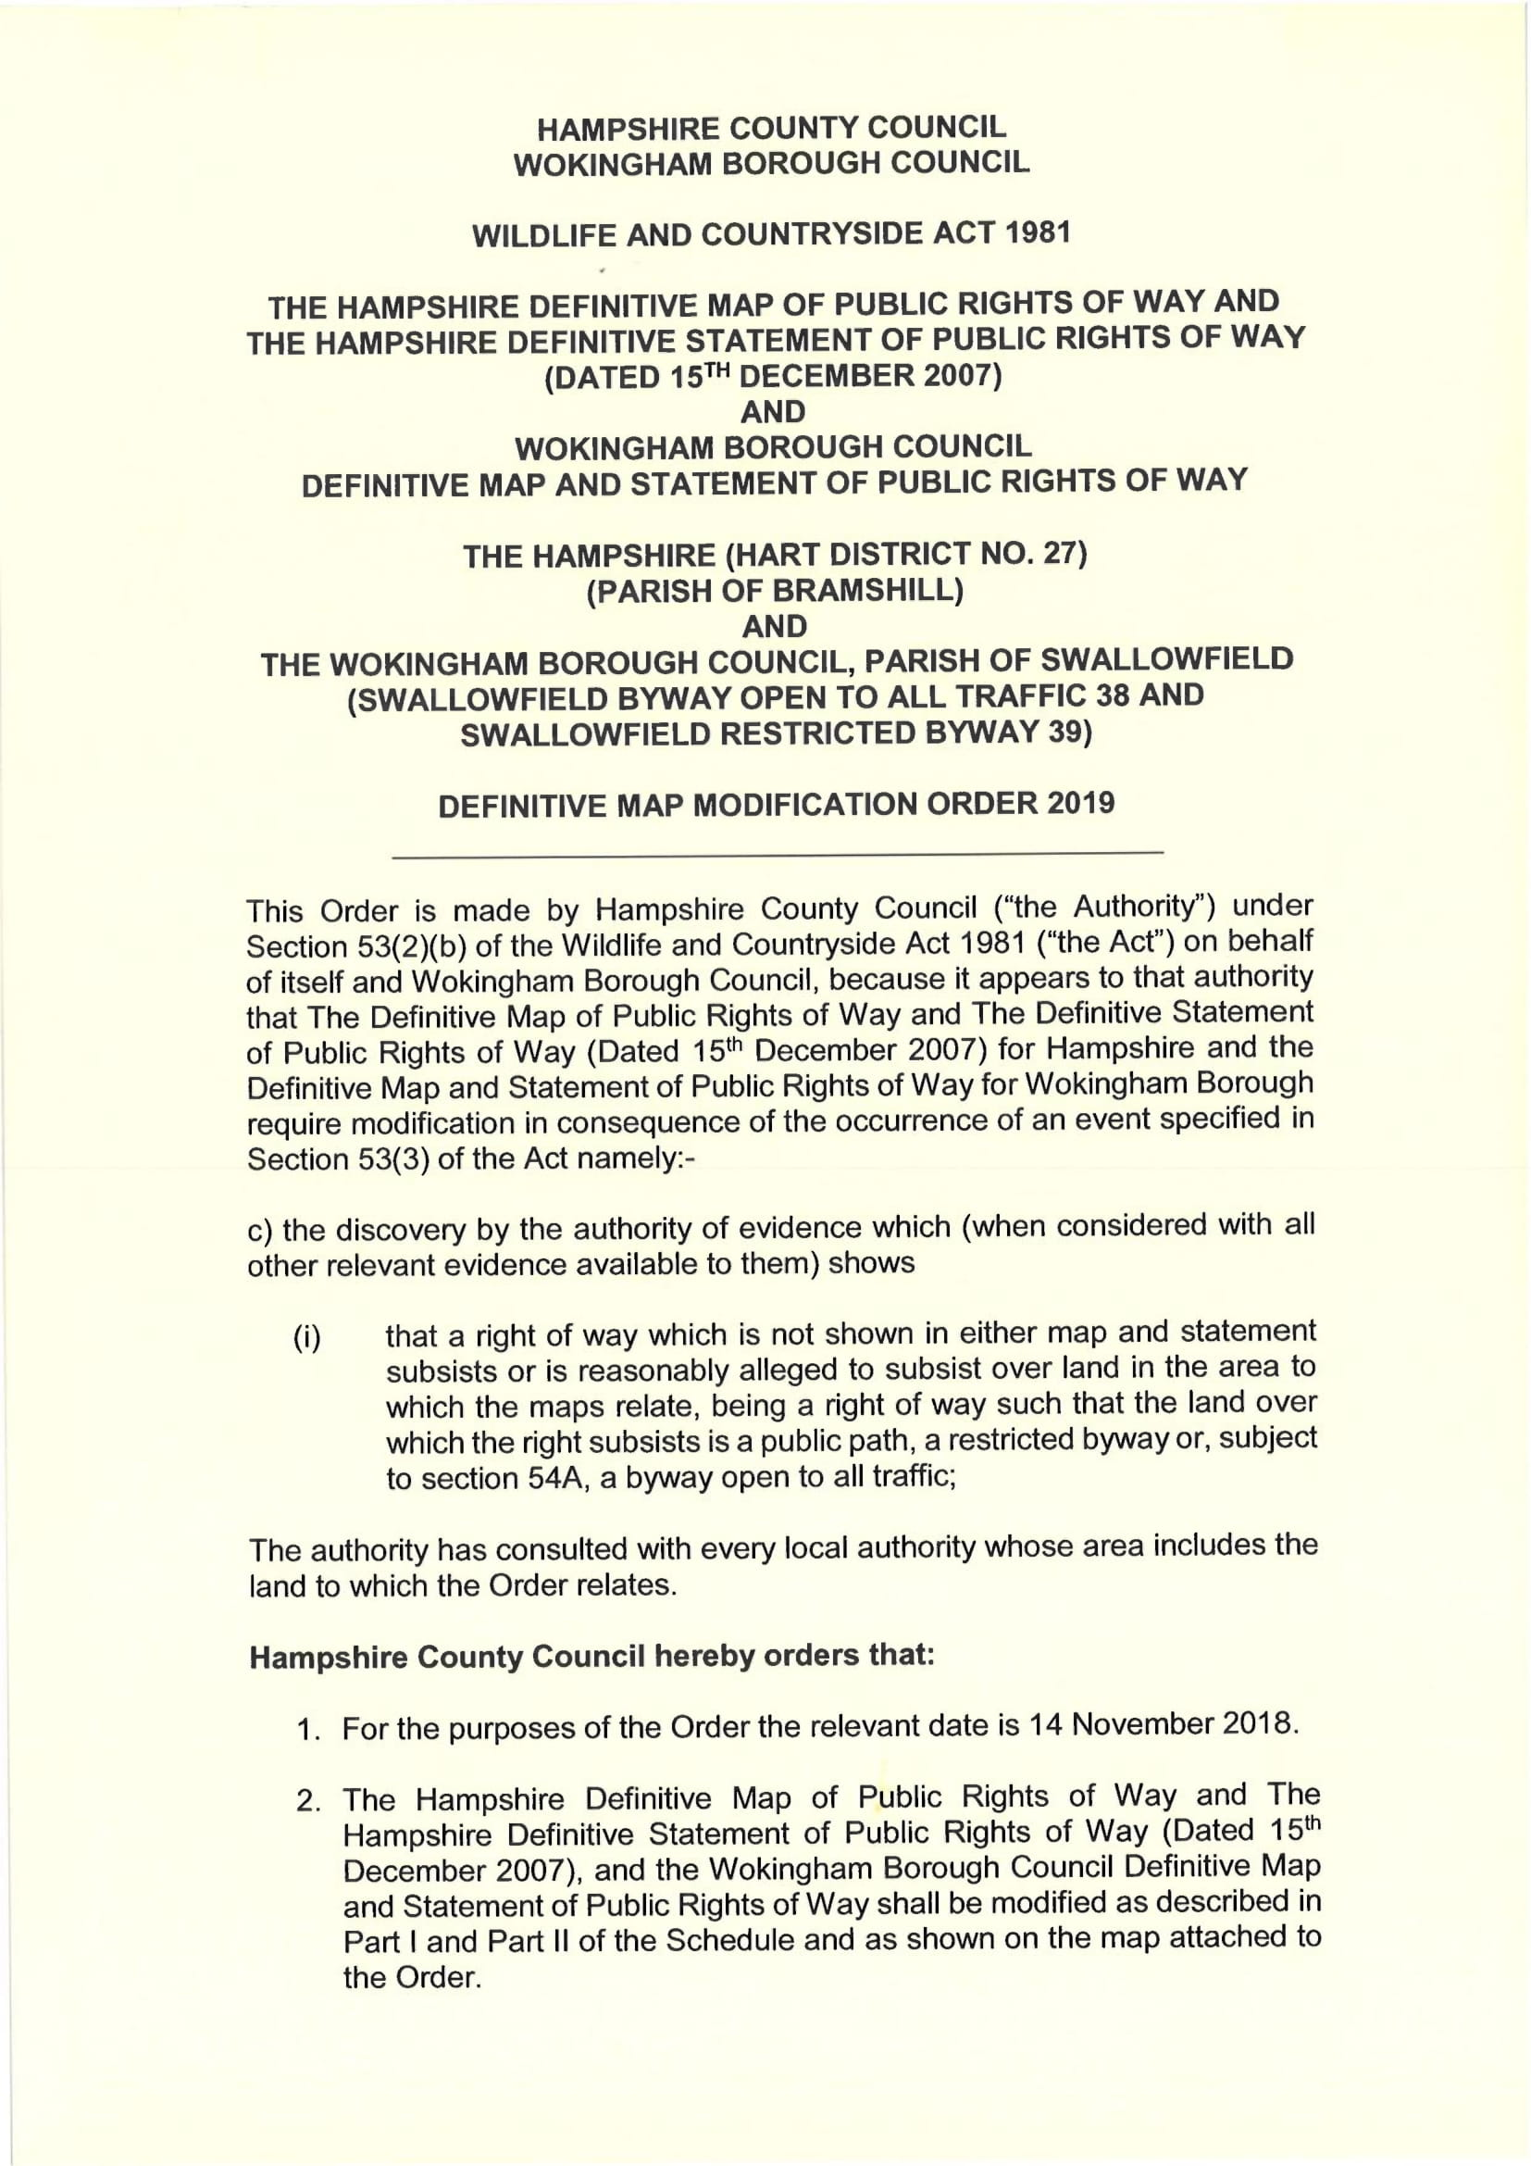
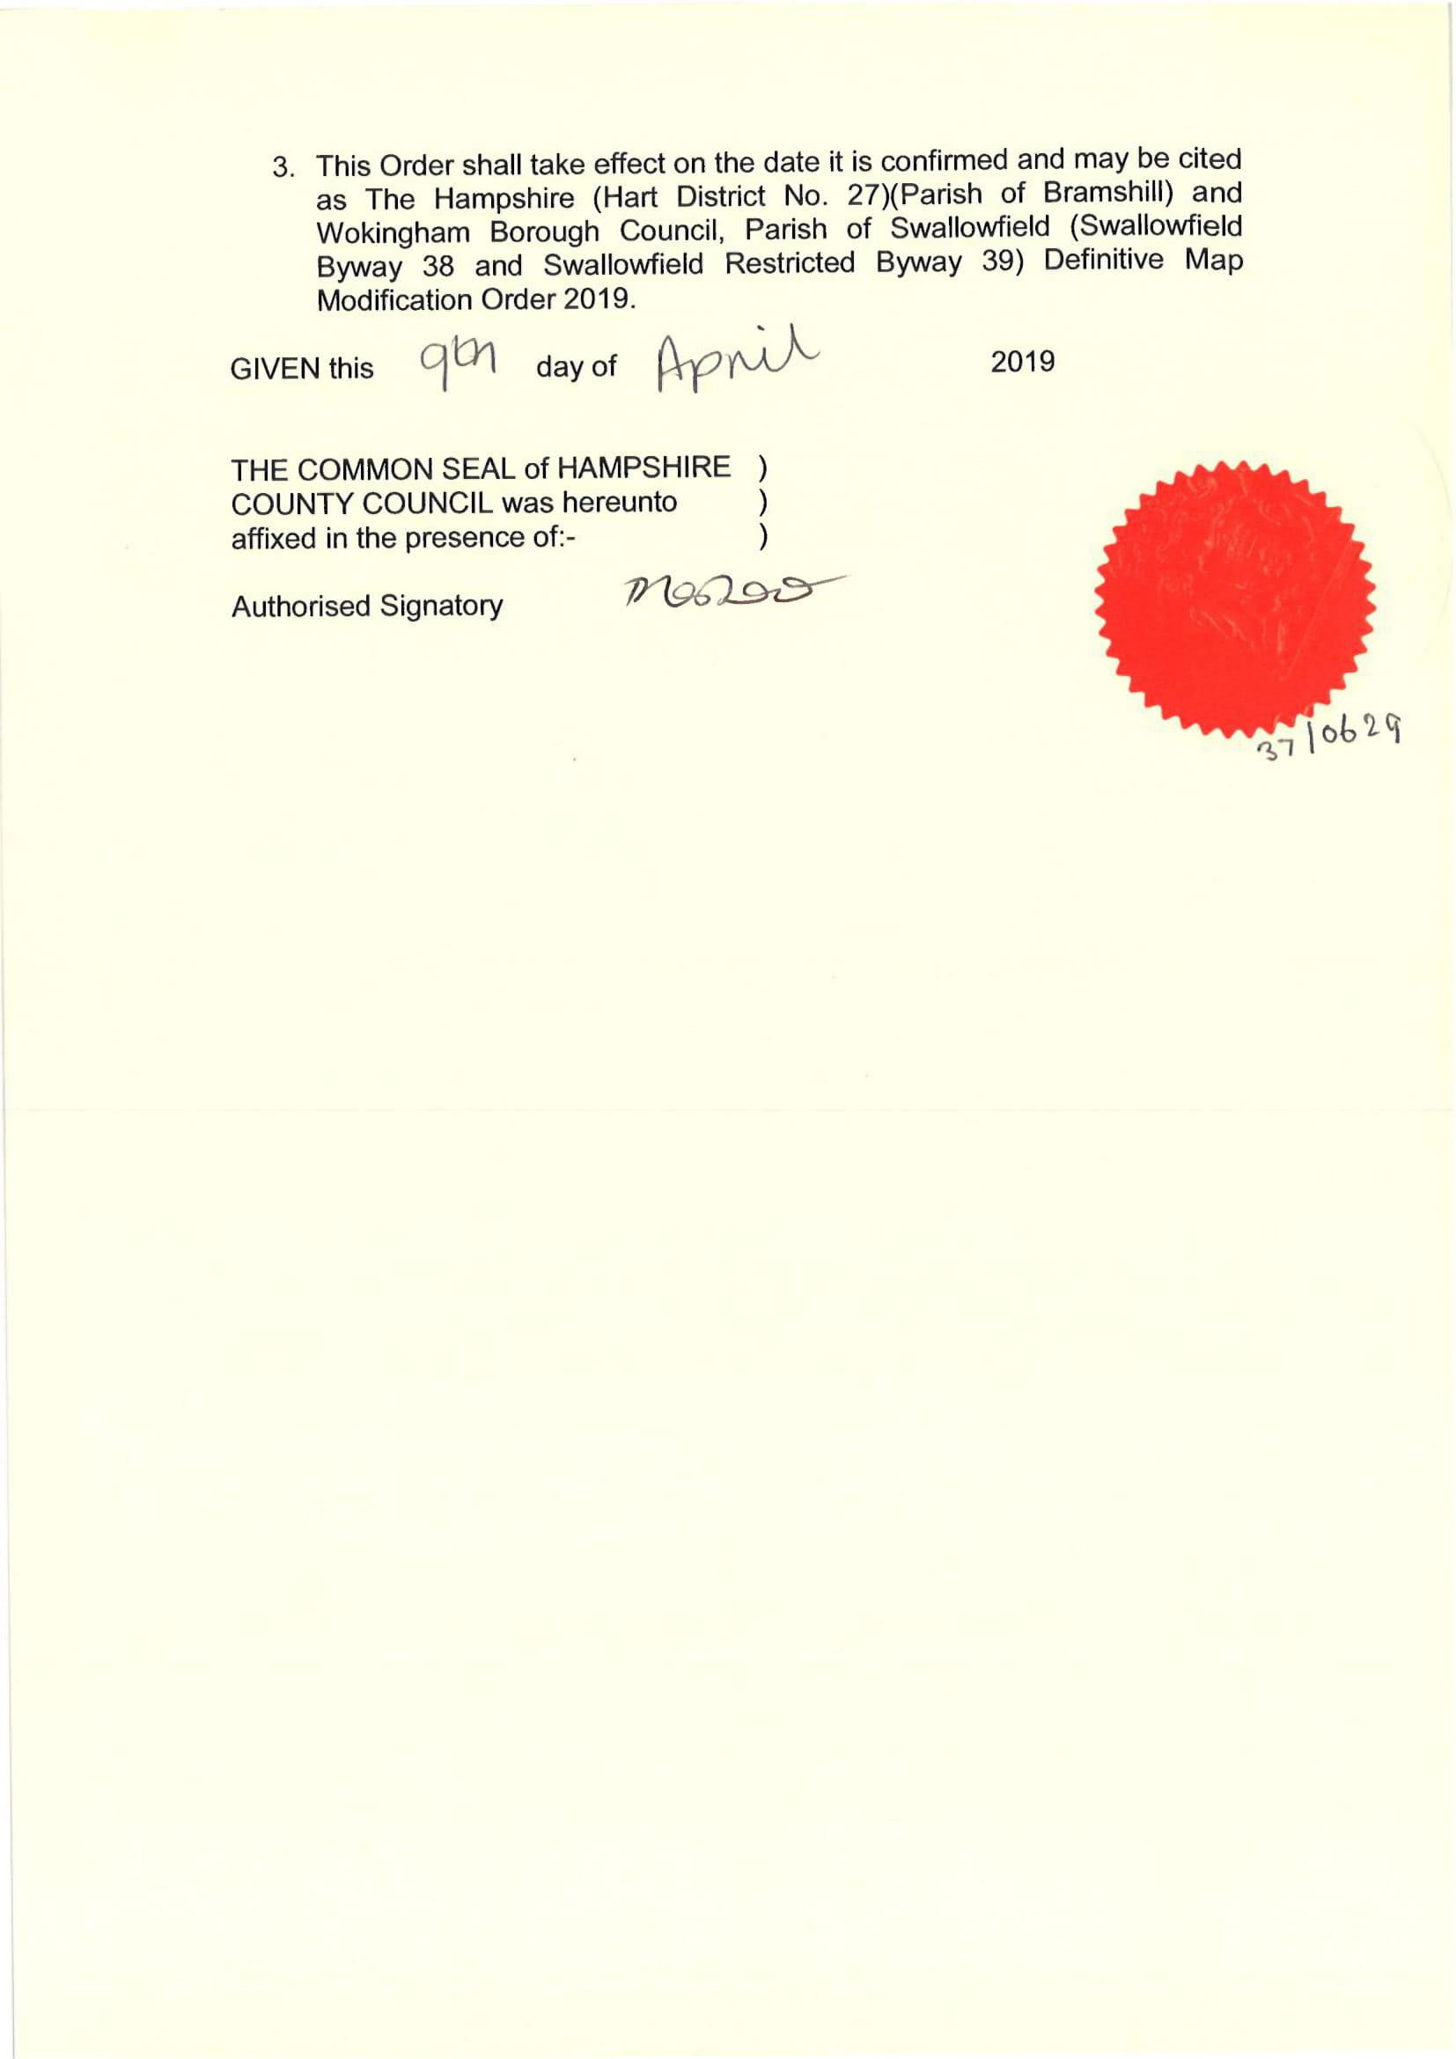
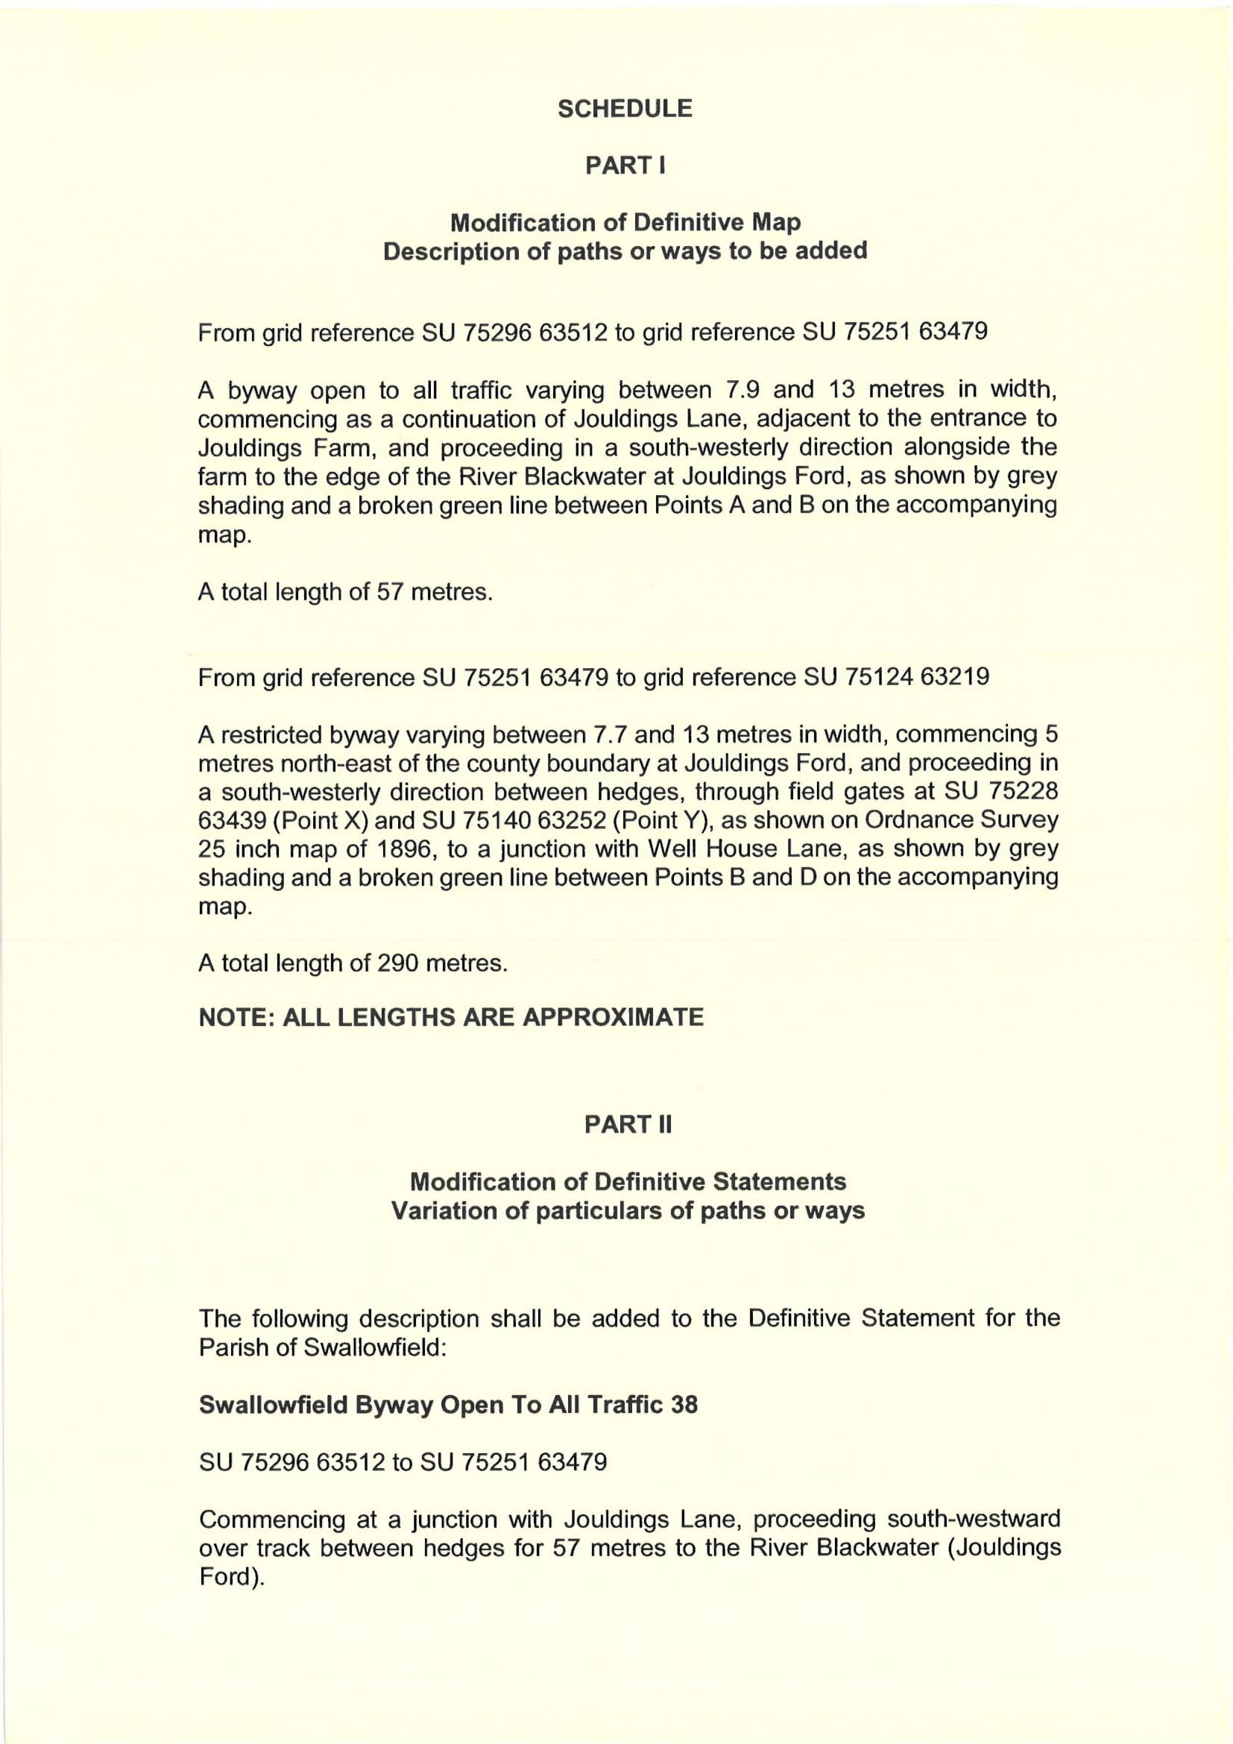
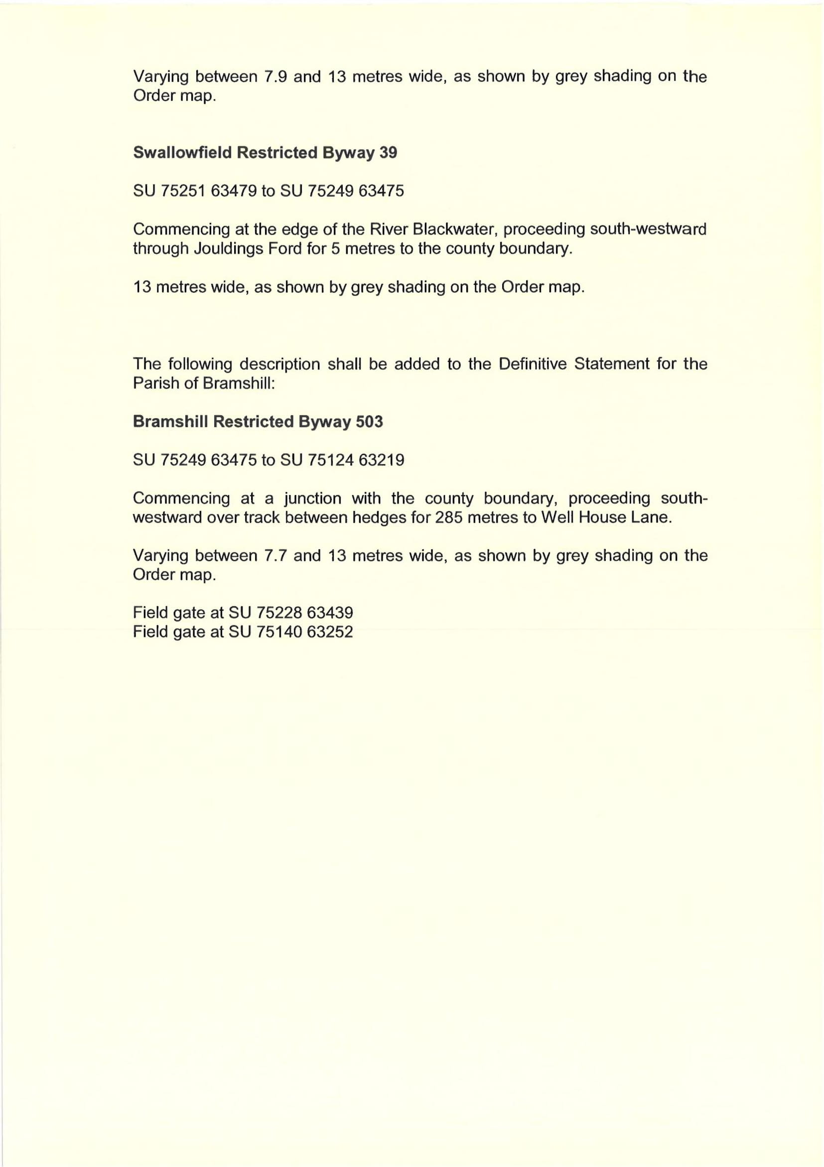
MAP NOT TO ORIGINAL SCALE

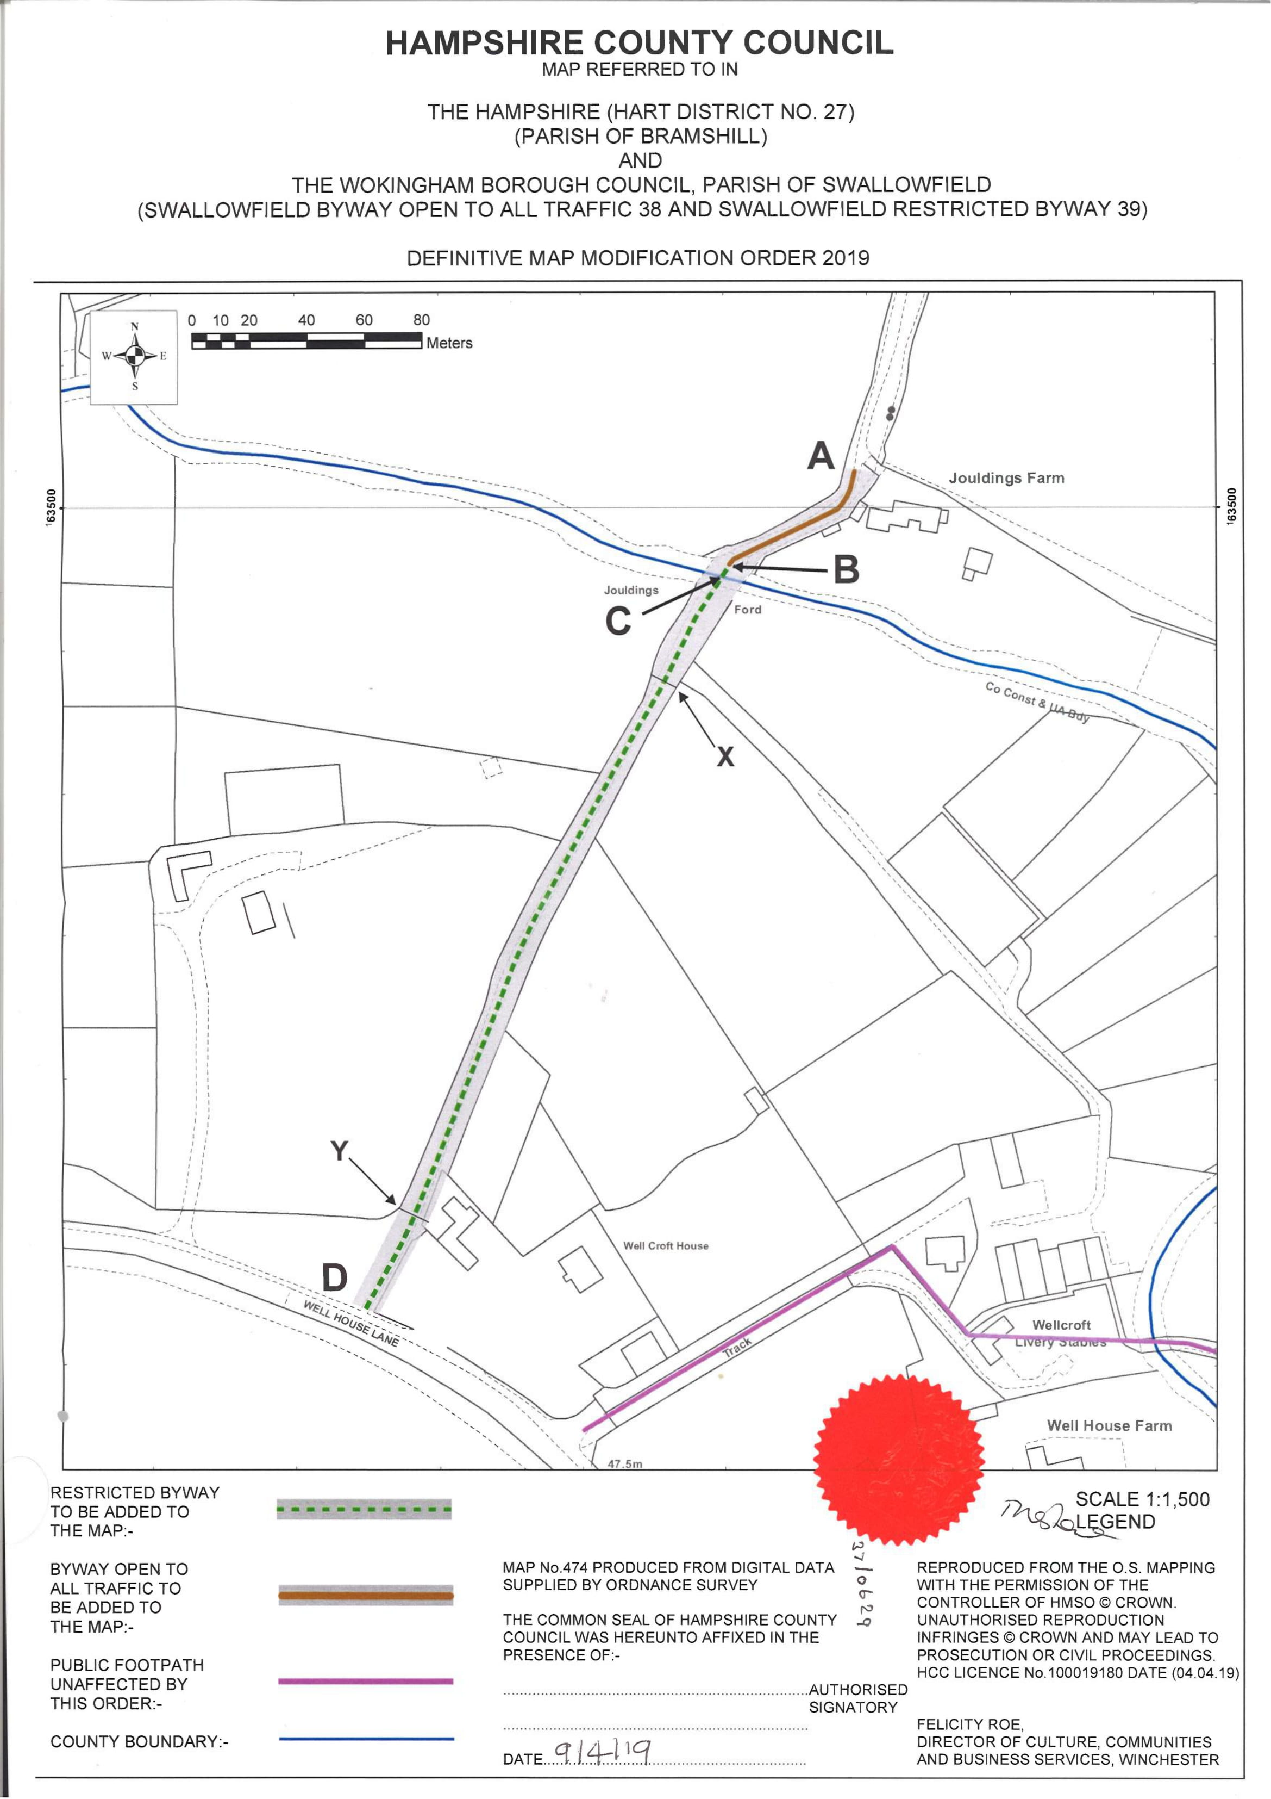

If you wish to make a legal submission, this should be submitted at the same time as your statement of case. Otherwise legal submissions will have to be submitted in writing on the day of the inquiry.

