
28 October 2021

Farming Statistics – Land use, livestock populations and agricultural workforce at 1 June 2021 - England
This release contains the estimates of crop areas and livestock numbers on commercial agricultural holdings in England on 1 June 2021 from the June Census of Agriculture. This release has been updated to include land ownership, poultry, horse, goat, farmed deer and camelid populations and the size of the agricultural workforce. Crop areas and populations of cattle, sheep and pigs remain unchanged to those published on 30 September 2021.

Agricultural land use and ownership
- The utilised agricultural area (UAA) in England saw a decrease between 2020 and 2021 and now stands at just over 8.8 million hectares.
- The total croppable area accounts for just over half (55%) of UAA and has increased by 0.5% to just over 4.9 million hectares in 2021.
- Permanent grassland accounts for an additional 40% of UAA and has decreased by 3.3% to 3.6 million hectares in 2021.
- The area of owned land in England decreased by 0.6% to 6.1 million hectares in 2021. Land rented in for a year or more remained at 2.9 million hectares.

Crops
- The total area of arable crops has increased by 2.2% since 2020, and now stands at 3.7 million hectares in 2021.
- Cereals and oilseed crops account for the majority (80%) of the total arable crop area. The area of cereal crops increased by 6.6% to almost 2.7 million hectares in 2021. This was due to a rise of 31% in the area of wheat which increased to almost 1.7 million hectares in 2021 and winter sown barley which increased by 36% to 345 thousand hectares. This was partly offset by the decrease in the area of spring sown barley which decreased by 41% to 471 thousand hectares.
- The area of oilseed crops fell by 18%, from 381 thousand hectares in 2020 to 313 thousand hectares in 2021. This was mainly due to a 21% decrease in the area of winter oilseed rape, which accounts for the majority (84%) of all oilseed crops.
- The area of horticultural crops accounts for 131 thousand hectares of land, a decrease of 4.7% compared to 2020.

Livestock
- The total number of cattle and calves in England is 5.1 million in June 2021, a decrease of 1.9% compared to 2020. The total breeding herd saw a smaller decrease of 1.8% and now stands at just under 1.8 million.
- In 2021, the total number of pigs in England increased by 5.4% to just over 4.2 million animals. The increase was mainly driven by the rise in the number of fattening pigs, which increased by 6.1% to just over 3.8 million animals in 2021.
- The total number of sheep and lambs decreased by 2.7%, from 15.0 million in 2020 to 14.6 million in 2021. The female breeding flock decreased by 1.5% to 6.9 million, with the number of lambs also decreasing by 3.9% to 7.4 million.
- The total number of breeding and laying fowl in England increased by 1.2% between 2020 and 2021 to 33.4 million. The number of table chickens (broilers) increased by 6.3% in 2021 to just under 98 million.
- In 2021, the number of horses on commercial holdings decreased by 1.8% to 150 thousand head and goats decreased by 3.0% to 88 thousand.

Agricultural workforce
- The total number of people working on agricultural holdings in England decreased by 1.4% from 302 thousand in 2020 to 297 thousand in 2021. Farmers, business partners, directors and spouses account for over half (60%) of the total workforce and saw a decrease of 1.6% to 179 thousand people in 2021. Whilst full-time farmers, business partners, directors and spouses remained almost unchanged at 94 thousand people, those that are part-time decreased by 3.4% to 85 thousand.

Contents

What you need to know about this release 4
National Statistics Status 4
Section 1 – Detailed results 5
1.1 Utilised agricultural area 5
1.2 Croppable area 5
1.3 Cereals and oilseeds 6
1.4 Fruit and vegetables 7
1.5 Cattle 7
1.6 Pigs 8
1.7 Sheep 8
1.8 Poultry 8
1.9 Other livestock 9
1.10 Agricultural workforce 9
1.11 Results tables 10
Section 2 – About these statistics 20
2.1 Survey methodology 20
2.2 Data analysis 21
2.3 Confidence indicators 21
2.4 Data uses and users 22
2.5 Other survey results and publications 22
2.6 Feedback 22

What you need to know about this release

Contact details
Responsible statistician: Sarah Thompson
Team: Farming Statistics – Department for Environment, Food and Rural Affairs
Email: farming-statistics@defra.gov.uk
Tel: 0300 060 0170

National Statistics Status
National Statistics status means that our statistics meet the highest standards of trustworthiness, quality and public value and it is our responsibility to maintain compliance with these standards.

The continued designation of these statistics as National Statistics was confirmed in 2014 following a full assessment by the UK Statistics Authority against the Code of Practice for Statistics.

Since the last review of these statistics in 2014, we have continued to comply with the Code of Practice for Statistics, and have made improvements including:
- Reviewed and amended the validation checks carried out on response data including validation against new administrative data sources to better assure ourselves of the quality of the statistics.
- Enhanced trustworthiness by removing pre-release access

For general enquiries about National Statistics, contact the National Statistics Public Enquiry Service:

Tel: 0845 601 3034
Email: info@statistics.gov.uk.
You can find National Statistics on the internet on the GOV.UK website.

Section 1 – Detailed results

1.1 Utilised agricultural area
The utilised agricultural area includes all arable and horticultural crops, uncropped arable land, land used for outdoor pigs, temporary and permanent grassland and common rough grazing. The total utilised agricultural area in England is just over 8.8 million hectares in 2021.
Figure 1 - Total utilised agricultural area at 1 June 2001 to 2021
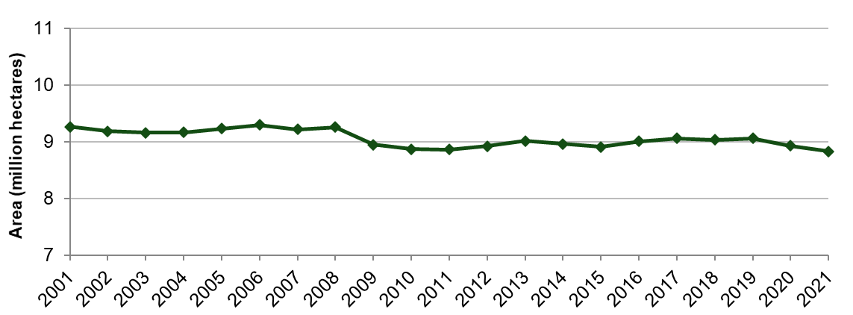
Figure 1 shows that the utilised agricultural area in England has remained stable around the 9 million hectare mark since 2000. The small drop seen between 2008 and 2009 is a result of register improvements made ahead of the 2010 Census which removed holdings that no longer have agricultural activity.

1.2 Croppable area
The area of land available for cropping saw a slight increase of 0.5% in 2021 and now stands at just under 4.9 million. The croppable area consists of cereals, oilseeds, potatoes, other arable crops, horticultural crops, uncropped arable land and temporary grassland.
Figure 2 - Total croppable area on 1 June 2021 compared to 1 June 2020
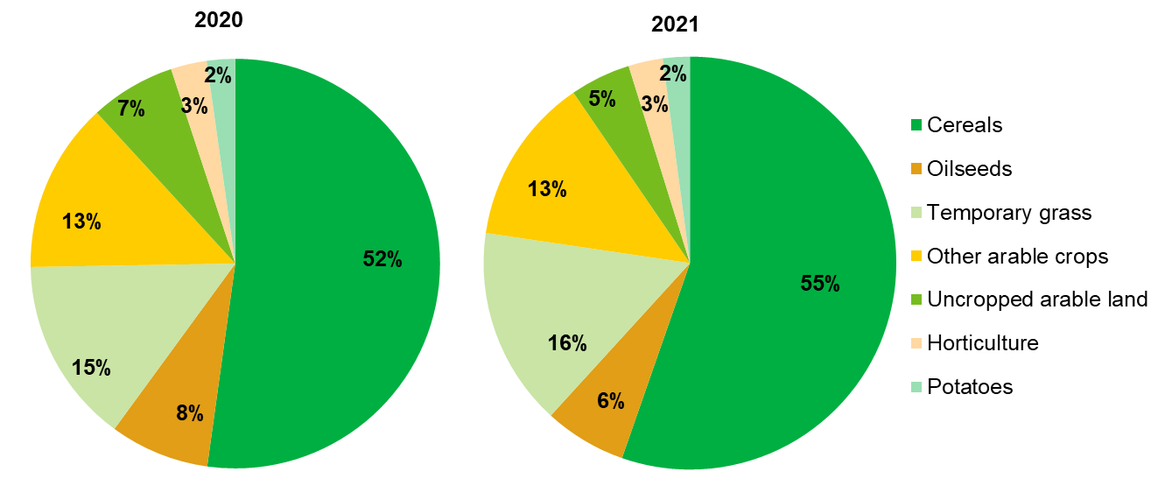

Figure 2 on the previous page shows that on the whole the proportion of croppable land used for each purpose remained similar between 2020 and 2021; however, some categories did see value changes. In particular, the area of uncropped arable land decreased by 29%, from 326 thousand hectares in 2020 to 231 thousand hectares in 2021. However, it still only accounts for 5% of the total croppable area.
Oilseeds, other arable crops, horticulture and potatoes, also all saw decreases in 2021 but the increases seen in cereals (6.6%) and temporary grass (6.5%) resulted in a 0.5% increase of the total croppable area.

1.3 Cereals and oilseeds
The total area of cereal crops in England increased by 6.6% between 2020 and 2021 and stands at almost 2.7 million hectares. With better weather conditions in the latter part of 2020 than 2019 enabling growers to plant their crops in the winter, we are seeing a return to more expected levels in the areas of cereal crops in England as shown in Figure 3 below.
The area of wheat rose by 31% between 2020 and 2021 and now stands at just under 1.7 million hectares and is a return to more expected levels following the large reduction last year.
Figure 3 - Area of wheat, barley and oilseed rape at 1 June 1990 to 2021
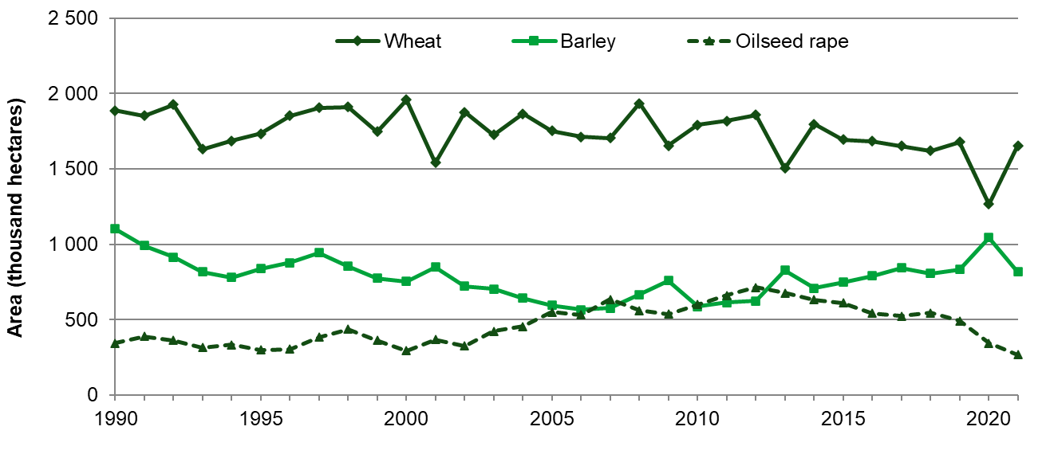
The area of winter sown barley increased by 36% in 2021 to 345 thousand hectares compared to 253 thousand hectares in 2020, with spring sown barley decreasing by 41%, the total barley area has seen a decrease of 22% and now stands at 816 thousand hectares.
The total area of oilseed rape fell by 22%, from 345 thousand hectares in 2020 to 268 thousand hectares in 2021. The decrease was due to a 21% fall in the area of winter sown oilseed rape which accounts for 98% of the total oilseed rape area and now stands at 262 thousand hectares. Spring oilseed rape saw a decrease of 55% in 2021. However, at 6 thousand hectares this still only accounts for 2% of the total oilseed rape area.

1.4 Fruit and vegetables
Figure 4 - Breakdown of small fruit on 1 June 2021
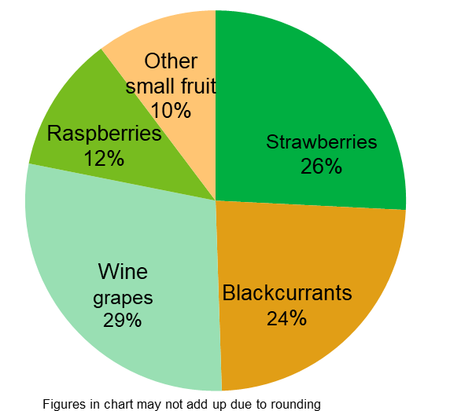
The total area of orchards and small fruit decreased by 0.6% between 2020 and 2021 to 31 thousand hectares. Orchards account for 68% of this total and cover just under 21 thousand hectares in 2021, a decrease of 0.2% since 2020.
The remaining area of just under 10 thousand hectares is used to grow small fruit. This area has decreased by 1.6% since 2020. Figure 4 shows the breakdown of small fruit areas in 2021. The largest proportion of the small fruit area is used to grow wine grapes (29%) with strawberries (26%) and blackcurrants (24%) being the next most common small fruit crops.
The area used to grow vegetables for human consumption decreased between 2020 and 2021 by 7.5%, to 89 thousand hectares. The majority (59%) of this area is used to grow other vegetables and salad however, this area decreased by 17% between 2020 and 2021.

1.5 Cattle
The total number of cattle and calves in England decreased by 1.9% between 2020 and 2021 and now stands at 5.1 million animals. The female breeding herd continues to account for just over a third (35%) of this total.
Figure 5 - Female dairy and beef herds at 1 June 2010 to 2021
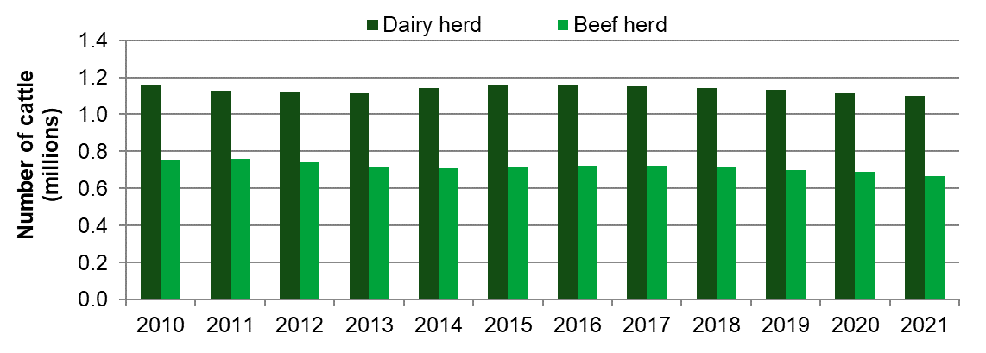
The breeding herd decreased slightly in 2021, falling by 1.8% to just under 1.8 million animals. The dairy herd accounts for the majority (62%) of the breeding herd and fell by 0.9% in 2021 and now stands at 1.1 million animals. The beef herd also saw a decrease between 2020 and 2021 of 3.3% to 665 thousand animals (Figure 5).

1.6 Pigs
The number of pigs in England has increased by 5.4% to just over 4.2 million, largely driven by a rise of 6.1% in the number of fattening pigs which account for 90% of all pigs (table 8). In contrast the size of the female breeding herd has fallen slightly on the year, down 1.8% to 313 thousand animals suggesting there has been an improvement in breeding sow performance in the last 12 months.
Figure 6 - Breakdown of the female pig breeding herd at 1 June 2010 to 2021
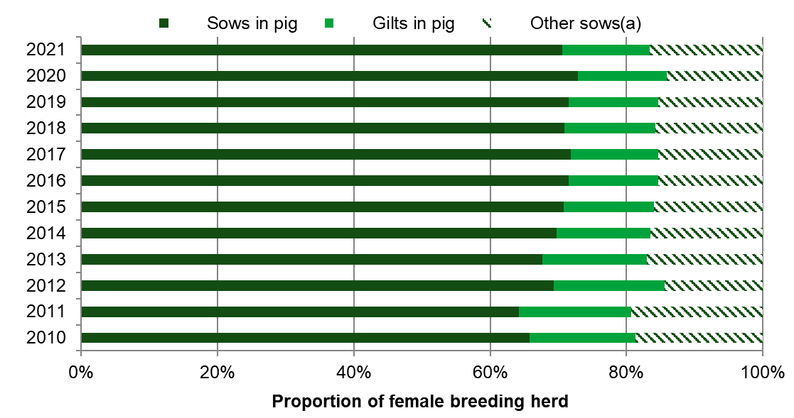
(a) Other sows are those either being suckled or dry sows kept for further breeding.
Other breeding pigs saw an increase in 2021 of 4.3%, rising from 86 to 90 thousand animals.

1.7 Sheep
The total number of sheep and lambs in England decreased by 2.7%, from 15.0 million in 2020 to 14.6 million in 2021. Lambs account for half of all sheep and decreased by 3.9% from 7.7 million in 2020 to 7.4 million in 2021. The female breeding flock account for a further 47% of all sheep and decreased by 1.5% to just under 6.9 million sheep in 2021.

1.8 Poultry
In 2021, the total number of breeding and laying fowl in England increased by 1.2% and now stands at 33.4 million birds. Hens and pullets laying eggs for eating account for the majority (75%) of the breeding and laying flock and increased by 1.8% from 24.5 million in 2020 to 24.9 million in 2021.
The number of table chickens (broilers) increased by 6.3%, from just under 92 million birds on 1 June 2020 to 97.8 million on 1 June 2021. Table chickens account for two thirds of all poultry in England and consumer demand remains strong.

The number of geese in England saw a decrease of 11%, falling from 134 thousand in 2020 to 118 thousand in 2021. However, the number of turkeys and ducks both saw increases in 2021, rising by 2.1% and 4.7% respectively.

1.9 Other livestock
In 2021, the number of horses on commercial holdings in England decreased by 1.8% falling from 153 to 150 thousand animals. The number of farmed deer increased by 29% and rose from 21 thousand in 2020 to 27 thousand in 2021. The number of goats saw a decrease, falling by 3.0% during the same period, to 88 thousand animals.

1.10 Agricultural workforce
The total number of people working in agriculture in England was 297 thousand on 1 June 2021, showing a decrease of 1.4% since 1 June 2020. Farmers, business partners, directors and spouses account for over half (60%) of the total workforce and saw a decrease (1.6%) to 179 thousand people in 2021. Salaried managers make up a much smaller proportion of the total (4%) and increased by 2.0% in 2021 to 12 thousand people.
Regular employees and casual workers make up the remainder (36%) of the total workforce. Full time regular workers decreased by 1.2% between 2020 and 2021 and now stand at just under 42 thousand. Part time regular workers saw an increase of 6.7% to 26 thousand people. These results are a snapshot of the workforce on the farm at 1 June, given the nature of agricultural work, it is therefore not unusual for the number of casual workers to vary from year to year. The number of casual workers decreased by 6.3% from 42 thousand people on 1 June 2020 to 39 thousand on 1 June 2021. See figure 7, below.
Figure 7: Number of regular and casual workers at 1 June 2003 to 2021
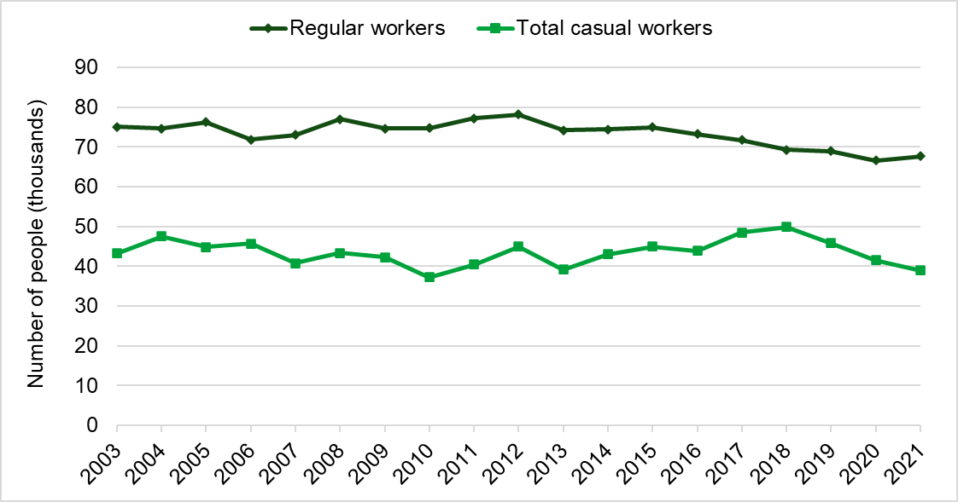

1.11 Results tables
Table 1: Summary of land use on commercial agricultural holdings on 1 June (thousand hectares)
Item | 2019 | 2020 | 2021 | % change 2021-20 | Jun 2021 confidence interval | Indicator
Utilised agricultural area (a) | 9,059 | 8,928 | 8,832 | -1.1 | +/- 41 | ✓✓✓
Total agricultural area | 9,605 | 9,479 | 9,374 | -1.1 | +/- 41 | ✓✓✓
Common rough grazing (b) | 399 | 399 | 399 | 0.0 | -
Total area on agricultural holdings | 9,206 | 9,080 | 8,976 | -1.2 | +/- 41 | ✓✓✓
Total croppable area | 4,914 | 4,840 | 4,864 | 0.5 | +/- 30 | ✓✓✓
Total crops | 4,028 | 3,803 | 3,876 | 1.9 | +/- 28 | ✓✓✓
Arable crops | 3,890 | 3,666 | 3,746 | 2.2 | +/- 27 | ✓✓✓
Cereals | 2,695 | 2,526 | 2,692 | 6.6 | +/- 24 | ✓✓✓
Oilseeds | 509 | 381 | 313 | -17.8 | +/- 8 | ✓✓✓
Potatoes | 109 | 108 | 103 | -5.3 | +/- 3 | ✓✓✓
Other crops | 577 | 651 | 638 | -2.0 | +/- 10 | ✓✓✓
Horticultural crops | 137 | 137 | 131 | -4.7 | +/- 4 | ✓✓✓
Uncropped arable land (c) | 191 | 326 | 231 | -29.2 | +/- 6 | ✓✓✓
Temporary grass under 5 years old | 696 | 710 | 756 | 6.5 | +/- 9 | ✓✓✓
Permanent grassland (incl. rough grazing) | 3,736 | 3,679 | 3,558 | -3.3 | +/- 27 | ✓✓✓
Grass over 5 years old | 3,294 | 3,242 | 3,119 | -3.8 | +/- 24 | ✓✓✓
Sole right rough grazing (d) | 442 | 437 | 439 | 0.3 | +/- 11 | ✓✓✓
Other land on agricultural holdings | 555 | 561 | 554 | -1.2 | +/- 7 | ✓✓✓
Woodland | 379 | 385 | 382 | -0.8 | +/- 6 | ✓✓✓
Land used for outdoor pigs | 10 | 10 | 12 | 17.8 | +/- 1 | ✓✓
All other non-agricultural land | 166 | 166 | 160 | -3.4 | +/- 4 | ✓✓✓
(a) Includes all arable and horticultural crops, uncropped arable land, common rough grazing, temporary and permanent grassland and land used for outdoor pigs (excludes woodland and other non-agricultural land).
(b) This area is an estimate of total common land in England. The vast majority is eligible for grazing and claimed upon under the Basic Payment Scheme (BPS) but isn’t necessarily used for grazing. The area was last revised in 2011.
(c) Includes all arable land not in production, including bare fallow, game strips, wild bird cover and game cover.
(d) Classified as mountains, hills, heathland or moorland.
Table 2: Areas of owned and rented land on commercial agricultural holdings on 1 June (thousand hectares)
Item | 2019 | 2020 | 2021 | % change 2021-20 | June 2021 confidence interval | Indicator
Land owned | 6,179 | 6,168 | 6,133 | -0.6 | +/- 36 | ✓✓✓
Land rented in for 1 year or more | 3,013 | 2,936 | 2,935 | 0.0 | +/- 34 | ✓✓✓
Full Agricultural Tenancies | 1,305 | 1,293 | 1,224 | -5.4 | +/- 19 | ✓✓✓
Farm Business Tenancies | 1,267 | 1,204 | 1,242 | 3.2 | +/- 24 | ✓✓✓
Other agreements | 441 | 439 | 469 | 6.9 | +/- 14 | ✓✓✓
Seasonally rented in land (a) | 542 | 519 | 523 | 0.7 | +/- 12 | ✓✓✓
Seasonally let out land (a) | 482 | 480 | 489 | 1.9 | +/- 14 | ✓✓✓
(a) Land rented for less than 1 year, including grazing licenses.
Table 3: Arable crops on commercial agricultural holdings on 1 June (thousand hectares)
Item | 2019 | 2020 | 2021 | % change 2021-20 | June 2021 confidence interval | Indicator
Total arable crops | 3,890 | 3,666 | 3,746 | 2.2 | +/- 27 | ✓✓✓
Cereals | 2,695 | 2,526 | 2,692 | 6.6 | +/- 24 | ✓✓✓
Wheat | 1,677 | 1,265 | 1,655 | 30.8 | +/- 19 | ✓✓✓
Barley | 832 | 1,045 | 816 | -21.9 | +/- 12 | ✓✓✓
winter | 388 | 253 | 345 | 36.3 | +/- 8 | ✓✓✓
spring | 444 | 792 | 471 | -40.5 | +/- 9 | ✓✓✓
Oats | 143 | 169 | 159 | -6.1 | +/- 6 | ✓✓✓
Rye, mixed corn and triticale | 43 | 46 | 62 | 33.0 | +/- 4 | ✓✓
Oilseed crops | 509 | 381 | 313 | -17.8 | +/- 8 | ✓✓✓
Oilseed rape | 492 | 345 | 268 | -22.2 | +/- 7 | ✓✓✓
winter | 488 | 331 | 262 | -20.8 | +/- 7 | ✓✓✓
spring | 4 | 14 | 6 | -54.5 | +/- 1 | ✓
Linseed | 15 | 33 | 41 | 24.2 | +/- 3 | ✓✓
Borage | 2 | 3 | 4 | 31.8 | +/- 0 | ✓
Potatoes | 109 | 108 | 103 | -5.3 | +/- 3 | ✓✓✓
Early crop (harvested on or before 31 July) | 11 | 11 | 11 | 1.9 | +/- 1 | ✓✓
Main crop (harvested after 31 July) | 98 | 98 | 92 | -6.1 | +/- 3 | ✓✓✓
Other (non-horticultural) crops | 577 | 651 | 638 | -2.0 | +/- 10 | ✓✓✓
Sugar beet (a) | 108 | 111 | 95 | -14.3 | +/- 3 | ✓✓✓
Field beans | 135 | 179 | 185 | 3.4 | +/- 6 | ✓✓✓
Peas for harvesting dry | 40 | 51 | 60 | 18.1 | +/- 4 | ✓✓
Maize | 211 | 223 | 209 | -6.1 | +/- 6 | ✓✓✓
of which grain maize | 9 | 12 | 15 | 27.2 | +/- 2 | ✓
of which fodder maize | 136 | 136 | 115 | -15.9 | +/- 4 | ✓✓✓
of which maize for anaerobic digestion | 67 | 75 | 80 | 6.7 | +/- 4 | ✓✓
Root crops, brassicas and fodder beet for stock feeding | 35 | 40 | 34 | -15.1 | +/- 2 | ✓✓✓
Leguminous forage crops | 15 | 14 | 15 | 5.5 | +/- 1 | ✓✓
Other crops for stockfeeding | 10 | 13 | 10 | -22.9 | +/- 1 | ✓
All other arable crops | 23 | 20 | 30 | 45.7 | +/- 2 | ✓✓
of which short rotation coppice | 2 | 2 | 4 | 78.9 | +/- 0.5 | ✓
of which miscanthus | 8 | 8 | 8 | -5.5 | +/- 0.4 | ✓✓
of which crops for aromatic or medicinal use(b) | 3 | na | 4 | - | +/- 0.9 | 

- Not for stockfeeding
- In 2020 there was insufficient response data to produce robust estimates, therefore the figures have been included in the total for other arable crops
Table 4: Fruit and vegetables grown in the open on commercial agricultural holdings on 1 June (thousand hectares)
Item | 2019 | 2020 | 2021 | % change 2021-20 | June 2021 confidence interval | Indicator
Total fruit and vegetables | 126 | 126 | 119 | -5.8 | +/- 4.1 | ✓✓✓
Orchards (a) | 21 | 21 | 21 | -0.2 | +/- 0.6 | ✓✓✓
Small fruit (b) | 10.2 | 9.8 | 9.6 | -1.6 | +/- 0.3 | ✓✓✓
Strawberries | 2.9 | 2.7 | 2.5 | -6.8 | +/- 0.2 | ✓✓
Raspberries | 1.3 | 1.3 | 1.1 | -12.9 | +/- 0.0 | ✓✓✓
Blackcurrants | 2.3 | 2.3 | 2.3 | 1.2 | +/- 0.1 | ✓✓
Wine grapes | 2.5 | 2.5 | 2.8 | 10.3 | +/- 0.2 | ✓✓
Other small fruit (incl. gooseberries & blackberries) | 1.2 | 1.1 | 1.0 | -8.8 | +/- 0.1 | ✓✓
Vegetables and salad for human consumption (c) | 94 | 96 | 89 | -7.5 | +/- 4.0 | ✓✓✓
Vining peas for processing | 27 | 26 | 29 | 10.0 | +/- 2.3 | ✓✓
Other peas and beans | 3 | 3 | 3 | 5.9 | +/- 0.5 | ✓
Culinary plants for human consumption (incl. herbs) | 4 | 4 | 4 | 21.1 | +/- 0.7 | ✓
All other vegetables and salad | 60 | 63 | 52 | -17.1 | +/- 3.1 | ✓✓
of which carrots | 7 | 7 | 6 | -16.6 | +/- 0.7 | ✓
of which onions | 13 | 13 | 10 | -22.6 | +/- 1.5 | ✓
(a) Includes both commercial and non-commercial orchards. Commercial orchards are those from which growers intend to sell fruit.
(b) Small fruit includes crops grown in Spanish tunnels.
(c) These figures relate to land usage on 1 June and are not necessarily good indicators of annual production as more than one crop may be obtained in each season; a crop may overlap two seasons,or may be planted after 1 June.

Table 5: Hardy nursery stock on commercial agricultural holdings on 1 June (hectares)
Item | 2019 | 2020 | 2021 | % change 2021-20 | June 2021 confidence interval | Indicator
Total hardy nursery stock, bulbs and flowers | 9,903 | 9,625 | 10,595 | 10.1 | +/- 436 | ✓✓✓
Christmas trees | 1,570 | 1,619 | 1,828 | 12.9 | +/- 100 | ✓✓
Perennial herbaceous plants | 405 | 395 | 329 | -16.8 | +/- 37 | ✓
Other hardy nursery stock | 2,051 | 2,008 | 2,008 | 0.0 | +/- 295 | ✓
Bulbs and flowers grown in the open | 5,876 | 5,603 | 6,430 | 14.8 | +/- 302 | ✓✓✓

Table 6: Glasshouses and protected crops on commercial agricultural holdings on 1 June (hectares) (a) (b)
Item | 2019 | 2020 | 2021 | % change 2021-20 | June 2021 confidence interval | Indicator
Total glasshouse area on 1 June | 1,195 | 1,188 | 1,154 | -2.9 | +/- 57 | ✓✓
Vegetables, salad and fruit | 684 | 661 | 652 | -1.4 | +/- 42 | ✓✓
Flowers, foliage and other plants | 409 | 408 | 418 | 2.5 | +/- 33 | ✓✓
Mushroom sheds(c) | na | na | na | - | -
Not in use on 1 June | 102 | 119 | 84 | -29.4 | +/- 19 | 
(a) These figures relate to land usage on 1 June and are not necessarily good indicators of annual production as more than one crop may be obtained in each season; a crop may overlap two seasons or may be planted after 1 June.
(b) ‘Glasshouse’ includes any fixed or mobile structure high enough to walk through, which is glazed or clad with film, rigid plastics or other glass substitutes. It excludes lights, low plastic tunnels, French and Spanish tunnels. These are reported as crops grown in the open and included in table 4.
(c) Since 2018 there has not been enough response data to produce robust estimates and therefore the figures are excluded from the results and the totals.

Table 7: Cattle and calves on agricultural holdings on 1 June (a) (thousands)
Item | 2019 | 2020 | 2021 | % change 2021-20
Total cattle and calves | 5,280 | 5,168 | 5,071 | -1.9
All female cattle | 3,832 | 3,776 | 3,719 | -1.5
Aged 2 years or more | 2,194 | 2,141 | 2,066 | -3.5
Total breeding herd | 1,829 | 1,800 | 1,767 | -1.8
- Beef herd | 699 | 688 | 665 | -3.3
- Dairy herd | 1,131 | 1,112 | 1,102 | -0.9
Other female cattle | 365 | 341 | 299 | -12.4
- Beef | 197 | 189 | 168 | -11.1
- Dairy | 167 | 152 | 130 | -14.1
Aged between 1 and 2 years | 789 | 780 | 775 | -0.6
- Beef | 479 | 475 | 466 | -1.9
- Dairy | 309 | 304 | 309 | 1.6
Less than 1 year | 849 | 855 | 877 | 2.6
- Beef | 533 | 534 | 541 | 1.3
- Dairy | 316 | 321 | 336 | 4.7
All male cattle | 1,448 | 1,393 | 1,352 | -2.9
Aged 2 years or more | 191 | 176 | 150 | -14.7
Aged between 1 and 2 years | 559 | 538 | 518 | -3.7
Less than 1 year | 698 | 679 | 684 | 0.8
(a) These figures have been sourced from the Cattle Tracing System (CTS). Confidence intervals and confidence indicators are not appropriate for this table as the data include returns from all holdings with cattle so are not subject to survey error.

Table 8: Pigs on commercial agricultural holdings on 1 June (thousand)
Item | 2019 | 2020 | 2021 | % change 2021-20 | June 2021 confidence interval | Indicator
Total pigs | 4,060 | 4,021 | 4,238 | 5.4 | +/- 102 | ✓✓✓
Breeding pigs | 410 | 405 | 403 | -0.5 | +/- 9 | ✓✓✓
Female breeding herd | 327 | 319 | 313 | -1.8 | +/- 8 | ✓✓✓
Sows in pig | 234 | 232 | 221 | -5.0 | +/- 7 | ✓✓✓
Gilts in pig | 43 | 41 | 40 | -3.5 | +/-2 | ✓✓
Other sows (a) | 50 | 45 | 52 | 15.9 | +/- 3 | ✓✓
Other breeding pigs | 83 | 86 | 90 | 4.3 | +/- 4 | ✓✓✓
Boars being used for service | 10 | 9 | 10 | 7.4 | +/- 0 | ✓✓✓
Gilts intended for first time breeding | 73 | 76 | 79 | 3.9 | +/- 4 | ✓✓✓
Fattening pigs (incl. barren sows) | 3,650 | 3,616 | 3,835 | 6.1 | +/- 102 | ✓✓✓
- Either being suckled or dry sows being kept for further breeding.

Table 9: Sheep and lambs on commercial agricultural holdings on 1 June (thousand)
Item | 2019 | 2020 | 2021 | % change 2021-20 | June 2021 confidence interval | Indicator
Total sheep and lambs | 15,390 | 15,027 | 14,626 | -2.7 | +/- 76 | ✓✓✓
Female breeding flock | 7,234 | 6,977 | 6,873 | -1.5 | +/- 49 | ✓✓✓
Ewes intended for further breeding | 5,597 | 5,409 | 5,224 | -3.4 | +/- 41 | ✓✓✓
Breeding ewes intended for slaughter | 521 | 495 | 564 | 14.0 | +/- 21 | ✓✓✓
Ewes intended for first time breeding | 1,115 | 1,073 | 1,085 | 1.1 | +/- 17 | ✓✓✓
Other sheep and lambs | 8,156 | 8,049 | 7,753 | -3.7 | +/- 59 | ✓✓✓
Lambs under 1 years old | 7,775 | 7,678 | 7,376 | -3.9 | +/- 58 | ✓✓✓
Rams | 193 | 184 | 183 | -0.4 | +/- 2 | ✓✓✓
Other sheep 1 year and over | 189 | 187 | 194 | 3.5 | +/- 10 | ✓✓✓

Table 10: Poultry on commercial agricultural holdings on 1 June (a) (thousand)
Item | 2019 | 2020 | 2021 | % change 2021-20 | June 2021 confidence interval | Indicator
Total poultry | 138,850 | 134,312 | 141,084 | 5.0 | +/- 5 100 | ✓✓✓
Total breeding and laying fowl | 33,799 | 33,031 | 33,443 | 1.2 | +/- 947 | ✓✓✓
Hens and pullets laying eggs for eating | 25,388 | 24,472 | 24,924 | 1.8 | +/- 897 | ✓✓✓
Breeding flock | 8,411 | 8,559 | 8,519 | -0.5 | +/- 351 | ✓✓✓
Table chickens (broilers) | 95,150 | 91,968 | 97,791 | 6.3 | +/- 4 983 | ✓✓
Other poultry | 9,901 | 9,313 | 9,850 | 5.8 | +/- 529 | ✓✓
Ducks | 1,712 | 1,832 | 1,919 | 4.7 | +/- 132 | ✓✓
Geese | 141 | 134 | 118 | -11.4 | +/- 6 | ✓✓✓
Turkeys | 3,802 | 3,535 | 3,608 | 2.1 | +/- 99 | ✓✓✓
All other poultry | 4,246 | 3,812 | 4,205 | 10.3 | +/- 503 | ✓
(a) Due to production cycles, subgroups within the poultry population are often volatile as the “point in time” nature of the June Survey can lead to large variations in the numbers in each category.

Table 11: All other livestock on commercial agricultural holdings on 1 June (a) (thousand)
Item | 2019 | 2020 | 2021 | % change 2021-20 | June 2021 confidence interval | Indicator
Total other livestock | 298 | 292 | 290 | -0.7 | +/- 7.3 | ✓✓✓
Goats | 89 | 90 | 88 | -3.0 | +/- 5.2 | ✓✓
Farmed deer | 22 | 21 | 27 | 28.5 | +/- 3.5 | ✓
Horses | 162 | 153 | 150 | -1.8 | +/- 2.7 | ✓✓✓
Any livestock not recorded elsewhere (a) | 26 | 28 | 25 | -8.9 | +/- 2.7 | ✓
- of which alpacas | 9 | 11 | 10 | -3.2 | +/- 1.2 | ✓
- of which llamas | 1 | 1 | 1 | -7.7 | +/- 0.2 | 
(a) Includes camelids, donkeys, mules and hinnies.

Table 12: Number of people working on commercial agricultural holdings on 1 June (thousand)
Item | 2019 | 2020 | 2021 | % change 2021-20 | June 2021 confidence interval | Indicator
Total labour force | 306 | 302 | 297 | -1.4 | +/- 1.8 | ✓✓✓
Farmers, partners, directors and spouses | 180 | 182 | 179 | -1.6 | +/- 0.9 | ✓✓✓
Full time | 93 | 94 | 94 | 0.2 | +/- 0.6 | ✓✓✓
Part time (a) | 87 | 88 | 85 | -3.4 | +/- 0.7 | ✓✓✓
Salaried managers | 12 | 12 | 12 | 2.0 | +/- 0.3 | ✓✓✓
Full time | 9 | 9 | 9 | -1.0 | +/- 0.3 | ✓✓✓
Part time (a) | 3 | 3 | 3 | 12.2 | +/- 0.1 | ✓✓✓
Regular and casual workers | 115 | 108 | 107 | -1.4 | +/- 1.6 | ✓✓✓
Regular workers | 69 | 67 | 68 | 1.7 | +/- 1.2 | ✓✓✓
Full time | 43 | 42 | 42 | -1.2 | +/- 1.0 | ✓✓✓
Part time | 26 | 24 | 26 | 6.7 | +/- 0.6 | ✓✓✓
Casual workers | 46 | 42 | 39 | -6.3 | +/- 1.1 | ✓✓✓
Male | 29 | 26 | 25 | -6.2 | +/- 0.7 | ✓✓✓
Female | 17 | 15 | 14 | -6.5 | +/- 0.8 | ✓✓
(a) Part-time is defined as working less than 39 hours per week.

Section 2 – About these statistics

2.1 Survey methodology
Full details of the survey methodology are available on the Defra Farming Business: detailed information web site.
The June Survey of Agriculture and Horticulture was historically a postal survey run annually. However, from 2011 onwards the survey has been run predominantly online with an option for farmers to complete a paper form if they prefer.

A full census was run every year until 1995, when it decreased to a sample survey with between 30,000 and 60,000 holdings currently surveyed each year, depending on requirements. However, a full Census is still carried out once every ten years to obtain a detailed snapshot of agricultural activity in England, with 2000 and 2010 being the most recent.

It was not possible to run the planned census in 2020 due to the impact of the coronavirus (COVID-19) pandemic. Instead, the Census has been run this year with a questionnaire sent to commercial holdings with significant levels of farming activity. A commercial holding is defined as a holding with more than five hectares of agricultural land, one hectare of orchards, 0.5 hectares of vegetables or 0.1 hectares of protected crops, or more than 10 cows, 50 pigs, 20 sheep, 20 goats or 1,000 poultry.

Therefore, in 2021 the survey was sent out to almost 107 thousand holdings. These results are based on responses from just over 64 thousand holdings, representing a response rate of 60%, with those holdings that came through as inactive removed.

Table 13 provides details of the census population and response rate broken down by farm size. The size of a farm is determined by its Standard Labour Requirement (SLR). i.e. the typical number of full-time workers required on the holding. In the SLR system, each livestock type and land-use has a theoretical amount of labour required each year. This value is multiplied by the land area or livestock numbers and then summed to give the SLR for the holding. For pig and poultry sectors, a special data collection exercise was run to collect data from a central point for some of the largest companies.

Table 13: June 2021 population size and response rate
Stratum | Description | Population size | Number of responses | Response rate (%)
1 | SLR < 0.5 | 53,928 | 32,818 | 61%
2 | SLR >= 0.5 and < 1 | 14,066 | 8,569 | 61%
3 | SLR >= 1 and < 2 | 13,745 | 8,353 | 61%
4 | SLR >= 2 and < 3 | 7,166 | 4,316 | 60%
5 | SLR >= 3 and < 5 | 6,916 | 4,044 | 58%
6 | SLR >= 5 | 7,636 | 4,109 | 54%
10 | SLR unknown | 3,259 | 1,868 | 57%
All |  | 106,937 | 64,077 | 60%

Cattle results are sourced from the Cattle Tracing System (CTS). The data include returns from all holdings with cattle so are not subject to survey error. More information on the use of this administrative data can be found on the “survey notes and guidance report”

2.2 Data analysis
The data are subject to rigorous validation checks which identify inconsistencies within the data or large year-on-year changes. Any records that have not been cleaned by the results production stage are excluded from the analysis.
Population totals are estimated for each question on the survey to account for the non-sampled and non-responding holdings. This survey uses the technique known as ratio raising, in which the trend between the sample data and base data (previous year’s data) is calculated for each stratum. The calculated ratio is then applied to the previous year’s population data to give England level estimates. For holdings where we do not have base data (new holdings or long-term non-responders) the sample estimates are raised according to the inverse sampling fraction.

2.3 Confidence indicators
We calculate the standard error for all our estimated figures. The standard error is a measure of the variation in the data. Typically, large estimates also have large standard errors. The standard error divided by the estimated total gives the relative standard error (RSE). This is expressed as a percentage and is easier to interpret than the standard error. Low RSEs indicate greater reliability in the figures, whereas estimates with high RSEs should be treated with caution.
Tick based confidence indicators have been shown against the June 2021 figures, ranging from 3 ticks (good) to 1 cross (poor). The ranges relate to the relative standard errors (RSE) as follows:
✓✓✓ indicates RSE <=2.5%
✓✓ indicates RSE >2.5 and <=5%
✓ indicates RSE >5 and <=10%
 indicates RSE >10 and <=20%
 indicates RSE >20%

We have also shown confidence intervals against the figures. They are based on the standard error multiplied by 1.96 which gives a 95% confidence interval. We are 95% confident that this interval contains the true value. The standard errors only give an indication of the sampling error. They do not take into account any other sources of survey errors, such as non-response bias or administrative data errors.
Data notes
- All figures in tables 1 to 12 relate to commercial holdings only with the exception of the cattle figures in table 7, which relate to all holdings. Further details on commercial holdings can be seen in the methodology section on page 19.
- All percentage changes are based on unrounded figures.
- Totals may not necessarily agree with the sum of their components due to rounding.

2.4 Data uses and users
Results from the June Survey of Agriculture and Horticulture have a wide range of uses and users with requests for data being made on a daily basis. A document providing information of specific uses and users can be found on our Structure of the agricultural industry in England and the UK at June web page

2.5 Other survey results and publications
Results from all the Defra farming surveys can be viewed on the Defra website. This also contains details of future publication dates.
The next Farming Statistics publications due from the June Survey of Agriculture and the Cereal and Oilseed Rape Production Survey are shown below. Please note that the publication dates are provisional and subject to change.
England Publications
- The next publications from the June Survey will relate to 2022 results. First early estimates of cereal, oilseed and uncropped arable land areas will be available in August 2022.
UK Publications
- 16 December 2021: Farming Statistics final crop areas, yields, livestock populations and agricultural workforce at 1 June 2021 – United Kingdom.
More detailed results from the June Survey can be found on our Structure of the agricultural industry in England and the UK at June web page. This includes various time series of crop areas and livestock numbers dating back as early as 1866 and detailed geographical breakdowns of the results.

2.6 Feedback
We welcome feedback and any thoughts to improve the publication further. Please send any feedback to: farming-statistics@defra.gov.uk. Suggested questions to help you structure your feedback are below but all feedback is welcome:
- How relevant is the current content of the publication to your needs as a user?
- What purpose do you require the data for?
- Which data do you find most useful?
- Is there any content that you did not find useful?
- Do you have any suggestions for further development of this release; including additional content, presentation and any other thoughts?

© Crown copyright 2021. You may re-use this information free of charge under the terms of the Open Government Licence v.3. To view this licence visit The National Archives.

