Dstl Engineering Severity Level (ESL) Matrix
When evaluating technology it is useful to know the range of conditions under which it can operate. Dstl has developed the ESL matrix which describes several different levels of operating conditions from 1 to 8
Understanding where technology is known to perform and conditions which are not possible helps understand potential application areas.
Please attach a copy of this document to your submission indicating as much as possible where your technology falls for each of the columns. A key is included indicating colours to use. Each separate column should be considered separately. So an example matrix may look like this

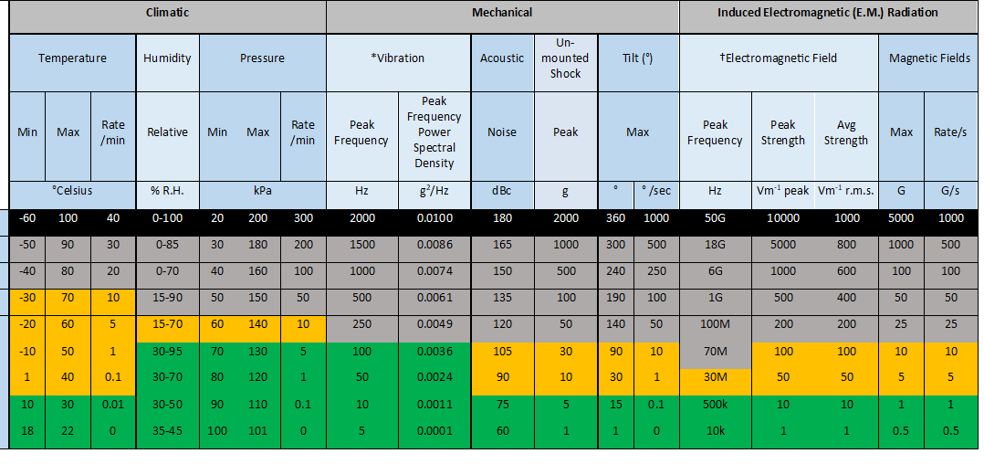
Green shaded cells identify conditions where it is known the equipment can operate
Amber shaded cells identify where the equipment can survive
Grey shaded cells identify conditions where it is not known how the equipment will perform
Black shaded cells identify known conditions which will cause equipment failure

KEY
Colour Key | Technology Capability | Description
Black | Inaccessible | The technology cannot operate under these conditions under any circumstance due to practical/technological/fundamental reasons.
Grey | Unknown | Best estimates should be given, but in cases where the response to the environment it truly unknown.
Amber | Current Survivable | The technology has been demonstrated (≥TRL 4) to survive under these conditions.
Green | Currently Operational | The technology has been demonstrated (≥TRL 4) to operate under these conditions.

ALTERNATIVE NAVIGATION FOR WEAPN SYSTEMS MARKET EVALUATION – ESL MATRIX

Organisation name:_________________________________________

ESL | Climatic |  |  |  |  |  |  | Mechanical |  |  |  |  |  | Induced Electromagnetic (E.M.) Radiation
ESL | Temperature |  |  | Humidity | Pressure |  |  | *Vibration |  | Acoustic | Un-mounted Shock | Tilt (°) |  | †Electromagnetic Field |  |  | Magnetic Fields
ESL | Min | Max | Rate /min | Relative | Min | Max | Rate /min | Peak Frequency | Peak Frequency Power Spectral Density | Noise | Peak | Max |  | Peak Frequency | Peak Strength | Avg Strength | Max | Rate/s
ESL | °Celsius |  |  | % R.H. | kPa |  |  | Hz | g2/Hz | dBc | g | ° | ° /sec | Hz | Vm-1 peak | Vm-1 r.m.s. | G | G/s
8 | -60 | 100 | 40 | 0-100 | 20 | 200 | 300 | 2000 | 0.0100 | 180 | 2000 | 360 | 1000 | 50G | 10000 | 1000 | 5000 | 1000
7 | -50 | 90 | 30 | 0-85 | 30 | 180 | 200 | 1500 | 0.0086 | 165 | 1000 | 300 | 500 | 18G | 5000 | 800 | 1000 | 500
6 | -40 | 80 | 20 | 0-70 | 40 | 160 | 100 | 1000 | 0.0074 | 150 | 500 | 240 | 250 | 6G | 1000 | 600 | 100 | 100
5 | -30 | 70 | 10 | 15-90 | 50 | 150 | 50 | 500 | 0.0061 | 135 | 100 | 190 | 100 | 1G | 500 | 400 | 50 | 50
4 | -20 | 60 | 5 | 15-70 | 60 | 140 | 10 | 250 | 0.0049 | 120 | 50 | 140 | 50 | 100M | 200 | 200 | 25 | 25
3 | -10 | 50 | 1 | 30-95 | 70 | 130 | 5 | 100 | 0.0036 | 105 | 30 | 90 | 10 | 70M | 100 | 100 | 10 | 10
2 | 1 | 40 | 0.1 | 30-70 | 80 | 120 | 1 | 50 | 0.0024 | 90 | 10 | 30 | 1 | 30M | 50 | 50 | 5 | 5
1 | 10 | 30 | 0.01 | 30-50 | 90 | 110 | 0.1 | 10 | 0.0011 | 75 | 5 | 15 | 0.1 | 500k | 10 | 10 | 1 | 1
0 | 18 | 22 | 0 | 35-45 | 100 | 101 | 0 | 5 | 0.0001 | 60 | 1 | 1 | 0 | 10k | 1 | 1 | 0.5 | 0.5

* Vibration: Peak acceleration power spectral density ESL value at the frequency ESL value stated.
† Electromagnetic (E.M.) Radiation: Peak and average field strengths at the EM peak frequency ESL value.

