Application Decision
by Richard Holland
Appointed by the Secretary of State for Environment, Food and Rural Affairs
Decision date: 14 December 2021

Application Ref: COM/3283317
CLEE HILL COMMON, SHROPSHIRE
Register Unit No: CL12
Commons Registration Authority: Shropshire Council
- The application, dated 17 September 2021, is made under Section 38 of the Commons Act 2006 (the 2006 Act) for consent to carry out restricted works on common land.
- The application is made by the Western Power Distribution (West Midlands) plc.
- The works comprise the erection of a glass reinforced plastic substation 3112 mm x 2264 mm x 2250 mm high. Approximately 520 m of trenchwork to contain approximately 1040 m of underground electric cable contained in rigid plastic ducting. The duration of the works is around 4 to 5 weeks.

Decision
- Consent is granted for the works in accordance with the application dated 17 September 2021 and accompanying plan, subject to the following conditions:-
- the works shall begin no later than three years from the date of this decision; and

ii. the common shall be restored within one month from the completion of the works.
- For the purposes of identification only the location of the works is shown as a red line within the common land boundary on the attached plan.
Preliminary Matters
- I have had regard to Defra’s Common Land consents policy in determining this application under section 38, which has been published for the guidance of both the Planning Inspectorate and applicants. However, every application will be considered on its merits and a determination will depart from the policy if it appears appropriate to do so. In such cases, the decision will explain why it has departed from the policy.
- This application has been determined solely on the basis of written evidence.
- I am required by section 39 of the 2006 Act to have regard to the following in determining this application:-
- the interests of persons having rights in relation to, or occupying, the land (and in particular persons exercising rights of common over it);
- the interests of the neighbourhood;
- the public interest; and
- any other matter considered to be relevant.

Reasons

The interests of those occupying or having rights over the land
- The landowners have been consulted about the application and have not objected. The applicant confirms that grazing rights are exercised daily. All active commoners have been consulted and no objections have been received. I am satisfied that the proposed works will not harm the interests of those occupying or having rights over the land.

The interests of the neighbourhood, and the protection of public rights of access
- The interests of the neighbourhood test relates to whether the works will unacceptably interfere with the way the common is used by local people. The works are required to provide an upgraded/enhanced electricity supply for National Air Traffic Services (NATS) radio and radar station. The works form part of a National Infrastructure Project and concern the security of air traffic over Heathrow Airport. The common is an open green space and is used for recreation. Any alternative to the works would require further development to secure the services and result in a loss of open space. The substation will be secured within an existing locked compound.
- I note that the works are of relatively short duration, small scale and, apart from the substation, will be placed underground. The substation will be located within an existing fenced NATS compound from which the public are excluded. I am satisfied that the works will not therefore interfere with the way the common is used by local people and will not impact on the interests of the neighbourhood or public rights of access.

Nature conservation and conservation of the landscape
- The common forms part of the Titterstone Clee Site of Special Scientific Interest (SSSI) and is located within the Shropshire Hills Area of Outstanding Natural Beauty (AONB). The applicant has submitted a copy of the SSSI assent from Natural England and confirms that the trench will be back filled on the same day to protect wildlife.
- The substation will be a muted dark forest green colour and will be located near existing NATS infrastructure; it will therefore, to a large extent, be subsumed by them. Subject to a condition that the common is restored, I am satisfied that the works will not harm nature conservation interests and will conserve the natural beauty of the AONB.

Archaeological remains and features of historic interest

11. The applicant has submitted confirmation of Scheduled Monument Consent dated 5 July 2021 from Historic England. I am satisfied that there is no evidence before me to indicate that the works will harm any archaeological remains and features of historic interest.

Conclusion

12. Defra’s policy guidance advises that that “works may be proposed in relation to common land which do not benefit the common, but confer some wider benefit on the local community, such as minor works undertaken by a statutory undertaker (e.g. a water utility) to provide or improve the public service to local residents and businesses … consent under section 38 may be appropriate where the works are of temporary duration (such as a worksite), where the works will be installed underground (such as a pipeline or pumping station), or where their physical presence would be so slight as to cause negligible impact on the land in question (such as a control booth or manhole), and the proposals ensure the full restoration of the land affected and confer a public benefit”. I am satisfied that the proposed works accord with the guidance.

13. I conclude that the works will not harm the interests set out in paragraph 5 above. Furthermore, by contributing to the security of air traffic over Heathrow Airport, the works are in the public interest. Consent is therefore granted for the works subject to the conditions at paragraph 1.

Richard Holland

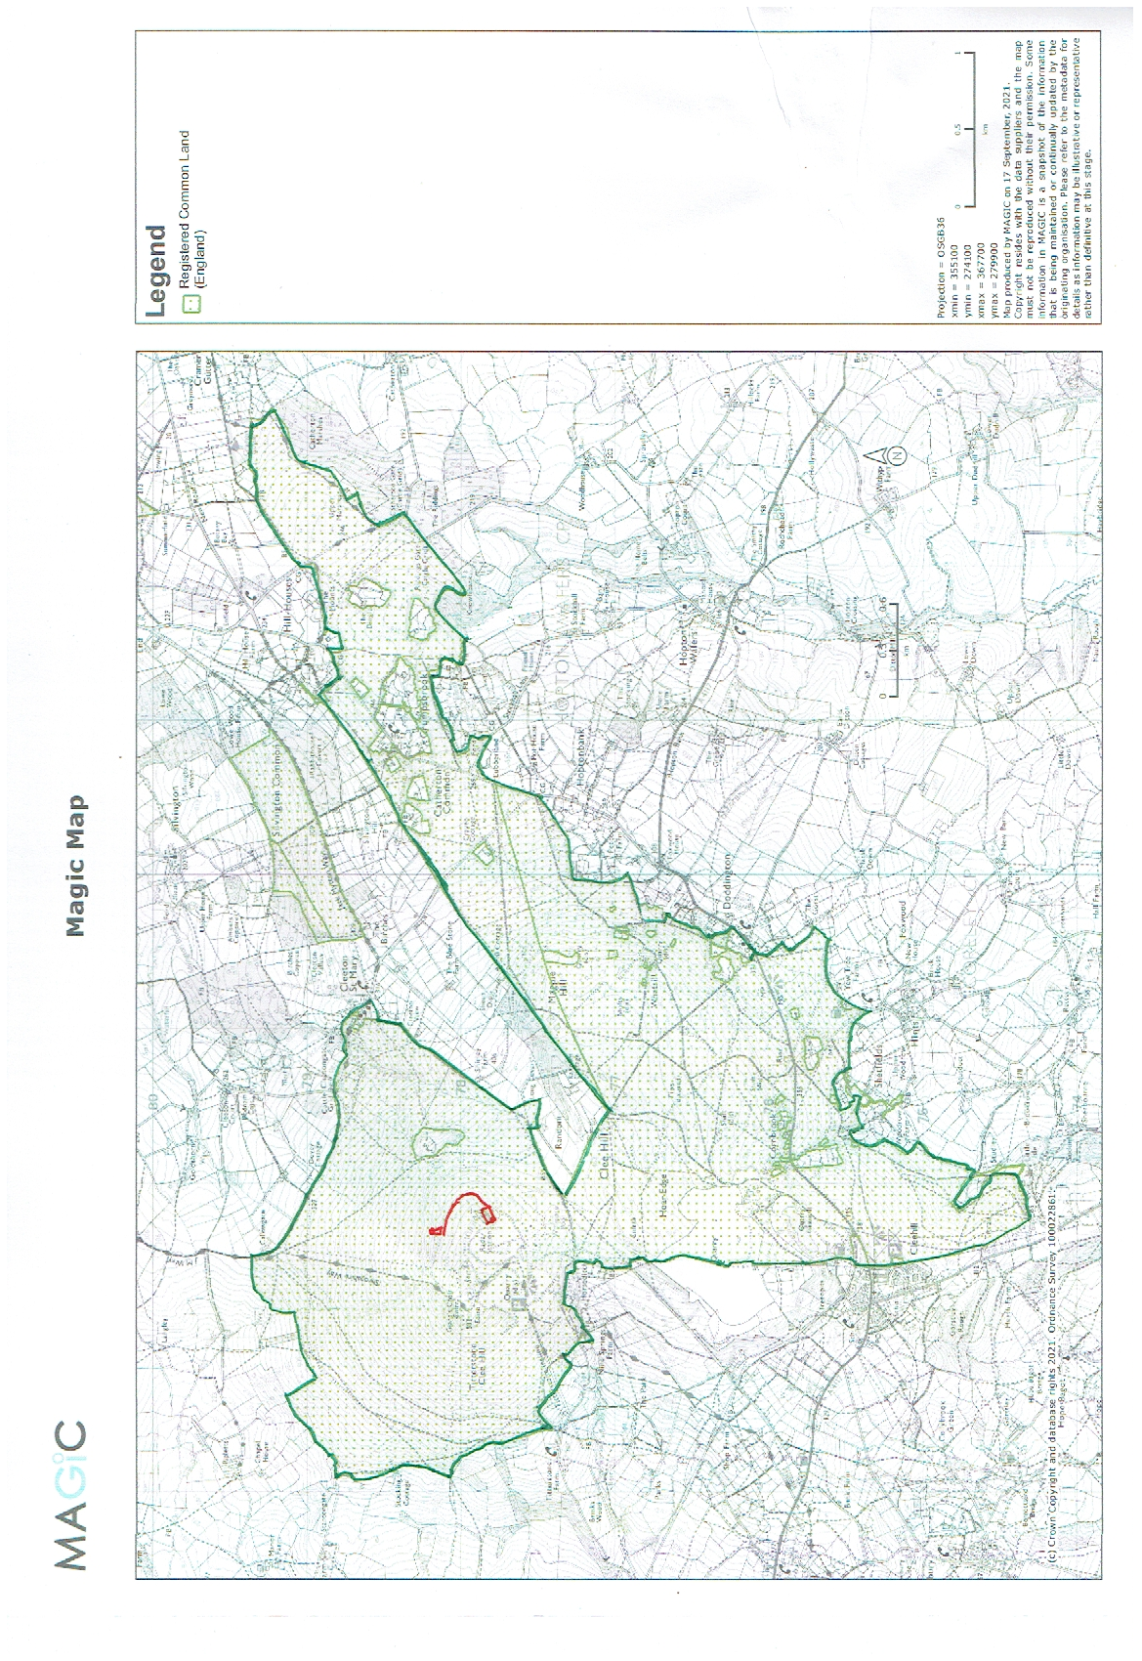

Common Land Consents policy (Defra November 2015)
Section 39(2) of the 2006 Act provides that the public interest includes the public interest in; nature conservation; the conservation of the landscape; the protection of public rights of access to any area of land; and the protection of archaeological remains and features of historic interest.

