NOTICE OF ORDER

Wildlife and Countryside Act 1981 – S53

The East Riding of Yorkshire Council (Howden Bridleway No. 17) Definitive Map and Statement Modification Order 2019

Notice is hereby given that the above referenced Order(s) has/have been submitted to the Secretary of State for Environment, Food and Rural Affairs for determination. An Inspector will be appointed by the Secretary of State to determine the Order(s).

The start date for the above Order(s) is 04 January 2022.

Consideration of the Order(s) will take the form of a hearing.

The Hearing will be held at the Holderness Room, County Hall, Beverley, East Yorkshire, HU17 9BA on 26 April 2022 at 10.00am.

The effect of the Order, if confirmed without modifications, will be to modify the definitive map and statement for the area by adding a length of bridleway in the parish of Howden some 223 metres in length commencing on Eastrington Bridleway No. 17 at Grid Reference SE 7540 3130 (Point A on the Map) and leading west-south-westerley to Wood Lane at Grid Reference SE 7518 3126 (Point B on the Map).

The bridleway will have a width of 4 metres. There are pinch points of 1.15 metres and 1.45 metres at Point B on the Map.

Any queries relating to this Order should be referred to Clive Richards at The Planning Inspectorate, Rights of Way Section, Room 3/A Eagle Wing, Temple Quay House, 2 The Square, Temple Quay, Bristol, BS1 6PN. Telephone: 0303 444 5502 Email: rightsofway2@planninginspectorate.gov.uk or clive.richards@planninginspectorate.gov.uk Please quote reference number ROW/3258617 on all correspondence.

Any person wishing to view the statements of case and other documents relating to this Order may be viewed online at The East Riding of Yorkshire Council website on:
https://www.eastriding.gov.uk/leisure/countryside-and-walks/public-rights-of-way/register-of-definitive-map-modification-order-applications/ under reference number S140095. Any queries should be directed to Steve Parker at the Council on steve.parker@eastriding.gov.uk – tel: 01482 393159.

Timetable for sending in statements of case

Within 8 weeks of the start date [by 01 March 2022]
The Order Making Authority must ensure their statement of case is received by the Secretary of State. As soon as possible after the deadline, the Secretary of State will send a copy (excluding copies of any supporting documents, although these will be available to view at the Authority’s offices) to everyone who has made an objection or representation, the applicant and any other person who has written to us in respect of the Order.

Within 12 weeks of the start date [by 29 March 2022]
Everyone who has made an objection or representation and anyone who wishes to give evidence at the Hearing must ensure their statement of case is received by the Secretary of State. As soon as possible after the deadline, the Secretary of State will send full copies to the Authority. Copies will also be sent to the applicant, every person who has made an objection or representation and any other person who has written to us in respect of the Order (excluding copies of any supporting documents - these will be available to view at the Authority’s offices).

Within the same period the applicant (if applicable) must ensure their statement of case is received by the Secretary of State. As soon as possible after the deadline, the Secretary of State will send a full copy to the Authority. Copies will also be sent to everyone who has made an objection or representation and any other person who has written to us in respect of the Order (excluding copies of any supporting documents - these will be available to view at the Authority’s offices).

All parties must keep to the timetable set out above and ensure that statements of case are received by the Secretary of State on time. Late documents will be returned.

We cannot accept any inflammatory, discriminatory or abusive comments. Any documents containing such comments will be returned.

Notice of order for hearing
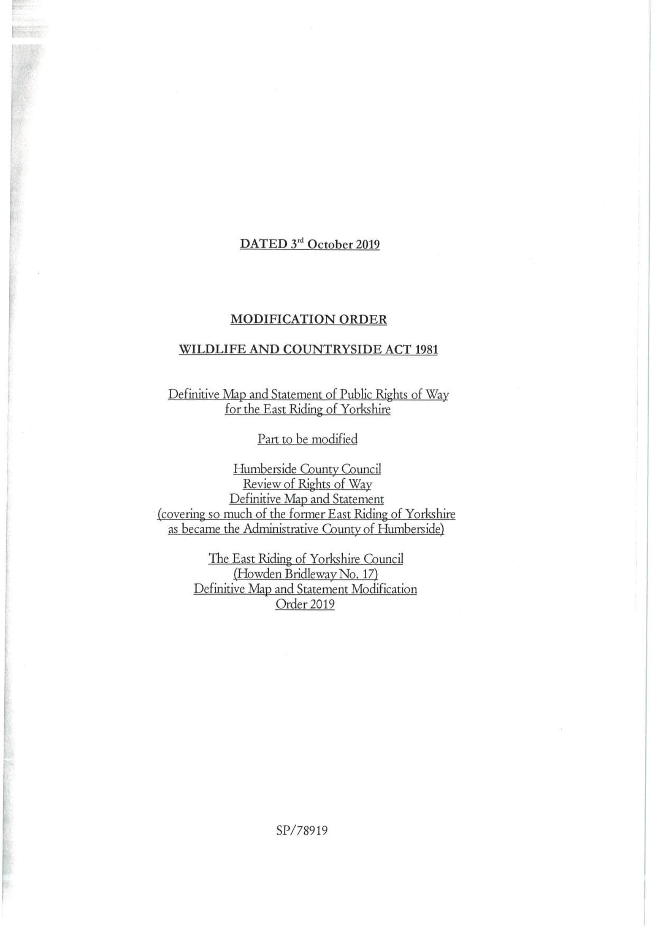
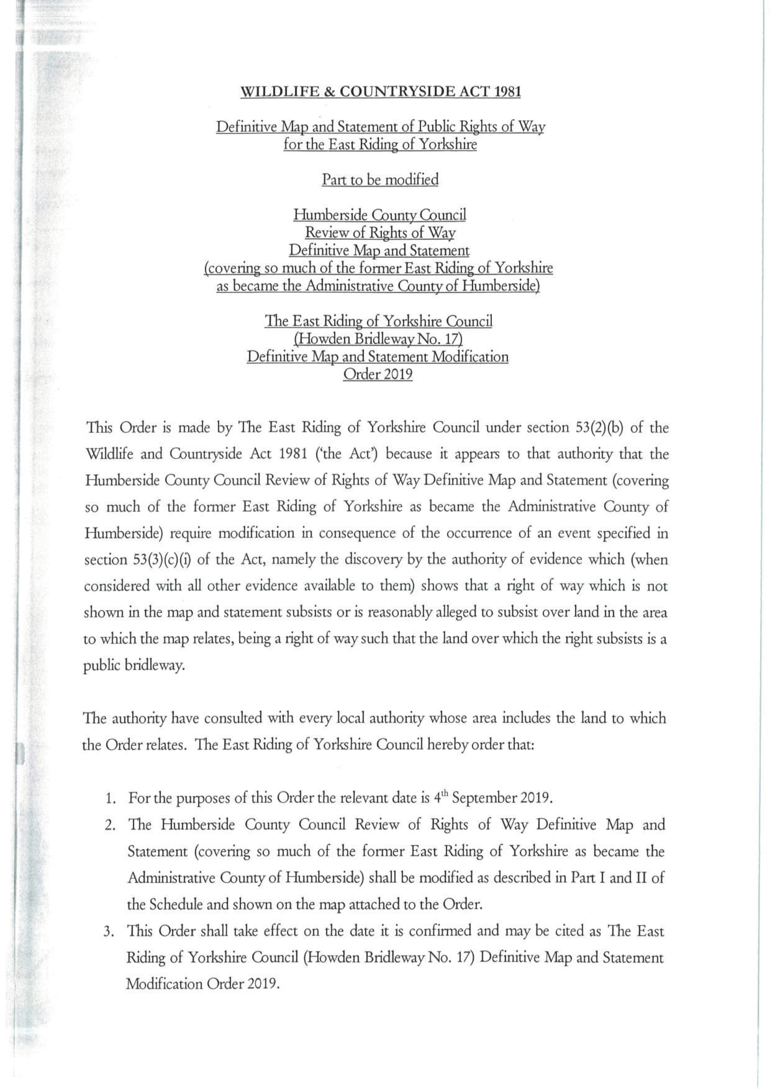
COPY - MAP NOT TO ORIGIAL SCALE

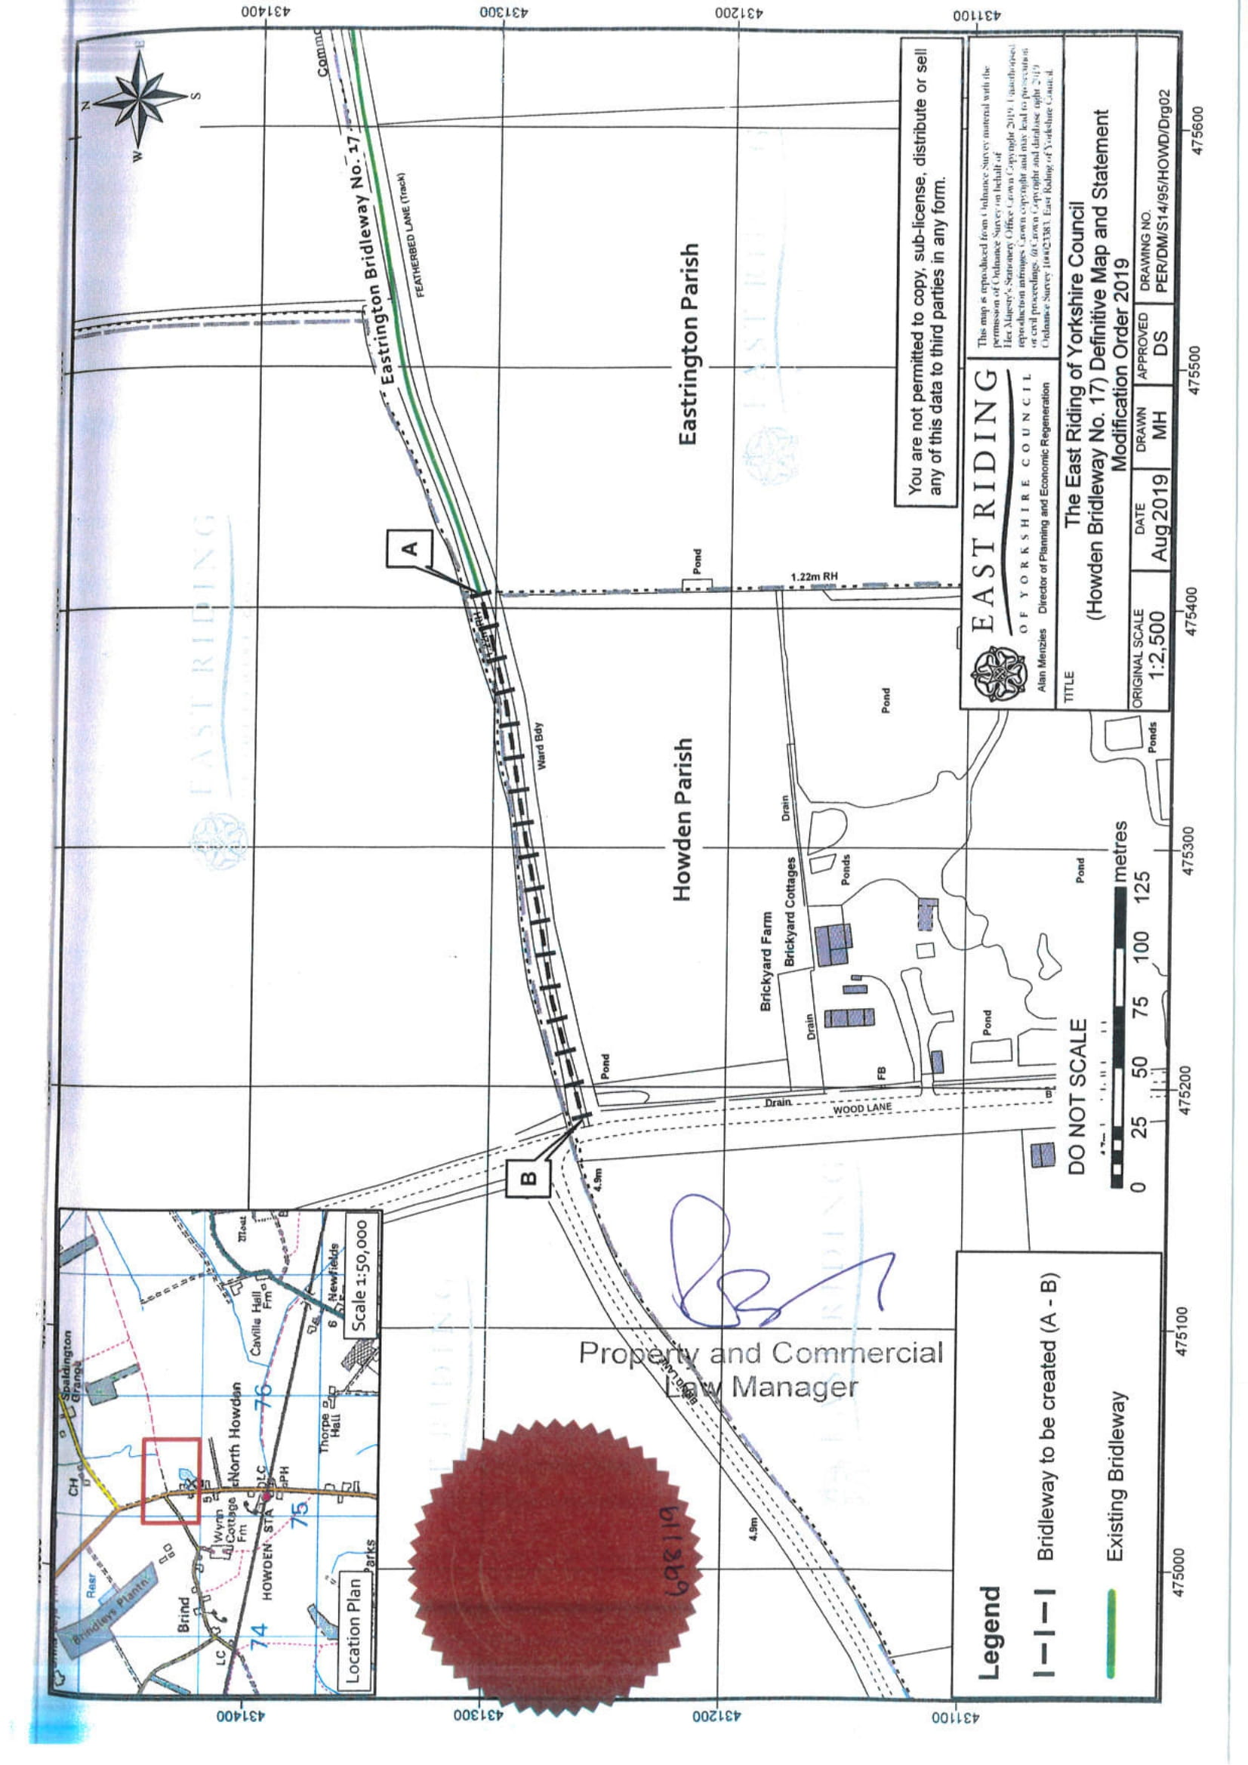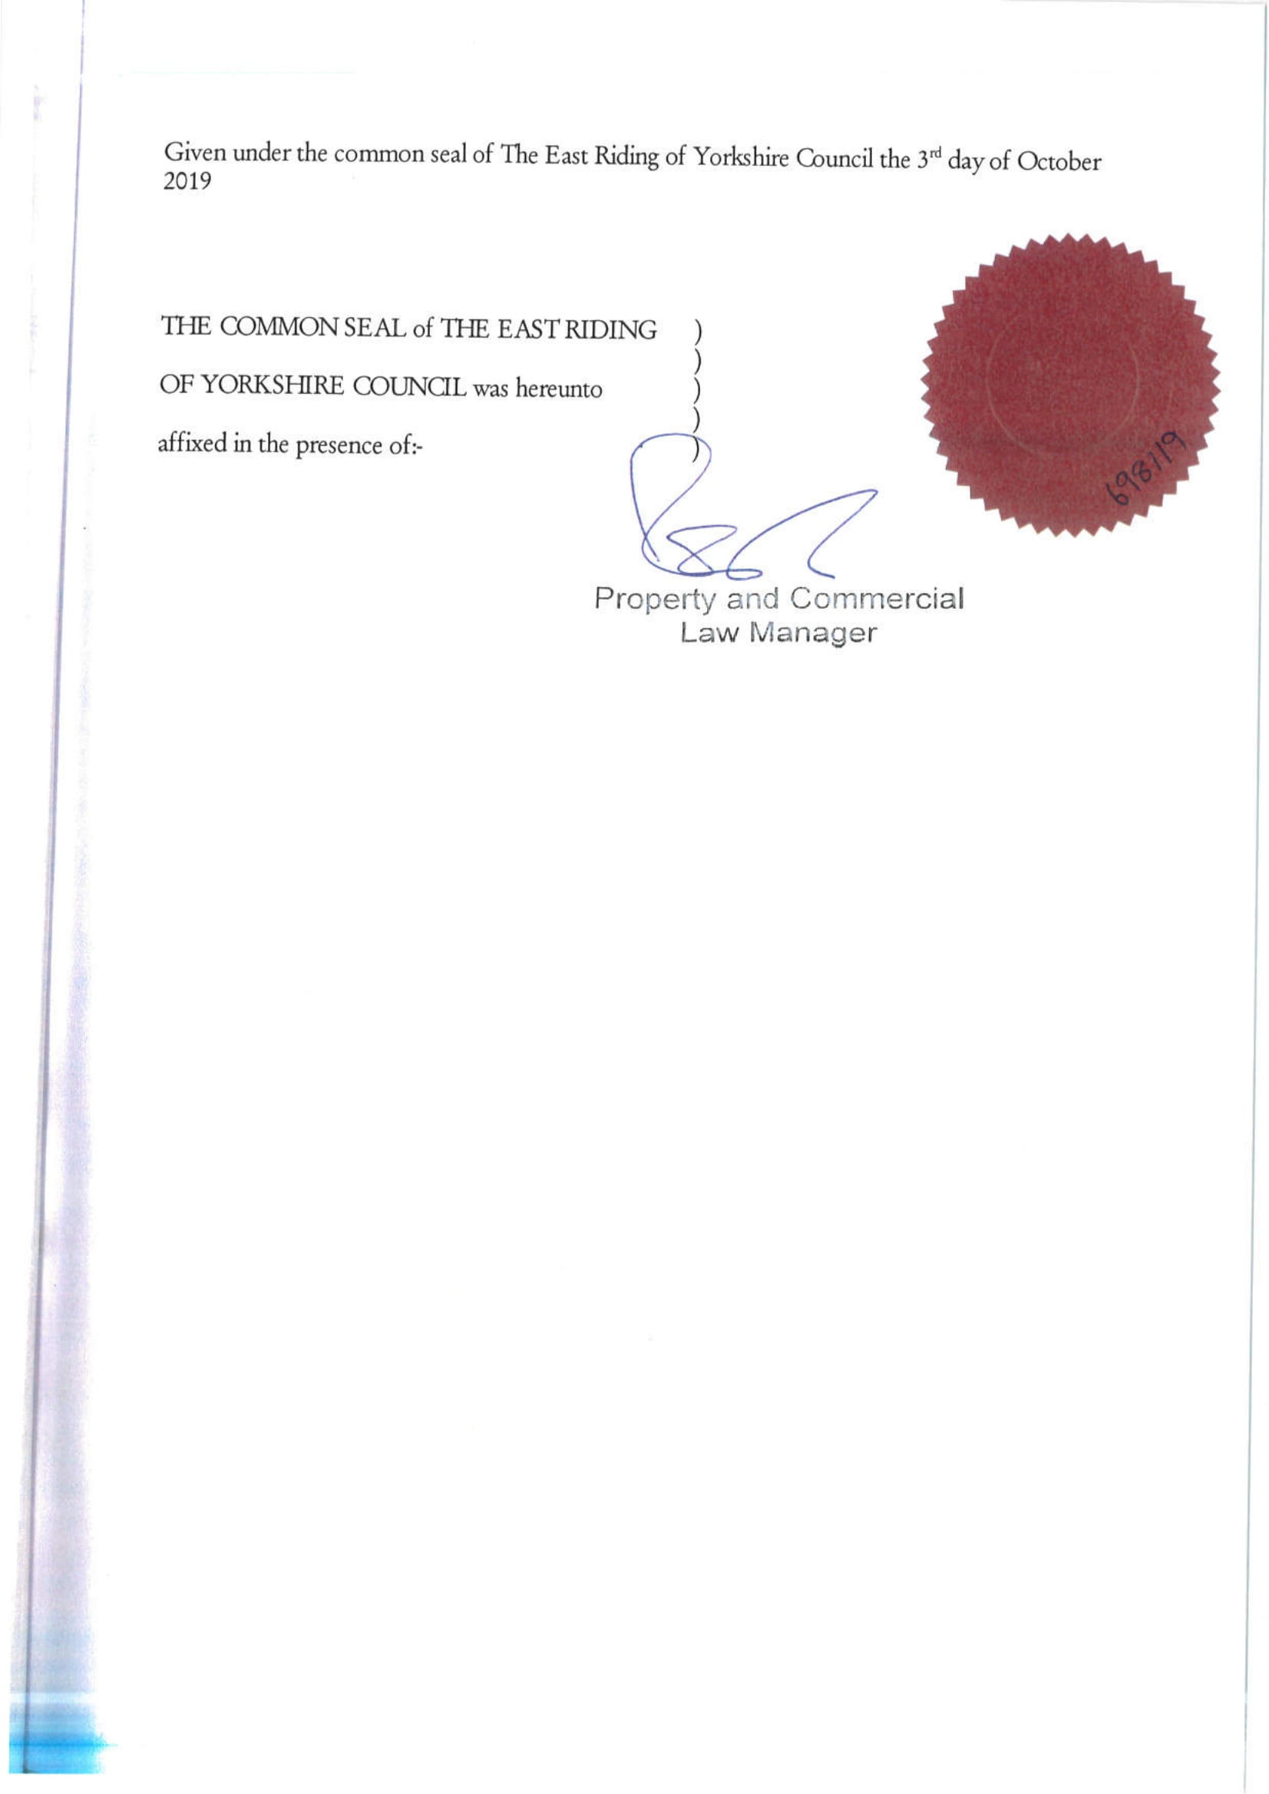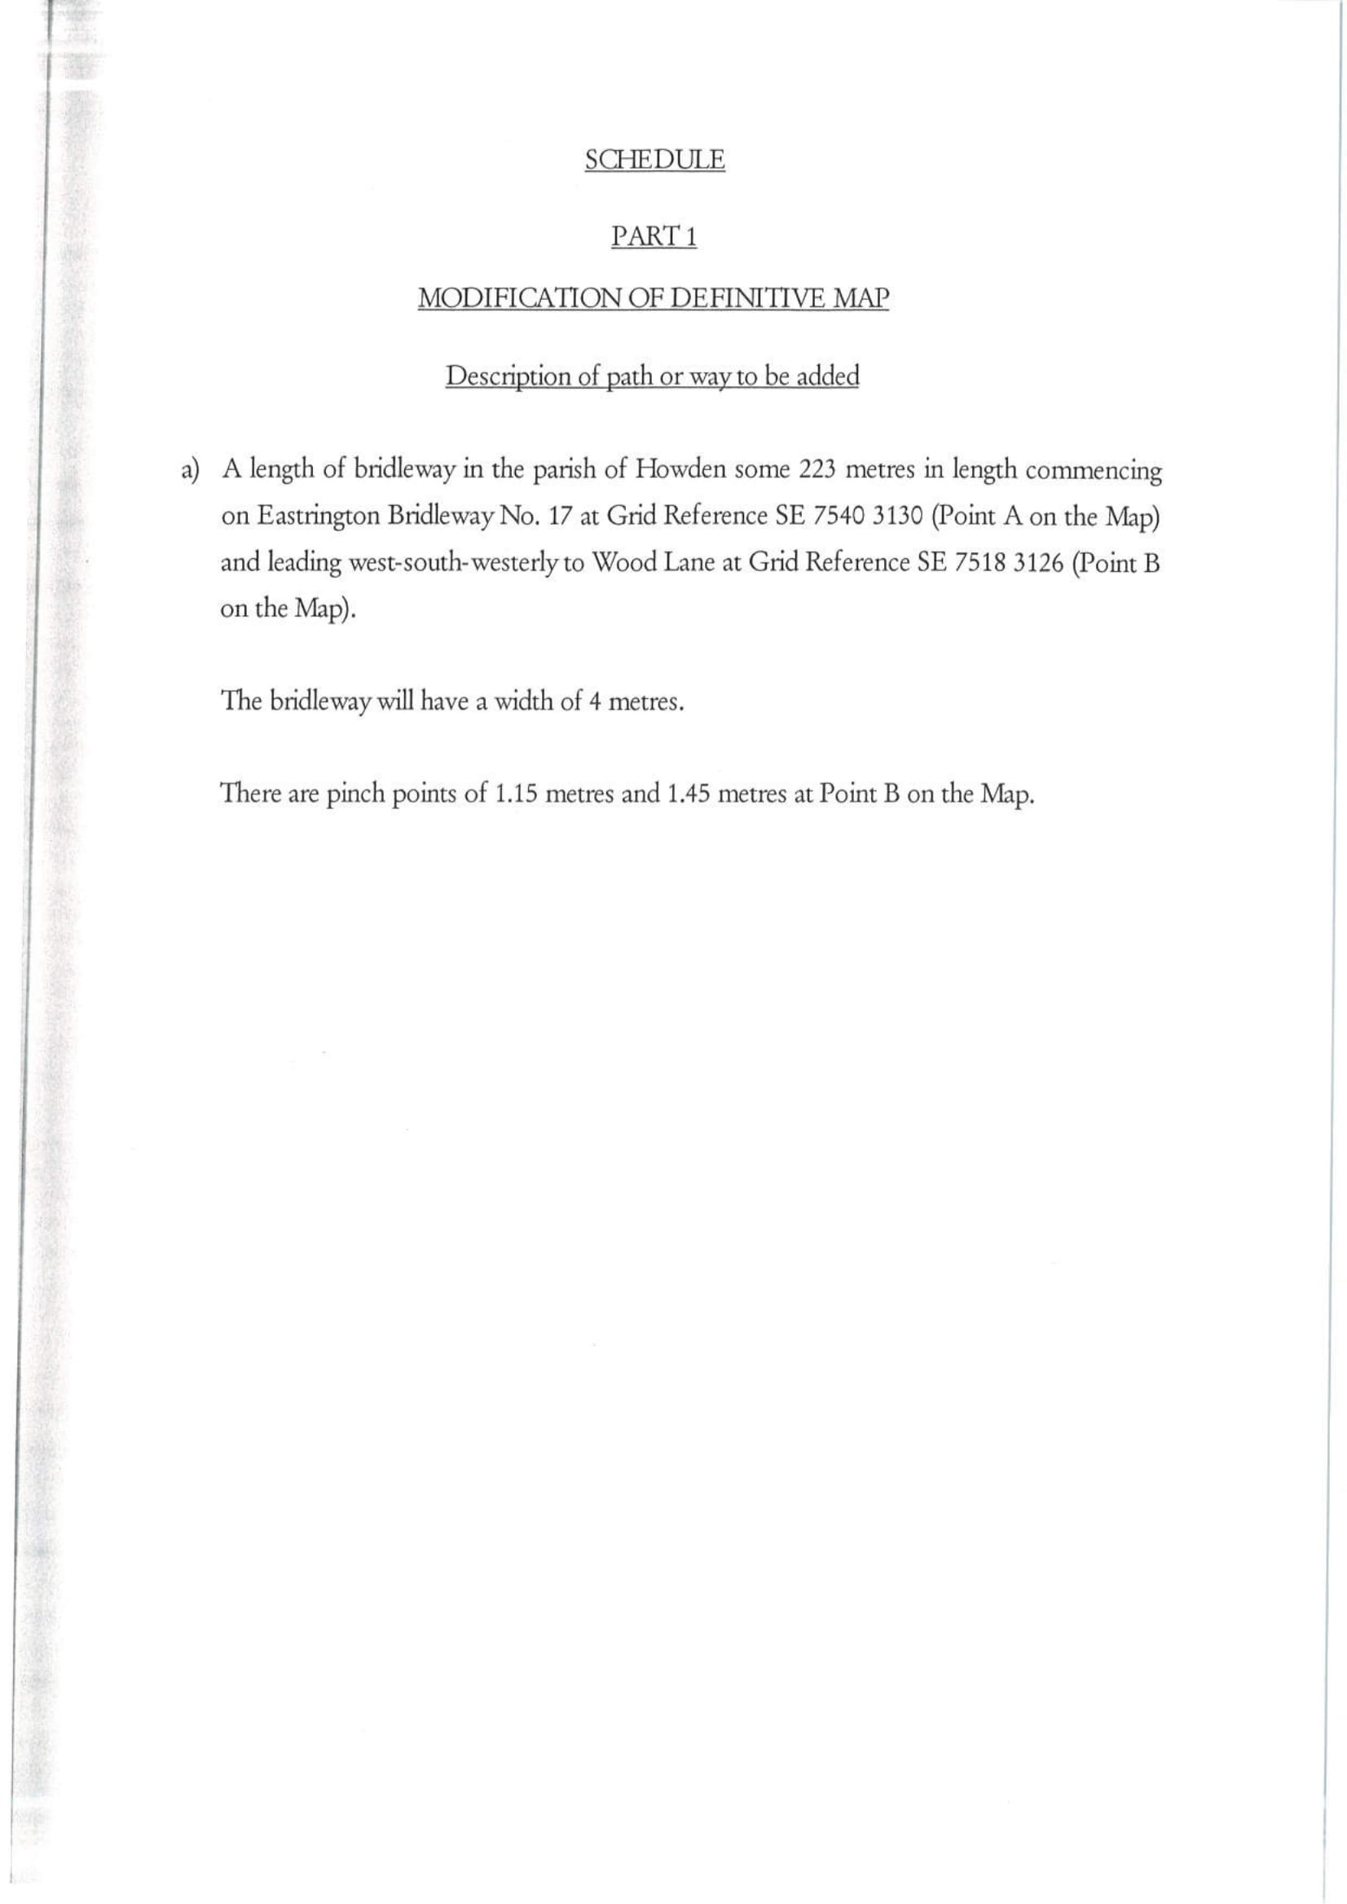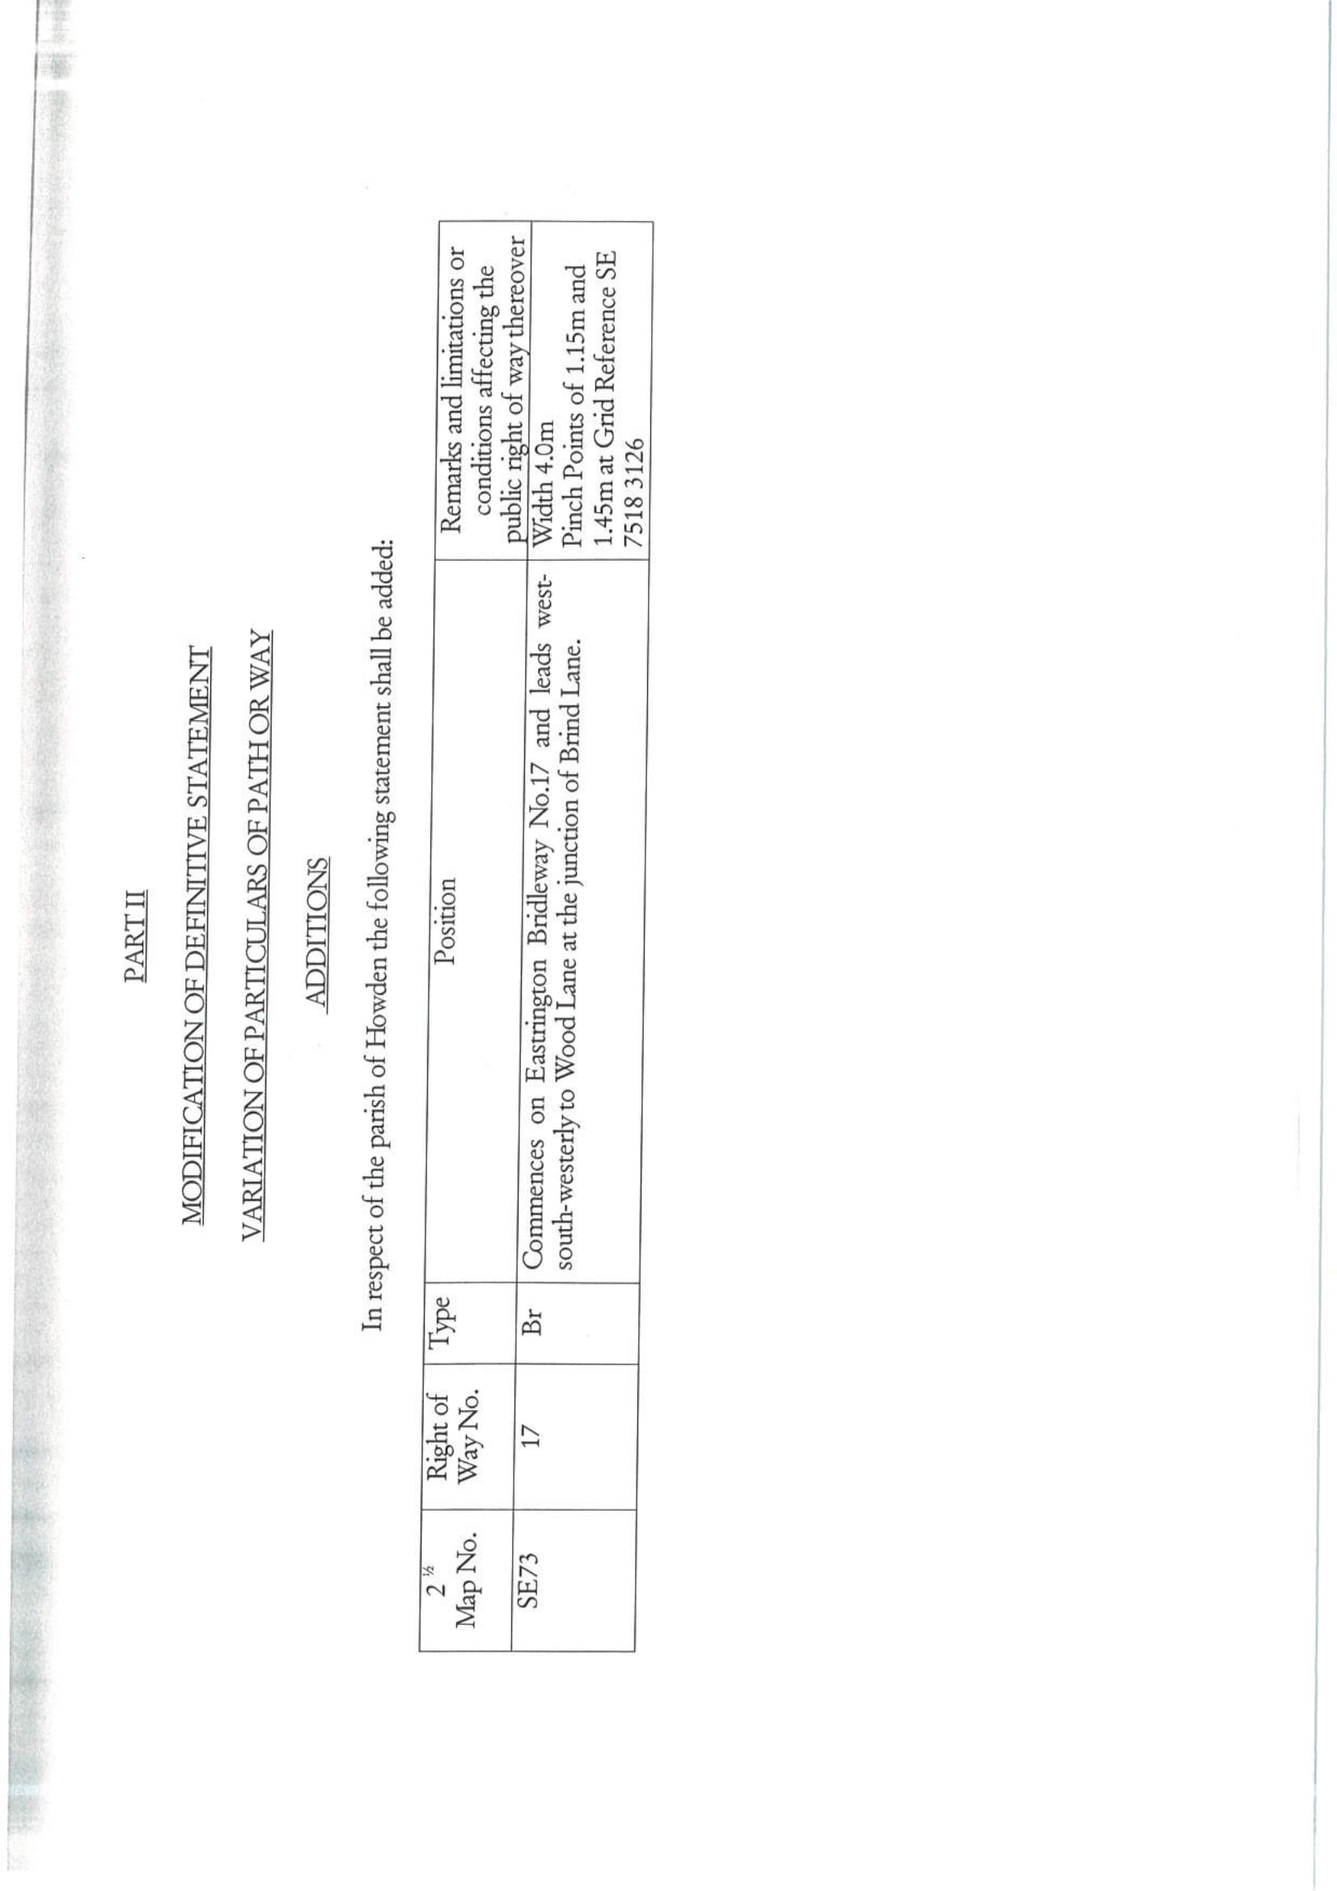

If you wish to make a legal submission, this should be submitted at the same time as your statement of case. Otherwise legal submissions will have to be submitted in writing on the day of the hearing.

