NOTICE OF ORDER
Highways Act 1980 S119
Hampshire County Council)
The Hampshire (New Forest District No. 7) (Parish of Breamore - Part of Footpath No. 17) Public Path Diversion and Definitive Map & Statement Mod Order 2020

Notice is hereby given that the above referenced Order has been submitted to the Secretary of State for Environment, Food and Rural Affairs for determination. An Inspector will be appointed by the Secretary of State to determine the Order.

The start date for the above Order is 14 December 2021.

Consideration of the Order will take the form of a public local inquiry.

The Inquiry will be held at Breamore Village Hall, Hulse Hall, Salisbury Road, Fordingbridge, Hampshire, SP6 2EA on 07 June 2021 at 10.00am.

The effect of the Order, if confirmed without modifications will be to divert the public Footpath that currently runs from Flood Street SU 1493 1732 (Point A) proceeding south-eastward along the access track serving Flood Street Farm, continuing through the garden to SU 1500 1730 (Point B), bearing north-eastward to SU 1503 1734 (Point C). A total length of 123 metres. To a new route A 2.5 metres wide path commencing at SU 1491 1735 (Point E), running eastwards from Flood Street across an arable field to SY 1499 1735 (Point D) then south-eastward to SU 1503 1734 (Point C). Approximately 115 metres in length

Any queries relating to this Order should be referred to Clive Richards at The Planning Inspectorate, Rights of Way Section, Room 3/A Eagle Wing, Temple Quay House, 2 The Square, Temple Quay, Bristol, BS1 6PN. Telephone: 0303 4445502. Email: clive.richards@planninginspectorate.gov.uk or rightsofway2@planninginspectorate.gov.uk Please quote reference number ROW/3262491 on all correspondence.

Any person wishing to view the statements of case and other documents relating to this Order may do so by appointment at Hampshire County Council, Podium Level, The Castle, Winchester, SO23 8UJ by contacting the Countryside Service Office on 0370 779 0202 to make an appointment. Any queries relating to documents should be directed to the Council. Our contact: Kim Dawkins, Tel: 0300 5551391, Email: kim.dawkins@hants.gov.uk

Timetable for sending in statements of case and proofs of evidence

Within 8 weeks of the start date by [by 08 February 2022]
The Order Making Authority must ensure their statement of case is received by the Secretary of State. As soon as possible after the deadline, the Secretary of State will send a copy (excluding copies of any supporting documents - these will be available to view at the Authority’s offices) to everyone who has made an objection or representation and the applicant and any other person who has written to us in respect of the Order.

Within 14 weeks of the start date [by 22 March 2022]
Everyone who has made an objection or representation and anyone who wishes to give evidence at the Inquiry must ensure their statement of case is received by the Secretary of State. As soon as possible after the deadline, the Secretary of State will send full copies to the Authority. Copies will also be sent to the applicant, every person who has made an objection or representation and any other person who has written to us in respect of the Order (excluding copies of any supporting documents - these will be available to view at the Authority’s offices).

Within the same period the applicant (if applicable) must ensure their statement of case is received by the Secretary of State. As soon as possible after the deadline, the Secretary of State will send a full copy to the Authority. Copies will also be sent to everyone who has made an objection or representation and any other person who has written to us in respect of the Order (excluding copies of any supporting documents - these will be available to view at the Authority’s offices).

4 weeks before the date of the inquiry [by 10 May 2022]

The Authority, everyone who has made an objection or representation, the applicant (if applicable) and anyone who wishes to give evidence at the Inquiry must ensure their proof of evidence (together with any summary) is received by the Secretary of State. As soon as possible after the deadline, the Secretary of State will send copies of:

- the Authority’s proof of evidence to everyone who has made an objection or representation, the applicant and anyone who has submitted a statement of case (including copies of any supporting documents – although none should be submitted with a proof of evidence);

- the applicant’s proof of evidence to the Authority, everyone who has made an objection or representation and anyone else who has submitted a statement of case (including copies of any supporting documents – although none should be submitted with a proof of evidence); and

- all other proofs of evidence to the Authority, the applicant, everyone who has made an objection or representation and anyone else who has submitted a statement of case (including copies of any supporting documents – although none should not be submitted with a proof of evidence).

All parties must keep to the timetable set out above and ensure that statements of case and proofs of evidence are received by the Secretary of State on time. Late documents will be returned.

We cannot accept any inflammatory, discriminatory or abusive comments. Any documents containing such comments will be returned.

Notice of order for inquiry
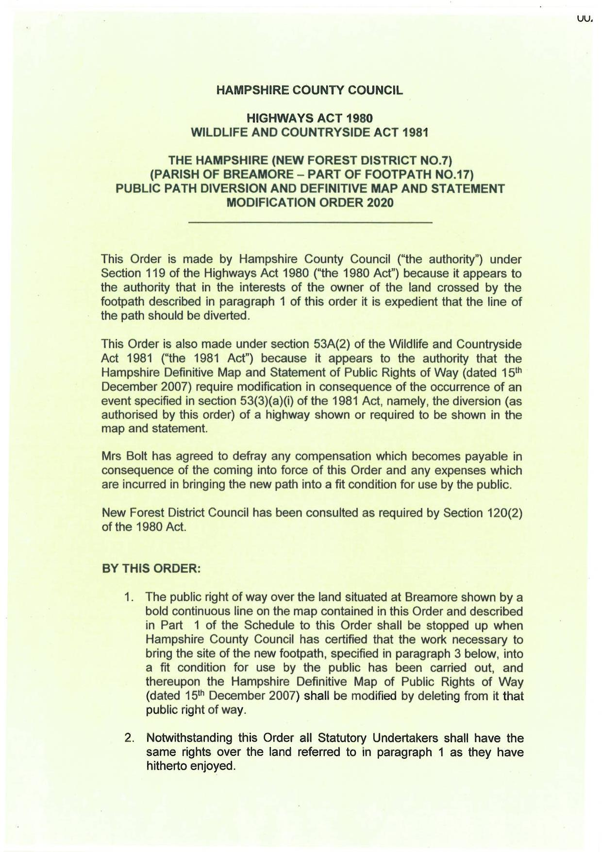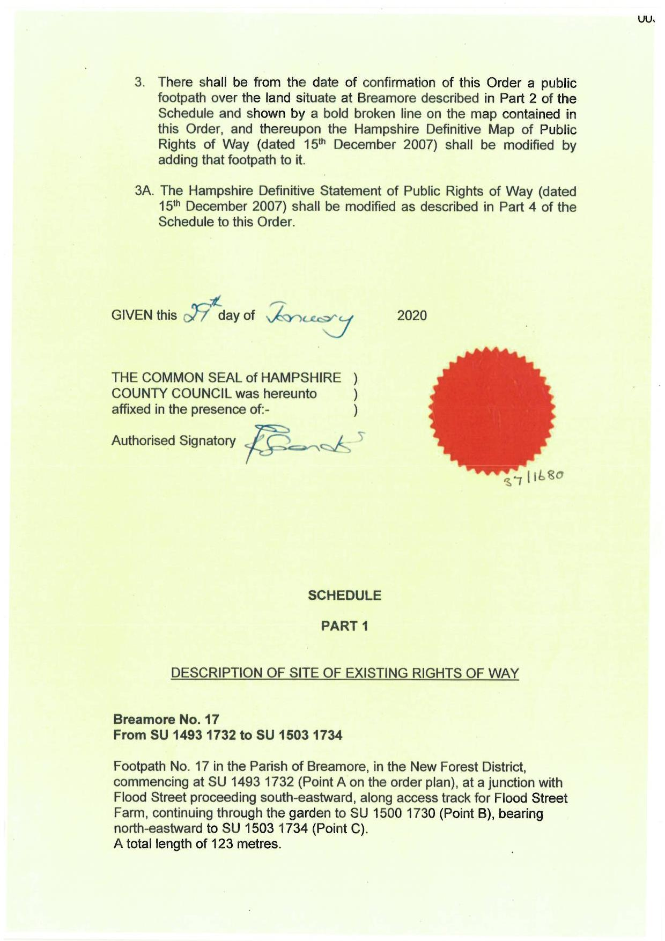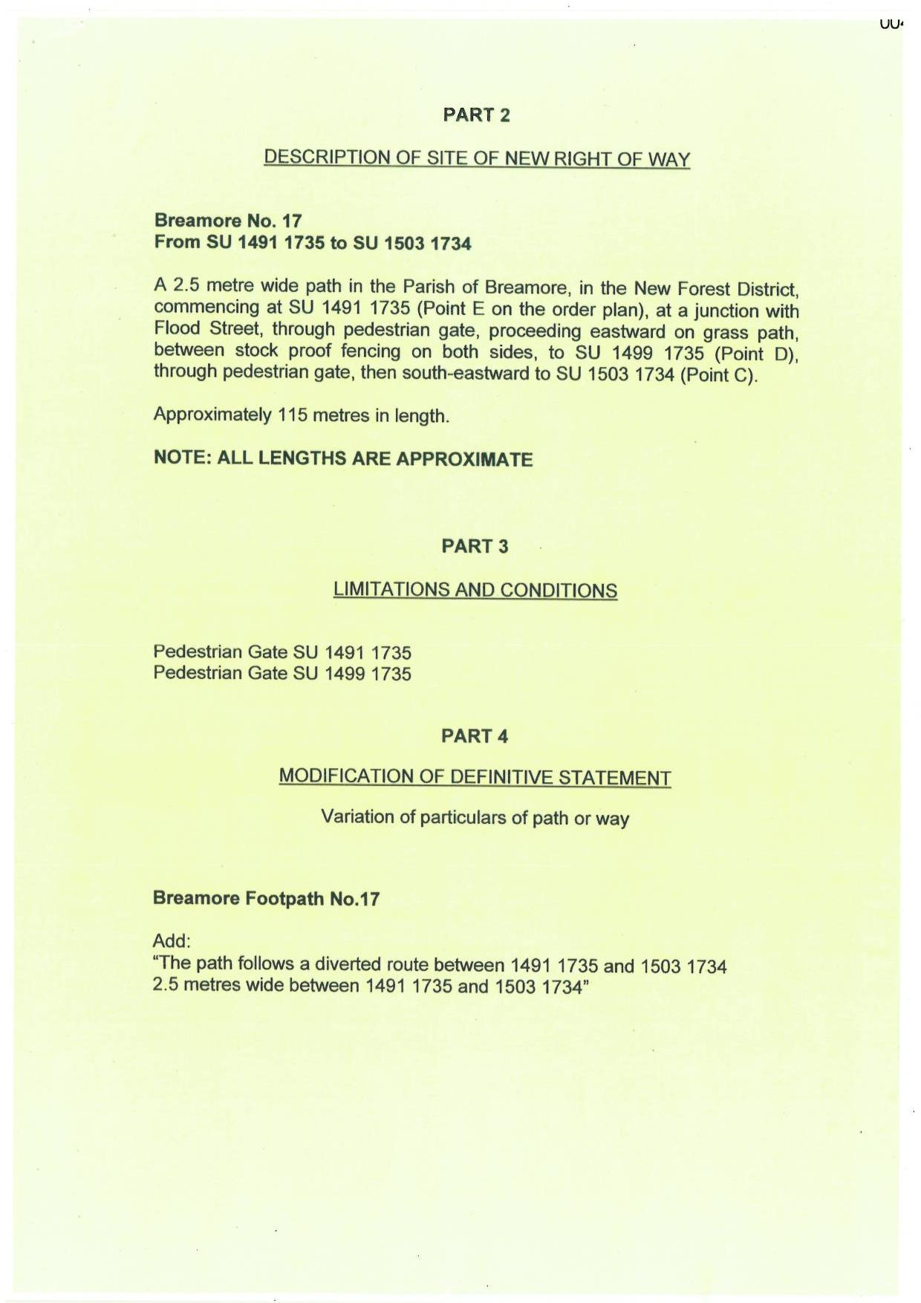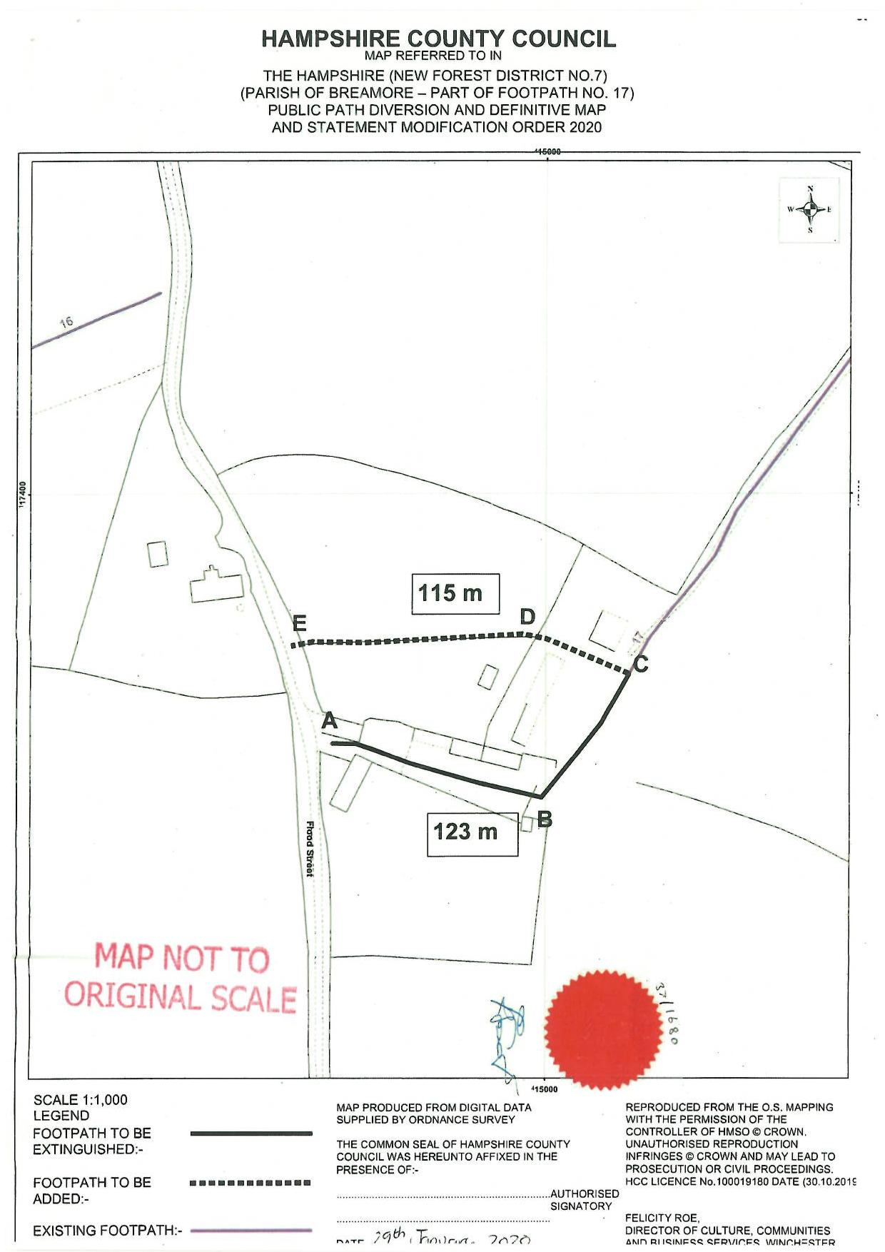

If you wish to make a legal submission, this should be submitted at the same time as your statement of case. Otherwise legal submissions will have to be submitted in writing on the day of the inquiry.

