NOTICE OF ORDER
Wildlife and Countryside Act 1981 – S53
Kent County Council
The Kent County Council (Public Footpath ZR281 (Part) Doddington) Definitive Map Modification Order 2021

Notice is hereby given that the above referenced Order has been submitted to the Secretary of State for Environment, Food and Rural Affairs for determination. An Inspector will be appointed by the Secretary of State to determine the Order.

The start date for the above Order is 30 November 2021.

Consideration of the Order will take the form of a hearing.

The Hearing will be held at Doddington Village Hall, The Street, Doddington, Kent, ME9 0BH on 22 March 2022 at 10.00am.

The effect of the Order, if confirmed without modifications, will be to modify the Definitive Map and Statement for the area by (a) deleting part of the public footpath numbered ZR281 which commences at NGR TQ 9330 5719 (Point D) and runs in a generally north-by-westerly direction for approximately 33 metres to NGR TQ 9329 5723 and then in a generally westerly direction for approximately 17 metres to NGR TQ 9327 5723 and then in a generally northerly direction for approximately 39 metres to NGR TQ 9327 5726 (Point C). As shown by the bold purple line between Points D and C in the Order Plan
And (b) adding a public footpath numbered ZR281 which commences at NGR TQ 9329 5719 (Point A) and runs in a north-by westerly direction for 24 metres to NGR TQ 9329 5721 and continues in a north westerly direction for 10 metres to NGR TQ 9328 5722 and continues in a north-by-westerly direction for 43 metres to NGR TQ 9327 5726 (the aforementioned Point C). As shown by the bold broken line, between Points A, B and C in the Order Plan.
The path will have a recorded width of 2.2 metres between points A and B (NGR TQ 9329 5720) and a recorded width of 1.5 metres between points B and C.
All distances are approximate, all directions are general.

Any queries relating to this Order should be referred to Clive Richards at The Planning Inspectorate, Rights of Way Section, Room 3/A Eagle Wing, Temple Quay House, 2 The Square, Temple Quay, Bristol, BS1 6PN. Telephone: 0303 4445502. Email: clive.richards@planninginspectorate.gov.uk or rightsofway2@planninginspectorate.gov.uk Please quote reference number ROW/3280233 on all correspondence.

Any person wishing to view the statements of case and other documents relating to this Order may do so by contacting Kent County Council. N.B. Due to ongoing Covid restrictions the OMA are unable to guarantee office access to view documents.
Therefore, anybody wishing to view the documents is requested to contact the Case Officer William Barfoot on 03000 418674 or william.barfoot@kent.gov.uk to arrange copies of documents to be sent

Timetable for sending in statements of case

Within 8 weeks of the start date [by 25 January 2022]
The Order Making Authority must ensure their statement of case is received by the Secretary of State. As soon as possible after the deadline, the Secretary of State will send a copy (excluding copies of any supporting documents, although these will be available to view at the Authority’s offices) to everyone who has made an objection or representation, the applicant and any other person who has written to us in respect of the Order.

Within 12 weeks of the start date [by 22 February 2022]
Everyone who has made an objection or representation and anyone who wishes to give evidence at the Hearing must ensure their statement of case is received by the Secretary of State. As soon as possible after the deadline, the Secretary of State will send full copies to the Authority. Copies will also be sent to the applicant, every person who has made an objection or representation and any other person who has written to us in respect of the Order (excluding copies of any supporting documents - these will be available to view at the Authority’s offices).

Within the same period the applicant (if applicable) must ensure their statement of case is received by the Secretary of State. As soon as possible after the deadline, the Secretary of State will send a full copy to the Authority. Copies will also be sent to everyone who has made an objection or representation and any other person who has written to us in respect of the Order (excluding copies of any supporting documents - these will be available to view at the Authority’s offices).

All parties must keep to the timetable set out above and ensure that statements of case are received by the Secretary of State on time. Late documents will be returned.

We cannot accept any inflammatory, discriminatory or abusive comments. Any documents containing such comments will be returned.

Notice of order for hearing
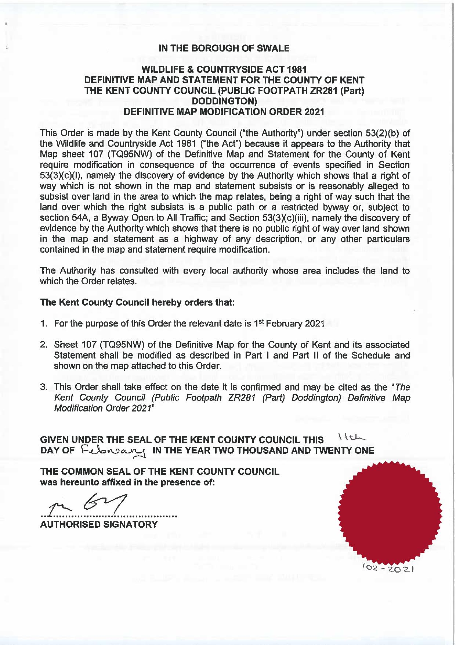
Order 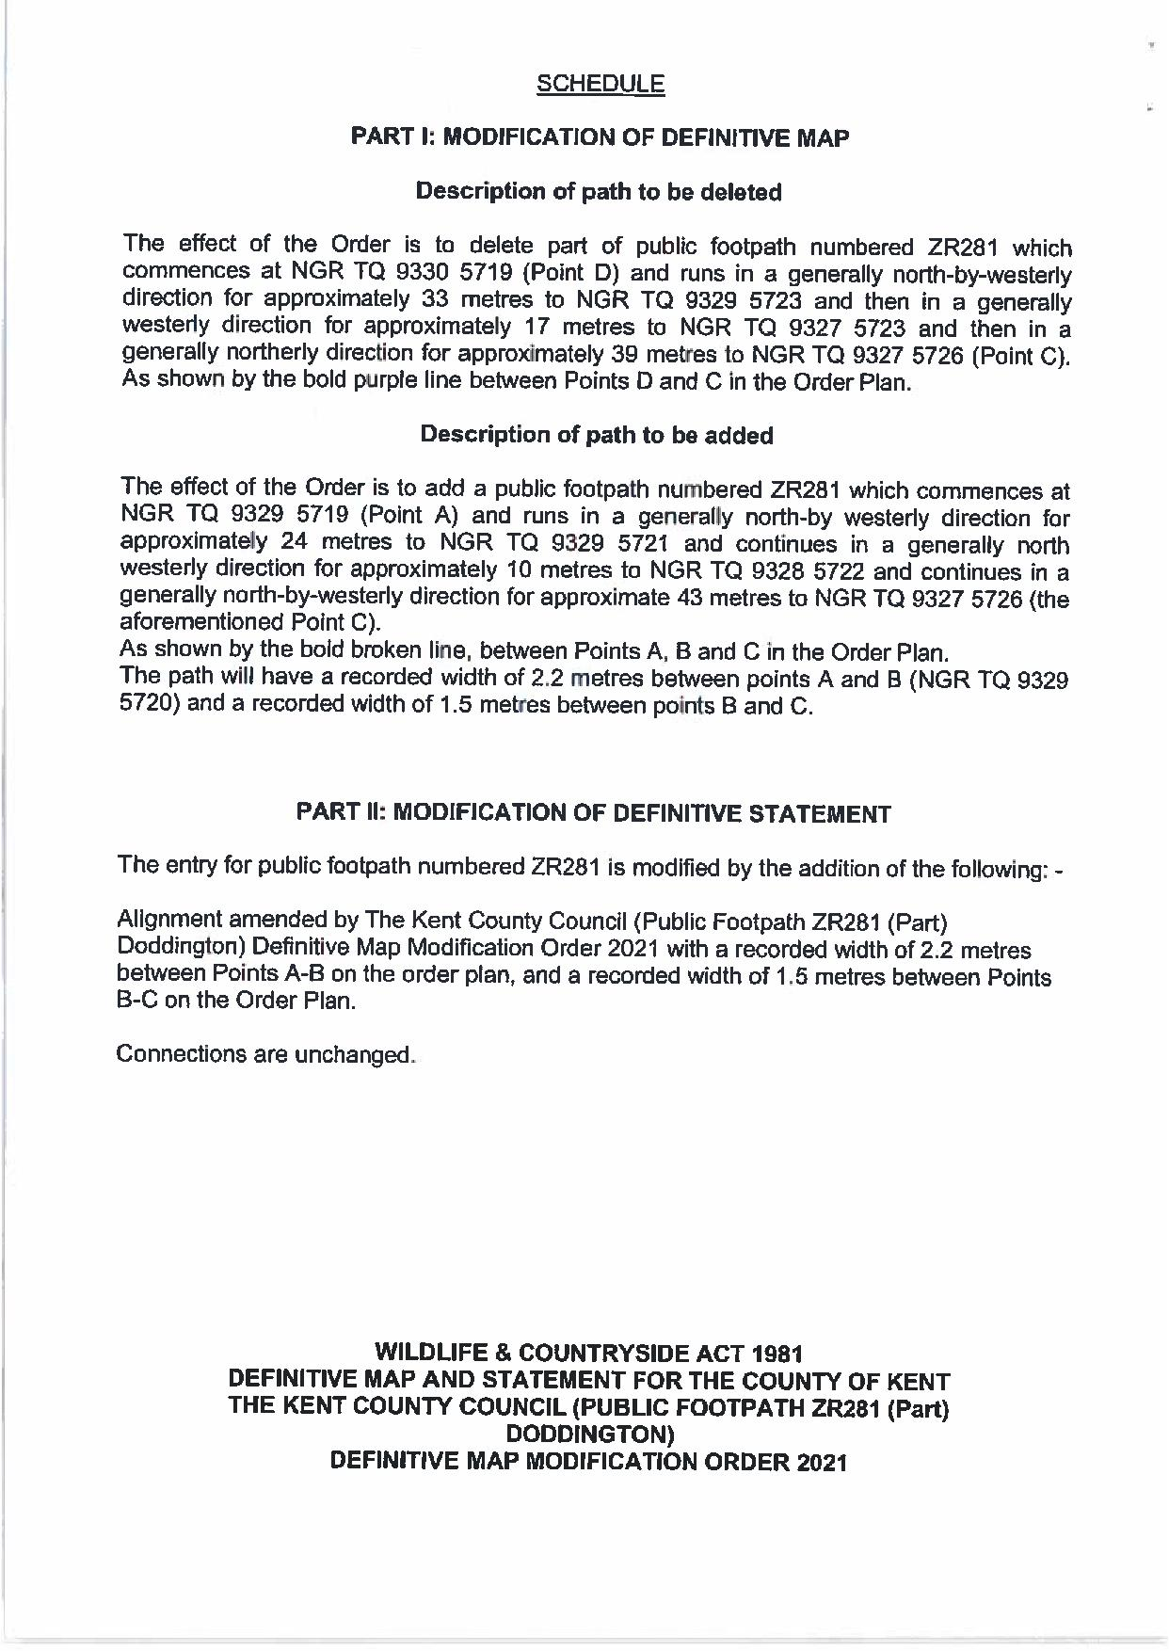
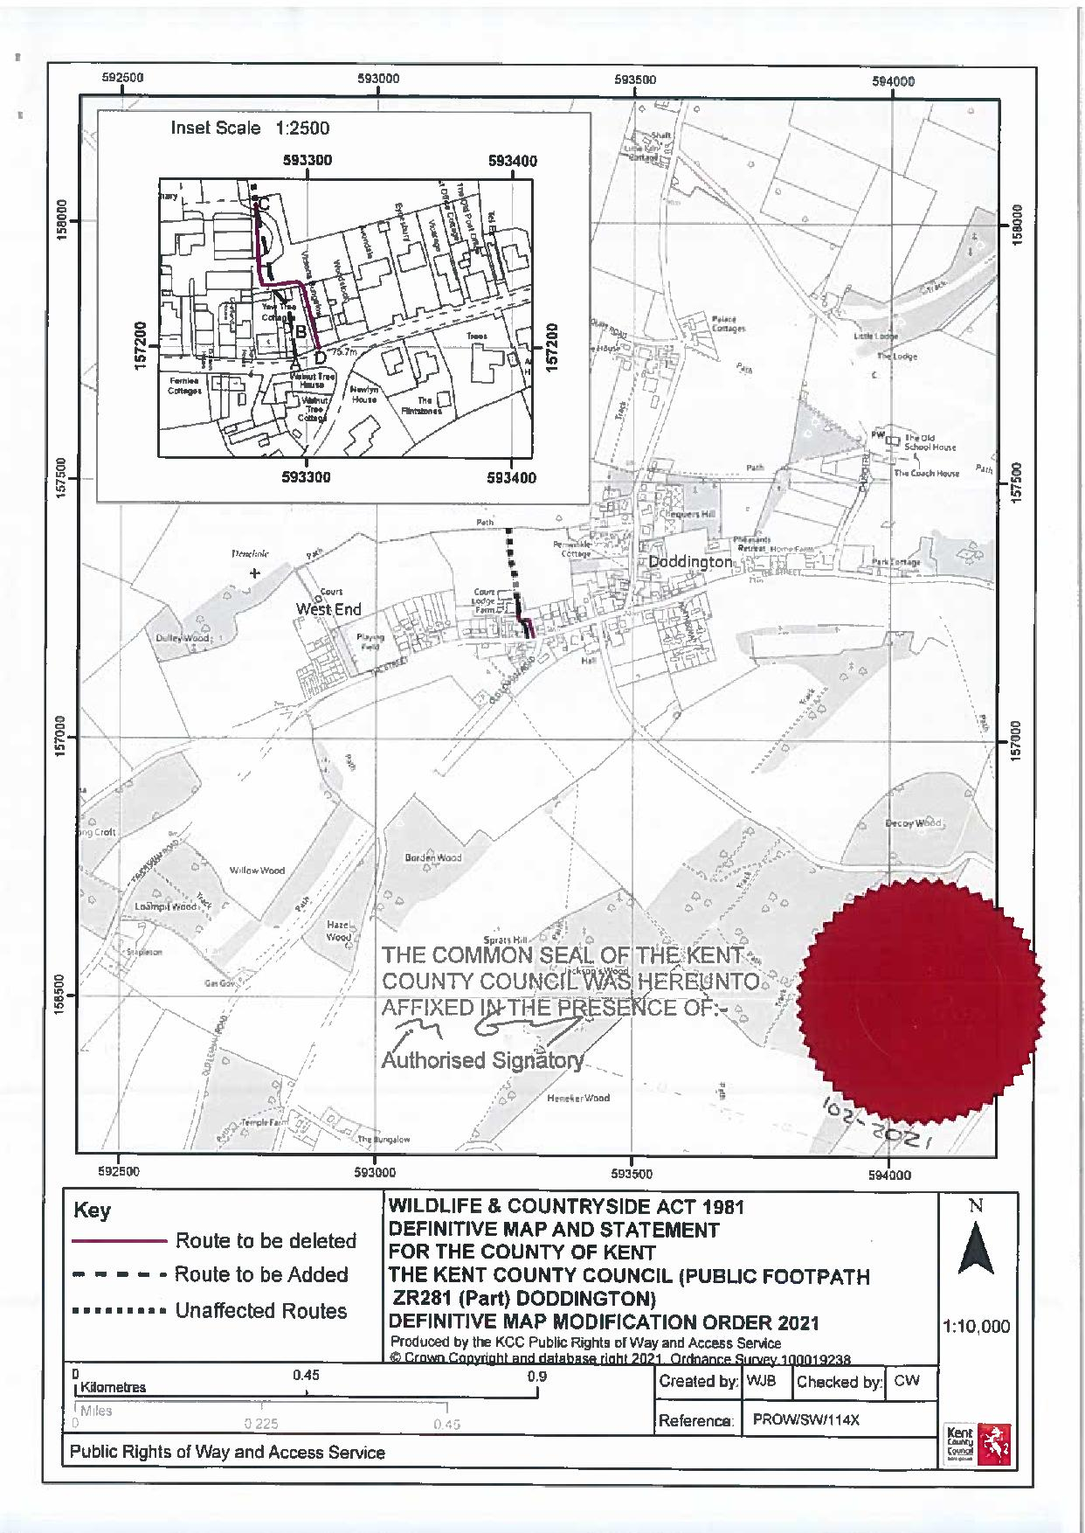

If you wish to make a legal submission, this should be submitted at the same time as your statement of case. Otherwise legal submissions will have to be submitted in writing on the day of the hearing.

