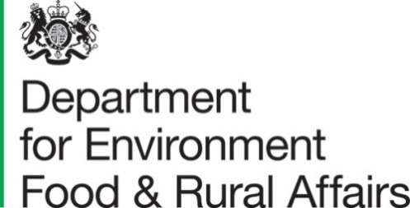
27 May 2021
Total Income from Farming in the United Kingdom, first estimate for 2020
This release presents the first estimate of Total Income from Farming (TIFF) for the United Kingdom for 2020, replacing the initial forecast figures published in December 2020. These estimates are more robust as they are based on additional data now available. Details of the changes are provided in the ‘Revisions’ section of this document. Some estimates for earlier years have also been revised due to the availability of additional / updated data.
Total Income from Farming is the total profit from all UK farming businesses on a calendar year basis. It measures the return to all entrepreneurs for their management, inputs, labour and capital invested.

Key Messages
- In 2020 Total Income from Farming is estimated to have been £4,119 million, a fall of £768 million (-15.7%) from 2019.
- In 2020, agriculture’s contribution to the UK economy (Gross Value Added at basic prices) was £9,435 million, a fall of £676 million (-6.7%) compared with 2019.
- The main drivers for the fall in Total Income from Farming were a £999 million (-10.0%) fall in the value of crop output, largely caused by unfavourable weather and a £310 million (-20%) fall in the value of output from inseparable non-agricultural activities (diversified activities) due to Covid-19 lockdowns. These more than offset a £490 million (+3.4%) rise in the value of total livestock output. Overall input costs were almost unchanged.

Figure 1: Total Income from Farming (TIFF) for the United Kingdom: 2015 to 2020 at Current Prices (not adjusted for inflation)
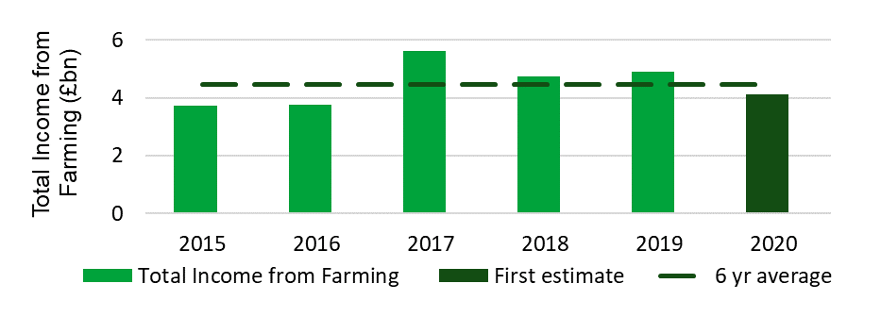

Contents

What you need to know about this release 4
National Statistics Status 4
Key words 5
Section 1 – Summary of long-term trends in real terms (adjusted for inflation) 6
Section 2 – Detailed comparison between 2020 and 2019 using Current prices (not adjusted for inflation) 9
2.1 Headline figures (comparisons with 2019 in current prices) 12
2.2 Crop Outputs (comparisons with 2019 in current prices) 12
2.3 Livestock Outputs (comparisons with 2019 in current prices) 13
2.4 Intermediate Consumption (comparisons with 2019 in current prices) 16
2.5 Compensation of employees (comparisons with 2019 in current prices) 17
2.6 Other subsidies on production (comparisons with 2019 in current prices) 17
Section 3 - About these statistics 18
3.1 Revisions 18
3.2 Covid-19 disruption and the production of these statistics 19
3.3 Summary quality report 19
3.4 Quality assurance 19
3.5 Development areas 20
3.6 Main users and uses of the aggregate agricultural accounts 20
3.7 User engagement 20
3.8 Future publications 20

What you need to know about this release

Contact details
Responsible statistician: Robin Karfoot, Area 2B, Foss House, Kings Pool, 1-2 Peasholme Green, York, YO1 7PX.
Telephone enquiries: 0208 026 6449.
Email: farmaccounts@defra.gov.uk.
Media enquiries: 0345 051 8486.
Public enquiries: 0845 601 3034.

National Statistics Status
National Statistics are produced to high professional standards. They undergo regular quality assurance reviews to ensure that they meet customer needs. They are produced free from any political interference.
The statistics last underwent a full assessment in 2014 by the UK Statistics Authority’s Assessment team. A copy of the full report can be found on the internet, Assessment Report 271 Statistics on Agriculture.
The continued designation of these statistics as National Statistics was confirmed in December 2017 following a compliance check by the UK Statistics Authority (now the Office for Statistics Regulation) against the Code of Practice for Statistics. The compliance check letter can be found on the UK Statistics Authority website.
Since the latest review by the Office for Statistics Regulation, we have continued to comply with the Code of Practice for Statistics and have enhanced data quality by reviewing methodologies and data sources.
For general enquiries about National Statistics, contact the National Statistics Public Enquiry Service:
Tel: 0845 601 3034
Email: info@statistics.gov.uk.
You can find National Statistics on the internet on the Gov.uk website.

Key words

Annual Work Unit (AWU) is equivalent to the input of one person in the farm business who is engaged in agricultural activities on a full-time basis over an entire calendar year.
Basic price is the market price plus directly paid subsidies that are linked to the production of specific products.
Current price is the value based on prices observed during the reference year (i.e. values not adjusted for inflation). The alternative to Current price is ‘Real terms’ (see below).
Entrepreneurial Labour refers to principal farmers and other workers who receive a share of Total Income from Farming.
Gross Domestic Product (GDP) is the market value of all goods and services produced by a national economy.
Gross output is the total value of output produced by farm businesses.
Gross Value Added (GVA) is computed as Gross output minus Intermediate consumption and represents that contribution of a business, sector or industry to Gross Domestic Product (GDP)
Intermediate consumption is the goods and services used as inputs in the productive process, e.g. feed, energy and fertiliser.
Real terms is where values from previous years have been adjusted for inflation. The alternative to Real terms is ‘Current price’ (see above).
Total Income from Farming (TIFF) is the income to those who own businesses within the agricultural industry.
The term income used throughout this notice refers to Total Income from Farming. This is the total profit from all UK farming businesses on a calendar year basis.

Section 1 – Summary of long-term trends in real terms (adjusted for inflation)

Values in this section are expressed in real terms at 2020 prices. The figures have been adjusted to take into account inflation, which allows more meaningful comparisons between years over the longer term. This section puts 2020 Total Income from Farming in the context of past figures. The make-up of the 2020 figure is examined in detail in Section 2.
The key drivers of agricultural income include the volume of production, commodity prices and the cost of inputs. These are themselves driven by a range of factors such as the weather, exchange rates, oil price and global supply and stocks of commodities. As a result, UK agricultural income tends to be volatile and fluctuate from year to year. In addition to these ever-present factors, agriculture in 2020 was also influenced by the Covid-19 pandemic and Brexit.
Total Income from Farming (TIFF) in 2020 was £4,119 million, a fall of £1,050 million (-20%) in real terms (adjusted for inflation) compared with 2019. This is the lowest value (in real terms) since 2007.
Over the longer term, UK TIFF rose strongly between 2000 and 2008 (see Figure 2). Since then, TIFF has remained close to or within the £4bn-£6bn range, but with some big year-on-year fluctuations, particularly in recent years. Looking more closely at recent years, TIFF fell sharply in 2015 driven by lower commodity prices and a stronger pound. In 2016 the exchange rate improved but a poor harvest and continued low commodity prices kept income low. In 2017, Total Income from Farming reached the highest point for 20 years as a result of a favourable combination of a weaker pound, strong commodity prices and high levels of production. In 2018, extreme weather conditions led to poor yields and pushed up the price of key inputs. These factors were not fully offset by strong commodity prices resulting in an 18% fall in TIFF that year. In 2019, favourable weather produced modest increases to both crop output and TIFF.
Figure 2 Agriculture industry income trends in the United Kingdom (in real terms at 2020 prices)
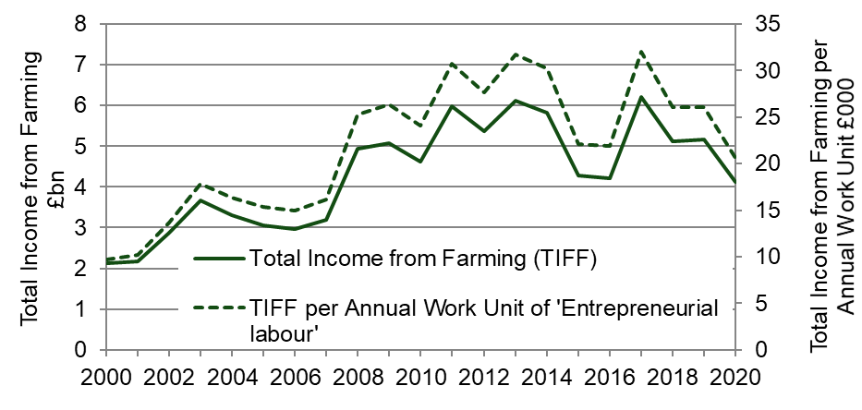

‘Total Income from Farming per Annual Work Unit of entrepreneurial labour’ is an alternative measure of income that divides income by the labour contribution of owners plus any other unpaid labour and allows comparisons to be made with other countries. Since 2000 it has followed a similar trend to Total Income from Farming (TIFF) but has performed slightly better relative to a baseline of the year 2000.

Table 1: Aggregate Agricultural Accounts: Summary of production and income accounts for the United Kingdom in real terms (adjusted for inflation at 2020 prices using the Office for National Statistics Gross Domestic Product deflator series ‘YBGB’)

£ million
 | Average  2013 to 2017 | 2018 | 2019 | 2020
Total crop output | 10,169 | 10,235 | 10,596 | 9,018
Total livestock output | 15,556 | 15,712 | 15,424 | 15,072
10 Other agricultural activities | 1,257 | 1,344 | 1,361 | 1,341
11 Inseparable non-agricultural activities | 1,387 | 1,552 | 1,638 | 1,239
12 Output (at market prices) | 28,370 | 28,843 | 29,019 | 26,670
13 Total subsidies (less taxes) on product | 38 | 50 | 50 | 47
14 Gross output at basic prices (12+13) | 28,408 | 28,893 | 29,069 | 26,717
25 Total intermediate consumption | 17,939 | 18,349 | 18,374 | 17,282
26 Gross value added at market prices (12-25) | 10,431 | 10,494 | 10,646 | 9,388
27 Gross value added at basic prices (14-25) | 10,469 | 10,544 | 10,696 | 9,435
28 Total consumption of Fixed Capital | 4,622 | 4,701 | 4,819 | 4,626
29 Net value added at market prices (26-28) | 5,809 | 5,793 | 5,826 | 4,762
30 Net value added at basic prices (27-28) | 5,847 | 5,843 | 5,876 | 4,809
31 Other taxes on production | -115 | -106 | -106 | -100
32 Other subsidies on production | 3,542 | 3,403 | 3,339 | 3,165
33 Net value added at factor cost (30+31+32) | 9,274 | 9,139 | 9,110 | 7,874
34 Compensation of employees | 2,849 | 2,915 | 2,855 | 2,767
35 Rent | 636 | 607 | 590 | 544
36 Interest | 459 | 503 | 495 | 444
37 Total Income from Farming (33-34-35-36) | 5,331 | 5,114 | 5,169 | 4,119
'Entrepreneurial Labour' (thousand Annual Work Units) (a)(b) | 193 | 196 | 198 | 200
Total Income from Farming per unit of 'entrepreneurial labour' (£ per AWU) (a)(b) | 27,595 | 26,030 | 26,056 | 20,562

(a) 'Entrepreneurial labour' refers to the owners of farm businesses and any other unpaid labour.

(b) Annual Work Unit (AWU) corresponds to the work performed by one person occupied on a full-time basis for a year.

Section 2 – Detailed comparison between 2020 and 2019 using current prices (not adjusted for inflation)

This comparison of the Total Income from Farming (TIFF) account from two most recent years is made between values that have not been adjusted for inflation. This approach is considered the most intuitive for comparisons over a short time period. See Table 2 for data expressed in current prices. Following the data is commentary offering explanation for the values estimated for 2020 and how they have changed since 2019.

Table 2: Aggregate Agricultural Accounts: Production and income account for the United Kingdom in current prices (not adjusted for inflation)

£ million
 |  | 2019 | 2020 | Change  2019 & 20  £ million | % Change  2019 & 20
1 Output of cereals |  | 3 629 | 2,759 | - 870 | -24%
of which: | wheat | 2,434 | 1,550 | - 885 | -36%
 | barley | 1,072 | 1,054 | - 18 | -2%
 | oats | 117 | 150 | 33 | 28%
2 Output of industrial crops |  | 984 | 737 | - 247 | -25%
of which: | oilseed rape | 586 | 358 | - 227 | -39%
 | protein crops | 145 | 155 | 10 | 7%
 | sugar beet | 210 | 172 | - 38 | -18%
3 Output of forage plants |  | 231 | 217 | - 14 | -6%
4 Output of vegetables and horticulture |  | 2,855 | 2,968 | 113 | 4%
of which: | fresh vegetables | 1,481 | 1,611 | 129 | 9%
 | plants and flowers | 1,374 | 1,358 | - 16 | -1%
5 Output of potatoes (including seeds) |  | 764 | 824 | 61 | 8%
6 Output of fruit |  | 917 | 1,041 | 124 | 13%
7 Output of other crop products, incl seeds |  | 637 | 472 | - 166 | -26%
Total crop output (sum 1-7) |  | 10,017 | 9,018 | - 999 | -10%
8 Output of livestock |  | 9,339 | 9,864 | 525 | 6%
primarily for meat |  | 8,034 | 8,573 | 540 | 7%
of which: | cattle | 2,729 | 2,929 | 200 | 7%
 | pigs | 1,342 | 1,442 | 100 | 7%
 | sheep | 1,250 | 1,346 | 96 | 8%
 | poultry | 2,671 | 2,813 | 142 | 5%
gross fixed capital formation |  | 1,306 | 1,291 | - 15 | -1%
of which: | cattle | 758 | 781 | 23 | 3%
 | pigs | 6 | 5 | - 1 | -13%
 | sheep | 272 | 270 | - 2 | -1%
 | poultry | 270 | 235 | - 35 | -13%
9 Output of livestock products |  | 5,242 | 5,208 | - 34 | -1%
of which: | milk | 4,462 | 4,383 | - 78 | -2%
 | eggs | 659 | 730 | 71 | 11%
Total livestock output (8+9) |  | 14,582 | 15,072 | 490 | 3%
10 Other agricultural activities |  | 1,287 | 1,341 | 54 | 4%
11 Inseparable non-agricultural activities |  | 1,549 | 1,239 | - 310 | -20%
12 Output (at market prices) (sum 1 to 11) |  | 27,434 | 26,670 | - 764 | -3%
13 Total subsidies (less taxes) on product |  | 47 | 47 | 0 | 0%
14 Gross output at basic prices (12+13) |  | 27,481 | 26,717 | - 764 | -3%

Table 2 (continued): Aggregate Agricultural Accounts: Production and income accounts in the United Kingdom in current prices (not adjusted for inflation)

£ million
 |  | 2019 | 2020 | Change  2019 & 20  £ million | % Change  2019 & 20
15 Seeds |  | 837 | 977 | 140 | 17%
16 Energy |  | 1,392 | 1,290 | - 102 | -7%
of which: | electricity and fuels for heating | 460 | 455 | - 5 | -1%
 | motor and machinery fuels | 932 | 835 | - 97 | -10%
17 Fertilisers |  | 1,388 | 1,147 | - 241 | -17%
18 Plant protection products |  | 1,001 | 1,097 | 96 | 10%
19 Veterinary expenses |  | 460 | 460 | 1 | 0%
20 Animal feed |  | 5,529 | 5,586 | 57 | 1%
of which: | compounds | 3,354 | 3,418 | 65 | 2%
 | straights | 1,442 | 1,588 | 146 | 10%
 | feed produced/used on farm  or bought from other farms | 734 | 580 | - 154 | -21%
21 Total maintenance |  | 1,790 | 1,822 | 33 | 2%
of which: | materials | 1,056 | 1,068 | 11 | 1%
 | buildings | 733 | 755 | 21 | 3%
22 Agricultural services |  | 1,287 | 1,341 | 54 | 4%
23 FISIM |  | 151 | 175 | 24 | 16%
24 Other goods and services |  | 3,536 | 3,387 | - 149 | -4%
25 Total intermediate consumption (sum 15 to 24) |  | 17,370 | 17,282 | - 88 | -1%
26 Gross value added at market prices (12-25) |  | 10,064 | 9,388 | - 676 | -7%
27 Gross value added at basic prices (14-25) |  | 10,111 | 9,435 | - 676 | -7%
28 Total consumption of Fixed Capital |  | 4,556 | 4,626 | 70 | 2%
of which: | equipment | 2,086 | 2,117 | 31 | 1%
 | buildings | 1,069 | 1,058 | - 12 | -1%
 | livestock | 1,400 | 1,451 | 51 | 4%
 | cattle | 824 | 881 | 57 | 7%
 | pigs | 6 | 5 | - 1 | -14%
 | sheep | 278 | 285 | 7 | 2%
 | poultry | 292 | 281 | - 12 | -4%
29 Net value added at market prices (26-28) |  | 5,508 | 4,762 | - 746 | -14%
30 Net value added at basic prices (27-28) |  | 5,555 | 4,809 | - 746 | -13%
31 Other taxes on production |  | -100 | -100 | 0 | 0%
32 Other subsidies on production |  | 3,156 | 3,165 | 9 | 0%
33 Net value added at factor cost (30+31+32) |  | 8,612 | 7,874 | - 738 | -9%
34 Compensation of employees |  | 2,699 | 2,767 | 68 | 3%
35 Rent |  | 558 | 544 | - 14 | -2%
36 Interest |  | 468 | 444 | - 24 | -5%
37 Total income from farming (33-34-35-36) |  | 4,886 | 4,119 | - 768 | -16%

2.1 Headline figures (comparisons with 2019 in current prices)

In 2020, Total Income from Farming in current prices (not adjusted for inflation) fell by £768 million to £4,119 million, a 15.7% fall from 2019.
Almost the entire fall in TIFF can be explained by Gross Output at basic prices which fell by £764 million. Overall costs in 2020 were similar to 2019, as were total subsidies.
The main contributors to this decrease are the fall in the value of output from wheat (-£885 million, -36%), oilseed rape (-£227 million, -39%) and inseparable non-agricultural activities (-£310 million, -20%).
Gross Value Added (GVA) at basic prices, which measures agriculture’s contribution to the Gross Domestic Product (GDP), fell by 6.7% (£676 million) to £9,435 million in 2020.

2.2 Crop Outputs (comparisons with 2019 in current prices)

The value of Total Crop Output for 2020 was £9,018 million, a fall of £999 million or 10% compared with 2019. In general, cereals and industrial crops struggled, whilst horticultural crops fared much better overall.
The value of output from cereals was £2,759 million, a fall of £870 million (-24%) on 2019. This fall was largely explained by wheat output which fell in value by £885 million (36%) to £1,550 million. Drilling of winter wheat in 2019/20 was badly affected by significant winter rain meaning that some planting was abandoned in favour of spring sowing of other crops. The very dry spring caused further problems and, whilst the harvest got off to a good start, heavy rain in mid / late August caused losses and quality issues. The result was a 24% fall in wheat area and reduced yields contributing to the smallest UK wheat harvest (by volume) since 1981. A price rise of 6.1% for wheat was not nearly enough to compensate for the 40% fall in volume.
The value of output from barley fell by £18 million (-1.7%) to £1,054 million. The large number of growers switching from winter wheat to spring barley meant that, despite the difficult season, barley production in 2020 was up slightly on the record harvests seen in 2019. The price of barley fell by 2.1%, due to plentiful supplies and lower demand from brewers because of hospitality venues being closed during Covid-19 lockdowns.
The value of output from oilseed rape (OSR) fell by £227 million (-39%) to £358 million. The planted area of oilseed rape fell again in 2020, this time by 28%, giving the smallest areas since 1989 and contributing to a 41% fall in volume. Wet weather during crop establishment and infestations of cabbage stem flea beetle proved problematic for growers.
The value of sugar beet fell by £38 million (-18%) to £172 million. The dry spring and aphid infestations follow two mild winters resulted in a 23% fall in production.
The value of output from fresh vegetables rose by £129 million (8.7%) to £1,611 million. Both volume and average price saw small rises in 2020, though fortunes were mixed over a wide variety of crops. Some crops such as carrots and onions struggled with the wet winter and very dry spring though the mixture of heat and rains later in the year proved favourable, particularly for brassica production.
The value of output from plants and flowers fell by £16 million (-1.2%) to £1,358 million. The sector was impacted by the first Covid-19 lockdown that closed garden centres during a critical selling period. Many nurseries successfully adapted their businesses and were able to recoup some sales later in the year.
The value of output from potatoes rose by £61 million (7.9%) to £824 million. Both volume and price were slightly higher in 2020 than in 2019.
The value of output from fruit rose by £124 million (13.5%) to £1,041 million. This was driven by a rise in average prices of 19%, which outweighed a 4.4% drop in volume. Despite a good harvest, Bramley apples saw a big rise in price due to low stocks carried over. Strawberries and blackcurrants also enjoyed significantly higher prices in 2020.

Figure 3: Percentage share of the value of total crop output in 2020
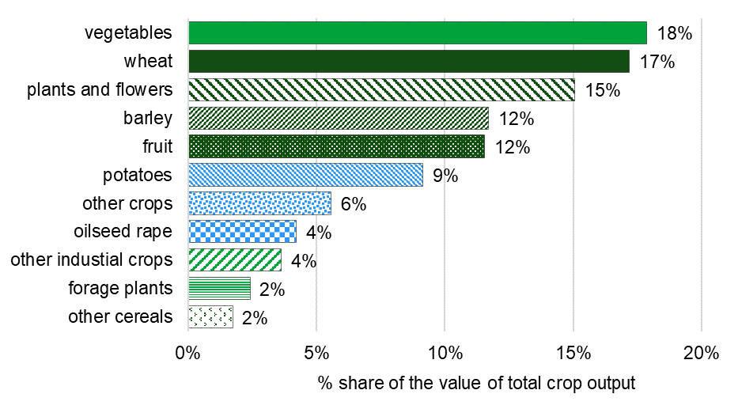

2.3 Livestock Outputs (comparisons with 2019 in current prices)
The value of total livestock output for 2020 was £15,072 million, a rise of £490 million or 3.4% compared with 2019. This was mainly driven by livestock primarily for meat rather than livestock products such as milk.
The value of output from livestock primarily for meat rose by £540 million (+6.7%) to £8,573 million, with all four main livestock groups (cattle, pigs, sheep and poultry) seeing rises in value of between 5% and 8% on 2019.
The value of output from cattle (for meat) rose by £200 million (+7.3%) to £2,929 million. Both volume and price showed small rises. The closure of hospitality outlets due to Covid-19 reduced demand for high value cuts. Initial concern that these cuts would be minced and carcase value would fall appear not to have been too damaging overall.
The value of output from pigs rose by £100 million (+7.4%) to £1,442 million. Both volume and price showed small rises as the market for pig meat proved resilient to Covid-19 lockdowns.
The value of output from sheep rose by £96 million (+7.7%) to £1,346 million. The volume of sheep meat production fell by 4.3% but this was outweighed by a 13% rise in price. The Easter lamb market was disrupted by the first Covid-19 lockdown, however, retail volumes were boosted by demand for takeaways throughout the second half of the year and prices were helped by reduced competition from New Zealand lamb.
The value of output from poultry (for meat) rose by £142 million (+5.3%) to £2,813 million. The main driver was broiler meat production which increased in both volume and price, though the volume of poultry exports fell. An increased demand was seen for free-range and organic chickens as consumers sought more luxury meals at home during Covid-19 lockdowns. The turkey market was forced to reduce placements as large Christmas gatherings were not anticipated to be possible.
The value of output from milk fell by £78 million (-1.8%) to £4,383 million. Milk consistently has the highest value of any individual item on the account by a considerable margin. In 2020 output from milk was worth 50% more than output from cattle (for meat) and almost three times as much as output from Wheat. The observed fall in value was almost entirely due to a fall of 0.55 pence per litre (-1.8%) in the average farmgate price to 28.56 pence per litre. The level of milk production was maintained and whilst market demands in the dairy sector shifted from hospitality (e.g. liquid milk for coffee) to households (e.g. butter for baking) during Covid-19 lockdowns.
The value of output from eggs rose by £71 million (+11%) to £730 million. This was almost entirely driven by an 11% increase in price, partly due to a continued move from caged production to higher welfare and organic systems. Demand for eggs benefited from an increase in baking during Covid-19 lockdowns.
Figure 4: Percentage share of the value of total livestock output in 2020
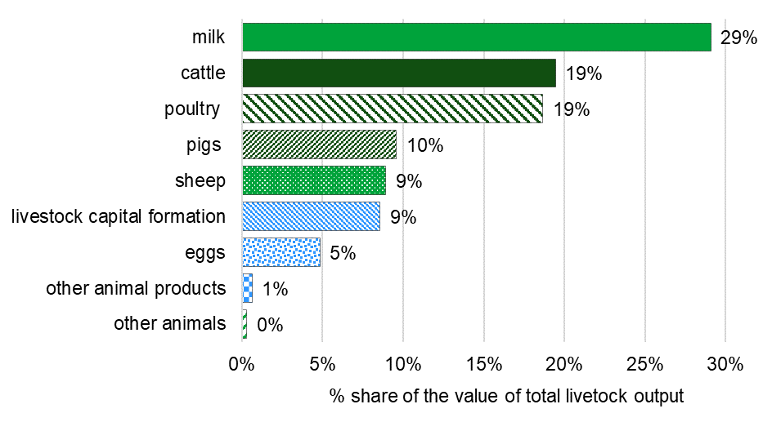

2.4 Intermediate Consumption (comparisons with 2019 in current prices)
Intermediate consumption is the goods and services used as inputs in the productive process, e.g. feed, energy and fertiliser.
The total cost of Intermediate Consumption in 2020 was £17,282 million, a fall of £88 million or -0.5% compared with 2019. This modest change is the sum of several more substantial rises and falls in the component cost categories, mostly influenced by weather events and the Covid-19 pandemic.
The cost of seeds rose by £140 million (+16.8%) to £977 million. This was almost entirely due to a 16.5% rise in the volume of seeds, with many cereal farmers sowing increased areas in spring 2020 in response to the unfavourable drilling and establishment conditions over winter 2019/20 before returning winter varieties in late 2020. Increased seed rates per hectare and an increase in the use of cover crops also contributed.
The cost of energy fell by £102 million (-7.3%) to £1,290 million. This was almost entirely due to a fall of £97 million (-10%) in the cost of motor and machinery fuels. There was a 4.5% increase in the volume of fuel used mainly due to the increase in spring sown cereals, but this was outweighed by a 14% fall in price due to lower global demand for oil because of Covid-19 related lockdowns.
The cost of fertilisers fell by £241 million (-17%) to £1,147 million. This was the largest nominal change of all the itemised Intermediate Consumption costs and resulted from falls in both the volume and price of fertilisers. Volume fell by 6.2% due to less fertiliser-intensive spring crops replacing winter sown crops for the 2020 harvest. The price of fertilisers fell by 12% as production is heavily reliant on energy, which fell in price in 2020.
The cost of plant protection products rose by £96 million (+9.6%) to £1,097 million. A reduced volume of fungicide was used due to lower than usual disease pressure thanks to the mild and dry spring, but price was higher because of the banning of Chlorothalomil. The volume of herbicide used rose as post emergence applications on winter sown crops were postponed from late 2019 to early 2020.
The cost of animal feed rose by £57 million (+1%) to £5,586 million. Animal feed is consistently the biggest percentage share of total Intermediate Consumption and comprises compounds, straights and feed produced and used on farm or purchased from other farms. Compounds consistently make up the majority of animal feed costs and in 2020 the cost of compounds rose by £65 million (+1.9%) to £3,418 million. The price rise of 0.8% was kept down partly by compounders switching from wheat to barley where possible. The cost of straights rose by £146 million (+10%) to £1,588 million owing to a 4.3% rise in volume and 5.6% rise in price. The cost of animal feed kept within the agricultural industry fell by £154 million (-21%) to £580 million.
The cost of other goods and services fell by £149 million (-4.2%) to £3,387 million. This was mainly driven by a significant reduction in the volume of straw purchased from other farms as a result of good stocks from 2019 and limited supply following the poor harvest in 2020.

Figure 5: Percentage share of the total value of intermediate consumption costs in 2020
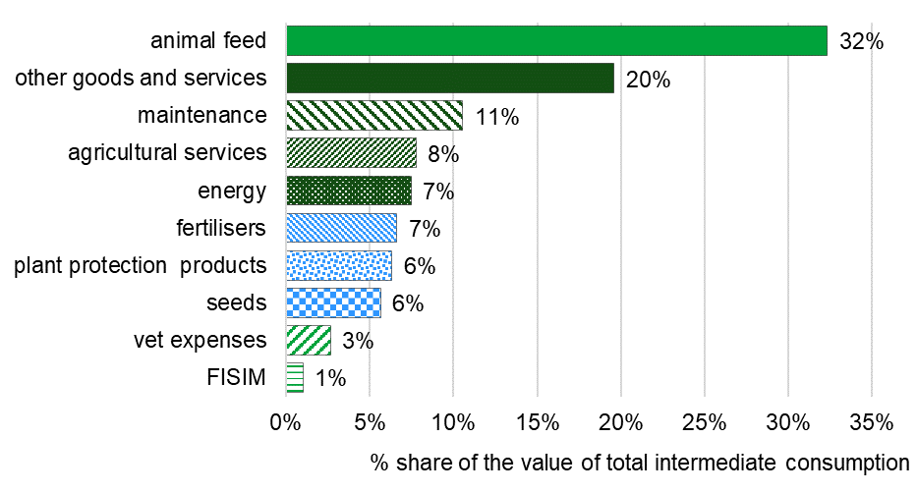

2.5 Compensation of employees (comparisons with 2019 in current prices)
The total cost of compensation of employees in 2020 was £2,767 million, a rise of £68 million or 2.5% compared with 2019. The rise was mainly driven by wage increases as the UK Labour force working in agriculture decreased slightly. Factors that are likely to have affected the labour market include Covid-19 restrictions, restricted international travel, and the introduction of the furlough scheme, which impacted on both regular and casual workers.

2.6 Other subsidies on production (comparisons with 2019 in current prices)
In 2020, Production-linked payments (‘Total subsidies (less taxes) on product’) were down by £0.15 million to £47.1 million. Other subsidies on production which include the Basic Payment Scheme and agri-environment payments totalled £3,165 million, a rise of £9 million or 0.3% compared with 2019.
2.2 Crop Outputs

Section 3 - About these statistics

3.1 Revisions
Revisions are intended to increase the precision of the estimates and are routinely the result of more data becoming available as the reporting year goes by. Sometimes additional revisions are necessary to refine the methodology or correct historical errors.
This release replaces the initial 2020 Total Income from Farming forecast, published in December 2020. Table 3 details the level of change to our best estimates for 2020 Total Income from Farming between these two releases.
Table 3.1: Aggregate impact of revisions to UK Total Income from Farming between December 2020 forecast and May 2021 first estimates.

Account item | Published December 2020 (forecast) | Published May 2021 (First estimates) | % change
Gross output at basic price (£m) | 26,160 | 26,717 | 2.1%
Intermediate consumption (£m) | 16,800 | 17,282 | 2.9%
GVA at basic price (£m) | 9,360 | 9,435 | 0.8%
Total Income from Farming (£m) | 4,151 | 4,119 | -0.8%

Total Income from Farming is sensitive to small percentage changes in the values of outputs and intermediate consumption. A combination of a revision downwards in output and revision upwards in intermediate consumption leads to more sizeable revisions in percentage terms to Gross Value Added and Total Income from Farming.

Table 3.2: Details of revisions to Total Income from Farming between December 2020 forecast and May 2021 first estimates.
Country | Years impacted directly | Revisions description
England, Wales | 2019 | Forecasts replaced by actual Farm Business Survey data, unavailable for use in the 2020 Forecasts published in December 2020 due to disruption to fieldwork caused by Covid-19. The first estimates in this release for 2020 are forecasts based on 2019 estimates, therefore this revision also significantly impacted them.
Scotland | 2019 | 2019 estimates published by Scottish government in July 2020 used to replace previous forecasts.
Northern Ireland | 2020 | Actual data used to replace forecasts.
UK | 2019-20 | Routine availability of more industry data including price indices for specific commodities.
UK | 1973-2020 | Removal of estimate for the value of output for ‘Equines’. A review concluded that there was insufficient evidence to support a non-zero estimate. This has reduced estimates for Output of Livestock in recent years by approximately £200 million.
UK | 2014-20 | Correction of error in potatoes calculation.

The figures in this release are first estimates and will be subject to further revision when second estimate results are published in November 2021.
Further information can be found on the webpage for Defra’s policy statement on revisions and correction’.

3.2 Covid-19 disruption and the production of these statistics
Some data used in the estimation of the UK Aggregate Agricultural Accounts are supplied to Defra by statisticians in the Devolved Administrations. Covid-19 has increased government reporting requirements whilst simultaneously making fieldwork more difficult. As a result, limited 2020 data has been available for Scotland and some 2020 data for Northern Ireland and Wales was received too late to be incorporated into the UK estimates. Where data has not been provided, basic forecasting techniques have been used to provide a plausible estimate for 2020. As a result of these issues, the first estimates for 2020 have a greater level of uncertainty than would usually be expected. When second estimates for 2020 are published in November 2021, we expect to have received and incorporated full 2020 estimates from each of the three Devolved Administrations.

3.3 Summary quality report

A summary quality report for this statistical release can be found on the GOV.UK website for Aggregate agricultural accounts.

3.4 Quality assurance
Defra has in place quality assurance processes to check the accuracy and reliability of the aggregate agricultural accounts that include:
- Ongoing review of methods employed in the calculation of the accounts.
- Assessment of the quality of the estimates of components of the accounts with internal experts.
- Discussion of components of the accounts with external experts.

3.5 Development areas

Defra statisticians carry out a continuous review of methods employed in making estimates of the production and income accounts. This may lead to revisions to data series owing to improvements in methods, in addition to the use of more up-to-date information.

3.6 Main users and uses of the aggregate agricultural accounts

The aggregate agricultural accounts are used both within government and by the wider agricultural industry in conjunction with other economic information to:
- Monitor the productivity and competitiveness of the farming industry.
- Inform policy decisions and to help monitor and evaluate current policies relating to agriculture in the UK by Government.
- Inform stakeholders of the performance of the agricultural industry.
- Inform research into the economic performance of the agricultural industry.

3.7 User engagement

As part of our ongoing commitment to compliance with the Code of Practice for Official Statistics, we wish to strengthen our engagement with users of these statistics and better understand the use made of them and the types of decisions that they inform. Consequently, we invite users to make themselves known, to advise us of the use they do, or might, make of these statistics, and what their wishes are in terms of engagement. Feedback on this notice and enquiries about these statistics are also welcome. Please see the contact details in the section ‘What you need to know about this release’.

3.8 Future publications

These first estimates for 2020 will be replaced by second estimates for 2020 in November 2021. The availability of additional data and revised data will be incorporated to improve the accuracy of the estimates. Data from the Farm Business Survey (FBS) 2020/21 will be used to replace forecasts currently used for Intermediate Consumption, Inseparable Non-Agricultural Activities and Compensation of Employees. Actual estimates from the Devolved Administrations should be available to replace forecasts as explained in section 3.2.
To find out the latest information on when UK government statistics will be released, go to the GOV.UK Research and statistics webpage and select ‘Statistics (up-coming)’.

