Order Decision
Site visit 9 October 2021
by Grahame Kean B.A. (Hons), Solicitor HCA
an Inspector appointed by the Secretary of State for Environment, Food and Rural Affairs
Decision date: 22 October 2021

Order Ref: ROW/3260434
- The Order is made under Section 53(2)(b) of the Wildlife and Countryside Act 1981 (‘the 1981 Act’) and is known as the District of Richmondshire (Outside the Yorkshire Dales National Park) Definitive Map and Statement: Bridleway No.20.10/8 and 20/10.9 Brough with St Giles Modification Order 2020.
- The Order is dated 14 February 2020 and proposes to modify the Definitive Map and Statement for the area by adding two lengths of bridleway as shown in the Order plan and described in the Order Schedule.
- There were 2 objections outstanding when North Yorkshire County Council (the Council) submitted the Order to the Secretary of State for Environment, Food and Rural Affairs for confirmation.

Summary of Decision: The Order is confirmed.

_________________________________________________________________

Preliminary matters and background
- An Unsurfaced Unclassified Road (UUR), number U7023, runs from Points A to F and from G to J on the Order Plan. U7023 used to run directly between F and G but, due to development of the A1 trunk road, that section was stopped up in 1958 and, in its place, a short length of road with bridleway rights connecting F and G was created and appears on the Definitive Map and Statement (DMS).
- The applicant is the British Horse Society (BHS) who on 2 January 2017 applied to record public bridleway rights in two sections, A – F and G – J, so as to connect either side of the existing bridleway F - G under the trunk road, which would then create a continuous bridleway A – J as shown on the Order plan.
- The Council is the Order Making Authority (OMA) and supports the Order.

Description of Order route
- The Order route runs east from a minor rural road 1km west of Catterick Bridge, on a track up to the River Swale, coinciding at Point C with the Coast-to-Coast path and continues alongside the river north of Thornbrough Farm. It then runs under the A1(M) to the section diverted as a bridleway, and up the slope to the original UUR alignment, crossing the former military railway (now a permissive bridleway) to its junction with the road at Catterick Bridge.
- The eastern section of the route was not visible on the ground when I visited, and is partially obstructed by a car park and boundary fencing. Field gates are on the western section. From the west under the A1(M) there are indications that the lower ground parallel to the river is used rather than the alignment of the bridleway up the side of the bank, although the alleged historic route is the subject of the application to modify the DMS and not the walked route.

Main issue and legal framework
- The main issue is whether the available evidence shows that, on the balance of probabilities, the DMS requires modification.
- The Order is made under section 53(2)(b) of the 1981 Act in consequence of an event specified in section 53(3)(c)(i), namely the discovery by the OMA of evidence which, when considered with all other relevant evidence, the OMA considers is sufficient to show that a right of way, not shown in the map and statement, subsists over the land in the area to which the map relates. The test to be applied to the evidence is on the balance of probabilities.
- By s32 Highways Act 1980 (the 1980 Act) I have to take account of any “map, plan or history of the locality or other relevant document” offered in evidence and give such weight to it as is justified by the circumstances, including its antiquity, the status of the person by whom and the purpose for which it was made or compiled, and the custody in which it has been kept and from which it is produced.
- No user evidence has been submitted. The evidence consists solely of historical maps and documents. The whole of the documents must be examined to assess their reliability, the official documents such as the definitive map, ordnance survey sheets, or tithe surveys, as well as other records such as commercially produced maps. Individual documents are considered as well as the evidence taken together as a whole.
- If confirmed, the Order would record the route in question as a bridleway. The Council desires to clarify the status of the route through this application, although investigation will not necessarily resolve the uncertainty as to whether it is a full vehicular highway. For its part, the applicant believes that the Order route benefitted from full vehicular rights albeit that the application and the Order propose a bridleway only.
- Any other modification deemed appropriate depends on the available evidence and if facts come to light which persuade me that the DMS should depart from the proposed order, I should modify it accordingly, subject to any representations and objections that would then need to be considered.

Reasons

Documentary evidence
- The evidence in this case includes historical maps, tithe records, Ordnance Survey (OS) maps, records made under the Finance Act 1910 and more recent highway records. The Order route is recorded as a publicly maintainable highway and has been shown as such in the Council’s records since 1929.
- The early commercial maps examined include those by Jeffery (1771), Tuke (1787), Greenwood (1817), and Carey (1834).
- Thomas Jeffery’s 1 inch to 1 mile map shows an “Inclosed Road” and Tuke’s Map shows an “other road” each as the main route west from Catterick Bridge. Greenwood’s Map shows a route with which the Order route is consistent, marked as a “cross road” which term has no clear definition, whilst Cary’s Map shows a through route from Catterick Bridge westward to St Giles Farm Road as a “parochial road".
- The scale of these maps is generally too small to determine whether the roads or ways they depict align with the Order route and therefore that they “show the application route” as the applicant states. Also the maps cannot be relied on to confirm a public status for the order route; just because mapmakers regarded a way as a public right of way of a particular status does not mean that they were necessarily correct.
- That said, there is clearly an historic way going west from Catterick Bridge which is somewhat consistent with the alignment of the Order route, and which has appeared persistently. In addition the Survey of the Lordship of Brough 1727 shows a way depicted as an enclosed road from what is probably Catterick Bridge to St Giles, and the Plan of Brough Estate 1836 depicts a road or way consistent with the Order route.
- The Tithe Map and Award for Brough 1842, in common with other such maps were not compiled with any intention to demonstrate rights of way. The western section of the Order route is coloured sienna as with other ways which are current public roads, but on its own is not conclusive as to the existence of a carriage road with public rights. The eastern section is shown as a double hashed line, ie of lower significance although it is part of a through route to the junction at Catterick Bridge.
- The OS 1” to 1 mile 1840 map shows a physical route in the form of what appears to be an enclosed road from the general vicinity of A up to B and possibly up to D but thereafter is lacking in definition although the way continues on to J at Catterick Bridge. In addition the 1857 OS Map has “bridle road” marked on the route. The 1854 OS Six-inch Map shows the general line of the Order route with reasonable clarity. It is annotated as “Bridle Road” once on the section of Order route A-B and again on the section east of Thornbrough Farm up to Catterick Bridge. The 1” OS 1898 map shows what appears to be a third class metalled road from Point A on the Order route to the vicinity of Thornbrough Farm but thereafter only shows a footpath running east along the rest of the route. The map does not provide support for the existence of a public carriageway road for this latter section.
- Thus it appears likely that the Order route was in place as a defined track or road by the time of Carey’s map, which has continued to be shown on historical mapping, albeit that the general impression is of a more enclosed way leading up to Thornbrough Farm than the section leading thence, eastward to Catterick Bridge. In any event the issue is whether this was a public or private road
- I have considered the other more recent OS maps, among them the relevant part of the 1913/14 map which shows a route corresponding to the Order route before the military railway was built, and the section continuing east past Thornbrough is labelled “BR” for bridle road. However the OS 1929 edition shows the same eastern section as one line rather than two and no “BR” annotation.
- The historic mapping evidence consistently shows a route along the line of the Order route since the late C18th. The earlier maps are very small scale so whilst it might be said that because they were shown at all suggests they were relatively substantial, they merely depict a physical entity on the ground and do not prove conclusively what rights may exist.
- However, taken as a whole the mapping evidence, including in particular the several OS maps that depict the route as a through route and labelled as a bridle road or way, demonstrate a likelihood that the route had public rights on horseback. Although not the “main” road by the mid nineteenth century onwards, its repeated annotation as BR or the like implies that it was not merely a private access to the properties it traversed. However there is no clear evidence it had acquired vehicular rights up to the end of the 19thC.
- The Bartholomew ½ inch Map of 1904 shows an “inferior” road from Thornbrough to Catterick Bridge “not to be recommended to cyclists”. Cyclists appeared then to have no right to use bridleways, as Section 85 of Local Government Act 1888 extended the definition of "carriage" to include bicycles. Since the legend distinguishes inferior roads from footpaths and bridleways, and the road is consistent with the general line of the Order route, the map arguably provides support for vehicular use. However it is on a small scale, the road is depicted similarly to, for example, the adjacent racecourse, the route west of Thornbrough is entirely obscured by writing, and there is the usual disclaimer as to evidence of a right of way. Therefore I do not find it a particularly reliable source of evidence to establish vehicular rights.
- Copies of maps, registers and field books pertaining to the Inland Revenue Finance Act 1910 have also been considered. Public vehicular roads were usually excluded from land to be assessed to tax, in favour of the owner whose land is crossed by these “white roads”. The copies of the map extracts are of poor quality and it is difficult to appreciate that, as the applicant has submitted, the Order route is shown as a track labelled BR for Bridle Road. However in the written description of the deductions made for Thornbrough Farm it states “Bridle Road” with underneath the word “Easement” but I am satisfied this is unrelated to the term Bridle Road. I agree that the evidence tends to show that the owner knew the Order route to have public rights on horseback.
- Both sections of the Order route are recorded on the current “List of Streets” (LoS), a public document kept by the Council as “a list of the streets within their area which are highways maintainable at the public expense” (s36(6) of the 1980 Act). Its primary purpose is to enable anyone to find out whether or not a given street or highway is maintainable at public expense. "Street" is widely defined, including any highway, road, lane, footway, alley or passage, an important qualification to bear in mind.
- As an unclassified road U7023, its exact status is unclear and the nature of rights (horseback, motor vehicle etc) has not been recorded, other than that all such routes are deemed to have at least a public footpath status. The LoS does not provide conclusive evidence of the public rights that exist over a particular way.
- By s67(1) of Natural Environment and Rural Communities Act 2006 (NERCA2006) existing public rights of way for mechanically propelled vehicles (MPVs) were extinguished over a way which, immediately before 2 May 2006, was not shown in the DMS or was shown as either a footpath, bridleway or restricted byway unless such rights were protected by an exemption. By s67(2)(b) public rights of way for MPVs not shown in the DMS but included in the LoS prior to 2 May 2006 are protected. The Order route continued to be recorded in this document but with no record of the actual rights users enjoy along it.
- The Order route is recorded by the highway authority within the North Riding of Yorkshire 1929 Highways Handover Map as a highway maintainable at public expense. The Council states therefore that it must have been continuing to be a valuable part of the highway network. This unclassified road U172 at the time would have been considered to carry vehicular rights and the maps in this book do not include footpaths or bridleways, but its inclusion is not in itself conclusive evidence of whether vehicular rights did in fact exist on the route. It is concerned primarily with those roads accepted by the then North Riding County Council from the rural district council as highways maintainable at public expense.
- That said, the handover map is significant in that a commitment to maintain at public expense can be regarded as good evidence of the highway authority’s acceptance that the road was then a public road. Otherwise however, the UCR classification has no legal standing as to whether the public may use the highway with vehicles, and all other relevant evidence must be taken into account.
- A more recent version of a list of maintained highways is found in the North Riding of Yorkshire Highways Act 1959 County Road Map. The relevant extracts only show vehicular highways, with a colour coded system that identifies, among other things, the approximate line of the Order route coloured blue with the number 45/5. This coding is said to signify current day unclassified or minor roads. It is strong evidence that the county council regarded the route as a highway maintainable at public expense, but somewhat less support to the contention that it is a vehicular highway.
- The present day LoS, as previously noted, shows the line of Order route as having the status of an Unclassified, Unsurfaced Road (UUR). Whilst this is evidence that the route is a highway, it does not definitively record the level of public rights on the route. Nevertheless the LoS, which is now in an online form, provides good detail of the line of the unclassified road which does coincide, as the OMA intends, with the two sections of the Order route as shown on the Order map.
- By 1958 the historic route, due to be affected by the construction of the A1, required a diversion preventing its severance, as described above. Within the 1958 Stopping Up Order the route is referred to as a ‘bridle road’ throughout. The Order provides strong evidence that in the late 1950s this route was considered to be a public highway and that its status was as a bridle road. The implication is that the route was not considered to be a public vehicular route at that time, but it was accepted that the status was higher than a public footpath. Where the Schedule refers to the two lengths of the bridleway to be stopped up the text refers once to “bridle road” and then to “bridle path”, and in the latter case it has been amended to read “bridle road” but that does not affect the nature of the rights, save possibly an implication as to the width of the route.
- Also considered are the draft definitive map and walking schedules for Brough with St Giles supplied by the applicant. The precise dates of the documents are uncertain but they relate to the process of compilation of the DMS in the 1950’s. The Order route is marked on the draft map in yellow as a county road, and the schedule indicates that it was understood to be a “green lane”. It was also considered by those completing it to be “BR” ie a bridleroad.

Other matters
- The owners of Thornbrough Farm object that the route became an access for private premises only when the A1 was upgraded in 1957 and is unsuitable for bridleway use because it passes through a farmyard, but accept that it may be used as a footpath. It is also objected that erosion alongside the river makes the route unsafe for users other than walkers, and should horses pass through the farmyard where vehicles are used, this would present a hazard.
- The owners of land at the western end of the route state that that no bridleway exists and that the section of footpath running to the north of their property could provide a suitable route for a bridleway. They state they have resided in a house immediately south of the Order route which they are unaware has been used as a bridleway, but that another footpath to the north provides an alternative route.
- The dangers of using a way, or the existence of an alternative way deemed to be more suitable, are valid expressions of concern, however they are not legally relevant to the issue before me which is essentially whether the evidence on the balance of probabilities, is sufficient to show that a right of way as claimed subsists over the Order route. There are no powers to take amenity or suitability issues into account in determining definitive map orders.
- The applicant proposes the replacement of the field gates along the Order route with bridlegates. However I agree with the Council that in consideration of the landowner’s continuing requirements for management of his land (and also in light of the historical location of such furniture) improvements should be able to be made to the gates to improve the ease of use by the public.

Summary and conclusion
- The evidence submitted, along with the UUR status of the route and taking into account the bridleway status shown on the historic OS and other maps, is sufficient to conclude that on the balance of probabilities that the route is a public highway. Moreover I am satisfied that the evidence points towards the likelihood that the Order route has at some point been dedicated and accepted as a bridleway, probably dating back to the early to mid-nineteenth century or even before. This status is further supported by the annotation of the OS maps from the mid C19th, and the early C20th. Taking the documentation as whole it has regularly and fairly consistently depicted the route as a bridleway all the way through to the 1950s when the draft definitive map was produced, and the stopping up order demonstrated that the route was considered to be a Bridle Road. As was pointed out, it would be perverse to suggest that only the section of the route the subject of that order should be considered to be a bridleway.
- However, the documentary evidence available does not indicate the existence of public vehicular rights over the Order route other than by repute and clearly there is no evidence of actual vehicular use. I recognise the general intent of successive highways authorities in including, in their LoS, roads that have vehicular rights, as well as the inferences that the applicant draws from comparing the way the Order route has been depicted in the various maps, with other roads that have become acknowledged vehicular ways and considered the extensive research carried out by the applicant. Looking at the evidence overall however, on balance I am not satisfied that there was dedication of the way for vehicular use.
- As I have not been able to find that vehicular rights have been shown to subsist on the available evidence, further consideration of the NERCA2006 is not necessary.
- I conclude that the Order should be confirmed on the grounds that the event specified in section 53(3)(c)(i) has occurred namely that, that the evidence shows, on the balance of probabilities, that a right of way subsists, namely a bridleway.

Formal Decision
- The Order is confirmed.

Grahame Kean

INSPECTOR

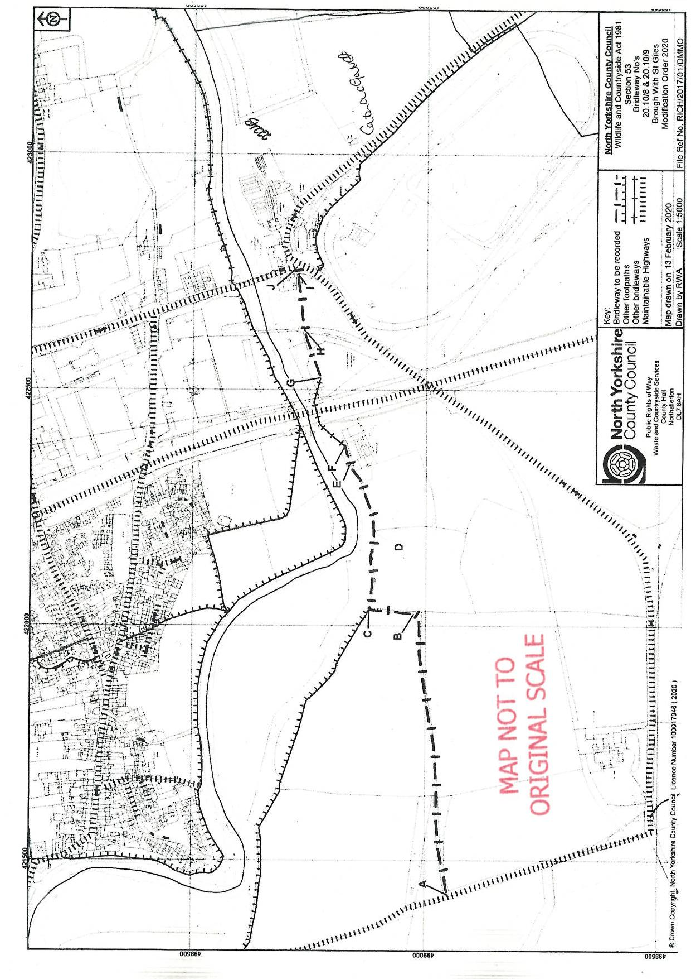

It is interesting that, although understandably not raised by the parties, close to the Order route there was said to be found a Roman altar with an inscription dedicated to Titus Irdas, "Deo qui vias et semitas commentus est", ie the God who devised roads and paths. For the avoidance of doubt I have not taken this into account.
The more commonly referred to easement is a private right, such as a private right of way, but it was common also to refer to a “public” easement as in the acquisition of public rights of passage by prescription. In the Finance Act extracts supplied, under the heading “charges easements and restrictions affecting the market value”, there is a discount of £18 applied to a field through which the racecourse has been taken. The extracts are cut and pasted into the text of the submission so the full context of the assessment is unclear. However the same amount of £18 faintly appears in the written description, so “easement” in my view relates to the racecourse, not the “Bridle Road”. Further, had the route been a vehicular way it should have been exempt rather than subject to deduction.
London – Edinburgh – Thurso Trunk Road (Catterick By-Pass Supplementary Improvements) Order 1958.
Enclosure awards often differentiated between public bridle roads and public bridle paths but not necessarily in terms of their status, rather their respective widths which tended to be narrower in the latter case.
Lasham Parish Meeting v Hampshire CC (1993) 65 P. & C.R. 331.

