  
  
  
  
**Output Specification:**

**School-specific Brief**  
  
**School-specific Annex SS7:**   
**Adjacency Diagrams**  
  
  
*[Insert full name of school]*  
*[DfE School URN: AAxxxx]*  
*[Project number]*

**November 2021**

Document Control

|  |  |  |  |  |
| --- | --- | --- | --- | --- |
| Revision | Status | Date | Author | Amendment |
| P01 | S2 | 2021-04-19 | AWI | First Issue. |
| P02 | S2 | 2021-10-27 | AWI | CF21 and MMC consultation / Document Control page added |
| P03 | S2 | 2021-11-23 | AWI | Non-material changes shared with MMC and CF21 |
| P04 | S2 | 2021-11-23 | AWI | Gov.uk publication |

Summary

This document is one of a number of Annexes to the School-specific Brief (SSB).

Review Date

Review dates for this document will be at 6-month intervals.

Who is this publication for?

This document is for technical professionals involved in the design and construction of school premises, as part of the Employer’s Requirements of the DfE Construction Framework. It may also be used as the basis of similar documentation for other procurement routes using the Output Specification.

Uniclass Codes

This document captures Uniclass codes for the management of exchange of information. To access all codes and associated titles reference should be made to [Uniclass 2015 | NBS (thenbs.com)](https://www.thenbs.com/our-tools/uniclass-2015)

## Adjacency Diagrams Template

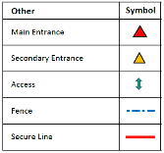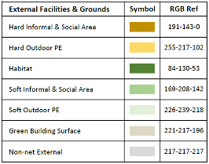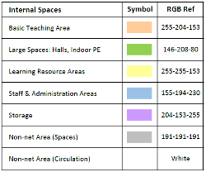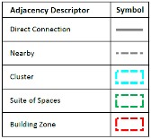

The Contractor shall design the Building(s) to adhere to the School-specific adjacency commentary illustrated by the Proposed Adjacency Diagrams, which set out the Responsible Body’s approach to managing and delivering education. These have been agreed as part of the Concept Control Option to meet the Responsible Body’s particular requirements and developed in line with BB103/ BB104 and the requirements set out in the SSB and SS1. There are two types of Adjacency Diagram as follows:

The **External Adjacency Diagram,** using the legend on the top right of this page, demonstrates the relationships between the external spaces. It also shows the principal connections between indoor and outdoor spaces, such as main entrance/exit routes into the building, links between indoor classrooms and outdoor teaching spaces and links between internal and external dining areas.

The **Internal Adjacency Diagram,** using the legend on the bottom right of this page, demonstrates the relationships between the internal spaces. The internal adjacency diagram also shows how the internal spaces are organised into **Departments**, **Suites** and **Clusters** (as defined in the GDB definitions).

*[****Drafting note:*** *The guidance and drafting notes (including example diagrams) on the pages that follow are to be deleted and replaced with the school specific External Adjacency Diagram and Internal Adjacency Diagram.*

* *All diagram(s) will be clearly presented and simple to read.*
* *Diagrams will match the appropriate legend on this page.*
* *All diagrams will indicate a North Arrow.*
* *In a Partial School Project, show the adjacencies of existing blocks to the new/remodelled blocks on the adjacency diagrams.]*

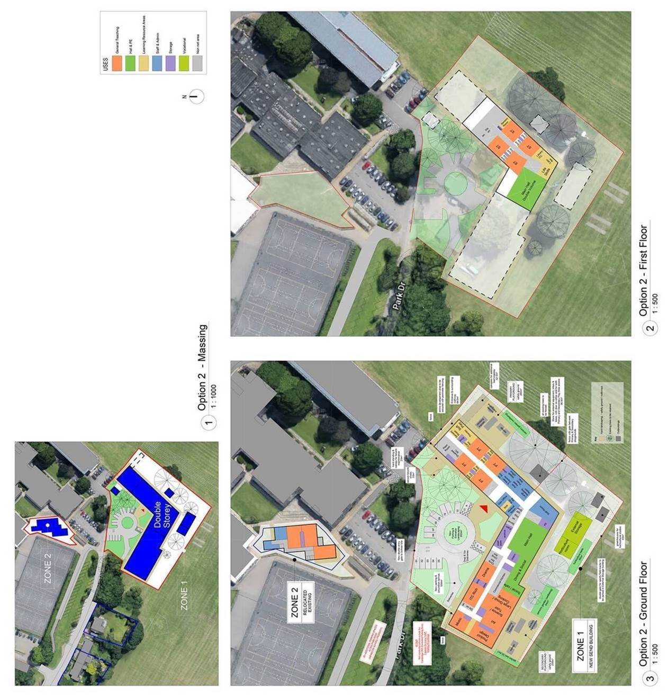

*[****Drafting Note:*** *The level of detail shown in the diagram on this page is the benchmark for the Proposed External Adjacency Diagram that depicts the Concept Control Option.*

* *This should be in line with BB103/ BB104, the requirements set out in the SSB and SS1 and the External Site Areas tool.*
* *The symbols and colours used should match the Legend in the page above.*
* *The naming of external spaces will align with those described within Technical Annex 1C: Definitions of External Spaces.*
* *The areas of external spaces will be clearly identified on the drawings and, when totalled, these will correspond with those listed in the Schedule of External Areas to be added to end of SS1.*

***Example: Proposed External Adjacency Diagram***

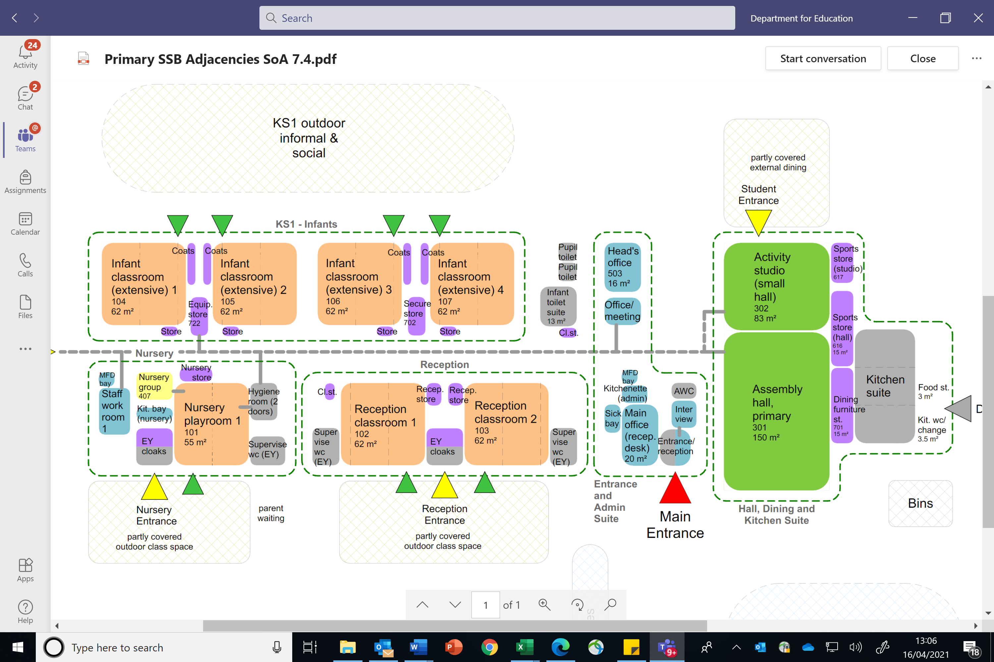

*[****Drafting Note:*** *Sample extract of an adjacency diagram using standard Clusters.*

* *Demonstrates diagrammatically how clusters could be organised within a standard grid*
* *Denotes suites of spaces for nursery, reception, infants, entrance and halls.]*

*[****Drafting Note:*** *Sample extract of an adjacency diagram depicting Departments and Suites.*

* *Use in conjunction with space adjacency diagram*
* *Consider adjacencies between suites as well as spaces.]*

*[****Drafting Note:*** *The level of detail shown on this page and the next page is the benchmark for the Proposed Internal Adjacency Diagram that depicts the Concept Control Option.*

* *This should be in line with BB103/ BB104, the requirements set out in the SSB and SS1 and the SoA tool.*
* *The adjacency diagrams, unlike floor plans, are to be informal and will depict the different types of space (Departments, Suites and Clusters) and critical relationships between the internal and external spaces.*
* *Where the design refers to an area, space, cluster, suite or department of spaces, the requirement has been deemed to comply with the aspects of the DfE OS relative to Section 2.3 ‘Internal Space’, thus meeting the requirement for compliant ‘dimension and proportions’ and ‘organisation and space’.*
* *If the proposal is a suitable standardised design solution (a layout based on typical clusters in the DfE design guides or a Contractor’s proposal or similar off-site scheme if referenced here), this may be submitted as the Proposed Internal Adjacency Diagram.*
* *The symbols and colours used should match the Legend in the page above.*
* *Identify how the Departments and/or Suites of Spaces are organised to meet the Responsible Body’s particular requirements. These should correspond with the SSB and SS1.*
* *Indicate how the spaces should be adjacent to each other (directly connected or nearby).*
* *The naming of internal spaces will align with those described within Technical Annex 1A and 1B: Definitions of Spaces in Mainstream Schools / Special Schools and AP. These will correspond with the unique room names and numbers listed in Annex SS1.*
* *Areas and room dimensions need not be shown in this drawing, and areas should be in line with SS1 where they are shown.*
* *Depict individual spaces to scale.*
* *Do not show internal walls.*
* *Spaces should be slightly exploded – this is a diagram, not a plan.*
* *Recognise the principles of off-site construction (references should be made to the appropriate Design Guide(s) where applicable).]*

***Example: Proposed Internal Adjacency Diagram***

***Example Ground Floor Adjacencies***

Lobby 02

628

Lobby 02

627

GEN 5 RC 1

GEN 5 STR 1

Pupil

Entrance 02

Pupil

Entrance 01

Corridor

625

Ext St

514

WCs 02

612

Stair 02

621

Hygiene

615

EYFS Play area

WCs 01

611

Office 03

406

St 01

503

Classroom 01

101

*Unique Rm name*

*Unique Rm #*

*Unique Rm name*

*Unique Rm #*

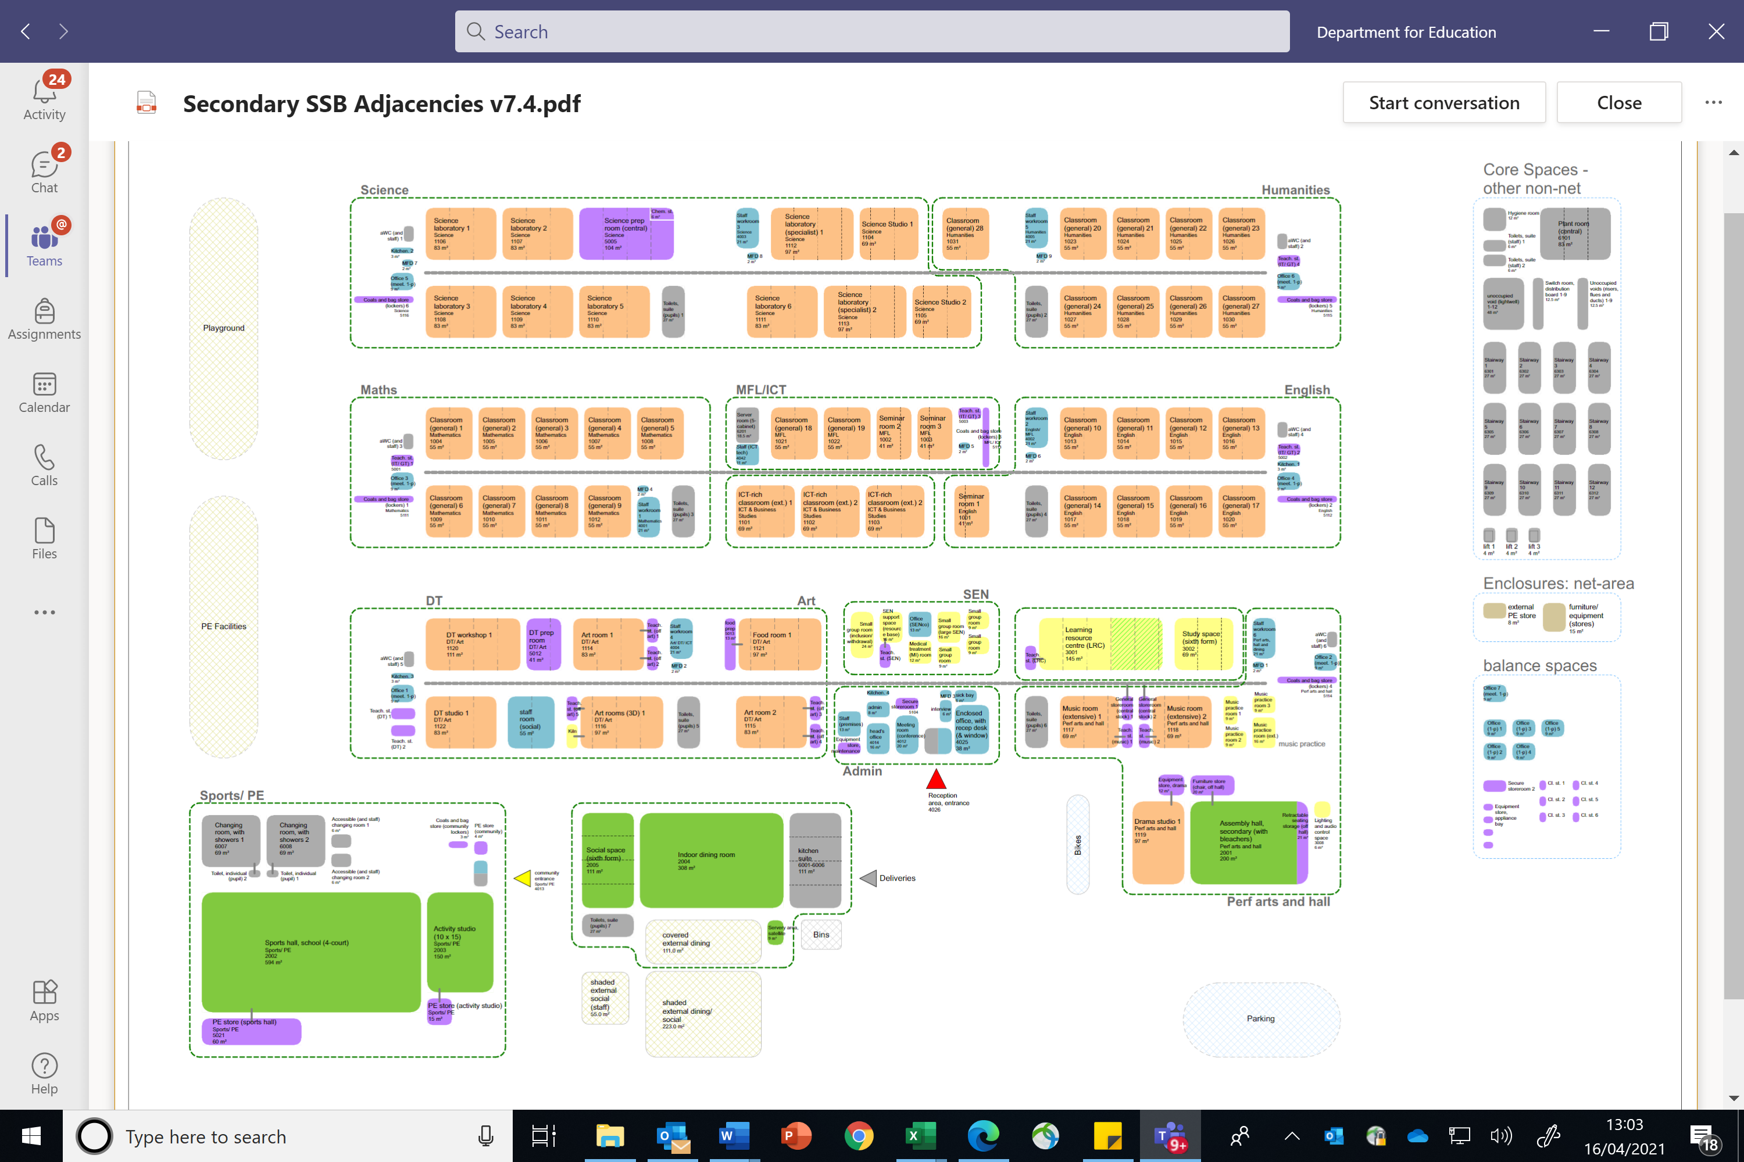

***Example Secondary school Adjacencies***

***Example Ground Floor Adjacencies***