Application Decision
by Richard Holland
Appointed by the Secretary of State for Environment, Food and Rural Affairs
Decision date: 29 November 2021

Application Ref: COM/3280617
THURSLEY COMMON, SURREY
Register Unit No: CL 213
Commons Registration Authority: Surrey County Council
- The application, dated 6 August 2021, is made under Section 38 of the Commons Act 2006 (the 2006 Act) for consent to carry out restricted works on common land.
- The application is made by Natural England.
- The works comprise a boardwalk (total area 1227 m²) and 4 temporary fenced compounds approximately 50 m² each for 6 months.

Decision
- Consent is granted for the works in accordance with the application dated 6 August 2021 and plan subject to the following conditions:

i. the works shall begin no later than 3 years from the date of this decision; and

ii. the temporary works shall be removed and the common fully restored within one month from the completion of the boardwalk.
- For the purposes of identification only the location of the boardwalk is outlined in red and the fenced compounds as black circles within the common land boundary outlined in green.

Preliminary Matters
- I have had regard to Defra’s Common Land consents policy in determining this application under section 38, which has been published for the guidance of both the Planning Inspectorate and applicants. However, every application will be considered on its merits and a determination will depart from the policy if it appears appropriate to do so. In such cases, the decision will explain why it has departed from the policy.
- This application has been determined solely on the basis of written evidence. Since making the application, Natural England has confirmed that consent is no longer sought for the raised stone path as it considers that this does not need consent under section 38 of the 2006 Act.
- I have taken account of the representations made by the Open Spaces Society, Elstead Parish Council, Thursley Parish Council and Historic England
- I am required by section 39 of the 2006 Act to have regard to the following in determining this application:-
- the interests of persons having rights in relation to, or occupying, the land (and in particular persons exercising rights of common over it);
- the interests of the neighbourhood;
- the public interest; and
- any other matter considered to be relevant.

Reasons

The interests of those occupying or having rights over the land
- The landowner is the applicant and there are no rights registered over the common. I am satisfied that the works will not harm the interests of those occupying the land and the interests of those having rights over the land is not at issue.

The interests of the neighbourhood and the protection of public rights of access
- The interests of the neighbourhood test relates to whether the works will impact on the way the common land is used by local people. The applicant explains that the works will replace/build a boardwalk destroyed by a wildfire in May 2020. The boardwalk will enable public access across an area of wet land, forming part of a National Nature Reserve, that is difficult to traverse while also protecting the common. The 4 fenced compounds are needed to meet storage, welfare and health and safety requirements during the construction works.
- I note that the works are well supported locally and the OSS, Thursley Parish Council and Elstead Parish Council confirm their support for the works. I consider that the permanent works will help facilitate regulated public access to a rare habitat and improve the public’s enjoyment of the common. I am satisfied that the fenced compounds are temporary in duration and are required during the construction period for health and safety purposes. I conclude that the works will benefit the interests of the neighbourhood and the protection of public rights of access.

Nature conservation and conservation of the landscape
- The common lies within the Thursley, Hankley and Frensham Commons Site of Special Scientific Interest (SSSI) Thursley, Hankley and Frensham Commons Special Protection Area (SPA), Thursley, Ash, Pirbright and Chobham Special Area of Conservation (SAC), Thursley and Ockley Bogs Ramsar and Surrey Hills Area of Outstanding Natural Beauty (AONB). The works will be constructed of either plastic effect timber or sustainably sourced FSC quality timber. The applicant explains that the works will be kept as a low feature, aligned to the topography of the land. The works are intended to have a minimum ecological footprint and prevent the erosion/muddying of older tracks.
- The temporary works will be removed and the common reinstated upon completion. I consider that the design of the permanent works is sympathetic to the landscape and will, by preventing erosion, help protect and maintain the common. I am satisfied the works will not harm nature conservation interests and will help conserve the natural beauty of the AONB.

Archaeological remains and features of historic interest
- HE had no comments to make on the application. I am satisfied that there is no evidence before me to indicate that the works will harm archaeological remains and features of historic interest.

Conclusion
- I conclude that the works will benefit the interests of the neighbourhood and public rights of access and will not harm the other interests set out in paragraph 6 above. Consent is granted for the works subject to the conditions set out in paragraph 1.

Richard Holland

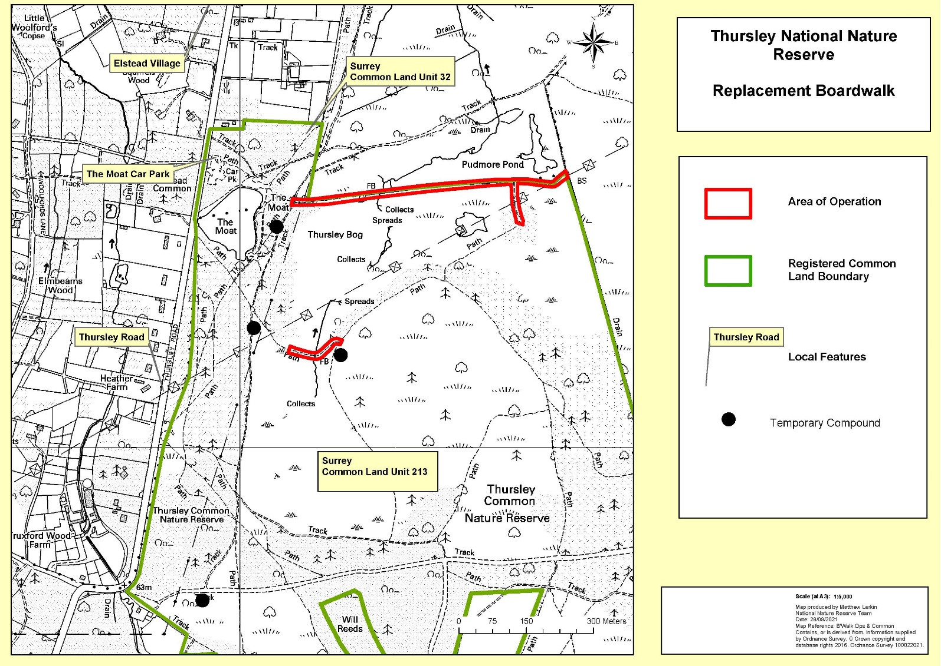

Common Land Consents policy (Defra November 2015)
Section 39(2) of the 2006 Act provides that the public interest includes the public interest in; nature conservation; the conservation of the landscape; the protection of public rights of access to any area of land; and the protection of archaeological remains and features of historic interest.

