All Change?

Travel tracker

Wave 5 report

May – June 2021

Ben Marshall, Lore Bizgan, Glenn Gottfried

Contents
Executive Summary 4
Introduction 11
Survey methodology 11
Fieldwork dates, ‘lockdown’ restrictions and reference periods 12
Modes of transport 15
Interpretation of data and statistical reliability 15
1. How often and why did people travel? 17
2. How has behaviour changed? 20
2.1. Overall change 20
2.2. Active travel 22
2.3. Travel by car, taxi and app-based minicab services 28
2.4. Public transport 37
2.5 Longitudinal analysis 44
Travel by car 44
Public transport 45
Active travel 46
2.6 Changes between January-March 2020 (before the pandemic) and May/June 2021 46
Travel by car 46
Public transport 47
Active travel 48
2.7 Was there mode switch? 48
3. Why did behaviour change? 54
3.1. Why did people travel? 54
3.2. Which modes did people use? 55
Shopping 55
Visiting friends and relatives 55
Commuting 56
Recreation and keep-fit 56
Travelling to medical, hospital and dentist appointments 57
3.3. Comparison of travel behaviour between June/July 2020 and May/June 2021 57
4. What were people’s short-term travel plans? 59
4.1. Propensity to travel during next four weeks 59
4.2. Propensity to travel ‘if all restrictions are lifted’ 61
4.3. Compliance and experiences of travelling during May/June 2021 62
5. What were people’s longer-term travel plans? 70
Appendices 79
Appendix A – Sample profile 79
Appendix B – Statistical reliability 80
Ipsos MORI’s standards and accreditations 82

Executive Summary
Ipsos MORI conducted a UK-wide online survey during May and June 2021 on behalf of the Department for Transport as part of the All change? research programme. The survey was the fifth in a series, designed in response to the Covid-19 pandemic to measure and explore the reasons for current and future changes in behaviour. All change? involves longitudinal analysis, looking at those participants who have taken part in the most recent wave and the previous wave, as well as those who have taken part in all five waves. This helps us to understand changes individuals have made, as well as changes at the aggregate level.
Fieldwork for the fifth wave started on 17th May - after Step 3 of the Roadmap for easing lockdown restrictions in England had come into effect - and finished on 8th June 2021. Although following different timetables to that of England’s, a similar, gradual process for easing lockdown restrictions was in place in Scotland, Wales, and Northern Ireland at the time of fieldwork. The survey asked about behaviours relating to the past 4 weeks, which for most respondents was a period covering May and June 2021, and also about likely behaviour “…if all restrictions are lifted (this is currently scheduled to be no earlier than 21st June)”.
The survey was completed before Step 4 of the Roadmap in England was postponed and took place at a time when the Delta variant was receiving increasing media attention at the national level. It is also important to note that social distancing rules and face covering requirements had not yet been lifted in England at the time fieldwork took place and perceptions may have since changed. At the end of the fieldwork period, 61% of UK adults had received a first dose of the vaccine although vaccination rates were higher among our sample; 71% had been vaccinated at the point they took part (compared to 30% at Wave 4).
The fourth survey took place during February-March 2021 – following the Prime Minister’s announcement of a Roadmap for England – the third survey was undertaken during November-December 2020, the second during July-August 2020, and the first between May and June 2020. These provide points of comparison alongside measurements of pre-pandemic behaviour which had been collected via the first survey of the All change? series and defined to respondents as the period between January and March 2020.
- Did behaviours change?
Overall, as restrictions were eased, people travelled more during May/June 2021 compared to February/March 2021, however, travel by all modes was still lower than pre-pandemic levels.
The incidence of car driving, and car passenger travel was lower in May/June 2021 compared to pre-pandemic levels (January-March 2020), but in line with levels in June/July 2020, during the easing of the first UK-wide lockdown. When compared to February/March 2021, overall levels of car travel were higher, and frequent car use (of once a week or more) also increased in May/June 2021.
Patterns in active travel changed little between November/December 2020 and February/March 2021, and while levels of walking or wheeling all the way to a destination and cycling increased in May/June 2021, they remained significantly lower than in June/July 2020 (a potential effect of the weather being unseasonably poor in May 2021):
- 65% of UK adults walked/wheeled all the way to a destination in May/June 2021 compared to 72% in June/July 2020.
- 18% of UK adults cycled in May/June 2021 compared to 27% in June/July 2020.
Following increases last summer (June/July 2020), and reductions in November/December 2020 and February/March 2021; bus, train and underground/metro use increased during May/June 2021. However, levels of use for all three public transport modes remained well below those seen prior to the pandemic:
- Overall bus use was in line with that in June/July 2020 when restrictions were last eased to a similar extent. Overall train/underground/metro use was significantly lower than it was last summer, although frequent use (once a week or more often) of these public transport modes was higher.
- Despite increased use of public transport between February/March 2021 and May/June 2021, the profile of users remained markedly different in comparison to the period before the pandemic. For example, those aged 16-34 years old made up 39% of train users before the pandemic, their share grew to 59% in May/June 2021.
- Younger age groups, those from ethnic minority communities and those living in London formed a greater share of those who recently travelled by bus, train, underground, metro and app-based mini-cab services compared to the period before the pandemic.
In general, the evidence suggests that people increased their travel across all modes compared to the first lockdown but travel overall reduced relative to pre-pandemic levels. There is limited evidence that many people shifted from using one mode (e.g. from bus) to using another (e.g. to car).
Longitudinal analysis, based on individuals who took part in survey waves 1 and 5, indicates that, compared to the period immediately before the pandemic:
- Twice as many people had decreased their car use (30%) as had increased it (12%) in May/June 2021 when compared to the period before the pandemic. People aged 55-75, from ethnic minorities, in higher social grade households and living in the East Midlands and the South West were most likely to have decreased how often they drove a car.
- Three times as many people decreased their bus use (32%) as had increased it (9%) – people living in urban areas were more likely to have decreased how often they travelled by bus compared to those in rural areas.
- By contrast, the proportion of people increasing active travel were similar to the proportion that decreased their frequency of active travel – 9% increased the frequency they cycled, while 10% decreased this; 31% increased the frequency they walked/wheeled all the way to a destination, while 32% decreased this.
- People who did less driving in May/June 2021 compared to before the pandemic, also reduced how often they used other modes.
- Conversely, people who increased how often they cycled during May/June 2021 compared to before the pandemic were also more likely to increase how much they walked all the way to a destination, compared to people who cycled less often.
As restrictions were eased, there was an increase in people taking part in activities they were unable to do during lockdown.
- Visiting friends and relatives as a reason for travel increased sharply to 44% of those who travelled in May/June 2021 (from 13% in February/March 2021).
- Travelling to a place of work was mentioned by 36% (up from 26%).
- 35% travelled for recreation (up from 25%).
- 13% travelled on holiday or to make a day trip somewhere (up from 1%).
- 25% travelled to access services, e.g. hairdressers, libraries, etc. (up from 5%).
As was the case in February/March 2021, shopping was the most common reason people travelled in May/June 2021; travelling for medical appointments increased as more adults were invited for a first or second dose vaccination.
- 77% said they travelled for shopping, significantly higher than any other reason and at a similar level to the proportion saying they travelled for shopping earlier this year in February/March (72%).
- Travel to medical appointments increased to 33% in May/June 2021 compared to 23% who travelled for this reason in November/December 2020 and 30% in February/March 2021.
Those who made journeys by public transport in the previous four weeks during May/June 2021 were mostly positive about their experience. Coronavirus cases remaining low and compliance with face covering and social distancing requirements were considered important in encouraging public transport use.
As was the case during November/December 2020 and February/March 2021, claimed compliance with social distancing and face covering requirements was high during May/June 2021. By wide margins, bus, train, underground and metro users were more positive than negative about several aspects of travel including cleanliness, ventilation and the ability to maintain distance from other passengers.
- When asked which two or three things would encourage them personally to consider travelling by some form of public transport “if restrictions are lifted”, Coronavirus cases remaining low (25%), compliance with wearing face masks/face coverings (23%), and passengers and staff following social distancing rules while travelling (19%) were considered important.
- Among lapsed public transport users (people that had used public transport pre-pandemic but not in the previous four weeks, representing 16% of UK adults), low cases (31%) and ventilation (21%) were considered more important, whereas service improvements such as more frequent services (10%) were considered less important in encouraging public transport use.
- What next? – lifting lockdown restrictions and vaccination
People expected to travel more in the four weeks following the survey, including on public transport, although higher levels of confidence using public transport related to continued progress with the vaccine roll out and the ability to socially distance.
As in both November/December 2020 and February/March 2021, during May/June 2021 there was some expectation of increased travel in the next four weeks, including more frequent use of public transport, particularly for train travel.
- 21% travelled by train during May/June 2021, while levels of expected use over the four week period following the survey was 26%.
- For bus and underground/metro services, expected use was in line with use in the previous 4 weeks (which had increased compared to February/March 2021) – a third (33%) expected to travel by bus, 16% by underground or metro.
Alongside an expected increase in travelling, levels of comfort with using public transport would increase significantly ‘if all restrictions are lifted’ and ‘when all adults in the UK have been offered their first and second dose of the vaccine’.
- 30% of UK adults said they would be either very’ or fairly comfortable travelling by bus in February/March 2021 while this increased to 49% in the event of restrictions being lifted.
- 74% of people said in May/June 2021 they would feel comfortable using public transport once all adults have been offered their second vaccine dose.
- Comfort levels also increased among a range of different groups at the point of all adults being offered second dose vaccinations, including those more likely to use public transport: younger people, people from ethnic minority backgrounds and/or living in London.
The anticipated lifting of all restrictions appeared to boost confidence in using public transport, with 49% saying they would feel comfortable travelling by bus, 54% by train and 35% by underground/metro services. However, when the prospect of ‘no social distancing’ was raised, this appeared to have the opposite effect. In this scenario, comfort in travelling by bus dropped from 49% to 31%, from 54% to 33% for train and from 35% to 24% for underground/metro services. It is also important to note that social distancing rules and face covering requirements had not yet been lifted in England and perceptions may have since changed.
- Comfort levels were higher among those who had used public transport frequently before the pandemic if all restrictions were lifted, and particularly among those who travelled by bus, train, underground or metro in the previous four weeks.
- However, discomfort if ‘no social distancing’ was possible increased even among those who had used public transport frequently before the pandemic.
- If all restrictions were lifted but social distancing was not possible, people were most likely to consider Coronavirus cases remaining low and compliance with face covering requirements as important in encouraging public transport use, as well as better ventilation onboard.
- In May/June 2021, the majority of UK adults supported retaining the requirement to wear face coverings (65%) and adhering to social distancing (56%) on public transport, even when all UK adults have been offered both vaccine doses.
- What next? – working, shopping and travelling overseas
There was an expectation that, once restrictions were lifted, the method of commuting would be more likely to return to pre-pandemic patterns, but the frequency of making journeys to a workplace would be lower than before.
Among those in work and compared to pre-pandemic, many expected to be travelling to a place of work less often after restrictions were lifted and in 12 months’ time.
- There was a decrease from 25% of those in work who worked at home 5 days a week in the past 4 weeks, to 15% who expected to do so if all restrictions were lifted.
- 10% of UK adults expected to travel to a place of work more frequently compared to before the pandemic, just under half of the 19% who expected to travel for this reason less frequently.
- Higher income groups (households with an income of £40,000 or more) were more likely to expect to commute less frequently (27%) compared to the pre-pandemic period.
Longitudinal analysis indicated that 41% of adults in London had decreased how often they travelled by train (versus 23% of the cohort overall) compared to pre-pandemic (January-March 2020), in contrast, 13% increased train travel. This was also the case for bus travel which decreased for 52% and increased for 16%.
Just over a third (35%) of those who travelled to a place of work once a month or more often before the pandemic (January-March 2020) did so by public transport, and a similar proportion (34%) of those who expected to travel to a place of work after restrictions were lifted also expected to use public transport. Expected journey times for outward and inward journeys by public transport were similar times to those made pre-pandemic.
This evidence pointed to a clear expectation that the method of commuting was much more likely to return to pre-pandemic patterns than the frequency of making journeys to a workplace. The autumn is likely to be pivotal though, as people and employers develop ‘return’ routines and policies.
People expected to shop closer to home and online more often than they did before the pandemic, although not as much as they did when restrictions were in place.
People shopped online more frequently in the 4 weeks to May/June 2021 compared to before the pandemic, but people largely expected to return to their pre-pandemic behaviour.
While people expected to use home delivery for supermarket shopping less frequently in the future, fewer expected to never do this compared to before the pandemic. People also expected to continue shopping closer to home in future, but less frequently compared to before the pandemic.
While people expected to be walking or wheeling all the way to a destination more often in 12 months’ time compared to before the pandemic, there has been a decrease in perceived reliance on public transport.
Asked to look ahead 12 months and to a situation without restrictions, a higher proportion of the public expected to be walking or wheeling all the way to a destination more (47%) compared to before the pandemic (while 15% did not expect to do so). Almost half expected to ‘go back to doing all of the things’ they did before the pandemic, including holidays and travel (compared to 24% who did not).
- Nearly half of lapsed public transport users (people who had used public transport pre-pandemic but not in the previous four weeks) expected to avoid public transport in 12 months’ time. While levels of perceived reliance on driving were in line with those in April/May 2020, there has been a decrease in perceived reliance on public transport, mainly among middle and older age groups.
- Those in work were less sure they would be working at home more often in 12 months’ time compared to the period before the pandemic than had been the case during the first UK-wide lockdown.
- The majority of the public (65%) thought that climate change is as serious a crisis as coronavirus, in line with perceptions in April/May 2020 (63%). By a margin of four to one, more said they were willing to reduce their contribution to climate change by doing more active travel than rejected this, although this sentiment has weakened over the period. In contrast, there has been no change in willingness to limit flying.
There has been little change in expectations to travel abroad and while interventions such as face coverings and pre-departure tests aid confidence to travel, people were less sure about the 3-tier country classification system.
In May/June, a quarter expected to travel abroad no sooner than 12 months after restrictions had been eased – 26% compared to 19% in November/December 2020, and 24% in February/March 2021. Shorter-term travel expectations - were in line with those in February/March (13%), with 12% expecting to travel abroad within the next 2 months
Low Coronavirus case numbers and deaths in the destination country were seen as being particularly important in shaping decisions about whether or not to travel abroad, but vaccination and restrictions were also considered important.
Confidence travelling abroad is aided by most of the interventions and restrictions covered by the survey (such as face coverings, the use of hand sanitizer and pre-departure tests), although relatively less so in terms of quarantining at home for 10 days.
The 3-tier classification system (countries listed as red (high risk), amber (moderate risk) and green (low risk)) was seen as a good idea, with 85% of people aware of the system in May/June 2021, but people were much less sure it would give them confidence to travel abroad (43% said it would, 57% didn’t or had no view either way).

Introduction
This report presents findings from analysis of a UK-wide survey commissioned by the Department for Transport (DfT) and undertaken during May-June 2021. The survey is part of a longitudinal programme of research for DfT including qualitative and quantitative components Ipsos MORI will follow-up and track changes in behaviour among the same group of people over time.
Findings from the first, second, third and fourth surveys, and from qualitative research conducted during September-October 2020, have been published by DfT.
The All change? research programme will inform DfT’s response to COVID-19, planning for infrastructure investment and strategic priorities including lower carbon behaviours and the ‘levelling-up’ agenda. It will do this by identifying how different groups of people in different types of areas including rural areas and different parts of the UK have been impacted, how they are responding to COVID, and how they can be best supported.
All change? has been designed to address several key research questions which form the structure of this report:
1. How often and why did people travel?
- 2. How has behaviour changed?
- 3. Why did this behaviour change?
- 4. What are likely behaviours in the next 4 weeks and why?
- 5. What are levels of confidence in travelling in the next 4 weeks?
- 6. What are people’s longer-term travel plans?
- 7. Will longer-term behaviours be active and sustainable?

Survey methodology
During spring 2020, Ipsos MORI conducted the first online survey of the All change? research programme. This involved 4,059 UK adults aged 16-75 years old. Sampling was structured to secure at least 2,000 completed surveys in England, 1,000 in Scotland, 650 in Wales and 200 in Northern Ireland to allow for more robust comparisons between different countries within the UK, supplemented by a booster sample of people from ethnic minority groups (455). Data has been weighted to the known UK population profile by age, gender, working status, ethnicity and social grade (see Appendix A).
As at waves 2, 3 and 4, wave 5 respondents were drawn from those who had taken part in previous waves and agreed to be recontacted. While waves 1 and 2 involved ‘top-up’ sampling to boost the overall sample to 4,000, this was not the case at wave 3 when the sample was drawn exclusively from our longitudinal cohort and contained no ‘fresh’ sample (meaning that there is no ‘cross-sectional’ analysis this wave). At wave 4, a ‘top-up’ exercise was undertaken to bolster the numbers among a selection of groups and geographies available for recontact at wave 5 (this reached 564 respondents). Wave 5 also involved a top-up exercise.
Of the 4,700 taking part at wave 5, 1,827 had previously taken part at wave 1 and 2,198 had taken part at wave 4.
We present results from analysis involving all respondents but also a more detailed longitudinal look at changes in behaviour among the 2,198 respondents who took part at wave 4 and 5 in order to understand the extent of most recent change and to address the second research question - how has behaviour changed?
Longitudinal analysis allows us to analyse changes in behaviour over time with the same people, permitting the detection of individual, participant-level changes between waves rather than aggregate-level changes (the latter can mask change e.g. some people switching from one mode to another and a similar proportion doing the opposite would have a neutral net effect overall).
Further detail regarding the profile of the overall sample, particular demographic groups and nations of the UK, is provided in Appendix A.

Fieldwork dates, ‘lockdown’ restrictions and reference periods
Wave 5 survey fieldwork was undertaken between 17 May-8 June 2021 in England, Scotland, Wales and Northern Ireland. This followed fieldwork as shown in Table 1 below:
Table 1: Survey waves and fieldwork dates
Wave | Fieldwork dates
1 | 15-22 May 2020  (England, Scotland and Northern Ireland)  28 May-4 June 2020  (Wales)
2 | 21 July-3 August 2020
3 | 27 November-7 December 2020
4 | 23 February-9 March 2021
5 | 17 May-8 June 2021
Several important developments occurred between the survey waves. While wave 1 took place during the full, UK-wide national lockdown period, wave 2 came after the easing of restrictions including the opening of pubs, restaurants and hairdressers on 4th July 2020 and many people returning to places of work. Two households were allowed to meet up and social distancing relaxed from 2 metres to ‘1 metre plus’ in England. Northern Ireland allowed the opening of pubs, restaurants and hairdressers a day earlier, on 3rd July, in Wales (outside only) on 13th July and Scotland on 15th July.
On 24th July 2020, face coverings/masks became compulsory in shops and most other enclosed public places in England during the wave 2 fieldwork period (having already been mandatory on public transport since 15th June) and restrictions were placed on Greater Manchester and parts of East Lancashire and Yorkshire (30th July) following the introduction of ‘local lockdown’ restrictions in Leicester on 29th June.
Wave 3 fieldwork was conducted during a second ‘lockdown’ in England which started on Thursday 5th November 2020 and finished on Wednesday 2nd December 2020. There were some important similarities and differences compared to the first, UK-wide, lockdown – for example, mixing with other households inside homes was not allowed, except for childcare and other support, but people who shielded in March did not have to shield again in late 2020 (although clinically vulnerable groups and over-60s were advised to limit social contacts and follow rules carefully).
In advance of fieldwork for wave 4, the Prime Minister announced the third lockdown in England on 4th January 2021 (which took effect on 6th January), with Wales, Scotland and Northern Ireland also using lockdown restrictions. The Government’s Roadmap for England was announced just before the start of fieldwork on 22nd February. At the point that fieldwork was completed, 22.8 million people had received first doses of the Covid-19 vaccine (34% of the population).
Fieldwork for the fifth wave started on 17th May - after Step 3 of the Roadmap for easing lockdown restrictions in England had come into effect - and finished on 8th June 2021. Restrictions were also being eased during this period in Scotland, Wales, and Northern Ireland, although following a different timetable to England (shown in Table 2 below). The survey asked about behaviours relating to the past 4 weeks, which for most respondents was a period covering May and June 2021, and also about likely behaviour “…if all restrictions are lifted (this is currently scheduled to be no earlier than 21st June)”.
The survey was completed before Step 4 was postponed but took place at a time when the Delta variant was receiving increasing national attention. At the end of the fieldwork period, 61% of UK adults had received a first dose vaccine although vaccination rates were higher among our sample; 71% had been vaccinated at the point they took part (compared to 30% at Wave 4).
At some questions, respondents were asked about behaviours, particularly the frequency of using different modes of travel, relating to the past 4 weeks as well as the period before the UK-wide lockdown (this reference period was defined as “between January and March 2020”).
Reflecting the fieldwork dates for previous waves, our report describes behaviours relating to:
- April/May 2020 (the four weeks prior to wave 1 fieldwork coincided with the first UK-wide lockdown);
- June/July 2020 (a four-week period during which restrictions were eased);
- November/December 2020 (a four-week period during which tighter restrictions were in place);
- February/March 2021 (another period of lockdown and the roll-out of the vaccination programme);
- May/June 2021 (a period during which restrictions were eased).
Table 2: Key milestones in lifting of restrictions (selection)
Wales | 17th May – Wales moved to Alert Level 2 including re-opening of indoor hospitality, indoor entertainment venues could re-open and an increased number of people could attend organised indoor and outdoor activities. Six people from six different households were able to meet indoors in cafes, pubs and restaurants.  International travel resumed under a traffic light system (aligned with England and Scotland). The Welsh Government advised travel abroad for essential purposes only.  7th June – There was a phased move to Alert Level 1. Up to 30 people were allowed to meet outdoors, and larger organised gatherings and events were able to take place outdoors (up to three households could form an extended household).
Northern Ireland | - 24th May – The Northern Ireland Executive allowed unlicensed and licensed premises to re-open indoors with mitigations as was tourist accommodation, post- wedding and civil partnership events and other hospitality events e.g. gala dinners, functions, ticketed or not.  - Visits indoors in domestic settings were allowed (confined to six people from no more than 2 households) with overnight stays permitted. Indoor visitor attractions, indoor group exercise and training were allowed to resume, with mitigations.  - The rules on social distancing in hospitality and retail did not change. The wearing of face coverings was mandatory in all indoor areas accessible by the public unless exempt. Travel in or out of Northern Ireland was not advised except where essential.
Scotland | - 17th May – The majority of Scotland’s mainland moved into Level 2 of the Strategic Framework (see below) except for the Moray Council area and Glasgow. Some Highland and Island Local authority areas moved into Level 1.  - 21st May – The Moray Council area moved to Level 2 (Glasgow remained at Level 3).  - 5th June – Glasgow moved to Level 2 from Level 3. Some authorities remained at Level 2 while 15 moved to Level 1. Highland and Island authorities moved to Level 0.  In Level 2 areas, up to six people from three households could meet in each other’s homes and gardens without the need for physical distancing and up to six people from three households could also meet indoors in places such as pubs, cafes and restaurants, while up to eight people from eight households could meet outdoors. The guidance remained to working from home where possible and to stay local for shopping and services; planning ahead and choosing active travel where possible.  In Level 1 areas, up to six people from three households could meet in each other’s homes (and could stay overnight), up to eight people from three households could meet in an indoor public place like a café, pub or restaurant, while up to 12 people from 12 households could meet outdoors.
England | - 17th May – Most legal restrictions on meeting others outdoors were lifted although gatherings of over 30 people remained illegal and, indoors, the Rule of 6 or two households continued to apply.  - Working from home “should continue wherever possible” and most businesses in all but the highest risk sectors were able to reopen. Indoor hospitality and indoor entertainment venues such as cinemas and children’s play areas, hotels, hostels and B&Bs reopened, and indoor adult group sports and exercise classes could resume.  - Advice for travellers was to “plan ahead and avoid the busiest times and routes if you can.” Overseas travel was subject to restrictions and testing/quarantine requirements depending on a traffic light system: “you should not travel to red and amber countries.”  - 14th June – Step 4 (the removal of all to remove all legal limits on social contact) was postponed.

Modes of transport
The survey covered the following modes (some of these are abbreviated within our commentary). These were presented to respondents at the first question in the survey (and at subsequent questions). To note, ‘car as a passenger’ was not defined any further but did sit separately from taxi and shared transport modes.
Car as a driver
Car as a passenger
Van/lorry
Motorbike/moped
Informal car-pooling (e.g. individuals that know each other and share a similar journey route)
Car club (e.g. ZipCar, Co-wheels) or ride-sharing apps (e.g. liftshare.com, blablacar.com)
App-based minicab services e.g. Uber
Taxi/black cab/minicab/private hire
Bus
Aeroplane/flying
Ferry/other water-based transport
Train
Tram
Underground rail/metro
Cycling (including e-bike)
Walking all the way to a destination or wheeling by a wheelchair or motorised scooter

Interpretation of data and statistical reliability
When interpreting survey results, we should be mindful that samples for Scotland, Wales and Northern Ireland are derived from initial booster samples designed to generate larger sample sizes than would otherwise have been achieved. As such, they allow for comparison with other parts of the UK rather than providing stand-alone survey datasets.
For the wave 5 survey overall, we can expect an overall sampling tolerance of +/- 1.4 percentage points for a 50% finding at the ‘95% confidence interval’. This will vary for sub-groups and geographies according to their sample sizes. Our commentary on changes in behaviour between waves and among groups and geographies focuses on statistically significant changes and differences, but not exclusively so and we have identified potentially important findings that are not statistically significant. Further detail is provided in Appendix B.
As at wave 3, we applied a bespoke weighting scheme to the wave 5 data, and the longitudinal cohort (the sub-sample of respondents who took part at waves 4 and 5), reflecting attrition between waves and the difference in profile between the achieved sample at wave 5 and the original 3,866 who agreed to be recontacted after completing the wave 1 survey as well as the (matched) profile of the overall, UK-wide samples who took part in waves 1 and 2.
This accounts for any differences in ‘return’ rates among the various groups within the sample and allows us to draw conclusions about the incidence of behaviours among the UK adults within sampling tolerances.
Where percentages do not sum to 100 this may be due to multi-code responses or rounding. This is also the case in terms of combinations not summing to their constituent parts e.g. the percentage who said they were comfortable travelling by public transport summing to the percentage who said they were very comfortable and the percentage who said they were fairly comfortable.

How often and why did people travel?
As with previous waves of All change?, driving and walking or wheeling a wheelchair or motorised scooter all the way to a destination were the most commonly used modes of transport across the UK during May/June 2021. In the previous four week period, almost two-thirds (65%) of the UK public walked all the way to a destination at least once while 68% travelled by driving a car.
In this section, we provide details of transport use across the most frequently used modes during May/June 2021, and we also describe the main reasons people gave for using each mode.
  - Active travel
Almost two-thirds (65%) of the UK public walked or wheeled all the way to a destination at least once during the past four weeks in May/June 2021 including 58% who did this once a week or more often, split between 15% who did this five days a week or more often, 15% who did this 3-4 days a week and 13% two days a week or more (shown in Figure 1). Just over a third, 35%, said they did not walk or wheel a wheelchair or motorised scooter all the way to a destination in the previous four weeks in May/June 2021, compared to 82% who said they did not cycle during this period.
Figure 1: Frequency of active travel during May/June 2021
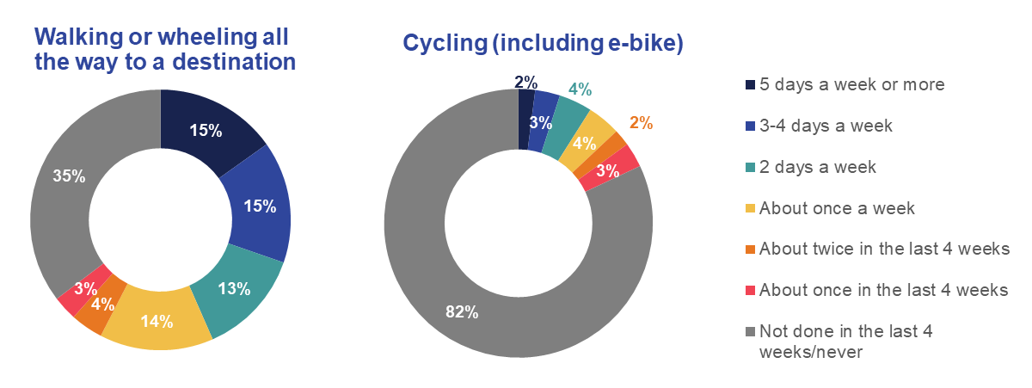
Source: Ipsos MORI/DfT, Base: 4,700 UK adults, 17 May-8 June 2021
Q1. Thinking about the last 4 weeks, how often, if at all, did you personally travel by the following modes of transport? It does not matter how long the journey was, or why you made it.
A majority, 55%, of those who travelled for recreation reasons or to keep fit, walked all the way to their destination while 15% cycled for this reason. Cycling was also a popular mode of choice among those who travelled to a place of education (as a pupil/student); 7% of people who travelled for this reason during May/June did so by cycling.
Walking or wheeling all the way to a destination was done for a variety of reasons; notably, 35% of those who went to a pub/bar/restaurant to sit outside walked there, as did 32% of those who ran errands for people and 30% of those who went shopping. Similarly, 29% of those who travelled to pick up or drop off children at a school/place of education/nursery etc. walked there; so too did 28% of those who travelled to a place of education (as a pupil/student) and to access services e.g. hairdressers, libraries, estate agents and banks.
  - Travel by car and taxi
Alongside walking or wheeling all the way to a destination, travelling by car as a driver and as a car passenger were among the most common ways of travelling during May/June 2021. Just under seven in ten, 68%, said they travelled by driving a car at least once in the previous four weeks of May/June 2021, and 66% of people were car passengers.
In May/June 2021, 63% said they drove a car at least once a week in the previous four weeks while 46% travelled this frequently as a car passenger (shown in Figure 2). Just under a quarter, 24%, said they drove a car five days a week or more often, 18% drove 3 or 4 days a week, and 9% once a week. Most of those who travelled as a car passenger did this about once a week (19%) but a higher proportion (27%) travelled this way 2 days a week or more frequently.
Figure 2: Frequency of driving or travelling as a car passenger during May/June 2021
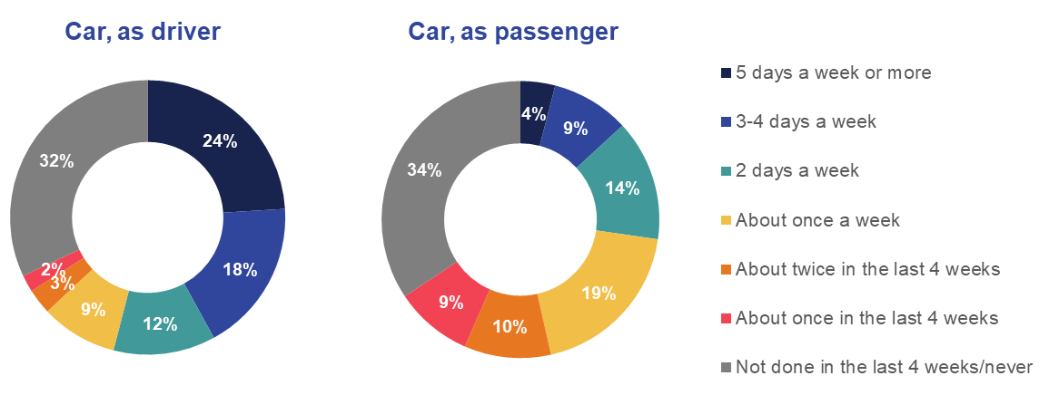
Source: Ipsos MORI/DfT, Base: 4,700 UK adults, 17 May-8 June 2021
Q1. Thinking about the last 4 weeks, how often, if at all, did you personally travel by the following modes of transport? It does not matter how long the journey was, or why you made it.
Driving was the mode of choice for those giving lifts to friends and family for other reasons, done by 85% of those who travelled for this reason. It was also a common mode among those who picked up or dropped off children at school/place of education/nursery etc. (68%) and for almost two thirds of those who commuted to a place of work (65%). It was also used by 61% of those who ran errands for people and by 60% of those who went shopping.
During May/June 2021, 46% of those who travelled for a holiday or a day trip somewhere travelled as a car passenger (47% drove there), as did 36% of those who travelled to visit friends/relatives and 30% of those who travelled to meet up with people indoors, and the same proportion of those who went to a pub/bar/restaurant to sit inside.
Across the UK, 17% used a taxi/black cab at least once in the previous four weeks in May/June 2021 while 13% used app-based minicab services such as Uber during this period. Taxis were used for a variety of reasons during May/June 2021 e.g. 6% of those went to a pub/bar/ restaurant to sit inside travelled there by taxi, as did the same proportion of those who travelled to access education (as a pupil/student). During May/June 2021, the main reason for taking an app-based minicab service was for travelling to access entertainment/arts and for business travel – this mode was used by 7% and 6% respectively of those who travelled for these reasons.
  - Travel by public transport
Just under a third of people, 31%, said they travelled by bus at least once in the previous four weeks in May/June 2021, higher than the proportion who travelled by train (21%) and by underground/metro (14%). Most use was infrequent too – 19% used a bus once a week or more often but this included 12% who did this once or twice a week (shown in Figure 3).
Figure 3: Frequency of bus, train and underground/metro use during May/June 2021
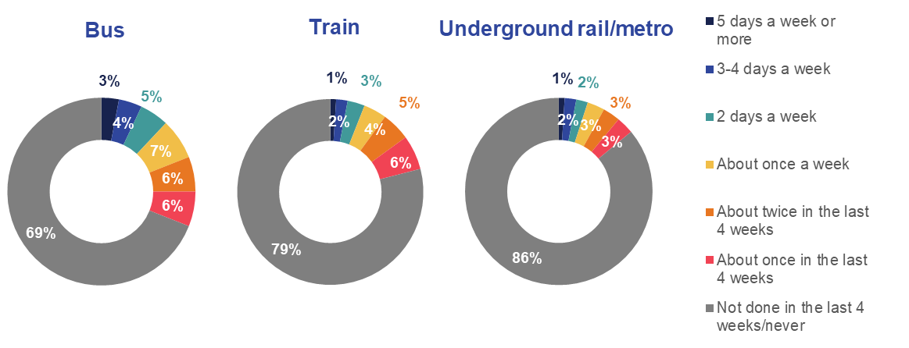
Source: Ipsos MORI/DfT, Base: 4,700 UK adults, 17 May-8 June 2021
Q1. Thinking about the last 4 weeks, how often, if at all, did you personally travel by the following modes of transport? It does not matter how long the journey was, or why you made it.
Reflecting the age profile of bus users during May/June 2021, 35% of those who travelled to a place of education did so by bus. Among those commuting to a place of work, 14% travelled by bus, 9% by train and 6% by underground/metro.
Among those who travelled to access entertainment, arts and events, 16% did this by bus, 15% by train and 14% travelled by underground/metro. Among those who travelled for a holiday or day trip somewhere, 15% did this by train, just 5% by bus (3% by coach) and 4% by underground/metro. Travel by train and underground/metro accounted for a larger proportion of business travel – 19% of those who travelled for this reason did so by train, 11% by underground/metro.

How has behaviour changed?
This section presents the extent and nature of the changes in travel behaviour based on cross-sectional and longitudinal analysis. We compare behaviours during May/June 2021 (wave 5) with February/March 2021 (wave 4). In February/March 2021, lockdown restrictions were in place and the UK started a gradual process of easing lockdown restrictions at the end of March 2021. The easing of restrictions period included the fieldwork dates for the fifth survey, ending on 19th July.
We also compare travel behaviour in May/June 2021 with January-March 2020, the pre-pandemic period before the start of the first UK-wide lockdown. We describe the main differences among selected demographic sub-groups and geographies, starting with active travel and car and taxi travel, before finishing with public transport.

2.1. Overall change
While the frequency of travel across all modes during February/March 2021 (wave 4) broadly reflected a continuation of behaviours from November/December 2020 (wave 3), the frequency of travel across all modes increased between February/March 2021 and May/June 2021 (wave 5), a period when restrictions were being eased across the UK.
Following a relatively stable period between November/December 2020 and February/March 2021, levels of active travel modes increased during May/June 2021. Patterns in active travel were similar to those of June/July 2020 (wave 2) but remained below pre-pandemic levels; in January-March 2020, 30% had cycled at least once while 78% had walked or wheeled all the way to a destination.
Cycling levels in the previous four weeks increased significantly in May/June 2021 – 18% cycled once a week or more often once a week/month compared to 15% in February/March 2021. The incidence of walking or wheeling all the way to a destination in May/June 2021 was in line with that in February/March 2021; 65% of UK adults compared to 63%.
Figure 4 below shows levels of frequent active travel in May/June 2021 were in line with those in February/March 2021, with 13% cycling and 58% walking/wheeling all the way to a destination once a week or more often in spring 2021.
Levels of car use in the previous four weeks were significantly higher in May/June 2021 compared to February/March 2021. The proportion who travelled by car as a driver increased from 63% to 68%, and there was an even steeper rise for travel as a car passenger from 54% to 66%. Usage levels did, though, remain significantly lower compared to January-March 2020, before the pandemic; when 80% of people travelled by car as a driver and 72% as a car passenger (shown in Figure 5).
Driving by car once a week or more often reached pre-pandemic levels in May/June (63%). This was not the case though for car passenger travel; 46% did this in May/June 2021 compared to 49% before the pandemic.

Figure 4: Frequency of active travel use during February/March 2021 compared to November/December 2020, June/July 2020, April/May 2020 and January-March 2020
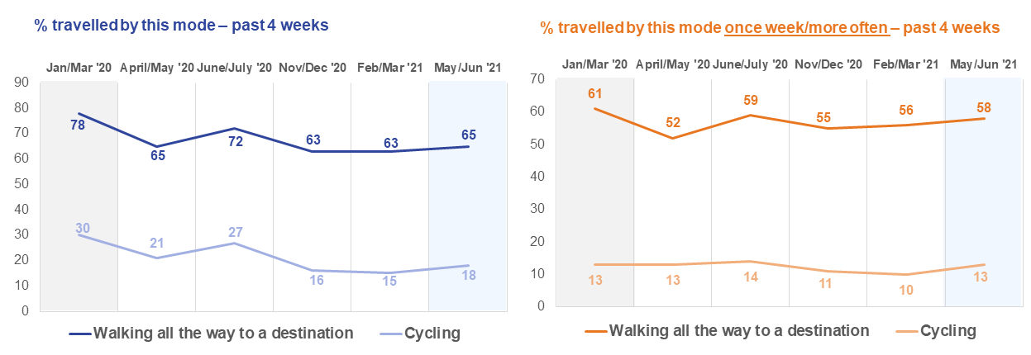
Source: Ipsos MORI/DfT, Base: 4,700 UK adults (Wave 5), 17 May-8 June 2021; 3,388 UK adults, 23 Feb – 9 March 2021 (Wave 4); 3,178 UK adults, 27 Nov-7 Dec 2020 (Wave 3); 4,061 UK adults, 21 July-3 August 2020 (wave 2); 4,059 UK adults, 15-22 May 2020 in England, Scotland and Northern Ireland, 28 May-4 June 2020 in Wales (wave 1), January-March 2020 (pre-lockdown). Q1. Thinking about the last 4 weeks, how often, if at all, did you personally travel by the following modes of transport?
(Wave 1) Q7. Now thinking back to the period immediately before the ‘lockdown’, that is the period between 1st January 2020 and the 23rd March, how often, if at all, would you say you personally travelled by the following modes of transport?
Figure 5: Frequency of car use (as driver or passenger) during February/March 2021 compared to November/December 2020, June/July 2020, April/May 2020 and January-March 2020
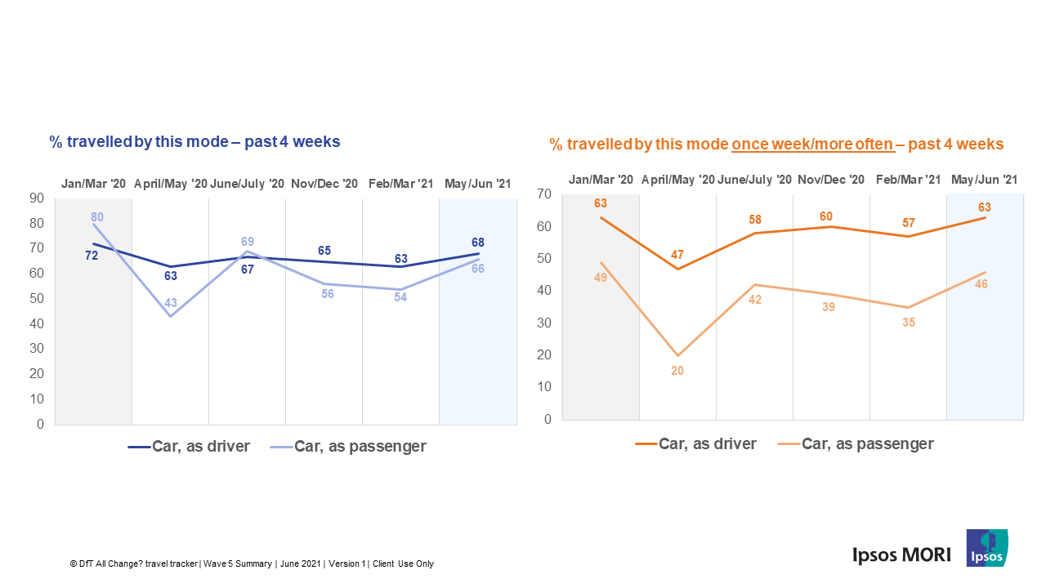
Source: Ipsos MORI/DfT, Base: 4,700 UK adults (Wave 5), 17 May-8 June 2021; 3,388 UK adults, 23 Feb-9 March 2021 (Wave 4); 3,178 UK adults, 27 Nov-7 Dec 2020 (Wave 3); 4,061 UK adults, 21 July-3 August 2020 (wave 2); 4,059 UK adults, 15-22 May 2020 in England, Scotland and Northern Ireland, 28 May-4 June 2020 in Wales (wave 1), January-March 2020 (pre-lockdown).Q1. Thinking about the last 4 weeks, how often, if at all, did you personally travel by the following modes of transport?
(Wave 1) Q7. Now thinking back to the period immediately before the ‘lockdown’, that is the period between 1st January 2020 and the 23rd March, how often, if at all, would you say you personally travelled by the following modes of transport?

As with car use and active travel, public transport use increased sharply in May/June 2021 compared to February/March 2021; 31% of people travelled by bus in the previous four weeks, up from 19%, 21% travelled by train, up from 10%, and 14% travelled by underground/metro, up from 6%.
This was also the pattern for frequent travel - using these modes once a week or more often. Frequent bus travel was much more common in May/June 2021 (19%) than in February/March 2021 (11%) and November/December 2020 (14%). Frequent travel by train and underground/metro was also higher – 10% and 8% respectively in May/June compared to 5% and 4% respectively in February/March 2021 (shown in Figure 6).
Figure 6: Frequency of public transport use during February/March 2021 compared to November/December 2020, June/July 2020, April/May 2020 and January-March 2020
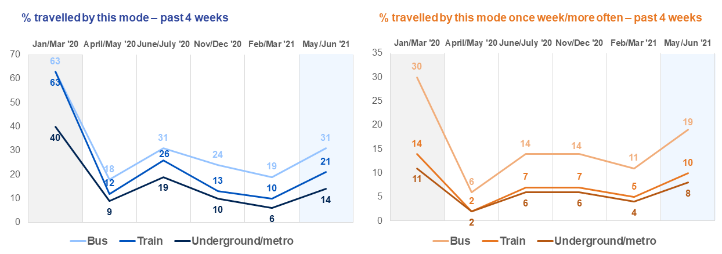
Source: Ipsos MORI/DfT, Base: 4,700 UK adults (Wave 5), 17 May-8 June 2021; 3,388 UK adults, 23 Feb-9 March 2021 (Wave 4); 3,178 UK adults, 27 Nov-7 Dec 2020 (Wave 3); 4,061 UK adults, 21 July-3 August 2020 (wave 2); 4,059 UK adults, 15-22 May 2020 in England, Scotland and Northern Ireland, 28 May-4 June 2020 in Wales (wave 1), January-March 2020 (pre-lockdown).
Q1. Thinking about the last 4 weeks, how often, if at all, did you personally travel by the following modes of transport?
(Wave 1) Q7. Now thinking back to the period immediately before the ‘lockdown’, that is the period between 1st January 2020 and the 23rd March, how often, if at all, would you say you personally travelled by the following modes of transport?

2.2. Active travel
There was an upward trend in the proportion of people who reported using active travel modes between February/March 2021 and May/June 2021.
Cycling
Table 3 shows the proportion of people within various subgroups who cycled in the period before the first UK-wide lockdown i.e. January-March 2020, followed by equivalent behaviours in the previous four weeks for each of the five survey waves. It shows that the incidence of cycling increased significantly in May/June 2021 compared to February/March 2021 and November/December 2020 but remained significantly lower compared to June/July 2020, April/May 2020 and pre-pandemic levels. It is important to note however that weather can impact active travel behaviour and May 2021 was particularly colder than Spring 2020.
The largest change in the incidence of cycling was among ethnic minority groups – this increased from 19% to 27% between February/March 2021 and May/June 2021. Younger adults aged 16-34 and those in full-/part-time employment also cycled more – there were six percentage points increases in cycling among both groups. Cycling also increased among those with a disability, up five percentage points to 16%. People from low-income households (earning up to £16,106 per annum) and older adults aged between 55-75 were among groups who cycled relatively less often.
Cycling increased significantly between February/March 2021 and May/June 2021 in each of England and Northern Ireland (up four percentage points to 19% and 13% respectively), and Scotland and Wales (up two percentage points to 13% 16%).
Walking or wheeling all the way to a destination
As shown in Table 4, across the UK, the proportion of those who walked or wheeled all the way to a destination in the previous four weeks in May/June 2021 was in line with February/March 2021. Those from an ethnic minority background (67%), younger adults aged 16-34 (72%) and those who don’t own a car or a bicycle (73%) were among groups most likely to have walked all the way to a destination in May/June 2021 and in higher proportions compared to February/March 2021.
More people in Wales (61%) walked all the way to a destination up from 50% in February/March 2021 although lower than last summer’s 68% (June/July 2020). There was, though, a drop in Northern Ireland of nine percentage points over the period between February/March 2021 and May/June 2021, from 56% to 47%.
Table 3: % who cycled during the last 4 weeks* – selected groups and geographies
(highlighted +/- indicates statistically significant change)
 | January-March 2020 | April/  May 2020 | June/July 2020 | November/  December 2020 | February/  March 2021 | May/June 2021 | +/- change:  Feb/Mar 2021 –  May/June - 2021
All UK | 30 | 21 | 27 | 16 | 15 | 18 | +3
England | 31 | 21 | 27 | 17 | 15 | 19 | +4
Scotland | 26 | 18 | 27 | 13 | 11 | 13 | +2
Wales | 27 | 18 | 24 | 14 | 14 | 16 | +2
Northern Ireland | 27 | 17 | 25 | 8 | 9 | 13 | +4
16-34 | 38 | 29 | 38 | 21 | 21 | 27 | +6
35-54 | 31 | 21 | 25 | 17 | 14 | 17 | +3
55-75 | 20 | 12 | 18 | 10 | 10 | 11 | +1
People with a disability | 24 | 17 | 22 | 13 | 11 | 16 | +5
Ethnic minority groups | 36 | 26 | 38 | 22 | 19 | 27 | +8
Working full/part-time | 32 | 23 | 30 | 18 | 16 | 22 | +6
Low income household | 27 | 20 | 26 | 13 | 12 | 10 | -2
Don’t own a car/bicycle | 12 | 6 | 10 | 5 | 2 | 3 | +1
Ipsos MORI/DfT, Base: 4,700 UK adults, 17 May-8 June 2021 (Wave 5); 3,388 UK adults, 23 Feb-9 March 2021 (Wave 4); 3,178 UK adults, 27 Nov-7 Dec 2020 (Wave 3); 4,061 UK adults, 21 July-3 August 2020 (wave 2); 4,059 UK adults, 15-22 May 2020 in England, Scotland and Northern Ireland, 28 May-4 June 2020 in Wales (wave 1), January-March 2020 (pre-lockdown).

Table 4: % who walked or wheeled all the way to a destination during the last 4 weeks* – selected groups and geographies
(highlighted +/- indicates statistically significant change)

 | January-March 2020 | April/  May 2020 | June/July 2020 | November/  December 2020 | February/March 2021 | May/June 2021 | +/- change:  Feb/March 2021 – May/June 2021
All UK | 78 | 65 | 72 | 63 | 63 | 65 | +2
England | 79 | 66 | 73 | 64 | 65 | 65 | 0
Scotland | 76 | 61 | 69 | 61 | 63 | 63 | 0
Wales | 75 | 62 | 68 | 57 | 50 | 61 | +11
Northern Ireland | 71 | 51 | 63 | 50 | 56 | 47 | -9
16-34 | 84 | 71 | 76 | 64 | 67 | 72 | +5
35-54 | 78 | 64 | 73 | 62 | 61 | 62 | +1
55-75 | 74 | 62 | 68 | 61 | 62 | 60 | -2
People with a disability | 79 | 68 | 71 | 60 | 61 | 63 | +2
Ethnic minority groups | 77 | 61 | 73 | 60 | 60 | 67 | +7
Working full/part-time | 78 | 64 | 71 | 63 | 62 | 64 | +2
Low income household | 75 | 66 | 76 | 63 | 63 | 65 | +2
Don’t own a car/bicycle | 84 | 81 | 82 | 75 | 71 | 73 | +2
Ipsos MORI/DfT, Base: 4,700 UK adults, 17 May-8 June 2021 (Wave 5); 3,388 UK adults, 23 Feb-9 March 2021 (Wave 4); 3,178 UK adults, 27 Nov-7 Dec 2020 (Wave 3); 4,061 UK adults, 21 July-3 August 2020 (wave 2); 4,059 UK adults, 15-22 May 2020 in England, Scotland and Northern Ireland, 28 May-4 June 2020 in Wales (wave 1), January-March 2020 (pre-lockdown).

2.3. Travel by car, taxi and app-based minicab services
Tables 5 and 6 show the proportion of people who travelled as a car driver and as a car passenger in the previous four weeks before each of the five surveys and the period immediately before the pandemic. Between February/March 2021 and May/June 2021, there was a significant increase in the proportions of those who travelled as a car driver – from 63% to 68% (the highest it has been in the All change? series) – and an even sharper increase in terms of being driven as a car passenger – from 54% to 66%.
Car as a driver
Driving increased by five percentage points in England and three percentage points in Northern Ireland between February/March 2021 and May/June 2021 reaching 67% and 72% of adults respectively. However, as shown in Table 5, there was a much larger increase among younger adults aged 16-34, from 52% in February/March 2021 to 61% in May/June 2021. More adults aged 35-54 years old travelled by car as a driver in May/June 2021 than in February/March 2021 - 67% compared to 63% - but this was higher among older adults aged 55-75 (75% unchanged since February/March 2021).
Driving also increased among people from ethnic minority backgrounds although from a much lower base; from 54% in February/March 2021 to 59% in May/June 2021. This was also the case among those with a disability and in full-/part-time employment.
Car as a passenger
In contrast to February/March 2021 when travelling as a car passenger decreased for many groups relative to November/December 2020, there has been a significant increase across all groups by May/June 2021. Travelling this way increased most significantly among those who didn’t own a car or a bicycle – from 27% in February March 2021 to 50% in May/June 2021. Table 6 shows that increases occurred among people with a disability and those from ethnic minority backgrounds.
Travelling as a car passenger during May/June 2021 was most common among younger adults aged 16-34 (81%) and in Northern Ireland (73%). As it had been in February/March 2021, travelling this way was least common in Scotland in May/June 2021 where it was done by 61% of people compared to 66% in England and 68% in Wales.
Taxi and app-based minicab services
The use of taxi/black cab (shown in Table 7) and app-based minicab services such as Uber (Table 8) also increased across the board between February/March 2021 and May/June 2021. Use of these modes increased the most among younger adults aged 16-34 and to a similar degree; from 15% for taxi/black cab in February/March 2021 to 30% in May/June 2021 and from 16% to 30% for app-based minicab services over the same period. This was also the case for those who said they don’t own a car or a bicycle and among ethnic minority groups but there was no change in the case of taxi/black cab use among low-income households (earning up to £16,106 a year) and a reduction in use of app-based minicab services.
Table 5: % drove a car during the last 4 weeks* – selected groups and geographies
(highlighted +/- indicates statistically significant change)
 | January-March 2020 | April/  May 2020 | June/July 2020 | November/  December 2020 | February/  March 2021 | May/June 2021 | +/- change:  Feb/Mar 2021 – May/June 2021
All UK | 72 | 63 | 67 | 65 | 63 | 68 | +5
England | 71 | 63 | 67 | 65 | 62 | 67 | +5
Scotland | 68 | 61 | 67 | 65 | 66 | 68 | +2
Wales | 76 | 72 | 74 | 72 | 71 | 71 | 0
Northern Ireland | 82 | 80 | 75 | 74 | 69 | 72 | +3
16-34 | 64 | 53 | 63 | 60 | 52 | 61 | +9
35-54 | 71 | 65 | 65 | 63 | 63 | 67 | +4
55-75 | 80 | 72 | 76 | 75 | 75 | 75 | 0
People with a disability | 68 | 60 | 62 | 58 | 59 | 62 | +3
Ethnic minority groups | 64 | 57 | 60 | 58 | 54 | 59 | +5
Working full/part-time | 79 | 71 | 75 | 74 | 73 | 75 | +2
Low income household | 57 | 49 | 52 | 49 | 49 | 50 | +1
Don’t own a car/bicycle | 15 | 3 | 12 | 7 | 5 | 8 | +3
Ipsos MORI/DfT, Base: 4,700 UK adults, 17 May-8 June 2021 (Wave 5); 3,388 UK adults, 23 Feb-9 March 2021 (Wave 4); 3,178 UK adults, 27 Nov-7 Dec 2020 (Wave 3); 4,061 UK adults, 21 July-3 August 2020 (wave 2); 4,059 UK adults, 15-22 May 2020 in England, Scotland and Northern Ireland, 28 May-4 June 2020 in Wales (wave 1), January-March 2020 (pre-lockdown).
Table 6: % travelled as a car passenger during the last 4 weeks* – selected groups and geographies
(highlighted +/- indicates statistically significant change)
 | January-March 2020 | April/May 2020 | June/July 2020 | November/  December 2020 | February/  March 2021 | May/June 2021 | +/- change:  Feb/Mar 2021 – May/June 2021
All UK | 80 | 43 | 69 | 56 | 54 | 66 | +12
England | 80 | 43 | 69 | 56 | 54 | 66 | +12
Scotland | 78 | 41 | 68 | 55 | 50 | 61 | +11
Wales | 81 | 44 | 70 | 65 | 56 | 68 | +12
Northern Ireland | 79 | 54 | 78 | 66 | 60 | 73 | +13
16-34 | 86 | 56 | 83 | 66 | 67 | 81 | +14
35-54 | 79 | 38 | 64 | 51 | 47 | 61 | +14
55-75 | 73 | 35 | 61 | 51 | 47 | 56 | +9
People with a disability | 77 | 43 | 69 | 55 | 51 | 67 | +16
Ethnic minority groups | 82 | 51 | 74 | 62 | 54 | 69 | +15
Working full/part-time | 81 | 42 | 70 | 58 | 53 | 66 | +13
Low income household | 70 | 37 | 61 | 47 | 42 | 52 | +10
Don’t own a car/bicycle | 66 | 28 | 49 | 36 | 27 | 50 | +23
Ipsos MORI/DfT, Base: 4,700 UK adults, 17 May-8 June 2021 (Wave 5); 3,388 UK adults, 23 Feb-9 March 2021 (Wave 4); 3,178 UK adults, 27 Nov-7 Dec 2020 (Wave 3); 4,061 UK adults, 21 July-3 August 2020 (wave 2); 4,059 UK adults, 15-22 May 2020 in England, Scotland and Northern Ireland, 28 May-4 June 2020 in Wales (wave 1), January-March 2020 (pre-lockdown).

Table 7: % travelled by taxi/black cab services during the last 4 weeks* – selected groups and geographies
(highlighted +/- indicates statistically significant change)
 | January-March 2020 | April/  May 2020 | June/July 2020 | November/  December 2020 | February/ March 2021 | May/June 2021 | +/- change:  Feb/Mar 2021 – May/June 2021
All UK | 46 | 11 | 26 | 12 | 10 | 17 | +7
England | 46 | 12 | 26 | 11 | 10 | 18 | +8
Scotland | 51 | 10 | 27 | 14 | 8 | 16 | +8
Wales | 37 | 9 | 23 | 16 | 10 | 12 | +2
Northern Ireland | 44 | 11 | 33 | 12 | 6 | 15 | +9
16-34 | 55 | 18 | 37 | 18 | 15 | 30 | +15
35-54 | 45 | 10 | 23 | 9 | 8 | 13 | +5
55-75 | 36 | 6 | 18 | 7 | 6 | 9 | +3
People with a disability | 45 | 13 | 26 | 14 | 13 | 20 | +7
Ethnic minority groups | 55 | 22 | 39 | 20 | 21 | 31 | +10
Working full/part-time | 48 | 12 | 29 | 12 | 11 | 20 | +9
Low income household | 44 | 15 | 27 | 16 | 11 | 11 | 0
Don’t own a car/bicycle | 57 | 16 | 32 | 21 | 16 | 26 | +10
Ipsos MORI/DfT, Base: 4,700 UK adults, 17 May – 8 June 2021 (Wave 5); 3,388 UK adults, 23 Feb-9 March 2021 (Wave 4); 3,178 UK adults, 27 Nov-7 Dec 2020 (Wave 3); 4,061 UK adults, 21 July-3 August 2020 (wave 2); 4,059 UK adults, 15-22 May 2020 in England, Scotland and Northern Ireland, 28 May-4 June 2020 in Wales (wave 1), January-March 2020 (pre-lockdown).
Table 8: % travelled by app-based minicab services (e.g. Uber) during the last 4 weeks* – selected groups and geographies
(highlighted +/- indicates statistically significant change)
 | January-March 2020 | April/  May 2020 | June/July 2020 | November/  December 2020 | February/ March 2021 | May/June 2021 | +/- Change:  Feb/ Mar 2021 – May/June 2021
All UK | 28 | 8 | 17 | 9 | 8 | 13 | +5
England | 29 | 8 | 17 | 10 | 8 | 15 | +7
Scotland | 23 | 5 | 13 | 5 | 5 | 6 | +1
Wales | 17 | 5 | 11 | 7 | 6 | 8 | +2
Northern Ireland | 21 | 4 | 14 | 4 | 1 | 7 | +6
16-34 | 46 | 15 | 34 | 18 | 16 | 30 | +14
35-54 | 26 | 6 | 11 | 6 | 6 | 7 | +1
55-75 | 12 | 3 | 5 | 3 | 1 | 2 | +1
People with a disability | 24 | 8 | 13 | 9 | 8 | 14 | +6
Ethnic minority groups | 50 | 19 | 38 | 24 | 24 | 31 | +7
Working full/part-time | 32 | 9 | 20 | 10 | 9 | 16 | +7
Low income household | 24 | 10 | 16 | 11 | 8 | 5 | -3
Don’t own a car/bicycle | 36 | 9 | 17 | 12 | 8 | 16 | +8
Ipsos MORI/DfT, Base: 4,700 UK adults, 17 May-8 June 2021 (Wave 5); 3,388 UK adults, 23 Feb-9 March 2021 (Wave 4); 3,178 UK adults, 27 Nov-7 Dec 2020 (Wave 3); 4,061 UK adults, 21 July-3 August 2020 (wave 2); 4,059 UK adults, 15-22 May 2020 in England, Scotland and Northern Ireland, 28 May-4 June 2020 in Wales (wave 1), January-March 2020 (pre-lockdown).

2.4. Public transport
As shown in Table 9, bus use in May/June 2021 was highest among those who don’t own a car or a bicycle (60%), among ethnic minority groups (49%) and younger adults aged 16-34 (45%). This was also the case for travelling by train (Table 10), done by 28% of those who don’t own a car or a bicycle, 40% of ethnic minority groups, and 38% of younger adults aged 16-34.
Travelling by these modes increased more sharply between February/March 2021 and May/June 2021 among 16-34-year olds than any group – from 23% to 45% for travelling by bus and from 16% to 38% by train. Levels of train use among this group were in line with those of June/July 2020 when restrictions were eased following the first UK-wide lockdown, while levels of bus use were higher compared to then (three percentage points higher at 45%).
The incidence of travelling by bus and train also increased between February/March 2021 and May/June 2021 among those with a disability, those in full-/part-time employment and those from a low-income household. Travelling by bus was higher in England (32%) and Scotland (31%) in May/June 2021 compared to Wales (20%) and Northern Ireland (18%). Train use was higher in England (23%) compared to Scotland (15%), Wales (12%) and Northern Ireland (7%).
Across the UK, travelling by underground/metro increased from just 6% in February/March 2021 to 14% in May/June 2021, the highest level it has been since June/July 2020 (19%) (shown in Table 11). The increase in use of this mode was greatest among younger age groups, ethnic minority groups and in London, where travel by underground/metro in the previous four weeks doubled between February/March 2021 (26%) and May/June 2021 (52%). Use of metro services in the North East of England also increased significantly during the same period, from 4% to 18%.
As a result of the changes described above and the fall in usage levels during lockdown periods, the profile of users of public transport has changed markedly since before the pandemic. For example, while those aged 16-34 years old made up 39% of train users before the pandemic, their share grew to 59% in May/June 2021 (approximately 33% of the adult population). Similarly, younger age groups, those from ethnic minority communities and those living in London constitute a greater share of those who recently travelled by bus, by train, by underground/metro and app-based mini-cab services compared to the period before the pandemic. By contrast, middle-aged and older groups and those with a disability accounted for a smaller proportion of users than they had done.

Table 9: % travelled by bus during the last 4 weeks* – selected groups and geographies
(highlighted +/- change indicates statistically significant change)
 | January-March 2020 | April/  May 2020 | June/ July 2020 | November/  December 2020 | February/  March 2021 | May/June 2021 | +/- Change:  Feb/ Mar 2021 – May/June 2021
All UK | 63 | 18 | 31 | 24 | 19 | 31 | +12
England | 63 | 19 | 31 | 24 | 19 | 32 | +13
Scotland | 66 | 16 | 32 | 29 | 16 | 31 | +15
Wales | 50 | 11 | 26 | 16 | 15 | 20 | +5
Northern Ireland | 57 | 19 | 25 | 13 | 8 | 18 | +10
16-34 | 72 | 25 | 42 | 31 | 23 | 45 | +22
35-54 | 58 | 17 | 26 | 20 | 17 | 25 | +8
55-75 | 58 | 12 | 25 | 20 | 16 | 23 | +7
People with a disability | 61 | 18 | 28 | 23 | 20 | 34 | +14
Ethnic minority groups | 75 | 32 | 53 | 39 | 38 | 49 | +11
Working full/part-time | 61 | 18 | 32 | 23 | 19 | 30 | +11
Low income household | 63 | 27 | 37 | 29 | 26 | 34 | +8
Don’t own a car/bicycle | 89 | 38 | 52 | 49 | 44 | 60 | +16
Ipsos MORI/DfT, Base: 4,700 UK adults, 17 May-8 June 2021 (Wave 5); 3,388 UK adults, 23 Feb-9 March 2021 (Wave 4); 3,178 UK adults, 27 Nov-7 Dec 2020 (Wave 3); 4,061 UK adults, 21 July-3 August 2020 (wave 2); 4,059 UK adults, 15-22 May 2020 in England, Scotland and Northern Ireland, 28 May-4 June 2020 in Wales (wave 1), January-March 2020 (pre-lockdown).
Table 10: % travelled by train during the last 4 weeks* – selected groups and geographies
(highlighted +/- indicates statistically significant change)
 | January-March 2020 | April/  May 2020 | June/July 2020 | November/  December 2020 | February/  March 2021 | May/June 2021 | +/- Change:  Feb/Mar 2021 – May/June 2021
All UK | 63 | 12 | 26 | 13 | 10 | 21 | +11
England | 64 | 12 | 26 | 14 | 10 | 23 | +13
Scotland | 64 | 9 | 12 | 12 | 6 | 15 | +9
Wales | 52 | 7 | 12 | 10 | 5 | 12 | +7
Northern Ireland | 47 | 9 | 11 | 4 | 4 | 7 | +3
16-34 | 73 | 19 | 38 | 23 | 16 | 38 | +22
35-54 | 59 | 10 | 20 | 10 | 8 | 15 | +7
55-75 | 55 | 6 | 19 | 6 | 5 | 10 | +5
People with a disability | 57 | 10 | 22 | 11 | 9 | 19 | +10
Ethnic minority groups | 71 | 24 | 45 | 13 | 21 | 40 | +19
Working full/part-time | 65 | 13 | 18 | 15 | 11 | 24 | +13
Low income household | 56 | 14 | 18 | 14 | 11 | 14 | +3
Don’t own a car/bicycle | 72 | 14 | 34 | 20 | 13 | 28 | +15
Ipsos MORI/DfT, Base: 4,700 UK adults, 17 May – 8 June 2021 (Wave 5); 3,388 UK adults, 23 Feb – 9 March 2021 (Wave 4); 3,178 UK adults, 27 Nov-7 Dec 2020 (Wave 3); 4,061 UK adults, 21 July-3 August 2020 (wave 2); 4,059 UK adults, 15-22 May 2020 in England, Scotland and Northern Ireland, 28 May-4 June 2020 in Wales (wave 1), January-March 2020 (pre-lockdown).
Table 11: % travelled by underground/metro during the last 4 weeks* – selected groups and geographies
(highlighted +/- indicates statistically significant change)
 | January-March 2020 | April/  May 2020 | June/July 2020 | November/  December 2020 | February/  March 2021 | May/June 2021 | +/- Change:  Feb/ Mar 2021 – May/June 2021
All UK | 40 | 9 | 19 | 10 | 6 | 14 | +8
London | 84 | 19 | 44 | 40 | 26 | 52 | +26
North East England | 50 | 11 | 23 | 9 | 4 | 18 | +14
16-34 | 50 | 16 | 31 | 16 | 9 | 25 | +16
35-54 | 38 | 7 | 14 | 8 | 6 | 11 | +5
55-75 | 32 | 4 | 13 | 4 | 4 | 6 | +2
People with a disability | 35 | 8 | 16 | 8 | 7 | 13 | +6
Ethnic minority groups | 60 | 20 | 39 | 30 | 19 | 35 | +16
Working full/part-time | 44 | 10 | 22 | 12 | 8 | 17 | +9
Low income household | 32 | 9 | 20 | 6 | 5 | 7 | +2
Don’t own a car/bicycle | 45 | 8 | 22 | 14 | 8 | 18 | +10
Ipsos MORI/DfT, Base: 4,700 UK adults, 17 May-8 June 2021 (Wave 5); 3,388 UK adults, 23 Feb-9 March 2021 (Wave 4); 3,178 UK adults, 27 Nov-7 Dec 2020 (Wave 3); 4,061 UK adults, 21 July-3 August 2020 (wave 2); 4,059 UK adults, 15-22 May 2020 in England, Scotland and Northern Ireland, 28 May-4 June 2020 in Wales (wave 1), January-March 2020 (pre-lockdown).

2.5 Longitudinal analysis
As restrictions were lifted, people travelled more during May/June 2021 than they had during February/March 2021. Although car driving did increase, travel as a car passenger increased by a larger proportion as did most modes of public transport.
As found in previous All change? reports, longitudinal analysis allows us to look at behaviour change at an individual level; showing us how often people used different modes of travel in May/June 2021 compared to how often the same people used these modes previously. This section focuses on the longitudinal group and changes individuals made between February/March 2021 and May/June 2021 in terms of their frequency of travelling by car, public transport and active travel. It also compares the frequency of travelling by some modes in May/June 2021 with behaviour in the period immediately before the first UK-wide lockdown (January-March 2020).
Changes between February/March 2021 and May/June 2021

Travel by car
Figure 7 shows that the majority (63%) of the longitudinal group (survey participants in both the February/March 2021 and May/June 2021 survey waves) did not change how often they travelled as a car driver however, over a quarter (28%) increased how often they drove a car compared to just 9% who decreased the amount they drove.
Figure 7: Travel frequency by selected modes among the longitudinal cohort – May/June 2021 vs. February/March 2021
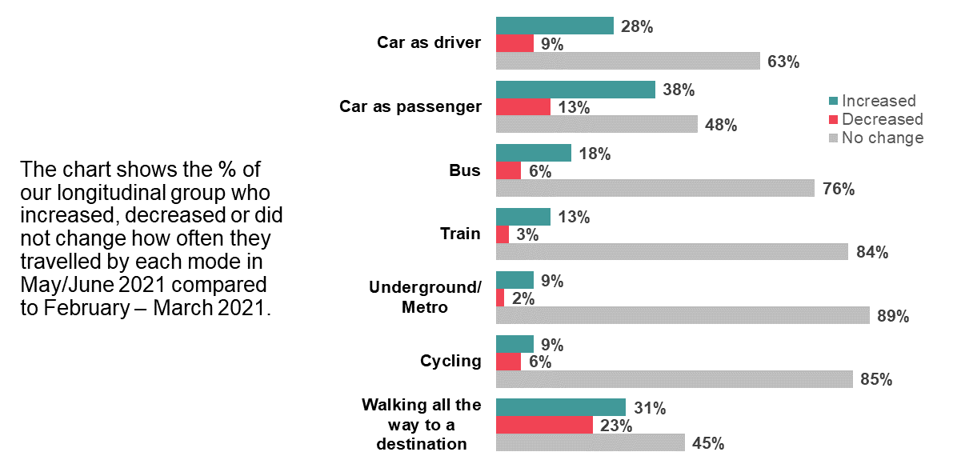
Source: Ipsos MORI/DfT 2,198 UK adults who participated in Wave 4 (23 Feb-9 March 2021) and Wave 5 (17 May-8 June 2021)
Similar to patterns observed in February/March 2021 (compared to November/December 2020), older people were the most likely age group to have increased how often they drove a car in May/June 2021 compared to February/March 2021. Over a third, 36%, of our longitudinal cohort aged 55-75 increased how often they drove compared to 27% of those aged 35-54 and 22% of those aged 16-34. Those within higher social grades were also more likely to have increased the frequency they travelled by driving a car compared to those within lower social grade households. Those from ethnic minority communities drove less frequently than other groups; 30% compared to 18%.
There were also differences in work commuting patterns. While 40% of those who travelled to a place of work 1-2 days per week prior to the pandemic increased how often they drove a car in May/June 2021 compared to February/March 2021, the equivalent was 28% of those who did so more frequently (between 3-5 days per week before the pandemic). A little more than a third, 35%, of those who did not commute to work before the pandemic also increased how often they drove, compared to 21% of commuters.
Young people were more likely than other age groups to have increased how often they travelled as a car passenger in May/June 2021 compared to February/March 2021. Nearly half (48%) of those aged 16-34 increased how often they travelled as a car passenger during this period compared to 37% of those aged 35-54 and 30% of those aged 55-75.
Those from higher social grade households were also more likely to have travelled as a passenger in a car more frequently in May/June 2021 compared to February/March 2021; 41% did this more frequently, higher than the 34% among lower social grade households.

Public transport
Between February/March 2021 and May/June 2021, 13% of the longitudinal group increased how often they travelled by train while 3% did this less often, and 84% did not change the frequency they did this.
Among our cohort, younger age groups were more likely than others to have increased the amount they used the train in May/June 2021 compared to February/March 2021; 19% of those aged 16-34 increased how often they used the train compared to 12% of those aged 35-54 and 7% aged 55-75. Those from ethnic minority communities were also more likely to have increased how often they travelled by train compared to other groups (22% compared to 11%), while those who commuted to work immediately prior to the pandemic were also more likely to have increased how often they travelled by train compared to those who did not commute (29% compared to 8%).
Those in London (27%) and the North West (23%) were also more likely to have increased how often they travelled by train compared to the overall UK average (13%).
Overall, 18% of the cohort increased how often they travelled by bus between February/March 2021 and May/June 2021; 6% decreased the frequency they used this mode. As with train use, it was younger age groups and those in London who were most likely to have changed how often they travelled by bus. This increased for 31% of those aged 16-24 compared to 18% across the cohort as a whole and decreased for 12% (it was 6% overall) while the frequency of using the bus increased for 42% of those in London and decreased for 11%.
Those not in work - typically older age groups - were more likely to have increased how often they travelled by bus compared to those in work (24% against 15%). As with travelling by driving a car, those who commuted between 1-2 days a week to work before the pandemic were more likely to have increased how often they travelled by bus compared to those who travelled to work 3-5 days a week (24% against 14%).

Active travel
Among our longitudinal cohort, a higher proportion increased (31%), than decreased (23%), how often they walked/wheeled all the way to a destination between February/March 2021 and May/June 2021. Over the same period, 9% increased how often they cycled, while 6% reduced cycling.
Very few groups were more likely than average to have increased the amount they walked between February/March 2021 and May/June 2021. However, those who travelled to work just 1-2 days per week prior to the pandemic were more likely to have increased the amount they walked compared to those who commuted 3-5 days per week (41% compared to 30%). This group were also more likely to have increased the amount they walked (41%) compared to the UK average overall (31%). Those within higher social grade households (25%) and groups other than ethnic minorities (24%) were more likely to have decreased the frequency they walked.
Men were more likely than women to have increased their frequency of cycling (12% compared to 7%) while ethnic minority communities were more likely to have decreased the amount they cycled compared to others (11% compared to 5%). Those who commuted 1-2 days a week to work prior to the pandemic were more likely to have decreased how often they cycled (15%) compared to those who commuted 3-5 days (5%) and the UK average (6%).

2.6 Changes between January-March 2020 (before the pandemic) and May/June 2021
In general, the evidence suggests that people increased their travel across all modes compared to the first lockdown but travel overall reduced relative to pre-pandemic levels. There is limited evidence that many people shifted from using one mode (e.g. from bus) to using another (e.g. to car).

Travel by car
Figure 8 below, shows how the use of each mode of transport has changed among the longitudinal group between May/June 2021 compared to the period just before the pandemic (January-March 2020). It shows that more people decreased, rather than increased, their car use, both driving and as a car passenger, between the two periods of time. Twice as many people decreased how often they travelled as a car driver (30%) as increased driving (12%).
Older people were most likely to have decreased how often they drove a car compared to before the pandemic; this happened among 36% of 55-75-year olds, a higher proportion than the 26% of 16-34-year olds and 27% of 35-54-year olds. Relative to the UK average (30%), people living in the East Midlands (46%) and South West (43%) were more likely to have decreased their driving, so too were people from ethnic minorities (31%) and those in higher social grade households (34%). However, those who commuted 1-2 days to work before the pandemic were more likely to have increased their driving (25%) than those who commuted 3-5 days per week (10%).
Figure 8: Travel frequency by selected modes among the longitudinal cohort – May/June 2021 vs. January-March 2020
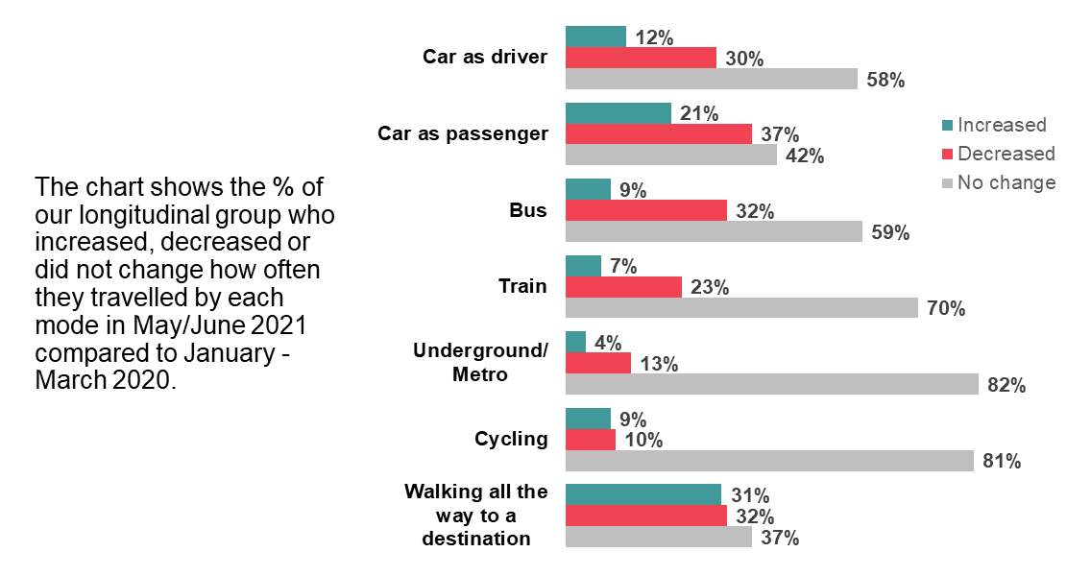
Source: Ipsos MORI/DfT 1,827 UK adults who participated in Wave 1 (15-22 May 2020/28 May-4 June 2020 in Wales) and Wave 5 (17 May-8 June 2021)
One in five of our cohort, 21%, increased how often they travelled as a car passenger in May/June 2021 compared to the period immediately before the pandemic, but this decreased for 37%. Women (40%) were more likely than men (33%) to travelled as a car passenger less often in May/June 2021 relative to the pre-pandemic period. This was also the case among those in full-/part-time work (39% compared to 31%). Ethnic minority groups were more likely to have increased how often they travelled as a car passenger (33%) compared to other groups (20%).

Public transport
Our longitudinal groups were more likely to have decreased the frequency they travelled by public transport modes than increased this compared to the pre-pandemic period. Three times as many people decreased their bus use (32%) as had increased this (9%), and 23% decreased their train use compared to 7% that had increased this.
While all age groups were more likely to have decreased rather than increased how often they travelled by train, those aged between 16-and 34 years of age were the group most likely to have travelled this way more frequently – 11% compared to 7% overall. Ethnic minority groups were more likely than other groups to have decreased their train usage (31% against 21%) and this was also the case among those in higher social grade households (26% compared to 16% among lower social grade households).
The biggest shifts occurred in London. There, 13% increased how often they travelled by train, but this decreased for 41% (compared to 23% of the cohort overall). This was also the case for travelling by bus; this increased for 16% but decreased for 52%. Similarly, people living in urban areas were more likely to have decreased how often they travelled by bus compared to those in rural areas - 35% against 21%.

Active travel
The proportions of people increasing active travel were similar to the proportion that decreased their frequency of active travel – 9% increased the frequency they cycled, while 10% decreased this; and 31% increased the frequency they walked/wheeled all the way to a destination, while 32% decreased this.
Those in our cohort aged 16-34 were more likely to have increased how often they walked all the way to a destination compared to other age groups; 38% did more of this in May/June 2021 compared to before the pandemic, a higher proportion than the equivalent 29% of 35-54-year olds and 26% of 55-75-year olds. People in Wales were more likely than average to have decreased the frequency they walked (39%) while the opposite was true in urban areas where 32% increased their frequency of walking or wheeling all the way to a destination compared to 23% in rural areas.
Men (13%) were more likely than women (7%) to have reduced how often they cycled compared to the pre-pandemic period. Ethnic minority groups (17%) were also more likely to have increased the amount they cycled, as were people living in London (also 17%). By contrast, those in work and living in higher social grade households (who also have a higher propensity to work from home) were relatively more likely to have decreased their cycling (both 11%) in May/June 2021, compared to the pre-pandemic period.

2.7 Was there mode switch?
Longitudinal analysis from the previous waves of All change?, found that if an individual increased their use of one mode of travel, they were likely to have increased their use of any other modes they used rather than switching between modes. This section investigates potential mode switch between February/March 2021 and May/June 2021 as well as providing a more long-term look at May/June 2021 and before the pandemic.
The survey cannot tell us definitively if people have switched – for that we would need detailed studies of individual journeys over time – but by looking at the longitudinal data we can glean some useful indications of behaviour at an individual rather than aggregate level. Moreover, analysis of statistical difference in behaviour between those who increased use of a mode, and those who decreased use of the same mode, is of interest because it is most likely to indicate that the change in mode use was not an across-the-board-change, but was a more defining characteristic of a behavioural group.
Figure 9 below shows changes in travel between February/March 2021 and May/June 2021 for individuals who changed how often they travelled by driving a car. Those who increased how often they travelled this way (on the left-hand side of Figure 9) were also more likely to have increased, rather than decreased, the frequency they used other transport modes during this period. People who decreased the amount they drove (on the right-hand side) were more likely to have also decreased other forms of transport use. However, this is not the case for all modes – for example, of those who decreased their driving, 25% increased the frequency they travelled by bus (compared to 10% of those who increased their driving).
Figure 10 shows that people who had increased how often they travelled by bus between February/March 2021 and May/June 2021 were also likely to have increased how often they used other modes of transport. While those who reduced their bus use (on the right-hand side of Figure 10) were more likely to have also reduced their use of other modes compared to those who travelled by bus more frequently (on the left-hand side), there was one notable difference; nearly a quarter (23%) of those who decreased how often they travelled by bus, increased the frequency they cycled. This compares with 10% of those who increased their bus use, indicating there may have been an element of mode shift from travelling by bus to cycling instead.
Figure 9: Mode increase/decrease among those who increased/decreased driving a car – May/June 2021 vs. February/March 2021
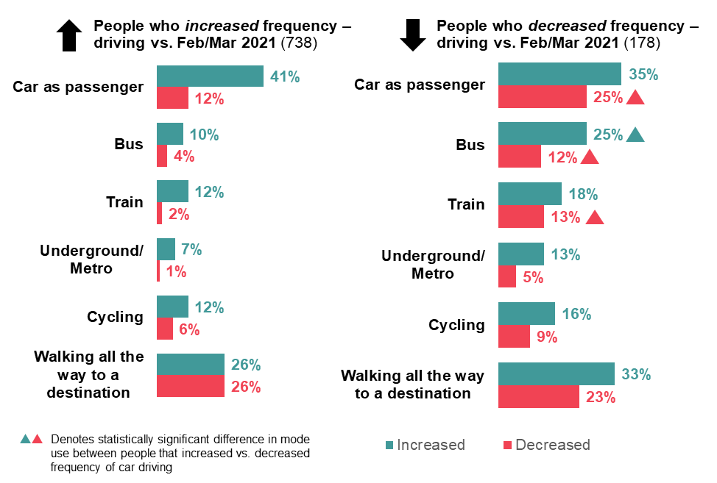
Source: Ipsos MORI/DfT 2,198 UK adults who participated in Wave 4 (23 Feb-9 March 2021) and Wave 5 (17 May-8 June 2021)

Figure 10: Mode increase/decrease among those who increased/decreased bus use – May/June 2021 vs. February/March 2021
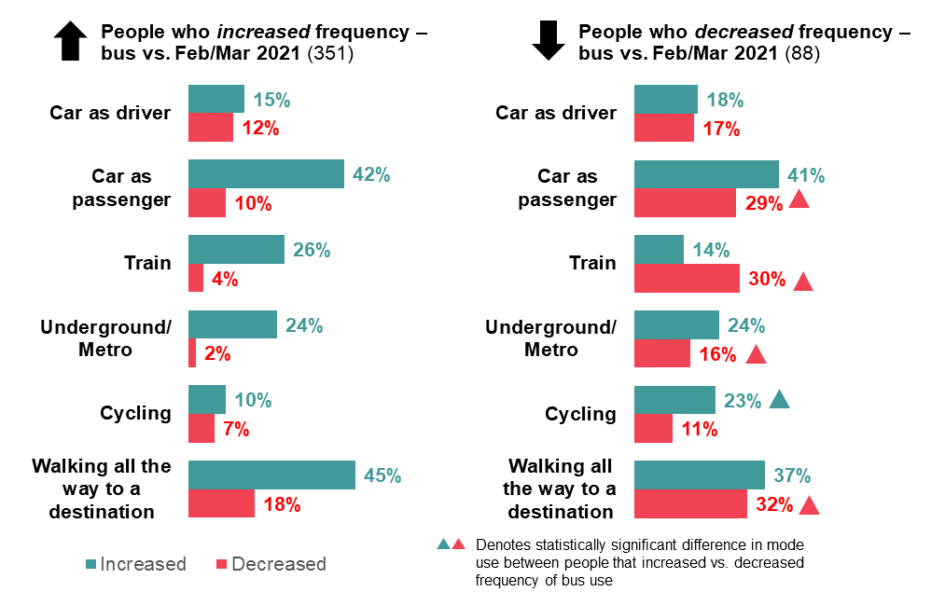
Source: Ipsos MORI/DfT 2,198 UK adults who participated in Wave 4 (23 Feb-9 March 2021) and Wave 5 (17 May-8 June 2021)
Figure 11 below summarises changes in the frequency of walking or wheeling all the way to a destination between February/March 2021 and May/June 2021. As with other modes, those who increased how often they walked during this period were also more likely to have increased other modes of travel as well. Most notably, a quarter (26%) of those whose frequency of walking or wheeling all the way to a destination increased, also travelled by bus more often; this was significantly higher than the incidence of this behaviour among those who walked less frequently (14%).
Figure 11: Mode increase/decrease among those who increased/decreased walking or wheeling all the way to a destination – May/June 2021 vs. February/March 2021
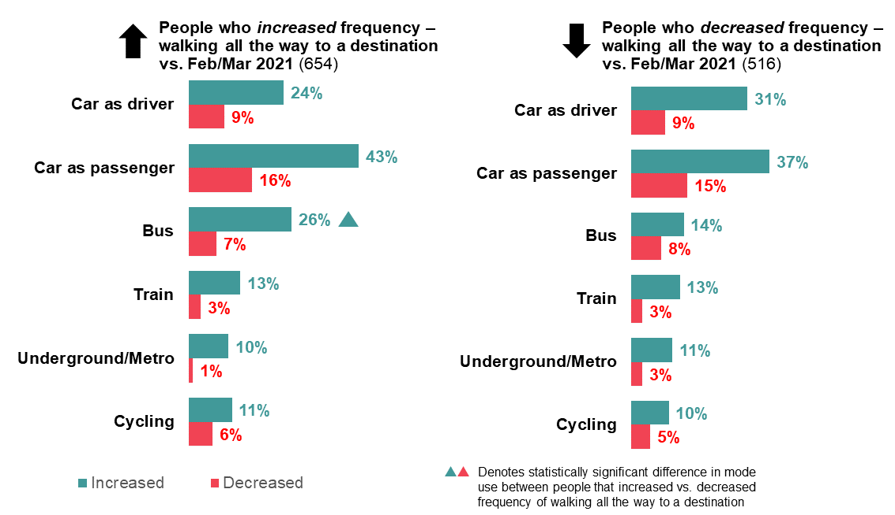
Source: Ipsos MORI/DfT 2,198 UK adults who participated in Wave 4 (23 Feb-9 March 2021) and Wave 5 (17 May-8 June 2021)
The longitudinal data also allows us to look at changes in mode use since the period immediately before the pandemic (January-March 2020). Figure 12 shows that those who travelled by car as a driver more often in May/June 2021 compared to before the pandemic, used public transport less frequently, although so too did those who travelled by car less often.

Figure 12: Mode increase/decrease among those who increased/decreased driving in a car – May/June 2021 vs. before the pandemic
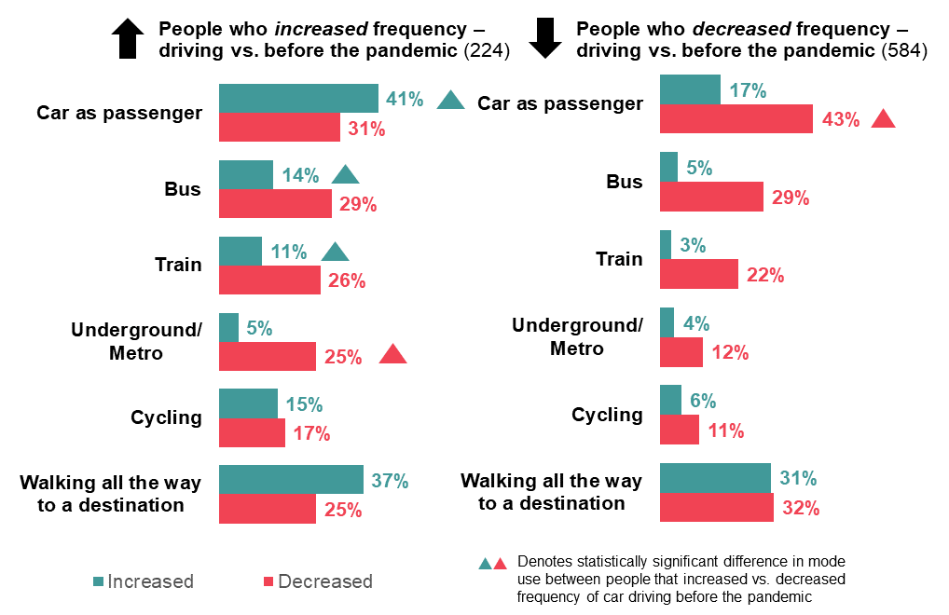
Source: Ipsos MORI/DfT 1,827 UK adults who participated in Wave 1 (15-22 May 2020/28 May-4 June 2020 in Wales) and Wave 5 (17 May-8 June 2021)
Figure 13 summarises changes in behaviour in terms of the frequency of travelling by bus between May/June 2021 and prior to the pandemic. Again, changes in frequency are strongly associated with one another – for example, those who reduced how often they travelled by bus were more likely to have also decreased the frequency they used other modes. Among those who travelled by bus less frequently, cycling was the only mode where there was an even split between increased and decreased frequency of use.
Figure 13: Mode increase/decrease among those who increased/decreased bus use – May/June 2021 vs. before the pandemic
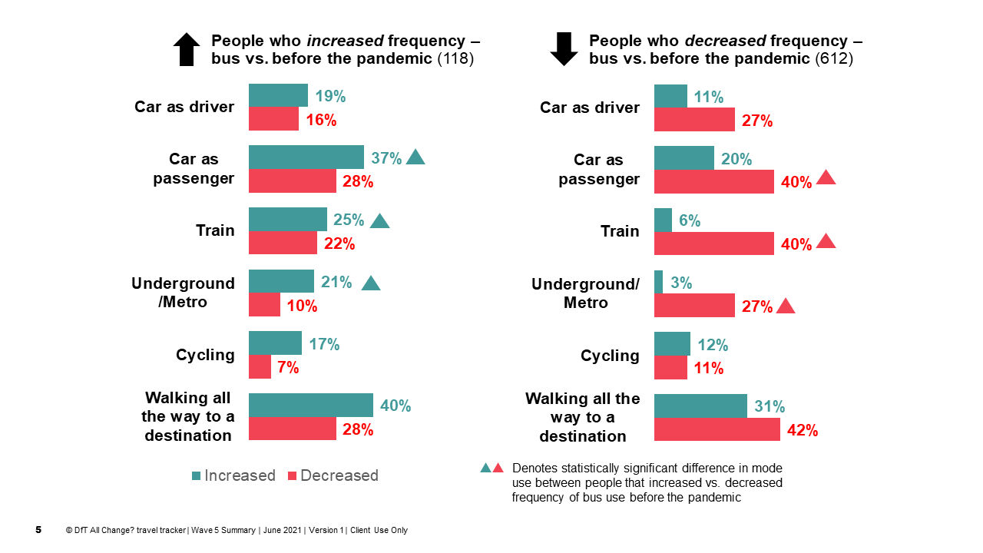
Source: Ipsos MORI/DfT 1,827 UK adults who participated in Wave 1 (15-22 May 2020/28 May-4 June 2020 in Wales) and Wave 5 (17 May-8 June 2021)
As shown in Figure 14, those who cycled less often in May/June 2021 compared to before the pandemic also used other modes less frequently, but those who cycled more often were significantly more likely to have increased the frequency they walked all the way to a destination.
Figure 14: Mode increase/decrease among those who increased/decreased cycling to a destination – May/June 2021 vs. before the pandemic
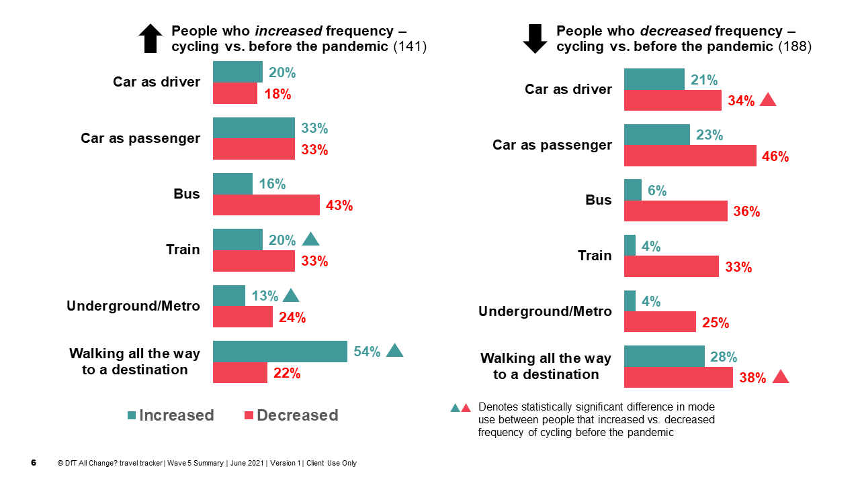
Source: Ipsos MORI/DfT 1,827 UK adults who participated in Wave 1 (15-22 May 2020/28 May-4 June 2020 in Wales) and Wave 5 (17 May-8 June 2021)

Why did behaviour change?
In February/March 2021, various lockdown restrictions were in place across the UK. At the beginning of March, the Government announced a gradual easing of restrictions outlined in a ‘Roadmap out of lockdown’ for England, planning for all restrictions to be lifted by 21st June if all previous steps were achieved as planned.
Fieldwork for the fifth survey overlapped with Step 3 of the Roadmap, when most legal restrictions on meeting others outdoors were lifted and two households were allowed to mix indoors. When fieldwork ended on 8th June, over 40 million people (75% of the adult population in the UK) had their first dose of vaccine and 28 million had both doses. However, on the 4th June, it was announced that the Delta variant was the most dominant strain in the UK, raising concerns around the higher transmission and hospitalisation rates compared to previous variants. A week after the survey ended, the Government announced the postponement of Step 4 of the Roadmap until the 19th July, when the UK was expected to be in a better position to remove all legal limits on social contact.
This section describes evidence on why and how people travelled during May/June 2021. It also compares behaviours between the two periods when restrictions were being eased – June/July 2020 and May June 2021 in England - in an effort to understand the potential motivations for these behaviours.

3.1. Why did people travel?
During May/June 2021, 99% of UK adults travelled (for any reason) compared to 97% during February/March 2021. On average, respondents identified 4.1 reasons for travelling, up sharply on 2.2 in February/March 2021 and 2.5 in November/December 2020. This average was higher among younger age groups (an average of 4.7 compared to 4.0 among 35-54-year-olds and 3.7 among those aged 55-75) as well as those in full-/part-time employment (4.4 compared to 3.6 among those who weren’t).
Figure 15 below presents the various reasons people travelled (by any mode) in the four weeks prior to taking part in the survey and how the proportion of people travelling for these reasons changed in May/June 2021 compared to February/March 2021 (wave 4) and November/December 2020 (wave 3). As with previous waves, shopping was the most common reason people travelled with 77% saying they travelled for this reason, significantly higher than any other reason and an increase from 72% in February/March 2021 and 74% in November/December 2020.
Other common reasons for travel were visiting friends and relatives (44%), commuting to a place of work (36%), and for recreation (35%). A third of people across the UK travelled to a medical, hospital or dentist appointment (33%), compared to 23% who travelled for this reason in November/December 2020 and 30% in February/March 2021, likely reflecting the roll out of the vaccination programme and attendance at vaccination centres.

Figure 15: Reasons people travelled in May/June 2021 and change vs. Feb/March 2021 and Nov/Dec 2020
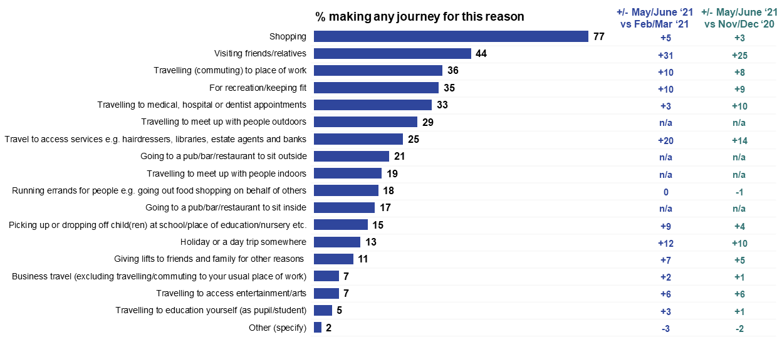
Source: Ipsos MORI/DfT; Base: All users of any transport mode at least once in the past four weeks (4,650) among 4,700 UK adults (Wave 5), 17 May – 8 June; (3,299) among 3,338 UK adults (Wave 4), 23 February – 9 March; (3,139) among 3,178 UK adults (Wave 3), 27 November – 7 December
Q2aNEW. Still thinking again about the last 4 weeks, for which of these reasons, if any, have you made a journey of any kind. It does not matter which mode(s) of transport you used. Please indicate all that apply.

3.2. Which modes did people use?

Shopping
Across the UK, 60% of those who travelled to go shopping drove a car, twice as many as those who walked (30%) or travelled as a car passenger (29%) for the same reason. Of those who went shopping, 12% travelled by bus - up from 8% in February/March 2021 - while significantly fewer people walked all the way to a destination for the same reason, down from 35% to 30%.
As in February/March 2021, people who went shopping and travelled as a car driver were more likely to be between 35-54 years old; 39% of this group drove to go shopping compared to 22% of 16-34-year olds. The younger age group were more likely to have travelled as a car passenger for shopping - 40%, compared to 25% of those aged 35-54 and 24% of older adults aged 55-75.
Those from ethnic minority backgrounds were less likely to have driven by car to go shopping (49%) compared to other groups (61%) but were more likely to have travelled by bus (18% against 11%). Similarly, those in employment (65%) and in higher income households (earning over £40,000/year) (76%) were more likely to go shopping by car as a driver compared to the unemployed (50%) and those on lower incomes (earning up to £16,106/year) (45%), who were more likely to travel by bus for this reason.

Visiting friends and relatives
Travelling for this reason trebled between February/March 2021 (13%) and May/June 2021 (44%), reflecting the changes in social distancing measures indoors. Over half (56%) of those who travelled to visit friends and family in May/June 2021 drove a car and over a third (36%) travelled as a car passenger - a significant increase compared to 29% in February/March 2021. One in ten, 10%, travelled by bus for this reason in line with February/March 2021.
Among those who travelled to visit friends and family, those not in work (12%), younger adults aged 16-34 (14%), people from ethnic minority backgrounds (17%) and, those without access to a car or bicycle (35%) were more likely to travel by bus compared to the average across the UK (10%). Travelling for this reason by bus was also higher in urban areas (11%), Scotland (14%) and London (30%).
Over two-thirds (68%) of older adults aged 55-75 drove a car to see friends and family in the previous four weeks during May/June 2021. Those from other backgrounds (59%), those in work (63%), in higher income households (66%) and those living in rural areas (70%), were also relatively more likely to drive a car for this reason.

Commuting
There was a 10-percentage point increase in the number of people who travelled to a place of work between February/March 2021 (26%) and May/June 2021 (36%). Most of those who travelled to their place of work in May/June 2021 drove (65%), but 12% travelled as a car passenger, 14% travelled by bus and 16% walked all the way.
Older commuters - those aged 55-75 - were more likely than average to have driven a car to work during May/June 2021 with 71% having done so compared to 60% of 16-34-year olds. Younger adults were more likely to have travelled to work as a car passenger; 17% compared to 10% and 6% of middle aged and older adults. They were also more likely to have travelled to work using app-based minicab services such as Uber and taxi services – 5% and 4% respectively of younger adults used these modes compared to just 1% of other age groups.
Those from ethnic minority backgrounds who travelled to a place of work during this period were more likely compared to the UK overall average to do this as a car passenger (20%) and by public transport modes - 27% travelled by bus while 18% commuted by train and the same proportion travelled by underground/metro.

Recreation and keep-fit
Over half (55%) of those who travelled for recreation and keep-fit purposes did so on foot – in line with November/December 2020 levels, but significantly lower than in February/March 2021 (62%). Walking or wheeling all the way to destination remained the most common way to travel for these reasons, followed by driving a car (35%), cycling (15%) and travelling as a car passenger (13%).
Those living in urban areas (59%), in Scotland (62%) and in London (64%) were more likely to travel for recreational reasons by foot compared to average. Similarly, those not in paid employment were more likely to walk for these reasons.
Older people were much more likely to have driven to access recreation and keep-fit; 42% compared to 30% of younger people aged 16-34. The 16-34-year old age group were more likely to have travelled by bus; 7% compared to 4% overall.

Travelling to medical, hospital and dentist appointments
Likely related to the vaccination roll-out programme, the proportion of people travelling to a medical, hospital or dentist appointment increased again in May/June 2021 reaching 33% compared to 30% in February/March 2021 and 23% in November/December 2020.
Driving a car was the preferred mode of choice among those who travelled for these reasons (49%), followed by travelling as a car passenger (25%), walking or wheeling all the way to a destination (19%) and travelling by bus (12%).
Of those that had been vaccinated (71% of our sample), over half (53%) drove a car to a medical appointment, followed by 23% who travelled in as a car passenger while 16% walked and 12% travelled by bus.
Among those who travelled for a medical appointment, a significantly higher proportion of older adults aged 55-75 (55%) drove by car, compared to 36% of younger adults aged 16-34. Those aged 16-34 were more likely to have travelled as a car passenger; 32% compared to 21% of 35-54-year olds and 23% of 55-75-year olds.
People from ethnic minority backgrounds were more likely to have travelled to a medical appointment by underground or metro (10% compared to 3% of adults overall) and tram (3% compared to 1%). They were also more likely to travel by taxi or black cab and an app-based minicab services.

3.3. Comparison of travel behaviour between June/July 2020 and May/June 2021
Of the five previous All change? survey waves, two have taken place during periods when lockdown restrictions were being eased in England and other parts of the UK – during June/July 2020 (wave 2) and May/June 2021 (wave 5). Table 12 below, summarises differences in terms of mode use and reasons for travel in England, although we recognise that there were important differences between the two periods in terms of restrictions (with wave 5 following three lockdown periods in England) but also the successful vaccination programme in 2021 and seasonal factors such as the weather.
In England, only 18% cycled during the previous four weeks during May/June 2021 compared to 27% in June/July 2020, while 65% walked all the way to a destination compared to 72%. As shown in Table 12, people were also more likely to have travelled by taxi or black cab and as a car passenger during June/July 2020 and to have travelled by train. Levels of travelling by car as a driver and by bus were similar across the two periods.
While the proportion of people who drove to go shopping in May/June 2021 remained in line with June/July 2020 (45% and 46% respectively), there was a significant increase in the proportion of people who drove to a place of work in May/June 2021 compared to June/July 2020 (23% vs. 19%), and a drop in the proportion who travelled by car to visit friends/relatives (25% vs. 27%).

Table 12: Overview comparison of travel behaviour between June/July 2020 and May/June 2021, when restrictions were eased in England
(highlighted +/- indicates statistically significant change)
 | June/July  2020 | May/June  2021
% travelled in a car as a driver - past 4 weeks | 67 | 68
% travelled as a car passenger - past 4 weeks | 69 | 66
% used bus - past 4 weeks | 31 | 31
% used train - past 4 weeks | 26 | 21
% walked to destination - past 4 weeks | 72 | 65
% cycled - past 4 weeks | 27 | 18
% used taxi - past 4 weeks | 26 | 17
% drove to go shopping | 46 | 45
% drove to commute | 19 | 23
% drove to visit friends/relatives | 27 | 25
Ipsos MORI/DfT, Base: 4,700 UK adults, 17 May-8 June 2021 (Wave 5); 4,061 UK adults, 21 July-3 August 2020 (Wave 2)

What were people’s short-term travel plans?
In this section, we report on findings from questions asking respondents to anticipate their use of different modes of transport in the subsequent four weeks. It is therefore important to consider the reference periods for both the All change? wave 4 (a period of lockdown and the roll-out of the vaccination programme) and for the most recent survey (a period during which restrictions were eased).
Wave 4 took place during the third lockdown in England (which came into effect on 6th January), with Wales, Scotland and Northern Ireland also using lockdown restrictions, and shortly after the Government’s Roadmap for England was announced (on 22nd February). The Roadmap identified four steps with step one due to fall within the forthcoming four-week period. Step 1 included the return of all children and students to face-to-face education in schools and colleges (8th March), allowing some outdoor social contact for recreation and exercise outdoors (also 8th March), ‘rule of six’ gatherings outdoors (29th March), the opening of outdoor sports facilities (29th March) and an end to the ‘stay at home’ rule (also 29th March).
The latest, wave 5 survey, was conducted after Step 3 of the Roadmap had come into effect in England which involved the lifting of most legal restrictions on meeting others outdoors (two households will be able to mix indoors, with the rule of six applying to indoor hospitality settings). Fieldwork was completed on 8th June before Step 4 in England was postponed on 14th June. Our survey asked questions about anticipated behaviour ‘if all restrictions are lifted (currently scheduled to be 21st June at the earliest)’ and took place against the backdrop of increased media attention towards the Delta variant.
Progress with the roll-out of the Covid-19 vaccination programme was another notable difference between fieldwork periods. At the start of fieldwork for the wave 4 survey (23rd February), 17.9 million people across the UK had received their first dose vaccinations as part of Phase 1 (targeting the nine priority groups) and, at its completion (9th March), 22.8 million had received their first dose. By the start of the wave 5 survey, 36.8 million people had received first dose vaccinations. This had risen to 40.7 million by the end of fieldwork.

4.1. Propensity to travel during next four weeks
As in both November/December 2020 and February/March 2021, there was some expectation of increased travel in the next four weeks during May/June 2021 including more frequent use of public transport, particularly for train travel (shown in Table 13). While 21% of people travelled by train during February/March 2021, levels of expected use over the four week-period following the survey in May/June 2021 was 26%.
There was no difference between past and expected travel by taxi or walking or wheeling all the way to a destination. For bus and underground/metro services expected use was in line with past use (which had increased compared to February/March 2021). In May/June 2021, a third, 33% expected to travel by bus and 16% by underground/metro.
Table 13: Proportion of people that travelled by each mode in past four weeks compared to the proportion that expected to travel in the next four weeks – May/June 2021
 | Past 4 weeks | Next 4 weeks | +  Difference
Walking or wheeling all the way to a destination | 65 | 65 | 0
Car driver | 68 | 66 | -2
Car passenger | 66 | 64 | -2
Bus | 31 | 33 | +2
Cycling | 18 | 21 | +3
Train | 21 | 26 | +5
Taxi | 17 | 17 | 0
Underground/metro | 14 | 16 | +2
Source: Ipsos MORI/DfT, 4,700 UK adults (Wave 5), 17 May-8 June 2021
Q1./Q1a. Thinking about the last 4 weeks, how often, if at all, did you personally travel by the following modes of transport?
Q12. Please now think about what you will be likely to do in the weeks ahead as some restrictions are eased. How often, if at all, do you think you will be to travel using these modes in the next 4 weeks or so? It does not matter how long you think the journeys would be, or why you will make them.
Table 14 below shows expected bus, train and underground/metro travel for different groups. Expected use of each mode was significantly higher among people who used the mode during the previous four weeks compared to the average. Levels of expected use were also higher than average among people who had used the mode pre-pandemic, those from ethnic minority backgrounds, those without access to a car or bicycle and among people who had used these modes once a week or more pre-pandemic (68% expected to use buses, the same proportion expected to travel by underground/metro, 66% to use trains). Levels were also higher for people who would feel comfortable travelling that way (49% bus, 37% train, 29% underground/metro), and especially among those living in London (65% bus, 46% train, 54% underground/metro).

Table 14: % expected to travel by bus/train/underground/metro - next four weeks – May/June 2021 (any frequency)
Group | Bus | Train | Underground/  metro
All adults | 33 | 26 | 16
16-34-year olds | 44 | 40 | 26
Ethnic minority background | 51 | 38 | 36
Used mode pre-Covid (any frequency) | 45 | 32 | 27
Comfortable travelling by mode next 4 weeks | 49 | 37 | 29
No access to car/bicycle | 59 | 34 | 21
London | 65 | 46 | 54
Used mode pre-Covid once a week/  more often | 68 | 66 | 68
Used mode in past 4 weeks | 84 | 82 | 80
Source: Ipsos MORI/DfT, 4,700 UK adults (Wave 5), 17 May-8 June 2021
Q12. Please now think about what you will be likely to do in the weeks ahead as some restrictions are eased. How often, if at all, do you think you will be to travel using these modes in the next 4 weeks or so? It does not matter how long you think the journeys would be, or why you will make them.

4.2. Propensity to travel ‘if all restrictions are lifted’
As shown in Table 15 below, expected use of public transport, active travel and car passenger travel increased significantly in the scenario ‘if all restrictions are lifted (this is currently scheduled to be no earlier than 21st June)’. Around half, 51% and 53%, expected to travel by bus and train respectively and a third - 34% - by underground/metro. There was also increased expectation of walking or wheeling all the way to a destination (70%), cycling (28%) and use of private modes i.e. driving (68%), travelling as a car passenger (74%) and in a taxi (36%).

Table 15: Proportion of people that expected to travel by each mode in the next four weeks compared to ‘if all restrictions are lifted’ – May/June 2021
 | Next 4 weeks | …if all restrictions are lifted | + difference
Walking or wheeling all the way to a destination | 65 | 70 | +5
Car driver | 66 | 68 | +2
Car passenger | 64 | 74 | +10
Bus | 33 | 51 | +18
Cycling | 21 | 28 | +7
Train | 26 | 53 | +27
Taxi | 17 | 36 | +19
Underground/metro | 16 | 34 | +18
Source: Ipsos MORI/DfT, 4,700 UK adults (Wave 5), 17 May-8 June 2021
Q12. Please now think about what you will be likely to do in the weeks ahead as some restrictions are eased. How often, if at all, do you think you will be to travel using these modes in the next 4 weeks or so? It does not matter how long you think the journeys would be, or why you will make them.
Q62NEW. Please now think about what you will be likely to do if all restrictions are lifted (this is currently scheduled to be no earlier than 21 June). How often, if at all, do you think you will travel using these modes?

4.3. Compliance and experiences of travelling during May/June 2021
Those who made journeys by public transport in the previous four weeks during May/June 2021 were mostly positive about their experience. As was the case during November/December 2020 and February/March 2021, levels of reported personal compliance with wearing face masks/coverings among those who travelled by public transport in the previous 4 weeks were high in May/June 2021 – the majority of public transport users said they wore a face mask/covering when using the bus (95%), the train (91%) and the underground/metro (88%). The equivalent figures for February/March 2021 were 93%, 91% and 90% respectively.
By wide margins, users of buses, trains and underground/metro were more positive than negative about several aspects of travel including cleanliness, ventilation and the ability to maintain distance from other passengers; the exception to this was the availability of hand sanitisers according to bus passengers. Ratings remained largely unchanged between February/March 2021 and May/June 2021, but there were some statistically significant differences, highlighted in Figure 16, Figure 17 and Figure 18. For example, 31% of bus passengers rated the ability to keep a safe distance from other bus passengers while travelling as very/fairly poor in May/June 2021, compared to 26% in February/March 2021. Ventilation was rated as being very or fairly poor in May/June 2021 by 34% of underground/metro passengers, 29% of those who travelled by train and 24% of bus users.
Figure 16: Ratings of Covid-related safety measures among bus users
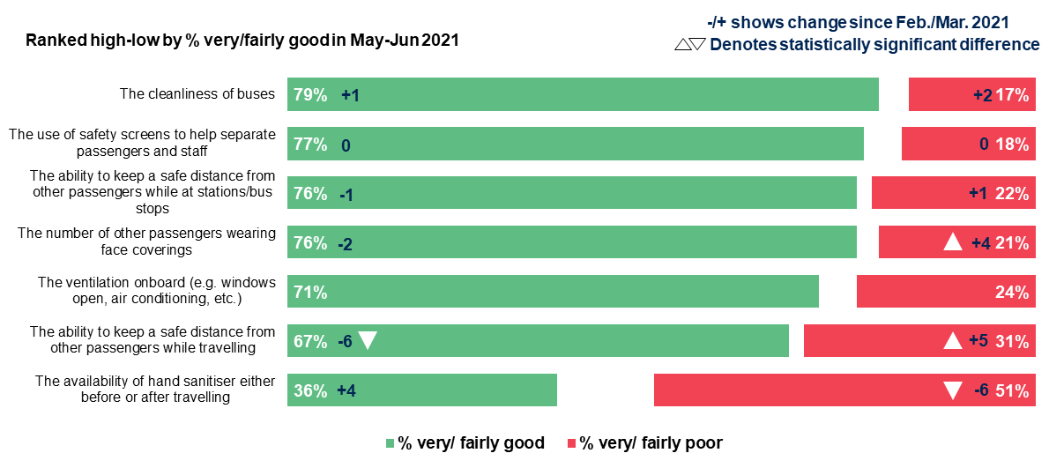
Source: Ipsos MORI/DfT; Base: All using a bus at least once in past 4 weeks (1,232) among 4,700 adults, 17 May-8 June 2021 (535 in February/March 2021)
NEWQ48_5. You said earlier that you travelled by bus in the last 4 weeks. Thinking back to the last journey you made by bus, how would you rate it in terms of the following…?
Figure 17: Ratings of Covid-related safety measures among train users
Stacked bar chart showing the ratings of a selection of COVID-19 safety measures among train users in May/June 2021 and the percentage points changes from February/March 2021. The arrows denote statistically significant changes.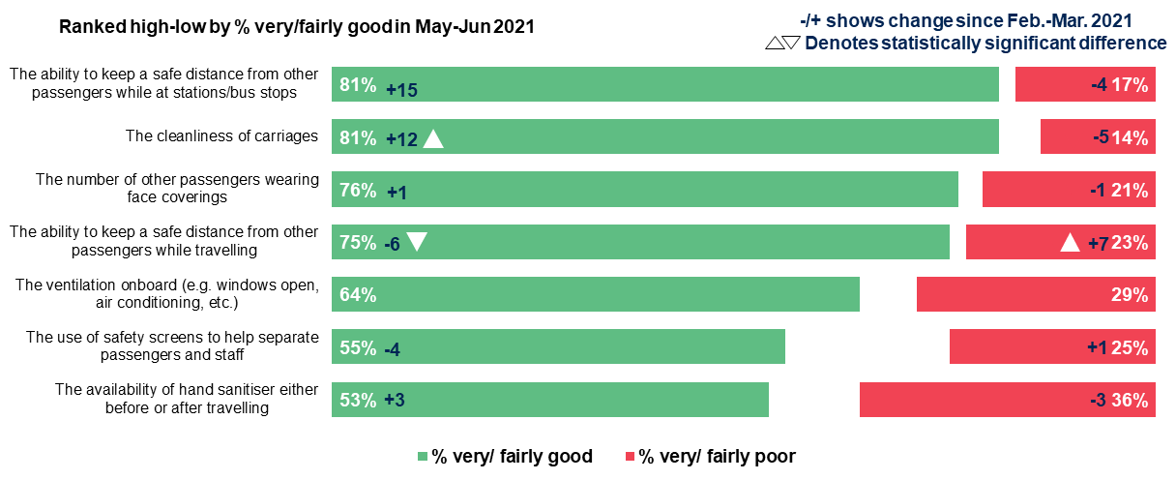
Source: Ipsos MORI/DfT; Base: All using a train at least once in past 4 weeks (731) among 4,700 adults, 17 May-8 June 2021 (267 in February/March 2021
NEWQ48_8. You said earlier that you travelled by train in the last 4 weeks. Thinking back to the last journey you made by train, how would you rate it in terms of the following…?
Figure 18: Ratings of Covid-related safety measures among underground/ metro users
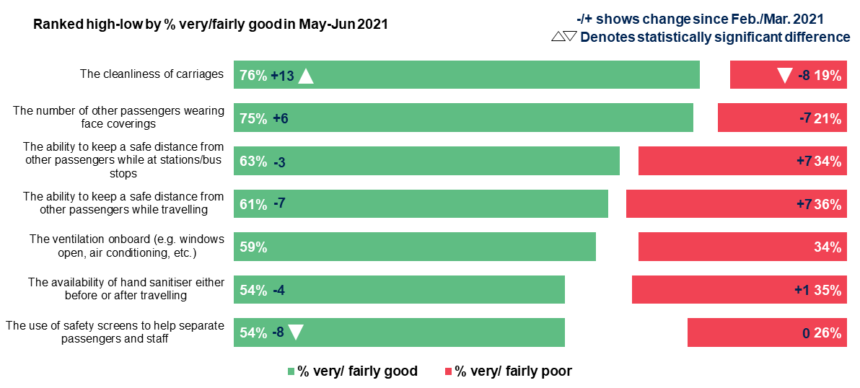
Source: Ipsos MORI/DfT; Base: All using underground/metro at least once in past 4 weeks (440) among 4,700 adults, 17 May-8 June 2021 (171 in February/March 2021
NEWQ48_10. You said earlier that you travelled by underground/metro in the last 4 weeks. Thinking back to the last journey you made by underground/metro, how would you rate it in terms of the following…?
  - Comfort in using public and shared transport ‘if all restrictions are lifted’
As shown in Figure 19 below, following an increase in levels of comfort travelling by public transport over the summer months during 2020, there was little change over the subsequent period between November/December 2020 and February/March 2021. However, alongside an expected increase in travelling in the next four weeks following May/June 2021, levels of comfort with using public transport would increase significantly ‘if all restrictions are lifted’ – also shown in Figure 19 below (via the hatched lines). For example, 30% of UK adults said they would be either very or fairly comfortable travelling by bus in February/March 2021 while this increased to 49% in the event of restrictions being lifted.
Levels of comfort ‘if all restrictions are lifted’ were higher among frequent users of each mode during the pre-pandemic period (January-March 2020) - for example, 65% of frequent bus users said they would be very or fairly comfortable travelling by bus if all restrictions are lifted. Similarly, seven in ten (71%) of those who had travelled by bus in the past four weeks said they were very or fairly confident doing so if restrictions are lifted – it was three-quarters (76%) of recent train users and two-thirds (66%) of underground/metro users.
Figure 19: Trends - comfort levels for using public transport in the next 4 weeks/’if all restrictions are lifted’
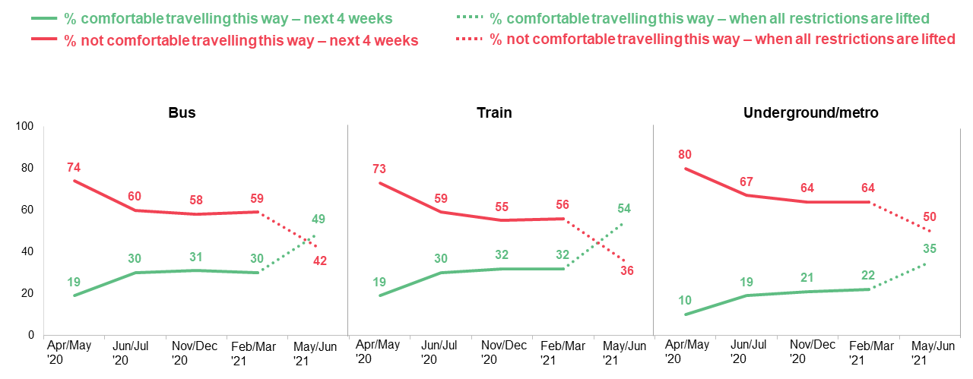
Source: Ipsos MORI/DfT, 4,700 UK adults (Wave 5), 17 May-8 June 2021
(Waves 1-4) Q14. Thinking about the next 4 weeks or so, how comfortable, if at all, do you think you would feel choosing to travel by the following modes of transport? It does not matter whether you think you actually will travel this way, or how often you have travelled this way in the past, it’s your impressions we are interested in.
(Wave 5) Q14. Still thinking about what you will do if all restrictions are lifted (currently scheduled to be 21 June at the earliest), how comfortable, if at all, do you think you would feel choosing to travel by the following modes of transport?
In February/March 2021, men were more likely than women to have said they would feel very or fairly comfortable travelling on public transport in the next four weeks, but this was not the case in May/June 2021 in the event of all restrictions being lifted. For example, in February/March 2021 a third (33%) of men said they would feel comfortable travelling by bus in the next four weeks compared to 28% of women, but the equivalent proportions in May/June 2021 ‘if all restrictions are lifted’ were 47% and 50% respectively. Similarly, while in February/March 2021 those from ethnic minority backgrounds were more likely than average to have said they would be very or fairly comfortable travelling by bus (35% compared to 30%), the gap narrowed in the event of all restrictions being lifted (51% to 49%).
People living in Greater London (62%) as well as 16-24-year-olds (61%) and those with no access to a car or bicycle (59%) were more comfortable using a bus relative to the UK average (49%). Around seven in ten (68%) of those who used any public transport modes, and 71% of those who said they travelled by bus in the last four weeks, said they would be comfortable travelling by bus in the next four weeks. Those living in Greater London were similarly more comfortable than average travelling by train (66%) and by underground/metro (55%).
  - Confidence in travelling by public transport – vaccination roll-out
The wave 4 survey in February/March 2021 showed the potentially significant and positive impact that vaccination roll-out could have on people’s willingness to use public transport. There was a significant increase in the proportion saying they would be very or fairly comfortable travelling by public transport as the vaccination programme rolled out, compared to a baseline derived from averaging comfort levels of travelling by bus, by train and by underground/metro in the next four weeks. In February/March 2021, 28% said they were very or fairly comfortable travelling by public transport in the next four weeks, rising to 75% at the point all adults in the UK had been offered their first and second dose of the vaccine.
This was also the case in May/June 2021. While 46% said they were comfortable travelling by public transport ”if all restrictions are lifted” – this was derived as an average across respondents’ levels of comfort for individual modes (bus, train and underground/metro services) – this increased to 74% at the prospect of all adults having been offered the first and second dose, shown in Figure 20 below.
Figure 20: Comfort levels – travelling by public transport modes if all restrictions are lifted / when second dose vaccine offered – May/June 2021
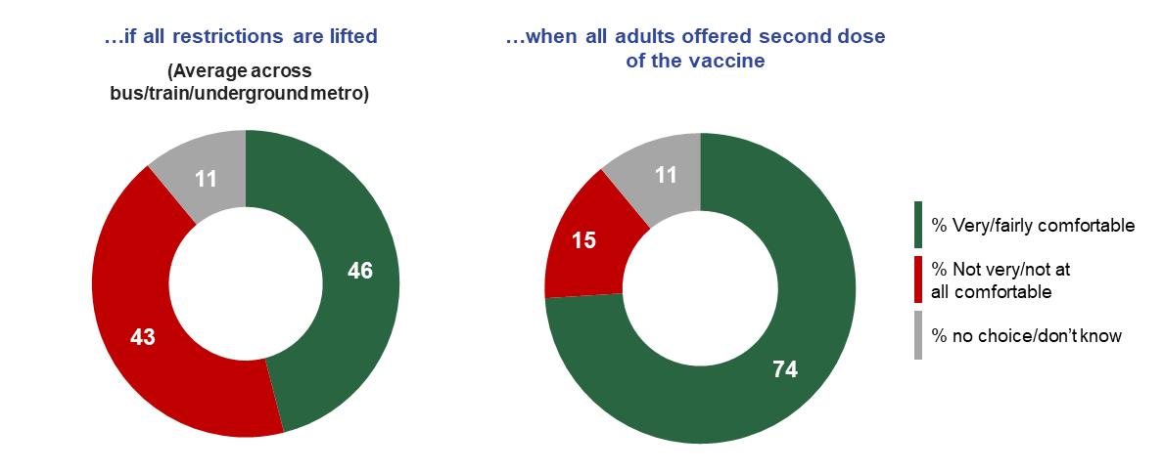
Source: Ipsos MORI/DfT, 4,700 UK adults (Wave 5), 17 May-8 June 2021
Q14. Still thinking about what you will do if all restrictions are lifted (currently scheduled to be 21 June at the earliest), how comfortable, if at all, do you think you would feel choosing to travel by the following modes of transport?
Q56NEW. How comfortable, if at all, do you think you would feel choosing to travel by some form of public transport – by bus, train, tram or underground/metro railway – if the following had happened before you wanted to make a journey? When all adults in the UK have been offered their first and second dose of the vaccine
While there was a potentially positive shift in opinion with the continued roll-out of the vaccination programme, it did not persuade all groups. For example, six in ten (60%) of those uncomfortable travelling by bus “if all restrictions are lifted” said they were comfortable travelling by public transport when second dose vaccinations had been offered to all adults, but three in ten (30%) were not.
However, at the point of all adults being offered second dose vaccinations, levels of comfort using public transport increased among a range of different groups, including those relatively more likely to use public transport such as younger age groups, those from ethnic minority backgrounds and people living in London, shown in Figure 21 below. As the chart shows there is little difference in comfort levels for the groups selected, with people who had been vaccinated feeling as comfortable as other groups using public transport if restrictions were lifted and when all adults in the UK had been offered their second dose.

Figure 21: Comfort levels among selected groups – February/March and May/June 2021
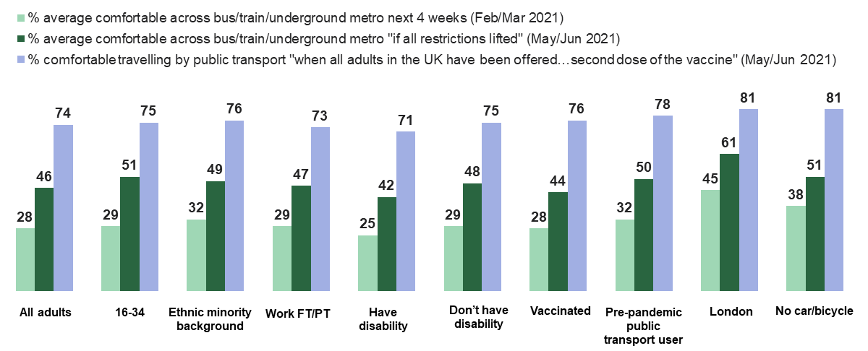
Source: Ipsos MORI/DfT, 4,700 UK adults (Wave 5), 17 May-8 June 2021; 3,388 UK adults, 23 Feb-9 March 2021 (Wave 4)
(Wave 5) Q14. Still thinking about what you will do if all restrictions are lifted (currently scheduled to be 21 June at the earliest), how comfortable, if at all, do you think you would feel choosing to travel by the following modes of transport?
Q56NEW. How comfortable, if at all, do you think you would feel choosing to travel by some form of public transport – by bus, train, tram or underground/metro railway – if the following had happened before you wanted to make a journey? When all adults in the UK have been offered their first and second dose of the vaccine
  - Confidence in travelling by public transport – no social distancing
Alongside an expected increase in travelling and an improvement in levels of comfort if restrictions are lifted and when all adults had been invited to have a second dose of the vaccine, the prospect of ‘no social distancing’ being possible if all restrictions were lifted worked in the opposite direction. In this scenario, and as shown in Table 16, confidence in travelling by bus was 18 percentage points lower compared to the lifting of restrictions, 21 percentage points lower for travelling by train and 11 percentage points lower for underground/metro services.
Table 16: Proportion very/fairly comfortable travelling by public transport modes if all restrictions are lifted / if social distancing was not possible – May/June 2021
 | …if all restrictions lifted | …social distancing was not possible | +  Difference
Bus | 49 | 31 | -18
Train | 54 | 33 | -21
Underground/metro | 35 | 24 | -11
Source: Ipsos MORI/DfT, 4,700 UK adults (Wave 5), 17 May-8 June 2021
Q14. Still thinking about what you will do if all restrictions are lifted (currently scheduled to be 21 June at the earliest), how comfortable, if at all, do you think you would feel choosing to
travel by the following modes of transport?
Q15bNEW. Still thinking about what you will do if all restrictions are lifted (currently scheduled to be 21 June at the earliest), how comfortable, if at all, do you think you would feel choosing to travel by the following modes of transport if social distancing was not possible
Levels of comfort changed across a range of different groups if social distancing was not possible, mostly falling back to levels of comfort seen in February/March 2021. For example, 32% of those who had used public transport before the pandemic (during January to March 2020) said that they were comfortable travelling by public transport in the next four weeks during February/March 2021. Half, 50%, said this was the case if all restrictions were lifted but this fell to 32% if social distancing was not possible.
Discomfort if ‘no social distancing is possible’ increased even among those who had said that they would be comfortable travelling by public transport if all restrictions are lifted. For example, 39% of those who had said they would be comfortable travelling by bus ‘if all restrictions are lifted’ said that they would not be if social distancing was not possible, in line with equivalent proportions for train (41%) and underground/metro (39%).
Regular, pre-pandemic users of public transport (those who travelled once a week or more often) were relatively more comfortable ‘if social distancing was not possible’, but many said they would not be. Among regular train users during January-March 2020, 37% said they would be not very or not all comfortable travelling by train ‘if social distancing was not possible’. Around half, 49%, of regular bus users before the pandemic said they would be ‘not very’ or ‘not all’ comfortable travelling by bus ‘if social distancing was not possible’. Similarly, half (50%) of regular pre-pandemic underground/metro said they would not feel comfortable travelling ‘if social distancing was not possible’ saying the same regarding underground/metro use.
If all restrictions were lifted but social distancing was not possible, people were most likely to consider requirements/compliance relating to face coverings as important in encouraging public transport use, as well as Coronavirus cases being low and better ventilation onboard. As shown in Figure 22, a third, 34%, chose face coverings remaining a mandatory requirement for travel by public transport from a list of 17, followed by cases remaining low (30%), Public/passengers wearing face masks/face coverings (also 30%) and better ventilation onboard (e.g. windows open, air conditioning, etc.) (selected by 29%).
Figure 22: Considered requirements/compliances if social distancing was not possible –May/June 2021
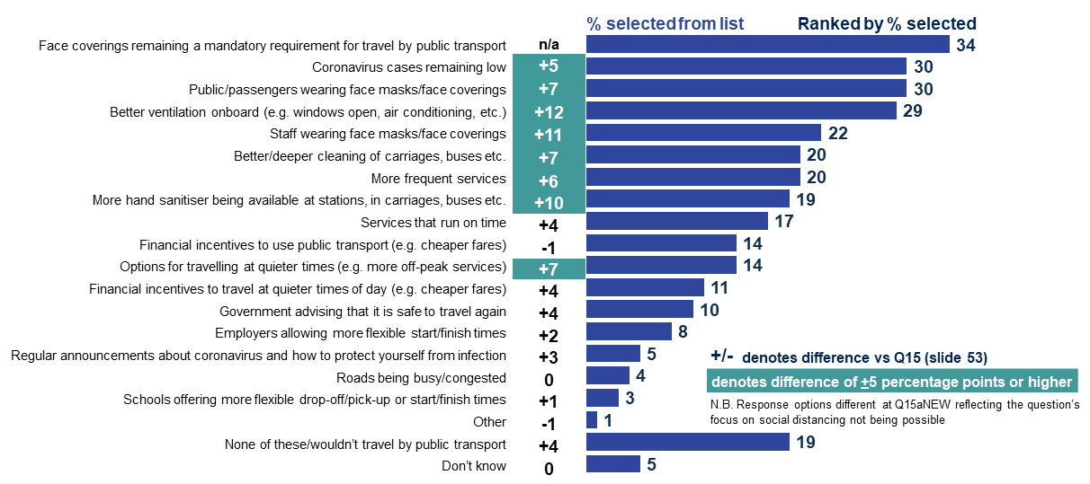
Source: Ipsos MORI. Base: 4,700 UK adults aged 16-75 (Wave 5) , 17 May-8 June 2021
Q15aNEW. Still thinking about what you will be likely to do if all restrictions are lifted (currently scheduled to be 21 June at the earliest) and imagine if the number of people using public transport meant that social distancing was not possible at bus stops, on platforms, and in stations and while travelling. If that happened, which of these measures, if any, would be important in encouraging you to consider using public transport?
  - Face coverings and social distancing
In February/March 2021, the majority of the public supported face covering and social distancing requirements for public transport even when all UK adults have been offered both vaccine doses. This sentiment strengthened in May/June 2021 from 61% in February/March 2021 to 65% for mask-wearing and from 58% to 63% for social distancing.
In May/June 2021, 65% supported face covering requirements if Coronavirus cases were low and 66% if the number of deaths were low. The same proportion (64%) supported social distancing requirements if cases were low, as supported this requirement in the event of low numbers of deaths.
When asked which two or three things would encourage them personally to consider travelling by some form of public transport “if restrictions are lifted”, Coronavirus cases remaining low (25%), compliance with wearing face masks/face coverings (23%), passengers and staff following social distancing rules while travelling (19%), and having better ventilation (17%) were considered important.
Low Coronavirus case numbers and public/passengers wearing face coverings were considered important by those uncomfortable using public transport, as well as those who felt comfortable using these services; with both groups equally likely to say these conditions were important to encourage public transport use.
People who felt uncomfortable using underground/metro were more likely than those who were comfortable to consider public/passengers wearing face masks/coverings (25% vs. 20%) and better ventilation on board (20% vs. 14%) as important. Across all modes, people who felt uncomfortable were more likely to consider compliance with face covering requirements as important, whereas people who felt comfortable were more likely to consider financial incentives and more frequent services as encouraging them to use public transport.
While 15% said that none of the measures encouraged them to use public transport or that they would not travel by public transport at all, this was a decrease from 31% in February/March 2021. However, it was higher, at 19%, if social distancing was not possible. In this scenario, a third (34%), considered face covering requirements, coronavirus cases remaining low (30%) and public/passengers wearing face masks/coverings (30%) and better ventilation onboard (29%) as important for encouraging public transport use.

What were people’s longer-term travel plans?
All waves throughout All change? have included questions relating to commuting and working from home and shopping. Wave 5 included more detailed questions about patterns of behaviour and covering the pre-pandemic period (January-March 2020), the last four weeks and expectations about behaviour ‘when restrictions are lifted’ and in 12 months’ time.
As was the case in February/March 2021, shopping was the most common reason people travelled in the previous four weeks in May/June – 77% travelled for this reason. This period, which involved an easing of restrictions, led to an increase in travelling to a place of work; up from 26% to 36%.
  - Working from home and commuting
Across the UK, two in five (39%) said they had worked from home, doing paid employment, at least one day a week in the four weeks or so before completing the survey. This was higher among Londoners, where more than half (53%) had worked from home at least one day a week in that period, as well as those with a household income of £40,000 per year or more (61%), those in higher social grade households (47%), and parents of school age children (53%).
Thinking about if all restrictions are lifted, the overall proportion who expected to work from home at least one day a week in a typical week dropped slightly, to 35%, from 39% currently. However, there was a 10-percentage point drop in the number of people expecting to work from home five days a week if all restrictions are lifted compared to the past four weeks, as shown in Figure 23.
Figure 23: Frequency of working from home during last four weeks (May/June 2021) and expected frequency of working from home if all restrictions are lifted
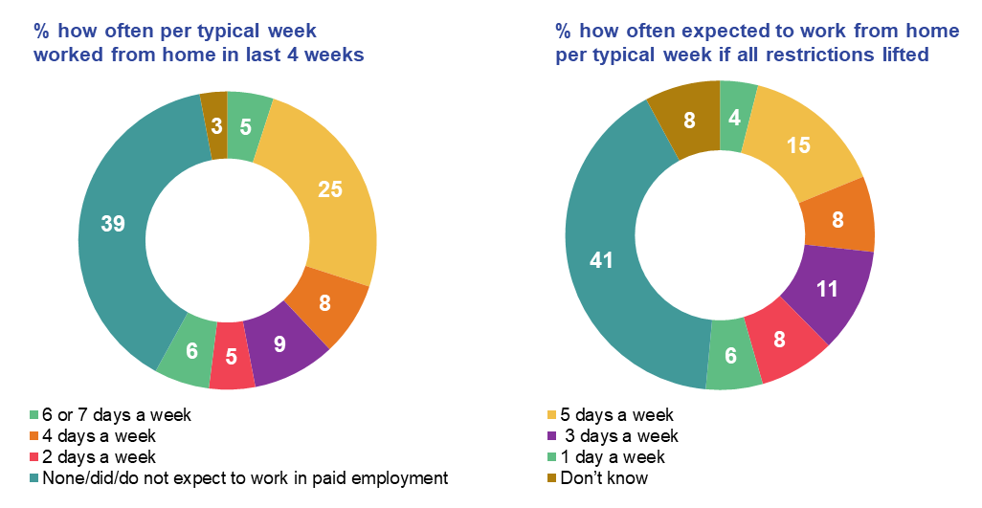
Source: Ipsos MORI/DfT, 4,700 UK adults (Wave 5), 17 May-8 June 2021
W5Q50aNEW. Now thinking about the last 4 weeks or so, how often, if at all, did you work from home, doing paid employment, in a typical week?
W5Q51aNEW. Now thinking about if all restrictions are lifted (currently scheduled to be 21 June at the earliest), how often, if at all, you expect to work from home, doing paid employment, in a typical week?
Among those who had worked from home in the past four weeks, many expect their working patterns to change if all restrictions are lifted (see Table 17). For example, while 44% of those who typically worked from home five days a week in the past four weeks said they expected to continue this pattern if all restrictions are lifted, 47% said they would work from home on fewer days, if at all, if all restrictions are lifted. Comparatively, just over half (53%) of those who worked 1 day a week expected to continue this pattern.
Table 17: Proportion of people (%) working from home in past four weeks and their expected working patterns if all restrictions are lifted – May/June 2021
 | 6 or 7 days a week | 5 days a week | 4 days a week | 3 days a week | 2 days a week | 1 day a week
More often | - | 1 | 13 | 14 | 23 | 16
The same amount | 62 | 44 | 34 | 39 | 44 | 53
Less often | 32 | 47 | 49 | 38 | 29 | 18
Don’t know | 6 | 8 | 4 | 8 | 5 | 12
Source: Ipsos MORI/DfT, Base: 2,582 UK adults in work (updated at Wave 5) 17 May-8 June 2021
Q50aNEW. Now thinking about the last 4 weeks or so, how often, if at all, did you work from home, doing paid employment, in a typical week?
Q51aNEW. Now thinking about if all restrictions are lifted (currently scheduled to be 21 June at the earliest), how often, if at all, you expect to work from home, doing paid employment, in a typical week?
As shown in Figure 24, during the period immediately before the first UK-wide ‘lockdown’ (the period between 1st January 2020 and 23rd March 2020) close to half of people in work (45%) travelled into work five days a week or more, rising to two-thirds (66%) who travelled into work three days a week or more. Relatively few people travelled to work less frequently than once a week in the period (9%), and roughly the same proportion (10%) did not travel to work at all in the period immediately before the first UK-wide ‘lockdown’.
More than one in four (27%) had not travelled to a place of work at all in the past four weeks, a similar proportion to those who had travelled to a place of work five days a week in that period (28%). A combined 47% of people in work said they had travelled to work at least three days a week or more in the past four weeks, substantially lower than the equivalent figure of 66% for the period before the first UK-wide ‘lockdown’ (January to March 2020).
Those who travelled frequently in May/June 2021 by train – once a week or more often – and those who travelled this often by underground/metro users (for whatever reason), were more likely to work from home full time than frequent pre-pandemic car drivers and bus users. Three in ten, 29%, of those who travelled by train frequently before the pandemic worked from home 5 days a week or more often in the previous four weeks in May-June 2021 compared to a similar proportion, 31%, among frequent underground/metro users, but just 23% of frequent bus users and 22% of frequent car drivers.
Many of those in work expected to travel to a place of work less often than before the pandemic, both in the short-term after restrictions are lifted, and the longer-term in 12 months’ time. As Figure 24 also shows, the proportion of people in work who expect to travel to a place of work five days a week or more if all restrictions are lifted, and in about 12 months’ time, is much closer to the proportion who did so during the last four weeks than it is to the incidence pre-pandemic.
By contrast, more people in work expect to commute less frequently. While 19% travelled to a place of work 3-4 days a week in the past four weeks, 24% expect to do so if all restrictions are lifted, and in about 12 months’ time. However, the vast majority expect to travel to a place of work at least some of the time. While 27% did not travel to a place of work in the past four weeks, just 9% and 7% respectively expect not to travel to a place of work at all if restrictions are lifted and in about 12 months’ time.
Figure 24: % of people who travelled to a place of work pre-pandemic/the past four weeks and expect to do so if restrictions are lifted/in 12 months’ time
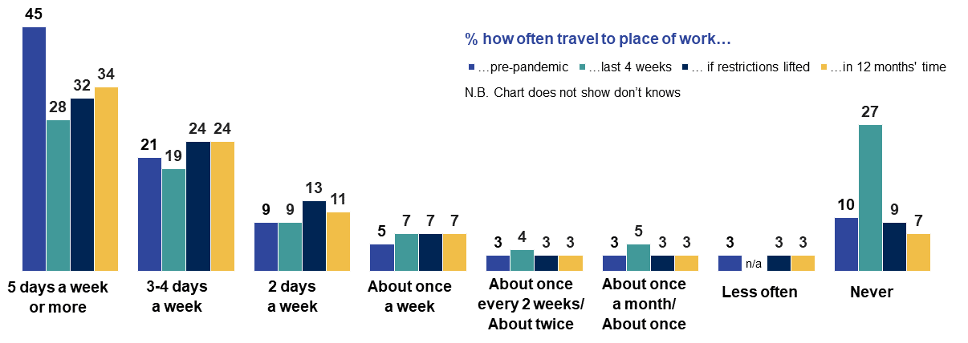Source: Ipsos MORI/DfT; Base: 2,582 UK adults in work 17 May-8 June 2021
Q63aNEW. How often, if at all, did you typically do each of the following during the period immediately before the first UK-wide ‘lockdown’, that is the period between 1st January 2020 and 23rd March 2020?
Q63bNEW. How often, if at all, did you typically do each of the following during the last 4 weeks?
Q63cNEW. How often, if at all, do you expect to do each of the following if all restrictions are lifted (currently scheduled to be 21 June at the earliest)?
Q63dNEW. How often, if at all, do you expect to do each of the following in about 12 months’ time?
Overall, among the population as a whole, 10% expected to travel to a place of work more frequently compared to before the pandemic, just under half the 19% who expected to travel for this reason less frequently. Higher income groups – 27% of those in households with an income of £40,000 or more – were well-represented among those expecting to commute less frequently compared to the pre-pandemic period, but the proportions expecting to commute less frequently were similar among those who travelled once a week or more often by bus, train and underground/metro before the pandemic.
While many people in work envisage a change in the number of days that they will travel to a place of work in a typical week if all restrictions are lifted compared to pre-pandemic, those who travel to work by public transport reported very similar commuting patterns in those two timeframes. The majority of those who used, and who expect to use, public transport to commute to a place of work said they did and will do so between 6am and 9.59am (69% pre-pandemic and 71% if all restrictions are lifted). Similarly, 66% and 64% respectively said they expect to commute home from a place of work between 3pm and 7.59pm. Off-peak commuting patterns pre-pandemic and if all restrictions are lifted also look very similar, suggesting that most future public transport commuters expected to travel at the same or similar time as they did before the pandemic.
Furthermore, the proportion of people who travelled to a place of work by public transport pre-pandemic (35% of those who travelled to a place of work) was almost identical to the proportion who expect to travel to a place of work if all restrictions are lifted (34%).
  - Shopping
People shopped online more frequently in the past four weeks than they did pre-pandemic. Close to half (49%) shopped online to purchase products at least once a week in the past four weeks, 11 percentage points higher than the 38% who did so pre-pandemic (January to March 2020).
Among those shopping online most frequently in the past four weeks, specifically those more likely to have done this at least once a week, were younger adults aged 25-34 (56%) and those aged 35-44 (61%), those with a disability (54%), parents of school age children (61%), and those living in rural areas (56%). This profile followed a similar pattern to pre-pandemic regular online shoppers, though those with a disability were no more likely than people overall to have shopped online weekly or more often in the period before the first UK-wide ‘lockdown’ (39% compared to 38%).
However, while online shopping was done more frequently in the past four weeks compared to pre-pandemic, people largely expected to return to their pre-pandemic behaviour (January-March 2020) if all restrictions are lifted, and in about 12 months’ time. As Figure 25 shows, the frequency of shopping online to purchase products pre-pandemic very closely matched the frequency of anticipated future online shopping.
Figure 25: % of people who shopped online pre-pandemic/the past four weeks and expect to do so if restrictions are lifted/in 12 months’ time
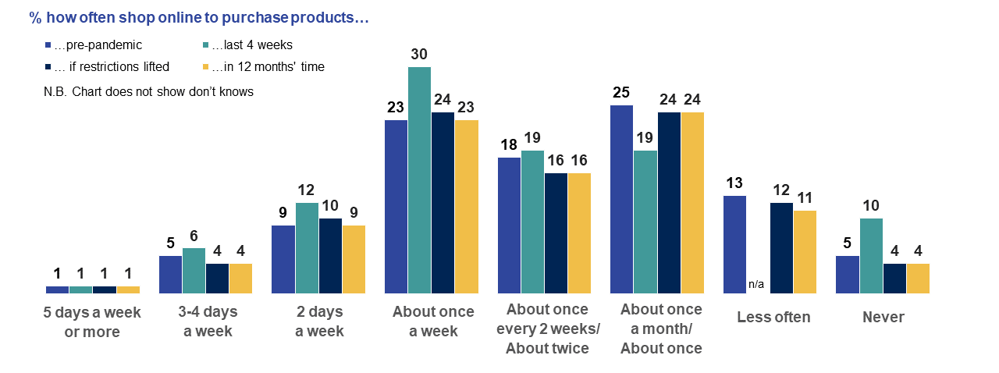Source: Ipsos MORI/DfT, Base: 4,700 UK adults (Wave 5), 17 May-8 June 2021
Q63aNEW. How often, if at all, did you typically do each of the following during the period immediately before the first UK-wide ‘lockdown’, that is the period between 1st January 2020 and 23rd March 2020?
Q63bNEW. How often, if at all, did you typically do each of the following during the last 4 weeks?
Q63cNEW. How often, if at all, do you expect to do each of the following if all restrictions are lifted (currently scheduled to be 21 June at the earliest)?
Q63dNEW. How often, if at all, do you expect to do each of the following in about 12 months’ time?
The proportion of people using home delivery for supermarket shopping was also higher over the past four weeks than pre-pandemic. The proportion who used home delivery for supermarket shopping at least weekly was 17% before the pandemic, increasing to 24% in the past four weeks. However, the majority of people (57%) did not use home delivery for supermarket shopping at all, far higher than the 10% who had not shopped online to purchase products in the same period.
Those more likely to use home delivery for supermarket shopping at least weekly were similar in profile to those who were more likely to have shopped online at least weekly, namely younger adults aged 25-34 (29%) and those aged 35-44 (27%), those with a disability (30%) and parents of school age children (37%). However, while those in rural households were more likely to shop online weekly than people overall, they were no more likely to make use of home delivery for supermarket shopping (26% compared to 24% of people overall).
While the anticipated frequency of use of home delivery for supermarket shopping if all restrictions are eased and in about 12 months’ time was lower than the frequency recorded over the past four weeks, the proportion who expected never to do this in future was lower than pre-pandemic, as Figure 26 shows.
Figure 26: % of people who used supermarket home delivery pre-pandemic/the past four weeks and expect to do so if restrictions are lifted/in 12 months’ time
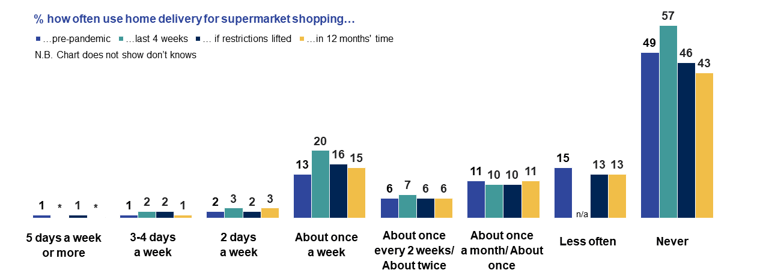
Source: Ipsos MORI/DfT, 4,700 UK adults (Wave 5), 17 May-8 June 2021
Q63aNEW. How often, if at all, did you typically do each of the following during the period immediately before the first UK-wide ‘lockdown’, that is the period between 1st January 2020 and 23rd March 2020?
Q63bNEW. How often, if at all, did you typically do each of the following during the last 4 weeks?
Q63cNEW. How often, if at all, do you expect to do each of the following if all restrictions are lifted (currently scheduled to be 21 June at the earliest)?
Q63dNEW. How often, if at all, do you expect to do each of the following in about 12 months’ time?
People were far more likely to have shopped close to home at least once a week in the past four weeks (69%) than to have shopped online to purchase products (49%) or used home delivery for supermarket shopping (24%) as frequently over the same time period.
However, unlike online shopping to purchase products and using home delivery for supermarket shopping, the frequency of people shopping close to home – that is, within 15-20 minutes’ walk of where they live – was no higher in the past four weeks of the survey than in the period immediately before the first UK-wide ‘lockdown’ (69% compared to 73%).
While a small proportion of the population overall, people were more likely to have not shopped close to home at all in the past four weeks than in the period pre-lockdown (12% compared to 7%). Looking ahead, people expected to continue shopping closer to home in future, at levels which are slightly less frequent than the period before Coronavirus. There was little difference in anticipated shopping close to home if all restrictions are lifted, and in about 12 months’ time, as Figure 27 shows.
Figure 27: % of people who shopped close to home pre-pandemic/the past four weeks and expect to do so if restrictions are lifted/in 12 months’ time
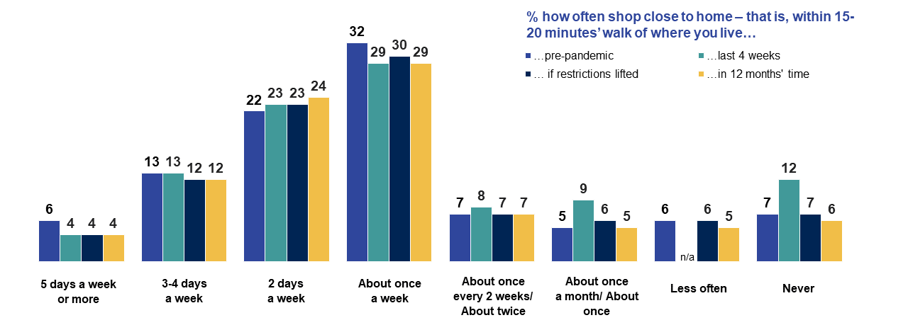
Source: Ipsos MORI/DfT, 4,700 UK adults (Wave 5), 17 May-8 June 2021
Q63aNEW. How often, if at all, did you typically do each of the following during the period immediately before the first UK-wide ‘lockdown’, that is the period between 1st January 2020 and 23rd March 2020?
Q63bNEW. How often, if at all, did you typically do each of the following during the last 4 weeks?
Q63cNEW. How often, if at all, do you expect to do each of the following if all restrictions are lifted (currently scheduled to be 21 June at the earliest)?
Q63dNEW. How often, if at all, do you expect to do each of the following in about 12 months’ time?
  - Sustainable travel and behaviours
People expect to walk more than they did before the pandemic (47%) in 12 months’ time, although this intention has weakened significantly since April/May 2020 when it was 57%.
Sentiment towards working at home has also changed over the past year. In April/May 2020, a third, 34%, said that they expected to be working at home more often in 12 months’ time than they did before the pandemic, but by May/June 2021 this had dropped to a quarter, 25% although expectations are higher among those living in London (34%) and the South East (29%).
During the first UK-wide lockdown, 36% expected to be working at home more in future because of technology (44% of those in work) but this had fallen to 30% in May/June 2021 (40% of those in work). Over the same period there has been a shift in the sentiment towards the idea that ‘I can do all my work from home just as easily as I could at my place of work before the lockdown’; while 35% disagreed with this statement in April/May 2020 (48% of those in work) this was 29% in May/June 2021 (42% of those in work).
In May/June 2021, 39% agreed that they ‘will avoid public transport more than they did before the pandemic’. Levels of agreement are slightly lower among the 16-24 age group (34%) who have used public transport in higher proportions during the pandemic. Expected avoidance is higher among those uncomfortable using public transport modes, and those who had regularly used the Strategic Road Network (SRN) three or more times a week in the past four weeks (45%).
Overall, 38% thought that even after restrictions have ended, they will take more of their holidays in the UK than abroad, and older people were relatively more likely to agree with this statement (42%). While 46% intend to ‘go back to doing all of the things they did before, including holidays and travel’, this feeling was strongest among younger adults - 54% among 16-24s and 53% among 25-34s – and those in higher income households (52%).
As in April/May 2020, around two-thirds, 65%, agreed that climate change was as serious as Coronavirus and the majority were willing to do more active travel to reduce their contribution to climate change. When considering changes in transport modes and usage, people were most willing to do more walking and/or cycling to reduce their contribution to climate change (56%), although this was even higher among those who have been working at home during the pandemic (69%) and over the past four weeks (67%). But overall, in line with weakening intention to walk more in the future, there was a significant reduction in the proportion who said they were willing to walk and cycle more for climate reasons (56% of UK adults said they would do this in May/June 2021, down from 62% in April/May 2020).
People were more willing to limit flying than increase their public transport usage to reduce their contribution to climate change; 39% said they were willing to limit flying or replace some flights with train or bus journeys, higher than the 36% willing to use public transport more to curb climate change.
Over half, 56%, said they could not get by without using their car and people’s ability to travel in more environmentally friendly ways differs geographically. For example, around half of those living in London (49%) agreed they would be willing to use public transport more to reduce their contribution to climate change, whereas those living in the West and East Midlands were relatively more likely to have said they are reliant on their car (66% and 65% respectively).
Younger age groups (16-34-year olds) are the most likely to have said they are willing to make greener transport choices; 64% to do more walking and cycling in future, 48% to use public transport more and 43% to limit flying.
Access/ownership of a bicycle or e-bike correlates with greater intention to fly less (45% of this group said they were willing to do this), walk and/or cycle more (64%) and use public transport more (40%). Frequent pre-pandemic public transport users were more likely to say they would limit flying (45%), whereas people on higher incomes were more likely to disagree; 29% did so compared to 22% overall.
There is some overlap between pro-environment attitudes. Just under eight in ten, 79% of those who agree that ‘I am willing to limit flying or replace some flights with train or bus journeys to reduce my contribution to climate change' also agree that ‘I am willing to do more walking and/or cycling to reduce my contribution to climate change', just 6% disagree. A majority, 56%, of those willing to limit flying also agree that ‘I am willing to use public transport more to reduce my contribution to climate change', but 17% disagree. The relationship is weakest between willingness to do more walking and/or cycling and willingness to use public transport – 35% of those who say they are willing to walk/cycle more say the same of public transport while 20% disagree.
  - Overseas travel
The proportion of people who expected to travel abroad within 12 months of restrictions being lifted reduced significantly to 44% in May/June 2021 having remained at around 50% in February/March 2021 and November/December 2020 (shown in Figure 28). In the longer-term, the proportion of people who said that they would wait until after 12 months to travel abroad increased further, from 24% in February/March 2021 to 26% in May/June 2021. Whereas shorter-term travel expectations - within the next 2 months - stayed in line with February/March 2021; 12% expected to travel abroad within this period.
Figure 28: Expectation of waiting period before travelling abroad after the lifting of travel restrictions
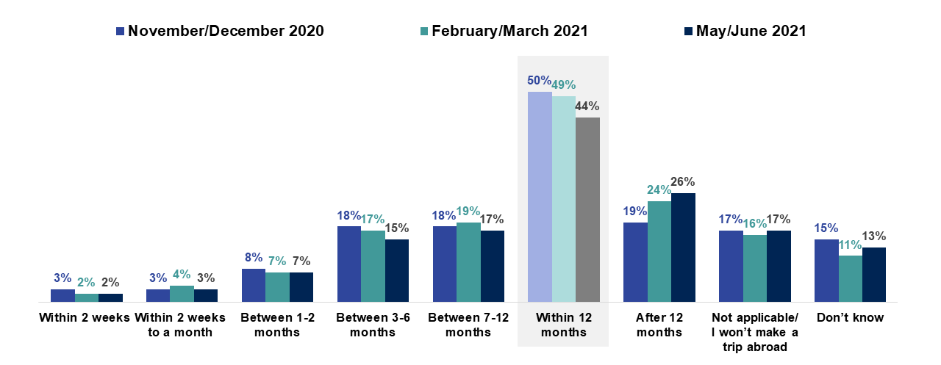
Source: Ipsos MORI/DfT; Base: 4,700 UK adults (Wave 5) 17 May – 8 June; 3,388 UK adults; (Wave 4) 23 Feb – 9 March; 3,178 UK adults (Wave 3) 27 Nov-7 Dec
- NEWQ49. Let’s think ahead to a time when travel restrictions have ended, how long after that time do you think it will be before you go on a trip abroad. It could be for any reason – a holiday, a short trip, a business trip or something else.
As we have seen previously, older adults are significantly more likely than younger adults to expect to travel after 12 months; 29% of those aged 55-75 years old compared to 22% of those in the 16-34 age group.
From 12th April, some restrictions were eased on overnight stays in parts of the UK and it was announced that international travel could resume from 17th May. In May/June 2021, people expected to take holidays in the UK before making trips to Europe or further afield. Excluding those who did not plan to go on holiday, most people thought they would wait about 3 months before going on holiday in the country they live in (22%) and 6 months before going on holiday somewhere else in the UK (16%). When thinking about holidays in Europe and outside Europe, the most common answer given was 12 months (25% and 22% respectively).
Over four in five (85%) had heard about The Government’s plan for the UK’s return to international travel, including the tier classification of countries which rate countries by risk level. People were mainly confident that they would be able to find out which tier the country they would like to visit was in (71% agreed they could find this out), a slightly lower proportion of 61% agreed that having a tiered system for international travel was a good idea. However, this did not correlate with high confidence to travel – 43% thought it gave them confidence in overseas travel, a quarter (25%) disagreed with this.
Younger people were significantly more likely than middle aged and older people to say that the country classification system gave them confidence to travel abroad; 49% of those aged 16-34 agreed compared to 40% and 41% for those aged 35-54 and 55-75.
Figure 29: Awareness and confidence in classification system for international travel
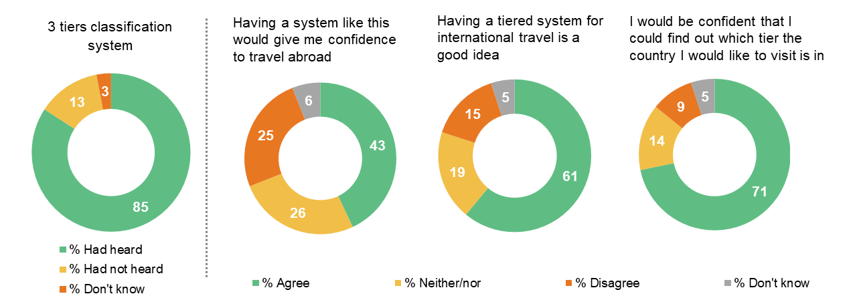
Source: Ipsos MORI/DfT; Base: 4,700 UK adults (Wave 5) 17 May – 8 June
Q66NEW. The Government recently published a plan for the return to international travel. This included classifying countries into one of three tiers…Before completing this survey, had you heard of this tier system or not?
Q67NEW. Here are some statements about a system in which countries are classified into green, amber or red tiers – with people arriving in the UK required to do different things depending on the tier of the country they have arrived from. To what extent do you agree or disagree with each statement?

Appendices

Appendix A – Sample profile
Table A.1: Wave five sample size, unweighted and weighted %s for selected population groups
Population group | Sample size (unweighted) | Unweighted % | Weighted %
UK adults aged 16-75 | 4,700 | 100 | 100
England | 2,764 | 59 | 84
Scotland | 1,052 | 22 | 8
Wales | 686 | 15 | 5
Northern Ireland | 198 | 4 | 3
Urban | 3,241 | 77* | 82*
Rural | 947 | 23* | 18*
Male | 2,216 | 47 | 49
Female | 2,469 | 53 | 50
16-24 | 359 | 8 | 13
25-34 | 572 | 12 | 20
35-44 | 627 | 13 | 16
45-54 | 762 | 16 | 19
55-75 | 2,380 | 51 | 31
Working full-time/part-time | 2,582 | 55 | 63
Not working | 2,118 | 45 | 37
Ethnic minority groups | 455 | 10 | 14
Up to £16,106 (‘lower’) | 374 | 19* | 22*
£16,106-£39,999 (‘medium’) | 923 | 46* | 46*
£40,000+ (‘higher’) | 708 | 35* | 32*
Long-standing mental or physical health condition or illness | 1,648 | 35* | 31*
Source: Ipsos MORI/DfT, 4,700 UK adults (Wave 5), 17th May – 8th June 2021
Where percentages do not sum to 100, this may be due to computer rounding
*indicates percentages of all those answering/data available

Appendix B – Statistical reliability
It is important to note that, strictly speaking, confidence intervals relate only to samples that have been selected using strict probability sampling methods but, in practice, it is reasonable to assume that these calculations provide a good indication of the confidence intervals relating to this survey given the approach used.
Table B.1 shows that we can expect an overall sampling tolerance (this refers to the upper and lower limit of error) of up to +/- 1.7 percentage points at the ‘95% confidence interval’ for a 50% finding the survey overall.
Table B.1: Survey sampling tolerances: overall level
Size of sample on which survey result is based and approximate sampling tolerances applicable to percentages at or near these levels.
 | 10% or 90% | 30% or 70% | 50%
1,000 | 1.9 | 2.8 | 3.1
2,000 | 1.3 | 2.0 | 2.2
4,700 | 0.9 | 1.3 | 1.4
For example, with a sample size of 4,700 where 30% say that they have travelled by car, then the chances are 19 in 20 that the ‘true’ value (i.e. the one which would have been obtained if the whole population of UK adults had been interviewed) will fall within the range of +1.3 percentage points from the survey result (i.e. between 28.7% and 31.3%).
The following table illustrates the sampling tolerances when comparing different sub-samples of respondents. If we once again assume a ‘95% confidence interval’, the differences between the results of two separate groups must be greater than the values given in the following table in order to be deemed ‘statistically significant’:
Table B.2: Survey sampling tolerances: sub-group level (rounded)
Sample sizes and differences required for significance at or near these percentage levels.
 | 10% or 90% | 30% or 70% | 50%
931 vs. 2,380  (16-34-year olds vs. 55-75-year olds) | 3 | 4 | 4
3,747 vs. 897  (vaccinated vs. not vaccinated) | 3 | 4 | 4
1,342 vs. 485 (pre-pandemic public transport user vs. non-user) | 4 | 5 | 6
For example, if 30% of 16-34-year olds give a particular answer compared to 34% of those aged 55-75 (assuming sample sizes in the table above), then the chances are 19 in 20 that this four-point difference is statistically significant.

  - Ipsos MORI’s standards and accreditations
Ipsos MORI’s standards and accreditations provide our clients with the peace of mind that they can always depend on us to deliver reliable, sustainable findings. Our focus on quality and continuous improvement means we have embedded a ‘right first time’ approach throughout our organisation.
ISO 20252
This is the international market research specific standard that supersedes BS 7911/MRQSA and incorporates IQCS (Interviewer Quality Control Scheme). It covers the five stages of a Market Research project. Ipsos MORI was the first company in the world to gain this accreditation.
ISO 27001
This is the international standard for information security designed to ensure the selection of adequate and proportionate security controls. Ipsos MORI was the first research company in the UK to be awarded this in August 2008.
ISO 9001
This is the international general company standard with a focus on continual improvement through quality management systems. In 1994, we became one of the early adopters of the ISO 9001 business standard.
Market Research Society (MRS) Company Partnership
By being an MRS Company Partner, Ipsos MORI endorses and supports the core MRS brand values of professionalism, research excellence and business effectiveness, and commits to comply with the MRS Code of Conduct throughout the organisation.
Data Protection Act 2018
Ipsos MORI is required to comply with the Data Protection Act 2018. It covers the processing of personal data and the protection of privacy.

These classifications are based on the occupation of the Chief Income Earner in the household. Higher social grades include ABC1 grades (managers, professionals, administration/clerical), lower social grades are C2DE (skilled and unskilled manual/long-term dependent on state benefit).
https://www.gov.uk/government/publications/covid-19-travel-behaviour-during-the-lockdown
Asked as ‘Shopping for food’ at Wave 2 (data shown here) with ‘Shopping ‘non-food’ asked separately at Wave 2; these were combined at Wave 3.
Source: https://coronavirus.data.gov.uk/details/vaccinations

