Staff Diversity: Official Statistics
18 November 2021

Introduction
This statistical release provides summary information on the staff who work at the Planning Inspectorate.

This increases our transparency and accountability to our customers, stakeholders and the wider public, providing reliable information of our staff diversity. It will help those considering joining the organisation decide “is this the sort of organisation I want to work for?”. Over time, routine publication will enable anyone to see what progress has been made in increasing the diversity of the organisation. This publication also supports our obligations under the Public Sector Equality Duty to provide information on its workforce identified by the Equality Act 2010.

These statistics have been published to ensure everyone has equal access to the information and to support the Planning Inspectorate’s commitment to release information where possible.

This statistical bulletin provides:
- Number of staff as of 31st March 2021; split between Inspector Profession and other professions
- Information and declaration rates
- Staff Diversity by protected characteristics
- Comparison with Civil Service characteristics where possible
- How the above have changed over recent years
- How the protected characteristics relate to each other (whether they are independent)

The information provided describes the status as of 31st March 2021. This provides a consistent picture with other published information and allows comparison with other government bodies, particularly through the Annual Civil Service Employment Survey, which uses this date as its benchmark. It is also the basis of gender pay information which will be published shortly by the Cabinet Office.

The publication of these statistics also supports the implementation of the Planning Inspectorates People Strategy and specifically the underpinning Equality, Diversity, and Inclusion Strategy. The Inspectorate are committed to ensuring that everything we do is fair, inclusive and promotes diversity in characteristics and thought. The vision of the ED&I strategy is to better reflect the diverse makeup of our customers and ensure that everyone feels more included in the workplace, regardless of their own backgrounds. A diverse workforce that feels valued and included can be more creative and innovative, produce more solutions-focussed outputs, feel a greater sense of community, and provide a better customer experience.

This Release also includes commentary from the Inspectorate on work being carried out to increase diversity, including the Equality, Diversity, and Inclusion strategy.

The information in this bulletin, describing the statistics as of 31st March, does not reflect the current status of the organisation. In particular, almost 50 staff left the organisation at the end of September 2021 as the staff and functions of Planning Inspectorate Wales transferred to the Welsh government.

The Planning Inspectorate
The Planning Inspectorate makes decisions and provides recommendations and advice on a range of land use planning-related issues across England. We do this in a fair, open, and timely way.

The Planning Inspectorate deals with planning appeals, national infrastructure planning applications, examinations of local plans and other planning-related and specialist casework in England. The Planning Inspectorate is an executive agency, sponsored by the Department for Levelling Up, Housing and Communities, previously known as the Ministry for Housing, Communities and Local Government.
Summary
The number of staff at the end of March 2021 was 855. This is a measure of headcount. Some of the staff worked part-time; and the full-time equivalent (FTE) count was 780.
There were 403 staff working in the Inspector Profession (most but not all of these are Planning Inspectors) – with a full-time equivalent of 358.4. This is less than half of the Inspectorate’s people – more work in support professions (452 headcount: 421.5 FTE), such as strategy, digital and data, human resources and finance.
Both headcount and FTE measures have been growing from 2018 to 2021.
More than half of staff are aged between 40 and 59, with 28% under 40. The median age of staff in the Planning Inspectorate is 48 years old.
Nine per cent of staff have a disability. This has remained stable over recent years.
Five per cent of staff identify as being of Black, Asian, or other ethnic minority staff (BAME). This is considerably below the civil service average of 13%. The proportion of BAME staff has increased since 2018.
The percentage of female staff in the Inspectorate is 45%, which is lower than the civil service, where 54% are female. This has remained stable over recent years.
Most of the Planning Inspectorate’s people are either of no religion (45%) or Christian (40%). Four per cent of staff are of any other religions, with 1% of staff being Muslim, 1% Sikh and other religions having lower proportions.
Overall, 4% of staff identified as being lesbian, gay, bisexual or trans-gender. This is below the civil service average of 6%. The number of LGBT staff has increased from 2018 to 2021 but the proportion has remained steady.
There were 256 people who worked part time in the planning inspectorate – that’s almost a third. The proportion working part time has decreased since 2018.
In general, the profile of people who work in the Inspector Profession is different from that of those in other professions. For example, comparing the Inspector Profession with other professions:
Inspector Profession | Other Professions
Older (82% over 40; median age 52) | Younger (63% over 40; median age 44)
5% disabled | 12% disabled
2.3% BAME | 7.5% BAME
36% Female | 53% Female
50% Christian; 48% No religion; 2% Other | 30% Christian; 64% No religion; 7% Other
27% attended state-run selective schools; 11% attended independent schools | 19% attended state-run selective schools; 7% attended independent schools
39% work part time | 22% work part time
The proportion of LGBT staff is similar for the Inspector Profession and other professions; there is also a similar profile in terms of parental qualification. These figures summarise the characteristics of the Inspector Profession as a whole, but there is of course diversity within this group.
Cluster analysis shows that staff who have been employed more recently appear to have more diverse characteristics, in particular higher percentages of BAME. As recruiting continues with current or new practices in place, fewer employees should be seen in clusters which are dominated by single characteristic values. Newer staff are however also less likely to declare their protected characteristics, and 21% of employees declaring two characteristics or fewer joined the Planning Inspectorate in the last two years. Further work is needed to understand the reasons behind this change and improve declaration rates to make future statistics more representative of the whole workforce.

Number of Staff and Profession
The number of staff at the end of March 2021 was 855. This is a measure of headcount. Some of the staff worked part-time; and the full-time equivalent count was 780.
Table 1 below shows the number of staff in the Planning Inspectorate as of 31/03/2021. This includes headcount (i.e., the number of different individuals) and full-time equivalents (FTE) where those working part time are counted in proportion with their contracted hours. There were 403 staff working in the Inspector Profession (not all of these are Planning inspectors) – with a full-time equivalent of 358.4. This is less than half of the Inspectorate’s people – more work in support professions (452 headcount: 421.5 FTE) such as strategy, digital and data, human resources, and finance.
Note that the Inspector Profession includes Planning Inspectors and other staff – as such, the number in the Inspector Profession is not the same as the number of Planning Inspectors published in other places.
The Inspector Profession includes Appeals Planning Officers, who submit reports to Planning Inspectors recommending whether the appeal should be allowed or dismissed (Householder Planning Service and s78 Planning Appeals).
Appeals Planning Officers and Apprentice HEOs assist in processing and determining Planning, Enforcement, and a range of other appeals (Tree preservation / replacement, High Hedges and Hedgerow).
Information on the number of people in each of these roles is given in Table 3. Further detail is in Annex A.
Other professions comprise the following categories: Commercial, Communications, Digital, Data and Technology, Finance, Human Resources, Knowledge and Information Management, Legal, Operational Delivery, Planning, Project Delivery and Analysis. Operational Delivery represents 60% of other professions.
Table 1 – Number of Staff as of 31 March 2021 by Profession
Profession | Headcount | FTE
Inspector Profession | 403 | 358.4
Other Professions | 452 | 421.5
Total | 855 | 779.9
Source: SAP HR
Figure 1 – Percentage of Staff by Profession (Headcount and Full Time Equivalent), As of 31 March 2021
Source: SAP HR

Figure 2 and Table 2 below show the change in number of staff from 2017 to 2021. Both headcount and FTE measures show an increase over this period, after being more or less the same between 2017 and 2018. The increase in the number of staff between 2018 and 2021 was due to the Inspectorate’s organisation redesign process. This redesign was put in place to help the Inspectorate better deliver its strategic goals, better deliver for customers, and better support the Inspectorate’s staff in their careers.
Figure 2 –Staff by Profession (Headcount and Full Time Equivalent), 2017 to 2021
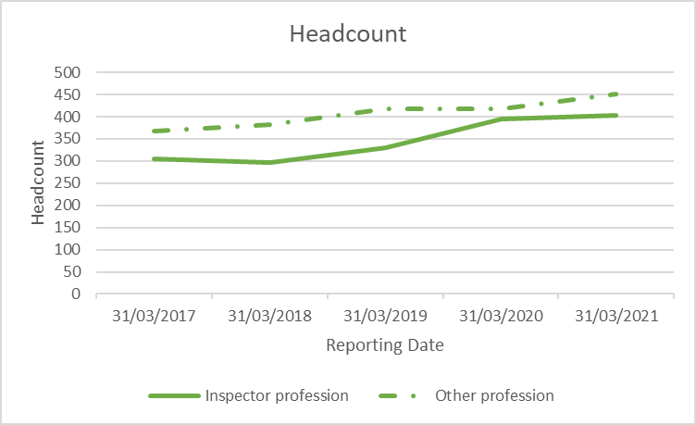 | 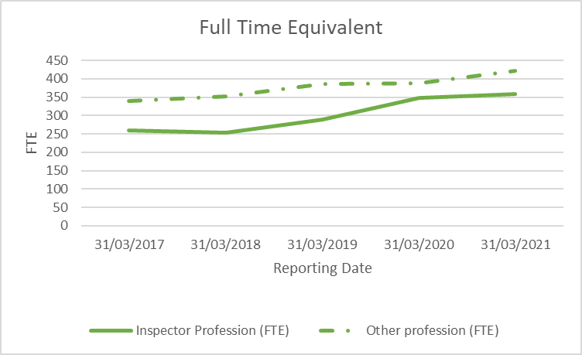
Source: SAP HR
Table 2 – Change in Number of Staff, 2017 to 2021
Headcount | 2017 | 2018 | 2019 | 2020 | 2021
Total Staff | 671 | 678 | 747 | 812 | 855
Inspector profession | 304 | 296 | 330 | 394 | 403
Other profession | 367 | 382 | 417 | 418 | 452
Full Time Equivalent | 2017 | 2018 | 2019 | 2020 | 2021
Total Staff (FTE) | 598.9 | 605.3 | 673.3 | 736.1 | 779.9
Inspector Profession (FTE) | 259.4 | 253.3 | 288.2 | 348.8 | 358.4
Other profession (FTE) | 339.5 | 352.0 | 385.2 | 387.2 | 421.5
Source: SAP HR; Note: Data as of 31/03 each year

Table 3 – Number of Staff by Grade as of 31 March 2021
Grade | Headcount | FTE
Total | 855 | 779.9
Apprentice HEO | 5 | 5.0
Appeals Planning Officer | 14 | 13.4
BAND 1 Inspector | 145 | 134.7
BAND 2 Inspector | 161 | 142.9
BAND 3 Inspector | 78 | 62.5
Total Inspector Profession | 403 | 358.4
Administrative Assistant (AA) | 10 | 8.7
Administrative Officer (AO) | 162 | 150.2
Executive Officer (EO) | 98 | 89.9
Higher Executive Officer (HEO) | 74 | 68.6
Senior Executive Officer (SEO) | 64 | 62.0
Grade 7 | 24 | 23.2
Grade 6 | 15 | 14.1
Senior Civil Service | 5 | 5.0
Total Other Professions | 452 | 421.5
Source: SAP HR
See Annex A for detail on the grades in the table above.

Information and Declaration Rates
The information in this release is drawn from the Planning Inspectorate’s Human Resources database (SAP).
In some instances, there is no record of someone’s personal characteristic. This can be for two main reasons:
- The Inspectorate has not asked the person about the characteristics, or
- The Inspectorate has asked, and the person has chosen the option of “prefer not to say”, (or similar) or chosen not to answer
Table 4 below shows the proportion of staff for whom the Planning Inspectorate hold information on different aspects of their personal information. The trend for this is upwards over time for every item except ethnicity.
Please note that all subsequent commentary and data give information limited to those on whom information is available. So, where a percentage is given (e.g., % with a disability) this excludes those staff (12% in this case) on whom this information is not held. This is potentially important, as those staff on whom no information is held may have a different profile – so the percentage given may not fully reflect the profile across all staff.

Table 4: Percentage of employees with recorded personal characteristics, 2018 - 2021
Characteristic | Mar-18 | Mar-19 | Mar-20 | Mar-21
Disability | 51% | 51% | 61% | 78%
Ethnicity | 86% | 77% | 78% | 86%
Religion | 46% | 48% | 58% | 71%
Sexual Orientation | 49% | 50% | 59% | 72%
Source: SAP HR; Data as of 31/03 each year
Note: All staff are required to disclose their sex, age and working pattern are thus information on these is recorded for 100% of employees.
Figure 3: Percentage of employees with recorded personal characteristics, 2018 - 2021
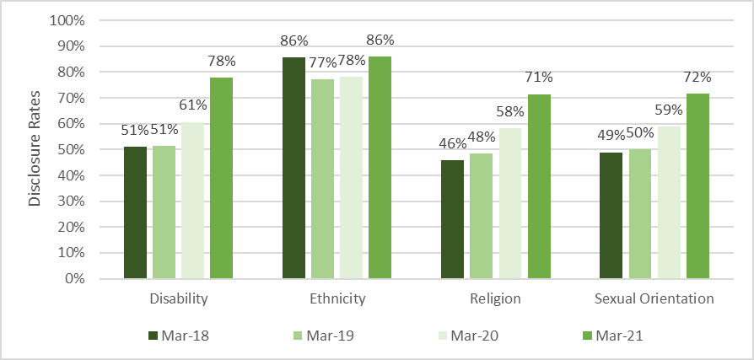
Source: SAP HR; Note: Data as of 31/03 each year.
Note: All staff are required to disclose their sex, age and working pattern are thus information on these is recorded for 100% of employees.

Note: in June 2017 a different system was introduced for HR data; it is not feasible to access 2017 data.

Also included in this publication is data on socio-economic characteristics. This is collected via a survey. Further information is included in the Background Quality Report.

The number of staff who did not to provide the Planning Inspectorate with their protected characteristics were comparable with rates for the wider Civil Service
(Civil Service declaration rates, Disability 82.5%, Ethnicity 86.2%, Religion 77.5%, Sexual Orientation 78.3%).

Non-disclosing employees
For all employees who have no record for at least two of the protected characteristics above, 21% have been employed at the Planning Inspectorate for fewer than two years. A further 12.5% have been employed for between two and four years.

These employees have a range of grades, but the largest proportions are AO (28%), Band 1 (18%), Band 2 (13%), HEO (12%) and EO (12%). There are more male (60%) than female (40%) employees who have no record. Unknown personal characteristics are more common for employees who are forty and above; 27% are aged 40-49 and 28% are aged 50-59, compared to less than 1% who are 16-29. More information about the characteristics of these employees can be found in the Clustering section of “How Characteristics Relate” below.

Figure 4: Number of years employed for staff who have no record for two or more personal characteristics in 2021, as a percentage
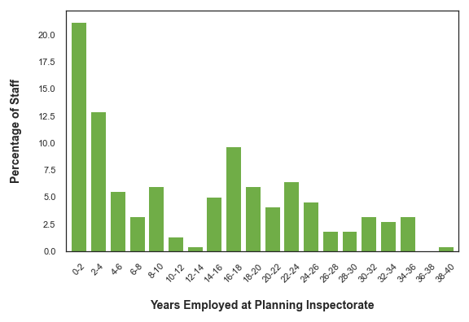
Source: SAP HR

Staff Diversity by Protected Characteristics
What follows is a breakdown of staff by various protected characteristics. This is presented in alphabetical order. Each section gives a figure for the Planning Inspectorate as a whole; and then gives separate figures for Inspectors and other professions, further split by grade groups. This is to help understand whether the characteristics apply evenly across all staff. Later sections of this bulletin explore how the factors relate to each other in more depth.
- Age
Table 5 below shows the age profile of staff in the Planning Inspectorate.
The median age of all staff is 47.6 years – 28% are under 40 and 72% are 40 and above. In the Inspector Profession the age profile is somewhat older, with a median age of 51.8 years, 17% under 40 and 83% aged 40 and over. Conversely in other professions staff have a younger profile. The median age is 44.1 years and 37% are under 40, 63% are 40 and above.
Table 5 – Age of Planning Inspectorate Staff as of 31 March 2021ª
 | Median Age | 16-29 | 30-39 | 40-49 | 50-59 | 60+
Total | 47.6 | 8% | 20% | 29% | 29% | 15%
BAND 1 | 44.3 | 5% | 26% | 35% | 27% | 7%
BAND 2 | 53.8 | 0% | 10% | 27% | 37% | 26%
BAND 3 | 56.7 | 0% | 5% | 17% | 36% | 42%
Inspector Profession Total | 51.8 | 2% | 15% | 28% | 33% | 22%
AA/AO | 42.9 | 24% | 20% | 20% | 23% | 12%
EO/HEO/SEO | 44 | 7% | 28% | 34% | 25% | 6%
G7/G6/SCS | 46.3 | 2% | 18% | 41% | 34% | 5%
Other Profession Total | 44.1 | 13% | 24% | 30% | 25% | 8%
Source: SAP HR
a. Due to rounding, percentages might not add to 100%.
Compared to the civil service, Planning Inspectorate Staff are older. For example:
- 16% of all civil servants are under 30; 8% of Planning Inspectorate staff.
- 39% of all civil servants are over 50; 43% of Planning Inspectorate staff.
- 10% of all civil servants are over 60; 15% of Planning Inspectorate staff.
Table 6 – Staff Age Profile: Planning inspectorate and Civil Service, Mar 2021ª
 | 16-29 | 30-39 | 40-49 | 50-59 | 60 and over
Planning Inspectorate | 8% | 20% | 29% | 29% | 15%
Civil Service | 16% | 21% | 23% | 29% | 10%
Sources: SAP HR, Annual Civil Service Employment Survey
a. Due to rounding, percentages might not add to 100%.

Over the last four years, the Inspectorate has a similar shaped age profile of its staff (Figure 5). As the number of staff in the Inspectorate increased the largest increases between 2018 and 2021 have been seen in the:
- 40-49 age group with a rise of 61
- 50-59 age group with a rise of 42
- 16-29 age group with a rise of 37.

Figure 5 - Age of Planning Inspectorate Staff by Headcount and Year, 2018-2021
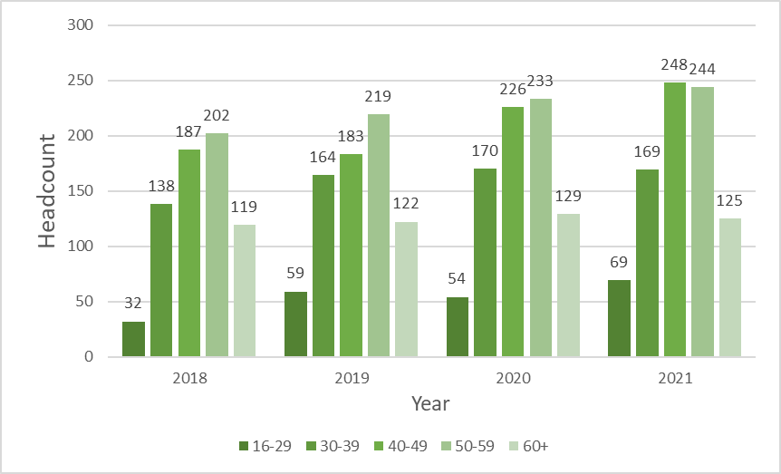
Source: SAP HR; Note: Data as of 31/03 each year

- Disability
Table 7 below shows the number of Planning Inspectorate staff declaring themselves as having a disability. In total, nine per cent of staff have a disability; with five percent of Inspector grades having a disability, and 12% of other professions.
Disability is higher among lower grade staff – with 20-24% of AAs and AOs (the lowest grades) having a disability and five per cent of senior managers (Grade 7 and above) having a disability (Figure 6). Similarly, the highest-grade Inspectors (Band 3) have the lowest disability rate (3%).
The Planning Inspectorate’s overall disability rate of 9% is below the overall Civil Service rate of 11% (2021 Q1).
Table 7 – Planning Inspectorate Staff Declaring Disability as of 31 March 21
 | % Disabled | No | Yes | Total
Total | 9% | 607 | 58 | 665
Inspector Profession Total | 5% | 294 | 14 | 308
BAND 1 /APO /APP HEO | ~% | 118-121 | 3-7 | 125
BAND 2 | 5% | 117 | 6 | 123
BAND 3 | ~% | 56-59 | <5 | 60
Other Professions Total | 12% | 313 | 44 | 357
AA/AO | 20-24% | 95-99 | 26-30 | 125
EO/HEO/SEO | 7% | 179 | 13 | 192
G7/G6/SCS | ~% | 35-39 | <5 | 40
Source: SAP HR

Figure 6 - Percentage of Staff Disabled as of 31 March 21
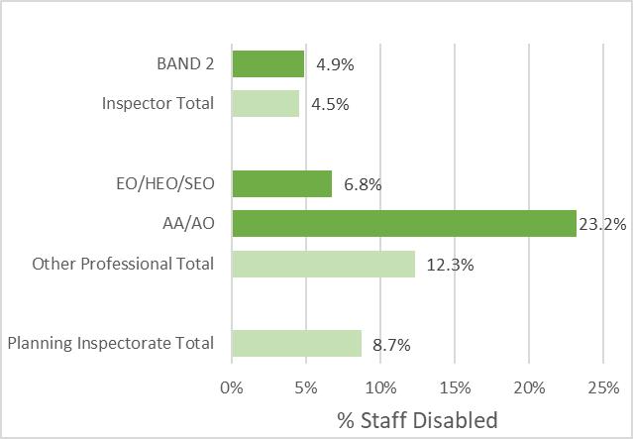
Source: SAP HR
The number of people with a disability has increased from 2018 to 2021 but the percentage of staff with a disability has reduced from a high of 10.4% in 2019 to 8.7% in 2021 (Table 8).
Table 8 – Change in Number and Percentage of Staff with Disability, 2018 – 2021
Number of Disabled Employees | 2018 | 2019 | 2020 | 2021
Total | 33 | 40 | 46 | 58
Inspector Profession | 7 | 11 | 11 | 14
Other Professions | 26 | 29 | 35 | 44
% Disabled (of total disclosed) | 2018 | 2019 | 2020 | 2021
Total | 9.5% | 10.4% | 9.3% | 8.7%
Inspector Profession | 6.5% | 8.1% | 5.1% | 4.5%
Other Professions | 10.9% | 11.7% | 12.6% | 12.3%
Source: SAP HR; Note: Data as of 31/03 each year

- Ethnicity
Overall, 5% of Planning Inspectorate staff identify as being of Black, Asian or other ethnic minority (BAME). This is considerably below the civil service average of 13%.
A lower proportion of Inspectors (two per cent) identify as BAME than do other professions (eight per cent). There are 15 BAME AAs and AOs – 11% of the grades, which is the grade with the highest representation.
Figure 7: Percentage of Staff Black, Asian and other Minority Ethnicity as of 31 March 21
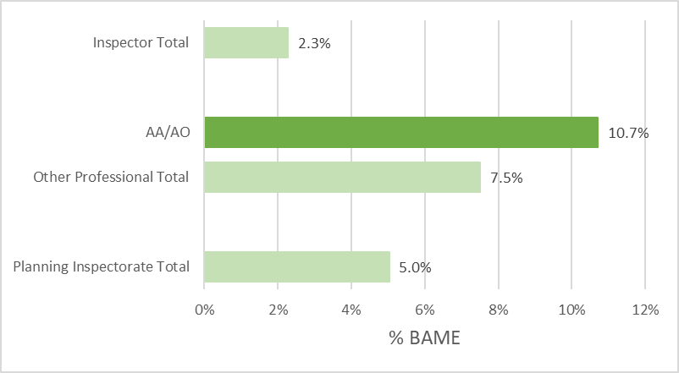
Source: SAP HR
Table 9 – Planning Inspectorate Staff Ethnicity as of 31 March 21
 | % BAME | White | BAME | Total
Total | 5% | 699 | 37 | 736
Other Professional Total | 8% | 357 | 29 | 386
AA/AO | 11% | 125 | 15 | 140
EO/HEO/SEO | ~% | 181-195 | 9-13 | 204
G7/G6/SCS | ~% | 37-41 | <5 | 42
Inspector Total | 2% | 342 | 8 | 350
Source: SAP HR
Table 10 below shows the ethnic groups of BAME staff within the planning inspectorate. The largest group is Asian (14 people) followed by Mixed (13 people).
It is not practical to break these down further without risking disclosing personal information about individuals, who have not given their consent to this disclosure.
Table 10 - Ethnicity of Black and other Minority Ethnic Staff as of 31 March 21
Asian | 14
Black | 5
Chinese | fewer than 5
Mixed | 13
Other | fewer than 5
Total | 37
Source: SAP HR

Both the number and percentage of BAME staff has risen over the last four years (Figure 8 & Table 11).
Table 11 – Change in Number and Percentage of BAME Staff, 2018 to 2021
Number of BAME Staff | 2018 | 2019 | 2020 | 2021
Total | 17 | 19 | 22 | 37
Inspector Profession | <5 | <5 | <5 | 8
Other Professions | 12-17 | 14-19 | 17-22 | 29
% BAME (of total disclosed) | 2018 | 2019 | 2020 | 2021
Total | 2.9% | 3.3% | 3.5% | 5.0%
Inspector Profession | <2% | <2% | <2% | 2.3%
Other Professions | 3.9% | 4.6% | 5.4% | 7.5%
Source: SAP HR; Note: Data as of 31/03 each year

Figure 8 - Number and Percentage of BAME Staff, 2018 to 2021
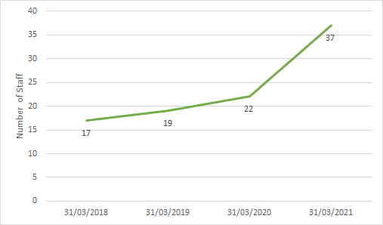 | 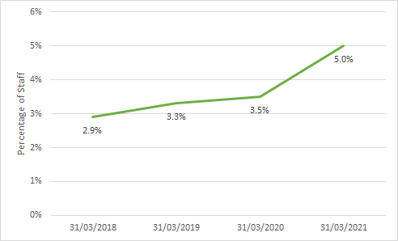
Source: SAP HR

- Sex
Table 12 and Figure 9 below show the sex (as registered at birth) of staff within the Planning Inspectorate. All references below to female or male staff are based on their sex, as this is the only gender data recorded. 45% of staff are female, which is lower than the civil service as a whole, where 54% are female. 36% of the Inspector profession are female; this is lower than the other professions, where over half (53%, akin to the civil service average) are female. Within the other professions, the highest percentage of females is in the lowest grade staff (60% of AA/ AO staff are female).
Table 12: Planning Inspectorate staff by sex as of 31 March 2021
 | % Female | Female | Male | Total
Total | 45% | 384 | 471 | 855
Other Professional Total | 53% | 240 | 212 | 452
AA/AO | 60% | 104 | 68 | 172
EO/HEO/SEO | 49% | 115 | 121 | 236
G7/G6/SCS | 48% | 21 | 23 | 44
Inspector Total | 36% | 144 | 259 | 403
Band 1 /APO /APP HEO | 40% | 65 | 99 | 164
Band 2 | 31% | 50 | 111 | 161
 | 37% | 29 | 49 | 78
Source: SAP HR
Figure 9 - Percentage of Staff Female as of 31 March 2021
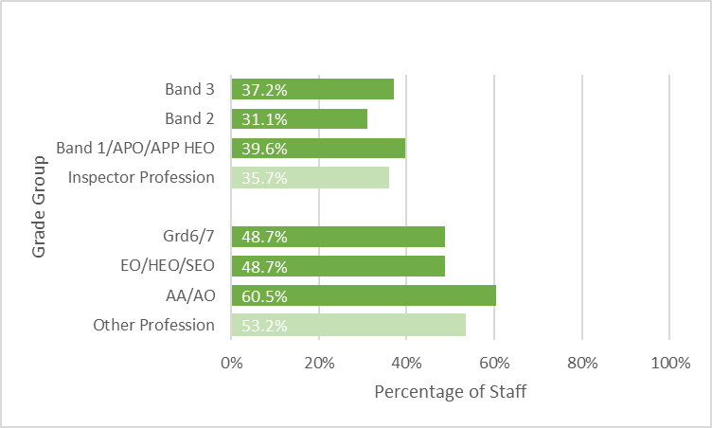
Source: SAP HR

The number of female staff has risen over the last four years, however, so too has the number of male staff meaning that the percentage of female staff in the Inspectorate has remained relatively stable (Figure 10 & Table 13).
Table 13 – Change in Number and Percentage of Female Staff, 2018 – 2021
Number of Female Staff | 2018 | 2019 | 2020 | 2021
Total | 306 | 345 | 358 | 384
Inspector Profession | 106 | 115 | 139 | 144
Other Professions | 200 | 230 | 219 | 240
% Female | 2018 | 2019 | 2020 | 2021
Total | 45.1% | 46.2% | 44.1% | 44.9%
Inspector Profession | 35.8% | 34.8% | 35.3% | 35.7%
Other Professions | 52.4% | 55.2% | 52.4% | 53.1%
Source: SAP HR Note: Data as of 31/03 each year
Figure 10 - Number and Percentage of Female Staff, 2018 to 2021
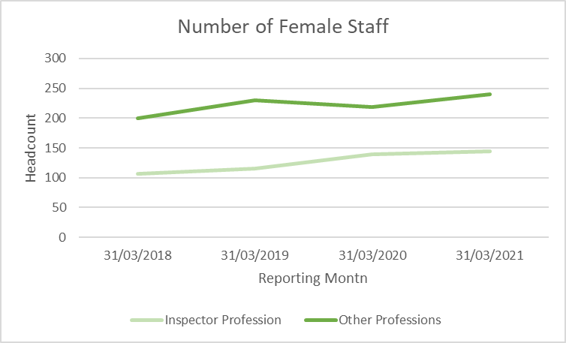 | 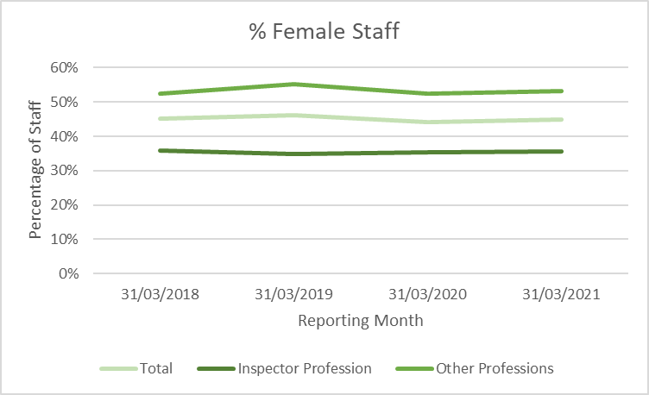
Source: SAP HR

- Religion/ Belief
Where staff have declared their religion, most are either of no religion (45%) or Christian (40%). Four per cent of staff are of any other religions, with 1% of staff being Muslim, 1% Sikh and other religions having lower proportions: there are fewer than 10 staff of each of these religions (see Figure 11 and Table 12 below).
As a contrast, across the Civil Service, 47% of staff are Christian; 40% are of No Religion; and 13% Other
Figure 11 - Religion of Planning Inspectorate Staff as of 31 March 2021
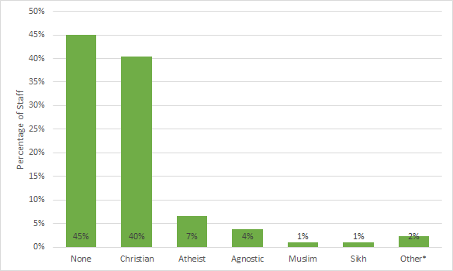
Source: SAP HR

Table 14 - Planning Inspectorate staff by Religion as of 31 March 2021
Religion | % of Staff | Number of staff
None | 45% | 275
Christian | 40% | 247
Atheist | 7% | 40
Agnostic | 4% | 23
Muslim | 1% | 6
Sikh | 1% | 6
Other* | 2% | 14
Total |  | 611
Source: SAP HR
Note: *Includes any other religious group where fewer than 5 staff members have disclosed their religion.
Table 15 – Change in Number and Percentage of Staff, 2018 – 2021
Number Christian | 2018 |  | 2019 |  | 2020 |  | 2021
Total | 129 | (42%) | 154 | (43%) | 209 | (44%) | 247 | (40%)
Inspector Profession | 87 | (51%) | 105 | (51%) | 140 | (51%) | 162 | (50%)
Other Professions | 42 | (30%) | 49 | (32%) | 69 | (35%) | 85 | (30%)
Number Other Religion | 2018 |  | 2019 |  | 2020 |  | 2021
Total | 15 | (5%) | 14 | (4%) | 18 | (4%) | 26 | (4%)
Inspector Profession | <5 | (<3%) | <5 | (<3%) | 7 | (3%) | 7 | (2%)
Other Professions | 12 | (9%) | 11 | (7%) | 11 | (6%) | 19 | (7%)
Number No Religion | 2018 |  | 2019 |  | 2020 |  | 2021
Total | 166 | (54%) | 193 | (53%) | 245 | (52%) | 338 | (55%)
Inspector Profession | 80 | (47%) | 99 | (48%) | 129 | (47%) | 155 | (48%)
Other Professions | 86 | (61%) | 94 | (61%) | 116 | (59%) | 183 | (64%)
Source: SAP HR; Note: Data as of 31/03 each year

- Sexual Orientation
Table 16 below shows the sexual orientation of Planning Inspectorate staff. Overall, 4% of staff identify as being lesbian, gay, bisexual or trans-gender. This is below the civil service average of 6%.
The proportions are similar across Inspectors and other professions. Further inference is limited due to the risk of disclosure.
Table 16 – Planning Inspectorate Staff Sexual Orientation as of 31/3/21
 | % LGBT | Heterosexual/ Straight | LGBT | Total
Total | 4% | 590 | 23 | 613
Other Professional Total | 4% | 281 | 13 | 294
AA/AO | ~% | 87-91 | <5 | 92
EO/HEO/SEO | 4% | 157 | 7 | 164
G7/G6/SCS | ~% | 33-37 | <5 | 38
Inspector Total | 3% | 309 | 10 | 319
BAND 1 / APO / APP HEO | ~% | 125-129 | <5 | 130
BAND 2 | ~% | 121-125 | <5 | 126
BAND 3 | ~% | 58-62 | <5 | 63
Source: SAP HR
The number of staff identifying as being lesbian, gay, bisexual or trans-gender has increased over the last four years from 13 in 2018 to 23 in 2021 (Table 17). However, proportionally, this peaked in 2019 and has reduced over the last couple of years.
Table 17 – Change in Number and Percentage of Staff LGBT, 2018 – 2021
Number of LGBT Employees | 2018 | 2019 | 2020 | 2021
Total | 13 | 19 | 18 | 23
Inspector Profession | 5 | 9 | 8 | 10
Other Professions | 8 | 10 | 10 | 13
% LGBT (of total disclosed) | 2018 | 2019 | 2020 | 2021
Total | 3.9% | 5.1% | 3.8% | 3.8%
Inspector Profession | 2.8% | 4.3% | 2.9% | 3.1%
Other Professions | 5.2% | 6.1% | 5.0% | 4.4%
Source: SAP HR; Note: Data as of 31/03 each year

- Socio-economic Background
Statistics on the Inspectorates staff socio-economic background helps the Inspectorate understand and address barriers to social mobility. Two elements of socio-economic background are included.
Table 18 below shows how people in the Planning inspectorate were educated. The majority (63%) attended state-run, non-selective schools; a further 23% attended state-run selective schools.
A higher proportion of those in the Inspector profession attended state-run selective schools (27%) and independent schools (11%) than those in the other professions (19% and 7%).

Table 18 – Education of Planning Inspectorate Staff, 2020
Education | Insp. profession | Insp % | Other profession | Other % | Total | Total %
State run – non-selective | 151 | 57% | 184 | 69% | 335 | 63%
State run - selective | 72 | 27% | 52 | 19% | 124 | 23%
Independent | 29 | 11% | 20 | 7% | 49 | 9%
Other (including outside UK) | 15 | 6% | 11 | 4% | 26 | 5%
DK/ Prefer not to say/ NK | 136 |  | 185 |  | 321
Source: SAP HR
As seen in Table 19 below, 37% of those in the Planning Inspectorate have a parent with a degree or higher. A further 46% have one or both parents with a qualification below degree level. There were 18 staff whose parents did not have a formal qualification. There is little difference in these proportions when comparing the inspector profession to other professions.
Table 19 – Parental Qualification of Planning Inspectorate Staff, 2020
Parental Qualification | Insp. profession | Insp % | Other profession | Other % | Total | Total %
At least degree | 93 | 37% | 85 | 36% | 178 | 37%
Qualification below degree | 109 | 44% | 112 | 48% | 221 | 46%
No formal qualification | 47 | 19% | 38 | 16% | 85 | 18%
DK/ Prefer not to say/ NK | 152 |  | 216 |  | 368
Source: SAP HR
Note: Excludes 3 individuals who answered “other” – this is to prevent risk of disclosure.
Time series data on socio-economic characteristics will be available in future annual publications.
- Working Pattern (full time/ part-time)
The proportion of staff working part-time is higher among Inspectors (39%) than among other professions (22%). More detail is given in Table 20 below. This shows that while the number of people working part time has increased since 2018, the proportion of all staff working part time has decreased.
Table 20 – Change in Number and Percentage of Staff working Part Time, 2018 – 2021
Number of Part time Employees | 2018 | 2019 | 2020 | 2021
Total | 235 | 242 | 257 | 256
Inspector Profession | 145 | 143 | 159 | 157
Other Professions | 90 | 99 | 98 | 99
% Part time | 2018 | 2019 | 2020 | 2021
Total | 34.7% | 32.4% | 31.7% | 29.9%
Inspector Profession | 49.0% | 43.3% | 40.4% | 39.0%
Other Professions | 23.6% | 23.7% | 23.4% | 21.9%
Source: SAP HR Note: Data as of 31/03 each year

How Characteristics Relate
The section above looked at staff numbers by characteristic, with each factor looked at independently of the others. This section looks at whether those characteristics are independent or linked.
A series of statistical tests have been carried out to test whether there is any link between different aspects of diversity. These are detailed at Annex B; and in the Background Quality Report.
Many of the characteristics do have a link, with some examples given below. Whether someone is in the Inspector Profession is clearly an important factor in relation to diversity: there is a significant difference in profiles between Inspectors and other professions, for: age; disability; ethnicity, sex, religion; and working pattern. The only characteristic which shows no difference across professions is sexual orientation (meaning Inspectors are no more or less likely to be LGBT than other professions).
Note that the results do not mean that one factor causes the difference in the other – there can be very complex explanations to the lack of independence, for instance both being related to a third factor. Also, because the numbers in some groups is low, small differences in reporting, even by just one person, can have an impact on the tests.
Some of the results are shown below – note that not all characteristics found to be related are shown.
Significant results | Finding
Ethnicity and profession | Inspector professions less likely to be BAME; other professions more likely to be BAME
Disability and profession | Inspector profession less likely to have a disability; other professions more likely to have a disability
Religion and Profession | Inspector profession disproportionately higher numbers Christian; disproportionately fewer atheist/ agnostic/ no religion / other.
Age and Working Pattern | Younger people less likely to work part time; older people more likely
Age and Sex | Older people disproportionately male; younger people disproportionately female
Sex and Working Pattern | Women more likely to work part time; men more likely to work full time.

The following aspects of diversity were found to be independent of each other – meaning there was no evidence to suggest the characteristics are related. For example, whether or not someone is disabled, is not related to their sex.

Found to be independent when tested
Profession and Sexual orientation | Profession and parental qualification
Age and disability | Age and sexual orientation
Disability and ethnicity | Disability and sex
Disability and Religion | Disability and school
Disability and parental qualification | Disability and working pattern
Ethnicity and sex | Ethnicity and school
Ethnicity and working pattern | Sex and Religion
Sex and School | Sex and parental Qualification
Religion and Sexual Orientation | Religion and parental Qualification
Religion and Working Pattern | Sexual Orientation and school
Sexual Orientation and parental qualification | Sexual Orientation and Working Pattern
School and Parental Qualification | School and Working Pattern

Diversity Clusters
Additional insight into the relationships between characteristics can be found using cluster analysis. This is an unsupervised (i.e. no indication of the ‘correct’ answer is provided) machine learning technique which clusters multivariate data into groups which are more similar. This can be helpful in identifying complex underlying patterns which are not obvious when looking at the characteristics one at a time. Ten groups are identified in Figure 12, which provides an infographic representation of the clustering results. Group bubble sizes are directly proportional to the number of employees they contain, and groups which were identified as more similar are displayed more closely together.

Figure 12: Groups of employees identified by clustering analysis, using data from 2021
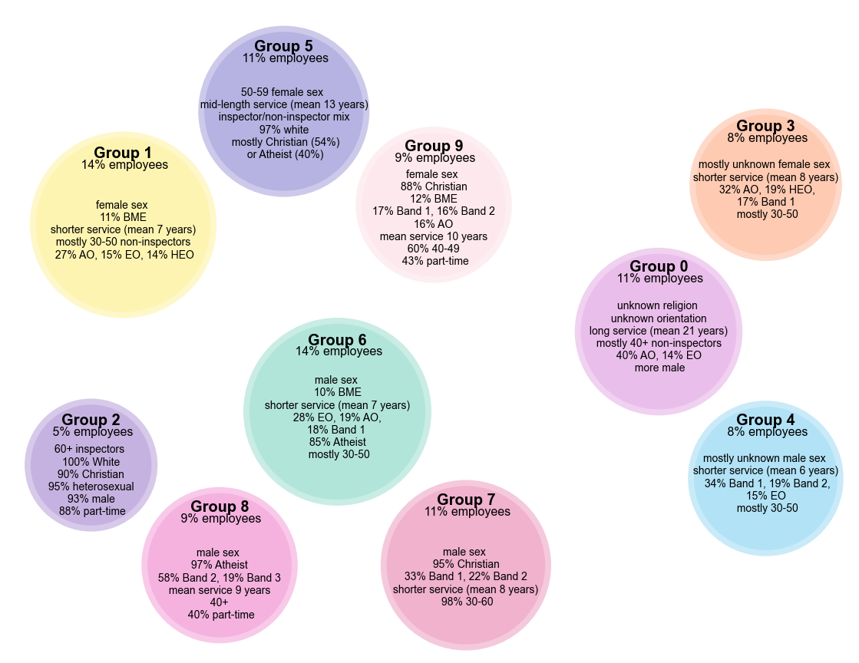
Source: SAP HR

These highlight a number of interesting patterns which will be investigated further in future work:
- Employees for whom two or more characteristics are unknown fall into three groups
  - Group 0 have unknown values for religion and orientation, but answers are provided for other characteristics. They have been employed for an average of 21 years at the Planning Inspectorate, and 54% are in AO or EO roles.
  - Group 3 and 4, however, have been more recently employed but have fewer known characteristics. Most employees in these groups have unknown values for religion, orientation, disability and ethnicity. They are separated based on sex and grade, with more inspectors in the male group. Most of these employees sit in the 30-50 age bracket.
- Employees who have joined the Planning Inspectorate more recently tend to have greater ethnic diversity
  - Groups 1, 6 and 9 have a higher percentage of BAME employees and a range of religions and roles
- There are smaller groups of employees which have less diverse characteristics, and these are dominated by male inspectors
  - Group 5 includes less diverse female staff, who are 97% white and 94% Christian or Atheist. They work in a mix of inspector and non-inspector roles, and most are aged 50-59
  - Group 2 is dominated by older inspectors (93% male) with white ethnic background, largely Christian religion and heterosexual orientation
  - Group 7 and 8 are all male employees largely in the inspector grades, with lower ethnic diversity and very high percentages of Atheist or Christian employees
- The number of characteristics which are unknown for employee was the most distinguishing characteristic when clustering them
- Other key characteristics included the length of time employed at the Planning Inspectorate, sex, part-time working, religion, and to a lesser extent age, ethnicity and band.
- The distribution of staff with disability and different sexual orientations is fairly even throughout the groups, with the exception of Group 2 – although the statistical tests above show that this does differ for inspector versus non-inspector groups of employees.

Approach to Equality, Diversity and Inclusion

The following section has been supplied by the Inspectorate’s Human Resources team, to give context to the statistics and an indication of the Inspectorate’s approach.

In September 2020 the Planning Inspectorate launched its five year Equality, Diversity and Inclusion approach and plan. This was developed using the data available to us about our employees, our vision of where we would like to be in 5 years' time and following best practice from the Chartered Institute of Personnel and Development (CIPD).

We recognise that this approach is only the start of our journey. It is very clear that we are not the diverse organisation we would wish to be.

That is why the Executive Team made Equality, Diversity and Inclusion a key priority in the business plan in 2021 and no doubt it will continue to be a priority until it becomes part of what we do as an organisation.

With this in mind we have carried out a number of diversity and inclusion activities in the last year:
- Awareness raising with blogs and news articles
- Promoting our existing employee networks for women and disabled employees, as well as launching new networks for Race and LGBTQQ+ employees.
- For National Inclusion week at the end of September we celebrated with external speakers, employees sharing their thoughts and personal experiences and our leaders ran inclusion sessions within their team meetings.
- We celebrated Black History Month in October by raising awareness of how Black people in history have helped to shape our world today.
- In April 2021 we signed up to Stonewall Workplace Equality Index as we are in the early stages of our ED&I journey and needed expert guidance to help formulate our plan to become more inclusive.
- We also signed the Race at Work Charter, making a commitment to our employees from minority ethnic backgrounds.

There is still so much to do to drive the diversity and inclusion agenda forward. We have undertaken a lot of activity in the last year, however we understand that we must continue this work if we want to meet our diversity and inclusion targets. That’s why we appointed a role dedicated to Apprenticeships and Outreach this year as we recognise that providing opportunities for people to join us early in their career and develop, as well as working with our young people in education environments to help them understand what a career in the Planning Inspectorate might look like, is integral to our diversity and inclusion agenda.

Data Sources

The statistics provided in this publication has used data from:

SAP HR – The Human Resources system database used to store all information regarding members of staff. This data source has been used to provide statistics on the demographics and Socio-economic background of staff employed by the Planning Inspectorate as at 31 March 2021.

Note that where information is based on self reporting, there is the possibility of mis-reporting (whether accidental or deliberate) While this is considered unlikely to be widespread, where percentages are very low, a small number of individuals would have noticeable impacts on the results. Thus the impact of mis-reporting on these figures could be high.

The Inspectorate regularly review the quality of information held and will continue to encourage regular updates by their employees, however an element of non-response can still be expected.

Definitions

Glossary
Term | Explanation
BAME | Black, Asian and minority ethnic
Disability | The Equality Act 2010 defines disability as a physical or a mental condition which has a substantial and long-term impact on your ability to do normal day to day activities.  The SAP HR system asked staff to select if they are disabled or not disabled. The Equality Act definition was not provided, and therefore there may be some under-reporting.
Full Time | See Working Pattern
FTE | Full Time Equivalent – a count of employees where those working part time are counted in proportion with their contracted hours.
Headcount | Total number of staff employed regardless of how many hours they work (i.e. the number of different individuals).
Inspector Profession | This includes Planning Inspectors, Appeals Planning Officers, and Apprentice HEOs.
LGBT | Lesbian, gay, bisexual, and transgender
Part Time | See Working Pattern
SAP | The Planning Inspectorate’s Human Resources database
Working Pattern | A full time member of staff is one contracted to work 37 hours a week throughout the year.  Staff contracted to work less than 37 hours a week, or not contracted to work for the whole year, are part time.

Compliance with the Code of Practice for Statistics
These statistics have been published in accordance with the Code of Practice for Statistics, which cover trustworthiness, quality, and value. They have been pre-announced, and publication is overseen by the Head of Profession.

Confidentiality and transparency
The tables in the report were scrutinised to ensure individual identities were not revealed inadvertently. Suppression has been applied to ensure individuals were not inadvertently identified dependent on their risk of exposure. Numbers less than five and the related percentages were suppressed and presented as ‘<5’ and ‘~%’. Where there was only one cell in a row or column that was less than five, the next smallest number (or numbers where there are tied values) was also suppressed or a range of values were presented so that numbers cannot simply be derived from totals.

Technical Notes
A Background Quality Report is published alongside this Statistical Release. It provides more detail on the quality of statistics in this publication.

Future Statistics
Forthcoming statistical releases
Information on Gender Pay Gap will be published by the Cabinet Office in December.
Some of the data provided in this release is also available in the Annual Civil Service Employment Statistics
https://www.gov.uk/government/statistics/civil-service-statistics-2021

This is the first of what will be an annual publication; it will be updated in September 2022, to cover the situation as of the end of March 2022.

The Planning Inspectorate publish statistics on casework (mostly appeals) each month. The next such statistics will be published on the 25th November.

Feedback and enquiries
The Planning Inspectorate welcome feedback on our statistical products. If you have any comments or questions about this publication or about our statistics in general, you can contact us as follows:

Public enquiries email statistics@planninginspectorate.gov.uk

Media enquiries 0303 444 5004
email press.office@planninginspectorate.gov.uk

Please note we are always looking for opportunities to improve our statistics with a view to making them as clear and helpful as possible for users. We would be delighted if you could contact us via the address below with any views on this approach; particularly on what content would be most useful and why.

email statistics@planninginspectorate.gov.uk

If you require information which is not available within this or other available publications, you may wish to submit a Request for Information under the Freedom of Information Act 2000 to the Planning Inspectorate. For more information, see: https://www.gov.uk/make-a-freedom-of-information-request/the-freedom-of-information-act

Annex A – Grades within the Planning Inspectorate

Included within the Planning Profession:
(From most senior to most junior)
Band 3 | Band 3 Planning Inspector (Highest level of Inspector)
Band 2 | Band 2 Planning Inspector
Band 1 | Band 1 Planning Inspector
APO | Appeals Planning Officer
APP HEO | Apprentice Higher Executive Officer

Included within other Professions:
(From most senior to most junior)
G5+ | Senior Civil Servant - Planning Inspectorate CEO and Directors
G6 | Grade 6 Senior Manager
G7 | Grade 7 Senior Manager
SEO | Senior Executive Officer
HEO | Higher Executive Officer
EO | Executive Officer
AO | Administrative Officer
AA | Administrative Assistant

Annex B – Tests of Independence of Diversity Characteristics

The table below shows whether there is a significant result when Chi-squared tests for independence was carried out (indicated by Y); or whether the factors were found to be independent (indicated by N).

 | Age | Disability | Ethnicity | Sex | Religion | Sexual Orientation | Socio-Economic: School | Socio-Economic: Parental Qual. | Working Pattern
Profession | Y | Y | Y | Y | Y | N | Y | N | Y
Age |  | N | Y | Y | Y | N | Y | Y | Y
Disability |  |  | N | N | N | Y | N | N | N
Ethnicity |  |  |  | N | Y | Y | N | Y | N
Sex |  |  |  |  | N | Y | N | N | Y
Religion |  |  |  |  |  | N | Y | N | N
Sexual Orientation |  |  |  |  |  |  | N | N | N
Socio-Econ: School |  |  |  |  |  |  |  | N | N
Socio-econ: Parental Qualification |  |  |  |  |  |  |  |  | Y

Of this total, 384 are inspectors. 352 are permanent inspectors in England (as published in the monthly statistical release for April 2021), 19 are permanent inspectors in Wales, and 13 are inspectors employed in England on a fixed term contract.
Cabinet Office, Civil Service Statistics, Quality and Methodology Information, cited 15 November 2021, URL, https://assets.publishing.service.gov.uk/government/uploads/system/uploads/attachment_data/file/1006258/Quality_and_methodology_information_for_Civil_Service_Statistics_2021_July_2021.pdf

