Application Decision
by Richard Holland
Appointed by the Secretary of State for Environment, Food and Rural Affairs
Decision date: 16 November 2021

Application Ref: COM/3278867
MOOR COMMON, BUCKINGHAMSHIRE
Register Unit No: CL49
Commons Registration Authority: Buckinghamshire Council
- The application, dated 28 June 2021, is made under Section 38 of the Commons Act 2006 (the 2006 Act) for consent to carry out restricted works on common land.
- The application is made by Mr M Davey
- The works comprise the widening and resurfacing of an 80 m² access.

Decision
- Consent is granted for the works in accordance with the application dated 28 June 2021 and the plan submitted with it subject to the condition that the works shall begin no later than three years from the date of this decision.
- For the purposes of identification only the location of the works is shown coloured red within the common land boundary on the attached plan.
Preliminary Matters
- I have had regard to Defra’s Common Land consents policy in determining this application under section 38, which has been published for the guidance of both the Planning Inspectorate and applicants. However, every application will be considered on its merits and a determination will depart from the policy if it appears appropriate to do so. In such cases, the decision will explain why it has departed from the policy.
- This application has been determined solely on the basis of written evidence.
- I have taken account of the representations made by SJ Achurch, Nigel and Anna Bacon, P Fairfax, Natural England (NE) and the Open Spaces Society (OSS).
- I am required by section 39 of the 2006 Act to have regard to the following in determining this application:-
- the interests of persons having rights in relation to, or occupying, the land (and in particular persons exercising rights of common over it);
- the interests of the neighbourhood;
- the public interest; and
- any other matter considered to be relevant.

Reasons

The interests of those occupying or having rights over the land
- The applicant says that he is the owner of the common and registered rights are not exercised over this part of the common. However, it is clear from the commons register that the rights are exercisable over all the common. Nevertheless, as the rights are not exercised, I am satisfied that there is no indication that the works will harm the interests of those occupying or having rights over the land.

The interests of the neighbourhood, and the protection of public rights of access
- The interests of the neighbourhood test relates to whether the works will unacceptably interfere with the way the common land is used by local people. The works are required to provide access to 2 new dwellings granted planning permission (APP/K0425/W/18/3218162). The works will widen an existing access from approximately 3.5 m to 4.1 m, which is used by the owners to access fields adjacent to the common. The applicant explains that this part of the common is a narrow tree belt alongside the road and is not readily accessible. The applicant is of the view that the common is not well used and usage may increase as a result of better access to the common and the land beyond. The common will remain wooded, unfenced and open.
- Among concerns raised is that the current access is only used very infrequently and question why the works would improve access. In response, the applicant explains that the current access has been used regularly over years for horses and sheep, use of the common is difficult because of the steep banks onto the land and the lack of pavements and an improved surface would increase access.
- I note that the access is used infrequently by the applicant and this part of the common is not well used by the public for either recreation or access. While it is unlikely that the works will encourage greater use of the common, I consider that they will not interfere with how the common is used nor harm the interests of the neighbourhood or public rights of access.

Nature conservation

11. NE comments that it is not aware that the works will benefit nature conservation. The applicant confirms that an ecological assessment was undertaken as part of the planning application. No objections on this issue were raised and I am satisfied that there is no evidence before me to indicate that the works will harm nature conservation interests.

Conservation of the landscape

12.The common is located within the Chiltern Area of Outstanding Natural Beauty (AONB). The applicant explains that the works will have a granite sett at the junction, with brick paviour and porous tarmacking. The applicant describes the area as in poor visual condition and considers that the works would improve the appearance of this part of the common.

13. Local residents are concerned that the existing access is a narrow, unmade rural track, and that the works will suburbanise the entrance, impact drainage; they question how the appearance of the common would be improved. NE comment that given the location and scale of the works it does not envisage any significant impact on the landscape. In response, the applicant explains that the track is currently unsurfaced and a permeable surface will be used.

14. The works are located on a narrow strip of common alongside a residential road lined by a number of nearby houses with surfaced accesses onto the road. While the tarmac/paviours surface may have a somewhat urbanising effect, I consider that the works are relatively small scale and are not out of keeping with the location. I am satisfied that, overall, the works will conserve the landscape and the natural beauty of the AONB.

Archaeological remains and features of historic interest

15. I am satisfied that there is no evidence before me to indicate that the works will harm any archaeological remains and features of historic interest.

Other matters

16. Issues raised about ownership of the common are beyond the scope of my considerations.

17. I note the concerns raised about consultation, however I am satisfied that the advertising requirements for this application were met.

18. Road safety is a matter for the highway authority (it has not objected to the application) and I note that the matter was addressed within the appeal decision (APP/K0425/W/18/32118162).

19. The OSS does not object to the works but asks that any consent should be subject to a condition that no consent is given for any gate or other barrier. However, as the application does not include such structures such a condition is not needed.

Conclusion

20. I am satisfied that the works accord with Defra policy guidance regarding the improvement of a vehicular way across a common as they will not interfere with public access nor harm the appearance of the common.

21. I conclude that the works will not harm the interests set out in paragraph 6 above. Consent is therefore granted for the works subject to the condition at paragraph 1.

Richard Holland

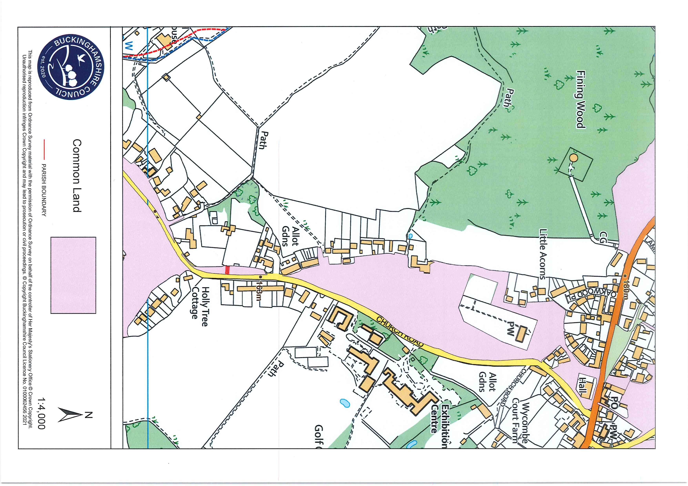

Common Land Consents policy (Defra November 2015)
Section 39(2) of the 2006 Act provides that the public interest includes the public interest in; nature conservation; the conservation of the landscape; the protection of public rights of access to any area of land; and the protection of archaeological remains and features of historic interest.

