Application Decision
by Richard Holland
Appointed by the Secretary of State for Environment, Food and Rural Affairs
Decision date: 16 November 2021

Application Ref: COM/3280620
Therfield Heath, Hertfordshire
Register Unit No: CL92
Commons Registration Authority: Hertfordshire County Council.
- The application, dated 5 August 2021, is made under Section 38 of the Commons Act 2006 (the 2006 Act) for consent to carry out restricted works on common land.
- The application is made by Dalcour Maclaren Ltd as agent for Affinity Water Limited.
- The works of up to 7 days duration comprise: i) excavation of a 3m x 3m trench for a 4m section of water pipe; and ii) installation of temporary 1.5m high blue rigid plastic barrier fencing enclosing a working area of up to 25m² for the duration of the works.

Decision
  - Consent is granted for the works in accordance with the application dated 5 August 2021 and accompanying plans subject to the condition that the common shall be restored, and the temporary fencing removed, no later than one month from the completion of the works.
  - For the purposes of identification only the location of the works is shown in yellow on the attached plan.

Preliminary Matters
  - I have had regard to Defra’s Common Land Consents Policy in determining this application under section 38, which has been published for the guidance of both the Planning Inspectorate and applicants. However, every application will be considered on its merits and a determination will depart from the policy if it appears appropriate to do so. In such cases, the decision will explain why it has departed from the policy.
  - This application has been determined solely on the basis of written evidence. I have taken account of the representations made by The Conservators of Therfield Heath and Greens (the Conservators), Natural England (NE), Historic England (HE) and the Open Spaces Society (OSS).
  - I am required by section 39 of the 2006 Act to have regard to the following in determining this application:-
- the interests of persons having rights in relation to, or occupying, the land (and in particular persons exercising rights of common over it);
- the interests of the neighbourhood;
- the public interest; and
- any other matter considered to be relevant.

Reasons

The interests of those occupying or having rights over the land
- The Trustees of the Therfield Regulation Trust (the Trust) own the land. The Trust is represented in this matter by the Conservators who have agreed to permit the works subject to the applicant and agent acting as superintendents of the works on behalf of, and reporting to, the Conservators.
- The applicant advises that just one of a number of commoners with registered rights to graze sheep on the common periodically exercises the right. The applicant further advises that the Church Commissioners for England hold freehold title to mine and mineral rights over the common, although the rights are not exercised, and that Royston Golf Club has rights over it as a reserved ground for playing golf. All these parties were consulted by the applicant but none have commented on the application.
- There is no evidence before me to suggest that any of the above rights and interests will be harmed by the works.

The interests of the neighbourhood and the protection of public rights of access
- The purpose of the works is to complete a small cross-section of water pipe between a new main in Baldock Road and an existing trunk main located within the common. The works are required to meet the applicant’s statutory obligation to provide a continued supply of water and to improve the supply pressure to properties in the nearby areas.
- The interests of the neighbourhood test relates to whether the works will unacceptably interfere with the way the common land is used by local people and is closely linked with the interests of public access. The application land is roadside verge opposite Baldock Road’s junction with the road known as Downlands. I consider it likely to be used for general recreational purposes and perhaps mainly by dog walkers and persons wishing to access the common from Downlands.
- The new section of pipe will be underground leaving no new permanent above ground features. The trench will be backfilled and the temporary fencing removed once the works are completed, which is expected to be within 7 days. The applicant advises that whilst up to 25m² of land may be enclosed by the temporary fencing, it may actually be as little as 10m². I am satisfied that public access over the common will be maintained as far as is practically possible during the works and that they will not have an unacceptable impact on local and public access rights over the common.

The public interest

Nature conservation and conservation of the landscape
- Part of Therfield Heath is designated as a Site of Special Scientific Interest (SSSI). The application land is outside of the SSSI designation but inside the SSSI Impact Risk Zone. However, NE advised that the works will not have a detrimental effect on the biodiversity of the common as a whole and I am satisfied that they will not harm nature conservation interests.
- The common has no specific landscape designation and the applicant confirms that it will be reinstated to its original condition, which can be required by attaching a suitable condition to the consent. The applicant has discussed specific reinstatement requirements with the Trust, including allowing the grass to naturally re-seed, and a photographic record of condition will be taken before the works begin. I am satisfied that the works will not have a lasting impact on the on landscape.

Archaeological remains and features of historic interest
- HE advised that there is potential for encountering undesignated archaeological remains at the location and a programme of archaeological mitigation may be required. It recommended that Hertfordshire County Council’s Historic Environment Team should be consulted about the need for, and scope of, any required works. The applicant consulted the Council’s Archaeology Service, which has not commented on the application. There is no evidence before me that leads me to think the works will harm the above interests.

Other matters
- Whilst the Conservators are content to permit the works, it is their view that section 38 consent is not needed for them. They contend that the underground works are permitted under the Water Industry Act 1991 and that the temporary fencing is permitted under The Commons Regulation (Therfield) Provisional Confirmation Act 1888. However, applicants should satisfy themselves that Secretary of State consent is needed for the works they wish to carry out. In this case, having considered the Conservators views, the applicant decided to continue with the section 38 application and it has been decided on its merits.

Conclusion
- Defra’s common land consents policy guidance advises that that works may be proposed which do not benefit the common but confer some wider benefit on the local community, such as minor works undertaken by a statutory undertaker where the works are of temporary duration (such as a worksite), where the works will be installed underground (such as a pipeline or pumping station) and where the proposals ensure the full restoration of the land affected and confer a public benefit. I am satisfied that the proposed works accord with this policy objective.
- I conclude that the proposed works will not unacceptably harm the interests set out at paragraph 5 above and will confer a public benefit by ensuring the continued integrity of water supply to the local community. Consent is therefore granted for the works subject to the condition set out in paragraph 1.

Richard Holland

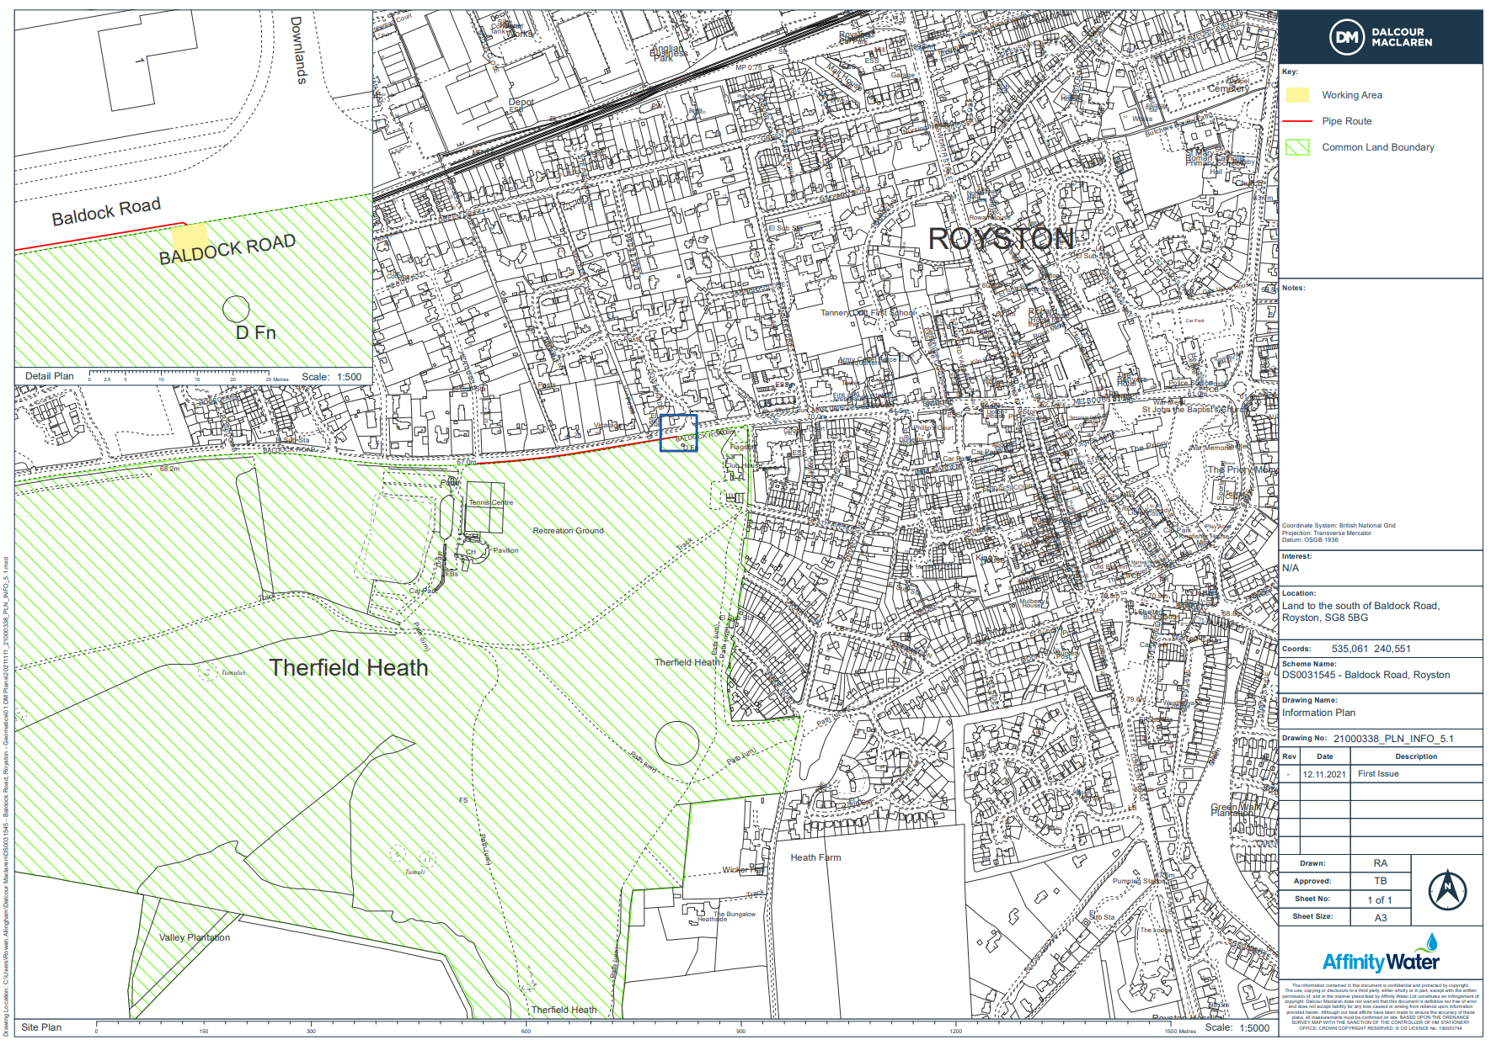

Common Land Consents Policy (Defra November 2015)
Section 39(2) of the 2006 Act provides that the public interest includes the public interest in; nature conservation; the conservation of the landscape; the protection of public rights of access to any area of land; and the protection of archaeological remains and features of historic interest.

