Order Decision
On papers on file
by Grahame Kean B.A. (Hons), Solicitor HCA
an Inspector appointed by the Secretary of State for Environment, Food and Rural Affairs
Decision date: 22 October 2021

Order Ref: ROW/3262266
- This Order is made under Section 53(2)(b) of the Wildlife and Countryside Act 1981 (the 1981 Act) and is known as the Cumbria County Council (Parish of Brigham: District of Allerdale) Public Path Modification Order No 2 2009.
- The Order is dated 20 February 2009 and proposes to modify the Definitive Map and Statement for the area by deleting part of a footpath as shown in the Order plan and described in the Order Schedule.
- There was one objection outstanding when Cumbria County Council submitted the Order to the Secretary of State for Environment, Food and Rural Affairs for determination.

Summary of Decision: The Order is not confirmed.

_________________________________________________________________

Procedural matters
- In the circumstances of this case I am satisfied that I can make the decision without the need for a site visit.
- Surveying authorities are required to modify the definitive map and statement (DMS) on the occurrence of “events” set out in s53(3) of the 1981 Act. The Order has been made under s53(3)(2)(b) allegedly in consequence of the occurrence of an event specified in Section 53(3)(c)(iii). This requires “discovery of evidence” which, when considered with all other relevant evidence available, shows: (iii) that there is no public right of way over land shown in the DMS as a highway of any description. The appellant must demonstrate that this is so, on the balance of probabilities.
- The Order, if confirmed without modifications, would modify the DMS for the area by deleting that section of public footpath no 216002 extending from grid reference NY 1032 3085 in a west-north-westerly then westerly direction for approximately 251 metres to grid reference NY 1009 3086.

Main issue
- The main issue is whether the available evidence shows that, on the balance of probabilities, the DMS requires modification.

Reasons
- There is an immediate problem with this Order because the evidence to support it either does not exist or has not been made available to me.
- The Order was made in 2009 following a report to the Council’s Development Control and Regulation Committee which recommended that “a section of footpath 216002…be deleted from [the DMS] as it was added in error and the public are equally well served by footpath 216005.”
- The report concluded that “there is clear evidence tending to show that it was always intended that footpath 216005 was to be added to the Definitive Map in place of part of footpath 216002”. However no such evidence appears in the report or has been made available to me.
- Furthermore the conclusion and reasons for making the Order were entirely misconceived. In deciding whether to add or delete a path to the DMS the only matter to be determined is whether public rights exist in law. Its condition and whether it is necessary, or an alternative route exists, are not relevant issues.
- The matter seems to have been considered in an earlier report to the relevant committee in 1981 when it was considered that a section of FP 216002 had been added to the DMS in error in the 1950’s. Thus in April 1981 the Council made an extinguishment order under s118 Highways Act 1980 but it was not confirmed due to an objection that it was more suitable than FP 216005. That procedure, unlike modification of the DMS, is potentially appropriate to seek stopping up of a footpath on the ground that it is unnecessary. However, neither report submitted, nor other information available actually demonstrates that a footpath has been wrongly added to the definitive map or statement.
- Indeed the Council does not support the Order and agrees with the objector that there has been no new evidence to displace the presumption that the definitive map is correct.
- In s.53(3)(c) "evidence'' is not restricted to new evidence or evidence not previously considered but given its ordinary meaning. Although one cannot simply re-examine the same evidence considered when the DMS was drawn up, the “new” evidence must be considered in the context of previous evidence.
- It would, for example, be sufficient that a drafting error is found due to recent research. But even if one inferred from the reports that some error had been made by including two draft versions of the same footpath, it is far from clear what was the nature of the error, which if any of the footpaths are correctly included and why. The route of FP 216002 is quite distinct from FP 216005.
- The decision of the Court of Appeal in Trevelyan v. Secretary of State for the Environment, Transport and the Regions [2001] 1 WLR 1264 clarifies that in the absence of evidence to the contrary, it should be assumed that the proper procedures were followed and “evidence of some substance” must be put in the balance, if it is to outweigh the initial presumption that the right of way exists.
- On my reading of the papers there is no evidence of any substance that points to the likelihood that PF 216002 was incorrectly included in the DMS.

Formal Decision
- The Order is not confirmed.

Grahame Kean

INSPECTOR
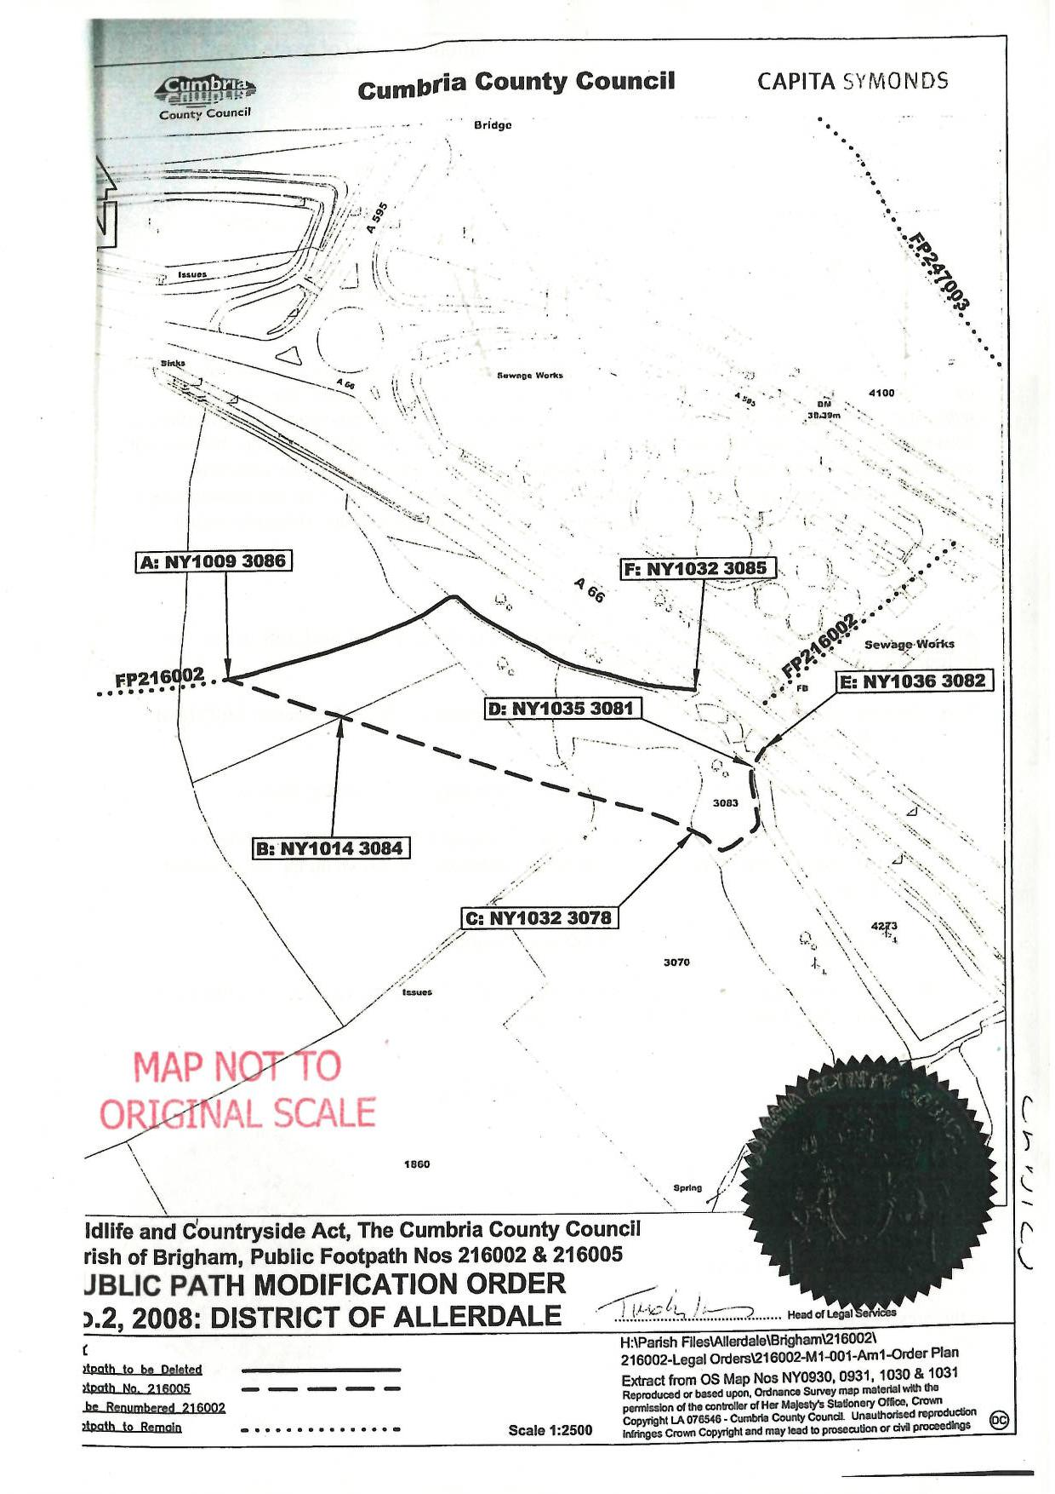

See Janusz Kotarski, Georgina Kotarski v Secretary of State for Environment, Food and Rural Affairs v Devon County Council [2010] EWHC 1036 (Admin).

