Application Decision
by Richard Holland
Appointed by the Secretary of State for Environment, Food and Rural Affairs
Decision date: 11 November 2021
Application Ref: COM/3278888
Felbridge Green, Surrey
Register Unit No: CL58
Commons Registration Authority: Surrey County Council

- The application, dated 8 July 2021, is made under Section 38 of the Commons Act 2006 (the 2006 Act) for consent to carry out restricted works on common land.
- The application is made by Vanderbilt South Limited.
- The works of up to approximately 14 days duration comprise:
- erection of four street lighting columns with surrounding concrete and underground electric cable connections at Crawley Down Road; and
- erection of temporary barriers around the four sites for the duration of the works.

Decision

1. Consent is granted for the works in accordance with the application dated 8 July 2021 and the plans submitted with it subject to the following conditions:
- the works shall begin no later than 3 years from the date of this decision; and
- all temporary barriers shall be removed and the land shall be fully reinstated, within one month from the completion of the works.

2. For the purposes of identification only, the location of the proposed works is shown in red on the attached plan.
Preliminary Matters

3. I have had regard to Defra’s Common Land consents policy in determining this application under section 38, which has been published for the guidance of both the Planning Inspectorate and applicants. However, every application will be considered on its merits and a determination will depart from the policy if it appears appropriate to do so. In such cases, the decision will explain why it has departed from the policy.

4. The village of Felbridge is largely within Surrey. Whilst the application land lies just within the West Sussex county boundary, Surrey County Council is both the Commons Registration Authority and the relevant Highways Authority.

5. This application has been determined solely on the basis of written evidence.
6. I have taken account of the representation made by the Open Spaces Society (OSS).

7. I am required by section 39 of the 2006 Act to have regard to the following in determining this application:-
- the interests of persons having rights in relation to, or occupying, the land (and in particular persons exercising rights of common over it);
- the interests of the neighbourhood;
- the public interest; and
- any other matter considered to be relevant.

Reasons

The interests of those occupying or having rights over the land

8. Pursuant to Commons Commissioner Decision 236/U/46 of 21 February 1977 the common land register for CL58 records that in the absence of any evidence as to the ownership of the land it is subject to protection by the local authority (Tandridge District Council - TDC) under s9 of the Commons Registration Act 1965 (now under s45 of the 2006 Act). The rights section of the register for CL58 records no rights of common.

9. There is no evidence before me to suggest that the works are likely to harm the interests of those occupying or having rights over the land (and in particular persons exercising rights of common over it).

The interests of the neighbourhood and public rights of access

10. Felbridge Green is a narrow strip of roadside grassed verge along a section of the north side of Crawley Down Road. The applicant advises that where a pavement separates the verge from the road, it forms part of the registered common. The applicant further advises that erection of the four lighting columns is a requirement of West Sussex County Council as a safety measure in relation to a housing development at 15 and 39 Crawley Down Road, for which outline planning permission was granted by Mid Sussex District Council on 4 January 2018 (Application reference DM/17/2570).

11. The housing development is on the south side of the road, which lies outside the common land boundary. The Highways Authority requested that the columns be placed on the north side of the road to comply with the required lighting design standards and to fill the gap between existing columns. The application plan shows that two of the columns will be on the pavement and the other two will be on the verge where there is no pavement.

12. The interests of the neighbourhood test relates to whether the works will impact on the way the common land is used by local people and is closely linked with interests of public access. I consider it likely that the pavement is used by pedestrians, as is the verge where necessary, and that the verge is otherwise used for informal recreation and dog walking.

13. I consider that the columns’ impact on public access along the pavement and over the verge will be minimal. The application plan shows that the temporary barriers will enclose only a very small area around each column site and I am satisfied that public access will be maintained as far as is practically possible during the 14 day works period.

14. I conclude that the works will not have an unacceptable or lasting impact on local and public access rights over the common. Indeed, additional lighting will benefit those using the common after dark.

The public interest

Nature conservation, conservation of the landscape and archaeological remains and features of historic interest

15. Natural England was consulted about the application but did not comment. There is no evidence before me to suggest that the works will harm nature conservation interests.

16. The common has no special landscape designation and the application land is along a residential road where other lighting columns and street furniture structures are present. I am satisfied that that the columns will not be out of place with their surroundings or cause serious harm to the landscape.

17. HE advised that on the basis of the information provided it had no comments to make. I am satisfied that the works are unlikely to harm any archaeological remains or features of historic interest.

Other matters

18. OSS suggests that the land is subject to a scheme of management under the Commons Act 1899 (made by Godstone Rural District Council on 28 March 1924 and confirmed by the Minister of Agriculture and Fisheries on 1 May 1924), which confers a power on TDC to ‘light the common’, so no separate Secretary of State consent is needed. However, the applicant advises that the columns are not to light the common but to light the carriageway to improve road safety and highlight the new junction into the development site. In any case, where a common is subject to a scheme of management applicants should satisfy themselves that Secretary of State consent is needed for the works. In this case an application for consent has been made and it has been decided on its merits.

19. OSS is also concerned that TDC in its capacity as regulator and manager of the common under the 1924 Scheme should have been consulted about the application rather than its Planning Department. However, as the works relate to registered common land I would expect the Planning Department to have referred the application to the relevant office within TDC. I am satisfied that the consultation requirements for the application have been met.

Conclusion

20. I conclude that the proposed works will not significantly harm the interests set out in paragraph 7 above and will be of use to persons using the common after dark. The works will also benefit road safety by improving visibility and illuminating a new highway junction. Consent is therefore granted for the works subject to the conditions set out in paragraph 1.

Richard Holland

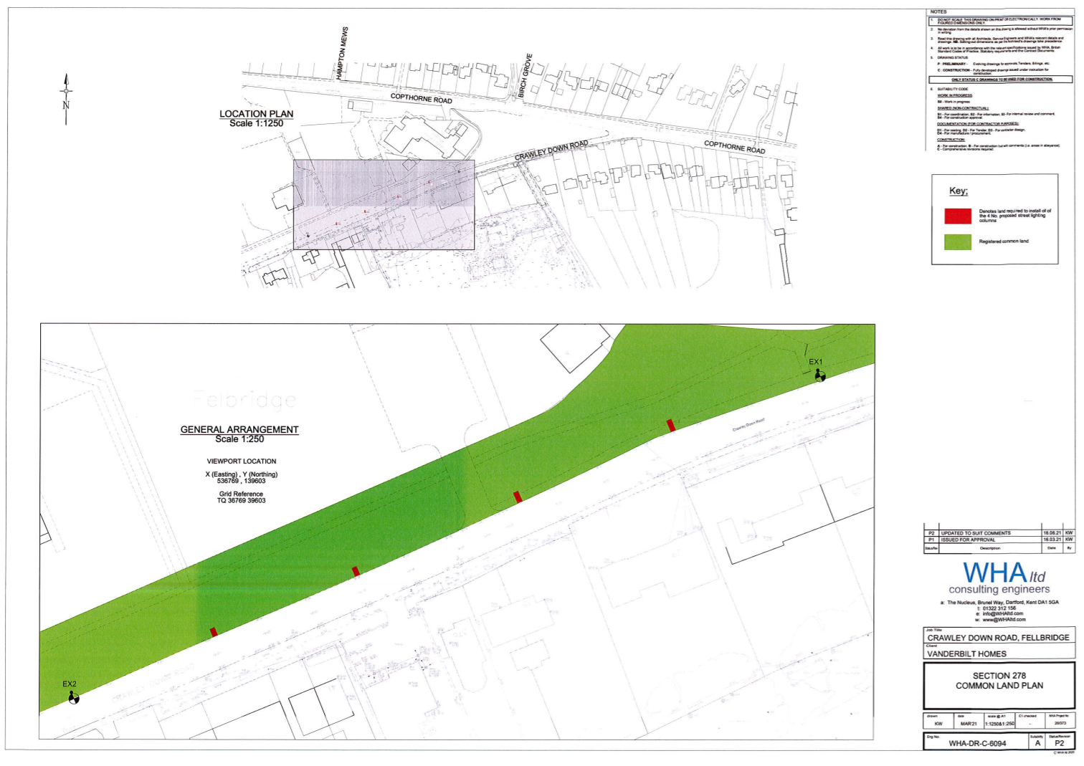

Common Land consents policy (Defra November 2015)
Section 39(2) of the 2006 Act provides that the public interest includes the public interest in; nature conservation; the conservation of the landscape; the protection of public rights of access to any area of land; and the protection of archaeological remains and features of historic interest.

