

Research on UK Union Connectivity

Ipsos MORI Report

November 2021

  - Contents
Executive Summary 4
National perspectives 9
England 9
Scotland 12
Wales 15
Northern Ireland 18
Introduction and methodology 21
Travel between UK nations in 2019 25
Inter-UK travel in 2019 25
Differences in inter-UK travel by demographic groups, journey frequency and nation 28
Views of journeys made to other UK nations 30
Interest in future travel to other UK nations 34
Perceived importance and impacts of improved UK connectivity 37
Perceived importance of improving transport links between UK nations 37
Perceived impacts of improved transport links between UK nations 38
Priorities for investment 42
Priorities for improvements to transport modes and infrastructure 42
Priorities for improvements in journey experience 44
Personal stories of inter-UK travel 47
Appendices 60

Executive Summary
Ipsos MORI conducted a UK-wide online survey during March 2021 on behalf of the Department for Transport to contribute evidence in support of the Union Connectivity Review (UCR). The Review is planning infrastructure investment and strategic priorities to improve connectivity. It will make use of evidence about travel patterns between the UK’s nations, as well as people’s priorities for improving inter-UK transport and travel.
The survey was designed following a small-scale qualitative research exercise, and follow-up qualitative interviews were conducted after survey results were analysed to explore the findings in greater detail.
The survey involved 3,700 UK adults aged 16-75 years old. Sampling was structured to secure nationally representative samples of 1,500 in England, 1,000 in Scotland and 1,000 in Wales, plus a small booster sample of 200 in Northern Ireland. An additional survey was completed by telephone in Northern Ireland to secure a nationally representative sample of 500 adults there. Commentary on Northern Ireland presented in this Summary and throughout this report is based on the telephone survey, while UK-wide findings make exclusive use of data collected online, to allow robust comparisons to be made.
The research gathered evidence on travel patterns between UK nations in 2019 – the last full year before the outbreak of the Coronavirus pandemic – including frequency of journeys made, journey purpose and transport modes used. The surveys also measured views of the ease, cost and time it takes to make journeys between and within UK nations, and interest in travelling to other UK nations in future, assuming travel restrictions are eased. Respondents gave their views on the importance of improving transport links between UK nations, and the potential impacts of this nationally, locally and personally, as well as the potential to deliver economic, environmental, social and quality of life benefits. They were asked to consider priorities for investment in improvements to inter-UK transport links, both in terms of types of transport mode and infrastructure, and other factors influencing journey experiences, including affordability, reliability and comfort of travel.
While fieldwork took place during a period of Coronavirus-related restrictions prohibiting some travel, the survey measured pre-pandemic travel behaviours. This was to provide a picture of inter-UK travel in 2019, the last full year before the outbreak of the pandemic, as well as to measure interest in travelling to other UK nations in future. People’s responses about future travel and priorities may well, though, have been influenced by their experiences and expectations about the pandemic and its impacts.

There was extensive travel between UK nations, particularly to England, before the pandemic
Overall, 45% of people in the UK travelled to another UK nation at least once in 2019. Nearly two-thirds of people, 64%, travelled to England from other nations at least once during the whole of 2019, compared with 27% who travelled at least once to Wales, 22% to Scotland and 10% to Northern Ireland. This made visiting Wales, Scotland or Northern Ireland far less common than going abroad, which 57% of UK adults did during 2019.
Those most likely to have frequently travelled between UK nations – once a month or more often – lived near to a border, had access to a motor vehicle, and included men, younger people and those in employment. Visiting family and friends and going on holiday were common reasons for travelling to another nation.
      - Proportion of UK adults who travelled to each nation in 2019, and most common reasons for travel (top three for journeys to each nation)
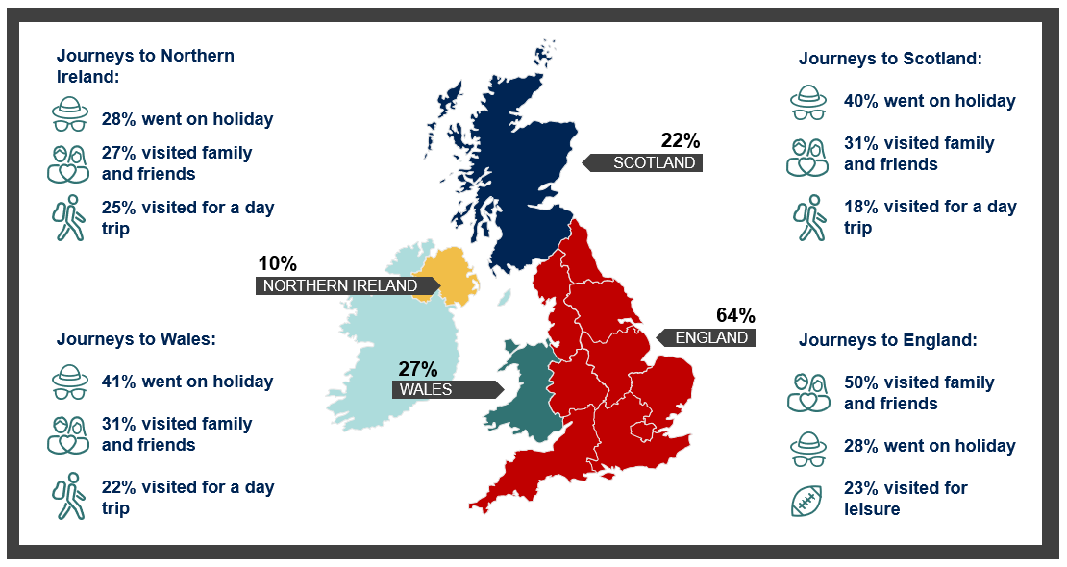Question wording: ‘Thinking about the whole of 2019 – that is the last full year before the outbreak of the Coronavirus pandemic – how often, if at all, did you personally do the following? Travel to…. [nation].’
‘You said that you travelled to England. Thinking about the last time you travelled there during 2019, which of these, if any, were reasons you made that journey? Please select as many as apply.’
Source: Ipsos MORI. Base: 3,700 UK adults aged 16-75 interviewed online, 9-19 March 2021, including 1,500 adults in England, 1,000 adults in Scotland, 1,000 adults in Wales and 200 adults in Northern Ireland. UK adults who travelled to another nation in 2019: 1,489 adults who travelled to England, 568 adults who travelled to Scotland, 561 adults who travelled to Wales and 342 adults who travelled to Northern Ireland.
Reasons for travel to England, the most visited nation in 2019, varied among different groups and geographies. For example, older people and those travelling there more often, were more likely than all adults who had travelled to England to have visited family and friends on their last journey during 2019. Younger people were more likely than all adults who had to visited England to have done so for shopping, and those aged 45-54 were more likely to go for business. Men were relatively more likely to visit England for leisure reasons, including sporting events.
Visiting family and friends in England was the most common reason for travelling there from all three other UK nations. However, day trips, shopping and leisure were also common reasons for travelling from Wales to England. For people in Scotland and Northern Ireland (who visited England less often than people in Wales), day trips and shopping were less common reasons for travel to England.
Car travel prevailed for travel between England, Scotland and Wales, especially between England and Wales – for example, travel to England by car from Wales was much more common than travel to Scotland this way. Flying and travelling by ferry were more commonly used modes of transport when travelling from Northern Ireland to other UK nations (flying was the most common way of making such journeys).

There was considerable interest in travelling within the UK in the future
If there were no Coronavirus-related restrictions, nearly three-quarters (73%) of people living outside of England said they would be interested in travelling there. Two-thirds (67%) said they would be interested in travelling to Scotland, six in ten (63%) to Wales and four in ten (40%) to Northern Ireland. Interest was high relative to past travel to other UK nations during 2019. Interest was higher among those who travelled to other nations during 2019, but also extended to those who rarely or never travelled to other nations in 2019.
Those interested in travelling to one UK nation were also generally interested in travelling to all other UK nations. Interest was generally higher among people in higher (ABC1) social grades, and among those who had a positive attitude towards the UK. Eight in ten (79%) adults aged 16-24 outside of England were interested in travelling there, including 39% who said they were very interested.

People place importance on travelling within the UK, and recognise the positive impacts of improved UK connectivity through transport links
Reflecting interest in future travel to other UK nations, a majority of people across the UK considered it very or fairly important to improve transport links between their own nation and other parts of the UK. Seventy nine percent said it was important to improve links with England, including 40% who said this was very important. This sentiment was echoed by nearly seven in ten for Scotland (69%), Wales (67%) and Northern Ireland (62%).
The survey shows that many people saw the importance of improving transport links regardless of past travel behaviour and personal interest in making journeys. For example, although 54% of adults in other UK nations were not interested in travelling to Northern Ireland, 62% said it was important to improve transport links to there. This opinion was more strongly felt in Scotland (69%) while in Wales, eight in ten (80%) felt it was important to improve transport links to neighbouring England.
The beneficial impacts of improving transport links within the UK are recognised. A majority thought improved connectivity would bolster economic growth at UK and national levels – across the UK, 60% thought that improving transport links between UK nations would make a positive difference to their own nation – and that it would improve a range of services and opportunities by a great deal or a fair amount. This included better access to transport hubs (72%), making it easier for people to move to live in other places in the UK (71%) and improving their ability to travel to go on holiday somewhere within the UK (70%).
Respondents were, though, less likely to expect a positive impact personally – half (49%) said that improving transport links between the different nations of the UK would make no difference to them – and people were also more circumspect about the impact of improved connectivity at regional levels. Forty six percent thought improved transport links would have a positive impact on their region, but 43% said it will make no difference.
There was more negativity though in terms of the impact of improved transport links between UK nations on the environment; 35% thought it would be detrimental, and 28% felt the same way about reducing carbon emissions in the UK. In each case, a quarter thought there would be no difference. Older age groups were more negative, as were ABC1 households and people living in rural areas.

Road and rail are key priorities for investment, affordability too
Over half of the UK public said train services and stations should be given the highest priority for improvements (51%), followed by motorways and major A roads (36%), and local roads (30%). Road and rail were rated as top priorities for investment in transport modes in England, Scotland and Wales, while in Northern Ireland, improvements to air and ferry travel were comparatively far more important.
Affordability for passengers and users was considered more important to improve than any other element of transport provision (respondents were shown eleven options) including, for example, quicker journeys, more seamless journeys and more comfort. Just over half, 54%, of people in the UK thought making journeys more affordable should be a priority, consistent across England (55%), Scotland (52%), Wales (49%) and Northern Ireland (55%). This reflects the relatively low ratings given by respondents for the cost of making a journey to each of the four UK nations, compared with more positive ratings of the time and ease of making a journey to get there.
Other priorities were making ticket prices more consistent regardless of how far in advance you book (chosen by 29%), quicker journeys (22%), reducing how often people have to change services or ways of travelling within a journey (22%) and making it easier for people to make journeys in more environmentally-friendly ways (21%).

There are many similarities in outlook but also some important geographical differences
People across the UK have many things in common, but there were also some important differences reflecting geographic, economic and social ties between different nations. For example, for people in Northern Ireland, it was particularly important to improve links to Scotland and England, and interest in travelling between Northern Ireland and Scotland was also relatively high.
Reflecting poorer ratings of journeys between Northern Ireland and other UK nations, people living there were far more likely than people in England to expect improved connectivity to have positive impacts on their own nation. They were also more likely than people elsewhere to think better transport links could lead to improvements across a range of aspects of quality of life, particularly in terms of improving opportunities to move to live elsewhere in the UK.
The following section of this report summarises perspectives in England, Northern Ireland, Scotland and Wales, respectively.

Building connectivity through transport
This survey research provides an evidence base covering public behaviours, attitudes and preferences in respect of inter-UK transport and travel. The qualitative research which preceded it, found connectivity to be a less tangible concept than a more relatable frame concerning improvements in transport links. However, the survey shows that the public recognise the potential for improvements to connectivity to deliver economic, social and quality of life benefits. A majority considered it important to improve transport links between their own and each of the other UK nations.
The public can foresee certain personal benefits too, with visiting family and friends a popular reason for travelling to other UK nations during 2019. However, as well as appreciating the social and economic case for improved transport links, consumer perspectives are also evident in the priority attached to the affordability of tickets and fares.
The public’s preferences were likely to reflect past experiences and necessity. For example, those who had travelled to other UK nations during 2019 were more likely than average to welcome further improvements and expect positive benefits. England – the most travelled to UK nation in 2019 – was a focus for interest in travelling in the future (Coronavirus restrictions may have boosted interest in travel for leisure within the UK, and this may or may not continue as restrictions are eased).
The survey further underlines ongoing public sensitivities about the environment, and the perceived potential negative effect that improving transport could have on the natural environment. And while more people expected improvements to make a positive difference to the region they live in, nearly as many said it would make no difference.
While the research shows public appetite for improving connectivity and a sense that it can generate benefits, particularly at a ‘macro’ level, the topic is neither salient nor especially tangible for most people. People do think that improving transport can boost prospects, but also appreciate that there may be some negative effects and trade-offs, and will likely want to know more about the practicalities before offering support.

National perspectives
This chapter provides a summary of key survey findings from each nation, using data from the telephone survey of adults in Northern Ireland for its summary. All other national summaries are based on nation-level data from the online survey of UK adults (see the introduction for details of survey methodologies).

England

Travel to other UK nations in 2019
England was the most common domestic destination for those in each of the other nations in the UK. More than three quarters of those in Wales (77%), three in five in Scotland (60%) and close to half of those in Northern Ireland (45%) travelled to England at least once in 2019. Travel from England to the other nations was lower by comparison (29% to Wales, 22% to Scotland, 10% to Northern Ireland), and substantially lower than the 57% of those in England who travelled abroad that year.
Travel from England to the other nations of the UK was typically infrequent. Wales, the most visited nation by those in England in 2019, was only visited monthly or more often by one in twenty (5%). Across England, those in regions proximate to other nations were typically more likely to have travelled to those nations in 2019. For example, close to half (49%) of those in the West Midlands, and two in five of those in the North West and South West (both 40%), travelled to Wales at least once in 2019, more than the 29% who did this across England overall. Similarly, those in the North East were far more likely to have travelled to Scotland in 2019 than in England overall (50% compared with 22%).
The profile of Londoners’ travel to other nations differed from that of the other regions of England. Along with people in the North West, Londoners travelled to Wales more frequently than people in other regions – 10% of Londoners and 9% of people in the North West travelled there once a month or more often, compared with 5% in England overall. Londoners were also more likely than people in other regions of England to have travelled to Scotland or Northern Ireland at all in 2019, and especially for frequent journeys. For example, 10% of Londoners travelled to Scotland once a month or more often (compared with 4% of people in England overall), and 10% travelled to Northern Ireland this often (compared with 3% overall).
This was driven in large part by Londoners being comparatively more likely to have travelled to Scotland and Wales for personal business and to shop. They were also comparatively more likely to have travelled to Wales to commute to and from work, and for school, college or university, including accompanying children (indicatively, Londoners travelling to Northern Ireland were more likely to have done so for work and personal business, though base sizes are insufficient to make results statistically significant).
Across England more generally, those who travelled to Wales were most likely to have done so to go on holiday (41%), to visit family or friends (31%) or for a day trip (23%). Those aged 16-24 were twice as likely to have travelled to Wales for school, college or university (including accompanying children) than those in England overall (11% compared with 6% overall), to shop (22% compared with 10% overall) or to go for leisure (25% compared with 15%). Reasons for travelling to Scotland followed the same pattern regarding the most common reasons for travel, to go on holiday (41%), to visit family or friends (30%) or for a day trip (19%).
Those who travelled from England to Scotland in 2019 were most likely to have done so by car or van, either as a driver (38%) or passenger (26%). Three in ten (29%) travelled by train and just under one in five (18%) flew by aeroplane. Those who travelled to Wales were more car/van-dependent (49% as driver, 37% as passenger), with fewer travelling by train (20%) or aeroplane (7%) by comparison. By contrast, close to half of those who travelled from England to Northern Ireland in 2019 flew by aeroplane (45%), 17% travelled by ferry as a driver or passenger in a car, and 12% took the ferry as a foot passenger.

Ratings of journeys to other UK nations
Respondents were asked to rate journeys to other nations (from their own) according to the time it takes to make a journey to get there, and the ease and cost of making a journey there. In terms of journey time, ease and cost, people in England were most positive about journeys from England to Wales and least positive (and knowledgeable) about journeys from England to Northern Ireland. For travel to Wales, people were, on balance, positive about journeys in terms of ease (54% good, 10% bad), journey time (50% good, 13% bad) and cost (46% good, 11% bad). Those living in the regions of England bordering Wales – South West, West Midlands and North West – were typically more positive than those in England more generally across all three measures.
Ratings of journeys to Scotland were slightly more negative for time and cost, with people in England most positive about the ease of travelling there (46% good, 12% bad), followed by journey time (36% good, 21% bad) and cost (32% good, 22% bad). People were less positive about journeys to Northern Ireland in these terms, but close to half said they did not know or that it depends when asked about journey ease, cost and time, reflecting the low numbers of people who travelled there in 2019.
Those in England were less negative about internal travel in England than those in other nations of the UK. While 44% in Wales and 31% in Scotland agreed that it is harder to travel within their own nation than it is for people to travel within other UK nations, only 22% in England agreed. However, those in the North East (38%) and London (30%) were more likely to agree with this statement.

Interest in travelling to other UK nations
As in other nations, there was interest among many adults in England to travel to other nations in the UK in the absence of travel restrictions because of Coronavirus. Two-thirds (67%) said they would be interested in travelling to Scotland and 66% interested in travelling to Wales, with two in five (41%) interested in travelling to Northern Ireland. Interest in travel to all three other nations was higher among those who think the Union is a good thing, while those in work and socio-economic grade ABC1 were more interested in travel to Scotland and Wales. There was also greater interest in travel to Scotland and Wales among people living in the regions of England where people more commonly travelled to those respective nations in 2019 (in the North East for Scotland, and South West, West Midlands and North West for Wales). Similarly, more than half of Londoners said they would be interested in travel to Northern Ireland. Those in the East of England were less interested in travel to all three nations relative to England overall.
      - Interest in travelling to other nations among adults in England, and perceived importance of improving transport links between England and other nations.
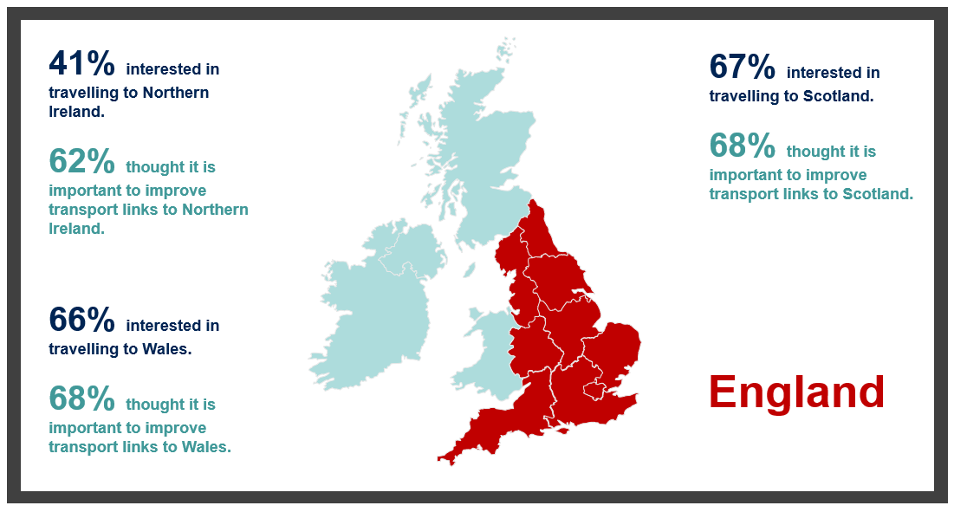Question wording: ‘Imagine there were no travel restrictions because of Coronavirus. How interested, if at all, would you personally be in travelling from England to [nation]?’. ‘How important, if at all, do you think it is to improve transport links between England and [nation]?’.
Source: Ipsos MORI. Base: 1,500 adults in England aged 16-75 interviewed online, 9-19 March 2021.

Perceived importance and impacts of improved UK transport connectivity
The majority of adults in England thought it is important to improve transport links between England and Scotland (68%), Wales (68%) and Northern Ireland (62%). The pattern of groups more likely to feel this way follows the pattern of groups more likely to be interested in travel to the respective nations. That is to say, perceived importance is higher among those favourable to the Union, and in regions in closer proximity to the respective nations too, as well as for Londoners with regard to links with Northern Ireland. Those who had travelled to each of the nations in 2019 were far more likely to consider it important to improve links between England and those nations.
However, those in England were the least likely of all nations to think that improving transport links between the different nations of the UK would make a positive difference to them personally, to England, or to the region in which they live. They were also comparatively less likely to think improved links would positively impact England’s economy. Nevertheless, adults in England were more closely aligned to other UK nations regarding the UK as a whole and its economy, where 65% and 62% respectively thought improved transport links would make a positive difference.
While typically lower than levels recorded in other nations, especially Northern Ireland, the majority of adults in England thought that improving transport links would improve access to important transport hubs (71%), make it easier for people to move to live in other places in the UK (71%) and enhance their ability to go on holiday somewhere in the UK (69%) by a great deal or fair amount. Those in London were more likely than adults in England more generally to be positive in this respect with regard to access to job opportunities (73% said this would be improved by a great deal or fair amount compared with 65% in England overall) and access to public services such as schools, universities and healthcare (67% compared with 56% in England overall).

Priorities for investment in inter-UK transport links
Regarding prioritisation of modal improvements, people in England were most keen for train services and stations (52%), motorways or major roads (37%) and local roads (29%) to be improved, following exactly the same pattern as those in Wales and Scotland. Within England, those in rural areas were more likely to think motorways and major roads should be prioritised than those in urban areas (45% compared with 36%). Meanwhile, those in urban areas were more likely to think that improving train services and stations should be prioritised (53% compared with 46% in rural areas). Those in the South West were more likely than people in any other region in England to want local roads prioritised. Londoners were, relatively speaking, keener on coach services being prioritised, while those in Yorkshire and the Humber were more likely than other regions to want train services and stations prioritised.
Following the same pattern in all other nations, adults in England felt journey affordability should be the top priority when thinking about improving journeys by air, by rail or by sea between the different nations of the UK. More than half of adults in England (55%) felt this way, higher than the other nations combined (51%). Within England, views on what should be prioritised were quite consistent across most key demographic groups, though there were a few notable differences of opinion on some specific aspects. For example, those in rural areas were more likely than those in urban areas to prioritise making it easier for people in more remote areas to travel (26% compared with 19%). Regionally, more Londoners wanted journey comfort prioritised compared with people in England overall (19% compared with 14%), while journeys that do not have too much waiting time were more of a priority to those in Yorkshire and the Humber (17% compared with 11% overall).

Scotland

Travel to other UK nations in 2019
Three in five people in Scotland (60%) travelled to England at least once in 2019, including 29% who travelled there once every 3-6 months, and nearly as many who travelled there just once (24%). This made travelling from Scotland to Wales and Northern Ireland far less common than travelling to England – only 12% made a journey to Wales, and 14% to Northern Ireland in 2019.
Meanwhile, people in Scotland were as likely to make a journey abroad as they were to travel to England. Fifty nine percent of people in Scotland did this at least once in 2019, driven by travel among higher social grades and people aged 25-44. Higher social grades were also more likely to have travelled to England once every 3-6 months (34% compared with 29% overall), and younger people aged 16-24 were more likely than overall to have travelled there once a month or more often (16% compared with 7%), as were people living near the border with England (30% of those within twenty five miles).
The top reason for travel to England – by some margin – was visiting family and friends (49%), followed by going on holiday (29%) and leisure, including going to a sporting event, the theatre, or a concert (20%). Journey purpose among those who travelled to Wales follows the same pattern. Going on holiday was a relatively more common reason for travelling to Northern Ireland – 34% travelled there for this reason in 2019, 32% visited to see family and friends and 15% travelled there for leisure.
Travelling by car or van was a common mode of transport used to reach England – 39% travelled this way as a driver, and 28% as a passenger. Compared with people in Wales and Northern Ireland, those in Scotland who travelled to England were also far more likely to have taken the train (34% did this). The same was the case for journeys made to Wales, where the proportion travelling there from Scotland by train (36%) was higher than for all other nations (20% overall). Aeroplane was the most commonly used transport mode used to reach Northern Ireland – 48% did this, while 18% travelled by ferry as a driver or passenger in a car, and 14% travelled by ferry as a foot passenger.

Ratings of journeys to other UK nations
Despite levels of travel from Scotland to England being higher than journeys made to Wales or Northern Ireland in 2019, people in Scotland were much less likely than those in other nations to rate journeys to England positively, according to cost, time or ease of travel. The same was the case for ratings of journeys to Wales on these criteria. Views of journeys made to Northern Ireland were more positive, by comparison. People in Scotland were more likely than those in England or Wales to rate the ease of journeys to Northern Ireland as good (34% compared with 25% overall). Ratings of the cost of journeys to Northern Ireland, and the time it takes to travel there, also compared favourably to ratings among people in other nations.
However, views among people in Scotland of the ease of travel within their nation were less positive. Half of adults in Scotland (50%) said it is easier to travel to another nation in the UK than it is to travel to some places in their own nation (compared with 37% of UK adults who said this). This sentiment was higher among those in higher social grades (55% of ABC1 social grades), among men (55%), people in urban areas (52%), those living more than fifty miles from the border (52%) and those who travelled to other UK nations at least once a month in 2019 (62%).
Likewise, nearly a third (31%) said it is harder to travel within Scotland than it is for people to travel within other nations of the UK, rising to 35% of men who said this, although a greater proportion disagreed (37%) and 23% had no view either way.

Interest in travelling to other UK nations
Interest in travelling to other nations (assuming no travel restrictions because of Coronavirus) mirrored past travel flows in 2019, with a greater proportion interested in travelling to England (67%) than those interested in travelling to Northern Ireland (44%) and Wales (42%). However, although lower, interest in travel to Northern Ireland and Wales was still much higher than actual travel there in 2019. Interest in travelling to Northern Ireland was also higher among people in Scotland than other UK nations (likewise, interest in travelling to Scotland was higher among people in Northern Ireland than those in England or Wales).
In line with overall findings, interest in travel to other nations in future was greater among those who travelled to other nations in 2019. Younger people were particularly interested in visiting all three other UK nations – for example, 80% of people aged 16-24 (compared with 67% overall) were interested in travel to England.
      - Interest in travelling to other nations among adults in Scotland, and perceived importance of improving transport links between Scotland and other nations
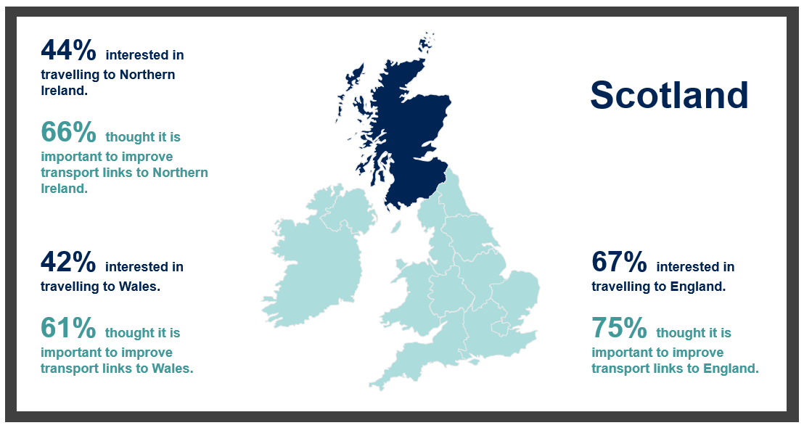Question wording: ‘Imagine there were no travel restrictions because of Coronavirus. How interested, if at all, would you personally be in travelling from Scotland to [nation]?’. ‘How important, if at all, do you think it is to improve transport links between Scotland and [nation]?’.
Source: Ipsos MORI. Base: 1,000 adults in Scotland aged 16-75 interviewed online, 9-19 March 2021.

Perceived importance and impacts of improved UK transport connectivity
Three quarters of people in Scotland (75%) believed improving transport links between Scotland and England is important. Even more likely than overall to say this were young people, who were also more interested than other age groups in travelling to England (84% of people aged 16-24 said this was important). The same was the case for people living further from the border with England (77% of people living more than fifty miles from the border) and those who had positive views of the UK (85% of those who said it was a ‘good thing’).
A lower, but sizeable majority, said it is important to improve transport links to Wales (61%, rising to 71% of people aged 16-24 who said this) and Northern Ireland (66%). When answering about both nations, as with the importance of improving transport links to England, perceived importance was greater among those who held positive views of the UK.
As well as a majority in Scotland believing it is important to improve transport links to other nations, adults in Scotland were more likely than those in other nations to anticipate positive differences would be made as a result to them personally (46% say this compared with 42% overall in the UK), the region in which they live (52% compared with 46%), to Scotland as a whole (67% compared with 63%) and to Scotland’s economy (67% compared with 60%). This may reflect the more negative opinions of Scotland’s transport links currently, a perceived need to improve them and a belief that this could have positive impacts nationally and locally.
However, people in Scotland were relatively more pessimistic about the impact on some of the aspects of quality of life that could potentially be improved by better UK connectivity, and the impact on the environment. For example, nearly a quarter of people in Scotland (24%) said improved transport links between nations would not make it easier for people to move to live elsewhere in the UK, rising to 29% of people aged 55-75. Twenty eight percent said access to job opportunities would not be improved very much, or at all – also higher than the UK average. Again, people aged 55-75 were even more likely to think this (36% said ‘not very much’ or ‘not at all’). People in Scotland were also more likely than the UK average to say improved inter-UK transport links would make a negative difference to carbon emissions (32% compared with 28% overall) and no difference to the natural environment (26% compared with 23% overall).

Priorities for investment in inter-UK transport links
Perhaps reflecting poorer views of how easy it is to travel within Scotland (compared to travel to and within other UK nations, people were more likely than the UK average to prioritise improvements to public transport and access to transport links. For example, adults in Scotland were more likely than in other nations to prioritise improving bus services (17% compared with the UK average of 14%), more frequent services, giving more choice about when to travel (18% compared with 16%), making it easier to get to major transport hubs such as airports and larger train stations (18% compared with 15%) and making it easier for people in more remote areas to travel (26% compared with 20%).

Wales

Travel to other UK nations in 2019
More than three quarters (77%) of people in Wales travelled to England at least once in 2019, and one in four (26%) made the journey at least once a month that year, which made the Wales to England route the most common travel route across all four nations in 2019. Around half travelled abroad – most commonly just once (22%) or twice (17%) during the year. Travel to Scotland (17% visited at least once) or Northern Ireland (9%) was comparatively rare, and mostly driven by younger adults travelling to those nations.
Those who travelled to another UK nation once a month or more often in 2019 were significantly more favourable towards the Union (78%) than those who did so just once (67%) or a few times (65%).
Men (30%) and those in work (29%) were more likely than average to have travelled from Wales to England at least monthly in 2019. People living in urban locations were no more likely than those in rural areas to have done so either frequently, or at all. However, those in close proximity to the English border were three times more likely than those living further from the border to travel to England at least once a month (47% of those living within twenty five miles compared with 15% living more than fifty miles from the border). Those in Wales who live further from the border with England typically travelled less frequently, with close to half (47%) travelling once every 3-6 months compared with 29% of those close to the border.
People in Wales who travelled to England did so for a variety of reasons, but most commonly to visit family and friends (51%), for a day trip (29%), to shop (28%), to go on holiday or for a leisure trip (both 26%). A further 15% travelled to England in order to go on holiday somewhere else from there (e.g. to an airport to fly overseas). Those in closer proximity to the border typically travelled to England for a wider variety of reasons than those living more than fifty miles away. Among the smaller group who travelled to Scotland in 2019, going on holiday (39%) was a more common reason for travel than visiting family or friends (27%). Of the minority of people in Wales who travelled to Northern Ireland (9% did this in 2019), around a third visited family and friends, and went on holiday there (33% and 32%, respectively).
By far the most common outbound mode of transport for those travelling to England in 2019 was car or van, either as a driver (54%) or passenger (40%), though close to one in four did so by train (23%). Those living in closer proximity to the English border were, relatively speaking, more likely to travel to England by car as a driver than those living further away. Similarly, inbound travel to Wales was undertaken most commonly by car or van as either a driver (48%) or passenger (37%), both higher than for any other nation. Travel to Wales from other UK nations by aeroplane, at 7%, was lower than for any nation in the UK, and more than two times less common than inbound journeys to Scotland by aeroplane (19%).

Ratings of journeys to other UK nations
By a margin of more than ten to one, people in Wales were more likely to rate the ease of making a journey to England as good (72%) than poor (7%). Those living more than fifty miles from the border were typically less positive than those in closer proximity when rating journeys to England based on the time taken, cost and ease of getting there. Meanwhile, older residents aged 55-75 tended to be more positive about journey cost and ease than younger residents.
Along with people in Scotland, those in Wales were among those most likely to agree that it is easier to travel to another nation in the UK than it is to travel to some places in their own nation, compared with those in England and Northern Ireland. They were also the most negative with regard to ease of internal travel, some 44% agreeing that it is harder to travel within Wales than it is for people to travel within other nations of the UK, compared with 24% who said this across the UK overall.

Interest in travelling to other UK nations
Interest in travelling to other nations (assuming no travel restrictions because of Coronavirus) was high, following the same pattern as 2019 travel. England was the most popular destination that Welsh residents were interested in visiting (80%), followed by Scotland (54%) and Northern Ireland (33%). While comparatively lower than stated interest in future travel to England, appetite for future travel to Scotland and Northern Ireland was far higher than actual travel to these nations in 2019.
      - Interest in travelling to other nations among adults in Wales, and perceived importance of improving transport links between Wales and other nations.
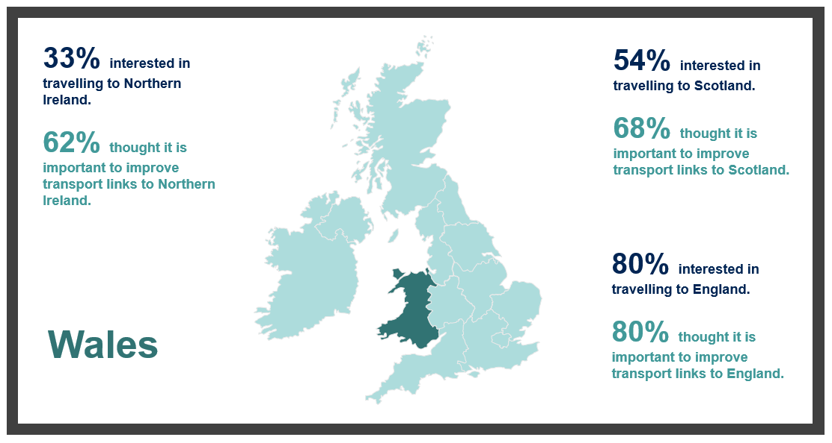Question wording: ‘Imagine there were no travel restrictions because of Coronavirus. How interested, if at all, would you personally be in travelling from Wales to [nation]?’. And: ‘How important, if at all, do you think it is to improve transport links between Wales and [nation]?’.
Source: Ipsos MORI. Base: 1,000 adults in Wales aged 16-75 interviewed online, 9-19 March 2021.

Perceived importance and impacts of improved UK transport connectivity
Four in five people in Wales (80%) believed improving transport links between Wales and England is important. Interestingly, those living further from the border with England were more likely to say improving transport links is important than those in closest proximity (85% compared with 77%), despite being less likely to have travelled to England frequently in 2019. Those in Wales with a positive predisposition to the Union were far more likely to think connectivity with England is important (87%), as were those in work (84%). While far more people in Wales considered it important to improve transport links to England than those who said it is not important (80% said ‘important’ compared with 15% who said ‘not important’), they were comparatively less likely to think it is important to improve transport links with Scotland and Northern Ireland. Sixty eight percent of people in Wales said it is important to improve transport links to Scotland (22% said it is not important), and 62% said this about transport links to Northern Ireland (26% said ‘not important’).
In Wales, enhanced transport links between nations of the UK were felt to make the most positive potential difference for Wales (71%) and the UK (68%) as a whole, and the respective economies of Wales (68%) and the UK (61%). Half of adults in Wales thought enhanced transport connectivity across the UK would benefit them personally (50%), and this was higher among younger adults aged 25-34 (64%), those in work (58%), and those who travelled at least monthly to another UK nation in 2019 (70%).
Relative to the rest of the UK, those in Wales were more likely to feel positively that improved transport links between UK nations would improve things like access to public services, entertainment, transport hubs and job opportunities. Across all of these categories, those aged 25-34 were among the groups most likely to feel improved transport links would improve these things a great deal or fair amount relative to the population in Wales overall. Seventy seven percent of adults in Wales in work thought access to job opportunities would be improved by better transport links between UK nations, compared with 62% of those not in work (which includes unemployed people, full-time parents, retired people and students).

Priorities for investment in inter-UK transport links
When thinking about ways to improve transport between the different nations of the UK, the modes that adults in Wales felt should be given highest priority were train services and rail stations (50%) and motorways or major roads (36%). People in Wales were, relatively speaking, more likely than the UK population overall to want improved local roads (34% compared with 30%) and improved bus services (19% compared with 14%) prioritised, while improving air travel/flights and airports was less likely to be seen as a priority (10% compared with 14% overall). Older people aged 55-75 in Wales were among those most likely to want improved roads – local and motorways/major roads – prioritised. Meanwhile, younger people aged 16-24 were more likely than other age groups in Wales to prioritise improved bus services (19% compared with 14% overall).
Like all other nations, journey affordability was the number one priority for adults in Wales regarding things that might improve journeys by air, by rail or by sea between the different nations of the UK. Close to half felt this should be given highest priority (49%). However, those in Wales were more likely to want access to major transport hubs (19% compared with 15% overall) and making it easier for those in more remote areas to travel (25% compared with 20%) to be prioritised compared with the UK population.
Journey affordability was a particular priority for women in Wales compared with men (53% compared with 43%, respectively), the latter being more concerned with journey speed by comparison (22% of men compared with 19% overall). Prioritising making journeys more environmentally friendly tended to be more important among younger rather than older people, while far more people in rural locations thought making it easier for those in more remote areas to travel should be a priority than those in urban locations (36% compared with 23%, respectively).

Northern Ireland

Travel to other UK nations in 2019
According to the telephone survey of adults in Northern Ireland, people here travelled to other parts of the UK in 2019 comparatively less than people in England, Scotland and Wales. Less than half made a journey to England (45%), including 16% who travelled there just once, 25% who made the journey once every 3-6 months and 4% who went once a month or more often. People in higher (A or B) social grades were more likely than overall to have travelled to England once every 3-6 months (33%), and those aged 35-44 were more likely than overall to have gone once a month or more (13%).
Travel to Scotland and Wales was less common than travel to England. Twenty eight percent of people made journeys to Scotland at least once, and only 6% travelled to Wales. This made people in Northern Ireland far more likely to have been abroad than to another UK nation. Sixty one percent did this, and of these people, 31% went abroad once every 3-6 months, 27% went just once and 3% went once a month or more (it should be noted that when responding about ‘travel abroad’, respondents may have answered based on travel to the Republic of Ireland).
Those who travelled to England were most commonly going to see family and friends (47%), particularly those in older age groups – 67% of those aged 55-75 who made a journey to England did so for this reason. Over one in five (23%) travelled to England for leisure, such as a sporting event, going to the theatre or a concert. Journeys to Scotland were most commonly made for the same reasons. Thirty five percent travelled there to see family and friends – rising to 52% among people aged 55-75 – and 29% visited for leisure.
Aeroplane was by far the most commonly used mode of transport used to travel to England in 2019 – 83% travelled this way, compared with only 11% who travelled by ferry as a driver or passenger in a car, and 6% who travelled by ferry as a foot passenger. In contrast, far fewer people travelled by aeroplane to Scotland, and the ferry was more commonly used. Forty six percent of people who travelled to Scotland made their journey by aeroplane, 35% by ferry as a driver or passenger and 20% by ferry as a foot passenger. Indicative figures for the small minority who travelled to Wales suggest around half travelled by aeroplane, and half took the ferry.

Ratings of journeys to other UK nations
Ratings of journeys made to Scotland were broadly similar to ratings of journeys made to England for ease, cost and time. This is despite travel to England being more common than travel to Scotland (from Northern Ireland) generally, and despite aeroplane being a more widely used mode of transport used to reach to England than Scotland. Ratings of journeys to Wales were much poorer, by comparison, reflecting lower travel volumes there. As with people in other UK nations, adults in Northern Ireland were more negative about the cost of journeys to other nations, than ease of travelling, or the time taken to make journeys there.
People in Northern Ireland were more likely to disagree than agree with the statement ‘It is easier to travel to another nation in the UK than it is to travel to some places in Northern Ireland’. Over half disagreed (55%), including 29% who said they strongly disagree, while 29% said they agree. This contrasts with findings from the online survey of people in other UK nations, who were more likely to agree than to disagree with the statement.

Interest in travelling to other UK nations
In the absence of travel restrictions because of Coronavirus, over two thirds of adults in Northern Ireland would be interested in travelling to England (67%) and Scotland (69%). Interest was higher among those who had travelled to these nations in 2019. Fewer people were interested in travelling to Wales in future (36%), but this was still much higher than the proportion who did travel to Wales in 2019 (6%).
      - Interest in travelling to other nations among adults in Northern Ireland, and perceived importance of improving transport links between Northern Ireland and other nations.
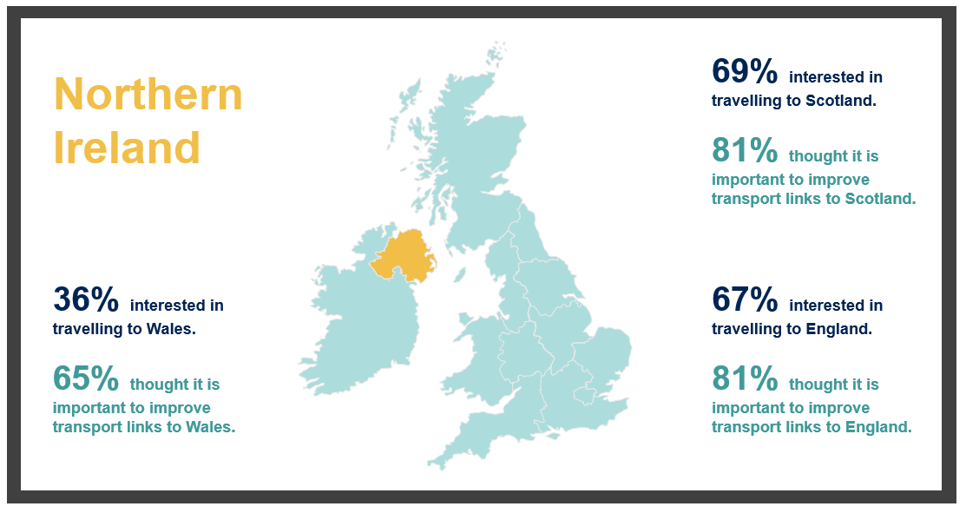Question wording: ‘Imagine there were no travel restrictions because of Coronavirus. How interested, if at all, would you personally be in travelling from Northern Ireland to [nation]?’. ‘How important, if at all, do you think it is to improve transport links between Northern Ireland and [nation]?’.
Source: Ipsos MORI. Base: 500 adults in Northern Ireland aged 16-75 interviewed by Computer Aided Telephone Interviewing, 12 March – 11 April 2021.

Perceived importance and impacts of improved UK transport connectivity
In Northern Ireland as in other UK nations, perceived importance of improving transport links reflects the nations most commonly travelled to in 2019, and future interest in travelling to other nations. Eighty one percent of adults considered it important to improve transport links to England – people in Northern Ireland were also more likely to have travelled to England than other nations in 2019, and over two-thirds (67%) were interested in doing so in future.
The same proportion considered it important to improve transport links to Scotland (81%), and 69% were interested in travelling to Scotland in future. ‘Importance’ and ‘interest’ figures for Wales were lower by comparison, but not insignificant – 65% said it is important to improve transport links to Wales, and 36% were interested in travelling there.
People were more likely to say that improved transport links between UK nations would make a positive difference at the national level for Northern Ireland (85%) and to the Northern Ireland’s economy (88%), than they were to say it would make a positive difference to them personally (70%) or for the region they live in (74%). In common with UK adults more widely, people in Northern Ireland were more pessimistic about the impacts on the environment. Thirty percent said improved inter-UK transport links would have a negative impact on the natural environment of the UK, including landscapes and natural habitats, and 36% said the same about reducing carbon emissions in the UK.
The aspect of quality of life which people most commonly felt would be improved a great deal or a fair amount by better inter-UK transport links was access to important transport hubs such as airports and larger train stations (88% said this). Eighty five percent said that access to job opportunities would be improved a great deal or a fair amount, and 84% said the same about access to entertainment and the arts (such as theatres, galleries, museums, sporting events, music events and concerts), rising to 93% among those aged 18-34 years. Eighty one percent said the same about making it easier for people to move to live in other places in the UK, and 81% said the ability for them personally to travel to go on holiday somewhere in the UK would be improved a great deal or a fair amount (higher among people aged 18-34, 90% of whom said this).
In general, the results of the telephone survey of people in Northern Ireland, when interpreted with the nation-filtered results from the online survey of UK adults, suggest people in Northern Ireland were more optimistic than in other UK nations about the potential for positive changes to quality of life as a result of improved inter-UK transport links.

Priorities for investment in inter-UK transport links
Reflecting transport modes most commonly used to travel between Northern Ireland and other nations, improvements to air and ferry travel were more of a priority for improvement than in other parts of the UK. Thirty eight percent said improving air travel, flights and airports should be given highest priority, and 26% said improving ferry services and ports should be top priority. Other modes of transport were considered important to prioritise by adults in Northern Ireland too. Thirty percent said this about improving train services and stations, and similar proportions said that improving motorway or major roads (31%) and local roads (29%) should be given highest priority. As with people in other UK nations, making journeys more affordable was the top priority (55%), followed by making ticket prices more consistent regardless of how far in advance you book (28%), making it easier for people in more remote areas to travel (28%) and more frequent services, giving more choice about when to travel (27%).

Introduction and methodology
This report presents findings from a study conducted by Ipsos MORI on behalf of the Department for Transport (DfT) to contribute evidence in support of the Union Connectivity Review (UCR). The Review is planning infrastructure investment and strategic priorities to improve connectivity and will make use of evidence about travel patterns between the UK’s nations travel as well as people’s priorities for improving inter-UK transport and travel.
Following an initial stage of small-scale qualitative research, Ipsos MORI conducted a UK-wide online survey during March 2021 and a survey of adults in Northern Ireland interviewed in March – April 2021 via Computer Aided Telephone Interviewing (CATI).
The research gathered evidence on travel patterns between UK nations in 2019 – the last full year before the outbreak of the Coronavirus pandemic – including frequency of journeys made, journey purpose and transport modes used. The surveys also measured views of the ease, costs and time it takes to make journeys between and within UK nations, and interest in travelling to other UK nations in future, assuming travel restrictions are eased. Respondents gave their views on the importance of improving transport links between UK nations and the potential impacts of this nationally, locally and personally, as well as the potential to deliver economic, environmental, social and quality of life benefits. They were asked to consider priorities for investment in improvements to inter-UK transport links, both in terms of types of transport mode and infrastructure, and other factors influencing journey experiences, including affordability, reliability and comfort of travel.

Qualitative research
Ipsos MORI conducted small-scale qualitative research between 16 and 25 February 2021. Six online video discussion groups were conducted, each group attended by participants recruited from a different nation and/or region. Discussion groups were held with participants from Scotland, Wales, the North of England, the South West of England, the West of Northern Ireland and the East of Northern Ireland (including Belfast).
Participants were ‘purposively’ sampled according to a range of demographic criteria and screening questions relating to their past travel patterns to allow groups to be attended by people with a range of experiences and views on the topic.
Fieldwork was conducted during February 2021. Each discussion group lasted two hours and was facilitated by an Ipsos MORI researcher using a semi-structured topic guide.
The purpose of the discussion groups was to the begin to explore the topic of inter-UK travel and transport connectivity across the UK and to inform questionnaire design for the quantitative surveys. The discussions provided an opportunity to ‘test’ key terms and question formulations – for example, discussing the term ‘union connectivity’, which was generally not a salient concept to participants, who tended to talk more in terms of ‘transport links’ between UK nations (hence this term was incorporated into the survey questionnaire).
Findings from the groups have also provided context, and generated detail, which helps illustrate some of the survey findings contained within this report. As such, verbatim quotes and insights have been included in this report.
Following the analysis of results from the two surveys conducted for this study (outlined below), Ipsos MORI conducted sixteen in-depth interviews to further explore key findings. Participants who had taken part in the survey and agreed to be recontacted were purposively sampled based on their survey responses and a range of demographic criteria. For example, four interviews each were conducted with participants in England, Wales, Scotland and Northern Ireland, including people who had travelled frequently to other nations, infrequently, or not at all.
Interviews were conducted by telephone or online in June and July 2021. Each interview lasted around one hour and was conducted by an Ipsos MORI researcher using a semi-structured topic guide.
The purpose of the interviews was to hear a diverse range of attitudes, travel experiences and priorities for UK transport connectivity. For example, the interviews explored in detail the barriers to travel among those who did not visit another UK nation at all in 2019, and the enablers which might encourage them to do so in future. The discussions also gathered contextual information about participants’ travel to other UK nations to uncover the factors shaping their views on the importance of future investment in improved inter-UK transport links.
The discussions generated personal ‘stories’ which add colour to the study findings – these can be found in ‘Personal stories of inter-UK travel’, which presents overall interview findings, along with eleven pen portraits.
Further details of the profile of the qualitative sample for discussion groups and in-depth interviews, can be found in the appendices.

Survey methodology
Ipsos MORI conducted an online survey of 3,700 UK adults aged 16-75 years old between 9 and 19 March 2021. Sampling was structured to secure representative samples of 1,500 in England, 1,000 in Scotland and 1,000 in Wales, plus a small booster sample of 200 Northern Ireland.
The Northern Ireland booster sample was weighted (along with the samples for England, Wales and Scotland) to generate a representative sample at the UK level. It did not produce a nationally representative sample of Northern Ireland, which is more robustly achieved using a telephone methodology, the sample for which allows demographic quotas to be met more rigorously in this (smaller) nation. Therefore, in order to secure a nationally representative sample of respondents in Northern Ireland, an additional survey was conducted by telephone between 12 March and 11 April 2021, in which 500 adults aged 18+ were interviewed. This ensured all UK nations were represented in the survey research at both national and UK levels.
Commentary on Northern Ireland presented throughout this report is based on the telephone survey, while UK-wide findings make exclusive use of data collected online to allow robust comparisons to be made. (Where UK survey data are presented, this includes the Northern Ireland booster sample of 200 respondents). It is important that these differences in survey methodology are borne in mind when making comparisons between findings from the telephone survey, an interviewer administered approach, with the online survey, a self-completion survey mode.
Quotas for the online survey were set by age, gender, working status and social grade (with the addition of Government Office Region in England). Quotas for the telephone survey of adults in Northern Ireland were set by age, gender, social grade, community background and local government district. Data for both surveys were weighted to the known population profile using Census and other data sources and in accordance with the size of their respective populations.

Fieldwork dates and ‘lockdown’ restrictions
During survey fieldwork, travel restrictions were in place across the UK due to the COVID-19 pandemic. Many of these restrictions were originally introduced at the start of ‘lockdown’ in March 2020 and were updated according to national timetables to manage infection rates.
        - Dates of research conducted for the study
Research activity | Fieldwork dates
Qualitative discussion groups | 16 – 25 February 2021
Online survey of UK adults | 9 – 19 March 2021
Telephone survey of adults in Northern Ireland | 12 March – 11 April 2021
Qualitative in-depth interviews | 28 June – 1 July 2021
Over the course of the fieldwork for this study, in 2021, several changes to travel restrictions took place in each nation.
In England, the Government published a Roadmap out of Lockdown on 22 February 2021, mapping out the lifting of restrictions in four steps throughout Spring. A full national lockdown was in place until 29 March, though schools were allowed to reopen on 8 March. The ‘stay at home’ rule ended in England on 29 March, allowing gatherings of up to six people or two households outdoors, as well as some outdoor sports and business activities. Other restrictions, such as working from home and prohibition of travel abroad, were still in place until 12 April.
In Scotland, a full national lockdown was in place during fieldwork, and on 16 March, the First Minister set out a timetable for the re-opening of parts of society until the end of May. From 2 April, the ‘stay at home’ guidance was updated and replaced with guidance to ‘stay local’, with hairdressers, garden centres and non-essential click and collect services open from 5 April.
In Wales, a full national lockdown was in place during fieldwork, with restrictions eased from 13 March, amending the ‘stay at home’ rule to ‘stay local’. A maximum of 4 people were then allowed to meet outdoors from 2 different households. A full Coronavirus control plan was set out by the Welsh Government on 19 March, with the ‘stay local’ restrictions lifted on 25 March, allowing six people to meet outdoors.
In Northern Ireland, a full national lockdown was in place until 1 April. However, primary schools reopened from 22 March, with secondary students returning for face-to-face teaching from 12 April. On this date, further restrictions were eased, with the ‘stay local’ message replacing the ‘stay at home guidance’, and a total of 10 people allowed to meet outdoors from two separate households.
In the survey, respondents were asked about their travel to other UK nations in 2019 – the last full year before the outbreak of the pandemic in the UK – and their interest in travelling to other UK nations in the future if there were no travel restrictions. The impact of COVID-19, the publication of the nations’ plans out of lockdown and differing restrictions during fieldwork should be considered when analysing these responses.

Interpretation of findings and statistical reliability
As this is a sample of the population, all results are subject to sampling tolerances (or ‘margins of error’) which means that some differences may not be statistically significant. As a broad guide, results for individual nations have a margin of error of 2-4 percentage points at the 95% confidence interval (depending on the percentage) when compared with results at the UK level..
For the online survey, an overall sampling tolerance of +/- 1.6 percentage points for a 50% finding at the ‘95% confidence interval’ can be expected. This will vary for sub-groups and geographies according to their sample sizes. Data are presented for each nation, and statistically significant differences between nations are reported in the commentary in this report. For all other subgroup analysis (for example between demographic subgroups and the total sample), commentary focuses only on statistically significant differences. The analysis of data, therefore, draws out different subgroups, but it is important to recognise that differences among groups are likely to reflect numerous, overlapping factors – for example, frequency of travel to other UK nations and living nearer or further from a national border.
Subgroup analysis according to respondents’ demographic characteristics includes commentary on differences between ‘ABC1’ and ‘C2DE’ social grades (where these are statistically significant). These classifications are based on the occupation of the chief income earner in the household. ABC1 represents higher social grades, while C2DE represents lower social grades.
Where percentages do not sum to 100, this may be due to computer rounding or questions that allow respondents to choose more than one response. This is also the case in terms of combinations not summing to their constituent parts, e.g. the percentage who said they were very interested in travelling to England and the percentage who said they were fairly interested in travelling to England summing to the percentage who said they were ‘interested’.
Qualitative findings in the report are descriptive and illustrative, not statistically representative.

Travel between UK nations in 2019
This chapter outlines inter-UK travel patterns in 2019 – the last full year prior to the outbreak of the COVID-19 pandemic. Travel to England was the most common, while the public travelled to Wales, Scotland and Northern Ireland less frequently than making journeys abroad. Journeys to England were also rated most favourably in terms of ease, time and cost of travelling there from other UK nations, and Northern Ireland was rated the least favourably. In general, journeys to other UK nations were more often made to visit family and friends or to go on holiday than for other reasons, and car travel predominated.

Inter-UK travel in 2019
Before the outbreak of the Coronavirus pandemic, 45% of people in the UK travelled to another UK nation at least once during 2019, and travel between nations tended towards England. By contrast, visiting Wales, Scotland or Northern Ireland was far less common than going abroad. Twenty eight percent of people in the UK travelled abroad once every 3-6 months, and nearly as many did this once during the year (25%), exceeding the proportion who travelled to England once in 2019 (20% of people in Scotland, Wales and Northern Ireland).
      - Frequency of travel to other UK nations in 2019
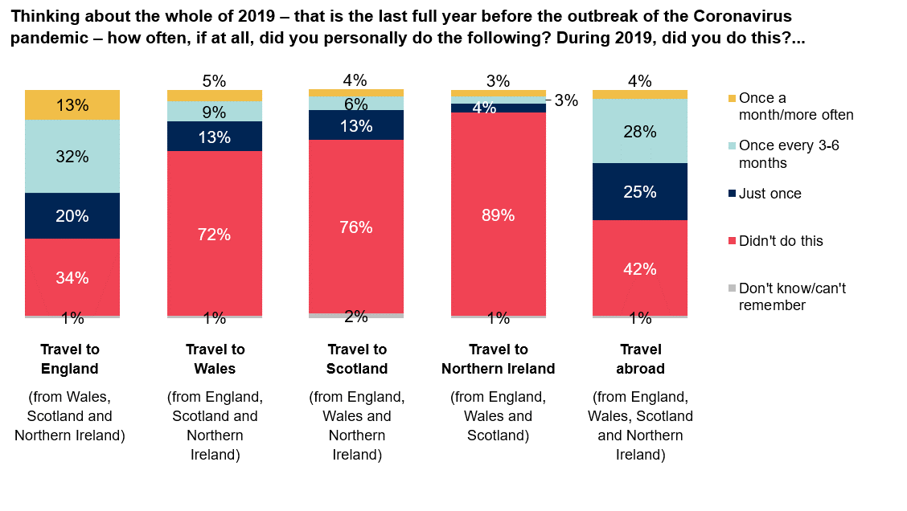Source: Ipsos MORI. Base: 3,700 UK adults aged 16-75 interviewed online, 9-19 March 2021, including 1,500 adults in England, 1,000 adults in Scotland, 1,000 adults in Wales and 200 adults in Northern Ireland.
Nearly two thirds of people travelled to England from other nations at least once in 2019 (64%), compared with 22% who travelled at least once to Scotland, 27% to Wales, 10% to Northern Ireland and 57% who travelled abroad. Inter-UK journeys were most commonly made from Wales or Scotland to England. By comparison, journeys between Northern Ireland and Wales or Scotland were much less commonly made in 2019.

        - Travel between UK nations in 2019 based on journeys made at least once.
Travelled at least once in 2019 |  | Nation | travelled | From:
 | All other UK nations | England | Wales | Scotland | Northern Ireland*
Nation travelled to:
England | 64% | - | 77% | 60% | 45%
Wales | 27% | 29% | - | 12% | 6%
Scotland | 22% | 22% | 17% | - | 28%
Northern Ireland | 10% | 10% | 9% | 14% | -
Abroad | 57% | 57% | 49% | 59% | 61%
Source: Ipsos MORI. Base: 3,700 UK adults aged 16-75 interviewed online, 9-19 March 2021, including 1,500 adults in England, 1,000 adults in Scotland, 1,000 adults in Wales and 200 adults in Northern Ireland.
*Results for Northern Ireland are presented based on a survey of 500 adults aged 18+ interviewed by Computer Aided Telephone Interviewing, 12 March – 11 April 2021.
Visiting family and friends and going on holiday were popular reasons for respondents’ last journey made to other UK nations in 2019.
The most common reason for travelling to England was to visit family and friends (50%), followed by going on holiday (28%) and leisure (including going to a sporting event, the theatre or to a concert – 23%). This also applies to journeys made to Wales, Scotland and Northern Ireland, though day trips were relatively more common reasons for travelling to these nations. Going on holiday was also a relatively more common reason for journeys made to Wales (41%) and to Scotland (40%). Meanwhile, travel to Northern Ireland was more likely than journeys to other nations to be for business (17%) and personal business (e.g. to attend an appointment – 21%).
      - Reasons for the last journey made to UK nations in 2019
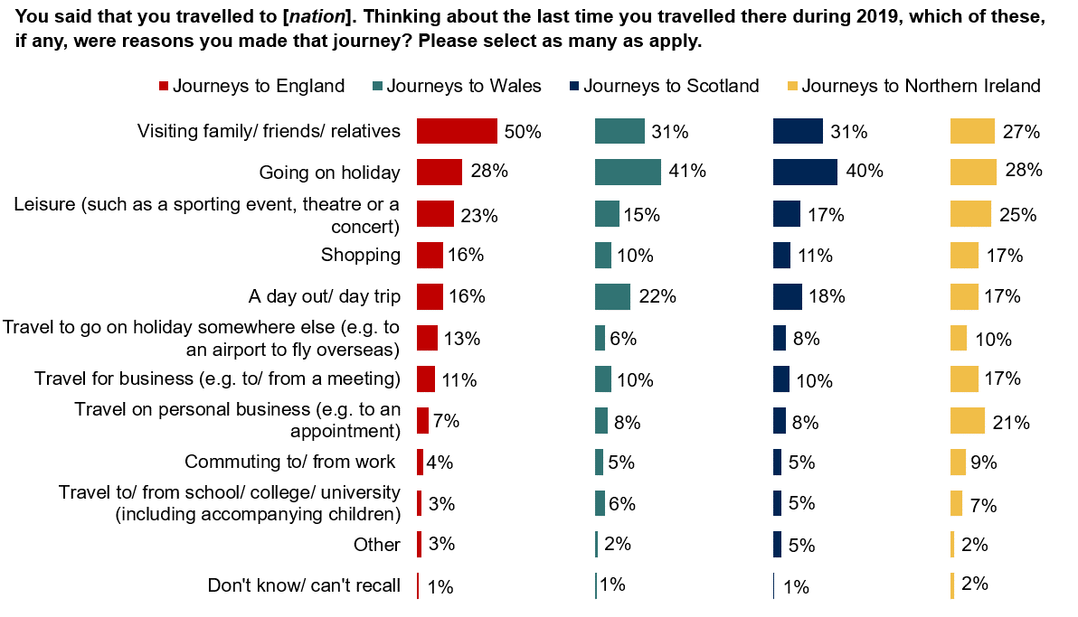Source: Ipsos MORI. Base: UK adults aged 16-75 interviewed online, 9-19 March 2021, who travelled to another nation in 2019. Including 1,489 adults who travelled to England, 568 adults who travelled to Scotland, 561 adults who travelled to Wales and 342 adults who travelled to Northern Ireland.
Participants in qualitative discussion groups and in-depth interviews described the journeys they had made to other UK nations, sharing a range of experiences and preferences regarding inter-UK travel compared with travel abroad (see ‘Personal stories of inter-UK travel’ for individual UK travel ‘stories’). Those who had made journeys to other UK nations had done so for reasons that reflect the survey findings. For example, participants recounted regular journeys to visit family, or even friends at university in other nations. Some made day trips or shopping visits to other nations, especially if they lived close to the border. One participant was heavily reliant on journeys from Wales into England for specialist children’s healthcare, and some travelled for work, including attending meetings, conferences or to play sport professionally.
Some visited other UK nations for holidays – although these journeys tended to be made less often, they were no less important to participants’ quality of life than travelling for other purposes.
“I live in a town in North Wales… [We are going to Northern Ireland] for two weeks to look after our father and mother-in-law. We do this three or four times a year.”
Male, 73, Wales
Even among those who seldom left their local area, some discussion group participants, however, mentioned they would rather go abroad for a holiday than travel to another part of the UK. They explained this was because of better weather and cheaper accommodation abroad, and affordable short haul flights compared to costly rail tickets in the UK.
“If I could go to Spain or Scotland, I’d go to Spain – the cost is a big factor.”
Male, 21, England
Survey findings show that those who had travelled to England, Wales or Scotland in 2019 were more likely to have made their journey by car or van than any other transport mode (respondents were asked to select all modes of transport used for any part of their journey). Over two in five (41%) had made their last journey to England in 2019 by car or van as the driver, and 30% had travelled this way as passenger. An even greater proportion had travelled this way to Wales (48% drove, and 37% travelled as a passenger, in a car or van).
Rail was more commonly used as a transport mode to reach England and Scotland, than Wales or Northern Ireland. Twenty seven percent of those who had visited England in 2019 travelled by rail as part of their last journey, rising to 34% among people travelling to England from Scotland. Twenty eight percent travelled to Scotland from other nations by rail. This compares to 20% who travelled to Wales this way, and 21% who used rail to reach Northern Ireland.
People were more likely to have travelled by aeroplane to Northern Ireland than any other UK nation (45% travelled this way), and aeroplane was more commonly used than the ferry.
Participants in qualitative group discussions explained it was quicker and cheaper to travel by aeroplane to and from Northern Ireland, and this transport mode offered greater comfort than the ferry, although some were guided by whichever mode offered cheaper tickets at the time of booking. Some also pointed to the lack of a direct ferry route between Wales and Northern Ireland. They suggested it was more common for people making this journey to travel via England and/or Scotland by aeroplane and other transport modes, than it was to take the ferry between Holyhead (North Wales) and Dublin, before travelling into Northern Ireland from the Republic.
      - Methods of transport used for the last journey made to UK nations in 2019
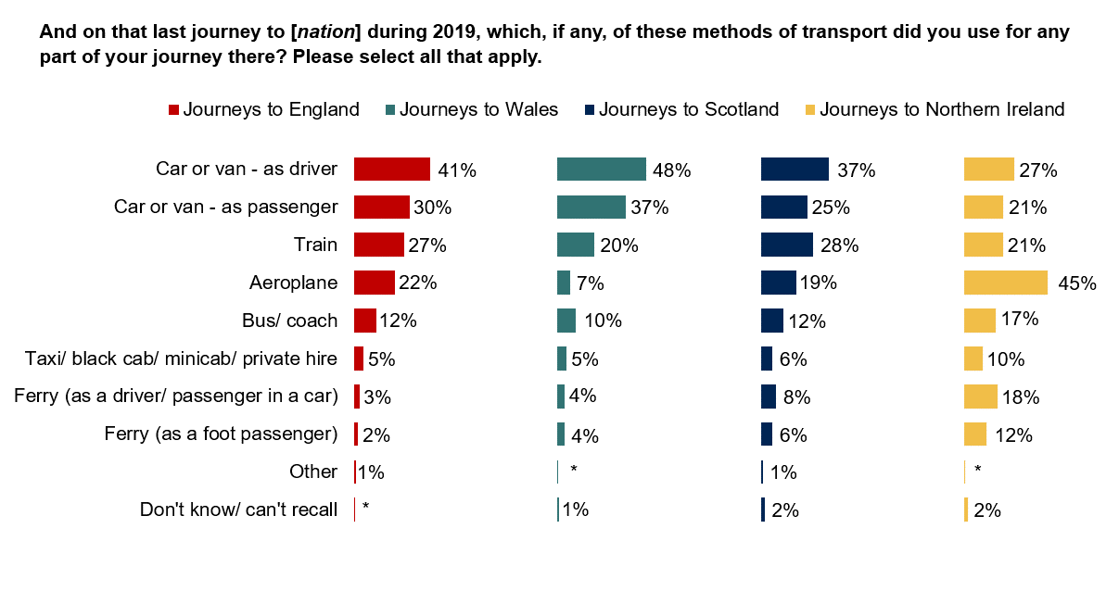Source: Ipsos MORI. Base: UK adults aged 16-75 interviewed online, 9-19 March 2021, who travelled to another nation in 2019. Including 1,489 adults who travelled to England, 568 adults who travelled to Scotland, 561 adults who travelled to Wales and 342 adults who travelled to Northern Ireland. An asterisk (*) indicates a figure less than 0.5%, but greater than zero.

Differences in inter-UK travel by demographic groups, journey frequency and nation
Proximity to the border of another UK nation, and access to a motor vehicle (the most commonly used transport mode to reach England, Wales and Scotland), were closely linked to travel between nations.
In all four UK nations, those living within twenty five miles of a national border were among the groups most likely to have travelled to another nation once a month or more in 2019. In general, people living closer to a national border also made their journeys for different reasons to the wider public (whose most common reasons for travel were visiting relatives and friends and going on holiday). For example, they were more likely than overall to have made their last 2019 journey to another UK nation for their commute, to travel to or from a place of education, to go shopping or for a day trip – journeys which tend to be made often (compared to holidays, for example). Certain journey purposes may also be reflected in the demographic groups which are also typically most likely to have travelled once a month or more to other nations in 2019. Among these are younger people (who may be travelling to school, college or university), and people in employment (who may be travelling for work).
Meanwhile, those living more than fifty miles from a border, and those without access to a motor vehicle, were more likely than overall to say they had not travelled to all three other UK nations at all in 2019. (The exception was travel to Northern Ireland – most commonly reached by aeroplane – where access to a motor vehicle made no difference to frequency of travel there).
Whereas younger people and those in employment were generally more likely than overall to have travelled frequently or infrequently (once every 3-6 months) to other nations, the converse was the case for ‘non-travellers’ to other nations. Older people, those in lower social grades (D and E) and people who were not working were less likely than overall to have travelled at all to any other UK nation in 2019.

Demographic differences in the types of journeys made to other nations
Where subgroup bases are large enough for analysis, there are some discernible differences by destination nation in the groups most likely to have travelled there in 2019, and their reasons for travel. Older people aged 55-75 were, for example, more likely than other age groups to have travelled to other nations for the types of journeys which are made less often, such as going on holiday or visiting family and friends. Meanwhile younger people aged 16-34 were among the groups more likely to travel to other nations for journeys that are typically made more often, such as shopping or for education, and men were more likely to visit for leisure reasons, including sporting events, theatre and concerts.
In common with journeys made to other UK nations, visiting family and friends and going on holiday were popular reasons for travel to England. Half of those who made a journey to England did so to visit family and friends on their last journey in 2019 (50%), and this was higher among those aged 55-75 (55%).
Meanwhile, younger people in other UK nations were especially more likely than overall to travel to England to go shopping (26% of 16-24 year olds compared with 16% overall). People aged 45-54 were more likely than overall to have made this journey for business (16% compared with 11% overall), and men were more likely to have visited England for leisure, including sporting events, going to theatre or a concert (27% compared with 23% overall).
Travel to England from Wales was more common and frequent than from Scotland or Northern Ireland. Twenty six percent of people in Wales travelled to England once a month or more in 2019 (compared with 7% of people in Scotland and 4% in Northern Ireland). People in Wales were more likely than any other nation to have made their last journey in 2019 to England for day trips (29%), shopping (28%) and leisure (26%), travel to go on holiday somewhere else (15%) and commuting (6%). The top reason for travelling from Wales to England, however, was visiting family and friends. Fifty one percent of people in Wales did this for their last 2019 journey, rising to 57% among those in ABC1 social grades in Wales.
Levels of travel to Scotland and Wales were much lower than travel to England. Among those who did travel to these nations, their last 2019 journey was most commonly made for a holiday. Forty one percent of visitors to Wales and 40% of visitors to Scotland travelled for this reason, rising to nearly half among people aged 55-75 (47% of this age group who travelled to Wales, and 49% to Scotland).
As with journeys made to England, younger people aged 16-24 were more likely to have visited Scotland to go shopping (23% compared to 11% overall), or a day trip (29% compared with 18% overall).
Younger people were also more likely than older groups to have made their last 2019 journey to Wales to go shopping (21% of people aged 16-24 compared with 10% overall). Likewise, people aged 16-24 were more likely than older people to have visited Wales to travel to or from their place of education (11% compared with 6% overall), for leisure (26% compared with 15%) or for travel on personal business (15% compared with 8%). This is largely driven by the age profile of, and reasons for journeys made by, people travelling from England to Wales. Adults in England aged 16-24 were twice as likely to have travelled to Wales for school, college or university (including accompanying children) than those in England overall (11% compared with 6% overall), for leisure (25% compared with 15%) or to shop (22% compared with 10% overall).
Journeys to Northern Ireland from other UK nations were most commonly made for holidays (28%), visiting family and friends (27%) and leisure (25%). As with travel to England, men were more likely than women to visit for leisure, including going to sporting events, the theatre and concerts: 31% of men vs 14% women. It was adults aged 25-34 who travelled the most for holidays (48%). People in Scotland were also more likely to have visited Northern Ireland for a holiday (34%) than people living in other UK nations.

Views of journeys made to other UK nations
Survey respondents were asked to rate journeys between their own nation and each other UK nation (irrespective of how frequently they had travelled there in 2019) according to the ease of making a journey to get there, the cost of doing so and the time it takes to make a journey to get there.
Ratings were generally most positive for ease, followed by time, with cost rated the least positively. Ratings of journeys to other nations also reflected 2019 travel patterns. England (the most travelled to nation) received the most positive ratings, and Northern Ireland the least, suggesting perceptions of journeys to other nations are linked to experience. When rating journeys to Wales, Scotland and Northern Ireland, significant proportions said they did not know, or ‘it depends’, which may reflect lower volumes and frequency of travel there compared with England.
      - Ratings of journeys to other nations according to ease, time and cost of making journeys there
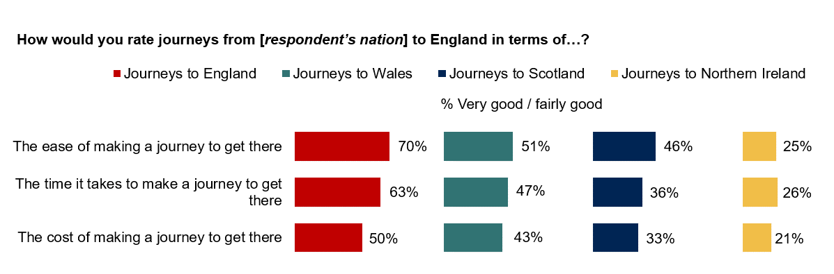Source: Ipsos MORI. Base: 3,700 UK adults aged 16-75 interviewed online, 9-19 March 2021, including 1,500 adults in England, 1,000 adults in Scotland, 1,000 adults in Wales and 200 adults in Northern Ireland.
England received the most positive ratings for all three criteria, followed by Wales, then Scotland and Northern Ireland, which received the least positive ratings of journeys there. This pattern mirrors levels of travel to other UK nations – with England the most travelled to, and Northern Ireland the least.
Seven in ten rated journeys to England positively in terms of ease (70%), with 27% who said this was very good. Positive ratings rose to 79% among those who had travelled to England in 2019. This figure was also higher among those with access to a motor vehicle (72%) and those living within twenty five miles of a border (81%) – groups that were also more likely to have travelled to England in 2019.
Ease of travel to Wales was rated positively by half of respondents (51%), rising to 54% of those in (neighbouring) England. This is almost double the proportions in Scotland and Northern Ireland saying the same (26% and 23%, respectively). Meanwhile, people in Northern Ireland were more likely than those in Wales and England to rate ease of travel to Scotland as very or fairly good. Seventy three percent in Northern Ireland (interviewed by telephone) said this, compared with 46% of UK adults overall (responding online).
The time it takes to travel to UK nations was again perceived to be best when considering travel to England, the most travelled to nation in 2019. Sixty three percent of UK adults said the time it takes to travel to England is good (22% said ‘very good’), rising to 69% among people in Wales – the most likely to have travelled to England at all in 2019.
Just over a third (36%) rated travel time to Scotland positively, compared with 26% who did the same for travel to Northern Ireland. Travel-time to Scotland was considered better amongst those in Northern Ireland (compared to those from England or Wales), and travel-time to Northern Ireland was considered better among those in Scotland.
Despite relatively high levels of travel to England in 2019, only half said the cost of travelling to England was good (50%). This was much lower when considering travel to Northern Ireland. Twenty one percent rated the cost of journeys to Northern Ireland positively, compared to a third (33%) who said this about the cost of journeys to Scotland, and 43% who said this of journeys to Wales. Those without a car were among the groups most likely to give negative ratings of the cost of travel to both England and Wales.
Across all three criteria, ratings of travel to Wales, Scotland and Northern Ireland had higher proportions saying ‘don’t know’ or ‘it depends’ than ratings of travel to England, likely reflecting the greater volume of journeys made by respondents to England than other UK nations.
In general, those who travelled to other nations frequently, and who are employed, in younger age groups, living near a border, and with access to a motor vehicle were more likely to give positive ratings for journeys to other nations based on cost, ease and time. These are also the groups most likely to have travelled to other nations in 2019, suggesting experience of travel is linked to more positive views. Those who did not travel to another UK nation in 2019 are no more likely to hold negative views, but are far more likely to respond ‘I don’t know’ or ‘it depends’.
Participants in qualitative discussion groups had different experiences and perceptions of travel to other nations – many travelled to other nations as often as they wanted and needed to, with no significant barriers. However, some explained that cost and time had been key factors determining whether to make a journey to other nations and which form of transport to use.
“I’d like to visit friends at different universities, in Scotland, in England. But I need to book it with four weeks’ notice. It gets too expensive as you get closer and becomes a hassle to arrange. I can’t just go tomorrow or next weekend.”
Female, 21, Wales
Participants – especially those outside of England – explained the high cost of rail tickets was barrier to travel. Travelling by car may afford greater comfort and convenience but takes far longer than the train to make journeys between England and Scotland, for example. They also described other barriers to travelling by train, including the need to book tickets in advance, changes in ticket prices depending on the time booked and needing to change trains several times, which was off-putting and inconvenient.
“I’ve only been [to Wales] a couple of times. It’s a fair drive, it’s not the easiest place to get to and it’s a long distance to get there. Rail is difficult, and with the changes it’s too complex and not viable.”
Male, 47, Scotland
Survey results indicate that national perspectives varied in terms of perceived ease of making journeys to other nations compared with journeys within respondents’ own nation. Over a third of UK adults (37%) said it is easier to travel to another nation in the UK than it is to travel to some places within their own nation, but 24% disagreed, and 29% had no feelings either way. The proportion who agreed with the statement rose to half of adults in Scotland (50%) and Wales (51%) – both more rural nations and travelled to much less than England in 2019. This sentiment was also more widely held among the groups most likely to have travelled to other nations once a month or more often in 2019 – for example those living within twenty five miles of a border (52%) and those in work (40%).
Nearly a quarter of UK adults (24%) considered it harder to travel within their own nation than it is for people to travel within other UK nations, although a greater proportion (31%) disagreed with this statement and 30% had no feelings either way. Again, those most likely to agree were in Scotland (31%) and Wales (44%). However, views in Scotland were more split, where a similar proportion (37%) did not agree with the statement.
      - Views of travel to other UK nations compared with travel within respondents’ own nation
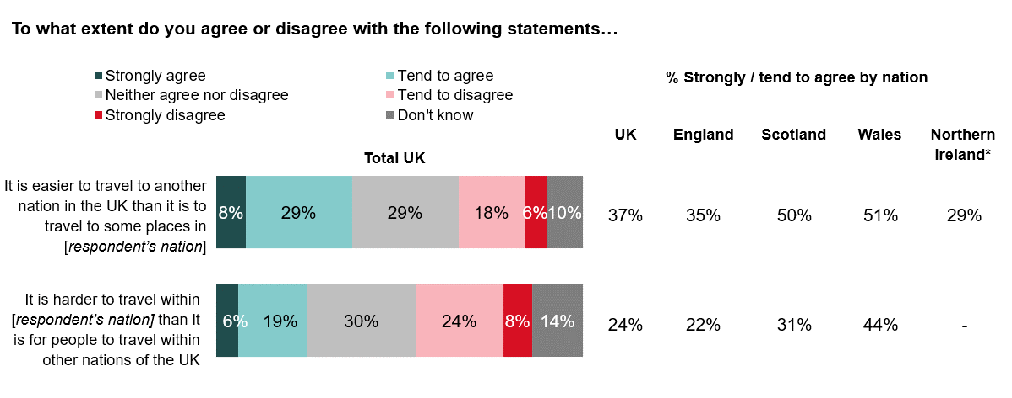Source: Ipsos MORI. Base: 3,700 UK adults aged 16-75 interviewed online, 9-19 March 2021, including 1,500 adults in England, 1,000 adults in Scotland, 1,000 adults in Wales and 200 adults in Northern Ireland.
*Results by nation for Northern Ireland are presented based on a survey of 500 adults aged 18+ interviewed by Computer Aided Telephone Interviewing, 12 March – 11 April 2021. Figures for Northern Ireland are not presented where this statement was not asked in the survey.
These findings echo the opinions shared in qualitative discussion groups, where some participants in Wales, Scotland and Northern Ireland felt that England’s transport network compares favourably to that of their own nations, in terms of road and rail infrastructure, and cost of travel.
Participants also described the challenge of reaching remote parts of their nation – particularly outside of England, but also with reference to rural English regions such as Cornwall – and reaching the main transport hubs to take the train, ferry or airplane to another nation. For example, in the West of Northern Ireland, reaching the airport in Belfast was described by some as more difficult than the onward journey by aeroplane to another nation. They explained this is due to expensive airport parking and a lack of direct buses from areas in the West to Belfast airport. In some cases, this framed opinions that local transport links should be prioritised for investment, not just new links between nations.
“There’s no such thing as going to the airport [in Belfast] and jumping on the train. Some of the buses don’t go to the airport either.”
Female, 55, Northern Ireland

Interest in future travel to other UK nations
This chapter presents respondents’ stated interest in travelling to other UK nations if there were no travel restrictions because of Coronavirus. Levels of interest were high, relative to past travel to other UK nations in 2019, especially between Scotland and Wales, and between Northern Ireland and Great Britain. So while past experience of UK travel shaped positive perceptions of journeys (as outlined in the previous chapter), the public’s interest in inter-UK travel was also relatively high even among those who rarely or never travelled to other nations in 2019. Interest is higher still among those who did travel to other nations, and mirrors levels of 2019 travel (interest in and past travel to England were greatest). Coronavirus restrictions on international travel may have boosted interest in travel for leisure within the UK, as was the case for some discussion group participants, and this may or may not continue as restrictions are eased.

Interest among the public in travelling to other UK nations in future
Interest in travelling to other UK nations if there were no travel restrictions was greatest for travelling to England, reflective of 2019 travel patterns to other nations. Over seven in ten people in other UK nations said they would be interested in travelling to England (73%), followed by Scotland (67%), Wales (63%) and Northern Ireland (40%).
      - Interest in travel to other UK nations if there were no travel restrictions because of Coronavirus
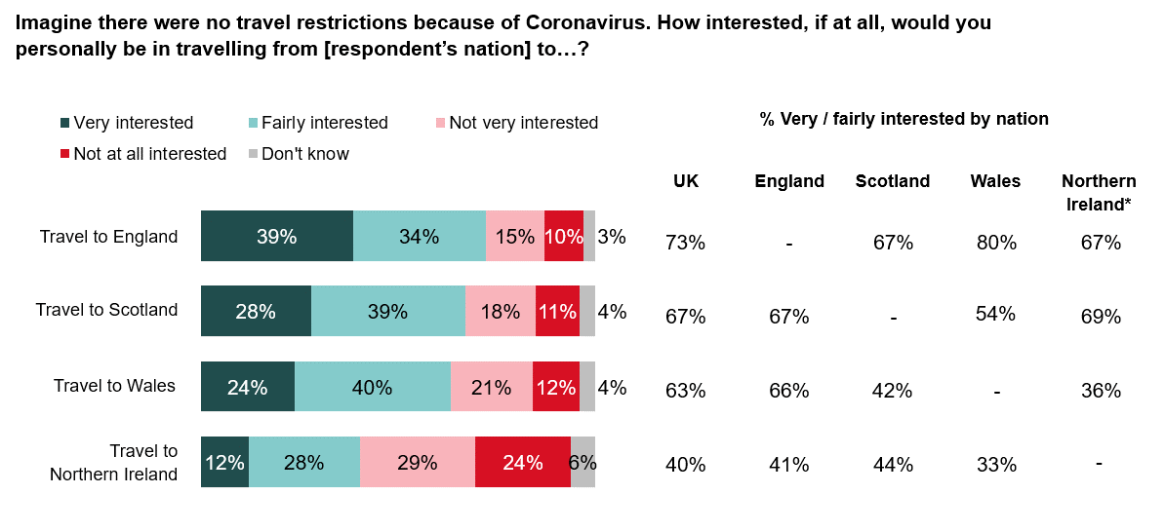Source: Ipsos MORI. Base: 3,700 UK adults aged 16-75 interviewed online, 9-19 March 2021, including 1,500 adults in England, 1,000 adults in Scotland, 1,000 adults in Wales and 200 adults in Northern Ireland. Interest in travel to each nation asked to respondents living in all other UK nations.
*Results by nation for Northern Ireland are presented based on a survey of 500 adults aged 18+ interviewed by Computer Aided Telephone Interviewing, 12 March – 11 April 2021.
Geography and distance between nations appeared to have an impact, with the majority interested in travel between neighbouring nations. For example, interest in travelling to Wales and England was highest amongst people in England (66%) and Wales (80%) respectively. Similarly, interest in travelling to Northern Ireland and Scotland was highest among people in Scotland (44%) and Northern Ireland (69% of adults interviewed by telephone) respectively. Levels of interest in travel between Wales and Northern Ireland were comparatively lower.
Compared to respondents’ self-reported journeys made in 2019, interest in future travel to other nations was even higher across all origin and destination nations. Moreover, those interested in travelling to one nation were also generally interested in travelling to all other nations.
      - Past travel to UK nations in 2019, and stated interest in travel to UK nations in future
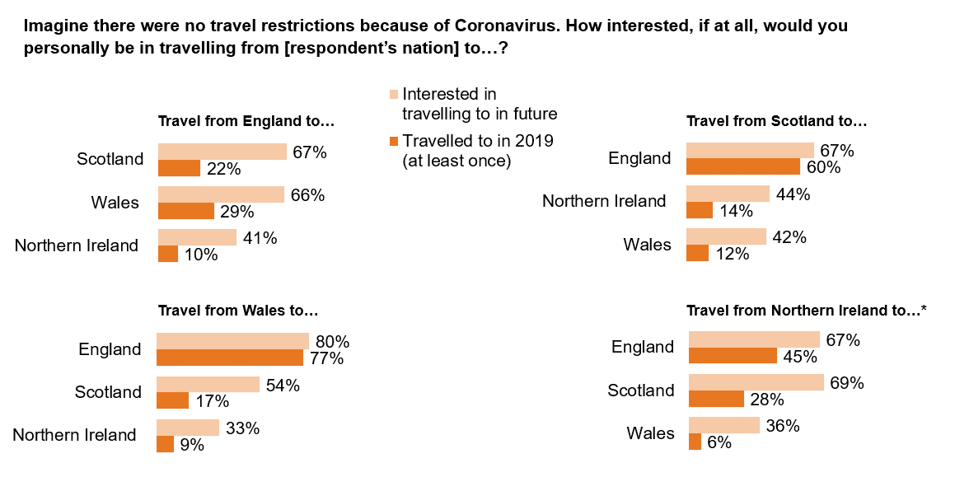Source: Ipsos MORI. Base: 3,700 UK adults aged 16-75 interviewed online, 9-19 March 2021, including 1,500 adults in England, 1,000 adults in Scotland, 1,000 adults in Wales and 200 adults in Northern Ireland. Interest in travel to each nation asked to respondents living in all other UK nations.
*Results by nation for Northern Ireland are presented based on a survey of 500 adults aged 18+ interviewed by Computer Aided Telephone Interviewing, 12 March – 11 April 2021.
Interest was generally higher among people in higher (ABC1) social grades, and those who had a positive attitude towards the UK. When asked about travel to England and to Northern Ireland from other nations, younger adults (aged 16-24) were also among the most likely to be interested in travelling there. This was most prominent among those interested in travelling to England – 79% of adults aged 16-24 in other nations were interested in travelling there, 39% said they were very interested.
Reflective of the profile of more frequent travellers in 2019, those living closer to borders were also among the most interested in travelling to other nations (except for interest in travelling to Scotland, where the proximity to the border did not have an impact).
Qualitative discussions in focus groups highlighted some of the factors that made inter-UK travel appealing. This included the benefits of being able to visit family in other nations, and the opportunity to experience different scenery and landscapes, in Scotland and Wales especially.
“There's a lot of stuff about coastal areas on Instagram which makes me want to go to Wales and Scotland.”
Female, 34, England
“Living in Wales, there’s nothing except family that would take me into England. We’ve got sea and mountains here, some lakes, and the people are fantastic. It wouldn’t bother me if I never went [to another nation].”
Male, 73, Wales
In some discussions, there was a sense that global travel restrictions due to the pandemic may give a new impetus to inter-UK travel, although not everyone agreed, and many were content with staying in their home nation.
“Now, with what we’ve gone through [during the pandemic], it’s important to enjoy what’s going on at home in the UK. We should go to other UK places first before going abroad.”
Male, 30, England

Perceived importance and impacts of improved UK connectivity
During qualitative focus groups, participants discussed the concept of ‘union connectivity’ and the role that improved transport links between UK nations could play. In general, the latter was a more tangible concept which participants articulated the benefits and importance of. Views of what the broader impacts of better transport links might be on union connectivity were more wide ranging, and the concept did not resonate with everyone. Participants were asked to consider the impacts of improved transport links on elements of quality of life, such as access to jobs and education, impacts on the environment and the economy, and impacts that could be felt locally or at the national level. Findings were used to refine the survey questionnaire, where survey respondents were asked to give their views on the importance and a range of possible impacts of improved transport links between nations.
As with interest in inter-UK travel, perceived importance of improving transport links between nations was related to past travel behaviour – those who had travelled to UK nations in 2019 were more likely than overall to say this is important. Perceived importance was also greatest when considering transport links between respondents’ own nation and England – the most travelled to UK nation in 2019, and the nation the public are most interested in visiting. People viewed the potential impacts of improved inter-UK transport links positively, in general, particularly as regards the impact on the UK as a whole, for the economy and for people’s quality of life. However, people were more divided about the expected impact on the environment and carbon emissions.

Perceived importance of improving transport links between UK nations
A majority considered it important to improve transport links between their own and each of the other UK nations, following a similar pattern to interest in travelling there. Seventy nine percent said it was important to improve links between their own nation and England (40% said this was very important). This figure was 69% for Scotland, 67% for Wales and 62% for Northern Ireland.
      - Perceived importance of improving transport links between respondents’ own nation and each other UK nation
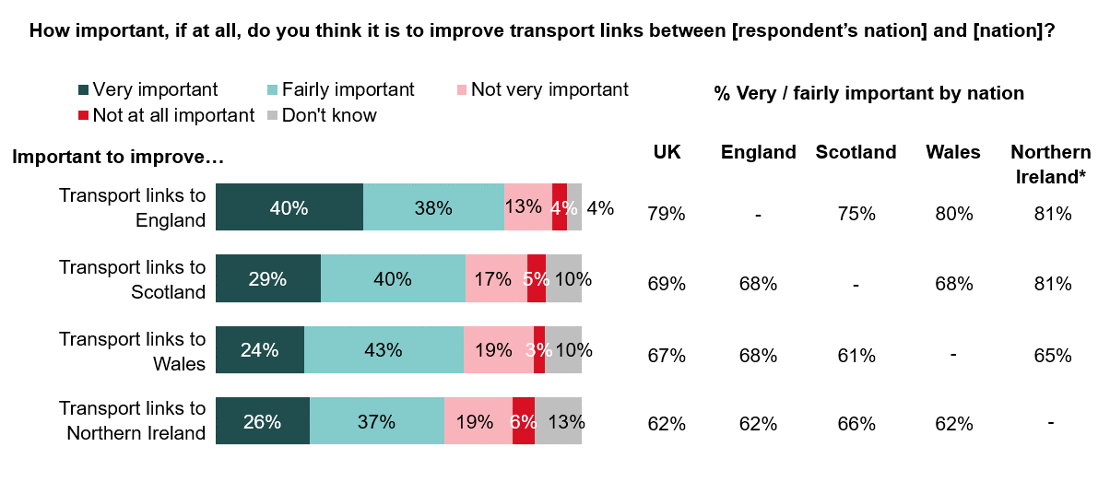Source: Ipsos MORI. Base: 3,700 UK adults aged 16-75 interviewed online, 9-19 March 2021, including 1,500 adults in England, 1,000 adults in Scotland, 1,000 adults in Wales and 200 adults in Northern Ireland. Question measured perceived importance of improving transport links between respondents’ own nation and each other UK nation.
*Results by nation for Northern Ireland are presented based on a survey of 500 adults aged 18+ interviewed by Computer Aided Telephone Interviewing, 12 March – 11 April 2021.
Although 54% of adults in other UK nations were not interested in travelling to Northern Ireland, 62% said it was important to improve transport links to this nation. This rises to 69% among people in Scotland.
In line with levels of interest and 2019 travel patterns, people in Northern Ireland were more likely to say (in the telephone survey) that it was important to improve transport links to England (81%) and Scotland (81%) than Wales (65%).
Likewise, a large majority of people in Wales (80%) felt it was important to improve transport links to (neighbouring) England. Smaller, but sizeable, proportions of people in Wales said it was important to improve transport links to Scotland (68%) and Northern Ireland (62%).
Perceptions of importance among people in England were relatively similar with reference to improving transport links to Wales (68%), Scotland (68%) and Northern Ireland (62%). This is despite differences in levels of travel to these nations in 2019, although survey findings also show that people in England were more likely to go abroad than to another UK nation.
Travelling to another UK nation in 2019, and being interested in doing so in future, made respondents more likely to think it is important to improve transport links between their own nation and each other UK nation. Attitudes also differed according to views of the UK, where those who said the UK is a ‘good thing’ were more likely than overall to say it is important to improve transport links between nations.

Perceived impacts of improved transport links between UK nations

Public perceptions of the impact of improved transport links on the UK, the economy, the environment, and personally
The public were more positive about the impact of improved UK transport links at the national level than locally. Sixty six percent of people in the UK thought improving transport links between UK nations would make a positive difference to the UK as a whole. Similar proportions anticipated a positive impact on the availability of goods and services transported within the UK (64%), on their own nation (63%) and on the economy of the UK (62%).
Relatively greater proportions of the UK public thought improved transport links would make no difference at regional levels and to them personally, driven by relatively more neutral views in England.
Forty six percent of UK adults thought improved transport links would have a positive impact on the region of the nation they live in, but nearly as many (43%) said it would make no difference. People in England were less likely than other UK nations to think improved transport links would positively impact their region. The North East of England was the exception, where 59% said their region would be positively impacted (compared with 46% overall).
Meanwhile, 42% of UK adults said improved transport links would have a positive impact on them personally. This rises to 49% among people aged 25-34, 47% of higher (AB) social grades and 54% of those in remote or isolated rural areas. However, nearly half of UK adults said it would make no difference to them personally (49%). People in England were again less likely than in other UK nations to say they would benefit personally from improved transport links to other nations. This could perhaps reflect 2019 travel and future interest in doing so generally tending towards England (rather than out of England). Indeed, people in England were also less likely than in other nations to say that their own nation would benefit from improved inter-UK transport links.
Certain demographic groups were more optimistic about the impact of improved connectivity generally (when asked about any of the statements), particularly higher social grades and those aged 25-34. This is the case, for example, for the perceived impact on the UK economy, on their own nation and at the personal level.
      - Public perceptions of the difference that improved transport links could make to aspects of the UK, its economy and the environment, and personally
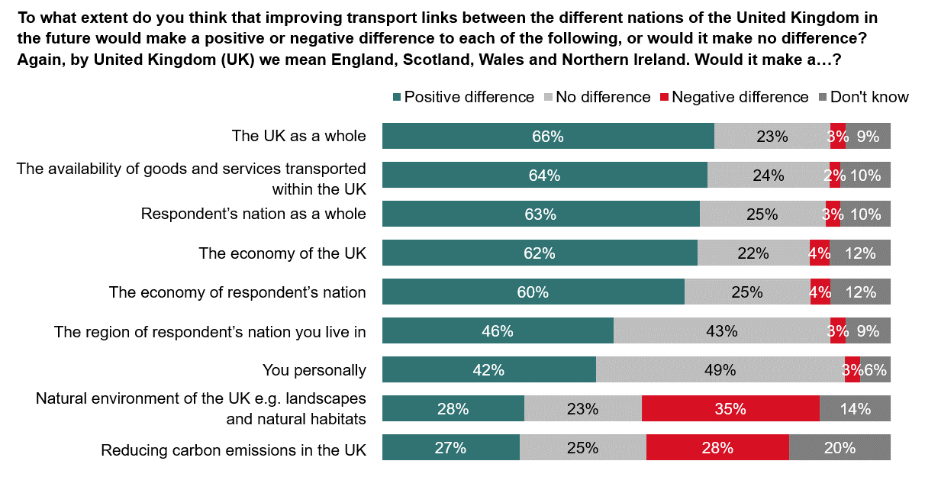Source: Ipsos MORI. Base: 3,700 UK adults aged 16-75 interviewed online, 9-19 March 2021, including 1,500 adults in England, 1,000 adults in Scotland, 1,000 adults in Wales and 200 adults in Northern Ireland.
Opinions were more divided as regards the impact of improved transport links on the environment. Thirty five percent of people in the UK thought its natural environment – including landscapes and natural habitats – would be negatively impacted, and 28% said the same regarding the impact on reducing carbon emissions (for both statements, around a quarter thought there would be no difference).
These findings chime with qualitative discussions, where participants suggested the only potential negative impact of better UK transport links could be on the environment. They typically referenced damage to the countryside resulting from new rail links. Some also anticipated greener, more environmentally friendly transport developments would come at a greater cost to the consumer, which could result in lower take up of ‘green’ public transport options.
“The environment is the one that jumps out. That [impact] will kick in over the next 30 years. People don’t have enough money for high speed rail.”
Male, 65, Northern Ireland
Some identified lower carbon emissions as a potential positive for the environment, provided transport developments are powered by electricity or hydrogen. However, these views were typically shared less readily than concern about physical damage to the countryside resulting from transport infrastructure development. Moreover, some participants felt that better public transport – including travelling by aeroplane – could result in higher volumes of inter-UK travel, leading to more carbon emissions overall. Many could not decide whether better inter-UK transport links would lead to positive or negative environmental outcomes, on balance.
“Could have a negative impact on the environment if it leads to more use of transport. That could have an effect on climate change if it means more emissions overall.”
Female, 63, England
Survey findings indicate that one in five people in the UK (20%) did not know what impact might be felt on reducing carbon emissions, and nearly as many said this about the impact on the environment, including landscapes and natural habitats (14%).
However, positive and negative views on the environmental impacts of improved transport links between nations are divided by age, social grade and experiences of travelling in 2019, and to some extent by gender.
More likely than overall to think improved connectivity would make a negative difference to emissions and the natural environment were people aged 45-54, those living in more rural areas, in higher social grades and those that generally travelled the least to other UK nations in 2019.
Meanwhile, among the groups most likely to think the natural environment would be positively impacted were younger age groups, people who were employed, people who generally travelled to other nation in 2019 and those who were interested in doing so in future. Those that travelled the most frequently in 2019 were also more likely than overall to think that carbon emissions would be positively impacted by better connectivity.
Men were more likely than women to think that improving transport links between UK nations would make no difference to the natural environment – 29% of men said this, compared with 17% of women. People aged 55-75 and those in lower social grades were also more likely to say this (27% of people aged 55-75 and 27% of C2DE, compared with 23% overall).

Public perceptions of the impact improved transport links between UK nations could have on quality of life
A majority of UK public thought that improving transport links between nations would improve a range of services and opportunities by a great deal or a fair amount. Seventy two percent said improved transport links would mean improved access to transport hubs, 71% said it would make it easier for people to move to live in other places in the UK, and 70% said it would improve the ability for them personally to travel to go on holiday somewhere in the UK.
People aged 25-34 and in work were more likely than overall to have said ability to travel for holidays in the UK would be improved by a great deal (39% and 33%, respectively, compared with 31% overall). The same was the case for people in nations other than England (39%) and people living within fifty miles of a border (37%).
Among the greatest perceived benefits of improving inter-UK transport links was access to important transport hubs – 72% said this would be improved by a great deal or a fair amount. Again, this view was more pronounced among people aged 25-34 (34% said this would be improved by a great deal, compared with 29% who said this overall), people in nations other than England (35%) and people living within fifty miles of a border (33%).
The perceived impact of improved inter-UK transport links was least positive with regards to access to public services such as schools, universities and healthcare, although a majority (57%) said this would be improved by a great deal or a fair amount. Younger people aged 16-34 – who were generally more likely than older age groups to have made more frequent journeys in 2019 – were more likely than overall to say this would be improved by a great deal or a fair amount (66% of people aged 16-34 said this, compared with 57% overall). Other subgroups which were the most likely to think public services would be improved by a great deal or a fair amount were people who travelled to another UK nation once a month or more in 2019 (73%), people living within twenty five miles of a border (68%), people in Wales (63%), people who felt the UK is a good thing (61%), women (60%) and people in C2DE social grades (59%).
      - Public perceptions of the extent to which improved transport links could improve a range of aspects relating to quality of life
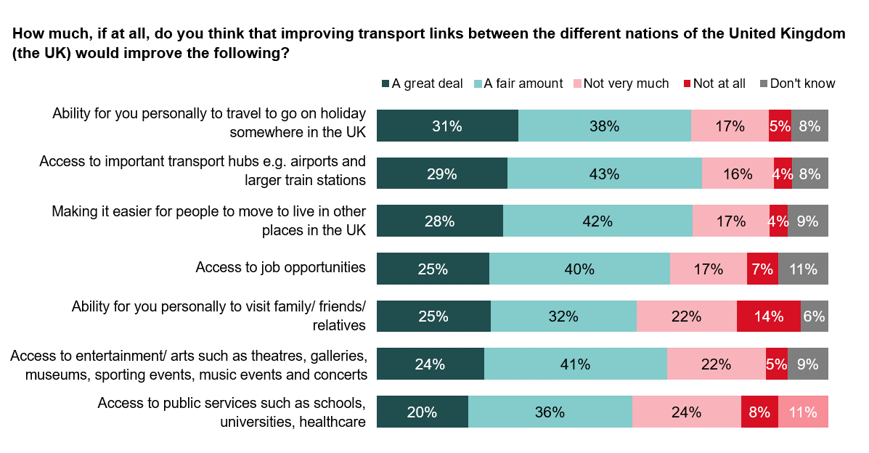Source: Ipsos MORI. Base: 3,700 UK adults aged 16-75 interviewed online, 9-19 March 2021, including 1,500 adults in England, 1,000 adults in Scotland, 1,000 adults in Wales and 200 adults in Northern Ireland.
Certain groups were more likely to say that better transport links will improve most or all of the examples presented. This includes women, younger people, those living in Wales, people living close to a border and more broadly, those who travelled frequently during 2019. This suggests the people most likely to see positive impacts to their quality of life as a result of better inter-UK transport links are those already making journeys relatively frequently.
People in Scotland were relatively more pessimistic about some of the aspects of quality of life that could potentially be improved by better UK connectivity. For example, nearly a quarter of people in Scotland said improved transport links between nations would not make it easier for people to move to live elsewhere in the UK (24%), and 28% said access to job opportunities would not be improved very much, or at all (both higher than the UK average).
Across nations, 65% said improved connectivity would improve access to entertainment and the arts by a great deal or fair amount, however over a quarter of the UK population (26%) said it would not. Among the groups most likely to say that improved inter-UK transport links would make a difference to this were younger age groups, those living closer to the border in their nations and people in Wales (76%). This finding could be driven by people living close to a border and people living in Wales, who were also more likely to have visited England in 2019 for leisure reasons, including the theatre or a concert.

Priorities for investment
This chapter summarises public priorities for investment in improvements to transport between UK nations. Respondents were asked which transport modes and types of transport infrastructure they would prioritise. They were also asked about their priorities in terms of aspects of journeys which the qualitative discussions suggested have a bearing on overall experience of travel to other nations, such as journey reliability, affordability, ease and comfort.
Road and rail were top priority transport modes for improvement. This was relatively consistent across nations and subgroups, with some exceptions, where priorities for improvements reflected past travel modes used to reach other nations in 2019 (for example, air travel being a top priority among people in Northern Ireland). Addressing affordability was also a top priority in all four nations by some margin, followed by making ticket prices more consistent, reflecting lower ratings of the cost of travel to all nations (relative to time and ease).

Priorities for improvements to transport modes and infrastructure
Road and rail were most commonly chosen as the one or two ways of improving transport between UK nations that the public considered highest priority. Over half of the UK public said train services and stations should be given highest priority for improvements (51%), followed by motorways and major A roads (36%) and local roads (30%).
      - Priorities for improvements to transport modes and transport infrastructure between the different nations of the UK
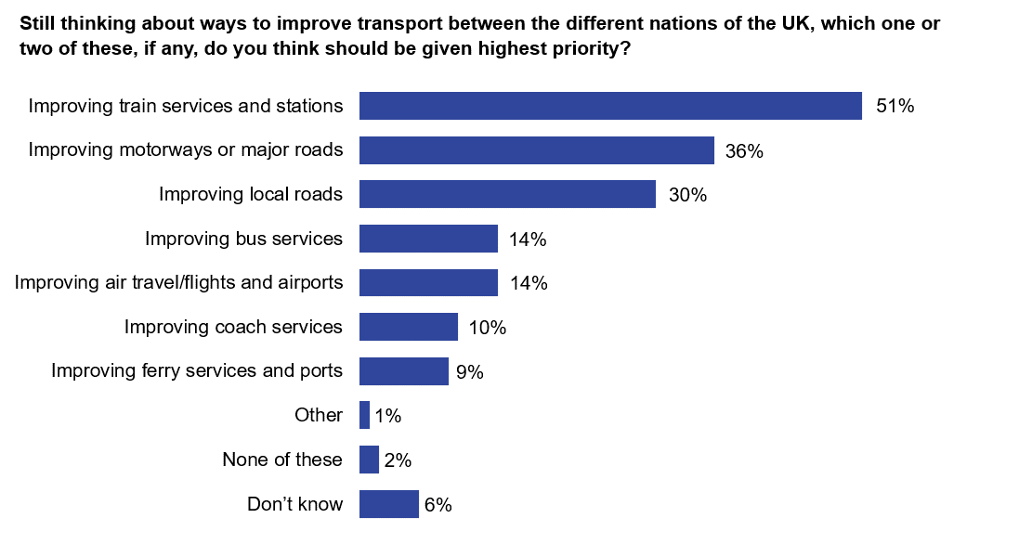Source: Ipsos MORI. Base: 3,700 UK adults aged 16-75 interviewed online, 9-19 March 2021, including 1,500 adults in England, 1,000 adults in Scotland, 1,000 adults in Wales and 200 adults in Northern Ireland. Respondents were asked to select up to two responses.
Priorities were relatively consistent across England, Wales and Scotland, with some exceptions. Local roads were higher priority in Wales than other nations (34% compared with 30% of people in the UK overall who prioritised this). People in Wales and Scotland were more likely than overall to prioritise improving bus services – 17% of people in Wales and 19% of people in Scotland chose this (higher than overall UK figure of 14%).
Within England, there were differences according to rurality and region. Over half of people in England living in urban areas prioritised train services and stations – 53%, compared with 46% in rural areas. This was highest in Yorkshire and the Humber, where 64% prioritised rail.
Those in rural areas in England meanwhile were more likely than overall to prioritise improvements to major and local roads (45% compared with 37% overall). This was reflected in regional patterns, where people living in the South West were more likely than people in other regions in England to prioritise local roads (39% compared with 29% overall in England), and the same was the case for people in the East Midlands in prioritising motorways and major A-roads (46% compared with 37% overall).
For Londoners, air travel and airports (18% compared with 13% overall) and coach services (16% compared with 10%) were top priorities. People in the North East were also more likely than overall in England to prioritise air travel (22%).
In Northern Ireland, public priorities reflected transport modes used in 2019 to travel between nations. According to the telephone survey of adults in Northern Ireland, the mode that respondents most commonly said should be improved was air travel, flights and airports (38% said this). This was followed by improving motorways and major A-roads (31%), improving train services and stations (30%), local roads (29%) and ferry services and ports (26%).
      - Priorities for improvements to transport modes and transport infrastructure between different nations of the UK (top three priorities by nation).
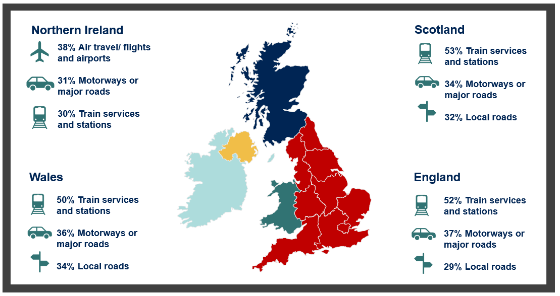Question wording: ‘Still thinking about ways to improve transport between the different nations of the UK, which one or two of these, if any, do you think should be given highest priority?’.
Source: Ipsos MORI. Base: 3,500 UK adults aged 16-75 interviewed online, 9-19 March 2021, including 1,500 adults in England, 1,000 adults in Scotland and 1,000 adults in Wales; and 500 adults in Northern Ireland aged 16-75 interviewed by Computer Aided Telephone Interviewing, 12 March – 11 April 2021.
Priorities also differed by age, social grade and vehicle ownership – again, reflecting the methods of transport people used to travel to other parts of the UK in 2019. Older people aged 55-75 were more likely to prioritise improving motorways and major roads (44% compared with 36% overall), as were those with access to a motor vehicle (41%). This age group were among the groups most likely to travel to other nations in 2019 by car, as a driver. Meanwhile, those aged 16-24 were more likely to prioritise improving bus services (19% compared with 14% overall) – in line with this age group being more likely than other ages to travel to England, Scotland and Wales by bus or coach. Higher social grades were more likely to prioritise train services and stations (54% of ABC1 compared with 51% overall).
“Personally, [my priority] would be rail and the reliability of it. Improving the existing stations that are there. Then rail and trains would become more [common forms] of transport. At the moment it’s the car. If [rail travel] became more reliable, lower cost, if there was more comfort, it would become part of everyday life.”
Female, 42, Wales

Priorities for improvements in journey experience
In line with relatively lower ratings of the cost of journeys (compared to ease and time) to all four UK nations, affordability was a top priority for improvement. Over half of people in the UK thought making journeys more affordable should be a priority (54%), and this was relatively consistent across the four nations. Nearly three in ten (29%) chose making ticket prices more consistent, regardless of how far in advance you book. Twenty two percent prioritised quicker journeys and the same proportion prioritised reducing the number of changes people need to make to services or the way they travel within a journey.
      - Priorities for improvements to aspects of journeys made between different nations of the UK
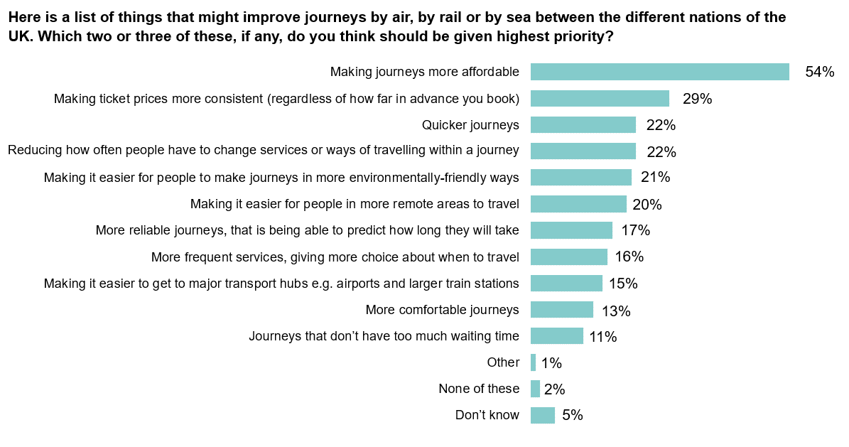Source: Ipsos MORI. Base: 3,700 UK adults aged 16-75 interviewed online, 9-19 March 2021, including 1,500 adults in England, 1,000 adults in Scotland, 1,000 adults in Wales and 200 adults in Northern Ireland. Respondents were asked to select two or three responses.
The groups most likely to prioritise affordability were people aged 45-54 (62%) and higher social grades (57% of people in ABC1 social grades), though there was no difference between those who were working and not. In 2019, these groups were generally more likely than others to travel to other UK nations by car or van, or in the case of travel to Scotland, people in ABC1 social grades were more likely than others to travel there by train. People in higher social grades were also more likely than overall to give poorer ratings of the cost of journeys to Scotland.
However, people aged 45-54 were also more likely than younger people aged 16-24 to say they did not travel at all in 2019 to each of the four UK nations, as were people in lower (DE) social grades.
“I can drive to England and back for a tenner. [The] train is £22.50. Unless they can sort the cost structure out, I wouldn’t be interested.”
Male, 73, Wales
Likewise, people in higher social grades were among the groups most likely to prioritise making ticket prices more consistent – 29% of people in the UK overall prioritised this, rising to 31% of people in ABC1 social grades, and 35% among the C1 social grade specifically. This latter group were also generally more likely than other demographic groups to have made their last 2019 journey to England (the most travelled to nation) or Scotland by train.
“It’s always [going to] be cost and speed over environmental.”
Female, 34, England
Affordability was more important to those who, when asked about their attitudes towards the UK, thought a United Kingdom is a good thing (56%). But it was less of a priority for those with more negative attitudes towards a United Kingdom, despite this group giving poorer ratings of travel to other UK nations based on cost. It should be noted that this group (of people who have a negative attitude towards a United Kingdom) were also generally less interested than overall in travelling to other UK nations in future, whereas those who are positive about the UK are more likely to want to do this.
Those living further away from borders to other nations were more likely to consider affordability a priority than those who live closer to borders. (People who live closer to borders were also more likely to give positive ratings for the cost of journeys to other nations). Fifty eight percent of those living more than fifty miles from a border prioritised affordability compared with 43% of those living within twenty five miles. Quicker journeys were also a clear priority for those living more than fifty miles from a border (24% said this, compared with 22% overall).
Affordability as a priority was also linked to past travel to other nations in 2019. Those who had not travelled to one or more other UK nations in 2019 were more likely than overall to prioritise affordability, while those who had travelled to another UK nation were generally less likely to.
Only 21% of the UK public prioritised ‘making it easier for people to make journeys in more environmentally friendly ways’, and this was consistent across nations. It was a higher priority among women than men – 24% of women said this, compared with 17% of men. Men were also more likely than women to think that improved connectivity would make no difference to the natural environment.
“[There is a] balance to find between making it green but also accessible with cost. Can’t price people out of travel.”
Male, 31, England
While people in higher social grades were generally more pessimistic about the impact of improved connectivity on the natural environment and carbon emissions, they were also more likely than overall to say that making it easier for people to make journeys in more environmentally friendly ways should be given highest priority. Twenty two percent of people in social grades ABC1 said this should be given highest priority, compared with 18% of people in social grades C2DE.
      - Priorities for improvements to aspects of journeys made between different nations of the UK (top three by nation).
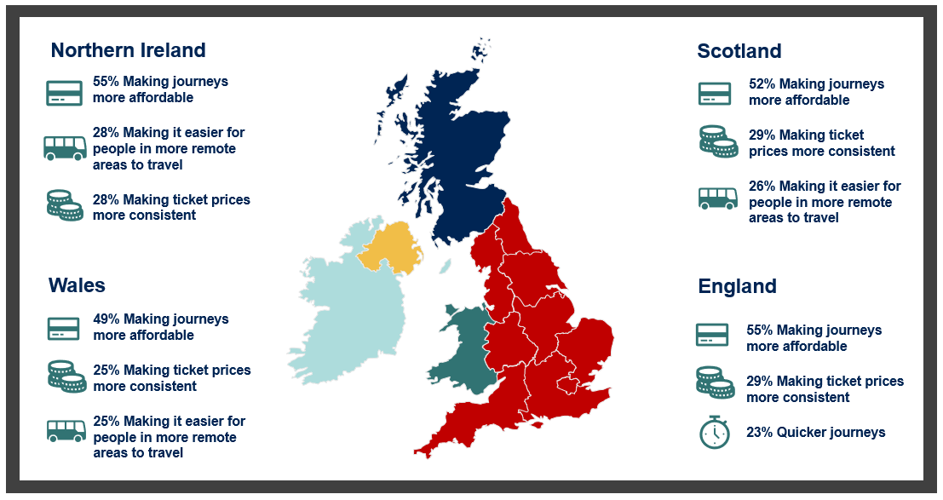Question wording: ‘Here is a list of things that might improve journeys by air, by rail or by sea between the different nations of the UK. Which two or three of these, if any, do you think should be given highest priority?’. Full response code regarding ticketing was ‘Making ticket prices more consistent (regardless of how far in advance you book)’.
Source: Ipsos MORI. Base: 3,500 UK adults aged 16-75 interviewed online, 9-19 March 2021, including 1,500 adults in England, 1,000 adults in Scotland and 1,000 adults in Wales; and 500 adults in Northern Ireland aged 16-75 interviewed by Computer Aided Telephone Interviewing, 12 March – 11 April 2021.
Across the UK, 22% of the population wanted higher priority given to making journeys quicker – this rose to 26% among men, 24% among people who work, 27% among people aged 25-34 and 24% among people who live more than fifty miles from a national border.
Sixteen percent of UK adults prioritised more frequent services, giving more choice about when to travel. This was again consistent across England and Wales, and higher among people in Scotland, 18% of whom prioritised this. Adults in Scotland were also more likely than overall to prioritise making it easier to get to major transport hubs such as airports and larger train stations (18%, compared with 15% overall) and making it easier for people in more remote areas to travel (26%, compared with 20% overall).
Journey reliability (being able to predict how long journeys will take) was a relatively less important priority than quicker journeys, prioritised by 17% of UK adults. However, journey reliability was a greater priority among older people aged 55-75 (20% of this age group prioritised reliability), who were generally more likely than other ages to have driven to other nations in 2019.
More comfortable journeys were a greater priority among people aged 16-24 (20% said this, compared with 13% overall) and men (15%). Meanwhile, 22% of UK adults prioritised reducing how often people have to change service or ways of travelling within a journey, rising to 26% among women.

Personal stories of inter-UK travel

Background and methodology
Ipsos MORI conducted sixteen in-depth interviews with participants in England, Wales, Scotland and Northern Ireland who completed the online survey conducted for this study (see ‘Introduction and methodology’ for more details). Participants were ‘purposively’ sampled, meaning they were selected based on certain survey responses (such as their travel to other UK nations in 2019) and according to a range of demographic criteria, rather than being representative of the UK population. This allowed a diverse range of attitudes, travel experiences and personal ‘stories’ to be heard across the interviews.
The personal stories described in this section can be categorised into three groups according to their travel to other nations in 2019: ‘frequent travellers’, those who travelled to another UK nation once a month or more often; ‘infrequent travellers’, those who travelled to another UK nation at least once, but less often than once a month; and ‘non-travellers’, those who did not travel to another UK nation at all. The survey findings showed variations in the types of individuals most likely to fall within each of these groups. In general, those more likely than UK adults overall to be frequent travellers lived near to a national border, had access to a motor vehicle, and included men, younger people and those in employment. Those more likely to have travelled infrequently had similar characteristics – they tended to be more likely to live near a border, and to be younger, in higher social grades (ABC1) and in employment. Meanwhile, older people, those in lower social grades (especially D and E) and people who were not working, were more likely than overall to be non-travellers.
Further details of interview participants’ demographics can be found in Appendix C. Interviews were conducted by telephone between 28 June and 1 July 2021. During this period, COVID-19 restrictions were in place throughout the UK and are referred to in the personal stories presented.
The purpose of the interviews was to explore people’s experiences of inter-UK travel, including barriers and enablers to travel, and to understand their views on the importance of improved transport links between UK nations. Eleven of the interviews are presented in this chapter as ‘pen portraits’, designed to tell personal stories. The pen portraits are not intended to be representative of the UK public – rather, they illustrate the survey findings in this report by painting a picture of some of the factors shaping experiences and views of inter-UK travel and transport improvements. Key findings from the interviews are summarised in the following paragraphs. Participants’ names have been replaced with pseudonyms, and photographs are illustrative only.

Summary of findings
Reflecting the diversity of the sixteen participants, the interviews uncovered a varied range of experiences of travel to other UK nations. Many of the inter-UK journeys participants made were routine, forming part of their travel habits. Participants who had travelled to another UK nation recently tended to describe ‘typical’ journeys or specific recurring reasons for travel, such as to visit family or for work. For these reasons in particular, participants generally felt the ability to travel to other UK nations was important. Those who relied on inter-UK transport links for work, to visit family or to make regular trips for leisure felt that not being able to make these journeys would significantly impact their lives. If they had to, they would seek alternative ways to travel to avoid cancelling these journeys altogether. Meanwhile, some participants were less concerned about their ability to travel to another UK nation – typically, if they could make the same type of trip easily without crossing a border (for example to go shopping).
Those who did not travel to other UK nations at all tended to attribute this to a lack of interest in doing so, often explaining they had no specific reason to visit, such as visiting family or travelling for work. For those who did not travel to other UK nations but would have liked to, affordability of transport and accessibility requirements were key barriers.
Participants were typically satisfied with their journeys to other UK nations and found it difficult to identify obvious improvements. After consideration, some suggested that journeys could be made better by providing more direct transport connections to rural areas to avoid having to change trains multiple times, improving the quality of motorways, making planes and trains more comfortable, and improving service stations for those making longer journeys by road.
Participants could see the wider benefits of improving transport connectivity between the UK nations, however many found it difficult to see how this might directly impact them personally. This was especially the case where participants were already satisfied with links between their local area and other UK nations. While participants did not believe improved transport links would lead them to travel to other parts of the UK for work or study, it would encourage them to travel to other UK nations for leisure or tourism.
Reflecting the survey findings, participants felt the Government should invest in road and rail. Specifically, they wanted to see improvements to the quality of motorways and smaller roads between the nations; and the frequency, reliability, cleanliness, directness and accessibility of trains to other UK nations. They generally felt that the environment should be part of the conversation around transport investment, but other factors, such as cost and reliability, should be considered first.
Participants felt that the Government could encourage them personally, and others, to travel more frequently to other UK nations by introducing cheaper tickets or rewards for regular travellers. They also suggested others might be encouraged to make inter-UK journeys if train connections were made smoother by improving physical accessibility (at stations and on carriages), and by making it simpler to change trains to complete journeys.
Participants tended to think that improving transport connections was an important aspect of ‘levelling up’ different parts of the country, through increasing tourism and improving job opportunities for people living in areas which are currently less well connected. However, some felt it was more important to focus on improving local transport connections, such as buses, to support ‘levelling up’, rather than improving connections between the different nations.

James, Scotland, frequent traveller

      - Age: 50
      - Modes of transport: car, train
James lives with his partner near Stirling, Scotland, and works full time. He is an avid driver, which has seen him travel extensively around the UK. James commutes to work in Stirling by driving an 80-mile round trip. Prior to the pandemic, aside from his regular commute, he made regular journeys to England to visit his family in Yorkshire, Blackpool, Manchester and Berkshire. Most of his visits to family were overnight stays, but on occasion he made the journeys there and back in a day, which he was able to do by leaving home at around 4.00 a.m., before the morning rush hour, and then returning late in the evening. In the past few years he has preferred to drive as this is convenient for him and he enjoys it, but previously he has also taken the train to England and travelled to London by aeroplane.
The pandemic made James more conscious of the importance of travelling around the UK because of the inability to travel abroad. When lockdowns relaxed slightly to allow travel within the UK, James and his partner made sure to take advantage of this and made as many trips to England as they could fit into their schedule. This included their usual visits to see family, but also journeys to places they had never previously been to, in Devon and Somerset, instead of trips abroad. All of James’ trips out of Scotland since the onset of the pandemic have been by car as he is keen to avoid using public transport given the health risks.
“With the pandemic, these trips [to England and Wales] became essential rather than just nice to have... When the rules allowed it, it went from one trip a month to however many I could fit into a month.”
One of the biggest issues James faces when making longer journeys to other UK nations is the quality of the motorway services, which he regards as outdated and bad value for money. He thinks the petrol is too expensive and the food is poor quality at these services.
“It would be nice to be able to have a proper rest on a long journey.”
For James, an additional barrier to travel to England is the presence of roadworks, which sometimes means there are speed restrictions and lane closures despite no visible works being underway. Traffic congestion slows James’ journeys into England from time to time, which he is able to mitigate by leaving very early in the morning. He also feels that investment in roads in Scotland is significantly lower than in England, with roads more regularly reaching capacity and more problems with potholes than he encounters in England.
Although James feels travel to England and Wales is too expensive given petrol costs, the pandemic has made him somewhat less inclined to travel abroad in future, which he believes will leave him with more money to spend on domestic trips, something which he looks forward to doing.

Lance, Scotland, infrequent traveller

      - Age: 71
      - Modes of transport: car
Lance is an artist who lives with his partner in Glasgow and travels infrequently to England. Before the pandemic, he and his partner would travel to Newcastle to visit family once every three months and also made ad-hoc journeys, including for a funeral. The year before the pandemic they also travelled to Wales for a holiday, where they rented a cottage in the countryside. When he drives, Lance prefers to take the scenic route to Newcastle which is around 3 to 4 hours of driving. Whilst this is not the most direct route, he enjoys the scenery and finds it easier than catching the train.
“I like the scenery and like to see more of the country than the motorway allows. I also drive quite slowly so don't like going on motorways. I choose the route which is not the most direct but the most interesting. I get to see how other people live in both England and Scotland.”
These trips to England are important for Lance, especially when he has something notable to get to, such as the funeral he attended. Although COVID-19 has prevented him from visiting family, he hopes that when restrictions ease, he can go back to visiting them by driving down to Newcastle every couple of months.
“It’s important that [travel connections] are there should I need them the future. But today they are like a hospital – I don’t need them.”
Lance would travel more frequently to big cities in England such as London and Birmingham if the road tolls and parking restrictions were less confusing. Because of this, he prefers to travel in Scotland, particularly when the weather is nice. He prefers to use his car, but occasionally parking restrictions have discouraged him from driving and he has taken a coach around Scotland.
“In London there’s a congestion charge but there are different by-laws in Birmingham and Manchester. It’s such a song and dance that I can’t be bothered.”
Lance loves skiing, and often drives up to remote slopes in the north of Scotland, where he enjoys spending some time in solitude. As he likes the peace and quiet, Lance does not want to see improvements to transport connections between the UK nations as he fears that roads will become congested with tourists and that remote parts of Scotland will become crowded.

Geraldine, Northern Ireland, infrequent traveller

      - Age: 63
      - Modes of transport: aeroplane, ferry, car, taxi
Geraldine is a businesswoman who lives with her husband close to Belfast, Northern Ireland, where she was born and raised. She has travelled around Northern Ireland extensively in her lifetime. Before the pandemic, she used to travel frequently to Scotland for leisure and shopping. She most recently travelled to Scotland to make use of the John Lewis, which is significantly bigger than her local John Lewis in Belfast. She has also travelled to England regularly for business and leisure – a few years ago she took a couple of weekends away in London with her husband to go shopping and to the theatre. Just before the pandemic she also travelled to Leeds to attend a business event, where she travelled by private jet, which was provided by her employer.
Geraldine prefers to travel to England and Scotland via aeroplane as this is quicker for her. She likes to take a taxi to and from the airports as this is convenient. However, she has in the past taken the ferry to Scotland and feels that although this is slower, it comes with the benefit of being able to drive onto the ferry and then make use of the car at the other end.
Due to concerns about catching COVID-19, Geraldine has not travelled since the onset of the pandemic and is waiting for a higher degree of vaccination coverage before organising trips to Scotland and England, which she hopes to do later in 2021.
Geraldine thinks that connections to the mainland have greatly improved recently. The staffing and organisation at airports have got better over the years, so she now spends much less time waiting at airports than she did in the past, when the process of security was very slow. Geraldine thinks the ferry services have also improved in terms of comfort, and that the frequency of both ferries and flights is better these days. As she finds it easy in normal times to travel to England and Scotland, she does not feel anything stops her from doing this more regularly – she normally travels as much as she would like to.
“Ten or fifteen years ago there were problems [with the ferry services] but these days it’s much better. Now they have business class which wasn’t an option before. There was also the SeaCat back then which was very uncomfortable. The ferries now are larger and more comfortable.”
However, Geraldine thinks driving in England and Scotland is less pleasant than in Northern Ireland, with greater traffic congestion and lower road surface quality. She feels that travel across the border to the Irish Republic is comparatively simpler than travel to the mainland, especially since the new motorway was built about a decade ago, which has halved journey times from Belfast to Dublin.

Peter, Northern Ireland, frequent traveller

      - Age: 61
      - Modes of transport: aeroplane, train, tube
Peter lives in Northern Ireland on his own; he is unemployed and is a devoted football fan. Prior to the pandemic he would travel once a month to London for an overnight trip to watch Chelsea Football Club play at their stadium, Stamford Bridge. These trips were a highlight of Peter’s month, and he loved the excitement of making the journey over to London in advance of the game.
To get to the games, Peter would fly over to London from either Belfast City or International airport and arrive at either Heathrow or Luton. From there he would get public transport, either the tube or the train, into London, where he would stay overnight in Hounslow. He found the journeys were always seamless and could not think of any improvements, although his choice to make the journey was dictated by the price of the flight. If it was too high, he would not travel. Taking the ferry instead was not an option for him – he had never done this before and worried about potential delays and having to take a new form of transport.
“If there were any delays or stresses to the principal mode of transport, I would get stressed very easily. I wouldn’t have enjoyed getting to the [football] ground any other way. I wouldn’t have gone if I couldn’t fly.”
Peter was deemed unfit to work in 2012 and has since had his driving licence suspended. These trips were therefore very important for him so that he could get out of Belfast and spend time doing something he enjoys. He has missed these journeys since the pandemic and has found it difficult not being able to make these journeys recently.
“[Travelling to Stamford Bridge is a] very important thing for me to do because I have been unfit to work since 2012 and I have certainly been separated from my wife for nearly three years now, [so] they are certainly cherished times. And every time I’ve been, they have never lost!”
Beyond his trips to watch Chelsea Football Club, Peter would like to travel to England for more sporting and music events. He feels it is “easy enough” to travel to Scotland and Wales because of the frequency and modes of travel available, such as the ferry, but is only interested in travelling to England. Peter finds it easier to travel within Northern Ireland, or to the Republic, than travelling to another UK nation, because he finds the size of Northern Ireland more manageable. However, due to the restrictions and Peter’s health problems, he rarely travels within Northern Ireland as he always must rely on a lift or public transport. He feels that very little could encourage him to travel more to other UK nations as he has seen a lot of it already, however lower transport costs would potentially convince him to make a different journey, beside his usual trips to the football. Although he would not personally use it as he cannot drive, Peter would like to see a bridge connecting Northern Ireland and mainland UK so that others can travel more easily by car between Great Britain and Northern Ireland.

Alice, Wales, frequent traveller

      - Age: 23
      - Mode of transport: train, car, taxi
Alice is a mother living in Pontypridd in South Wales; she works part time and earns the minimum wage. Before the pandemic, Alice and her family enjoyed frequent visits to England, taking the train to Bristol for a day trip with her sons or going to Devon for a long weekend. She also visited her stepfather’s family in West Bromwich regularly. Alice’s sons, aged 2 and 3, love going on the train, so trips to Bristol Zoo were always a fun day out for the family. Alice thinks it is cheap and easy to get to England. To get to Bristol she would take a car or taxi from Pontypridd to Cardiff station, then a 45-minute train to Bristol. Alice thinks it is important that she can make these trips to England with her family and that the transport connections are easy for her.
“They were quite important [the trips] - it was nice to have family time. It was quite important [to be able to get the train] because it's convenient as well, isn't it - you don't really have to plan it. You don't have to think ‘oh I've got to put petrol in.’”
Growing up, Alice did not have a car, which is why when her Mum arranges long weekends for the family in Devon and West Bromwich, she always books the train. Alice thinks that her Mum feels nostalgic about the train journeys she used to go on with Alice when she was little and even though the family prefer not to change trains more than two or three times, she still thinks that the journeys are pleasant with comfy seats, tables, and head rests.
Alice also likes to travel within Wales, catching the train to Barry Island or visiting Cardiff for the day with her sons. She likes that Wales has so many beaches, museums, and other attractions to visit and keep the boys happy. Since Alice’s family all live within a 10 to 15-mile radius, she doesn’t feel the need to go on any major journeys within Wales. She rarely visits North Wales, for example, as she feels that the 3 to 4-hour drive to get there is not worthwhile, especially since England is just an hour drive or train ride away.
“It’s definitely easier to go over to England than to make journeys within Wales. More people commute over that way, a lot of people I know are from here and work in Bristol. Those routes are more used by people, so they've made them more accessible than up to north Wales and further afield.”
Alice wants to visit Scotland and Northern Ireland soon but is apprehensive about the long journeys to get there, especially if she were to travel with her young boys. She would be more encouraged to travel there if these nations were connected by direct trains and if tickets were cheaper.
“It would be good if there was some sort of main link to go straight from for example Cardiff, straight into London, or Edinburgh – the main cities. And then… you could get on a different train or bus from there. But it would be good to have a main link between all of them – Northern Ireland, Scotland, Wales and England.”

Samir, Wales, infrequent traveller

      - Age: 44
      - Mode of transport: car
Samir lives in Wales, near the English border, with his wife, Susan. Samir lives a busy life and makes use of his car to get around his local area and to other parts of the UK. Prior to the pandemic, he would travel by car to England every couple of months with his wife to go shopping and for social events. He would usually go to Hereford, close to the border, for shopping trips and to Birmingham to meet friends. While Samir found the journeys “mostly fine”, he did find the roads were of a better standard in Wales than on the English side of the border. This was most notable on B-roads that have potholes and he found can be too narrow. He also feels that the speed limit could be increased on some roads but is resigned to the fact that this is not going to happen.
“Better roads are the only way [my journey could be improved]; wider roads and a better network. In my opinion, the speed limits can be changed on some roads, increased in some places definitely.”
If Samir was unable to make these trips to England in his car he would find alternatives; he would have to take the train to Birmingham which would require a 30-minute drive to the train station. Samir did not consider these journeys especially important because they were for shopping, which he could also do in Wales. However, he did enjoy the variety that travelling to England brought to his shopping experience.
“Well I wouldn’t say [journeys to England] are as important [as travelling in Wales] but it’s nice to be able to go somewhere different. But there’s nothing stopping me travelling in Wales and doing my shopping in Wales.”
Samir relies on transport connections to England when he flies out to India every few years to visit his family. Because of this, he thinks it is important to maintain good transport connections between England and Wales. Samir also thinks he could potentially get a better paid job somewhere in England, and that if transport connections were improved, he would be more open to commuting there daily.
In the near future, Samir thinks that he will still travel to Hereford in England once or twice a month as he did before. He also plans to go to Chester in England about once a year for a car show he enjoys attending. Samir hopes his postponed holiday to Scotland will go ahead at some point. Because of the pandemic he will avoid using public transport and will always opt for the car because he likes his personal space and to have his own music on. He also thinks trains are too complicated to take when connections are involved.
Samir sees no barriers to travelling to other UK nations, apart from the ferry crossing to Northern Ireland, which seems too complicated to take. Compared with travelling in Wales he finds travelling within England easier because of the road signs; he finds the Welsh signs confusing due to the multiple languages. Samir would find it easier to travel to other nations if road repair works were not done over bank holidays, which makes his journeys more difficult.

Fatima, England, frequent traveller

      - Age: 18
      - Modes of transport: aeroplane, car, taxi
Fatima lives in Essex, England with her Mum and is a college student. Fatima has family in all four nations of the UK and has travelled extensively to visit them. Before the pandemic she travelled once a month or so to see her Dad in Scotland, and almost as often to Wales and Northern Ireland to visit extended family or accompany her Mum on her business trips.
Fatima’s family prefers to drive to Wales and Scotland when they go to visit family there. Fatima’s Mum would drive her and her four siblings to Scotland and Wales, despite the very long journey times. It would take 9-10 hours to drive to see her Dad in Scotland, but Fatima did not mind the long journey even though it was difficult for her younger brother and sister. They preferred to make the journeys by car to avoid the stress of travelling by train; they could stop for meals when needed, they could easily transport their baggage and they did not need to change trains. Fatima enjoys flying and is always excited when she gets the opportunity to go to Northern Ireland. When she travels there, she takes a taxi with her mother to London Stansted Airport, before flying to Belfast and being picked up by a family friend.
“I don’t really mind [travelling by car to Scotland]. I don’t mind sitting in the car, but my siblings get quite agitated. We’d never get the train though – that would be way too much stress for my Mum. Going by car is just all one journey.”
These journeys are very important to Fatima so that she can stay in touch with her family, especially her father, who lives in rural Scotland. Since the pandemic, she has missed out on valuable family time and her family have missed her too – communicating by Skype leaves them feeling distant.
As restrictions ease, apart from resuming visits to see family in Wales, Scotland and Northern Ireland, Fatima has little appetite to travel to other parts of the UK. She occasionally travels by train to London to go shopping with friends, but she has no other reason to make longer journeys within England, even though it is easier for her to do this than to travel to the other UK nations. Fatima would like travel to be cheaper so that she can visit her family more frequently.
For Fatima, improvements to roads between the UK nations would make the most difference to her life. However, she feels it is important that any such developments do not harm the environment and wildlife.
“The environment should be considered, because if there are loads of cars on the motorway the fuel from the cars enters the air, it’s not good for your health. Also, wild animals, if they want to build.”

Liam, England, frequent traveller

      - Age: 46
      - Mode of transport: train
Liam is from England and lives with his partner in Norfolk. He works for a company with offices all around the UK. As part of his job, before the pandemic he would travel on business trips to Wales and Scotland every month or so. Being able to make these journeys was very important to Liam’s career; for his work, meeting people for the first time in person was much better than speaking over the phone. These trips have therefore helped him to establish good working relationships with people outside of his organisation, something which he has found more challenging to do since working from home.
“[These trips are] really important. They couldn’t have been done by phone... If you are meeting someone important for the first time you can’t do it over a voice call.”
To get to Scotland for work, Liam would first take the train from Norfolk to London, then he would take a Virgin train from London Euston to Edinburgh or Glasgow. Liam often travelled first class for work, especially if the journey time was more than a couple of hours. He finds the train convenient because he can travel and work at the same time. He is usually satisfied with the service on the journey, although he feels that on-board announcements could be more frequent.
Liam also took the train to get to Cardiff for work. He felt that he could drive to Wales but the train is better overall for him as it means he can take work calls and be able to take notes at the same time, which he would not be able to do in the car.
Liam finds it very easy to travel within England but thinks that it can be more difficult travelling within Scotland and Wales as he believes there has been less investment by the Government in transport connections there. He would like to travel to other places within the UK, including Northern Ireland, but feels he does not have the time on weekends to do this.
“It’s easy to make a journey in England, it really is. There’s been more investment in English transport whether we like it or not. I find it far easier to get from A to B in England than I do in Wales and Scotland.”

Farhad, England, non-traveller

      - Age: 44
Farhad lives in Yorkshire and has never travelled to Wales, Scotland or Northern Ireland. When Farhad chooses to travel, he prefers to visit places abroad like in Europe or Asia instead of visiting the other UK nations.
“Normally when I travel, I go to Europe or Asia so I don't have much interest in travelling to other UK nations.”
Being unable to travel abroad during the pandemic has encouraged Farhad to consider travelling within the UK. He recognises that it is not particularly difficult or far to get to Wales and Scotland from where he lives. For Farhad, it is important to find the right time around his own personal commitments like work and his son’s school. Farhad is also still apprehensive about travelling during the pandemic and so would only plan a visit to another UK nation once restrictions have eased.
“The pandemic and my fear of contracting the virus prevented me from travelling within the UK. The media and everything says not to go to certain areas.”
Farhad goes on holiday in England at least once a year and has visited places like Blackpool and Alton Towers theme parks. He also used to commute to work before the pandemic. He would like to visit more places within England when the pandemic is over. Farhad does not drive for environmental reasons so if he was going to travel more, he would use public transport.
“I would like to do it more often because my family would like me to take more time off work and go to visit places.”

Martin, England, non-traveller

      - Age: 66
Martin lives in South East England, near Gatwick airport. He lives with his wife and is retired. Martin used to travel extensively to other nations in the UK when he was younger and enjoyed making long journeys and exploring different parts of the country. However, recently he has stopped travelling to other UK nations as he finds the cost of travel is too expensive. Before the pandemic, he made several journeys by car within England – he drove around his local area for shopping and drove a few times a year up to Yorkshire to visit family. In the future he would like to start making longer trips again and travel to Scotland by train.
“The costs [of travel] at the moment are very high.”
Martin recently looked into spending a week away in Wales or taking a long weekend in Scotland but found the accommodation and the petrol for the journey was too expensive. Martin feels there is little difference between travelling to Northern England or to Wales for him, but Scotland feels like a long way as he would have to book somewhere to stay overnight, which would bring additional costs. Martin also finds it difficult to make longer journeys within the UK, such as to Scotland, as he has health issues which make it uncomfortable for him to be sat down in a car or on a train for an extended period of time. Health and financial barriers aside, he feels that if trains were cleaner, faster, more frequent and there were more direct links to other places in the UK, he would be encouraged to travel more often to other UK nations.
“We’ve looked into having a week away in Wales or a long weekend in Scotland, but the accommodation is far too expensive, as is petrol.”
Martin thinks it is very important that transport connections between UK nations are improved, and that this will bring the four nations together by letting people see and explore different parts of the country. He thinks rail travel is an important way to connect people, and that if the quality of rail travel was improved and brought back to a level similar to when he was younger, this would encourage others to travel more regularly and explore the UK.
“I do find it terrible, I used to use the trains a lot when I was younger. Now I pity all those old and disabled people who just cannot get on trains or use them. We should not be stuck as England we should be Great Britain and be able to travel between the different nations.”

Deirdre, Scotland, non-traveller

      - Age: 65
Deirdre is 65 and lives alone in Livingston, between Edinburgh and Glasgow. She has not travelled for a couple of years to another UK nation because her arthritis has prevented her from making longer journeys. Journeys she used to make, such as driving to visit friends in Barrow, Cumbria, which takes around four hours, are now too long for her. Having to stay overnight in places in England is difficult for her as her house in Livingston is set up to support her with her arthritis. She doubts she will be able to travel again to another UK nation until she gets a hip replacement.
“Arthritis makes it difficult for me to drive. Going to stay over somewhere is also difficult. I need the correct mattress and pillow.”
Deirdre would like to travel more in Scotland, to places like Iona. However, she feels connections to more remote places in Scotland such as Shetland or Orkney are “a nightmare” and mean that fewer people go there than would like to, cutting them off from the rest of the UK. In the future she would also like to travel to North Wales for a meditation retreat which she used to attend before her arthritis made it difficult for her to travel.
If Deirdre’s arthritis improved, she would be interested in taking the train to England. However, she worries, as someone who is slightly older, how she would book a seat. She also feels daunted by the different rail network providers and having to make connections between them. Deirdre feels that being able to travel to another UK nation would make a big difference to her life and that travelling to other nations changes your outlook on life and makes you more open-minded.
“It’s the linking and the cost [that are difficult]. When you book a train ticket and the rate prices go up and down it’s so complicated, far more complicated than it used to be. Having different rail networks is also difficult.”

Appendices
Additional information including the survey question set and data tables that formed part of this research are available upon request from the contact details that can be found on the back cover of this report.

Appendix A: Discussion groups – achieved and target sample profile
Participants were recruited from the following regions:
- Group 1: East of Northern Ireland (further than 30-40 miles from the border with the Republic of Ireland, including Belfast and surrounding areas).
- Group 2: West of Northern Ireland (within 30-40 miles of the border with the Republic of Ireland, including Derry/Londonderry).
- Group 3: North of England (further than 30-40 miles from a national border, in Yorkshire and the Humber, including Leeds and Bradford).
- Group 4: South West of England (within 30-40 miles of the border with Wales, including Bristol, Bath, North Somerset and North East Somerset).
- Group 5: Scotland (a mix of areas within 30-40 miles of the border with England, including the Scottish Borders region, and areas more than 30-40 miles from the border, including Edinburgh and Glasgow).
- Group 6: Wales (a mix of areas in North Wales within 30-40 miles of the border with England, including Wrexham, and areas more than 30-40 miles from the border, including Conwy).
The tables below present the target recruitment quotas, and the numbers who took part in discussion groups for each quota (‘achieved’).
Gender
Gender | Total achieved | Group 1 | Northern Ireland (East) |  | Group 2 |  | Northern Ireland (West) | Group 3 |  | England (North) | Group 4 |  | England (South West) | Group 5 |  | Scotland | Group 6 |  | Wales
 |  | Target |  | Achieved | Target | Achieved |  | Target | Achieved |  | Target | Achieved |  | Target | Achieved |  | Target | Achieved
Female | 18 | 1-4 |  | 3 | 1-4 | 2 |  | 1-4 | 3 |  | 1-4 | 3 |  | 1-4 | 3 |  | 1-4 | 4
Male | 18 | 1-4 |  | 3 | 1-4 | 4 |  | 1-4 | 3 |  | 1-4 | 3 |  | 1-4 | 3 |  | 1-4 | 2

Age
Age | Total achieved | Group 1 |  | Northern Ireland (East) | Group 2 |  | Northern Ireland (West) | Group 3 |  | England (North) | Group 4 |  | England (South West) | Group 5 |  | Scotland | Group 6 |  | Wales
 |  | Target | Achieved |  | Target | Achieved |  | Target | Achieved |  | Target | Achieved |  | Target | Achieved |  | Target | Achieved
18-34 | 15 | 1-3 | 2 |  | 1-3 | 2 |  | 1-3 | 3 |  | 1-3 | 3 |  | 1-3 | 2 |  | 1-3 | 3
35-54 | 11 | 1-3 | 3 |  | 1-3 | 2 |  | 1-3 | 2 |  | 1-3 | 1 |  | 1-3 | 2 |  | 1-3 | 2
55-75 | 10 | 1-3 | 1 |  | 1-3 | 2 |  | 1-3 | 1 |  | 1-3 | 2 |  | 1-3 | 2 |  | 1-3 | 1

Ethnicity
Ethnicity | Total achieved | Across all |  | groups
 |  | Target | Achieved
Ethnic minority group | 3 | 3-4 | 3

Socio-economic grade (‘SEG’)
SEG | Total achieved | Group 1 |  | Northern Ireland (East) | Group 2 |  | Northern Ireland (West) | Group 3 |  | England (North) | Group 4 |  | England (South West) | Group 5 |  | Scotland | Group 6 |  | Wales
 |  | Target | Achieved |  | Target | Achieved |  | Target | Achieved |  | Target | Achieved |  | Target | Achieved |  | Target | Achieved
ABC1 | 19 | 1-4 | 3 |  | 1-4 | 3 |  | 1-4 | 0 |  | 1-4 | 4 |  | 1-4 | 3 |  | 1-4 | 3
C2DE | 17 | 1-4 | 3 |  | 1-4 | 3 |  | 1-4 | 6 |  | 1-4 | 2 |  | 1-4 | 3 |  | 1-4 | 3

Employment status
Employment | Total achieved | Group 1 |  | Northern Ireland (East) | Group 2 |  | Northern Ireland (West) | Group 3 |  | England (North) | Group 4 |  | England (South West) | Group 5 |  | Scotland | Group 6 |  | Wales
 |  | Target | Achieved |  | Target | Achieved |  | Target | Achieved |  | Target | Achieved |  | Target | Achieved |  | Target | Achieved
Full/part time | 23 | 2-5 | 5 |  | 2-5 | 5 |  | 2-5 | 5 |  | 2-5 | 4 |  | 2-5 | 3 |  | 2-5 | 2
Unemployed/  retired/student | 12 | 1-4 | 1 |  | 1-4 | 1 |  | 1-4 | 1 |  | 1-4 | 2 |  | 1-4 | 3 |  | 1-4 | 4

Transport mode used for last long-distance journey made
Transport mode usage | Total achieved | Group 1 |  | Northern Ireland (East) | Group 2 |  | Northern Ireland (West) | Group 3 |  | England (North) | Group 4 |  | England (South West) | Group 5 Scotland |  | Scotland | Group 6 |  | Wales
 |  | Target | Achieved |  | Target | Achieved |  | Target | Achieved |  | Target | Achieved |  | Target | Achieved |  | Target | Achieved
Car/van | 17 | Mix | 0 |  | Mix | 4 |  | Mix | 2 |  | Mix | 3 |  | Mix | 4 |  | Mix | 4
Bus | 2 | Mix | 0 |  | Mix | 0 |  | Mix |  |  | Mix | 1 |  | Mix | 0 |  | Mix | 0
Train | 4 | Mix | 1 |  | Mix | 1 |  | Mix | 1 |  | Mix | 0 |  | Mix | 1 |  | Mix | 1
Ferry | 2 | Mix | 1 |  | Mix | 0 |  | Mix |  |  | Mix | 0 |  | Mix | 1 |  | Mix | 0
Plane | 5 | Mix | 3 |  | Mix | 2 |  | Mix |  |  | Mix | 0 |  | Mix | 0 |  | Mix | 0
Lorry | 1 | Mix | 0 |  | Mix | 1 |  | Mix |  |  | Mix | 0 |  | Mix | 0 |  | Mix | 0

Access to a motor vehicle
No car access | Total achieved | Group 1 |  | Northern Ireland (East) | Group 2 |  | Northern Ireland (West) | Group 3 |  | England  (North) | Group 4 |  | England  (South West) | Group 5 |  | Scotland | Group 6 |  | Wales
 |  | Target | Achieved |  | Target | Achieved |  | Target | Achieved |  | Target | Achieved |  | Target | Achieved |  | Target | Achieved
No access to motor vehicle | 9 | 1-2 | 2 |  | 1-2 | 1 |  | 1-2 | 1 |  | 1-2 | 2 |  | 1-2 | 2 |  | 1-2 | 1

Urban/rural dwelling

Urban/rural | Total achieved | Group 1 |  | Northern Ireland (East) | Group 2 |  | Northern Ireland (West) | Group 3 |  | England (North) | Group 4 |  | England (South West) | Group 5 |  | Scotland | Group 6 |  | Wales
 |  | Target | Achieved |  | Target | Achieved |  | Target | Achieved |  | Target | Achieved |  | Target | Achieved |  | Target | Achieved
Urban |  | N/A | 4 |  | N/A | 4 |  | N/A | 4 |  | N/A | 3 |  | N/A | 3 |  | N/A | 2
Rural |  | N/A | 2 |  | N/A | 2 |  | N/A | 2 |  | N/A | 3 |  | N/A | 3 |  | N/A | 4

Travel to another UK nation in the past two years (for either work or leisure purposes, on at least one occasion)
Travel to another UK nation in past 2 years | Total achieved | Group 1 |  | Northern Ireland (East) | Group 2 |  | Northern Ireland (West) | Group 3 |  | England (North) | Group 4 |  | England (South West) | Group 5 |  | Scotland | Group 6 |  | Wales
 |  | Target | Achieved |  | Target | Achieved |  | Target | Achieved |  | Target | Achieved |  | Target | Achieved |  | Target | Achieved
Travelled to another UK nation in past 2 years |  | 1-3 | 3 |  | 1-3 | 3 |  | 1-3 | 4 |  | 1-3 | 3 |  | 1-3 | 3 |  | 1-3 | 4
Not travelled to another UK nation in past 2 years |  | N/A | 3 |  | N/A | 3 |  | N/A | 2 |  | N/A | 3 |  | N/A | 3 |  | N/A | 2

Journeys of over two hours in duration made in the past two years
Journeys over 2 hours in past 2 years | Total achieved | Group 1 |  | Northern Ireland (East) | Group 2 |  | Northern Ireland (West) | Group 3 |  | England (North) | Group 4 |  | England (South West) | Group 5 |  | Scotland | Group 6 |  | Wales
 |  | Target | Achieved |  | Target | Achieved |  | Target | Achieved |  | Target | Achieved |  | Target | Achieved |  | Target | Achieved
Made journey over 2 hours in past 2 years |  | 1-3 | 4 |  | 1-3 | 3 |  | 1-3 | 3 |  | 1-3 | 4 |  | 1-3 | 3 |  | 1-3 | 3
Not made journey over 2 hours in past 2 years |  | N/A | 2 |  | N/A | 3 |  | N/A | 3 |  | N/A | 2 |  | N/A | 3 |  | N/A | 3

Not made a journey of at least two hours, and not travelled to another UK nation in the past two years
Not made 2+hr journey AND not travelled to UK nation past 2 years | Total achieved | Group 1 |  | Northern Ireland (East) | Group 2 |  | Northern Ireland (West) | Group 3 |  | England (North) | Group 4 |  | England (South West) | Group 5 |  | Scotland | Group 6 |  | Wales
 |  | Target | Achieved |  | Target | Achieved |  | Target | Achieved |  | Target | Achieved |  | Target | Achieved |  | Target | Achieved
Done neither |  | 1-3 | 2 |  | 1-3 | 2 |  | 1-3 | 3 |  | 1-3 | 2 |  | 1-3 | 2 |  | 1-3 | 2

Appendix B: Discussion group topic guide and stimulus materials
It should be noted that the topic guide is used as an aide or guide, and not a script. Since qualitative discussions allow for spontaneous and open-ended responses, it is not expected that every question is asked to every participant individually. Rather, the topic guide provides the moderator with a structure for the discussions, an indication of the topics that should be covered to address the research questions and the potential line of questioning to do this, including key questions to ask.
Primary objectives:
- To test draft questionnaire wording and language used around UK travel behaviour and the perceived impact and importance of transport connectivity within and across UK nations.
- To better understand how people think and talk about travel to other UK nations, and their personal views of transport links between UK nations.
- To find out how well people understand the role that travel and transport links play in UK connectivity, including for society as a whole and the economy.
Secondary objectives:
- To better understand travel behaviours and attitudes towards travel within and across UK nations.
Moderator instructions:
Bold: Key questions
Not bold: Prompts and follow up questions
CAPITALS: Interviewer instructions
Where relevant, mention group’s nation first when all four UK nations are listed.

Timing | Section | Purpose
10 mins | 1. Welcome and introductions
5.30 – 5.40pm | ADMIT PARTICIPANTS TO GROUP AND CHECK FOR ANY TECHNICAL ISSUES  INTRODUCE SELF AND IPSOS MORI (independent research organisation).  INTRODUCE TOPIC FOR THE DISCUSSION – We are conducting research for the Department for Transport about people’s travel and transport across the nations of the United Kingdom, and the role of transport connectivity in the UK. This means we will be discussing travel and transport between England, Scotland, Wales and Northern Ireland – the UK nations. We are holding several groups like this one, with people in each of the four nations.  EXPLAIN THE ROLE OF IPSOS MORI – independent researchers aiming to help you share your views, ensuring we hear from everyone in the group.  SET OUT GROUND RULES FOR DISCUSSION:  - All opinions are valid/no right or wrong answers.  - Disagreements are fine but please respect each other’s opinions  - Please try not to talk over one another, so that we can hear each other clearly – I will help with this too as the moderator.  - We have a lot to cover, so I may move us on at points.  - We’re keen to hear from everyone in the group, so I will make sure everyone gets a chance to speak.  - Please try not to be distracted – mobile phones away and on silent, there will be a comfort break halfway through.  - Please turn off any downloads or anything else that might slow down your computer/internet connection.  - Your incentives will be administered after completing the group.  - Colleagues from Ipsos MORI and from DfT are observing this group, however they have no more information about you than what can be seen on the screen.  EXPLAIN CONFIDENTIALITY AND MRS:  All our research adheres to the Market Research Society Code of Conduct and the General Data Protection Regulation/Data Protection Act. This means that all data collected is kept confidential, anonymised and held securely before being deleted.  ASK PERMISSION TO RECORD VIDEO AND SOUND – TRANSCRIBE FOR QUOTES, NO DETAILED ATTRIBUTION.  TURN ON RECORDING USING OBS  CLARIFY LENGTH OF THE GROUP (2 HOURS) AND FINISHING TIME (7.30PM).  Does anyone have any questions before we start? | To explain purpose of the research and set out ground rules.  To explain the discussion is about the UK (not GB). Ensure throughout that participants are clear on whether discussing their own nation (e.g. Scotland) or the UK
20 mins | 2. Icebreaker/warmup and (personal) travel to other nations within the UK
5.40 – 6.00pm | We’re going to start by thinking about the journeys that you make within the UK, both before the Covid-19 pandemic and since the beginning of the first UK lockdown in March 2020.  Please can you introduce yourself by telling me your name, and can you tell me about the last journey you made to another nation in the UK, if you’ve ever done this? I’d like to know when and where you went, how you travelled and what the purpose of your trip was.  If you’ve never made a journey to another UK nation, please answer the same questions but about the last long journey you made within your nation.  PROBES:  - Can you remember when exactly this was? Which year?  - How long did it take to get there?  - Is this a regular trip you make? If so, how often do you make this trip?  - Did you travel with anyone else on this trip?  - How did you decide on a mode of transport for this journey? BY ‘MODE OF TRANSPORT’ WE MEAN BY ROAD, BY BUS, COACH, TRAIN, ETC.  - Could you have made the trip using another mode of transport?  - What, if anything, would make you more likely to use an alternative mode of transport for this journey?  - To what extent do you consider the environment when choosing how to travel?  NORTHERN IRELAND: Which do you more often – travelling to the Republic of Ireland, or travelling to another UK nation?  IF TRAVEL TO THE REPUBLIC: What do you travel there for? How do you get there?  How satisfied are you with transport links to other nations of the UK?  What makes you say that? What are you thinking about specifically? What criteria are you weighing up?  MODERATOR TO ASK ABOUT ANY FURTHER CRITERIA NOT ALREADY COVERED, AND MAKE SURE TO COVER EASE OF ACCESS AND ENVIRONMENTAL IMPACT:  I have a few more things to ask about which you might be thinking of when thinking about how satisfied you are with transport links to other UK nations.  What does [_______] mean to you when thinking about your transport links to other nations of the UK? GO THROUGH CRITERIA NOT ALREADY COVERED. CAN PROBE FOR EXAMPLES  - availability  - ease of access – PROBE WHETHER THINKING IN TERMS OF PHYSICAL ACCESS (E.G. FOR DISABLED PEOPLE), OR EASE OF REACHING TRANSPORT HUBS/MODES  - comfort  - capacity  - frequency  - speed and overall journey time  - quality  - reliability  - cost  - environmental impact [MAKE SURE TO COVER]  What other things might influence how satisfied you are with transport links between nations? | To introduce participants to each other and warm up, and begin thinking about the topic  To understand how people recall previous journeys to other UK nations, including frequency, how memorable the journeys are, whether they can place in a calendar year and what the appropriate reference period is for past and future travel to other UK nations.  To understand the criteria participants use to assess travel within the UK and language used to describe this – the ‘dimensions’ of satisfaction.  [Avoid discussion of impact of Covid-19 on travel]
10 mins | 3. Barriers and enablers to travelling between UK nations (for self and others/society)
6.00 -6.10pm | With no travel restrictions, how easy or difficult would it be for you personally to travel to [England/Scotland/Wales/Northern Ireland]? What makes you say this?  ASK FOR EACH NATION THEY DO NOT LIVE IN, AND PROBE FOR EASY OR DIFFICULT AND WHY. PROBE:  - Journey time  - Proximity to/accessibility of transport hubs/links  - Frequency of public transport  - Cost of travel (ticket cost, fuel cost)  - Stages in the door-to-door journey [PROBE FOR BARRIERS AND ENABLERS IN EACH STAGE OF THE JOURNEY – E.G. GETTING TO THE AIRPORT]  - Anything else  How does travelling to other UK nations compare with making longer journeys within England/Scotland/Wales/N.I. (VARY PER GROUP)? Which is easier or more difficult for you, and why? For example, think about going east-west, north-south within your country, or to more remote areas which are harder to reach – is that easier or more difficult to get to another UK nation?  FOR NORTHERN IRELAND IF NOT ALREADY COVERED: How does travelling around Northern Ireland and over to the Republic compare with travelling to another UK nation? Which is easier or more difficult, and why?  Would you like to travel (more) regularly to another nation in the UK? Which one?  PROBE:  - What interests you about travelling to other nations in the UK?  - What might encourage you to do this?  Apart from the current travel restrictions, what’s stopping you from doing this/doing this more?  - Lack of interest, need or willingness  - Journey time  - Proximity to/accessibility of transport links  - Frequency of trains/buses  - Cost of travel (ticket cost, fuel cost)  - Stages in the door-to-door journey – what are the barriers at each stage?  - Anything else – what about other people who live in England/Scotland/Wales/Northern Ireland? What might be stopping them from travelling to other UK nations?  What, if anything, would encourage you personally to travel to other UK nations more often?  PROBE:  - Cheaper tickets  - More frequent train / flights / buses etc.  - More direct travel links  - Reasons to travel e.g. having a job, visiting family & friends  - Promotion / advertising  - Cost of staycation  - Anything else – what about other people who live in England/Wales/Scotland/Northern Ireland? What might encourage them to travel to other UK nations more often? PROBE FOR WHO – E.G. THOSE LIVING NEAR BORDERS  What difference could the ability to travel more easily between nations in the UK make to your life? | To understand what makes it easy (enablers) or difficult (barriers) for people to travel across UK nations. And if this differs by nation.  To understand how ease of travel between nations compares to long distance travel within the same nation, and why.  To find out the potential motivators people identify to travel across nations (and where transport fits into these) beyond ‘need’.  To find out what might make a difference to the amount of travel people do across nations.
5 mins | 4. Perceived importance of transport connectivity (to self and others/society)
6.10 -6.15pm | Let’s sum up before our comfort break. So far we’ve talked about how often you travel to other UK nations, and how easy or difficult this.  How important is it for you personally to be able to travel to other UK nations easily? Why?  How important is it for other people in your nation to be able to travel to other UK nations easily? Why? Which groups/who?  How does this compare with making longer journeys within England/Scotland/Wales/N.I. (VARY PER GROUP)? Which is more important, and why?  Thank you for all your thoughts so far. We’re going to take a 5-10 minute break, before returning for our next topics for discussion. | Understand perceived importance and benefits of travel between UK nations, compared with importance of travel within nations.  Find out whether participant think in terms of personal benefits, or benefits for wider society
5 mins  (to 6:20) | COMFORT BREAK  ASK PARTICIPANTS TO REMAIN IN THE ZOOM CALL BUT TURN OFF CAMERA/MIC IF THEY LIKE
45 mins | 5. Understanding of ‘UK connectivity’ and the role of transport connectivity between UK nations
20 mins  6:20 - 6:40 | In the first half of the session we talked about our own travel between UK nations. For the second half, we’re going to think about UK transport more broadly.  I’m now going to read you a couple of sentences about why improving UK transport connectivity might be important, and I’d like to hear your views on it.  MODERATOR READ OUT AND SHOW ON SCREEN:  Transport connectivity is central to people’s lives. Transport networks ensure that supermarkets are stocked, and doctor’s appointments are met. It provides the opportunity for people to see their favourite football team play, attend a dream job interview and to visit their families. It keeps people connected to each other and to the wider world. The government is considering the quality and availability of road, rail, air and sea links between England, Wales, Scotland and Northern Ireland and how it can improve transport between nations.  - Firstly, do you have any questions about these statements? Is anything unclear?  - What do you understand by them/what is it telling you? Can you put this in your own words?  - What, if anything, stood out in these sentences? Now that you’ve heard this, how important do you think UK transport connectivity is?  - How, if at all, does hearing these sentences change how you previously thought about transport connectivity between different UK nations?  - Looking at the second sentence – what do you think about the government focusing on or considering this? PROBE QUALITY AND AVAILABILITY IF THIS DOES NOT COME UP  Now I’d also like to read you something similar, but slightly different…  MODERATOR READ OUT AND SHOW ON SCREEN:  The ability to move people and goods across the country is vital to the success of business, the growth of regional economies, and access for people to jobs, housing, education and health services. The government is considering the quality and availability of road, rail, air and sea links between England, Wales, Scotland and Northern Ireland and how it can improve transport between nations.  - Do you have any questions about these statements? Is anything unclear?  - What do you understand by them/what is it telling you? Can you put this in your own words?  - What, if anything, stood out in these sentences? Now that you’ve heard this, how important do you think UK transport connectivity is?  - How is this different to the first statement? [REPEAT IF NECESSARY]  - How, if at all, does hearing these sentences change how you previously thought about transport connectivity between different UK nations?  - The second sentence is the same as before – any further thoughts on this?  Given what we have just spoken about – the transport connections and networks, in and between England, Scotland Wales and Northern Ireland – do you think ‘UK transport connectivity’ is the right term for this?  MODERATOR TO BE ALIVE TO OTHER TERMS USED IN THE QUESTION ABOVE, WHICH PARTICIPANTS MIGHT PREFER TO USE THROUGHOUT THE REST OF THE SESSION. | Move the group on from thinking about personal travel between UK nations, to the concept of connectivity of the UK.  First, to get a ‘cold read’ of two statements to be tested, before drilling down into more detail.  To find out what participants understand ‘UK connectivity’ to mean.
25 mins  6:40 – 7:05pm | How well connected would you say UK nations are currently to each other? In what ways? What makes you say this?  N.B. IF PARTICIPANTS CONSIDER INTERNET/NON-TRANPORT FORMS OF CONNECTIVITY, BRING THEM BACK TO TRANSPORT.  Why is transport connectivity across the UK important? Who or what might transport connectivity between UK nations be important for? Please think about the benefits of connectivity for society, and the economy.  PROBE IF NEEDED: WHAT WOULD HAPPEN WITHOUT TRANSPORT LINKS ACROSS UK NATIONS?  FOR NEXT QUESTIONS IN NORTHERN IRELAND, BRING BACK TO TRANSPORT LINKS IF DIVERGES TO BREXIT – ‘IS THAT BECAUSE OR A PROBLEM WITH TRASNPORT CONNECTIONS, OR IS THAT A BREXIT TRADE PROBLEM?’ ETC).  We’ve discussed some reasons why UK connectivity might be important – next we’d like to dig deeper into some of these ideas….  - How important is UK transport connectivity to people’s quality of life? By ‘quality of life’ we mean being able to access what you need to support a good standard of living.  - What are the important things you need to access to support a good quality of life?  - What makes a good quality of life?  - Can you think of anything that you can’t easily access now, which would improve your quality of life?  - Can you give me some examples of how improved transport links between the nations might improve people’s quality of life?  - And how important is UK transport connectivity for the economy?  - What types of things are you thinking of? (E.G. TRADE, BUSINESS, TOURISM, JOB CREATION)  - Are you thinking of the [NATION] economy or the UK economy?  - Can you give me some examples of how improved transport links between the nations might help the economy?  We’ve talked about some of the things that improved transport connections between UK nations might help with. I’m going to share my screen and ask you which of the following might be most positively impacted, and which might be most negatively impacted, by better transport links between UK nations...  SHARE SCREEN WITH STIMULUS (BELOW PROMPTS). STIMULUS ARE SPLIT OVER TWO SLIDES TO READ & DISCUSS, THEN COMBINED ON THE NEXT SLIDE TO RESPOND TO QUESTIONS.  - Access to services such as education (including universities), healthcare, banks, leisure facilities, entertainment  - Access to goods, including range, quality, price  - Supply of goods and transportation of freight [EXPLORE WHAT PEOPLE UNDERTSAND BY THIS] e.g. goods/services/range/quality  - Travel for work and job opportunities  - Local economic growth  - National economic growth  - Choice of where to live  - Leisure and social activities, e.g. shopping, visiting friends or relatives  - Tourism and visits to other UK nations for holidays or day trips  - Tourism and travelling to nations outside the UK (using transport links)  - The environment and climate change [MAKE SURE TO COVER]  - Culture and heritage  Which of these might be positively impacted by improved transport links between UK nations? Why/how?  Would any of these be negatively impacted by improved transport links between UK nations? Why/how?  [IF NOT COVERED YET:] And which would be MOST impacted by better transport links between UK nations, either positively or negatively?  Which are most reliant on good transport links?  PROBE TO ENSURE THE GROUP HAVE CONSIDERED ALL STATEMENTS  Is anything missing? Is there anything else we haven’t already talked about which might benefit from better transport connectivity between nations in the UK?  REMOVE STIMULUS FROM SCREENSHARE  Of the benefits we’ve discussed, which would you say are the most important? Why?  PROBE:  - What difference could improved transport connectivity between the UK nations make to your life?  - What difference could improved transport connectivity between the UK nations make to England/Scotland/Wales/N.I. (VARY PER GROUP)?  - And what difference could improved transport connectivity between the UK nations make to the UK as a whole?  - Which groups in society do you think might benefit most from improved transport connectivity between the UK nations?  PROBE: Those living close to borders? those who travel for work? | To understand how well-connected people think the four nations are and the salience of transport.  To find out how well people understand the role of UK transport connectivity for people’s quality of life and for the economy.  To find out which elements of quality of life and the economy they think might be positively/ negatively impacted by improved transport connectivity  To understand perceived impact and perceived importance of improved connectivity to self, nation and UK
20 mins | 6. Government investment in transport connectivity between UK nations
7.05 -7.25pm | We are now going to think about whether transport connectivity across the UK should be improved in the longer term, and how best to do this.  This might mean improving existing connections or making new ones. We’re still thinking about transport connectivity between England, Scotland, Wales and Northern Ireland via road, rail and air, and across the Irish Sea.  We’re keen to find out what you think the UK Government should focus on or prioritise, to achieve this.  NORTHERN IRELAND: IF DISCUSSION MOVES TO LOCAL TRANSPORT AND TRANSLINK IN NORTHERN IRELAND, THIS IS IMPORTANT TO HEAR, BUT STAY FOCUSED ON ‘HOW COULD THAT IMPROVE UK CONNECTIVITY? HOW MUCH OF A PRIORITY IS THIS?' (LOCAL CONNECTIONS MIGHT BE IMPORTANT TO REACH UK TRANSPORT HUBS, ETC). DICUSSION OF NI-SCOTLAND TUNNEL/BRIDGE ETC ALL RELEVANT HERE.  If the UK Government was going to invest in and spend money on UK transport connectivity, what should they prioritise?  SPONTANOUS RESPONSES FIRST, TO FIND OUT IF THEY MENTION MODE, GEOGRAPHY, UPGRADE VS NEW, DECARBONISATION/GREEEN TRANSPORT, ETC  THEN PROBE – What would be best for connectivity across the UK?  - Which modes and types of transport? Flights, trains, buses, roads  - Developing existing links, or creating new ones (i.e. new roads, railways, bridges, ferries, ports)?  - Local or national?  - Across which nations?  - Or within nations?  - REVISIT DIMENSIONS OF SATISFACTION WITH TRANSPORT CONNECTIVITY ACROSS NATIONS FROM EARLIER: Thinking about all the different things which contribute to your satisfaction with transport connectivity which we talked about earlier, how do these factor into how you are considering what the UK Government should invest in?  - Greater frequency?  - Better quality?  - Better reliability?  - Journey time/speed?  - Capacity?  - Improved/quicker/smoother end to end journey?  - Price/cost  - More direct links?  - Environmental impact?  To what extent should the UK Government invest in ‘green’ or more environmentally friendly transport connections? For example, this could mean investing in improved public transport for people to use instead of travelling by car, or even flying.  How important should the environment be compared to other factors when investment decisions are made about transport connections? PROBE: IS IT MORE OR LESS IMPORTANT THAN COST, JOURNEY TIMES, COMFORT, ETC  What type of improvement in transport connectivity would be most beneficial to you personally?  What type of improvement might be most beneficial to England/ Scotland/Wales/Northern Ireland (VARY PER GROUP)?  And what type of improvement on transport connectivity would be most beneficial to the UK as a whole? | Understand how participants think about issues of government spending on connectivity: local vs national, individual vs societal
5 mins | 7. Wrap up and final thoughts
7.25-7.30pm | We’re almost at the end of our discussion. Before we finish, I’d like to get your overall thoughts on all that we have discussed tonight.  If you were telling someone else about what we’ve talked about this evening, or perhaps talking to them about the concept of UK connectivity and why it’s important, what would you tell them?  I’d like you to imagine you are the minister for transport and your job is to get the public interested in improving UK Connectivity. How would you go about doing this?  PROBE: What messages do you think would make people care about this issue?  Do you have anything final to add or any final questions?  THANK AND EXPLAIN THAT THE RESEARCH WILL BE USED BY THE UK GOVERNMENT TO INFORM THE UK CONNECTIVITY REVIEW.  EXPLAIN THAT PARTICIPANTS WILL RECEIVE THANK YOU INCENTIVE MONEY DIRECTLY FROM CRITERIA WITHIN FIVE WORKING DAYS – CONTACT THE RECRUITER IF ANY PROBLEMS  CLOSE GROUP | Gather final thoughts and thank participants

Discussion group stimulus material:
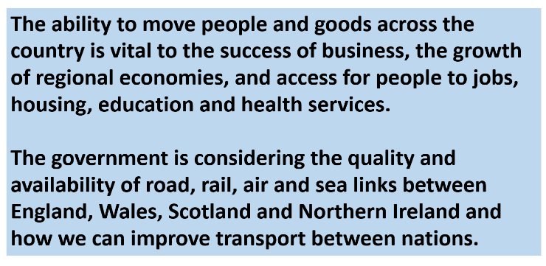
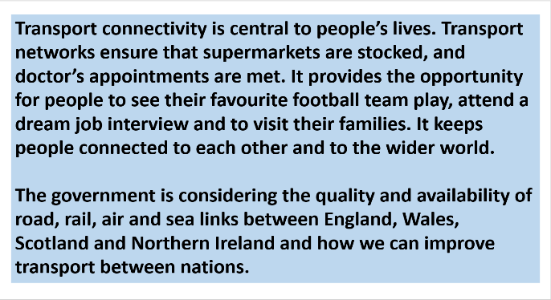

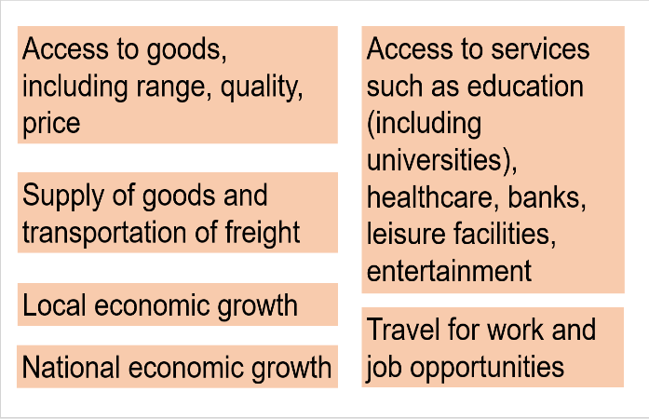
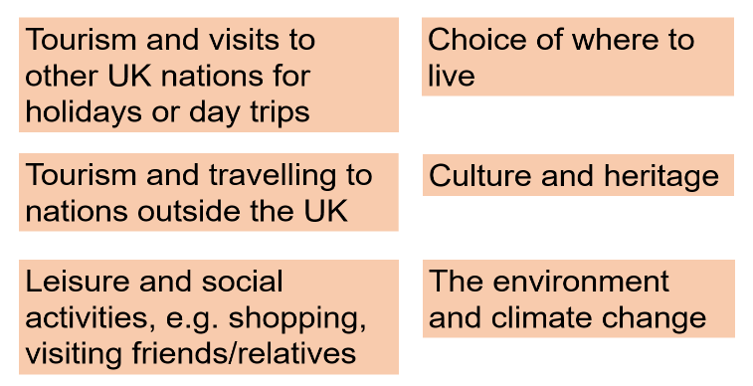

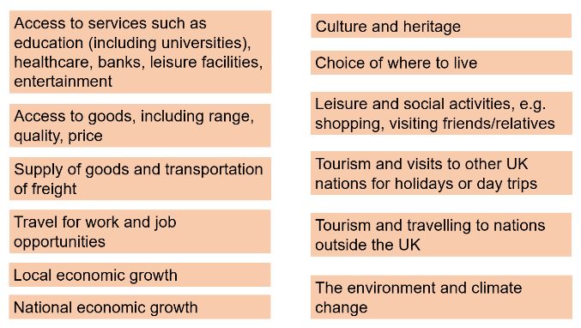

Appendix C: Follow-up in-depth interviews: achieved and target sample profile
Gender
Gender | Across all depths
 | Target | Achieved
Male | 7-9 | 8
Female | 7-9 | 8

Age
Age | Across all depths
 | Target | Achieved
16 – 34 | 4-6 | 4
35 – 54 | 4-6 | 6
55 - 75 | 4-6 | 6

Ethnicity
Ethnicity | Across all depths
 | Target | Achieved
Ethnic minority group | 1-3 | 4

Socio-economic grade (‘SEG’)
Social grade (SEG) | Across all depths
 | Target | Achieved
ABC1 | 4-6 | 11
C2DE | 4-6 | 5

Proximity to a national border
Proximity to border | Across all depths
 | Target | Achieved
Less than 50 miles to a border | 6 | 5
More than 50 miles to a border | 6 | 6

Attitudes towards travel to and within UK nations
Statement: “It is easier to travel to another UK nation than some places in [respondent’s own] nation.” | Across all depths
 | Target | Achieved
Agree with the statement | 4 | 6
Disagree with the statement | 4 | 6

Regional breakdown of participants in England
Region (England only) | Across all depths
 | Target | Achieved
North West | n/a | 0
East of England | n/a | 2
South East | n/a | 1
Greater London | n/a | 0
West Midlands | n/a | 0
Yorkshire and Humberside | n/a | 1

Frequency of travel to other UK nations in 2019
Frequency of travel to at least one other UK nation in 2019 | Across all depths
 | Target | Achieved
Frequent (once a month or more) | 4-6 | 4
Infrequent (once every 3-6 months) | 4-6 | 5
Non-travellers (did not travel to another UK nation at all in 2019) | 4-6 | 7

Appendix D: Follow-up in-depth interview discussion guide
It should be noted that the topic guide is used as an aide or guide, and not a script. Since qualitative discussions allow for spontaneous and open-ended responses, it is not expected that every question is asked to every participant individually. Rather, the topic guide provides the moderator with a structure for the discussions, an indication of the topics that should be covered to address the research questions and the potential line of questioning to do this, including key questions to ask.
Objectives:
- Build on findings from the focus groups and survey to explore in more depth people’s travel behaviour and views on the transport links between the nations of the UK
- ‘Paint a picture’ of the role that travel to other UK nations plays in people’s lives.

These interviews will be written up into eight ‘pen portraits’, each of which will summarise one participant’s travel behaviours, views and priorities.

Participants have been sampled based on demographic criteria, the nation in which they live and their responses to the following survey topics:
- Frequency of travel to other UK nations
- Proximity to UK nation internal border
- Reasons for travel to other nations
- Views on ease of travel within own nation vs travel between nations
- Views on importance of improving travel links between UK nations.

Interviewers will be provided with participants’ responses to the above survey topics in advance of the interview and should familiarise themselves with these.

Interview instructions:

Bold: Key questions
Not bold: Prompts and follow up questions
CAPITALS: Interviewer instructions

Where relevant, mention interviewee’s nation first when all four UK nations are listed.

Timing | Section | Purpose
5 mins | 1. Welcome and introductions
 | ASK PARTICIPANT TO LEAVE CAMERA OFF – WE DO NOT HAVE PERMISSION TO HAVE THESE ON  INTRODUCE SELF AND IPSOS MORI (independent research organisation).  INTRODUCE TOPIC FOR THE DISCUSSION – We are conducting research for the Department for Transport about people’s travel and transport across the nations of the United Kingdom, and the role of transport connectivity in the UK. This means we will be discussing travel and transport between England, Scotland, Wales and Northern Ireland – the UK nations. We are speaking to various other people across the four nations as part of this research, and the study builds on findings from the survey on this topic that you completed in March.  EXPLAIN THE ROLE OF IPSOS MORI – independent researchers aiming to help you share your views and experiences.  - No right or wrong answers, we are just interested in your views  - We have a lot to cover, so I may move us on at points  - Please try not to be distracted – mobile phones away and on silent  - Your incentives will be administered after completing the interview.  EXPLAIN CONFIDENTIALITY AND MRS:  All our research adheres to the Market Research Society Code of Conduct and the General Data Protection Regulation/Data Protection Act. This means that all data collected is kept confidential, anonymised and held securely before being deleted.  ASK PERMISSION TO RECORD INTERVIEW (NO VIDEO) – WE WILL TRANSCRIBE FOR QUOTES, BUT NO DETAILED ATTRIBUTION.  TURN ON RECORDING  CLARIFY LENGTH OF THE INTERVIEW (1 HOUR) AND FINISHING TIME.  Do you have any questions before we start? | To explain purpose of the research  To explain the discussion is about the UK (not GB). Ensure throughout that participant is clear on whether discussing their own nation (e.g. Scotland) or the UK
15 mins | 2. Personal travel behaviour
 | Past travel behaviour  We’re going to begin by looking back at the journeys you made to other nations within the UK before the Covid-19 pandemic, in 2019. Just to recap, in the survey you said you travelled to…. [RECAP THE JOURNEYS THEY SAID THEY MADE TO OTHER NATIONS – I.E. TO WHICH NATION AND HOW OFTEN THEY DID THIS IN 2019 – ACCORDING TO THE SURVEY DATA].  ASK TO THOSE WHO MADE JOURNEYS TO OTHER NATIONS:  FOR EACH KEY JOURNEY TYPE/ROUTE, ASK THE FOLLOWING 4 QUESTIONS (GO THROUGH MORE THAN ONCE IF THEY MAKE JOURNEYS AT DIFFERENT FREQUENCIES, FOR DIFFERENT REASONS, TO OTHER NATIONS).  - ASK FOR EACH JOURNEY TYPE: Can you tell me more about this journey? What was the purpose of the journey?  - Whereabouts within [NATIONS] were you travelling to and from?  - What mode(s) of transport did you use? Why? Please include all of the types of transport you used for the door to door journey.  - How much, if at all, did environmental considerations factor into your decision on how to travel?  - How did you find the journey(s)? Were any parts of the journey particularly easy or difficult? If so, which parts, and why?  IF NOT COVERED ALREADY: During 2019, or before that, did you make any other regular or occasional journeys to another UK nation that we’ve not talked about?  How important or not was it to you to be able to make these journeys, and why? (PROBE FOR DIFFERENT JOURNEY TYPES MENTIONED).  ASK FOR EACH JOURNEY TYPE IF TIME – IF NOT ENOUGH TIME, ASK FOR THE MAIN JOURNEY TYPE THEY MADE  Thinking about the journeys you have described so far, what would have happened if you were unable to make the journeys in the way you did?  PROBES FOR EACH KEY JOURNEY TYPE MENTIONED:  - Would you have travelled via a different transport mode (if so, which?), or would you have chosen not to travel at all? What difference would that have made?  - How would your life have been different if you couldn’t have made these journeys?  Thinking about the types of journeys we’ve talked about, how could they have been improved, if at all?  [IF RELEVANT]: And how important would such an improvement be to you?  ASK THOSE WHO DID NOT TRAVEL AT ALL IN 2019 TO ALL THREE OF THE UK NATIONS THEY DO NOT LIVE IN:  You said in your survey responses that in 2019, you did not travel to any of the other UK nations. Can I just check, was there anything that stopped you from making a journey to another nation in the UK?  - To what extent is that something you’d have been interested in doing, or not?  - Why/why not?  - What impact, if at all, did not travelling to another UK nation have for you?  ASK ALL  How, if at all, did you travel to other UK nations during 2020? Did the pandemic change the way you travel between UK nations during this time? [N.B. WE ARE ASKING ABOUT 2020 HERE, NOT TRAVEL NOW/IN 2021 – THAT’S COMING UP IN NEXT SECTION].  PROBE:  - Changes to frequency of travel?  - Changes to destination?  - Changes to mode of travel? E.g. avoiding public transport  - Changes to time of travel? E.g. avoiding rush hour  Current travel behaviour  Now I’d like you to think about journeys you’ve made over the past few months since the lockdown restrictions began easing earlier this year. During this period how often have you travelled to another nation within the UK?  IF THEY HAVE MADE JOURNEY(S) TO OTHER UK NATIONS IN 2021:  - Which nation(s) were you travelling to, and how often?  - Whereabouts within each nation were you travelling to and from?  - Again, can you describe the journeys in terms of why and how you travelled, and who with? (Please think about the whole door-to-door journey)  - How did you find the journey(s)? Were any parts of the journey particularly easy or difficult? If so, which parts, and why?  How would your life be different if you couldn’t make these journeys? How important is it for you to be able to make these journeys, and why?  IF THEY HAVE NOT MADE JOURNEY(S) TO OTHER UK NATIONS IN 2021:  Is there anything that has stopped you from making a journey to another nation in the UK this year?  - To what extent is that something you’d have been interested in doing, or not?  - Why/why not?  - What impact, if at all, has not travelling to another UK nation had for you?  Is there anything that has encouraged you to make a journey to another nation in the UK since the lockdown restrictions began easing earlier this year? Why/why not?  PROBE: Not being able to travel abroad  Intended future travel behaviour  And now I’d like you to think about the future, when Covid-19 travel restrictions are lifted. How often do you think you will travel to other nations within the UK? Why/why not?  PROBE:  - Which nations? Travelling whereabouts?  - Travelling for different reasons? With who?  - How has this changed, if at all, since the pandemic? PROBE - Travelling less due to increased use of technology (e.g. Zoom) for personal use or work? Travelling more, to visit friends/family, to go on holiday in the UK?  - PROBE ON THE NEAR FUTURE, AND IN A FEW YEARS’ TIME  How, if at all, do you think the pandemic has influenced how you plan to travel to other UK nations in the future, if you think you’ll do this? Why?  PROBE:  - Using different modes? e.g. avoiding public transport  - Travelling at different times? | To warm up the participant to the topic  To understand participant’s past, current and intended journeys to other nations, which will provide context to their views in later sections  To find out how easy or difficult they found/find these journeys to other nations, and how important these journeys are to them
15 mins | 3. Barriers and enablers to travelling between UK nations
 | We’re now going to think about what makes it easier or more difficult for you, and for others, to travel between UK nations.  We’ve discussed this a little already with reference to the journeys you’ve made to other nations in the past/in terms of why you haven’t travelled to other nations in the past [ADJUST ACCORDINGLY].  With no COVID-related travel restrictions, how easy or difficult would it be for you personally to travel to [England/Scotland/Wales/Northern Ireland]? What makes you say this?  ASK FOR EACH NATION THEY DO NOT LIVE IN AND HAVE NOT ALREADY DISCUSSED IN TERMS OF JOURNEY THEY HAVE MADE. PROBE FOR EASY OR DIFFICULT AND WHY. AVOID LENGTHY DISCUSSION OF COST/AFFORDABILITY, BUT RECORD SPONTANEOUS RESONSES ON THIS. ADDITIONAL PROBES:  - Journey time  - Proximity to/accessibility of transport hubs/links  - Frequency of public transport  - Stages in the door-to-door journey [PROBE FOR BARRIERS AND ENABLERS IN EACH STAGE OF THE JOURNEY – E.G. GETTING TO THE AIRPORT]  - Impact on the environment  - Anything else  We’ve been talking about your travel to other nations within the UK. Now we’d like to briefly ask you about your travel within your own nation and how this might differ to travelling to another nation.  What types of journeys do you make within your own nation? Where do you tend to travel to? How? How often?  Would you like to travel more regularly within your own nation? Why/why not?  What, if anything, encourages you to travel within your own nation?  What, if anything, discourages you from travelling within your own nation?  How does travelling to other UK nations compare with making longer journeys within England/Scotland/Wales/N.I. [ASK ABOUT PARTICIPANT’S COUNTRY]? Which is easier or more difficult for you, and why? For example, think about going east-west, north-south within your country, or to more remote areas which are harder to reach – is that easier or more difficult to get to than getting to another UK nation?  How does travelling within [PARTICIPANT’S NATION] compare with travelling within another nation within the UK?  PROBE: How different, if at all, does it feel? Why?  FOR NORTHERN IRELAND IF NOT ALREADY COVERED: How does travelling around Northern Ireland and over to the Republic compare with travelling to another UK nation? Which is easier or more difficult, and why?  ASK ALL: Would you like to travel (more) regularly to another nation in the UK? Which one? PROBE: Why/what interests you about travelling to other nations in the UK?  What difference could the ability to travel more easily between nations in the UK make to your life?  What’s stopping you from doing this/doing this more?  AVOID LENGTHY DISCUSSION OF COST/AFFORDABILITY. PROBES:  - Lack of interest, need or willingness  - Journey time  - Proximity to/accessibility of transport links  - Frequency of trains/buses  - Cost of travel (ticket cost, fuel cost)  - Stages in the door-to-door journey – what are the barriers at each stage?  - Anything else – what about other people who live in England/Scotland/Wales/Northern Ireland? What might be stopping them from travelling to other UK nations?  How much does the impact on the environment influence your decisions about how or how often you travel to other nations within the UK?  What, if anything, would encourage you personally to travel to other UK nations more often?  ASK ABOUT EACH UK NATION  AVOID DISCUSSION OF COST/CHEAPER TICKETS. PROBE:  - More frequent train / flights / buses etc.  - More direct travel links  - Reasons to travel e.g. having a job, visiting family & friends  - Promotion / advertising  - Cost of staycation  And what do you think might encourage others within the UK to travel to UK nations outside of their own more often?  ASK ABOUT EACH UK NATION. AVOID DISCUSSION OF COST/CHEAPER TICKETS. PROBE:  - More frequent train / flights / buses etc.  - More direct travel links  - Reasons to travel e.g. having a job, visiting family & friends  - Promotion / advertising  - Cost of staycation | To understand what makes it easy (enablers) or difficult (barriers) for people to travel across UK nations  To understand how ease of travel between nations compares to long distance travel within the same nation, and why, and to find out if crossing a national border feels different in some way to travelling within a nation  To find out the potential motivators people identify to travel across nations  To find out what might make a difference to the amount of travel people do across nations
10 mins | 4. Perceived importance of transport connectivity
 | IF NOT COVERED IN PREVIOUS SECTION: How important is it for you personally to be able to travel to other UK nations easily? Why?  How does this compare with making longer journeys within England/Scotland/Wales/N.I. (VARY PER GROUP)? Which is more important, and why?  What difference could improved transport connectivity between the UK nations make to your life?  What difference could improved transport connectivity between the UK nations make to England/Scotland/Wales/N.I. (USE PARTICIPANT’S COUNTRY)? | Understand perceived importance and benefits of travel between UK nations, compared with importance of travel within nations
12 mins | 6. Government investment in transport connectivity between UK nations
 | To finish, we are going to think about how transport connectivity across the UK could be improved in the longer term.  This might mean improving existing connections or making new ones. We’re still thinking about transport connectivity between England, Scotland, Wales and Northern Ireland via road, rail and air, and across the Irish Sea.  NORTHERN IRELAND: IF DISCUSSION MOVES TO LOCAL TRANSPORT AND TRANSLINK IN NORTHERN IRELAND, THIS IS IMPORTANT TO HEAR, BUT STAY FOCUSED ON ‘HOW COULD THAT IMPROVE UK CONNECTIVITY? HOW MUCH OF A PRIORITY IS THIS?' (LOCAL CONNECTIONS MIGHT BE IMPORTANT TO REACH UK TRANSPORT HUBS, ETC). DICUSSION OF NI-SCOTLAND TUNNEL/BRIDGE ETC ALL RELEVANT HERE.  What could the UK Government do to improve your personal experience of travelling between the different UK nations?  What could the UK Government do to encourage you to travel more often between the different UK nations?  What could the UK Government do to encourage others to travel more often between the different UK nations?  If there was money to improve transport links between the nations of the UK, what do you think this should be spent on?  PROBE:  - Between what nations in particular?  - Which modes of transport?  - Developing existing links, or creating new ones (i.e. new roads, railways, bridges, ferries, ports)?  - Improving quality/greater frequency/better reliability/decreasing journey times/more direct links?  What type of investment might be most beneficial to England/ Scotland/Wales/Northern Ireland [ASK ABOUT PARTICIPANT’S NATION]?  How much should the impact on the environment be considered when investment decisions are made about transport connections between nations within the UK? PROBE: IS IT MORE OR LESS IMPORTANT THAN JOURNEY TIMES, COMFORT, COST ETC  And when we say ‘environment’, what specifically are you thinking of?  PROBE: The countryside? Biodiversity? Climate change and greenhouse gas emissions from transport?  In 2019 the UK Government announced its commitment to ‘levelling up’ parts of the UK. How, if at all, do you think investment in transport connections between the nations of the UK could help to support levelling up in your nation? And what about in your local area/region? [ASK ABOUT BOTH]  [ASK AS RELEVANT TO PARTICIPANT]: How, if at all, would transport investment and development improve your access to education? And what about your access to employment?  If there was good connectivity to another part of the UK to access education or employment, would you use it? Why/why not? | Understand what participants think the Government should do to improve their experience of travelling between different UK nations  Understand what participants think UK Government should spend money on to improve UK transport connectivity
3 mins | Wrap up
We’ve now come to the end of our discussion.
Do you have anything final to add about what we have been discussing or any questions?
And if we had we need to contact you in the next six weeks in case we have any further questions on this topic for this study, would we have your permission to contact you?
Thank you for taking the time to take part in this research.
EXPLAIN INCENTIVES – WILL BE PROCESSED AND ARRIVE WITHIN EIGHT DAYS
END INTERVIEW

Ipsos MORI’s standards and accreditations
Ipsos MORI’s standards and accreditations provide our clients with the peace of mind that they can always depend on us to deliver reliable, sustainable findings. Our focus on quality and continuous improvement means we have embedded a “right first time” approach throughout our organisation.

ISO 20252
This is the international market research specific standard that supersedes
BS 7911/MRQSA and incorporates IQCS (Interviewer Quality Control Scheme). It covers the five stages of a Market Research project. Ipsos MORI was the first company in the world to gain this accreditation.

Market Research Society (MRS) Company Partnership
By being an MRS Company Partner, Ipsos MORI endorses and supports the core MRS brand values of professionalism, research excellence and business effectiveness, and commits to comply with the MRS Code of Conduct throughout the organisation. We were the first company to sign up to the requirements and self-regulation of the MRS Code. More than 350 companies have followed our lead.

ISO 9001
This is the international general company standard with a focus on continual improvement through quality management systems. In 1994, we became one of the early adopters of the ISO 9001 business standard.

ISO 27001
This is the international standard for information security, designed to ensure the selection of adequate and proportionate security controls. Ipsos MORI was the first research company in the UK to be awarded this in August 2008.
 | The UK General Data Protection Regulation (GDPR)  and the UK Data Protection Act (DPA) 2018  Ipsos MORI is required to comply with the UK GDPR and the UK DPA. It covers the processing of personal data and the protection of privacy.
 | HMG Cyber Essentials  This is a government-backed scheme and a key deliverable of the UK’s National Cyber Security Programme. Ipsos MORI was assessment-validated for Cyber Essentials certification in 2016. Cyber Essentials defines a set of controls which, when properly implemented, provide organisations with basic protection from the most prevalent forms of threat coming from the internet.
 | Fair Data  Ipsos MORI is signed up as a “Fair Data” company, agreeing to adhere to 10 core principles. The principles support and complement other standards such as ISOs, and the requirements of Data Protection legislation.

