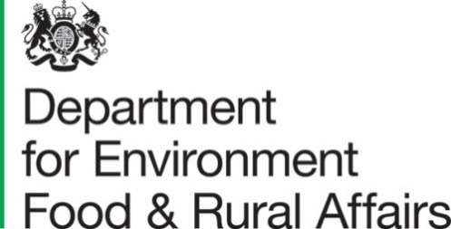

8th April 2021

Forecasts of Farm Business Income by type of farm, England, 2020/21

This statistical notice provides forecasts of Farm Business Income for 2020/21 alongside results from the Farm Business Survey for the years 2015/16 to 2019/20 (Table 1.1). These figures are for March/February years with the latest estimates covering the 2020 harvest and including the 2020 rate of the Basic Payment Scheme (which is included within the total farm output and therefore contributes to Farm Business Income). Actual survey results for this period will be published in November 2021.
The forecasts for 2020/21 are derived from information available in early March 2021 for prices, livestock populations, marketings, crop areas, yields and input costs and are intended as a broad indication of how incomes for each farm type are expected to move compared with 2019/20. The forecasts are subject to a margin of error, reflecting, in particular, the fact that farm income is derived as the relatively small difference between total output and total input; small percentage changes in either of these can result in large percentage changes in income. It should also be noted that within each year there is a wide range in income across farms around the average figures published here.

Key results
- Challenging weather conditions (the extremely wet autumn / winter of 2019 and the spring drought of 2020) along with the Covid-19 pandemic are expected to be the key drivers influencing Farm Business Income in 2020/21.
- In 2020/21, average Farm Business Income on cereal and general cropping farms is expected to fall with lower yields and areas driving a reduction in output despite higher prices for many crops in comparison to 2019/20.
- With the exception of specialist pig farms, average income on livestock farms is forecast to rise. Increased output driven by firm prices and strong domestic demand is expected to more than offset a rise in input costs, primarily for feed.
- Compared to 2019, the average 2020 Basic Payment is expected to increase by around 2 percent across all farm types.

Contents

What you need to know about this release 3
Section 1 Farm Business Income by farm type 4
1.1 Summary graphic: Farm Business Income by farm type 4
1.2 Background 5
1.3 Detailed Results 5
Section 2 Background information 9
2.1 Accuracy and reliability of results 9
2.2 Definition of Farm Business Income 9
2.3 Survey coverage and weighting 9
2.4 Availability of results 10
2.5 User engagement 10

What you need to know about this release

Contact details

Responsible statistician: Alison Wray
Email: fbsqueries@defra.gov.uk
Telephone: 0208 026 6119

National Statistics Status

National Statistics status means that our statistics meet the highest standards of trustworthiness, quality and public value, and it is our responsibility to maintain compliance with these standards.
These statistics last underwent a full assessment [Assessment Report 271 Statistics on Agriculture] against the Code of Practice for Statistics in 2014. Since the last review by the Office for Statistics Regulation, we have continued to comply with the Code of Practice for Statistics across the FBS.
For general enquiries about National Statistics, contact the National Statistics Public Enquiry Service:
Tel: 0845 601 3034
Email: info@statistics.gov.uk.
You can find National Statistics on the internet on the Gov.uk website.

Key words

Farm type: the farm type classification indicates the predominant activity on the farm.
Farm Business Income: for non-corporate businesses, Farm Business Income represents the financial return to all unpaid labour (farmers and spouses, non-principal partners and their spouses and family workers) and on all their capital invested in the farm business, including land and buildings. For corporate businesses it represents the financial return on the shareholders capital invested in the farm business.
In essence Farm Business Income is the same as Net Profit, which as a standard financial accounting measure of income is used widely within and outside agriculture. Using the term Farm Business Income rather than Net Profit, gives an indication of the measure’s farm management accounting rather than financial accounting origins, accurately describes its composition and is intuitively recognisable to users as a measure of farm income.

Section 1 Farm Business Income by farm type

1.1 Summary graphic: forecast of Farm Business Income by farm type
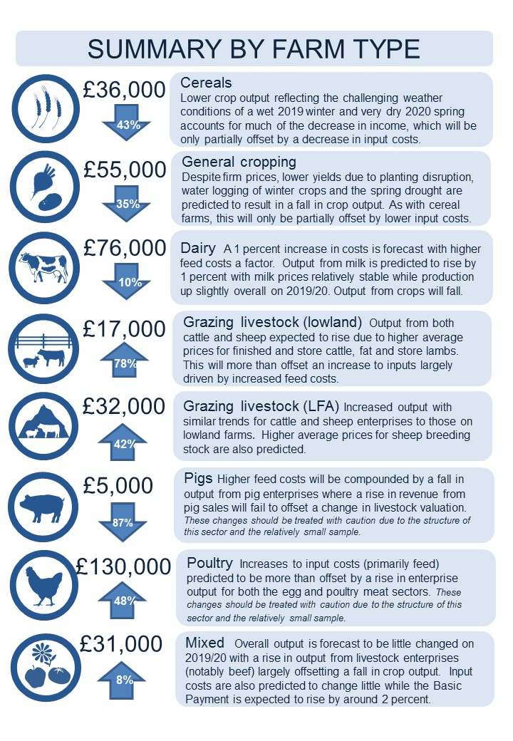

1.2 Background

Data on farm business incomes are used to monitor and evaluate Government policies and to inform wider research into the economic performance, productivity and competitiveness of the agricultural industry. The data are widely used by the industry for benchmarking and are currently provided to the EU as part of the Farm Accountancy Data Network (FADN).

1.3 Detailed Results

The average income on cereal farms is forecast to fall by around 43 percent in 2020/21 to £36,000 (Table 1.1). Despite prices remaining firm, areas and yields are predicted to be lower for many crops as a result of the extremely wet planting conditions in the autumn and winter of 2019/20 and the very dry spring of 2020. This is expected to have a substantial impact on crop output which is forecast to fall by 17 percent. Moves to grow alternative crops such as spring barley (where crop area increased by about a quarter), oats and pulses are not expected to compensate for losses of output from other crops, particularly wheat and oilseed rape. Input costs on cereal farms are predicted to fall by around 2 percent, notably for machinery depreciation and fertiliser costs (reflecting lower prices and reduced crop areas) and other crops costs. The Basic Payment is forecast to increase by 2 percent while agri-environment Scheme payments are expected to be little changed on 2019/20.

On general cropping farms, average Farm Business Income is forecast to decrease by just over a third to £55,000 (Table 1.1). As with cereal farms, lower crop output is predicted to be the key driver with a fall in wheat output a major influencing factor. Despite price rises for peas, beans, oilseed rape and sugar beet, yields are expected to be heavily impacted by the adverse weather conditions. For oilseed rape, reduced yields are also expected to be compounded by a reduction in crop area and continuing problems with cabbage stem flea beetle. Although potato yields are forecast to be around the 5 year average despite the challenging weather, prices are expected to be lower compared to 2019 with less demand from some sectors, such as hospitality, due to Covid-19 restrictions a likely contributing factor. Overall agricultural output is forecast to decrease by 7 percent compared to 2019/20. At the same time, input costs on general cropping farms will fall very slightly (by around 1 percent) while the Basic Payment will go up by around 2 percent.

Average Farm Business Income on dairy farms is expected to decrease by 10 percent to £76,000 (Table 1.1). Input costs will increase by 1 percent, with rises for feed costs (reflecting higher cereal prices), machinery and other livestock costs. These increases will be partially offset by a decrease in crop costs, mainly the cost of fertilisers. Output from milk and milk products is forecast to increase by 1 percent; the result of milk prices remaining relatively stable while milk production, although lower than usual during the normal spring peak due to Covid-19 related pressures, is expected to be slightly higher overall than in 2019/20. It is important to note the wide variation in milk prices with some farmers receiving considerably more or less than the average. Additionally, in 2020, Covid-19 impacted some farms more severely than others depending on whether they were supplying milk to the retail or hospitality sectors. Output from crops, particularly from cereals, is predicted to fall. These factors will result in overall agricultural output remaining static. As for other farm types, the Basic Payment is expected to increase by around 2 percent.

On lowland grazing livestock farms, average income is predicted to rise by 78 percent in 2020/21 to £17,000 (Table 1.1). Output from cattle enterprises is expected to increase with higher average prices for both finished and store cattle; tight supplies are predicted to be a factor with imports down as a result of Covid-19 restrictions and an increase in retail demand helping to offset the closure of the hospitality outlets. Similar factors are expected to influence output from sheep which is also forecast to increase with prices for fat and store lambs higher across most of the year. Livestock output is forecast to go up by around 18 percent and overall agricultural output by 9 percent on this type of farm. In comparison, input costs are forecast to rise by 2 percent with higher feed costs accounting for most of the increase.

In 2020/21, the average income on LFA grazing livestock farms is forecast to increase by 42 percent to £32,000 (Table 1.1). Livestock output on LFA farms is expected to go up by around 17 percent with similar trends for cattle and sheep enterprises as those seen on lowland farms. Farms in the LFA are also predicted to benefit from further increases to fat lamb prices from July onwards, when lambs start to be sold off this type of farm. Sheep breeding stock prices, an important source of income on upland farms, are also expected to be higher compared to 2019. As with lowland farms, costs are predicted to increase, particularly feed costs but with small rises also seen across a range of other items including machinery and other livestock costs. Agri-environment payments, which represent an important source of income for these type of farms, are expected to increase by around 6 percent.

Forecasts for specialist pig farms are subject to a considerable degree of uncertainty reflecting both the structure of this sector and the relatively small sample of these farms in the Farm Business Survey. For this type of farm average Farm Business Income is forecast to fall to around £5,000 compared to £37,700 in 2019/20 (Table 1.1), a decrease of around 87 percent. A rise in input costs of 5 percent driven by increased feed costs (linked to the rise in cereal prices), is expected to be a key driver. Output from pig enterprises is forecast to fall by 1 percent. An increase in revenue from pig sales, driven by firmer prices at the start of the year, is expected to be offset by a change in livestock valuation with the value of weaners, store pigs and cull sows estimated to be lower at closing, compared to opening, valuation. Average prices for finished pigs are predicted to move to a downward trend from the summer of 2020 onwards, with Covid-19 related challenges a contributing factor along with the detection of African Swine Fever in Germany.

Forecasts for specialist poultry farms are subject to a considerable degree of uncertainty reflecting both the structure of this sector and the relatively small sample of these farms in the Farm Business Survey. On this type of farm average income for 2020/21 is expected to be around £130,000, an increase of 48 percent compared to 2019/20 (Table 1.1). Increased egg prices following strong retail demand during the Covid-19 lockdowns are expected to be a major driver increasing poultry output by 7 percent. Output from poultry meat is also forecast to rise. In comparison, input costs are expected to go up by 2 percent. As with other livestock farms it is anticipated that the biggest cost increase will be for feed costs.

On mixed farms incomes are expected to increase by 8 percent to £31,000 (Table 1.1). These type of farms reflect all the enterprises found in the more specialist farm types reported above. Overall output is forecast to be little changed on 2019/20, with a rise in output from livestock enterprises (notably beef) largely offset by a fall in crop output. Input costs will also remain little changed compared to the previous year. As for other farm types, it is anticipated that the Basic Payment will increase by around 2 percent while agri-environment Payments will be largely unchanged.

Table 1.1 Average Farm Business Income per farm at current prices (£/farm) (a)
Farm Type | 2017/18 | 2018/19 | 2019/20 | 2020/21 forecast | % Change 2020/21-  2019/20
At current prices
Cereals | 62,100 | 67,300 | 63,000 | 36,000 | -43%
General cropping | 87,200 | 106,400 | 84,000 | 55,000 | -35%
Dairy | 118,500 | 79,700 | 84,800 | 76,000 | -10%
Grazing livestock (Lowland) | 20,500 | 12,500 | 9,400 | 17,000 | 78%
Grazing livestock (LFA) | 27,000 | 15,500 | 22,800 | 32,000 | 42%
Specialist pigs (b) | 29,800 | 29,600 | 37,700 | 5,000 | -87%
Specialist poultry (b) | 94,800 | 74,700 | 87,900 | 130,000 | 48%
Mixed | 43,400 | 45,500 | 28,900 | 31,000 | 8%
- Data for forecast year rounded to the nearest thousand. The percentages shown are calculated against the unrounded figures. Years ending at end of February.

- The sample sizes for specialist pig and poultry farms are relatively small and the confidence intervals relatively large. Results for individual farms can have a large influence on the overall results.

Table 1.2 Average Farm Business Income per farm in real terms (a) at 2020/21 prices (£/farm) (b)
Farm Type | 2017/18 | 2018/19 | 2019/20 | 2020/21 forecast | % Change  2020/21- 2020/19
In real terms at 2020/21 prices (a)
Cereals | 65,800 | 72,900 | 66,600 | 36,000 | -46%
General cropping | 92,400 | 115,200 | 89,600 | 55,000 | -39%
Dairy | 125,600 | 86,300 | 90,000 | 76,000 | -15%
Grazing livestock (Lowland) | 21,700 | 13,500 | 9,900 | 17,000 | 68%
Grazing livestock (LFA) | 28,600 | 16,800 | 24,200 | 32,000 | 34%
Specialist pigs (c) | 31,600 | 32,100 | 40,000 | 5,000 | -88%
Specialist poultry (c) | 100,500 | 80,900 | 93,200 | 130,000 | 40%
Mixed | 46,000 | 49,300 | 30,600 | 31,000 | 2%
- Uses GDP deflator.

- Data for forecast year rounded to the nearest thousand. The percentages shown are calculated against the unrounded figures. Years ending at end of February.

- The sample sizes for specialist pig and poultry farms are relatively small and the confidence intervals relatively large. Results for individual farms can have a large influence on the overall results.

Section 2 Background information

2.1 Accuracy and reliability of results
The forecasts shown in this release for 2020/21 are provisional, based on information available in early March 2021 for prices, livestock populations, marketings, crop areas and yields. The relative changes, compared to the previous 12 months, are then applied to aggregate data from the most recent Farm Business Survey (FBS) for each robust farm type. A level of estimation is necessary, particularly for variables where no market information is available. Outturn results (which will be published in November 2021 based on results for the 2020/21 FBS), could differ from these forecasts for several reasons. These include changes to the sample and to the weighting framework. In 2020/21, of the 1,664 farms that were included in the FBS target population around 97 farms came into the sample that weren’t present in 2019/20. In addition, the FBS weights are refreshed each year in line with the latest farm population data from the June Survey of Agriculture.

2.2 Definition of Farm Business Income
For non corporate businesses, Farm Business Income represents the financial return to all unpaid labour (farmers and spouses, non-principal partners and their spouses and family workers) and on all their capital invested in the farm business, including land and buildings. For corporate businesses it represents the financial return on the shareholders capital invested in the farm business.

In essence Farm Business Income is the same as Net Profit, which as a standard financial accounting measure of income is used widely within and outside agriculture. Using the term Farm Business Income rather than Net Profit, gives an indication of the measure’s farm management accounting rather than financial accounting origins, accurately describes its composition and is intuitively recognisable to users as a measure of farm income.

2.3 Survey coverage and weighting
The Farm Business Survey (FBS) is an annual survey providing information on the financial position and physical and economic performance of commercial farm businesses in England. It covers all types of farming in all regions of the country and includes owner-occupied, tenanted and mixed tenure farms. The FBS only includes farm businesses with a Standard Output of at least €25,000, based on activity recorded in the previous June Survey of Agriculture and Horticulture. In 2019, this accounted for approximately 56,521 farm businesses. Data are collected from a sample of around 1,750 farm businesses by face to face interviews with farmers, conducted by highly trained researchers.
Each record is given a weight to make the sample representative of the population. Initial weights are applied to the FBS records based on the inverse sampling fraction. These weights are then adjusted by calibrating certain totals to match published totals from other surveys so that they can be used to produce unbiased estimators of a number of different target variables.
More detailed information about the Farm Business Survey and the data collected can be found at https://www.gov.uk/farm-business-survey-technical-notes-and-guidance

2.4 Availability of results
All Defra statistical notices can be viewed on the Gov.UK site at: https://www.gov.uk/government/organisations/department-for-environment-food-rural-affairs/about/statistics.
Results from the Farm Business Survey including time series in spreadsheet format can be found at: https://www.gov.uk/government/collections/farm-business-survey

2.5 User engagement
As part of our ongoing commitment to compliance with the Code of Practice for Official Statistics we wish to strengthen our engagement with users of these statistics and better understand the use made of them and the types of decisions that they inform. Consequently, we invite users to make contact to advise us of the use they do, or might, make of these statistics, and what their wishes are in terms of engagement. Feedback on this statistical release and enquiries about these statistics are also welcome.
Please contact Alison Wray at fbs.queries@defra.gov.uk.

© Crown copyright 2021. You may re-use this information free of charge under the terms of the Open Government Licence v.3. To view this licence visit www.nationalarchives.gov.uk/doc/open-government-licence/version/3/

Further information on calibration weighting can be found in the ‘Statistical Issues’ document at the following link: https://www.gov.uk/government/uploads/system/uploads/attachment_data/file/557607/fbs-statisticalinformation-4oct16.pdf

