Application Decision
by Richard Holland
Appointed by the Secretary of State for Environment, Food and Rural Affairs
Decision date: 28 October 2021

Application Ref: COM 3244132
Church Green, Hooley, Surrey
Register Unit No: CL79
Commons Registration Authority: Surrey County Council.
- The application, dated 18 November 2019, is made under Section 38 of Commons Act 2006 (the 2006 Act) for consent to carry out restricted works on common land.
- The application is made by Reigate and Banstead Borough Council.
- The works comprise the installation of 33 wooden posts and one metal drop post along the north east edge of the common at a length of 50 metres.

Decision
  - Consent is granted for the works in accordance with the application dated 18 November 2019 and accompanying plans.

  - For the purposes of identification only the location of the works is shown as a red line on the attached plan.

Preliminary Matters
  - The application is wholly retrospective, with all works carried out.
  - I have had regard to Defra’s Common Land Consents Policy in determining this application under section 38, which has been published for the guidance of both the Planning Inspectorate and applicants. However, every application will be considered on its merits and a determination will depart from the policy if it appears appropriate to do so. In such cases, the decision will explain why it has departed from the policy.
  - This application has been determined solely on the basis of written evidence. I have taken account of the representation made by Natural England (NE) and Surrey County Council’s Archaeological Officer.
  - I am required by section 39 of the 2006 Act to have regard to the following in determining this application:-
- the interests of persons having rights in relation to, or occupying, the land (and in particular persons exercising rights of common over it);
- the interests of the neighbourhood;
- the public interest; and
- any other matter considered to be relevant.

Reasons

The interests of those occupying or having rights over the land
  - The applicant, Reigate and Banstead Borough Council (the Council), owns and manages the land. The works are therefore in the interests of the landowner.
  - The common land register for Church Green (CL79) records no rights of common or any claims to easements over the land that may be harmed by the works.

The interests of the neighbourhood and the protection of public rights of access
  - The application states that the works are needed because CL79 is vulnerable to incursions. Whilst no further details about this are given in the application form, I am satisfied from subsequent correspondence that the works are part of a wider action by the Council to discourage unauthorised vehicular access and encampment on common land in the area, which has been a problem in recent years.
  - The interests of the neighbourhood test relates to whether the works will unacceptably interfere with the way the land is used by local people and is closely linked with public rights of access. CL79 covers approximately 0.7 hectares in the village of Hooley. It is fragmented around the edges with the main section occupying a triangular area bounded on all three sides by Elmore Road and Star Lane. I consider it likely that the common is well used by local people for recreational purposes and that the war memorial in the southern corner is of interest to visitors.
  - A photograph of a section of the wooden posts submitted by the Council shows adequate gaps between them for pedestrians, wheelchair users and pushchairs to access the common. I am satisfied that, in themselves, the posts have only a very small impact on access and are in the interests of the neighbourhood as they protect the common from damage that may be caused by unauthorised vehicular access.

Nature conservation
  - NE advised that due to the type and scope of the works it would not make representations about the application. There is no evidence before me to suggest that the works will harm nature conservation interests.

Conservation of the landscape
  - The Council advises that the common lies within an Area of Great Landscape Value (AGLV) and that the posts are wooden to be in keeping with the surrounding environment. I am satisfied from Council’s photograph that the posts, along with the metal drop post, do not cause serious visual harm to the landscape.

Archaeological remains and features of historic interest
  - Surrey County Council’s Archaeological Officer confirms that the works will not impact upon any designated heritage assets. Whilst a search of the Surrey Historic Environment Record indicates that a small part of the area is identified as being of High Archaeological Potential, the small scale and localised impact of the posts means it is highly unlikely that there will be a destructive impact on significant archaeological remains. I am satisfied that the works are unlikely to harm archaeological remains and features of historic interest.

Conclusion
  - I conclude that the works do not significantly harm any of the interests set out in paragraph 6 above; indeed, they are in the interests of the neighbourhood by helping to protect the common from the harmful effects of unauthorised vehicular access. Consent should therefore be granted subject to the conditions set out in paragraph 1.

Richard Holland

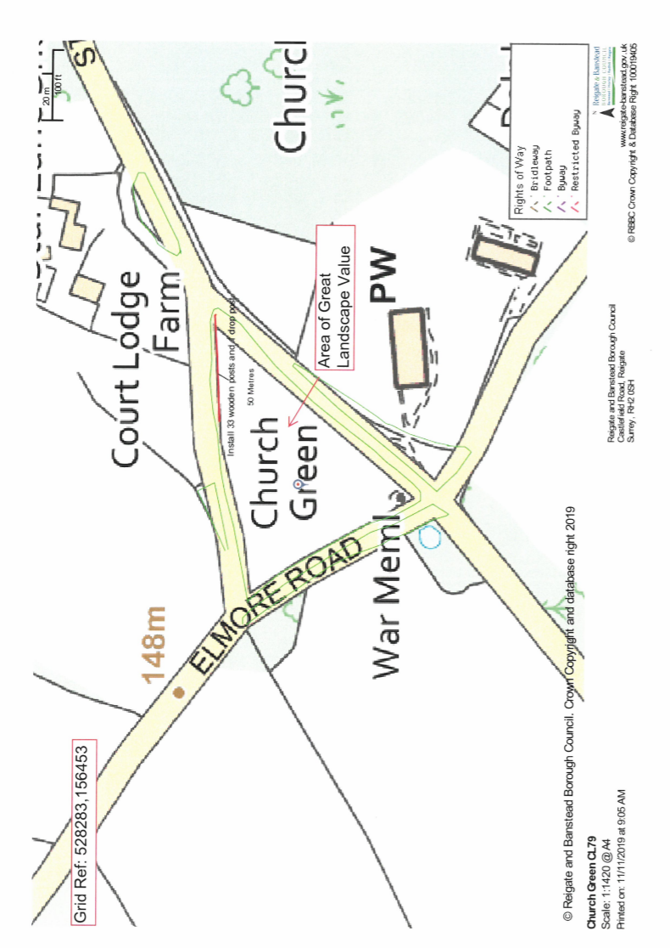

Common Land Consents Policy (Defra November 2015)
Section 39(2) of the 2006 Act provides that the public interest includes the public interest in; nature conservation; the conservation of the landscape; the protection of public rights of access to any area of land; and the protection of archaeological remains and features of historic interest.

