Official Statistics
21 October 2021

Introduction
This statistical release provides summary information on appeals, which represent the highest volume (in terms of number of cases) of the work of the Planning Inspectorate.

These statistics are produced each month and the focus is on timeliness, as that is an area in which stakeholders have an interest. Information on the decisions that have been made is also included; and on the number of Inspectors available to make those decisions.

Consultation with our users – Removal of virtual events data

In this statistical release we have been publishing data on the number of virtual events being held each month. The Planning Inspectorate recommenced face-to-face events for hearings and inquiries from Monday 13th September 2021. There also continues to be significant concerns with the quality of the data collected on virtual events.

In the last release readers were invited to contact us if they had any concerns or comments on this proposal. No comments have been received. Future releases will no longer include data on virtual events.

These statistics have been published to ensure everyone has equal access to the information and to support the Planning Inspectorate’s commitment to release information where possible.

This statistical bulletin provides:
- Appeals decisions and events held from October 2020 to September 2021
- The time taken to reach those decisions
- Number of open cases
- Number of Inspectors
- Number of virtual events

The Planning Inspectorate
The Planning Inspectorate makes decision and provides recommendations and advice on a range of land use planning-related issues across England. We do this in a fair, open, and timely way.

The Planning Inspectorate deals with planning appeals, national infrastructure planning applications, examinations of local plans and other planning-related and specialist casework in England. The Planning Inspectorate is an executive agency, sponsored by the Department for Levelling Up, Housing and Communities, previously known as the Ministry for Housing, Communities and Local Government.
Summary
Impact of Covid-19 pandemic
This statistical release reflects that, as with everyone else, the Inspectorate has now been operating for over 12 months with the impact of the Covid-19 pandemic. Previous statistical releases have outlined the impact of the pandemic on the Inspectorate in three ways: events were suspended during the first national lockdown in Spring 2020; subsequent timeliness measures increased; and the number of open cases also increased.

Performance
The mean average time to make a decision, across all cases in the last 12 months (Oct 20 to Sep 21), was 27 weeks. The median time was 23 weeks.
The median time to decide a case increased by 0.3 weeks between August and September 21, with the September median being 24.3 weeks.

Median timeliness by procedure type is shown in the summary table below.

Procedure type | Last 12 months | September 21
Written Representations | 22 weeks | 24 weeks
Hearings | 47 weeks | 50 weeks
Inquiries | 60 weeks | 36 weeks

Performance had been improving between November 20 and March 21 (the time to issue a decision had been decreasing). For inquiries, in the last three months, cases have taken longer to decide as a result of very old enforcement inquiry cases being decided.

The median time for Planning cases was, apart from February and March 21, above 20 weeks for the last 12 months. Across the whole year, the median time to decision is 22 weeks.

Enforcement decisions made in the last 12 months had a median decision time of 35 weeks. Looking at the annual totals, the median and mean time to decision for specialist decisions have been broadly the same as for enforcement decisions, and longer than the median for planning decisions. Since February 21 there has been a change in this trend, with Specialist cases being quicker than Enforcement

The median time for planning appeals decided by inquiry under the Rosewell Process over the 12 months to September 21 is 34 weeks. This is quicker than other types of casework decided by inquiry.

Decisions
The Planning Inspectorate has made 18,041 appeal decisions in the last 12 months, an average of over 1,500 per month. The number of decisions in September 21 was slightly higher than this average at 1,546.

Written representations decisions had recovered to pre-pandemic levels between October and December 20 (pre-pandemic being between approximately 1,600 and 2,000 decisions per month).

Decisions in September 21 (1,476) were higher than the previous two months (1,199 in July and 1,102 in August 21) but still below pre-pandemic levels.

There were 642 decisions made on hearings during the last 12 months. Decisions for hearings since December 20 have ranged between approximately 40 and 80 per month. Pre-pandemic levels for hearing decisions were between 50 and 100 decisions per month.

There were 405 decisions made on inquiries during the last 12 months. Decisions for inquiries since December 20 have ranged between approximately 20 and 60. Pre-pandemic levels for inquiry decisions were between 15 and 90 decisions per month.

Open Cases
At the end of September 2021, the Planning Inspectorate had over twelve thousand five hundred cases open (12,592).

Planning Inspectors
There were 345 Planning Inspectors employed by the Inspectorate in September 2021 – with a full-time equivalent of 306.6.

Virtual Events
The Inspectorate are continuing to carry out events ‘virtually’. There were 30 cases involving Virtual Events during September 21. There continue to be concerns about the quality of the data on virtual events: there appears to be under-recording despite the introduction of system changes aimed at improving the quality of data. This data will not be reported in future statistical releases.

Decisions, Events & Open Cases
The number of decisions issued in September 21 was 1,546. This was 27% higher than the previous month and a return to levels seen prior to the summer months of 2021. The number of decisions in September 21 was also slightly higher than the average 1,500 decisions issued each month, over the last 12 months. The months that had decision volumes lower than 1,500 were August 20, April 21,July 21 and August 21.
The number of events held in September 21 was 24% more than the previous month, and the 4th highest in the past 12 months. In the last 12 months the highest number of events held was October 20, when just over 1900 events were held.
Higher decision and event volumes for September 2021 can partly be attributed to Inspectors taking less leave compared to July and August 2021.
The median time to decide a case slightly increased by 0.3 weeks between August and September 21, with the September median being 24.3 weeks. Performance had been improving between November 20 and March 21.
Figure 1: Number of events held, decisions issued and median time between valid date & decision date; Oct 20 to Sep 21
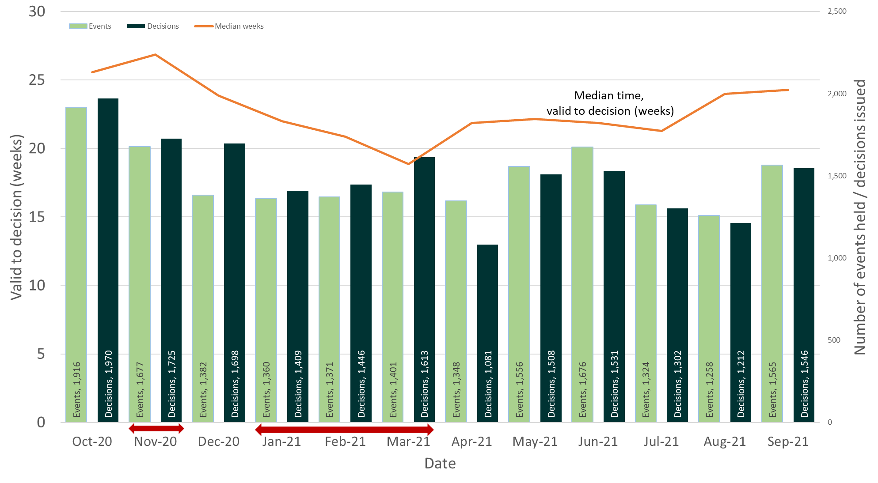
Source: Horizon, Picaso, Inspector Scheduling System
Note – Red arrows indicate periods when national lockdowns were in effect
Table 1: Number of events held, decisions issued and median time between valid date & decision date; Oct 20 to Sep 21
Month | Oct 20 | Nov 20 | Dec 20 | Jan 20 | Feb 21 | Mar 21 | Apr 21 | May 21 | Jun 21 | Jul 21 | Aug 21 | Sep 21 |  | Total
Events Held | 1,916 | 1,677 | 1,382 | 1,360 | 1,371 | 1,401 | 1,348 | 1,556 | 1,676 | 1,324r | 1,258r | 1,565 |  | 18,422
Decisions | 1,970 | 1,725 | 1,698 | 1,409 | 1,446 | 1,613 | 1,081 | 1,508 | 1,531 | 1,302 | 1,212 | 1,546 |  | 18,075
Median | 25.6 | 26.9 | 23.9 | 22.0 | 20.9 | 18.9 | 21.9 | 22.1 | 21.9 | 21.3 | 24.0 | 24.3 |  | 22.9
Source: Horizon, Picaso, Inspector Scheduling System. r denotes revision – a change of more than 5 cases since last month (see Background Quality Report for more information)

The number of open cases stands at its highest point in the last 12 months, at over 12,500 cases. The numbers of receipts averages at over 1,700 per month, over the last 12 months. The number closed averages just below 1,700 per month, over the last 12 months.

Note – The number of cases closed is higher than the number of decisions, as it includes cases where an appeal is withdrawn, notice is withdrawn, or the appeal is turned away.

Figure 2: Number of cases received, closed and open; Oct 20 to Sep 21
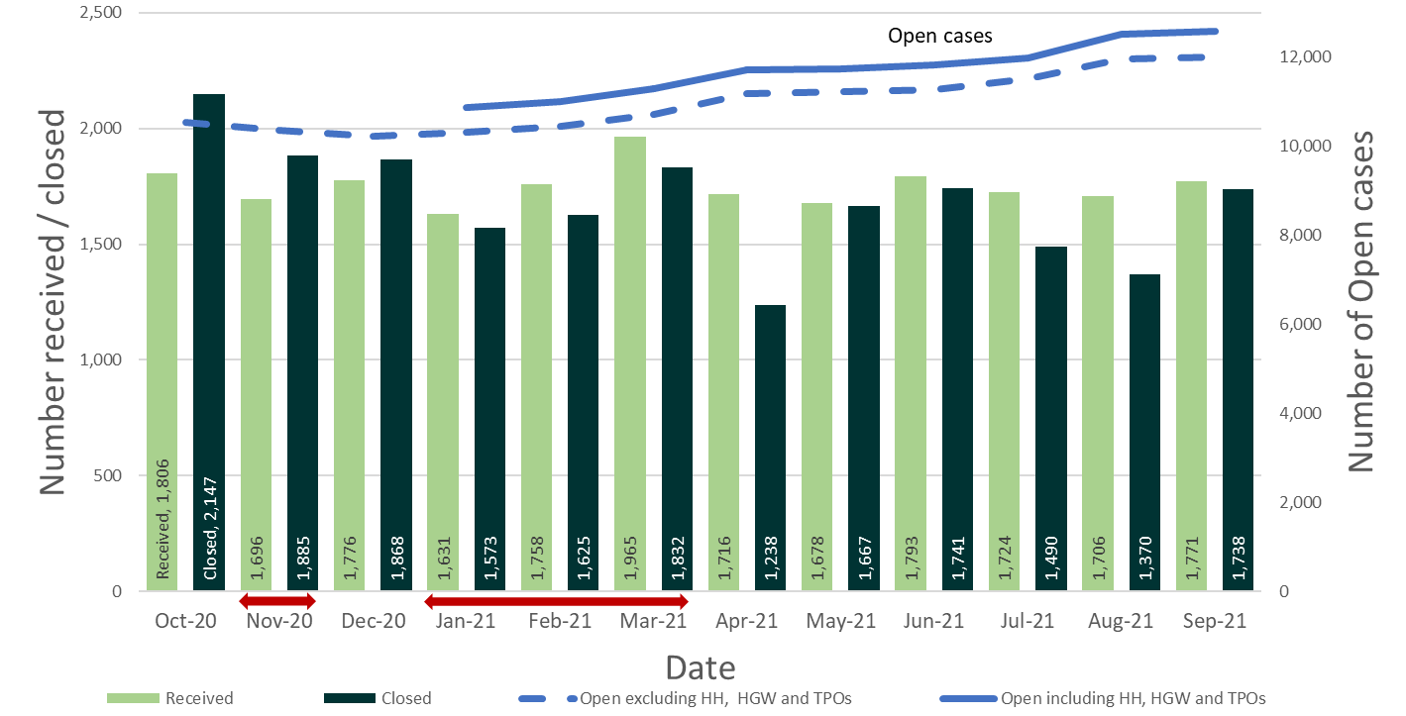
Source: Horizon and Picaso
Note – Red arrows indicate periods when national lockdowns were in effect
Data note 1 - the count of open cases from December 2020 onwards has been revised to include some specialist casework types that were previously excluded: High Hedge (HH), Hedgerow (HGW) and Tree Preservation Order (TPO).
Data note 2 – there is a known anomaly that means that the number of open cases does not exactly follow the volumes of cases closed or received (for example the number of open cases can increase between months even though the number closed exceeded the number received). The main reasons for this have been identified and are detailed in the Background Quality Report.
Table 2: Number of cases received, closed and open; Oct 20 to Sep 21
Month | Oct 20 | Nov 20 | Dec 20 | Jan 20 | Feb 21 | Mar 21 | Apr 21 | May 21 | Jun 21 | Jul 21 | Aug 21 | Sep 21 | Total
Received | 1,806 | 1,696 | 1,776 | 1,631 | 1,758 | 1,965 | 1,716 | 1,678 | 1,793 | 1,724 | 1,706 | 1,771 | 20,860
Closed | 2,147 | 1,885 | 1,868 | 1,573 | 1,625 | 1,832 | 1,238 | 1,667 | 1,741 | 1,490 | 1,370 | 1,738 | 20,189
Open (excl. HH, HGW, TPO) | 10,539 | 10,367 | 10,233 | 10,314 | 10,447 | 10,719 | 11,183 | 11,223 | 11,266 | 11,509 | 11,961 | 12,015
Open(All) |  |  |  | 10,880 | 11,001 | 11,293 | 11,725 | 11,733 | 11,823 | 11,987 | 12,525 | 12,592
Source: Horizon and Picaso. r denotes revision – a change of more than 5 cases since last month (see Background Quality Report for more information)

Number of Decisions
The Planning Inspectorate has made 18,041 appeal decisions in the last 12 months, an average of over 1,500 per month. Table 3 below shows the monthly breakdown with fewer decisions for the months of April 21, July 21 and August 21. This is thought to be due to the impact of staff taking more leave in 2021 than in 2020.
Table 3: Appeal Decisions; Oct 20 to Sep 21
Month | Oct 20 | Nov 20 | Dec 20 | Jan 20 | Feb 21 | Mar 21 | Apr 21 | May 21 | Jun 21 | Jul 21 | Aug 21 | Sep 21 | Total
Decisions | 1,970 | 1,725 | 1,698 | 1,409 | 1,446 | 1,613 | 1,081 | 1,508 | 1,531 | 1,302 | 1,212 | 1,546 | 18,041
Source: Horizon and Picaso.
Figure 3 – Appeal Decisions; Oct 20 to Sep 21
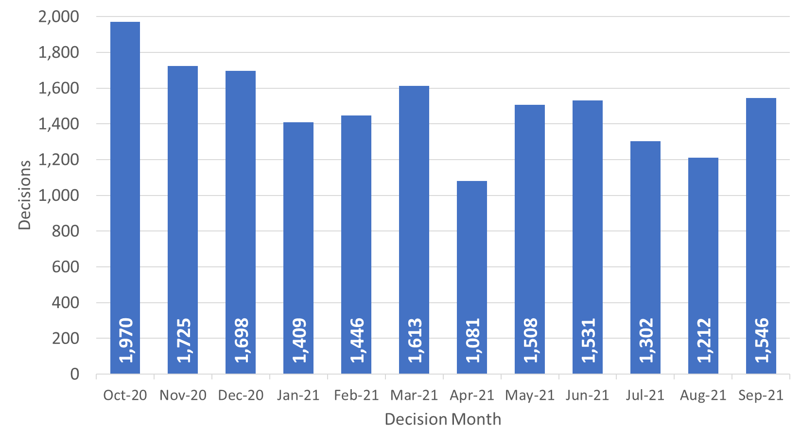
Source: Horizon and Picaso
Decisions by procedure and case type

Planning Inspectors work on a broader range of work than the appeals featured in this Release. For example, they also work on examining Nationally Significant Infrastructure Project applications, Local Plans, Compulsory Purchase Order applications and many other specialist licencing/application types.

Table 4 below gives the numbers of appeal decisions made broken down by whether the case was dealt with by written representations, hearings, or inquiries.

The large majority of decisions (16,994) were made on written representations. This is about ninety four percent of all appeal decisions made. Table 4 shows that written representations decisions had recovered to pre-pandemic levels between October and December 20 (pre-pandemic being between approximately 1,600 and 2,000 decisions per month). Decisions in July 21 (1,199) and August 21 (1,103) were low, with only April 21 (994) having less written representation decisions issued.

There were 642 decisions made on hearings during the last 12 months. Decisions for hearings since December 20 have ranged between approximately 40 and 80 per month. Pre-pandemic levels for hearing decisions were between 50 and 100 decisions per month.

There were 405 decisions made on inquiries during the last 12 months. Decisions for inquiries since December 20 have ranged between approximately 20 and 60. Pre-pandemic levels for inquiry decisions were between 15 and 90 decisions per month.

Table 4: Appeal Decisions by procedure and casework category; Oct 20 to Sep 21
Month | Oct 20 | Nov 20 | Dec 20 | Jan 20 | Feb 21 | Mar 21 | Apr 21 | May 21 | Jun 21 | Jul 21 | Aug 21 | Sep 21 | Total
Written Representations | 1,917 | 1,672 | 1,612 | 1,325 | 1,383 | 1,527 | 994 | 1,391 | 1,395 | 1,199 | 1,103 | 1,476 | 16,994
Hearings | 40 | 33 | 60 | 58 | 44 | 53 | 52 | 65 | 80 | 66 | 51 | 40 | 642
Inquiries | 13 | 20 | 26 | 26 | 19 | 33 | 35 | 52 | 56 | 37 | 58 | 30 | 405
Total | 1,970 | 1,725 | 1,698 | 1,409 | 1,446 | 1,613 | 1,081 | 1,508 | 1,531 | 1,302 | 1,212 | 1,546 | 18,041
Month | Oct 20 | Nov 20 | Dec 20 | Jan 20 | Feb 21 | Mar 21 | Apr 21 | May 21 | Jun 21 | Jul 21 | Aug 21 | Sep 21 | Total
Planning | 1,638 | 1,484 | 1,463 | 1,184 | 1,242 | 1,414 | 938 | 1,288 | 1,270 | 1,078 | 973 | 1,368 | 15,340
Enforcement | 281 | 195 | 186 | 164 | 112 | 150 | 100 | 161 | 200 | 179 | 186 | 148 | 2,062
Specialist | 51 | 46 | 49 | 61 | 92 | 49 | 43 | 59 | 61 | 45 | 53 | 30 | 639
Total | 1,970 | 1,725 | 1,698 | 1,409 | 1,446 | 1,613 | 1,081 | 1,508 | 1,531 | 1,302 | 1,212 | 1,546 | 18,041
Source: Horizon and Picaso. r denotes revision – a change of more than 5 cases since last month

What are Planning cases? The Planning category includes s78 planning appeals, householder appeals, commercial appeals, listed building consent appeals, advertisement appeals and s106 planning obligation appeals.

What are Enforcement cases? Enforcement covers enforcement appeals (i.e., appeals against the issue of an enforcement notice by a local planning authority), enforcement listed building notice appeals and lawful development certificate appeals.

What are Specialist cases? This category covers a wide range of different types of casework including Common Land, Environment, Purchase Notice, Rights of Way orders (including Schedule 14 cases), Tree Preservation Orders, Hedgerows and High Hedges cases.

The large majority of cases were planning (15,340). This is about eighty-five per cent of all appeal decisions made. There were 2,062 enforcement decisions and 639 specialist decisions. These totals are also shown in Table 4 and Figure 4 below.

Trends for planning decisions show similar patterns to written representations. The number of enforcement decisions had been decreasing month on month between October 20 and February 21 but have since increased, with the exception of April 21. Specialist casework figures continue to vary each month, from a low of 30 (September 21) to a high of 92 (February 21).

Figure 4 – Appeal Decisions by Procedure and Casework Category; Oct 20 to Sep 21
Appeal Decisions by Procedure | Appeals Decisions by Casework Category
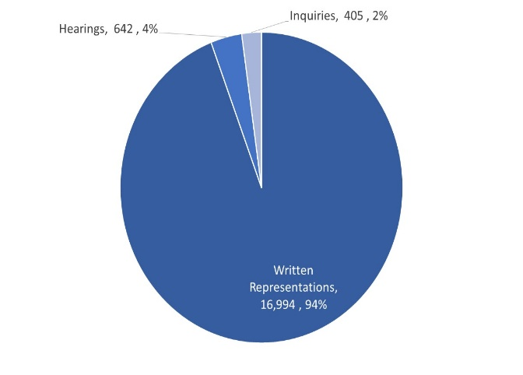 | 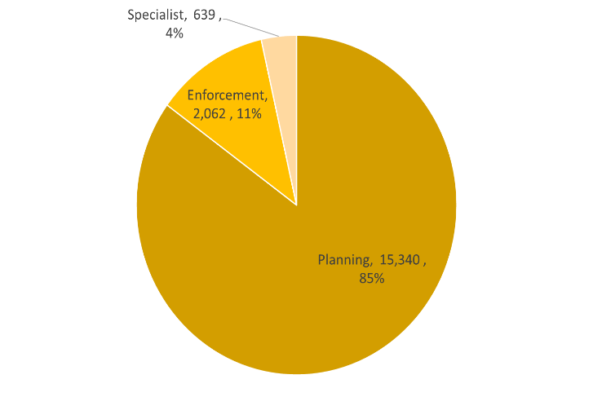
Source: Horizon and Picaso

Decision timeliness
It is important for people to know how long an appeal is going to take, so that they can make plans and decisions based on this information. This section covers the timeliness of decisions (i.e., how long it takes to make a decision) across our appeal casework. In addition to an overall measure, timeliness is analysed by procedure type and casework category, as timeliness varies a great deal depending on these characteristics.

Table 5 below shows that the mean average time to make a decision, across all cases in the last 12 months was 27 weeks. Figure 5 shows the mean has been above 25 weeks for the last 12 months, except for March 21. Unusually, the mean average reduced for September 21 (from 31 weeks in August 21 to 28.6 weeks in September 21) but the median average slightly increased (from 24 weeks in August 21 to 24.3 weeks in September 21). The standard deviation – a measure of variation – reduced in September 21 back to levels seen pre April 21.

Table 5 also shows the median time for the last 12 months is 23 weeks. Each month the median is less than the mean; this is due to the larger impact on the mean of very long cases.

The median timeliness increased between June 20 to Nov 20, peaking at almost 27 weeks. Between December 20 to March 21 there was a reduction in the median time to decision, down to a low in March 21 of 19 weeks. The median time has since been increasing, to 24.3 weeks in September 21.

Also included in the table is the standard deviation of decision timeliness. A lower standard deviation would demonstrate greater consistency in the Planning Inspectorate’s decision timeliness. The data shows that the variability was getting less towards the end of 2020 and most of the early months of 2021 but then increased. September 21 was back to previously seen levels.

What are mean, median, and standard deviation?
Measure | Definition
Mean | The total time taken divided by the number of cases. Also referred to as the ‘average’. A measure of how long each case would take, if the total time taken was spread evenly across all cases.
Median | This is the time taken by the ‘middle’ case if all cases were sorted from quickest to longest
Standard deviation | This is a measure of variability or spread. It is calculated by examining how much each value differs from the mean. A higher standard deviation means the individual decision times vary more widely around the mean.

Table 5: Mean, Median and Standard Deviation of Time to Decision; Oct 20 to Sep 21
Month | Oct 20 | Nov 20 | Dec 20 | Jan 20 | Feb 21 | Mar 21 | Apr 21 | May 21 | Jun 21 | Jul 21 | Aug 21 | Sep 21 | Total
Valid to Decision (mean weeks) | 28.4 | 28.5 | 27.8 | 27.7 | 26.7 | 23.9 | 27.3 | 26.2 | 28.3 | 27.3 | 31.0 | 28.6 | 27.5
Valid to Decision (median weeks) | 25.6 | 26.9 | 23.9 | 22.0 | 20.9 | 18.9 | 21.9 | 22.1 | 21.9 | 21.3 | 24.0 | 24.3 | 23.0
Standard Deviation (weeks) | 14.9 | 12.9 | 15.6 | 18.1 | 16.9 | 16.0 | 18.7 | 16.7 | 19.7 | 18.5 | 23.3 | 16.7 | 17.0
Source: Horizon and Picaso

Figure 5: Mean and Median time to decision; Oct 20 to Sep 21
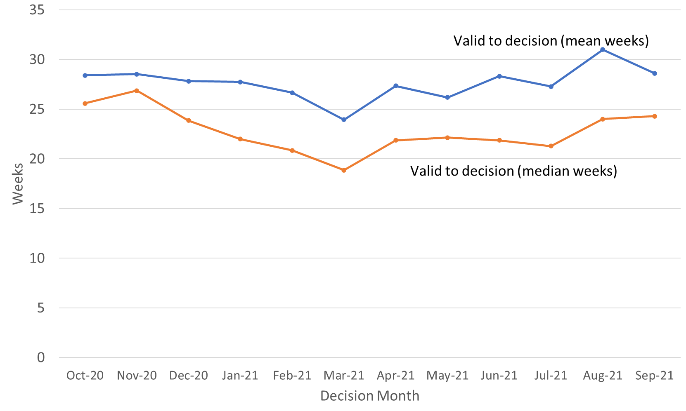
Source: Horizon and Picaso

Procedure Type
Table 6 below shows decision timeliness broken down by the procedure type. Hearings and inquires take longer than written representations – with inquiries taking more than twice as long as written representations. Because 19 of every 20 cases are by written representation, the timeliness measures for written representations is similar to the measure across all cases.

Where a small number of cases has been decided, the average timeliness (whether mean or median) is less meaningful as a measure than where there are many cases. Those areas shaded in the table below should be treated with caution as there are fewer than 20 cases decided.

The median time for written representations over the 12 months to September 21 is 22 weeks. The median time for inquiries over the 12 months to September 21 is over a year - 60 weeks. The median time for hearings is less at 47 weeks. For each of these procedure types, the mean is higher as it is more affected by the longest cases.

Table 6: Mean and Median Time to Decision, with standard deviation, by procedure; Oct 20 to Sep 21
Measure | Procedure | Oct 20 | Nov 20 | Dec 20 | Jan 20 | Feb  21 | Mar 21 | Apr 21 | May 21 | Jun 21 | Jul  21 | Aug 21 | Sep 21 | Total
Valid to Decision (mean weeks) | Written Representations | 27.9 | 28.0 | 26.6 | 25.8 | 25.3 | 22.1 | 24.1 | 24.1 | 25.0 | 24.5 | 27.2 | 27.3 | 25.8
 | Hearings | 49.8 | 37.3 | 49.6 | 59.8 | 47.5 | 56.7 | 63.8 | 42.8 | 57.0 | 50.1 | 49.8 | 57.1 | 52.2
 | Inquiries | 43.8 | 58.5 | 52.8 | 53.9 | 76.3 | 57.6 | 64.4 | 61.7 | 70.9 | 77.5r | 86.0r | 56.5 | 66.2
 | All Cases | 28.4 | 28.5 | 27.8 | 27.7 | 26.7 | 23.9 | 27.3 | 26.2 | 28.3 | 27.3 | 31.0 | 28.6 | 27.5
Valid to Decision (median weeks) | Written Representations | 25.1 | 26.6 | 23.1 | 21.3 | 20.4 | 18.4 | 20.9 | 21.1 | 20.7 | 20.4 | 23.0 | 23.6 | 22.1
 | Hearings | 40.1 | 37.3 | 43.9 | 51.5 | 49.0 | 52.4 | 62.0 | 39.6 | 61.3 | 44.1 | 43.9 | 50.4 | 47.0
 | Inquiries | 37.3 | 55.0 | 40.1 | 47.3 | 68.1 | 41.3 | 62.4 | 66.0 | 64.6 | 79.0 | 92.6r | 35.6 | 60.2
 | All Cases | 25.6 | 26.9 | 23.9 | 22.0 | 20.9 | 18.9 | 21.9 | 22.1 | 21.9 | 21.3 | 24.0 | 24.3 | 23.0
Standard Deviation (weeks) | Written Representations | 14.2 | 12.3 | 14.0 | 15.2 | 14.8 | 12.6 | 13.6 | 14.0 | 13.9 | 13.3 | 15.9 | 14.0 | 13.9
 | Hearings | 25.5 | 14.7 | 20.0 | 29.1 | 20.9 | 26.3 | 26.9 | 18.3 | 21.7 | 19.6 | 27.5 | 27.5 | 24.3
 | Inquiries | 17.4 | 14.0 | 31.0 | 30.5 | 36.9 | 31.3 | 27.8 | 26.1 | 42.8 | 43.8 | 47.2 | 40.8 | 37.7
 | All Cases | 14.9 | 12.9 | 15.6 | 18.1 | 16.9 | 16.0 | 18.7 | 16.7 | 19.7 | 18.5 | 23.3 | 16.7 | 17.0
Source: Horizon and Picaso. Cells shaded grey had fewer than 20 decisions.

The standard deviation information indicates that for all three procedures, there is considerable variation, meaning times are widely spread about the mean. For written representations, the amount of variation does not appear to be either increasing or decreasing through the year. Hearings have experienced higher month to month changes, and for inquiries the last two months have been higher (therefore more variable) than previous months.

Casework Category
The nature of the cases the Planning Inspectorate deal with varies widely and several factors play a part in determining how long it takes to make a decision. One such factor is the casework type. Table 7 below shows the time taken to decide, in planning cases, in enforcement cases, and in specialist cases, as does Figure 6.

The median time to decision for planning cases (there are many more of these decisions than in the other categories) is lower than for other casework categories, apart from in March 21 and May 21. Table 7 and Figure 6 shows the median time for planning cases was, apart from February and March 21, above 20 weeks for the last 12 months. Across the whole year, the median time to decision is 22 weeks.

Annex B gives information on mean and median time to decision, with standard deviation, for these procedure types, split by planning, enforcement, and specialist casework categories.

Table 7: Decisions, Mean, Median and Standard Deviation of Time to Decision – Planning, Enforcement, Specialist Cases; Oct 20 to Sep 21
Casework Category | Measure | Oct 20 | Nov 20 | Dec 20 | Jan 20 | Feb 21 | Mar 21 | Apr 21 | May 21 | Jun 21 | Jul 21 | Aug 21 | Sep 21 | Total
Planning Cases | Valid to Decision (mean wks) | 25.6 | 27.0 | 25.4 | 24.6 | 23.2 | 21.9 | 24.7 | 24.4 | 25.2 | 24.4 | 26.3 | 26.9 | 24.9
 | Valid to Decision (median wks) | 24.1 | 25.6 | 22.7 | 20.8 | 19.6 | 18.3 | 20.9 | 21.6 | 20.7 | 20.4 | 23.0 | 23.6 | 21.9
 | St. dev. of decision (weeks) | 11.3 | 11.3 | 12.3 | 12.3 | 11.6 | 12.4 | 14.6 | 13.0 | 15.2 | 13.8 | 14.8 | 13.5 | 12.8
Enforcement Cases | Valid to Decision (mean wks) | _{42.8} | _{37.7} | _{42.1} | _{43.8} | _{42.7} | _{41.6} | _{47.6} | _{40.6} | _{45.7} | _{42.7} | _{54.4} | _{40.7} | 42.9
 | Valid to Decision (median wks) | _{38.4} | _{34.6} | _{36.9} | _{37.8} | _{34.9} | _{30.5} | _{35.2} | _{28.3} | _{38.9} | _{32.3} | _{41.4r} | _{33.2} | 35.1
 | St. dev. of decision (weeks) | _{20.5} | _{16.8} | _{23.1} | _{29.0} | _{26.7} | _{26.2} | _{29.4} | _{28.9} | _{29.7} | _{29.4} | _{38.3} | _{26.3} | 26.6
Specialist Cases | Valid to Decision (mean wks) | 39.0 | 39.4 | 45.3 | 46.1 | 53.7 | 29.1 | 36.7 | 24.8 | 36.6 | 34.3 | 35.2 | 48.7 | 40.0
 | Valid to Decision (median wks) | 37.3r | 41.1 | 45.6 | 52.9 | 53.6 | 15.0 | 22.0 | 15.6 | 28.0 | 22.4 | 18.0 | 31.7 | 33.7
 | St. dev. of decision (weeks) | 26.6 | 18.3 | 24.6 | 33.7 | 24.7 | 28.3 | 30.4 | 21.8 | 27.7 | 27.4 | 29.9 | 36.1 | 28.5
Source: Horizon and Picaso. r denotes revision – a change of more than 0.5 weeks since last month.
Figure 6 – Median time to decision by casework area; Oct 20 to Sep 21
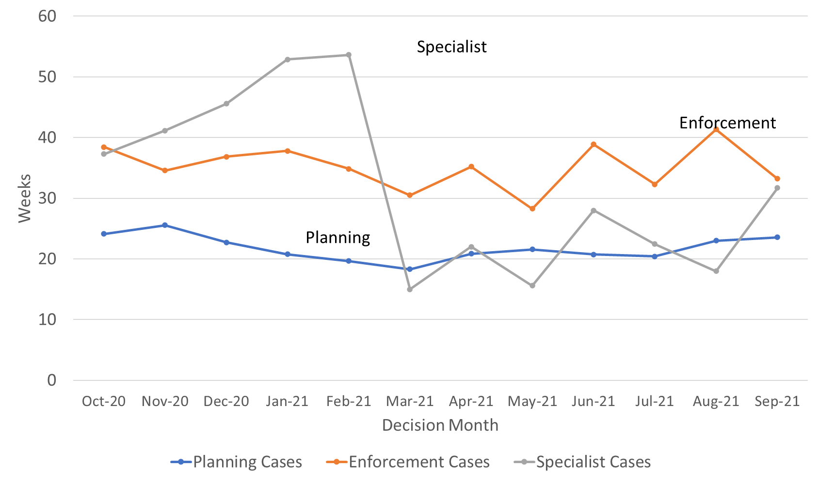
Source: Horizon and Picaso
Enforcement decisions made in the last 12 months had a median decision time of 35 weeks. For the last 12 months the mean is 43 weeks. The median time for enforcement decisions is longer than the median decision time for planning cases.
There are considerably fewer specialist cases which means results are more liable to be distorted by extreme values. Looking at the annual totals, the median and mean time to decision for specialist decisions had been broadly the same as for enforcement decisions, and longer than the median for planning decisions. Since February 21 there has been a change in this trend, with Specialist cases being quicker than Enforcement. The mix of casework being decided under the Specialist group has changed, and there was a concentrated effort to decide a high number of older Tree Preservation Order (TPO) cases that has influenced performance figures.
Note that the Inspectorate publishes each month, information on the mean and median times from valid to decision, for selected appeal types. The information published also breaks down the time for each stage of the process. See Annex C for further details.

Planning Inquiry Decisions
For planning appeals decided by the inquiry process, The Planning Inspectorate has been implementing recommendations from the Rosewell review.

The median time for inquiries over the 12 months to July 21 is 34 weeks, with the mean being marginally higher at 39 weeks. The median time has now been below 30 weeks for the last three months. Except for February 21, decision volumes have been above ten per month since Dec 20, reaching their highest level in June 21 (30 decisions).

Table 8: Decisions, Mean and Median Time to Decision, Planning Inquiry cases under Rosewell process; Oct 20 to Sep 21
Measure | Oct 20 | Nov 20 | Dec 20 | Jan 20 | Feb 21 | Mar 21 | Apr 21 | May 21 | Jun 21 | Jul 21 | Aug 21 | Sep 21 | Total
Decisions | 7 | 7 | 18 | 13 | 8 | 15 | 17 | 16 | 30 | 11 | 15 | 19 | 176
Mean (weeks) | 45.7 | 45.7 | 35.3 | 36.5 | 40.7 | 36.7 | 53.5 | 34.3 | 40.7 | 32.0r | 39.6 | 30.5 | 38.8
Median (weeks) | 32.6 | 50.9 | 39.4 | 40.3 | 40.7 | 33.7 | 51.9 | 30.1 | 33.9 | 29.1r | 25.1r | 26.9 | 33.6
St. Dev. (weeks) | 22.1 | 9.1 | 10.2 | 12.2 | 7.9 | 12.0 | 31.1 | 9.9 | 22.1 | 12.0 | 41.9r | 10.7 | 21.2
Source: Horizon. r denotes revision – a change of more than 0.5 weeks since last month.
Most inquiry decisions now being issued are under the revised ‘Rosewell’ process but some inquiries, for example those that are linked together with associated enforcement cases, do not follow the Rosewell process.

Table 9: Decisions, Planning Inquiry cases under non-Rosewell process; Oct 20 to Sep 21
Month | Oct 20 | Nov 20 | Dec 20 | Jan 20 | Feb 21 | Mar 21 | Apr 21 | May 21 | Jun 21 | Jul 21 | Aug 21 | Sep 21 | Total
Decisions | 1 | 5 | 0 | 1 | 1 | 1 | 1 | 4 | 7 | 2 | 3 | 1 | 27
Source: Horizon
Figure 7 below shows the mean and median time to decision for planning inquiry cases under the Rosewell process.

Figure 7: Mean, Median Time to Decision, Rosewell Inquiry Process; Oct 20 to Sep 21
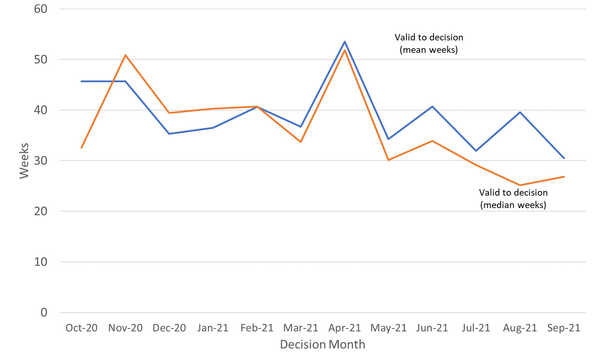
Source: Horizon

Open Cases
At the end of September 21, the Planning Inspectorate had over twelve thousand five hundred cases open (12,592). This is higher than the previous month. The open cases comprised over 10,600 cases being handled through written representations; just over 1,000 through hearings; and over 700 through inquiries. This is not the number of ‘live’ hearings and inquiries since it includes cases where the event (hearing or inquiry) has yet to start, as well as those where the event has finished but the decision has yet to be issued.

For each procedure type, there are more cases with an event scheduled but not yet started, than at any other stage in the process. Event refers to either a site visit, hearing, or inquiry.

Table 10: Open cases by procedure and stage, as of end of September 2021
Procedure | Case received but yet to be deemed valid | Case deemed valid, event date yet to be set / in the future | Event complete but decision not yet issued |  | Total
Written Representations | 1,244 | 7,732 | 1,672 |  | 10,648
Hearings | 80 | 912 | 103 |  | 1,095
Inquiries | 5 | 596 | 111 |  | 712
Total | 1,329 | 9,368 | 1,895 |  | 12,592
Source: Horizon
Note there are 137 cases that have no procedure type recorded (see Background Quality Report for more detail) These are included in the total row but excluded from the breakdown by procedure.

Data note 1 - the count of open cases from December 2020 onwards has been revised to include some specialist casework types that were previously excluded: High Hedge (HH), Hedgerow (HGW) and Tree Preservation Order (TPO).
Data note 2 – there is a known anomaly that means that the number of open cases does not exactly follow the volumes of cases closed or received (for example the number of open cases can increase between months even though the number closed exceeded the number received). The main reasons for this have been identified and are detailed in the Background Quality Report.
Inspectors

Table 11 below shows the number of inspectors in the Planning Inspectorate in each month from October 20 to September 21. This includes headcount (i.e., the number of different individuals) and full-time equivalents (FTE) where those working part time are counted in proportion with their contracted hours. There were 345 Planning Inspectors employed by the Inspectorate in September 21 – with a full-time equivalent of 306.6.

By both measures (headcount and FTE) the highest Inspector resource in the last 12 months was in April 21; and by both, the number at the end of January 21 was the lowest.

Table 11: Planning Inspectors – Headcount and FTE; Oct 20 to Sep 21 (at end of month)
Month | Oct 20 | Nov 20 | Dec 20 | Jan 20 | Feb 21 | Mar 21 | Apr 21 | May 21 | Jun 21 | Jul 21 | Aug 21 | Sep 21
Headcount | 347 | 345 | 345 | 343 | 345 | 352 | 355 | 353 | 349 | 347 | 346 | 345
FTE | 310.0 | 308.1 | 308.1 | 305.4 | 308.1 | 314.4 | 317.0 | 314.4 | 310.8 | 308.4 | 307.8 | 306.6
Source: SAP HR

As above, Planning Inspectors work on a broader range of work than the appeals featured in this Release. They also work on applications and examinations. Please note that data on Planning Inspectors is only applicable to salaried employees (it does not include fixed term contract Inspectors or non-salaried Inspectors).

Virtual Events

The Planning Inspectorate has continued moving casework forward during the pandemic by adapting the ways of working so that examinations, hearings, and inquiries (which would previously have been held face-to-face) could take place virtually.

The Inspectorate are continuing to increase the number of events carried out ‘virtually’. There appears to be under-recording despite the introduction of system changes aimed at improving the quality of data.

The table and graph below give the number of virtual events that have occurred each month. There were 30 cases involving Virtual Events during September 21.

Consultation with our users – Removal of virtual events data

In this statistical release we have been publishing data on the number of virtual events being held each month. The Planning Inspectorate recommenced face-to-face events for hearings and inquiries from Monday 13th September 2021. There also continues to be significant concerns with the quality of the data collected on virtual events.

In the last release readers were invited to email us if they had any concerns or comments on this proposal. No comments have been received. Future releases will no longer include data on virtual events.

Data quality and corrections
There are concerns about the quality and accuracy of the data collection methods for virtual events data. Changes to recording systems aimed at reducing under-recording have been implemented but do not appear to be providing fully reliable information.
See the Background Quality Report for further information.

Table 12: Virtual Events, Oct 20 to Sep 21^{P}
Case Type | Oct 20 | Nov 20 | Dec 20 | Jan 21 | Feb 21 | Mar 21 | Apr 21 | May 21 | Jun 21 | Jul 21 | Aug 21 | Sep 21
s78 Hearings | 41 | 43 | 38 | 32 | 23 | 32 | 32 | 24 | 35 | 17 | 4 | 6
s78 Inquiries | 11 | 17 | 18 | 15 | 13 | 22 | 16 | 25 | 20 | 12 | 11 | 9
Enforcement | 15 | 18 | 21 | 29 | 37 | 30 | 29 | 16 | 18 | 20 | 9 | 5
Local Plans | 14 | 12 | 12 | 5 | 7 | 9 | 5 | 6 | 11 | 6 | 0 | 5
National Infrastructure | 10 (3) | 3 (30) | 18 (9) | 7 (18) | 8 (7) | 2 (8) | 7 (2) | 1 (1) | 4 (1) | 0 (0) | 2 (1) | 0 (0)
Other | 4 | 16 | 6 | 11 | 10 | 9 | 5 | 5 | 5 | 3 | 2 | 5
Total | 95  (88) | 109 (136) | 113 (104) | 99 (110) | 98  (97) | 104 (110) | 94  (89) | 77  (77) | 93  (90) | 58  (58) | 28  (27) | 30  (30)
Source: Virtual Events ‘Triage’ data and SharePoint list, data as at 13/10/21

Numbers in brackets show count of events but note concerns below over counting sessions on same day. Local Plans are counted as cases where at least one sitting day occurred in a month.
‘Other’ case type includes specialist casework like Environmental appeals, Transport examinations and Rights of Way cases

Some virtual events have occurred, but the source data does not record the casework type. These have not been included in the above table.

P – These numbers should be treated as provisional due to concerns about quality and accuracy.

Note – some cases can have multiple ‘events’ – for example an inquiry may sit over four to eight days but would only be counted as one ‘event’. On the other hand, casework like National Infrastructure may have multiple events for the same project. For Local Plans, cases are counted as having held a virtual event, if at least one sitting day occurred that month.

Figure 8: Virtual Events; Oct 20 to Sep 21^{P}
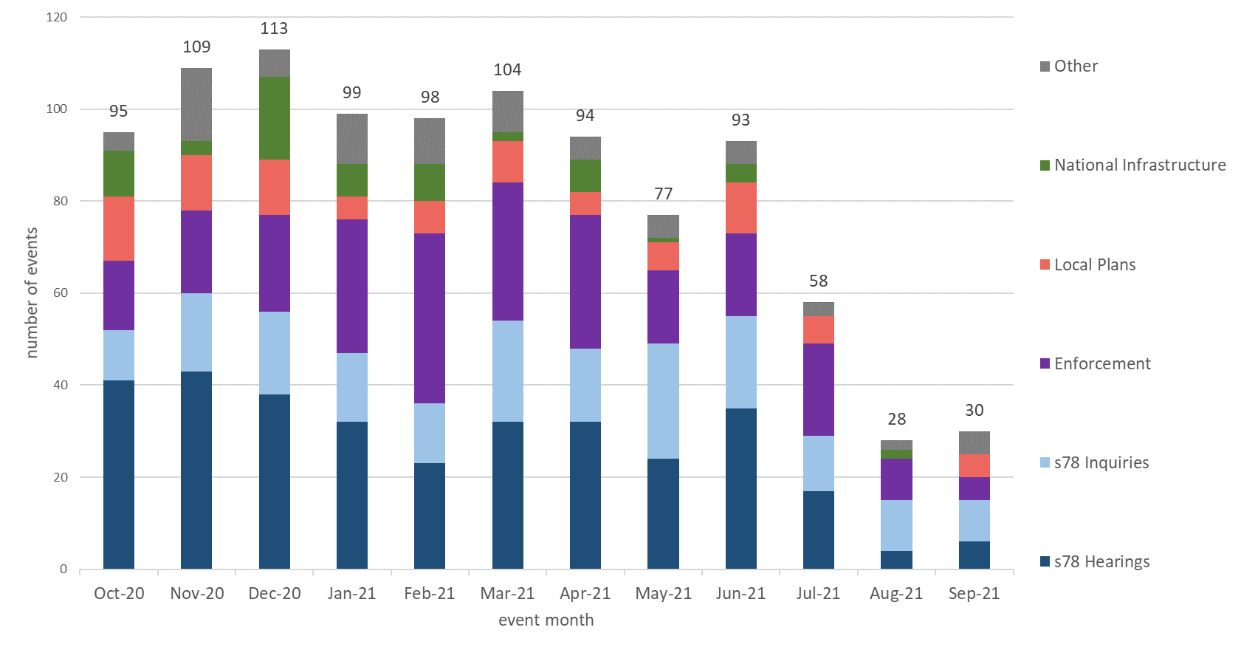
Source: Virtual Events ‘Triage’ data and SharePoint list, data as at 13/10/21
P – These numbers should be treated as provisional.

For National Infrastructure, the number given in the table is the number of projects that have held virtual events. The number in brackets is the number of individual events but this is potentially misleading as multiple sessions on the same day (e.g., morning and afternoon sessions) have been counted as separate events.

Quarterly Volume Statistics

The Inspectorate has also published a series of tables of quarterly data. The quarterly volume statistics differ from the monthly statistical release. Some of the data published is on casework types that The Planning Inspectorate deals with, that are larger in scale but smaller in volume. The best examples of this are Nationally Significant Infrastructure Projects and Local Plans, where volumes never go into the hundreds, and the time between submission to report issue can be over a year. Other data breaks appeals down into more detail than in the monthly totals. This data has been published on a quarterly basis for many years as management information.

All tables can be found at https://www.gov.uk/government/publications/planning-inspectorate-statistics

Section 78 Planning appeals

Appeals received compared decisions
In the last 12 rolling months, October 2020 to September 2021, there have been 10,893 appeals received, compared to 10,951 for the period October 2019 to September 2020.

In the last five complete financial years (April 2016 to March 2021) the highest level of quarterly receipts occurred in October to December 2017 and the highest number of decisions was in July to September 2019.

The number of appeals received in the first two quarters of 2021/22 (5,276) was just 3 fewer than the same period in 2020/21. Appeal receipts since the pandemic started average around 2,700 per quarter (April 20 to September 21).

Figure 9: Number of s78 Planning appeals receipts and decision, 2015/16 to 2021/22, by quarter
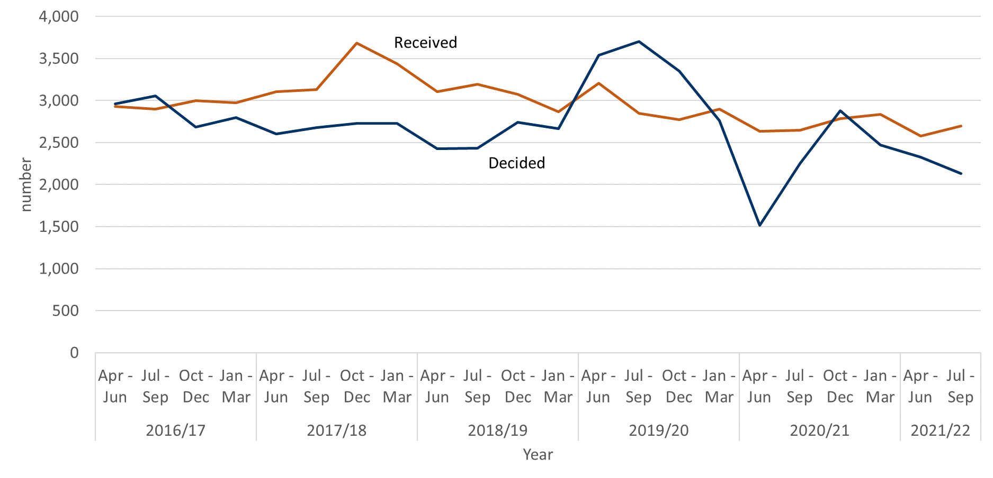
Source: Horizon & Picaso. Full published data in Tables 2.1 and Table 2.4. See Annex D, Table A, for full data table.

The number of decisions being issued has declined since the October to December 2020 quarter. The latest quarter of 2021/22, July to September, was 6% less than the April to June 2021 quarter. Compared to first two quarters of 2020/21 the number of decisions issued is 16% higher in 2021/22 – but this is mainly due to the significant impact of the first lockdown in 2020 on decision numbers.

Appeals Allowed
The percentage of planning appeals that were allowed in the latest quarter was 28%. This is a slight fall of 3% compared to the previous quarter. However the latest quarter is still the second highest percentage allowed quarter since the start of 2019/20.

The overall percentage allowed is heavily influenced by the number of written representations appeals allowed, as this procedure type contributes by far the greatest number of decisions each year. There has been slightly more variation in the percentage allowed for hearings and inquiries. See Figure 11 below for further details.

Figure 10: S78 planning appeals, percentage allowed, 2015/16 to 2021/22, by quarter
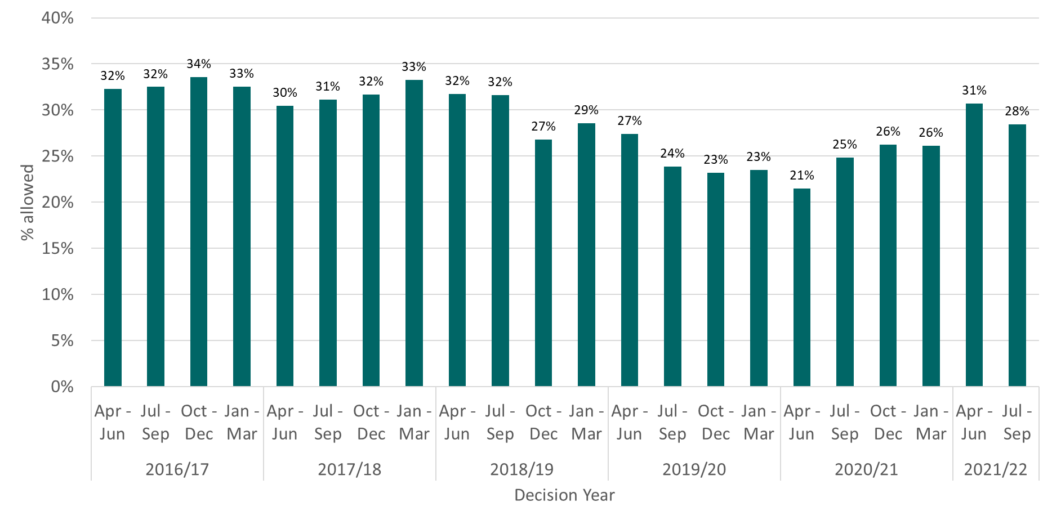
Source: Horizon & Picaso. Full published data in Table 2.4 s78 planning appeals decided.
See Annex D, Table B, for full data table

Figure 11: S78 planning appeals, percentage allowed by procedure type, 2015/16 to 2021/22, by quarter
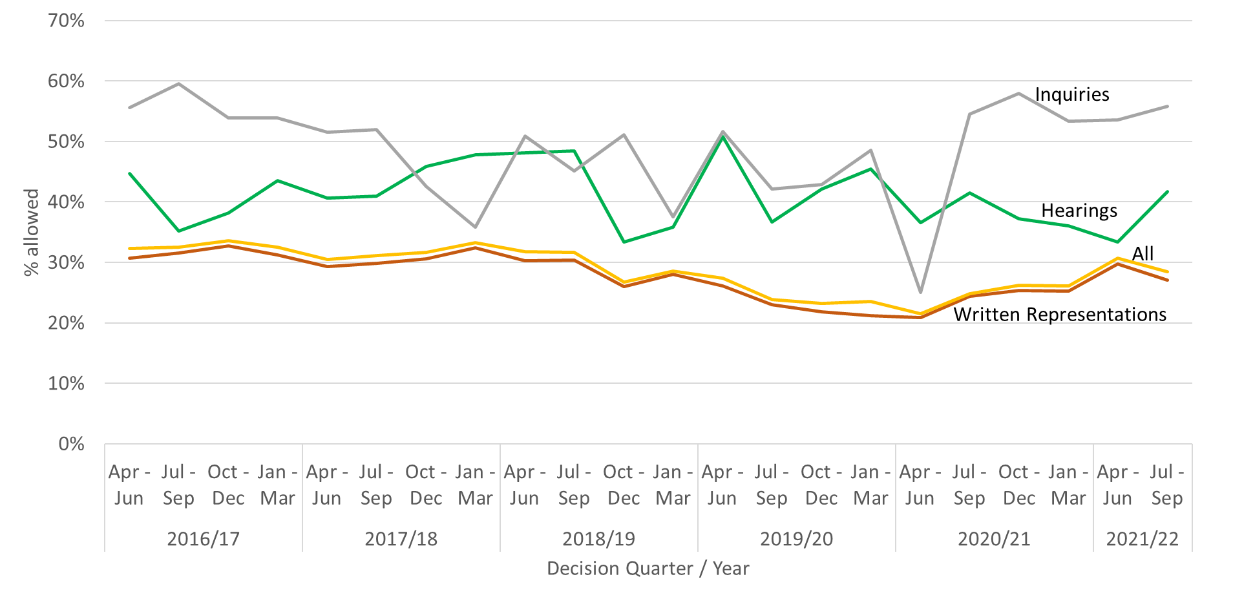

Source: Horizon & Picaso. Full published data in Table 2.4 s78 planning appeals decided.
See Annex D, Table B, for full data table

Figure 12: S78 planning appeals, number of appeals allowed, 2015/16 to 2021/22, by quarter
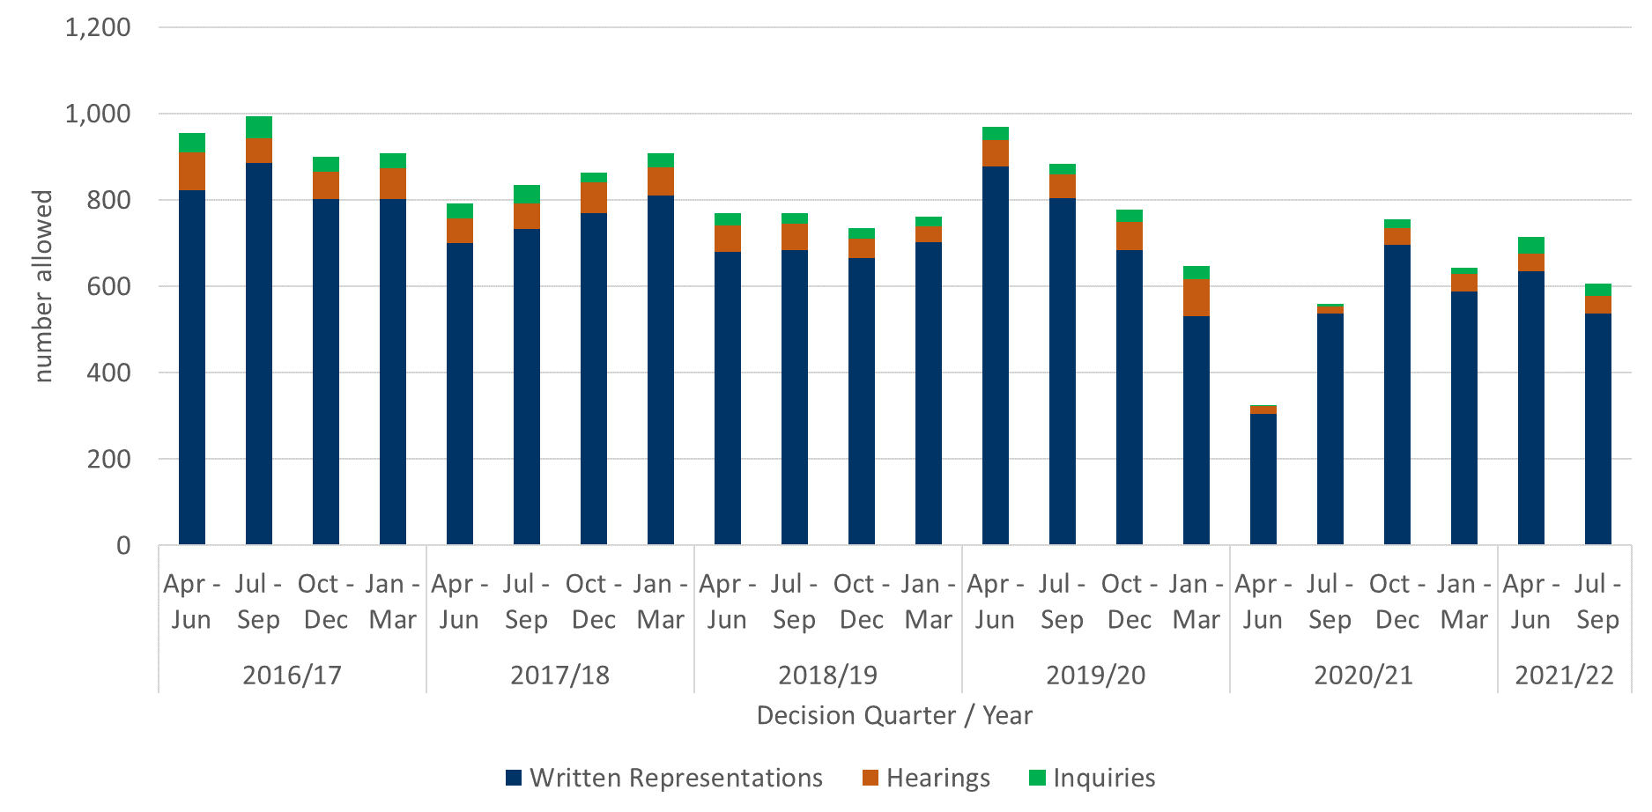

Source: Horizon & Picaso. Full published data in Table 2.4 s78 planning appeals decided.
See Annex D, Table C, for full data table

Annex A – Content of ad-hoc Statistical Releases, 2020

Note: The Table below covers ad-hoc statistical releases. From November 2020 onwards, the content is fixed, so is the same as this publication.

Date | March 2020 | April 2020 | July 2020 | September 2020 | October 2020
Content | Appeals receipts and decisions in the last 12 and 24 months (1st March 2018 – 29th February 2020)  Number of section 78 Planning Appeals received / decided / within target that used the written representation method in the last 12 months (1st March 2019 – 29th February 2020)  Number of dwellings decided, and number of dwellings allowed by appeal decisions between 1st January 2017 and 31st December 2019.  Number of Planning Inspectors employed by the Planning Inspectorate at the end of each quarter between 31st March 2017 and 31st December 2019. | Appeals receipts and decisions between 17th March 2020 and 22nd April 2020  Live appeals in the system as at 23rd April 2020  Number of appeals involving housing within the system as at 23rd April 2020  Virtual site visits | Appeals decisions between 17th March 2020 and 22nd June 2020  Number of open cases  Number of virtual events  Number of appeals  involving housing within the system as at 12th June 2020 | Appeals decisions between 17th March 2020 and 21st September 2020  Number of open cases  Number of virtual events | Appeals decisions from October 2019 to September 2020  Number of open cases  Number of virtual events
Scope | England only  Planning cases, Enforcement cases and Rights of Way orders | England only  Planning cases, Enforcement cases and Rights of Way orders | England only  Planning cases, Enforcement cases and Rights of Way orders | England only  Planning cases, Enforcement cases and Rights of Way orders | England only  Planning cases, Enforcement cases, Specialist cases: Common Land, Rights of Way orders, Tree Preservation Orders, High Hedges appeals and Hedgerow appeals

Annex B – Mean and median time to decision, with standard deviation, for planning, enforcement, and specialist casework
Planning
Measure | Procedure | Oct 20 | Nov 20 | Dec 20 | Jan  20 | Feb 21 | Mar 21 | Apr 21 | May 21 | Jun 21 | Jul  21 | Aug 21 | Sep 21 | Total
Valid to decision (mean weeks) | Written Representations | 25.2 | 26.6 | 24.6 | 23.7 | 22.5 | 21.0 | 22.9 | 23.4 | 23.5 | 23.3 | 25.2 | 26.3 | 24.0
 | Hearings | 39.7 | 35.0 | 45.9 | 46.2 | 41.2 | 48.0 | 56.1 | 40.6 | 49.2 | 43.1 | 41.3 | 54.7 | 45.1
 | Inquiries | 44.6 | 54.9 | 35.3 | 40.4 | 50.6 | 35.8 | 54.9 | 44.8 | 53.5 | 53.5r | 49.2r | 36.6 | 46.4
 | All Cases | 25.6 | 27.0 | 25.4 | 24.6 | 23.2 | 21.9 | 24.7 | 24.4 | 25.2 | 24.4 | 26.3 | 26.9 | 24.9
Valid to decision (median weeks) | Written Representations | 23.9 | 25.4 | 22.0 | 20.4 | 19.4 | 18.0 | 20.1 | 21.0 | 19.9 | 19.7 | 22.4 | 23.1 | 21.3
 | Hearings | 34.0 | 36.1 | 43.0 | 46.6 | 46.4 | 44.8 | 56.9 | 37.3 | 45.4 | 42.0 | 37.4 | 50.4 | 41.9
 | Inquiries | 34.8 | 53.9 | 39.4 | 40.7 | 42.9 | 33.6 | 52.4 | 32.9 | 36.9 | 30.9r | 30.0r | 27.9 | 36.9
 | All Cases | 24.1 | 25.6 | 22.7 | 20.8 | 19.6 | 18.3 | 20.9 | 21.6 | 20.7 | 20.4 | 23.0 | 23.6 | 21.9
Standard Deviation (weeks) | Written Representations | 10.7 | 10.9 | 11.4 | 10.8 | 10.5 | 10.9 | 11.2 | 11.7 | 11.9 | 11.3 | 12.0 | 12.3 | 11.2
 | Hearings | 18.5 | 13.3 | 17.4 | 23.0 | 16.7 | 24.6 | 23.6 | 18.7 | 20.7 | 16.5 | 18.6 | 24.0 | 20.5
 | Inquiries | 20.8 | 13.1 | 10.2 | 18.4 | 29.0 | 12.1 | 30.7 | 23.5 | 37.3 | 51.6r | 51.2r | 28.8 | 32.1
 | All Cases | 11.3 | 11.3 | 12.3 | 12.3 | 11.6 | 12.4 | 14.6 | 13.0 | 15.2 | 13.8 | 14.8 | 13.5 | 12.8

- For all three measures (mean, median and standard deviation) the trend for Planning Written Representations has been consistent over the last 12 months.
- The median for Planning hearings has been increasing over the last 12 months. There are months with reductions in the median compared to the previous month but the median for October 20 was 34 weeks and it is 50 weeks in September 21. This increasing median reflects a backlog of cases built up by the impact of the pandemic and setting up the processes for holding events virtually.
- Both the mean and median for Planning inquiries has been generally reducing over the last 12 months, not always from month to month.
- The standard deviation for Planning inquiries has been higher in the latest months of the past year, showing the impact of deciding long running cases in July and August 21, compared to previous months.

Enforcement
Measure | Procedure | Oct 20 | Nov 20 | Dec 20 | Jan  20 | Feb 21 | Mar 21 | Apr 21 | May 21 | Jun  21 | Jul  21 | Aug 21 | Sep 21 | Total
Valid to decision (mean weeks) | Written Representations | 41.4 | 36.7 | 38.3 | 36.9 | 35.4 | 32.3 | 34.4 | 31.5 | 33.1 | 32.2 | 39.8 | 33.8 | 36.3
 | Hearings | 84.4 | 54.4 | 64.3 | 82.7 | 66.3 | 78.5 | 77.9 | 50.9 | 62.6 | 64.1 | 70.7 | 60.0 | 67.7
 | Inquiries | 43.9 | 62.5 | 102.9 | 75.4 | 108.7 | 81.8 | 73.8 | 71.3 | 104.9 | 90.6 | 104.1 | 101.6 | 88.3
 | All Cases | 42.8 | 37.7 | 42.1 | 43.8 | 42.7 | 41.6 | 47.6 | 40.6 | 45.7 | 42.7 | 54.4 | 40.7 | 42.9
Valid to decision (median weeks) | Written Representations | 36.9 | 33.9 | 35.2 | 31.1 | 28.1 | 27.6 | 29.6 | 24.9 | 29.1 | 26.0 | 35.2r | 28.1 | 31.4
 | Hearings | 89.0 | 56.0 | 68.5 | 78.8 | 68.8 | 84.4 | 71.3 | 45.2 | 61.6 | 67.3 | 56.0 | 50.8 | 65.1
 | Inquiries | 42.6 | 56.1 | 99.0 | 86.1 | 125.3 | 86.7 | 62.4 | 66.0 | 108.0 | 92.9 | 122.3 | 94.5 | 86.7
 | All Cases | 38.4 | 34.6 | 36.9 | 37.8 | 34.9 | 30.5 | 35.2 | 28.3 | 38.9 | 32.3 | 41.4 | 33.2 | 35.1
Standard Deviation (weeks) | Written Representations | 19.3 | 16.3 | 18.9 | 23.2 | 17.8 | 16.9 | 20.9 | 25.6 | 17.8 | 19.6 | 25.8 | 16.8 | 19.7
 | Hearings | 12.8 | 12.3 | 22.6 | 23.2 | 22.2 | 15.6 | 28.0 | 13.6 | 18.5 | 17.9 | 34.2 | 31.1 | 24.3
 | Inquiries | 10.1 | 10.1 | 19.2 | 38.1 | 23.2 | 26.8 | 20.3 | 21.4 | 30.7 | 35.0 | 34.9 | 32.0 | 32.8
 | All Cases | 20.5 | 16.8 | 23.1 | 29.0 | 26.7 | 26.2 | 29.4 | 28.9 | 29.7 | 29.4 | 38.3 | 26.3 | 26.6

- The mean and median measures for Enforcement Written Representations show a slight overall improvement (41.4 weeks in October 20 compared to 33.8 weeks in September 21), but a variable in year trend.
- Enforcement hearings show variable trends for all three measures; mean, median and standard deviation. There are smaller numbers of decisions for this casework / procedure group that can influence these measures.
- Enforcement inquiries are now generally taking longer than they were a year ago. As with Planning hearings, the effect of the pandemic is evident in these measures. Also, this grouping can be disproportionatley affected by cases that involve multiple linked appeals (for example multiple people served an enforcement notice by a local authority appeal to The Planning Inspectorate, each person appealing is treated as a separate appeal but all appeals are decided in one decision letter by one Inspector).

Specialist
Measure | Procedure | Oct 20 | Nov  20 | Dec  20 | Jan  20 | Feb 21 | Mar 21 | Apr 21 | May 21 | Jun 21 | Jul  21 | Aug 21 | Sep 21 | Total
Valid to decision (mean weeks) | Written Representations | 39.0 | 37.5 | 44.7 | 42.7 | 52.8 | 27.1 | 33.3 | 22.8 | 34.5 | 28.8 | 29.3 | 46.8 | 37.7
 | Hearings | 0.0 | - | - | 89.8 | 65.0 | 80.0 | 82.1 | 60.0 | 100.8 | - | 78.3 | - | 82.5
 | Inquiries | 37.3 | 66.7 | 59.9 | 58.4 | 77.6 | 18.0 | 85.1 | 100.0 | - | 90.2 | 84.6 | 75.2 | 70.8
 | All Cases | 39.0 | 39.4 | 45.3 | 46.1 | 53.7 | 29.1 | 36.7 | 24.8 | 36.6 | 34.3 | 35.2 | 48.7 | 40.0
Valid to decision (median weeks) | Written Representations | 37.4r | 39.1 | 44.0 | 43.6 | 53.1 | 14.9 | 21.9 | 15.3 | 26.9 | 21.0 | 17.3 | 27.7 | 31.0
 | Hearings | - | - | - | 102.1 | 65.0 | 80.0 | 82.1 | 60.0 | 100.8 | - | 95.0 | - | 94.4
 | Inquiries | 37.3r | 60.4 | 59.9 | 64.0 | 81.9 | 18.0 | 85.1 | 100.0 | - | 94.3 | 88.4 | 75.2 | 73.7
 | All Cases | 37.3 | 41.1 | 45.6 | 52.9 | 53.6 | 15.0 | 22.0 | 15.6 | 28.0 | 22.4 | 18.0 | 31.7 | 33.7
Standard Deviation (weeks) | Written Representations | 26.9 | 16.7 | 24.8 | 33.3 | 24.5 | 26.9 | 28.4 | 19.1 | 25.4 | 21.9 | 25.0 | 36.6 | 27.4
 | Hearings | - | - | - | 18.1 | 0.0 | 16.3 | 12.9 | 0.0 | 7.1 | - | 31.5 | - | 21.8
 | Inquiries | 0.0 | 17.3 | 13.1 | 19.5 | 19.9 | 0.0 | 0.0 | 0.0 | - | 9.6 | 11.5 | 8.2 | 22.1
 | All Cases | 26.6 | 18.3 | 24.6 | 33.7 | 24.7 | 28.3 | 30.4 | 21.8 | 27.7 | 27.4 | 29.9 | 36.1 | 28.5
r denotes revision – a change of more than 0.5 weeks since last month.
- The number of decisions for Specialist cases is low (see Table 4), and this makes it less easy to see trends for Specialist cases decided by hearings and inquiries.
- The highest volume of decisions is against Written Representations, and over the last 12 months all three measures see variable trends. The mean for varies between 23 weeks (May 21) and 53 weeks (February 21). The median average has a low of 15 weeks (March 21) and a high of 53 weeks (February 21).

Annex C – Detailed Information on timeliness (September)

The information below is published today on the number and length of decisions made in September 2021:
Casework Type | Procedure Type | Mean (weeks) | Median (weeks) | Decisions
s78 planning appeals | Written Representations | 29.1 | 27.1 | 804
 | Hearings | 54.7 | 50.4 | 22
 | Inquiries | 36.6 | 27.9 | 20
Householder appeals | Written Representations | 21.1 | 19.6 | 459
Enforcement appeals | Written Representations | 34.1 | 28.4 | 98
 | Hearings | 60.0 | 50.8 | 18
 | Inquiries | 108.3 | 94.5 | 6

The smaller the number of decisions, the less helpful the mean and median are as measures for summarising performance. Particular care should be taken when there are fewer than twenty decisions. These are shaded grey in the table but have been provided for completeness and transparency.

The information published below shows the time taken for different stages of the appeals process:
 | s78 planning appeals |  |  | Householder appeals
 | Written Representations | Hearings | Inquiries
Weeks between valid date & start date
Mean (average) | 13.9 | 24.1 | 5.9 | 9.9
Median (average) | 15.1 | 23.9 | 3.9 | 10.6
Cases that started in September 21 | 862 | 44 | 20 | 640
Weeks between start date & event date
Mean (average) | 13.7 | 26.7 | 23.3 | 8.3
Median (average) | 9.6 | 26.7 | 16.0 | 6.0
Cases where an event occurred during September 21 | 747 | 33 | 13 | 403
Weeks between event date & decision date
Mean (average) | 6.1 | 9.8 | 9.9 | 3.8
Median (average) | 4.4 | 8.5 | 10.1 | 2.9
Cases that have been decided in September 21 | 801 | 22 | 20 | 458

- Valid date – the date a case is deemed to have been validly received
- Start date – date when a case has started its documentation phase (requesting statements and additional information) and an Inspector resource has usually been identified to carry out the case
- Event date – the date of either a site visit, hearing, or inquiry
- Decision date – the date the decision was issued by The Planning Inspectorate

Annex D – Data tables

Table A S78 planning appeals received and decided

Year or Quarter |  | received | decided
2015/16 | Apr - Jun | 2,944 | 1,963
 | Jul - Sep | 2,972 | 2,539
 | Oct - Dec | 2,927 | 2,447
 | Jan - Mar | 2,955 | 3,332
2016/17 | Apr - Jun | 2,929 | 2,958
 | Jul - Sep | 2,895 | 3,056
 | Oct - Dec | 2,997 | 2,683
 | Jan - Mar | 2,972 | 2,796
2017/18 | Apr - Jun | 3,108 | 2,600
 | Jul - Sep | 3,132 | 2,680
 | Oct - Dec | 3,685 | 2,728
 | Jan - Mar | 3,437 | 2,733
2018/19 | Apr - Jun | 3,104 | 2,428
 | Jul - Sep | 3,193 | 2,431
 | Oct - Dec | 3,075 | 2,741
 | Jan - Mar | 2,867 | 2,666
2019/20 | Apr - Jun | 3,203 | 3,540
 | Jul - Sep | 2,849 | 3,705
 | Oct - Dec | 2,772 | 3,350
 | Jan - Mar | 2,900 | 2,759
2020/21 | Apr – Jun | 2,632 | 1,514
 | Jul – Sep | 2,647 | 2,253
 | Oct – Dec | 2,783 | 2,880
 | Jan - Mar | 2,834 | 2,468
2021/22 | Apr – Jun | 2,577 | 2,327
 | Jul - Sep | 2,699 | 2,133

Table B S78 planning appeals, percentage allowed by procedure type

Year or Quarter |  | Written Representations | Hearings | Inquiries | All
2016/17 | Apr - Jun | 31% | 45% | 56% | 32%
 | Jul - Sep | 32% | 35% | 60% | 32%
 | Oct - Dec | 33% | 38% | 54% | 34%
 | Jan - Mar | 31% | 44% | 54% | 33%
2017/18 | Apr - Jun | 29% | 41% | 51% | 30%
 | Jul - Sep | 30% | 41% | 52% | 31%
 | Oct - Dec | 31% | 46% | 43% | 32%
 | Jan - Mar | 32% | 48% | 36% | 33%
2018/19 | Apr - Jun | 30% | 48% | 51% | 32%
 | Jul - Sep | 30% | 48% | 45% | 32%
 | Oct - Dec | 26% | 33% | 51% | 27%
 | Jan - Mar | 28% | 36% | 38% | 29%
2019/20 | Apr - Jun | 26% | 51% | 52% | 27%
 | Jul - Sep | 23% | 37% | 42% | 24%
 | Oct - Dec | 22% | 42% | 43% | 23%
 | Jan - Mar | 21% | 45% | 48% | 23%
2020/21 | Apr - Jun | 21% | 37% | 25% | 21%
 | Jul - Sep | 24% | 41% | 55% | 25%
 | Oct - Dec | 25% | 37% | 58% | 26%
 | Jan - Mar | 25% | 36% | 53% | 26%
2021/22 | Apr - Jun | 30% | 33% | 54% | 31%
 | Jul - Sep | 27% | 42% | 56% | 28%

Table C s78 planning appeals, percentage allowed by procedure type

Year or Quarter |  | Written Representations | Hearings | Inquiries | All
2016/17 | Apr - Jun | 822 | 88 | 45 | 955
 | Jul - Sep | 885 | 58 | 50 | 993
 | Oct - Dec | 802 | 63 | 35 | 900
 | Jan - Mar | 803 | 71 | 35 | 909
2017/18 | Apr - Jun | 701 | 56 | 35 | 792
 | Jul - Sep | 732 | 61 | 41 | 834
 | Oct - Dec | 769 | 72 | 23 | 864
 | Jan - Mar | 811 | 65 | 33 | 909
2018/19 | Apr - Jun | 679 | 62 | 29 | 770
 | Jul - Sep | 683 | 63 | 23 | 769
 | Oct - Dec | 666 | 44 | 24 | 734
 | Jan - Mar | 702 | 38 | 21 | 761
2019/20 | Apr - Jun | 877 | 62 | 31 | 970
 | Jul - Sep | 805 | 55 | 24 | 884
 | Oct - Dec | 683 | 67 | 27 | 777
 | Jan - Mar | 532 | 84 | 32 | 648
2020/21 | Apr - Jun | 304 | 19 | 2 | 325
 | Jul - Sep | 537 | 17 | 6 | 560
 | Oct - Dec | 696 | 38 | 22 | 756
 | Jan - Mar | 588 | 40 | 16 | 644
2021/22 | Apr - Jun | 636 | 40 | 38 | 714
 | Jul - Sep | 538 | 40 | 29 | 607

Annex E – Casework types included in this release

Planning covers s78 planning appeals, Householder appeals, Commercial appeals, s20 Listed Building appeals, Advertisement appeals, s106 Planning Obligation appeals and Called In Planning Applications.

Enforcement covers s174 Enforcement appeals, s39 Enforcement Listed Building appeals and Lawful Development Certificate appeals.

Specialist casework includes Common Land, Rights of Way orders, Purchase orders, Tree Preservation Orders, High Hedges appeals and Hedgerow appeals.
(Note that the data on Open Cases in previous publications excluded Tree Preservation Orders and High Hedges and Hedgerow appeals.)

Background notes

Data sources
Horizon / Picaso – The main casework management systems used for processing appeals casework (note that Picaso is no longer a live system).
SAP HR – The Human Resources system database used to store all information regarding members of staff.

Measure | Definition
Mean | The total time taken divided by the number of cases. Also referred to as the ‘average’. A measure of how long each case would take, if the total time taken was spread evenly across all cases.
Median | This is the time taken by the ‘middle’ case if all cases were sorted from quickest to longest
Standard deviation | This is a measure of variability or spread. It is calculated by examining how much each value differs from the mean. A higher standard deviation means the individual decision times vary more widely around the mean.

Compliance with the Code of Practice for Statistics
These statistics have been published in accordance with the Code of Practice for Statistics, which cover trustworthiness, quality, and value. They have been pre-announced, and publication is overseen by the Head of Profession.

Technical Notes
A Background Quality Report is published alongside this Statistical Release. It provides more detail on the quality of statistics in this publication.

Data quality | Data on cases is taken from a live casework system, and details of cases can change for a number of reasons even after a decision has been made. We are seeking to get a better understanding of the nature and volume of these changes and will provide further information as it is available.  We carry out regular checks on the quality of our data and may undertake ad hoc data cleansing exercises. Therefore, all the data for the last 12 rolling months is published in provisional form.  We have indicated in this publication any data where a number of cases has changed by more than five cases in a month; or where a measure (mean, median or standard deviation) has changed by more than 0.5 weeks.
Virtual Events | Data is currently being sourced from an operational MS Excel workbook. It is therefore being constantly updated and refined and may result in data may changing between monthly publications.  There are concerns about the quality and accuracy of the data collection methods. Definitions of what constitutes an event are being refined, as this differs according to the type of casework. Whilst this work is in progress these numbers should be treated as provisional.  Data for Local Plans is now being sourced from information recorded by Inspectors on their timesheets.
Measuring weeks | Data are measured in days and then converted to weeks.  Note that not all decimal values are possible where converting days to weeks. 1 day is 1/7 of a week, or 0.14 weeks (to two decimal places). 2 days = 0.29; 3 days = 0.43; 4 days = 0.57; 5 days = 0.71; 6 days = 0.86.  When these are used to calculate averages, or displayed to one decimal place, the result will not equate to a full day which can be misleading: it may appear that we are measuring part days (e.g. 19.8 weeks) but we only measure in whole days.

Glossary
Term | Explanation
Appeals | The right to appeal a planning decision made by a local authority is a key feature of the planning system, as is appealing when an authority is taking too long.
Appeals decided | Number of appeals by the date the appeal was decided by The Planning Inspectorate.
Appeals received | Number of appeals by the date the appeal was received by The Planning Inspectorate.
Applications | Planning Inspectorate manage the application process for proposed Nationally Significant Infrastructure Projects (NSIPs) within England and Wales in line with the 2008 Planning Act.
Closed | The total number of appeals decided, withdrawn, or turned away.
Decision | The outcome of the case e.g. appeal allowed or rejected. The date of the decision is taken as the date a decision letter is sent to the appellant.
Event | A site visit, hearing, or inquiry (may be virtual)
Event Type | The different options of how an Inspector visits a site for a written representations appeal.
Examinations | The process of examining local plans is dealt with by the Planning Inspectorate. Every Local Planning Authority is required to have a local plan. This includes a vision for the future and plan to address housing needs in the area.  When a Local Planning Authority has finished preparing and consulting on a local plan it must be submitted to the Secretary of State who appoints an Inspector to carry out an independent examination.
FTE | Full Time Equivalent – a count of employees where those working part time are counted in proportion with their contracted hours.
Headcount | Total number of staff employed regardless of how many hours they work (i.e. the number of different individuals).
Hearings | A hearing involves the submission of written evidence by the main parties and a hearing once all the written submissions have been received.  This takes the form of a round-the-table discussion (in person or virtually) that will be led by the planning inspector. It allows for all parties to respond to any questions that the inspector might have, and to let everyone make their case known.  Source: Planning Portal
Inquiries | An inquiry is usually used for complex cases where legal issues may need to be considered. The main parties will usually have legal representatives to present their case and to cross-examine any witnesses. Prior to the inquiry date, the Planning Inspectorate will expect to have received various documents from all parties that will be taking part in the appeal. These may include statements of case and proofs of evidence from expert witnesses. Third parties may also take part. The inquiry will be led by the inspector and will follow a formal procedure.  At some point during or on conclusion of the inquiry the inspector and the main parties will undertake a site visit.  Source: Planning Portal
Live appeals | Number of live appeals in that have an appeal valid date but no end date (either decision date or a closed date, e.g. for appeals that have been withdrawn).
Open Cases | Number of cases that have been received but on which a decision has not yet been made/ issued. Will differ from Live Appeals as it includes those received but not yet verified.
Procedure Type | The method by which The Planning Inspectorate processes and decides appeals.
Written Representations | Most planning appeals are decided by the written representations’ procedure. With this procedure the Inspector considers written evidence from the appellant, the LPA and anyone else who has an interest in the appeal. The site is also likely to be visited.

Contact Us

The Planning Inspectorate welcome feedback on our statistical products. If you have any comments or questions about this publication or about our statistics in general, you can contact us as follows:
Media enquiries 0303 444 5004
email press.office@planninginspectorate.gov.uk

Public enquiries email statistics@planninginspectorate.gov.uk

Please note we are currently reviewing our statistics with a view to making them as clear and helpful as possible for users. We would be delighted if you could contact us via the address below with any views on this approach; particularly on what content would be most useful and why.

email statistics@planninginspectorate.gov.uk

If you require information which is not available within this or other available publications, you may wish to submit a Request for Information under the Freedom of Information Act 2000 to the Planning Inspectorate. For more information, see: https://www.gov.uk/make-a-freedom-of-information-request/the-freedom-of-information-act

See Annex A for breakdown of what has been included in recent releases.
The appeal types include planning & related appeals, Enforcement and Specialist casework (covering a range of casework types). Please note that some previous releases covered only Rights of Way orders within Specialist casework. Annex A details the scope of previous releases, Annex D the scope of this release and Background Notes has further information.
Open cases are any that have been received but on which a decision has not yet been made/ issued. Cases included comprise Planning, Enforcement, and the following Specialist cases: Common Land, Environment, Purchase Notice and Rights of Way, Tree Preservation Orders, Hedgerows and High Hedges cases. Note that previous publications excluded Tree Preservation Order, Hedgerow and High Hedge cases from open cases totals. See Background Quality report for more information.
See the section on Decision timeliness for more, including definitions of the average measures used in this release.
A site visit, hearing, or inquiry. From April 2020 onwards all hearings and inquiries have been held virtually.
The appeal types include planning & related appeals, Enforcement and Specialist casework (covering a range of casework types). Please note that some previous releases covered only Rights of Way orders within Specialist casework. Annex A details the scope of previous releases, Annex D the scope of this release and Background Notes has further information.
Data on volumes for Nationally Significant Infrastructure projects and Local Plans can be seen here; https://www.gov.uk/government/publications/planning-inspectorate-statistics (Tables 1.1 and 1.2)
The time to make a decision is measured from the time we judge we have enough information for the case to proceed (i.e. it is deemed ’valid’) to the time a decision letter is issued. We estimate that most cases are ‘validated’ (the difference between receipt date and the validation process being completed) in a week or less.
The decisions made in a given month will include those that started many months before, and thus do not give an accurate indication of how decisions submitted, or deemed ‘valid’ in that month, will take.
Specialist cases comprise Common Land, Rights of Way, Tree Preservation Orders, High Hedges appeals and Hedgerow appeals
Data also published on gov.uk at https://www.gov.uk/guidance/appeals-average-timescales-for-arranging-inquiries-and-hearings
The ‘Rosewell’ process introduced changes to how the inquiry event date was agreed and a firm timetable for submission of documentation. Further information on what the Rosewell Review concluded is at https://www.gov.uk/government/publications/independent-review-of-planning-appeal-inquiries-report
Open cases are any that have been received but on which a decision has not yet been made/ issued. Cases included comprise Planning, Enforcement, and the following Specialist cases: Common Land, Environment, Purchase Notice and Rights of Way, Tree Preservation Orders, Hedgerows and High Hedges cases. Note that previous publications excluded Tree Preservation Order, Hedgerow and High Hedge cases from open cases totals. See Background Quality report for more information.
Data as at the last day of the month.
Virtual Events data includes casework types not covered elsewhere in this release, including Local Plans and Nationally Significant Infrastructure Projects.
s78 planning appeals are the highest volume of appeals the Inspectorate receives. These are appeals against refusal of planning application, conditions attached to a planning application approval on non-decision within the specified time period of a planning application by a local planning authority
Also published on gov.uk here https://www.gov.uk/guidance/appeals-average-timescales-for-arranging-inquiries-and-hearings

