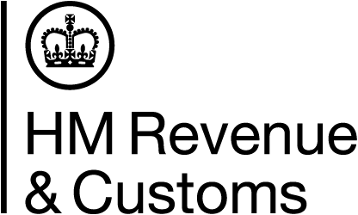 | Compliance checks series – CC/FS1K
Coronavirus (COVID-19) impacts on visits
We’re only carrying out visits where it’s safe to do so
We’re carrying out visits where a visit is the best way of doing our work, and it’s safe to do so. Where it’s better to do our checks without a visit, we will. But we’ll still need to visit business premises or meet
with customers to do some of our checks or gather information. All of our visits will be subject to a
risk-assessment and authorisation procedure before they take place.
We’re taking the right precautions
The safety of our customers and our staff is our priority. You’ll be contacted prior to an announced visit to make sure that we’ll be able to do our visit safely on your premises.
All visits and meetings whether arranged or unannounced will be done in line with government
guidelines on:
- social distancing
- hygiene
- the use of PPE (personal protective equipment)
When needed, HMRC staff will use HMRC supplied PPE and hygiene products, which include:
- face coverings
- gloves
- sanitisation products
Visits and meetings will go on no longer than is needed to do our checks or gather the information
we need.
Where meetings take place in HMRC buildings they’ll also be conducted in line with the government guidelines on:
- social distancing
- hygiene
- the use of PPE
More information
For more information about Coronavirus (COVID-19), go to www.gov.uk/coronavirus

