Order Decision
Site visit made on 18 May 2021
by Graham Wyatt BA (Hons) MRTPI
an Inspector appointed by the Secretary of State for Environment, Food and Rural Affairs
Decision date: 24 August 2021

Order Ref: ROW/3246799
- The Order is made under section 257 of the Town and Country Planning Act 1990. It is known as (Footpath No 80, East of Warren Crescent, Oxford) Public Path Diversion Order No. 2 2019
- The Order is dated 14 May 2019 and proposes to divert the public footpath shown on the Order plan and described in the Order Schedule in consequence of planning permission being granted.
- There were 29 objections outstanding when Oxford City Council submitted the Order to the Secretary of State for Environment, Food and Rural Affairs.
Summary of Decision: The Order is confirmed.

Procedural Matters
- The Order has been made because Oxford City Council (the Council) is satisfied that it is necessary to divert the footpath to enable development to be carried out in accordance with the planning permission which has already been granted in relation to Warren Crescent. The works in question consist of the erection of 10 dwellings which had not started at the time of my visit.
- There were 29 objections to the Order. However, no one requested to be heard and I carried out an accompanied visit on Tuesday 18 May 2021 where I was able to walk the existing and proposed route of the footpath in question. Although there was some debate whether the footpath had been obstructed by fencing erected around the development site, I found that it was indeed unobstructed and navigable.

Main Issue
- In deciding whether to confirm the Order or not, I have discretion to consider the interests of the general public and the potential effects of the Order on particular members of the public, such as those that may occupy a property adjoining the existing path. I must weigh any such disadvantages against the advantages of the proposed Order.

Reasons

Whether it is necessary to divert the footpath to enable development to be carried out
- Section 257(1) of the Town and Country Planning Act 1990 (the Act) provides for an Order to be made authorising the stopping up or diversion of a footpath if it is necessary to do so in order to enable a development to be carried out in accordance with planning permission already granted under Part III of the Act.
- Planning permission was granted for the erection of 10 x 3-bed dwellings (use class C3) together with associated car parking, cycles and bin storage. Diversion of public footpath. (Amended plans and description) on 26 September 2016. This development has not been implemented.
- It needs to be determined whether it is necessary to divert the footpath to enable this development to be carried out in full. Condition 2 in the permission states that the development shall be carried out strictly in accordance with the plan numbered 1932-A-L-WC-010 which details the layout of the proposed development. Condition 4 also requires the submission of details of the means of enclosure at the site, to include palisade fencing to the rear.
- The Council consider that it is necessary to divert the footpath as its route cuts directly through the rear garden areas of the development as proposed and close to the rear elevations of two of the approved dwellings. Thus, I consider that it is necessary to divert Footpath 80 to enable the development to be carried out.

The disadvantages or loss likely to arise as a result of the diversion
- Footpath 80 currently crosses are an area of grassed land that sits between a pair of semi-detached dwellings at 29-31 Warren Crescent (WC) and a block of flats at 33-43 WC. Instead of crossing the grassed area, the footpath would be diverted west along the side of the proposed dwellings, onto the estate road and southwards across the front of the development, to then divert east along the other side of the development to re-join the existing footpath to the rear of 33-43 WC.
- The development would provide 10 dwellings, each of which would have a car parking space to be accessed directly from WC. Walkers of the diverted footpath would need to walk in front of each of the proposed dwellings, and the parking spaces. Rights of Way Circular 1/09 (Guidance for Local Authorities) October 2009 states at paragraph 7.8 that, in considering potential revisions to an existing right of way, any alternative alignment should avoid the use of estate roads for the purpose wherever it is possible and preference should be given to the use of made up estate paths through landscaped or open space areas away from vehicular traffic.
- Drawing 1932-A-L-WC-110 Rev 04 indicates that a new footway would be created to the front of the dwellings, following the alignment of WC between points E-F. Therefore, walkers would not be required to walk on the road. Moreover, the proposed route would be traffic free between points A-D-E and F-G-C. It is unlikely that the estate road is the subject of high volumes of vehicular traffic and users are unlikely to be inconvenienced between points E-F in this respect. Thus, I do not consider that there would be disadvantages to users in terms of the physical characteristics of the proposed route.
- Furthermore, whilst maintaining a link between point A - C, walkers of this particular part of the overall circular route would be diverted by some 124m out of a total route of some 1.3km and would still be able to undertake their journey along footpath 80 should they so wish. Additionally, the part of the footpath to be diverted looks over, but is not within the Lye Valley Nature Reserve SSSI (LVNR) and is within a more suburban context. Moreover, there is no substantive evidence before me that the integrity or the enjoyment of the LVNR would be adversely affected by the proposed diversion, that walkers would not be able to continue to enjoy its amenities or that wildlife would be disturbed or endangered.
- There is no reason why incidents of fly-tipping is likely to occur as a result of the rear gardens of the proposed dwellings backing onto the LVNR. In any event, other mechanisms exist to resolve such matters. Consequently, there is no loss of, or disadvantage to, the public in this respect.

Impact upon persons whose properties adjoin or are near the footpath
- There is no evidence before me from which I could conclude that persons whose properties adjoin or are near the existing right of way would suffer loss or inconvenience as a result of the proposed diversion.

Whether the Order should be confirmed
- The Order has been made to enable a development of 10 dwellings to be erected which has an extant planning permission. It is clear that the development would obstruct part of footpath 80 and I have concluded that the proposed diversion would not result in an inconvenience or loss to the public in general or to those whose properties are adjacent to the footpath.
- The advantage of the Order is that planning permission already granted on the site can be carried out whilst retaining footpath 80. I conclude that there would be no disadvantage or loss to other parties which would outweigh the advantages conferred by the Order.

Other Matters
- Since the Council made the Order that is the subject of this decision, it has confirmed that a separate Order has been made to create a footpath to the rear of the proposed dwellings. However, this is a separate matter and I am bound to consider the diversion that is before me and which is the subject of Order No.2, 2019.
- In exercising my function on behalf of a public authority, I am aware of my duty under the Human Rights Act 1998, notably Articles 3, 12 and 24, which bestow a right to life, liberty and security, that no one shall be subjected to arbitrary interference, and the right to rest and leisure. In considering these matters, I have found that any interference would be necessary and proportionate and there would not be a violation of anyone’s human rights in that regard.
- The site benefits from planning permission to erect dwellings on the site and I have no remit to enter into the merits of the development, which includes the loss of the green space.

Conclusion
- I do not consider that there are any disadvantages to outweigh the benefits of the Order which will allow the development to take place in accordance with the planning permission. Having regard to this and the matters raised in the written representation, I conclude that the Order should be confirmed.

Formal Decision
- The Order is confirmed.

Graham Wyatt

INSPECTOR

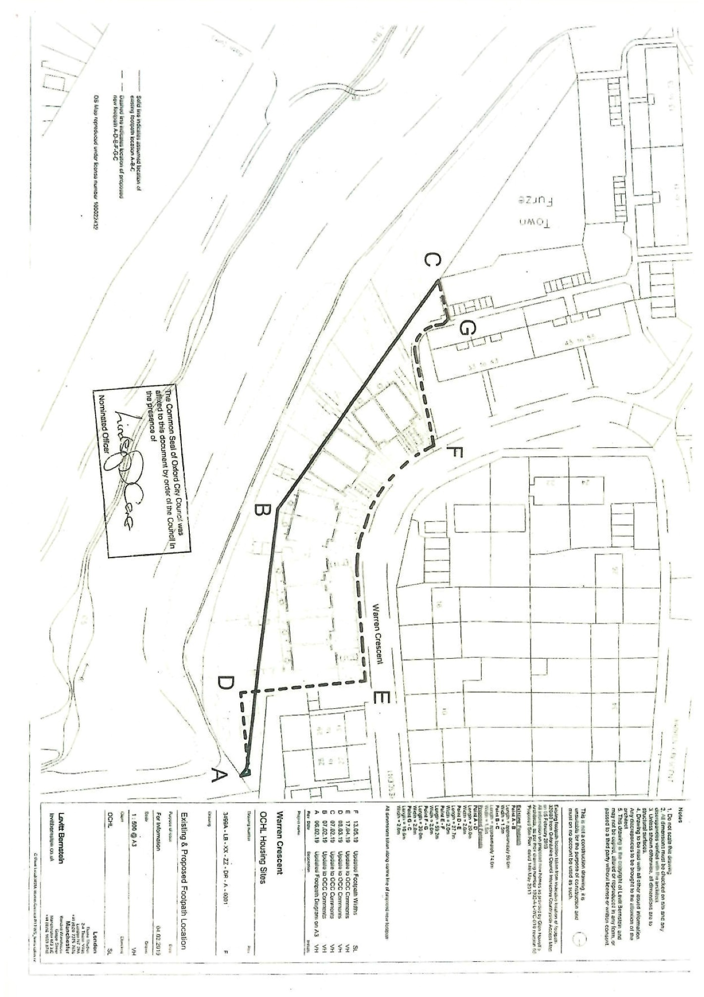

Points referred to are taken from the Order Map
Site of Special Scientific Interest

