Order Decisions
Site visit made on 29 June 2021
by J J Evans BA (Hons) MA MRTPI
an Inspector appointed by the Secretary of State for Environment, Food and Rural Affairs
Decision date: 27 SEPTEMBER 2021

Order A Ref: ROW/3246113
- This Order is made under Section 26 of the Highways Act 1980 (the 1980 Act) and is known as the Bath and North East Somerset Council (Public Footpaths, Bath Racecourse, Charlcombe and North Stoke) Public Path Creation Order 2019.
- The Order is dated 16 May 2019 and proposes to create public footpaths as shown on the Order Map and described in the Order Schedule.
- There were five objections to the Order when Bath and North East Somerset Council submitted the Order to the Secretary of State for Environment, Food and Rural Affairs for confirmation.

Summary of Decision: The Order is confirmed with modifications that do not require advertising as set out below in the Formal Decision.

Order B Ref: ROW/3246115
- This Order is made under Section 118 of the Highways Act 1980 (the 1980 Act) and is known as the Bath and North East Somerset Council (Public Footpaths, Bath Racecourse, Charlcombe) Public Path Extinguishment Order 2019.
- The Order is dated 16 May 2019 and proposes to extinguish the public footpaths as shown on the Order Map and described in the Order Schedule.
- There were five objections to the Order when Bath and North East Somerset Council submitted the Order to the Secretary of State for Environment, Food and Rural Affairs for confirmation.

Summary of Decision: The Order is confirmed.

Procedural Matters
- The Orders seek to create and extinguish footpaths within land owned by Bath Racecourse. In considering whether or not to confirm the Orders, I have considered the proposals for the creation and extinguishment of the footpaths separately.
- I undertook an unaccompanied site visit whereby I walked the paths that were to be created as well as those to be extinguished. At the time of my visit the racecourse was being used as a vaccination centre for the Covid pandemic. As a result, part of the legal routes of the paths between Points A–B, part of the route between Points A–H, and approximately half of the distance between Points B-C were inaccessible. Nevertheless, I was able to observe the general alignment of the routes and gained a good understanding of the effect of the proposed creation and extinguishments.
- The Council have drawn my attention to a typographical error on the Order Map for Order A. The Order Map refers to footpath BA5/65 instead of BA5/61 (Points S–T–U–V-G). I have had regard to this correction in my decision.

Main Issues

Order A
- The requirements of Section 26 of the 1980 Act are that before confirming this Order I must be satisfied that there is a need for the footpaths along the lines indicated on the Order Map and that it is expedient to create them having regard to:
- the extent to which the paths would add to the convenience or enjoyment of a substantial section of the public or to the convenience of local residents; and
- the effect the creation of the paths would have on the rights of persons with an interest in the land, taking into account the provisions for compensation.
- I should also have regard to any material provision of a Rights of Way Improvement Plan (ROWIP) prepared by any local authority whose area includes land over which the proposed paths would be created.

Order B
- The requirements of Section 118 of the 1980 Act are that before confirming this Order I must be satisfied that it is expedient that the paths should be stopped up having regard to:
- the extent that it appears that the path would, apart from the Order, be likely to be used by the public; and
- the effect which the extinguishment of the rights of way would have, as respects land served by the paths, account being taken of the provisions as to compensation.
- I should also have regard to any material provision of a ROWIP prepared by any local authority whose area includes land over which the paths would be extinguished.
- In addition, where an Order to stop up a path is concurrent with an Order to create a new path, I may also have regard to the extent which the Public Path Creation Order would provide an alternative path, when considering the extent to which the path would be likely to be used.

Reasons

Order A
- As referred to above, there are racecourse buildings, fences and uses obstructing the legal routes, with the presence of the vaccination centre providing further obstruction. In addition, there are no breaks within the safety railings of the racetrack to allow unimpeded use of the paths that cross the track. Such obstructions are a matter for the Council to address, and when considering the convenience of the routes I must disregard any obstructions or temporary circumstances which prevent or diminish the use of the paths by the public.

The need for the footpaths
- Bath Racecourse is positioned on a high plateau of land close to the edge of a steep scarp slope, below which are the incised valleys around Bath and the low land that extends towards the Severn Estuary. The racetrack is to the southern side of the racecourse buildings, stables and car park, with Lansdown Golf Course to the north. There are several rights of way in the area. Those within the Racecourse provide connectivity with the extensive network of public paths in the area, including the nearby Cotswold Way National Trail and the Cotswold Way Circular Walk, both of which are routes promoted by the Council.
- The proposed new footpaths are already used by the public as alternatives to the legal routes that are proposed for extinguishment. Walkers currently use alternative ways where the paths are obstructed by buildings and fences. For those paths crossing the racetrack, the safety barriers provide obstructions, and there was little evidence of wear in the grass surfaces of these paths.
- By contrast, all of the proposed paths show extensive wear in the grass surfaces, with defined and visible lines worn on the proposed routes of BA5/64 and BA5/65. From the evidence of wear apparent and the numbers of walkers I saw at my visit, the racecourse is a popular area, and a well-used choice is to walk around the edge of the track rather than across it using the legal paths. There was also evidence of wear indicating that the proposed routes are currently used to provide alternative ways to link to other public paths, including with the Cotswold Way Circular Walk (Point S) and the Cotswold Way National Trail (Point P).
- I note there is support for the Order from the local branch of The Ramblers and from the Cotswold Voluntary Parish Wardens, both of whom consider the proposals an improvement over the existing situation. Consequently, from the evidence before me, including what I observed on site, there is a need for the footpaths.

The benefits to the public and local residents
- The landowner allows mostly unrestricted public use of its land, with a number of paths having been worn in the grass around the racetrack. The Council consider the use of the paths to be primarily for pleasure rather than utility, and during my site inspection I saw that the racecourse is a popular area with walkers. There are other public paths around the edge of the racetrack and these and the proposed lines for BA5/65 and BA5/64 are popular routes and evidently well used. This popularity is understandable due to the attractive nature of the scenery, with panoramic views out over the surrounding landscape towards Bath and Wales.
- There are a small cluster of residential properties at Lansdown, but given the rural location of the area, the paths would fulfil a recreational need, particularly as they are separated from any large settlements by both distance and steep topography. The proposed routes would maintain connectivity within the network, retaining and providing options for short and long-distance recreational routes with which to enjoy the area.
- The racecourse buildings and fenced areas prevent the public using the legal routes, with walkers already diverting around them by virtue of the proposed routes (ie BA18/29 and BA5/62). In seeking to remove walkers from crossing the racetrack on the legal paths, the proposed routes would go around the edges of the racecourse, with a section of BA18/29 making use of the existing surfaced track between the entrance drive to the stables. Although in total the new routes would be longer, they would maintain the general direction of travel experienced along the legal paths. Moreover, as the existing paths cross the racetrack in seven different places, removing public access from the track would improve the safety of walkers, riders, horses and spectators, thereby providing significant public benefit. Whilst objectors consider there are ways of managing the conflict, including signage and marshals on race days, given the nature of the use of the racetrack and that the existing paths cross over it in so many different places, diverting the paths around the track would be the safest option for all concerned.
- The proposed routes would maintain, and in some cases improve the options for and the convenience of connectivity with the rights of way network, whilst providing a circular route around the racecourse. The provision of direct links at Points W and S would remove the current necessity of walking along Lansdown Lane and Lansdown Road to connect to other paths. These proposed points would be directly opposite links with other footpaths and would provide users with clear visibility of traffic when crossing the roads.
- Objections have been received concerning the proximity of BA5/61 to Lansdown Lane and Lansdown Road. With regard to the busy nature of both these roads, removing the need to walk along them to link with other paths would be a positive benefit, as would be the provision of road crossing points with long sight lines. Whilst I note concerns regarding traffic pollution, the area is not part of the Council’s Air Quality Annual Status monitoring. The proposed route of BA5/61 is segregated from the highway verges by a dry-stone wall, unlike the current situation of having to walk along the road verges and footways, where they exist. Several objectors mention enjoying birdsong, but the busy nature of the nearby roads is such that along both the legal routes and those proposed, vehicle noise is audible for some distance away, including along the length of the legal route of BA5/35.
- Users would still experience the attractive panoramas that are available over Bath, Bristol and the Severn Estuary when walking along the new routes of BA5/64 and BA5/65. Access to local points of interest, such as the Prospect Stile viewing point and the Little Down hillfort would be retained, as would the views of Beckford Tower when walking towards Lansdown Lane along BA5/65 and BA5/61. Concerns have been raised regarding the proximity of walkers to the race barriers and agricultural boundaries. Whilst the proposed route of BA5/65 would be physically constrained, views and vistas over the racecourse would remain and would be comparable on the proposed routes to those experienced on the existing paths. In addition, walking along the edge of the scarp along BA5/65 would provide a verdant contrast to the mown and long grass of the racecourse, with close views of woodland flora and fauna available.
- Near to the buildings and car parks (Points N–M-L–J–K–H) the new paths would utilise the existing hard surfaces and access roads that serve the racecourse buildings. Much of the racetrack and land around it is mown grass, and the proposed routes, like most of the existing paths, would be across managed grass. In the winter some of the paths may become muddy due to the erosion of the grass, but despite references to sections being slippery, dangerous and boggy, there is little evidence provided or apparent on site that this would be a significant problem. The proposed paths would be level with only one short slope of approximately 8m long near Point R. However, the slope has a gentle and consistent profile, and this combined with the short nature of the gradient would not preclude people from using the path, as evident by the worn tracks upon it.
- Users of proposed path BA5/65 would be walking between the racetrack barrier and stone walls, but apart from some narrowing due to overhanging vegetation, the width of the path would be sufficient to allow walkers to pass. Dogs may well stray onto the racecourse, golf course, and nearby roads, but this would be a matter for the owners to address, as would preventing dogs from worrying livestock.
- Objectors have also raised concerns regarding the danger to walkers from golfers playing at Lansdown Golf Course. There are already paths through the golf course (BA5/43) and another close to the edge (BA5/37). The new route between Points J-K–H would be the nearest section to the golf course, and as it would be very close to the existing ones, the risk would be similar to that currently experienced, with both walkers and golfers having to undertake care and consideration of each other’s presence.
- Taken as a whole, there would be some public disbenefits but the benefits to the public and local residents arising from the proposal would outweigh the harm.

The effect on persons with an interest in the land
- The land crossed by the existing and proposed paths is owned and managed by Bath Racecourse. The legal routes cross the racetrack in seven places and to either side of the track there are plastic safety barriers that form a total of fourteen obstructions to BA5/35, BA5/45 and BA5/46. The landowner wishes to retain the safety barriers throughout the year, to provide management and safety improvements for the public and for horses and riders.
- As well as the obstructions caused by the operation of the Covid vaccination centre, part of the legal routes of BA5/45 and BA5/37 have been obstructed by the fencing, buildings and associated operations that occur around the stables, reception, hospitality, and grandstand buildings. The proposed routes (Points N-M-L-J-K-H) are already in use by the public, and the landowner wishes to formalise this occurrence.
- The landowner owns both the existing and proposed routes and has submitted the application for the changes. Compensation matters have not been raised. It would be in the interests of the owner of the land to create the new footpaths as alternatives to those to be extinguished.

Conclusions with regard to Order A
- Having regard to the above, there is a need for the footpaths. The proposed paths would be expedient to the convenience and enjoyment of a substantial section of the public and to local residents, and they would improve public safety. The new paths would also be expedient with regard to the rights of persons with an interest in the land. On balance the benefits of the creation of the paths outweighs the disadvantages. I thereby conclude that Order A should be confirmed, subject to the modifications previously mentioned as regards correcting the typographical error on the Order Map.

Order B
- There are obstructions to the legal routes within the racecourse, but even if removed, many would continue to use the routes around the track or walk on the trackways through and round the stables and racecourse buildings. The proposed routes would be natural routes to walk so as to avoid the racecourse buildings and the track. They would maintain the desire for many users to create a circular route around the racetrack, as well as provide connectivity with nearby paths. This would include the provision of more convenient and safer crossing points over Lansdown Road and Lansdown Lane, as well as removing the need to walk alongside busy roads.
- As referred to above, the owner of the land crossed by the legal paths would benefit from the extinguishments, and there would also be public benefits. I am not aware of any effect of the proposed closures on any other land served by the paths.

Conclusions with regard to Order B
- Overall, when taken in conjunction with the creation of the paths specified in Order A, it is expedient that the paths in Order B should be extinguished. I thereby conclude that Order B should be confirmed.

Rights of Way Improvement Plan
- The Council have referred to three Statements of Action in the ROWIP. These Actions are concerned with identifying and carrying out improvements for people with mobility difficulties and visual impairments; identifying road safety improvements to enable increased use of routes; and identifying gaps in the wider recreational network to improve accessibility and connectivity (Actions 4.3, 4.4 and 4.6 respectively). Having regard to my findings above, the Orders are in accordance with such Actions.

Other Matters
- The land crossed by the paths is part of the Bath Racecourse and does not appear to be in use for agriculture or forestry. Consequently, it would be unlikely that there would be any negative impact upon agricultural or forestry operations arising from the proposals.
- There is no evidence before me that the proposals would impact upon habitat conservation or species diversity. The new footpaths are unlikely to have any adverse impact upon the natural beauty of the area.
- Two of the new routes (BA5/64 and BA5/65) would be close to the boundaries of the racecourse land with neighbouring woodlands and agricultural fields, and a concern has been raised that the new paths could bring dogs into contact with livestock in adjoining fields. Article 1 of the First Protocol of the Human Rights Act confers rights for the peaceful enjoyment of possessions and non-deprivation of possessions. The racecourse allows permissive use of much of their land, and the proposed routes are currently well used including by dog walkers. The fields adjacent to the proposed paths are delineated by a mixture of stone walls and wire fences. Given this and the public benefit arising from the proposed paths, the likely harm or interference to property would be insufficient to give rise to a violation of the rights of adjoining landowners.
- I have also had due regard to the Public Sector Equality Duty contained in Section 149 of the Equality Act 2010 which sets out the need to eliminate unlawful discrimation, harassment and victimisation, and to advance equality of opportunity and foster good relations between people who share a protected characteristic and people who do not share it. Objectors have referred to the short section of incline near Point R, and the dangerous slippery and muddy nature of the new paths.
- Point R would be the only incline and I appreciate that part of the attraction of the area is that it offers level walking. However, the slope near Point R would be over a grassed surface and would have a gradual, short and shallow gradient. Apart from the use of existing tracks near the racecourse buildings, none of the existing paths are surfaced, with most of the existing and proposed paths being grass.
- The re-siting of the points to cross Lansdown Lane and Lansdown Road would offer improved visibility when crossing over these busy roads. The provision of kissing gates near Points V and S would improve access by creating a gap in the drystone walls rather than having to climb over stonework.
- Having regard to these circumstances, there would be no disproportionality introduced to persons with protected characteristics.

Formal Decisions
- Order A is confirmed, subject to the following modifications on the Order Map:
- The Order Map shall be amended to refer to BA5/61 instead of BA5/65.
- Order B is confirmed.

J J Evans

INSPECTOR

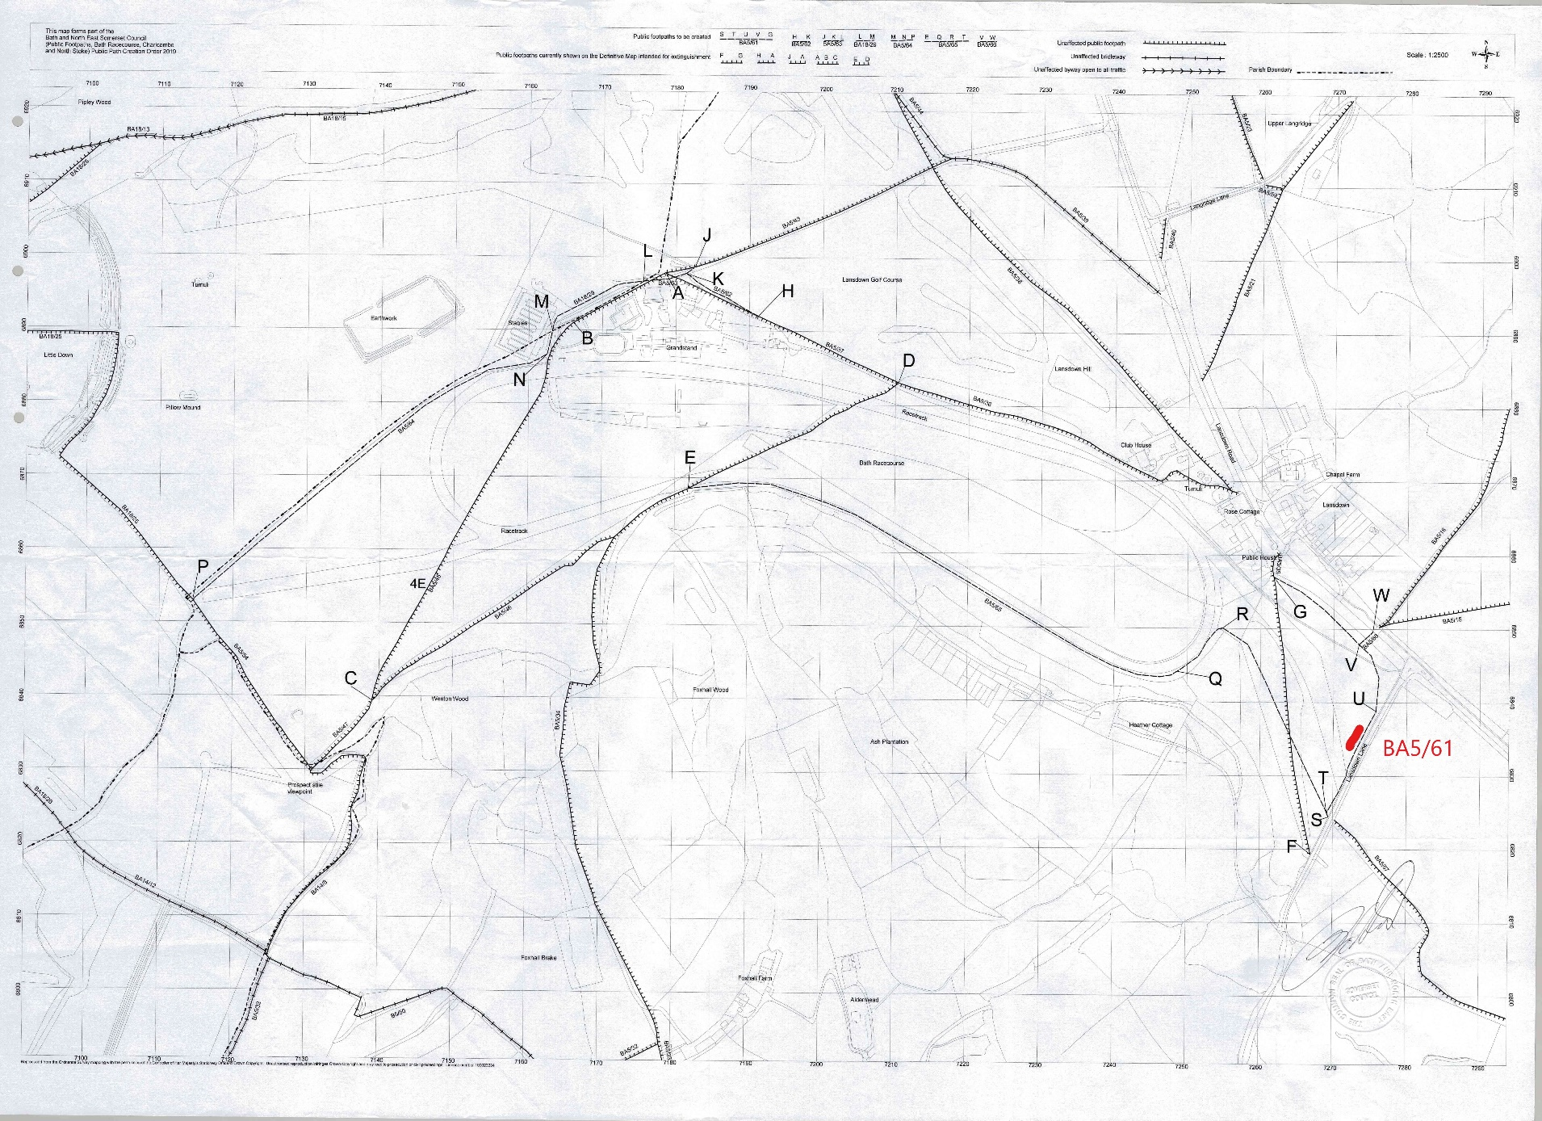
MODIFIED CREATION ORDER AT A4 – MAP NOT TO ORIGINAL SCALE

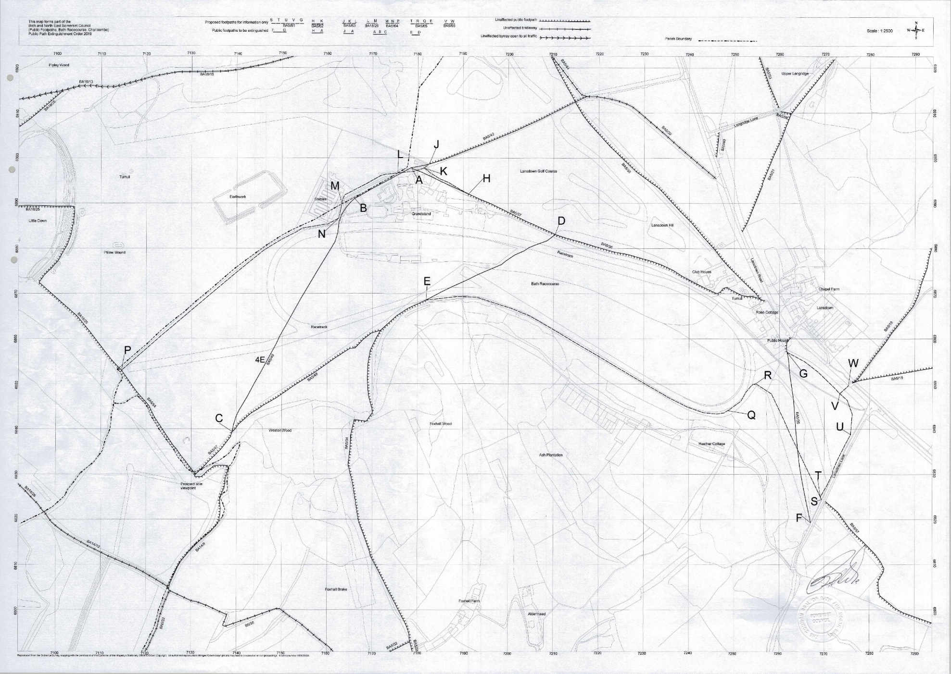
EXTINGUISHMENT ORDER AT A4 – MAP NOT TO ORIGNAL SCALE

