Order Decision
Site visit made on 21 July 2021
by Susan Doran BA Hons MIPROW
an Inspector appointed by the Secretary of State for Environment, Food and Rural Affairs
Decision date: 6 October 2021

Order Ref: ROW/3245803
- This Order is made under Section 53(2)(b) of the Wildlife and Countryside Act 1981 and is known as the City Council of Bristol Definitive Map and Statement Modification Order No. 2, 2019.
- The Order is dated 28 May 2019 and proposes to modify the Definitive Map and Statement for the area by adding a public footpath as shown in the Order plan and described in the Order Schedule.
- There were two objections outstanding when the City Council of Bristol submitted the Order to the Secretary of State for Environment, Food and Rural Affairs for confirmation.
Summary of Decision: The Order is proposed for confirmation subject to modifications set out below in the Formal Decision

Preliminary Matters
- This Order concerns the addition of a public footpath between Nos.147 and 149 Crow Lane and Machin Road, Henbury, Bristol. From the footway of Crow Lane, point B on the Order plan, the Order route follows a passageway between buildings, passing a pinch-point (A), and emerging into a yard which it crosses to reach the footway of Machin Road, point C.
- In response to a point raised by the current landowner, objecting to the Order, the City Council of Bristol (‘the Council’) requested modifications, in the event that I decide to confirm the Order. These concern the realignment of the Order route across the yard to its termination at Machin Road, and I consider this below.
- In addition to the objections two representations were received. However, neither address matters that I can take into account in reaching my decision.

The Main Issues
- The Order has been made in consequence of the occurrence of an event specified in Section 53(3)(b) of the 1981 Act, being the expiration, in relation to any way in the area to which the map relates, of any period such that the enjoyment by the public of the way during that period raises a presumption that the way has been dedicated as a public path. The Council relies upon use by the public which is considered sufficient to raise a presumption of dedication as required by the tests laid down in Section 31 of the Highways Act 1980.
- This requires me to consider the date on which the right of the public to use the claimed footpath was brought into question; whether the claimed footpath was used by the public as of right and without interruption for a period of not less than 20 years ending on the date on which their right to do so was brought into question; and whether there is sufficient evidence that there was during this 20-year period no intention on the part of the landowner to dedicate the claimed footpath.
- The main issues in this case are whether there was no intention by the landowner to dedicate a public right of way; the alignment of the Order route approaching Machin Road, and its width.

Reasons

When use of the claimed route was brought into question
- Metal fencing and gates were erected across the Order route in 2014 effectively preventing through passage. However, prior to this, in early 2012, notices had been put up at either end of the route stating, ‘Private No Public Right of Way’. The current landowner states similar notices were in place before this date. However, there is no supporting evidence for this. Accordingly, I consider the signs put up in 2012 brought into question the right of the public to use the route, providing a 20-year period of 1992 to 2012.

Whether the claimed route was used by the public as of right and without interruption
- Evidence of use was provided in 8 user evidence forms, with use claimed between 1961 and 2013. Claimed use was on foot mainly to go to the supermarket and shops and to the car park on Machin Road, with use varying from daily to between 50 and 300 times a year and was therefore regular and frequent. All claimants knew and/or had seen others using the route. However, I consider that use by one claimant to take out rubbish may amount to private rather than public use, and I have discounted it.
- Users acknowledged the pinch-point (A) caused by the presence of a barrier. Nevertheless, all claimed continued uninterrupted use notwithstanding the barrier’s presence throughout the 20-year period in question. None of the forms referred to any signs prior to 2012; none of the claimants sought permission to use the Order route; and none said they had been challenged. Neither is there anything to suggest that claimed use was by force.
- The Council claims that public use is supported in Google Street View imagery where people are seen on the route. However, whilst they may be suggestive of use, I do not consider it can be determined from these photographs whether these people were members of the public or had a private right to be there.
- Landowner evidence referred to use, by for example school children and youngsters “squeezing through the gap” several times a day, as a short cut.
- On balance, I find the user evidence as of right, that is without force, permission, or secrecy, and sufficient to raise a presumption of dedication of the claimed route as a public right of way.

Whether there was no intention to dedicate a public right of way
- The land appears originally to have been owned by the Council and was gated at the Machin Road end, but the gate was not replaced after it was damaged. Accordingly, until fenced and gated in 2014, there was open access from Machin Road.
- It is claimed that a sign in place in 1966, well before the 20-year period under consideration, stated ‘No Thoroughfare’, but there is no supporting evidence for this. Although they had acquired the site crossed by the Order route in 2007, the current landowner had occupied No 147 Crow Lane since 1983. Over a 35-year period (homemade) signs are said to have been in place on internal and external site walls, though no record was kept of them. Their wording included ‘Private Property’, ‘No Fly Tipping’, ‘No Parking’ and ‘No Right of Way’. Apparently, these were ignored, defaced, removed, or destroyed, but from 1983 to 1996 were replaced as soon as possible, and from 1996 checked twice a week and replaced twice a year. As regards their wording, I consider the signs ineffective in demonstrating a lack of intention to dedicate, with the exception of any stating there was no public right of way. However, there is no evidence to corroborate the presence of such signs, or indeed the erection of any signs between 2007 and early 2012 during the ownership of the current landowner. There is nothing to indicate the Council had put up any signs to deter use of the claimed way by the public during its ownership up to 2007.
- The barrier at A, the footings of which remain evident and were inspected on the accompanied site visit, restricted the available width considerably throughout the 20-year period. The barrier was described as existing to prevent passage. In addition, a 9-inch (23 cm) step at this location had to be negotiated. Both the current landowner and other staff members had stopped or attempted to stop people squeezing past the barrier, stating some had been turned back. They had made similar challenges prior to owning the land. Challenges amounted to 20 or so individuals a week mostly during daylight hours, though no further details of names or dates are available. Some use is described as anti-social behaviour. None of those providing evidence of use reported having been challenged.
- At times the route was obstructed by vehicles and deliveries at the Machin Road end. However, these would have been temporary and not in my view intended to prevent use by the public.
- One Objector to the Order stated they had not seen anyone using the route, although this is not evidence that people did not use it, but rather that they had not witnessed use themselves.
- There is no evidence that the Council as landowner took any actions to indicate that they had no intention to dedicate a public right of way, and I am not convinced that the actions of the current landowner were sufficient to indicate such an intention. The barrier, in place throughout the 20-year period, served to prevent unauthorised access other than on foot which was afforded via the narrow gap to one side. Some of those with an interest in the land challenged some people attempting to use the Order route. Whilst they may not have considered it to be a public right of way, I conclude this was not effectively communicated to the public during their ownership from 2007 onwards either through claimed challenges, or by signage, until early 2012 when use was brought into question.
- I conclude there is insufficient evidence on behalf of the landowners to indicate a lack of intention to dedicate during the 20-year period in question.
- In view of the above, I am satisfied that a public right of way on foot subsists.

Alignment and width
- As part of its investigation, the Council consulted a variety of sources. Maps dated 1957, 1968, and 2006 attached to land registry records are consistent in showing a solid line at A, the earlier maps also indicating a set of steps on the west side of the passageway (to access the adjoining property). All show lines, or a line, and a wide gap at the Machin Road end suggesting some sort of boundary or boundaries with an open access. This is consistent with the evidence of the current landowner and with photographs taken by the Council in 2018 which show a brick wall on the east side of the yard at the Machin Road end, and a drop kerb. All the maps and photographs show access at B was open.
- The termination point of the Order route at Machin Road (C on the Order plan), coincides with the location of a brick wall present during part of the 20-year period which would have prevented access. I agree with the current landowner that this alignment, crossing the yard to C, is not supported in the evidence adduced.
- The plan attached to the application, together with plans accompanying the user evidence forms, indicate a route crossing the yard to terminate further to the north-east. This point is consistent with the line and gap shown on the maps described above (paragraph 21), the brick wall, gap and drop kerb seen at the site visit, and with the evidence of the current landowner regarding these features. It is also consistent with the modification sought by the Council. To more accurately reflect the route used by the public, I propose to modify the Order plan and description of the Order route in Parts I and II of the Order to follow this alignment.
- The evidence considered above supports the presence of a narrow gap at A alongside the barrier throughout the 20-year period (paragraph 15). Whilst the recollections of users varied as regards its actual width, a measurement taken at the site visit confirmed this to be 33cm. Accordingly, dedication of the Order route is subject to a limitation to the width at this point, as already stated in the Order, notwithstanding its small size. The width of the remainder of the Order route is stated in the Order as both 2 metres and a minimum width of 2 metres. A 2 metres width is not inconsistent with the passageway (save for the limitation at A), and with a reasonable width across the open yard that would enable two people to pass. For clarity, however, I propose to delete the reference to a ‘minimum’ width.

Other matters
- In reaching my decision, under the 1981 Act, I am unable to take into account such matters as the suitability or desirability of the Order route for use by the public, nor issues such as alleged anti-social behaviour. Nor is the impact on the residential amenity a matter that has a bearing on my decision. Nevertheless, I understand the sincere concerns that have been raised.

Conclusions
- Having regard to these and all other matters raised in the written representations, I conclude the Order should be proposed for confirmation with modifications as described above and set out below.

Formal Decision
- I propose to confirm the Order subject to the following modifications:
- In Part I of the Schedule to the Order, ‘Description of path to be added’, delete ‘for 41m’ in line 4; amend the grid reference for point C to ST 56936 79119, and amend 147 to ‘145’ in line 5; delete 41 and replace with ‘35’ and delete ‘minimum’ in line 6
- In Part II of the Schedule to the Order, ‘Description of Route’ beneath the heading ‘TO’ and ‘Location’ amend 147 to ‘145’ and the grid reference to ST 56936 79119; and beneath the heading ‘Particulars…’ ‘General Description of Route’ delete 41 and replace with ‘35’
- On the plan attached to the Order, modify the alignment of the route between C and the passageway to a new line north-east of C as shown by a dashed red line

Since the confirmed Order would affect land not affected by the Order as made, I am required by virtue of Paragraph 8(2) of Schedule 15 to the Wildlife and Countryside Act 1981 to give notice of the proposal to modify the Order and to give an opportunity for objections and representations to be made to these proposed modifications. A letter will be sent to interested persons about the advertisement procedure.

S Doran

Inspector

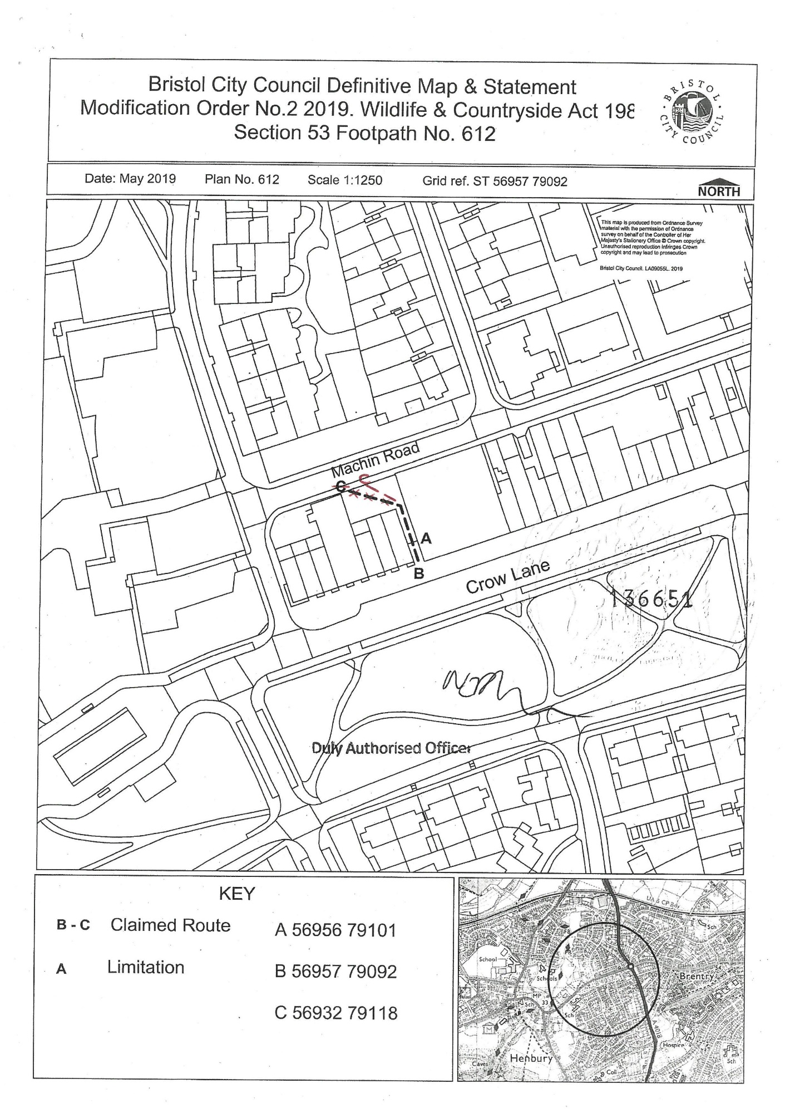

Paragraph 25

